Test Report

for

DegreeOverview

Prepared by Bohui WU, Xuan WANG, Fuhao RUAN, Yu WU

Lily

05/26/2021

Contents

1. Brief description 1

2. Test date and performer 1

3. References 1

4. Error report 1

5. Appendix 2

# Brief description

The entire test took one hour to complete. The major challenge of the test is the software used in the testing runs extremely slow and crashes some testers’ computers.

# Test date and performer

All tests were run by Bohui WU, Xuan WANG, Fuhao RUAN, Yu WU on May 26, 2021, on their personal computers.

# References

Test Plan for DegressOverview v1.4 prepared by Lily.

# Error report

|  |  |  |
| --- | --- | --- |
| Test case ID | Expected result | Actual result |
| D1_2 | The page shows an empty table, and the drop-down menu indicates the student has no performance report. | The page shows an empty table, but the drop-down menu did not indicate the student has no performance report. Instead, an empty drop-down menu was presented. |

# Appendix

**5.1 Appendix 1: Screenshots of TestComplete**

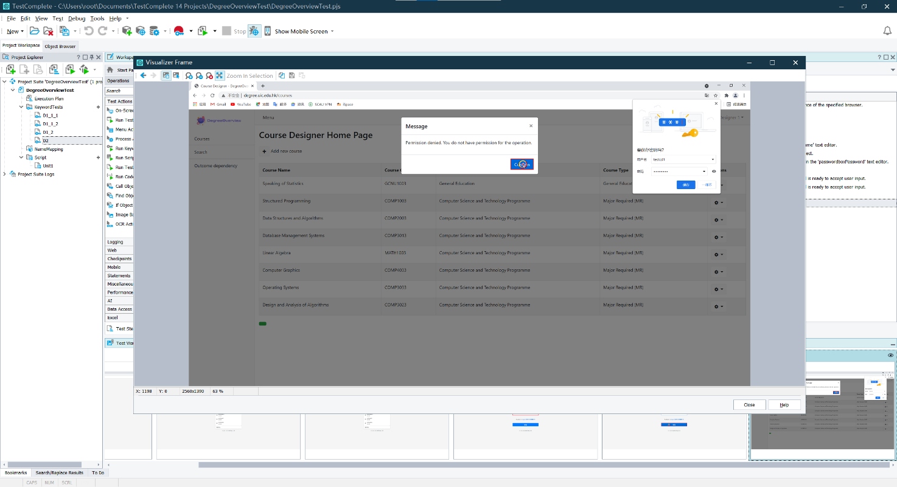

Figure 1: Visualize the frame during test D2

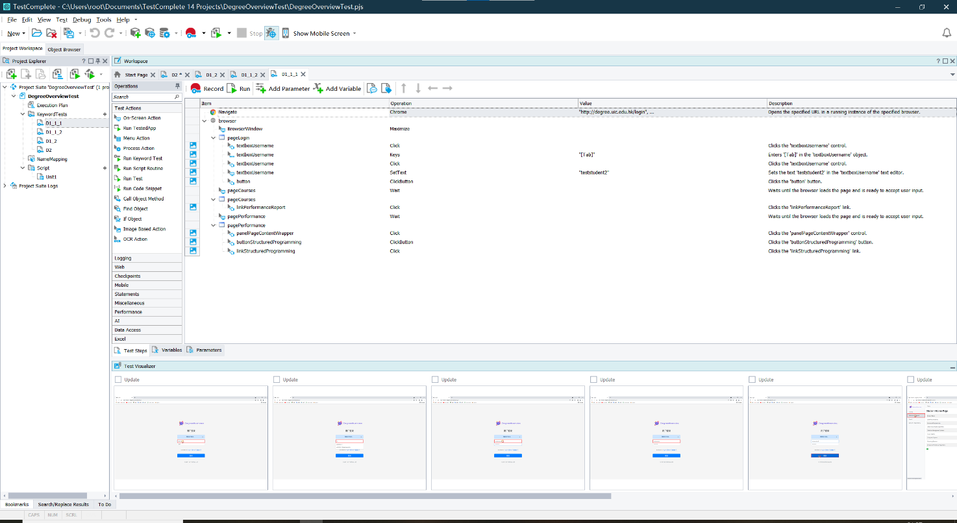

Figure 2: The recorded actions for D1_1_1

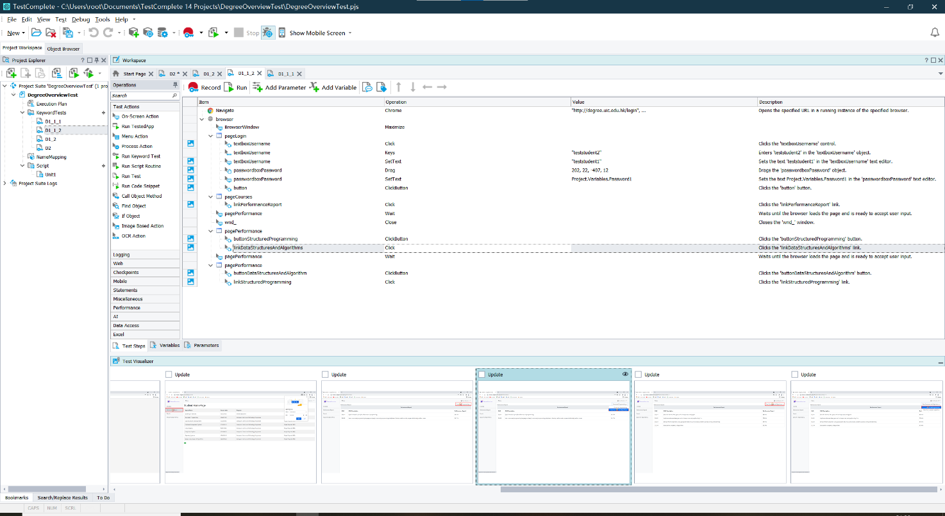

Figure 3: Relate an action with the frame in the visualizer

**5.2 Appendix 2: Text-Based View of Script**

CheckCILOPerformanceStudent()

{

web_add_cookie("lang=en-US; DOMAIN=degree.uic.edu.hk");

web_url("login",

"URL=http://degree.uic.edu.hk/login",

"Resource=0",

"RecContentType=text/html",

"Referer=",

"Snapshot=t9.inf",

"Mode=HTML",

LAST);

web_set_sockets_option("SSL_VERSION", "AUTO");

web_submit_form("login_2",

"Snapshot=t10.inf",

ITEMDATA,

"Name=username", "Value=teststudent1", ENDITEM,

"Name=password", "Value=12345678", ENDITEM,

EXTRARES,

"Url=/static/font-awesome-4.7.0/fonts/fontawesome-webfont.eot?v=4.7.0", "Referer=http://degree.uic.edu.hk/courses", ENDITEM,

LAST);

web_link("Performance Report",

"Text=Performance Report",

"Snapshot=t11.inf",

LAST);

return 0;

}