**Mooli Ordering System**

**System Design Specification (SDS)**

**1.1**

**April 22nd, 2020**

Group X

**Computer Science and Technology Program**

**United International College**

1. Document Change Log

|  |  |  |  |
| --- | --- | --- | --- |
| ***Change Date*** | ***Changed By*** | ***Version*** | ***Change Description*** |
| 04/22/2020 | Group 7 | *1.0* | Initial release of the document |
| 05/01/2020 |  | 1.1 | Changed the design pattern of the software to MVC |
| 05/15/2020 |  | 1.2 | Updated screenshots of the design |
| 05/18/2020 |  | 1.3 | Updated the database design |
| 5/20/2020 |  | 1.4 | Updated the ER diagram |
|  |  |  |  |
|  |  |  |  |
|  |  |  |  |
|  |  |  |  |
|  |  |  |  |

1. Table of Contents

1. Document Change Log 2

2. Table of Contents 3

3. Design Overview 4

4. Tools and Standards 5

4.1. Tools 5

4.2. Standards 5

5. User Interface Design 6

5.1. Usage Scenario 1 6

5.2. Usage Scenario 2 6

6. Database Design 7

7. Diagrams 8

1. Design Overview

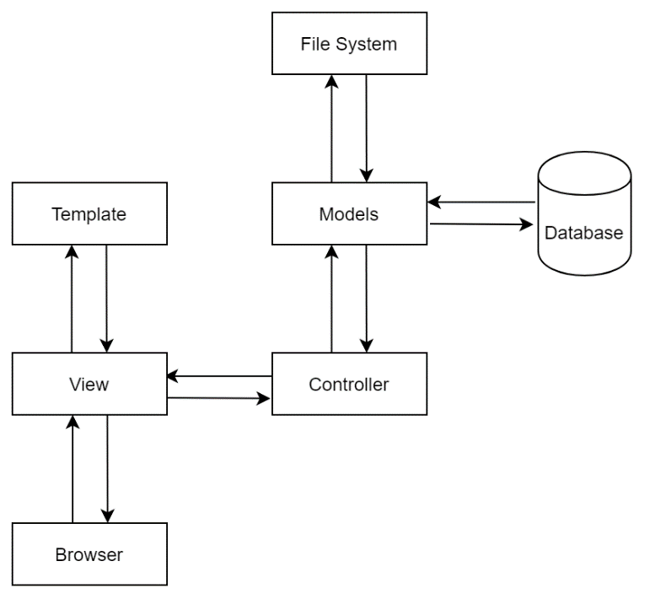 The software’s design pattern follows the modified MVC design pattern for web applications.

When a request comes in from the browser, the views will serve as a router that routes the request to various end-points. At each end-point, the view will send the request to the controllers.

The controllers will deal with the logic of the incoming request and translate the logic of the request data into the information the models can understand.

Then, the controller will send the request to the models, where the interactions with the database and file system will take place. If no errors are found in the models, the required information or a None object will be returned to indicate the process went as expected. If an error did occur, an exception would be raised.

After the interaction, the requested information will be sent back to the controller for error encapsulation and further processing (if needed).

Next, the required information or the error message will be sent back to the views. The views will assembly the information with the corresponding templates using a template rendering engine.

Finally, the webpage will be sent to the user.

1. Tools and Standards

## Tools

The software requires the use of HTML, CSS, JavaScript, MySQL, and Python.

## Standards

Browser for development:

* Google Chrome (Version 81.0.1044.138)

Cloud storage for the code:

* GitHub

Version control system:

* Git 2.26.2

Tool for back-end testing (early stage of development)

* Postman

Dependencies:

* CSS and JavaScript
  + Bootstrap 4.4.1
  + Font Awesome 4.7.0
  + jQuery 3.4.1
  + Popper
* Python
  + bcrypt 3.1.7
  + certifi 2020.4.5.1
  + cffi 1.14.0
  + click 7.1.1
  + cryptography 2.9.2
  + dnspython 1.16.0
  + email-validator 1.1.0
  + Flask 1.1.2
  + Flask-WTF 0.14.3
  + idna 2.9
  + itsdangerous 1.1.0
  + Jinja2 2.11.2
  + MarkupSafe 1.1.1
  + paramiko 2.7.1
  + pycparser 2.20
  + PyMySQL 0.9.3
  + PyNaCl 1.3.0
  + six 1.14.0
  + validate-email 1.3
  + Werkzeug 1.0.1
  + wincertstore 0.2
  + WTForms 2.3.1
* Database
  + MySQL 15.1 Distrib 1.4.11-MariaDB

1. User Interface Design

## Home page

The home page is mainly used for displaying products. It is the first UI the customer would see when the customer opens the application or the website. The screenshot of the home page is shown below. Up at the top, there is an image. The image is mainly used for decoration purposes. To the left of the screen shows all the categories the user can select from. To the right, it shows the products within the category.

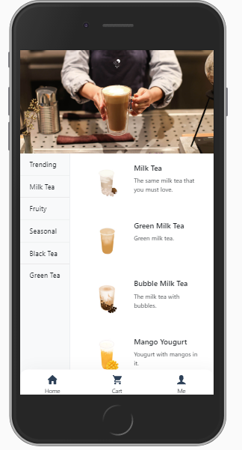

Figure

## User authentication

If the user tries to click on “add to cart” in the product details page, the “cart” or “me” button down at the navigation bar, the user will be taken to the page that tells the user login is required. From the page, the user can choose to sign in or sign up. In the sign-in page, the user needs to enter the username and password. If the username or password is wrong, an error message indicating the information the user provided had an error. If all the credentials are current, the user will be taken back to the home page.

In the signup page, the user needs to provide a username the user prefers, an email address, and a password twice. By clicking on the username and password field, the requirements for the field will appear in the form of a tooltip. If the user’s username isn’t between 6 and 24 characters and only contains letters and digits, an error message will be given, indicating the username is invalid. The same goes for email and password.

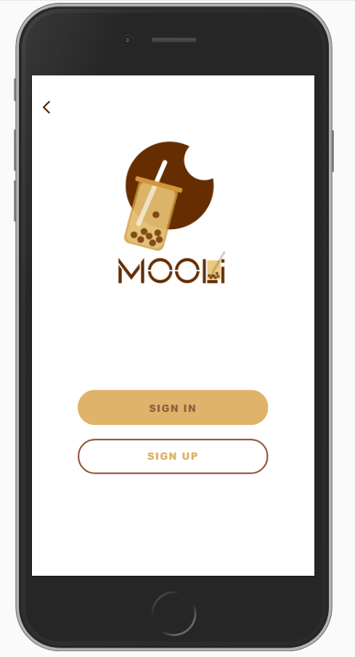

Figure

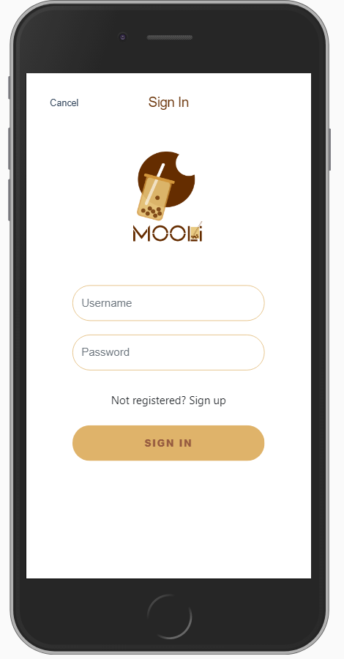

Figure

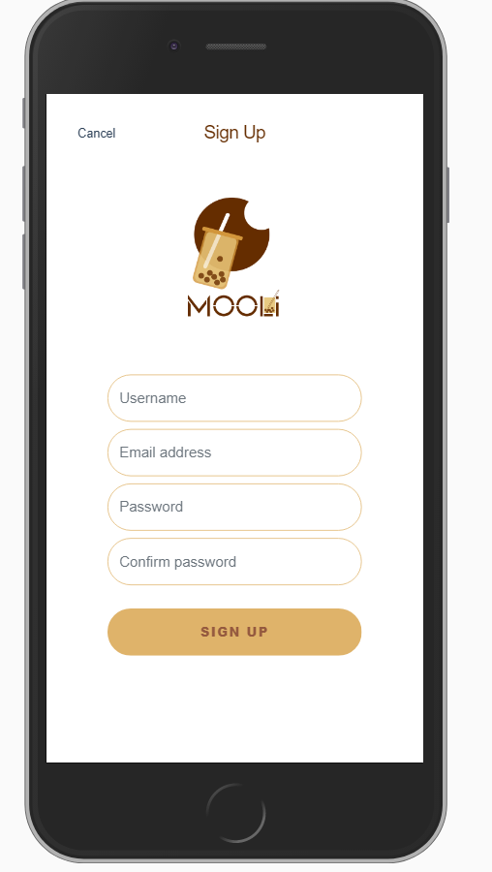

Figure

## Product information

Figure two shows when the user has clicked on one of the products. On the page, the customer gets detailed information about the product. It contains a title, a brief description, a price, and an option to add the product to the cart.

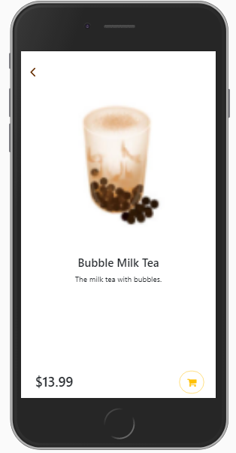

Figure

## Cart

The cart page shows all the products the user has added to the cart. For each entry in the cart, it contains a thumbnail of the product, a title, the price for the product, the amount the user has chosen, and a sub-total for the entry. The user can click the “+” or “-” to adjust the amount. The cross at the top-right corner of each entry can be used to delete the cart item. Down the screen, there’s another card showing the bill total and the grand total of the order. The customer can click on “proceed to pay” to proceed to the checkout page.

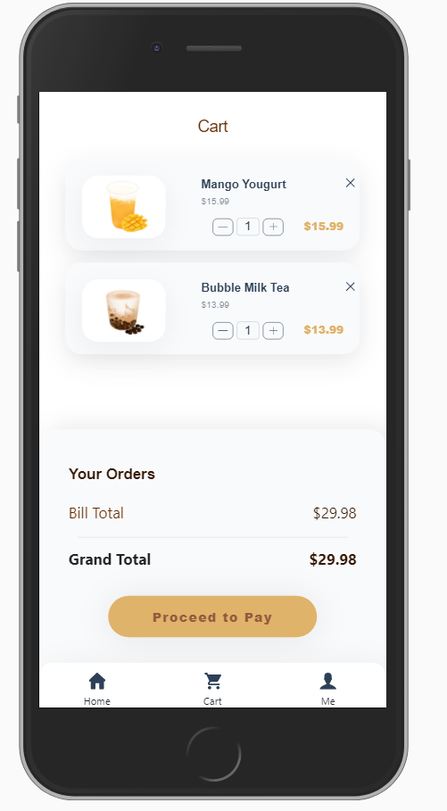

Figure

## Me

The page requires the user to be logged in before accessing. The page contains a balance of the user. To the bottom-left of the “balance card,” the user can redeem (add funds to the balance) from a gift card the shop provides. The option “account info” is designed to be used for updating the user’s information. The “about” page shows information about the copyright of the current software. The logout option can be used when the customers wish to log out of the system.

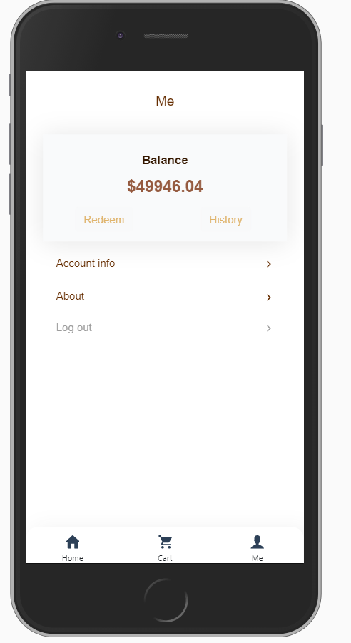

Figure

## Redeem page

The page is used when users wish to redeem from a gift card. The user must enter a correct redeem code in order to redeem. If an incorrect redeem code is given, the page will give an error saying the redeem code is invalid. If the redeem happened as expected, the user will be taken back to the “me” page.

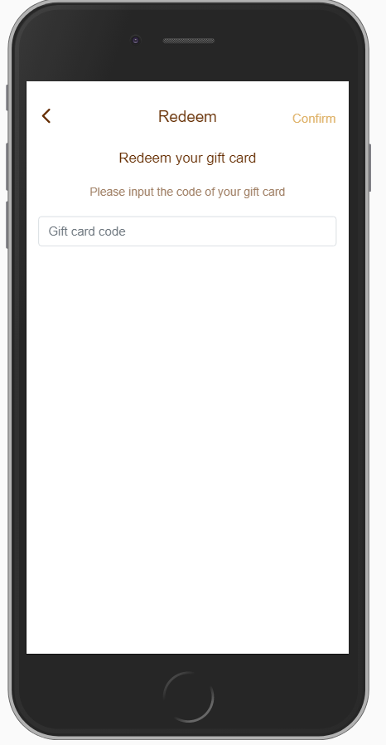

Figure

## Account information

Within the account information page, the user will be able to update his or her personal information. The page contains the avatar of the current account (if the user did not upload an image, the default avatar would be shown). Down the avatar, the user can choose to change the avatar or change the password. Down the two buttons, the user can update his name (including first name and last name), the phone, and the gender.

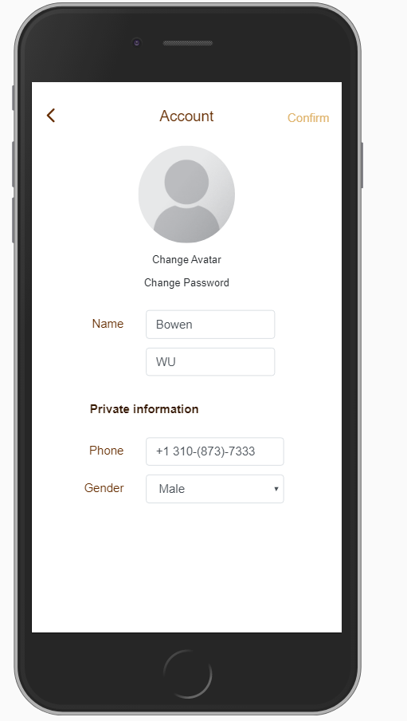

Figure

## Changing avatar

Within the page, the user can select an image from his or her phone and upload it to the server. The file size should be less than 4M. After uploading the image and click “confirm,” if the image passes all the chekcs (including the file size), the image will be set as the account’s avatar.

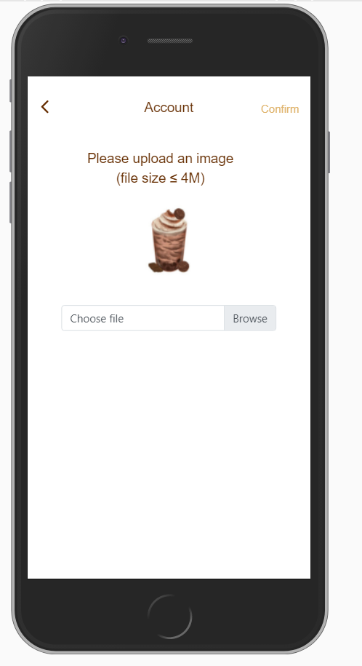

Figure

## Changing the password

The user can update his or her password using this page. The user must provide the old password and the new password (twice) in order to update the password. If the old password is wrong, the user will be notified that he or she had entered the wrong password (Incorrect password). If the new two new passwords didn’t match one another, the user would also be notified, “new passwords do not match.” When all the checks, including the requirements of the password, the password will be updated.

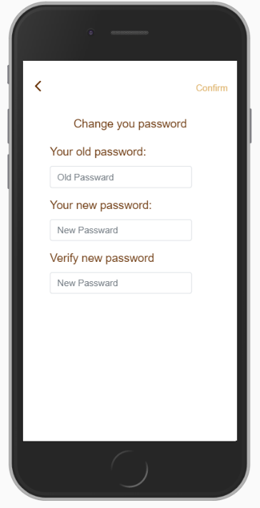

Figure

## Checkout – 1 (coupn)

By clicking “proceed to pay” in the cart page, the user will be taken to the page that asks the user for coupon code. If the user doesn’t have a coupon code, the user can click on the “skip” button at the top-right corner of the screen. If the user has (know) a coupon code, the user can enter the coupon code and click “verify.” If the coupon code is activated, the user will be taken to the payment page. If the coupon code is not activate, or incorrect, the user will be notified. There are four possibilities for the occurrence of an error:

* The coupon code does not exist.
* The coupon code is not activated yet.
* The coupon code has expired.
* The current bill’s total hasn’t reached the threshold of the coupon code (the bill is not expensive enough to be eligible for the discount)

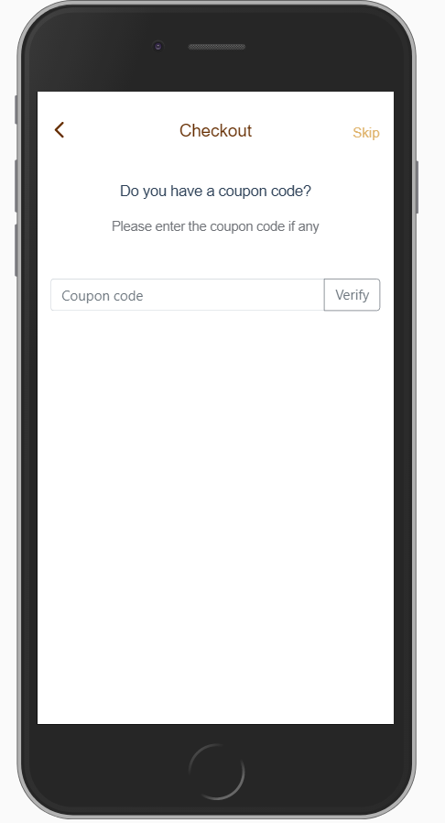

Figure

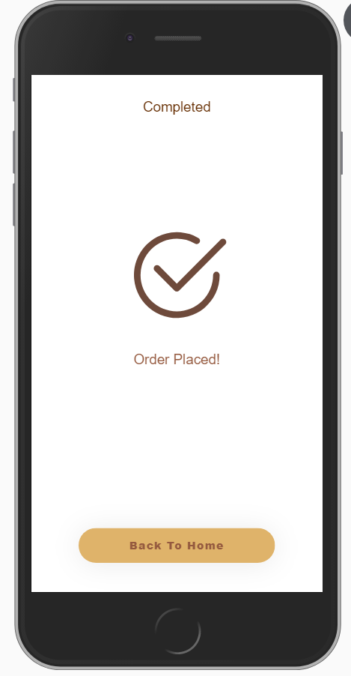

Figure

## Checkout – 2 (payment)

The page shows the payment options (currently, the option is locked down to balance). Down the page, it shows the bill total, the amount the user is eligible for the discount, and the grand total the user has to pay. By clicking “confirm” at the top-right of the screen, the user will be taken to the success page indicating the order has been placed. Otherwise, an error message will be given. Possibilities for the occurrence of an error includes, but not limited to:

* Internal error, most likely, the server has disconnected from the database.
* Insufficient amount in user’s account.
* The cart contains no product.

## Checkout – 2 (payment)

The page shows the payment options (currently, the option is locked down to balance). Down the page, it shows the bill total, the amount the user is eligible for the discount, and the grand total the user has to pay. By clicking “confirm” at the top-right of the screen, the user will be taken to the success page indicating the order has been placed. Otherwise, an error message will be given. Possibilities for the occurrence of an error includes, but not limited to:

* Internal error, most likely, the server has disconnected from the database.
* Insufficient amount in user’s account.
* The cart contains no product.

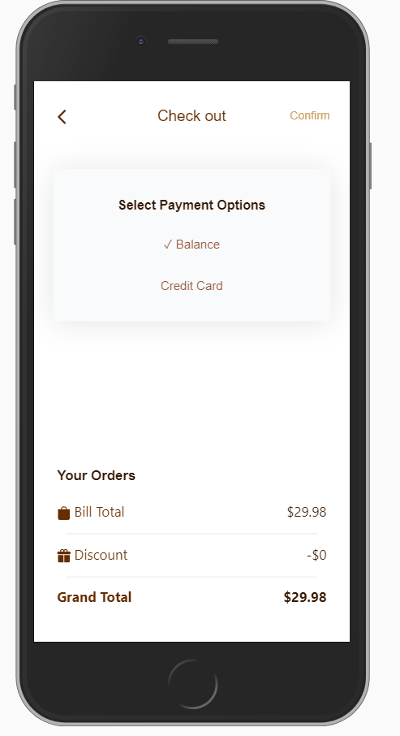

Figure

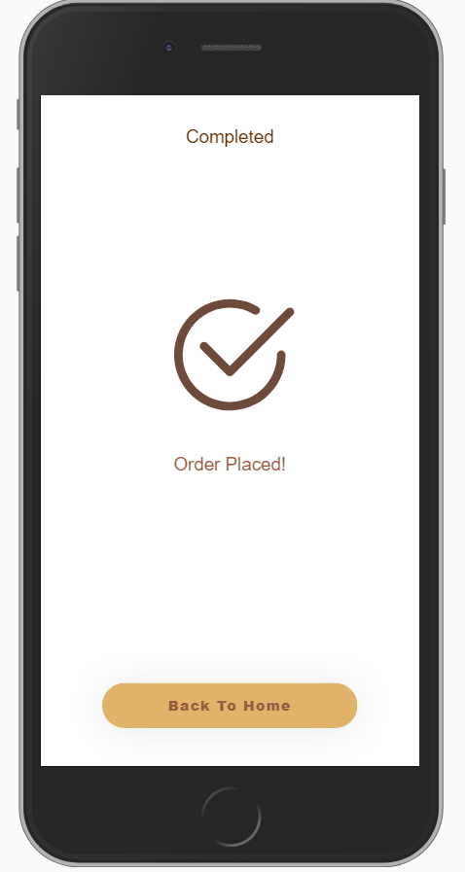

Figure

## Staff login

The staff login page is only eligible for staff to log in. Even though staff and customers share the same set of user pool, staff can be logged in as a customer, but a customer can not be logged in as a staff. If a user tries to log in to the staff end, the user will be given the error message “not a staff.” The staff must provide the correct credential in order to log in.

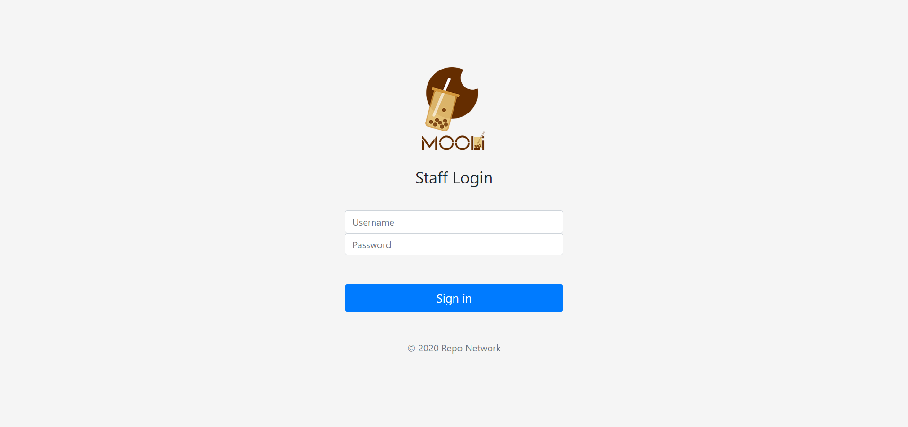

Figure

## On-going orders

The on-going orders page contains all the on-going orders. The page will refresh automatically every 5s, so new orders will be shown automatically. The title of each card contains the order id of the order. The body of the card contains the user’s name (most likely that the user won’t provide) and the username of the order, the products the user has selected, the status of the product. The cook and update the status of the order accordingly. In the status of “pending,” the cook can cancel the order or confirm the order (update status from “pending” to “processing”). When the order is processing, the cook can update the status to “ready for pickup” or back to the previous state “pending.” After the customer has picked up the products he or she ordered, the cook can click on “done,” and the order will disappear from the screen. The most recent order comes to the last of the screen.

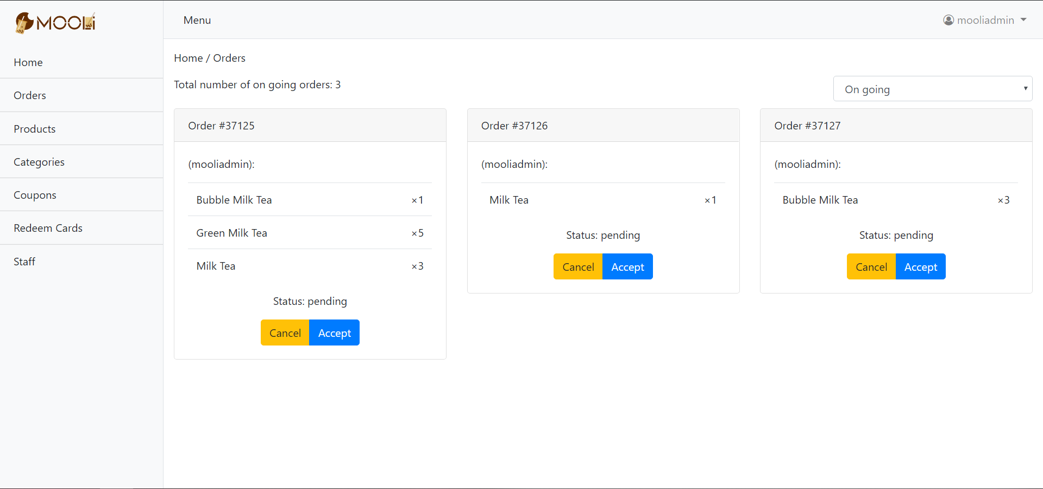

Figure

## Previous orders

All previous orders will be stored in the database and can be viewed here. For each entry, it contains the order id, the username, and name (if the user has provided), the total, the actual amount the customer paid, the time the order was placed, and the status of the order. To the right, clicking on the gear button will bring up a drop-down menu. The staff can choose the view of the detailed information of the product (shown in Figure 19), or refund the order. Please be note that the customer required the order should not be refunded automatically after being canceled.

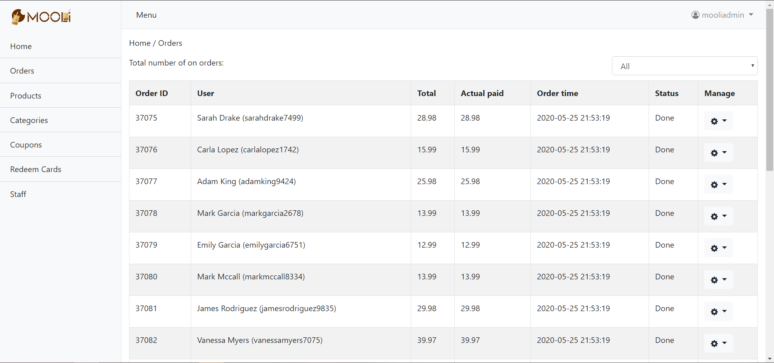

Figure

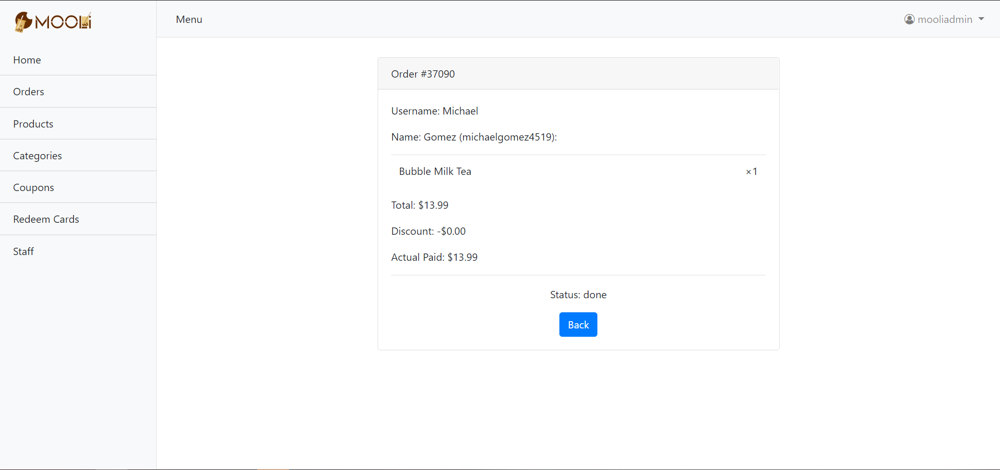

Figure

## Product management

The page is used to manage the product. Clicking on the “+” button at the top-left, a window will open (figure 21). On the page, the staff can add information about the product. In the staff entered invalid information, like a duplicated product name, an error message will be given to the staff (figure 22). Opening the gear button of a entry, the staff have the option to edit the product information, update the picture and thumbnail of the product, and delete the product. Editing the product is similar to creating new products, so it will not be explained again.

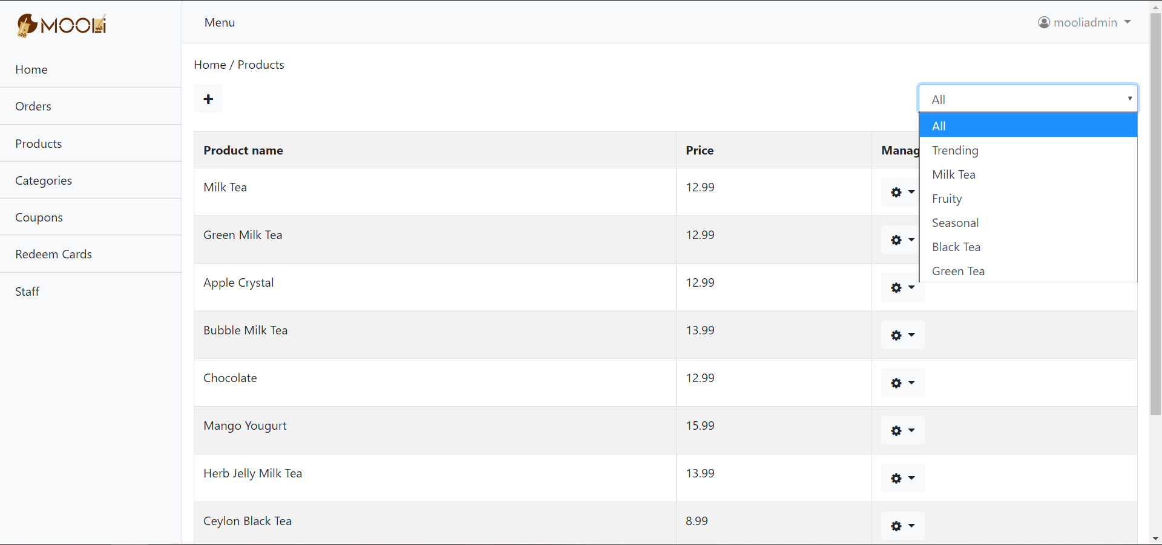

Figure

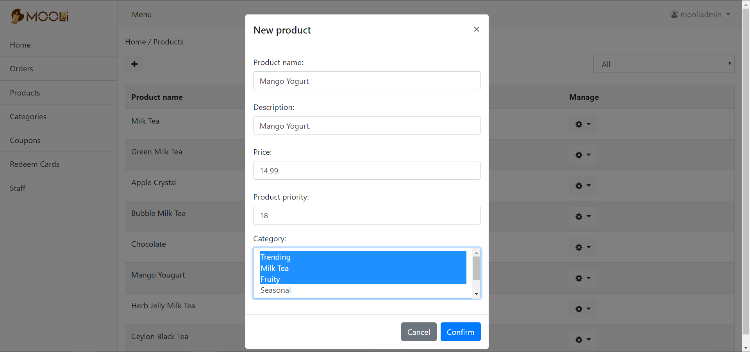

Figure

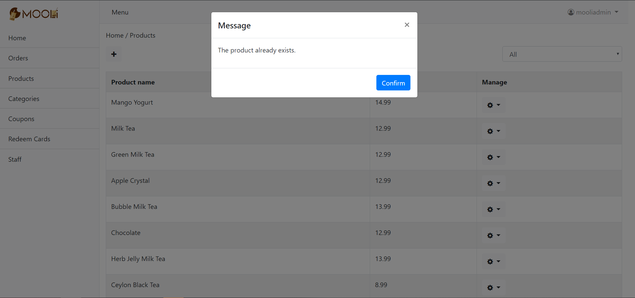

Figure

## Category management

The category management page manages all the categories. The logic for the operation is similar to products, so it will not be explained again for the sake of simplicity.

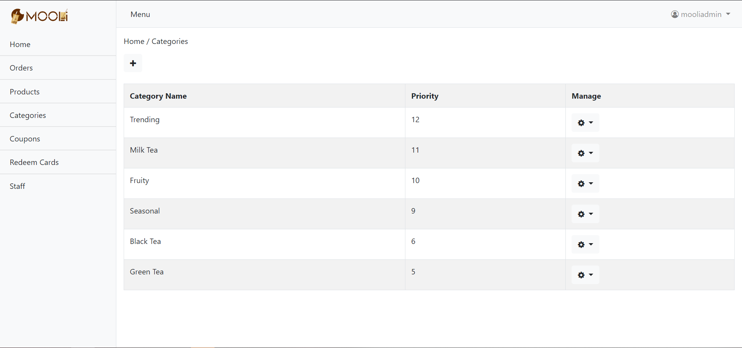

Figure

## Category management

The category management page manages all the categories. The logic for the operation is similar to products, so it will not be explained again for the sake of simplicity.

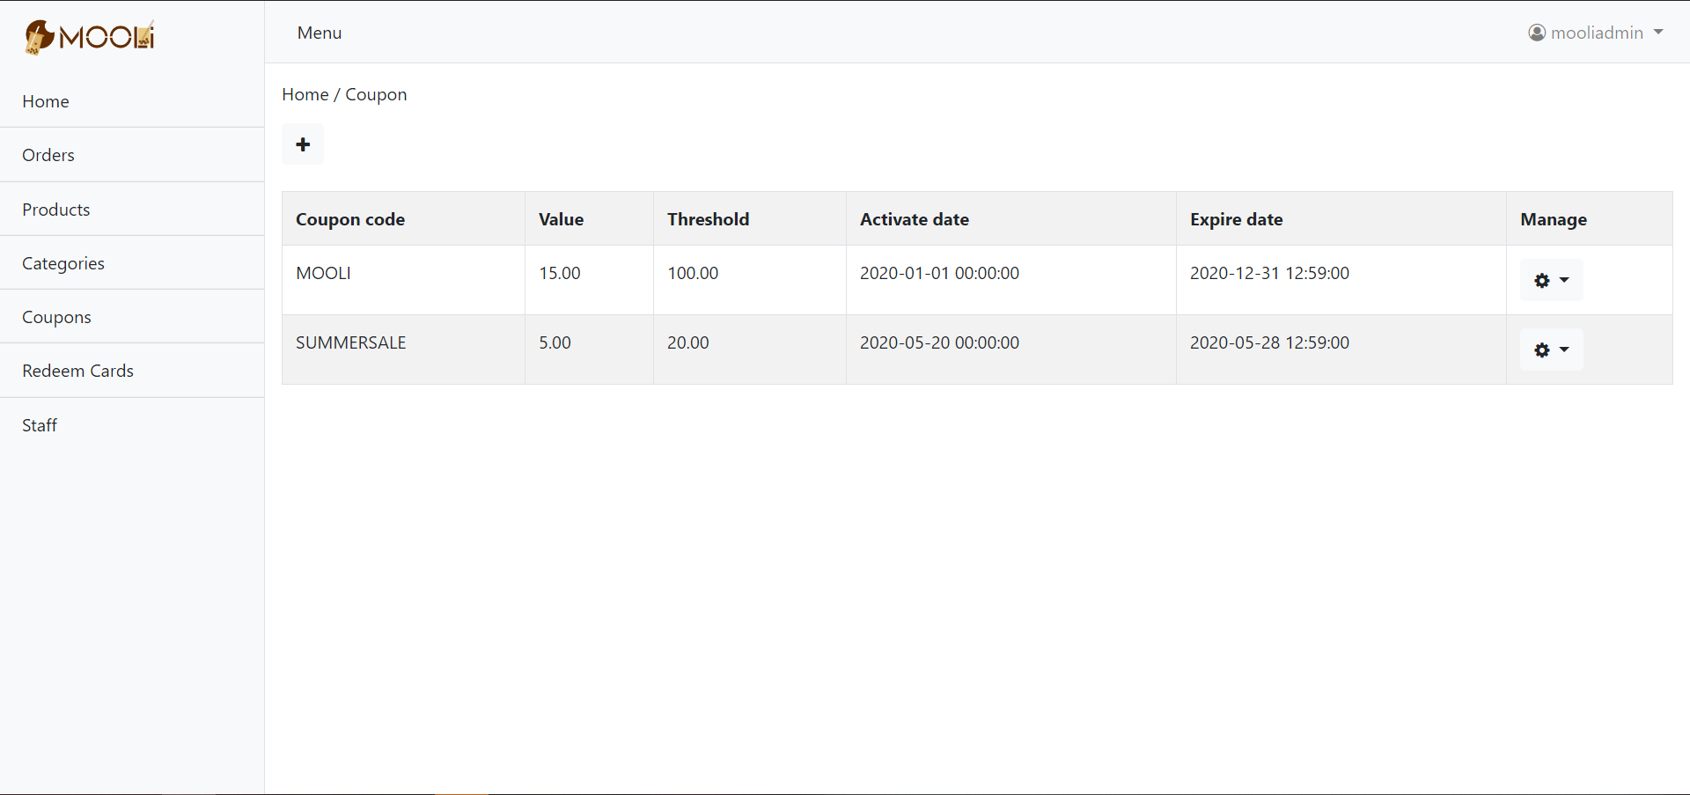

Figure

## Redeem cards management

The redeem cards management page manages all the redeem cards. To generate redeem cards, the staff have to provide the value of the redeem card and the number of redeeming cards of the same value the staff wishes to generate at once (figure 26). To the right of the drop-down menu, the staff can choose to delete the redeem card.

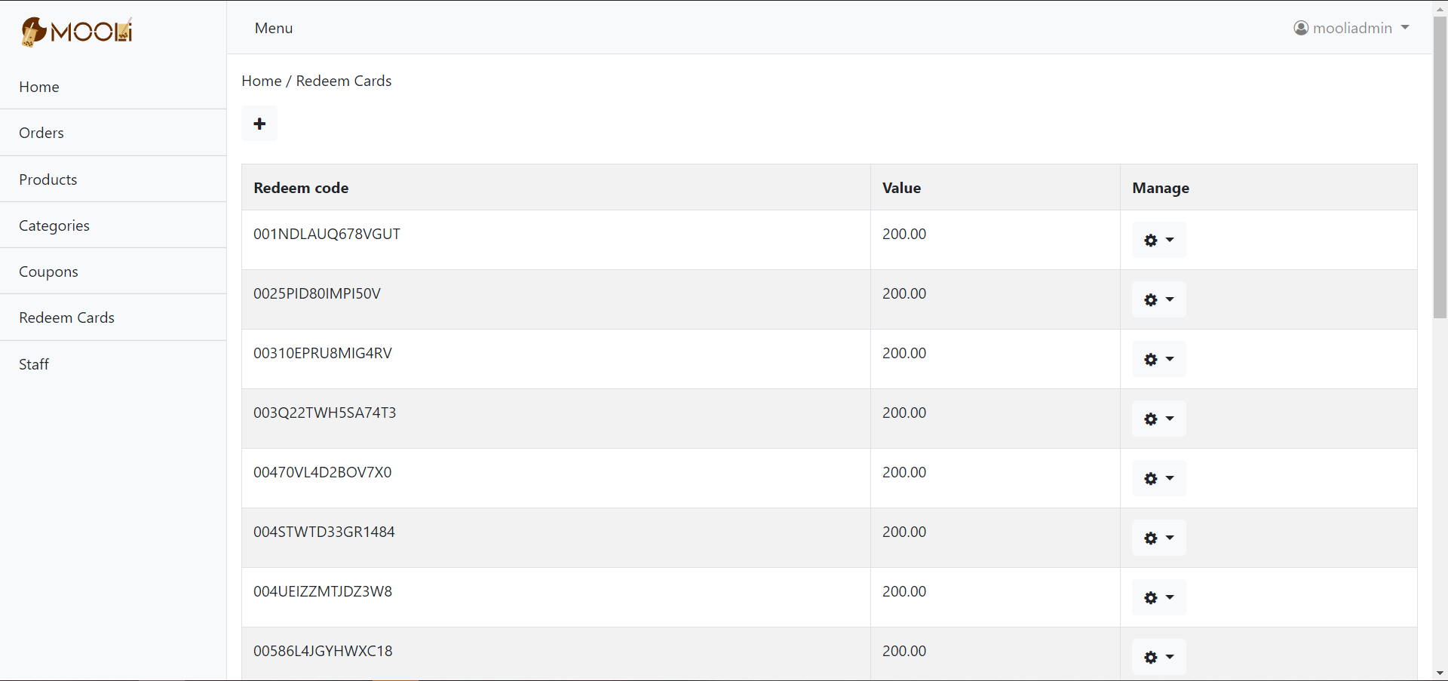

Figure

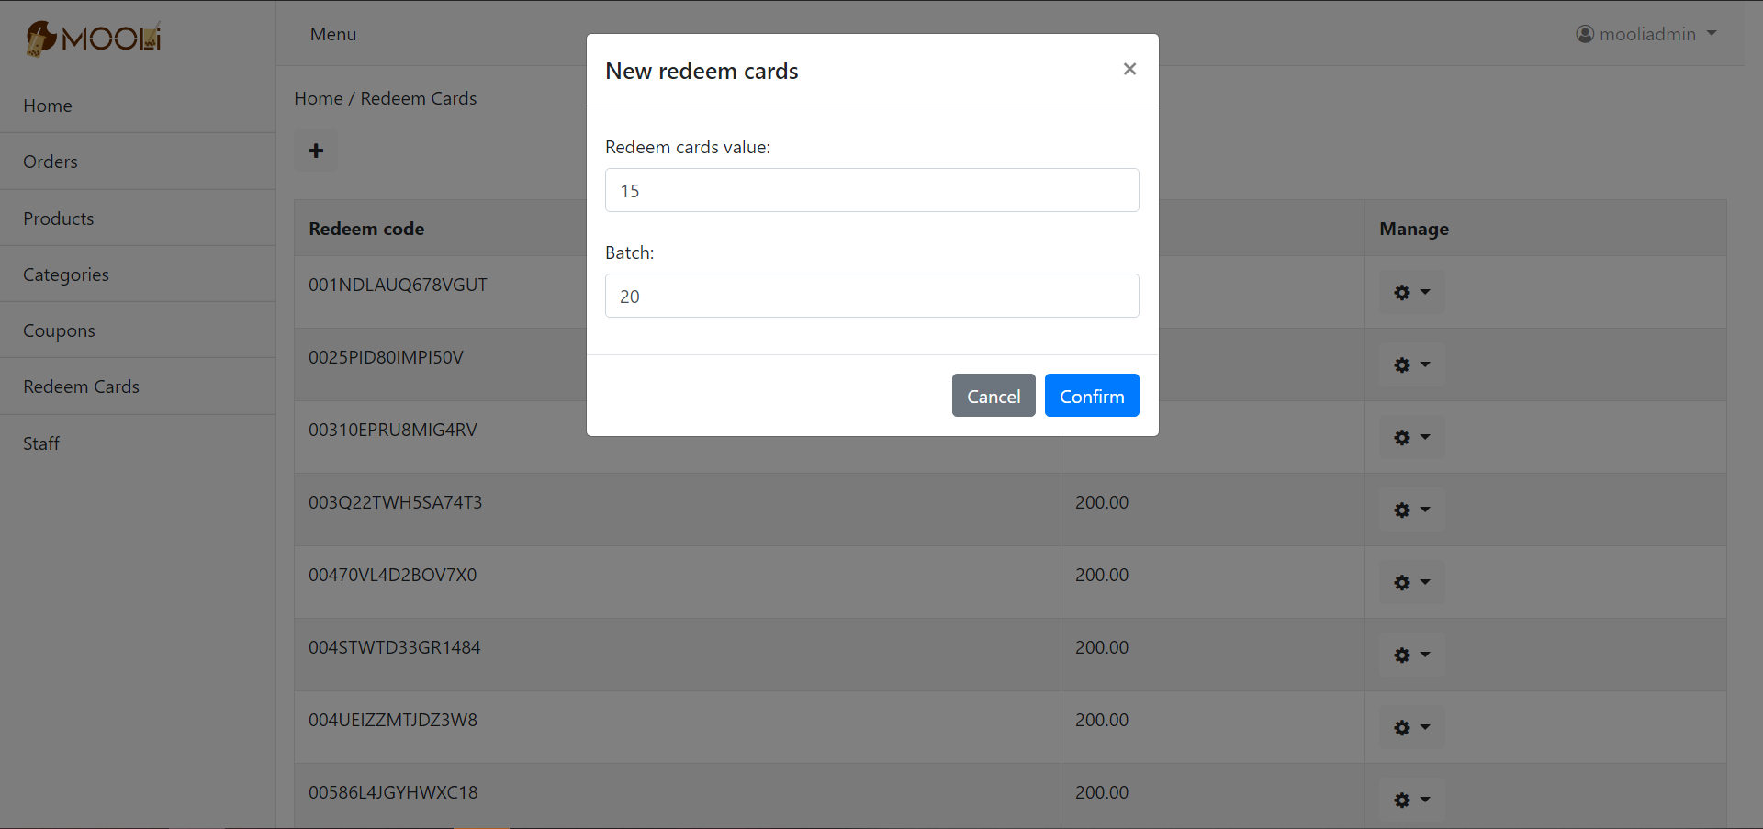

Figure

## Staff management

The staff management page shows all the staff. For each staff, the page shows the user id, username, email, name, role, phone number. Under to drop-down menu, the staff can change the staff’s information, including the role, first name, last name, gender, and phone number. The username and email address should not be changed. The staff can also delete specific staff. After removing from the staff list, the user will only be able to log in to the customer end.

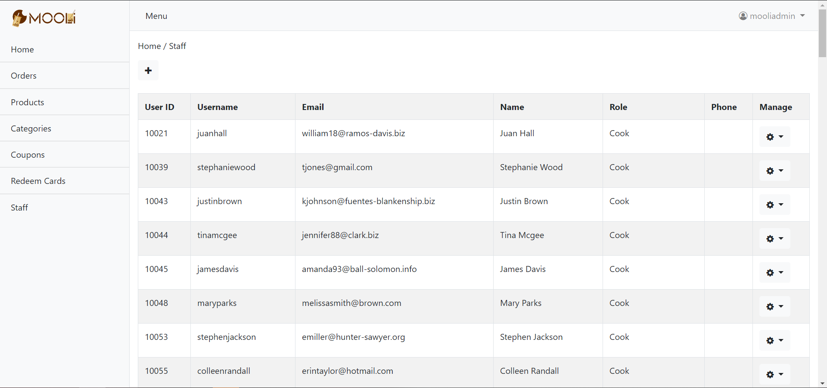

Figure

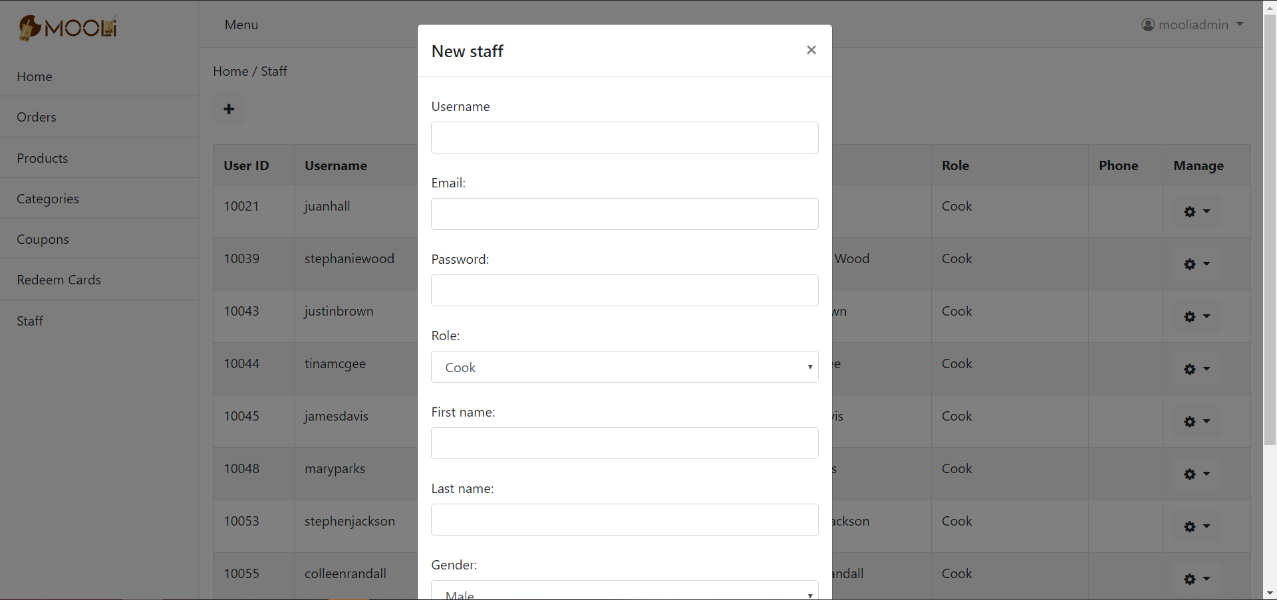

Figure

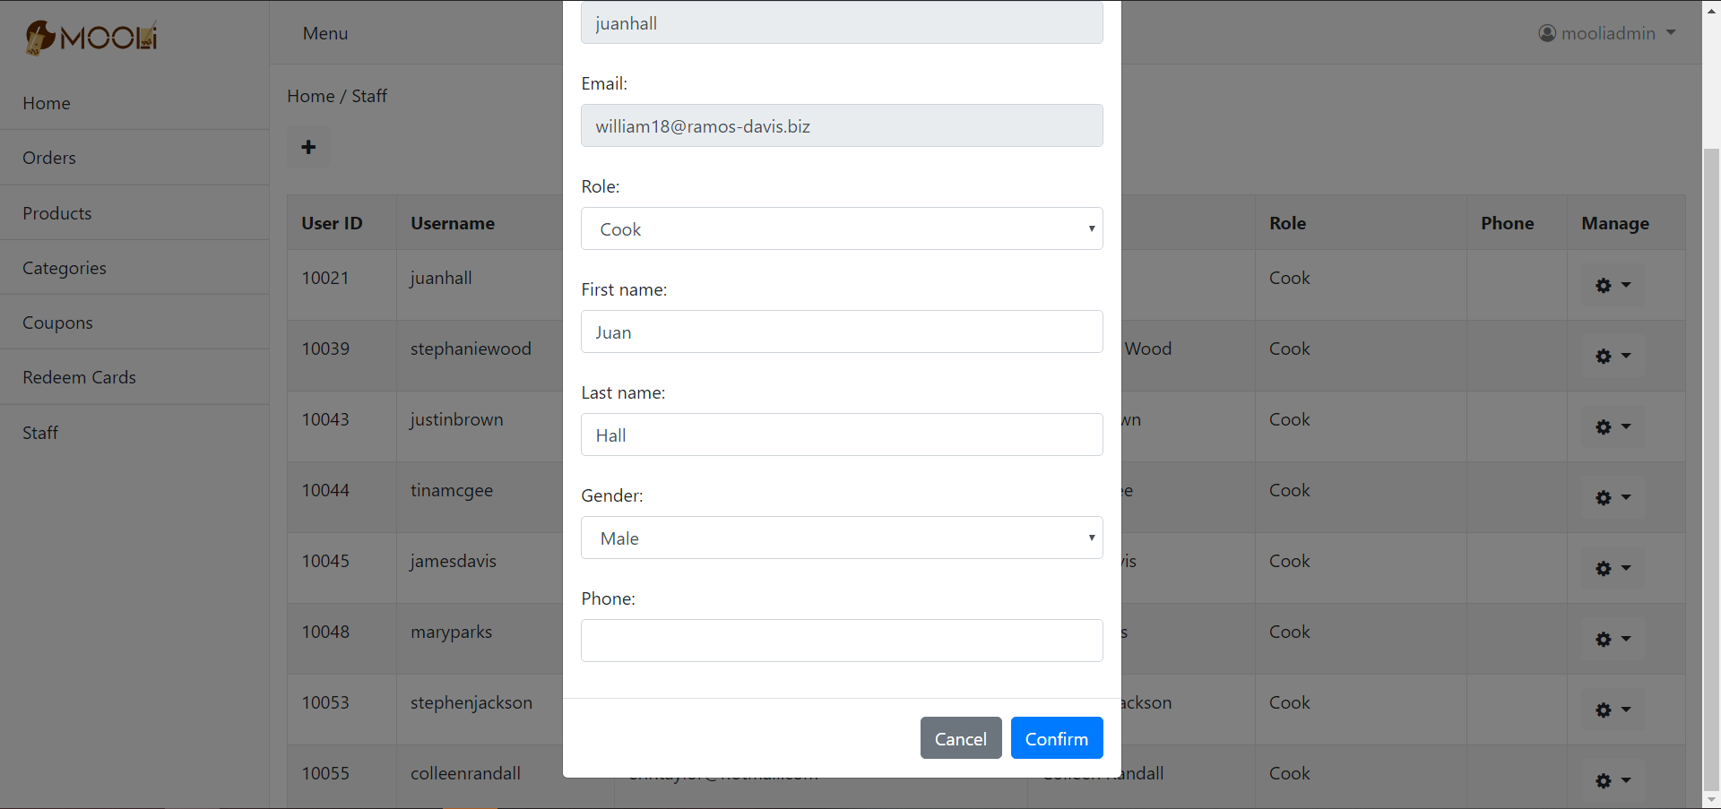

Figure

## Staff role

Differents staff has different roles. The role “super admin” is guaranteed to have all the permissions of the system. If a staff tries to access an unauthorized feature, an error message will be given to the staff.

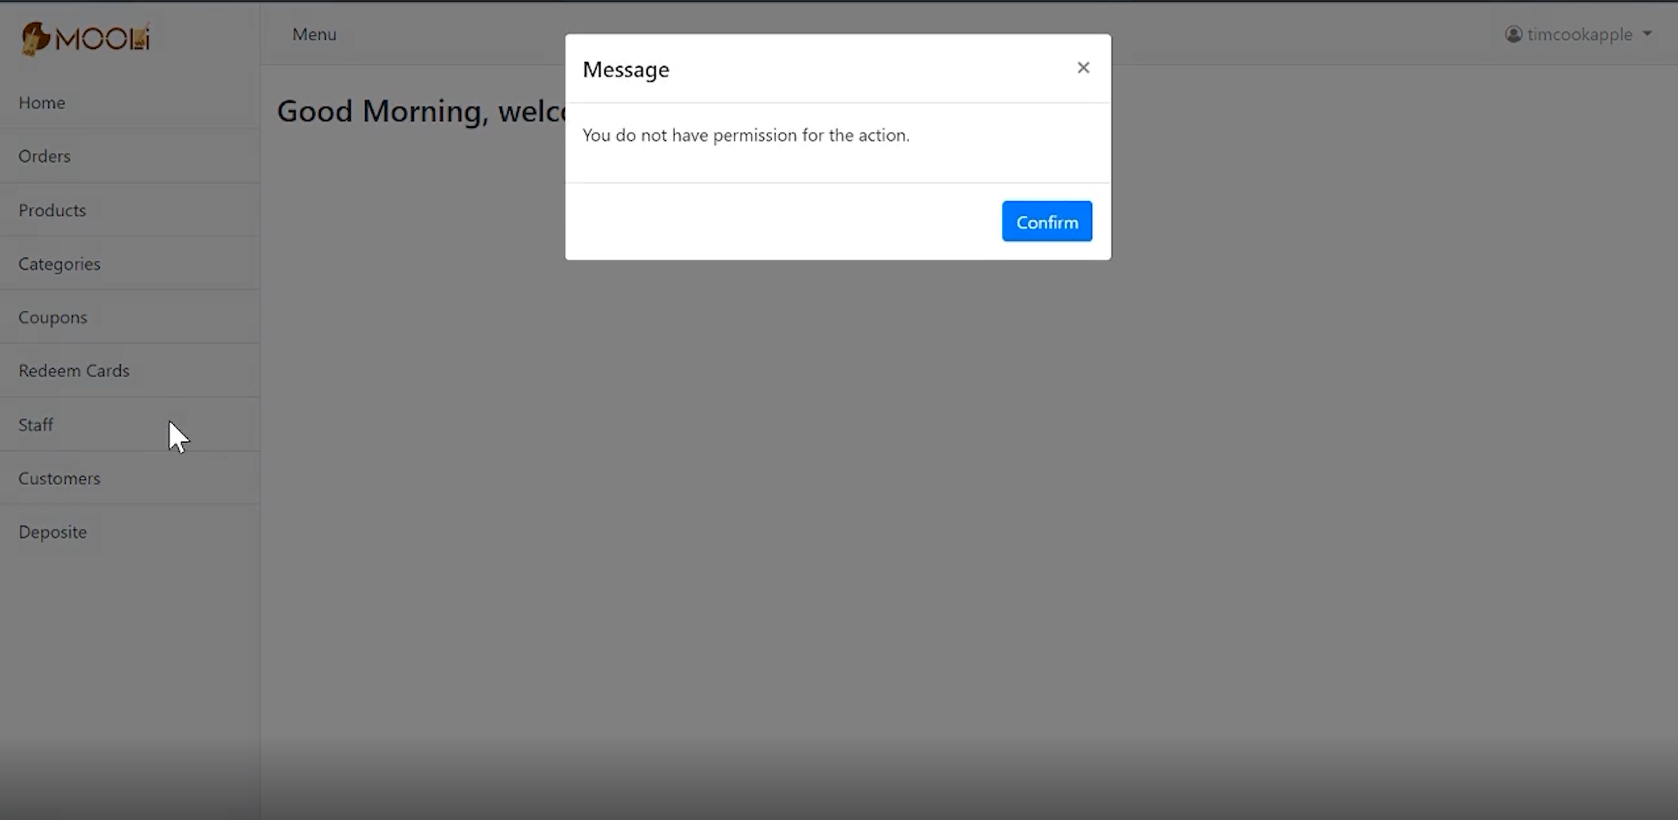

Figure

## Changing password

Every staff can change his or her password. The staff must provide the old password and the new password twice in order to change the password. The logic is the same as the process of changing the password in the customer end, so it will not be explained here again for simplicity.

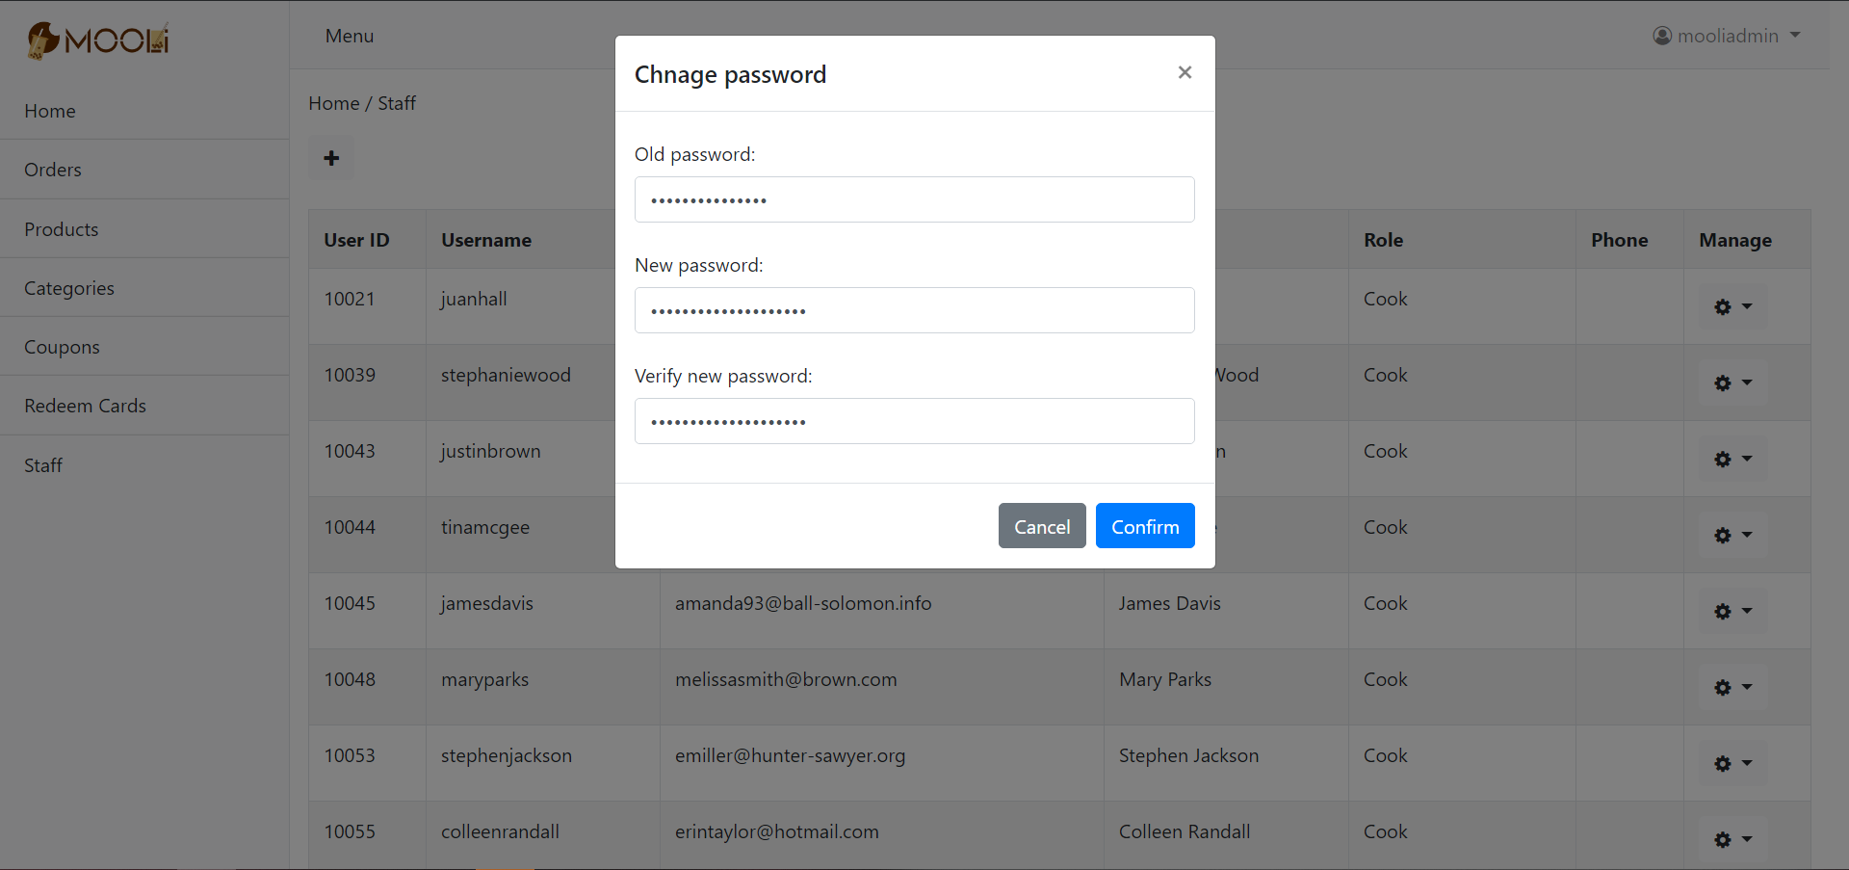

1. Database Design

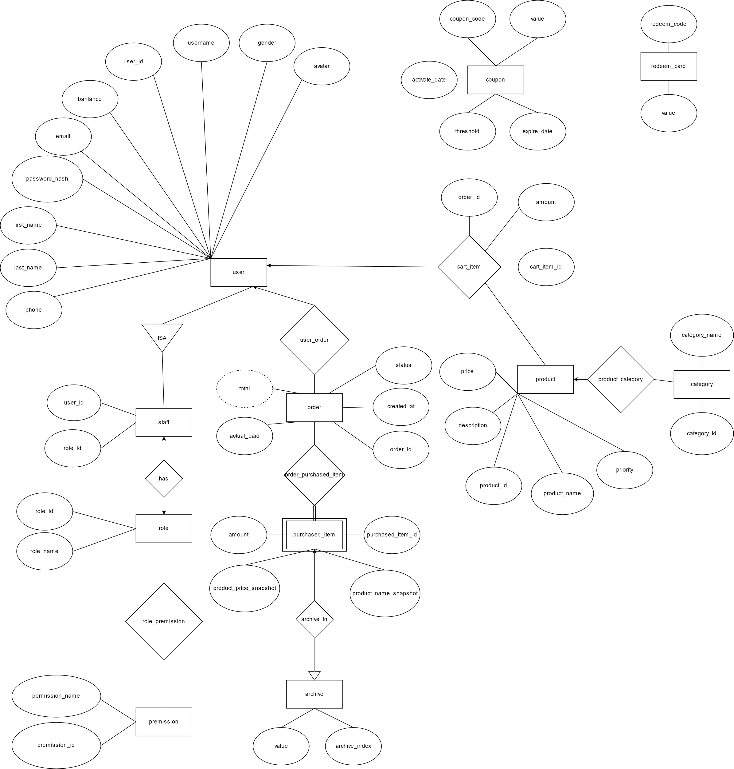

1. Diagrams

## 