Paper《Topic-to-Essay Generation with Neural Networks》

* Abstract: propose multi-topic coverage vector, which learns the weight of each topic and is sequentially updated during the decoding process. Afterwards this vector is fed to an attention model to guide the generator.
* Writing attributes:essay generation requires to consider multiple topics and outputs a long unstructured plain text, while poetry generation centers around one topic and predicts a strict structural output.
* Target:Given topics, essay generation aims at generating an article (a paragraph) under the theme of these topics.
* TAV-LSTM: topic representation:

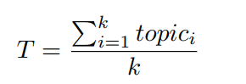

topic:word embedding of i=th word

g(): linear function

f():activation function

* TAT-LSTM: average value cannot reflect the true distribution of topics.

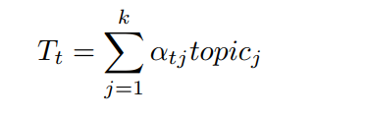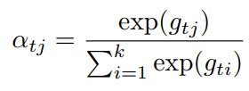 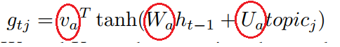

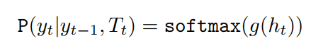

Topicj: word embedding of topic word j.

Red words: three matrices that need to be optimized during model training

Gtj: is the attention score on  
topicj at time step t.

* MTA-LSTM: TAT-LSTM ignores the past attentional historical information, which may lead some topic words appear repeatedly while the others do not appear in the generated text.

topic coverage vector: each dimension of which represents the degree to which a topic word needs to be expressed in future generation.

*φj*, which can be regarded as a discourse-level importance weight for topicj.

Topic coverage vector:C0 as [1:0; 1:0; 1:0; 1:0; 1:0]

N: controlling the length of equation to control the rate of decay.

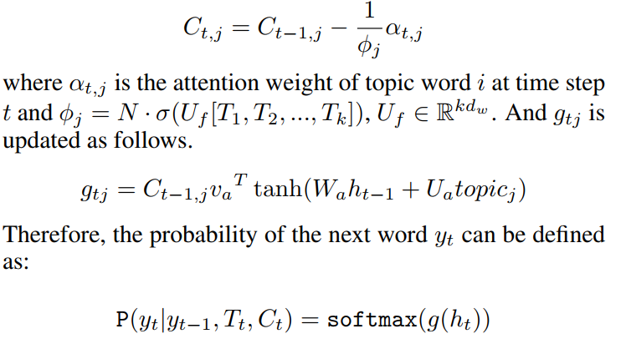

Loss: maximize the log-likelihood of the training corpus.