**RAGHU ENGINEEIRNG COLLEGE**

**Department of Mechanical Engineering**



## CERTIFICATE

This is to certify that the project report entitled **“Fabrication of Automated Sand Purifier”** is a bonafide record of the work done by **R.Varun(19981A03C5)**, **S.Eswar Adarsh(19981A03E2), P.Rahul Kumar(19981A03C2), T.Santhosh Kumar(19981A03F6) G.Joginaidu(19981A0345)** in partial fulfilment of the requirement for the award of the degree of Bachelor of Technologyin the Department of Mechanical Engineering **,** Raghu Engineering College Dakamarri Visakhapatnam.

**Project Guide**

**Head of the Department J.Ramesh Naidu**

Professor and Head of Department Associate Professor

Department of Mechanical Engineering, Department of Mechanical Engineering,

Raghu Engineering College Raghu Engineering College

**EXTERNAL EXAMINER**

**FABRICATION OF AUTOMATED SAND PURIFIER**

# TABLE OF CONTENT

|  |  |  |
| --- | --- | --- |
| * **ABSRACT** |  | **4** |
| * **INTRODUCTION** |  | **5** |
| * **LITERATURE REVIEW** |  | **6** |
| * **EQUIPMENTS REQUIRED** |  |  |
| * **DESCRIPTION OF THE EQUIPMENTS** |  | **7** |
| * **MOTOR** |  | **8** |
| * **ROTATING WHEEL** |  | **9** |
| * **CONNECTING RODS** |  | **10** |
| * **GI SAND FILTERATION NET** |  | **11** |
| * **SIEVE FRAME** |  | **12** |
| * **WHEELS** |  | **13** |
| * **SUPPORTING BASE** |  | **14** |
| * **WORKING PRINCIPLE** |  | **15** |
| * **INSTALLATION PROCESS** |  | **16** |
| * **ANALYSIS** |  | **17** |
| * **FUTURE ASPECT** |  | **18** |
| * **COST ESTIMATION** |  | **19** |
| * **CONCLUSION** |  | **20** |
| * **REFERENCES** |  | **21** |

**ABSTRACT**

Many natural and manufactured materials occur in a disperse form, which means that they consist of differently shaped and sized particles. The particle size distribution, i.e. the number of particles of different sizes, is responsible for important physical and chemical properties such as: mechanical bulk behavior, surface reaction, taste, miscibility, filtration properties, conductivity etc. This list could be continued at great length. The examples clearly show how important it is to have knowledge of the particle distribution, particularly within the context of quality assurance in the production of bulk goods. If the particle distribution changes during the manufacturing process then the quality of the finished product will also change. Only a continuous monitoring of the particle size distribution can guarantee a constant product quality.

The regular way to separate unneeded particles from the sand, the manual sieving process is done. In this process time consumption is high and labor cost is extra. Time and thinking has changed now. As per demand the need of fine sand must be quick and at cheaper cost. For this reason the idea of automatic sand filtration is generated. Automation of any machine will help in producing the desired product at a faster time and no skillful worker is needed to control the machine. After a certain period of time the choice of manual process will be changed and the automatic machine will be acceptable globally.

This project describes the process of automatic sieving process and runs through electrical energy. It is also represent the saving of time with no manpower is needed actively and easy to implement.

# INTRODUCTION

The sand filter requires a certain range of sand grain sizes to effectively treat for required production. Continuous crushing by rocks the sand is originated, that is why the sand is angular in structure and has different grain sizes. There are different methods for determining the particle distribution. The choice of a particular method depends primarily on the dispersion status, i.e. on the degree of fineness of the sample. The oldest and best-known method is particle size determination by sieve analysis. The particle size distribution is defined via the mass or volume. Sieve analysis is used to divide the particulate material into size fractions and then to determine the weight of these fractions. In this way a relatively broad particle size spectrum can be analysed quickly and reliably.

* Based on sieve analysis grain size of sand can be classified by
  1. Fine sand (1.58mm),
  2. Coarse sand (3.17mm),
  3. Gravelly sand (7.62mm).
* Based on grain size of sand, sieve can be classified by

1. Woven wire mesh sieves (20micrometer-3.55mm)
2. Perforated plate sieves (1mm-125mm)
3. American standard sieves (20micrometer-200mm) The different sieving processes are:
4. Manual and mechanical sieving
5. Automatic and mechanical sieving
6. Dry and wet sieving

***NOTE:*** Our project is based upon automatic and mechanical sieving.

# LITERATURE REVIEW

“Sanjay N. Havaldar, Altaf Somani, Anushka Pikle, Yash Siriah & Samiksha Patil; International Journal of Current Engineering & Technology, 02 March 2016 (E-ISSN 2277 – 4106). This paper analyzes the design of a pedal operated water filtration system to be used by local dwellers. It works on the principle of compression and sudden release of a tube by creating negative pressure in the tube and this vacuum created draws water from the sump into the pump while rollers push the water through to the filter where adsorption takes place to purify the water. “Technology (IJERT), 01 January 2013. In this paper, design and construction of pedal operated water pump which is used in small irrigation and garden irrigation. The pedal operated pump can be constructed using local material and skill. A water system includes a Centrifugal pump operated by pedal power. “Sanjay N.Havaldar, Altaf Somani, Anusha Pikle, Yash Siriah and Samiksha Patil”, InternationalJournal of Current Engineering and Technology (IMPRESSCO), 4 March 2016. This paper analyses the design of a pedal operated water filtration system to be used by local dwellers. It works on the principle of compression and sudden release of a tube by creating negative pressure in the tube and this vacuum created draws water from the sump into the pump while rollers push the water through to the filter where adsorption takes place to purify the water. The design comprises of a peristaltic pump powered by pedaling, a filter and hose or flexible tube. As the operator sits on the seat and pedals, the pedal crank transfers the motion to the rotor thus the rollers and the tube is squeezed by the set of rollers to move the fluid.

# EQUIPMENTS REQUIRED

## MOTOR

1. WOODEN ROTOR
2. CONNECTING RODS
3. GI SAND FILTERATION NET
4. SIEVE FRAME
5. WHEEL
6. SUPPORTING BASE

**DESCRIPTION OF THE EQUIPMENTS**

# MOTOR:-

An electric motor is an [electrical machine](https://en.wikipedia.org/wiki/Electric_machine) that converts [electrical](https://en.wikipedia.org/wiki/Electrical_energy) [energy](https://en.wikipedia.org/wiki/Electrical_energy) into [mechanical energy](https://en.wikipedia.org/wiki/Mechanical_energy). The reverse of this is the conversion of mechanical energy into electrical energy and is done by an [electric](https://en.wikipedia.org/wiki/Electric_generator) [generator](https://en.wikipedia.org/wiki/Electric_generator), which has much in common with a motor.

Most electric motors operate through the interaction between an electric motor's [magnetic field](https://en.wikipedia.org/wiki/Magnetic_field) and [winding currents](https://en.wikipedia.org/wiki/Electrical_conductor) to generate force. In certain applications, such as in [regenerative braking](https://en.wikipedia.org/wiki/Regenerative_braking) with [traction](https://en.wikipedia.org/wiki/Traction_motor) [motors](https://en.wikipedia.org/wiki/Traction_motor) in the transportation industry, electric motors can also be used in reverse as generators to convert mechanical energy into electric power.

For our project purpose we are using 60 watt single phase A.C. motor with 1000 rpm, which operation 50 Hz A.C. frequency.

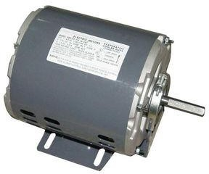

# WOODEN ROTOR:-

The single phase A.C. motor is connected with a 20cm diameter wooden wheel, i.e., rotor around its shaft which is then connected with the connecting rods.

This helps in producing rectilinear motion needed for the Sieve movement.

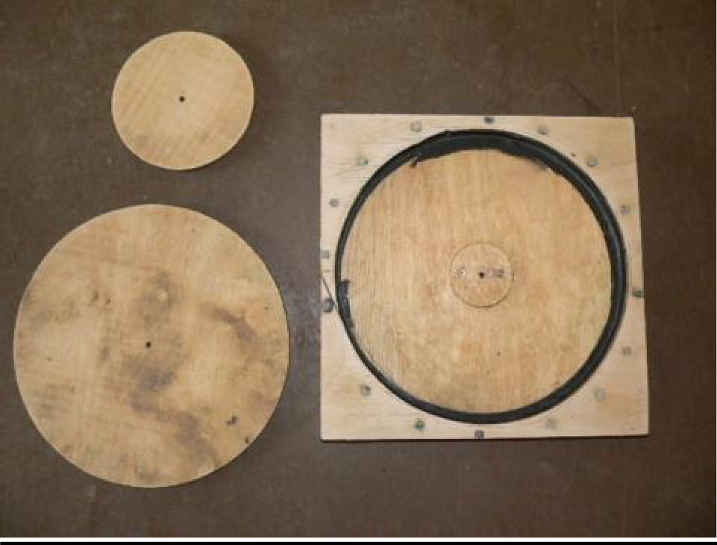

# CONNECTING RODS: -

A connecting rod is a shaft which connects a [piston](https://en.wikipedia.org/wiki/Piston) to a [crank](https://en.wikipedia.org/wiki/Crank_(mechanism)) or [crankshaft](https://en.wikipedia.org/wiki/Crankshaft) in a [reciprocating engine](https://en.wikipedia.org/wiki/Reciprocating_engine). Together with the crank, it forms a simple mechanism that converts reciprocating motion into rotating motion.

A connecting rod may also convert rotating motion into reciprocating motion, its original use. Earlier mechanisms, such as the chain, could only impart pulling motion. Being rigid, a connecting rod may transmit either push or pull, allowing the rod to rotate the crank through both halves of a revolution. In a few two-stroke engines the connecting rod is only required to push.

For our project purpose we are using to connecting rods with 20cm and 15 cm and the breadth of those is 3 cm.

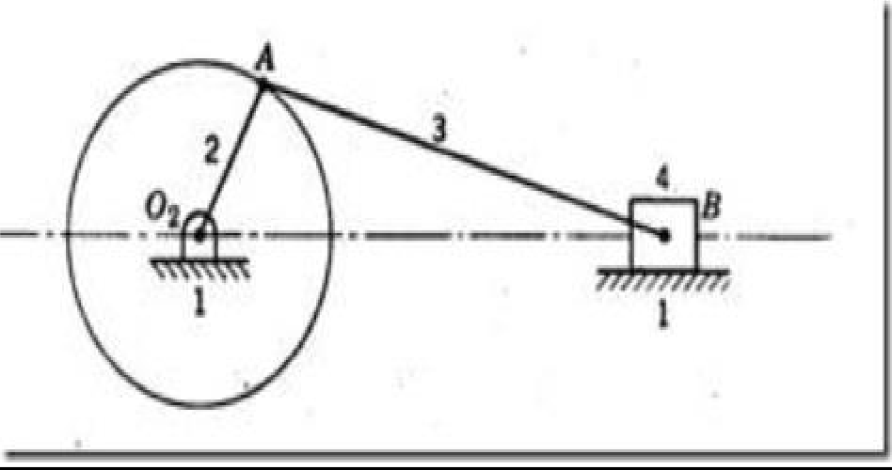

# GI SAND FILTERATION NET:-

A sieve, or sifter, is a device for separating wanted elements from unwanted material or for characterizing the particle size distribution of a sample, typically using a woven screen such as a mesh or net or metal. The word "sift" derives from "sieve". In cooking, a sifter is used to separate and break up clumps in dry ingredients such as [flour](https://en.wikipedia.org/wiki/Flour), as well as to aerate and combine them. A strainer is a form of sieve used to separate solids from liquid.

Sieving is a simple technique for separating particles of different sizes. A sieve such as used for sifting flour has very small holes. Coarse particles are separated or broken up by grinding against one-another and screen openings. Depending upon the types of particles to be separated, sieves with different types of holes are used. Sieves are also used to separate stones from sand. Sieving plays an important role in food industries where sieves (often vibrating) are used to prevent the contamination of the product by foreign bodies. The design of the industrial sieve is here of primary importance.

For our project purpose we are using 21.5 inchX21 inch fine sieve sheet for separating unwanted particles from sand.

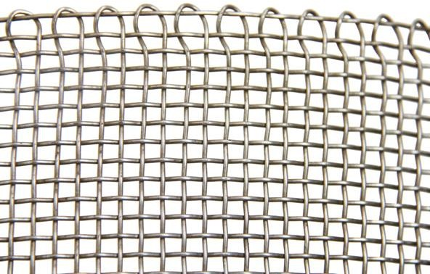

# SIEVE FRAME:-

Wooden Frames are generally square or rectangular, though circular and oval frames are not uncommon. Frames in more unusual shapes such as football shapes, stars, hearts can be hand carved by a professional wood carver or carpenter (or possibly molded out of wood pulp). There are also picture frames designed to go around corners. A popular design is the scoop, an indent in the frame adding depth.

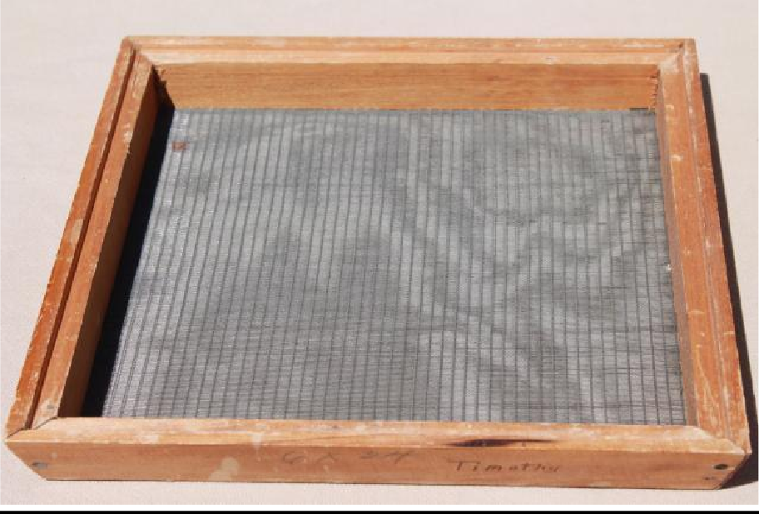

# WHEEL: -

A wheel is a circular component that is intended to rotate on an [axle](https://en.wikipedia.org/wiki/Axle) [bearing](https://en.wikipedia.org/wiki/Bearing_(mechanical)). The wheel is one of the key components of the [wheel and axle](https://en.wikipedia.org/wiki/Wheel_and_axle) which is one of the [six simple machines](https://en.wikipedia.org/wiki/Simple_machine). Wheels, in conjunction with axles, allow heavy objects to be moved easily facilitating movement or transportation while supporting a load, or performing labor in machines.

In this project we are using small wheel attached with the wooden frame for smooth movement with less friction.

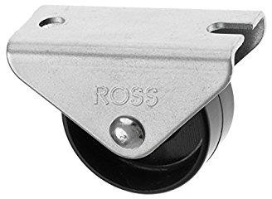

# SUPPORTING BASE: -

The supported frame is used to support the components. The total arrangement is depending on this frame. This frame is made of iron or mild steel.

For our project purpose we are using 2.5 feet X 2 feet iron frame to support the whole system. Upward part is slightly sloped for better separation.

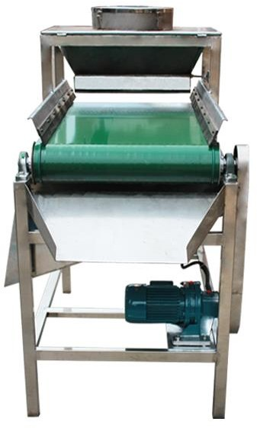

# WORKING PRINCIPLE

Reciprocating motion, also called reciprocation, is a repetitive up-and- down or back-and-forth linear [motion](https://en.wikipedia.org/wiki/Motion_(physics)). It is found in a wide range of mechanisms, including [reciprocating engines](https://en.wikipedia.org/wiki/Reciprocating_engine) and [pumps](https://en.wikipedia.org/wiki/Pump). The two opposite motions that comprise a single reciprocation cycle are called [strokes](https://en.wikipedia.org/wiki/Stroke_(engine)).

A [crank](https://en.wikipedia.org/wiki/Crank_(mechanism)) can be used to convert [circular motion](https://en.wikipedia.org/wiki/Circular_motion) into reciprocating motion, or conversely turn reciprocating motion into circular motion.

For example, inside an [internal combustion engine](https://en.wikipedia.org/wiki/Internal_combustion_engine) (a type of reciprocating engine), the expansion of burning fuel in the [cylinders](https://en.wikipedia.org/wiki/Cylinder_(engine)) periodically pushes the [piston](https://en.wikipedia.org/wiki/Piston) down, which, through the [connecting rod](https://en.wikipedia.org/wiki/Connecting_rod), turns the [crankshaft](https://en.wikipedia.org/wiki/Crankshaft). The continuing rotation of the crankshaft drives the piston back up, ready for the next cycle. The piston moves in a reciprocating motion, which is converted into circular motion of the crankshaft, which ultimately propels the vehicle or does other useful work.

Reciprocating motion is close to, but different from, [sinusoidal](https://en.wikipedia.org/wiki/Sine_wave) [simple](https://en.wikipedia.org/wiki/Simple_harmonic_motion) [harmonic motion](https://en.wikipedia.org/wiki/Simple_harmonic_motion). The point on the crankshaft which connects to the connecting rod, rotates smoothly at a constant velocity in a circle. Thus, the horizontal displacement, of that point, is indeed exactly sinusoidal by definition. However, during the cycle, the angle of the connecting rod changes continuously. So, the horizontal displacement of the "far" end of the connecting rod (i.e., connected to the piston) differs from sinusoidal.

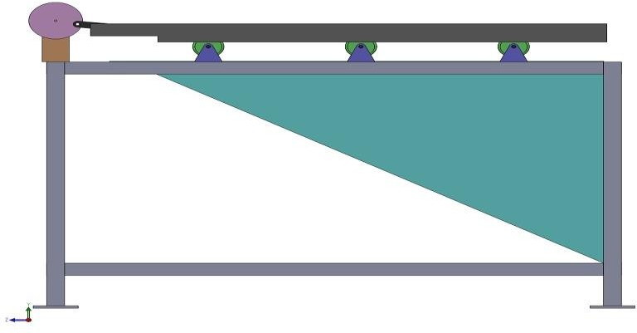

# INSTALLATION PROCESS

After all the above mentioned equipment have been bought and prepared, the installation has been done in following steps:

* 1. The wooden frame acts as the supporting base of the system around which other equipment has been installed.
  2. The sieve frame is fitted with sliding at the bottom and it is put upon the upper rectangular frame.
  3. The sieve is then connected to the connecting rods using Nuts and Bolts.
  4. The far end of the second connecting rod is then fitted to the rotor.
  5. This rotor is connected to the shaft .
  6. The rotor is fitted with the iron frame.

# ANALYSIS

After the installation process has been done, we observed the following when the project is run:

|  |  |  |  |
| --- | --- | --- | --- |
| SL.NO. |  | MANUAL  SIEVE | AUTOMATIC  SIEVE |
| 1. | QUANTITY OF SAND PER  MINUTE | 1 kg | At least we require  0.5 HP motor to perform this test. |
| 2. | QUALITY OF SAND | Fine |

***NOTE***: We assumed that our project would require the 60 watt single phase

A.C. motor and continued with the project accordingly. But now we realize that it can continue with manual power to check whether the project is successful or not.

# FUTURE ASPECT

Following all types of operation can be carried out by the proper pedal attachment as per the requirement. Here are some

Operations:

1. Rice Threshing
2. Winnowing
3. Corn Shelling
4. Peanut Shelling
5. Operating a Circular Saw
6. Water Pumping from a Shallow Well
7. Operating a Wood Working Lathe

**COST ESTIMATION**

|  |  |  |
| --- | --- | --- |
| **SL.NO.** | **ITEM** | **PRICE ( IN RS.)** |
| 1. | MOTOR | 800.00 |
| 2. | SUPPORTING BASE | 2250.00 |
| 3. | STEEL NET | 240.00 |
| 4. | WOODEN SIEVE FRAME | 1800.00 |
| 5. | WOODEN ROTOR | 220.00 |
| 6. | WHEEL | 160.00 |
| 7. | CONNECTING RODS | 400.00 |
| 8. | MISCELLANEOUS | 500.00 |
| TOTAL | | 6370.00 |

**COST ESTIMATION FOR PROTOTYPE**

|  |  |  |
| --- | --- | --- |
| **SL.NO.** | **ITEM** | **PRICE** |
| 1 | Wooden Raw Material | 300.00 |
| 2 | Steel Net | 100.00 |
| 3 | Plywood | 40.00 |
| 4 | Wooden Rotor | 150.00 |
| 5 | Connecting Rods(Plastic) | 30.00 |
| 6 | Miscellaneous | 200.00 |
| Total | | 820.00 |

**CONCLUSION**

Thus, a low cost and simple design automatically operated sand filter and separated machine is fabricated. This machine reduces human effort and hence we don’t need multiple persons to filter the sand.

This simple design of conventional design which can enhance day today household needs and daily day to day purposes and it can be also used in for industrial applications. By using this method we can do any operation as per our requirement with the use of electricity.

# REFERENCES

1. Assistant, Appliance. How Water Filters Work. 2013. 14 March 2014.
2. B.V, Verder International. “The Green Peristaltic Pump”. 16 March 2014.
3. Flahiff, Daniel. "Aquaduct Bike Purifies Water as you Pedal." 08 November 2008. Inhabitat.com March 2014.
4. Folkner, David. "Peristaltic Pump" 20 March 2012. Power point Presentation. 6 April2014.
5. Lipton, Josh. "Trailer for Adult Passengers" 4 July 2007. BikeShopHub.com Blogs. March 2014

ACKNOWLEDGMENT

We would like to thank Prof. HOD, Mechanical Department & for giving us opportunity to deliver a presentation on this interesting topic. I am heartily thankful to our Project Guide

**Mr. J.Ramesh Naidu** whose encouragement, guidance and support from the initial to the final level enabled me to develop an understanding of the subject. I would like to thank my college for giving us the opportunity to do research on the topic.

**PROJECT BATCH- C3**

**19981A03C5 RAPARTHIVARUN**

**19981A03E2 S.ESWAR ADARSH**

**19981A03C2 P.RAHUL KUMAR**

**19981A03F6 T.SANTHOSH KUMAR**

**19981A0345 S.JOGINAIDU**