**Cryptography**

**Links:**

* **index.html**
* **network security.html**
* **Methods.html**
* **cybersecurity companies.html**
* **Evelotion.html**
* **about me.html**

**Source Code:**

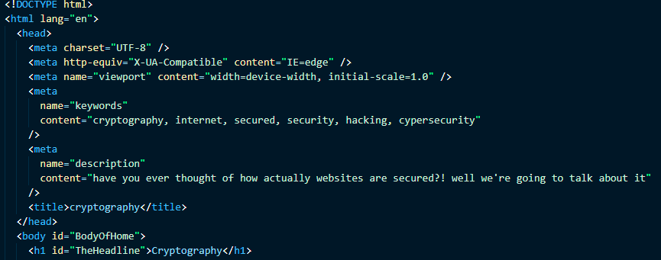

**About me:**

Name: Mohamed Ahmed Rabea Mahrous

Section: 29

B.N: 16

I.D: 644

GitHub link: <https://github.com/Rapea/Html-Project-Repository>

GitHub pages link:  <https://rapea.github.io/Html-Project-Repository/>