|  |
| --- |
| Sci-fi Shooting gun  Unity 3D Component Monobehaviour |
| M.Raphael Caesar Ponda’ag Tanjung Duren Timur Raya 2  Jakarta, 11470  +628111515078  rcpondaag@gmail.com |

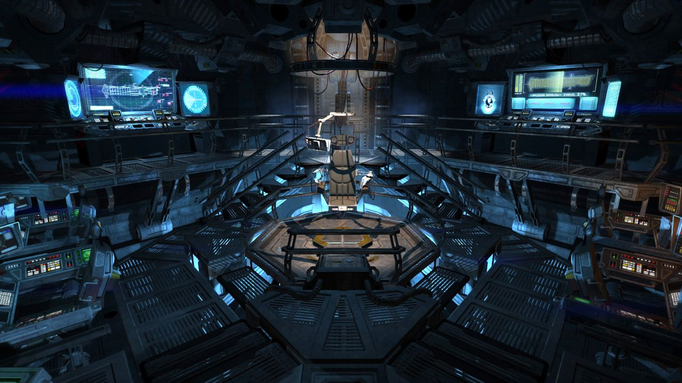

Sci-fi Shooting Gun is a Unity3d Component that can shoot anything that contained with <Target> script,also can make the <Target> destroyed/disappear.

For example :

This Wooden crate

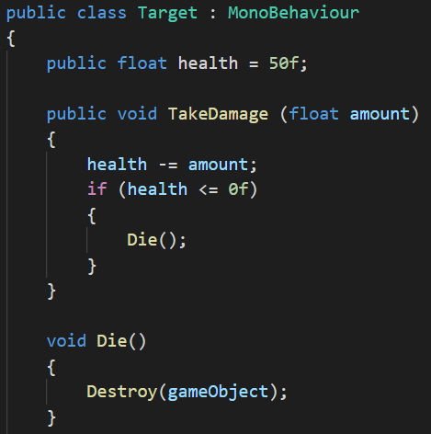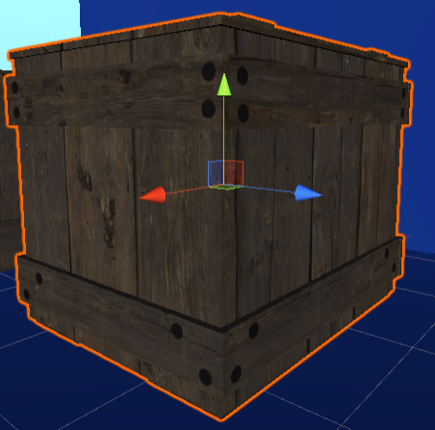II added script that makes that wooden crate identified as <Target>,also for the HP thing,if the <Target> HP reached 0,it will destroy the <Target>.And also, there is 1 thing that I want to tell,why am I use float? Why not int,double,etc? Because the HP will decrease for what the damage does to the wooden crate,if the damage does 10.5,it needs decimal number,so i use float variable,not int,double,etc.

For the sci-fi gun(Pistol) :

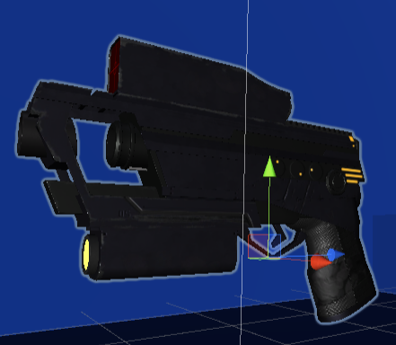This pistol can shoot whatever you want,you want shoot it to the sky,ground,sea,tree,even small object also can shoot it,but it can’t destroy object that is not use <Target> script,so the object is indestructible.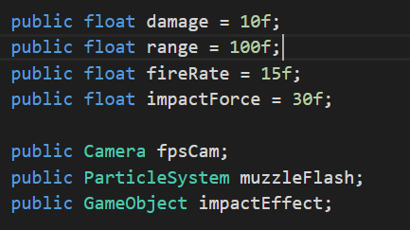

So,I added some code to the pistol,so it can shoot by which range it should be,also you can setting the firerate,you can also make this pistol become a freaking machine gun if you put a BIG number to the firerate,for the impactForce,it will give the object some impact from receiving laser from this pistol,and yeah it is laser,not a bullet.

You can also add the particle for each the pistol shoot,and the impact effect for the effect that pistol did to the object.

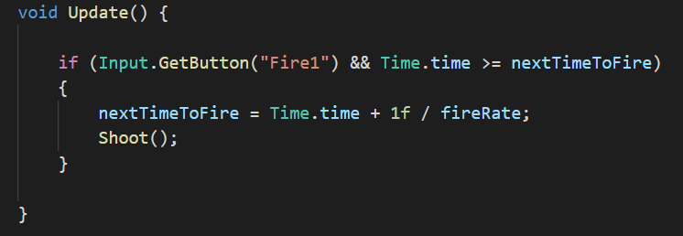

This is going to be the next time to fire,so I can fire right off the back,then check here if the player presses the fire button (“Fire1” means left mouse button,it is default button from unity) and our current time(Time.time) if that time is greater than or equal to the next time to fire,and if i want to shoot and i also want to set the next time to fire equal to our current time(Time.time) +1 divided by the fire rate(+1 / fireRate) this means that if our fire rate is four ,I am going to add ¼, which is 0.25 to our current time(Time.time) and so I am going to shoot in intervals of 0.25 seconds the greater the fire rate the less time between shots.

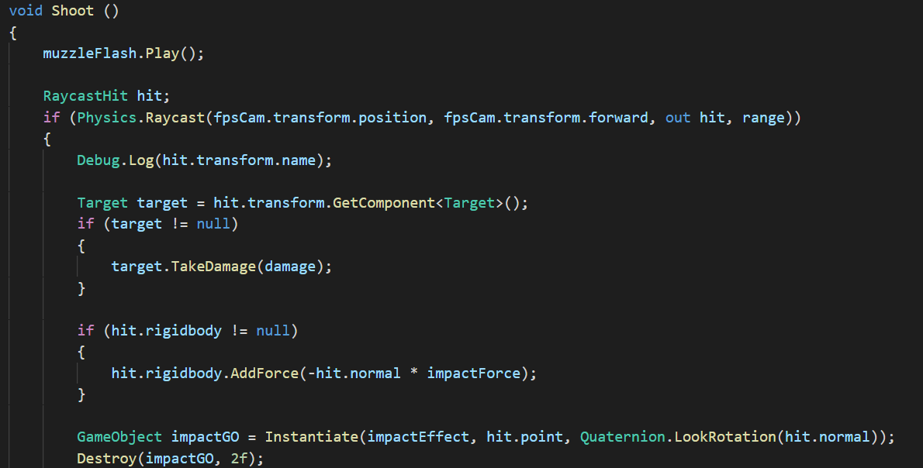

Last thing I want to tell,it is about the things will do after i shoot,for the muzzleFlash.play(); it will trigger the particle system that i use for the shoot particle.

For the Physics.Raycast, this is a variable that i use to store some information about what i hit with our Ray.

Sometimes,i want to gather some information and put it inside of the hit variable,so i will use out hit, this means that unity will automatically put all the information i need into this variable and then finally and this is totally optional i can input our range so that if objects are further away than 100 units i aren't going to be able to hit them.

The Debug things,it just displaying the name of the object that i hit in the console.

Target target = hit.transform.GetComponent<Target>(); means,if the sci-fi shooting gun that i use hit the object that has the <Target> script,it will trigger something,for example :

if (target != null)

{

Target.TakeDamage(damage);

}

It means that the target will take damage from this sci-fi shooting gun that has this Pistol script.

And also for this one,

if (hit.rigidbody != null)

{

hit.rigidbody.AddForce(-hit.normal * impactForce);

}

It means it allows us to add a force in a given direction, now i could use the direction I am currently looking in to add a force to the object that i shoot at.

For the really last thing is about :

GameObject impactGO = Instantiate(impactEffect, hit.point, Quaternion.LookRotation(hit.normal));

Destroy(impactGO, 2f);

if i select our sci-fi shooting gun(pistol) and put in our impact effect,i should see that when i hit play i have this awesome impact and it gives itself nicely impact effect to the surface that i shoot,but the only problem with this is that i am currently instantiating a lot of objects and during a game, our hierarchy is really going to mess up,just make sure to quickly destroy these after use to do,i need a reference to the object that i just spawned and i will store that as a game object,i call it something like impact game object, and set it equal to the instantiated object,so i can go destroy and the object,what i want to destroy is my impact game object and i want to destroy it ,let’s say two seconds (Destroy(impactGO, 2f);), now our object should clean themselves up.

Flowchart

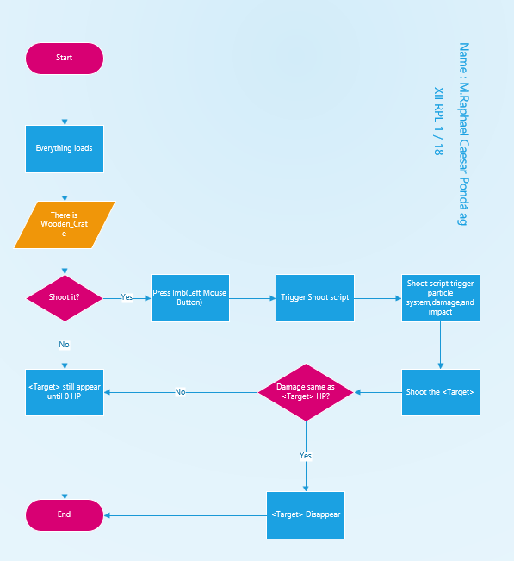

M.Raphael Caesar Ponda’ag

XI RPL 1/18

Sci-fi Shooting Gun