Assignment 4: Shadows, Reflection, and Refraction

Group Members:
Giovanni Barbieri
Raphael Brunold

Exercises solved:
Exercise 1: Shadows – solved
Exercise 2: Reflections – solved
Exercise 3: Simple Refractions – solved
Exercise 4: Fresnel effect – solved
all exercises solved

Final result:
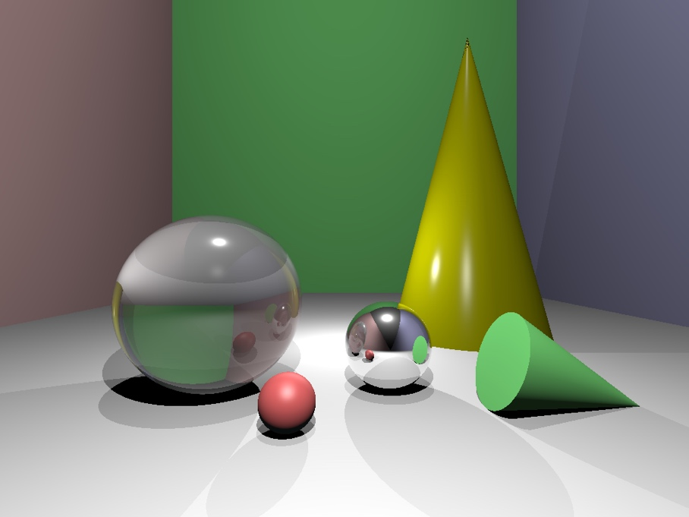

Resolution: 1024 x 768
Maximum recursion depth: 6
Time to render this image: 6.40388 seconds

Compiled with C++ version 11 (or newer) with g++ -std=c++11 main.cpp

We added the comment “Assignment 4” at most places where we added / changed code.

Encountered problems:
- Initially, we did not fully understand how the recursive rays from reflection (and later refraction) are supposed to add up to the final result. But after understanding this core concept, we were able to implement it.
- After implementing just the reflection, we had to rethink how to correctly handle materials that were reflective / non-reflective and transparent / non-transparent.
- Understanding how to implement the total internal reflection (TIR) was challenging for a moment, but we got it right after some tries.

After implementing everything, we made some tests, like adding a large red sphere behind the refraction sphere. The result, which can be seen below in the ‘progress pictures’ section, visually confirms that the refraction works as intended.

Declaration of AI use: We asked individual questions to clarify errors and confirm ideas.

Progress pictures:
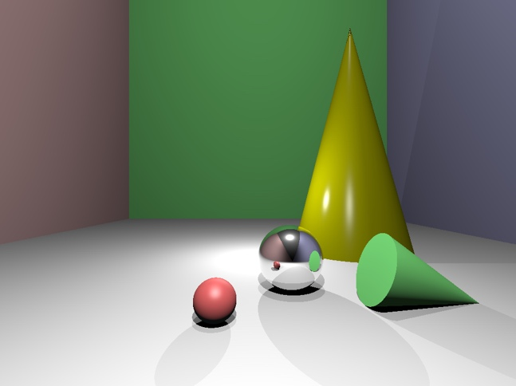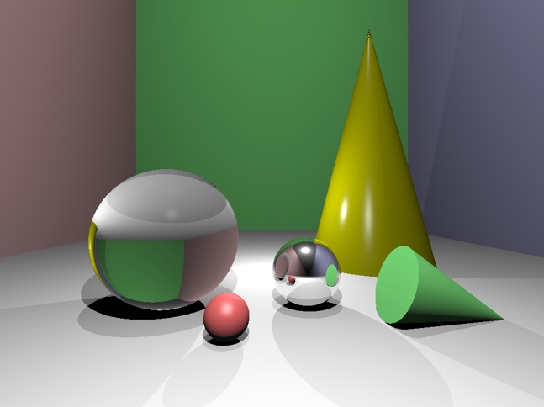
Shadows and reflection (ex. 1 & 2) Simple refraction (ex. 3)

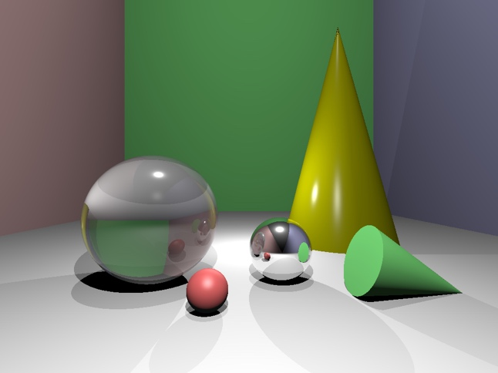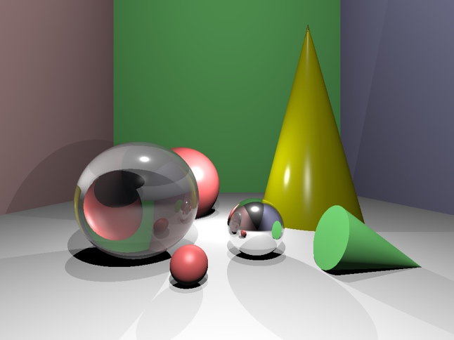
Fresnel effect (ex. 4) – final result Some testing –
added red sphere behind refraction sphere

