Assignment 3: Meshes

Group Members:
Giovanni Barbieri
Raphael Brunold

Exercises solved:
Exercise 1: Implement ray-triangle intersection & OBJ file parsing – solved
Exercise 2: Implement smooth shading – solved
Bonus Exercise 3: Create own object in Blender and add it to the scene – solved
all exercises solved

Final result:
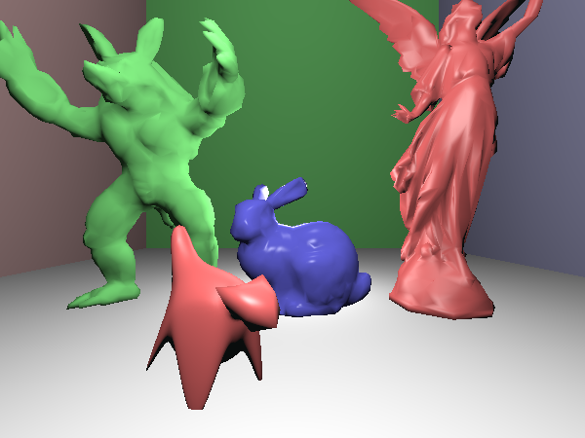
Resolution: 600 x 450 (instead of 1024 x 768)
Time to render this image: 492.865 seconds

We sculpted the red “cat” in Blender for the Bonus Exercise 3 and exported the OBJ file.

Encountered problems:
After understanding the math of the barycentric coordinates, we had no problems implementing the ray-triangle intersection.
Our biggest challenge was setting up the alignment between 1) the OBJ file parsing output, 2) the triangle creation, and 3) constructing the mesh by creating a triangle for the parsed list.
Also, we had to think carefully about where transformations happen.

Declaration of AI use: We asked individual questions to clarify errors and confirm ideas.
Progress pictures:
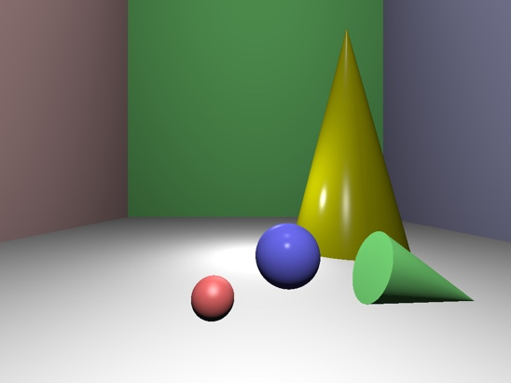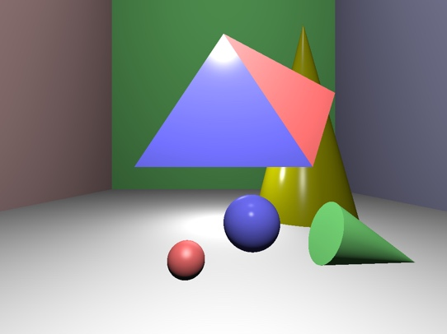
Initial scene Implemented triangles

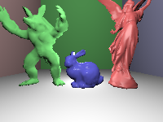
Implemented meshes, flat and smooth shading (low resolution for testing)

