**EXACTNESS**: **EX**periments gener**A**tor for **C**ombina**T**orial screening of **N** dim**E**n**S**ion **S**pace

This Matlab interface was developed in order to automatically generate a set of experiments to screen a N-element composition space using a combinatorial approach with a magnetron sputtering deposition technic, with two or three cathodes. The starting point of this method is based on simplex centroid mixture design, in order to screen the space as uniformly as possible. From the composition points given by the mixture design, all linear gradients passing by 3 of them / 2D planes passing by 7 of them are computed. Then a set of gradients/planes is randomly chosen in order to pass at least once by each point.

Objectives :

* Adaptation to user needs
  + The users can enter the elements of the composition space they want to explore (from 3 elements to 10).
  + Chose if they are using two or three cathodes
  + Indicate if they want to preferentially explore some point of the mixture design.
* Representation of the composition space and of the gradients/planes that are explored.
* Give the list of targets that allow to perform the experiments

Documentation:

1. User main parameters input

At the execution of the Matlab main program “Gradients_simplexe_N” a first window appears:

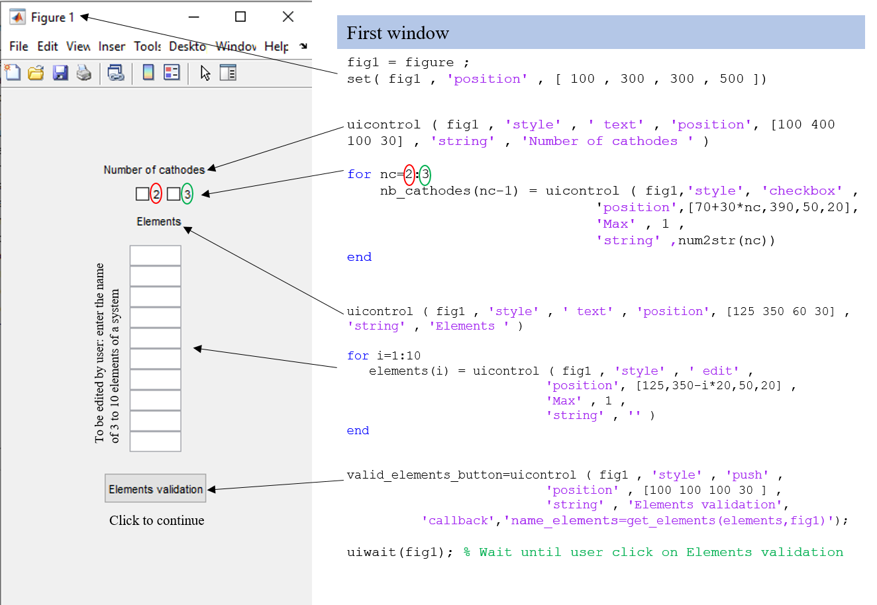

An example of a user input (used all along this documentation) is given here. The “Elements validation” button correspond to a callback function that will allow to store the name of the composition space elements as well as the number of cathodes. First variables are then generated.

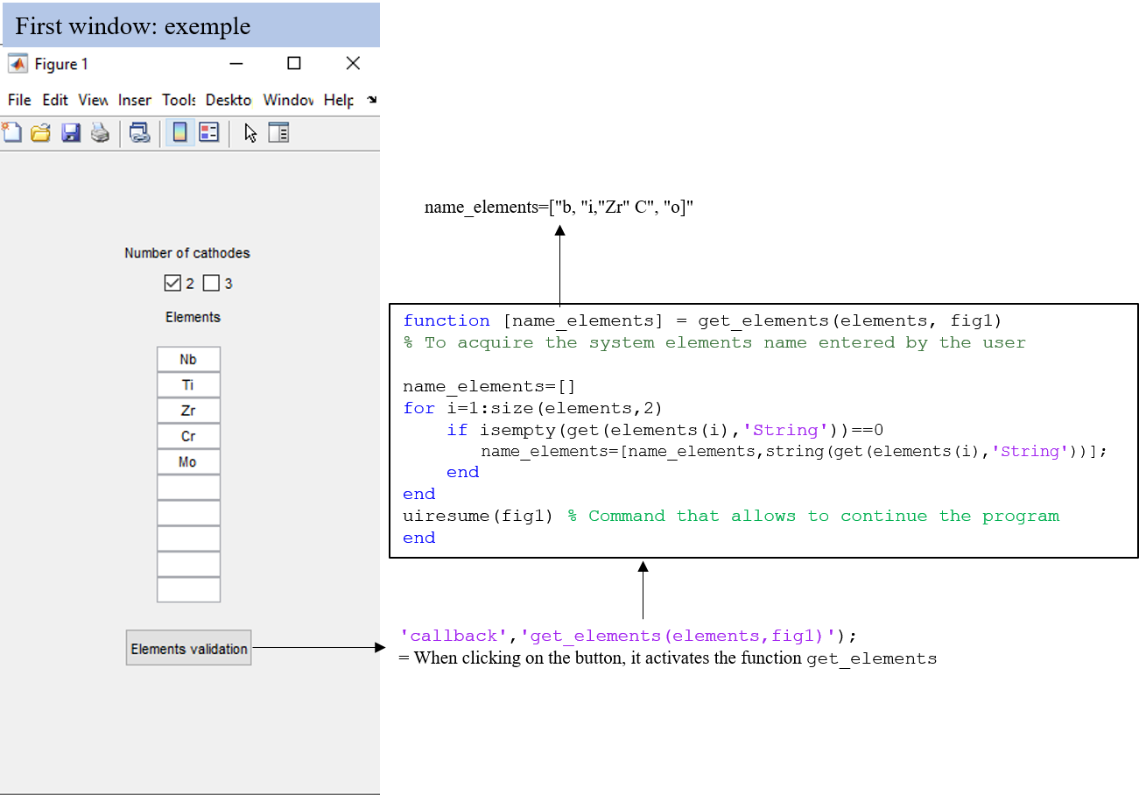

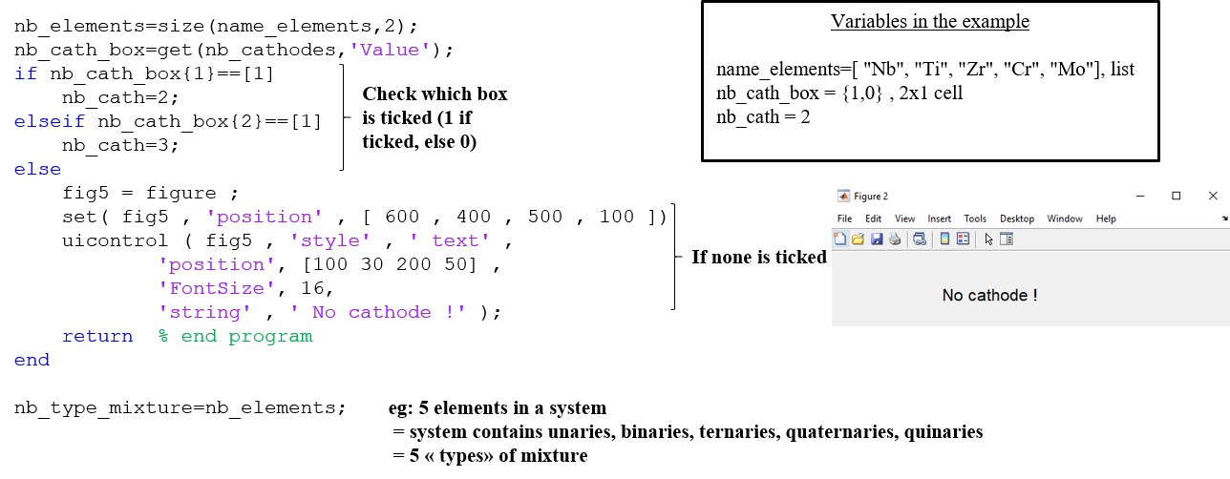

1. Computing the coordinates of the mixture design points

The computation of gradients/planes will be done geometrically. Thus, the calculation of the coordinates of the mixture design points is necessary. It will also allow to later obtain a representation of the composition space and of the experimental gradients/planes that will be explore.

Three cases are considered:

* For three elements, the composition space is a 2D space, the coordinates of the three vertices can be easily calculated and the points can be simply represented.
* For four elements, the composition space is a 3D space, the coordinates of the four vertices can be easily calculated and the points can be simply represented.
* For five or more elements, the composition space is in 4D or more. The representation of these spaces is more difficult: it will consist in a dynamic projection of the space in 3D. Using the [delaunayTriangulation](https://www.mathworks.com/help/releases/R2019b/matlab/ref/delaunaytriangulation.html) function, this is possible. The coordinates of the vertices generation is handled by the gallery function

From the vertices coordinates, one is able to compute the coordinates of all equimolar binaries, ternaries…

