Exercise 1 :

1.
http://www.uniprot.org/uniprot/?query=name%3APhenylalanine-4-hydroxylase+AND+gene%3APAH&sort=score
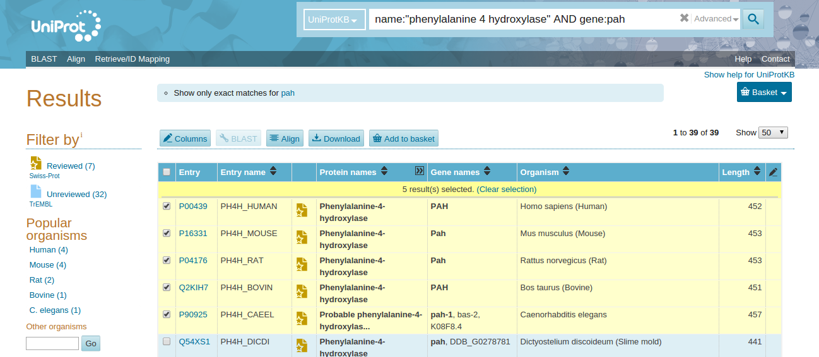
=> ex11_les_sequences.fasta

2.
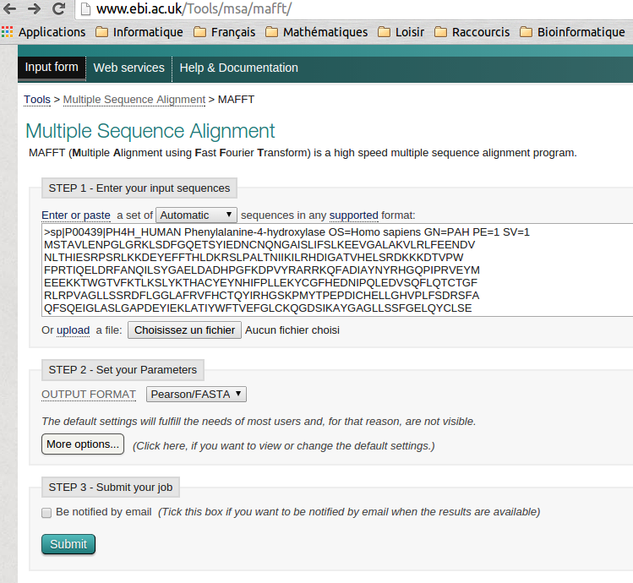
The job results will be available for 7 days.: http://www.ebi.ac.uk/Tools/

Input Sequences
mafft-I20141114-205824-0070-17716437-es.input
Tool Output
mafft-I20141114-205824-0070-17716437-es.output
Alignment in FASTA format
mafft-I20141114-205824-0070-17716437-es.fasta
Guide Tree
mafft-I20141114-205824-0070-17716437-es.tree
Phylogenetic Tree
mafft-I20141114-205824-0070-17716437-es.ph
Percent Identity Matrix
mafft-I20141114-205824-0070-17716437-es.pim

3. http://mobyle.pasteur.fr/cgi-bin/portal.py#forms::protdist

Enter your data below:
file: ex12_mafft-I20141114-205824-0070-17716437-es.output

Outfile (PhylipDistanceMatrix)
5
sp|P00439| 0.000000 0.077624 0.081118 0.083439 0.709223
sp|Q2KIH7| 0.077624 0.000000 0.088065 0.095235 0.718423
sp|P16331| 0.081118 0.088065 0.000000 0.018110 0.723634
sp|P04176| 0.083439 0.095235 0.018110 0.000000 0.713036
sp|P90925| 0.709223 0.718423 0.723634 0.713036 0.000000

4. http://mobyle.pasteur.fr/cgi-bin/portal.py#forms::neighbor

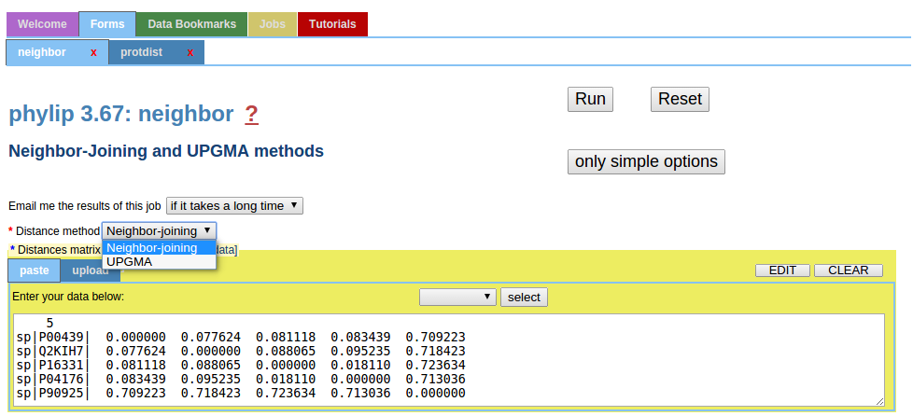
Neighbor output file (Text) ( neighbor_joining_P27199436045885.zip )

5 Populations

Neighbor-Joining/UPGMA method version 3.67

Neighbor-joining method

Negative branch lengths allowed

+--sp|Q2KIH7|
!
! +sp|P16331|
! +-1
2-3 +sp|P04176|
! !
! +----------------------------------------sp|P90925|
!
+-sp|P00439|

remember: this is an unrooted tree!

Between And Length
------- --- ------
2 sp|Q2KIH7| 0.04345
2 3 0.00241
3 1 0.03668
1 sp|P16331| 0.00924
1 sp|P04176| 0.00887
3 sp|P90925| 0.67260
2 sp|P00439| 0.03417

Neighbor output file (Text) ( neighbor_UPGMA_T27250230797052.zip )

5 Populations

Neighbor-Joining/UPGMA method version 3.67

UPGMA method

Negative branch lengths allowed

+-sp|P00439|
+-2
! +-sp|Q2KIH7|
+------------------3
! ! +sp|P16331|
--4 +-1
! +sp|P04176|
!
+--------------------sp|P90925|

From To Length Height
---- -- ------ ------
4 3 0.31456 0.31456
3 2 0.00467 0.31923
2 sp|P00439| 0.03881 0.35804
2 sp|Q2KIH7| 0.03881 0.35804
3 1 0.03443 0.34898
1 sp|P16331| 0.00906 0.35804
1 sp|P04176| 0.00906 0.35804
4 sp|P90925| 0.35804 0.35804

7. http://sequenceconversion.bugaco.com/converter/biology/sequences/
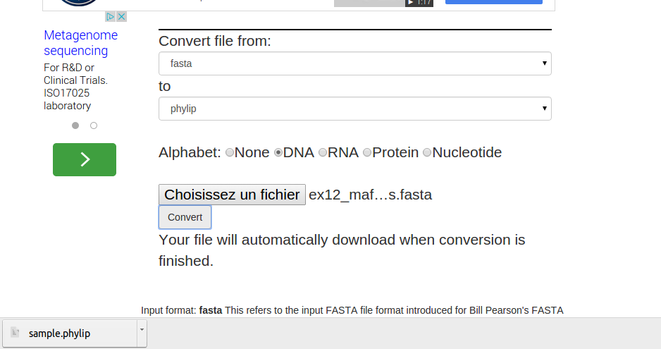
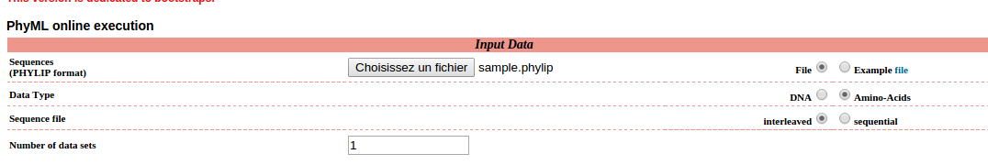
JobID : 625258
Analysis name : aagb_tme_02_ex_01
Please find enclosed an archive containing your inferred tree in Newick format and PhyML files.
Manipulate this tree by clicking on the link below (available for 30 days).
http://www.atgc-montpellier.

Download : sample_phylip_phyml.zip
http://www.trex.uqam.ca/index.php?action=newick
sample_phylip_phyml_tree.txt
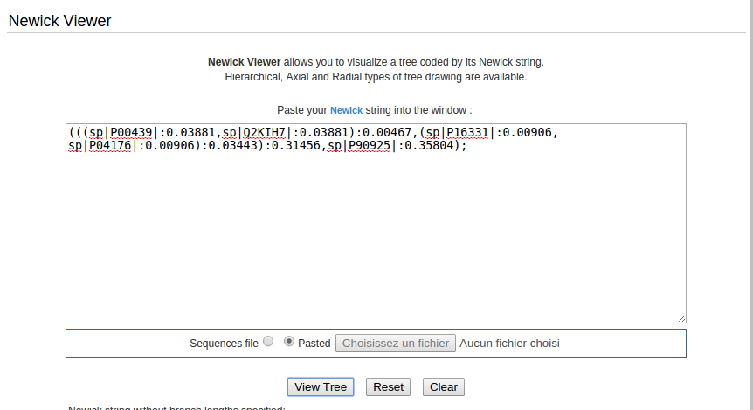
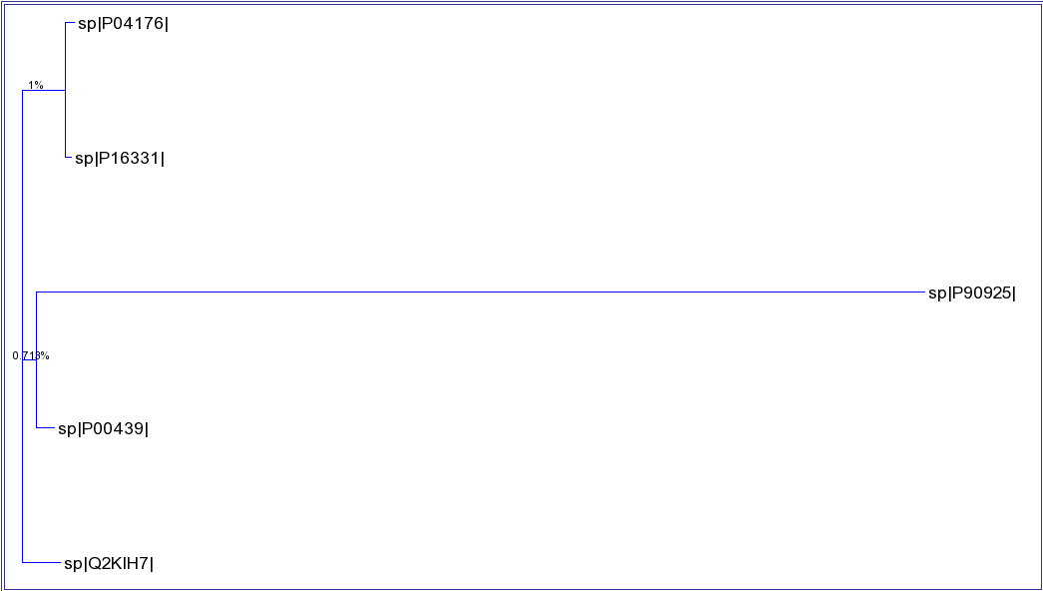
tree.svg

