Exercise 1: UPGMA

1. Take the distance matrix below and construct a tree by using the UPGMA algorithm. Explain each step showing all values.

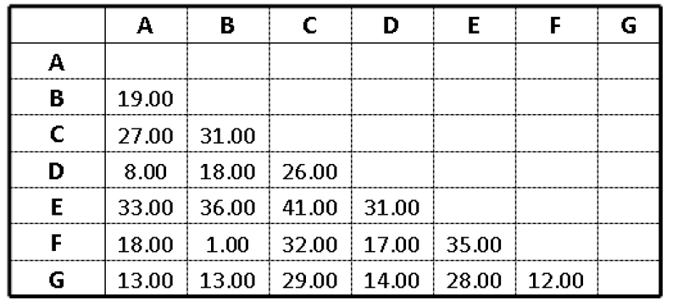
Dans la matrice D0, la distance de B et F est le minimum. Par conséquence, les deux sont joins.

B et F sont enlevés, puis rajouter un BF. Dans cet étape, on monte de B et F au jointe dans l'arbre phylogénétique. Ensuite, les nouvelles distances sont calculées.

Dans la nouvelle matrice D1, A et D sont les plus proches. Donc on répète l'élimination et la combinaison, puis recalculer les distances entre le nouveau et les autres.

Selon la formule :
d(AD,BF) = [ 2 * d(A, BF) + 2 * d(D,BF) ] / 4 = [ 2 * 18,5 + 2 * 17,5 ] / 4 = 18
d(AD,C) = [ 1 * d(A, C) + 1 * d(D,C) ] / 2 = [ 27 + 26 ] / 2 = 26,5

Après monter au jointe des BF et G. Certain distances sont refaites.
d(AD,BFG) = [ 4 * d(AD,BF) + 2 * d(AD,G) ] / 6 = [ 4 * 18 + 2 * 13,5 ] / 6 = 16,50
d(C, BFG) = [ 2 * d(C,BF) + 1 * d(C,G) ] / 3 = [ 2 * 31,5 + 1 * 29 ] / 3 ≈ 30,67

Et puis, D4 montre les distances aux niveau du jointe de AD et BFG.

En fin, la distance du jointe de ADBFG et C à E.

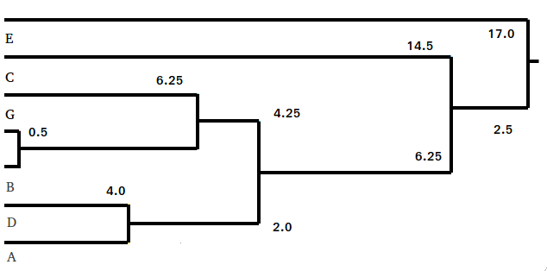
L'arbre phylogénétique UPGMA :

Exercise 2: PAH
Here we consider the phenylalanine-4-hydroxylase enzyme. Its role is to degrade phenylalanine. In human, a mutation in its gene is responsible for the phenylketonuria disease.

1. Download the human, rat (Rattus norvegicus), mouse (Mus musculus), cow (Bos taurus) and Caenorhabditis elegans sequences of phenylalanine-4-hydroxylase from SwissProt http://www.uniprot.org/ (search for “phenylalanine-4-hydroxylase” to get them) . Align them using CLUSTAL (you can use http://www.ebi.ac.uk/Tools/msa/clustalo/) Save it in Phylip format and include this file in your report.

5 462
sp|P90925|----MPPAGQDDLDFLKY-AMESYVADVNADIGKTTIVFTLREKAGALAE
sp|Q2KIH7|MSALVLESRALGRKLSDFGQETSYIEGNSDQN-AVSLIFSLKEEVGALAR
sp|P00439|MSTAVLENPGLGRKLSDFGQETSYIEDNCNQNGAISLIFSLKEEVGALAK
sp|P16331|MAAVVLENGVLSRKLSDFGQETSYIEDNSNQNGAVSLIFSLKEEVGALAK
sp|P04176|MAAVVLENGVLSRKLSDFGQETSYIEDNSNQNGAISLIFSLKEEVGALAK

TLKLFQAHDVNLSHIESRPSKTHEGCYEVLVEFAEAEDHRKIEGVIEHFQ
VLRLFEENDINLTHIESRPSRLRKDEYEFFTNLDQRSV-PALANIIKILR
VLRLFEENDVNLTHIESRPSRLKKDEYEFFTHLDKRSL-PALTNIIKILR
VLRLFEENEINLTHIESRPSRLNKDEYEFFTYLDKRSK-PVLGSIIKSLR
VLRLFEENDINLTHIESRPSRLNKDEYEFFTYLDKRTK-PVLGSIIKSLR

QKAEKKVLVQDWNTKNKQNKDSVPWFPQKINDIDQFANRILSYGAELDAD
HDI----GATVHELSRDKKKDTVPWFPRTIQELDNFANQVLSYGAELDAD
HDI----GATVHELSRDKKKDTVPWFPRTIQELDRFANQILSYGAELDAD
NDI----GATVHELSRDKEKNTVPWFPRTIQELDRFANQILSYGAELDAD
NDI----GATVHELSRDKEKNTVPWFPRTIQELDRFANQILSYGAELDAD

HPGFKDMTYRERRKFFADIAFNFKHGDKIPTITYTDEEIATWRTVYNELT
HPGFKDPVYRARRKQFADIAYNYRHGQPIPRVEYTEEEKKTWGTVFRTLK
HPGFKDPVYRARRKQFADIAYNYRHGQPIPRVEYMEEEKKTWGTVFKTLK
HPGFKDPVYRARRKQFADIAYNYRHGQPIPRVEYTEEERKTWGTVFRTLK
HPGFKDPVYRARRKQFADIAYNYRHGQPIPRVEYTEEEKQTWGTVFRTLK

VMYPKNACQEFNYIFPLLQQNCGFGPDRIPQLQDVSDFLKDCTGYTIRPV
SLYKTHACYEHNHIFPLLEKYCGFREDNIPQLEEVSQFLQSCTGFRLRPV
SLYKTHACYEYNHIFPLLEKYCGFHEDNIPQLEDVSQFLQTCTGFRLRPV
ALYKTHACYEHNHIFPLLEKYCGFREDNIPQLEDVSQFLQTCTGFRLRPV
ALYKTHACYEHNHIFPLLEKYCGFREDNIPQLEDVSQFLQTCTGFRLRPV

AGLLSSRDFLAGLAFRVFHSTQYIRHHSAPKYTPEPDICHELLGHVPLFA
AGLLSSRDFLGGLAFRVFHCTQYIRHGSKPMYTPEPDICHELLGHVPLFS
AGLLSSRDFLGGLAFRVFHCTQYIRHGSKPMYTPEPDICHELLGHVPLFS
AGLLSSRDFLGGLAFRVFHCTQYIRHGSKPMYTPEPDICHELLGHVPLFS
AGLLSSRDFLGGLAFRVFHCTQYIRHGSKPMYTPEPDICHELLGHVPLFS

DVEFAQFSQEIGLASLGAPDDVIEKLATLYWFTIEFGICQQDGEKKAYGA
DRSFAQFSQEIGLASLGAPDEYIEKLATIYWFTVEFGLCKQGDSIKAYGA
DRSFAQFSQEIGLASLGAPDEYIEKLATIYWFTVEFGLCKQGDSIKAYGA
DRSFAQFSQEIGLASLGAPDEYIEKLATIYWFTVEFGLCKEGDSIKAYGA
DRSFAQFSQEIGLASLGAPDEYIEKLATIYWFTVEFGLCKEGDSIKAYGA

GLLSSFGELQYALSDKPEVVDFDPAVCCVTKYPITEYQPKYFLAESFASA
GLLSSFGELQYCLSDKPKLLPLELEKTAVQEYTITEFQPLYYVAESFNDA
GLLSSFGELQYCLSEKPKLLPLELEKTAIQNYTVTEFQPLYYVAESFNDA
GLLSSFGELQYCLSDKPKLLPLELEKTACQEYTVTEFQPLYYVAESFNDA
GLLSSFGELQYCLSDKPKLLPLELEKTACQEYSVTEFQPLYYVAESFSDA

KNKLKSWAATINRPFQIRYNAYTQRVEILDKVAALQRLARDIRSDISTLE
KEKVRNFAATIPRPFSVHYDPYTQRIEVLDNTQQLKILADSISSEVEILC
KEKVRNFAATIPRPFSVRYDPYTQRIEVLDNTQQLKILADSINSEIGILC
KEKVRTFAATIPRPFSVRYDPYTQRVEVLDNTQQLKILADSINSEVGILC
KEKVRTFAATIPRPFSVRYDPYTQRVEVLDNTQQLKILADSINSEVGILC

EALGKVNNLKMK
SALQKLK-----
SALQKIK-----
HALQKIKS----
NALQKIKS----

2. Use the program protdist (PHYLIP package) to compute a distance matrix for the downloaded sequences. Include the matrix in your report.

5
sp|P90925| 0.000000 0.750310 0.747691 0.748962 0.738990
sp|Q2KIH7| 0.750310 0.000000 0.077624 0.088065 0.095235
sp|P00439| 0.747691 0.077624 0.000000 0.081118 0.083439
sp|P16331| 0.748962 0.088065 0.081118 0.000000 0.018110
sp|P04176| 0.738990 0.095235 0.083439 0.018110 0.000000

3. Use the program neighbor to compute an UPGMA tree and a Neighbor Joining Include both trees to your report. For better visualization, you can use
http://iubio.bio.indiana.edu/treeapp/treeprint-form.html

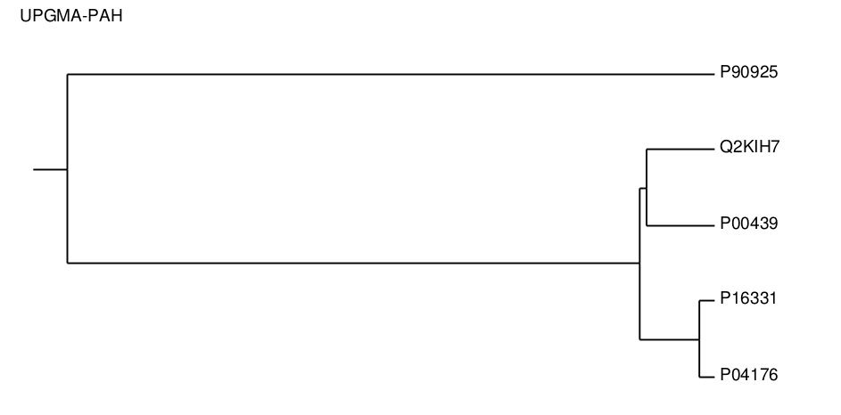

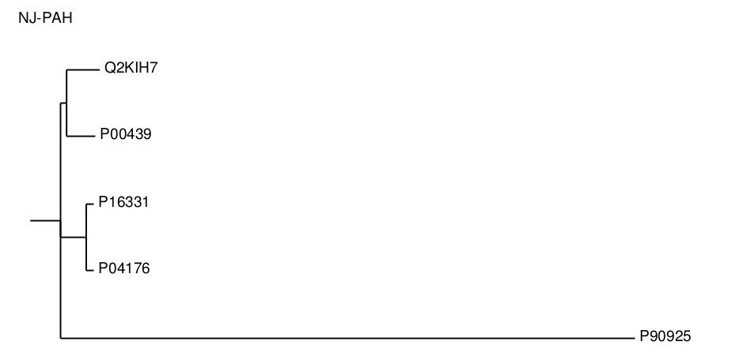
4. Considering NJ produces an unrooted tree, are the two trees different? Justify our answer.

Les deux algorithmes ont le même arbre déraciné.
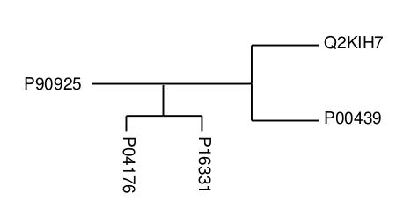

5. What is an additive matrix? Is the distance matrix produced in 2 additive? Use the 4 points condition.

A matrix that satisfies the four point condition is called additive.

Four-point condition :
D(i,j) + D(m,n) ≤ max{D(i,m) + D(j,n), D(j,m) + D(i,n)}

sp|Q2KIH7| 0.000000 0.077624 0.088065 0.095235
sp|P00439| 0.077624 0.000000 0.081118 0.083439
sp|P16331| 0.088065 0.081118 0.000000 0.018110
sp|P04176| 0.095235 0.083439 0.018110 0.000000

sp|P90925| 0.000000 0.747691 0.748962 0.738990
sp|P00439| 0.747691 0.000000 0.081118 0.083439
sp|P16331| 0.748962 0.081118 0.000000 0.018110
sp|P04176| 0.738990 0.083439 0.018110 0.000000

sp|P90925| 0.000000 0.750310 0.748962 0.738990
sp|Q2KIH7| 0.750310 0.000000 0.088065 0.095235
sp|P16331| 0.748962 0.088065 0.000000 0.018110
sp|P04176| 0.738990 0.095235 0.018110 0.000000

sp|P90925| 0.000000 0.750310 0.747691 0.738990
sp|Q2KIH7| 0.750310 0.000000 0.077624 0.095235
sp|P00439| 0.747691 0.077624 0.000000 0.083439
sp|P04176| 0.738990 0.095235 0.083439 0.000000

sp|P90925| 0.000000 0.750310 0.747691 0.748962
sp|Q2KIH7| 0.750310 0.000000 0.077624 0.088065
sp|P00439| 0.747691 0.077624 0.000000 0.081118
sp|P16331| 0.748962 0.088065 0.081118 0.000000

