SOFTWARE ENGINEERING – PROJECT PROPOSAL
PrivateFind
AI-assisted campus lost and found with private ownership verification and a smart locker
Course | Software Engineering, Sejong University
Instructor | Rajendra Dhakal, Ph.D.
Team | Roaster
Members | Zohidjon Mahmudjonov Murodjon Ugli, Umarov Muslimbek,  Gerthofer Simon, Falk Raphael
Category | Web application with embedded / IoT component
Version | Week 7 (13 October 2026): implementation status, verification rules and work distribution updated

Contents
1 Project Title and Team Roster 3
2 System Architecture 3
2.1 System Overview 4
3 Tools Used and Technology Stack 5
4 Description and Working Principle 5
4.1 Problem 5
4.2 Main Functions 5
4.3 Matching 6
4.4 Ownership Verification 6
4.5 Smart Locker and Boundary Conditions 6
4.6 Requirements (SRS Summary) 6
5 Work Distribution 7
5.1 Work Breakdown Structure 7
5.2 Effort Estimation with COCOMO 7
6 Detailed Timeline Weeks 1 to 13 8
6.1 Gantt Chart 8
6.2 Staff Allocation 11
6.3 Critical Path 11
7 Work Completed Before Week 3 11
7.1 Team Formation and Skill Matrix 11
7.2 Ideation and Theme Selection 11
7.3 Problem Statement, Personas and Scope 11
7.4 Initial System Architecture Sketch 12
8 Development Process and Main Risks 12
9 System Design 13
9.1 Use Case Diagram 13
9.2 Sequence Diagram: Collect Item 14
9.3 State Diagram: Locker Compartment 14
9.4 Database Design 15
9.5 Interfaces 16
9.6 User Interface 16
9.7 Locker Hardware 17
9.8 Implementation Status (Weeks 6–7) 17
10 References 18

1 Project Title and Team Roster
Project title: PrivateFind – an AI-assisted campus lost-and-found system with private ownership verification and smart locker handover.
A finder puts a found item into a smart locker and uploads a few photos. AI turns the photos into item attributes, and a Match Score suggests possible items to the owner. Before the locker opens, the owner has to prove ownership with private details.
Name | Student ID | Role | E-mail
Zohidjon Mahmudjonov Murodjon Ugli | 23013058 | Team leader, AI and backend | zohidjon.mah@gmail.com
Umarov Muslimbek | 23012870 | UI and frontend | muslimbekumarov8@gmail.com
Gerthofer Simon | 26040296 | Database and data layer | simon.gerthofer@gmail.com
Falk Raphael | 26040280 | IoT, hardware and locker | 1401raphael@gmail.com

We work in one GitHub repository (github.com/Raphael10191/PrivateFind) and meet once a week. Zohidjon leads the meeting and checks every submission; Raphael keeps the schedule and the meeting notes up to date.

2 System Architecture
PrivateFind follows the pipeline required for embedded projects: sensors ESP32 REST API database web UI (Figure 1).
Web browser (Jinja2, Bootstrap)
Finder QR pages
(deposit)
Owner pages
(report, claim)
Admin pages
(review)
Smart locker
Keypad,
IR sensors
ESP32
firmware
Servos,
LCD
FastAPI backend (Python 3.13)
auth
reporting
lost_reports
matching
(Match Score)
verification
(Ownership Score)
claims
locker_api
ai_client
audit
admin
SQLAlchemy + Alembic
MySQL 8
Photo storage (private)
Hosted AI API (image + text)
HTTP
REST over Wi-Fi
API calls
Figure 1: System architecture and backend modules
Figure 2 on the next page shows the whole system on one page: the users, the workflow steps 1–6 and who builds which part.

2.1 System Overview
Zohidjon: backend, AI
Muslimbek: UI
Simon: database, matching
Raphael: locker, hardware
Finder
Owner
Administrator
Web UI (browser, mobile-first)
QR deposit page
1–3 photos, category, location
(no account)
Owner pages
lost-item report,
candidates, evidence,
pickup code
Admin pages
review claims,
correct AI data
FastAPI backend (Python)
Item & deposit service
saves the found item, picks a free compartment
Matching Engine
Match Score 0–100 → top 3 candidates
Verification Engine
Ownership Score → approve / review / reject
Code service
one-time deposit and pickup codes
Auth & roles
username + e-mail
AI client
only the backend calls AI
Audit log & limits
attempts, cooldown
Locker API
REST for the ESP32
Rule: browser and ESP32 never touch the database
or the AI directly – everything goes through here.
1
4
5
Hosted AI API (external)
photos + note → item attributes
(category, colour, brand,
private details)
text → similarity
2
MySQL 8 database

users, found items,
attributes (public / private),
lost reports, matches,
claims, evidence,
lockers, deposit sessions,
codes (hashed), audit log

+ private photo storage
SQL
Smart locker (ESP32, 2 compartments)
Keypad 4x4
enter code + #
LCD 16x2
instructions
ESP32
Wi-Fi, firmware
forwards codes,
no own decisions
Servo locks
open the door
IR sensors
item inside?
Comp.
1
Comp.
2
REST over Wi-Fi
+ device key
3
6
Figure 2: System overview with users, workflow steps 1–6 and team responsibilities
Four rules keep the parts separate:
- The browser and the ESP32 only talk to the FastAPI backend.
- Only the backend accesses MySQL (through SQLAlchemy).
- Only the backend calls the AI API. The API key stays on the server.
- The ESP32 does not decide if a code is valid. It only forwards the code.
Runtime data flow (numbers as in Figure 2)
- The finder scans the QR code on the locker, takes one to three photos, picks the category and adds the location and an optional note.
- The AI extracts attributes. The backend assigns a free compartment and a deposit code.
- The finder enters the code, puts the item in and closes the door. The IR sensor confirms it.
- The owner signs in, reports the lost item and sees the top candidates.
- The owner submits private details. The system approves, rejects or sends the claim to an admin.
- After approval the owner gets a one-time pickup code and opens the compartment.

3 Tools Used and Technology Stack
Area | Tools
Backend | Python 3.13, FastAPI, Pydantic
Database | MySQL 8, SQLAlchemy 2, Alembic
Frontend | HTML, Jinja2, Bootstrap 5, JavaScript
AI | Hosted multimodal AI API for photo attributes and text similarity (no embeddings); no own model training
Embedded | ESP32, Arduino C++
Security | Session cookies, Argon2
Testing | pytest, HTTPX
Deployment | MySQL in Docker (Docker Compose); the backend runs with one command
Design and version control | Google Stitch, Git and GitHub

Hardware
Component | Qty | Status
ESP32 DevKit (ESP32-WROOM-32D) | 1 | Bought in Week 5
4x4 keypad | 1 | Bought in Week 5
SG90 servo (door lock) | 2 | 1 bought, 1 in Week 6
IR presence sensor | 2 | Week 6
16x2 LCD with I2C module | 1 | Week 6
Breadboards, jumper wires, capacitor | – | Bought in Week 5
Enclosure with 2 compartments | 1 | Weeks 9–11

4 Description and Working Principle

4.1 Problem
Finders do not want to spend time on a long registration. Public photos help people who claim items that are not theirs. And a good AI match is not a proof of ownership. PrivateFind keeps the deposit quick, keeps the evidence private and separates matching from verification.

4.2 Main Functions
- Quick deposit with a QR code: one to three photos, category and location, no account for the finder
- AI extraction of public and private item attributes
- Lost-item report by the owner before any candidate is shown
- Match Score and the top three candidates
- Ownership claim with private evidence, admin review for unclear cases
- One-time deposit and pickup codes at the locker
- Audit log of all important actions

4.3 Matching
Open items are filtered by category and date. The Match Score (0–100) is calculated as:
25% category + 15% location + 15% time + 25% attributes + 20% semantic similarity
Up to three candidates with a score of at least 60 are shown. The score only ranks candidates. It never proves ownership.

4.4 Ownership Verification
The claimant describes private details, for example the contents, a sticker, damage or the last digits of a serial number. Each detail has a weight by attribute type (strong 3, distinctive 2, generic 1). A mismatch is only critical if the stored attribute is reliable: the AI was confident (confidence 0.8 or higher) or an administrator confirmed it. The Ownership Score decides:
- 80 or more, at least one strong detail and no critical conflict: approved, pickup code is issued
- 50–79 or a generic item (e.g. a plain umbrella): review by an administrator
- Below 50 or a critical mismatch: rejected
The claimant is never told which detail was wrong. The first approved claim reserves the item.
After three failed claims on the same item, the account has to wait one hour before it can claim this item again. Requests are rate-limited per IP address. Every failed claim is written to the audit log, which the administrator can see. Failed claims of other users never make the check harder for the real owner.

4.5 Smart Locker and Boundary Conditions
The locker has two compartments with opaque doors. Each has a servo lock and an IR sensor. Deposit and pickup codes are single-use and belong to one compartment.
- Owners register with a username, an e-mail address and a password. Finders need no account.
- Expired or used codes never open the locker.
- If no compartment is free, the QR page does not accept a deposit.
- If the AI or the locker is not available, we use mock services. Failed AI jobs are retried or corrected by an admin.

4.6 Requirements (SRS Summary)
The SRS was finished in Week 3. The table shows the main functional (FR) and non-functional (NFR) requirements.
ID | Requirement
FR1 | The finder deposits an item with the QR code, one to three photos, the category, the location and an optional note, without an account.
FR2 | The system extracts public and private attributes from the photos, the category and the finder’s note with a hosted AI.
FR3 | Owners sign in with a username and password and create a lost-item report.
FR4 | The system calculates a Match Score and shows the top 3 candidates with public data only.
FR5 | The owner submits private evidence. The system approves, rejects or sends the claim to an admin.
FR6 | The locker opens only with a valid one-time deposit or pickup code.
FR7 | Administrators review claims, correct item data and see the audit log.
NFR1 | Security: photos and private attributes are never public. Passwords and codes are stored as hashes.
NFR2 | Only the backend uses the database and the AI. The AI never approves claims or opens the locker.
NFR3 | Performance: web requests take under 2 seconds, AI processing under 10 seconds in the demo.
NFR4 | Usability: target of less than one minute for a deposit on a phone; checked in the UI tests.
NFR5 | Reliability: every code check and claim decision is logged. After three failed claims on an item, the account waits one hour.
Data storage: all data is stored in MySQL, photos in a private folder on the server. UI scope: mobile-first web pages for three roles (finder, owner, administrator).

5 Work Distribution
Module / deliverable | Owner | Support
Requirements (SRS) | All | Zohidjon consolidates
Database model and migrations | Simon | Zohidjon
Matching Engine (Match Score) | Simon | Zohidjon (AI similarity)
AI attribute extraction | Zohidjon | Muslimbek (upload UI)
Authentication and roles | Zohidjon | Simon
Ownership Verification Engine | Zohidjon | Simon
Audit log, attempt and rate limits | Simon | Zohidjon
Wireframes and all UI screens | Muslimbek | Zohidjon, Simon
Locker REST API and code lifecycle | Raphael | Simon
ESP32 firmware and physical locker | Raphael | Simon
Unit and API tests | Zohidjon | Simon
End-to-end and locker tests, test report | Raphael | All

5.1 Work Breakdown Structure
The WBS has 12 phases and 54 work packages with 455 planned hours (Figure 3). All work packages with their hours are listed in the Gantt chart (Figure 4).
PrivateFind – 455 h
1 Project management
65 h
2 Requirements and SDLC
20 h
3 Estimation and planning
30 h
4 Design
39 h
5 Scheduling and setup
34 h
6 Increment 1 (MVP)
75 h
7 Integration and reuse
28 h
8 Security
30 h
9 Final features
51 h
10 Integration and review
35 h
11 QA and completion
23 h
12 Deployment and showcase
25 h
Figure 3: Work breakdown structure (level 1) with planned hours
Member | Hours | Share
Zohidjon | 120 | 26.3 %
Muslimbek | 100 | 22.0 %
Simon | 119 | 26.2 %
Raphael | 116 | 25.5 %
Total | 455 | 100 %

5.2 Effort Estimation with COCOMO
We estimated the size of each module with three values (optimistic, likely, pessimistic) and the PERT formula (O + 4M + P) / 6. Only our own code is counted, not tests or reused libraries.
Module | Language | O | M | P | Expected LOC
Authentication and users | Python | 250 | 400 | 600 | 408
Found-item reporting and QR deposit | Python | 300 | 450 | 700 | 467
AI service integration | Python | 250 | 400 | 650 | 417
Matching Engine | Python | 250 | 400 | 600 | 408
Ownership Verification Engine | Python | 300 | 450 | 700 | 467
Claims, reservation, admin review | Python | 250 | 400 | 600 | 408
Locker REST API and codes | Python | 200 | 350 | 550 | 358
Security: limits and audit log | Python | 200 | 300 | 500 | 317
Data layer (models, migrations) | Python/SQL | 400 | 600 | 900 | 617
Web UI (templates, JavaScript) | HTML/JS | 800 | 1,200 | 1,800 | 1,233
ESP32 firmware | C++ | 350 | 550 | 850 | 567
Total |  | 3,550 | 5,500 | 8,450 | 5,667

With 5.67 KLOC we used Basic COCOMO (Boehm, 1981): E = a × KLOC^b, D = 2.5 × E^d, Staff = E / D. One person-month (PM) is 152 working hours.
Mode | a / b | Effort (PM) | Duration (months) | Staff | Effort (h)
Organic | 2.4 / 1.05 | 14.8 | 7.0 | 2.1 | 2,254
Semi-detached (used) | 3.0 / 1.12 | 20.9 | 7.2 | 2.9 | 3,182
Embedded | 3.6 / 1.20 | 28.9 | 7.3 | 3.9 | 4,387

We use semi-detached mode, because our experience is mixed and the web, AI and embedded parts work together. For PrivateFind this means 5.67 KLOC, an effort of 20.9 PM and a timeline of 7.2 months with about 3 persons. Our plan has 420 hours for Weeks 3–13 (455 hours with Weeks 14–15). COCOMO assumes professional projects without much reuse. We reuse frameworks and a hosted AI, so we see the gap as a scope risk: strict scope, mocks and a new estimate after the MVP.

6 Detailed Timeline Weeks 1 to 13
Week | Phase | Work and deliverable (milestone)
1 | Ideation | Team, topic, first proposal
2 | Requirements | SRS draft
3 | SDLC | Final SRS and SDLC justification (M1)
4 | Estimation | COCOMO, WBS, Gantt chart (M2)
5 | Design | System design: architecture, ER diagram, UI mockups (M3)
6 | Setup | Final Gantt chart, repository, DB schema, FastAPI skeleton (M4)
7 | Core logic | QR deposit, lost report, login, DB persistence (M5); proposal presentation on 13 and 15 Oct
8 | MVP | Midterm demo with a mock locker (M6)
9 | Reuse | Libraries, AI API (attributes and similarity), ESP32 libraries
10 | Security | Access control, input validation, attempt and rate limits
11 | Final features | Verification, admin review, physical locker (M7)
12 | Integration | End-to-end tests, code review, release candidate (M8)
13 | Testing | Unit, API, DB and locker tests; final code and test report (M9)
14 | Deployment | Setup scripts, user and maintenance manual
15 | Showcase | Live demo and final presentation (M10)
Milestones and definition of done:
ID | Milestone | Week | Definition of done
M1 | Requirements and SDLC approved | 3 | Team agrees on finder effort, AI limits, verification rules and scope.
M2 | Estimation, WBS and schedule agreed | 4 | COCOMO, WBS and first Gantt chart with staff allocation are agreed.
M3 | Design approved | 5 | Architecture, ER diagram, AI data format and wireframes are reviewed.
M4 | Schedule, repository and DB ready | 6 | Final schedule; repository, dev environment and DB schema exist.
M5 | First running increment | 7 | QR deposit, lost report and DB persistence work through FastAPI.
M6 | MVP | 8 | A photo becomes item attributes; one candidate and claim work end to end.
M7 | Feature complete | 11 | Matching, verification, admin review and the real locker work together.
M8 | Release candidate | 12 | All must-have features are integrated, tested and reviewed.
M9 | Project complete | 13 | All tests are done and no high-severity bug is open.
M10 | Final showcase | 15 | Live demo and final presentation are given.

6.1 Gantt Chart
Figure 4 shows two screenshots of the sheet “Gantt Chart” from our planning workbook. Each bar is one work package with its owner and hours. Columns for status and progress tracking are hidden.

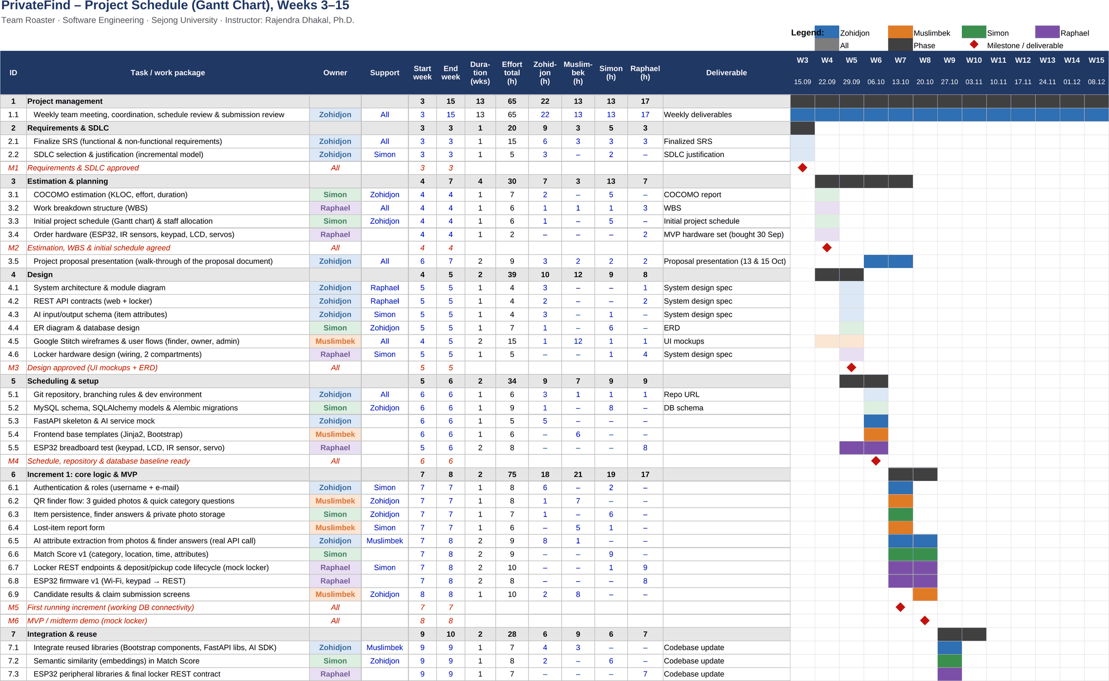
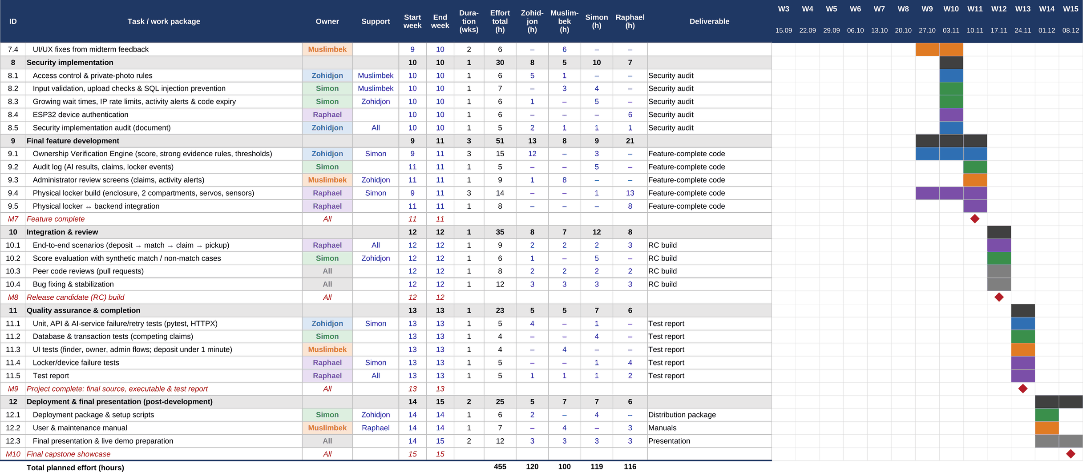
Figure 4: Gantt chart of PrivateFind, Weeks 3 to 15

6.2 Staff Allocation
Planned hours per member and week (rounded):
Member | W3 | W4 | W5 | W6 | W7 | W8 | W9 | W10 | W11 | W12 | W13 | W14 | W15 | Total
Zohidjon | 11 | 6 | 11 | 12 | 15 | 8 | 12 | 14 | 7 | 10 | 6 | 5 | 3 | 120
Muslimbek | 4 | 8 | 7 | 9 | 15 | 10 | 7 | 9 | 9 | 8 | 6 | 6 | 2 | 100
Simon | 6 | 13 | 10 | 11 | 16 | 6 | 8 | 12 | 7 | 13 | 8 | 7 | 2 | 119
Raphael | 4 | 7 | 13 | 7 | 11 | 10 | 13 | 13 | 13 | 9 | 7 | 6 | 3 | 116
Team | 25 | 34 | 41 | 39 | 57 | 34 | 40 | 48 | 36 | 40 | 27 | 24 | 10 | 455

On average each member works about 9 hours per week. Week 7 is the peak (about 15–16 hours for Zohidjon, Muslimbek and Simon), because the presentation and the first implementation week come together. Support hours can be moved to Week 6.

6.3 Critical Path
The course has a deliverable almost every week, so nearly all packages are critical. Only 7.1 and 7.2 have one or two weeks of float. The longest chains are:
- Software: ER diagram DB schema item persistence Match Score MVP verification feature complete
- Hardware: order parts breadboard test ESP32 firmware locker build integration
We check the plan in every weekly meeting and update the workbook if something is late.

7 Work Completed Before Week 3

7.1 Team Formation and Skill Matrix
Member | Frontend | Backend / AI | Database | Hardware
Zohidjon | Working | Primary | Working | Basic
Muslimbek | Primary | Basic | Basic | Basic
Simon | Basic | Working | Primary | Support
Raphael | Basic | Working | Support | Primary

Primary = responsible, Working = can implement, Support = helps, Basic = can test.

7.2 Ideation and Theme Selection
Session | Discussion | Decision
8 Sep | Simple lost-and-found website vs. locker only vs. both. A website alone is too simple, a locker alone shows too little software. | Ownership verification as core problem, locker for the handover
10 Sep | Finders get no benefit, so the effort for them must be very low. | QR code, photo and short note, no finder account
17 Sep | Public photos help false claims; an AI match alone is no proof. | Hosted AI for attributes, Match Score, separate Ownership Score

The scope is feasible: we use an existing AI API instead of training a model, the rules are simple and testable, and the locker has only two compartments.

7.3 Problem Statement, Personas and Scope
A finder needs a fast way to secure an item. An owner needs good matches without showing the details that prove ownership.
Persona | Goal | Needs
Finder | Hand over a found item quickly | QR code, under one minute, no contact data
Owner | Find the item and prove ownership | Good ranking, private evidence, safe pickup
Administrator | Handle unclear claims and AI errors | Private evidence view, audit history

In scope: QR deposit, private photo storage, AI attributes, owner accounts, Match Score, ownership claims, one-time codes, two-compartment locker, audit log, admin review.
Out of scope: model training, public photo browsing, rewards, chatbot, mobile app, connection to university systems.
Known limitations: The finder sees the item and could claim it himself; unusual claims are shown to the administrator, but this cannot be fully prevented. The locker has only two compartments, because it is a prototype that shows the concept.

7.4 Initial System Architecture Sketch
The first sketch already had the boundaries of Figure 1: browser, backend, database and ESP32. Only the backend talks to the database and the AI service.
Browser / Web UI
FastAPI
MySQL
AI API
ESP32
HTTP
Figure 5: Initial system architecture sketch from the early project phase

8 Development Process and Main Risks
In Week 3 we compared the development models from the lecture and chose incremental development:
Model | Fit for PrivateFind
Waterfall | No. AI and hardware results are uncertain, so we need feedback before the end.
V-Model | No. Strong test planning, but too much documentation for our 13 weeks.
Agile (Scrum, XP) | Partly. We use short cycles and weekly meetings, but not the full Scrum roles.
Incremental (chosen) | Yes. Requirements are fixed early, then we deliver working increments.
Increment 1 (Weeks 7–8) ends with the MVP. Increment 2 (Weeks 9–11) adds reuse, security and the remaining features.
Risk | Impact | Mitigation
AI extracts a wrong attribute | Medium | Store confidence, admin can correct, test with real photos
False claimant | High | Hide photos and details, owner report first, strong evidence required, wait time after failed claims, audit log
Generic item, weak evidence | Medium | No automatic approval, admin review
AI service slow or unavailable | Medium | Mock in development, retry, limit images
Hardware delay | Medium | Mock locker until Week 9; MVP parts already work (Week 5)
Scope growth | Medium | No chatbot, rewards or mobile app
Campus Wi-Fi blocks the ESP32 | Low | Phone hotspot for the demo
Workload peaks | Medium | Weekly Gantt update, move support hours
Dependability measures (lecture Chapter 7):
Property | How PrivateFind supports it
Availability | Mock AI and mock locker during development; phone hotspot if the campus Wi-Fi blocks the ESP32
Reliability | One owner per item through a database transaction; every code check and claim decision is logged
Security | Passwords and codes only as hashes; wait time after failed claims, IP rate limits and the audit log
Error tolerance | Category drop-down for finders; codes expire; the administrator can correct AI errors

9 System Design
This chapter is the Week 5 deliverable; section 9.8 adds the implementation status of Weeks 6 and 7. Figure 1 in chapter 2 shows the architecture and the modules. Here we add UML models from Chapter 5 for the main interactions and the locker behaviour, the ER diagram and the UI wireframes.

9.1 Use Case Diagram
Actors can be people or other systems. Finder, owner and administrator are people; the smart locker and the AI service are systems (Figure 6).
Report found item
Deposit item
Collect item
Report lost item
View candidates
Submit ownership evidence
Review claim
Correct item data
View audit log
Finder
Owner
Administrator
«system»
Smart Locker
«system»
AI Service
Figure 6: Use case diagram

9.2 Sequence Diagram: Collect Item
Figure 7 shows the pickup at the locker. The ESP32 only forwards the code; the backend checks it and tells the locker which compartment to open.
Owner
F: LockerFirmware
L: LockerAPI
D: Database
enterCode(code), #
validateCode(deviceKey, code)
findCode(codeHash)
code record
alt
[code valid]
markUsed(), setState(PICKUP_OPEN)
open(compNo)
unlock, LCD 'Take item'
take item, close door, #
reportState(compNo, EMPTY)
setReturned(), freeCompartment()
[code invalid or expired]
logFailedAttempt()
deny()
LCD 'Invalid code'
Figure 7: Sequence diagram for “Collect item”

9.3 State Diagram: Locker Compartment
Each compartment is always in one of six states (Figure 8). “Door closed” means the user closed the door and pressed #, because the locker has no door sensor. The IR sensor then shows if an item is inside.
Free
Do: show 'Scan QR'
Deposit reserved
Do: wait for code
Deposit open
Do: unlock door
Occupied
Do: keep locked
Pickup reserved
Do: wait for code
Pickup open
Do: unlock door
Deposit code issued
Code expired
Valid code
Door closed
[item detected]
Door closed [no item]
Claim approved
Code expired
Valid code
Door closed
[no item]
Door closed [item still inside]
Invalid code
Invalid code
Figure 8: State diagram of a locker compartment

9.4 Database Design
Figure 9 shows the ER diagram with 13 tables. We use the UML multiplicities from Chapter 5: 1 = exactly one, 0..1 = none or one, * = many, 1..* = at least one. Many-to-many relations are split by a table: match_candidate links lost reports and found items, ownership_evidence links claims and item attributes.
user
PK user_id
username
email
password_hash
role
created_at
claim
PK claim_id
FK match_id
FK user_id
status
ownership_score
attempt_no
FK reviewed_by
reviewed_at
created_at
ownership_evidence
PK evidence_id
FK claim_id
FK matched_attribute_id
detail_type
claimed_value
is_critical
comparison_score
result
item_attribute
PK attribute_id
FK item_id
name
value
confidence
visibility
weight
source
lost_report
PK report_id
FK user_id
category
location
lost_from, lost_to
brand_model
description
unique_marks
status
created_at
match_candidate
PK match_id
FK report_id
FK item_id
category_score
location_score
time_score
attribute_score
semantic_score
total_score
created_at
found_item
PK item_id
FK session_id
FK compartment_id
category
location
finder_note
found_at
status
ai_status
created_at
item_photo
PK photo_id
FK item_id
storage_path
uploaded_at
audit_log
PK log_id
FK user_id
action
entity_type
entity_id
details
created_at
access_code
PK code_id
FK compartment_id
FK item_id
FK claim_id
type
code_hash
created_at
expires_at
used_at
compartment
PK compartment_id
FK locker_id
number
state
deposit_session
PK session_id
FK locker_id
token_hash
created_at
expires_at
status
locker
PK locker_id
device_id
device_key_hash
location
last_seen_at
1
*
1
1..*
*
0..1
1
*
1
*
*
1
1
*
1
*
*
1
1
1..3
1
*
0..1
1
1..*
1
*
1
*
1
0..1
0..1
0..1
*
Figure 9: ER diagram of the PrivateFind database
- Public / private: item_attribute.visibility decides what candidates may see. Private attributes are only used for verification. item_attribute.source shows if an attribute comes from the AI or an administrator.
- One owner per item: the approval locks the found_item row and reserves the item in one transaction.
- Codes: access codes and the device key are stored as hashes with an expiry time.
- Traceable score: match_candidate stores the five partial scores and the total, so every Match Score can be explained.
- Finder sessions: deposit_session belongs to one locker and one found item, expires after a short time and stores the token only as a hash.
- History: a compartment keeps its old items as history, but only one active item is allowed at a time.
The schema is implemented with SQLAlchemy models and a first Alembic migration that creates all 13 tables (Week 6). A second migration adds five fields the backend needs: public_summary, description and ai_error in found_item, color in lost_report and shown in match_candidate.

9.5 Interfaces
All interfaces use JSON over HTTP; for the prototype the locker and the backend run on one local network. The ESP32 sends its device key in every request.
Endpoint | Used by | Purpose
POST /api/deposits | Finder | Upload one to three photos, category, location and note, get compartment and deposit code
POST /api/lost-reports | Owner | Create a lost-item report
GET /api/lost-reports/{id}/candidates | Owner | Top 3 candidates (public data only)
POST /api/claims | Owner | Submit ownership evidence, get decision
POST /api/admin/claims/{id}/decision | Admin | Approve or reject a claim
POST /api/device/codes/validate | ESP32 | Check a keypad code, answer open or deny
POST /api/device/compartments/{no}/state | ESP32 | Report if an item is inside

The AI service returns JSON with category, colours, brand, public attributes and private attributes, each with a confidence value. Pydantic checks the answer before it is stored.

9.6 User Interface
The pages are mobile-first, because finders and owners use their phone at the locker. Full photos are never shown to owners, only a short public summary. The deposit page asks the finder for one to three photos, the category and the location.
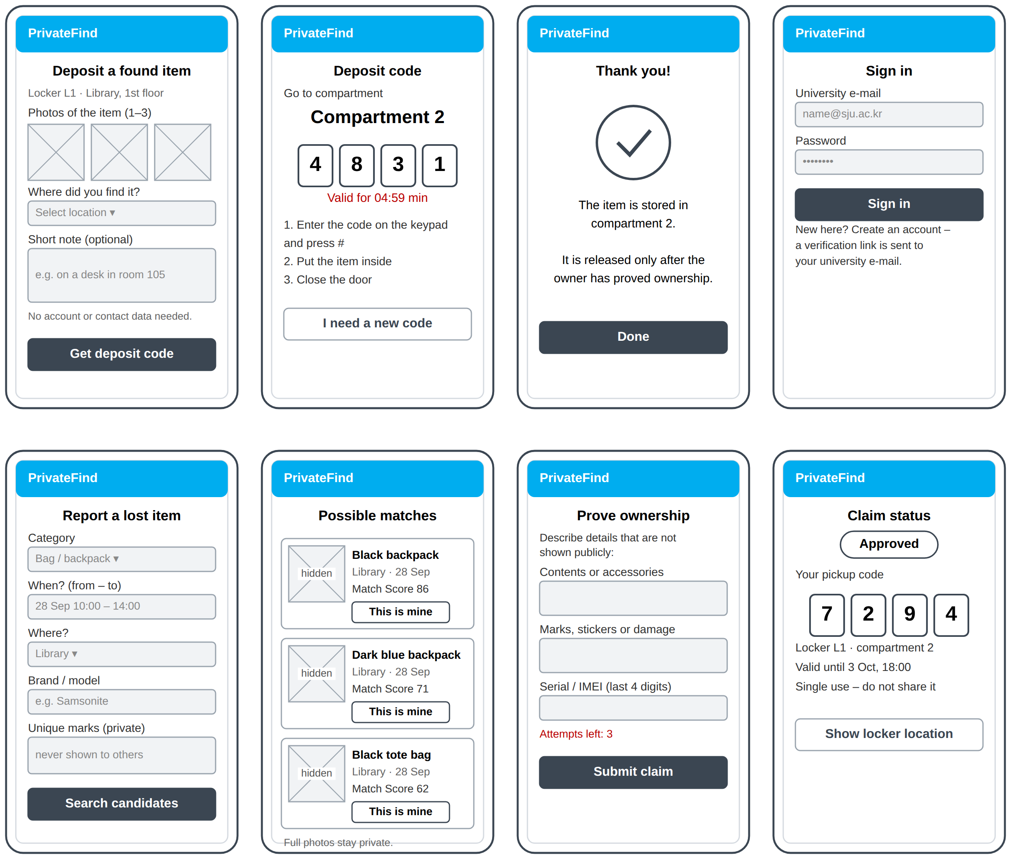
Figure 10: Wireframes of the finder flow (top) and the owner flow (bottom)

9.7 Locker Hardware
Component | ESP32 pin | Note
4x4 keypad | GPIO 13, 14, 27, 26 / 25, 33, 32, 4 | Rows / columns
16x2 LCD (I2C) | GPIO 21 (SDA), 22 (SCL) | 5 V supply
Servo compartment 1 / 2 | GPIO 18 / 19 | External 5 V, capacitor, common GND
IR sensor 1 / 2 | GPIO 34 / 35 | Input-only pins
The pin assignment above represents the planned final locker configuration. The current Week 5 breadboard prototype uses a temporary pin assignment for the keypad and first servo. The firmware will be remapped to the final assignment when the LCD, sensors and second compartment are integrated.

The ESP32, the keypad and the first servo already run on the breadboard (Figure 11). The other parts are ordered in Week 6.
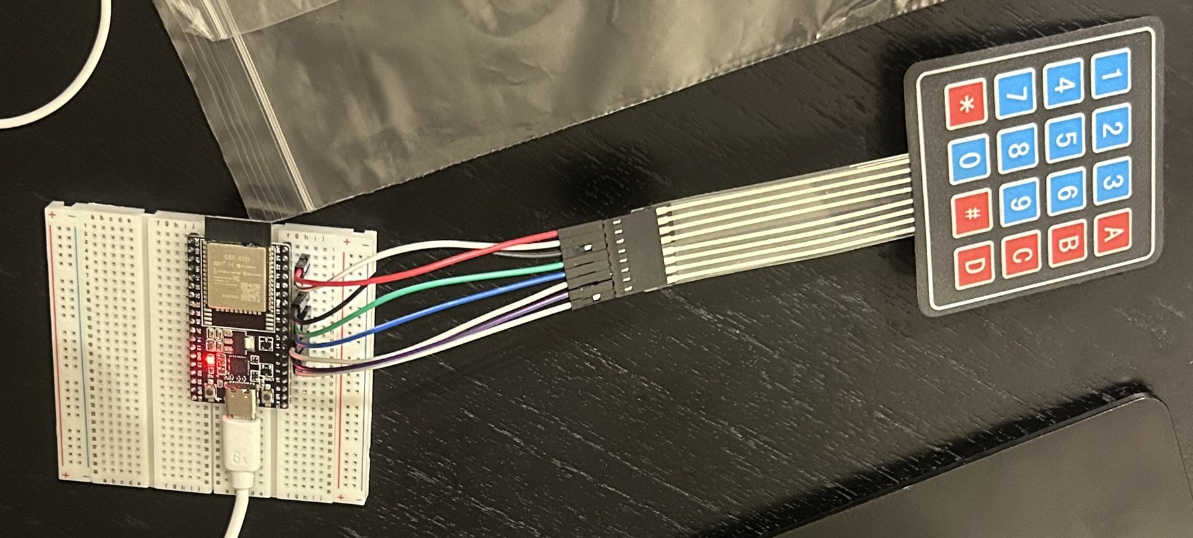
Figure 11: Breadboard test with ESP32 and keypad (Week 5)

9.8 Implementation Status (Weeks 6–7)
Status at the start of Week 7 (repository: github.com/Raphael10191/PrivateFind):
- Database: SQLAlchemy models for all 13 tables and a first Alembic migration, applied to a local MySQL database (branch simon/database, pull request to main).
- Backend: FastAPI with a health check and a first locker endpoint that checks a keypad code and logs every attempt (test code, not yet connected to the database). A fuller backend with tests (auth, deposit, AI with retry, matching, claims, admin and the device API) is being ported into the repository as a pull request on top of the 13 tables.
- Locker: the ESP32 with keypad and first servo sends the entered code over Wi-Fi to this endpoint and opens the servo when the code is accepted (Figure 11).
- In progress in Week 7 (M5): login, QR deposit with photos and category, item persistence and the lost-item report through FastAPI and MySQL.

10 References
Boehm, B. W. (1981). Software Engineering Economics. Prentice Hall.
Sommerville, I. Software Engineering, 10th edition. Pearson.
Sejong University (2026). Software Engineering Project Proposal Guidelines.
Sejong University (2026). Software Engineering Project Guide: Schedule, Themes and Tools.

