
Practical Task: Secure File Management & User Configuration on Kali Linux
Objective:
Demonstrate your understanding of fundamental Linux file system and user management commands. You are tasked with setting up a secure workspace for a newly created user and organizing files with proper permissions and structure.
Instructions:
You must not use the root user to complete the file operations. A new user must be created and all steps (except useradd and usermod) must be performed using that user’s account.
TASK STEPS:
1. Create a New User:
o Create a new user named agent007 with a home directory and assign /bin/bash as their shell.
o Add this user to the sudo group.
sudo useradd -m -s /bin/bash -G sudo agent007
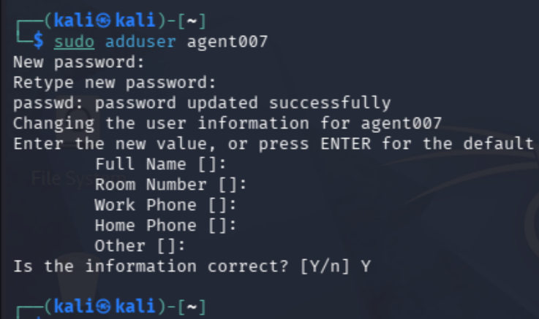

2. Switch to the New User:
o Set a password for agent007.
o Switch to the new user and perform the rest of the steps using this account. 3. Setup Workspace:
o Inside /home/agent007/, create a directory structure as follows:
/home/agent007/mission/
├── intel/
└── ops/
└── backup/
o Use mkdir and cd commands to navigate and create this structure.
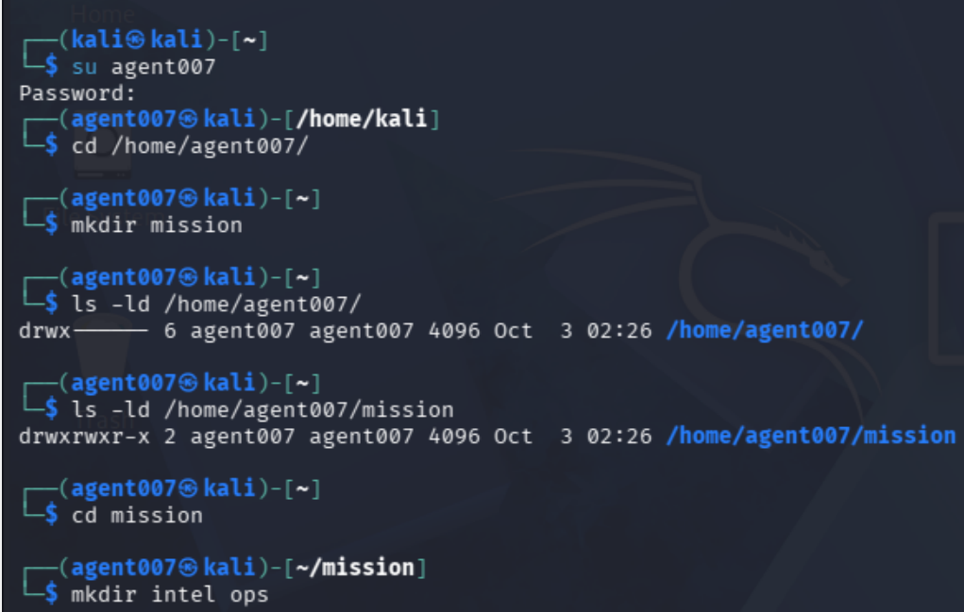

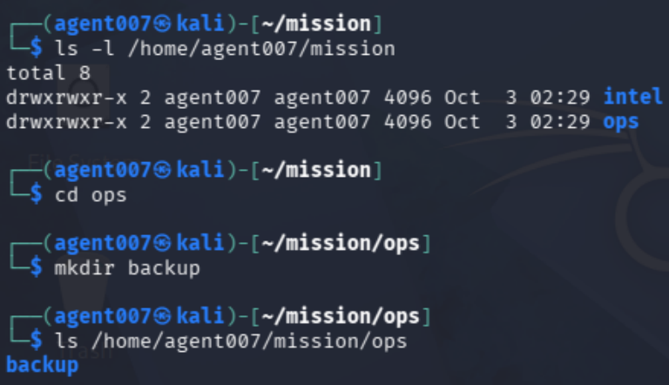
4. File Creation and Listing:
o Inside intel/, create three empty files: targets.txt, routes.txt, and keys.txt.
o Use ls, ls -l, and ls -la to list contents and view permissions of the files and directories. Redirect the output of each listing to separate files named
listing1.txt, listing2.txt, and listing3.txt inside the intel/folder.

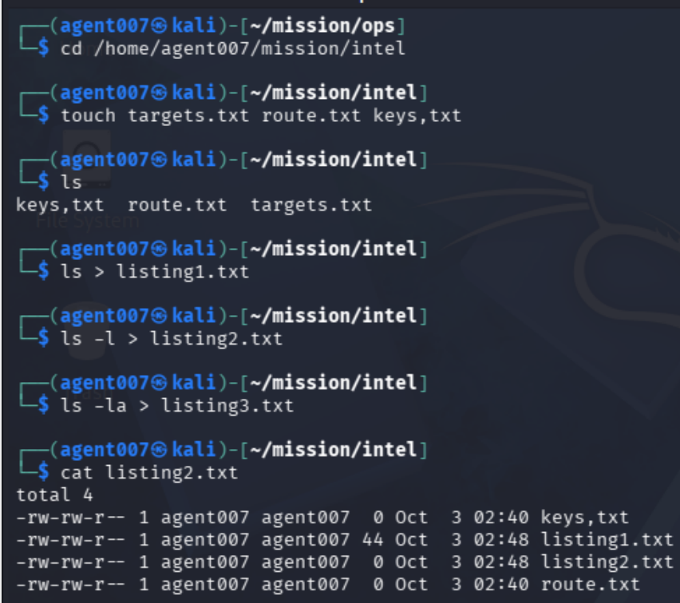

5. Copy and Remove Files:
o Copy routes.txt to the backup/ folder.
o Delete keys.txt from intel/ using rm.
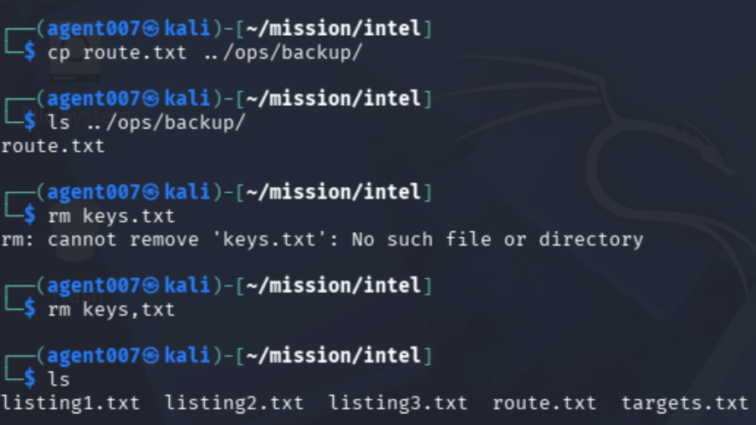

6. Permissions Handling:
o Change the permissions of targets.txt so that:
▪ Owner can read and write.
▪ Group can only read.
▪ Others have no permissions.
o Use chmod and verify using ls -l.

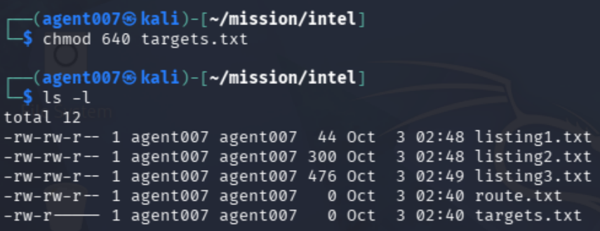

7. Simulate an Error and Recover:
o Intentionally remove the ops/backup/routes.txt file.
o Copy the routes.txt from intel/ back into the backup/ folder.
o (This tests cp and basic error recovery.)
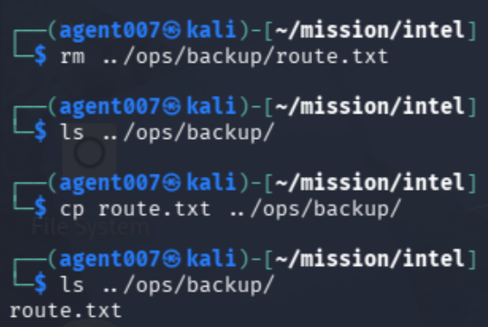

8. Advanced Permissions & Ownership:
o As root, change the ownership of intel/targets.txt to another user (e.g., root), then switch back to agent007 and observe the result using ls -l.

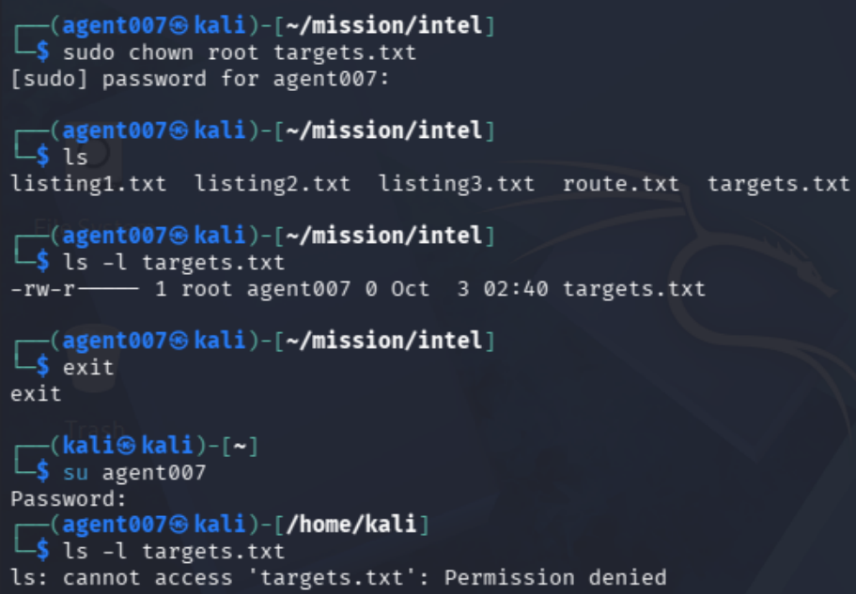

Text Explanation of what chmod, ls -l and useradd do…
chmod changes the permissions on a file or folder, controlling who can read, write, or execute it (for example, chmod 755 script.sh).
ls -l lists the contents of a directory in long format, showing each item's permissions, owner, group, size, and last modified date.
useradd creates a new user account on the system (for example, useradd alice), and it is usually run with admin privileges.

Linux Task01
Instructor: Mr. Dennis
Trainee: Raphael

