**BOT ORCHESTRATION/BOT DISCOVERY** Version 1.0 July 27, 2018

The program is the connection of many specific service chat bots that are used to their own strengths in one end user experience. With just one outlet messaging platform a user will be able to interact with the desired chatbot making multiple services available in just one easy outlet instead of having to go and find many numerous individual chatbots to get the desired services a user wants.

**GETTING STARTED**

**Prerequisites**

* Have a facebook developer account with a messenger app created
* Have Python 3.6 installed with requests library
* A NLP engine able to access such as LUIS
* AWS Lambda and API Gateway

**Installing on a local env**

1. Download the files and run DictStorageAPI.py and FacebookWebhookFourthEdition.py
2. Create two lambda functions and run inline Python 3.6 code. One use code in OrchestratorAPIApp and Overall_Luis(Already made these functions available on Infosys account)
3. Create API gateways for both lambda functions so that you have post functions. If you do create new functions don’t forget to change the url in the code in files in Step 1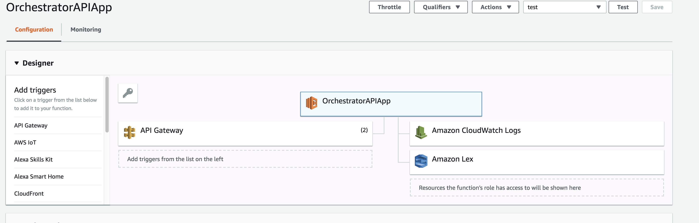
4. Create the correct permissions. Follow prompts of AWS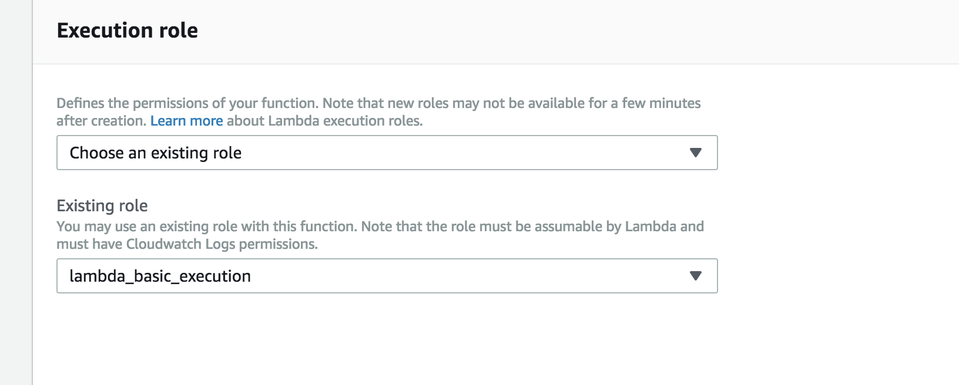
5. Create Lex bots as you see fit
6. Create a LUIS app. Make it so the intents in the app correspond to the name of your bots in LEX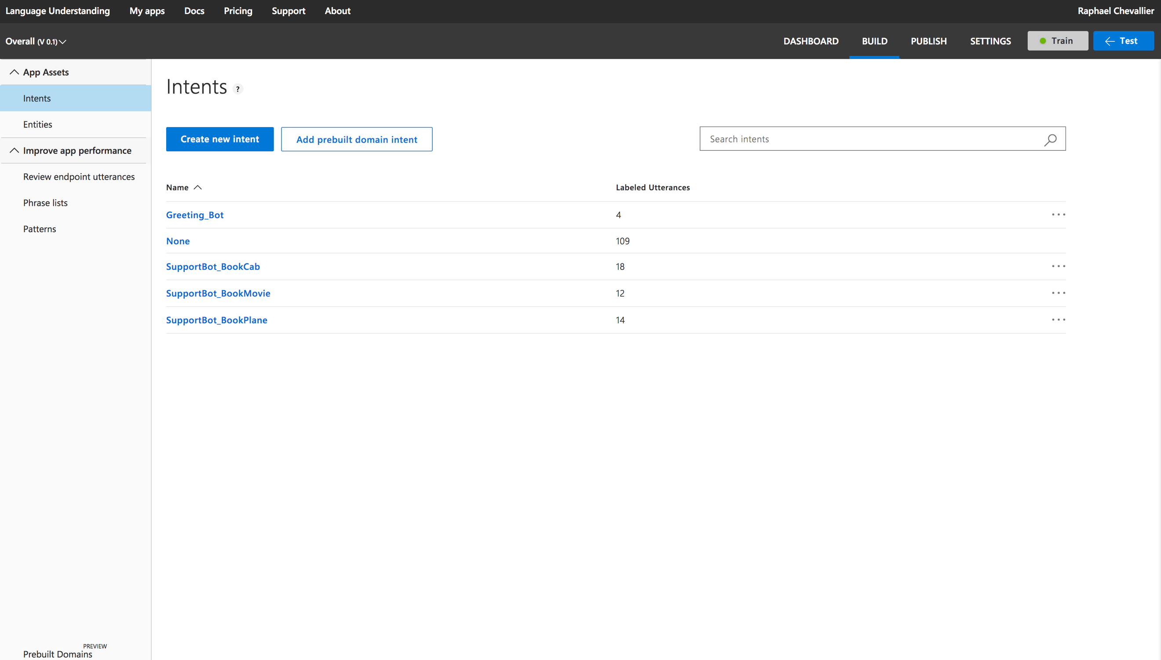
7. Create utterances of LUIS intents with the same utterances used in the LEX bots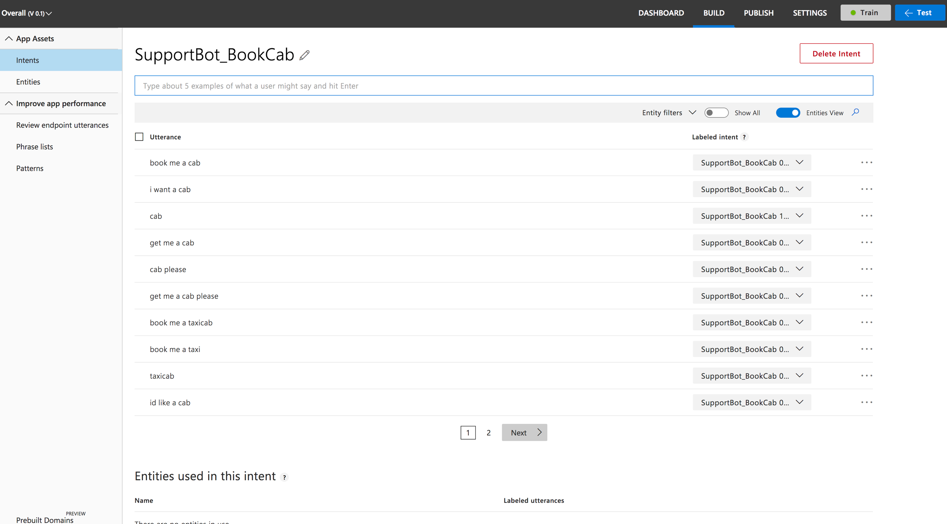
8. Run the port of the FacebookWebhookFourthEdition through ngrok and use the https url created to add to your facebook app with the key that is found at the top of the file code.
9. Make sure the GET requests returns a 200 response

**RUNNING TESTS**

Test by messaging the pages inbox and the bot will respond

Break the bot by trying new utterances that weren’t added to the lex bots or LUIS

Try to confuse the logic algorithm for choosing the correct bot by changing intents constantly

**DEPLOYMENT**

DictStorageAPI.py as in its name is just an API. It would be a lot more efficient as a full blown database to store many user information. Run FacebookWebhookFourthEdition.py on servers

**BUILT WITH**

* LUIS.AI
* AWS Lambda and API Gateway
* Amazon Lex
* Facebook and Facebook Messenger

**AUTHORS**

* Raphael Chevallier - *Initial Work* - Infosys

-email: [raphaelchevallier@hotmail.com](mailto:raphaelchevallier@hotmail.com)

-phone: +1 (778)-581-6345

**LICENSE**

**ACKNOWLEDGMENTS**

Thank you to my mentor at the time, Sundar RamaKrishnan, for helping me with small issues throughout the project building