Using WHATIF_visualize

last updated: 19 May 2020 by Raphael (rapp@env.dtu.dk)

Follow these simple steps to visualize the results from the WHAT-IF model using power BI. This guide assumes you have the WHAT-IF model and know how to run it. If you wish to compare only some key indicators of different scenarios, look at **How_to_Compare_Scenarios.docx** which is simpler.

# 1 Pre-requirements

**1.1** Install power BI desktop

<https://powerbi.microsoft.com/en-us/downloads/>

**1.2** Get the WHATIF_visualize_vX.pbix file which is the template file for WHAT-IF results

# 2 Aggregate scenarios

**2.1** Run the WHAT-IF model for the desired scenarios using *WHATIF_main.py*, *WHATIF_scenario.py* or *WHATIF_mpc.py*, the output will be found in the *Results* folder (by default the results will be in a folder named after the day, date and time of the model run, e.g. *Mon28_10_2019_11h32*).

You need to make sure you export the files necessary for powerBI, by choosing EXPORT = 'all' in *WHATIF_scenario.py,* *WHATIF_main.py*, or *WHATIF_mpc.py*



The output of the model runs should then contain the following:

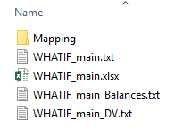

*Mapping* contains the links in the model (e.g. between reservoirs and catchments, markets and countries, crops and cultures …).   
By default, there will be 4 outputs by scenario (in *WHATIF_main.py*, the default *ScenarioName* is *WHATIF_main*):  
*ScenarioName*.txt (selected results as a python dictionary)  
*ScenarioName.*xlsx(detailed results in an excel file)  
*ScenarioName_Balances.*txt (Water, Energy, Food and Economic balances as a python dictionary)  
*ScenarioName_DV.*txt(contains all the decision variables as a python dictionary)

**2.2** Define which scenarios to aggregate in the *Scenarios_to_compare.xlsx* file which should be located in the main folder of the WHAT-IF model.

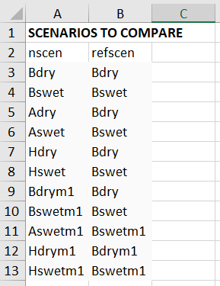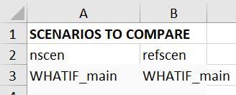

In the *nscen* column put the names of the scenarios you want to see in your results and in the *refscen* column the scenario it should be compared to.

The scenarios do not need to come from a same model run – but you need to put all scenarios you want to compare in a same folder. (Warning: be aware of Mapping parameters – they need to be the same or contained – e.g. a scenario can have more reservoirs than another – but if a same reservoir is at different location between two scenarios this won't work for power BI)

**2.3** Run *WHATIF_scenario_to_powerBI.py*

For now: your panda library should be version 0.23.4 , the script might not work on 0.25.x or above

Within the script, they are two options you need to define:

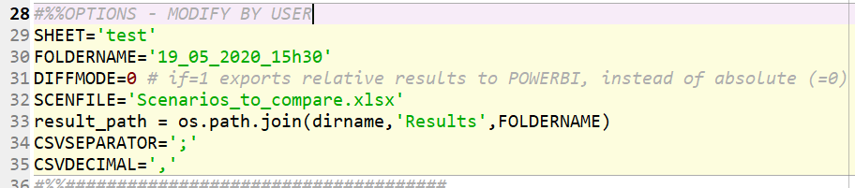  
SHEET='YourExcelSheetName' where scenarios are listed within *Scenarios_to_compare.xslx (*you can so define different lists of scenarios in different sheets and activate the one you want*)*FOLDERNAME*=*'NameFolderResults'within the *Results* folder of WHAT-IF (e.g. *Mon28_10_2019_11h32*)  
DIFFMODE=0 or 1 (For power BI, 0: use absolute values, 1: use relative value between *nscen* and *refscen*)  
SCENFILE=*'Scenarios_to_compare.xslx'* by default (no need to change)  
CSVSEPARATOR = separator in CSV files, needs to match your powerBI settings  
CSVDECIMAL = decimal in CSV files, needs to match your powerBI settings. You can customize regional settings in powerBI: file-options and settings – options – regional settings.

This script will produce the following outputs in your result folder:  
*Balances* used for power BI *DecisionVariables* used for power BI

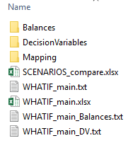

# 3 Use power BI

**You can use the output from previous steps to create your own template**, or you can use the existing one by following these steps:

**3.1** open the *WHATIF_visualize_vX.pbix* file with power BI (the location of the file does not matter)

**3.2** In *Edit Queries* – *Edit Parameters* define the path to results and shapefiles

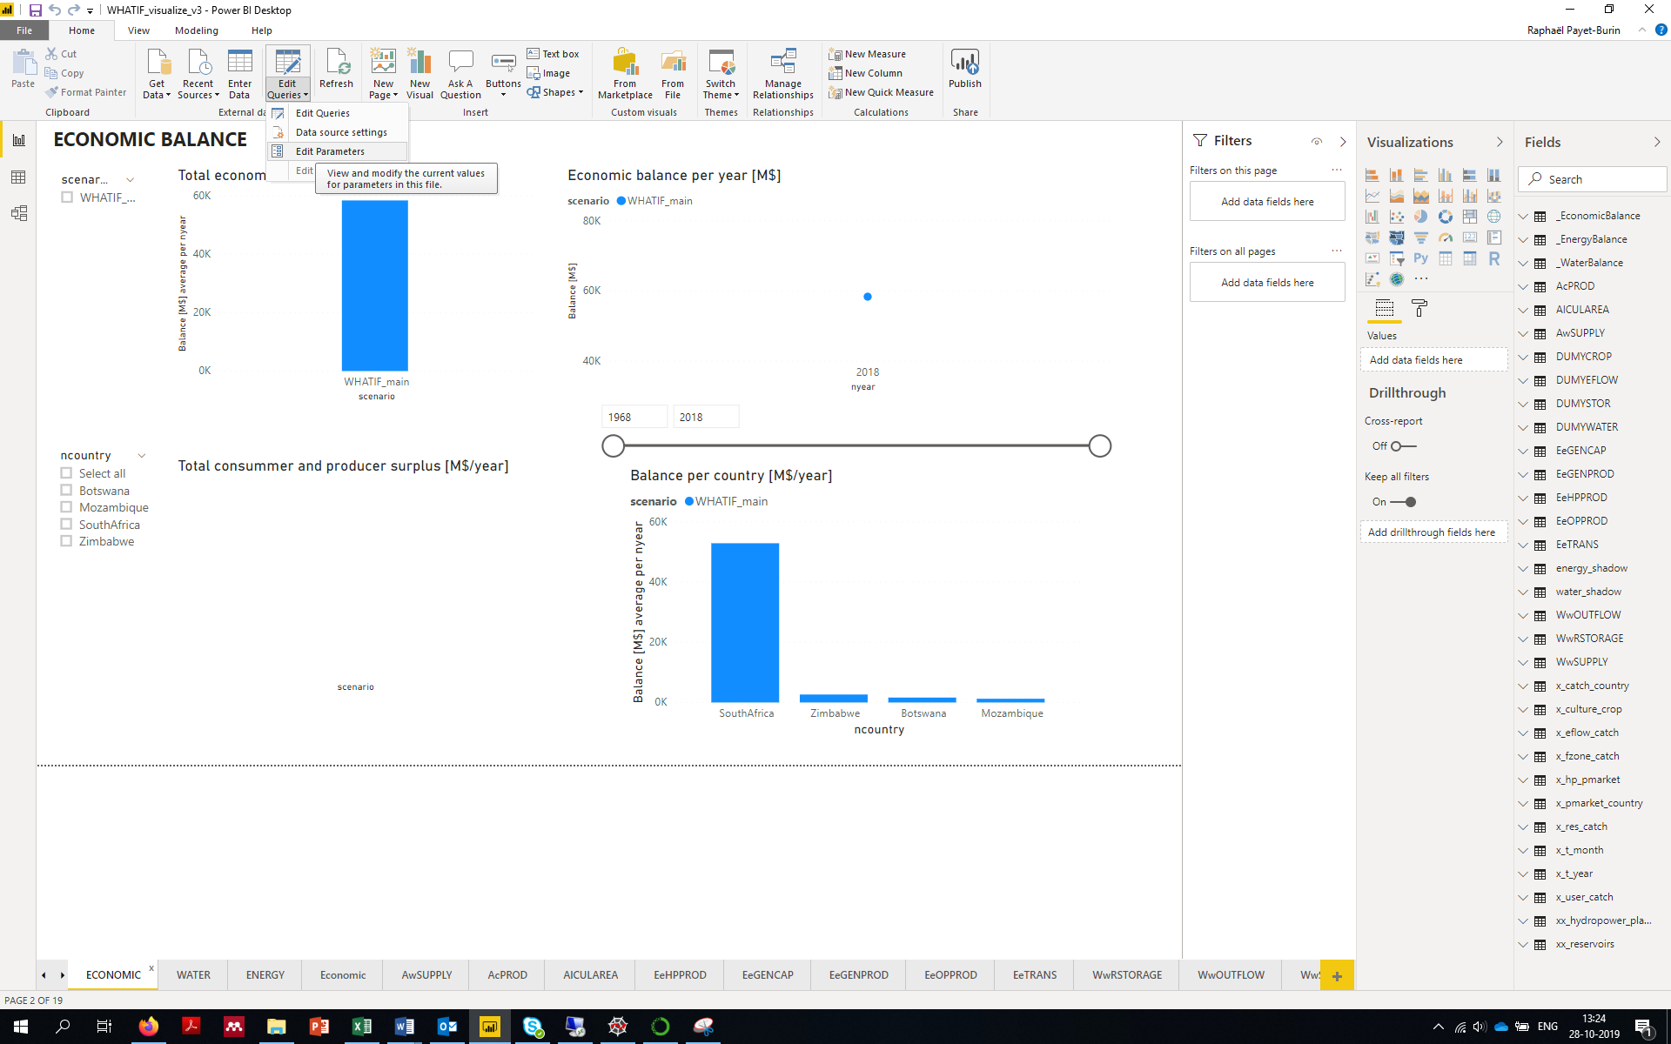

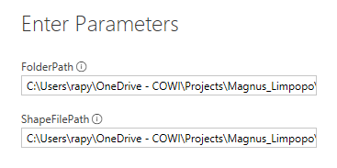

FolderPath = FULL PATH (not relative) to your Results folder (e.g. YourWhatifFolder\Results\Mon28_10_2019_11h32\)

ShapeFilePath = FULL PATH to your shapefiles (by default in YourWhatifFolder\Data\Shapefiles\)

For now: you need to end your path by a \ (backslash)

You NEED to have shapefiles for power BI to load your results– see **Appendix A: How to generate a shapefile or a list of X,Y coordinates** - or use the default ones form the Zambezi Study case (they will not work – but you will be able to see your non-shapefile dependent results = most of them)

**3.3** **WE MADE IT !!!** You can now look through your results by using power BI's interactive features

If you want to load other results (by changing the path as in step **3.2**) you might see blank results – this is because power BI has still previous scenarios selected – you just need to reset the scenario slicers.

You can create your own graphs in addition to power BI template – BE AWARE OF UNITS! - – BE AWARE OF UNITS! - – BE AWARE OF UNITS! - – BE AWARE OF UNITS! - – BE AWARE OF UNITS! - – BE AWARE OF UNITS! - - you got it – BE AWARE OF UNITS! - !!!!!!!!! look at **Appendix B: Use yearly/scenario/category average in power BI**

The default WHATIF_visualize template should be unit consistent – however it might be that when you look at multiple scenarios you might sum the values instead of averaging. If units are not stated and you need to assume the standard units of WHAT-IF (M$, Mm³, kt, 1000 ha, GWh, MW, normally per year or per month)

# Appendix

**A How to generate a shapefile or a list of X,Y coordinates**

<https://docs.microsoft.com/en-us/power-bi/visuals/desktop-shape-map>  
<http://datanrg.blogspot.com/2018/12/using-wgs-84-shape-maps-in-power-bi.html>

Activate shape map in the options of power BI (tutorial 1)

In QGIS:  
**Create a copy of your shapefile using system coordinate WGS 84 (ESPG:4326)**Convert to json file in <https://mapshaper.org/>   
Replace *Countries_WGS84.json* and *Catchments_WGS84.json* in *Data/Shapefiles* by your countries and catchments shapefiles.  
Replace *ReservoirsBI.xslx* and *HydropowersBI.xslx* by your list of reservoirs and hydropower plants, X and Y coordinates can be generated with QGIS – make sur projection is **WGS 84 (ESPG:4326)**

**B Use yearly/scenario/category average in power BI**

From the Data containing different scenarios, different spaces and different time steps (or more indices), one thing one has to be careful about is what is the value that will be shown. Sum, average? This can be chosen when dragging the data in a graph. However, one might want to do a mix. A pure sum will sum up all time steps, all scenarios, all spaces. Except if it's a graph with time on the axis, Usually we want to have the time (e.g. yearly) average, in this case you can:

-"Create a new quick measure" by right clicking the data

-select "Average per Category" in "Calculation"

-use "Sum of …" in "Base value"

-choose the time index in the "Category"

**C Setting a relative path to data**

When you import data to a power BI doc, the path to the data power BI is an absolute path, hence if you transfer the power BI doc and the data, if the other person/computer tries to refresh the data, it will fail (as it will look for that path).

The solution is to :

1 create a parameter that will be the path to the directory containing the data (how to create a parameter: <https://powerbi.microsoft.com/en-us/blog/deep-dive-into-query-parameters-and-power-bi-templates/>)

2 In "File", "Options and settings", "Data source settings", update the path to data by using the parameter you defined in step 1 – hence the new user/computer, just needs to update the path to data in the parameter ("Edit queries", "Edit parameter") instead of updating every data file.