**IoT Cloud Platforms**

An IoT platform is a multi-layer technology that enables straightforward provisioning, management, and automation of connected devices within the Internet of Things universe. It basically connects your hardware, however diverse, to the cloud by using flexible connectivity options, enterprise-grade security mechanisms, and broad data processing powers. For developers, an IoT platform provides a set of ready-to-use features that greatly speed up development of applications for connected devices as well as take care of scalability and cross-device compatibility.

Thus, an IoT platform can be wearing different hats depending on how you look at it. It is commonly referred to as middleware when we talk about how it connects remote devices to user applications (or other devices) and manages all the interactions between the hardware and the application layers. It is also known as a cloud enablement platform or IoT enablement platform to pinpoint its major business value, that is empowering standard devices with cloud-based applications and services. Finally, under the name of the IoT application enablement platform, it shifts the focus to being a key tool for IoT developers.

In the four typical layers of the IoT stack, which are things, connectivity, core IoT features, and applications & analytics, a top-of-the-range IoT platform should provide you with the majority of IoT functionality needed for developing your connected devices and smart things.

Your devices connect to the platform, which sits in the cloud or in your on-premises data center, either directly or by using an IoT gateway. A gateway comes useful whenever your endpoints aren’t capable of direct cloud communication or, for example, you need some computing power on edge. You can also use an IoT gateway to convert protocols, for example, when your endpoints are in LoRaWAN network but you need them to communicate with the cloud over MQTT.

An IoT platform itself can be decomposed into several layers. At the bottom there is the infrastructure level, which is something that enables the functioning of the platform. You can find here components for container management, internal platform messaging, orchestration of IoT solution clusters, and others.

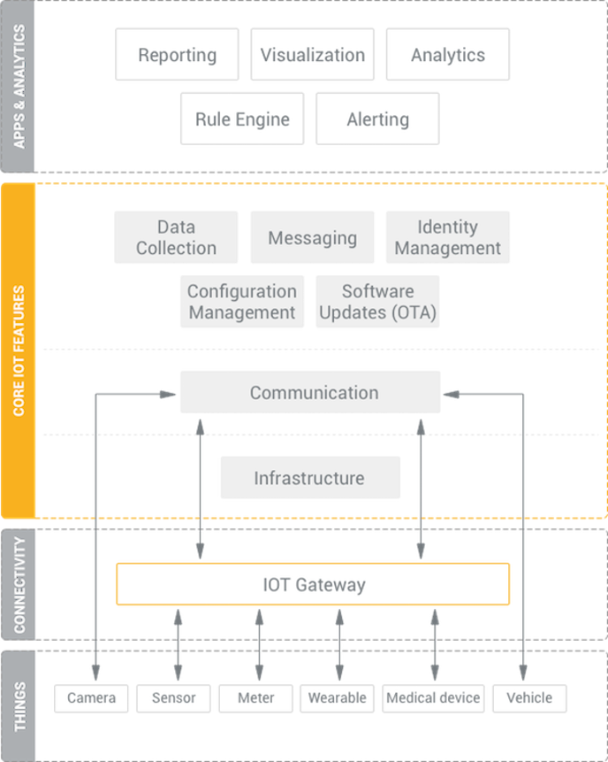

The communication layer enables messaging for the devices; in other words, this is where devices connect to the cloud to perform different operations.

The following layer represents core IoT features provided by the platform. Among the essential ones are data collection, device management, configuration management, messaging, and OTA software updates.

Sitting on top of core IoT features, there is another layer, which is less related to data exchange between devices but rather to processing of this data in the platform. There is reporting, which allows you to generate custom reports. There is visualization for data representation in user applications. Then, there are a rule engine, analytics, and alerting for notifying you about any anomalies detected in your IoT solution.

Importantly, the best IoT platforms allow you to add your own industry-specific components and third-party applications. Without such flexibility adapting an IoT platform for a particular business scenario could bear significant extra cost and delay the solution delivery indefinitely.