DPP Capgemini — Technical Documentation
Digital Product Passport Backend (Fashion)
2026
Table of Contents

Overview
The dpp_capgemini project is a backend for an EU-ESPR–oriented Digital Product Passport (DPP) targeted at the fashion industry. It is implemented as a TUM × Capgemini student project.
The schema is strictly aligned with the Fashion DPP Object Field Catalogue (Fashion_DPP_Object_Field_Catalogue.xlsm) — 11 MVP entities, no extras. Sprint 2+ catalogue objects (Compliance Record, Sustainability Metric, Visibility Rule, Document Link, Certificate as N:N) are intentionally deferred.
Technology stack
- SAP Cloud Application Programming Model (CAP), Node.js, @sap/cds ^9
- CDS data model, OData V4 services, auto-generated OpenAPI / Swagger
- SQLite (development) / SAP HANA Cloud (production on SAP BTP)
- XSUAA authentication with two application roles (company_advanced, company_user). The platform issues a single scope; the backend resolves the role and tenant from the Users table.
- Public consumer endpoint (/public/dpp/:token, no login) with HMAC-signed QR-code PNG
- Jest unit tests + cds.test integration tests
This document follows the four required architecture deliverables:
- BTP Architecture — where the application runs on the SAP Business Technology Platform
- Software Architecture — internal structure, services, endpoints
- Semantic Model — conceptual entity relationships
- Technical Data Model — physical database schema as deployed

1. BTP Architecture
Deployment topology on SAP Business Technology Platform. The diagram embeds the official SAP BTP Solution Diagrams icons (Apache-2.0, https://github.com/SAP/btp-solution-diagrams).
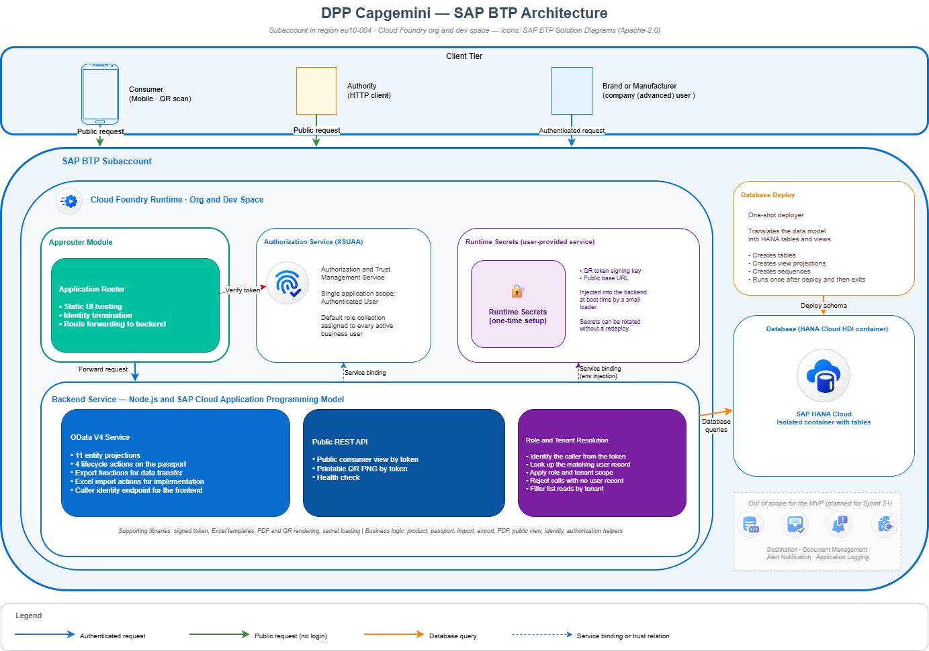
BTP architecture

1.1 Platform services in use
Service | Role | Status
SAP HANA Cloud | Stores all 11 catalogue tables in an isolated database container | In use
Cloud Foundry Runtime | Hosts the backend service application | In use
Authorization and Trust Management (XSUAA) | Issues and verifies authentication tokens. Single application scope; role and tenant resolved inside the application from the user table. | In use
Application Router | Terminates the user session and serves the static UI | In use
Runtime Secrets (user-provided service) | Holds the signing key for QR tokens and the public base URL | One-time setup per space
Destination Service | Future ERP integration | Out of scope for the MVP
Document Management Service | Future compliance attachments | Sprint 2+
Alert Notification | Future operations monitoring | Sprint 2+
Application Logging | Future centralised logs | Sprint 2+

1.2 Subaccount coordinates
Parameter | Description
Subaccount | Dedicated subaccount in region eu10-004
Cloud Foundry Org | Provisioned by the platform team
Cloud Foundry Space | Dev (current) — staging and production planned
Public route | Application router URL on the SAP Cloud domain — the same URL is written into every QR code so consumer scans resolve correctly

2. Software Architecture
Layers: client → BTP platform → API layer (authenticated OData and public REST) → business logic → supporting libraries → database. The platform also surfaces a Swagger UI and a health check endpoint.
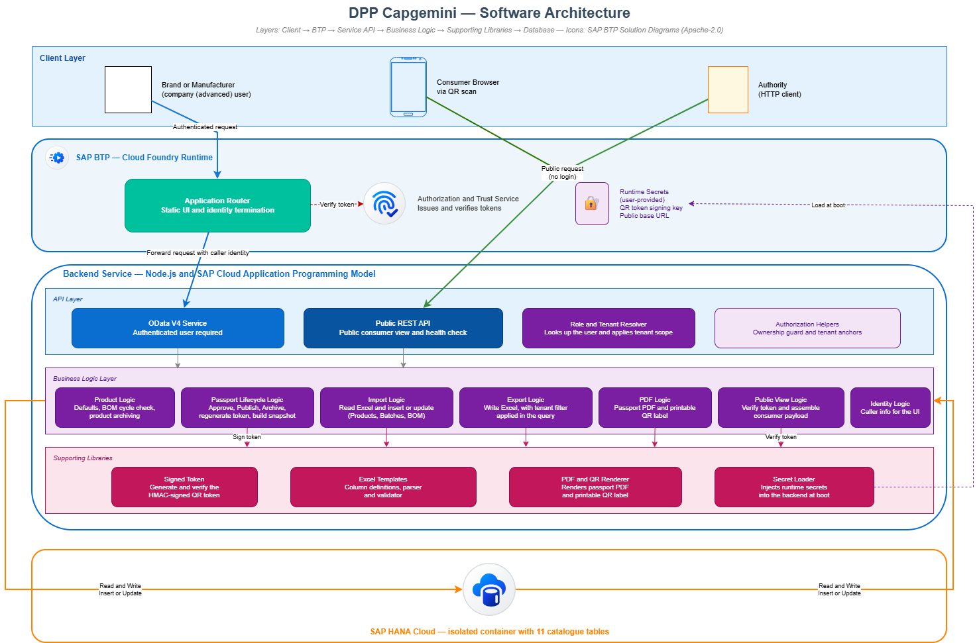
Software architecture

2.1 Component overview
Client layer
- A SAPUI5 or Fiori Elements UI is planned for Sprint 2+; the current MVP exposes the backend directly via OData
- Consumers reach the system from a mobile browser via QR scan
- Market surveillance authorities use any HTTP client and the same public token URL as consumers
BTP platform layer
- Application Router handles single sign-on and serves the static UI
- Authorization and Trust Service (XSUAA) issues and verifies tokens
- Runtime Secrets are stored in a user-provided service and injected at boot
API layer
- Authenticated OData V4 service exposing 11 entity projections, 4 lifecycle actions and 1 QR-image function on the passport
- Public REST endpoints for the consumer view, the QR image and the health check
- A role and tenant resolver looks up the caller in the user table and applies tenant scope before any handler runs
Business logic layer
- Product logic — applies defaults, runs the bill-of-materials cycle check, archives products
- Passport lifecycle logic — approves, publishes, archives passports; rotates QR codes; builds aggregated snapshots
- Public view logic — verifies the signed QR token and assembles the consumer payload
- Identity logic — returns the caller’s identity to the UI
Supporting libraries
- Signed token library (creates and verifies the QR token)
- Secret loader (injects runtime secrets into the backend)
Database
- SAP HANA Cloud, single isolated database container, 11 catalogue tables

2.2 Endpoint inventory
Method | Path | Required role | Purpose
GET | /odata/v4/dpp/$metadata | any authenticated | Service metadata
GET / POST / PATCH / DELETE | /odata/v4/dpp/<entity> | role-restricted | CRUD on the 11 catalogue entities (tenant-scoped)
POST | /odata/v4/dpp/DPPs(id)/DPPService.approveDPP | company_advanced | draft → approved (with validation)
POST | /odata/v4/dpp/DPPs(id)/DPPService.publishDPP | company_advanced | approved → published + snapshot + QR rotation
POST | /odata/v4/dpp/DPPs(id)/DPPService.archiveDPP | company_advanced | → archived
POST | /odata/v4/dpp/DPPs(id)/DPPService.regenerateQRToken | company_advanced | new HMAC token, previous → replaced
GET | /odata/v4/dpp/DPPs(id)/DPPService.generateQRCode | company_advanced | Base64 PNG
GET | /odata/v4/dpp/me() | any authenticated | Caller’s identity, role and organisation
GET | /public/dpp/:token | none | Consumer / authority DTO (JSON)
GET | /public/dpp/:token/qr.png | none | Printable QR PNG
GET | /$api-docs/odata/v4/dpp | none | Swagger UI
GET | /healthz | none | Liveness probe

3. Semantic Model (Entity Relationship)
The semantic view of the data model — concepts and relationships, without implementation detail. Foreign-key columns, audit timestamps and operational marker fields are intentionally omitted (they are present in the Technical Data Model in section 4). The structural shape is identical to the technical view, but the attribute lists are reduced to those that carry business meaning.
Organizations sit at the top of the master-data tree; they own Users, Business Partners, and Products. A Product fans out through Product Variants → Batches → Product Items, and each Product Item owns a 1:1 Product Passport. The Product Passport keeps a history of QR Codes (latest = active). Product BOMs link a parent Product to a component Product (back to the same entity), so the entire chain repeats recursively for materials and components.
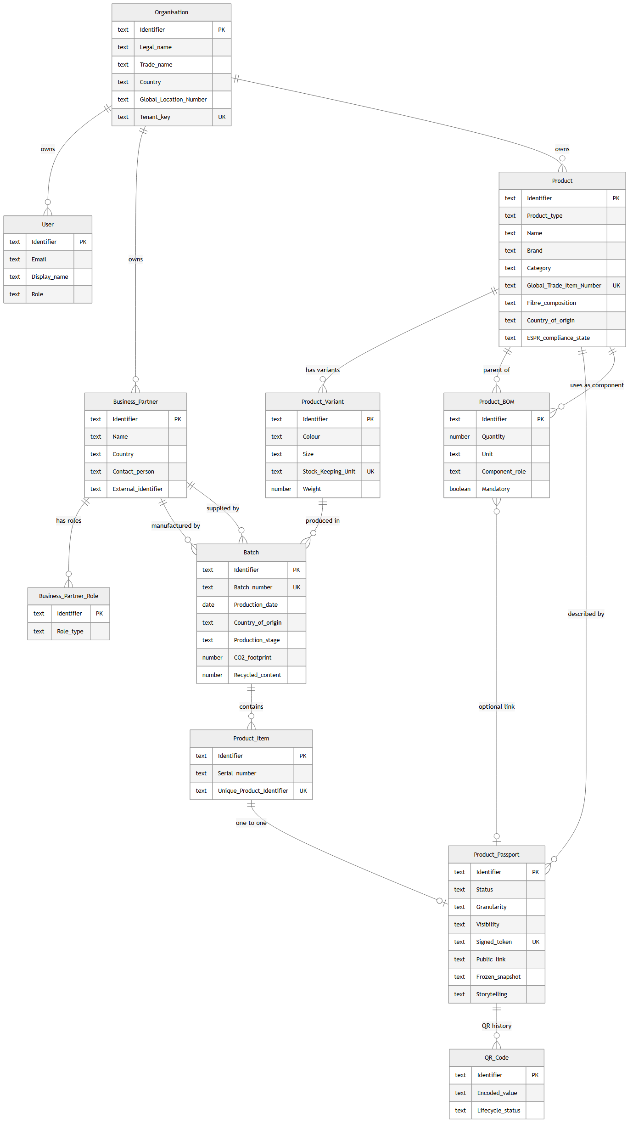
Semantic ER diagram

3.1 Business-relevant attributes per entity
- Organisation — Identifier, Legal name, Trade name, Country, Global Location Number, Tenant key.
- User — Identifier, Email, Display name, Role.
- Business Partner — Identifier, Name, Country, Contact person, External identifier (GLN / VAT / DUNS).
- Business Partner Role — Identifier, Role type.
- Product — Identifier, Product type (finished or material), Name, Brand, Category, Global Trade Item Number, Fibre composition, Country of origin, ESPR compliance state.
- Product Variant — Identifier, Colour, Size, Stock Keeping Unit, Weight.
- Batch — Identifier, Batch number, Production date, Country of origin, Production stage, CO2 footprint, Recycled content.
- Product Item — Identifier, Serial number, Unique Product Identifier.
- Product BOM — Identifier, Quantity, Unit, Component role, Mandatory flag.
- Product Passport — Identifier, Status, Granularity, Visibility, Signed token, Public link, Frozen snapshot, Storytelling.
- QR Code — Identifier, Encoded value, Lifecycle status.
The full column-level details with HANA data types and constraints are in section 4.

3.2 Cardinalities
Cross-referenced with the official field catalogue (sheet 5):
Relationship | Cardinality | Catalogue reference
Organisation → Users | one to many | R2
Organisation → Products | one to many | R3
Business Partner → Business Partner Roles | one to many | R4
Product → Product Variants | one to many | R5
Product Variant → Batches | one to many | R6
Batch → Product Items | one to many | R7
Product Item → Product Passport | one to one | R8
Product Passport → QR Codes | one active plus history | R9
Product → Bill of Materials (as parent) | one to many | R10
Bill of Materials → Product (as component) | many to one | R11
Bill of Materials → Product Passport (linked material) | many to optional one | R12

4. Technical Data Model (Data Schema)
The physical schema as deployed to SAP HANA Cloud. The diagram below shows all 11 tables with their columns, HANA SQL data types, constraints, and foreign-key references.
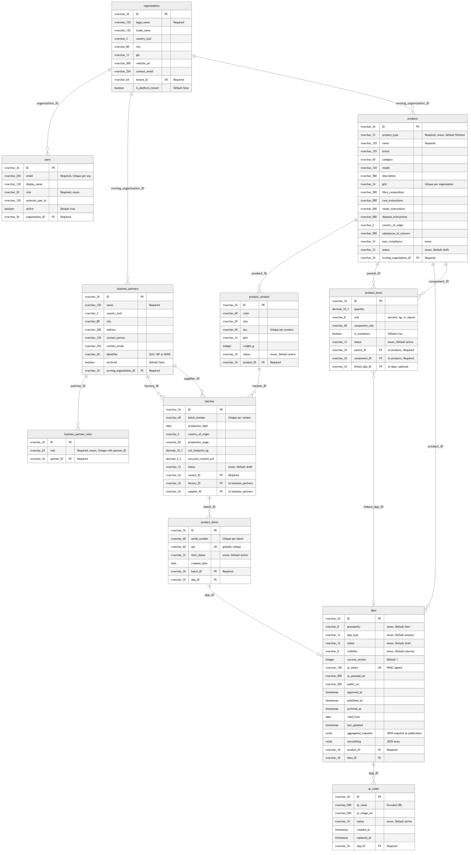
Technical Data Model
The data model is declared in CDS (SAP Cloud Application Programming Model) and lives under db/. It is split into four files:
- db/common.cds — base types and enumerations
- db/org.cds — Company, Users, Business Partners
- db/product.cds — Products, Variants, Batches, Items, BOM
- db/dpp.cds — Digital Product Passport and QR Codes

4.1 Types and Enumerations (common.cds)
Type | Definition | Purpose
CountryISO2 | String(2) | ISO-3166-1 alpha-2 country code
GTIN | String(14) | Global Trade Item Number
GLN | String(13) | Global Location Number
EmailAddr | String(254) | RFC 5321-compliant e-mail
URL | String(500) | External references, QR payload
ProductType | enum | finished, material, component, packaging
ProductStatus | enum | draft, approved, published, archived
VariantStatus | enum | active, inactive, archived
BatchStatus | enum | draft, approved, archived
BOMStatus | enum | active, archived
ItemStatus | enum | active, sold, repaired, recycled, disposed, archived
DPPStatus | enum | draft, in_review, approved, published, archived
DPPType | enum | product, material
Visibility | enum | internal, public
Granularity | enum | model, batch, item
QRCodeStatus | enum | active, invalid, replaced
ESPRComplianceStatus | enum | draft, in_review, compliant, non_compliant
UserRole | enum | company_advanced, company_user
BusinessPartnerRole | enum | supplier, manufacturer, recycler, certification_body, distributor, retailer, logistics_provider
The identified aspect provides a readable String(36) key instead of a UUID. This is a deliberate choice so that sample IDs such as dpp-12345 and upstream system identifiers can be kept unchanged.

4.2 Company, User and Business Partner Entities (org.cds)

Organizations (Company)
The tenant is represented by the tenant_id column (UNIQUE). Mapped to the catalogue’s “Company” object.
Field | Type | Constraint
ID | String(36) | Primary key
legal_name | String(120) | not null
trade_name | String(120)
country_iso2 | CountryISO2
city | String(80)
gln | GLN
website_url | URL
contact_email | EmailAddr
tenant_id | String(64) | not null, UNIQUE
is_platform_tenant | Boolean | default false

Users
n:1 to Organizations; UNIQUE constraint on (email, organization); external_user_id links to the XSUAA subject.
Field | Type | Notes
ID | String(36) | Primary key
email | EmailAddr | not null
display_name | String(120)
organization | Association to Organizations | not null
role | UserRole | not null
external_user_id | String(120) | XSUAA subject mapping
active | Boolean | default true

BusinessPartners
External economic operators (factories, suppliers, certification bodies). Tenant-scoped via owning_organization.
Field | Type | Notes
ID | String(36) | Primary key
owning_organization | Association to Organizations | not null
name | String(120) | not null
country_iso2 | CountryISO2
city | String(80)
address | String(200)
contact_person | String(120)
contact_email | EmailAddr
identifier | String(40) | GLN / VAT / DUNS
archived | Boolean | default false
roles | Composition of BusinessPartnerRoles | a partner can hold multiple roles

BusinessPartnerRoles
Bridge table — one partner may simultaneously act as supplier, manufacturer, recycler, etc.
Field | Type | Notes
ID | String(36) | Primary key
partner | Association to BusinessPartners | not null
role | BusinessPartnerRole | not null
UNIQUE on (partner, role).

4.3 Product Hierarchy (product.cds)
The catalogue-aligned hierarchy is Product → ProductVariant → Batch → ProductItem → DPP + QR. BOM lines link a parent product to a component product (back to the same Products entity), so the chain repeats recursively for materials/components.

Products
Generic product master data: a finished product, material, component or packaging. Tenant-scoped via owning_organization.
Field | Type | Notes
ID | String(36) | Primary key
owning_organization | Association to Organizations | not null
product_type | ProductType | not null, default finished
name | String(120) | not null
brand | String(120)
category | String(60)
model | String(120)
description | String(500)
gtin | GTIN | UNIQUE per organization
fibre_composition | String(500) | catalogue Sheet 3 R32
care_instructions | String(500)
repair_instructions | String(500)
disposal_instructions | String(500)
country_of_origin | CountryISO2 | high-level origin
substances_of_concern | String(500) | REACH / SCIP text (Sheet 3 R37)
espr_compliance | ESPRComplianceStatus | default draft
status | ProductStatus | default draft

ProductVariants
n:1 to Products. A variant captures color/size/SKU and identification at variant level.
Field | Type | Notes
ID | String(36) | Primary key
product | Association to Products | not null
color | String(40)
size | String(20)
sku | String(40) | UNIQUE per product
gtin | GTIN
weight_g | Integer
status | VariantStatus | default active

Batches
n:1 to ProductVariants. Captures production-time information (factory, country, CO₂).
Field | Type | Notes
ID | String(36) | Primary key
variant | Association to ProductVariants | not null
batch_number | String(40) | UNIQUE per variant
production_date | Date
factory | Association to BusinessPartners | optional
supplier | Association to BusinessPartners | optional
country_of_origin | CountryISO2
production_stage | String(60)
co2_footprint_kg | Decimal(10,3)
recycled_content_pct | Decimal(5,2)
status | BatchStatus | default draft

ProductItems
The serialised, uniquely identifiable physical item. Each item gets its own DPP.
Field | Type | Notes
ID | String(36) | Primary key
batch | Association to Batches | not null
serial_number | String(40) | UNIQUE per batch
upi | String(60) | UNIQUE global — Unique Product Identity (catalogue R61)
item_status | ItemStatus | default active
created_date | Date
dpp | Association to DPPs | linked after publish

ProductBOMs
Bill of Materials: an edge between a parent Product and a component Product. The component is also a Products row, so it can carry its own variants/batches/items/DPPs.
Field | Type | Notes
ID | String(36) | Primary key
parent | Association to Products | not null — finished/parent product
component | Association to Products | not null — material/component
quantity | Decimal(10,3)
unit | String(8) | %, kg, m, pcs
component_role | String(60) | e.g. “Main fabric”
is_mandatory | Boolean | default true
linked_dpp | Association to DPPs | optional link to a material DPP
status | BOMStatus | default active
UNIQUE on (parent, component). Self-loops and transitive cycles are rejected by handler.

4.4 Digital Product Passport (dpp.cds)

DPPs
The central passport entity. Item-level by default but supports model- and batch-granularity for non-serialised products.
Field | Type | Meaning
ID | String(36) | Primary key
product | Association to Products | not null — always anchored on the model
item | Association to ProductItems | optional — required for item-level DPPs
granularity | Granularity | default item
dpp_type | DPPType | default product
status | DPPStatus | default draft
visibility | Visibility | default internal
current_version | Integer | default 1, incremented on re-publish
qr_token | String(128) | UNIQUE, HMAC-signed
qr_payload_url | URL | encoded into the QR PNG
public_url | URL | stable direct link to the DPP page
approved_at, published_at, archived_at | Timestamp | lifecycle markers
valid_from | Date
last_updated | Timestamp
aggregated_snapshot | LargeString | JSON snapshot built on publish
storytelling | LargeString | optional JSON array of {title, body, media_url, media_type}

QRCodes
History of every QR token ever minted for a DPP. The most recent row has status='active'; previous rows are kept with status='replaced' for traceability.
Field | Type | Notes
ID | String(36) | Primary key
dpp | Association to DPPs | not null
qr_value | URL | encoded URL on the physical label
qr_image_url | URL | optional pointer to a rendered PNG
status | QRCodeStatus | active, invalid, replaced
created_at | Timestamp
replaced_at | Timestamp

4.5 Uniqueness and Integrity Constraints
- Organizations.tenant_id UNIQUE
- Users (email, organization) UNIQUE
- BusinessPartnerRoles (partner, role) UNIQUE
- Products (gtin, owning_organization) UNIQUE
- ProductVariants (sku, product) UNIQUE
- Batches (batch_number, variant) UNIQUE
- ProductItems.upi UNIQUE (global)
- ProductItems (serial_number, batch) UNIQUE
- ProductBOMs (parent, component) UNIQUE — no duplicate BOM edges, no self-loops, no cycles
- DPPs.qr_token UNIQUE

4.6 CDS → HANA → ABAP type mapping
Modelling type | HANA SQL | ABAP equivalent | Notes
String(n) | NVARCHAR(n) | CHAR(n) or SSTRING | UTF-16 in HANA
LargeString | NCLOB | STRING | Up to 2 GB
Boolean | BOOLEAN | BOOLE_D or ABAP_BOOL
Integer | INTEGER | INT4 | 32-bit signed
Integer64 | BIGINT | INT8 | 64-bit signed
Decimal(p,s) | DECIMAL(p,s) | DEC(p,s)
Date | DATE | DATS | YYYYMMDD
Time | TIME | TIMS | HHMMSS
Timestamp | TIMESTAMP | TIMESTAMPL | 100 ns precision
UUID | NVARCHAR(36) | SYSUUID_C32 or SYSUUID_X16

