DPP Capgemini — Technical Documentation
Digital Product Passport Backend (Fashion)
2026

Overview
The dpp_capgemini project is a backend for an EU-ESPR–oriented Digital Product Passport (DPP) targeted at the fashion industry. It is implemented as a TUM × Capgemini student project.
The schema is aligned with the Fashion DPP Object Field Catalogue (Fashion_DPP_Object_Field_Catalogue.xlsm), simplified to the MVP-relevant subset (12 entities). A DPP can be issued at three granularities: on a finished product, narrowed to a concrete production batch, or — at the finest level — on an individual serialised Product Item within a batch. Each Product Item carries exactly one unique DPP (with its own QR code), created automatically when the item is added. Bill-of-Materials links are anchored at the variant level and may attach an internal sub-DPP or an external supplier-DPP URL, forming a DPP hierarchy that is aggregated live on public read. The public DPP view can additionally show marketing links (ads / product info) — either per DPP or organisation-wide (e.g. a seasonal campaign). Sprint 2+ catalogue objects (Compliance Record, Sustainability Metric, Visibility Rule, Document Link, Certificate as N:N) are intentionally deferred.
Technology stack
- SAP Cloud Application Programming Model (CAP), Node.js, @sap/cds ^9
- CDS data model, OData V4 services, auto-generated OpenAPI / Swagger
- SQLite (development) / SAP HANA Cloud (production on SAP BTP)
- XSUAA authentication with two application roles (company_advanced, company_user). The platform issues a single scope; the backend resolves the role and tenant from the Users table.
- Public consumer endpoint (/public/dpp/:token, no login) with HMAC-signed QR-code PNG
- Jest unit tests + cds.test integration tests
This document follows the four required architecture deliverables:
- BTP Architecture — where the application runs on the SAP Business Technology Platform
- Software Architecture — internal structure, services, endpoints
- Semantic Model — conceptual entity relationships
- Technical Data Model — physical database schema as deployed

1. BTP Architecture
Deployment topology on SAP Business Technology Platform. The diagram embeds the official SAP BTP Solution Diagrams icons (Apache-2.0, https://github.com/SAP/btp-solution-diagrams).
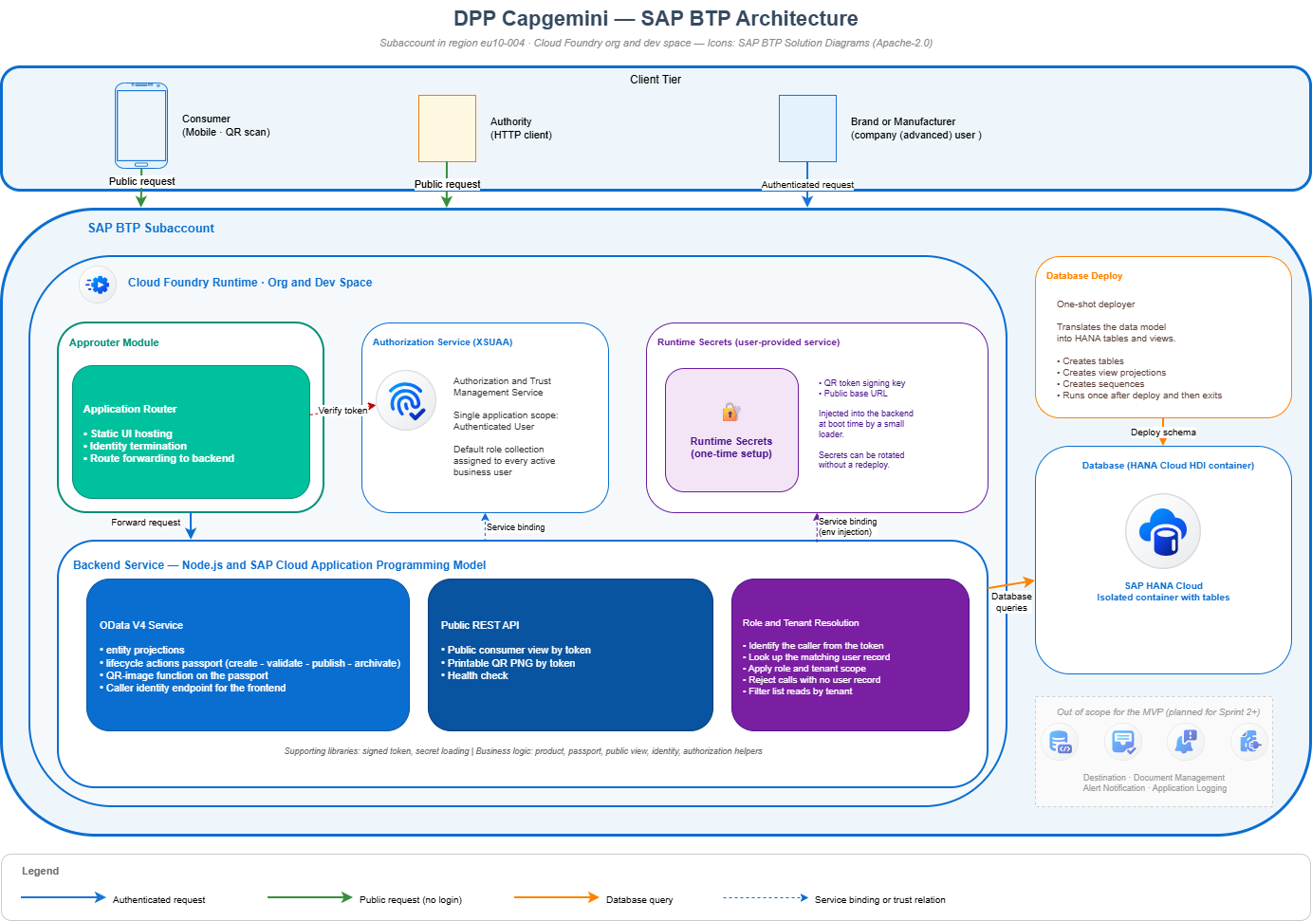
BTP architecture

1.1 Platform services in use
Service | Role | Status
SAP HANA Cloud | Stores the 12 schema tables in an isolated database container | In use
Cloud Foundry Runtime | Hosts the backend service application | In use
Authorization and Trust Management (XSUAA) | Issues and verifies authentication tokens. Single application scope; role and tenant resolved inside the application from the user table. | In use
Application Router | Terminates the user session and serves the static UI | In use
Runtime Secrets (user-provided service) | Holds the signing key for QR tokens and the public base URL | One-time setup per space
Destination Service | Future ERP integration | Out of scope for the MVP
Document Management Service | Future compliance attachments | Sprint 2+
Alert Notification | Future operations monitoring | Sprint 2+
Application Logging | Future centralised logs | Sprint 2+

1.2 Subaccount coordinates
Parameter | Description
Subaccount | Dedicated subaccount in region eu10-004
Cloud Foundry Org | Provisioned by the platform team
Cloud Foundry Space | Dev (current) — staging and production planned
Public route | Application router URL on the SAP Cloud domain — the same URL is written into every QR code so consumer scans resolve correctly

2. Software Architecture
Layers: client → BTP platform → API layer (authenticated OData and public REST) → business logic → supporting libraries → database. The platform also surfaces a Swagger UI and a health check endpoint.
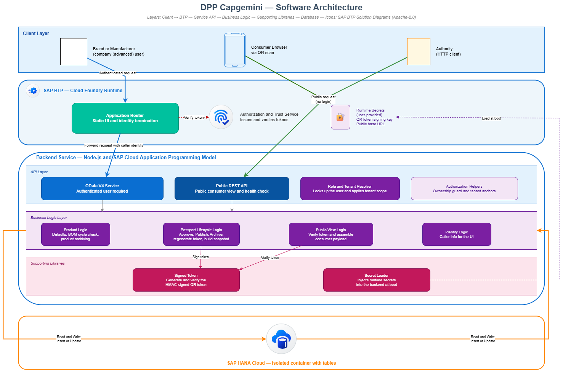
Software architecture

2.1 Component overview
Client layer
- A SAPUI5 or Fiori Elements UI is planned for Sprint 2+; the current MVP exposes the backend directly via OData
- Consumers reach the system from a mobile browser via QR scan
- Market surveillance authorities use any HTTP client and the same public token URL as consumers
BTP platform layer
- Application Router handles single sign-on and serves the static UI
- Authorization and Trust Service (XSUAA) issues and verifies tokens
- Runtime Secrets are stored in a user-provided service and injected at boot
API layer
- Authenticated OData V4 service exposing 12 entity projections, 4 lifecycle actions and 1 QR-image function on the passport
- Public REST endpoints for the consumer view, the QR image and the health check
- A role and tenant resolver looks up the caller in the user table and applies tenant scope before any handler runs
Business logic layer
- Product logic — applies defaults, runs the bill-of-materials cycle check, archives products
- Product-item logic — on creation of a serialised item, resolves its product/variant/batch chain and auto-creates the unique item-level DPP plus an active QR code
- Marketing-link logic — tenant-defaults and validates marketing links; the public view surfaces active, in-window links (per DPP or organisation-wide), sorted by display order
- Passport lifecycle logic — approves, publishes, archives passports; rotates QR codes; builds aggregated snapshots
- Public view logic — verifies the signed QR token, traverses the DPP hierarchy and assembles the consumer payload including the live aggregation
- Identity logic — returns the caller’s identity to the UI
Supporting libraries
- Signed token library (creates and verifies the QR token)
- Secret loader (injects runtime secrets into the backend)
- Aggregator library (srv/lib/aggregator.js) — recursive DPP-hierarchy aggregation with a plug-in registry of field aggregators (weighted sum, weighted average, string union, fibre rollup). New aggregators can be registered without touching existing logic.
Database
- SAP HANA Cloud, single isolated database container, 12 schema tables

2.2 Endpoint inventory
Method | Path | Required role | Purpose
GET | /odata/v4/dpp/$metadata | any authenticated | Service metadata
GET / POST / PATCH / DELETE | /odata/v4/dpp/<entity> | role-restricted | CRUD on the 12 catalogue entities (tenant-scoped)
POST | /odata/v4/dpp/DPPs(id)/DPPService.approveDPP | company_advanced | draft → approved (with validation)
POST | /odata/v4/dpp/DPPs(id)/DPPService.publishDPP | company_advanced | approved → published + snapshot + QR rotation
POST | /odata/v4/dpp/DPPs(id)/DPPService.archiveDPP | company_advanced | → archived
POST | /odata/v4/dpp/DPPs(id)/DPPService.regenerateQRToken | company_advanced | new HMAC token, previous → replaced
GET | /odata/v4/dpp/DPPs(id)/DPPService.generateQRCode | company_advanced | Base64 PNG
GET | /odata/v4/dpp/me() | any authenticated | Caller’s identity, role and organisation
GET | /public/dpp/:token | none | Consumer / authority DTO (JSON)
GET | /public/dpp/:token/qr.png | none | Printable QR PNG
GET | /$api-docs/odata/v4/dpp | none | Swagger UI
GET | /healthz | none | Liveness probe

3. Semantic Model (Entity Relationship)
The semantic view of the data model — concepts and relationships, without implementation detail. Foreign-key columns, audit timestamps and operational marker fields are intentionally omitted (they are present in the Technical Data Model in section 4). The structural shape is identical to the technical view, but the attribute lists are reduced to those that carry business meaning.
Organizations sit at the top of the master-data tree; they own Users, Business Partners, and Products. A Product fans out through Product Variants → Batches → Product Items (individual serialised units). A Product Passport describes a finished product from the producer’s view; it is anchored on a Product and may narrow to a concrete Batch, to the producing Variant, and — at the finest level — to a single Product Item. Each Product Item carries exactly one unique Passport (1:1). Each Passport keeps a history of QR Codes (latest = active). Bill-of-Materials lines hang from a Product Variant and reference a component Product. A BOM edge can attach either an internal sub-DPP (another Passport in the system) or an external supplier-DPP URL — this forms a DPP hierarchy that is traversed and aggregated live when a public consumer scans the QR code.
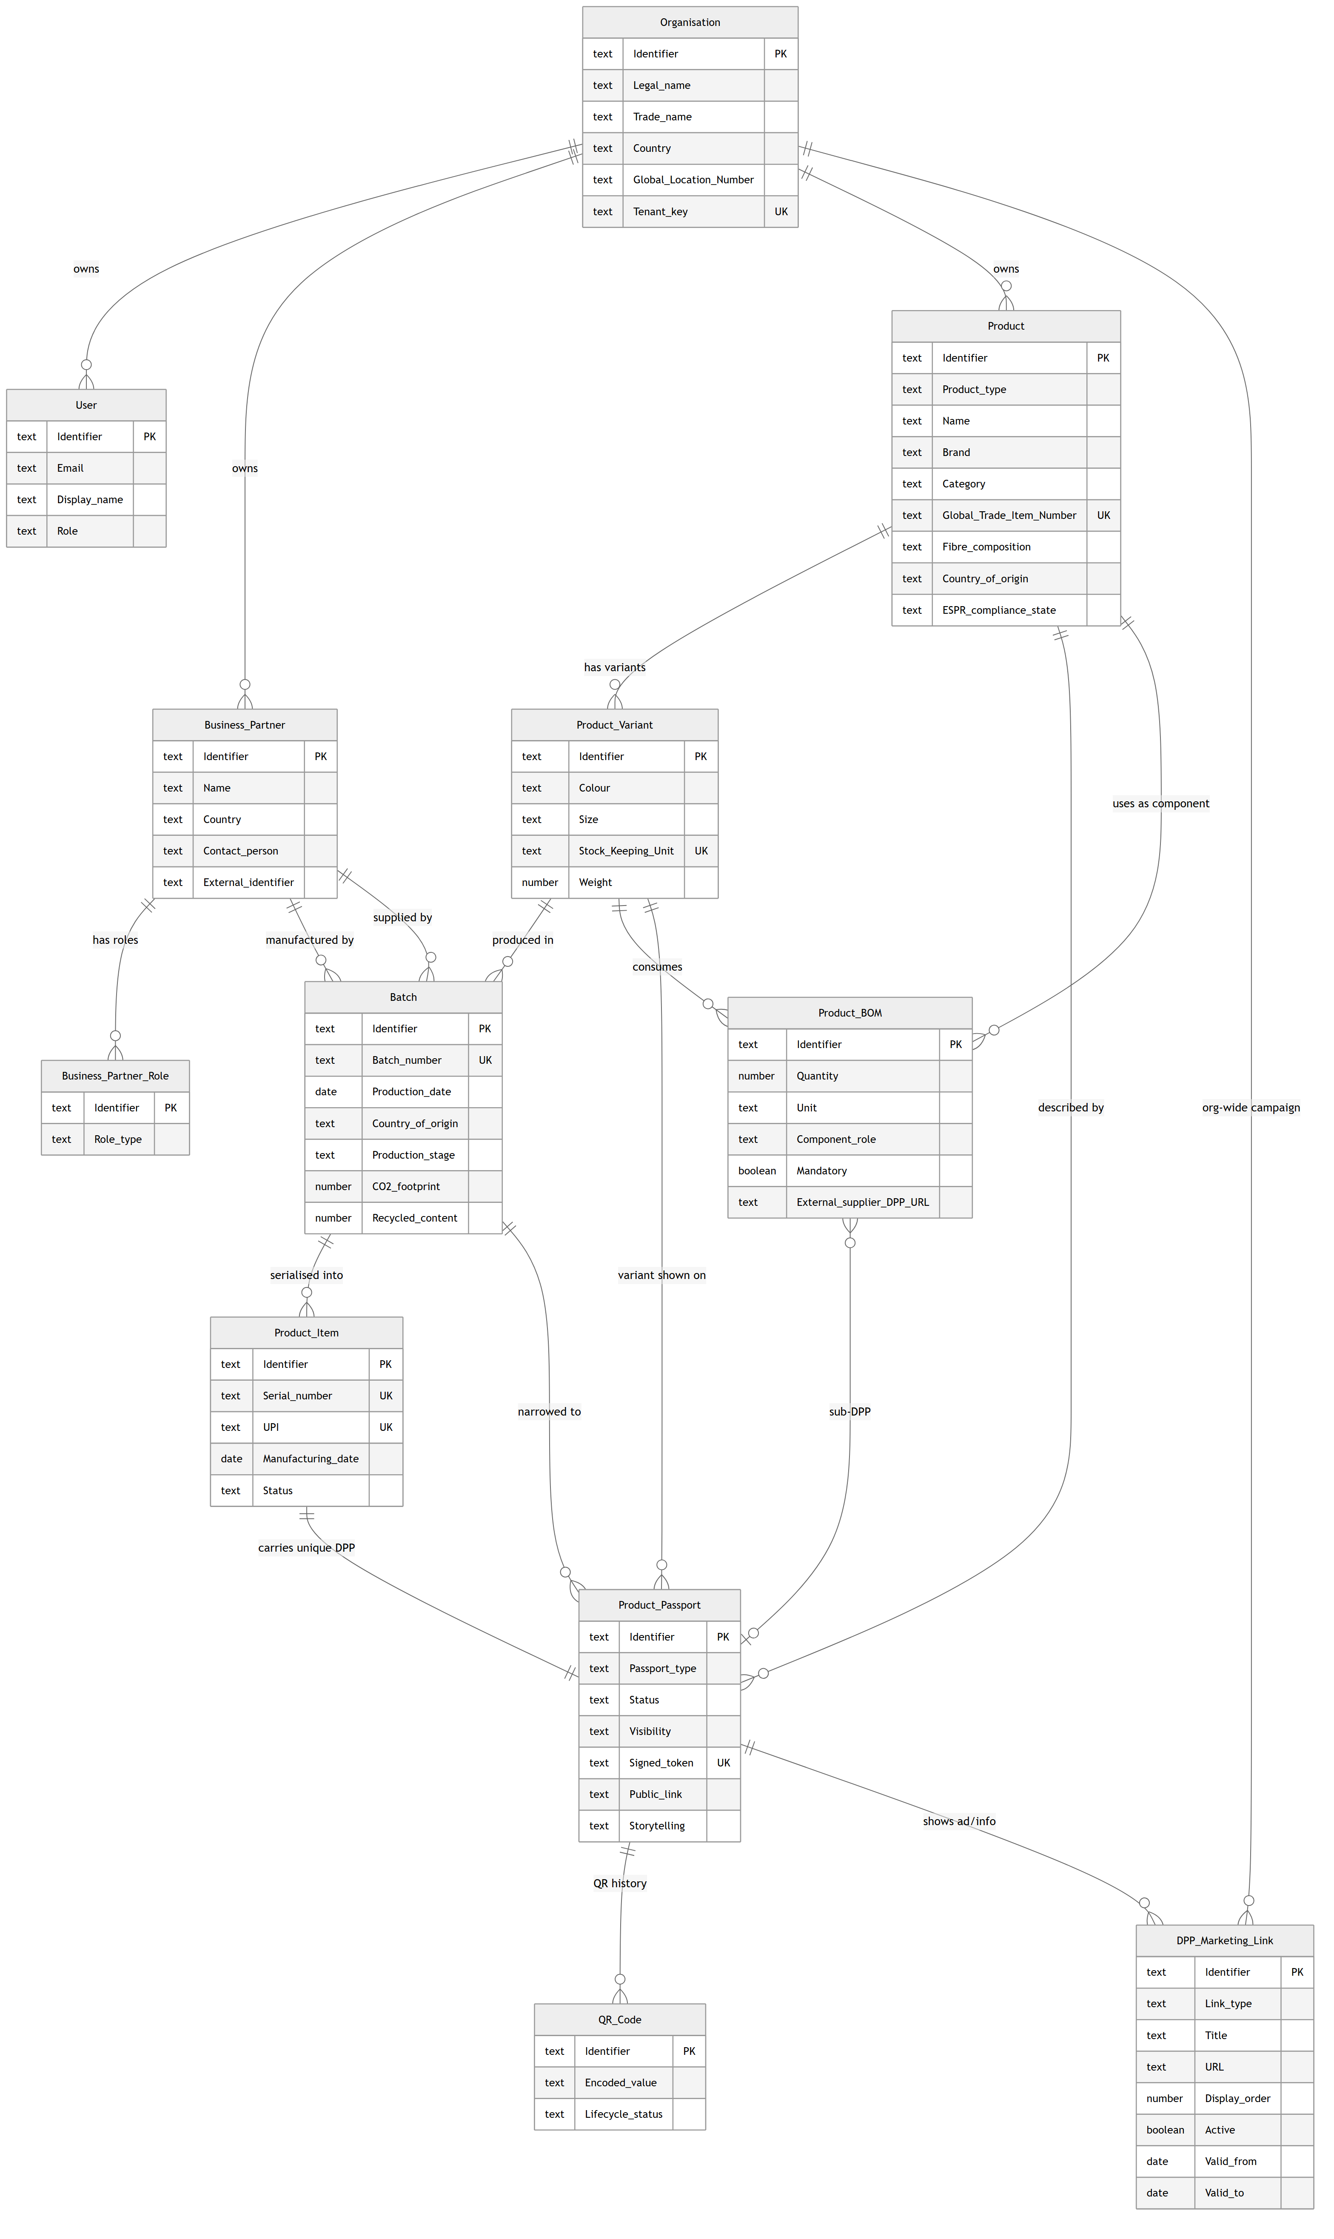
Semantic ER diagram

3.1 Business-relevant attributes per entity
- Organisation — Identifier, Legal name, Trade name, Country, Global Location Number, Tenant key.
- User — Identifier, Email, Display name, Role.
- Business Partner — Identifier, Name, Country, Contact person, External identifier (GLN / VAT / DUNS).
- Business Partner Role — Identifier, Role type.
- Product — Identifier, Product type (finished, material, component or packaging), Name, Brand, Category, Global Trade Item Number, Fibre composition, Country of origin, ESPR compliance state.
- Product Variant — Identifier, Colour, Size, Stock Keeping Unit, Weight.
- Batch — Identifier, Batch number, Production date, Country of origin, Production stage, CO2 footprint, Recycled content.
- Product Item — Identifier, Serial number, UPI (Unique Product Identifier, ESPR), Manufacturing date, Status. An individual serialised unit within a batch; carries exactly one unique Passport.
- Product BOM — Identifier, Quantity, Unit, Component role, Mandatory flag, Internal sub-passport link, External supplier-DPP URL.
- Product Passport — Identifier, Passport type (product / material / item), Status, Visibility, Signed token, Public link, Optional aggregation cache, Storytelling.
- QR Code — Identifier, Encoded value, Lifecycle status.
- DPP Marketing Link — Identifier, Link type, Title, URL, Display order, Active flag, Validity window. Shown on the public DPP view; either DPP-specific or organisation-wide.
The full column-level details with HANA data types and constraints are in section 4.

3.2 Cardinalities
Relationship | Cardinality | Notes
Organisation → Users | one to many | tenant-scoped
Organisation → Products | one to many | tenant-scoped
Organisation → Business Partners | one to many | tenant-scoped
Business Partner → Business Partner Roles | one to many | a partner can hold several roles
Product → Product Variants | one to many | colour / size / SKU
Product Variant → Batches | one to many | production runs
Batch → Product Items | one to many | individual serialised units
Product Variant → Bill of Materials (as parent) | one to many | BOM anchored at variant
Bill of Materials → Product (as component) | many to one | component is itself a Product
Bill of Materials → Product Passport (internal sub-DPP) | many to optional one | optional, mutually informative with the external link
Product → Product Passport | one to many | DPP describes a finished-product view
Batch → Product Passport | one to many (optional) | optional narrowing to a concrete batch
Product Variant → Product Passport | one to many (optional) | optional link to the represented variant
Product Item → Product Passport | one to one | each item carries exactly one unique DPP
Product Passport → QR Codes | one active plus history | rotation keeps a single active row
Product Passport → Marketing Links | one to many (optional) | DPP-specific ads / product info
Organisation → Marketing Links | one to many | org-wide campaigns (DPP link null)

4. Technical Data Model (Data Schema)
The physical schema as deployed to SAP HANA Cloud. The diagram below shows all 12 tables with their columns, HANA SQL data types, constraints, and foreign-key references.
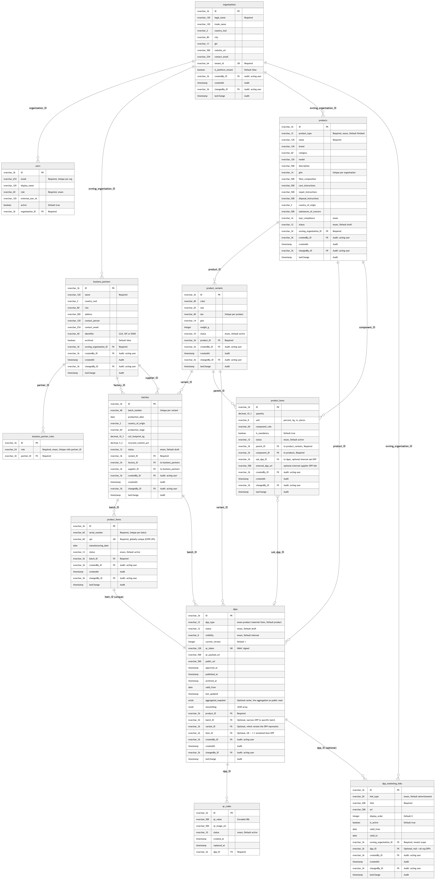
Technical Data Model
The data model is declared in CDS (SAP Cloud Application Programming Model) and lives under db/. It is split into four files:
- db/common.cds — base types and enumerations
- db/org.cds — Company, Users, Business Partners
- db/product.cds — Products, Variants, Batches, Product Items, Bill of Materials
- db/dpp.cds — Digital Product Passport, QR Codes and Marketing Links

4.1 Types and Enumerations (common.cds)
Type | Definition | Purpose
CountryISO2 | String(2) | ISO-3166-1 alpha-2 country code
GTIN | String(14) | Global Trade Item Number
GLN | String(13) | Global Location Number
EmailAddr | String(254) | RFC 5321-compliant e-mail
URL | String(500) | External references, QR payload
ProductType | enum | finished, material, component, packaging
ProductStatus | enum | draft, approved, published, archived
VariantStatus | enum | active, inactive, archived
BatchStatus | enum | draft, approved, archived
ProductItemStatus | enum | active, sold, returned, recycled, archived
BOMStatus | enum | active, archived
DPPStatus | enum | draft, in_review, approved, published, archived
DPPType | enum | product, material, item
Visibility | enum | internal, public
QRCodeStatus | enum | active, invalid, replaced
ESPRComplianceStatus | enum | draft, in_review, compliant, non_compliant
MarketingLinkType | enum | advertisement, product_info, care_product, promotion, related_product, other
UserRole | enum | company_advanced, company_user
BusinessPartnerRole | enum | supplier, manufacturer, recycler, certification_body, distributor, retailer, logistics_provider
The identified aspect provides a readable String(36) key instead of a UUID. This is a deliberate choice so that sample IDs such as dpp-12345 and upstream system identifiers can be kept unchanged.

The audited aspect (catalogue audit fields)
The catalogue business objects — Organizations, BusinessPartners, Products, ProductVariants, Batches, ProductItems, ProductBOMs and DPPs — plus the DPPMarketingLinks extension include a shared audited aspect (defined in db/org.cds) with the four catalogue audit fields:
Field | Type | Column | Meaning
createdBy | Association to Users | createdBy_ID | user who created the row
changedBy | Association to Users | changedBy_ID | user of the most recent change
createdAt | Timestamp | createdAt | creation time
lastChange | Timestamp | lastChange | time of the most recent change
All four are stamped server-side by the central before('CREATE') / before('UPDATE') handlers in srv/dpp-service.js; client-supplied values are ignored. createdBy / changedBy reference the acting Users row (resolved from the authenticated identity). Per the catalogue, Users, BusinessPartnerRoles and QRCodes are not audited (QRCodes already carries its own created_at).

4.2 Company, User and Business Partner Entities (org.cds)

Organizations (Company)
The tenant is represented by the tenant_id column (UNIQUE). Mapped to the catalogue’s “Company” object.
Field | Type | Constraint
ID | String(36) | Primary key
legal_name | String(120) | not null
trade_name | String(120)
country_iso2 | CountryISO2
city | String(80)
gln | GLN
website_url | URL
contact_email | EmailAddr
tenant_id | String(64) | not null, UNIQUE
is_platform_tenant | Boolean | default false

Users
n:1 to Organizations; UNIQUE constraint on (email, organization); external_user_id links to the XSUAA subject.
Field | Type | Notes
ID | String(36) | Primary key
email | EmailAddr | not null
display_name | String(120)
organization | Association to Organizations | not null
role | UserRole | not null
external_user_id | String(120) | XSUAA subject mapping
active | Boolean | default true

BusinessPartners
External economic operators (factories, suppliers, certification bodies). Tenant-scoped via owning_organization.
Field | Type | Notes
ID | String(36) | Primary key
owning_organization | Association to Organizations | not null
name | String(120) | not null
country_iso2 | CountryISO2
city | String(80)
address | String(200)
contact_person | String(120)
contact_email | EmailAddr
identifier | String(40) | GLN / VAT / DUNS
archived | Boolean | default false
roles | Composition of BusinessPartnerRoles | a partner can hold multiple roles

BusinessPartnerRoles
Bridge table — one partner may simultaneously act as supplier, manufacturer, recycler, etc.
Field | Type | Notes
ID | String(36) | Primary key
partner | Association to BusinessPartners | not null
role | BusinessPartnerRole | not null
UNIQUE on (partner, role).

4.3 Product Hierarchy (product.cds)
The hierarchy is Product → ProductVariant → Batch → ProductItem → DPP + QR. Bill-of-Materials lines hang from a ProductVariants row and reference a component Products row. A BOM edge can attach either an internal DPPs row (sub_dpp) or an external supplier-DPP URL (external_dpp_url); the consumer-facing read traverses this graph recursively and aggregates values across levels.

Products
Generic product master data: a finished product, material, component or packaging. Tenant-scoped via owning_organization.
Field | Type | Notes
ID | String(36) | Primary key
owning_organization | Association to Organizations | not null
product_type | ProductType | not null, default finished
name | String(120) | not null
brand | String(120)
category | String(60)
model | String(120)
description | String(500)
gtin | GTIN | UNIQUE per organization
fibre_composition | String(500) | catalogue Sheet 3 R32
care_instructions | String(500)
repair_instructions | String(500)
disposal_instructions | String(500)
country_of_origin | CountryISO2 | high-level origin
substances_of_concern | String(500) | REACH / SCIP text (Sheet 3 R37)
espr_compliance | ESPRComplianceStatus | default draft
status | ProductStatus | default draft

ProductVariants
n:1 to Products. A variant captures color/size/SKU and identification at variant level. The Bill of Materials is anchored here (bom Composition).
Field | Type | Notes
ID | String(36) | Primary key
product | Association to Products | not null
color | String(40)
size | String(20)
sku | String(40) | UNIQUE per product
gtin | GTIN
weight_g | Integer
status | VariantStatus | default active
bom | Composition of many ProductBOMs | child BOM edges

Batches
n:1 to ProductVariants. Captures production-time information (factory, country, CO₂).
Field | Type | Notes
ID | String(36) | Primary key
variant | Association to ProductVariants | not null
batch_number | String(40) | UNIQUE per variant
production_date | Date
factory | Association to BusinessPartners | optional
supplier | Association to BusinessPartners | optional
country_of_origin | CountryISO2
production_stage | String(60)
co2_footprint_kg | Decimal(10,3)
recycled_content_pct | Decimal(5,2)
status | BatchStatus | default draft
items | Association to many ProductItems | serialised units produced in the batch

ProductItems
n:1 to Batches. An individual serialised unit produced within a batch — the finest level of the product hierarchy. Each item carries exactly one unique DPP, created automatically on insert (see srv/handlers/product-item-handlers.js).
Field | Type | Notes
ID | String(36) | Primary key
batch | Association to Batches | not null
serial_number | String(60) | not null — manufacturer serial, UNIQUE per batch
upi | String(60) | not null, globally UNIQUE — Unique Product Identifier (ESPR); the identifier the DPP/QR resolves to
manufacturing_date | Date
status | ProductItemStatus | default active
dpp | Association to DPPs | 1:1 reverse navigation (dpp.item = $self)
The UPI (Unique Product Identifier) is the ESPR-defined, globally unique product key carried by the data carrier (QR). A caller may supply a standardised UPI (e.g. GS1 / GTIN + serial); if omitted, the handler mints a unique one (UPI-<uuid>). It is distinct from serial_number, which is the manufacturer’s internal serial (unique only within its batch).
On CREATE, the handler resolves the batch → variant → product chain and inserts a matching DPPs row (dpp_type='item', status='draft') with a freshly minted qr_token and an active QRCodes row, so every serialised item immediately has a unique, scannable passport.

ProductBOMs
Bill of Materials: an edge between a parent ProductVariant and a component Product. The component is itself a Products row, so the chain repeats recursively (its own variants, batches and DPPs). A BOM line may attach an internal sub-DPP and/or an external supplier-DPP URL — the consumer-side read traverses these links to build a hierarchical aggregation.
Field | Type | Notes
ID | String(36) | Primary key
parent | Association to ProductVariants | not null — finished-product variant
component | Association to Products | not null — material/component product
quantity | Decimal(10,3)
unit | String(8) | %, kg, m, pcs
component_role | String(60) | e.g. “Main fabric”
is_mandatory | Boolean | default true
sub_dpp | Association to DPPs | optional internal sub-DPP
external_dpp_url | URL | optional external supplier-DPP link
status | BOMStatus | default active
UNIQUE on (parent, component). A self-loop (parent.product = component) and transitive cycles are rejected by handler. The cycle check walks BOM edges by expanding each Product into its Variants and then into their outgoing BOM rows.

4.4 Digital Product Passport (dpp.cds)

DPPs
The central passport entity. A DPP represents a finished product from the perspective of its producer. The optional batch, variant and item links progressively narrow the passport: batch to a concrete production run, variant to the represented variant, and item to a single serialised unit. An item-level DPP (dpp_type='item') is linked 1:1 to its ProductItems row. Without these links the passport applies on a model/product level.
Field | Type | Meaning
ID | String(36) | Primary key
product | Association to Products | not null — describes which product the DPP belongs to
batch | Association to Batches | optional — narrows the DPP to a specific batch
variant | Association to ProductVariants | optional — which variant the DPP represents
item | Association to ProductItems | optional, UNIQUE — 1:1 link for serialised item-level DPPs
dpp_type | DPPType | default product (product / material / item)
status | DPPStatus | default draft
visibility | Visibility | default internal
current_version | Integer | default 1, incremented on re-publish
qr_token | String(128) | UNIQUE, HMAC-signed
qr_payload_url | URL | encoded into the QR PNG
public_url | URL | stable direct link to the DPP page
approved_at, published_at, archived_at | Timestamp | lifecycle markers
valid_from | Date
last_updated | Timestamp
aggregated_snapshot | LargeString | optional cache of the last aggregation; the public read computes aggregations live
storytelling | LargeString | optional JSON array of {title, body, media_url, media_type}
The hierarchical aggregation is computed on-demand by srv/lib/aggregator.js. For every public read it walks the BOM graph downwards from the DPP’s variant, recurses into every sub_dpp, and combines self values with weighted child contributions. Out-of-the-box aggregators: co2_footprint_kg (weighted sum), recycled_content_pct (weighted average), substances_of_concern (union), fibre_composition (rollup). Additional aggregators can be registered at runtime through registerAggregator(name, def). Sub-DPPs that are external (URL only) or missing are reported as missing entries with incomplete: true on the response.

QRCodes
History of every QR token ever minted for a DPP. The most recent row has status='active'; previous rows are kept with status='replaced' for traceability.
Field | Type | Notes
ID | String(36) | Primary key
dpp | Association to DPPs | not null
qr_value | URL | encoded URL on the physical label
qr_image_url | URL | optional pointer to a rendered PNG
status | QRCodeStatus | active, invalid, replaced
created_at | Timestamp
replaced_at | Timestamp

DPPMarketingLinks
Marketing / advertising links shown on the public DPP view (ads, product info, care products, promotions). A link is either attached to a specific dpp (e.g. an item-level care-product ad) or organisation-wide when dpp is null (e.g. a “Summer sale” campaign shown across all the organisation’s published DPPs). Tenant-scoped via owning_organization; includes the audited aspect.
Field | Type | Notes
ID | String(36) | Primary key
owning_organization | Association to Organizations | not null — tenant scope
dpp | Association to DPPs | optional — null = applies to all of the org’s DPPs
link_type | MarketingLinkType | default advertisement
title | String(200) | not null
url | URL | target link
display_order | Integer | default 0 — ascending sort in the view
is_active | Boolean | default true
valid_from | Date | optional start of the display window
valid_to | Date | optional end of the display window
The public consumer read (srv/handlers/public-handler.js) returns, for a published/public DPP, all is_active links of the DPP’s organisation whose validity window covers the current date and that either target this DPP or are org-wide (dpp null), sorted by display_order.

4.5 Uniqueness and Integrity Constraints
- Organizations.tenant_id UNIQUE
- Users (email, organization) UNIQUE
- BusinessPartnerRoles (partner, role) UNIQUE
- Products (gtin, owning_organization) UNIQUE
- ProductVariants (sku, product) UNIQUE
- Batches (batch_number, variant) UNIQUE
- ProductItems (serial_number, batch) UNIQUE — no duplicate serials within a batch
- ProductItems.upi UNIQUE — globally unique product identifier (ESPR)
- ProductBOMs (parent, component) UNIQUE — no duplicate BOM edges, no self-loops, no cycles (parent is a Variant)
- DPPs.qr_token UNIQUE
- DPPs.item UNIQUE — exactly one DPP per serialised item (1:1)

4.6 CDS → HANA → ABAP type mapping
Modelling type | HANA SQL | ABAP equivalent | Notes
String(n) | NVARCHAR(n) | CHAR(n) or SSTRING | UTF-16 in HANA
LargeString | NCLOB | STRING | Up to 2 GB
Boolean | BOOLEAN | BOOLE_D or ABAP_BOOL
Integer | INTEGER | INT4 | 32-bit signed
Integer64 | BIGINT | INT8 | 64-bit signed
Decimal(p,s) | DECIMAL(p,s) | DEC(p,s)
Date | DATE | DATS | YYYYMMDD
Time | TIME | TIMS | HHMMSS
Timestamp | TIMESTAMP | TIMESTAMPL | 100 ns precision
UUID | NVARCHAR(36) | SYSUUID_C32 or SYSUUID_X16

