DPP Capgemini — Technical Documentation
Digital Product Passport Backend (Fashion)
2026
Table of Contents

Overview
The dpp_capgemini project is a backend for an EU-ESPR–oriented Digital Product Passport (DPP) targeted at the fashion industry. It is implemented as a TUM × Capgemini student project.
The schema is strictly aligned with the Fashion DPP Object Field Catalogue (Fashion_DPP_Object_Field_Catalogue.xlsm) — 11 MVP entities, no extras. Sprint 2+ catalogue objects (Compliance Record, Sustainability Metric, Visibility Rule, Document Link, Certificate as N:N) are intentionally deferred.
Technology stack
- SAP Cloud Application Programming Model (CAP), Node.js, @sap/cds ^9
- CDS data model, OData V4 services, auto-generated OpenAPI / Swagger
- SQLite (development) / SAP HANA Cloud (production on SAP BTP)
- XSUAA authentication with three roles: company_advanced, company_user, end_user (XSUAA issues a single AuthenticatedUser scope; the backend resolves the application role + tenant from the Users table)
- Public consumer endpoint (/public/dpp/:token, no login) with HMAC-signed QR-code PNG
- Excel import/export (XLSX) and PDF export (DPP + QR label) via PDFKit
- Jest unit tests + cds.test integration tests

1. Technical Data Model (Data Schema)
The data model is declared in CDS (SAP Cloud Application Programming Model) and lives under db/. It is split into four files:
- db/common.cds — base types and enumerations
- db/org.cds — Company, Users, Business Partners
- db/product.cds — Products, Variants, Batches, Items, BOM
- db/dpp.cds — Digital Product Passport and QR Codes

1.1 Types and Enumerations (common.cds)
Type | Definition | Purpose
CountryISO2 | String(2) | ISO-3166-1 alpha-2 country code
GTIN | String(14) | Global Trade Item Number
GLN | String(13) | Global Location Number
EmailAddr | String(254) | RFC 5321-compliant e-mail
URL | String(500) | External references, QR payload
ProductType | enum | finished, material, component, packaging
ProductStatus | enum | draft, approved, published, archived
VariantStatus | enum | active, inactive, archived
BatchStatus | enum | draft, approved, archived
BOMStatus | enum | active, archived
ItemStatus | enum | active, sold, repaired, recycled, disposed, archived
DPPStatus | enum | draft, in_review, approved, published, archived
DPPType | enum | product, material
Visibility | enum | internal, public
Granularity | enum | model, batch, item
QRCodeStatus | enum | active, invalid, replaced
ESPRComplianceStatus | enum | draft, in_review, compliant, non_compliant
UserRole | enum | company_advanced, company_user, end_user
BusinessPartnerRole | enum | supplier, manufacturer, recycler, certification_body, distributor, retailer, logistics_provider
The identified aspect provides a readable String(36) key instead of a UUID. This is a deliberate choice so that sample IDs such as dpp-12345 and upstream system identifiers can be kept unchanged.

1.2 Company, User and Business Partner Entities (org.cds)

Organizations (Company)
The tenant is represented by the tenant_id column (UNIQUE). Mapped to the catalogue’s “Company” object.
Field | Type | Constraint
ID | String(36) | Primary key
legal_name | String(120) | not null
trade_name | String(120)
country_iso2 | CountryISO2
city | String(80)
gln | GLN
website_url | URL
contact_email | EmailAddr
tenant_id | String(64) | not null, UNIQUE
is_platform_tenant | Boolean | default false

Users
n:1 to Organizations; UNIQUE constraint on (email, organization); external_user_id links to the XSUAA subject.
Field | Type | Notes
ID | String(36) | Primary key
email | EmailAddr | not null
display_name | String(120)
organization | Association to Organizations | not null
role | UserRole | not null
external_user_id | String(120) | XSUAA subject mapping
active | Boolean | default true (US1.10 Deactivate User)

BusinessPartners
External economic operators (factories, suppliers, certification bodies). Tenant-scoped via owning_organization.
Field | Type | Notes
ID | String(36) | Primary key
owning_organization | Association to Organizations | not null
name | String(120) | not null
country_iso2 | CountryISO2
city | String(80)
address | String(200)
contact_person | String(120)
contact_email | EmailAddr
identifier | String(40) | GLN / VAT / DUNS
archived | Boolean | default false
roles | Composition of BusinessPartnerRoles | a partner can hold multiple roles

BusinessPartnerRoles
Bridge table — one partner may simultaneously act as supplier, manufacturer, recycler, etc. (US2.3).
Field | Type | Notes
ID | String(36) | Primary key
partner | Association to BusinessPartners | not null
role | BusinessPartnerRole | not null
UNIQUE on (partner, role).

1.3 Product Hierarchy (product.cds)
The catalogue-aligned hierarchy is Product → ProductVariant → Batch → ProductItem → DPP + QR. BOM lines link a parent product to a component product (back to the same Products entity), so the chain repeats recursively for materials/components.

Products
Generic product master data: a finished product, material, component or packaging. Tenant-scoped via owning_organization.
Field | Type | Notes
ID | String(36) | Primary key
owning_organization | Association to Organizations | not null
product_type | ProductType | not null, default finished
name | String(120) | not null
brand | String(120)
category | String(60)
model | String(120)
description | String(500)
gtin | GTIN | UNIQUE per organization
fibre_composition | String(500) | catalogue Sheet 3 R32
care_instructions | String(500)
repair_instructions | String(500)
disposal_instructions | String(500)
country_of_origin | CountryISO2 | high-level origin
substances_of_concern | String(500) | REACH / SCIP text (Sheet 3 R37)
espr_compliance | ESPRComplianceStatus | default draft
status | ProductStatus | default draft

ProductVariants
n:1 to Products. A variant captures color/size/SKU and identification at variant level.
Field | Type | Notes
ID | String(36) | Primary key
product | Association to Products | not null
color | String(40)
size | String(20)
sku | String(40) | UNIQUE per product
gtin | GTIN
weight_g | Integer
status | VariantStatus | default active

Batches
n:1 to ProductVariants. Captures production-time information (factory, country, CO₂).
Field | Type | Notes
ID | String(36) | Primary key
variant | Association to ProductVariants | not null
batch_number | String(40) | UNIQUE per variant
production_date | Date
factory | Association to BusinessPartners | optional
supplier | Association to BusinessPartners | optional
country_of_origin | CountryISO2
production_stage | String(60)
co2_footprint_kg | Decimal(10,3)
recycled_content_pct | Decimal(5,2)
status | BatchStatus | default draft

ProductItems
The serialised, uniquely identifiable physical item. Each item gets its own DPP.
Field | Type | Notes
ID | String(36) | Primary key
batch | Association to Batches | not null
serial_number | String(40) | UNIQUE per batch
upi | String(60) | UNIQUE global — Unique Product Identity (catalogue R61)
item_status | ItemStatus | default active
created_date | Date
dpp | Association to DPPs | linked after publishDPP

ProductBOMs
Bill of Materials: an edge between a parent Product and a component Product. The component is also a Products row, so it can carry its own variants/batches/items/DPPs.
Field | Type | Notes
ID | String(36) | Primary key
parent | Association to Products | not null — finished/parent product
component | Association to Products | not null — material/component
quantity | Decimal(10,3)
unit | String(8) | %, kg, m, pcs
component_role | String(60) | e.g. “Main fabric”
is_mandatory | Boolean | default true
linked_dpp | Association to DPPs | optional link to a material DPP (US4.9)
status | BOMStatus | default active
UNIQUE on (parent, component). Self-loops and transitive cycles are rejected by handler.

1.4 Digital Product Passport (dpp.cds)

DPPs
The central passport entity. Item-level by default but supports model- and batch-granularity for non-serialised products.
Field | Type | Meaning
ID | String(36) | Primary key
product | Association to Products | not null — always anchored on the model
item | Association to ProductItems | optional — required for item-level DPPs
granularity | Granularity | default item
dpp_type | DPPType | default product
status | DPPStatus | default draft
visibility | Visibility | default internal
current_version | Integer | default 1, incremented on re-publish
qr_token | String(128) | UNIQUE, HMAC-signed
qr_payload_url | URL | encoded into the QR PNG
public_url | URL | stable direct link to the DPP page
approved_at, published_at, archived_at | Timestamp | lifecycle markers
valid_from | Date
last_updated | Timestamp
aggregated_snapshot | LargeString | JSON snapshot built on publishDPP
storytelling | LargeString | optional JSON array of {title, body, media_url, media_type}

QRCodes
History of every QR token ever minted for a DPP. The most recent row has status='active'; previous rows are kept with status='replaced' for traceability (US6.8).
Field | Type | Notes
ID | String(36) | Primary key
dpp | Association to DPPs | not null
qr_value | URL | encoded URL on the physical label
qr_image_url | URL | optional pointer to a rendered PNG
status | QRCodeStatus | active, invalid, replaced
created_at | Timestamp
replaced_at | Timestamp

1.5 Uniqueness and Integrity Constraints
- Organizations.tenant_id UNIQUE
- Users (email, organization) UNIQUE
- BusinessPartnerRoles (partner, role) UNIQUE
- Products (gtin, owning_organization) UNIQUE
- ProductVariants (sku, product) UNIQUE
- Batches (batch_number, variant) UNIQUE
- ProductItems.upi UNIQUE (global)
- ProductItems (serial_number, batch) UNIQUE
- ProductBOMs (parent, component) UNIQUE — no duplicate BOM edges, no self-loops, no cycles
- DPPs.qr_token UNIQUE

2. Architecture Diagrams

2.1 Software Architecture
Three client classes (internal company users, public auditor/HTTP-clients, and anonymous consumers) connect to a CAP runtime hosted on SAP BTP Cloud Foundry. Authenticated traffic flows through the Application Router and XSUAA; the public consumer route bypasses authentication and is mounted directly on the Express bootstrap. Persistence targets SQLite for local development and SAP HANA Cloud in production.
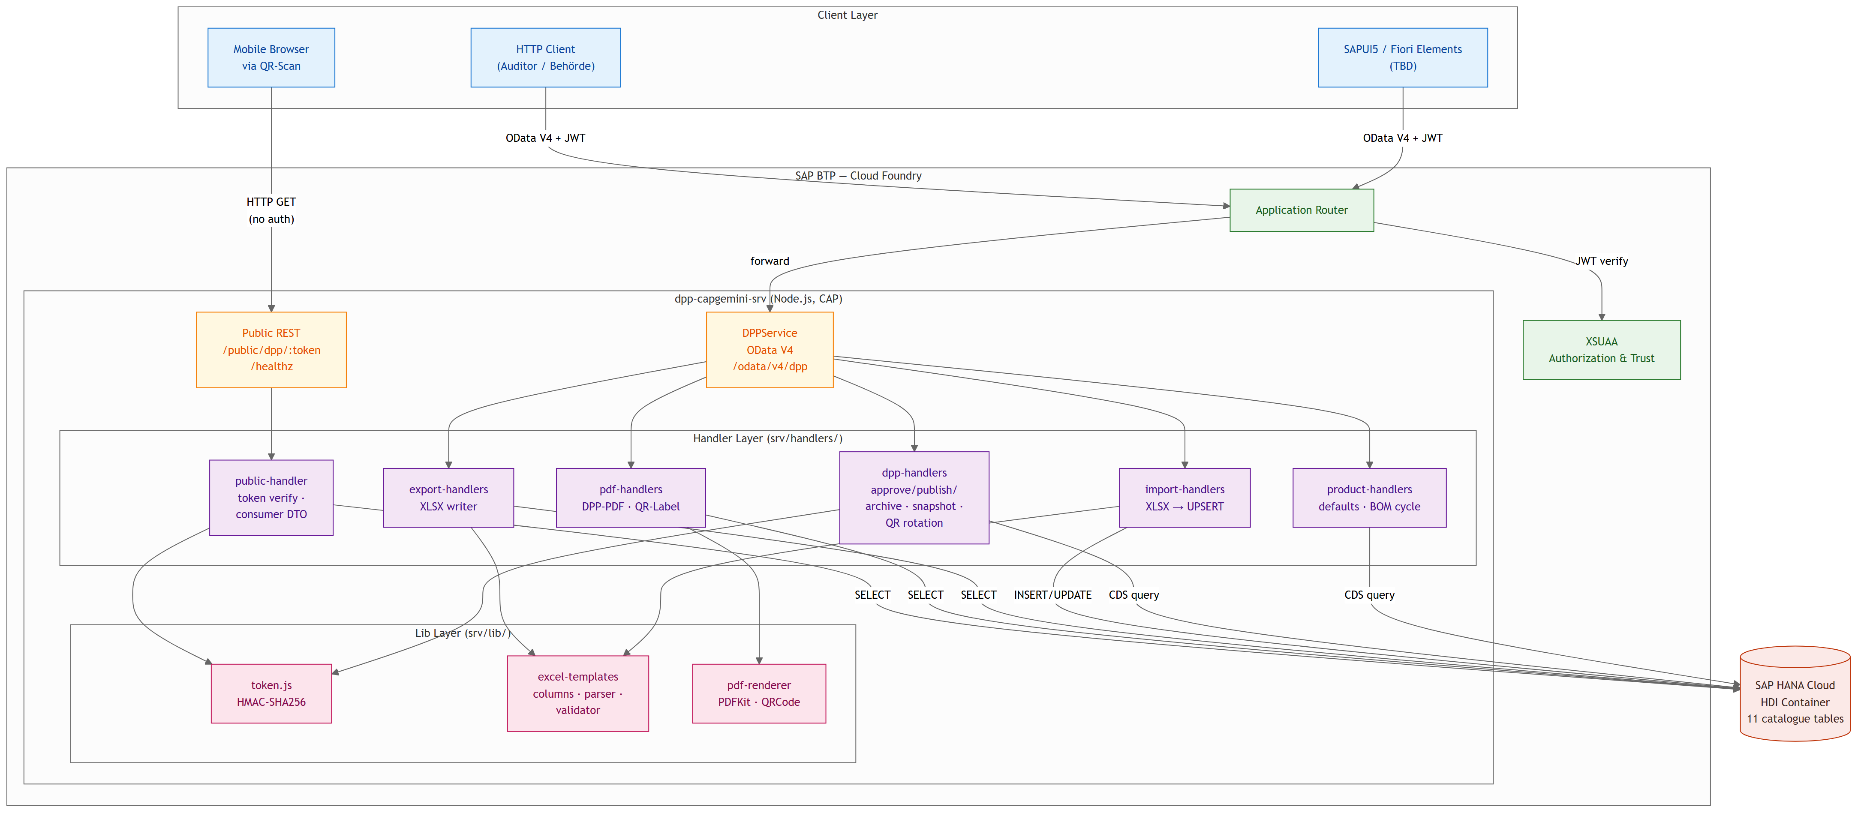
Software architecture
Component responsibilities.
- Application Router — terminates user sessions and forwards JWTs to CAP services (production).
- XSUAA — issues OAuth2 JWTs and exposes role-template-driven scopes (admin, advanced, user, viewer).
- DPPService — tenant-scoped CRUD for the 11 catalogue entities, plus DPP-lifecycle actions and Excel/PDF actions.
- Public Handler — anonymous consumer route serving a visibility-filtered Consumer DTO and the QR PNG.
- Handler modules — product-handlers (defaults, BOM cycle guard), dpp-handlers (workflow + snapshot + QR rotation), import-handlers (XLSX → UPSERT), export-handlers (XLSX writer), pdf-handlers (DPP-PDF + QR-Label), public-handler.
- Lib modules — token.js (HMAC-SHA256), excel-templates.js (column metadata + parser/validator), pdf-renderer.js (PDFKit + qrcode).
- Persistence — SQLite locally, SAP HANA Cloud in production; the CDS model is portable across both.

2.2 ER Diagram (Data Model)
Organizations sit at the top of the master-data tree; they own Users, BusinessPartners, and Products. A Product fans out through ProductVariants → Batches → ProductItems, and each ProductItem owns a 1:1 DPP. The DPP keeps a history of QRCodes (latest = active). ProductBOMs link a parent Product to a component Product (back to the same entity), so the entire chain repeats recursively for materials and components.
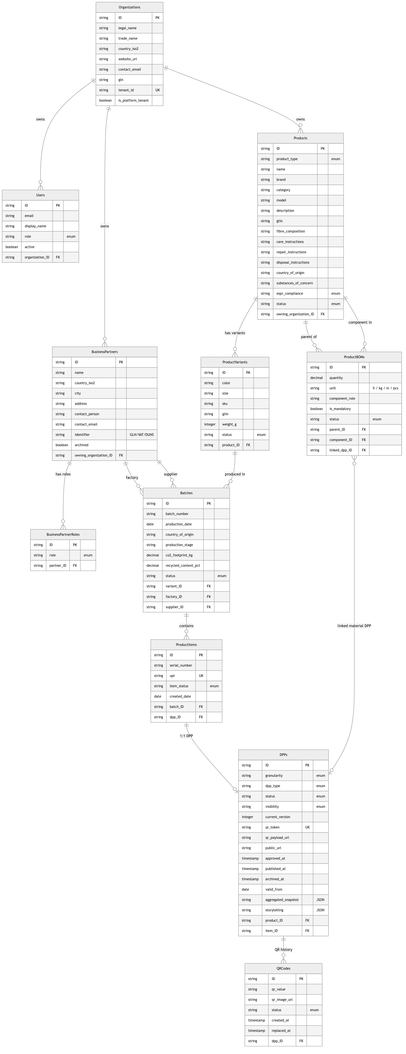
ER diagram
Key entity attributes (compact view).
- Organizations — ID (PK), tenant_id (UNIQUE), legal_name, country_iso2, website_url, contact_email.
- Products — ID (PK), product_type, name, brand, category, country_of_origin, substances_of_concern, espr_compliance, status, owning_organization (FK).
- ProductVariants — ID (PK), product (FK), color, size, sku (UNIQUE per product), gtin, status.
- Batches — ID (PK), variant (FK), batch_number (UNIQUE per variant), production_date, factory/supplier (FK), country_of_origin, co2_footprint_kg, recycled_content_pct, status.
- ProductItems — ID (PK), batch (FK), serial_number, upi (UNIQUE), item_status, dpp (FK).
- ProductBOMs — parent (FK), component (FK), quantity, unit, component_role, linked_dpp (FK); UNIQUE on the edge, no cycles allowed.
- DPPs — ID (PK), product (FK), item (FK), status, visibility, current_version, qr_token (UNIQUE), public_url, aggregated_snapshot (JSON), published_at, archived_at.
- QRCodes — dpp (FK), qr_value, status (active/invalid/replaced), created_at, replaced_at.

2.3 DPP Lifecycle (State Machine)
DPP status moves from draft (or optionally in_review) to approved, then published. Re-publishing increments current_version. Any state can be moved to archived. The catalogue mandates these five status values (Sheet 3 R79).
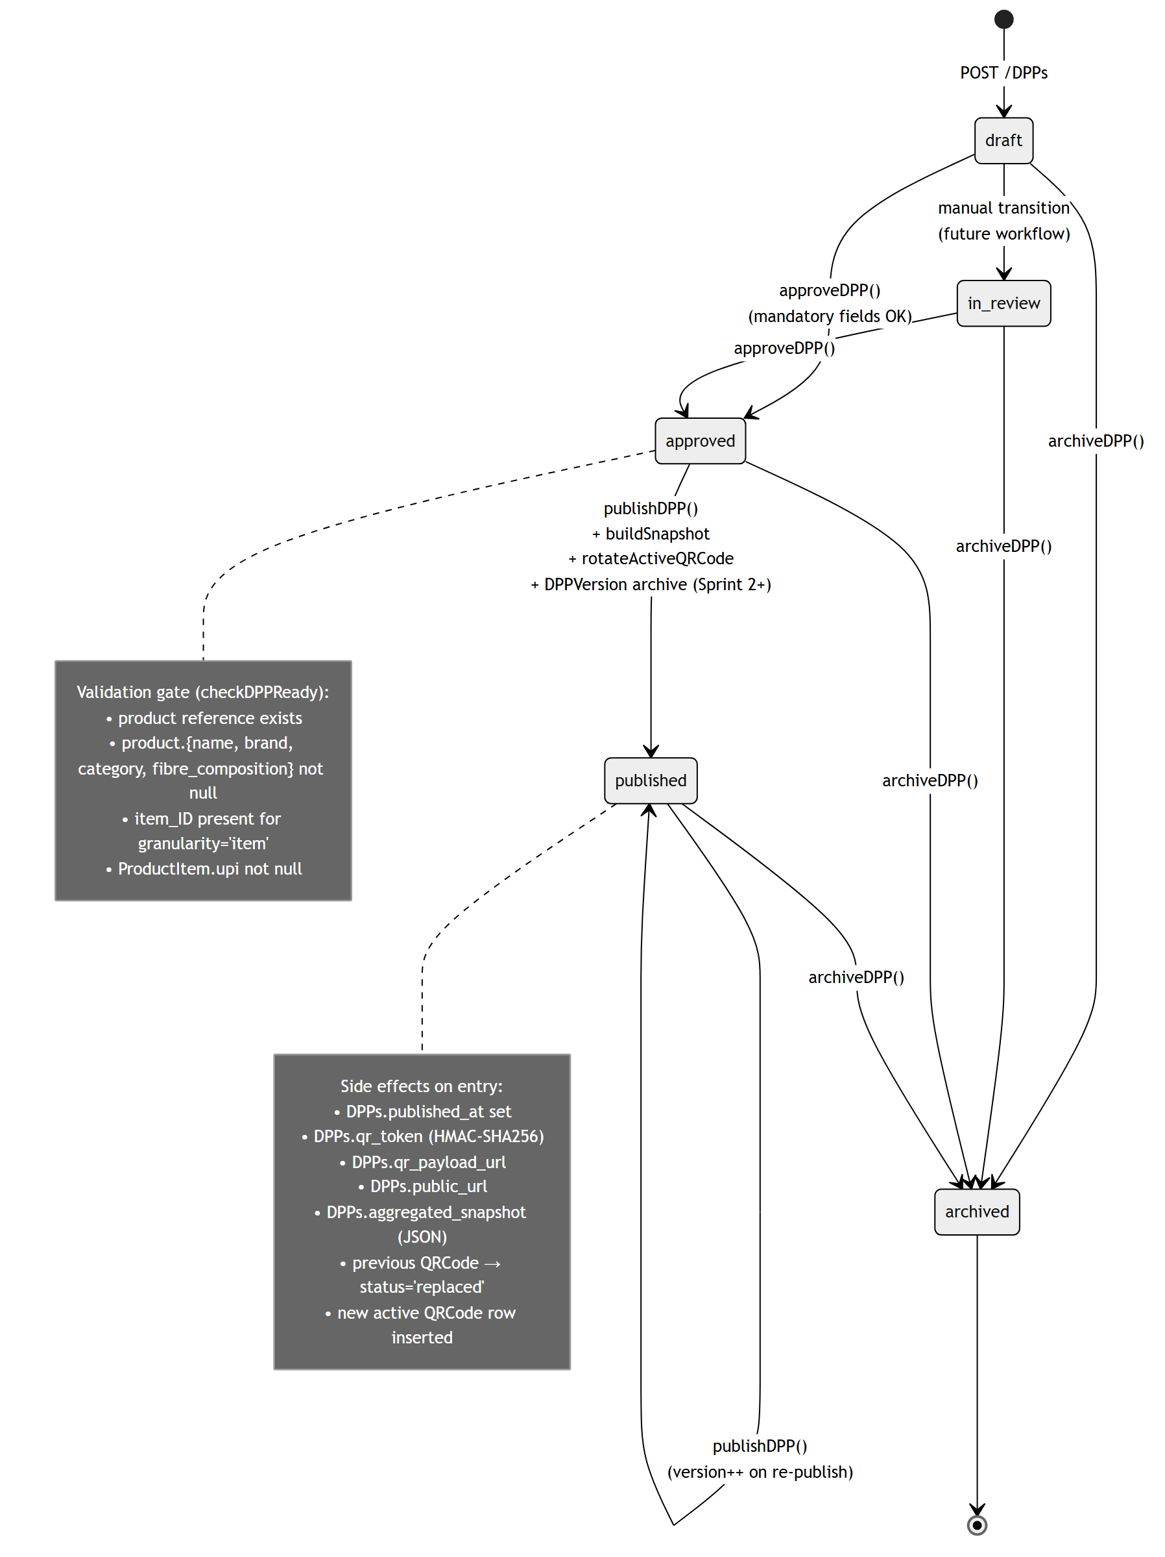
DPP lifecycle
The approveDPP and publishDPP actions both invoke the inline validator checkDPPReady, which rejects with HTTP 400 if mandatory product or item fields are missing. On publishDPP, the handler additionally builds an aggregated JSON snapshot, stores it in DPPs.aggregated_snapshot, rotates the active QR (status='active' → 'replaced' for the previous one, new active row inserted), and updates DPPs.qr_token / qr_payload_url / public_url.

2.4 Sprint-1 Demo Workflow
The end-to-end happy-path sequence used as the MVP acceptance test (Epics document, Sprint-1 demo scenario). A company advanced user creates the supply-chain stack from Business Partner down to Item, then approves and publishes the DPP. The published QR code resolves anonymously to the Consumer DTO.
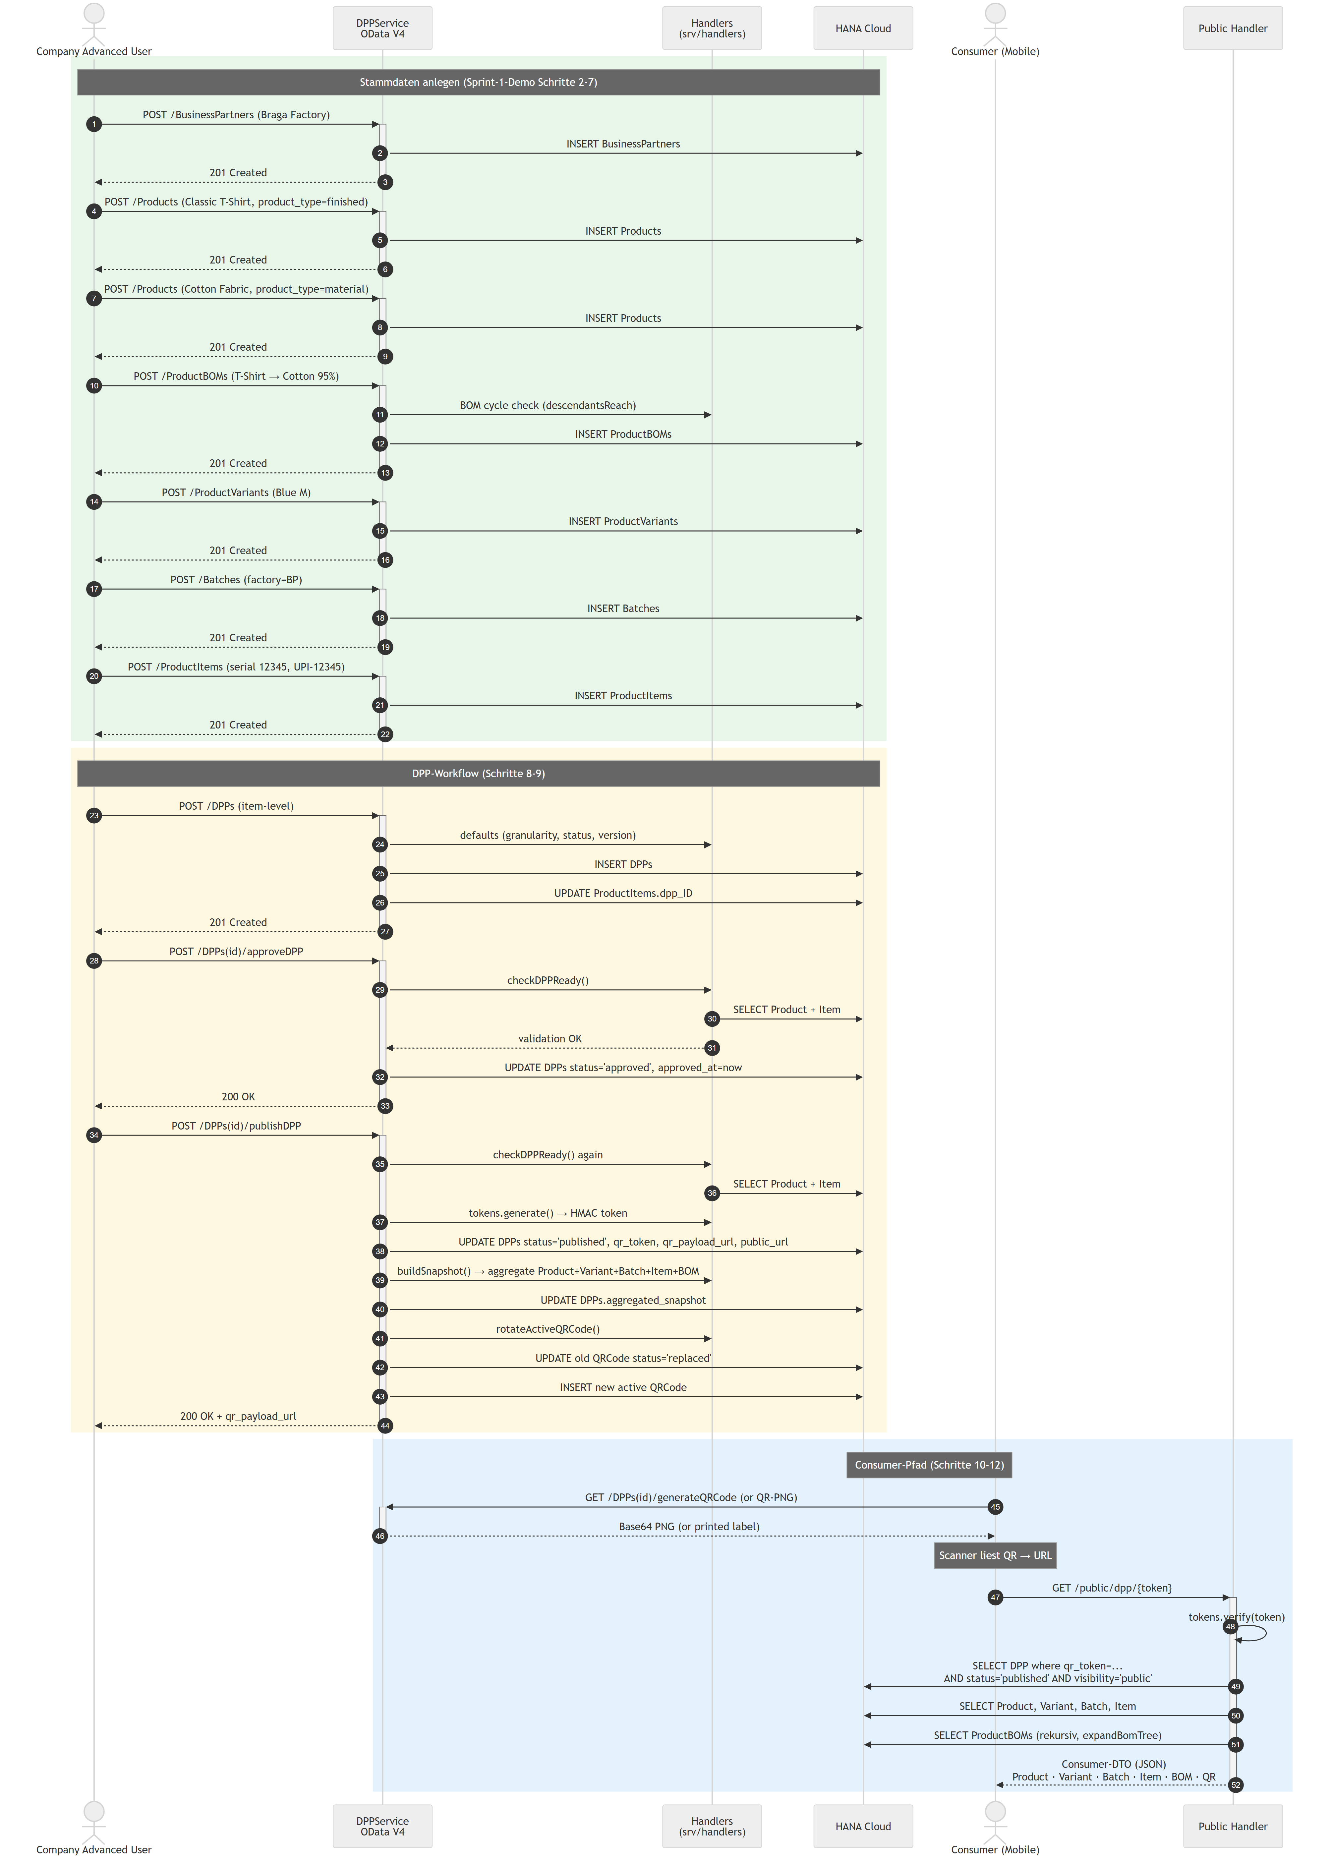
Sprint-1 demo sequence
Token format.
<uuid-v4>.<base64url(HMAC-SHA256(QR_TOKEN_HMAC_SECRET, uuid))>
The HMAC prefix lets the public route reject forged tokens in constant time (timingSafeEqual) before any database lookup. Sensitive fields (tenant, audit columns, internal counters) are intentionally excluded from the Consumer DTO.

2.5 BTP Deployment Architecture
Deployment topology onto SAP BTP Cloud Foundry. The diagram embeds the official SAP BTP Solution Diagrams icons (Apache-2.0, https://github.com/SAP/btp-solution-diagrams) for Cloud Foundry Runtime, HANA Cloud, XSUAA, and the out-of-scope services (Destination, Document Management, Alert Notification, Application Logging).
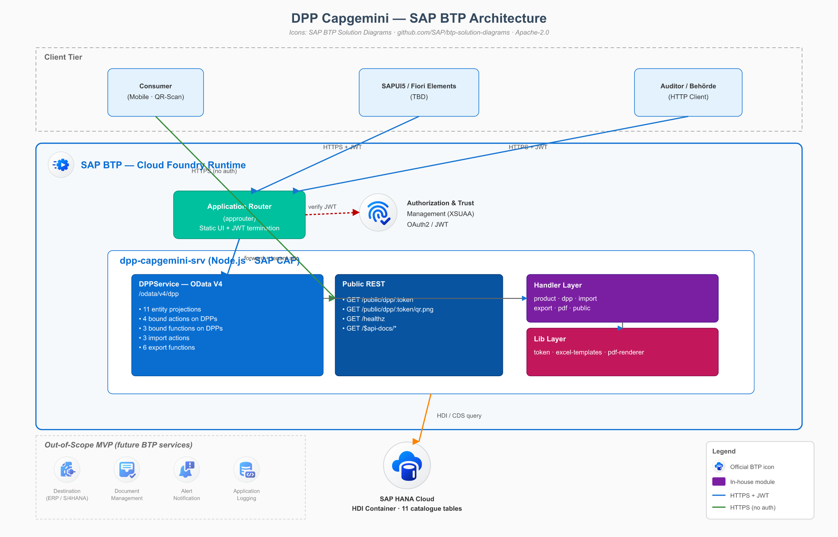
BTP architecture
The editable source is diagrams/btp-architecture.drawio; the SVG export is in diagrams/btp-architecture.svg. See diagrams/README.md for the rendering workflow and the URLs of the embedded icons.

2.6 Role / Capability Matrix
XSUAA issues a single scope $XSAPPNAME.AuthenticatedUser. The application-internal role (company_advanced, company_user, end_user) and the tenant attribute are resolved by the backend from the Users table at request time, then applied by CAP’s @restrict rules combined with a where clause that pins each query to Organizations.tenant_id = $user.tenant.
Capability | company_advanced | company_user | end_user | public (no auth)
Read tenant DPPs / Products / Batches / Items via DPPService | yes | yes | — | —
Create / update / delete master data | yes | — | — | —
Approve / publish / archive DPP | yes | — | — | —
Manage Users | yes | — | — | —
Excel import (Products / Batches / BOM) | yes | — | — | —
Excel / PDF export | yes | yes | — | —
Cross-tenant read-only via AuthorityService | — | — | yes | —
Read published, public-visible DPP via QR token | — | — | — | yes

3. Endpoints
Method | Path | Required Role | Purpose
GET | /odata/v4/dpp/$metadata | any authenticated | Service metadata
GET / POST / PATCH / DELETE | /odata/v4/dpp/<entity> | role-restricted | CRUD on the 11 catalogue entities
POST | /odata/v4/dpp/DPPs(id)/DPPService.approveDPP | company_advanced | draft → approved (with validation)
POST | /odata/v4/dpp/DPPs(id)/DPPService.publishDPP | company_advanced | approved → published + snapshot + QR rotation
POST | /odata/v4/dpp/DPPs(id)/DPPService.archiveDPP | company_advanced | → archived
POST | /odata/v4/dpp/DPPs(id)/DPPService.regenerateQRToken | company_advanced | new HMAC token, previous → replaced
GET | /odata/v4/dpp/DPPs(id)/DPPService.generateQRCode | company_advanced | Base64 PNG
GET | /odata/v4/dpp/DPPs(id)/DPPService.exportDPPasPDF | company_advanced | DPP rendered as PDF
GET | /odata/v4/dpp/DPPs(id)/DPPService.generateQRLabel | company_advanced | printable label PDF
POST | /odata/v4/dpp/importProducts | company_advanced | Excel XLSX UPSERT
POST | /odata/v4/dpp/importBatches | company_advanced | Excel XLSX UPSERT
POST | /odata/v4/dpp/importBOM | company_advanced | Excel XLSX UPSERT
GET | /odata/v4/dpp/downloadTemplate(template=...) | company_advanced / company_user | XLSX template
GET | /odata/v4/dpp/exportProducts() | company_advanced / company_user | XLSX export
GET | /odata/v4/dpp/exportBOM() | company_advanced / company_user | XLSX export
GET | /odata/v4/dpp/exportDPP(dppId=...) | company_advanced / company_user | single-DPP XLSX
GET | /odata/v4/dpp/exportDPPs(dppIds=...) | company_advanced / company_user | bulk-DPP XLSX
GET | /odata/v4/dpp/exportTraceability() | company_advanced / company_user | multi-sheet XLSX (Products→BOM)
GET | /odata/v4/authority/<entity> | end_user | Cross-tenant read-only
GET | /public/dpp/:token | none | Consumer DTO (JSON)
GET | /public/dpp/:token/qr.png | none | printable QR PNG
GET | /$api-docs/odata/v4/dpp | — | Swagger UI
GET | /healthz | none | liveness probe

4. Mock Users (Local Development)
Basic-Auth, password x. Configured via .cdsrc.json under requires.auth.[development].users.
User | Role | Tenant
alice.advanced | company_advanced | ORG-A (Greenline)
carol.user | company_user | ORG-A
dan.advanced.b | company_advanced | ORG-B (Fashionista)
eve.enduser | end_user | — (cross-tenant via AuthorityService only)
kka_learn_235 | company_advanced | ORG-A (BTP shared learn-tenant)
alice.advanced covers most company-internal scenarios. dan.advanced.b verifies tenant isolation between ORG-A and ORG-B. eve.enduser is required for /odata/v4/authority. kka_learn_235 is provided for SAP BTP learn-tenant demos.

