**BILLCLINTON DUBE**

**ENGINEERING DEPARTMENT-MINING**

**JANUARY MONTHLY REPORT**

**CIRCULATION**

Mr. M Tongogara : Coach (Foreman)

Mr. T Masendeke : Mentor (U/G Section Engineer)

Mr. E Berejena : Resident Engineer

Mr. M Dicha : Underground Manager

# ACKNOWLEDGEMENTS

I pay my sincere gratitude to all the Jena mines staff for this much needed opportunity they allowed me to take the burden for the benefit of the attaché. I thank the Engineering department as a whole for the warm welcome and guidance offered on daily basis. Mostly I want to give thanks to Mr. T. Masendeke (section engineer) for being the Supervisor and mentor who plays a crucial role in making sure that I get the knowledge that suits my trade at all cost. I also want to give thanks to Mr. Muchena (electrician), Mr. Mpofu (boiler maker) and also Mr. T. Tongogara (electrical foreman) for the advices and knowledge shared when working with them.

. ABSTRACT

This report is mainly focused on the practices and involvements of the trainee during the month of January at Jena mines as student in Engineering department from 4 January to 3 February 2022.

Contents

ACKNOWLEDGEMENTS 2

1 INTRODUCTION 2

2 INDUSTRIAL COMPRESSORS 3

2.1WHAT IS A COMPRESSOR 3

2.2 TYPES OF COMPRESSORS AT JENA MINES 3

2.2.1 SCREW COMPRESORS 3

2.2.2 PISTON COMPRESSORS 5

2.3 CALCULATION OF LEAKAGES OF JENA MINES COMPRESSED AIR SYSTEM 7

2.4 MANTAINANCE OF COMPRESSORS 8

2.4.1 AIR COMPRESSOR MAINTENANCE TIPS 9

2.5 RECCOMENDATIONS AND CONCLUSIONS 13

3 BEARINGS 13

3.1PRINCIPLE OF OPERATION OF BEARINGS 14

3.2 COMPONENTS / PARTS OF A STANDARD BEARING 15

3.3 MAINTANANCE OF BEARINGS 17

3.4 RECOMMENDATIONS AND CONCLUSIONS 19

4.0 COMMENTS 20

TABLE OF FIGURES

Figure 1. schematic of screw compressor 6

Figure 2. piston compressor 7

Figure 3.components of bearings 15

# 1 INTRODUCTION

According to the program, in the month of January the trainee had to cover aspects that mainly include hoisting and the basics of fitting including maintenance of machinery and equipment, sizing of machinery and also installation of machinery. Jena Mines uses a lot of machinery that needs continuous monitoring, conditioning and maintenance since these machines and operations are a vital to the day-to-day production of this mine. In this report the trainee will outline that became of interest during this period of training.

# 2 INDUSTRIAL COMPRESSORS

## 2.1WHAT IS A COMPRESSOR

The function of a compressor is to take a definite quantity of fluid (usually a gas, often air) and deliver it at a required pressure

## 2.2 TYPES OF COMPRESSORS AT JENA MINES

Jena Mines have two types of compressors that are piston and screw compressors.

There is ML250 compressor at Termite section from Ingersol Rand with a capacity of 1738 CFM.

There are two GA200 compressors at leopardess from Atlas Copco with capacity of 1527 CFM each.

All these three are all screw compressors.

There is also ER8 compressor that have a capacity of 2500 CFM and is the only piston or reciprocating compressor at Jena Mines.

### 2.2.1 SCREW COMPRESORS

These have high mass rate but low-pressure ratio.

Air enters a sealed chamber where it is trapped between two contra-rotating rotors. As the rotors intermesh, they reduce the volume of trapped air and deliver it compressed to the proper pressure level. This allows the rotary screw air compressor to operate with temperatures approximately one half that generated by a reciprocating compressor. This enables the compressor to operate in a continuous duty.

Advantages

* Designed to provide pulsation-free air 24 hours a day
* 100% continuous duty
* Quiet operation
* Energy efficient at full load
* Extended service intervals
* Reliable long life
* Improved air quality

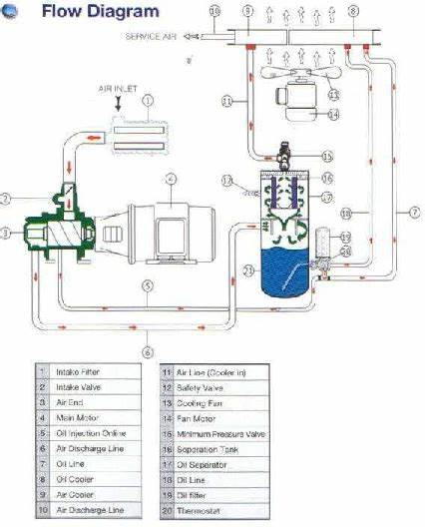

Figure . schematic of screw compressor

### 2.2.2 PISTON COMPRESSORS

These have low mass flow rate (kg/s) and high-pressure ratio.

In a piston compressor with a valve system and two stainless steel valve discs, the piston moves downward and draws air into the cylinder. The largest disc flexes to fold downward, allowing the air to pass. When the piston moves upward, the large disc flexes again to seal against the valve seat. The compressed air is then forced through the hole in the valve seat and delivered to the end process.

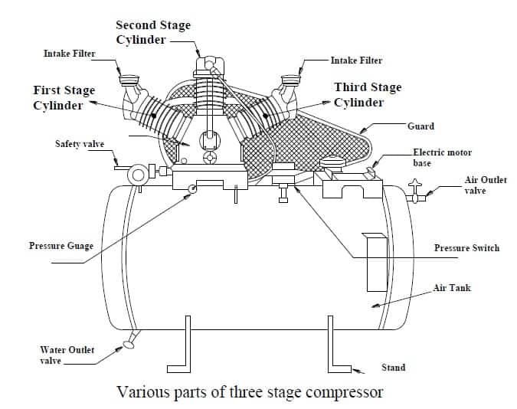

Figure . piston compressor

ADVANTAGES OF PISTON COMPRESSORS

1.Relatively Low Maintenance Cost

2.Ability to have high pressure and high power

3. Can be located close to point‐of‐use avoiding lengthy piping runs and pressure drops

4.Durable, efficient and affordable

5. Significant product life

## 2.3 CALCULATION OF LEAKAGES OF JENA MINES COMPRESSED AIR SYSTEM

The compressor cycle time measuring exercise was carried out on the 19th of January 2022 from 18:15hrs when all pneumatic powered machines and exercises were presumed to be down due to shift changeover. The following cycle times were recorded during the time when all ends were closed.

|  |  |  |  |
| --- | --- | --- | --- |
| Cycle time measurements | |  |  |
| **Cycle** | **Loading/ hr:min:sec** | **Unloading/ hr:min:sec** | **Total cycle time/ hr:min:sec** |
| 1 | 00:01:28 | 00:04:02 | 0:05:30 |
| 2 | 00:01:27 | 00:04:02 | 0:05:29 |
| 3 | 00:01:29 | 00:04:52 | 0:06:21 |
| 4 | 00:01:28 | 00:03:42 | 0:05:10 |
| 5 | 00:01:30 | 00:04:06 | 0:05:36 |
| **Average** | 00:01:28 | 00:04:09 | 00:05:37 |

The average loading time represents the time that the compressor is automatically loaded, and pressure drops from 6.5 bars until it reaches 5.8. The unloading time represents the time the compressors is unloaded and loads pressure from 5.8 bars to 6.5 bars until it is loaded. Equation [1.1] was used to quantify the leakages in the line.

$Leakage \left(\%\right)=\frac{T x 100}{T+t}$……………1.1

Where,

T = Loaded time (seconds).

t = unloaded time (seconds).

The calculated leakage is **26%.**

The leakage is a percentage of the total compressor capacity lost. For a well-maintained system, leakages should account for less than 10% of total compressed air capacity.

## 2.4 MANTAINANCE OF COMPRESSORS

Air compressor maintenance involves a set of practices that need to be performed to varying degrees on compressors of all makes and models.

Compressors should be routinely inspected on key components of the machine and service them, if necessary. Failure to do so could result in premature failure and costly repairs.

At Jena Gold Mine, industrial air compressor maintenance is one of the crucial areas of system management and with so many machines, tools and functions such as the air loaders that rely on compressed air, it is crucial to ensure that all compressors within this mine are capable of performing as needed when needed. The failure of an industrial compressor can result in costly downtime.

Due to the high stakes at play, commercial air compressor maintenance at an industry like this becomes critical

Rotary screw air compressor maintenance is especially important because of the high-powered tools that rely on such machines. The powering of pneumatic jackhammers, for instance, relies on rotary screw compressor.

Minor problems can easily grow into major problems when not remedied in time, air compressor preventive maintenance can save both money and time. After all, certain preventive steps are easy to learn and only take a few minutes to complete. Neglecting such steps, however, could result in costly repair bills down the line.

At Jena Mines, there is a schedule to maintain all the compressors at different dates of the week. (Weekly planned maintenance)

### 2.4.1 AIR COMPRESSOR MAINTENANCE TIPS

An air compressor employs a series of processes that turn incoming ambient air into a power source for tools and machinery. As such, an air compressor consists of various parts, each of which must be maintained to ensure their proper function. Basically, a compressor needs to have its oil changed, its filters cleaned and its after cooler inspected [every three months](https://www.compressorworld.com/blog/air-compressor-maintenance/), and have its filters replaced and connections tightened at least [once every year](https://www.compressorworld.com/blog/air-compressor-maintenance/).

**1. Read the User Manual**

Some of the most common problems with an air compressor are easy to solve with the help of the user manual. For instance, there might be an issue with one of the connections or inlets that won’t initially make sense. A none-too-uncommon mistake in cases like these is for the operator to tinker with things manually in the hope of fixing the problem. However, fixing the compressor should never be fixed without reading the manual first. Failure to follow this step could cost you down the line. In any case, an air compressor user manual can help fix some of the more common, everyday problems the proper way and avoid the types of mistakes that could otherwise void your warranty.

**2. Tighten the Nuts and Bolts**

As an air compressor goes through month after month of daily use, some of the nuts and bolts are bound to become loose. After all, as the machine vibrates, the parts that comprise the machine move. Loose screws and fasteners are not a sign that the machine is falling apart, just an indicator that it is time to pull out a wrench. This looseness is typically the result of vibrations, which intensify when an air compressor is used to power heavy-duty tools.

To determine whether loose nuts or bolts are indeed the issue at hand, manually test each fastener to see if there is any give. With a firm grip of the wrench, twist on the loose fastener until the bolt tightens. Only turn the nut to the point where it no longer moves to avoid stripping the bolt.

**3. Clean the Intake Valves**

If an air compressor is to function at maximum efficiency, it must have clean intake vents. Dust particles and other air-bound elements are bound to get sucked into the vents. Therefore, it is important to clean the vents regularly. Problems due to clogged intake vents can arise when vents are not cleaned on weekly basis. Intake valves can also become dirty in working environments with various air-bound particles.

**4. Change the Air Filter**

Throughout the course of a daily usage cycle, the filter inside an air compressor will trap lots of junk. The filter is designed to bear a heavy load. Without the filter, dust and other impurities could easily put a drag on the air compressor and degrade the performance of pneumatic tools.

However, even the filter itself can reach its limits. While the job of the filter is to collect all the dust that would otherwise infect the compressed air and degrade the quality of end-point operations, the filter becomes less and less capable as it fills. Therefore, it is crucial to [change out the air filter annually](https://www.compressorworld.com/blog/category/accessories/).

**5. Drain Condensate from the Tanks**

An inevitable byproduct of compressed air is moisture, which accumulates inside the machine in the form of condensate. The moisture tank inside an air compressor is designed to suck the water out of the outgoing air. This way, the air itself remains dry and pure as it reaches the endpoint.

As with the filters, the moisture tank eventually fills up. If the tank becomes too full, the water can move to other parts of the machine and re-infect the air. Even worse, the water can rot and send rank smells and impurities through the compressed air system. Therefore, it is crucial to drain the moisture tank on a regular basis.

**6. Inspect the Air Compressor Shutoff System**

There are times when an air compressor will need to shut itself down to protect its well-being. A typical example would be when the machine gets too hot to perform adequately. If pushed to work in such conditions, the machine could overheat internally and parts could ultimately fail. The larger the machine, the greater and more costly the loss could be in a situation where overheating occurs.

For internal protection, most of today’s compressors are equipped with safety shutoff mechanisms. The mechanism is designed to activate when a compressor becomes either too hot or pressure-deprived to perform properly. In much the same way an overheated computer will lock up and reboot, the shutoff system of an air compressor protects the machine’s internal components from getting fried.

However, the mechanism itself can sometimes fail to activate. Shutoffs can be even more problematic in humid working conditions, where the high intensity of a given operation and the pressure this puts on a compressor is compounded by the temperature of the ambient air. Checking user’s manual for instructions on how to inspect the safety system and ensure it operates as needed.

**7. Change Out the Oil**

In humid working environments, oil can lose its viscosity and ultimately fail to provide proper lubrication to the various internal components of an air compressor. This lack of lubrication can result in metal friction and stress along the moving metal parts, which could possibly wear down and fail long before their time. Likewise, colder working environments can cause oil to become sludgy, especially if moisture gets into the mix.

At the start of each usage cycle, top off your oil supply. Oil should be changed on a regular basis and if the machine had been domain for some time, then a fresh supply of oil should be added. Oil must have proper viscosity and be free of impurities in order to circulate properly.

**8. Change the Air/Oil Separator**

Oil-lubricated air compressors function internally with oil mist. In other words, the compressors disperse oil within the machine in tandem with the air. However, the oil gets extracted from the air with an oil separator before the air leaves the machine. This way, the machine stays lubricated while the air remains dry at the endpoint.

Consequently, the air can get oil-corrupted if the oil separator ceases to work properly. On various pneumatic functions, the presence of oily mist could be disastrous. Therefore, it is important to replace the oil filter after every 2,000 hours of use or fewer to ensure the compressed air remains pure and free of oil.

## 2.5 RECCOMENDATIONS AND CONCLUSIONS

Since there are 3 compressors at leopardess maintenance of these compressors should be arranged in such a way that one compressor is attended to whilst the other two are operating as this increase the availability of compressors.

Once maintenance is done records should be kept so as to remind and keep to date issues relating the compressors, time last maintained and everything that is of vital to the well condition of the compressors.

From the calculated values of leakages of pipeline of compressed air, it shows that compressors are being strained and hence the need to maintain and close leakages in the pipeline in order to reduce these losses.

# 3 BEARINGS

A bearing is a machine element that constrains relative motion and is used to reduce friction between moving parts of a machine to obtain the desired motion. For example, A load of a rotating fan is supported by a bearing while reducing noise and vibration and restricting the movement to a radial axis.

The main functions of bearings are:

To reduce friction between moving rotatory parts.

To support rotating parts of a machine.

To bear radial and thrust load.

## 3.1PRINCIPLE OF OPERATION OF BEARINGS

Bearings typically have to deal with two kinds of loading, radial, and thrust/axial loads.

Radial load is the load acting perpendicular to the longitudinal axis.

Axial or Thrust load is the load acting parallel to the longitudinal axis.

The Combined load is the load acting both parallel and perpendicular to the longitudinal axis. Depending on where the bearing is being used, it may handle radial loading, thrust loading or both.

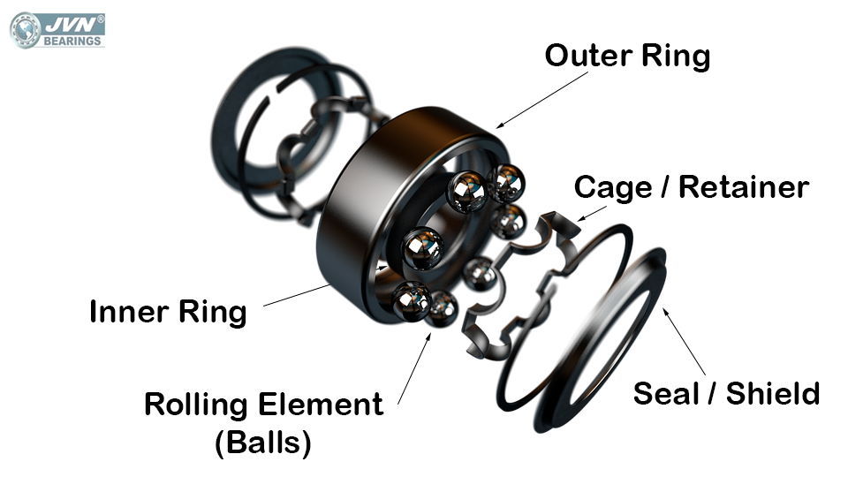

Figure 3.components of bearings

## 3.2 COMPONENTS / PARTS OF A STANDARD BEARING

The standard essential components of a bearing are as follows:

Inner Ring

The Inner Ring is the smaller of the two bearing rings. It has a groove on its outer diameter to form a raceway for the balls. The surface of outside diameter path is finished to extremely tight tolerances and is honed to be a very smooth surface. The inner ring is mounted on the shaft and it is the rotating element.

Outer Ring

The Outer Ring is the larger of the two bearing rings. On outer ring, there is a groove on its inside diameter to form a pathway for the balls. It also has the same high precision finish of the inner ring. The outer ring is usually held stationery.

Rolling Element: (Balls, Cylindrical Rollers, Spherical Rollers, Tapered Rollers, Needle Rollers)

The rolling elements separate the inner ring and outer ring and permit the bearing to rotate with minimal friction. The dimension of the rolling elements is made slightly smaller than the track on the inner and outer rings. Rolling element dimensions are controlled to very high accuracy. Surface finish and size variations are important attributes. These attributes are controlled to a micro inch level.

Cage (Retainer)

The purpose of the cage in bearings is to separate the rolling elements, maintaining a constant spacing between the inner and outer rings, to accurately guide the rolling elements in the path during rotation and to prevent the rolling elements from falling out.

Lubrication

The lubricant is an integral part of a bearing’s standard components. Lubrication is added to reduce friction losses in bearing between inner and outer rings.

Other Optional Bearing components

The other additional components shields and seals enhance the performance and life of the ball bearing. These optional components are added to the bearing as per the customer requirement to increase the performance of the bearing.

Shields

The shield is a stamped, profiled sheet metal disc. Shield is pressed into a very small groove on the inside edge diameter of the outer ring. A small space or gap remains open between the outside diameter of the inner ring and shield. Because the shield does not contact the inner ring of the bearing, there is no added friction between the shield and bearing. This results in a bearing that has a very low torque. Purpose of shields is to keep larger particles of contamination from entering the bearing.

Seals

The seal is also inserted into the very small groove on the inside, edge diameter of the outer ring. The inner edge of the seal is molded into a specifically designed lip configuration.

## 3.3 MAINTANANCE OF BEARINGS

1. Handle with care

Bearings are delicate enough to get damaged quickly. As such, it is very important that they are stored horizontally in a clean and dry environment with their packaging intact. Do not expose them to any airborne contaminants, as even a tiny speck of dirt can cause premature failure. Never hammer or pound them, or apply a direct force on it or its outer ring, which can cause damage to the rolling elements, resulting in misalignment. The most important thing to remember is to never remove bearings from their packaging until ready for use.

2. Check the bearing housing and shaft

Whenever a bearing is used for mounting, it is crucial that the housing and shaft are inspected for any sort of physical condition or damage. Always use a soft cloth to wipe the surfaces clean and make sure any nicks and burrs are removed.

3. Mount the bearings correctly

The method used to mount the bearings depends on the type of bearing. For example, bearings with cylindrical bores are generally mounted through a press fit method. Bearings with tapered bores can be mounted directly on tapered or cylindrical shafts with the use of tapered sleeves. However, pressure should be applied only with a press fit because without it the raceways can become damaged.

4. Avoid preheating or overheating

The maximum heating allowed on the bearings depends on the heat treatment of the material. If they are heated above the permitted limit, they can permanently deform or soften the bearing steel, lowering load carrying capacity and resulting in a failure. Always heat the bearings using induction heaters, and never with an open flame.

5. Always use the proper tools

Specialized tools like bearing pullers, bearing fitting tool kits, oil injector kits, hydraulic nuts, or induction heaters should be used in the mounting and dismounting processes. These tools ensure the smooth process of mounting or dismounting, in order to minimize the risk of damage.

6. Avoid corrosion

It is crucial that you should not expose bearings to the presence of water for a long time, as it will lead to rust and corrosion. It will also cause the premature failure of the bearings, which can affect the machine performance and productivity. As a result, it will increase your operating costs. Also, make sure to wear gloves when handling bearings. Perspiration can also lead to rust and corrosion.

7. Proper lubrication

If you want to have a prolonged life of your bearings, it is crucial that they should be properly lubricated. The correct lubricant depends on the environmental conditions, temperature, speed and load. In this case, it is advisable that you should follow your manufacturer’s recommendations

## 3.4 RECOMMENDATIONS AND CONCLUSIONS

Since there are various and a wide range of types of bearings its wise to write down all the types used at Jena Mines whenever new machinery is brought so that spares are ordered since these parts require a lot of changing.

To reduce breakdowns due to bearing failure, average lifetime of bearings should be noted and changed before failure.

Passing electricity through bearings weakens them, boiler makers should earth the part to be welded when using a welding machine to avoid passing the current through the bearings.

# 4.0 COMMENTS

MENTOR……………………………………………………………………………………………………………………………………………………………………………………………………………………………………………………………………………………………………………………………………………………………………………………………………………………………………………………………………………………………………………………………………………………………………………………………………………………………………………………………………………………………………………………………………………………………………………………………………………………………………………………………………………………………………………………………………………………………………………………………………………………………………………………………………………………………………………………………………………………………………………………………………………………………………………………………………………………………………………………………………………………………………………………………………………………………………………………………………………….