Preassessment Data Report #2
M/V Selendang Ayu Oil Spill
Surveys of Intertidal, Subtidal, and Anadromous Stream Habitats

NOAA
Damage Assessment, Remediation, and Restoration Program

Based on field surveys by John Cubit, Lisa DiPinto, Allan Fukuyama, Daniel Hahn,
John Hudson, Nick Iadanza, Janis Krukoff, Carolyn Kurle, Sandra Lindstrom,
Danielle Savarese, Laresa Syverson, Ian Zelo

January 2008

Abstract. On 8 December 2004, the Selendang Ayu went aground on Unalaska Island and spilled approximately 321,000 gallons of IFO 380 fuel oil and approximately 15,000 gallons of diesel fuel. About 70 miles of shoreline were within the area of principal oiling, defined as shoreline response segments where some portion required cleanup action. As a preliminary step in the natural resource damage assessment (NRDA) process, NOAA conducted preassessment surveys from December 27, 2004 through February 1, 2005 and from June 2 through 23, 2005. In the winter surveys, NOAA damage assessment teams examined the shoreline for patterns of oil movement and deposition, but daytime high tides were too high to comprehensively examine intertidal habitats for indications of oil impacts on the biota in these habitats. During two extreme low-tide series in June 2005, NOAA and scientists working for the responsible party conducted preassessment surveys of biota in intertidal, subtidal, and stream habitats in the spill area. In visual surveys of the perennial biota (algae and invertebrates) in rocky intertidal habitats, indications of possible adverse impacts of Selendang Ayu oil were observed at Spray Cape, but there were no other visible loss of species or reduced abundances of biota observed at other sites that could be attributed to the oil in the time period of 8 December 2004 to 20 June 2005. Shoreline clean-up operations, such as burning of oiled debris, use of heavy equipment, and removal of sand and other material from sections of oiled beaches, very probably killed or removed some beach-wrack biota and infauna to varying degrees. Between 20 and 23 June 2005, the teams observed beach cleaning operations that resulted in the release of oil into surface waters; this release apparently caused bleaching and necrosis of marine algae at HMP-11a. Warm conditions increase both the mobility and toxicity of heavy fuel oil, and these clean up-related oil releases and potential impacts resulting from those releasesmay have continued into the summer months after the field study data collection ended on 23 June 2005. In addition, the U.S. Coast Guard documented more releases of oil from the wrecked Selendang Ayu in October and December 2005, some of which stranded on the shoreline. The preassessment-scale surveys were designed to detect gross, acute, readily visible effects, such as acute mass mortality of biota, occurring before 23 June 2005. However, the observations made, as described herein, suggest that injury likely occurred to intertidal and subtidal biota. Additionally, injury to a variety of marine resources can be inferred from experience with similar-sized spills in similar environments and from the scientific literature.

Introduction

Preassessment surveys of intertidal, subtidal, and anadromous stream habitats, and associated fauna and flora were conducted in two time periods. In December 2004-January 2005, NOAA staff conducted preliminary field surveys of intertidal shores, subtidal habitats, and freshwater streams on Unalaska Island, in the area affected by the Selendang Ayu oil spill. These winter surveys mainly focused on documenting patterns of habitat oiling. Short day lengths, high daytime tides, and adverse weather conditions limited the observations that could be made of biota in these habitats. In June 2005, NOAA teams returned to the spill area during a series of extreme low tides to specifically conduct a second set of preassessment surveys of the biota in intertidal, subtidal, and anadromous stream habitats. Observations made during these surveys are presented below.

Description of the Selendang Ayu Oil Spill

On 8 December 2004, the Selendang Ayu grounded and broke in half on Spray Cape, Unalaska Island, 53º 38’ 04” N, 167º 07’ 30” W (Figure 1). An estimated 335,732 gallons of fuels, mostly Intermediate Fuel Oil (IFO 380), were released following the grounding. Additional information about the incident is available at the Unified Command Website for the Selendang Ayu incident:
http://www.dec.state.ak.us/spar/perp/response/sum_fy05/041207201/041207201_index.htm.

The Unified Command for the Selendang Ayu oil spill divided the 469 miles of shoreline in the potentially spill-affected area into 806 segments (Figure 2). Of these, 123 segments (70 miles) received enough oil somewhere in the segment to require oil clean-up treatment. The sum total of the length of oiled shoreline within all these segments was over 20 miles. One hundred and two of the oiled segments were actually approved for clean-up operations. Primarily because of safety concerns for the cleanup personnel, the remaining 21 segments were not treated.

Beach cleaning operations in the summer of 2005 remobilized unspecified quantities of stranded oil back into surface waters. In October and December 2005, storm waves moved the wrecked sections of the Selendang Ayu, causing the release of unknown quantities of additional oil for unknown periods of time. A civilian aircraft reported observing sheen around the vessel on 21 October 2005. The Coast Guard conducted occasional overflights following this report. On 24 October 2005, the Coast Guard conducted two overflights and reported seeing sheen and emulsified oil. This release was thought to have the potential to oil SCAT segments SPR 8, 10, 11, 12 and SKS 1, 2, 3, 4, and 5. The Coast Guard reported seeing a slow rainbow sheen burping up 350 yards from the stern section the following day, and saw a dull sheen the next day. No new oil was observed on the next four overflights conducted from 27 October through 26 November2005, but a thin sheen was observed on 1 December 2005 (information on reports of aerial observations came from a summary compiled by J. Hampton, Coast Guard). Through October 25, 2005, the Unified Command estimated that approximately 1,000 gallons of emulsified oil was released from the Selendang Ayu as a result of the storm waves (http://www.dec.state.ak.us/spar/perp/response/sum_fy05/041207201/sitreps/041207201_sr_105.pdf), but this estimate has not been updated and may have missed possible releases occurring before and after October 24, 2005 on days without overflights. There is also no known estimate of the amount of oil that was reportedly released during the December storm.

Surveys of the Spill Area

Winter Surveys: Observations of oil and biota from NOAA field surveys conducted in December 2004 – February 2005.

Objectives: The main objectives of the winter surveys were to document patterns of oiling in habitats and collect ephemeral data (including samples of biota and oil taken from the shore).

Methods: NOAA pre-assessment teams conducted field surveys of the spill area on-foot from 27 December 2004 through 1 February 2005, in addition to observations made by Rapid Assessment Technique (RAT) and Shoreline Cleanup Assessment Technique (SCAT) teams. NOAA personnel participating in the pre-assessment field surveys were: Lisa DiPinto, Nick Iadanza, John Cubit, Doug Helton, Ian Zelo, and Daniel Hahn, with assistance from Danielle Savarese (Stratus Consulting). Janis Krukoff and Laresa Syverson (both with Qawalangin Tribe) and USFWS personnel also participated in these surveys. The USFWS vessel M/V Tiglax was used as a working platform. Landing on beaches was accomplished using skiffs. The selection of shoreline segments surveyed was determined by the USFWS sampling plan used to survey the segments for bird carcasses. This was a stratified-random design, with the strata being wave-exposed, wave-protected, and accumulation beaches. Segments were randomly selected within these strata. Segment identification codes were the same as was designated for SCAT surveys and is shown in Figure 2.

Observations and Discussion: In these winter surveys, days were short and daytime tides were high, so observations were limited to the highest portions of the intertidal zone. However, SCAT surveys documented that most of the oil on the shoreline e had been deposited at higher tide elevations by storm waves in the supratidal zone and in the seaward edge of the terrestrial vegetation. Most of the vegetation is Aleutian rye grass. In the winter, the above-ground portions of this grass were dead, straw-like, and appeared to have an affinity for the oil. In these high locations the oil was beyond the reach of the normal tides. Some of the oil was buried beneath gravel and cobble in storm berms. Evidence of mobile oil in the form of patties (congealed oil mixed with straw from Aleutian rye grass) was also observed. Many of the patties were about the size, shape, and thickness of shoe soles, sporadically stranded on the beaches. In these winter temperatures, any remobilized oil would not be liquid and would not form spreading slicks.

With temperatures around freezing (~32ºF, ~0ºC), most of the oil stranded on the shore was the consistency of thick, cold, sticky peanut butter. To illustrate the consistency of the Selendang Ayu oil in winter, the oil could be picked up as a lump with a wooden tongue depressor without losing its shape. When placed in seawater, it did not give off sheen and barely floated (it floated with more than 95% of the lump below the surface of the water). Nick Iadanza observed that the oil appeared less viscous on days with temperatures in the forties (ºF) (~8ºC) and produced sheen when placed in seawater.
Most of the oil we observed was partially emulsified (i.e., had incorporated water and become an oil-water mix). It was a medium brown color instead of black. When pressed with a tongue depressor, the masses of brown oil exuded droplets of water.
Numerous samples of potentially and visibly oiled sediments, the oil itself, and various kinds of biota (mostly mussels) were taken. These samples are being held in frozen storage and could be analyzed if the Trustees determine the information is needed.

In examining the invertebrate fauna of high beaches at Spray Cape (SPR11 and SPR13) on 7 January 2005, Dan Hahn reported amphipods and isopods coated with oil. These oil-coated crustaceans were both live and dead. Some of these appeared to have crawled upwards through the overlying oil. Ty Wyatt (USFWS) made similar observations, including photo-documentation (Wyatt, pers. comm.).

Additional observations of oil movement and deposition were made during the June 2005 surveys described below. Numerous photos illustrating the oiled shorelines and history of the Selendang Ayu oil spill are shown on the Incident Command website: http://www.dec.state.ak.us/spar/perp/response/sum_fy05/041207201/041207201_ph_index.htm

June Surveys: Observations of oil and biota from NOAA field surveys conducted in June 2005

Objectives: The objectives for the June 2005 surveys were the following:

- Identify resources at risk; that is, identify fresh, brackish, and marine water biota and habitat in the spill area that could have been injured as a result of the oil spill, including clean-up activities.
- Document degree of exposure of natural resources to Selendang Ayu oil. (This objective incorporated SCAT data already collected and documented presence of oil in the environment and in/on biota.)
- Document indications of possible resource injury caused by the Selendang Ayu oil spill and clean-up actions.
- Collect ephemeral data (data that would be lost if not recorded by these surveys at this time) regarding potential injury to trust resources.
- Collect any additional information necessary for designing or implementing future NRDA and restoration studies.

Surveys of Intertidal Habitats in June 2005

Methods: The NOAA and responsible party preassessment team conducted two sets of surveys of intertidal habitats in June 2005, coinciding with the minus low tide series of 2-9 June and 19-23 June. The extreme low tides during these two periods facilitated our access to the lowest intertidal levels of the shores in the spill area.

The primary scientific personnel conducting the intertidal surveys for NOAA are all marine biologists with years of experience surveying intertidal biota in Alaska and/or the Pacific Northwest.

- John Cubit (Lead scientist), marine ecologist, NOAA Damage Assessment Center: all June 2005 surveys (2-9 June and 19-23 June)
- Allan Fukuyama, marine ecologist, University of Washington: first June surveys (2-9 June 2005)
- Sandra Lindstrom, marine phycologist, University of British Columbia: first June surveys (2-9 June 2005)
- Carolyn Kurle, marine ecologist specializing in Aleutian Intertidal biota, University of California, Santa Cruz: second June surveys (19-23 June 2005)

Ian Zelo (NOAA Hazmat) was data manager and participated in various field surveys. Nick Iadanza (NOAA DAC) and John Hudson (NMFS Auke Bay Laboratory) also participated in these intertidal field studies, but focused primarily on surveys of anadromous fish streams (see stream section below and their separate reports in the appendices). Jordan Stout (USFWS) conducted the photo-documentation for Cubit’s surveys in the first tide series. Christian Marcotte provided field support for Carolyn Kurle’s surveys. Amy Merten (NOAA Hazmat) also contributed field support. Representatives of the responsible party who participated in the surveys were Gary Mauseth, Bruce Kvan, Greg Challenger (all of Polaris Applied Sciences), and Jon Houghton (Pentec Environmental).

The work platform for these studies was the F/V Ocean Olympic, a 155-foot commercial crab fishing vessel whose use was arranged and paid for by the Responsible Party. Shores were accessed by skiffs with experienced skiff operators. In the fjord-like coastline of the spill area, the captain of the F/V Ocean Olympic was able to position the vessel near all the study areas for rapid access by skiff. This arrangement allowed the field team to visit any shore at any time of day, weather permitting, and then process data aboard the vessel. High surf prevented landing on some shores on some days, but visits to all shores of interest (as described below) were achieved by adjusting schedules around wave conditions. Thus the choice and number of shoreline locations visited was not restricted by accessibility.

Survey sites were chosen to maximize the following:

- Geographic variation in the spatial patterns and degrees of oil exposure (e.g., amount of exposed surface covered with oil, amount of oil buried in beach, amount of oil deposited on high shore, extent of exposure to oil remobilized by beach cleaning operations, etc.). The northern extreme of the geographic range was Volcano Bay; the southern extreme was Chernofski Harbor (see map, Figure 1). The sites at the outer range of the surveys were only exposed to sporadic tar patties, as far as is known.
- Ranges of substrate and shore types (e.g., mud, sand, gravel, cobble, boulder, solid bed rock, vertical shore, horizontal platforms, and combinations thereof).
- Ranges of wave exposure (ranging from very high energy, wave-exposed, shores to very wave-protected, lake-like, inner inlets, with many intermediate shores within this gradient). The highly indented shoreline of the spill area had many bays and inlets, creating a high diversity of wave-exposure regimes.
- Variations in types and diversities of intertidal biological communities (e.g., tidal marsh, algal dominated, invertebrate dominated, high diversity, low diversity, cryptic [under rock], exposed).
- Per the methods described in the following, we also chose sites in the field to make matched comparisons of recently oiled and not oiled (“reference”) sites. This was done to scientifically investigate and test hypotheses regarding causality of effects observed during the field surveys.

Shoreline location segments (e.g., “SKN14”) were identified using the alphanumeric system instituted by the Selendang Ayu Unified Command (see map in Figure 1).

Field Methods: Because the location of the Selendang Ayu oil spill was remote and difficult to access, there was little preliminary information regarding possible impacts on which to base our survey designs. Therefore, we used an adaptive survey strategy in which one day’s observations were used to determine the next day’s operations. This strategy included field designation of gradients of oil exposure and designation of unoiled reference sites to test hypotheses that oil exposure caused any apparent adverse effects observed in the field.

In the field, the adaptive survey process was designed to function as follows. If apparent injury to biota was observed in the field, the first step was to determine if this injury was consistent with exposure to oil, as opposed to other factors, such as predation or effects of low tide exposure. Next, the shoreline location having apparently injured biota was compared to a “reference” location, which was the nearest location that had the same shoreline aspect (exposure to wave action, elevation, topography, etc.,) and habitat type, but with little or no exposure to oil. If similar injury also occurred in the reference location, the hypothesis that the injury was likely a result of exposure to oil discharged from the Selendang Ayu could be rejected.

As described below, at each site close-up examinations of the biota and substrata were made at all accessible shore levels. This included wading into shallow subtidal areas where shoreline slope and wave conditions permitted. The field surveys were conducted around the daytime low tides. The surveys started at upper tidal levels of the shore during the falling tide and proceeded to the lowest intertidal levels as the tide receded. Most intertidal surveys were conducted on foot after landing from skiffs. Vertical rock faces emerging from deeper water were surveyed from skiffs positioned next to the rock face. Observations of shallow subtidal biota were accomplished by wading into these habitats or floating over them in the skiffs. Deeper subtidal biota were surveyed by divers and video cameras, as described in the subtidal section.

- Observations were made directly in the habitat surveyed, not from a distance. Biota were examined within arm’s length.
- In the field, biota were examined, the condition, degree and distribution of oiling, and any indications of impacts of oil on the biota were documented. These observations were made by field biologists familiar with the taxonomy, appearance, and ecology of these species, including the effects of natural factors on these biota.
- Biota were specifically inspected for visible oiling, abnormal coloration, necrosis, empty shells, abnormal behavior, mortality, and any other indications of possible oil exposure and oil effects. In particular, biota more than seven months old, i.e. preceding the Selendang Ayu grounding and oil spill, were carefully examined.
- Fronds of large algae were lifted as necessary to view biota and oil, if any, beneath the fronds.
- On beaches and boulder shores, boulders and cobble were lifted and gravel excavated, to examine cryptic biota.
- Documentation of the observations made during the survey was by field notes and digital photographs, primarily.
- Photographs were taken as close as necessary to document the species present, the condition of the biota, and patterns of oiling, if oil was present. Most documentation photos covered an area of about 0.25-1 square meter. Photographs of larger areas were used to document habitat-scale features.
- Locations of photographs were recorded using the combined software set of Ozi Explorer (www.oziexplorer.com) and Ozi Photo Tool (oziphototool.alistairdickie.com). This software combination linked the GPS tracks to the digital photographs. GPS waypoints were used to link observations made in field notes to specific shore locations .
9. Voucher specimens were taken as necessary.

Each day when field biologists returned to the F/V Ocean Olympic, project data manager Ian Zelo downloaded data from the GPS units and digital camera media using the Ozi Explorer and Ozi Photo Tool programs described above.

Observations and Discussion: Portions of 55 shoreline segments (Table 1) were surveyed according to the procedures described above. Photo-documentation was extensive, totaling approximately 13GB of digital photos.

Rocky shore biota On shores with substrata of physically stable bedrock and boulders, an established biota of perennial marine algae and marine invertebrates was found (Table 2). Shores along the northeastern portion of Spray Cape (SPR11-SPR14) are near the wreck of the Selendang Ayu. In these segments, splatters of oil remained high on the shore. Here Lindstrom reported that the kelps (Laminaria longipes and other species) were reduced to stipes--the main portions of the blades were absent. Also, grazer populations appeared to be reduced. Bedrock at lower tidal elevations and fronds of the perennial algae Fucus, Mastocarpus, Petrocelis, and Laminaria in the mid-intertidal zone were overgrown by ephemeral green algae (e.g., Acrosiphonia Ulothrix, and Urospora).

On other shores, both oiled and unoiled, the perennial species were of a size and condition that indicated they had been present before the Selendang Ayu oil spill—i.e., they had settled and grown before 8 December 2004. In close and careful examination of the perennial biota there were no indications of visible acute mortality or other adverse effects on these perennial biota, except for Spray Cape and HMP-11a which was exposed to remobilized oil from beach clean-up operations in June, 2005.

Rocky shores were examined for the “green shore phenomena” caused by mortality of herbivores, which has been observed in other spills and in controlled field experiments removing herbivores. At all sites except Spray Cape, no clear indications of blooms of ephemeral algae that exceeded the normal spring blooms of algae found on these kinds of shores in the spring were found. Patterns of grazing marks, grazing patches, and herbivore distribution in these habitats indicated that Littorina sitkana and limpets (Lottiidae) were consuming the bloom-forming algae, forming cleared areas in the stands of the ephemeral algae. However, Lindstrom believes that the extent of growth of ephemeral green algae (Acrosiphonia, Urospora, and Ulothrix) at Spray Cape exceeded normal seasonal growth, especially where these green algae were growing as epiphytes on perennial algae in the mid-intertidal zone and on bedrock at lower tidal elevations. Lindstrom attributed the extent of this bloom to a general lack of grazers at these tidal elevations at this site. The cause for the observed lack of grazers cannot be attributed to oil exposure with the available information.

Beaches of cobble, gravel, sand. An abundant and diverse assemblage of cryptic beach invertebrates was observed beneath cobble, drift seaweeds and other beach wrack. These included talitrid amphipods (“beach hoppers”), centipedes, arachnids, and kelp flies. The talitrids were at densities of 1 to 10 per 100 cm². In some cases, beach biota were within 10 cm of mats of buried oil, but no oil was found on the biota. In addition, on 19 June 2005, oiled wrack (accumulations of dead plant material) harboring amphipods living in direct contact with oil was observed on the beach at SKN-6. Although the amphipods did not appear oiled or to be experiencing acute effects from the oil, amphipods living in such close proximity to oil could serve as potential vectors of oil to higher trophic levels. Foxes were seen overturning rocks and wrack on beaches, apparently feeding on the beach invertebrates found there.

In the course of the surveys, large amounts of beach material were observed being removed from heavily oiled sections of beaches for disposal at waste sites. This material probably contained beach biota. For example, the excavating machinery at SKN-11 was removing the oiled cobble and gravel, placing it in “Super Sacks” for transport out of the area. Any biota in the beach material would have also been removed. Excavating machinery could have also crushed beach biota. In addition, oily debris was moved into piles and burned on some beaches which would have killed beach-wrack fauna and infauna in the vicinity of the fires. Many of the areas where burning of debris was conducted were in high wave energy areas with cobble and pebble sediments that are unstable and dynamic and may have less interstitial biota than areas with lower wave energy and finer sediments.
(http://www.dec.state.ak.us/spar/perp/response/sum_fy05/041207201/041207201_OiledDebrisBurns24May05.pdf)

Observations of remobilized oil and apparent impacts on rocky shore substrata and biota:
Beginning on 20 June 2005, new deposits of sticky brown oil were observed in some of the areas surveyed. The oil appeared to have been released from beach cleaning operations in adjacent shoreline segments. In some cases, excavations had been made into layers of oil buried in gravel-cobble beaches, and high tides had lifted oil out of the excavations. Segment HMP-12 was a pilot project for “berm relocation” and “surf-washing,” in which oiled beach material from a section of high beach was bulldozed into a lower intertidal area where wave action could remove the oil. Berm relocation was also used at segments SKN-05, SKN-06, and SKS-04. Table 3 summarizes currently available information from various sources on the response actions taken at each SCAT segment. Because there has not yet been a compiled and verified accounting of the actions taken at all segments, the information in Table 3 should be regarded as giving an approximate sense of what occurred, except descriptions of clean up at segments directly observed by the survey teams for this report.

On 20 June 2005, at the rocky point at HMP-11a, rainbow sheens of oil were observed on tide pools, including oil streaming from floating droplets of black oil. In the mid-tide zone sticky, brown oil was deposited on the rock surface and on attached biota. The fronds of Palmaria and holdfasts of Alaria in this zone were oiled. In the high intertidal zone and splash-zone, freshly deposited, shiny, sticky oil was also present on rock substrata and on the fronds of the red alga Porphyra. Fresh oil was also present on wrack at the higher high water level. The oil appeared to be remobilized from beach cleaning operations to the west of HMP-11a, in segments HMP-11b and HMP-12. Dry tilling to expose buried oil at HMP-12 for removal by natural factors is shown in the photo at the end of this document. (A list of all photos available on the Unified Command website can be found at:
http://www.dec.state.ak.us/spar/perp/response/sum_fy05/041207201/041207201_ph_index.htm).

Freshly remobilized oil was observed in the north part of Skan Bay during the calm weather of 22 June 2005. There were oil sheens on the water surface of the cove at SKN-10 and SKN-11. Oil sheens here ranged from silver through rainbow in color and some brown-black patches of oil were also observed on the water surface of the cove at these SCAT segments. Rainbow sheen covered about 50% of the water surface in the landward part of the cove—an area of several hundred square meters, occupying the landward end of the cove, and extending about 100 m from the beach at the head of the cove. Bands of floating black oil about 1 cm thick were accumulated against the floating fronds of the kelp Alaria—the fronds were acting like low-profile oil booms. The oiled Alaria bed was about 50 m by 100 m. An on-scene biological advisor for the clean-up said that high tides had washed oil from the excavations made to remove buried oil from the beach. Oil was buried in the berm of the beach at SKN-11 and the beach wrack was more than 80% oiled. A backhoe/front loader and two excavators were digging oiled sediment out of the beach, and the highest concentrations of oil in the water and on the shore were at the beach cleaning operations, diminishing with distance from the excavation sites. There were no booms in place to retain the oil when we made these observations, but (pom-pom) booms were placed along the beach later in the day. The rocky shoreline of SKN-10 projected seawards from the oiled beach at SKN-11, forming the south side of the oiled cove. Freshly deposited, sticky, oil was most evident in the upper intertidal zone of SKN-10, forming a band of oil- a “bath-tub ring” effect- on the rocks. The band was about 20 cm – 45 cm wide (vertical measure) and the coating of oil ranged in thickness from stain to about 5 mm. Shiny black oil was observed on barnacles, mussels, limpets (Lottia spp.), Littorina sitkana, and Fucus. At the beach end of the shore (nearest the remobilized oil), 100% of the Porphyra were coated with oil.

Upon returning to HMP-11a on 23 June 2005, it appeared that more than 90% of the red alga Palmaria had oil on their fronds. The typical color of this alga is dark purple-red to wine red, however, >90% of the oiled fronds (by surface area) were bleached to a light yellow-green color, some almost white, and the tips of the fronds were ragged. Less than 40% of the Alaria were oiled at the base. More than 80% of the normally bright green Acrosiphonia were also discolored (bleached tips and tan-brown coloration over >80% of the frond surface), although no oil was seen on the fronds of this alga. Submerged Palmaria at HMP-11a were also oiled and bleached. As documented in the field photos, all of these algae were common within their zones.

To evaluate effects of remobilized oil on the intertidal algae, HMP-13 was chosen as a “reference” site for HMP-11a. HMP-13 was the next rocky point to the west of HMP-11a, about 1 mile away. It faced the same direction and had similar wave exposure, but no remobilized oil was found there on 23 June 2005. HMP-13 appeared to be up-current or up-wind from the HMP-11a and the remobilized oil. Clean-up operations in the Hump Back Bay area were underway before HMP-13 was surveyed, so it is possible that the algae at the HMP-13 “reference” site had been oiled prior to the observations. Oil was not observed on the fronds of Palmaria at HMP-13, but these algae showed the bleached discoloration similar to, but less than, the oiled fronds at HMP-11a. However, the Palmaria fronds at the HMP-13 reference site were not ragged like those at the HMP-11a oiled site. The Acrosiphonia was also much less discolored at HMP-13. Bleached fronds of Alaria were similar in appearance at sites with recent exposure to oil and at sites without recent exposure to oil.

In the lower intertidal zone, three species of large brown algae appear to have been affected by the oil. Agarum (or possibly Thalassiophyllum) and Alaria were discolored, an effect that diminished with distance from the oiled beach. Laminaria formed a nearly continuous bed along the low tide shoreline. The Laminaria were bleached and ragged at the end of the shoreline near the beach cleaning operations; this phenomenon decreased to near zero with distance from the beach cleaning operations. Agarum, Alaria, and Laminaria are normally dark brown color. The bleached fronds were pale brown to pale greenish brown. Although Palmaria had some bleaching, and Acrosiphonia some discoloration, at the HMP-13 reference site, these effects were greater at HMP-11a. Because fronds of Palmaria spp. and Acrosiphonia spp. can bleach or change color and erode naturally in the summer when they release reproductive cells (S. Lindstrom, pers. comm.), it cannot be concluded that the all of observed color changes, bleaching, and erosion in these two algal species occurred solely as a result of exposure to Selendang Ayu oil. However, it can be concluded that most of the adverse effects observed on these and other algal species at HMP-11a was probably due to oil exposure.

Summary of June Intertidal Surveys In the June 2005 survey of intertidal beaches, the subsurface beach fauna were observed living in close association with deposits of oil without any visible oiling on the animals or causing any readily observable effects. However, beach cleaning operations were seen removing large amounts of beach sediment and wrack at some locations, probably removing beach fauna at the same time. A total of 666,592 bags of oily waste material were removed from the shorelines in the spill area as of June 19, 2006. Use of excavators, front-loaders, and other heavy equipment on beaches probably crushed beach-wrack biota and infauna. Burning of oily debris on beaches probably caused additional mortality of the fauna located there.

Observations at Spray Cape (SPR11-SPR13) indicated that some biota had experienced recent adverse impacts by oil or some other factor. Kelps were reduced to stipes. Herbivore abundance appeared to be reduced. Epiphytic overgrowth of various perennial algae by ephemeral green algae at this site, but not others, indicates a reduction in herbivory. The extent of growth of these ephemeral green algae on low intertidal bedrock also indicated reduced herbivory. Although the rotting deposit of beans (“Bean Beach”) was primarily to the southwest of SPR11-SPR13, some rotting beans were also present in segments SPR11-SPR13 and nutrients or other substances released by the beans may have caused, or contributed to, the adverse effects observed for segments SPR11-SPR13.

In the pre-assessment surveys between 27 December 2004 and 20 June 2005, no evidence was found of acute mortality of perennial marine biota (algae and invertebrates) on rocky shore segments other than Spray Cape. On these rocky shores, the major groups of long-lived marine algae and invertebrates of the intertidal and shallow subtidal rocky habitats appeared to be largely intact. No observable changes in abundances or conditions of intertidal biota correlated with degrees of oiling were found prior to 20 June 2005. For example, the large barnacle Semibalanus cariosus has a life span of more than a year and has a strong test (shell) that can persist for many months after the animal dies. Therefore, it was a useful indicator of mortality caused by the spilled oil. If the oil had killed this barnacle, a higher relative proportion of empty tests at sites more exposed to oil should have been found. Empty tests of this barnacle were found at all sites, regardless of oiling. However, at all sites more than 50% of the barnacles were alive, and no obvious correlation was found between number of empty tests and degree of oiling as judged by the amount of oil deposited on nearby beaches or reported to have been in the area in SCAT surveys. These observations were consistent over a wide range of sites and for many different types of long-lived biota and suggest that the mortality that was observed is likely due to natural factors. Prior to 20 June 2005, the Selendang Ayu oil spill probably did not cause acute mortality for most of the perennial intertidal biota in the spill area except at Spray Cape (but see footnote 2).

However, starting 20 June 2005 indications of adverse impacts were found on various species of marine algae that was likely caused by oil that was recently remobilized from beach cleaning operations during the warming weather of the Aleutian spring and early summer. To separate effects of oil exposure from non-oil factors, such as exposure during the spring low tides, the conditions of the alga fronds were compared as follows: (1) along gradients of exposure to remobilized oil and (2) between sites that differed in the amount of visible remobilized oil. These observations indicated exposure to remobilized oil was a probable cause of adverse impacts on the algae Palmaria, Laminaria, Acrosiphonia, and Agarum, all of which showed signs of bleaching and tissue erosion in the areas exposed to oil released from buried deposits of oil by beach cleaning operations. As noted earlier, there was some bleaching of Palmaria and discoloration of Acrosiphonia at the reference site (HMP-13), but these effects were much greater at HMP-11a, suggesting that oil exposure was the predominant cause of these adverse effects.

The surveys ended on 23 June 2005, and no further observations were made on the potential long-term impacts of the Selendang Ayu oil released into the spill area by beach cleaning operations in the summer of 2005. However, mechanical excavation and/or tilling occurred at ten or more segments, in addition to that observed at HMP-11b and HMP-12 during the June Survey, and it is likely that some oil was remobilized by the clean up operations at some of these other segments. In addition to Selendang Ayu oil released from shoreline deposits, the U.S. Coast Guard also reported releases of oil in October and December 2005 when storms shifted the hull of the Selendang Ayu (Table 4). A U.S. Coast Guard overflight on 1 December, 2005 reported sheening originating from the stern section of the vessel. Dan Magone (5 Dec 2005, in litt.) also observed oil slicks on 1 December 2005 in Skan Bay, but the source was unknown. It is also worth noting that many segments where oil had not been observed in winter clean up operations were visibly oiled when the clean up resumed in spring 2005. Many of these segments were observed by helicopter and fixed-wing aircraft in the winter SCAT surveys, however, and oiling at some locations may have been missed with this method. A summary of reports of remobilized oil is given in Table 4.

Oil persisted in 26 segments at levels above that determined as “end point” by the Unified Command after clean up operations ended in 2005 (Table 4). When the response officially ended on 23 June 2006, six segments had still not achieved end point status, with residual oil left to be removed by natural processes. This lingering oil has the potential to cause some continuing level of injury until natural recovery occurs.

Surveys of Subtidal Habitats in June 2005

Methods: Subtidal habitats were briefly surveyed by divers using the same basic methods of close-up observations employed in the intertidal surveys and by tethered video. These subtidal surveys were conducted on the same cruise as the intertidal surveys. The divers examined the subtidal habitats for presence of oil and indications of injury that may have resulted from exposure to oil. In addition a tethered video camera was deployed from the Ocean Olympic to look for presence of oil and potential injury. The diver representing NOAA was Alan Fukuyama, who also participated in the intertidal surveys. Gary Mauseth or Greg Challenger represented the responsible party on the dives, with Bruce Kvan as back-up.

Observations and Discussion: The diving team did four dives: one at Alimuda Bay, two at Humpback Bay, and one at Spray Cape near the Selendang Ayu wreck. The latter three were in the main spill area; Alimuda Bay received less oil. Cold water conditions limited the duration of the dives to about 30-35 minutes. Divers did not go below 61 feet. Most of the habitats surveyed were in depths less than 50 feet.

The divers found scattered “tar spots” in 15-20 feet of water in one of the Humpback Bay locations, which was adjacent to HMP-12. This was just offshore of the location of a test berm relocation exercise. Videos from the tethered camera and the divers found no definite indications of adverse impacts of oil in this area. No oil was observed at the other three dive locations.

Surveys of Anadromous Fish and Streams in June 2005

Methods: In June 2005, Nick Iadanza and John Hudson surveyed ten anadromous fish stream systems for presence of oil and fish and other indications of potential exposure of the fish to oil (Table 5). These ten streams were chosen because:

- The streams were in the set of streams monitored for dissolved PAHs (polycyclic aromatic hydrocarbons) by the NOAA Auke Bay Laboratory team. This set included both oiled and unoiled streams. The Auke Bay study results are reported separately in the report in the Administrative Record, entitled “Selendang Ayu oil risk to early life stage salmon” (Mark G. Carls, John Hudson and Stanley D. Rice, NOAA/NMFS/Auke Bay Laboratory, 11305 Glacier Hwy. Juneau, AK 99801)

- SCAT surveys had reported oil up into the stream system, not just at the mouth of the stream.

The surveyors walked the streams, making close visual observations for the presence of oil and fish. In some cases, they examined submerged rock surfaces for biota and collected fish in sieves for closer examination.

Observations and Discussion: In the June 2005 surveys, oil sheen was found on upstream (freshwater) portions of the stream system at SKN 14, including in rearing habitat for coho salmon and Dolly Varden char. Of the anadromous streams visited, SKN-14 contained the highest quantity and quality of coho salmon rearing habitat. Because oil was deposited along the banks of this system for up to 1.7 km upstream of the mouth, large numbers of juvenile coho, and their invertebrate prey, were potentially exposed to oil. Sculpin eggs were also present.

Tar spots and tar balls were also found in the stream bed at MKS-5. This stream contained juvenile coho salmon (young of the year through 2-year old stages) and Dolly Varden Char.

The stream at HMP-12 was examined on 20 June 2005, when clean-up crews were working on a deposit of oil from the adjacent beach at HMP-11b. The high intertidal area at HMP-12 had been tilled to expose the buried oil to removal by natural factors after bulk removal of oil deposits by hand, which includes remobilization by wave action, according to information posted on the Unified Command website (http://www.dec.state.ak.us/spar/perp/response/sum_fy05/041207201/041207201_index.htm). Oil-stained rocks and tar balls mixed with sediment were found along portions of the stream bank, where Iadanza reported 100% cover of oil on stream banks on the lower 100m of stream during a 19 January 2005 site visit. In the second trip to HMP-12 (23 June 2005), a 60% cover of oil was observed deposited on a gravel berm adjacent to the salmonid stream at a distance of 80 - 100m from the stream mouth. On both visits to HMP-12 (20 and 23 June 2005), oil sheen was seen in the intertidal areas of the beach on both sides of the stream mouth, below the location where beach materials had been redistributed. There was oiled wrack near the stream mouth and oil-stained rocks in the stream mouth.

Most of the visible deposits of oil in the winter surveys had been removed from the upstream (freshwater) portions of the remaining previously oiled streams that they examined by the time of the June, 2005 surveys. However, some oil still remained on the marine beaches at the mouths of some of these streams. At HMP 11, oil sheen was observed draining from marine beach cleaning operations on both sides of the stream. Oil and oil sheen was also observed on the marine beach at PTN 3. Oil was also found on the marine beaches and rocks of shoreline segments SKN 14, SPR 3, PTN 3, HMP 11, and HMP 12, at, or adjacent to the mouths of anadromous fish streams.

Observations of possible effects of oil on fish in anadromous streams Coho salmon, Dolly Varden char, and sculpin were observed in streams that had been oiled to some degree by Selendang Ayu oil. These observations are not sufficient in themselves to detect adverse impacts, if any, of the oil but they strongly suggest exposure of these fish to oil.

However, mortality of the smelt eulachon (Thaleicthys pacificus) was observed in Humpback Bay (HMP 9 and HMP 12) on 20 June 2005 in areas where oil was being remobilized by beach-cleaning operations. On this date, fresh, sticky oil recently deposited on the shore at these sites or immediately adjacent to these sites was observed. At the high tide line of the beach at the mouth of the stream at HMP-12, 332 dead adult eulachon were found. Examination of a sub-sample of these fish indicated that the females were full of eggs and the males had testes that were intact; the fish had not yet spawned. The condition of the fish indicated they had died within the previous 24 hours. Schools of live eulachon were observed in the stream HMP-12. Approximately 200 dead eulachon were observed under similar circumstances at the mouth of the stream at HMP-9. These eulachon were also in pre-spawning condition (full of eggs and testes intact).

Dead eulachon were observed being eaten by kittiwakes, a juvenile bald eagle, and a fox during the survey at this site. The eulachon could therefore have served as a mechanism to get oil into the food web. It is not certain that the eulachon were killed by oil from the Selendang Ayu, in part because no “control” sites or other reference information were available to determine if such mortality occurs naturally. However oil was present in the environment when and where the fish died, and the gravid condition of the dead fish indicated mortality was not a result of spawning, so mortality from exposure to oil is one possible cause of death (among other possibilities).

The presence of oil in June 2005 on the marine beaches at the mouths of five streams indicates the potential for storms waves and tides to subsequently move the oil and recontaminate the lower reaches of these streams after the June surveys were finished. Oil released from beach cleaning operations in summer/fall 2005 and discharged from the Selendang Ayu starting in the fall of 2005 could have also recontaminated the streams after our June 2005 surveys.

The stream surveys conducted in late June 2005 are not sufficient in themselves to determine if salmonids in the Selendang Ayu spill area were injured, or not, by the oil that washed into the freshwater streams in early December 2004. The necessary comparative data from previous years combined with other sites to determine if the coho salmon and Dolly Varden char observed in these streams were at reduced or unimpacted densities are not available. Pink salmon juveniles probably would have migrated to sea before June 2005, especially because the winter of 2004-2005 was reported as unusually warm, which would have accelerated time to hatching and alevin development, so there may have been some mortality to juvenile pink salmon that would not be observed during the June 2005 survey. It is possible that fish in the oiled streams could have suffered sub-lethal adverse effects, such as impaired development, growth, reproduction, long-term survival, or site-return from exposure to non-lethal concentrations of oil.

Determination

The observations made during the winter and June surveys, together with information coming from the Unified Command, are sufficient to make the determination that some level of injury did occur to at least some of the resources and habitats examined in the intertidal, subtidal and anadromous stream surveys as a result of the Selendang Ayu oil spill, including from the clean-up operations that took place following the spill. The most evident injuries are those caused by the response - removal of oiled sediments or burning of wrack from the shoreline with its associated fauna - and those to habitats, such as the oiled vegetation and heavily oiled shoreline of some salmonid streams. Some of the impacts to algal species in and around those being actively cleaned during the June 2005 survey may have resulted from remobilized oil. These impacts could have continued throughout the clean-up operations in the rest of the summer. At Spray Cape, there appears to have been a lack of herbivores, possibly a result of the spill, and resulting bloom of ephemeral green algae. There were also observations of dead eulachon, which could potentially be a result of exposure to oil from the Selendang Ayu.

Much of the most apparent and likely injury appears to be the result of response actions taken during warmer weather at some of the most heavily oiled areas. Biota in these areas and those nearby were exposed to remobilized oil, and some injury is likely to have resulted from that exposure- such as the apparent oil-related injuries to some algal species. While not observable in our surveys, there is also likely to have been sub-lethal effects to some biota within the areas most affected by the spill. However, the magnitude of likely injury resulting from the Selendang Ayu incident is relatively moderate, except perhaps at the most heavily oiled areas and those in the vicinity of oil remobilized during the cleanup operations in the spring and summer of 2005. The total length of shoreline where oil was observed to be present is approximately twenty miles, so some degree of injury to these habitats and biota likely occurred over a large area. The observations made during the winter and June surveys, together with information obtained from the response efforts, and what can be reasonably inferred from experience with the effects of similarly-sized spills in similar environments and the scientific literature indicate that an as yet undetermined amount of restoration will be needed to address the injury to natural resources and services in the intertidal, subtidal, and anadromous stream habitats.

Contact John Kern at john.kern@noaa.gov for more information

Figure 1. SCAT survey map showing most of the area surveyed in the studies described in this report. Chernofski Harbor is about 20 km southwest of “ALM” (Alimuda Bay) at lower left.

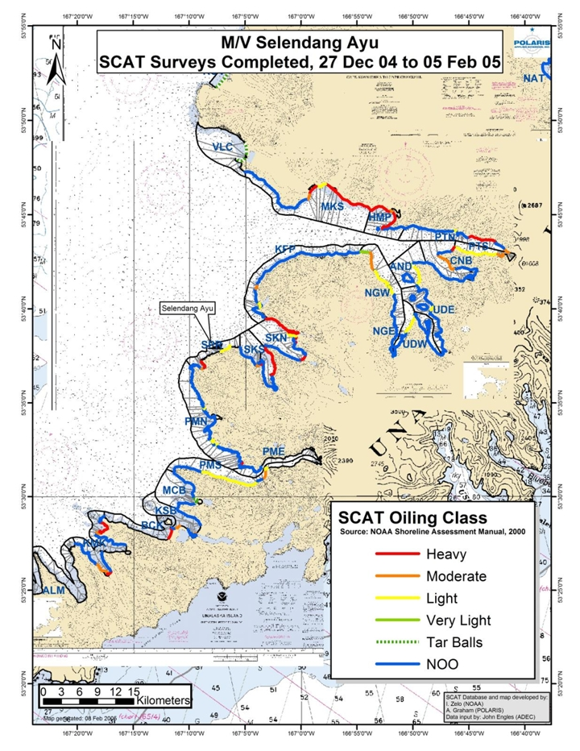

Figure 2. Detailed map of SCAT segments (1 of 6)
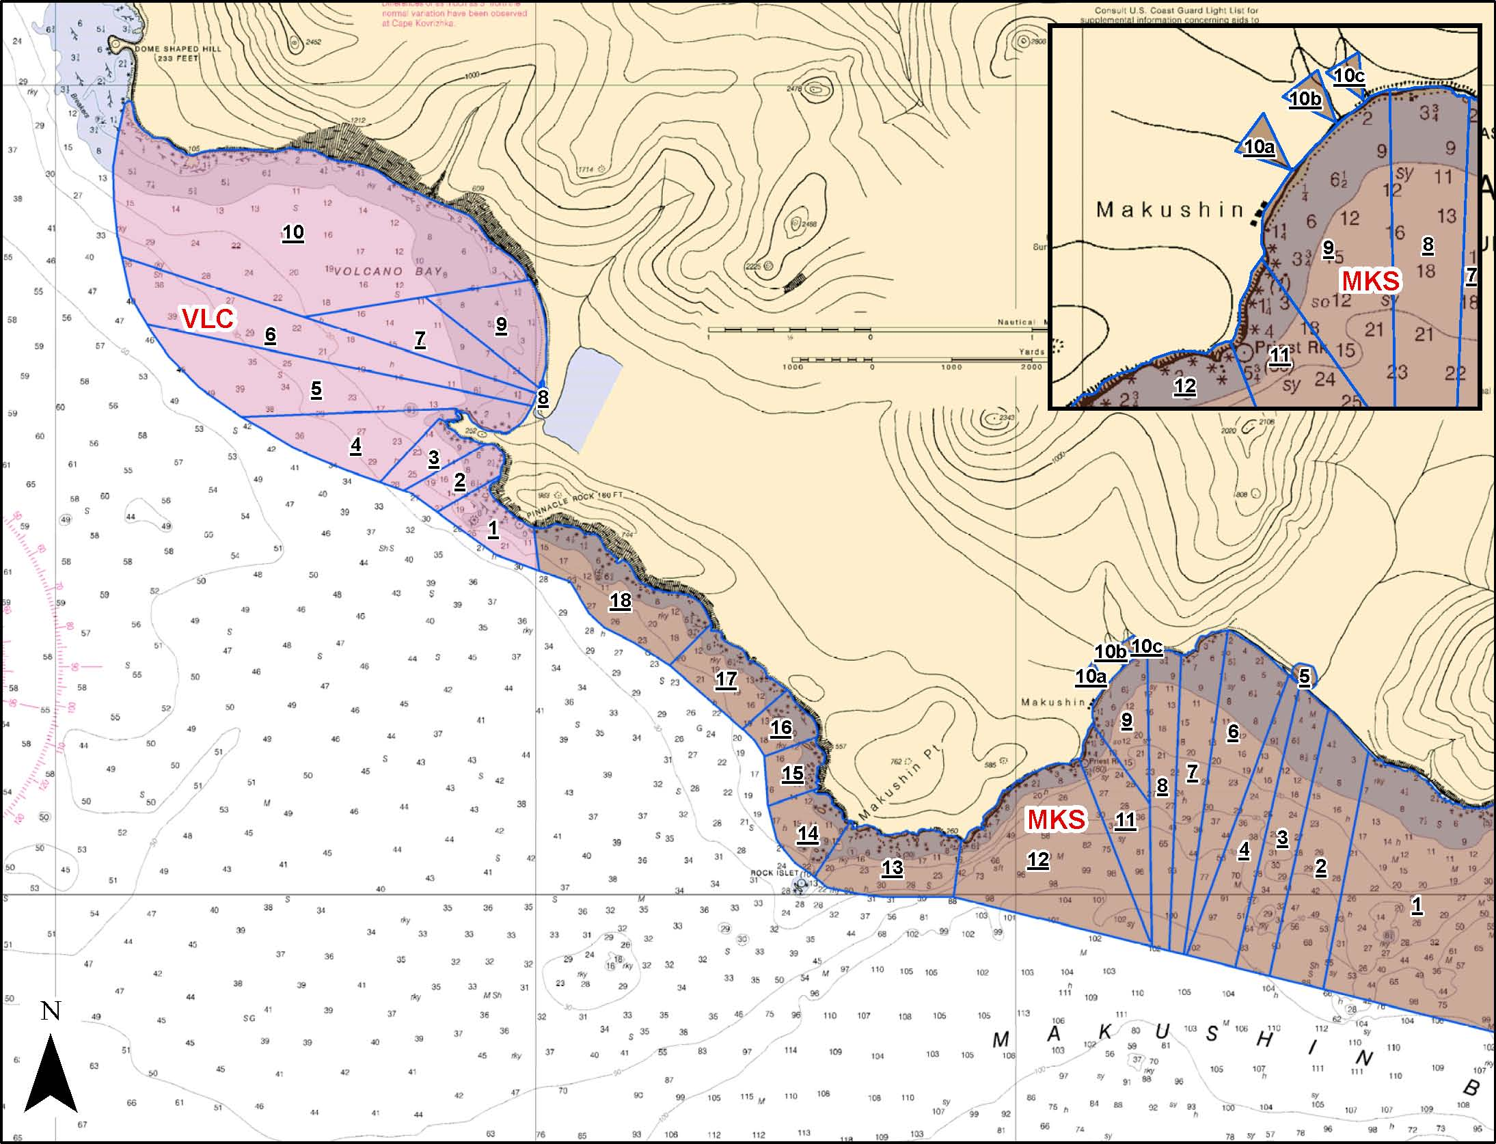

Figure 2. Detailed map of SCAT segments (2 of 6)
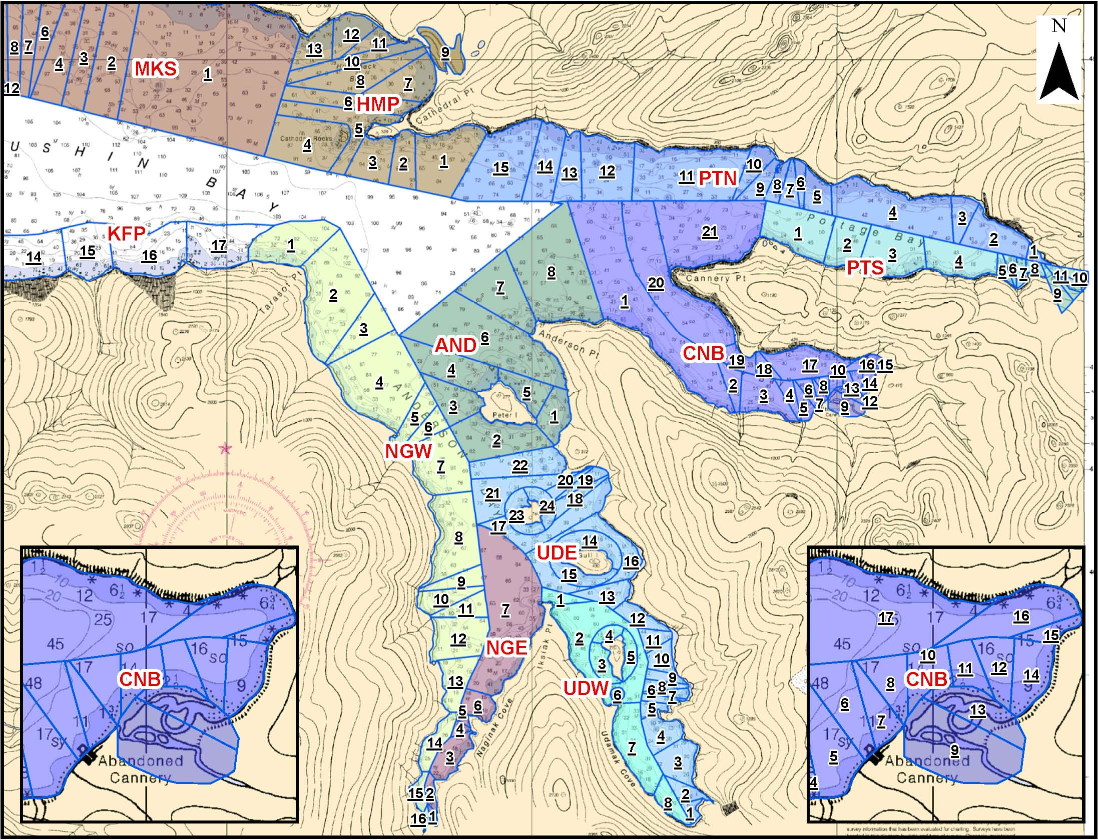
Figure 2. Detailed map of SCAT segments (3 of 6)
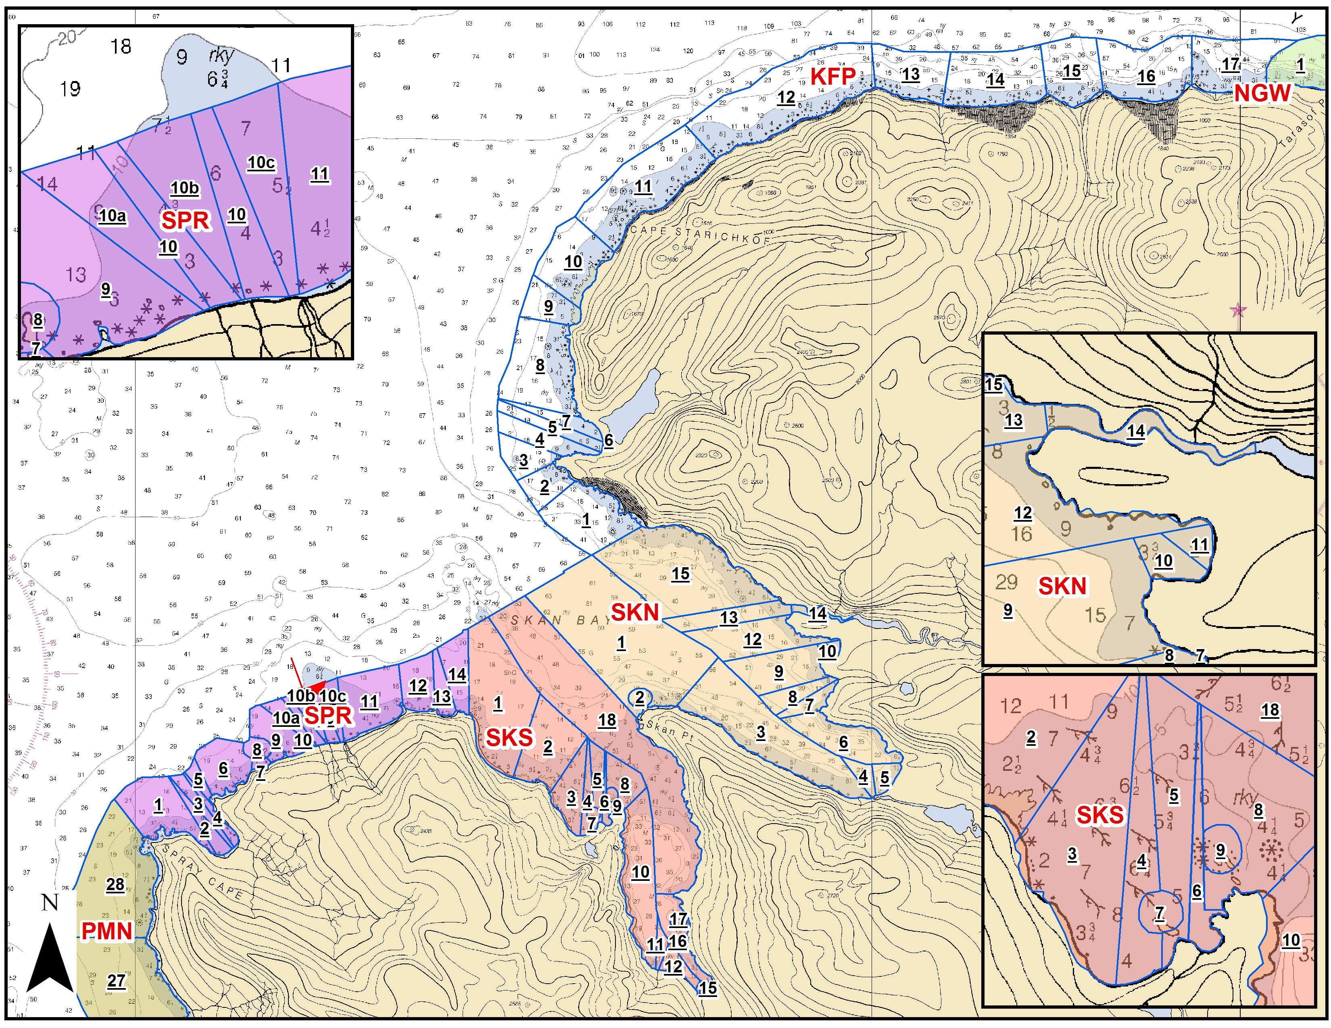
Figure 2. Detailed map of SCAT segments (4 of 6)
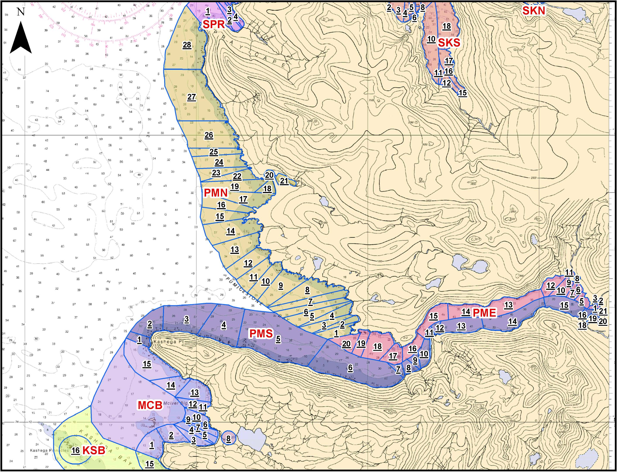
Figure 2. Detailed map of SCAT segments (5 of 6)
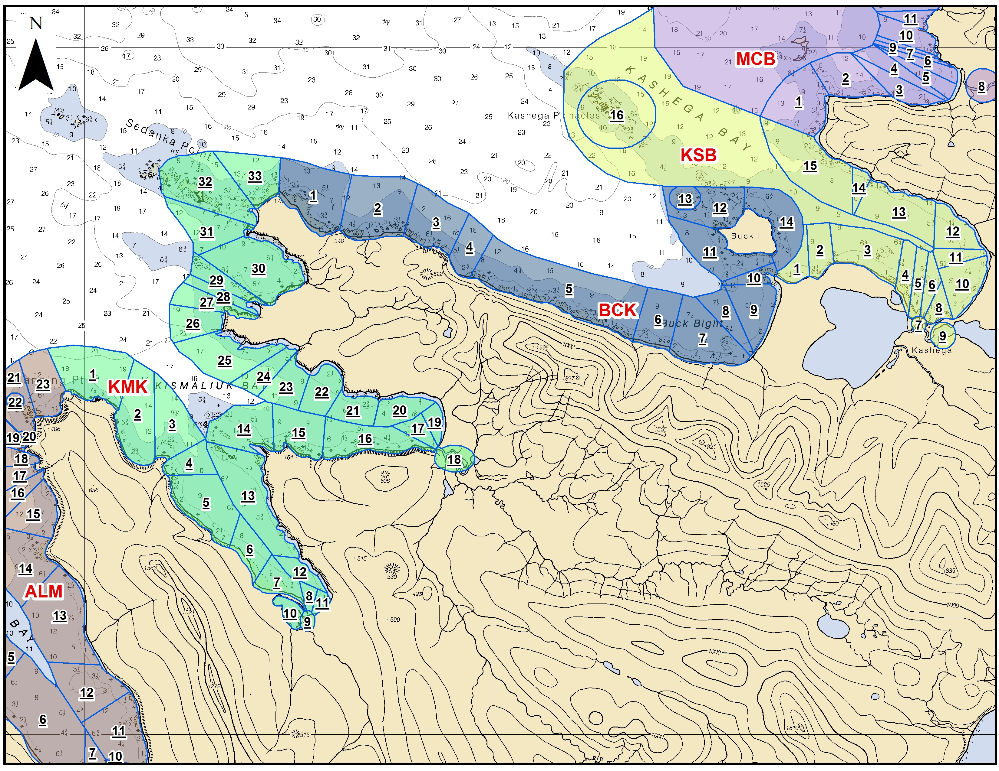
Figure 2. Detailed map of SCAT segments (6 of 6)
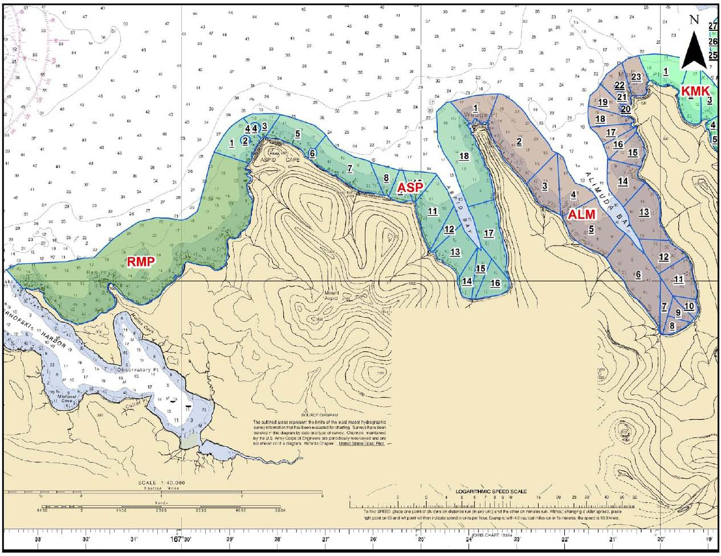

Table 1. Selendang Ayu oil spill segments surveyed in June 2005.
Date | Segment | Date | Segment
6/2/2005 | ALM 8 | 6/9/052 | UDE3
 | ALM 7 |  | UDE1
 | ALM 6 |  | VLC9
 | ALM10 |  | VLC10
 | CFS 19
 | CFS 20 | 6/19/2005 | SKN 3
6/3/2005 | KMK 30 |  | SKN 4
 | PMS 7 |  | SKN 7
 | PMS 10 |  | SKN 6
6/4/2005 | SPR 11 |  | PMS 16
 | SPR12 | 6/20/2005 | HMP 12
 | SKS 4 |  | HMP 9
 | SKS 6 |  | PTN 3
6/5/2005 | CNB9 |  | PTS 11
 | CNB10 | 6/21/2005 | MKS 4
 | PTN2 |  | MKS 5
 | PTN3 |  | MKS 6
6/6/2005 | HMP7 |  | SPR 2
 | HMP6 |  | SPR 3
 | HMP10 |  | UDW 1
 | HMP11 | 6/22/2005 | SKN 14
 | HMP5 |  | SKN 10
6/7/2005 | SKN8 |  | SKN 11
 | SKN9 |  | SKN 7
 | SKN11 |  | PMS 20
 | SKN12 | 6/23/2005 | HMP 11
 | SKN14 |  | HMP 13
 | SKN15
6/8/2005 | SKS 18
 | SKS 14
 | SKS 15
 | SKS 16
 | SKS 17

Table 2. Examples of mature perennial biota found on rocky shores in the spill area, June 2005.
Invertebrates | Common name category
Henricia | starfish
Katharina | chiton
Littorina sitkana | snail
Lottia digitalis | limpet
Lottia pelta | limpet
Nucella emarginata | snail
Calliostoma ligatum. | snail
Balanus glandula | barnacle
Semibalanus cariosus | barnacle
Mytilus trossulus | mussel
Marine algae
Laminaria | kelp
Alaria | kelp
Cymathere | kelp
Fucus | rockweed
Hedophyllum | kelp
Neorhodomela larix | red alga
Petrocelis | tar-spot alga
Agarum (or possibly Thalassiophyllum) | kelp
The individuals of these species were large enough that they were probably present in the spill area before 8 December 2004, when the Selendang Ayu wrecked at Spray Cape.

Table 3. Summary of clean up methods by segment. Segments in bold type were locations not treated due to safety concerns. Does not include segments which had no observable oil (NOO) in winter (2004-2005) and which had a No Further Treatment (NFT) recommendation in spring (2005). When more than one oiling category is used for a segment, the highest was put in this table.
SEGMENT NAME | WINTER OILING CAT. | SPRING OILING CAT. | SPRING  CLEAN-UP? | MANUAL CLEAN-UP | MECH. REMOVAL | MECH. TILL | BERM RELOC-ATION | OPEN BURN
ALM03 | NOO | MODERATE | YES | X
ALM09 | NOO | MODERATE
AND01 | LIGHT | LIGHT | NFT
AND06 | LIGHT | LIGHT | YES | X
AND07 | NOO | HEAVY | NFT
AND08 | NOO | HEAVY | YES | X
ASP07 | NOO | LIGHT | YES | X
ASP14 | NOO | MODERATE | YES | X
ASP15 | NOO | LIGHT | YES | X
ASP16 | NOO | LIGHT | YES | X
BCK07 | NOO | HEAVY | YES | X
BCK09 | HEAVY | MODERATE | YES | X
BCK11 |  | HEAVY | YES | X
CBE21 | HEAVY | NOO | NFT
CNB01 | NOO | MODERATE | YES | X
CNB10 | NOO | LIGHT | YES | X
CNB11 | NOO | LIGHT | YES | X
CNB14 | NOO | LIGHT | YES | X
CNB15 | NOO | LIGHT | YES | X
CNB17 | NOO | MODERATE | YES | X
CNB19 | MODERATE | LIGHT | NFT
CNB20 | MODERATE | HEAVY | YES | X
CNB21 | HEAVY | HEAVY | YES | X
HMP02 | NOO | HEAVY | YES
HMP03 | NOO | HEAVY | YES
HMP05 | HEAVY | HEAVY | YES | X
HMP06 | HEAVY | HEAVY | YES | X
HMP07 | HEAVY | HEAVY | YES | X | X | X
HMP08 | HEAVY | LIGHT | YES | X
HMP10 | HEAVY | HEAVY | YES | X
HMP11 | HEAVY | HEAVY | YES | X | X | X |  | X
HMP12 | HEAVY | HEAVY | YES | X | X | X | X
HMP13 | HEAVY | HEAVY | YES | X
KFP01 | NOO | HEAVY | YES | X
KFP02 | NOO | HEAVY | YES | X
KFP03 | NOO | HEAVY | YES | X
KFP04 | NOO | VERY LIGHT | X | X
KFP05 | LIGHT | VERY LIGHT | NFT
KFP07 | LIGHT | VERY LIGHT | NFT
KFP08 | NOO | HEAVY | YES | X |  |  |  | X
KFP09 | MODERATE | HEAVY | YES | X
KFP10 | NOO | HEAVY | YES | X
KMK02 | NOO | HEAVY | YES | X
KMK06 | MODERATE | MODERATE
KMK07 | MODERATE | HEAVY | YES | X |  | X
KMK08 | HEAVY | NOO | NO
KMK09 | HEAVY | HEAVY | YES | X
KMK11 | HEAVY | LIGHT | YES | X
KMK15 | NOO | LIGHT | YES | X
KMK26 | NOO | HEAVY | YES | X
KMK27 | MODERATE | HEAVY | YES | X
KMK28 | HEAVY | HEAVY | YES | X
KMK29 | HEAVY | LIGHT | NFT
KMK30 | HEAVY | HEAVY | YES | X
KMK32 | NOO | MODERATE | YES | X
KSB01 | NOO | MODERATE | YES | X
KSB02 | MODERATE | HEAVY | YES | X
KSB03 | NOO | HEAVY | YES | X
KSB08 | MODERATE | MODERATE | YES | X
KSB10 | HEAVY | MODERATE | YES | X
KSB15 | NOO | LIGHT | YES | X
KTS19 |  | LIGHT | YES | X
MKS01 | HEAVY | HEAVY | YES | X | X | X |  | X
MKS02 | HEAVY | HEAVY | YES | X | X | X
MKS03 | HEAVY | LIGHT | YES | X
MKS04 | HEAVY | NOO | NFT
MKS05 | HEAVY | HEAVY | YES | X
MKS06 | HEAVY | HEAVY | YES | X
MKS07 | LIGHT | HEAVY | YES | X
MKS08 | LIGHT | NOO | NFT
MKS09 | HEAVY | HEAVY | YES | X
MKS10 | HEAVY | NOO | NFT
MKS11 | HEAVY | HEAVY | YES | X
MKS12 | NOO | HEAVY | YES | X
MKS13 | NOO | HEAVY | NFT
MKS14 | NOO | HEAVY | NFT
MKS15 | NOO | HEAVY | NFT
MKS16 | NOO | HEAVY | NFT
MKS17 | NOO | HEAVY | NFT
MKS18 | NOO | HEAVY | NFT
NGE07 | LIGHT | LIGHT | YES | X
NGW01 | LIGHT | LIGHT | NFT
NGW02 | MODERATE | LIGHT | YES | X
NGW03 | MODERATE | LIGHT | YES | X
NGW04 | LIGHT | LIGHT | NFT
NGW05 | LIGHT | LIGHT | NFT
NGW06 | LIGHT | LIGHT | NFT
NGW07 | LIGHT | LIGHT
PMN02 | HEAVY | NOO | NFT
PMN10 | LIGHT | NOO | NFT
PMN12 | LIGHT | LIGHT | NFT
PMN13 | NOO | VERY LIGHT | NFT
PMN15 | NOO | MODERATE | YES | X
PMN16 | NOO | MODERATE | YES | X
PMN24 | LIGHT | NOO | NFT
PMN25 | LIGHT | NOO | NFT
PMN28 | NOO | HEAVY | YES | X
PMS05 | LIGHT | LIGHT
PMS06 | LIGHT | MODERATE | YES | X
PMS10 | MODERATE | MODERATE | YES | X
PMS11 | LIGHT | LIGHT
PTN01 | MODERATE | LIGHT | NFT
PTN02 | NOO | HEAVY | YES | X
PTN03 | HEAVY | HEAVY | YES | X
PTN04 | HEAVY | HEAVY | YES | X
PTN10 | LIGHT | HEAVY | YES | X
PTS01 | LIGHT | HEAVY | YES | X
PTS03 | LIGHT | NOO | NFT
PTS04 | LIGHT | NOO | NFT
PTS05 | MODERATE | MODERATE | NFT
PTS06 | NOO | NOO | NO
PTS07 | MODERATE | LIGHT | NFT
PTS08 | MODERATE | NOO | NFT
PTS10 |  | MODERATE | NFT
SKN04 | NOO | LIGHT | YES | X
SKN05 | HEAVY | HEAVY | YES | X |  | X | X | X
SKN06 | NOO | MODERATE | YES | X |  |  | X
SKN08 | HEAVY | MODERATE | YES | X |  |  |  | X
SKN11 | HEAVY | HEAVY | YES | X | X | X |  | X
SKN12 | LIGHT | HEAVY | YES | X
SKN13 | HEAVY | MODERATE | YES | X
SKN14 | HEAVY | HEAVY | YES | X
SKN15 | HEAVY | HEAVY | YES | X |  |  |  | X
SKS01 | NOO | HEAVY | YES | X
SKS02 | NOO | HEAVY | YES | X
SKS03 | NOO | HEAVY | YES | X
SKS04 | MODERATE | HEAVY | YES | X | X | X | X
SKS06 | HEAVY | HEAVY | YES | X
SKS10 | NOO | HEAVY | YES | X
SKS11 | NOO | HEAVY | YES | X
SKS12 | NOO | LIGHT | YES | X
SKS13 | NOO | MODERATE | YES | X
SKS14 | NOO | MODERATE | YES | X
SKS15 | NOO | HEAVY | YES | X
SKS16 | NOO | HEAVY | YES | X
SKS17 | NOO | MODERATE | YES | X
SKS18 | HEAVY | HEAVY | YES | X | X | X
SMB06 |  | HEAVY | YES | X
SPR01 | NOO | MODERATE | YES | X
SPR02 | HEAVY | MODERATE | YES | X
SPR03 | NOO | LIGHT | YES | X
SPR04 | HEAVY | MODERATE | YES | X
SPR05 | HEAVY | NOO | NFT
SPR07 |  | MODERATE | YES | X
SPR09 |  | MODERATE | YES | X
SPR10 |  | LIGHT | YES | X
SPR11 | LIGHT | HEAVY | YES | X
SPR12 |  | HEAVY | YES | X
UDE16 | LIGHT | LIGHT | YES | X
WDE03 | MODERATE
UDW01 | NOO | HEAVY | YES | X
UDW04 | NOO | LIGHT | YES | X
UNK03 |  | LIGHT | YES | X
VLC01 |  | HEAVY | YES | X
VLC10a |  | LIGHT | YES | X

Table 4. Summary of observations pertinent to oil remobilization made in the Selendang Ayu spill area from June 2005 onwards.
DATES | OBSERVATIONS
20-23 June 2005: | NOAA survey teams documented remobilized oil from beach cleaning operations in Skan Bay (SKN10-11) and probably from beach cleaning operations in Hump Back Bay (~HMP10-12).
August-September 2005 | Scott Arnold, Alaska Department of Health and Social Services, reported elevated levels of total PAHs in blue mussels from various locations in Skan Bay, but not in other nearby bays
~September 2005: | Mark Carls reported increase of oil in PEMD samplers at Skan Bay (SKN-14).
21 October 2005 | Unnamed observer in civilian aircraft reported what appeared to be a sheen around thevessel. Coast Guard reported oil from Selendang in water and onshore around wreck (Spray Cape) and Skan Bay.
24 October 2005 | Coast Guard reported seeing sheen and emulsified oil coming from the stern of the Selendang Ayu.
25 October 2005 | Coast Guard observed a rainbow sheen burping up from around 350 yards from the vessel.
1 December 2005: | Coast Guard/ADEC reported sheening from the vessel (POLREP 104).
1 December 2005 | Dan Magone reported oil on about 200 feet of shoreline near the Selendang; “grass has distinctive droopy look….”
3 December 2005 | Dan Magone reported “ribbon of oil sheen” in inner bay of “Lower Skan Bay”.
Feb or March 2006(?) | Seaduck crews reported sticky oil blobs on beach and oiled scaup.

Table 5. Final Status of 2005 Non-End Point Segments
SEGMENT | SEGMENT LENGTH (km) | OILED LENGTH (km) | FINAL STATUS | DATE of STATUS DETERMINATION
BCK11 | 0.951 | 0.08 | End Point Reached | 6/8/06
HMP06 | 0.463 | 0.08 | Natural Recovery | 6/6/06
HMP11b | 0.300 | 0.12 | End Point Reached | 6/6/06
KFP01 | 1.494 | 0.635 | Natural Recovery | 6/13/06
KFP02 | 0.536 | 0.38 | End Point Reached | 6/12/06
KFP03 | 0.239 | 0.03 | End Point Reached | 6/12/06
KFP10a | 1.102 | 0.36 | End Point Reached | 6/12/06
KMK26 | 0.265 | 0.02 | End Point Reached | 6/4/06
KMK30 | 1.839 | 0.04 | End Point Reached | 6/4/06
MKS13 | 1.507 | 0.02 | End Point Reached | 6/4/06
MKS14 | 0.688 | 0.14 | Natural Recovery | 6/4/06
MKS16 | 0.681 | 0.265 | Natural Recovery | 6/4/06
MKS17 | 1.294 | 0.08 | End Point Reached | 6/4/06
SKN05 | 0.676 | 0.6 | End Point Reached | 6/5/06
SKN06 | 1.854 | 0.02 | End Point Reached | 6/5/06
SKN08 | 0.128 | 0.082 | End Point Reached | 6/5/06
SKN11 | 0.210 | 0.24 | End Point Reached | 6/5/06q
SKN12 | 1.172 | 0.025 | End Point Reached | 6/5/06
SKN15 | 2.610 | 2.073 | Natural Recovery | 6/12/06
SKS03 | 0.865 | 0.122 | Natural Recovery | 6/8/06
SKS04 | 0.235 | 0.235 | End Point Reached | 6/8/06
SKS06 | 0.439 | 0.04 | End Point Reached | 6/8/06
SKS11c | 0.045 | 0.08 | End Point Reached | 6/12/06
SKS18d,e,g | 3.610 | 0.354 | End Point Reached | 6/12/06
SPR11a | 1.210 | 0.1 | Natural Recovery | 6/8/06
SPR12 | 0.593 | 0.2 | End Point Reached | 6/8/06

Table 6. Locations of anadromous fish streams surveyed in June 2005.
 | Incident Command Segment Code | General Location Name | Site of Auke Bay Hydrocarbon Monitoring Stations
1. | MKS 5 | Makushin Bay South (Glacier Valley Creek) | X
2. | HMP 9 | Humpback Bay
3. | HMP12 | Humpback Bay
4. | PTN 3 | Portage Bay North
5. | PTS 10 | Portage Bay South
6. | SKN 4 | Skan North | X
7. | SKN 14 | Skan North | X
8. | SPR 3 | Spray Cape
9. | PMN 20/21 | Pumicestone North | X
10. | PMS 16 | Pumicestone South | X

Photo of Dry Tilling to Expose Buried Oil at HMP-12 (2 December 2005)
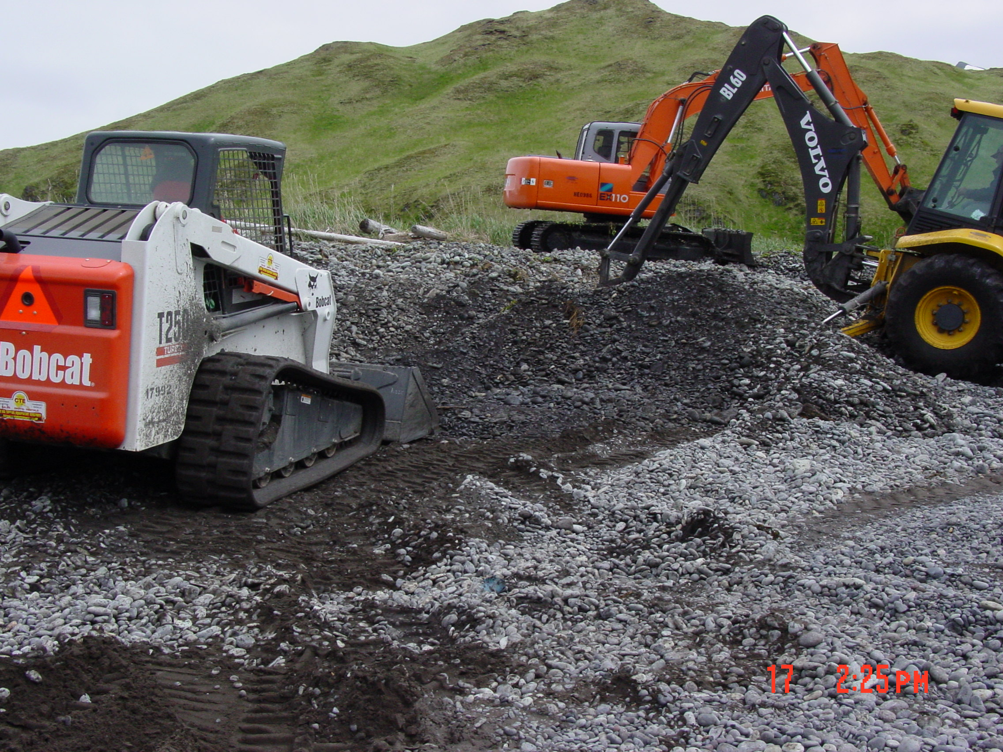
(photo taken by ADEC)

They were identified to the Trustees as being marine ecologists, biologists, and fisheries biologists with years of experience in Alaska and the Pacific Northwest.
Responsible party representatives have suggested that the reduction in grazers could be due to smothering by the large quantity of soybeans deposited on the beach.
Responsible party representatives believe that the distribution of tar spots was less than 5% at this location.
Reported in Carls, Hudson, and Rice, 2008: Selendang Ayu oil risk to early life stage salom, preassessment data report.

