Coastal and Marine Ecological Classification Standard
Version III

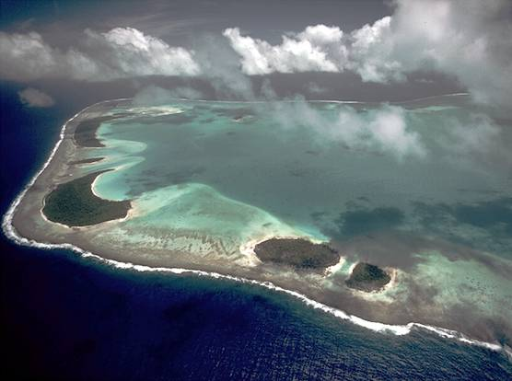

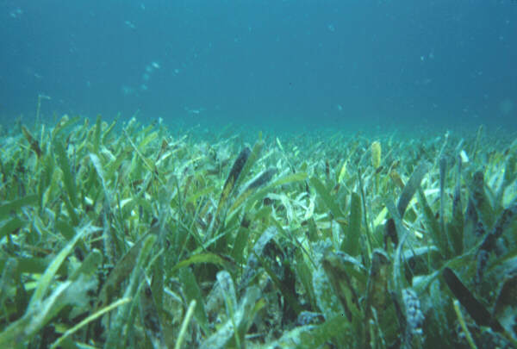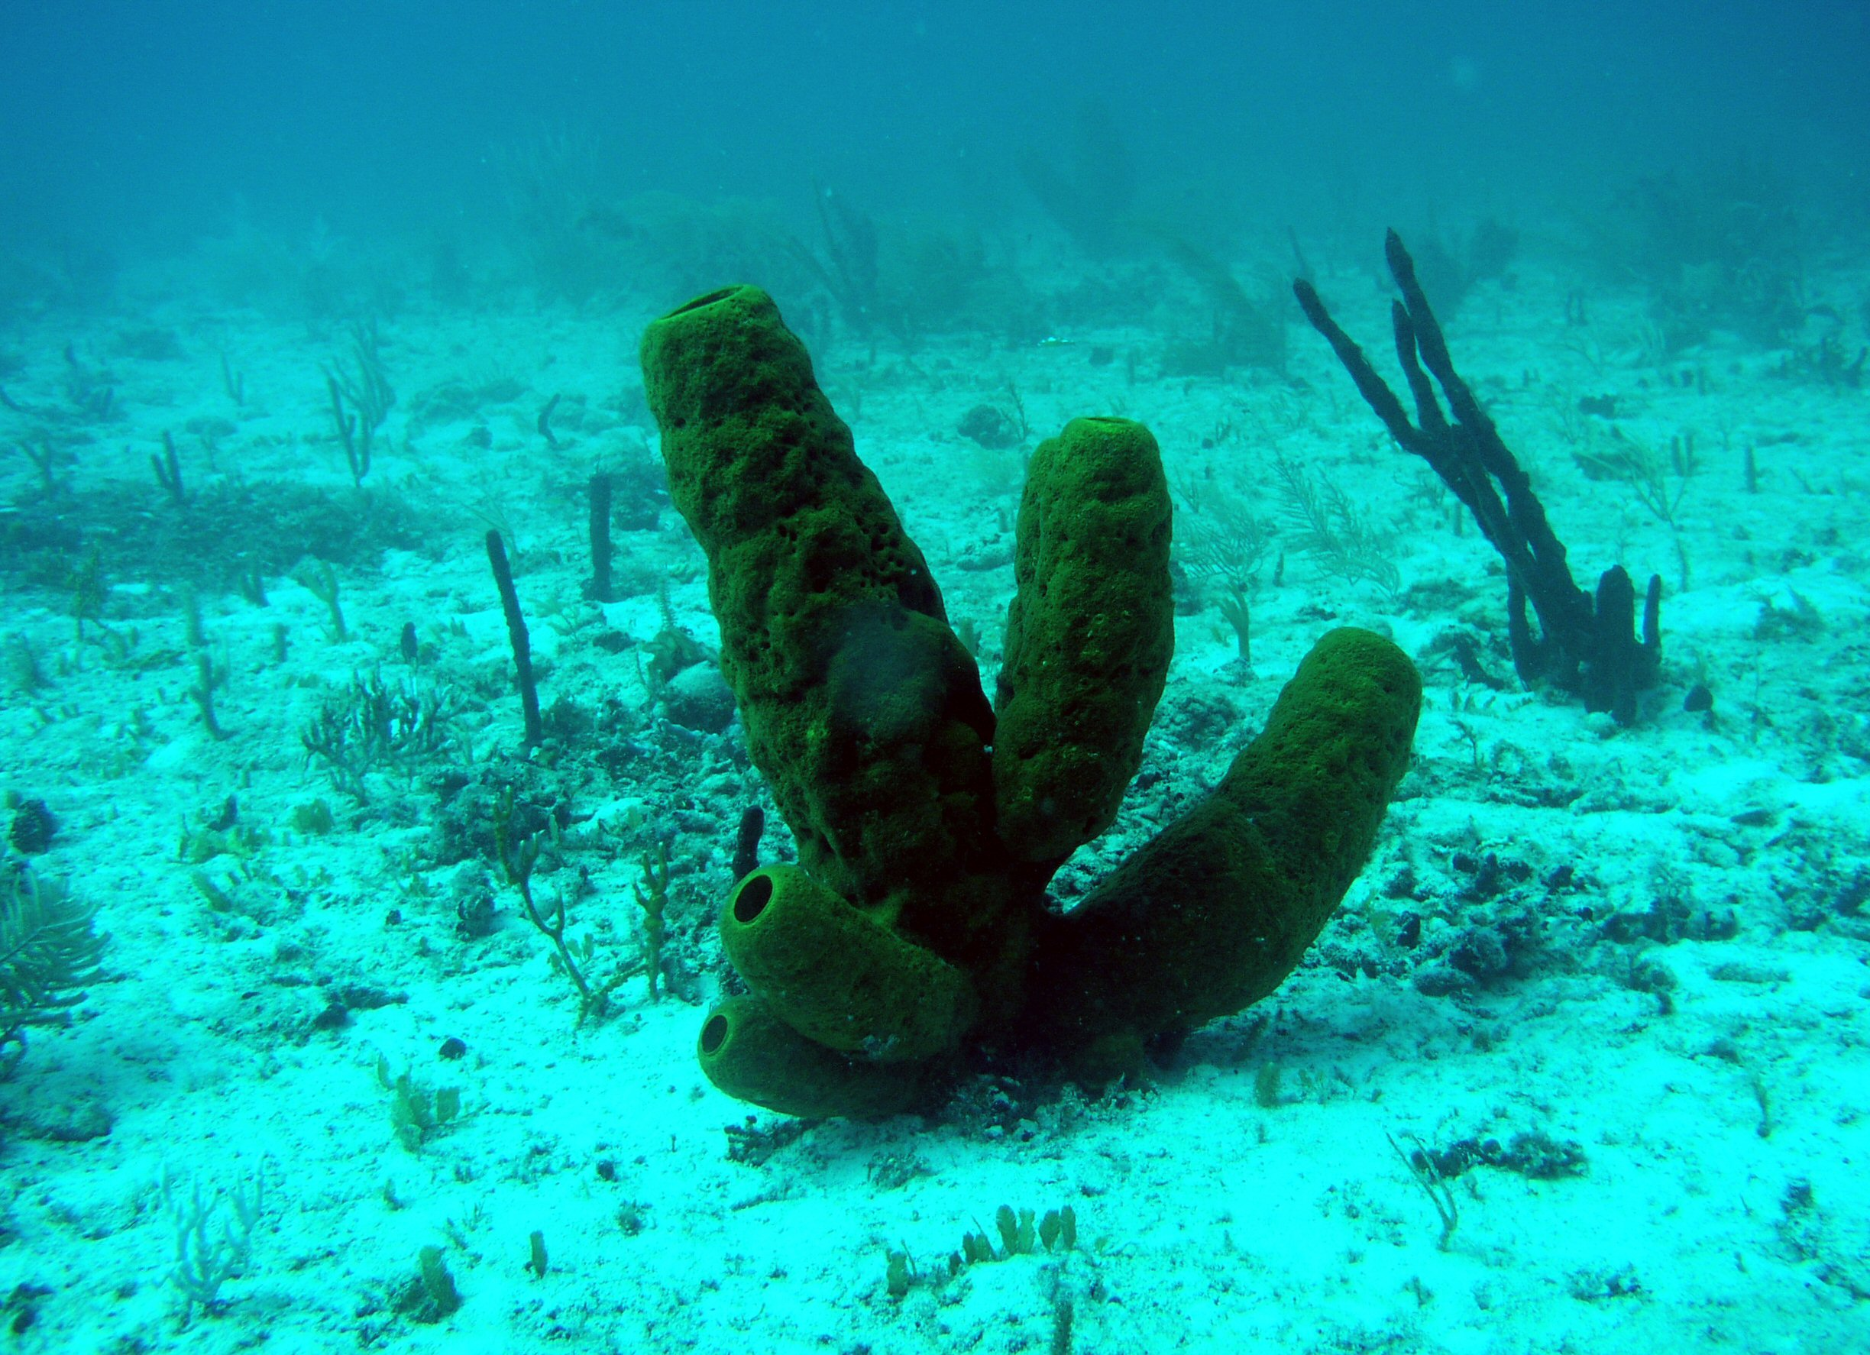




Front cover photos:
United States Department of Commerce NOAA. NOAA Central Library. NOAA Sanctuaries Collection. Paige Gill. Florida Keys National Marine Sanctuary.

United States Department of Commerce NOAA. NOAA CCMA Biogeography Team. Barrel, Tube Sponge [Upright/Erect Sponge] (Porifera btv. Spp

Citation: Madden, C, K. Goodin, B. Allee, M. Finkbeiner, D. Bamford. 2008. Coastal and Marine Ecological Classification Standard. NOAA and NatureServe. 77p

This work was supported in part with funding to NatureServe from the U.S. Environmental Protection Agency, Gulf of Mexico Program (Assistance Agreement MX 96473607-0) and the Organization of American States (Inter-American Biodiversity Information Network - Ecosystem Thematic Network).

NatureServe
1101 Wilson Boulevard, 15th Floor
Arlington, VA 22209
703-908-1800
www.natureserve.org

NOAA Coastal Services Center
2234 South Hobson Avenue
Charleston, SC 29405-2413
843-740-1200 (phone) • 843-740-1224 (fax)
www.csc.noaa.gov

Coastal and Marine
Ecological Classification Standard
Version III

Christopher J. Madden, Ph. D
Kathleen L. Goodin
Rebecca Allee, Ph.D.
Mark Finkbeiner
Danielle E. Bamford

Acknowledgements
Placeholder for final document.
Table of Contents

Acknowledgements 4
Executive Summary 6
Introduction 9
Guiding Principles 11
The Benthic Cover Component 13
System 14
Subsystem 17
Cover Type 18
Class and Subclass 18
Group 23
Biotope 26
The Water Column Component 27
System 27
Water Column Depth Zones 27
Water Column Structure 28
Macrohydroform 28
Mesohydroform 29
Lifeform 29
Biotope 30
The Geoform Component 31
Megageoform 32
Mesogeoform 32
Macrogeoform 33
Microgeoform 33
Anthropogenic Geoforms 34
Standard Attributes 35
Classifiers 35
Modifiers 35
Glossary 46
References 52
Literature Cited 53
Appendix A – Benthic Cover Component Units 56
Appendix B – Water Column Component Classifiers 59
Appendix C – GeoForm Component Classifiers 60
Appendix D – Standard Attributes 62
Appendix E - Comparison of CMECS Version III to CMECS Version II 64
Appendix F – Comparison of CMECS Benthic Component to FGDC Wetlands Classification Standard 73
Appendix G - Ecoregions for the United States 76

Executive Summary
Coastal and marine planners and managers are faced with a complex environment in which to make difficult decisions about habitat conservation and resource management. Given this complexity and recognizing the vastness of the marine environment for which the United States has jurisdiction, there is an urgent and increasing need for a national habitat classification approach that can be used to develop strategies for resource management and conservation. To meet this need the National Oceanic and Atmospheric Administration and NatureServe developed the Coastal and Marine Ecological Classification Standard (CMECS), a classification standard that is relevant to all U.S. coastal and marine environments and that can be applied on local, regional and continental scales. The classification provides a structure for synthesizing data so that habitats can be characterized and reported in a standard way, and information can be aggregated and evaluated across the national landscape and seascape. Built on existing classification efforts and informed by a series of technical meetings and workshops, the CMECS standard integrates the current state of knowledge about ecological and habitat classification. The result is an ecosystem-oriented, science-based framework to allow effective identification, monitoring, protection, and restoration of unique biotic assemblages, protected species, critical habitat, and important ecosystem components.
A few of the many potential applications of the classification include:
• Development of a coastal marine biodiversity inventory for North America
• Delineation of regions for Marine Protected Areas and developing guidelines for their management
• Identification of important habitats and critical hotspots for conservation
• Identification of Essential Fish Habitat
• Formation of a scientific basis for the development, implementation and monitoring of ecosystem-based management strategies for coastal systems

Previous versions of CMECS (Madden et al. 2004, Madden et al. 2005) and a precursor (Allee et al 2000) were developed with the input of over 40 coastal and marine habitat experts. CMECS Version III is the product of further refinement with an added emphasis on mapping applications. Most changes in Version III were made to align CMECS with two Federal Geographic Data Committee Standards: 1) the Classification of Wetlands and Deepwater Habitats of the United States (Cowardin et al. 1979) – the federal standard for classifying and mapping wetland and deepwater habitats, and 2) The U.S. National Vegetation Classification – the federal standard for classifying vegetation (Jennings et al., in press, FGDC 2007). The resulting CMECS Version III standard is applicable on spatial scales of less than one square meter to thousands of square kilometers and can be used in littoral, benthic and pelagic zones of estuarine, coastal and open ocean systems.

CMECS Version III has three distinct components each describing a different aspect of the coastal and marine environment. Taken together, these components provide a structured way to organize information about coastal and marine habitats and a standard terminology for describing them. The fundamental component is the Benthic Cover Component (BCC). This hierarchical system describes the geomorphologic, physico-chemical and biological composition of the coastal and marine substrate. The Water Column Component (WCC) describes the structure, patterns, processes and biology of the overlying water column. The Geoform Component (GFC) describes the major geomorphic or structural characteristics of the coast and seafloor at various scales. The flexibility of the CMECS classification standard will support a variety of local and regional applications.

In addition to the three components, CMECS provides a list of standard attributes -- a consistent set of variables that provide the basis for classification and description of the CMECS units. When required to define a unit, these standard attributes are called “classifiers”. When used to further describe a unit, these standard attributes are called “modifiers”. Standard attributes provide a consistent standard for data collection and application

Specifically, the Benthic Cover Component (BCC) classifies geologic and biotic cover of the substrate at different spatial scales and places the associated biology in the context of the physical habitat. This component is organized into a branched hierarchy of seven nested levels which correspond to both functional ecological relationships at progressively smaller spatial scales. The BCC branches into five Systems (nearshore neritic, oceanic, estuarine and freshwater influenced) at the highest level based on salinity, depth and enclosure and two Subsystems defined by tidal regime (i.e., intertidal or subtidal). Each Subsystem further divides into Classes (e.g. coral reef, aquatic bed) and then Subclasses (e.g. spur and groove reef, rooted vascular vegetation), largely adopting the values in the FGDC wetland classification standard (Cowardin et al. 1979). Groups are defined within the Subclasses based on factors that reflect the variance in biotic composition of the Biotopes. Biotopes represent broad biological associations identified by dominant or diagnostic species that are fixed to the substrate.

The Water Column Component (WCC) describes the structure, pattern and processes of the water column. While highly variable spatially and temporally, conceptually the water column is composed of repeating structures and processes that strongly influence the distribution and condition of the biota. This classification component employs seven classifiers. The WCC classifiers can be used alone or in combination to describe the structure and composition of the water column – the classification of the water column is not strictly hierarchical. The first category, System, is the same as that of the BCC and should always be used to put the water column units into the same context as the BCC. Additional classifiers address depth (vertical zonation), structure (upper and lower water column), macrohydroform (e.g., major ocean currents, large coastal fronts) mesohydroform hydrographic features (e.g. waves), dominant lifeforms and biotopes. Because of its dynamic and three-dimensional nature, the water column can be a challenge to map. The WCC is intended to be mapped independently of the other components of the classification standard to provide information on distinct water column ecological units as necessary. However, it can be overlain on the BCC and GFC components to help users understand the vertical component of the marine environment.

The Geoform Component (GFC) describes the structure of the coastline and sea floor at multiple scales. A Geoform is equivalent in concept to a terrestrial landform (e.g., mountain, butte, moraine etc) and likewise varies in scale from very large (e.g., seamount, embayment) to very small (e.g., tidepool, sand ripple). Geoforms shape the large scale seascape in repeatable and predictable ways by providing structure, channeling energy flows, regulating bioenergetics, and controlling transfer rates of energy, material and organisms. The morphology of these features controls such processes as water exchange rates and water turnover times, hydrologic transport, energy and nutrient cycling, shelter and exposure and migration and spawning patterns. The framework for the GFC is based largely on the structure described by Greene et al. (2007), but expands it and re-organizes some options to encompass a larger number of coastal and nearshore features. As with the WCC, the GFC is intended to be mapped as a separate layer from the BCC. When overlain on the BCC, the GFC layer can provide additional insight into how benthic patterns vary with the structure of the substrate. GFC types may also be used independently when information on structure is required to meet the objectives of a given project.

Each component of the classification is in different stages of development. The BCC framework is complete and all types though from System through the Subclass level have been identified and described. The concepts of the Group and Biotope level have been developed, but additional work is needed to identify and describe the units within these levels. Some Group and Biotope units listed in this document are considered “draft” and may be subject to modification as the standard is applied at local levels. The framework of the GFC is also complete, but additional work may be needed to identify and describe the units at all levels. The framework of the WCC is in the process of being reviewed and refined and additional work will be completed to develop the rules for combining the classifiers to identify and describe the water column units.

Introduction

Coastal and marine planners and managers are faced with a complex environment in which to make difficult decisions about habitat conservation and resource management. Given this complexity and recognizing the vastness of the marine environment for which the United States has jurisdiction, there is an urgent and increasing need for a national habitat classification approach that can be used to develop strategies for resource management and conservation. To meet this need NOAA and NatureServe developed the Coastal and Marine Ecological Classification Standard (CMECS), a classification standard that is relevant to all U.S. coastal and marine environments and that can be applied on local, regional and continental scales. The continuing goal of the CMECS standard is to permit the classification of ecological and habitat units within a simple standard format that uses a common terminology. This is intended to allow effective identification, monitoring, protection, and restoration of unique biotic assemblages, protected species, critical habitat, and important ecosystem components. This classification standard will provide a standard protocol for identifying and naming both new and existing ecological types.

Previous versions of CMECS (Madden et al. 2004, Madden et al. 2005) and a precursor (Allee et al. 2000) were developed with the input of over 40 coastal and marine habitat experts. CMECS Version III is the product of further refinement with an added emphasis on mapping applications. Most changes in Version III were made to align CMECS with two Federal Geographic Data Committee Standards: 1) the Classification of Wetlands and Deepwater Habitats of the United States (Cowardin et al. 1979) – the federal standard for classifying and mapping wetland and deepwater habitats, and 2) The U.S. National Vegetation Classification – the federal standard for classifying vegetation (Jennings et al., in press, FGDC 2007). See Appendix E for a discussion of the differences between Version II and Version III and the relationship between Version III and the wetland and vegetation standards.

CMECS Version III has three distinct components each describing a different aspect of the coastal and marine environment. Taken together, these components provide a structured way to organize information about coastal and marine habitats and a standard terminology for describing them. The fundamental component is the Benthic Cover Component (BCC). This hierarchical system describes the geologic and biotic composition and cover of the coastal and marine substrate [example types include Unconsolidated Bottom – Sand, Spur and Groove Reef, and Rooted Vascular Vegetation (=seagrass bed)]. The Water Column Component (WCC) describes the structure, patterns and processes of the overlying water column (example types are defined by depth, water column structure, hydrologic formation and biotic composition). The Geoform Component (GFC) describes the major geomorphic or structural characteristics of the coast and seafloor at various scales (example units include abyssal plain, seamount, delta, and beach).

The three component systems can be used alone or together depending on user needs.
The BCC is the primary component of CMECS and should be the starting point and reporting standard used for projects that require inventory, classification, description or mapping of benthic communities. The GFC can be used to provide additional structural information to augment the information in the BCC. The GFC is intended to be mapped as a separate layer from the BCC. When overlain on the BCC, the GFC layer can provide additional insight into how benthic patterns vary with the structure of the substrate. GFC types may also be used independently when information on structure is required to meet a given project’s objectives. Likewise the WCC is intended to be mapped independently from the other components of the Standard to provide information on distinct water column ecological units. It can be overlain on the BCC and GFC components to help users understand the vertical component of the marine environment. Application of these three components over time will help users better understand interactions and patterns of covariance among them.

In addition to the three components, CMECS provides a list of standard attributes -- a consistent set of variables that provide the basis for classification and description of the CMECS units. When required to define a unit, these standard attributes are called “classifiers”. When not required for classification, but used to further describe a unit, these standard attributes are called “modifiers”. Standard attributes provide a consistent standard for data collection and application.
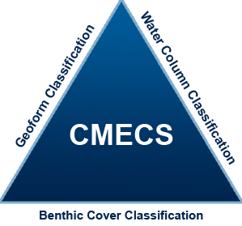

The domain of CMECS Version III extends from land within the tidal splash zone and continental waters where ocean derived salts measure more than 0.5 PSU (Practical Salinity Units), seaward to the deep ocean. It encompasses estuaries, tidal wetlands, euhaline and oligohaline rivers, anchialine lakes, shorelines, islands, the intertidal zone, the benthic zone and the entire water column from the coast to the deep ocean.

Guiding Principles
Meet National, Regional and Local Needs
Most existing classification systems have been developed for regional or local applications. The operative scales of these classifications, from tens of meters to thousands of meters, reflect the scale at which many state agencies monitor and manage resources. These local and regional classifications do not readily support the comparison of results across different systems, habitats and classifications nationally. A national classification standard incorporates the knowledge provided by local classifications and allows aggregation and assessment across diverse systems.

CMECS was designed to operate at different spatial scales that may address different objectives. For example, a federal management agency seeking to identify and catalog the benthic habitats of the large estuaries in North America can restrict its analysis to the upper four levels of the benthic classification hierarchy. A local agency classifying habitats within a single estuary may want to use the bottom two or three levels of the benthic classification hierarchy. Using CMECS as a common standard, both agencies will be able to organize and compare results using a unified vocabulary within a common and interoperable data framework. The framework provides the end-user with the tools to build the bottom levels of habitat and biology into the larger conceptual framework and into a database catalog of types.

Build on Existing Work
A goal of CMECS is to integrate both existing data and ongoing data collection efforts to ensure that existing data and knowledge are reflected in the standard. Few continental-scale classifications currently exist. Examples include the EUNIS system in Europe (EEA 1999, Connor 1997), the Integrated Marine and Coastal Regionalization for Australia (IMCRA 1998), the Classification of Wetlands and Deepwater Habitats of the U.S. (Cowardin et al. 1979) and the NOAA classification draft (Allee et al. 2000). CMECS incorporates portions of and articulates with these existing coastal and marine classifications where appropriate. Concepts, units and definitions from these and other classification frameworks such as the classification of potential marine benthic habitats by Greene et al. 2007, and the NOAA Coral Classification (U.S. National Oceanic and Atmospheric Administration 2001) provide input to this classification. CMECS also draws on the concepts identified in other state-level classifications such as the SCHEME system in Florida (Madley et al. 2002) and that of Dethier (1990) for the state of Washington.

Create an Ecological Classification
CMECS was developed to provide a comprehensive approach to classify repeating, ecologically meaningful habitats – similar to the Linnaean goal of classifying and describing all species on earth. CMECS units (especially lower level units on the scale of a few meters) are not solely defined based on whether they can be identified from remote imagery or other currently available sensing technology. However, the mapping of CMECS units will be one of the primary applications of the system, and each classification unit represents a measurable space and can be ascribed to a specific place in the marine realm with defined geographic boundaries. The “mappability” of each classification unit has been considered during the process of defining the unit, and ease of mapping application was accommodated wherever possible. Because current mapping technology is limited in the details that can be interpreted, in situ data collection may be required for identifying and mapping the lower level types.

Allow for a Dynamic Content Standard
CMECS Version III will provide a catalogue of accepted standard types. The classification structure, content, and definitions will grow and evolve with use of the classification and associated development of new information. Following the model of the FGDC vegetation standard, CMECS will be a dynamic content standard (FGDC 2007). The overall structure and format will remain relatively stable, but a formal peer review process will be established for submitting new types for acceptance into the standard.

Provide Modifiers to Meet Individual Needs
CMECS was developed for application at both national and local scales. Local users may be interested in tracking a finer level of detail on a particular unit than is provided in the standard catalogue of types. To meet this need, CMECS provides a standard list of modifiers that allows users to further parse standard types at any level of the hierarchy based on such qualities as substrate, energy, salinity, turbidity or characteristic structural components. This will provide flexibility to local users while allowing them to report on the standard types to meet national-level reporting needs.

Document Terminology
A glossary of terms representing the official classification nomenclature is an integral part of the classification standard. Universally recognizable and accepted terms for classification descriptors are used, and they replace or translate local vernacular or popular usages.

The Benthic Cover Component
The benthic component of CMECS is a classification of the geologic and biotic cover of the substrate at different spatial scales and places the associated biology in the context of the physical habitat. The benthic component is organized into a branched hierarchy of seven nested levels (Figure 1). The levels correspond to both functional ecological relationships and progressively smaller map scales from the order of 1:1,000,000 (System) to the order of 1:1 (Group/Biotope). The classification branches into five Systems at the highest level based on salinity, depth and enclosure. Subsystems are defined by tidal regime (i.e., intertidal or subtidal). Each Subsystem further divides into Classes and then Subclasses, largely adopting the values in the FGDC wetland classification standard (Cowardin et al. 1979) (although some definitions have been modified to accommodate uniquely marine characteristics – see Appendix A). The Groups include factors or groups of factors within subclasses that collectively reflect the ecological function and biotic composition of the Biotopes. Biotopes represent broad associations identified by dominant or diagnostic species that are fixed to the substrate.

See Appendix A for a table of the BCC and Appendix D for a table of Standard Attributes.

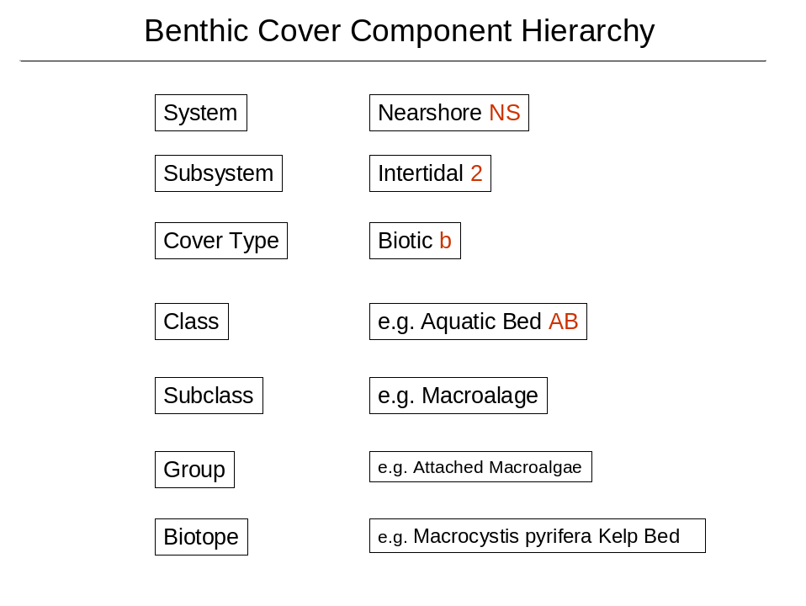

Figure 1. The CMECS Benthic Cover Component Hierarchy, an overview. The left side depicts the levels of the hierarchy. The right column highlights an example classification.

System
Systems are differentiated from one another by a combination of salinity, geomorphology and depth. Salinity is first used to separate the truly marine systems from those influenced by freshwater. Three systems, Nearshore, Neritic and Oceanic, are truly marine -- all having salinities greater than 30 PSU throughout the year (Figure 2). They are distinguished from each other by depth and relative distance from the continental shelf. Two Systems, Estuarine, and Freshwater Influenced, are at least occasionally diluted (<30PSU) by significant freshwater input during the year. The Estuarine and Freshwater Influenced Systems are distinguished from each other by the degree of enclosure by land.

Nearshore
Nearshore Systems are truly marine in character (> 30 PSU throughout the year). The Nearshore System extends from the land margin to the 30 m depth contour. The proximity of land and nearshore processes strongly influences waters and benthos of these systems although the biota and physics are marine. In these systems, water column and benthic processes are strongly coupled to each other. The vertical circulation of the water column generally distributes bottom nutrients and sediments throughout the water column and the photic zone generally extends through a significant portion of the entire water column. This supports the growth of vegetation on the bottom, and so seagrass and macroalgal beds are often found in these systems.

Neritic
The Neritic System is also truly marine (> 30 PSU throughout the year) and extends from the 30 m depth contour to the continental shelf break, which occurs at approximately at 200 m (150 m – 300 m) water depth. The seaward boundary is at the shelf break, regardless of depth. Neritic waters and benthos are less coupled to terrigenous processes and more strictly marine in character. Depending on shelf morphology, waters at the 30 m isobath can be quite distant from the continent or they may lie relatively close to land. For example in waters offshore of South Carolina and Georgia, the 30 m isobath can be more than 30 mi offshore in some places while the Neritic System along the south Florida coast occurs within five miles of shore. These systems are strongly influenced by deep ocean biogeochemistry and physical processes and their water columns and benthos are less physically coupled, often reflected in distinct surface and bottom water layers. Because these waters are less influenced by coastal inputs, they are generally clearer than in Nearshore systems and light penetration in Neritic systems can reach significant depths and often the ocean bottom.

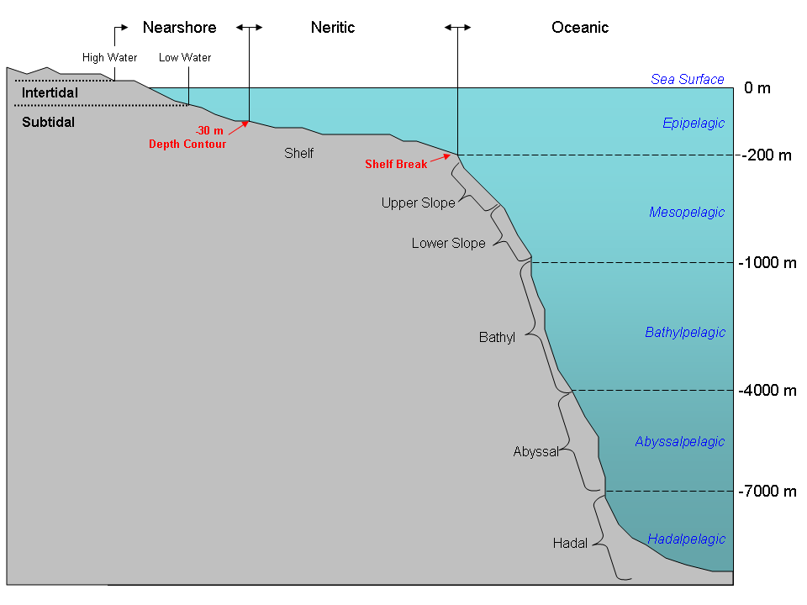
Figure 2. Relationship between Water Column Depth Zones and Benthic Environment. Modified from McGraw-Hill Companies, Inc.

Oceanic
The Oceanic System has true marine salinity levels (> 30 PSU- although oceanic salinity is typically 35 PSU) and represents the marine realm beyond the continental shelf break, which generally occurs at 150m-300m depth. Water depth in these systems can range to several thousand meters. The boundary created by the depth discontinuity at the shelf break establishes strong and identifiable constraints on the processes in the system and represents a logical breakpoint in the classification for the division of major marine Systems. The marine waters of the Oceanic System are sufficiently distant from land that they receive little or no influence of fresh water, nutrient and sediment inputs, except around islands. With great depth, the sea bottom diminishes in importance in influencing pelagic processes and there is little or no interaction of ocean bottom with the vast majority of the overlying water column. Light is greatly attenuated within the water column and does not reach the bottom. Surface waters do not mix to the bottom and an upper mixed layer is separated from bottom waters by a density gradient or pycnocline generated by a strong temperature or salinity differential. In the case of oceanic islands where a continental shelf is absent, the island itself possesses a Nearshore System to a depth of 30 m and a Neritic System to a depth of 200 m. The Oceanic System is defined in the case of steep-sided islands to begin beyond the shelf break if applicable or where water depth exceeds the 200 m depth contour.

Estuarine
The Estuarine System consists of tidal habitats and adjacent tidal wetlands with water that is at least occasionally diluted by freshwater runoff from the land (<30PSU) and is at least partially enclosed by land but has open, party obstructed, or sporadic access to the open ocean. The salinity may be periodically increased above that of the open ocean by evaporation. The Estuarine System extends upstream and landward to where ocean derived salts measure less than 0.5%◦ during the period of average annual low flow and seaward to an imaginary line closing the mouth of a river, lagoon, fjord or embayment.

The geomorphology and hydrology determine the degree of the physical enclosure, which in turn impacts the residence time for water within an estuary and the steepness of biological, physical and chemical gradients between terrestrial and marine end members. The degree of enclosure defines Estuarine Systems, and establishes a degree of temporal, chemical, biological and ecological distinctiveness from marine waters and biogeochemistry. A river flowing directly into the ocean is very different than a coastal Estuarine System that slowly discharges into the ocean.

Estuarine Systems can occur on the continental land mass or on islands in waters of any depth, provided they have sufficient enclosure and significant freshwater flow. Although they are coastal features by definition, many Estuarine Systems have water depths much greater than 30 m. In parts of the Puget Sound, Chesapeake Bay, and San Francisco Bay, the 30 m isobath is contained within the enclosed area of the estuary, and central channels can be much deeper than 30 m. All areas within the enclosed morphology that generally defines the estuary are classified as Estuarine, regardless of depth. The depth of an estuarine water column can be significantly greater than 30 m and retain the characteristics of an estuary.

Freshwater Influenced
Freshwater Influenced Systems are systems that have no distinct enclosing morphology, yet receive a significant amount of fresh water input from land during at least part of the year (<30 PSU). In such cases, an unenclosed marine water column may be influenced by fresh water in the form of an active river plume, direct freshwater runoff, diffuse non-point runoff, an advected fresh water lens, mesohaline coastal water mass or a ground water seep discharge. The Freshwater Influenced Systems can occur in waters of Nearshore or Neritic depths, provided the region is influenced by fresh water that reduces salinity to below 30 PSU. These systems are more spatially and temporally variable than others, strongly influenced by seasonal outflow from rivers, true estuaries or land and ocean currents (Figures 3 and 4). Because of the frequently stratified nature of waters in this class, Freshwater Influenced Systems may spatially overlay water of true marine salinities (Nearshore).
Figure 4. Mississippi River plume in the Gulf of Mexico. An example of a Freshwater-influenced Regime.

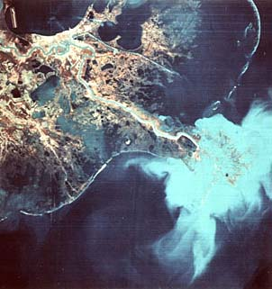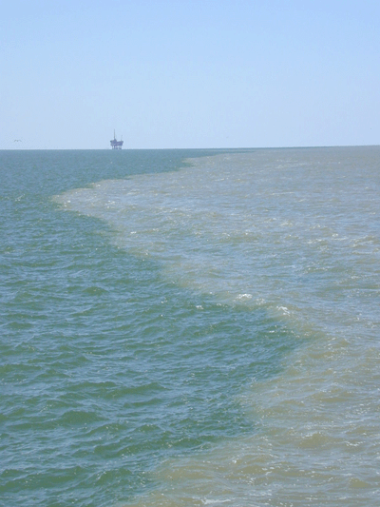
Figures 3 and 4. Mississippi River plume in the Gulf of Mexico. Freshwater plume edge.

Subsystem
The Subsystems are defined by their tidal regime.

Subtidal – The substrate is continuously submerged relative to the extreme low tide line.

Intertidal – The substrate is regularly and periodically exposed and flooded by tides. This zone includes the supratidal zone -- the area above the high tide line in the splash zone that is affected by spray, splash, aerosols and overwash. This interface is regularly exposed to the air by tidal movement. Aquatic organisms inhabiting these physically energetic habitats are adapted to periods of exposure to the air and to wave action. Included in these subsystems is the region of non-tidal wetlands and uplands that are periodically saturated by saline waters at or above the soil surface.

Cover Type
Cover is determined by the percent cover of biota.

Biotic Cover - A substrate characterized by a growth, colonization, or encrustation of vegetation or epifauna with greater than 10 % cover.

Abiotic Cover - Abiotic substrate features are dominant. Less than 10% of the substrate is covered with either vegetation or epifauna (infauna may be present at any density).

Class and Subclass
Classes and Subclasses are determined by the dominant (in terms of percent cover) geologic or biotic cover of the substrate. For Classes defined by biota, Subclasses are defined by either structure (for coral reefs) or dominant lifeforms or taxa (for all other classes). For all Classes defined by geologic substrate, the Subclasses are defined by the composition and particle size of the substrate. Class and Subclass definitions largely follow that of the FGDC Wetland Standard (Cowardin et al. 1979). See Appendix F for a discussion of departures from the wetland standard. Reef Subclasses are largely based on the NOAA Coral Classification (U.S. National Oceanic and Atmospheric Administration 2001).

Mollusc Communities - Ridge-like or mound-like structures or beds formed by the colonization and growth of mollusks. These classes occur in both the intertidal and subtidal subsystems.

Bivalve Bed/Reef - Ridge-like or mound-like structures formed by the colonization and growth of bivalve mollusks.

Gastropod Bed/Reef - Gastropod reefs or beds consist of consolidated aggregations of living or dead gastropod mollusks, usually those of the vermetidae and turritellidae families.

Worm Reefs and other Worm Communities - Areas dominated by worm species including structures formed by the colonization and growth of Sabellariid worm species, tube worms as well as burrowing worms that form above ground structures. These classes occur in both the intertidal and subtidal subsystems.

Worm Reefs - Ridge-like or mound-like structures formed by the colonization and growth of Sabellariid worm species.
Tube Worms –Areas dominated by tube forming worms.

Coral Reefs and other Coral Communities – Includes ridge-like or mound-like structures formed by the colonization and growth of hard coral species as well as assemblages of non reef-forming hard corals, soft corals and associates such as sponges and hydroids. These environments occur in both the intertidal and subtidal subsystems.

Spur and Groove Reef - A system of shallow ridges (spurs) separated by deep channels (grooves) oriented perpendicular to the reef crest and extending down the upper seaward slope.

Patch Reef(s) - Coral formations that have no organized structural axis relative to the contours of the shore or shelf. A surrounding halo of sand is often a distinguishing feature of this habitat type when it occurs adjacent to submerged vegetation.

Linear Reef - A linear coral formation that is oriented parallel to the shore or the shelf edge.

Aggregate Reef – Reef with high relief, lacking the sand channels of the spur and groove reef.

Reef Rubble - Dead, unstable coral pieces. This habitat often occurs landward of well-developed reef formations in the reef crest or back reef zone

Deep Coral Reef - Non-photosynthetic coral formed in deep waters averaging 70-1000 m. Deep-water coral reefs typically consist of thickets of live coral atop unconsolidated sediment and coral rubble, usually on an underlying rock base structure. Deep reefs are found in strong currents or upwelling zones.

Scattered Coral/Rock - Scattered rocks or small, isolated coral heads that are too small to be delineated individually (i.e., smaller than individual patch reef).

Coral Garden - Aquatic beds dominated by non-reef forming soft corals, sponges or other sedentary or attached macro-invertebrates. Scattered hard corals may be present, but not dominant. Seagrass cover less than 10%.

Aquatic Bed (= Submerged Aquatic Vegetation) – Subtidal or intertidal bottoms vegetated by communities of a dominant type of greater than 10% vascular plant, macroalgae, or microorganism and its associated biota. Bed organisms are obligately hydrophytic but can withstand periods of exposure to air.

Macroalgae – Aquatic beds dominated by macroalgae such as kelp, fucoids and other seaweeds.

Rooted Vascular (=seagrass bed) – Aquatic beds dominated by submerged rooted vascular species such as seagrasses (Figure 5).
Figure 5. Tropical rooted vascular seagrass bed. Florida Keys National Marine Sanctuary.

Microbial Mat - Microbial mats are colonies of microscopic organisms including benthic microalgae such as diatoms, as well as photosynthetic and chemoautotrophic bacteria that form a film on the surface of the sediment either subtidally or subaereally (Figure 6). There may be high levels of biotic diversity within microbial mats. Microbial mats are often encountered in extreme environments where grazing pressure is reduced. They can be observed from the high intertidal zone to deep sea areas around thermal vents.

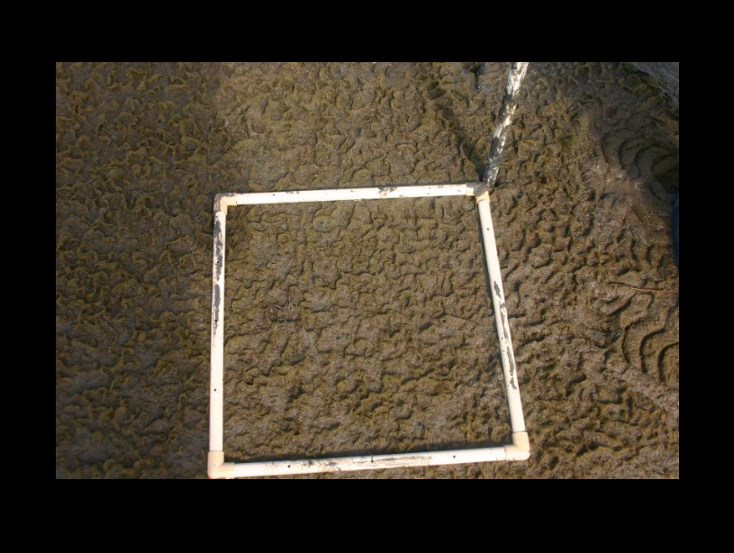
Figure 6. Microbial Mat. Tidal flat Humboldt Bay, California.

Emergent/Low Shrub Wetland – The emergent/low shrub wetland class is characterized by erect, rooted, herbaceous hydrophytes and low shrubs. These wetlands are usually dominated by perennial plants and the emergent vegetation is present for most of the growing season in most years. Though the FGDC wetland standard identifies many types of emergent wetland types, only the coastal marshes and shrublands are saltwater influenced and therefore the only emergent wetlands included in this classification. These environments occur only within the intertidal subsystem.

Coastal Marsh (=salt marsh) - Communities dominated by emergent herbaceous halophytic vegetation along low-wave energy intertidal areas and river mouths. Low shrubs may be present.

Tidal Shrubland – Communities dominated by low shrub halophytic vegetation along low-wave energy intertidal areas and river mouths.

Forested Wetland – The forested wetland class is characterized by areas dominated by tree species (i.e., single stemmed woody plants). Areas dominated by tree seedlings, saplings and dwarf trees are placed in this Class. Though the FGDC wetland standard identifies many types of forested wetlands, only the mangroves are saltwater influenced and are therefore the only forested wetlands included in this classification. These environments occur only within the intertidal subsystem.

Mangrove - Tidally influenced, dense, low forests dominated by true mangroves and associates (Figure 7). Non-tidal basin wetlands are out of the scope of this classification. See the USNVC for classification of these communities.

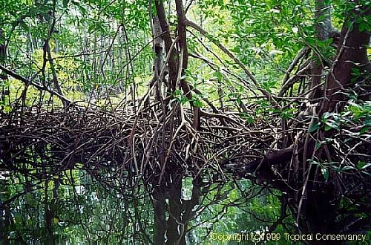
Figure 7. Red mangrove forest

Rock Bottom – Subtidal benthic substrates having a cover of large rocks, boulders, pavement or bedrock 75% or greater and vegetative cover of less than 10%.

Bedrock – Substrate with bedrock covering 75% or more of the surface and less than 10% aerial coverage of macrophytes.

Pavement - Substrate has less than 75% aerial cover of bedrock, but pavement -- flat, generally unbroken hard bottom substrate formed by deposition and consolidation of soft material and overlying a deeper bedrock substrate -- alone or in combination with bedrock cover 75% or more of the area.

Boulder/Rubble – Substrate has less than 75% aerial cover of bedrock, but stones and boulders (>257 mm) alone or in combination with bedrock cover 75% or more of the area. Coverage of macrophytes is less than 10%.

Unconsolidated Bottom – Subtidal benthic substrates having at least 25% cover of particles smaller than stones, and a vegetative cover less than 10%.

Cobble/gravel - Greater than 50% of the unconsolidated particles smaller than stones are cobble/gravel (grain size 2-257 mm). Shell fragments, sand and silt often fill the spaces between the larger particles. Stones and boulders may be found scattered on some cobble-gravel shores or benthos.

Sand – Greater than 50% of the unconsolidated particles smaller than stones are sand (particles 0.07-2mm) which may be either calcareous or terrigenous in origin.

Mud – Greater than 50% of the unconsolidated particles smaller than stones are silt and clay or carbonate mud (grain size <0.07 mm). Anaerobic conditions often exist below the surfaces and often have a higher organic content than cobble-gravel or sand shores or benthos. Mud may include:
Clay: fine mineral particulates of kaolin with high cohesiveness
Silt: very fine mud particles laid down after water transport and deposition
Carbonate muds: fine particulates of calcium carbonate with high cohesiveness

Organic - Unconsolidated substrate largely comprised of decomposing particles of dead plant and animal tissue.

Shell - Substrate that is dominated by and composed of small bits of broken shell remnants.

Mixed Sediments – No single unconsolidated substrate type represents more than 50% of the total composition.

Rocky Shore - Exposed intertidal shoreline characterized by bedrock, stones or boulders which singly or in combination have an aerial cover of 75% or more and an aerial coverage by vegetation of less than 10%.

Bedrock – Substrate with bedrock covering 75% or more of the surface and less than 10% aerial coverage of macrophytes.

Pavement - Substrate has less than 75% aerial cover of bedrock, but pavement -- flat, generally unbroken hard bottom substrate formed by deposition and consolidation of soft material and overlying a deeper bedrock substrate -- alone or in combination with bedrock cover 75% or more of the area.

Boulder/Rubble – Substrate has less than 75% aerial cover of bedrock, but stones and boulders (>257 mm) alone or in combination with bedrock cover 75% or more of the area. Coverage of macrophytes is less than 10%.

Unconsolidated Shore – Exposed intertidal unconsolidated shoreline having at least 25% cover of particles smaller than stones, and a vegetative cover less than 10%.

Cobble/gravel - Greater than 50% of the unconsolidated particles smaller than stones are cobble/gravel (grain size 2-257 mm). Shell fragments, sand and silt often fill the spaces between the larger particles. Stones and boulders may be found scattered on some cobble-gravel shores or benthos.

Sand – Greater than 50% of the unconsolidated particles smaller than stones are sand (particles 0.07-2mm) which may be either calcareous or terrigenous in origin.

Mud – Greater than 50% of the unconsolidated particles smaller than stones are silt and clay or carbonate mud (grain size <0.07 mm). Anaerobic conditions often exist below the surfaces and often have a higher organic content than cobble-gravel or sand shores or benthos. Mud may include:
Clay: fine mineral particulates of kaolin with high cohesiveness
Silt: very fine mud particles laid down after water transport and deposition
Carbonate muds: fine particulates of calcium carbonate with high cohesiveness

Organic - Unconsolidated substrate largely comprised of decomposing particles of dead plant and animal tissue.

Shell - Substrate that is dominated by and composed of small bits of broken shell remnants.

Mixed Sediments – No single unconsolidated substrate type represents more than 50% of the total composition.

Group
The Group level is defined by factors or groups of factors within subclasses that collectively reflect the ecological function and biotic composition of the biotope. These factors may be structural, positional, taxonomic, ecological or environmental and vary by Subclass. Some units within the Group level have been developed, additional work will be needed to identify and describe additional units within these levels. Some group types listed in this document are considered “draft” and are subject to modification as the standard is applied at local levels.

Scattered Hard Coral/Rock Subclass Groups

Scattered Hard Coral/Rock in Unconsolidated Sediment - Scattered rocks or small, isolated coral heads that are too small to be delineated individually (i.e., smaller than individual patch reef) occurring on cobble/gravel, sand, mud or mixed unconsolidated sediments.

Scattered Hard Coral/Rock in Hard Sediment - Scattered rocks or small, isolated coral heads that are too small to be delineated individually (i.e., smaller than individual patch reef) occurring on bedrock, pavement, boulders or other hard sediment.

Macroalgae Subclass Groups

Attached or Encrusting Algae - submersed non-vascular macrophyte vegetation attached to a hard substrate by a holdfast or root, e.g. Kelp (Fucus sp.) (Figure 8).

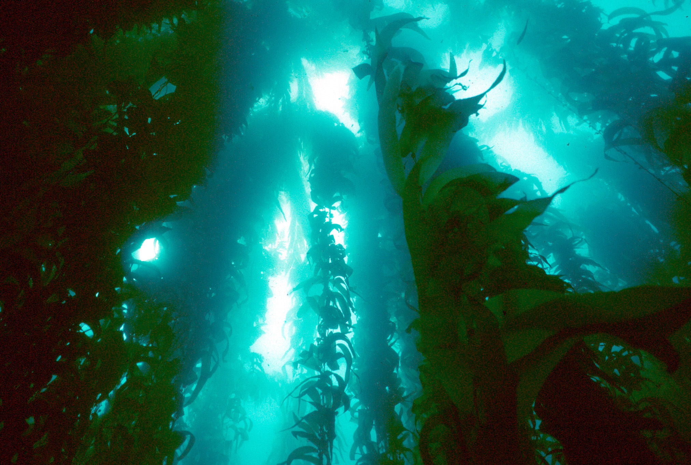
Figure 8. Attached Macroalgae; Giant kelp forest, coastal California.

Floating Algae- See water column component.

Drift Algae- Habitat with 10% or more cover of mixed or monospecific macroalgae that is not attached to the substrate (Figure 9).
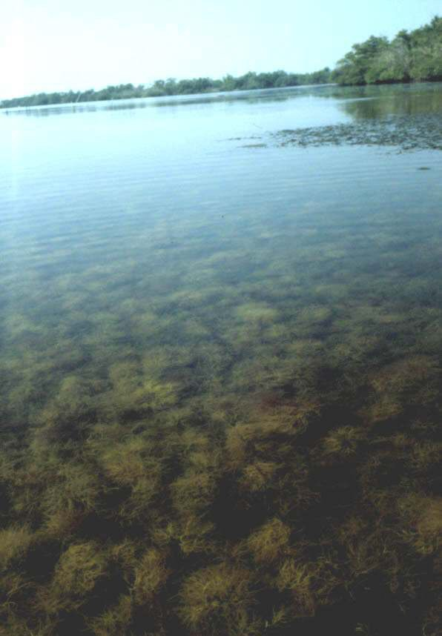
Figure 9. Drift macroalgae accumulated on top of seagrass meadow; Indian River Lagoon, Florida (Courtesy of St. John’s River Water Management District).

Organic Subclass Groups

Woody Debris - Softbottom or unconsolidated sediment characterized by the presence of coarse partially decomposed recalcitrant woody plant material from trees and shrubs.

Detritus - Fragments of dead organic, primarily soft plant material.

Ooze - Soft unconsolidated bottom material in the deep sea formed from the tests of deposited and partially decomposed phytoplankton. Types of oozes include globagarina, diatomaceous and siliceous.

Peat - Highly organic semi-consolidated substrate characterized by soft, compressible remnants of partially decomposed plant material with high humic content. The original plant material is generally dead emergent vegetation in a wetland environment that is prevented from fully decomposing by acidic and anaerobic conditions.

Shell Subclass Groups

Hash - Subtidal bottom sediments principally comprised of mollusc or bivalve shell fragments mixed with sand or mud.

Coquina Sediment - Unconsolidated intertidal/supratidal sediments consisting almost exclusively of broken shell fragments.

Rocky Shore Class/Boulder Subclass Groups
Potential Classes
No energy - No detectable waves or current motion
Low energy - Very weak currents (0-2 kn) or wave action (gentle swell)
Moderate energy - Wind waves or moderate tidal currents (2-4 kn)
High energy - Strong currents (>4 kn), oceanic swell, breaking waves

Biotope
A Biotope is a repeatable physical habitat and its biological associations. A Biotope is uniform in structure and environment, and is defined by conspicuous diagnostic species [i.e. those species whose relative abundance or constancy distinguish one association from another (FGDC 2007)]. The diagnostic species can include plants, attached sessile fauna and unattached but relatively non-motile fauna and bacterial colonies.

The biotope concept has been employed for several years in Europe and has been defined as the “physical habitat… and its community of animals and plants (Costello 2003).” The primary characteristic of the Biotope is the “high fidelity” relationship between the physical habitat and strongly associated diagnostic plant and animal species. Biotope occurrences have similar biotic composition and structure and must have diagnostic features that enable their recognition repeatably. A species is used to define and name a Biotope if it is conspicuous, dominant, or has a high constancy and is physically linked to the habitat. “Non-motile” is defined as an individual organism that cannot move beyond the frame of reference of the habitat unit boundary within one day. Epibenthic organisms like corals anemones, sponges, hydroids, and benthic infauna such as polychaetes can define a Biotope.

For habitats dominated by vegetation such as mangroves, coastal marshes and seagrass beds, the biotope is equivalent to the “Alliance” level of the National Vegetation Classification – “a vegetation classification unit defined on the basis of a characteristic range of species composition, diagnostic species occurrence, habitat conditions and physiognomy” (FGDC 2007).

The concepts of the Biotope level have been developed, but additional work is needed to identify and describe the types within these levels. Biotope types listed in this document are considered “draft” and are subject to modification as the standard is applied at local levels.

The Water Column Component
The Water Column Component (WCC) describes the structure, pattern and processes of the subtidal water column. While highly variable spatially and temporally, conceptually, the water column is composed of repeating structures and processes that strongly influence the distribution and condition of the biota. Because of its dynamic and vertical nature, the water column can be a challenge to map. For this reason, CMECS identifies the water column as a separate component of the standard that can be mapped independently from the BCC. In fact in many cases it will be preferable to map individual zones of the WCC as separate layers.

The WCC framework classifiers can be used alone or in combination to describe the structure and composition of the water column – the framework of the water column is not strictly hierarchical. The System is the same as that of the BCC and should always be used to put the water column types into the same context as the BCC. Water Column Depth provides a standard list of vertical depth zones of the water column. Water Column Structure provides an ecological zonation of the water column determined by water density differences caused by clines in temperature or salinity. Macrohydroform and Mesohydroform describe major hydrographic features at different scales. Generally, Macrohydroforms are large scale features associated with Neritic and Oceanic Systems and Mesohydroforms are smaller hydrographic features associated with Estuarine and Nearshore Systems. Lifeforms are groups of Biotopes defined by dominant lifeform such as phytoplankton, zooplankton, vegetation mats etc. Biotopes of the water column are repeating dominant floating or suspended taxa (usually genera or species). The framework of the WCC is in the process of being reviewed and refined and additional work needs to be completed to develop the rules for combining the classifiers to identify and describe the water column units.

See Appendix B for a table of the WCC and Appendix D for a table of the Standard Attributes.

System
System is also used as a primary attribute of the WCC. The definitions and values are the same as for the BCC. See System definitions above.

Water Column Depth Zones
The water column is divided into several vertical zones based on water depth.

Zone | Depth (m)
Sea Surface | 0
Epipelagic | > 0-200
Mesopelagic | 200-1000
Bathylpelagic | 1000-4000
Abyssalpelagic | 4000-7000
Hadalpelagic | >7000

Water Column Structure
The water column can be subdivided into an upper mixed layer and a bottom layer, separated by a pycnocline. This is often ecologically relevant in terms of habitat, although two layers are not always present. An important functional distinction is created by temperature or salinity differences in the upper and bottom layers of the water column. When present, the upper layer is separated from the lower layer by a difference in density, which results in a barrier to mixing between the layers. The two water layers define separate mixing zones and energy regimes, create barriers to movement of materials and fauna and create an interface where intense biological processes may occur. Stratified water masses are highly stable, and waters may maintain stratification for many months. Stratification is broken down usually on a seasonal or annual basis by wind or current energy input. In the case of thermally stratified water columns, breakdown is usually initiated by homogenation of the densities of the two vertically separated water masses by a convergence in their temperatures.

Upper water column layer - in a two-layer water column, the area above the sharp density gradient (pycnocline) which includes the air-water interface. Pycnoclines are generally formed by salinity or temperature differences between the upper and lower water layers and create effective barriers to transport across layers. The water layers remain largely distinct even having current regimes that flow in opposite directions in certain estuaries.

Pycnocline - The layer of rapid density transition between the upper and bottom layers.

Bottom water column layer- In a two-layer water column, the waters below the pycnocline or mixed layer compose the bottom water column layer.

Benthic boundary layer - A thin water layer just above the bottom that is strongly influenced by the benthos and distinct from the overlying waters. It is often characterized by sharp reduction in current speeds, a nephelitic turbidity layer and high rates of diffusive interaction with biogeochemical components in the sediments. This layer is often strongly associated with small benthic or demersal organisms.

Macrohydroform
Major hydrographic features of marine systems are called Macrohydroforms. Macrohydroforms are large physical features or boundaries created by water masses of 10,000 m² or larger in area. These are generally (but not exclusively) associated with the deeper waters of the Neritic and Oceanic Systems. Examples include major ocean currents (such as the Gulf Stream), large coastal fronts, the great ocean gyres and upwellings. Macrohydroforms represent hydrological environments that define large scale patterns in the composition and dynamics of both the smaller scale physical worlds contained within them and the biota associated with its divisions. While dynamic in nature, Macrohydroforms shape the large scale seascape in repeatable and predictable ways by providing structure, channeling energy flows, regulating bioenergetics, and controlling transfer rates of energy, material and organisms. See Appendix B for specific macrohydroforms.

Mesohydroform
Mesohydroforms are mid- to small scale hydrographic features generally associated with Estuarine and Nearshore Systems. See Appendix B for specific mesohydroforms.

Lifeform
Groups of Biotopes identified by dominant lifeforms or taxa.

Phytoplankton bloom – A high concentration of phytoplankton in an area, caused by increased reproduction (Garrison, 2005). Blooms reflect populations above the normal level for an area.
Floating microbial mat - Microbial accumulations that occasionally form on the water surface as a film or scum.

Floating vegetation mat - Accumulations of floating vascular plants. In the marine environment these can often consist of rafts of detached leaves and stems from either terrestrial or aquatic vegetation. As these rafts either sink or wash up on shore they become either detritus or wrack respectively.

Floating Vascular – Aquatic beds dominated by floating vascular species such as pondweeds (mostly occurring in the oligohaline areas of estuaries). May include rooted species that float on the surface (such as Lirio acuatica)

Phytoplankton maximum layer - A layer of the water column where phytoplankton have accumulated. These can be associated with thermoclines or other strata in the water column.

Drift macroalgae - Macroalgal accumulations suspended in the water column.

Floating macroalgae - Macroalgal accumulations at the surface. Often these are formed of algae specifically adapted for this environment such as Sargassum.

Zooplankton swarms - Large concentrations of zooplankton such as crustaceans and copepods that form in response to specific light, current, turbulence, and abundance conditions.

Zooplankton patches - Smaller accumulations of planktonic crustaceans, copepods, etc.

Jelly fish aggregations - Schools or large numbers of jellyfish within the water column.

Biotope
Biotopes of the Water Column are floating or suspended aggregations of biota and are defined by the dominant taxa (usually genera or species). Biotope patterns and distributions are determined by and associated with water column structure and dynamics. Motile, free-swimming or vagile faunal species are not included in the biotope. Biotopes for the Water Column Component will be determined as the standard continues in development.

The Geoform Component
The Geoform Component (GFC) describes the structure of the coastline and sea floor at multiple scales. A Geoform is equivalent in concept to a terrestrial landform (e.g., mountain, butte, moraine, etc.) and likewise varies in scale from very large (e.g., seamount, embayment) to very small (e.g., tidepool, ripple). Geoforms shape the large scale seascape in repeatable and predictable ways by providing structure, channeling energy flows, regulating bioenergetics, and controlling transfer rates of energy, material and organisms. The morphology of these features controls such processes as water exchange rates and water turnover times, hydrologic and energy cycling, shelter and exposure to energy inputs and migration and spawning patterns.

The framework for the GFC is based largely on the structure described by Greene et al. (2007), but expands the options to include a larger number of coastal and nearshore features. At the largest scale, Megageoforms (equivalent to Greene’s Megahabitat) are large structures that range from kilometers to 10’s of kilometers in size (e.g., Abyssal Plain, Seamount). The Mesogeoform (equivalent to Greene’s Mesohabitat) are structures that are 10’s of meters to kilometers in size (e.g., delta, embayment, lagoon) (Figure 10). The Macrogeoform (equivalent to Greene’s Macrohabitat) range in size from 1 m to 10’s of meters (e.g., coral head, rock outcrop). The Microgeoform ranges in size from centimeters to less than a meter (riffle, individual coral head). This level is slightly different from Greene’s Microhabitat in that it does not include substrate particles such as sand, gravel, and cobble because these attributes are included in the BCC of CMECS III. Because many of these general Geoform types can occur at multiple spatial scales (e.g., an island can occur from continental scale to the scale of several meters), the same Geoforms occur in more than one category. Where this occurs, it is modified with an indication of the scale at which it occurs (e.g. island (meso-scale). In addition to the natural geoforms from Greene we also include artificial structures that can be applied at any scale. The standard attribute categories are available to further describe geoform features.

Additional work is needed to identify and describe the types at all levels in the GFC. GFC types listed in this document are considered “draft” and are subject to modification as the standard is applied at local levels. See Appendix C for a table of the GFC and Appendix D for a table of the Standard Attributes.

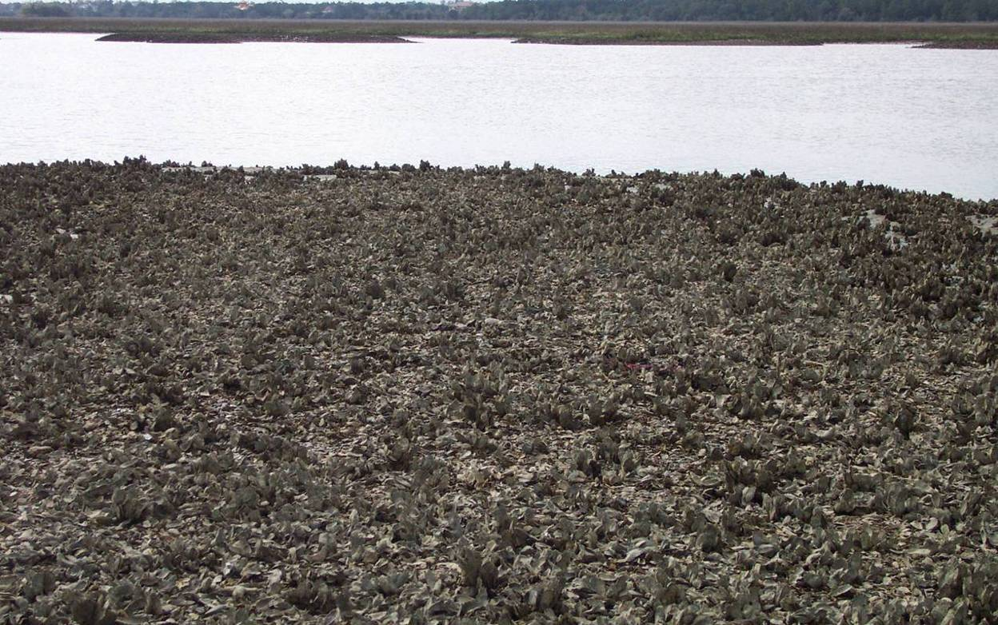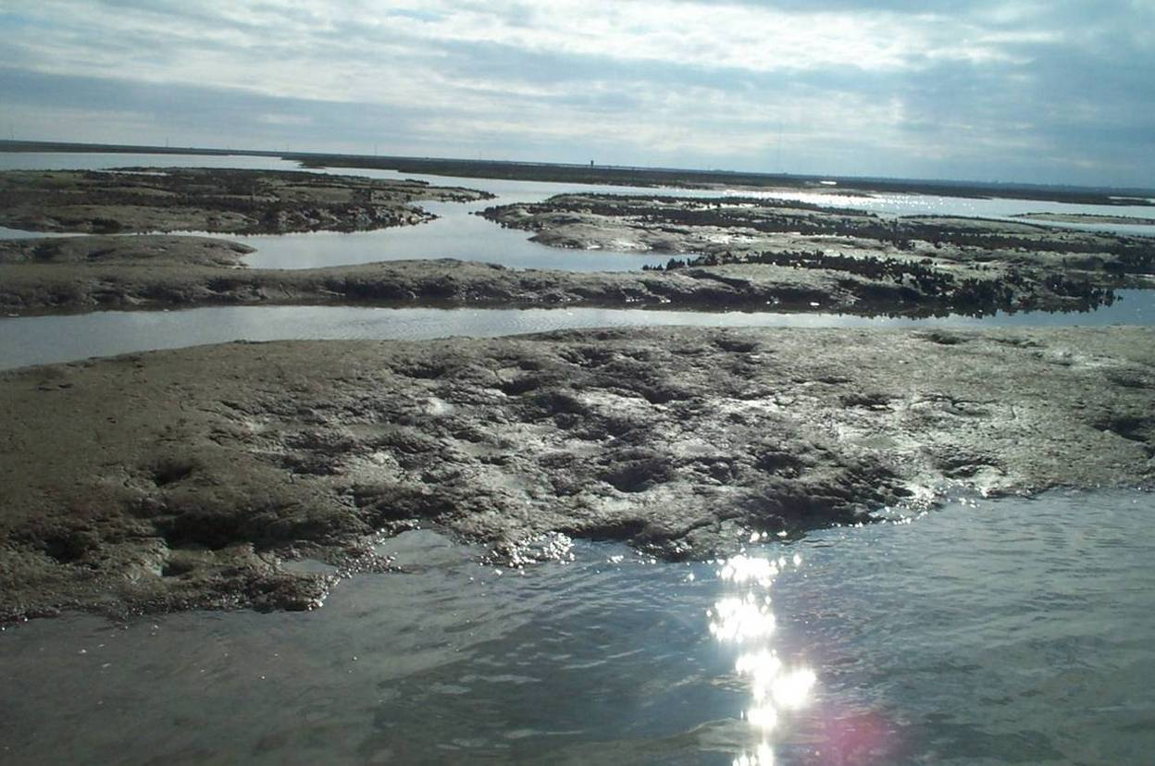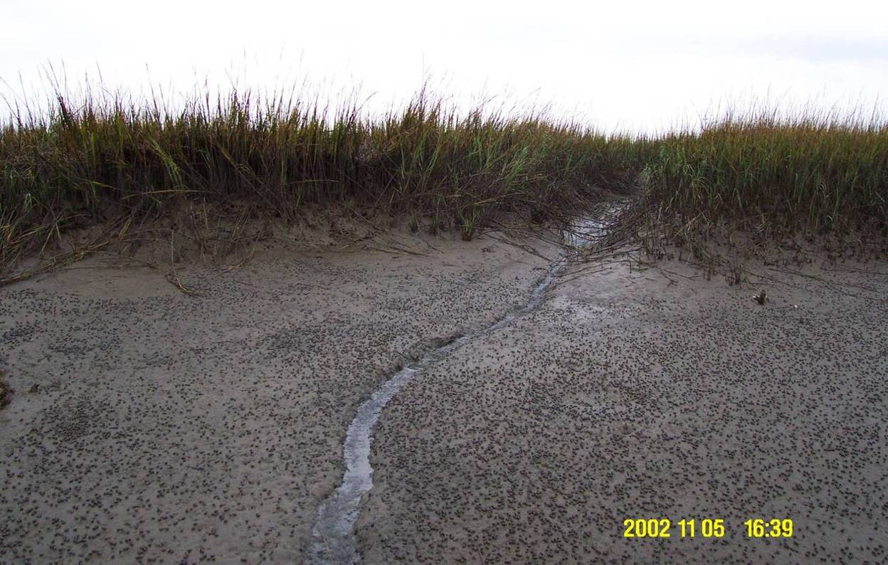
Figure 10. Examples of Meso, Macro, and Micro-scale Channel Geoforms. Hamlin Sound, South Carolina.

Megageoform
Definition taken directly from Greene et al. 2007 definition of Megahabitat.
Large feature that has dimensions ranging from kilometers to 10s of kilometers, and larger. Megageoforms lie within major physiographic provinces such as the continental shelf, continental slope, or abyssal plain. These features can be defined with the use of small-scale (1:1,000,000 or greater) bathymetric maps and satellite topographic images.

Mesogeoform
Definition taken directly from Greene et al. 2007 definition of Mesohabitat.
Mesogeoforms range in size from 10s of meters to kilometers and include such features as small seamounts, canyons and extensive bedrock outcrops (Figure 11). These morphological features can be defined using geologic or geomorphic maps and bathymetric images of the seafloor at scales of 1:250,000 or less.
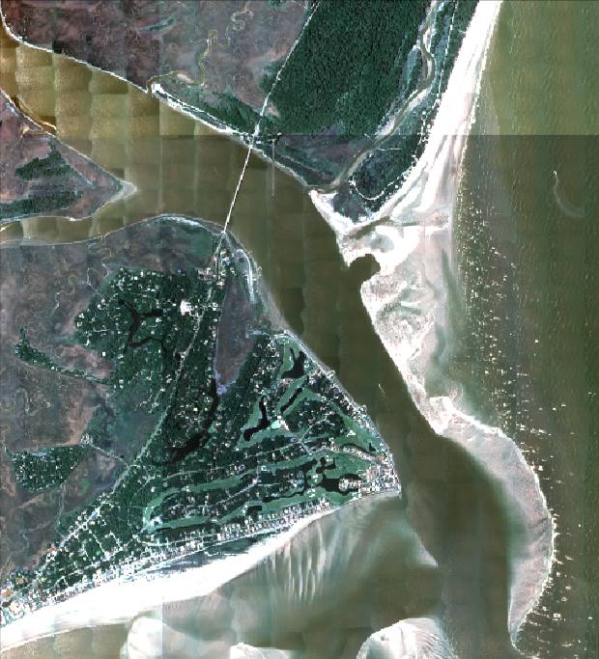
Figure 11. Example of Meso-scale Geoform: Inlet. Fripp Inlet, South Carolina.

Macrogeoform
Definition taken directly from Greene et al. 2007 definition of Macrohabitat.
A macrogeoform ranges in size from one to 10 meters and may consist of features such as large boulders, reefs, bedrock outcrops and bedforms (sediment waves) (Figure 12). These features can be defined using sediment or geologic maps and bathymetric images of the seafloor at scales of 1:50,000 and less. In addition, macrogeoforms can be defined through in situ observational data such as video and photographs.

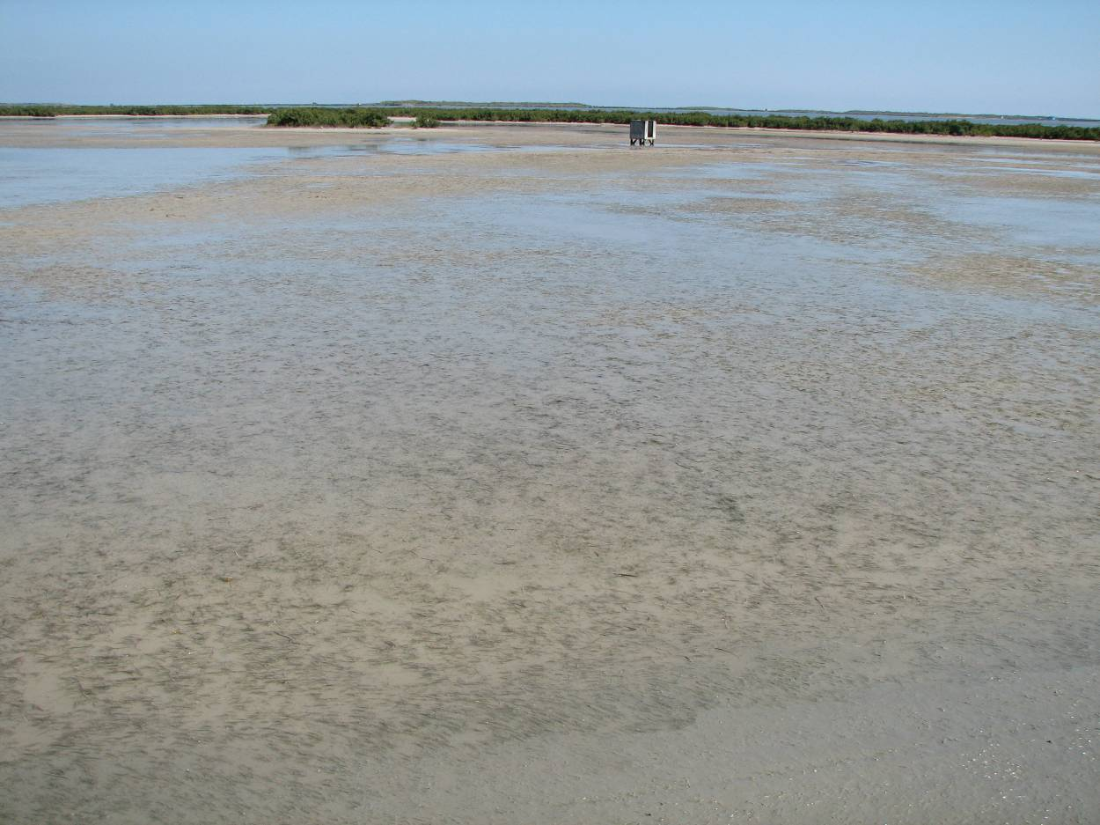
Figure 12. Example of Macro-scale Geoform: Flat. Lower Laguna Madre, Texas.

Microgeoform
Definition adapted from Greene et al., 2007 definition of Microgeoform.
A microgeoform ranges in size from centimeters to one meter and consists of holes, interfaces and cracks and crevices in bedrock outcrops, ripples (Figure 13). Individual biogenic structures such as redtree corals (Primnoa spp.) and anemones (e.g., Metridium farcimen) are included.

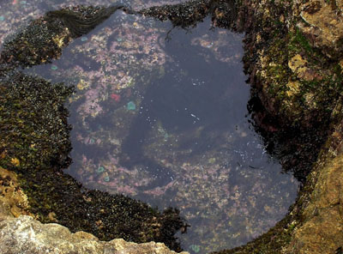
Figure 13. Pacific coast tide pool; a micro-scale Geoform. (Courtesy U.S. Fish and Wildlife Service).

Anthropogenic Geoforms
In many coastal regions artificial structures are a significant part of the environment. Features such as piers, breakwaters, bulkheads, and berms provide attachment surfaces for plants and sessile animals. They can also provide shelter from predators and from prevailing current, and can support small niche communities that increase overall biodiversity. However, these structures can also have negative effects such as altering natural hydrodynamic patterns, interfering with animal movement, and increasing contaminant loading into nearshore areas and thus are often of interest to resource managers. Appendix C lists some of the more common anthropogenic geoforms. Included in this list are features that are the result of human activity such as scars and trawl marks. Since these features vary widely in size, the types in this category can be applied at any scale (Figure 14).

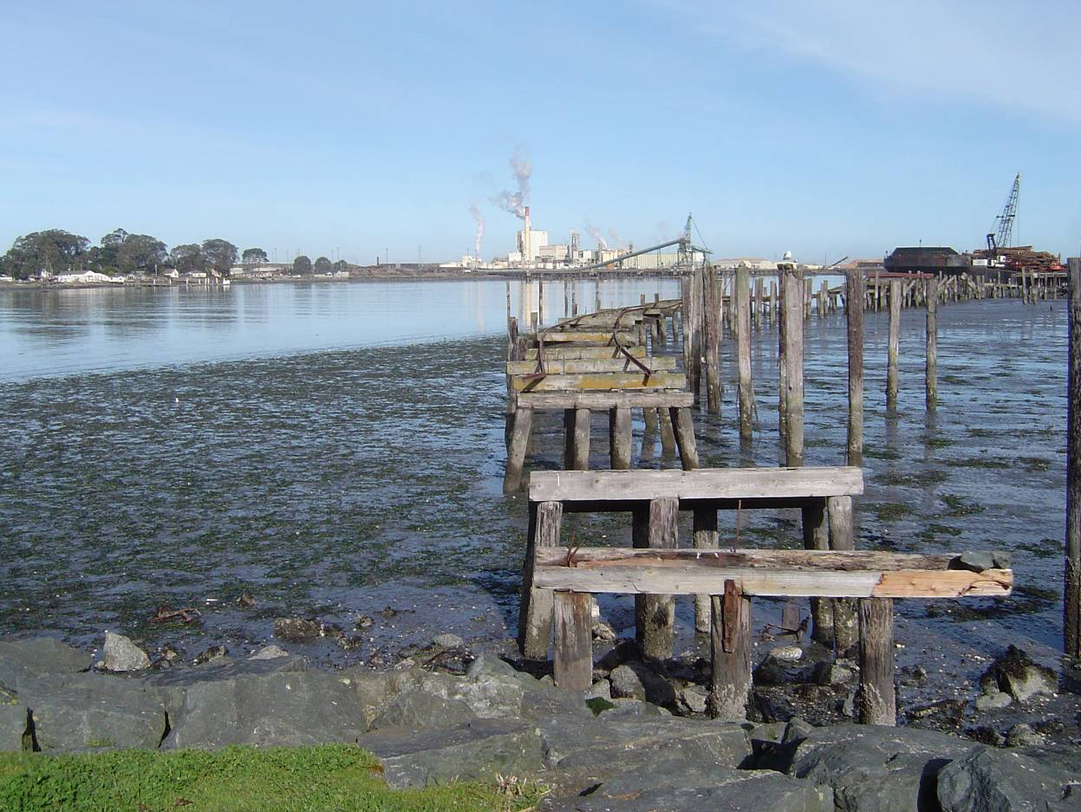
Figure 14. Example of an anthropogenic Geoform structure. Abandoned rail trestle, Humboldt Bay, California.

Standard Attributes
Standard attributes are physico-chemical, physical, spatial, geomorphologic, biological, anthropogenic, and biogeographic variables with defined categorical values that are used to classify or further describe CMECS types. Standard attributes fall into two general categories, classifiers and modifiers.

Classifiers
Are standard attributes that are necessary to define a type and distinguish one type in the classification from another. The thresholds and ranges of these attributes determine the conceptual boundaries of each type. For example, salinity is a classifier for the System level. A salinity value of >30 PSU separates the truly marine systems from the Estuarine and Freshwater Influenced Systems. A user must have information on the classifiers in order to fit a given type into the classification.

Modifiers
Are standard attributes that can be applied when additional information is needed to further characterize the type for individual applications. Modifiers provide additional environmental, structural, or biotic information about the type that is useful for description and application, but are not required to classify it.

Some standard attributes may be used as classifiers in one component of the classification but can also be used as modifiers in another component of the classification. Standard attributes that are used as classifiers are noted in italics below.

Salinity
Classifier for System

Salinity is grouped into categories in units of PSU (practical salinity units, nearly equivalent to PPT, parts per thousand) following Cowardin et al. (1979), Dethier (1990) and with ranges slightly modified from Howes (1994, 2002):

Salinity Category | Salinity Level
Fresh | 0 PSU
Oligohaline | >0-5 PSU
Mesohaline | 5-18 PSU
Polyhaline | 18-30 PSU
Euhaline | 30-40 PSU
Hyperhaline | >40 PSU

An underlying benthic area subjected to overlying waters of a particular salinity regime will be designated according to the category of the overlying water. Thus characterizing the benthos will require measurement of overlying water characteristics. This is particularly important close to shore or in estuaries as the tendency of the coastal water column to stratify will often result in water mass characteristics at the surface that are not the same as the bottom water layer that influences the benthos.

Enclosure
Classifier for System

Enclosure represents the degree of isolation of a water body from other waters due to enclosure by a land mass. In estuaries, enclosure determines the degree of exchange of water, materials, energy and biota between the estuary and the sea. More enclosed waterbodies have longer water residence times, can tend to be more evaporative and hypersaline, and can more readily trap and retain materials within them.

Closure | Angular Gap (Degree)
Unenclosed | 150 - >180 angular gap from estuary head to estuary mouth. No confining land masses seaward of estuary headwaters.
Partially enclosed | 90 - 150 angular gap from estuary head to estuary mouth.
Significantly enclosed | 45 - 90 angular gap from estuary head to estuary mouth.
Very enclosed | 10 - 45 angular gap from estuary head to estuary mouth.
Enclosed | Essentially separated from the ocean. Waters that are completely surrounded by land or with a narrow channel connection to the sea. Includes perched estuaries and lagoonal estuaries.
Intermittent | Class of estuaries that regularly close due to low flow, opening seasonally during high flow. Also called ICOLL (Intermittently Closed and Open Lake or Lagoon)

Position Relative to Shelf Break
Classifier for System

This classifier indicates the position of an area of the ocean relative to the edge of the Continental Shelf. There are two positions considered here:
Seaward of the shelf break - Where the continental platform begins to steepen toward the continental slope, defines the Oceanic System; and
Landward of the shelf break - Defines the outer limit Neritic System.

The depth at which the Shelf Break occurs ranges from 150 to 300 m and generally averages approximately 200 m.

Benthic Depth Zones
The depths of these zones vary depending on regional geology. It is often useful to describe a specific depth or range of depths for the bottom. The CMECS depth zones represent the major divisions in a gradient from land to the deep ocean bottom. They are generally based on the zones in which surf or ocean swell influences bottom communities, the lower limits of vegetation such as kelp, overall photic availability and temperature. The types within this category are drawn or adapted from Greene et al, and Connor. This category is intended for use with the Benthic Cover and GeoForm components as Water Column Depth Zone is part of the Water Column framework.

Zone | Depth (m)
Shallow Infralittoral | 0 - 5
Deep Infralittoral | 5 - 30
Circalittoral | 30 - 80
Circalittoral (offshore) | 80 - 200
Mesobenthic | 200-1000
Bathybenthic | 1000-4000
Abyssalbenthic | 4000-7000
Hadalbenthic | >7000

Substrate Composition
Classifier for Class and Subclass (with Percent Cover Range)

To identify Classes and Subclasses, the user must know the relative percent cover of the following biotic and abiotic features of the substrate.

Bivalve | Emergent Herbaceous Vegetation | Cobble/Gravel
Gastropod | Shrub | Sand
Worm | Tree | Mud
Coral | Bedrock | Organic
Macroalgae | Pavement | Shell
Rooted Vascular | Boulder

Percent Cover Range
Classifier for Class and Subclass (with Substrate Composition)

This standard attribute is used to describe the density of substrate components.

To classify a unit to the Class and Subclass level, a user needs to know the relative percent cover of each of the components of the substrate (see substrate composition above). The degree of substrate cover for each is assessed using the following ranges (after the Scheme classification of Madley et al. 2003).

It can also be used as a modifier to describe the density of vegetation such as seagrasses or other substrate components.

Percent Cover Category | Range
Bare/Sparse | <10% cover
Moderately Sparse | 10- 25%
Moderate | 25-75 %
Dense | 75%-90%
Complete | 90-100%

Energy Type
For energy type, CMECS follows a simplification of the concept introduced by Dethier (1990), and as employed in several subsequent classifications (Holthus and Maragos 1995, Howes 1994, 2002, Schoch 1999, Allee et al. 2000). The work of Schoch (1999) provides the basis for a detailed near-shore classification of energy intensity and type on land-sea margins. This classification utilizes a very simple energy classification related to the force of water movement, whether tidal, wave or current. This force is an important sieve that determines the kinds of animals and flora that can maintain attachment or position in a particular habitat. Energy level also determines the substrate type by suspending, transporting and sorting fractions of substrate particulates of smaller grain size. A winnowing of, or absence of, fine sediments characterizes high current and wave energy areas. Finally, energy can shape the bed form (sand waves, sand ripples) and erode or accrete geoforms. Highly impacted areas are typified by the presence of erosive features, such as beach scarps or bare rock substrates.

The terminology of “degree of exposure” common in many other classifications is not used in CMECS in favor of the more accurate term “energy.” Exposure is a subjective term that includes qualification of both the direction of the feature relative to hydrodynamic energetics and the energy of the system at a given point in time. An exposed and open coast may in fact be very quiescent depending on the season or direction facing. “Energy,” along with a quantitative scale, is a more accurate indicator of the actual force with which a particular coastal or marine feature is impacted.
The energy modifier applies to all three components of the classification (benthic, water column and geoform). Within the intertidal and subtidal benthic zones the energy acts on shaping the geoforms. Within the water column, the energy is related to current speeds (in knots), wave intensity and tidal motions. The concept is modified from Dethier (1990) and Zacharias et al. (1998) with type categories as follows:

Energy Type | Intensity
Wind | coherent directional motion of the atmosphere
Current | coherent directional motion of the water
Surface wave | vertical and transverse oscillating surface water motion due to wind or seismic energy
Internal wave | vertical and transverse oscillating water motion below the surface due to seismic energy or pressure differential
Tide | periodic horizontally oscillating water motion

Energy Intensity
Potential Classifier for Group
Energy intensity is classified according to the following scale:

Energy | Intensity
No energy | no detectable waves or current motion
Low energy | very weak currents (0-2 kn) or wave action (gentle swell)
Moderate energy | wind waves or moderate tidal currents (2-4 kn)
High energy | strong currents (>4 kn), oceanic swell, breaking waves

Energy Direction
Energy can also be classified according to its principal direction of travel or influence. In the case of tidal energy, this is generally an oscillation between onshore and offshore motions. In the case of currents and waves, the energy is direction. The following energy direction categories are used:

Energy Direction | Description
Upward | ascending and perpendicular to the sea surface or bottom
Downward | descending and perpendicular to the sea surface or bottom
Horizontal | parallel to the sea surface or bottom
Baroclinic | motion along lines of equal pressure within the water column
Seaward | on land, water currents following topographic gradient toward the sea
Circular | motion in a closed circular form
Mixed | combination of more than one of above directions

Tide Range
The tide range modifier refers to the difference between mean high tide and mean low tide at the coast. While the intertidal Subsystem is defined by the area submerged by tide between the extreme high and low tides, the mean range gives a more consistent idea of the energy and amplitude of the average tide. Tide range is categorized as:

Tide Category | Range
Microtidal | <0.1 m
Small tide range | 0.1- 1 m
Moderate tide range | 1-5 m
Large tide range | >5 m

Primary Water Source
The primary water source modifier refers to the provenance of water flowing through or into a formation. This can range from freshwater inputs from river watersheds or sloughs to local exchanges through tidal passes. The categories are as follows:

Primary Water Source | Provenance
Watershed | for flowing freshwater, the upstream watershed
Local estuary exchange | tidal exchange that is primarily estuarine water
Local ocean exchange | tidal exchange that is primarily marine water
River | tidal exchange or plume flow that is primarily river water
Estuary | plume flow that is from the estuary
Marine | unidirectional flow that is primarily marine

Profile
Profile refers to the elevation of the feature relative to surrounding level of the water or bed:

Profile | Relative Height
None | 0
Low | 0-2 m
Medium | 2-5 m
high | >5 m

Slope
Slope refers to the angle of the substrate; Greene et al.’s (1999) geological classification is followed here to characterize slope as:

Slope | Vertical Angle
Flat | 0-5°
Sloping | 5-30°
Steeply sloping | 30-45°
Vertical | 45-90°
Overhang | >90°

Temperature
Temperature categories are established in intervals of 10°C, deemed sufficient in range and resolution to provide meaningful differences yet yielding a parsimonious number of categories. Temperature categories are based on the BCMEC classification for Canada (Howes 1994, 2002, Zacharias et al. 1998), modified to add the higher temperature ranges typical of the subtropics and tropics. The caveat that differential surface and bottom characteristics occur in the water column holds for temperature as well as salinity. Categories for water mass temperature are established as follows:

Temperature Category | Degrees
Frozen | ≤ 0° C with surface ice
Superchilled | ≤ 0° C without ice
Cold | 0-10° C
Temperate | 10-20° C
Warm | 20-30° C
Hot | >30° C

Anthropogenic Impact
Development - coastal or marine areas that have been modified by construction of durable and persistent human construction (e.g., artificial reef, pier, seawall, marina, residence, drilling platform).

Impoundment/Diversion - artificial construction that impedes, redirects or retains hydrological flow by building or placing barriers such as levees or dams, either to retain water or to prevent inundation (e.g., dam, levee, dike, berm, seawall, pier).

Dredged area/Channel - Landscape that is mechanically altered by the removal of sediments or other materials (e.g. shell), for deepening or widening channels (e.g. for navigation or alteration to hydrology), or for other bathymetric modification.

Deposition - materials such as sand or shell that are placed on or in an area of coast or a water body.

Contamination - discharge of unnatural compounds or levels of nutrient, sewage, metals or pesticide to coastal waters or substrates from anthropogenic sources significantly above natural loading levels.

Rugosity
Definition adapted from Green et al., 2007. Rugosity is a function of the amount of surface area for a given planar area of the seafloor and is quantified through gridded X, Y, Z data. The following table illustrates the five rugosity types and their associated numeric values.

Rugosity Types | Values
Very Low | -1 – 0
Low | 0 – 1
Moderate | 1 - 2
High | 2 – 3
Very High | 3+

Oxygen
Oxygen concentration is often an important water column modifier. Oxygen is critical to aerobic organisms and aerobic processes, such as chemical oxidation and microbial respiration. The oxygen regime modifier is determined according to the following ranges:

Oxygen Regime | Concentration
Anoxic | 0-2 mg/L
Hypoxic | 2-4 mg/L
Oxic | 4-10 mg/L
Oxygen saturated | 10-12 mg/L
Oxygen supersaturated | >12 mg/L

Turbidity
Turbidity is important for organisms that hunt for prey or escape using visual cues, and of course for photosynthetic organisms. Categories for the turbidity modifier have not previously been established in a coastal-marine classification system. The proposed categories for turbidity are based on simple secchi depth readings:

Turbidity Category | Secchi Depth Reading
Extremely Turbid | <1 m
Highly Turbid | 1-2 m
Moderately turbid | 2-5 m
Clear | 5-20 m
Extremely clear | >20 m

Turbidity Type and Turbidity Provenance
An important qualitative characteristic of turbidity is the provenance of the attenuating substance - whether the reduced water clarity is derived from chlorophyll pigments (i.e. phytoplankton blooms), from color due to dissolved substances in the water (gelbstoffe, tannin), from mineral imported terrigenous sediments or from carbonate particulates in resuspension. It is proposed that this qualitative assessment be classified in addition to a qualitative or quantitative evaluation of the degree of turbidity in the water column. The following qualitative classification of turbidity type and provenance should be applied to the degree best discernable in the field:

Turbidity Type
Chlorophyll - attenuation produced by chlorophyll a, b, c or d as constituents of live phytoplankton in the water column

Mineral particulates - attenuation produced by suspended inorganic sediments derived from soil and rock weathering

Carbonate particulates - attenuation produced by suspended precipitated CaCO₃ in the water column, generally creating an opaque “milky” appearance

Colloidal precipitates - dispersed particulates which precipitate out of the dispersion medium (water) to form aggregations such as marine snow

Dissolved color - substances dissolved in water that have color and absorb light within a specific wavelength band depending on the color

Detritus - attenuation due to larger organic detritus particles in suspension

Mixed - attenuation due to a variety of the above sources and substances

Turbidity Provenance
Autochthonous - (e.g. bloom) generated in situ by biogenic processes

Allochthonous - originating outside of the system and transported into the system

Resuspended - deposited materials mixed into the water column by currents (e.g. bottom sediments)

Precipitated - solutes such as CaCO₃ that precipitate out of solution

Terrigenous origin - materials, water or energy in a water body in land drainage

Marine origin - materials, water or energy originating in the ocean

Photic Quality
Photic quality is a highly variable parameter. In many Nearshore cases, light penetrates deeply, and the photic zone extends to the bottom of the water column; in others, almost the entire water column is dark. All Systems are aphotic for at least part of every day, during nighttime. Degree of exposure of a particular place to light depends on the depth, sun angle, time of year etc. Moreover, the depth of the shift from photic to aphotic occurs at different points in the water column, depending on the ecosystem, watershed, the amount of turbidity in the water, etc. The important functional distinction of the photic regime is between the part of the water column within which plants can photosynthesize and animals can feed and defend visually, and where they cannot.

Vertical zones are relative to the penetration of light: photic and aphotic, for both water column and benthic components:

Photic - that region of the water column that is lighted, i.e. ambient light is > 2% of surface light. This is ecologically significant because it is considered the photosynthetic compensation point, where respiration equals autotrophic production

Aphotic - that part of the water column below the compensation depth that receives less than 2% of the surface light, and where plants cannot achieve positive photosynthetic production

Seasonally photic - regularly varies between photic and aphotic

Trophic Status
Trophic status is a general categorization of the abundance of dissolved macronutrients (DIN and DIP) and level of primary productivity of a unit. In broad terms, the trophic status gives an indication of the health of the system via the balance of production and consumption and is measured by chlorophyll concentration in water columns and by total biomass in macroalgal and rooted vascular plant communities. For water column phytoplankton communities, the modifier categories are:

Trophic Status - Phytoplankton | Chlorophyll Level
Oligotrophic | < 5 µg/L chlorophyll a
Mesotrophic | 5-50 µg/L chlorophyll a
Eutrophic | > 50 µg/L chlorophyll a

The trophic categories were derived, with modification, from the NOAA Estuarine Eutrophication Survey (NOAA 1997).

Temporal Persistence
The temporal persistence descriptor describes the permanency or variability of a hydromorphic or geomorphic feature. Though qualitative and relative, it is useful is distinguishing between features that are similar in morphology but are temporally diverse in terms of stability. An example is a mud shoal versus a mudbank. The former tends to be moved by changing currents or storms, while the latter is more stable and persistent. Classes are:

Persistence | Stability
Low | weeks to months
Medium | Months to years
High | Decadal
Permanent | Stable
Variable | Varies regularly
Stochastic | Varies stochastically

Ecological Region
The Coastal and Marine Ecological Classification Standard provides a means to identify the ecological region within which a particular unit resides via the use of a biogeographic descriptor called Ecoregion. Ecoregions are defined as very large areas of the coasts and oceans that are relatively homogeneous with regard to physical and biological variables and reflect ecological boundaries determined by climate (temperate, tropical, polar), physical structure, such as major currents or ocean basins, and the characteristics of the biological associations, such as isolation or endemism. Marine ecoregions are defined by large seas, currents and regions of coherent sea surface temperature or ice cover. Spalding et al. (2007) recently published an article defining marine ecoregions for the world based on extensive literature review and workshops. CMECS will adopt these ecoregions as defined (Appendix G).

Glossary

Abyssal: Deep bottom area or portion of submerged earthform between 4000-7000 m.

Abyssalpelagic: A vertical depth zone of the water column defined only by depth of the water; 4000 – 7000 meters.

Anthropogenic: Caused by humans.

Artificial reef: Man-made reef formed by placing suitable long-lived, stable and environmentally safe materials (usually steel or concrete) on a selected area of ocean bottom. Once the material is in place it acts in the same way that naturally occurring rock outcroppings do in providing hard substrate necessary in the basic formation of a live-bottom reef community.

Atoll: A ringlike coral island and reef that nearly or entirely encloses a lagoon.

Bank: Submerged earthform with a crest at a depth of 20-200 m in oceanic waters and of 0-5 m in nearshore and neritic waters. The rising ground bordering a lake, river or sea.

Bathyl: Deep oceanic bottom areas between depths of 200- 4000 m.

Bathypelagic: A vertical depth zone of the water column defined only by depth of the water;; 1000 – 4000 meters.
Beach: The zone above the water line at the shore of a body of water, marked by an accumulation of sand, stone, or gravel that has been deposited by the tide or waves.
Benthic boundary layer: A thin water layer just above the bottom that is strongly influenced by the benthos and distinct from the overlying waters. It is often characterized by sharp reduction in current speeds, a nephelitic turbidity layer and high rates of diffusive interaction with biogeochemical components in the sediments. This layer is often most strongly associated with small benthic or demersal organisms.

Biotope: A repeatable physical habitat and its biological associations, uniform in structure and environment, defined by conspicuous diagnostic species. These are broad associations identified by dominant or diagnostic species that are fixed to the substrate for the benthic component or floating or suspended aggregations of biota for the WCC.

Canyon: Submerged earthform consisting of an incised large-scale submarine feature on a high angle slope normally associated with the continental shelf.

Channel: The bed of a stream or river; the deeper part of a river or harbor, especially a deep navigable passage; a broad strait, especially one that connects two seas; a trench, furrow, or groove.
Cobble: A rock fragment between 64 and 256 millimeters in diameter, especially one that has been naturally rounded.

Coastal Marsh (=Salt Marsh): Area of low, flat, poorly drained ground that is subject to daily or occasional flooding by salt water or brackish water. Communities dominated by emergent herbaceous halophytic vegetation along low-wave energy intertidal areas and river mouths. Low shrubs may be present or even dominant.

Continental Rise: Part of the continental margin; the ocean floor from the continental slope to the abyssal plain; generally has a gentle slope and smooth topography.

Continental Shelf: The part of the continental margin from the coastal shore to the shelf break and continental slope; usually extending to a depth of about 200 meters and with a very slight slope, roughly 0.1 degrees; includes continental and oceanic sediments down to the ocean floor. The zone bordering a continent extending from the line of permanent immersion to the depth, usually 200 m, where there is a marked or rather steep descent toward the great depths. The region of the oceanic bottom that extends outward from the shoreline with an average slope of less than 1:100, to a line where the gradient begins to exceed 1:40 (the continental slope).

Continental Shelf Break: The edge of the continental shelf, usually at a depth of 200m, where depths and slope begin to increase rapidly. The depth at which the Shelf Break occurs ranges from 150 to 300 m and generally averages approximately 200 m.

Continental Slope: Part of the continental margin; the ocean floor from the continental shelf to the continental rise or oceanic trench. Usually to a depth of about 200 meters. The continental slope typically has a relatively steep grade, from 3 to 6 degrees. The declivity from the offshore border of the continental shelf to oceanic depths. It is characterized by a marked increase in slope.

Coral head: Colony made up of individual coral polyps.

Coral reef: Massive limestone structure built up through the constructional cementing and depositional activities of hermatypic fauna (e.g., hard corals) and flora (e.g., coralline algae). This class includes ridge-like or mound-like structures formed by the colonization and growth of hard coral species as well as assemblages of non reef-forming hard corals, soft corals and associates such as sponges, hydroids. These environments occur in both the intertidal and subtidal subsystems.

Delta: A low triangular area where a river divides before entering a larger body of water.

Dune: A ridge of sand created by the wind.

Dune System: Coastal dunes featuring succession.

Embayment: Coastal water body that is partially enclosed or surrounded by a landmass but that has a significant open connection to the sea.

Emergent Wetland: Class characterized by erect, rooted, herbaceous hydrophytes and low shrubs. These wetlands are usually dominated by perennial plants and the emergent vegetation is present for most of the growing season in most years. Only coastal marshes and shrublands that are saltwater-influenced are included in this classification. These environments occur only within the intertidal subsystem.

Epibenthic: Relates to the area on top of the sea floor; benthic organisms that live on top of the sediments, rocks, logs or plants. These organisms may be freely moving or sessile (permanently attached to a surface) and can define a Biotope.

Epipelagic: A vertical depth zone of the water column defined only by depth of the water; greater than 0 meters up to 200 meters.

Estuarine System: Tidal habitats and adjacent tidal wetlands with water that is at least occasionally diluted by freshwater runoff from the land (<30PSU) and is semi-enclosed by land but has open, party obstructed, or sporadic access to the open ocean. The salinity may be periodically increased above that of the open ocean by evaporation. Extends upstream and landward to where ocean derived salts measure less than 0.5%◦ during the period of average annual low flow and seaward to an imaginary line closing the mouth of a river, lagoon, fjord or embayment.

Fault: A fracture in rock along which there has been an observable amount of displacement. Faults are rarely single planar units; normally they occur as parallel to sub-parallel sets of planes along which movement has taken place to a greater or lesser extent. Such sets are called fault or fracture-zones.

Flat: A level landform composed of unconsolidated sediments (usually sand or mud) which are normally contiguous with the shore.

Freshwater Influenced System: Systems that have no distinct enclosing morphology, yet receive a significant amount of fresh water input from land during at least part of the year (<30 PSU); may be influenced by freshwater in the form of an active river plume, direct freshwater runoff, diffuse non-point runoff, an advected fresh water lens, mesohaline coastal water mass or a ground water seep discharge.

Forested Wetland: Class characterized by areas dominated by tree species (i.e., single stemmed woody plants). Areas dominated by tree seedlings, saplings and dwarf trees are placed in this class. Only saltwater-influenced mangroves are included in this classification. These environments occur only within the intertidal subsystem.

Front: The phenomenon created at the boundary between two different water masses.

Geoform: Describes the structure of the coastline and sea floor at multiple scales; equivalent in concept to a terrestrial landform (e.g., mountain, butte, moraine etc) and likewise varies in scale from very large (e.g., seamount, embayment) to very small (e.g., tidepool, ripple). Geoforms shape the large scale seascape in repeatable and predictable ways by providing structure, channeling energy flows, regulating bioenergetics, and controlling transfer rates of energy, material and organisms.

Hadal: Deepest bottom area or portion of submerged geoform at depths of >7000 m.

Hadalpelagic: Deepest vertical depth zone of the water column; greater than 7000 meters.

Hole: A deep place in a body of water.

Hydroform: Large physical structures formed by water movements within a system; describes major hydrographic features at different scales (macro/meso).

Intertidal: Subsystem where substrate is regularly and periodically exposed and flooded by tides. This subsystem includes the supratidal zone -- the area above the high tide line in the splash zone that is affected by spray, splash, aerosols and overwash. This interface is regularly exposed to the air by tidal movement.

Island: Emergent land mass larger than 1 km² in area completely surrounded by water.

Kelp: any of numerous large seaweeds found in colder seas and belonging to the order Laminariales (about 30 genera) of brown algae.

Lagoon: Coastal water body entirely or almost entirely enclosed by a landmass with minimal connection to the sea; a shallow, sheltered body of water separated from the open sea by coral reefs, sand bars, and/or barrier islands. A shallow body of water, as a pond or lake, which usually has a shallow restricted inlet from the sea.

Ledge: An underwater ridge or rock shelf.

Littoral: The zone on the coast where land meets sea. Often called the intertidal zone but is more comprehensive, including the supratidal and infratidal zones. Of, or pertaining to, a shore, especially a seashore. The region of land bordering a body of water. The shallow water region with light penetration to the bottom.

Mangrove: Tidally influenced, dense, low forests dominated by true mangroves and associates; common name for any of several species of inshore tropical trees or shrubs that dominate the mangal associations.

Marine: Waters that receive no freshwater input from land and are substantially of full oceanic salinity (>30 psu) throughout the year.

Mesopelagic: A vertical depth zone of the water column defined only by depth of the water; 200 – 1000 meters.

Moraine: General term for material deposited beneath, along the sides, and/or at the terminus of a glacier.

Nearshore System: Waters that are truly marine in character (> 30 PSU throughout the year); extends from the land margin to the 30 m depth contour. The proximity of land and nearshore processes strongly influences waters and benthos of these systems although the biota and physics are marine.

Neritic System: Marine waters (> 30 psu year round) between the 30 m depth contour and the continental shelf break, which occurs at approximately at 200 m water depth.

Oceanic System: The marine realm beyond the continental shelf break; waters that are generally deeper than 200 m.

Patch Reef: Coral formations that have no organized structural axis relative to the contours of the shore or shelf. A surrounding halo of sand is often a distinguishing feature of this habitat type when it occurs adjacent to submerged vegetation.

Peninsula: An elongated portion of land nearly surrounded by water and connected to a larger body of land, usually by a neck or an isthmus.

Pycnocline: A region of rapid density change with vertical position, caused usually by temperature (thermocline) or salinity (halocline) stratification.

Reef: A large ridge or mound-like structure within a body of water that is built by calcareous organisms such as corals, red algae, and bivalves; a ridge of rock or other material lying just below the surface of the sea.

Rocky Shore: Exposed intertidal shoreline characterized by bedrock, stones or boulders which singly or in combination have an aerial cover of 75% or more and an aerial coverage by vegetation of less than 10%.

Sand Waves: Longshore sand waves are large-scale features that maintain form while migrating along the shore with speeds on the order of kilometers per year; Large-scale asymmetrical bedforms in sandy river beds having high length to height ratios and continuous crestlines.

Sea Surface: A vertical depth zone of the water column defined only by depth of the water; 0 meters.

Seabed: Subtidal ocean bottom, completely covered by the water at all times. Distinct from the bottom within the littoral intertidal zone.

Seamount: Conical mountain rising 1000 m or more above the sea floor; a submarine volcano in the abyssal plain.

Shoal: A detached area of any material except rock or coral. The depths over it are a danger to surface navigation. Similar continental or insular shelf features of greater depths are usually termed banks; To become shallow gradually; To cause to become shallow; To proceed from a greater to a lesser depth of water.

Slough: A small muddy marshland or tidal waterway which usually connects other tidal areas.

Spur and Groove Reef: A system of shallow ridges (spurs) separated by deep channels (grooves) oriented perpendicular to the reef crest and extending down the upper seaward slope.

Supratidal: The area above the level of high tide affected by spray, splash, aerosols and overwash.

System: Areas differentiated from one another by a combination of salinity, geomorphology and depth.

Trench: An elongated submerged geoform depression on the deepest margin of the ocean floor generally at depths >7000; typically associated with subduction zones along boundaries between oceanic and continental plates.

Unconsolidated: Substrates having at least 25% cover of particles smaller than stones, and a vegetative cover less than 10%.

Upper Water Column: In a two-layer water column, the area above the sharp density gradient (pycnocline) which includes the air-water interface.

Upwelling: Hydroform created by wind action or divergent surface currents that cause deeper waters to move up and replace the surface water. These areas are often exposed to nutrient-rich deep waters rising to the surface from below the pycnocline. The process by which water rises from a deeper to a shallower depth, usually as a result of offshore surface water flow. It is most prominent where persistent wind blows parallel to a coastline so that the resultant Ekman transport moves surface water away from the coast.

Worm Reef: Class representing areas dominated by worm species including structures formed by the colonization and growth of Sabellariid worm species, tube worms as well as burrowing worms that form above ground structures. This class occurs in both the intertidal and subtidal subsystems.

References

http://research.myfwc.com/engine/download_redirection_process.asp?file=benthic%5Fatlas%5F4544%2Epdf&objid=23848&dltype=publication
http://www.tiscali.co.uk/reference/encyclopaedia/hutchinson/m0006397.html
http://www.fao.org/fi/glossary/default.asp
http://www.streamnet.org/pub-ed/ff/Glossary/#l
http://www.csc.noaa.gov/text/glossary.html#glossary
http://www.google.com/search?hl=en&q=epibenthic&btnG=Google+Search
http://lakes.chebucto.org/ZOOBENTH/BENTHOS/benthos.html
http://www.ocean.udel.edu/deepsea/level-2/geology/vents.html

http://www.dnr.sc.gov/marine/pub/seascience/artreef.html
http://dictionary.reference.com/
http://www.dcr.virginia.gov/dnh/ncglossary.htm#B
http://www.brevardcounty.us/environmental_management/assets/documents/pdf/dunebrochure.pdf
http://www.townplanning.sabah.gov.my/iczm/Reports/Coastal%20Profile%20Sabah/ch18/18-DICTIONARY%20OF%20TERMS.html
http://www.awi-bremerhaven.de/GEO/Geochem/bbl.htm
http://en.wikipedia.org/wiki/Main_Page
http://www.npwrc.usgs.gov/index.htm
http://www.nmfs.noaa.gov/habitat/habitatprotection/hptype/hptype2.htm
http://www.dfo-mpo.gc.ca/canwaters-eauxcan/bbb-lgb/library-bibliotheque/glossary-glossaire/index_e.asp#M
http://myfwc.com/viewing/landcovers/shrubswp.html

Literature Cited

Allee, R. J., Dethier, M., Brown, D. Deegan, L. Ford, G. R., Hourigan, T. R., Maragos, J., Schoch, C., Sealey, K., Twilley, R., Weinstein, M. P., and M. Yoklavich, Mary. 2000. Marine and Estuarine Ecosystem and Habitat Classification. NOAA Technical Memorandum. NMFS-F/SPO-43.

Ambler, Julie W. Ref: Zooplankton swarms: Characteristics, proximal cues, and proposed advantages. Hydrobiologia ISSN 0018-8158.

Bailey. R. G., Avers, P. E., King, T. and McNab, W. H. 1994. Ecoregions and Subregions of the United States. Washington DC: U.S. Dept. of Agriculture Forest Service.

Commission for Environmental Cooperation. 1997. Terrestrial Ecoregions of North America. Level I and II. Ecological Regional of North America- Toward a Common Perspective. (1997 CEC).

Connor, D. W. 1997. Marine biotope classification for Britain and Ireland. Joint Nature Conservation Review, Peterborough, UK.

Costello, M. J. 2003. Role of on-line species information systems in taxonomy and biodiversity. In: C. H. R. Heip, S. Hummel and P. H. van Avesaath [eds.] Biodiversity of coastal marine ecosystems, Pattern and process. A Euroconference. NIOO-CEME, Yerseke, Netherlands, pp 54-55.

Cowardin, L. M., V. Carter, F. C. Golet and E. T. LaRoe. 1979. Classification of wetlands and deepwater habitats of the United States. U.S. Fish and Wildlife Service. FWS/OBS-79/31 GPO 024-010-00524-6 Washington DC 103 pp. Davies, C. and D. Moss 1999. EUNIS. European Universities Information System.

Dethier, M. 1990. A Marine and Estuarine Habitat Classification System for Washington State. Washington State Dept. of Natural Resources.

European Environment Agency. 1999. European Topic Centre on Nature Conservation 1999. Work Programme: Task 4.3 EUNIS Habitat Classification, Draft Final Report. 209 pp.

FGDC. 2007. National Vegetation Classification Standard, Version 2 – Working Draft. FGDC-STD-005 (version 2), November 30, 2007. Vegetation Subcommittee, Federal Geographic Data Committee, FGDC Secretariat, U.S. Geological Survey. Reston, VA. 59p (+ Appendices)

F.M.H. Reid, E. Stewart, R.W. Eppley, and D. Goodman. 1978. Spatial distribution of phytoplankton species in a chlorophyll maximum layers off Southern California. Limnology and Oceanography, Vol. 23, No. 2. pp. 219-226.

Garrison, Tom. 2005. Oceanography: An Invitation to Marine Science. Belmont, CA.

Greene, H.G., Bizzarro, J.J., O’Connell, V.M. and Brylinsky, C.K. 2007. Construction of digital potential marine benthic habitat maps using a coded classification scheme and its applications, in Todd, B.J., and Greene, H.G., eds., Mapping the Seafloor for Habitat Characterization: Geological Association of Canada, Special Paper 47, pp 147-162.

Greene, H.G. M.M. Yoklavich, R. M. Starr, V. M. O’Connell, W. W. Wakefield, D. E. Sullivan, J. E. McRea, Jr. and G.M. Caillet. 1999. A classification scheme for deep seafloor habitats. Oceanologia Acta. 22(6)663-678.

Jon Gulbrandsen. Ref: Artemia Swarming-Mechanisms and Suggested Reasons. Journal of Plankton Research, Vol. 23 No. 7 pp.659-669.

Holthus, P. F. and James E. Maragos. 1995. Marine Ecosystem Classification for the Tropical Island Pacific. In: J. E. Maragos, M. N. Peterson, L.G. Eldredge, J.E. Bardach and H.F. Takeuchi [eds] Marine and Coastal Biodiversity in the Tropical Island Pacific Region. V 1: Species Systematics and Information Management Priorities. Program on Environment, East-West Center, Honolulu, HI, pp: 239-278.

Howes, D. E., J. R. Harper, and E. Owens. 1994. British Columbia physical shore-zone mapping system. British Columbia, Canada: Resource Inventory Committee.

Howes, Zacharias, Canessa Roff and Hines. 2002. British Columbia Marine Ecological Classification.

Interim Marine and Coastal Regionalisation of Australia 1998, An ecosystem classification for marine and coastal environments, Version 3.3, IMCRA Technical Group - Environment Australia for the Australian and New Zealand Environment and Conservation Council, Canberra.

Jennings, M.D., D.Faber-Langendoen, O.L.Loucks, R.K.Peet and D.Roberts. (in press). Characterizing associations and alliances of the U.S. National Vegetation Classification. Ecological Monographs.

Madden, C. J. and Dennis H. Grossman 2004. A Framework for a Coastal/Marine Ecological Classification Standard. NatureServe, Arlington, VA

Madden, Christopher J., Dennis H. Grossman, and Kathleen L. Goodin. 2005. Coastal and Marine Systems of North America: Framework for an Ecological Classification Standard: Version II. NatureServe, Arlington, Virginia.

Madley, Kevin et al. 2002. Florida System for Classification of Habitats in Estuarine and Marine Environments (SCHEME). Florida Fish and Wildlife Conservation Commission Florida Marine Research Institute.

NWI Reference - See National Wetland Inventory
http://www.fws.gov/nwi/

Schoch, C. 1999. Identifying replicate habitats in the nearshore: Partitioning the heterogeneity of complex shorelines. Report. OR State Univ., Corvallis, OR. 65 pp.

U.S. National Oceanic and Atmospheric Administration (NOAA). 1997. NOAA’s Estuarine Eutrophication Survey, Vol. 4: Gulf of Mexico Region. Silver Spring, MD. Office of Ocean Resources and Assessment. 77 pp.

U.S. National Oceanic and Atmospheric Administration. National Ocean Service, National Centers for Coastal Ocean Science Biogeography Program 2001.
Benthic Habitats of Puerto Rico and the U.S. Virgin Islands. CD-ROM. Silver Spring, MD: National Oceanic and Atmospheric Administration.
Methods Used to Map the Benthic Habitats of Puerto Rico and the U.S. Virgin Islands.

Zacharias, M.A., Howes, Don E., Harper, J. R., and Wainwright, Peter. 1998. The British Columbia Marine Ecosystem Classification: Rationale, Development, and Verification. Coastal Management 26:105-124.

Appendix A – Benthic Cover Component Units
System | Subsystem | Cover Type | Class | Subclass | Group | Biotope
Estuarine [ES] | Intertidal [1] | Abiotic [a] | Mollusc Communities [MC] | Bivalve Bed/Reef [1] | Oyster Bed/Reef [a] | Crassostrea sp. Oyster Reef
Nearshore [NS] | Subtidal [2] | Biotic [b] |  |  | Mussel Bed [b] | Mytilus sp. Mussel Bed
Neritic [NE] |  |  |  | Gastropod Bed/Reef [2]
Oceanic [OC] |  |  | Worm Reef and other Worm Communities [WC] | Worm Reefs [1] |  | Sabellaria sp. Worm Reef
Freshwater Influenced [FI] |  |  |  | Tube Worms [2]
 |  |  | Coral Reefs and other Coral Communities [CC] | Spur and Groove Reef [1] |  | Porites sp. Reef
 |  |  |  |  |  | Acropora sp. Reef
 |  |  |  |  |  | Montipora sp. Reef
 |  |  |  | Patch Reef [2]
 |  |  |  | Linear Reef [3]
 |  |  |  | Aggregate Reef [4]
 |  |  |  | Reef Rubble [5]
 |  |  |  | Deep Coral Reef [6] |  | Oculina sp Deep Coral Reef
 |  |  |  |  |  | Lophelia sp. Deep Coral Reef
 |  |  |  | Scattered Coral/Rock [7] | Scattered Coral/Rock on unconsolidated bottom [a]
 |  |  |  |  | Scattered Coral/Rock on hard bottom [b]
 |  |  |  | Coral Garden [8]
 |  |  | Aquatic Bed [AB] | Macroalgae [1] | Attached or Encrusting algae [a] | Macrocystis sp. Kelp Bed
 |  |  |  |  |  | Porolithon sp. Encrustation
 |  |  |  |  | Drift algae [b] | Laurrentia sp. Drift Algae
 |  |  |  |  |  | Gracilaria sp. Drift Algae
 |  |  |  | Rooted Vascular [3] | NVC Groups TBD | Zostera sp. Seagrass Meadow
 |  |  |  |  |  | Thalassia sp. Seagrass Meadow
 |  |  |  | Floating Vascular [4]
 |  |  |  | Microbial Mat [1] | Microphytobenthos [a]
 |  |  |  |  | Bacterial Mat [b]
 |  |  |  |  | Mixed Phytoplankton [c]
 |  |  | Emergent/Low Shrub Wetlands [EM] | Coastal Marsh [1] | NVC Groups TBD | Spartina sp. Salt Marsh
 |  |  |  | Tidal Shrubland [2] | NVC Groups TBD | Baccharis sp. Shrub Salt Marsh
 |  |  | Forested Wetlands [FO] | Mangrove [1] | NVC Groups TBD | Rhizophora sp. Forest
 |  |  | Rock Bottom [RB] | Bedrock [1] | TBD (possibly energy classes)
 |  |  |  | Pavement [2]
 |  |  |  | Boulder/Rubble [3]
 |  |  | Unconsolidated Bottom [UB] | Cobble/Gravel [1] | TBD (possibly energy classes)
 |  |  |  | Sand [2]
 |  |  |  | Mud [3] | Clay
 |  |  |  |  | Silt | Mercenaria sp. Clam Bed
 |  |  |  |  | Carbonate mud
 |  |  |  | Organic [4] | Woody Debris [a]
 |  |  |  |  | Detritus [b]
 |  |  |  |  | Ooze [c]
 |  |  |  |  | Peat [d]
 |  |  |  | Shell [5] | Hash [a]
 |  |  |  |  | Coquina [b]
 |  |  |  | Mixed Sediments [6]
 |  |  | Rocky Shore [RS] | Bedrock [1] | TBD (possibly energy classes)
 |  |  |  | Pavement [3]
 |  |  |  | Boulder/Rubble [2]
 |  |  | Unconsolidated Shore [US] | Cobble/Gravel [1] | TBD (possibly energy classes)
 |  |  |  | Sand (> 50%) [2]
 |  |  |  | Mud [3]
 |  |  |  | Organic (>50%) [4] | Woody Debris [a]
 |  |  |  |  | Detritus [b]
 |  |  |  |  | Ooze [c]
 |  |  |  |  | Peat [d]
 |  |  |  | Shell (>50%) [5] | Hash [a]
 |  |  |  |  | Coquina [b]
 |  |  |  | Mixed Sediments [6]

Appendix B – Water Column Component Classifiers
System | Depth Zones | Water Column Structure | Macrohydroforms | Mesohydroforms | Life Form | Biotope
Estuarine | Sea surface | Upper (mixed) water layer | Coastal water mass | Counter current | Phytoplankton bloom
Freshwater-influenced | Epipelagic | Pycnocline | Gyre | Convergence | Floating microbial mat
Nearshore marine | Mesopelagic | Bottom water layer | Plume | Divergence | Floating vegetation mat
Neritic | Bathylpelagic | Benthic boundary layer | Freshwater lens | Effluent | Zooplankton swarm
Oceanic | Abyssalpelagic |  | Frontal boundary | Entrainment | Zooplankton patch
 | Hadalpelagic |  | Mesoscale eddy | Tributary discharge | Jelly fish assemblage
 |  |  | Major ocean current | Groundwater seep | Floating macroalgae | Sargassum natans mats
 |  |  | Density current | River current | Phytoplankton maximum layer
 |  |  | Plunging current | Small fresh water lens
 |  |  | Turbidity current | Internal wave
 |  |  | Downwelling | Surface wave
 |  |  | Upwelling | Surf
 |  |  | Ocean counter current | Surface foam
 |  |  | Warm and cold core rings | Salt wedge
 |  |  | Ice | Langmuir cell
 |  |  | Hydrothermal vents
 |  |  | Turbidity current

Appendix C – GeoForm Component Classifiers
Megageoform | Mesogeoform | Macrogeoform | Microgeoform | Anthropogenic Geoforms
Abyssal plain | Anchialine lake | Bank | Channel | Artificial reef
Basin floor, borderland | Apron, deep fan, bajada | Base | Flat | Berm
Bight | Atoll | Boulder | Fracture | Dam
Continental margin | Bank | Coral head | Gully | Dredge deposit/Mound
Continental rise | Basin/island flank, Flank | Crown | Hole | Dredged channel, groove or hole
Continental shelf, island shelf | Bay | Fan | Hummock | Dike
Continental slope | Beach | Flank | Ledge | Drilling platform
Enclosed sea | Canyon | Flat, floor | Pavement | Harbor
Fracture zone, spreading center | Carbonate reef (Coral Reef) | Head | Sand ripple | Jetty
Island | Channel bank | Hole | Scour mark | Levee
Ridge, seamount | Crown | Rock outcrop | Solution pit | Marina
Shelf break | Delta | Sediment wave | Sand wave | Pier
 | Embayment | Streambed | Tidepool | Seawall
 | Face | Swale | Pockmark | Shipwreck
 | Fjord | Tidal channel |  | Trawl disturbance
 | Flank | Trench |  | Scar/Prop scar
 | Flat, floor | Wall |  | Pilings
 | Guyot | Dune
 | Harbor
 | Ice feature
 | Inland sea
 | Inlet, tidal channel
 | Island
 | Lagoon
 | Landslide
 | Levee
 | Moraine
 | Mound, depression, linear ridge
 | Non-coral reef
 | Open shoreline
 | Overbank deposit (levee)
 | Peninsula
 | Pinnacle
 | Rill (linear deposit or depression)
 | River channel
 | Rock outcrop
 | Rubble zone
 | Scarp, cliff, fault, slump
 | Seabed
 | Seamount
 | Shoal
 | Slough
 | Slump
 | Sound
 | Terrace
 | Trench
 | Wall
 | Fore reef
 | Back reef
 | Reef crown
 | Reef halo
 | Reef crest
 | Back reef
 | Reef flat
 | Lava Field
 | Volcanic Plain

Appendix D – Standard Attributes

Salinity | Enclosure | Position Relative to Shelf Break | Depth Zones | Percent Cover | Energy Type | Energy Intensity
Fresh | Unenclosed | Seaward | Shallow Infralittoral | Bare/Sparse | Wind | No Energy
Oligohaline | Partially enclosed | Landward | Deep Infralittoral | Moderately Sparse | Current | Low Energy
Mesohaline | Significantly enclosed |  | Circalittoral | Moderate | Surface Wave | Moderate Energy
Polyhaline | Very enclosed |  | Circalittoral (offshore) | Moderately Dense | Internal Wave | High Energy
Euhaline | Enclosed |  | Mesobenthic | Complete | Tide
Hyperhaline | Intermittent |  | Bathybenthic
 |  |  | Abyssalbenthic
 |  |  | Hadalbenthic

Energy Direction | Tide Range | Primary Water Source | Profile | Slope | Temperature | Anthropogenic Impact
Upward | Microtidal | Watershed | None | Flat | Frozen | Development
Downward | Small Tidal Range | Local Estuary Exchange | Low | Sloping | Superchilled | Impoundment/Diversion
Horizontal | Moderate Tidal Range | Local Ocean Exchange | Medium | Steeply Sloping | Cold | Dredged Area/Channel
Baroclinic | Large Tidal Range | River | High | Vertical | Temperate | Deposition
Seaward |  | Estuary |  | Overhang | Warm | Contamination
Circular |  | Marine |  |  | Hot | Trawled/Harvested
Mixed |  |  |  |  |  | Restoration Area
 |  |  |  |  |  | Scarring
 |  |  |  |  |  | Aquaculture

Rugosity | Oxygen | Turbidity | Photic Quality | Trophic Status | Temporal Persistence
Very Low | Anoxic | Extremely turbid | Photic | Oligotrophic | Low
Low | Hypoxic | Highly turbid | Aphotic | Mesotrophic | Medium
Moderate | Oxic | Moderately turbid | Seasonally photic | Eutrophic | High
High | Oxygen saturated | Clear |  |  | Permanent
Very High | Oxygen Supersaturated | Extremely clear |  |  | Variable
 |  |  |  |  | Stochastic

Appendix E - Comparison of CMECS Version III to CMECS Version II

The following discussion identifies the major differences between CMECS Version III and CMECS Version II and references the concepts in the FGDC Wetland Classification Standard (based on Cowardin et al, 1979 - from here on “the wetland standard”) that provided impetus for making the changes. Refer to Tables 1 and 2 for a comparison diagram.

Regime to System
CMECS Version III renames the highest level of the hierarchy to the wetland standard’s “System,” terminology, replacing ‘Regime.’ Both versions of the classification define types at this level as large scale areas differentiated by a combination of salinity, geomorphology and depth using similar parameters. Because the wetland standard does not differentiate the marine environment by significant parameters such as depth, both CMECS Versions II and III split the wetland standard’s single “Marine System” into three Systems: “Nearshore”, “Neritic” and “Oceanic” based on ocean depth (see “System” in main document for definitions of these systems). CMECS Version III retained the Estuarine system as in CMECS II, with minor modification to the definition to align it to the wetland standard. Because they are defined as freshwater systems, the “Riverine”, “Lacustrine”, and “Palustrine” systems found in the wetland standard are not part of the CMECS classification in either version II or III.

Subsystems
The wetland standard divides Systems into two Subsystems, the Intertidal and Subtidal. CMECS Version III adopts these two wetland standard Subsystems with no further modification. In CMECS Version II, tidal regimes were considered under the Zone category and included 1) the Littoral Zone –encompassing both exposed and submerged littoral habitats – 2) the Bottom Zone encompassing all subtidal habitats beyond the littoral zone and 3) the Water Column Zone. The CMECS II Littoral Zone included supratidal areas, defined as the area of littoral land above the high tide line in the splash zone that is affected by spray, splash, aerosols, and overwash. These areas are now included in the Intertidal Subsystem. The Littoral Zone also include infratidal areas, defined as the area of littoral land below the waterline that is completely covered by water but experiences the effects of waves and tides. These are now subsumed in the Subtidal System but can be applied as a specific modifier within the Subtidal Subsystem as needed.

Formations and Macrohabitats
Geomorphic features of coastal-marine systems, referred to as Formations in CMECS Version II, represent the physiognomic structures that define patterns in compositions and dynamics of associated biota. In CMECS Version III, formations are now called Geoforms (the equivalent concept in the terrestrial realm is the landform) and are no longer included directly in the benthic hierarchy but have been retained as a separate Geoform Component (GFC). Likewise, the “macrohabitat” level of CMECS Version II, defined as “spatially large and complex geomorphic, hydromorphic or vegetative structures of the coastal and marine environment which support multiple distinct biological associations” (Madden et al. 2005) were ported to the new GFC to represent smaller scale geomorphic categories that nest within the “Formations.” See the section on GFC for further detail.

Zones
Pilot mapping applications of CMECS Version II identified that mapping the benthic zone and the overlying water column on the same GIS layer caused a proliferation of map units. To clarify the distinction between the benthic and water column components of the classification the WCC portions of CMECS II were pulled out of the hierarchy and are handled as a separate component. Separating the WCC from the BCC provides users greater flexibility to create separate GIS layers for each and overlay them based on the objectives of their individual projects.

Because the BCC includes both benthic and littoral values from the Zone level in Version II and the WCC handles the water column value, there was no longer a need for Zone as a separate level of the classification so it was removed from the hierarchy.

Cover
CMECS Version III was not only guided by the desire to provide more consistency with the wetland standard but also to accommodate the needs for the coastal and marine mapping community. The original intent behind developing a national coastal and marine classification standard was to provide a means for consistent analyses of the biodiversity within these systems. Developers desired a standard that provided a comprehensive list of existing ecological units and that was not limited by what could be sensed with currently available technology. However, realistically managers rely on available technology when a map is required as a management tool. Current mapping technologies allow managers to assess habitats based on expectations of its suitability for a particular species of concern. In response to and recognition of practical applications of a classification standard, CMECS Version III has a new hierarchical level based on the aerial percent cover of biota. Visual cover was noted as an important distinction among habitat mappers who rely on data that current technology can provide. In many cases, one will not be able to identify substrates if there is flora or fauna covering the surface. Adding a level to address cover will provide mappers with an avenue to continue the classification process without requiring knowledge of the underlying substrates within a colonized benthic habitat.

Class and Subclass
CMECS Version III has adopted the Class and Subclass levels of the wetland standard with some revision. CMECS Version III retained the wetland standard classes of Rock Bottom, Unconsolidated Bottom, Aquatic Bed, Rocky Shore, Unconsolidated Shore and Forested Wetland. Because the need for differentiation among types of reefs or other bioengineered structures within the Estuarine and marine Systems is critical, the Reef Class from the wetland standard was divided into three new classes representing different reef or other bioengineered community types (e.g. mussel beds): mollusc, worm and coral. The wetland standard Classes, Emergent Wetland and Scrub-shrub Wetland were combined in CMECS Version III into one Class, Emergent/Low Shrub Wetland. This was done to better accommodate the salt marsh communities described in the FGDC Vegetation Classification that does not differentiate herbaceous from shrub dominated communities at this level. While some Subclasses from the wetland standard are easy to transition into a coastal and marine classification standard, e.g., those found under Classes such as Rock Bottom and Unconsolidated Bottom, the unique flora and fauna found in the coastal and marine environments necessitates definition of multiple Subclasses that one will not find in the wetland standard.

Habitat to Group
In CMECS Version II, Habitats were defined as physical units of the environment that are directly used by the biota for food, shelter, spawning and/or refuge. This unit was generally used to identify the key structural characteristics that reflect the variation in Biotopes within a given Macrohabitat. This concept was difficult to apply because of the variation in scale of habitats that are used to complete life history stages of different organisms. The term “habitat” also conjures many different meanings to different potential users of the classification. As a result, this unit was replaced with the new “Group” level in CMECS Version III. In CMECS III, the Group plays a similar role, but is not restricted to geomorphic characters and does not imply that particular life history stages are associated with individual habitats.

Biotope
No significant definitional changes were made to the Biotope level in CMECS Version III, but USNVC Alliances were adopted as Biotopes for types dominated by vascular vegetation (e.g., mangroves, salt marshes, seagrasses).

Table 1. Cross-walk of Littoral and Bottom Zone Types from CMECS Version II to CMECS Version III Benthic Cover Component
Coastal and Marine Ecological Standard Version II |  | Fate of Version II types or Source of Version III types | Coastal and Marine Ecological Standard Version III
Regime | Nearshore Marine | No Change | System | Nearshore
 | Estuarine | No Change |  | Estuarine
 | Neritic | No Change |  | Neritic
 | Oceanic | No Change |  | Oceanic
 | Freshwater Influenced | No Change |  | Freshwater Influenced
 |  | Adopted from Cowardin | Subsystem | Intertidal
 |  | " " |  | Subtidal
Formation | GeoForm | Moved upward to Geo Form Component
 |  | Newly developed | Cover Type | Biotic Cover
 |  | " " |  | Abiotic Cover
Zone | Littoral | Now reflected in BCC/Intertidal units
 | Bottom | Moved upward to BCC/Subtidal units
 |  | Adopted from Cowardin | Class | Mollusc Communities
 |  | Modified from Cowardin |  | Worm Reefs and Worm Communities
 |  | " " |  | Coral Reefs and Coral Communities
 |  | Adopted from Cowardin |  | Aquatic Bed
 |  | Modified from Cowardin |  | Emergent-Low Shrub Wetland
 |  | Adopted from Cowardin |  | Forested Wetland
 |  | " " |  | Rock Bottom
 |  | " " |  | Unconsolidated Bottom
 |  | " " |  | Rocky Shore
 |  | " " |  | Unconsolidated Shore
Macrohabitat (Littoral) | ex. Supratidal - Sand Dune | These categories translated to Intertidal Cover Type, Class and Subclass. Scale dependencies removed
 | ex. Intertidal - Rocky Intertidal | " "
Macrohabitat (Bottom) | ex. Sandy - Softbottom | These categories translated to Subtidal Cover Type, Class and Subclass. Scale dependencies removed.
 | ex. Subbenthic Sands | " "
 |  | Adopted from SCHEME | Subclass | Bivalve Bed/Reef
 |  | " " |  | Gastropod Bed/Reef
 |  | Adopted from NOAA Corals Classification |  | Spur and Groove Reef
 |  | " " |  | Patch Reef
 |  | " " |  | Linear Reef
 |  | " " |  | Aggregate Reef
 |  | " " |  | Reef Rubble
 |  | Newly developed |  | Deep Coral Reef
 |  | Adopted from NOAA Corals Classification |  | Scattered Coral/Rock
 |  | Newly developed |  | Coral Garden
 |  | Adopted from SCHEME |  | Macroalgae
 |  | Adopted from Cowardin |  | Rooted Vascular
 |  | Newly developed |  | Microbial Mat
 |  | Modified from Cowardin |  | Coastal Marsh
 |  | Adopted from NVC |  | Mangrove
 |  | Adopted from Cowardin |  | Bedrock
 |  | Adopted from SCHEME |  | Pavement
 |  | Adopted from Cowardin |  | Boulder/Rubble
 |  | " " |  | Cobble/Gravel
 |  | " " |  | Sand
 |  | " " |  | Mud
 |  | " " |  | Organic
 |  | Newly developed |  | Shell
 |  | Newly developed |  | Mixed Sediments
Habitat (Littoral) | ex. Dune Swale in Saltwater Splash Zone | These categories distributed to Intertidal Groups. Physical elements translated to GeoForm Types
 | ex. High Energy Rocky Intertidal - Boulders | " "
Habitat (Bottom) | ex. Sparsely Vegetated Sand Ripples | These categories distributed to Subtidal Groups. Physical elements translated to GeoForm Types
 | ex. Bioturbated Sulfitic Muds | " "
 |  | Newly developed | Group | ex. Woody debris
 |  | " " |  | ex. Shell hash
Biotope | ex. Laminaria digitata kelp bed | No Change | Biotope | ex. Laminaria digitata kelp bed

Table 2. Cross-walk of Water Column Zone Types from CMECS Version II to CMECS Version III Water Column Component
Coastal and Marine Ecological Standard Version II |  | Fate of Version II types or Source of Version III types | Coastal and Marine Ecological Standard Version III
Regime | Nearshore Marine | No Change | System | Nearshore
 | Estuarine | No Change |  | Estuarine
 | Neritic | No Change |  | Neritic
 | Oceanic | No Change |  | Oceanic
 | Freshwater Influenced | No Change |  | Freshwater Influenced
Formation | HydroForm | Moved to macrohydroforms and mesohydroforms. Scale parameters adopted from Greene et al. | Macrohydroforms | Coastal Water Mass
 |  |  |  | Gyre
 |  |  |  | Plume
 |  |  |  | Freshwater Lens
 |  |  |  | Frontal Boundary
 |  |  |  | Macroscale Eddy
 |  |  |  | Major Ocean Current
 |  |  |  | Density Current
 |  |  |  | Plunging Current
 |  |  |  | Turbidity Current
 |  |  |  | Downwelling
 |  |  |  | Upwelling
 |  |  |  | Ocean Counter Current
 |  |  |  | Warm and Cold Core Rings
 |  |  |  | Ice
 |  |  |  | Hydrothermal Vents
 |  |  | Mesohydroforms | Counter Current
 |  |  |  | Convergence
 |  |  |  | Divergence
 |  |  |  | Effluent
 |  |  |  | Entrainment
 |  |  |  | Tributary Discharge
 |  |  |  | Groundwater Seep
 |  |  |  | River Current
 |  |  |  | Small Fresh-Water Lens
 |  |  |  | Internal Wave
 |  |  |  | Surface Wave
 |  |  |  | Surf
 |  |  |  | Surface Foam
 |  |  |  | Salt Wedge
 |  |  |  | Langmuir Cell
 |  | Drawn from VII Water Column descriptors | Depth Zones | Sea Surface
 |  |  |  | Epipelagic
 |  |  |  | Mesopelagic
 |  |  |  | Bathylpelagic
 |  |  |  | Abyssalpelagic
 |  |  |  | Hadalpelagic
Zone | Water Column | Moved upward to WCC
 |  | Drawn from VII Water Column descriptors | Water Column Structure | Upper (mixed) Layer
 |  |  |  | Pycnocline
 |  |  |  | Bottom Water Layer
 |  |  |  | Benthic Boundary Layer
Macrohabitat (Water Column) | ex. Upper Layer - Estuarine-Turbidity Maximum | These categories distributed among WCC Categories.
 | ex. Bottom Layer - Benthic- Boundary Layer
Habitat (Water Column) | ex. Oligohaline - Photic- Mixing Zone | These categories distributed among WCC Categories.
 | ex. Euryhaline - Aphotic - Hypoxic Zone
 |  | Newly developed | Biotic Clusters | Phytoplankton Bloom
 |  |  |  | Floating Microbial Mat
 |  |  |  | Floating Vegetation
 |  |  |  | Zooplankton Swarms
 |  |  |  | Zooplankton Patches
 |  |  |  | Jellyfish Assemblages
 |  |  |  | Floating/Suspended Macroalgae
 |  |  |  | Phytoplankton Maximum Layer
 |  | Drawn from VII Water Column descriptors | Salinity | Fresh
 |  |  |  | Oligohaline
 |  |  |  | Mesohaline
 |  |  |  | Polyhaline
 |  |  |  | Euhaline
 |  |  |  | Hyperhaline
 |  | Drawn from VII Water Column descriptors | Oxygen | Anoxic
 |  |  |  | Hypoxic
 |  |  |  | Oxic
 |  |  |  | Oxygen Saturated
 |  |  |  | Supersaturated
 |  | Drawn from VII Water Column descriptors | Turbidity | Extremely Turbid
 |  |  |  | Highly Turbid
 |  |  |  | Clear
 |  |  |  | Extremely Clear
 |  | Drawn from VII Water Column descriptors | Photic Quality | Photic
 |  |  |  | Aphotic
 |  |  |  | Seasonally Photic
 |  | Drawn from VII Water Column descriptors | Trophic Status | Oligotrophic
 |  |  |  | Mesotrophic
 |  |  |  | Eutrophic
 |  | Drawn from VII Water Column descriptors | Temperature Class | Frozen
 |  |  |  | Superchilled
 |  |  |  | Cold
 |  |  |  | Temperate
 |  |  |  | Warm
 |  |  |  | Hot

Appendix F – Comparison of CMECS Benthic Component to FGDC Wetlands Classification Standard

One objective for developing a national coastal and marine habitat classification standard was to provide common terminology. Many of the changes evident in CMECS Version III were made to better align CMECS with the existing wetland standard where possible and to ensure that like concepts and units in the two classifications are defined consistently providing for a seamless classification data layer from the continental divide to out beyond the continental shelves. A major benefit of aligning with the wetland standard is its proven utility and well defined protocols for mapping wetlands (National Wetland Inventory).

Although the wetland standard has been widely used for mapping U.S. freshwater and estuarine wetland systems, its application in marine systems has not been as widespread. In the coastal and marine realm, the wetland standard does not differentiate habitats sufficiently suitable for management purposes. CMECS departs from the wetland standard in several areas to address this need. Refer to the Table below for a comparison diagram.

Relationship Between FGDC Wetland Classification Standard and CMECS Benthic Cover Component.

 | Classification of Wetlands and Deepwater Habitats of the United States | Coastal and Marine Ecological Classification Standard
System | Marine | Nearshore
 | included in Marine | Neritic
 | included in Marine | Oceanic
 | included in Marine | Freshwater Influenced
 | Estuarine | Estuarine
Subsystem | Intertidal | Intertidal
 | Subtidal | Subtidal
Cover Type | not included | Biotic Cover
 | not included | Abiotic Cover
Class | Unconsolidated Shore | Unconsolidated Shore
 | Rocky Shore | Rocky Shore
 | Emergent Wetland | Emergent-Low Shrub Wetland
 | Scrub-Shrub Wetland(SS) | included in Emergent-Low Shrub Wetland
 | Forested Wetland(F) | Forested Wetland
 | Aquatic Bed | Aquatic Bed
 | Reef | Coral Reefs and Coral Communities
 | included in Reef | Worm Reefs and Worm Communities
 | included in Reef | Mollusc Communities
 | Rock Bottom | Rock Bottom
 | Unconsolidated Bottom | Unconsolidated Bottom
Subclass | Cobble/Gravel | Cobble/Gravel
 | Sand | Sand
 | Mud | Mud
 | Organic | Organic
 | included in Organic | Shell
 | not included | Mixed Sediments
 | Bedrock | Bedrock
 |  | Pavement
 | Rubble | Boulder/Rubble
 | Persistent* | Coastal Marsh
 | Non-Persistent* | included in Coastal Marsh
 | Needle-Leaved Evergreen(SS) | included in Coastal Marsh
 | Broad-Leaved Evergreen(SS) | included in Coastal Marsh
 | Needle-Leaved Deciduous(SS) | included in Coastal Marsh
 | Broad-Leaved Deciduous(SS) | included in Coastal Marsh
 | Dead(S) | not included
 | Needle-Leaved Evergreen(F) | reflected in Group and Biotope levels
 | Broad-Leaved Evergreen(F) | Mangroves
 | Needle-Leaved Deciduous(F) | reflected in Group and Biotope levels
 | Broad-Leaved Deciduous(F) | reflected in Group and Biotope levels
 | Dead(F) | not included
 | Algal | Macroalgae
 | Rooted Vascular | Rooted Vascular
 | not included | Microbial Mat
 | Aquatic Moss | not included
 | Floating | included in Water Column Component
 | Mollusc | Bivalve Reef
 | included in Mollusc | Gastropod Reef
 | Worm | Worm Reef
 | Coral | Spur and Groove Reef
 | included in Coral | Patch Reef
 | included in Coral | Linear Reef
 | included in Coral | Aggregate Reef
 | included in Coral | Reef Rubble
 | included in Coral | Deep Coral Reef
 | included in Coral | Scattered Coral/Rock
 | included in Coral | Coral Garden

* Emergent Wetland Persistence addressed through CMECS descriptor/modifier

Appendix G - Ecoregions for the United States
Adapted from Marine Ecoregions of the World (Spalding et al. 2007)

12. Beaufort Sea—continental coast and shelf
13. Chukchi Sea
14. Eastern Bering Sea
39. Scotian Shelf
40. Gulf of Maine/Bay of Fundy
41. Virginian
42. Carolinian
43. Northern Gulf of Mexico
53. Aleutian Islands
54. Gulf of Alaska
55. North American Pacific Fijordland
56. Puget Trough/Georgia Basin
57. Oregon, Washington, Vancouver Coast and Shelf
58. Northern California
59. Southern California Bight
70. Floridian
152. Hawaii
