caBench-to-Bedside v2.0
Design Document

Document Change History
Version Number | Date | Contributor | Description
V1.0 | March 6, 2007 | Washington University/Persistent Systems | Draft document
V1.0 | July 29, 2007 | Washington University/Persistent Systems | Reviewed and updated for beta release
V2.0 | July 01, 2008 | Washington University/Persistent Systems | Reviewed and updated for release



This is a U.S. Government work. July 21, 2008

Model caBIG™ Open Source Software License
v.2

Release Date: January 7, 2008

Copyright Notice. Copyright 2008 School of Medicine, Washington University in St. Louis (“caBIG™ Participant”). ca Bench-to-Bedside was created with NCI funding and is part of the caBIG™ initiative. The software subject to this notice and license includes both human readable source code form and machine readable, binary, object code form (the “caBIG™ Software”).
This caBIG™ Software License (the “License”) is between caBIG™ Participant and You. “You (or “Your”) shall mean a person or an entity, and all other entities that control, are controlled by, or are under common control with the entity. “Control” for purposes of this definition means (i) the direct or indirect power to cause the direction or management of such entity, whether by contract or otherwise, or (ii) ownership of fifty percent (50%) or more of the outstanding shares, or (iii) beneficial ownership of such entity.
License. Provided that You agree to the conditions described below, caBIG™ Participant grants You a non-exclusive, worldwide, perpetual, fully-paid-up, no-charge, irrevocable, transferable and royalty-free right and license in its rights in the caBIG™ Software, including any copyright or patent rights therein, to (i) use, install, disclose, access, operate, execute, reproduce, copy, modify, translate, market, publicly display, publicly perform, and prepare derivative works of the caBIG™ Software in any manner and for any purpose, and to have or permit others to do so; (ii) make, have made, use, practice, sell, and offer for sale, import, and/or otherwise dispose of caBIG™ Software (or portions thereof); (iii) distribute and have distributed to and by third parties the caBIG™ Software and any modifications and derivative works thereof; and (iv) sublicense the foregoing rights set out in (i), (ii) and (iii) to third parties, including the right to license such rights to further third parties. For sake of clarity, and not by way of limitation, caBIG™ Participant shall have no right of accounting or right of payment from You or Your sublicensees for the rights granted under this License. This License is granted at no charge to You. Your downloading, copying, modifying, displaying, distributing or use of caBIG™ Software constitutes acceptance of all of the terms and conditions of this Agreement. If you do not agree to such terms and conditions, you have no right to download, copy, modify, display, distribute or use the caBIG™ Software.
- Your redistributions of the source code for the caBIG™ Software must retain the above copyright notice, this list of conditions and the disclaimer and limitation of liability of Article 6 below. Your redistributions in object code form must reproduce the above copyright notice, this list of conditions and the disclaimer of Article 6 in the documentation and/or other materials provided with the distribution, if any.
- Your end-user documentation included with the redistribution, if any, must include the following acknowledgment: “This product includes software developed by School of Medicine, Washington University in St. Louis.” If You do not include such end-user documentation, You shall include this acknowledgment in the caBIG™ Software itself, wherever such third-party acknowledgments normally appear.
- You may not use the names “School of Medicine, Washington University in St. Louis”, “The National Cancer Institute”, “NCI”, “Cancer Bioinformatics Grid” or “caBIG™” to endorse or promote products derived from this caBIG™ Software. This License does not authorize You to use any trademarks, service marks, trade names, logos or product names of either caBIG™ Participant, NCI or caBIG™, except as required to comply with the terms of this License.
- For sake of clarity, and not by way of limitation, You may incorporate this caBIG™ Software into Your proprietary programs and into any third party proprietary programs. However, if You incorporate the caBIG™ Software into third party proprietary programs, You agree that You are solely responsible for obtaining any permission from such third parties required to incorporate the caBIG™ Software into such third party proprietary programs and for informing Your sublicensees, including without limitation Your end-users, of their obligation to secure any required permissions from such third parties before incorporating the caBIG™ Software into such third party proprietary software programs. In the event that You fail to obtain such permissions, You agree to indemnify caBIG™ Participant for any claims against caBIG™ Participant by such third parties, except to the extent prohibited by law, resulting from Your failure to obtain such permissions.
- For sake of clarity, and not by way of limitation, You may add Your own copyright statement to Your modifications and to the derivative works, and You may provide additional or different license terms and conditions in Your sublicenses of modifications of the caBIG™ Software, or any derivative works of the caBIG™ Software as a whole, provided Your use, reproduction, and distribution of the Work otherwise complies with the conditions stated in this License.
- THIS caBIG™ SOFTWARE IS PROVIDED "AS IS" AND ANY EXPRESSED OR IMPLIED WARRANTIES (INCLUDING, BUT NOT LIMITED TO, THE IMPLIED WARRANTIES OF MERCHANTABILITY, NON-INFRINGEMENT AND FITNESS FOR A PARTICULAR PURPOSE) ARE DISCLAIMED. IN NO EVENT SHALL THE SCHOOL OF MEDICINE, WASHINGTON UNIVERSITY IN ST. LOUIS OR ITS AFFILIATES BE LIABLE FOR ANY DIRECT, INDIRECT, INCIDENTAL, SPECIAL, EXEMPLARY, OR CONSEQUENTIAL DAMAGES (INCLUDING, BUT NOT LIMITED TO, PROCUREMENT OF SUBSTITUTE GOODS OR SERVICES; LOSS OF USE, DATA, OR PROFITS; OR BUSINESS INTERRUPTION) HOWEVER CAUSED AND ON ANY THEORY OF LIABILITY, WHETHER IN CONTRACT, STRICT LIABILITY, OR TORT (INCLUDING NEGLIGENCE OR OTHERWISE) ARISING IN ANY WAY OUT OF THE USE OF THIS caBIG™ SOFTWARE, EVEN IF ADVISED OF THE POSSIBILITY OF SUCH DAMAGE.
Index
Chapter 1 Introduction 1
Chapter 2 High Level Architecture 2
Overview 2
Why caB2B uses client-Server based architecture? 2
Client-Server Communication 3
Chapter 3 Metadata Repository 8
Overview 8
What is Dynamic Extensions? 8
Storing UML model 9
Path Generation Module 11
Category 13
Metadata Cache 18
Chapter 4 Metadata Search 20
Overview 20
Backend Implementation 20
User Interface 23
Chapter 5 Query Object 25
Overview 25
Class diagram 27
Chapter 6 Query Engine 28
Overview 28
Class diagram 28
Sequence diagram 30
Flowchart 31
Lazy initialization 31
Chapter 7 Querying caArray using caB2B 35
Scope 35
Supporting caArray in caB2B 35
Query Result Transformers 37
Chapter 8 Querying secure data services 41
Overview 41
APIs to use 41
Implementation 42
Chapter 9 Custom UI Components 45
Overview 45
List of customized components 45
Lazy Table Model 46
Chapter 10 Dynamic UI generation for add/edit limits 49
Overview 49
Design 49
Chapter 11 Visual Query Interface OR Diagrammatic (DAG) view 54
Overview 54
User Interface Design 55
Query Building 58
Chapter 12 Pagination Swing Component 59
Overview 59
Design Details 60
Chapter 13 Search Data Wizard 67
Overview 67
Class Diagram 67
Sequence Diagram 69
Chapter 14 View Results 70
Chapter 15 Record Customization 72
Overview 72
Why customize IRecord? 72
Steps in customizing a record 72
Result Configuration XML 73
IRecord and its extensions 75
Query Result Transformers 76
Data list transformers 78
Result Renderers 82
Chapter 16 Data List 84
Overview 84
View Data list 84
Data List Operations 85
Chapter 17 Experiment 88
Overview 88
Experiment Data Model 88
Saving an Experiment 89
Opening an Experiment 89
Custom Data category 91
Chapter 18 Charting 93
Overview 93
Classes Involved 93
Sequence diagram 94
Chapter 19 Spreadsheet Component 96
Overview 96
Class Diagram 98
Chapter 20 Analytical Services Invoker 100
Overview 100
Entity to Analytical Service Mapping XML 100
Classes involved 101
Chapter 21 Appendix 103
Dynamic Extension and MDR 103

List of Figures
Figure 1 caB2B Client-Server Architecture 2
Figure 2 Example of client server communication via an EJB lookup 5
Figure 3 Class diagram showing usage of EJB with PathFinderBean example 6
Figure 4 Classes involved in storing UML model to MDR 10
Figure 5 Class diagram of Path Generation Module 12
Figure 6 diagram for classes in category 14
Figure 7 Sequence diagram saving a category 15
Figure 8 Category XML structure 16
Figure 9 Example of Category XML file 16
Figure 10 Classes involved in category creation 17
Figure 11 Classes in Metadata cache module 18
Figure 12 Classes- Metadata Search backend 20
Figure 13 Classes- Metadata Search user interface 22
Figure 14 Interfaces that compose the query object 25
Figure 15 Interfaces and classes that compose the query engine 26
Figure 16 Sequence diagram to show how a query is executed and results are returned 28
Figure 17 Detailed steps within the QueryExecutor 29
Figure 18 Sequence diagram - Lazy Initialization 32
Figure 19 IRecord and its caArray extensions 34
Figure 20 Query Result Transformers 35
Figure 21 caArray Query Result transformer 37
Figure 22 caB2B Login dialog 40
Figure 23 Class Diagram for User Authentication 41
Figure 24 Sequence diagram of User Authentication 42
Figure 25 Classes Involved in Lazy Table Model component 45
Figure 26 Flow of events in displaying BDQ 46
Figure 27 Snippet of DTD used for dynamic UI configuration XML 48
Figure 28 Detailed steps for generating UI component for an attribute 50
Figure 29 Class diagram for classes participating in dynamic UI generation 51
Figure 30 Basic workflow in the DAG 53
Figure 31 Class diagram for classes in the DAG view 54
Figure 32 Class diagram for classes related to ambiguity resolver 55
Figure 33 Client query builder interface for client side query building 56
Figure 34 Snapshot of a Pagination component 59
Figure 35 Classes involved in Pagination component 62
Figure 36 Pagination Sequence Diagram 63
Figure 37 Class diagram for the Search dialog wizard 65
Figure 38 sequence diagram for navigation from step1 to step2 in the wizard 67
Figure 39 Classes involved in displaying query results 68
Figure 40 Order of instantiation of panels for view results 69
Figure 41 Sample ResultConfiguration.xml 71
Figure 42 IRecord and its extensions 73
Figure 43 Query Result Transformers 75
Figure 44 Query Result transformers 76
Figure 45 Data list savers and factory 77
Figure 46 Data list retrievers 78
Figure 47 Caarray extensions for data list operations 79
Figure 48 Result Panel Model 80
Figure 49 Flow of events while displaying results 81
Figure 50 Classes involved in displaying data-list 82
Figure 51 Sequence diagram for retrieving records of a data list 84
Figure 52 Sequence diagram for saving records of a data list 85
Figure 53 Experiment data model 86
Figure 54 Flow of evens for saving experiment 87
Figure 55 Experiment UI model 88
Figure 56 Flow of event for Open Experiment 89
Figure 57 flow for saving the custom data category 90
Figure 58 Classes Involved in Charting 91
Figure 59 Flow of events happening during chart generation 92
Figure 60 Classes Involved in Spreadsheet component 96
Figure 61 Sample EntityToAnalyticalServiceMapping.xml 97
Figure 627 Metadata Repository backbone 99
Figure 63 Dynamic extension basic metadata 100
Figure 64 Inheritance Metadata 102
Figure 65 Attribute Data Elements 103

Introduction
This document explains the design of the components and modules present in caBench-To-Bedside (caB2B) project. It provides details of different components that are being developed as a part of caB2B application and may be are shared across other applications.

High Level Architecture

Overview
This section describes the overall architecture and high level design of the caB2B.
The caB2B application is a highly user interaction-rich application that will allow the user to perform the following:
- Search and query different grid enabled data services to acquire data sets of interest
- Save data sets and create an ‘experiment’ in order to analyze and visualize this information
- Perform different analyses using different grid enabled analytical services
- Visualize analysis results using a rich collection of windows
- Execute workflow jobs, time-taking queries, or analyses asynchronously
- Share experimental results amongst multiple caB2B users

The caB2B application has a client-server based architecture.
The caB2B client is a desktop application (implemented in Java Swing) which provides the user a graphical user interface to search for data sets of interest, create experiments, and view different analysis results.
The caB2B server performs backend activities associated with user interactions. The server caches static data such as classes and attributes from domain models and their associations as well as query execution results. Following diagram shows overall architecture of caB2B. We will see the components shown in this diagram in later sections.
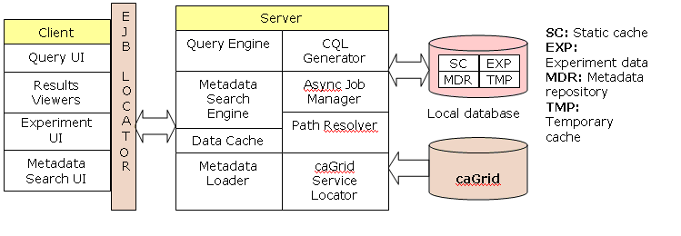
Figure 1 caB2B Client-Server Architecture

Why caB2B uses client-Server based architecture?

The rationale for selecting a client-server based architecture is as follows:
- A centralized caB2B server avoids the need to install a database per client.
- Server stores common data required by all the caB2B clients which includes
- The parsed UML model classes and attributes and their associations obtained by downloading models registered in the caDSR.
- All possible paths between pairs of UML classes.
- Disk space consumption is reduced on the client as common data is stored on the server.
- Common data which needs to be refreshed such as by downloading UML models are fetched by the caB2B server periodically from some source external to caB2B. Thus each client does not need to acquire such updates as this activity is centralized with clients connected to sever to receive the latest updates.
- The caB2B server caches static data such as all the classes from the domain models and their associated paths resulting in significant performance gain.
- Asynchronous tasks such as performing analytical services, executing complex queries and workflow management may be performed by the caB2B sever allowing the caB2B client to be interactive. The user can perform other tasks until the caB2B server completes its task and returns results back to the client.
- The user created experiments and query results are stored on the server. Hence these results and experiments may be shared across multiple users connected to the same caB2B server.

Client-Server Communication
Communication between the caB2B client and caB2B server is established through RMI-IIOP i.e. "Remote Method Invocation over the Internet Inter-ORB Protocol". Enterprise Java Beans (EJB) is a part of Java RMI-IIOP i.e. EJB is a remote object and can be called from a different JVM. For more details on this, please refer to the references section. The diagram in Fig. 2 shows the architecture of the caB2B application that portrays how the client interacts with the server using EJBs:

The reasons for using EJBs
- EJB enables an easy access to remote Java object (i.e. the stubs are generated automatically by the container).
- It is very easy to call EJB from a standalone client. With an EJB, lookup and creation logic are encapsulated in one place. The client code is not aware of existence of EJB on some remote machine which is catering its request. The client just calls remote methods as if they are being called locally.
- An EJB's life cycle is managed by a J2EE-compliant server.
- EJB provides failover and load balancing i.e. one instance of a stateless EJB can cater to more than one client simultaneously.
- An EJB can "publish" a Java API centrally as a RemoteInterface. Such an API is referred to as a BusinessInterface in caB2B. The class providing that API may be looked up and methods may be called from any remote web application/standalone application.
- All EJBs are stateless session beans. For example, the EJB associated with a query engine executes the user specified query and returns the result.
- EJB is an open standard designed for vendor independence. The EJB specification is developed and supported by all major open source and commercial vendors in the enterprise Java community.

Dependency on EJB:
One important point to note here is that none of the business logic components have any dependency on EJB. In fact, components like query interface, metadata repository, metadata search and diagrammatic query view (DAG) are some of the components that are reused across caTissue Suite and caB2B. Note that caTissue Suite is a web-based application developed in Java Struts framework whereas caB2B is a desktop application developed in Java Swing framework. In spite of these fundamental differences, the reuse of most of the components illustrates that the business logic components do not have any dependency on the technology used to communicate between the client and the server (EJB in this case).
Note: We are currently using EJB 2.1 and will be migrating to EJB 3 in the next release of the caB2B application.

A Sample scenario
During the server startup, each EJB’s Home Object (i.e. factory for creating EJB instances) is tied with a name in the JNDI (see references) tree on the same server. When the client needs to call a method on the server, it does the following:
- It asks the EJB-locator to locate the appropriate EJB instance that provides the required functionality in the form of a BusinessInterface. Each locator instance is aware of which JNDI tree to refer to.
- The Locator looks up the ‘Home Object’ of the corresponding EJB in the JNDI tree and uses it to get the EJB instance.
- The client calls the required method on this business interface.
The following sequence diagram describes a sample flow of EJB lookup remotely. For example, finding all paths between two UML classes (entities) in the application:
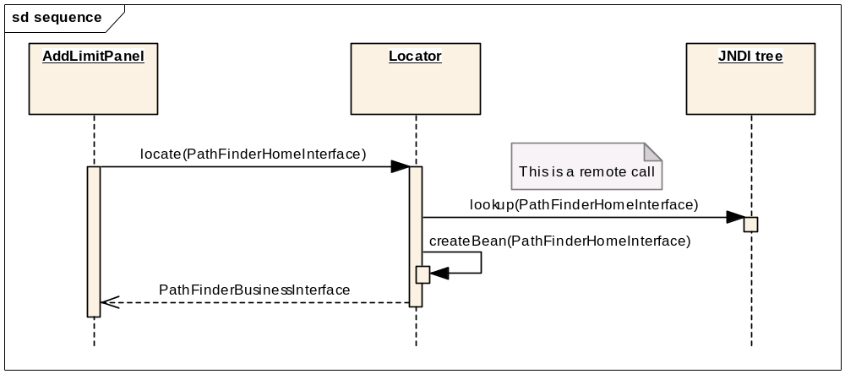
Figure 2 Example of client server communication via an EJB lookup
- PathFinderBusinessInterface has a method getAllPossiblePaths(). It accepts a source and a destination and then returns a list of possible Paths.
- An EJB, PathFinderBean implements this interface.
- Its home interface is PathFinderHomeInterface. EJB’s remote interface i.e. PathFinderRemoteInteface will extend PathFinderBusinessInterface.
- The UI will call Locator to find the appropriate class for finding paths. Locator will lookup the PathFinderHomeInterface from the JNDI tree and will call create () on it which returns PathFinderBusinessInterface. Locator will return that to the UI.
- The UI calls getAllPossiblePaths() on PathFinderBusinessInterface to get the list of Paths.

Classes involved in client-server communication
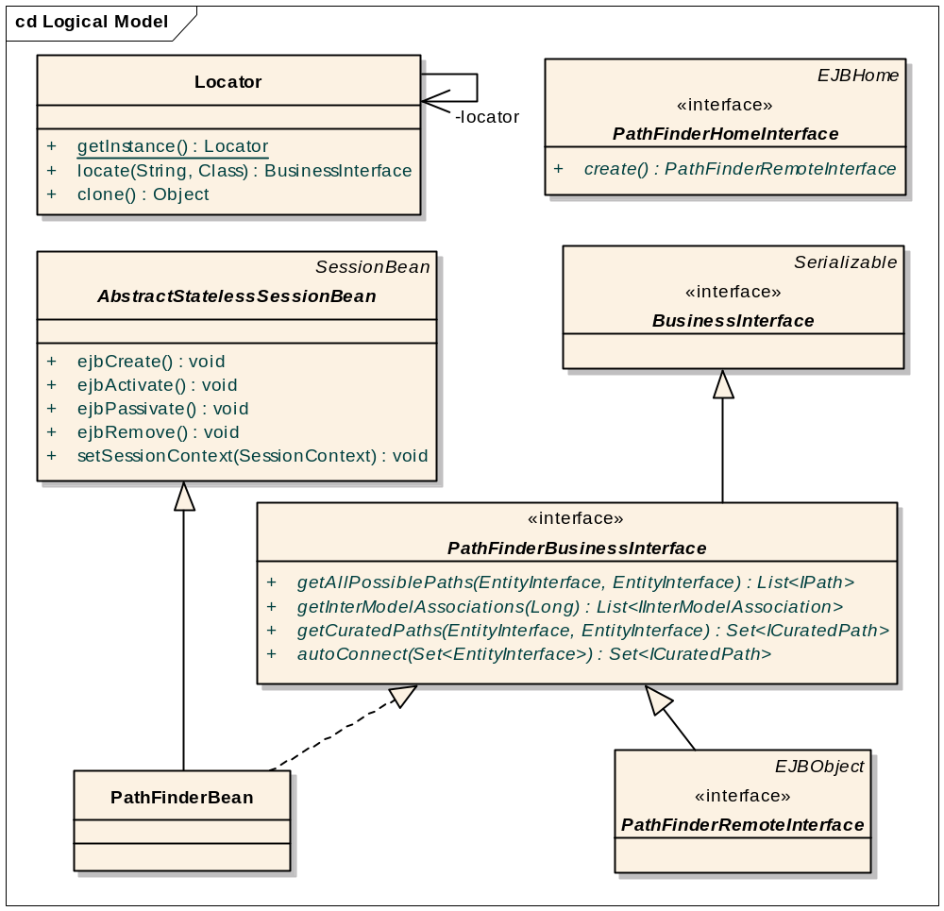
Figure 3 Class diagram showing usage of EJB with PathFinderBean example
Locator is responsible for all EJB lookups which is a singleton class. The caB2B server to be contacted is configured in "cab2b.properties". Locator looks up the Home Object of corresponding EJB in JNDI tree and uses it to get EJB instance. It has the following method to lookup BusinessInterface locate(String ejbName, Class homeClassForEJB).
AbstractStatelessSessionBean is an abstract class which represents a Stateless Session Enterprise Java Bean. Each Stateless Session Bean must extend this class if it not extending something else. This avoids the need of each bean to implement methods from the javax.ejb.SessionBean class.
A home interface of an EJB defines the methods that allow a remote client to create, find, and remove EJB objects. It extends javax.ejb.EJBHome.

An EJB's remote interface provides a remote client view of an EJB object. It defines the business methods that may be called by a remote client. The remote interface must extend the javax.ejb.EJBObject interface and corresponding business interface.
BusinessInterface is a marker interface. All business interfaces must extend this interface. Each EJB has a business interface which defines the enterprise Bean specific business methods. This is to put a compile time check on the methods exposed by EJB and methods implemented by EJB.

Metadata Repository

Overview
One of the basic requirements of caB2B is to be able to download a UML model of any application from the caDSR and provide capabilities to build a query to fetch data from that data source. In order to understand the design of caB2B it is necessary to first understand the design and concept of the metadata repository (MDR).

MDR stores the metadata for an UML model including its semantic annotations like all CDEs including permissible values by decomposing the annotated UML model obtained from caDSR.

It also contains all-to-all paths between every two classes. The caB2B server pre-calculates the paths between all pairs of classes in the UML model and stores them in the MDR. Classes from different applications are connected based on their attribute’s CDE match. This involves matching the concept codes of the classes and their attributes in order. Finally, given the amount of information it stores, it is also possible to get all the paths between two classes across two different UML models based on semantic interoperability.

The design of MDR is the basic foundation for caB2B backend. It enables the caB2B query engine to provide the following functionalities:
- Metadata search
- Auto generation of user interface for entering predicates
- Automatic path resolution between two query predicates
- Category support
- Inter model queries based on semantic joins

caB2B uses Dynamic Extensions framework to store the UML model along with its semantic annotations.

What is Dynamic Extensions?
Dynamic Extensions is a framework that allows creating business objects dynamically in the form of entities and attributes. Following are the Dynamic Extensions (DE) terms regularly referred in this document:
- Entity is a UML class.
- Attribute is a UML attribute.
- Association is relationship between any two entities.

The metadata definition of entity and attribute includes:
- Model Properties (i.e. Data type, Precision etc.)
- Semantic properties (i.e. concept codes)
- Value domain specification (CDE public id, permissible values etc.)

For the detailed design of MDR, please refer to Section Overview and UML metadata of the Dynamic Extensions design document.

Note: Since Dynamic Extensions design document is not formally released, those two sections are appended to the Appendix of this document. Once the DE design document is released, the appendix will be deleted.

Storing UML model
This activity involves following
- Parsing the domain model downloaded from caDSR using caGrid APIs
- Storing the metadata in DE along with inheritance relations.
- Finding out semantic relations of entities from current model to entities already present in system (coming from different model)
The class diagram below shows all the classes involved in parsing domain models, storing them in MDR, and finding and storing all possible non-redundant paths.
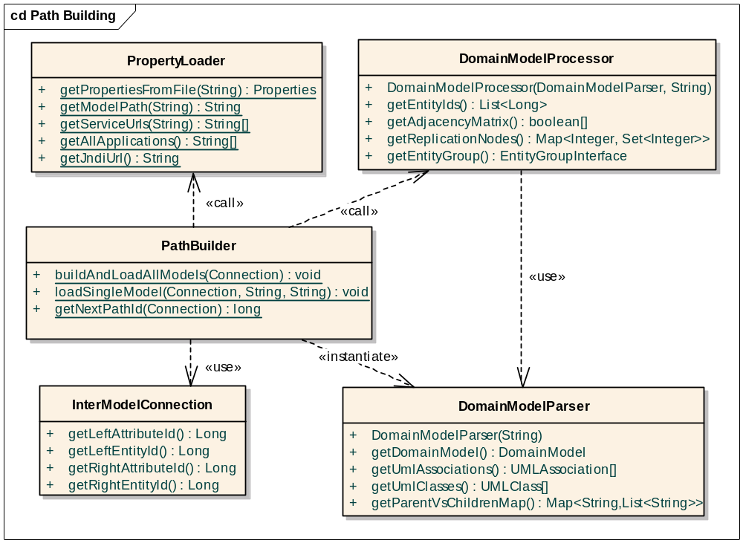
Figure 4 Classes involved in storing UML model to MDR
- PathBuilder is a controller that calls different utility classes to populate MDR by decomposing models defined in cab2b.properties file. It loads all possible non-redundant paths for a given model to database.
- DomainModelProcessor stores the decomposed UML model to MDR. It first transforms model into DE’s objects and processes inheritance relationships in the model. Then DomainModelProcessor stores these objects in MDR. It also generates an adjacency matrix and related information required for path calculation. An instance of this class refers to one domain model
- DomainModelParser converts a domain model XML file located at a given path to caGrid metadata objects using the caGrid metadata utility (gov.nih.nci.cagrid.common.Utils).
- PropertyLoader handles fetching properties from "cab2b.properties" file. It provides methods
    - To get all the models loaded in caB2B
    - To get the file system path for the domain model XML of a given application
- InterModelConnection represents one link present between two entities from different models. This link is a pair of semantically equivalent (i.e. reused CDEs) attributes of classes from different models.

Path Generation Module

Steps and Classes Involved
This module calculates all possible ways to connect any two entities in the same model. It consumes the adjacency matrix generated by DomainModelProcessor. It converts that to a Graph object which is an adjacency list representation of a (directed) graph. Each vertex of the graph is a Node. This module outputs set of edu.wustl.cab2b.server.path.pathgen.Path which is an immutable representation of a path, as a collection of the following:
- Source/From edu.wustl.cab2b.server.path.pathgen.Node
- Destination/To edu.wustl.cab2b.server.path.pathgen.Node
- A java.util.List of intermediate nodes needed to traverse from fromNode to toNode.
At any point in time, GraphPathFinderCache contains all the paths between all pairs of nodes that have been computed till then. When the algorithm terminates, this cache will thus contain all the resultant paths. This cache helps avoid recalculation of paths between a pair of nodes, and thus improves efficiency. Figure below shows all the classes involved in this module.
PathReplicationUtil replicates paths of parent entity to its child. For example suppose P1, C1, P2, C2 are classes. C1 is child of P1 and C2 is child of P2. There is a bi-directional association present between P1 and P2. There is no association between C1 and C2. Then system generates following paths along with normal path between P1 and P2

  - Path between P1 and C2
  - Path between C1 and P2
  - Path between C1 and C2

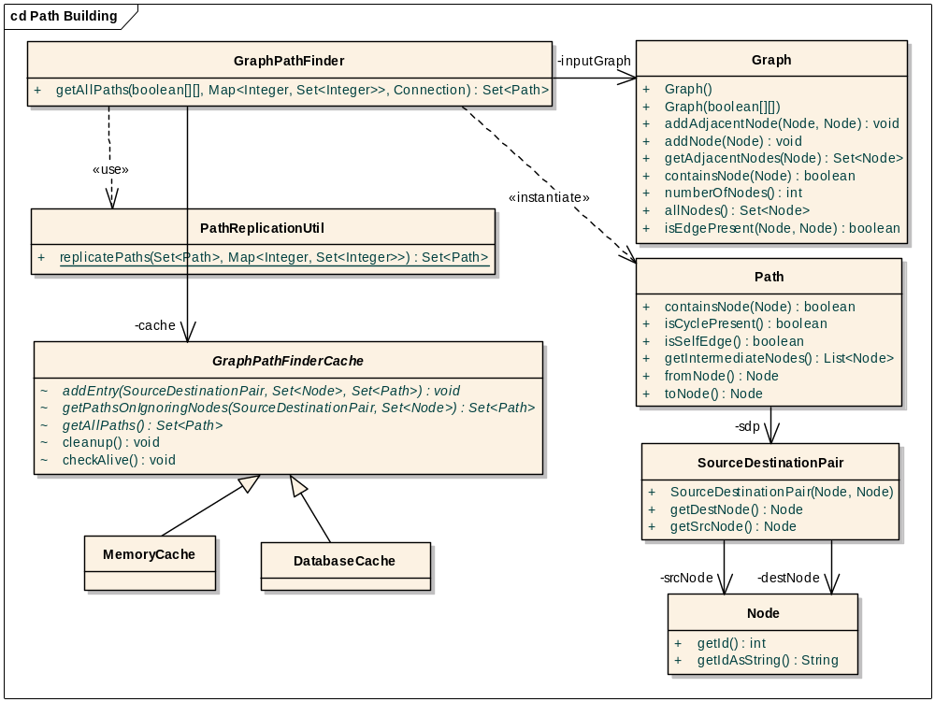
Figure 5 Class diagram of Path Generation Module

Algorithm for Path Generation
This algorithm computes all possible paths present in a directed graph. No path returned should contain a cycle. Suppose the graph is (V, E) where V is the set of vertices and E is the set of edges. A source-destination-pair (SDP) is represented as i->j.
GraphPathFinderCache.getPathsOnIgnoringNodes(SDP, Set) method returns the set of paths for given SDP and ignored nodes. Denote the SDP by i->j, and ignoredNodes by N.
Let n(p) denote the nodes in a path p. Then, given that N1 ⊆ N2, we can compute P(i->j, N1 from P(i->j, N2) using the following formula
P(i->j, N1) = {p : p ∈ P(i->j, N2), n(p) ∩ N1 = {} }.
Thus this method is expected to do the following:

  - If there is an entry in the cache P(i->j, N), return it, else continue.
  - If there exists an entry in the cache P(i->j, M) such that M ⊆ N then compute P(i->j, N) using above formula and return it, else continue
  - Return null
Note that if an empty set of paths is returned, it means that it has been computed already and there are no paths present, i.e. P(i->j, N) = {}. The algorithm is as follows:
For each pair of nodes {i, j : i ∈ V, j ∈ V, i ≠ j} in the graph, call getPaths(i->j, {}). Self-edges (a self-edge is a path of the form i->i) are then added to the resulting set of paths. getPaths() is the method where the core of the algorithm resides. Suppose P(i->j, N) is the set of paths about to be returned from getPaths(). Following is what happens on a call getPaths(i->j, N), where N is the ignoredNodesSet :

  - Let X = GraphPathFinderCache.getPathsOnIgnoringNodes(SDP, Set) with (i->j, N) as parameters;
    - If X != null, then P(i->j, N) = X; return P(i->j, N).
    - Else continue.
  - If i->j ∈ E then add a path i->j to P(i->j, N).
  - Let K = {k : k ∈ V, k ≠ i, k ≠ j, k ∈ N, i->k ∈ E).
    - For each k ∈ K, do the following:
  - Call getPaths (k->j, N ∪ {i}). Suppose the returned set of paths is R.
  - For each path Rx (0 < x < |R|) in R, add the path i->Rx to P(i->j, N).
  - Add P(i->j, N) to the cache.
  - Return P(i->j, N)

Category

What is a Category
Category is a collection of attributes from one or more UML classes. These UML classes may be from same or different applications. The UML classes in a category should be directly or indirectly connected using UML associations.

As an illustration of the usage of category, consider the following use case: Get all genes with annotation which are associated with a given "Gene" through pubMed literature abstract i.e. get list of genes having literature relationship correlation value > 0.5 and have relationship with given gene.

The UML diagram for the classes in the query is
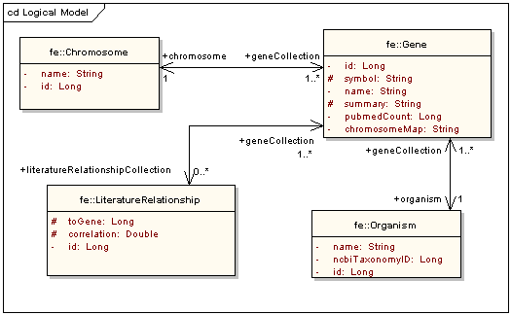
Figure 6 diagram for classes in category
To build the example query, user would
- Search the four classes individually
- Add limits on each of them
- Connect all the classes in the DAG view

Shortcomings of above process:
- UML Class is a collection of attributes that makes sense to developers and bioinformaticians.
- The steps described above are cumbersome and time-consuming
- Each user who wishes to perform this query has to follow this process every time

In certain cases it may be found/felt that each user will define limits on specific attributes of certain logically related classes and connect them by similar paths. In such cases, those attributes can be grouped together to build predefined units with unambiguous paths to save users’ time. These predefined units are categories.

Benefits
- Ability to apply limits on attributes of several UML classes in one go
- Paths among classes in a category will be predefined in metadata. Thus, the user need not find paths required to traverse logically related classes every time.
- End-user sees attributes in a single logical unit even though they belong to different classes due to modeling constraints
- Users with limited knowledge of UML domain models can query on categories.
- Advanced users can also use categories as building blocks for their complex queries

Creating a Category
Category is defined as a well-formed XML file called category XML. CategoryXmlParser parses this file and generates an InputCategory object. PersistCategory converts InputCategory to Category hibernate-object which will be saved by CategoryOperations. This flow is explained in sequence diagram in Fig. 7
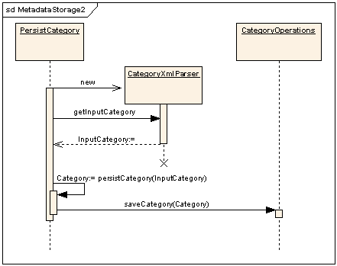
Figure 7 Sequence diagram saving a category
Category XML
This is a well-formed XML file, which defines a category. All categories are initially defined as a Category XML and then they are imported into the caB2B MDR. The structure of this file is as shown in Fig. 8.

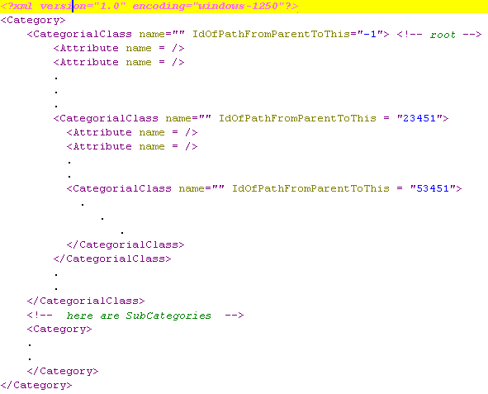
Figure 8 Category XML structure

Figure 9 shows an example of the Category XML file for the category “Genomic identifiers”

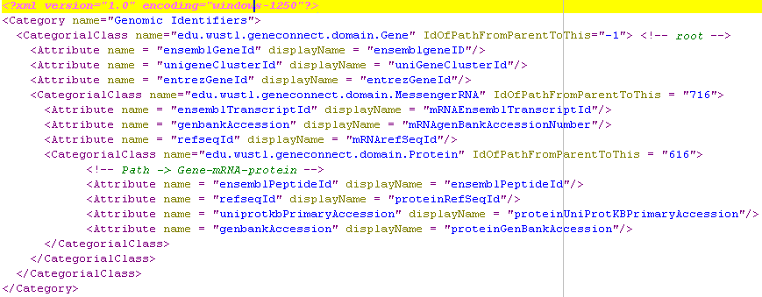
Figure 9 Example of Category XML file

Class Diagram
Classes involved in category creation are shown in figure shown below.
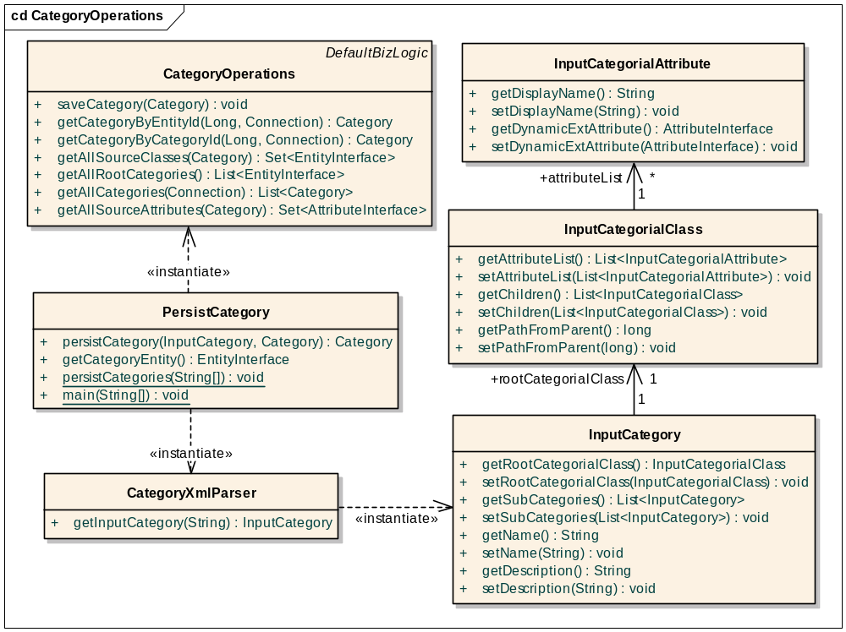
Figure 10 Classes involved in category creation
- InputCategory is an object representation of the "Category" tag of category XML.
- InputCategorialClass is an object representation of the “CategorialClass" tag of category XML.
- InputCategorialAttribute is an object representation of the "Attribute" tag of category XML.
- CategoryXmlParser provides methods to parse a category XML (see references) file and converts it into Java object form. These Java objects will be used in actual category creation and saving.
- PersistCategory provides methods to save a category in the database. It uses CategoryXmlParser to convert a category XML to corresponding objects (InputCategory) and then builds actual Category objects and saves them to the database using Hibernate.
- CategoryOperations provides functions for database operations needed for a category such as save and retrieve.

Metadata Cache
Contents of MDR are needed frequently by various cab2b-components. To improve efficiency, by avoiding database calls, metadata cache module is introduced. Classes involved in this module are shown in diagram of Fig. 11.
IEntityCache is an interface with methods needed for metadata search. Those will be explained in Metadata Search section later. AbstractEntityCache is an abstract class having all the methods exposed by this module. All components access MRD information through this class only. It provides variety of methods to get metadata along with providing searching methods from IEntityCache. getCab2bEntityGroups () is the only abstract method in AbstractEntityCache. This method is used to populate the cache. So it is up to implementer’s responsibility to decide how it will get entity groups. There are two implementing classes EntityCache and ClientSideCache.
EntityCache calls dynamic extension API directly to get entity groups. EntityCache is a singleton class residing in server side. It is instantiated and populated on first server call. It is then used by all of the components running at server side. ClientSideCache calls an EJB UtilityBean to get entity groups as it won’t have direct access to DE APIs. It is also a singleton class which is instantiated and populated before launching client. It is then used by all of the components running at client side.
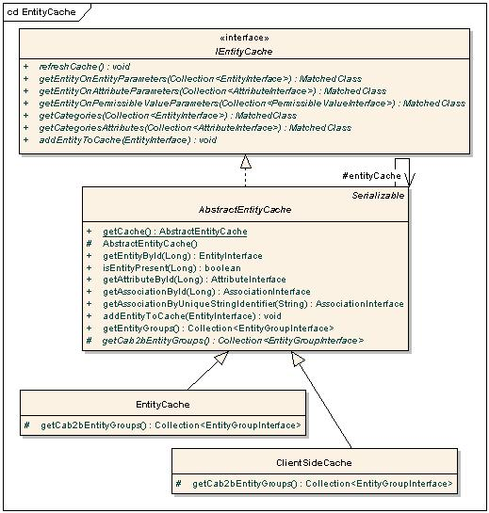
Figure 11 Classes in Metadata cache module

Metadata Search

Overview

As the end users may not be familiar with object models, there should be an approach for them to first search for the entity on which they want to query. For example, an end user will not know which entity has the attribute for clinical diagnosis in the caTissue object model. The metadata enables users to first search for entities based on metadata such as names, attribute names, permissible values, or definitions using free text search or using concept codes. This module has backend search implementation and a user interface to specify search conditions and to display search results.

Backend Implementation
Metadata search back end part exposes one method on MetadataSearch class
search(int[] searchTarget, String[] searchString, int basedOn)
- basedOn: the basis of search, whether a text based or concept code based search is asked
- searchString[]: Array of Strings created by splitting string entered by user based on space characters
- searchTraget[]: Where to search is specified by this. Typical values are class, attribute, permissible values, class-description and attribute-description
The dataset to be searched is decided by the IEntityCache object passed to construct MetadataSearch object. IEntityCache provides searching methods like
- getEntityOnEntityParameters(entityCollection)
- getEntityOnAttributeParameters(attributeCollection)
- getEntityOnPermissibleValueParameters(PVCollection)
- getCategories(Collection<EntityInterface> entityCollection)
- getCategoriesAttributes(attributeCollection)
Each of the above methods returns a MatchedClass object. MatchedClass is a wrapper around a set of entities. The search () method searches each searchTarget for all strings in searchString array by calling one of the above methods of IEntityCache for each searchString. It then merges the results of all individual searches using a method createResultClass () and returns one MatchedClass object.
CompareUtil is responsible for deciding whether a particular entity, attribute, permissible value or semantic property is matching the user’s criterion. It has compare() methods which takes a pair of entities, attributes, permissible values or semantic properties and returns a boolean. If the user entered string is found in string to be searched, then it is appended to the result. The diagram of Fig. 12 shows all of the classes along with their behaviors and relationships with each other.

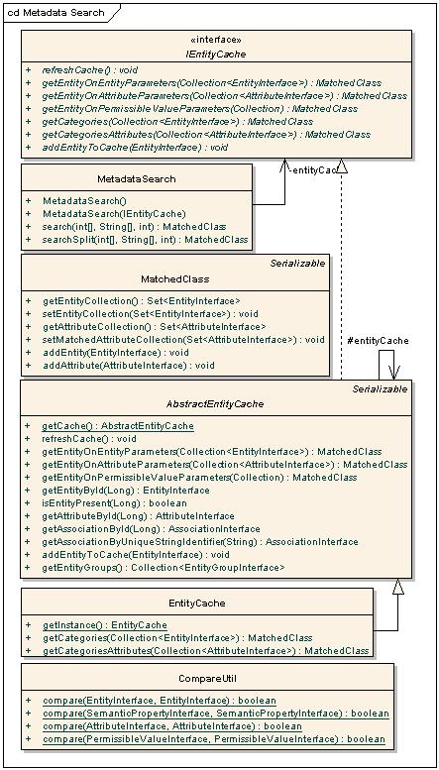
Figure 12 Classes- Metadata Search backend

User Interface

User interface of this module mainly consists of a SearchPanel. AdvancedSerachPanel and SearchResultPanel are embedded in main SearchPanel for common functionalities and code reuse. AdvancedSearchPanel is the panel where user specifies search criterion, SearchResultPanel displays search results using pagination component (for details refer to chapter Pagination Component). The diagram below shows these classes along with their local classes.
- AdvancedSearchPanel: It is a class which contains commonalities between the collapsible portions of the advanced/category search panels for the 'Choose Category' as well as 'AddLimit' section from the main search dialog. TaskPaneMouseLister is its local class. The collapsible portion provides options for searching category, attribute, permissible values with provision of concept code or text search.
- SearchResultPanel: This class that contains commonalities required for displaying results from the 'AddLimit' and 'Choose Category' section from the main search dialog. MyCellRenderer, AddLimitButtonListner, CDETableModel, EditLimitButtonListner, AttributeDetailsLinkListener are its local class.
- SearchPanel: It is the main class that contains UI commonalities between the advanced/category search panels for the 'Choose Category' as well as 'AddLimit' section from the main search dialog. SearchActionListener is its local class.

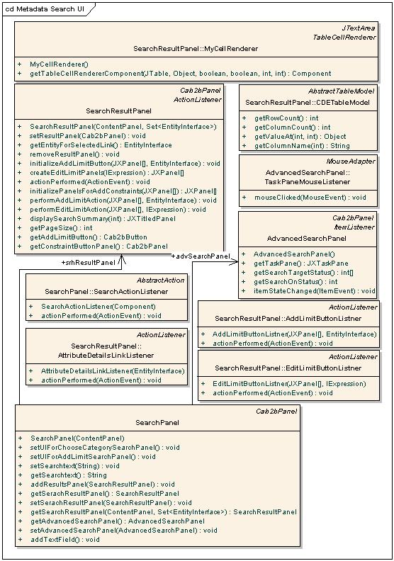
Figure 13 Classes- Metadata Search user interface

Query Object

Overview
The query-object (IQuery) provides the interfaces used to represent a user-defined query. The query consists of outputs (represented by IOutputTreeNode) and constraints (represented by IConstraints). User defined conditions (e.g. Participant.sex = ‘female’) are represented by ICondition. Conditions on different attributes of an entity are grouped together as a rule (represented by IRule). Various rules/expressions on an entity can be logically grouped into an expression (represented by IExpression). An expression thus consists of operands (i.e. rules or sub expressions; this is represented by IExpressionOperand) connected by logical operators (AND, OR). Operands in an expression may also be parenthesized.

The various expressions thus formed need to be linked together. Two expressions are linked by an association (represented by IAssociation). These linkages among the expressions constitute the join graph (represented by IJoinGraph).

Interface Summary
ICondition | A condition containing an attribute, relational operator and value(s). E.g. participant.sex = 'Male' forms one ICondition
IRule | A list of conditions on different attributes of an entity.  The conditions in a rule are implicitly linked by an AND condition.
ILogicalConnector | Represents a logical connector (AND / OR). The nesting represents the number of parentheses (depth of parentheses) around the logic portion (AND or OR) of the connector.
IExpressionId | An immutable wrapper around int used to uniquely identify an expression within a query. It is auto generated when an expression is added to a query (using IConstraints.addExpression).
IExpression | A list of operands, and the logical connectors (AND, OR) together form a logical expression. The connectors are identified by the position of the operands on either side. An IExpression belongs to a constraint entity and constraints on another associated entity will be present as a sub expression on the associated entity. Conversely, if an expression has a sub expression, there must be an association in the join graph from the parent expression to the sub expression.  Note: "sub expression" refers to an operand that is the IExpressionId of the child expression. The entity of the sub expression will generally be different from the entity of this expression (the exception is when a class is associated to itself, e.g. Specimen class in caTissue Core). The expression for an ExpressionId is found from IConstraints.
IExpressionOperand | A marker interface for an operand. An operand is either a sub expression (in which case, the corresponding expression id is added), or a rule.
IJoinGraph | A rooted, directed acyclic graph with expressions as vertices, and associations as edges. The graph will always contain all the expressions' ids (obtained from IConstraints) as vertices. The vertices will be added to/removed from the Joingraph as and when expressions are added to/removed from IConstraints. The methods in Joingraph can only add/remove associations among the vertices.  If v1 and v2 are two vertices, the direction will be v1->v2 if v2 is a sub expression of v1. This graph determines the join conditions in the query. E.g. for each edge (v1, v2) there will be a join between the entities (IConstraintEntity) of the expressions denoted by v1 and v2; and the join condition is determined by the information in IAssociation.
IQueryEntity | An entity on which the user specifies limits (constraints)  e.g. Participant is an IQueryEntity
IConstraints | Contains information about the constraints of a query. It contains a list of IExpressions. This list is indexed by IExpressionId. This is global storage for all the expressions in a query. Calling the addExpression() method here creates an IExpression. It also contains a join graph for specifying how the expressions are linked together.
IOutputEntity | An entity which is desired as the output of the query.
IOutputTreeNode | The output entities of a query form a tree with vertex as IOutputEntity and edge as IAssociation. IOutputTreeNode represents one node of this tree.
IQuery | The query object representing a complete user-defined query consisting of outputs and constraints.

Class diagram
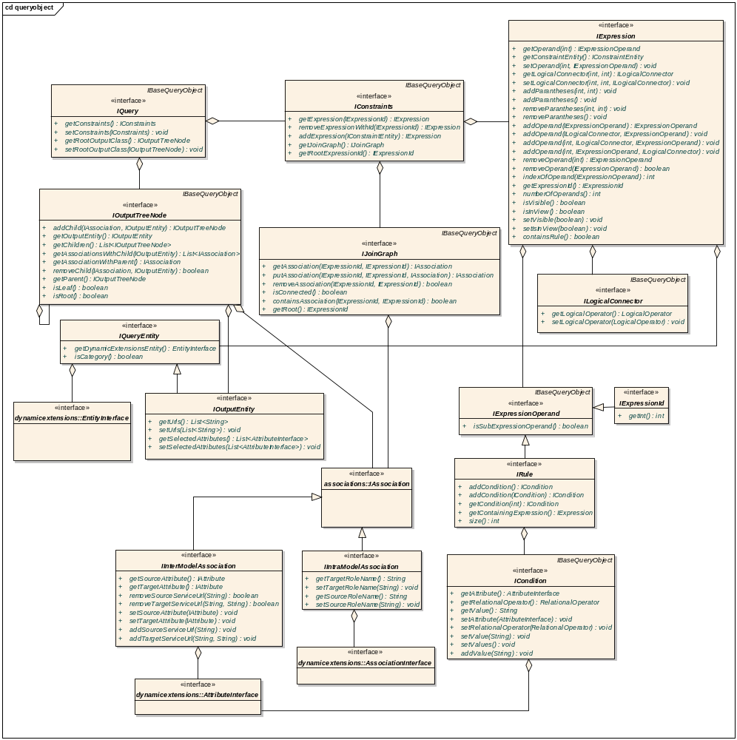
Figure 14 Interfaces that compose the query object

Query Engine
Query engine interprets the query object and converts it to DCQL(s), executes DCQL(s) and gets result back from data services

Overview
The category constraints made by the user using the caB2B client’s DAG view are stored in the query-object i.e. ICab2bQuery (which extends IQuery to add information regarding output class’ service URLs). The query engine is an EJB that processes the ICab2bQuery to form the corresponding DCQL, executes the DCQL, and returns the results back to the client.

Class diagram
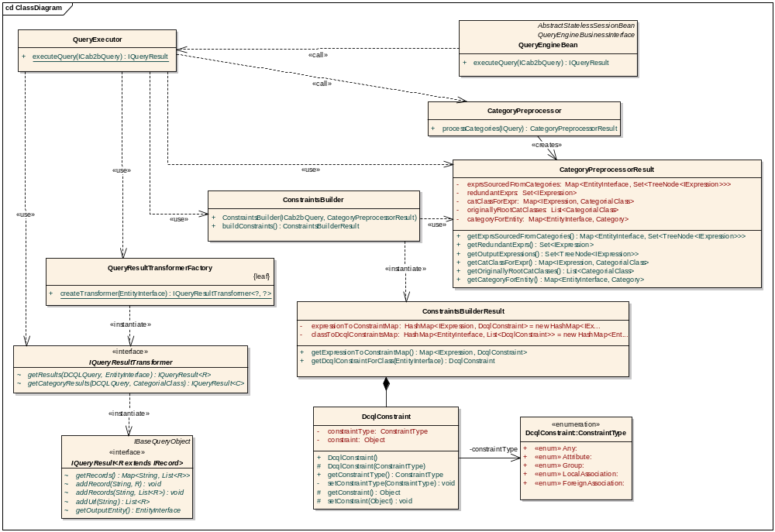
Figure 15 Interfaces and classes that compose the query engine
Description of classes and their interactions:
- QueryEngineBean is an EJB that receives the calls for query execution from the caB2B client. It just forwards the call to QueryExecutor.
- IQueryResult is a map of the service URL to records obtained from that service. The records are represented as a two-dimensional array with columns corresponding to attributes and rows corresponding to values.
- QueryExecutor uses the ConstraintsBuilder to form DCQL(s), hands over the DCQL(s) to an appropriate transformer and returns the resulting IQueryResult. Multiple DCQLs are fired when the output is category; CategoryPreprocessorResult is used in this process.
- CategoryPreprocessor modifies an input IConstraints by expanding the IExpressions on categories to its constituent classes. Thus IConstraints is modified to only contain IExpressions on classes.
- CategoryPreprocessorResult represents the results of the CategoryPreprocessor. It provides additional information about the relationship between the original category entities in the query and the new expressions created for them.
- ConstraintsBuilder processes an IQuery object and returns a corresponding ConstraintsBuilderResult object (See Figure 13.0). It uses the CategoryPreprocessorResult for this processing.
- DcqlConstraint is a wrapper around any of the following four types of objects that compose a part of the caGrid DCQLQuery. For details related to these and DCQLQuery please see the caGrid Programmer’s Guide
    - Attribute
    - Association
    - ForeignAssociation
    - Group
- ConstraintType is used to distinguish among the above four types of constraints.
- ConstraintsBuilderResult provides the DCQLConstraint corresponding to each IExpression in the query.
- QueryResultTransformerFactory provides the appropriate transformer.+
- IQueryResultTransformer executes the DCQL using the caGrid FQP and transforms the results to appropriate IRecord. See Query Result Transformers (Chapter Record Customization)

Sequence diagram
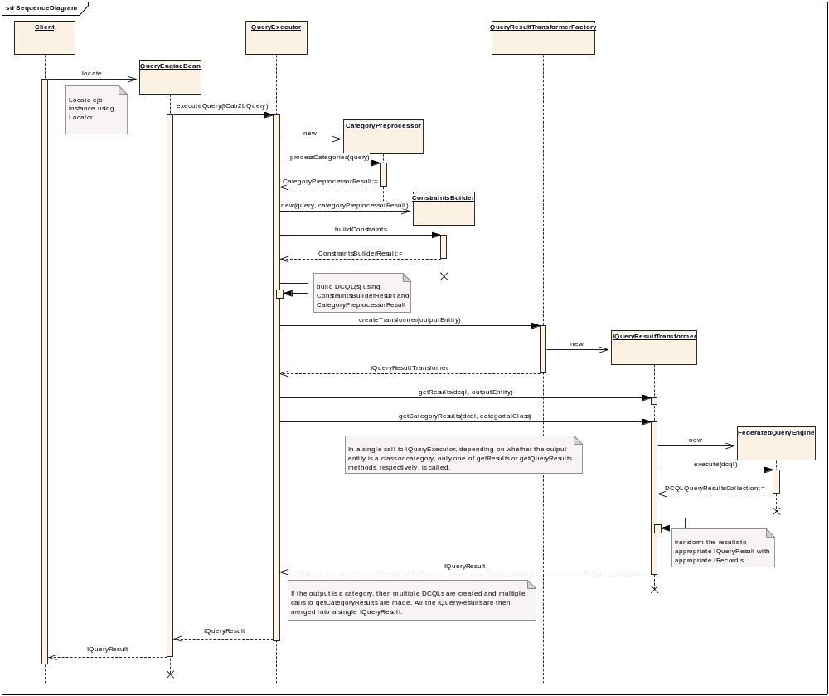
Figure 16 Sequence diagram to show how a query is executed and results are returned

Flowchart
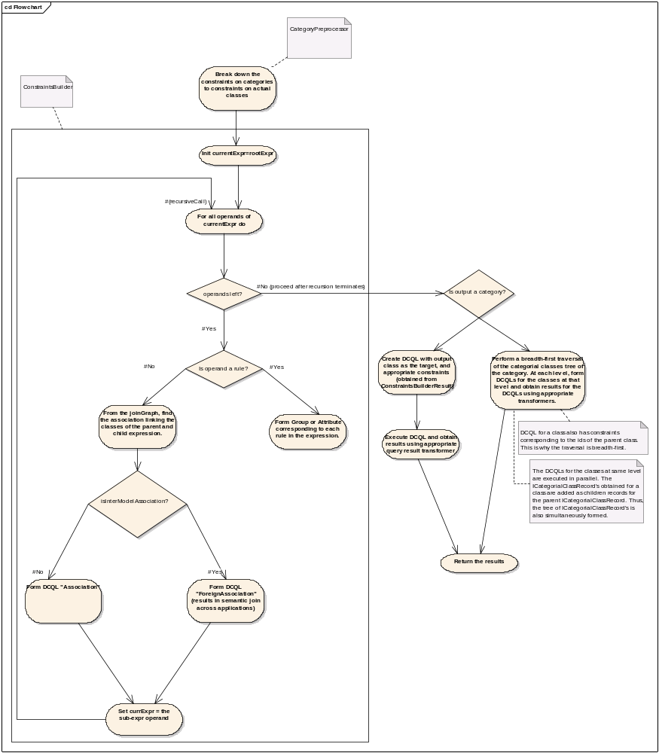
Figure 17 Detailed steps within the QueryExecutor

Lazy initialization
Sometimes a record may be very big i.e. it may consume a lot memory. An example is a biodatacube. Sending the complete record from the caB2B server to the client would be unreasonable in such case because:
- Client-side memory would be relatively less.
- The user may not wish to see the complete record; only some parts of it may be of interest at a time.
- Client performance may deteriorate due to the large amount of network traffic.
Thus, it is required, in some cases, to be able to initialize a record lazily.
Lazy initialization entails the following:
- Store the complete record on the server side, and provide a handle to it. This is performed by edu.wustl.cab2b.server.queryengine.LazyInitializer. A complete record is represented by the interface edu.wustl.cab2b.common.queryengine.resul.IFullyInitializedRecord.
- Maintain the handle as part of a partially initialized record. A partially initialized record is represented by the interface edu.wustl.cab2b.common.queryengine.result.IPartiallyInitializedRecord.
- Obtain data for the uninitialized portions by providing a handle to the fully initialized record, and parameters that identify the portions to fetch. The lazy parameters are represented by edu.wustl.cab2b.common.queryengine.result.ILazyParams; the method that does this lazy initialization is LazyInitializer.getView().

Details of these interfaces and classes follow:

edu.wustl.cab2b.server.queryengine.LazyInitializer
- int register(IFullyInitializedRecord fir) Registers a fully initialized record, and provides a handle to it. Currently, the record is stored in an in-memory map.
- IPartiallyInitializedRecord getView(int handle, ILazyParams params) Identifies the fully initialized record corresponding to the handle, and requests it to provide the IPartiallyInitializedRecord corresponding to given ILazyParams.
- IFullyInitializedRecord getFullyInitializedRecord(int handle) Returns the IFullyInitializedRecord corresponding to the handle.
- void unregister(int handle Unregisters the record. Currently, the record is removed from the in-memory map.

edu.wustl.cab2b.common.queryengine.result.IFullyInitializedRecord:
- IPartiallyInitializedRecord view(ILazyParams params, int handle)
Returns the partially initialized record that corresponds to the parameters. The handle is passed on to the newly created IPartiallyInitializedRecord.

edu.wustl.cab2b.common.queryengine.result.IPartiallyInitializedRecord
- int handle() The handle to the fully initialized record.
- ILazyParams initializationParams() The parameters with which this record was created.

Example – BioAssayData
A BioAssayData record contains a biodatacube, which is a three-dimensional array. The dimensions of this array can be quite large, and thus the cube may require a huge amount of memory. Lazy initialization of this record is performed by lazily initializing the contents of this array based on the indices of the cells the user is viewing.

Following interfaces thus represent partially and fully initialized records respectively:
- cab2b.common.caarray.IPartiallyInitializedBioAssayDataRecord
- cab2b.common.caarray.IFullyInitializedBioAssayDataRecord

Refer to Record Customization for the class diagram showing the genealogy of these interfaces. The lazy parameters for this scenario are represented by LazyParams from package edu.wustl.cab2b.common.queryengine.result.I3DDataRecord

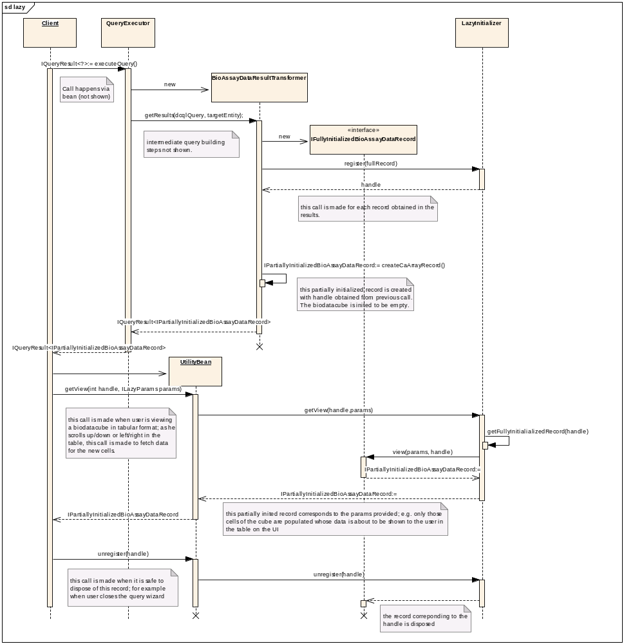
Figure 18 Sequence diagram - Lazy Initialization

Querying caArray using caB2B

Scope
Querying the caArray data service requires extensions to the default caB2B querying mechanism. This document first explains the reason why these extensions are required. It then explains the design of the relevant portions of caB2B query module, and the actual extensions implemented to support querying caArray.
Note that the content of this document is an edited extract of Chapter 13 “Record Customization” of the caB2B 1.0 design document.

Prerequisite
Any application that is to be supported by caB2B has to be registered with the metadata repository of caB2B. So, the caArray domain model xml has to be loaded to the caB2B metadata repository.

Supporting caArray in caB2B

Overview
In caB2B, the user defines a query on the DAG. This user-defined query is transformed to appropriate DCQL. The DCQLQueryResults obtained by executing this DCQL are then transformed into an IQueryResult.

The IQueryResult is a caB2B-specific representation of the results. Logically, IQueryResult is a collection of records (represented by IRecord’s). This chapter explains how this caB2B-specific representation (i.e. IRecord) is customized to support querying the caArray data service.
The IRecord IRecord is a map from an attribute to its value.

Why customize IRecord for caArray?
The default IRecord represents the record of a UML class, as obtained from a data service that uses the default (de)serialization mechanisms of caGrid. A custom subtype of IRecord would be defined to add more information to such a record.
The caArray data service provides custom (de)serialization. It returns more information than can be represented by IRecord; it returns identifiers of classes associated to the target class. To store this information, a custom record has to be defined.

Steps in customizing IRecord for caArray
- Define appropriate subtype of IRecord; this is ICaArrayRecord.
- Implement a query result transformer. This will be responsible for transforming CQLResults into ICaArrayRecord.
- Register the custom implementation in the configuration xml “ResultConfiguration.xml”.
The following sections explain the above steps in detail.

IRecord and its extensions for caArray
Following are the basic interfaces; the other interfaces are either markers or mixins to represent the records from caArray data service.
- IRecord: The most basic interface; it represents a record as a set of attribute-value pairs.
- IRecordWithAssociatedIdentifiers: Represents a record that can provide identifiers of associated classes as well.
- ICategorialClassRecord: Represents the records of a category. The records form a tree; the structure of the tree corresponds to the tree of classes in the category.

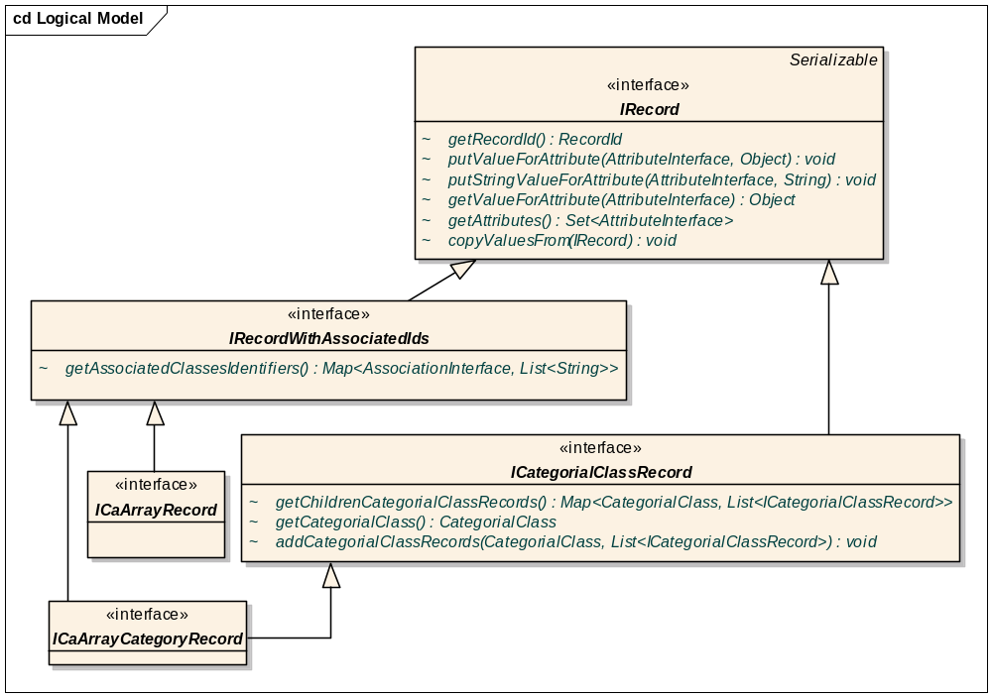
Figure 19 IRecord and its caArray extensions

Query Result Transformers
A query result transformer is defined by the interface edu.wustl.cab2b.server.queryengine.resulttransformers.IQueryResultTransfomer<R extends IRecord, C extends ICategorialClassRecord> and is responsible for executing a DCQL and transforming the results into an appropriate IQueryResult. Following are the methods in IQueryResultTransformer:
- IQueryResult<R> getResults(DCQLQuery query, EntityInterface targetEntity);
<R> the type of records created when executing a query for a class.
  - query the DCQL.
  - targetEntity the target entity (corresponds to the target object of the dcql).
- IQueryResult<C> getCategoryResults(DCQLQuery query, CategorialClass categorialClass);
<C> the type of records created when executing a query for a category.
  - query the DCQL whose target object corresponds to the actual UML class represented by the categorial class.
  - categorialClass the categorial class.

Class diagrams for query result transformers are shown below.
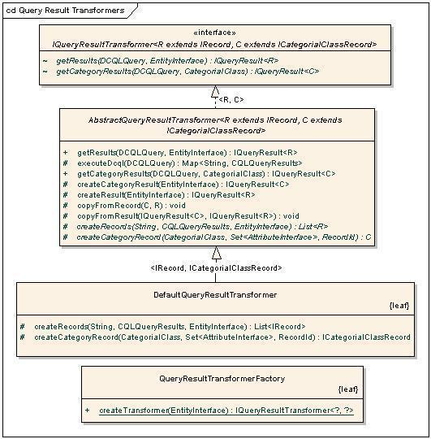
Figure 20 Query Result Transformers

Note: The text on the generalization links refers to type parameters e.g. declaration of DefaultQueryResultTransformer is class DefaultQueryResultTransformer extends AbstractQueryResultTransformer<IRecord, ICategorialClassRecord>
QueryResultTransformerFactory refers ResultConfiguration.xml to obtain the appropriate transformer.

Inbuilt implementations of IQueryResultTransformer
- AbstractQueryResultTransformer This abstract class provides a skeletal implementation of a query result transformer. Concrete implementations need only implement the createRecords() and createCategoryRecords() methods. Additional hooks are provided and can be used to customize the creation and population of the records in the result.
- DefaultQueryResultTransformer This is the caB2B default query result transformer. It parses the gov.nih.nci.cagrid.cqlresultset.CQLQueryResults xml and extracts the values for the attributes of the target entity. The records in the results are of the basic types IRecord and ICategorialClassRecord.

Customization for caArray
The interface cab2b.server.caarray.resulttransformer.ICaArrayRecord is used to represent a record of the caArray application. As explained previously, the caArray service returns identifiers of classes associated to the target class. Thus, an application-level transformer is defined for caArray that uses the caArray deserializers and reads this information.
- AbstractCaArrayResultTransfomer: Provides an implementation of the method createRecords() of AbstractQueryResultTransformer. It also handles the deserialization of the caArray results xml into objects and transforms these objects to ICaArrayRecord using reflection.
- DefaultCaArrayResultTransformer: This is the transformer for classes in the caArray application. It provides an implementation of the createCaArrayRecord() method of AbstractCaArrayResultTransfomer.

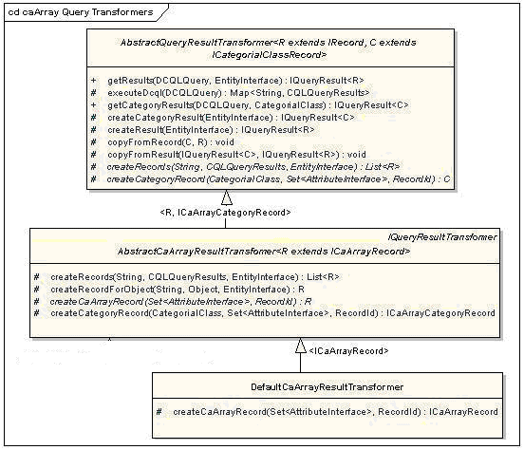
Figure 21 caArray Query Result transformer

Result Configuration XML
The query result transformer defined for caArray has to be registered with the caB2B application in the ResultConfiguration.xml file as shown below. Refer the first entry <application name=”caArray” >.
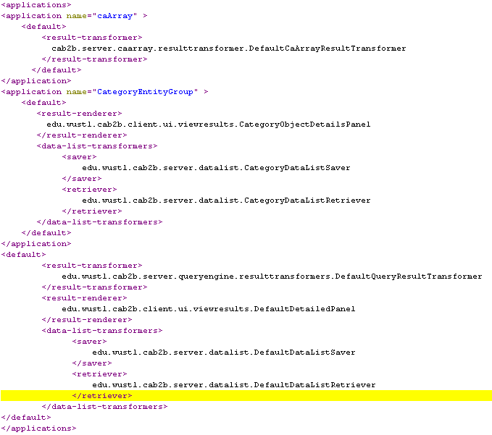

Querying secure data services

Overview
To query to a secure data service we need to pass grid credentials to the Federated Query Engine (FQE). A grid credential (also called as grid proxy) is a short term certificate. Getting this certificate is a two step process:
- Authenticating user on an authentication service
Authentication service is a grid service which accepts user name and password, and validates the user. If the user is a valid grid user then a SAMLAssertion (a SAML certificate) is returned indicating successful authentication.
- Obtaining grid proxy
The SAML certificate is passed to another grid service called Dorian which returns a proxy certificate. As mentioned earlier, proxy is a short term certificate, with a life span of maximum of 12 hours. After completion of a lifetime, it has to be renewed using the SAML.

At times a Dorian service can work as authentication service but a separate authentication service can also do this job. In order to be able to get SAML assertion from authentication service, we need to have the certification authorities (CA) certificates in the USER_HOME/.globus directory. The certificates in this directory correspond to certificate authorities that you trust for issuing credentials. Absence of these certificates will not allow you to complete the authentication process. How to get these certificates is explained on caGrid wiki
http://www.cagrid.org/wiki/GTS:1.2:Administrators_Guide:Syncing_With_the_Trust_Fabric
In caB2B, the authentication is currently performed at the server side. At the client side, a login dialog is presented to the user asking for grid user name and password. These credentials are then passed to caB2B server for authentication. Current design assumes that the authentication service is Dorian.

APIs to use
CaGrid provides following authentication related APIs.

Following classes are used.
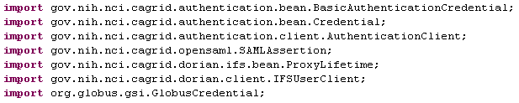

Create authentication credentials
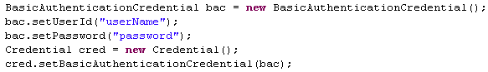

Authenticating user

Getting proxy from Dorian
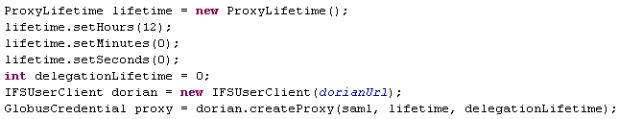

Implementation

Following are the classes used in implementation:
- LoginFrame is the entry point of the application. When user launches the application, a dialog pops up prompting user to enter grid username, grid password and name of the authentication service to check the credentials on (e.g. if user has created an account on training service, training option from the dropdown is to be selected). The proposed screen for login is given below
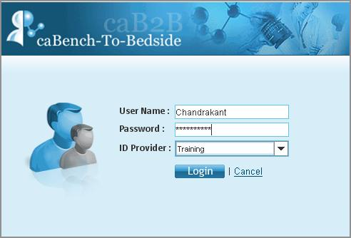
Figure 22 caB2B Login dialog
- UserValidator is a client side class that calls UserBean for authentication. It is also contains the proxy certificate received as a result of successful validation.
- UserBean is an EJB that UserValidator calls to pass validation request to server side.
- UserOperations is the class to which UserBean delegates its operations. validateUser() method of this class takes username, password and the authentication URL and returns the proxy after validation.
- getDorianUrl(String idP) method of PropertyLoader returns the authentication service URL based on the grid name passed.
- CommonUtils class has a method executeQuery() which is used by query API to fire a query. This method internally calls getProxy() method of UserValidator class to fire a query on secure data service.

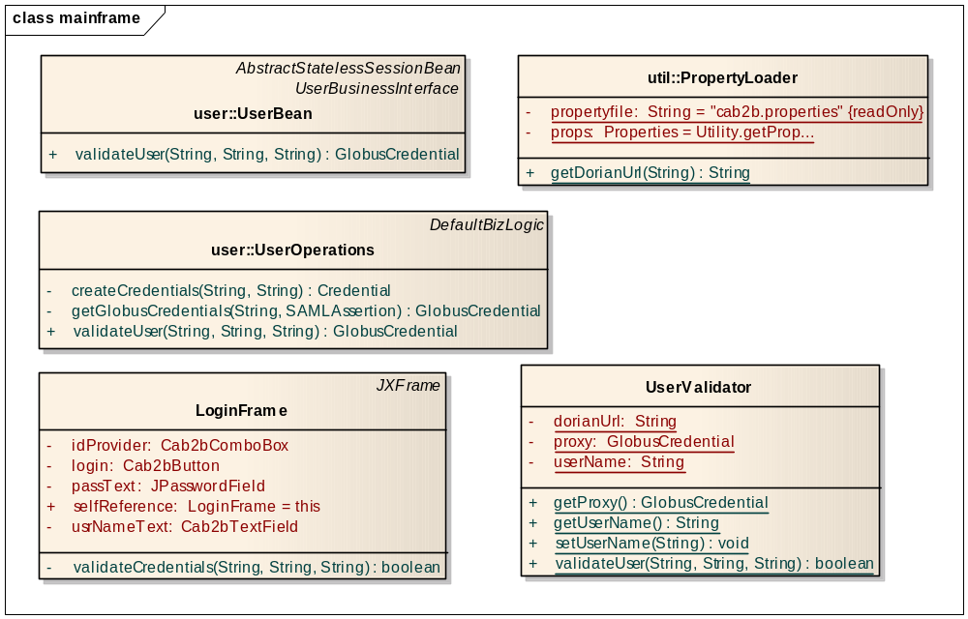
Figure 23 Class Diagram for User Authentication

Sequence diagram:
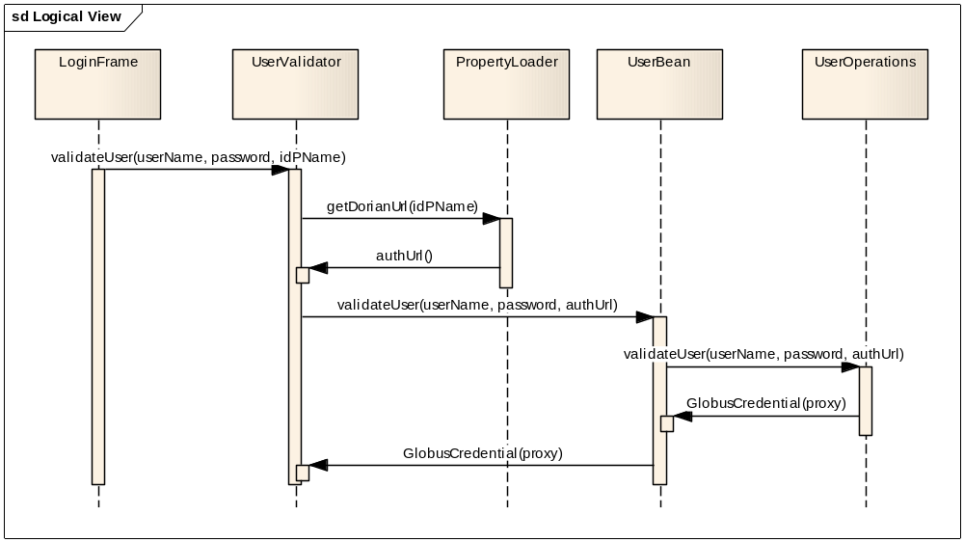
Figure 24 Sequence diagram of User Authentication

Custom UI Components

Overview
The usual practice of UI development is to use standard UI controls with their default properties and behavior. The problem with this approach is:
  - If the application requires a property (e.g. font for labels) to be standardized across the application, a change is needed at every place wherever that component is instantiated. This is quite cumbersome.
  - Sometimes standard component doesn’t provide required functionality and onlyprovides limited functionality
Aforementioned problems are avoided by creating several components (see table) by customizing and extending the standard Swing and SwingX components. Customization includes modifying some default property and/or behavior for the standard component to suit the requirements.

The Usability Engineering group makes UI standards available. For example, all button labels should be of ‘Arial 10pt Normal’. This is achieved by defining ‘Cab2bButton’ that extends ‘JButton’ and sets the font at the time of creation. So whenever a ‘Cab2bButton’ is created, it comes with customized font by default. Also, font can be changed very easily by only modifying ‘Cab2bButton’ class and the change would be reflected across all buttons in the application.

List of customized components

Original  Component | Customized Component Name | Customization details | Usability related?
JButton | Cab2bButton | Default font and preferred size is set | Yes
JLabel | Cab2bLabel | Default font, background color is set | Yes
JCheckBox | Cab2bCheckBox | Default font, background color is set | Yes
JComboBox | Cab2bComboBox | Default font, background color and preferred size are set. | Yes
JRadioButton | Cab2bRadioButton | Default font, background color is set. | Yes
JTextField | Cab2bTextField | Default preferred size set. | Yes
JFormattedTextField | Cab2bFormatted-TextField | Customized to handle field validation like, field accepts only positive integer, floats and alphanumeric strings. | No
JXHyperlink | Cab2bHyperlink  Cab2bHyperlinkUI | Customized by default to show the hyperlink text underlined and each hyperlink associated with a user object. Default visited and un-visited hyperlink color is set as per recommendation. | Associating user object with hyperlink is application specific.
JXDatePicker | Cab2bDatePicker | Default preferred size is set. | Yes
JXPanel | Cab2bPanel | Panel background color is by default se t to white. It can be changed to any other color by passing the appropriate Color object. | Yes
JXTitledPanel | Cab2bTitledPanel | This panel background color is by default set to white. | Yes
TableModel | LazyTableModel | Added the ability to fetch table data as and when needed to display huge data in table form. | No
JXTable | Cab2bTable  Cab2bDefaultTableModel | By default, “select all” of table rows are enabled. Shows long texts in a text area with text wrapping. | No
 | StackedBox | Customized to look as per the Visual Design specification. | Yes
Table 1 Customized components in the caB2B application

Lazy Table Model
This is component developed for visualization of huge spreadsheet data. It only fetches data that is currently required. It additionally caches the data to improve performance. The list of classes involved is

- LazyDataSourceInterface: This is used by LazyTableModelInterface to fetch the data only when required. It provides the description of the data such as number of rows, number of columns etc. The method getData(int row,int column) has a responsibility to fetch the data from the source (that may be a servlet, ejb or anything). Additionally it can cache the data.
- AbstractLazyDataSource: provides a sample implementation of the getData method. It converts the location of the required data to the cacheable page unit. Then fetches the data of the page from the data source, caches the page and extract required data from the page.
- BDQDataSource: This is the implementation of the AbstractLazyDataSource for bio data cube (BDQ) object. It provides implementation to fetch the portion of data for BDQ from the server and to extract the required data from the page. It converts x and y co-ordinate into the dimensions of the 3D representation of the BDQ object.
- PageDimension is used by data source to paginate the data. It gives the dimension of the pages of a particular data. Page represents a small block of data. The huge data can be broken down into the pages. PageInfo represents metadata about the page. It provides information like starting x and Y coordinate of a page in original data.
- LazyTableModelInterface: This is marker interface for the table models that uses LazyDataSourceInterface to fetch actual data.
- DefaultLazyTableModel: delegates all calls to the contained data source.
- CacheInterface: provides method to cache the pages of the data. This is used by data source.
- BucketCache: This is implementation of the cache based on bucket of the pages. It keeps the fixed bucket of the pages. Each page can go into a particular bucket depending on its coordinate. If a particular bucket is already occupied, the new page replaces existing page from that location.
- MatrixCache: This is similar to bucketCache with two dimensional bucket structures. Pages are put into a particular location of the matrix based on its coordinate. If it is already occupied the new page replaces existing page from that location.

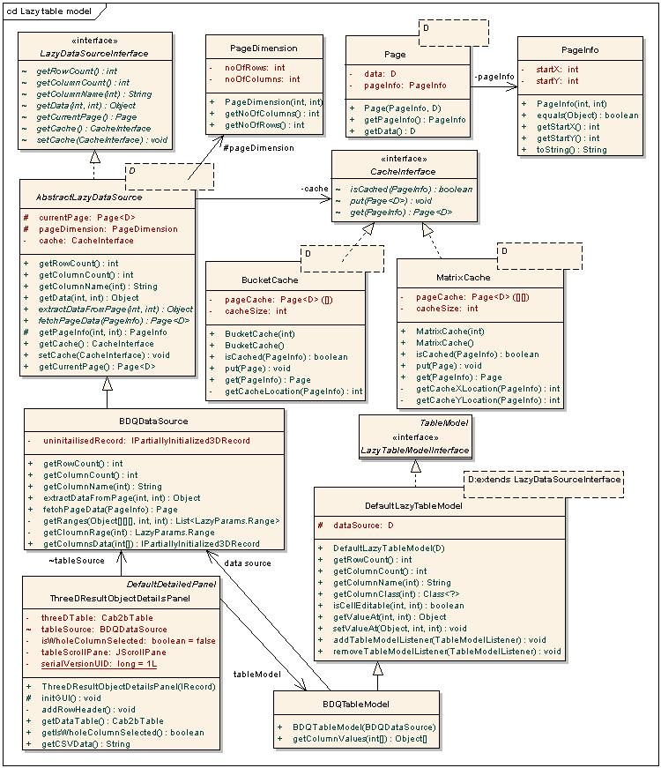
Figure 25 Classes Involved in Lazy Table Model component

This component has been used to display Bio Data cube object. Following sequence diagram shows further details.
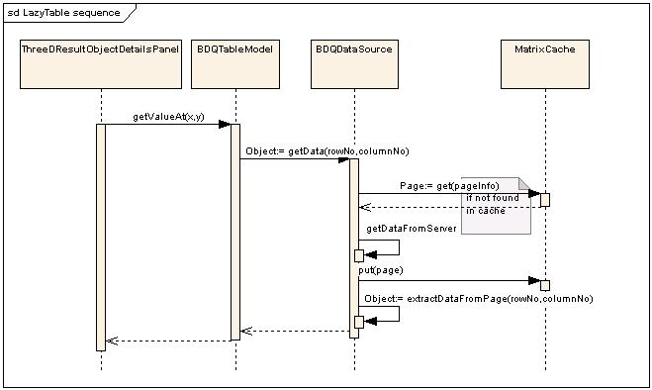
Figure 26 Flow of events in displaying BDQ

Dynamic UI generation for add/edit limits

Overview
The ‘Add Limit’ / ‘Edit Limit’ functionality of search data module allows the user to specify rules/constraints on the attributes of a selected entity like “edu.wustl.fe.Gene” or “Gene Annotation” respectively. Once the user decides the category on which to add a limit, the system auto generates the user interface with following properties:
  - Alphabetically sorted list of attributes
  - Attributes name are modified to make them user friendly (for example, clinicalDiagnosis should be Clinical Diagnosis)
  - Based on the data type of each attribute
  - Applicable set of operators are visible
  - Data type based validation
  - If the attribute has permissible values, these are displayed in a multi-select list box.
The section below describes the design details of dynamic UI generation for the Add / Edit limit functionality

Design
The dynamic UI generation is based on the following principles:
- The metadata for each attribute contains all the required information such as data type and permissible values
- An XML file contains information about the display names for operators and UI properties.

For each entity the UI is auto generated based on its metadata and the XML file configuration

Metadata representation
Before we go into details of dynamic UI generation, is it important to understand how metadata for an entity is represented. For more details on these classes please refer to section Metadata Repository.

Dynamic UI configuration XML
This requirement needs mapping of attribute data type to all the information needed to visually render the UI component corresponding to that attribute. The information for rendering includes the following:
- List of operators for a given data type and context (enumerated or non-enumerated)
- The class name for the actual UI component to be instantiated, again for a given type and context.
- The UI component representing any attribute should show user friendly attribute name (i.e. by parsing the camel case words)
- Condition selection drop-down box
- Control to specify values for selected condition. This portion of the component is variable and changes according to the data type and context of the attribute (e.g. all attributes that contain enumeration, this would always be shown as a multi-select list box)

This mapping is captured in a configuration file in XML format. Reasons for the XML configuration file.
- Defining a configuration file to capture the mapping information helps abstract that information out of the code. This means some of the UI rendering information captured in the configuration file can change without having to compile the code.
- XML allows for validations by defining a DTD. The validation can further be made strict by defining data as actual xml elements. Thus (See Figure 3.0), the DTD mandates that the XML document have a data element for all the data types and include an operator list for all of them.
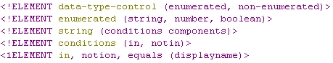
Figure 27 Snippet of DTD used for dynamic UI configuration XML

data-type-control - This is the root node of the control and can contain enumerated or non-enumerated nodes as children
enumerated - This tag is parent of all the enumerated data types.
non-enumerated - This tag is parent of all the non-enumerated data type
string, number, boolean - these tags are the actual data type nodes which contain information such as operators associated with this node, display names of these operators, and the component which will render the attribute of this data type. Refer to file dynamicUI.xml for this.

Auto generation of UI
The configuration XML file is parsed using a DOM parser and the information is organized into the maps shown in the table below. This is a one-time activity and happens for the first instance, when UI needs to be dynamically generated for a class or category. All the logic is encapsulated in the ParseXMLFile class.

Map type | Details
Enum -Operator map  Note: ‘Enum’ in this column implies an attribute containing permissible values. | Key = Enumeration representing data type.  Value = Collection of enumerations representing operators
Enum-Component map | Key = Enumeration representing data type.  Value = Name of UI component to be rendered
Non-Enum-Operator map | Key = Enumeration representing data type.  Value = Collection of enumerations representing operators
Non-Enumerated-Component map | Key = Enumeration representing data type.  Value = Name of UI component to be rendered

Given an ‘EntityInterface’, for every ‘AttributeInterface’ contained therein, the dynamic UI generation generates the UI component (details given here), based on the metadata of the attribute. The following flow-chart explains details for this activity:
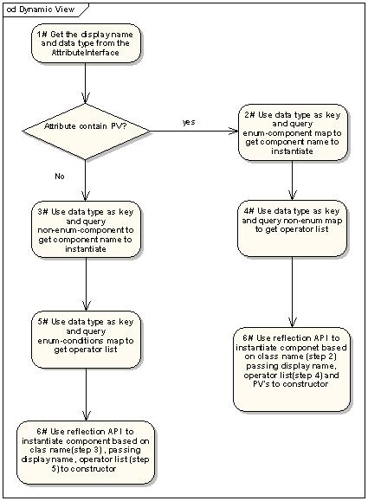
Figure 28 Detailed steps for generating UI component for an attribute
The SwingUIManager class has a static method generateUIPanel(EntityInterface) that iterates over the collection of attributes and processes metadata information based on the flow chart above to generate the UI component (Cab2bPanel) for that attribute. It then returns an array of these UI components that are added to a panel to represent the Add/Limit UI screen.

The UML diagram below shows the different classes involved in dynamic UI generation

IComponent - UI component should provide API to get selected condition, corresponding values and the attribute entity it represents. Thus one needs to have a common interface containing these APIs, which every data type specific UI component should implement. This is the interface containing methods to get/set UI component details for every attribute type.

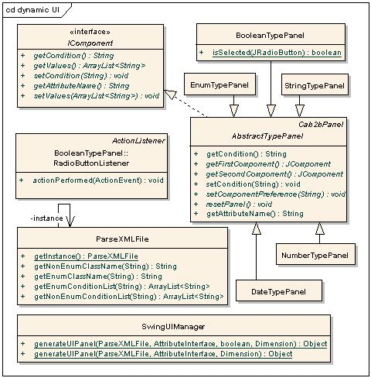
Figure 29 Class diagram for classes participating in dynamic UI generation

AbstractTypePanel - This is an abstract UI component class, which contains common functionalities needed by all the attribute type UI components. It implements the IComponent. This component contains APIs to set UI for the condition list and user-friendly attribute names. Additionally it has abstract methods getFirstComponent() and getSecondComponent() to facilitate implementing class to provide the specific JComponent object specific to the specific data type. For each data type there is one class which extends this class, for example NumberTypePane for Numeric data types like integer, long, and double. StringTypePanel for String data type

Visual Query Interface OR Diagrammatic (DAG) view

Overview
The primary goal of this feature is to allow the user to do the following:
- View the category constraints added to the query in the form of graph nodes.
- Link the selected category constraints visually
- Edit / delete query constraints
- Resolve ambiguities if multiple paths are available between the source and target class / category constraints to link.
- The textual representation of the query expression

The basic design of the DAG view is to visually represent each constraint (i.e. a limit on class or category) as a node of the graph and allow linking of constraints as edges of the graph. NetBean’s Graph Library supports visualization and editing of node-edge structures using drag and drop (org-netbeans-graph.jar), and it is platform independent.

This section describes the design for the same. Chapters Metadata search and Query Object are perquisites for this chapter.

The diagram (Figure 30 Basic workflow in the DAG) shows the basic workflow of the DAG view. The sequence of steps involved in the DAG view is as below:

- User searches for the classes / categories for which he wants to form a query.
- From the returned results, the user selects the class / category of interest. The Add Limit page shows all the attributes associated with selected class / category.
- User specifies constraints on attributes and adds this constrained entity to query graph.
- User may search and add different constraints to the query by repeating steps 1-3
- User may select any two constrained entities and link them using the ‘Connect Nodes’ button.
- If multiple paths are available for selected nodes, user may select multiple paths to connect these entities.
- User may repeat step 6, to connect different constrained entities in the query graph
- User may edit constrained entity and change the rules / constraints added on the attributes of the entity.

NOTE: Two entity nodes can be linked only if adding the selected path doesn’t form a cycle in the query graph.

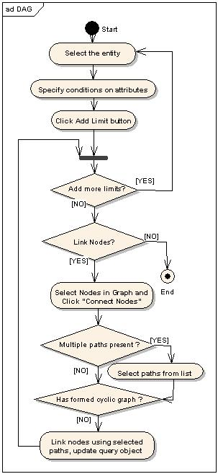
Figure 30 Basic workflow in the DAG

User Interface Design
This section describes the design of the user interface of the DAG view. It describes the classes that constitute visualization of the DAG view. The class diagram in Fig. 31 details the classes and interactions amongst them.
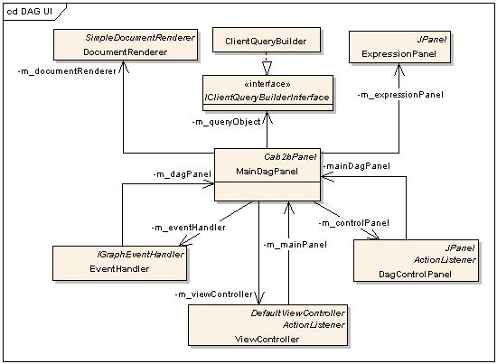
Figure 31 Class diagram for classes in the DAG view
- MainDagPanel: This class forms the core of the DAG view and is responsible for handling different user actions, related to query construction and updating the visual query graph. To display DAG on panel this class creates a JComponent that renders nodes and links using createView(…) method on GraphFactory from NetBean’s graph library.Whenever a user adds a limit UpdateGraph(…) method adds an IExpression object representing the constrained category to the graph.
  - LinkNode(…) method links two nodes if the caB2B server has a valid path between the selected entities. If the system contains multiple paths between selected expressions, the ambiguity resolver allows the user to select paths of interest and links nodes with selected paths.
  - deletePath() and deleteExpression() methods delete the selected link and expression respectively from the UI as well as the backend query object. GetExpressionString () returns the textual representation of the IQuery object. This class also holds a reference of the IClientQueryBuilder (a wrapper over the IQuery). The backend query building section describes this in detail.
- DagControlPanel: This class controls different user activities such as selected nodes and clearing the DAG view.
- ExpressionPanel: This class provides the textual representation query object to the user.
Apart from these UI classes, there are classes, which hold UI details of every link and node that is rendered on the DAG panel. These classes and their details are described as follows:
- GenericNode, ClassNode and ClassNodeRender are involved in implementing the graph node functionality. These are the classes which hold information such as how to render the node, what expression the node holds, and what other nodes are linked to this expression.
- SimpleLinkRenderer and OrthogonalLinkRouterLinkRenderer implement the graph link related functionality. These classes mainly perform rendering of graph link.
- IconPortRenderer and SimplePortRenderer are responsible for rendering connection ports. In order to link two nodes, one needs to add ports to the source and destination nodes.
Ambiguity resolver UI classes
This provides a user interface to show all the possible paths between selected source and target expression entities and allows the user to select paths of interest. This functionality queries the caB2B server to get all the available paths between source and destination expression entities. The class diagram below shows classes involved in implementing this functionality.
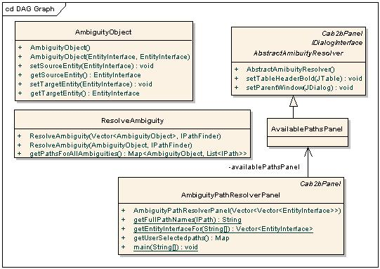
Figure 32 Class diagram for classes related to ambiguity resolver
- ResolveAmbiguity: This class queries caB2B server to get all the possible paths between source and destination entities and pops up a dialog box containing an instance of AvailablePathsPanel in order to allow the user to select multiple paths. In case of a single path, this class doesn’t show this dialog box.
- AvailablePathsPanel: This panel holds the UI to show ambiguous paths.
- AmbiguityObject: The bean class holding the details of the entities between which the system has to find paths and resolve the ambiguity.
- AmbiguityPathResolverPanel This displays list of available paths for the current source, target entity and allows the user to select one or more paths from it.

Query Building
The data of visually constructed query is stored in an IQuery object. DAG holds a reference to this object. The IQuery object needs to be modified whenever the user links nodes, adds or deletes links or nodes from the view. The IClientQueryBuilder interface defines method to update the query object according to the user’s actions. ClientQueryBuilder implements the IClientQueryBuilder. The class diagram below shows different methods on interface.

addExpressio adds the constrained category element to query object when the user adds a limit.
addPath adds the associations between source and destination entities specified by an IPath object. removeExpression method removes the expression with the specified ExpressionId from the graph. removeAssociation removes specified association between two ExpressionIds.

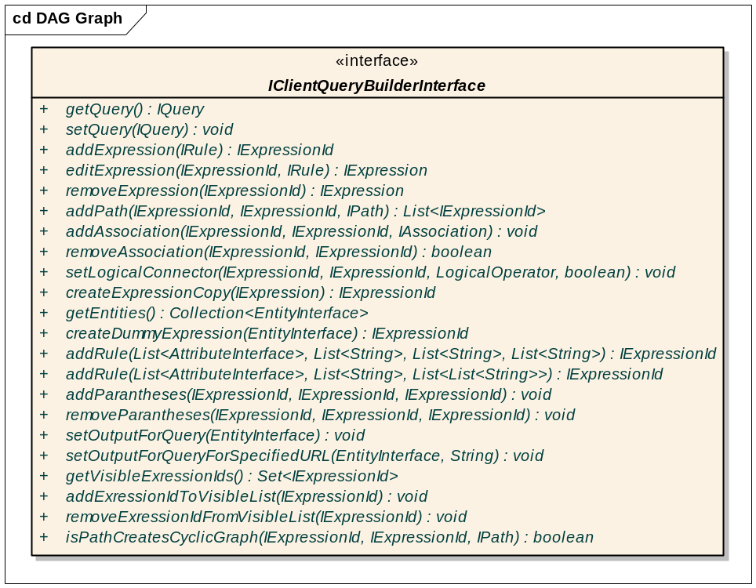
Figure 33 Client query builder interface for client side query building

Pagination Swing Component

Overview
In caB2B there are several instances where the user has to view large data sets. The examples of such instances include viewing results of a metadata search or viewing the results of a query. Traditionally, viewing of such large data sets is facilitated by enabling scrolling of the results. However, this approach makes it extremely cumbersome for the end-user to view the results, especially in case of larger data sets.

A better approach would be to paginate the results, much like the numbers of a book. This presents an organized view of the results and makes browsing large data sets extremely convenient.

Since it is required to show a paginated view at several places in the application, it becomes paramount to design a generic component (hence forth referred to as Pagination component) that can be re-used across all screens. In other words the nature of data to be paginated should not matter to the component.

In addition, it should also be possible to configure the pagination component, both during initialization as well as dynamically at a later stage to paginate results based on some sorting criterion. The sorting criterion could vary from being alphabetical to some context specific sorting (for e.g. sorting a category search based on the relevance of use). Thus the design for the generic component should be flexible enough to plug the different sorting algorithms, depending on the context in which it is used.

It should also be possible for the generic pagination component to select data elements for certain context-specific operations (like the ability to select data elements to add to the data list from the query results) by simply turning off or on the feature at the time of configuring and initializing the component in the application.

Given the generic nature of the component, the pagination component should dynamically compute the amount of space available on the screen and compute the number of elements to be displayed on a single page and consequently the total number of pages.

The pagination component is designed based on all the considerations mentioned above. Each element in the data set is displayed as a hyper-link with the provision to display some description associated with it. Additionally, the design allows for custom behavior for hyper-link clicks.

Design Details
The basic design for this component is based on the Swing UI MVC pattern; please refer to the UML Diagrams shown below.

View
The JPagination class constitutes the view for the component. It is an instance of JPanel and is further made up of the following components:
- JGroupActionPanel which extends JPanel and has hyperlinks which can perform group selection operation on the page elements. More is explained on group selection actions in Controller part.
- PagePanel which is a JPanel which is used to display the data elements for a given page. Each display element is again an instance of JPageElement which extends JPanel.
- JPageBar extends JPanel, contains hyperlinks to support navigation across pages.
The above three sub components can be arranged in any order.
The page elements which are displayed in page panel can be displayed in different configurations, the two important configurations are:

- A linear list of page elements one below the other displayed in the page panel
- A grid of page elements displayed in a matrix format. I.e. n page elements by m page elements.
Pagination component with three sub-components and check boxes for selections

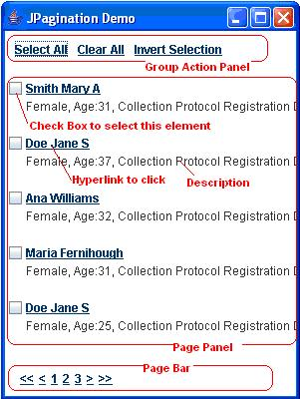
Figure 34 Snapshot of a Pagination component

Controller
- Selections
Some of the group selection actions available on the page elements are:
- Select All – by clicking on “Select All” hyperlink available in the group action panel, user can select all visible and in-visible page elements.
- Clear All – by clicking on the “Clear All” hyperlink available in the group action panel, user can clear all the selections they have made in the visible and in-visible pages.
- Invert All – by clicking on the “Invert All” hyperlink available in the group action panel, user can invert the selections made in all visible and in-visible pages. Using Invert All action second time should bring back the original selections.

PageSelectionModel provides the backend for the above actions; there are other APIs in this class to get status on the current selections like
- Number selections made till now, in all pages.
- Is any element selected or not.
- Is selection empty

JPagination provides API to add and remove PageSelectionListener to it. This enables user to listen for element selection, the event received is PageSelectionEvent if any page elements selection changes.

JPagination has API’s to dynamically turn on and off the pagination component’s elements selectable or not.

- Navigation
There are basically three kinds of hyperlinks in the page bar to aid navigation
- “Next Page”, “Previous Page” hyperlinks usually represented by “>”, “<” characters are used to sequentially navigate forward or backward through pages. User clicks on these hyperlink results in page panel showing the corresponding page.
- User can directly view any page by clicking a page index hyperlink. Page index hyperlinks are numbers if the pager is numeric pager, alphabets if the pager is alphabetic pager, etc. These hyperlinks provide direct access to the desired page, unlike the Next Page”, “Previous Page” hyperlinks which are for sequential access.
- Since there can possibly be many page index hyperlinks, page bar usually shows a small set of page index hyperlinks (5,10, etc) out of the all page indices. So to provide navigation through these page index hyperlinks, there are “Next Page Indices” and “Previous Page Indices” hyperlinks respectively. User action on these hyperlinks updates the visible current page index hyperlinks.
The text representing the “Next Page”, “Previous Page”, “Next Page Indices” and “Previous Page Indices” hyperlinks can be changed to any string or characters at the time of instantiation or can be changed dynamically(yet to implement).

Mouse Wheel Support
JPagination implements MouseWheelListener interface to provide fast sequential navigation through pages. Mouse wheel action automatically updates the current page index highlighting in the page bar.

Automatic Page Resize:
JPagination when provided with its parent components reference can automatically resize the pages (i.e. element per page) depending on the free space available with the parent component. This functionality is implemented by adding ComponentListener to the parent component and firing appropriate events when the parent component resizes in the action listener method

Model
The Pager interface, which is an interface to the pagination model and the implementing classes such as PaginationModel essentially form the data model. The AbstractPager is an abstract class which provides the skeletal implementation for the Pager interface
AbstractPager also provides definition for final method subPage(). This method will be called only when the pager is non-numeric, to sub paginate the main pages whose size is more than desired.
AbstractPager also keeps a copy of original collection of page elements intact, since this is needed for future use. Events like, changing the pager at runtime needs the original page elements collection (This functionality is not implemented in the current version).
AbstractPager has a map data structure which maps page index to a small collection of page elements called page. The Actually data structures are HashMap for map, String for page index and Vector for page. AbstractPager also keeps a ready list of all page indices that are there in the Map data structure as map’s keys
All concrete pager classes should extend the AbstractPager class and compulsorily override the page() method, with their own logic to paginate the elements except NumericPager.
The reason PaginationModel implements the Pager interface is to provide consistent API’s to the view part. If PaginationModel doesn’t conform to the Pager interface there can be chances where we introduce some methods in PaginationModel which are not there in Pager instances. The other way of think at it is, since Delegation in the patter used in PaginationModel, it becomes a kind of norm to have all the methods which are available in Pager be present in PaginationModel.
Thus the pagination model and paginating process is clearly separated from the view part by using Pager interface and its concrete classes.
Pagination Levels: Pagination should be done at two levels
- Level-1 Pagination: Can be any one of Numeric, Alphabetic, Keywords, Frequency, and etc based Pagination.
- Level-2 Pagination: Is always a Numeric Pagination depending on the Level-1 Pagination. If Level-1 pagination is a Numeric Pagination then there is no need to have Level-2 Pagination. If Level-1 pagination is anything other than Numeric, we need Level-2 numeric pagination since non-numeric pagination doesn’t conform to the condition that a page should have fixed number of page elements.
Thus level-1 pager is variable, it can be any kind of pagination, but level-2 pagination is always a numeric pager, if level-1 pager in non-numeric. And this probably explains the reason why the subPage method in AbstractPager is final, so that the actually concrete classes like AlphbeticPager can not override it, even by mistake.
If level-1 pager is a numeric pager then there is no work for sub page method.
Example: Let us consider Alphabetic pagination as the Level-1 pagination, there may be cases like page index “A” having a 20 page elements which can’t be displayed on the screen without a scroll pane, but page index “B” may have only 2 page elements which will fit in one single page.
But for page with index “A” we have to again break the page with 20 elements into much smaller page. Numeric Pager is the best choice for this kind of Level-2 pagination.
Level-2 pagination depends on the page size of the selected page in the Level-1 pagination. Hence the page with index “A” the numeric pager may provide numeric page indices 1,2,3,4 for page with index “A”, but for page with index “B” there is no need of second level page indices.
Note: Level-2 paging (sub paging) for non-numeric pager is not yet implemented.

UML Diagrams
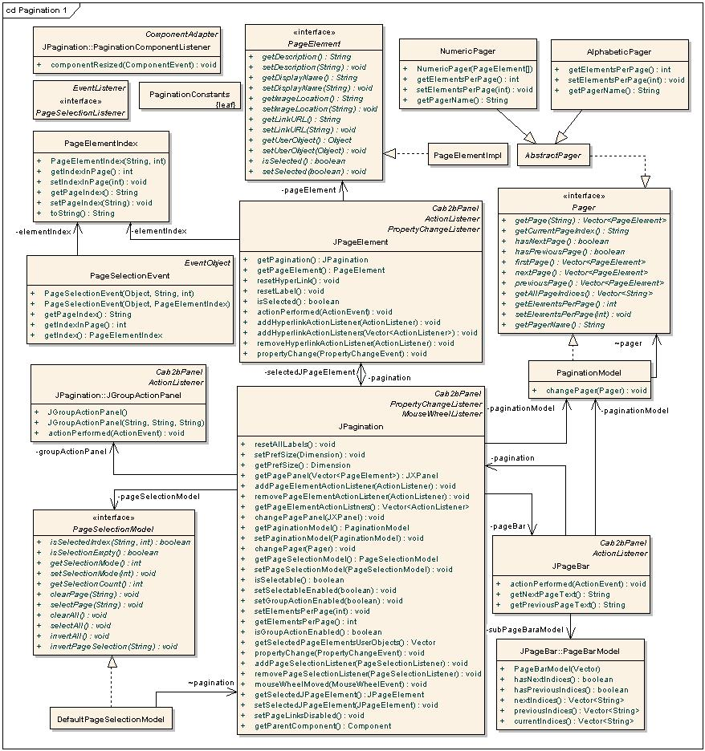
Figure 35 Classes involved in Pagination component

Sequence Diagram
The sequence diagram above describes the way in which pagination component is initialized first. The input to pagination component is a collection of page elements, each page element implementing PageElement interface
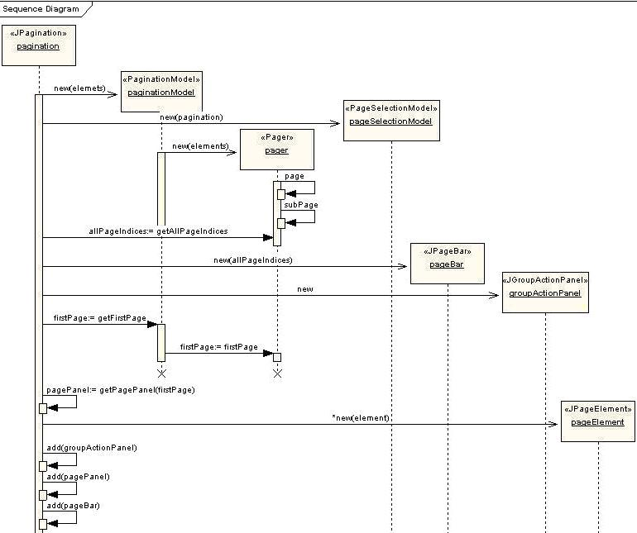
Figure 36 Pagination Sequence Diagram
The steps of event happening while constructing pagination component is explained as below:
- JPagination accepts collection of elements as the parameter.
- Creates a new instance of PaginationModel passing elements collection.
- PaginationModel in-turn passes the elements collection to a subclass of Pager interface.
- Pager internally calls the page() method to paginates the elements collection depending on some criteria.
- JPagination then gets all page indices from the pager to construct JPageBar sub component.
- JPagination gets first page from the pager to construct the page panel sub component.
- JPagination constructs JGroupActionPanel sub component, and adds all these three subcomponents to it.

Pagination Usage in caB2B:
In the current version of caB2B, pagination component is used in two places
- In the advanced search feature to show the search result. Here, selection of page elements is not needed; hence elements don’t have check boxes and the group action panel. This is achieved by calling appropriate API’s in the JPagination class.
- In View search result feature to show the results got from data services. Here selection of page elements is important, since user would like to add the selected elements to the data list. Hence check boxes and group action panels are enabled by calling appropriate API’s in the JPagination class.
These are the two instances which highlight the fact that Pagination component is generic in nature, which can be used in scenarios where long list of data needs to be displayed in the GUI.

Search Data Wizard

Overview
The search data for experiment dialog is a wizard based UI that allows the end-user to sequentially follow all the steps required to build, fire and view the results of a caB2B query. In this document, we shall understand the basic composition of the wizard as well as the navigation mechanism while moving from one step to another.

Class Diagram
The following is the class diagram that illustrates the composition of the search dialog wizard.
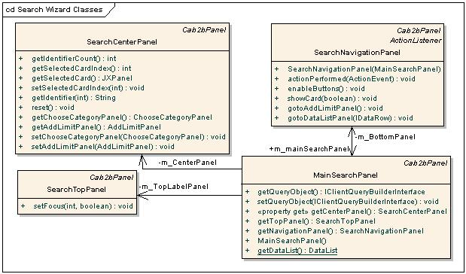
Figure 37 Class diagram for the Search dialog wizard
MainSearchPanel is the container class that represents the main wizard UI. It is an instance of Cab2bPanel and uses an instance of BorderLayout to manage the layout of its components. It is made up of the SearchTopPanel (added to the north region), the SearchCenterPanel (added to the center region) and the SearchNavigationPanel (added to the south region). The component is initialized at creation time.

The class provides getter methods to access each of these panels, so as to facilitate communication between the panels (For e.g. it is required for the SearchNavigationPanel to communicate with the SearchTopPanel). It also stores a reference to a cab2b implementation of the IclientQueryBuilderInterface, so that the reference can be available at every stage of the query building.
Cab2bPanel is a customized panel so that certain properties (like background color) can be centrally set and used across the application.

SearchTopPanel is the component that forms the top section of the wizard and its function is to visually indicate to the user the step that he is currently performing.

This component is an instance of Cab2bPanel and is composed of as many numbers of panels as there are steps in the wizard (in this case 5). It uses an instance of GridLayout to manage the layout of the child panels. Each panel is made of an instance of Cab2bLabel containing the appropriate text for the step in the wizard. The component is initialized at creation time such that panel corresponding to step1 has a white background and no border, while the panels for the remaining steps have a blue background and a LineBorder, which is black in color. The panel with the white background is always used to indicate to the end-user the step that he/she is currently performing.

The setFocus (int index, boolean blnForward) public API sets the background color of the panel corresponding to the step indicated by the index parameter, to white. The boolean parameter is used to indicate the traversal of the navigation so the adjacent panel (to the left or right depending on direction of traversal) can be reset.

SearchCenterPanel is an instance of Cab2bPanel and is a container class for all the UI components needed for each step in the wizard. The UI component for each step is again an instance Cab2bPanel; thereby making this a container of as many Cab2bPanels as there are steps.

It uses an instance of CardLayout to manage all the cards or in other words to manage all the Cab2bPanels needed at each step of the wizard. This component is initialized to contain and show the first card corresponding to the first step. Subsequent cards are added dynamically based on action taken in previous steps and shown as and when the user navigates across steps. The component also maintains state information like the currently selected card (the current step the user is on), and provided getter and setter methods for accessing and setting the value respectively.

SearchNavigationPanel is the component that provides functionality to navigate across the wizard. It is an instance of Cab2bPanel and uses an instance of FlowLayout to manage the layout of all its child components (instances of Cab2bButtons to facilitate navigation)

The component is also the event listener for its child buttons. For all navigations in the forward direction (refer to sequence diagram), it queries the SearchCenterPanel to get the current step. It then loads and adds the UI component corresponding to the next step to the SearchCenterPanel, if that is not already added.
However, there is an exception to the above action. In case of viewing search results, the UI component for viewing search results is always newly created and added.

For navigations in the reverse direction the component merely asks the SearchCenterPanel to show the previous card. If the next or previous component is successfully loaded and added, it then calls the setFocus() API on the SearchTopPanel .

Sequence Diagram
The sequence diagram below illustrates the flow of control when the user chooses to navigate from step1 to step2 (for the first time) in the wizard.
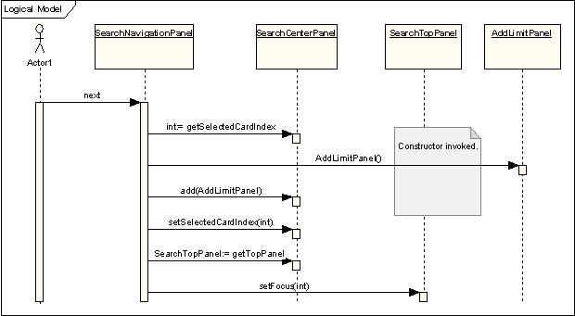
Figure 38 sequence diagram for navigation from step1 to step2 in the wizard

View Results
This section explains the classes involved in showing the query result.
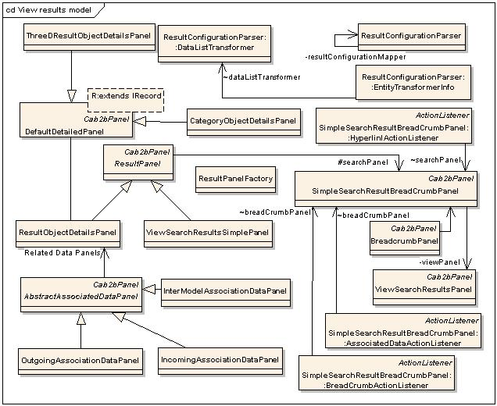
Figure 39 Classes involved in displaying query results

- ViewSearchResultsPanel displays the result of the query in two ways. In a simple view and a comprehensive view (not yet implemented).
- SimpleSearchResultBreadCrumbPanel represents one breadcrumb page of the result. It contains result panel, a data list summary panel and a breadcrumb panel to return to this result page. It contains result panel for a single object or list of object. It also provides the implantation for the listener of the breadcrumb, to view the details of a particular object and to show the related data.
- ResultPanel is an abstract class for the panel used to for the result. It provides the operation like add to data list and apply data list.
- ViewSearchResultsSimplePanel is a panel to display the list of objects. When the result of the query contains more than one object this panel is instantiated. It contains the pagination component to show the result.
- ResultObjectDetailsPanel is a panel to display the details of single object. When the result of the query contains a single object or when the detail of object is viewed, this panel is instantiated. It uses ResultPanelFactory to create the panel which is applicable for the object to be shown. It also contains the reference to the applicable related data panels.
- AbstractAssociatedDataPanel is the base class for all the data panels used for showing associated (related) data. Its iniGUI() method creates the hyperlink for each of the related data.
- IncomingAssociationDataPanel represents the data which is related by incoming association for the object that is currently displayed.
- OutgoingAssociationDataPanel represents the data which is related by outgoing association for the object that is currently displayed.
- InterModelAssociationDataPanel represents the data which is related by an inter model association for the object that is currently displayed.
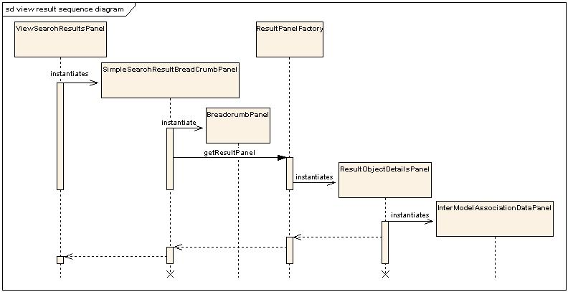
Figure 40 Order of instantiation of panels for view results

Record Customization

Overview
A user-defined query, represented by the query object, is transformed to appropriate DCQL. DCQLQueryResults obtained by executing this DCQL is then transformed into an IQueryResult.
IQueryResult is a caB2B-specific representation of the results. Logically, IQueryResult is a collection of records (represented by IRecord’s). This chapter explains how this caB2B-specific representation (i.e. IRecord) can be customized based on the application/category being queried.

The IRecord
IRecord is a map from an attribute to its value.

Why customize IRecord?
The default IRecord represents the record of a UML class, as obtained from a data service that uses the default (de)serialization mechanisms of caGrid. A custom subtype of IRecord would be defined to add more information to such a record. Such a need can arise due to following reasons:
- Custom (de)serialization by data services
A service might in some cases return more information than can be represented by IRecord. An example is the caArray service that returns identifiers of classes associated to the target class. To store this information, a custom record has to be defined.
- Complex attributes
Some entities can have complex attributes which cannot be represented directly in IRecord. For example,
  - A BioAssayData record obtained from caArray data service has a bioDataCube attribute. This is a three-dimensional array of objects.
  - Each category record has other associated children category records.

Steps in customizing a record
- Identify the entity or application for which the customized record has to be defined. Define appropriate subtype of IRecord, say ICustomRecord.
- Implement any of the following components related to this customization:
- Query result transformer: Responsible for transforming CQLResults into ICustomRecord.
- Record details UI panel: Responsible for displaying ICustomRecord on the UI.
- Data list transformers: Specify how an ICustomRecord is persisted as part of a datalist
  - Data list saver: Responsible for saving an ICustomRecord when it is part of a data list.
  - Data list retriever: Responsible for creating an appropriate ICustomRecord while retrieving a data list.
- Register these implementations in the configuration xml “ResultConfiguration.xml”.

Result Configuration XML
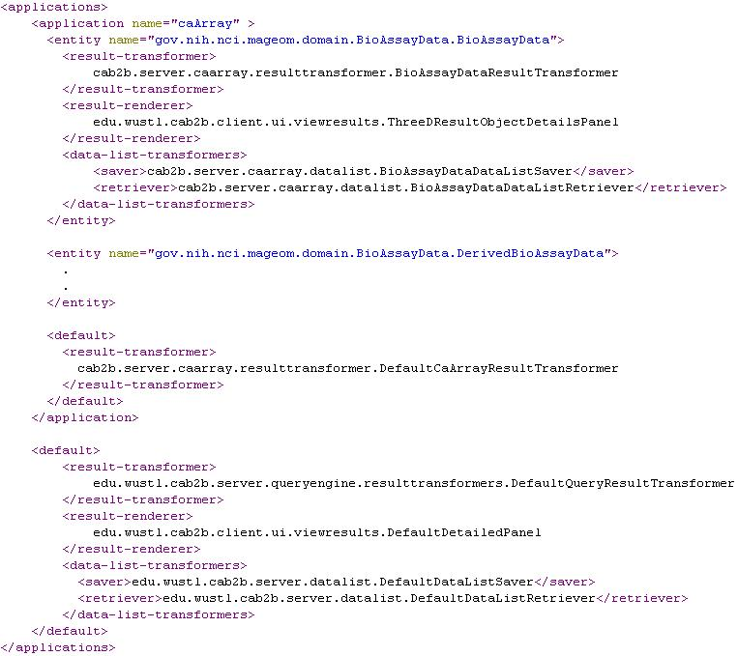
Figure 41 Sample ResultConfiguration.xml
Note that the following are provided by caB2B:
- Customizations for “CategoryEntityGroup”
- caB2B defaults (the outermost default tag)

caArray is an example of a custom-extension. caArray has its own default query-result-transfomer that overrides the caB2B default query-result-transformer. But caArray needs customized result-renderers and datalist-transformers for the class BioAssayData.

ResultConfigurationParser
This is a singleton class which parses the ResultConfiguration.xml file and provides following methods for accessing the entries. If no entry is found for a given entity, the caB2B default is returned.
- getResultRenderer(String applicationName, String entityName)
- getResultTransformer(String applicationName, String entityName)
- getDataListSaver(String applicationName, String entityName)
- getDataListRetriever(String applicationName, String entityName)

IRecord and its extensions
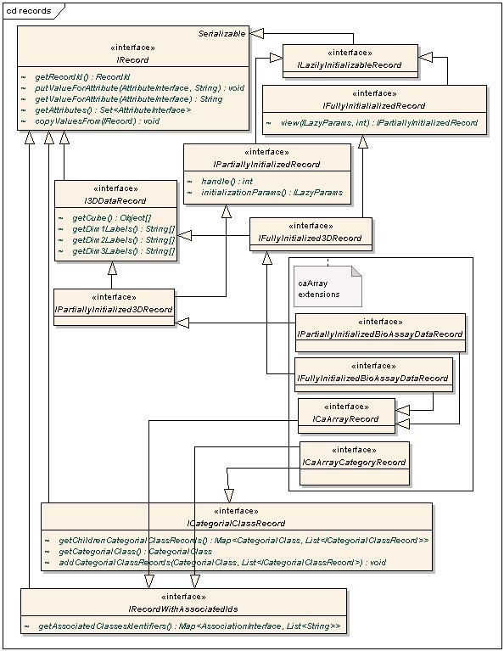
Figure 42 IRecord and its extensions
Following are the basic interfaces; other interfaces are either markers or mixins.
- IRecord: The most basic interface; it represents a record as a set of attribute-value pairs.
- IRecordWithAssociatedIdentifiers: Represents a record that can provide identifiers of associated classes as well.
- I3DDataRecord: Represents a record that has additional three-dimensional data. Methods provide the 3D matrix, and metadata about the dimensions.
- IPartiallyInitializedRecord and IFullyInitializedRecord: These interfaces are used for lazily initializing a record. See Lazy Table Model (Chapter Custom UI components) for more details.
- ICategorialClassRecord: Represents the records of a category. The records form a tree; the structure of the tree corresponds to the tree of classes in the category.

Query Result Transformers
A query result transformer is defined by the interface edu.wustl.cab2b.server.queryengine.resulttransformers.IQueryResultTransfomer<R extends IRecord, C extends ICategorialClassRecord> and is responsible for executing a DCQL and transforming the results into an appropriate IQueryResult. Following are the methods in IQueryResultTransformer:
- IQueryResult<R> getResults(DCQLQuery query, EntityInterface targetEntity);
<R> the type of records created when executing a query for a class.
Parameters:
    - query the DCQL.
    - targetEntity the target entity (corresponds to the target object of the dcql).
- IQueryResult<C> getCategoryResults(DCQLQuery query, CategorialClass categorialClass);
<C> the type of records created when executing a query for a category.
Parameters:
  - query the DCQL whose target object corresponds to the actual UML class represented by the categorial class.
  - categorialClass the categorial class.

Class diagrams for query result transformers are shown below.
Note: The text on the generalization links refers to type parameters e.g. declaration of DefaultQueryResultTransformer is class DefaultQueryResultTransformer extends AbstractQueryResultTransformer<IRecord, ICategorialClassRecord>
QueryResultTransformerFactory refers ResultConfigurationParser to obtain the appropriate transformer.

Inbuilt implementations of IQueryResultTransformer
- AbstractQueryResultTransformer This abstract class provides a skeletal implementation of a query result transformer. Concrete implementations need only implement the createRecords() and createCategoryRecords() methods. Additional hooks are provided and can be used to customize the creation and population of the records in the result.
- DefaultQueryResultTransformer This is the caB2B default query result transformer. It parses the gov.nih.nci.cagrid.cqlresultset.CQLQueryResults xml and extracts the values for the attributes of the target entity. The records in the results are of the basic types IRecord and ICategorialClassRecord.
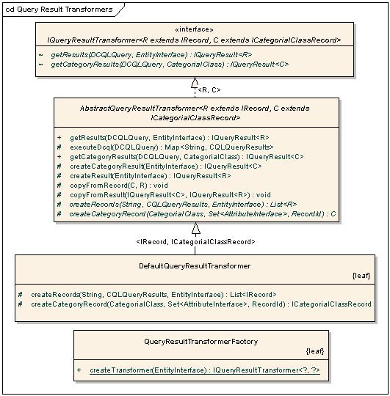
Figure 43 Query Result Transformers

Customization example – caArray
The interface cab2b.server.caarray.resulttransformer.ICaArrayRecord is used to represent a record of the caArray application. As explained previously, the caArray service returns identifiers of classes associated to the target class. Thus, an application-level transformer is defined for caArray that uses the caArray deserializers and reads this information.
- AbstractCaArrayResultTransfomer: Provides an implementation of the method createRecords() of AbstractQueryResultTransformer. It also handles the deserialization of the caArray results xml into objects and transforms these objects to ICaarrayRecord using reflection.
- DefaultCaArrayResultTransformer: This is the caArray application level default transformer.
- BioAssayDataResultTransformer: The caArray service returns a biodata cube as data associated to any BioAssayData. This transformer is required to read the biodatacube and transform it to an appropriate IPartiallyInitializedBioAssayDataRecord. (For details of lazy initialization, refer Lazy Table Model (Chapter Custom UI components)

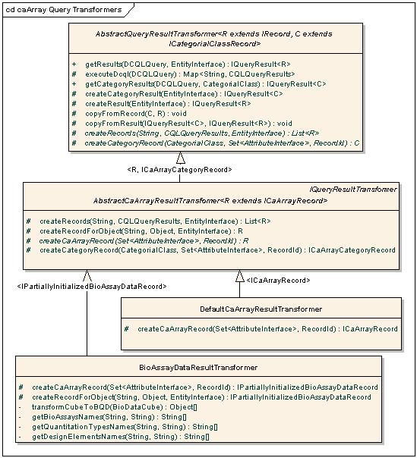
Figure 44 Query Result transformers

Data list transformers
A data list is saved using the dynamic extensions (DE) API. To do this, following transformations are needed:
- From IRecord to DE specific representation of the record; this is needed while saving a data list.
- From DE specific representation of a record to its corresponding IRecord; this is needed while retrieving a data list.
The corresponding saver and retriever interfaces are
- edu.wustl.cab2b.server.datalist.DataListSaver
- edu.wustl.cab2b.server.datalist.DataListRetrieve
These interfaces identify the operations that can vary depending on the record customization. For saving a data list, a new entity is created for which records are populated. A saver customizes the attributes/associations of the new entity that is created.
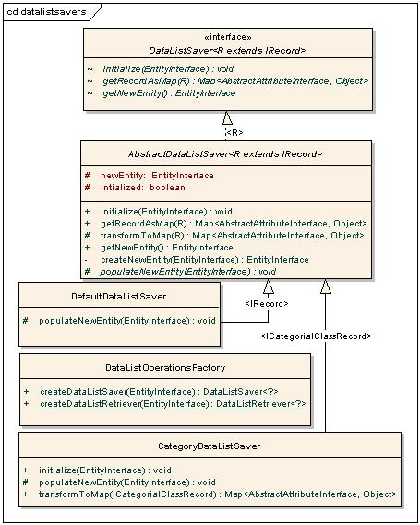
Figure 45 Data list savers and factory
For example, consider a specialization of IRecord called IFooBarRecord which represents records for an entity FooBarEnt. IFooBarRecord provides additional info, say, through the method getFoo(). In this case, we can have a FooBarSaver and FooBarRetriever. FooBarSaver.getNewEntity() method will return an entity that contains all attributes from FooBarEnt, and an additional attribute called "foo". The method FooBarSaver.getRecordAsMap() will appropriately put an entry into the map for the attribute "foo", by reading the value from IFooBarRecord.getFoo().

Then, while retrieving the records, the value of the attribute "foo" of the entity "FooBarEnt" will be set for the property IFooBarRecord.foo by the corresponding retriever. This would be done in the method FooBarRetriver. getEntityRecords(List<Long> recordIds).

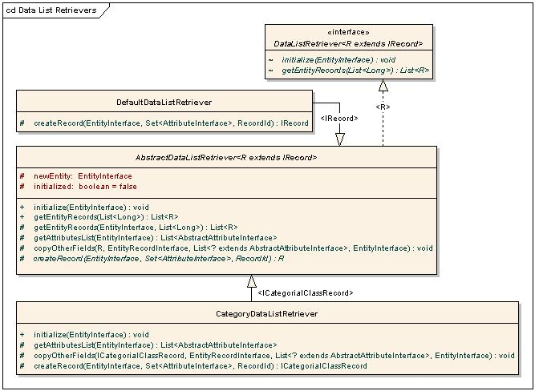
Figure 46 Data list retrievers

Inbuilt implementations of DataListSaver / DataListRetriever
- AbstractDataListSaver: Skeletal implementation of a DataListSaver. A concrete implementation need only implement the method populateNewEntity() to add attributes and/or associations to the newly created entity.
- AbstractDataListRetriever: Skeletal implementation of a DataListRetriever. A concrete implementation need only implement the method createRecord () to create an instance of appropriate subtype of IRecord.
- DefaultDataListSaver: This is the default caB2B data list saver; the new entity it creates is a clone of the original entity.
- DefaultDataListRetriever: This is the default caB2B data list retriever; it creates records of the basic type IRecord.
- CategoryDataListSaver: New entities are created to represent the classes and associations within the category and the records are stored into appropriate entities.
- CategoryDataListRetriever: The records from the multiple entities are grouped together to reconstruct the ICategorialClassRecord’s.

Customization example – caArray
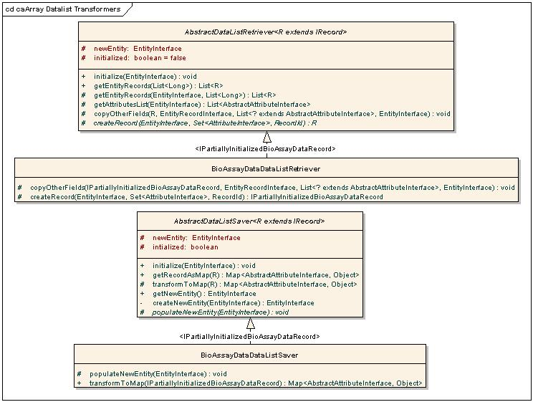
Figure 47 Caarray extensions for data list operations
- BioAssayDataDataListSaver: As explained previously, the records of BioAssayData contain a biodatacube which also has to be persisted. Currently, this saver creates blob columns for the biodatacube and its metadata.
- BioAssayDataDataListRetriever: This retriever reads the data from the corresponding blob columns and populates this in the IPartiallyInitializedBioAssayDataRecord representation of the record.

Result Renderers
The result renders are used to render the complete details of single record.

ResultPanelFactory uses ResultConfigurationParser to obtain the appropriate renderer for the given type of the record. The default render is edu.wustl.cab2b.client.ui.viewresults. DefaultDetailedPanel. It accepts IRecords and renders attributes and its values in the form of a table with a row for each attribute.

CategoryObjectDetailsPanel extends the functionality of default renderer to display the tree like structure of the category. It accepts ICategorialClassRecord as an input. It displays the attributes of the root categorical class using parent renderer (i.e. DefaultDetailedPanel). It creates B2BTreeNode structure for the associated child categories. If a particular child has a single record or one-one association with the parent its records are displayed along with the parent itself and not in a separate node. JTreeTable is the custom UI component that accepts B2BTreeNode to display tree structure of the categories.
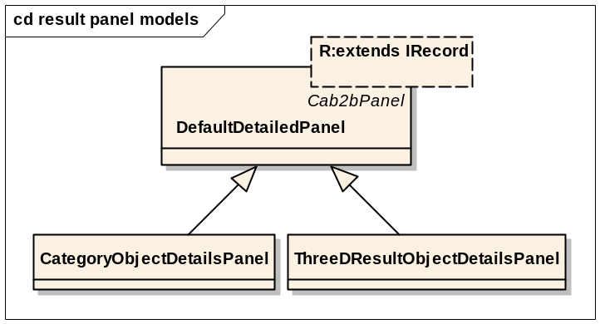
Figure 48 Result Panel Model
ThreeDResultObjectDetailsPanel is the renderer for the caArray object “Bio data cube”. It is a three dimensional representation of micro array data. It uses LazyTableModel to show the huge data.

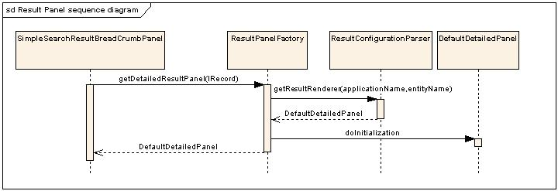
Figure 49 Flow of events while displaying results

Data List

Overview
The user’s selected data is represented by the data list. After adding data into the data list, user can save it and create experiment out of it. It is more like a shopping cart where user adds the data in which he / she is interested.

View Data list
Following diagram illustrates the classes involved in displaying the data list.
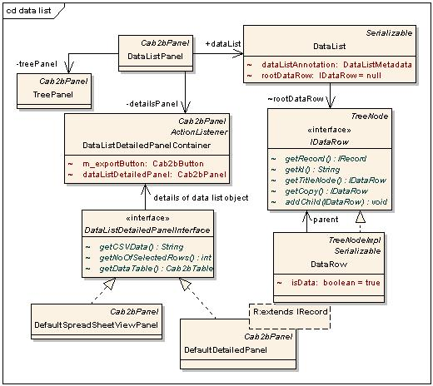
Figure 50 Classes involved in displaying data-list
- DataRow class represents a single object added into the data list. It gives the tree like structure of the user’s data. The similar types of the objects are grouped by an IDataRow and are distinguished by setting isData flag to false (It is referred as a title node).
- DataList represents current selected data. It contains a tree of IDataRow. The root of the tree is represented by a single IDataRow.
- DataListPanel is the container panel for data list. It contains DataListDetailedPanelContainer and TreePanel
- TreePanel contains the tree of the data list. On selecting a particular node its details are displayed in the DataListDetailedPanelContainer.
- DataListDetailedPanelInterface is implemented by a class that can be used to show the details of objects in datalist. The getCSVData() method returns the comma separated values of the object. This is used for exporting the details of the object.
- DataListDetailedPanelContainer displays the details of the selected IDataRow from TreePanel. If it is title node, then objects under it are displayed in the form of the spreadsheet using DefaultSpreadSheetViewPanel. If it is a single object the details are displayed using DefaultDetailedPanel.

Data List Operations
Save and retrieve are the main operations related to data list.
A new model is created using the dynamic extensions (DE) API corresponding to each data list. Since a data list is a set of trees, a dummy root entity is created which has these trees as children. The dummy root entity is thus representative of the data list. Then the records are saved as records of the respective entities of this model using DE. These steps are orchestrated by the DataListOperationsController. It has two methods:
- DataListMetadata saveDataList(IDataRow rootRecordDataRow, DataListMetadata dataListMetadata). It saves the data list into the database. In the process, appropriate DataListSaver is invoked to obtain the DE specific representation of the records and the new model to be created. See Data list transformers (Chapter CRecord Customization)
- List<IRecord> getEntityRecords(Long entityId). Return records of the given entity. It delegates the operation to appropriate DataListRetriever. See Data list transformers (Chapter CRecord Customization)
Following are the sequence diagrams illustrating the flow while retrieving and saving records of a data list
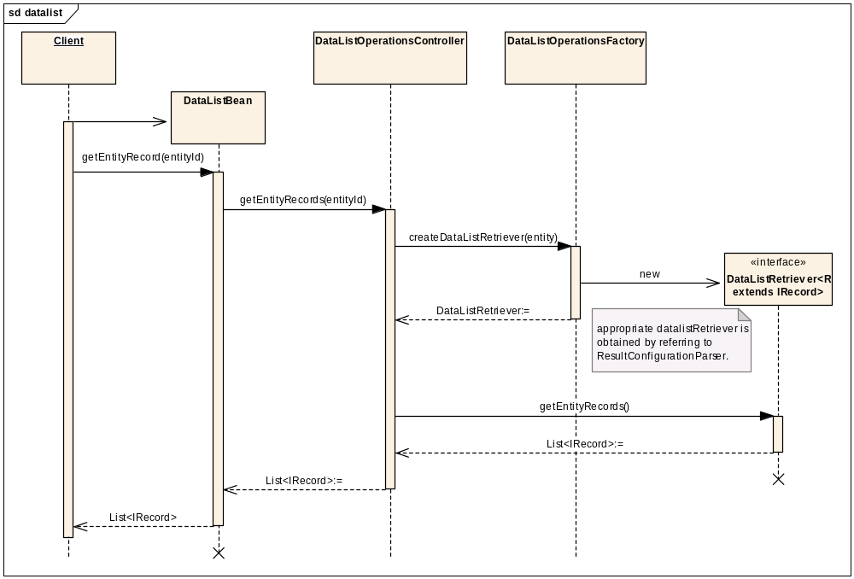
Figure 51 Sequence diagram for retrieving records of a data list
The factory DataListOperationsFactory provides the appropriate DataListRetriever or DataListSaver by referring to ResultConfigurationParser..

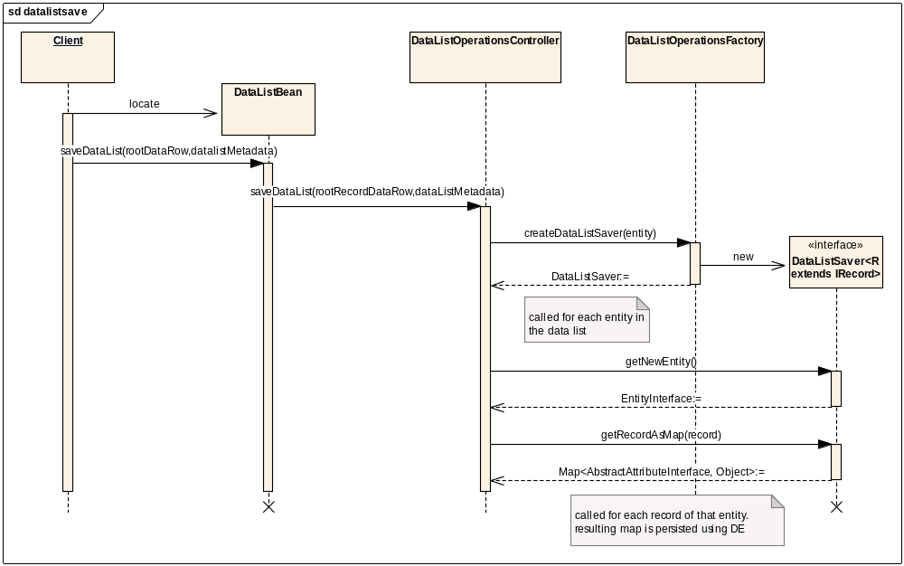
Figure 52 Sequence diagram for saving records of a data list

Experiment

Overview
Using this feature, the user can create the experiment out of saved data-list. After creating experiment, user can perform various operations on it like visualizing data by employing viewers, perform analysis or filtering of the data etc.

Experiment Data Model
Following figure 53 shows the experiment data model.

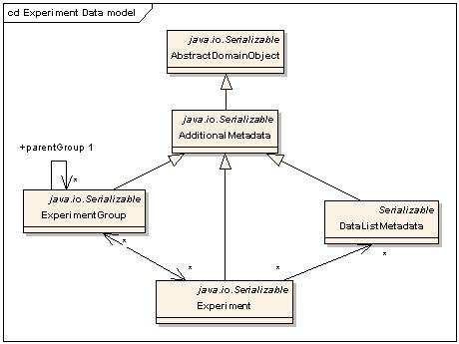
Figure 53 Experiment data model
- AbstractDomainObject is the base of all the domain objects in caB2B. It provides id and activity status fields required for all the domain objects
- AdditionalMetadata provides the additional information for the experiment and related objects. It includes name, description, created time and last updated time.
- Experiment contains the one or more DataListMetadata.
- ExperimentGroup is logical grouping of the experiments. It also has a parent group. This gives the folder (tree like) structure for experiment and experiment group.
- DataListMetadata is the object that represents the actual data saved. It contains the one or more entity ids that correspond to the DE entity ids created for the saved data.

Saving an Experiment
Following sequence diagram shows the flow of events while creating and saving a new experiment:
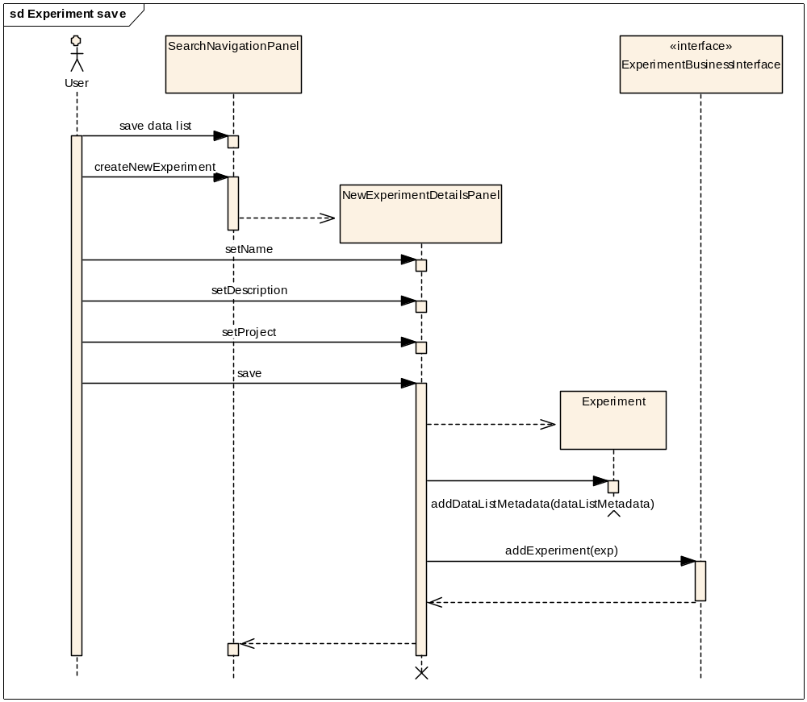
Figure 54 Flow of evens for saving experiment

Opening an Experiment
Following are the classes involved in displaying the experiment.
- ExperimentPanel is used to display details of all experiments. It is invoked when Experiment tab on GlobalNavigation panel is clicked. It contains ExperimentHierarchyPanel on left hand side and ExperimentDetailsPanel on right hand side.
- ExperimentHierarchyPanel is a panel to display experiments folder structure in the form of project and sub projects. On click of link in the tree details of the selected experiment or group are shown in ExperimentDetails panel.
- ExperimentDetailsPanel displays the information of the selected experiment group or experiment in a spreadsheet format. On the click of experiment name, ExperimentOpenPanel gets invoked.
- ExperimentOpenPanel is the main panel used to display the actual data in the selected experiment. It has ExperimentStackBox embedded in left hand side and ExperimentDataCategoryGridPanel embedded in right hand side.
- ExperimentStackBox is used to display data and the other tools that user can invoke on the data of the experiment. It contains panels to show the categories in the experiment. It also contains Filter panel, Visualization Panel and analytical services panel. On click of link in the data category tree, the details of selected data category are shown in ExperimentDataCategoryGridPanel.
- ExperimentDataCategoryGridPanel is the base panel to display actual data in the experiment in the form of spreadsheet. It also acts as container for the dynamic tabs that gets added as user performs visualization and analytical tasks.

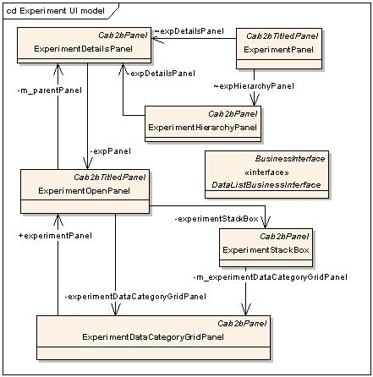
Figure 55 Experiment UI model

Following sequence diagram illustrates the flow of events while opening an experiment.
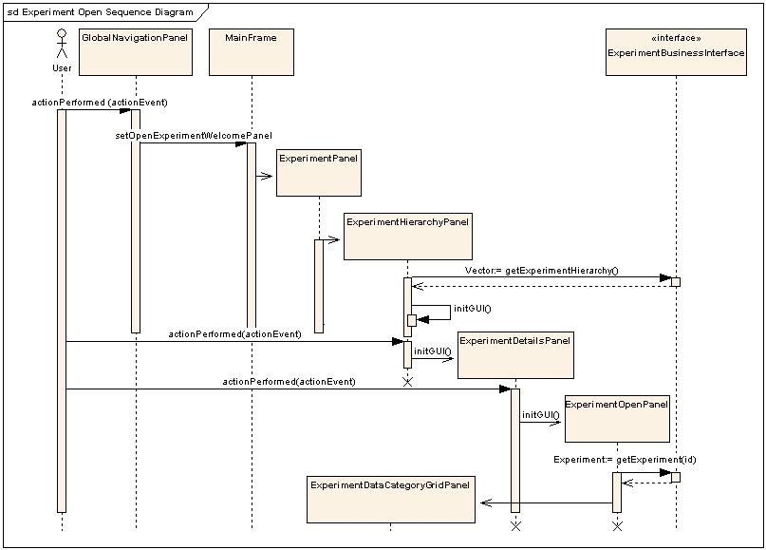
Figure 56 Flow of event for Open Experiment

Custom Data category
User can filter the data present in the experiment and save that sub set of the data as a custom data category. When user creates custom category, the current data present in the ExperimentDataCategoryGridPanel is taken and a new data list is created. This is distinguished with the other data list by setting its isCustomDataCategory flag to true. This data list is added is then saved along with its metadata and actual data. After this it is added into the current experiment and then UI is updated to reflect the change.

Following sequence diagram illustrates the flow of events while saving the custom data category.
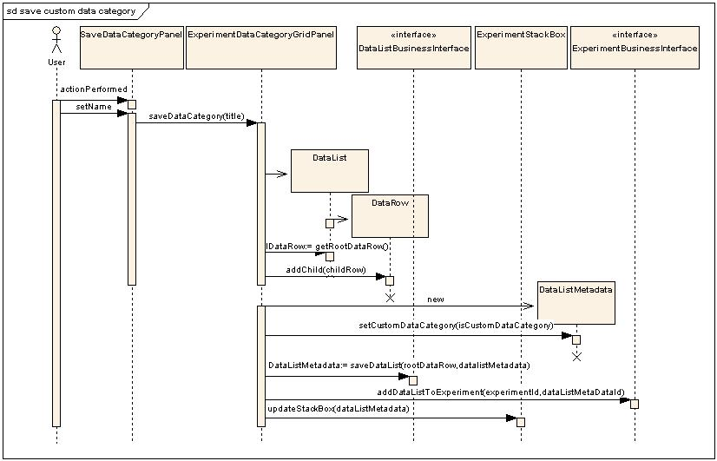
Figure 57 flow for saving the custom data category

Charting

Overview
The experiment data saved by the user after searching and saving the data list can be scrutinized either by Analytical services or Visualization tools. Cab2b chart is one of the options available for visualization. It allows the user to see the various numerical data graphically by generating various charts out of it.

Classes Involved
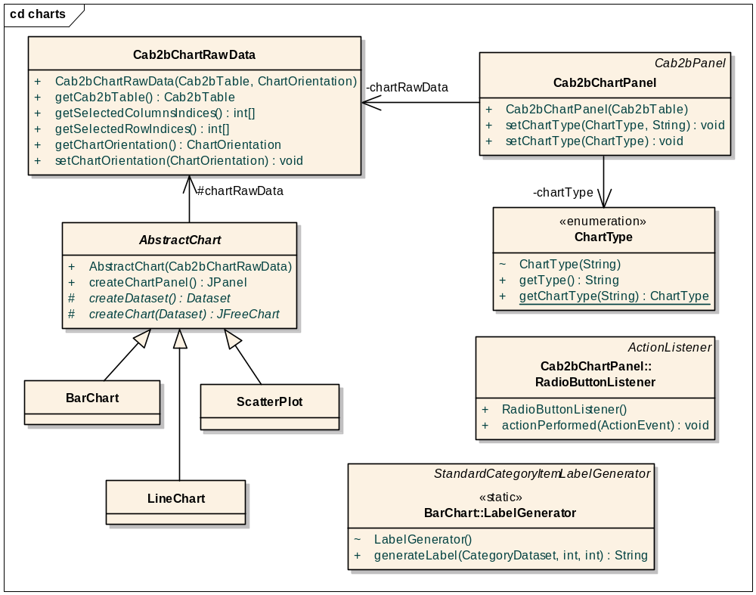
Figure 58 Classes Involved in Charting

Cab2bChartRawData stores the reference to the data table, the indices of the rows and columns selected in the data table, and the series of the charts (i.e. row wise or column wise) to be displayed.

ChartType is a wrapper around any of the following three types of charts that Cab2bChartPanel uses to decide which chart is to be rendered.
- BAR_CHART
- LINE_CHART
- SCATTER_PLOT
Cab2bChartPanel displays the requested chart. It also has the options to change the series of the chart. Cab2bChartPanel:RadioButtonListener acts on the selected option to change the series of the chart.
AbstractChart is the base class of all the chart classes. It holds the data to be rendered and provides a functionality that creates the chart panel.
BarChart is the chart class that renders the data to generate the bar chart.
BarChart:LabelGenerator is used by BarChart to generate the labels required in the chart.
LineChart is the chart class that renders the data to generate the line chart.
ScatterPlot is the chart class that renders the data to generate the scatter plot.

Sequence diagram
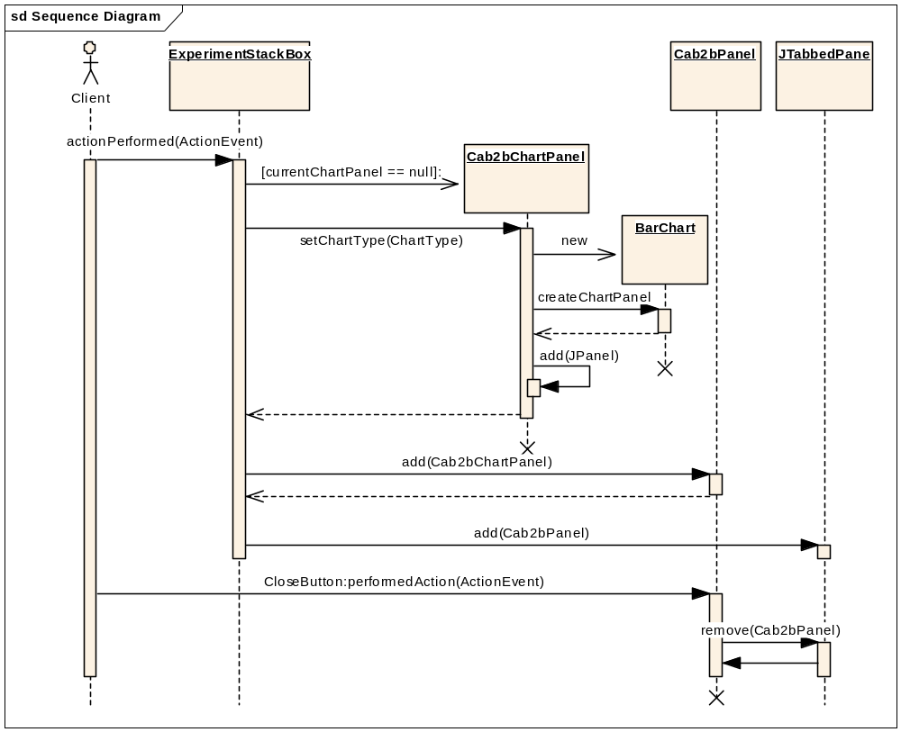
Figure 59 Flow of events happening during chart generation
Future functionalities
- Display large chart with scroll bars.
- To limit the legends of the chart to be displayed.

Spreadsheet Component

Overview
This component provides various tool bar menus with excellent graphical interface.
JSheet: JSheet is the main class of SpreadSheet component and is extended from JPanel. The class contains references for all components that can be set on SpreadSheet and some special methods like setAdditionalToolbarActions() which appends new JButtons in the Toolbar, with the specified actions.
The JSheet class contains following important instance variables which help in event handling and customization of components.
Class/Variable Name | Description
SheetCustomizationConsole | The Visual components that accepts User settings: which Columns to view
ColumnFilterVerticalConsole | This panel presents context sensitive Filter Control for single column. The last selected Column in Data View is picked up.  This is the visual component that shows applicable filter as GUI to user, providing chance for correction.
InternalPCListener | Sheet Configuration Monitoring
SheetCustomizationModel | Sheet Customization (Visibility & Filters) is kept here.
createSampleValuesFromModel | Indicator flag if sample values from filter should be created from Table Model, or  filter should be disabled if NOT explicitly provided.
ColSelectionListener | Column Selection Listener class
ViewDataConsole | The actual Visual Component that renders table on the screen for the user
selectionRowMode | If this is true, SelectionHanger is allowed to paint itself as selected, if and only if table cell selected is true as per model.

ViewDataConsole: Represents data modeling and action event handling for all visible components set on JSheet. This class contains action listener classes for all toolbar buttons and also some special methods like public void removeComponentFromToolBar() which helps in customizing toolbar component on JSheet.

Following are the list of important action listener classes used in ViewDataConsole class.

Class/Variable Name | Description
ShowDetailsAction | Action class for ‘Show Details’ button on JSheet tool bar. On clicking shows details of the selected row.
AddUserColAction | Action class for ‘Add Column’ button on JSheet tool bar. It adds editable user column to JSheet.
CopyAction | Action class for ‘Copy’ button on JSheet tool bar. Copy to clipboard.
ResetAllAction | Action class for ‘Reset’button on JSheet tool bar.
SelectAllAction | Action class for ‘Select All’ button on JSheet tool bar.
PasteFromClipAction | Action class for ‘Paste’ button on JSheet tool bar.
ExportSelectionAction | Action class for ‘Export’ button on JSheet tool bar.
ShowCustomizationConsoleAction | Action class for ‘Properties’ button on JSheet tool bar.
ClearSelectionAction | Action class for ‘Clear’ button on JSheet tool bar.
butToolbarAdditionalAL | List of additional toolbar actions...

CompositeTableModel: This is a data model extended from AbstractTableModel class and picks data from both Read-Only and Extensible Data Models. This class contains TableModel for storing the Read only component of the table data and DefaultTableModel for storing and maintaining the New Columns of the table data in JSheet.
JSheetViewDataModel: Similar to CompositeTableModel, this is a data model class extended from AbstractTableModel class and picks data only from visible columns in table. This model helps in creating Custom data categories and Data Categories for the selected experiment.
ColumnFilterVerticleConsole: This class extends Panel and is responsible for Filter component associated with Spreadsheet. It is tightly bounded with its associated model and uses different action listener classes for different types of filter components.
Following is the list of important the action listener and data model classes for different Filter components in SpreadSheet component.

Class/Variable Name | Description
ColumnFilterModel | Define filter model for all columns from Spreadsheet
ListItemSelectionListener | List selection listener class for List type filter
PatternPropertyChangeListener | Document change listener class for Pattern type filter
RangeChangeListener | Property change listener class for range filter

ColumnFilterModel: This class defines filter data model for all columns in Spreadsheet. It stores the information about currently applied filter on a particular column and all required details from column related to filter e.g. max-range, min-range, pattern-filter string etc. It works only on values that are naturally comparable and passes value to a particular filter model component e.g. Range Filter, List filter, Pattern filter etc.
SheetCustomizationConsole: This is a user interface class extended from JPanel class. The class represents all columns’ property page where user can Reset column settings, add extra Columns, set the column to be visible or invisible and can view all columns and respective filters in a single page. The class uses SheetCustomizationModel as data model.

SheetCustomizationModel: Table Model implemented to accept and keep Column Visibility Settings. Mainly used for handling data model of SheetCustomizationConsole page.
FiltersViewConsole: This is a main class used to design and handle Filter component screen associated with JSheet component. The class contains references for SheetCustomizationModel, ConsolidatedFilterViewTblModel and ChangeListener classes to identify any changes in data model.
ConsolidatedFilterViewTblModel: This class defines data model for FilterViewConsole class. The data model collects information from SheetCustomizationModel class and handles data modeling for FilterViewConsole UI panel.

Class Diagram
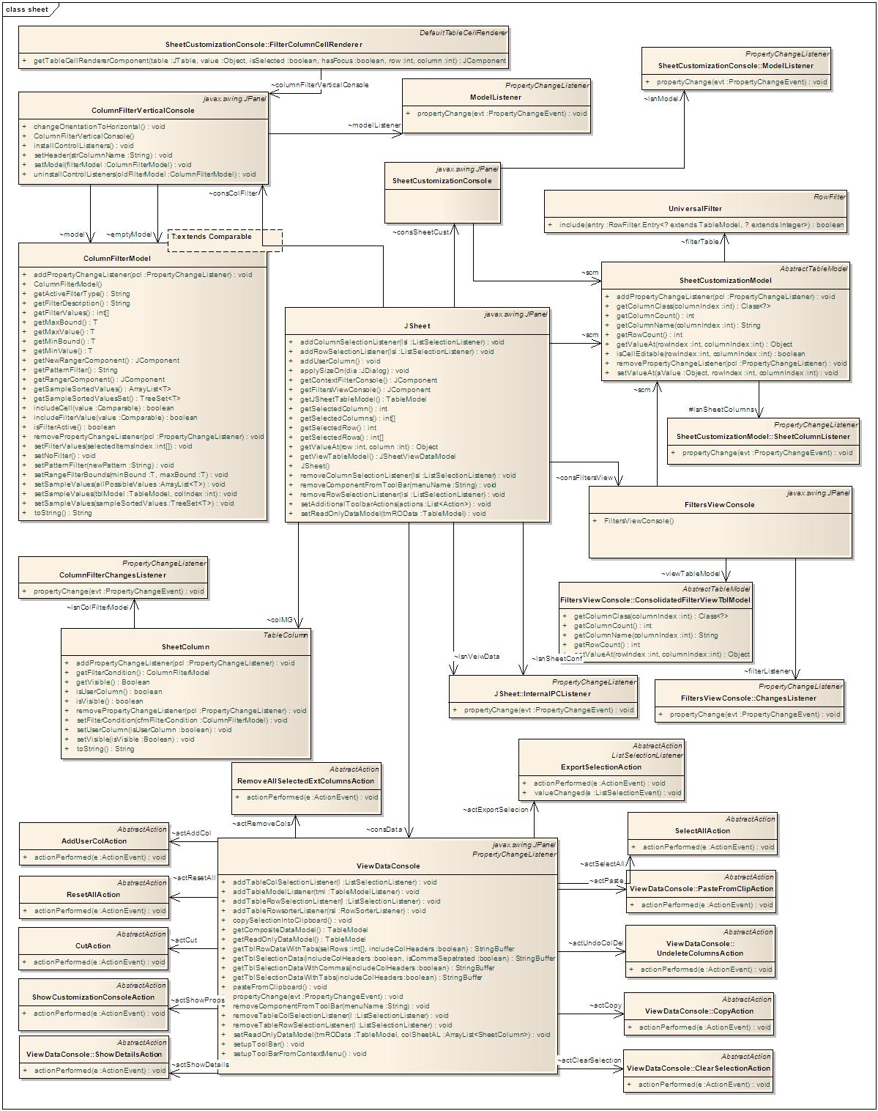
Figure 60 Classes Involved in Spreadsheet component

Analytical Services Invoker

Overview
Analytical services are the services which transform the data from one form to another by applying some algorithm on it. When a user views records of a particular entity, analytical services applicable for that entity are shown in left-hand-side stack box.

Entity to Analytical Service Mapping XML
Finding analytical services for an entity is a metadata driven process Found using a file EntityToAnalyticalServiceMapping.xml. Figure 61 below shows a sample of this configuration file.

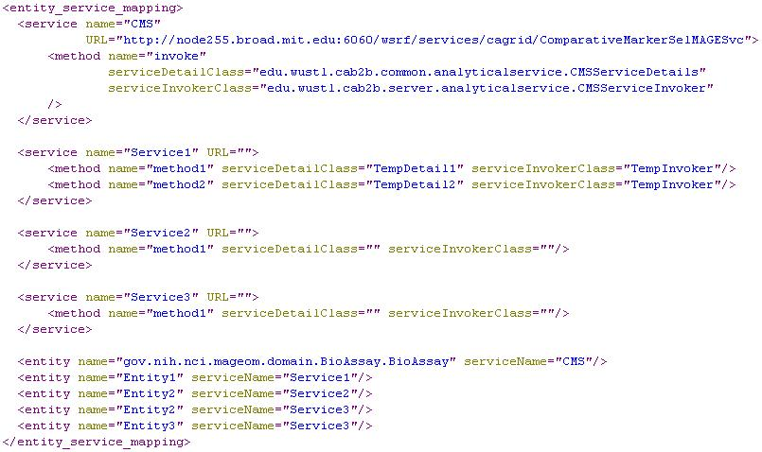
Figure 61 Sample EntityToAnalyticalServiceMapping.xml
- <entity>: This file has <entity> tag that specifies what feature providesmapping between entity and its one applicable service. There can be multiple services applicable for an entity. In this case, there will be those many <entity> tags with different service names.
- <service>: This file has one <service> tag per service. It has a unique name for the service which is shown to the user and a URL is provided that points to the running instance of that service.
- <method> tag in the service states which method of a service is to be invoked. Attribute serviceDetailsClass presents the class which holds details of the service. The class mentioned here must implement ServiceDetailsInterface. There is a method on this interface getRequiredEntities () which returns a list of entities. One of them will be the one for which user is currently viewing the data. For other entities a dynamic UI is generated to specify values for its attributes. Attribute serviceInvokerClass specifies which class to be used to invoke the service. The class mentioned here must implement ServiceInvokerInterface.

Classes involved
Diagram below shows the classes involved at the backend. It also shows implementation details for comparative marker selection analytical service.
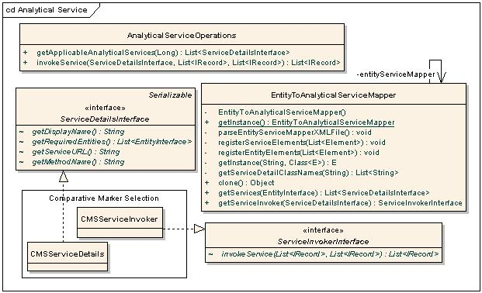
Figure 56 Classes involved in getting and invoking analytical services
- ServiceDetailsInterface: It defines the methods needed to describe any analytical service such as its name, required entities, URL pointing to service instance. All the classes mentioned as value of attribute serviceDetailsClass in above XML file must implement this interface
- ServiceInvokerInterface: It defines the method to invoke an analytical service. All the classes mentioned as value of attribute serviceInvokerClass in above XML file must implement this interface
- EntityToAnalyticalServiceMapper: This is a singleton class which parses the EntityToAnalyticalServiceMapping.xml file and stores the mapping information into an internal map. This class provides the methods to get the service interface and the service invoker interface.
- AnalyticalServiceOperations: This class has a method to get applicable analytical services which returns a list of ServiceDetailsInterface for a given entity. It also has method invoke () to call the service with passed data.
- CMSServiceDetails and CMSServiceInvoker are the real extensions implemented to invoke comparative marker selection analytical service.

Appendix

Dynamic Extension and MDR

Overview
One of the most important components of the DE project is its metadata repository. MDR can contain metadata about dynamic extensions or static UML models. Each DE is also a UML model. The MDR is very important component not just for DE, but also for applications such as caB2B and caTissue Suite. The basic backbone of MDR is as shown in Figure 1 Metadata Repository backbone.

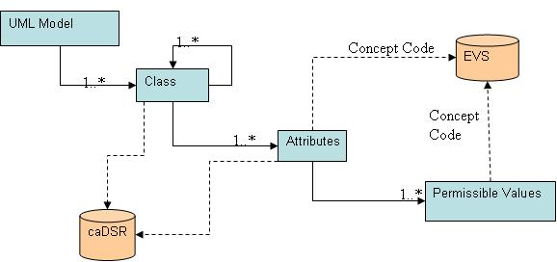
Figure 627 Metadata Repository backbone
MDR contains the following metadata for a domain model:
- Classes
- Attributes
- Data type
- Concept codes
- Description
- Permissible values

In case the domain model is created using the dynamic extensions user interface, the MDR will contain the UI display properties and the database mapping information for each attribute. The metadata for the user interface contains:
- Type of UI Control
- Properties like height, width, password like string and so forth
- Mandatory or optional attribute
Table to which the entity maps and column to which the attribute maps

UML Metadata
This contains all the information present in the UML model such as class, attributes, and associations including the permissible values. Following diagram shows the classes involved in entity creation along with the relationships involved in these classes.
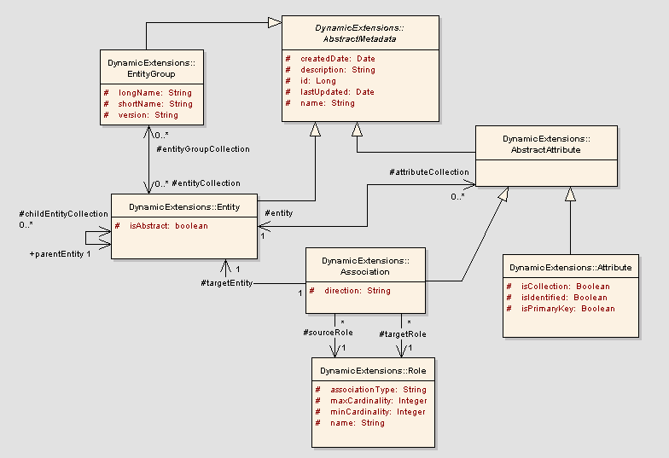
Figure 63 Dynamic extension basic metadata
AbstractMetadata: This is an abstract base class from which the backbone metadata objects are derived. This class contains generic attributes which are part of all objects (like create date, last updated and so forth).

EntityGroup: An entity group is a logical collection of entities. For example, all classes of an application are loaded under one entity group. It contains multiple entities.
Entity: This class represents an UML class. An entity is associated to itself to specify its parent entity. An entity can have zero or one parent entity. An entity can also have zero or more children entities.

AbstractAttribute: An entity can either have zero or more primitive attributes, or have zero or more associated classes. This is represented by the AbstractAttribute class. It is the base class for Association and Attribute classes.
Attribute: The class represents a primitive attribute. For example, name is an attribute of the user entity. Attribute can be of following types:
  - String attribute
  - Double attribute
  - Short attribute
  - Long attribute
  - Boolean Attribute
  - Date attribute
  - ByteArray (for BLOB/CLOB)

Following diagram shows how attribute type is defined or changed in attribute.

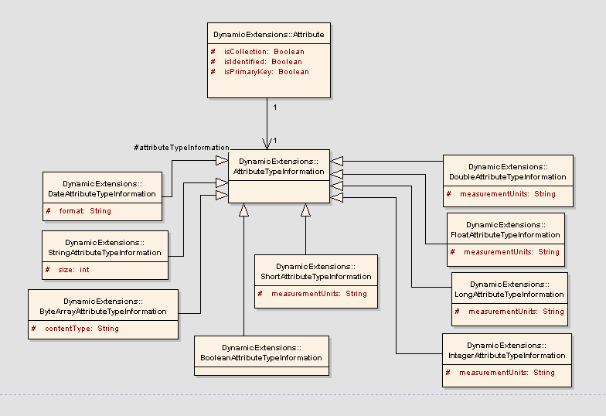
Figure 59 Attribute Type Metadata
Attribute class is associated with the class “AttributeTypeInformation” that specifies the type of the attribute.
AttributeTypeInformation: This class represents the type of the attribute. Attribute type can be any of the above mentioned types. This class is an abstract class which is extended by all the specific primitive attribute types like DoubleAttributeTypeInformation or StringAttributeTypeInformation.
Role: This class describes an association’s cardinality and the association type. The class has the following attributes
- associationType: This could be two types of association: containment or linking. Containment association type is one of Person and Address where the Person entity will contain Address entity within it. The Address object does not exist on its own. Linking association type is one of User and Study. Here, both the objects can be created independently. The user can be part of multiple studies and a study can contain multiple users.
- maxCardinality: Maximum cardinality of association (for example, 1 or many)
- minCardinality: Maximum cardinality of association (for example, 0, 1 or many)
- name: The role name of the association.
Association: This class represents the associations that an entity can have with other entities. E.g. a User entity is associated with Institute entity.
- sourceRole: This represents the role of the association from the source context.
- targetRole: This represents the role of the association from the target context.

Inheritance Metadata support
One of the main aspects of any application is the inheritance between its entities. So when any object model is loaded into DE database, this hierarchy of objects should be preserved. This section explains how inheritance is preserved in DE using the required metadata objects of DE. Following diagram explains the required objects and relationships for inheritance.

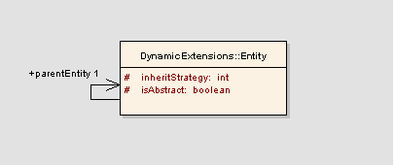
Figure 64 Inheritance Metadata
Entity: Entity object represents the java class in any object model. So to maintain the hierarchy of classes, following attributes and associations are maintained.

isAbstract: This flag maintains whether the entity is abstract or not.
inheritStrategy: This attribute stores the Hibernate’s strategy to store the actual data in the actual database. Allowed values for this attribute are:
  - Joined subclass
  - Subclass
  - Table per concrete class.

Attribute data elements and default values
An attribute can have values that are derived from some fixed source or some user defined set of allowable values. For example, gender attribute can have only fixed values like male and female. Additionally, the attribute can have one of them as a default value. This information is saved in following way. The diagram shows the way in which the allowable and default values are stored in DE
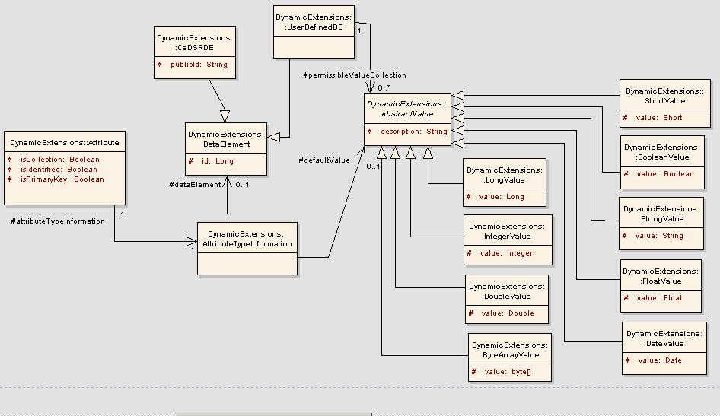
Figure 65 Attribute Data Elements
caDSRDE holds all the common information for all the types of data elements. Some of the associations of this class are:
- AttributeTypeInformation: Source of the allowable values is specific to the attribute type. So to represent this information correctly, AttributeTypeInformation class is associated with the DataElement so that it represents the type of source for the attribute.
AbstractValue: This class represents a value, an attribute can have. This value can be used as a default value or as one of the allowable values. The class acts as a base class for the entire attribute type specific value.

