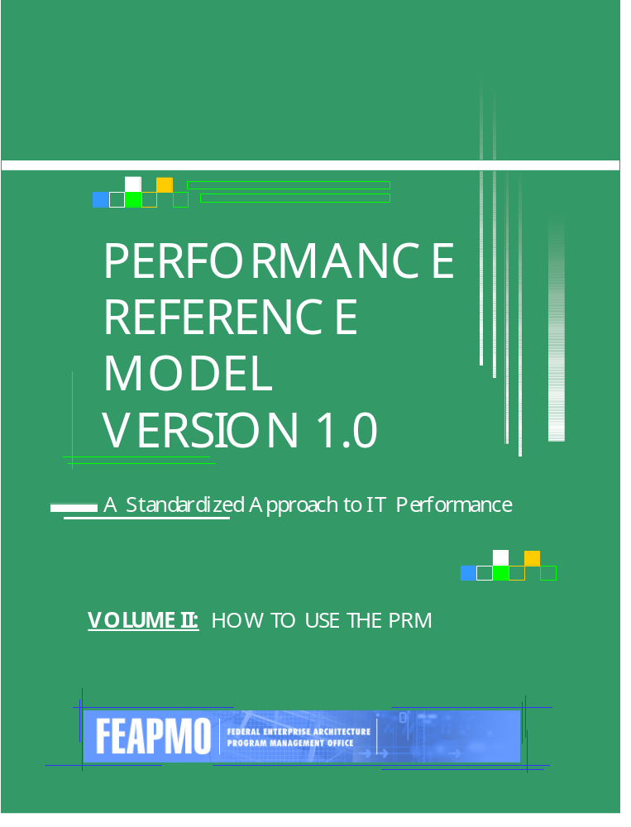

The Federal Enterprise Architecture Program Management Office

The Performance Reference Model Version 1.0:
A Standardized Approach to IT Performance
June 2003
Volume II: How to Use the PRM

Table of Contents
Table of Contents ii
1. A Process for Improvement 3
A SUGGESTED PROCESS TO USE THE PRM 3
PRM PHASE I – ALIGN WITH THE PRM 5
PRM Phase I.1 - Determine Line of Sight from Outcomes to Inputs 5
PRM Phase I.2 - Identify and Define PRM Measurement Indicators 8
PRM PHASE II - EXPLORE AND DEFINE IMPROVEMENTS 12
PRM Phase II.1 - Conduct Baseline Analysis 12
PRM Phase II.2 - Set Improvement Targets 14
PRM Phase II.3 - Identify, Select, and Propose Improvements 15
PRM PHASE III - MEASURE PROGRESS 17
PRM Phase III.1 - Implement improvements 17
PRM Phase III.2 - Track progress toward improvement targets 18
PRM PHASE IV - USE PERFORMANCE INFORMATION 19
PRM Phase IV.1 - Evaluate progress 19
PRM Phase IV.2 - Inform IT project and program management 20
2. Using the PRM Within Existing Management Processes 22
Budget 22
Government Performance and Results Act 23
Program Assessment Rating Tool 23
IT Capital Planning and Investment Control 23
Enterprise Architecture 24
Appendix A: How to Use the PRM to Complete the OMB Exhibit 300 27
A-11 REQUIRES AGENCIES TO USE THE PRM FOR MAJOR IT INITIATIVES THAT ARE DME IN FY 2005 27
AGENCIES CAN EASILY INCORPORATE THE PRM INTO EXHIBIT 300 I.C, TABLE 2 29
Examples of IT Investments Using the PRM to Complete Section I.C, Table 2 31

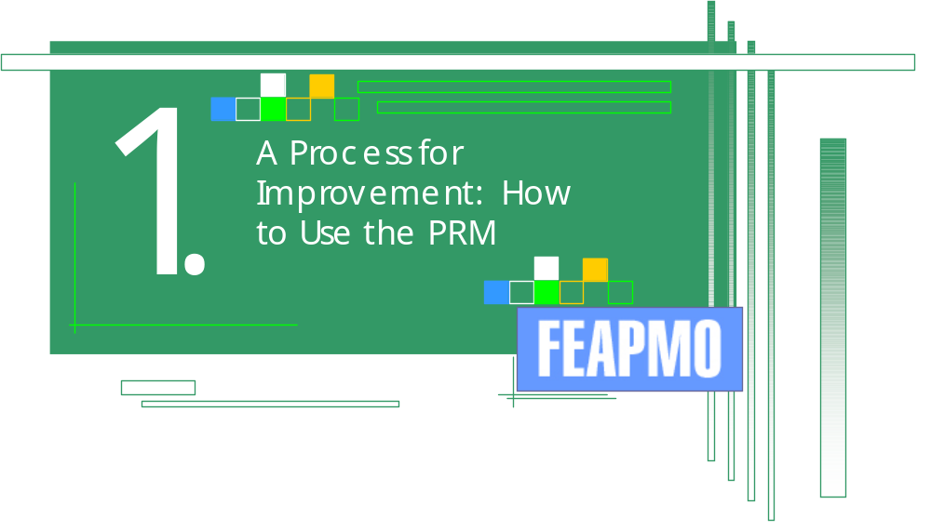

1. A Process for Improvement
This section provides an overview of a suggested process to use the PRM. Details of Version 1.0 of the PRM are provided in Volume I: Version 1.0 Release Document.

A SUGGESTED PROCESS TO USE THE PRM
To help agencies use the PRM, the FEA-PMO is suggesting a high-level process. This process has been identified through examining best practices and builds from existing management processes that are relevant to the PRM. This process consists of four phases that follow the PRM from developing Operationalized Measurement Indicators through measuring progress and making more informed management decisions. Stated otherwise, the suggested process to use the PRM focuses heavily on its primary purpose to develop IT performance information that can be used to improve decision-making and performance. As with all aspects of the PRM, this suggested process will be refined and improved as lessons learned emerge.
The suggested PRM process described below follows the “flow” of PRM-related performance information through the IT lifecycle. However, the suggested process also acknowledges that IT initiatives must be developed in a business-driven context to be truly successful and accordingly identifies intersections with other processes, such as GPRA, that are relevant when using IT to improve performance.
This process is not meant to replace any existing federal-level or agency processes. Agencies are encouraged to use the PRM and the information it produces in a way that makes sense for their specific environment. Figure 1 on the following page shows the suggested process phases and steps to use the PRM throughout the IT lifecycle.

FIGURE 1: SUGGESTED PROCESS PHASES AND STEPS TO USE THE PRM
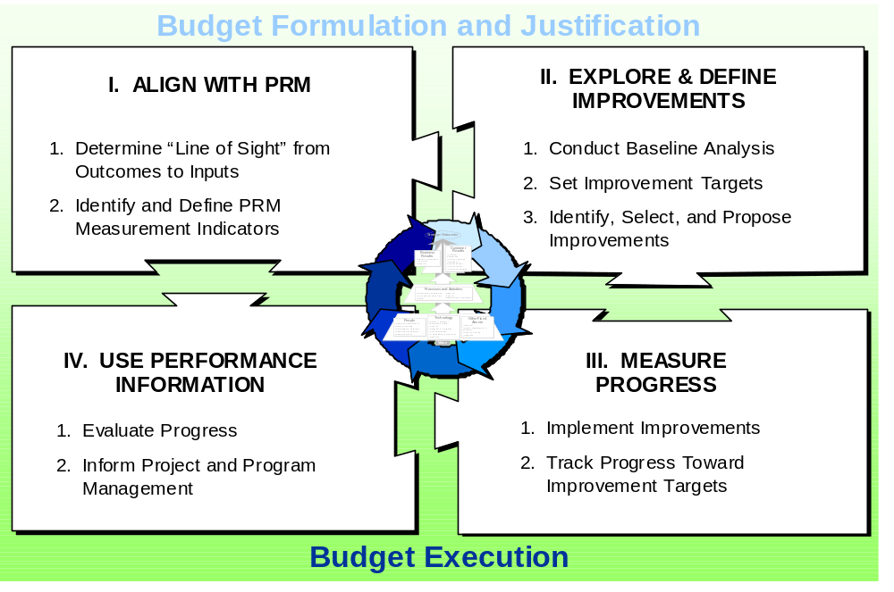

Throughout this suggested process, the degree of cross-agency collaboration necessary will depend on how much collaboration the specific environment requires. For example, an agency-specific IT initiative may need to collaborate with other agencies minimally or not at all. However, a cross-agency IT initiative may require significant collaboration to define and measure what are the shared priorities that the IT will help these organizations achieve.
In practice, the application of the PRM process to any specific IT initiative will differ based on many factors, including:
The degree of improvement that is needed;
Whether a new IT initiative is being developed or an existing one is being modernized or enhanced;
Whether one’s frame of reference is that of an IT project manager, a program manager, an agency CIO or CFO, a Line of Business Owner, an OMB examiner, or other decision-maker; and
What other existing management initiatives, processes, and data collection efforts are currently underway that can be leveraged.
As with any successful improvement initiative, several best practices are critical to PRM implementation. These include:
Top leadership support and commitment to change;
Ongoing involvement and buy-in from front-line employees;
Identification and engagement of other critical business partners and stakeholders from the very beginning;
A diverse team with a broad perspective and representation to shepherd the improvements needed;
A strong and ongoing partnership between business and IT communities within the agency; and
Managing change and communicating priorities and progress both internally and externally.

PRM PHASE I – ALIGN WITH THE PRM
This section provides information on how agencies can align with the PRM.

PRM Phase I.1 - Determine Line of Sight from Outcomes to Inputs
A critical first step in aligning with the PRM is to understand the “line of sight” from the IT initiative through outputs, then to outcomes. This places the IT initiative in its proper context when assessing a program’s or agency’s overall progress. This is in part because IT initiatives generally contribute to outputs and outcomes, but rarely achieve them on their own. This step can consist of at least two key tasks:
PRM Phase I.1.A - Understand context and performance drivers
Before attempting to draw the line of sight, additional background information may be helpful. The type of information will vary depending on the specific agency and/or IT initiative, as well on what perspectives (e.g. program officials, IT project manager, budget, EA) are represented when completing this task. Key context and background information may include:
PRM POINT: The strategic and annual goals and measured identified in an agency’s GPRA plans should be the drivers when identifying relevant outcomes that an IT initiative contributes to.
Relevant legislative and Congressional mandates for the IT initiative and/or the program it supports;
Relevant BRM Lines of Business and Sub-functions the IT initiative supports;
Relevant agency business lines and/or functions the IT initiative supports;
Agencies, bureaus, and/or programs that align with those Sub-functions or functions;
PRM POINT: How an IT initiative aligns with the Business Reference Model provides the starting point to “operationalize” the appropriate Generic Measurement Indicator in the Mission and Business Results Measurement Area
Applicable strategic and annuals goals for these entities;
Applicable measures or indicators for these goals; and
Existing performance gaps or constraints that need to be addressed (GAO, IG, Congress, OMB, PART Assessments, etc).
As discussed in Volume I: Version 1.0 Release Document, agencies should leverage the work already done to align their IT initiatives to the Business Reference Model. Determining what Line of Business and Sub-function the IT initiatives supports is the starting point to identify Operationalized Measurement Indicators in both the Mission and Business Results and Processes and Activities Measurement Areas.
After agencies have provided their FY 2005 Exhibit 300s to OMB, the Federal Enterprise Architecture Management System (FEAMS) can be a valuable tool for agencies to identify other federal agencies that may conduct the same or similar Lines of Business and Sub-Functions. FEAMS is a web-based tool that will display how major IT initiatives can be characterized through each FEA reference model. Selected agency and OMB officials will have access to FEAMS during relevant times of the year to identify collaboration opportunities with other federal agencies.
PRM Phase I.1.B - Understand what contributes to performance and how
The “line of sight” for the IT initiative consists of identifying its cause and effect relationship with other inputs, then outputs, and outcomes. This relationship should be identified by starting with the desired outcome, then cascading down to outputs and inputs—specifically the IT initiative. The figure below suggests key considerations to understand WHAT contributes to performance—and HOW inputs contribute to outputs, and by extension, outcomes.
PRM POINT: Developing a line of sight can be especially useful for cross-agency IT initiatives. The line of sight can articulate what aspect of each agency plays a role and how that aspect can be measured, if appropriate, through the PRM.
Generally, more informative Operationalized Measurement Indicators result when the line of sight is more detailed. This information can be invaluable later in the IT lifecycle when agencies conduct Post Implementation Reviews to determine whether the initiative was successful.
Figure 2 below graphically depicts the line of sight and suggests some simple questions that should be addressed to understand at least at a high-level how an IT initiative contributes to outputs and outcomes.
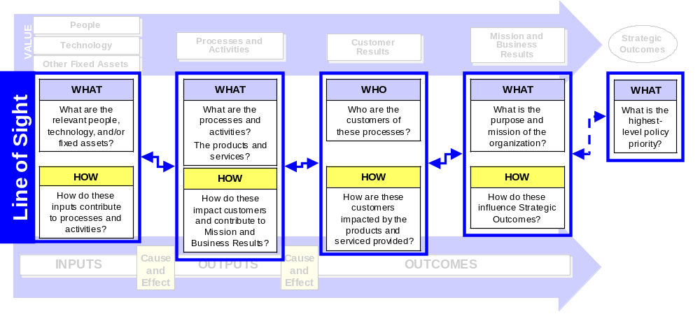
FIGURE 2: KEY QUESTIONS TO DETERMINE LINE OF SIGHT

This type of thinking is not new. Program logic models, value chain analysis, and theory of constraints analysis all provide the basis to identify these relationships. At its essence the line of sight consists of thinking through two aspects critical to identifying adequate Measurement Indicators (1) WHAT is in the line of sight and (2) HOW does each element in the line of sight relate?
Key questions to determine what is in the line of sight include:
What inputs (for the PRM an IT initiative) contribute to what processes?
What customers receive the products and services those processes produce?
What mission or business results do the outputs of those processes contribute to or influence?
Key questions to determine how each element in the line of sight relates include:
How does the IT initiative contribute to processes and activities (what capabilities does it actually provide)?
How do the processes and activities impact customers and contribute to mission and business results?
It is important to remember that the line of sight often will over-simply the true relationship between an IT initiative and the processes, customers, and business results it supports. These relationships will rarely be direct “cause and effect” and more often an association or perceived relationship. As such the point of the line of sight is not to portray that an IT initiative is completely responsible for improvements in processes and activities. Further, the line of sight does not suggest that the outputs from a process or activity are the only influences on customer results or mission and business results.
However, the line of sight is a valuable exercise that both IT project managers and key business or program stakeholders should participate in. Drawing the line of sight will more clearly reveal what exactly the IT initiative will provide—and what it will not provide. This will yield important insight to leverage when using the PRM to identify Measurement Indicators within each required Measurement Area.
In summary, the line of sight uses the PRM structure to identify what the IT initiative does, how it does it, and how it can be measured through the PRM. Figure 3 on the following page shows an example line of sight using the IRS Free Filing E-Gov Initiative.
FIGURE 3: EXAMPLE LINE OF SIGHT ANALYSIS FOR IRS FREE FILING
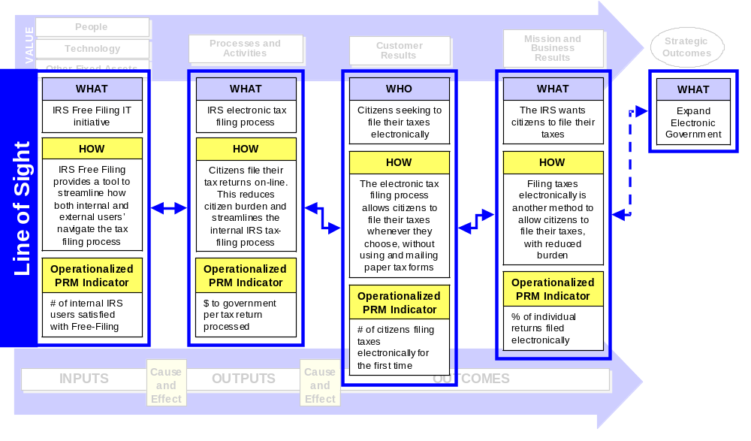

PRM Phase I.2 - Identify and Define PRM Measurement Indicators
Against the backdrop of the information identified in I.1, PRM Measurement Indicators can now be chosen. This step can consist of at least three key tasks:
PRM Phase I.2.A - Determine and “operationalize” possible PRM Measurement Indicators
The information learned about the context and line of sight should be used to help determine which PRM indicators could be used. During the FY 2005 budget formulation process OMB Circular A-11 requires that at least one Measurement Indicator in four Measurement Areas be chosen. These Areas are (1) Mission and Business Results, (2) Customer Results, (3) Processes and Activities, and (4) Technology. In each of these Areas the inventory of Indicators should be reviewed to determine which Measurement Indicators could possibly apply. After choosing the possible Generic Measurement Indicators, each will then need to be uniquely tailored or “operationalized” to reflect the specific environment. See Appendix A for more guidance on how to complete Table 2 of the Exhibit 300 for IT initiatives seeking DME funding in FY 2005.
For example, an outcome-oriented Indicator in the Mission and Business Results Area could be operationalized as shown below:
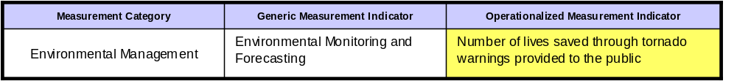

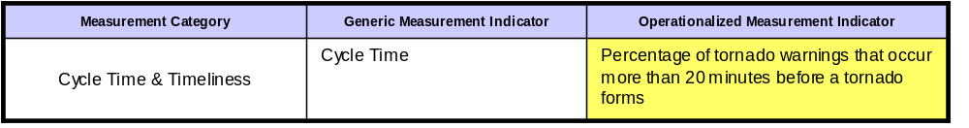
An output-oriented Indicator in the Processes and Activities Area could be operationalized as shown below:

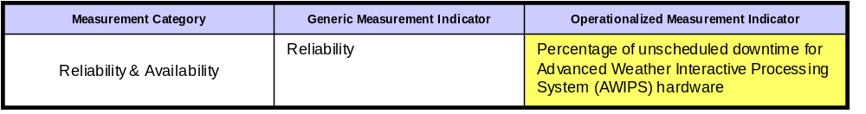
An Indicator in the Technology Area could be operationalized as shown below:

It is important to note that in the above example, only the Technology Measurement Indicator is directly attributable to the IT initiative, AWIPS. The Processes and Activities and Mission and Business Results Indicators merely describe what AWIPS contributes to. So naturally, these Indicators would not be defined by an IT project manager. Rather, they would be created through the programmatic budget and GPRA processes. The IT project manager would then use the line of sight analysis to identify that AWIPS contributes to these Indicators and identify them as part of the line of sight for AWIPS. This requires a strong partnership between the IT and business communities within an agency.
The degree of commonality or standardization across agencies’ use of the PRM will depend upon whether the IT initiative is being managed by a single agency or multiple agencies. All major IT initiatives requesting DME funding for FY 2005 will be identifying at least one indicator in the four required Measurement Areas. However, unless OMB, a Managing Partner, or Line of Business owner dictates collaboration at the Measurement Category, Generic Measurement Indicator, and Operationalized Measurement Indicator levels, agencies will independently use the PRM during FY 2005 budget formulation. Figure 4 depicts how the degree of cross-agency standardization using the PRM decreases with each level of granularity of the PRM.
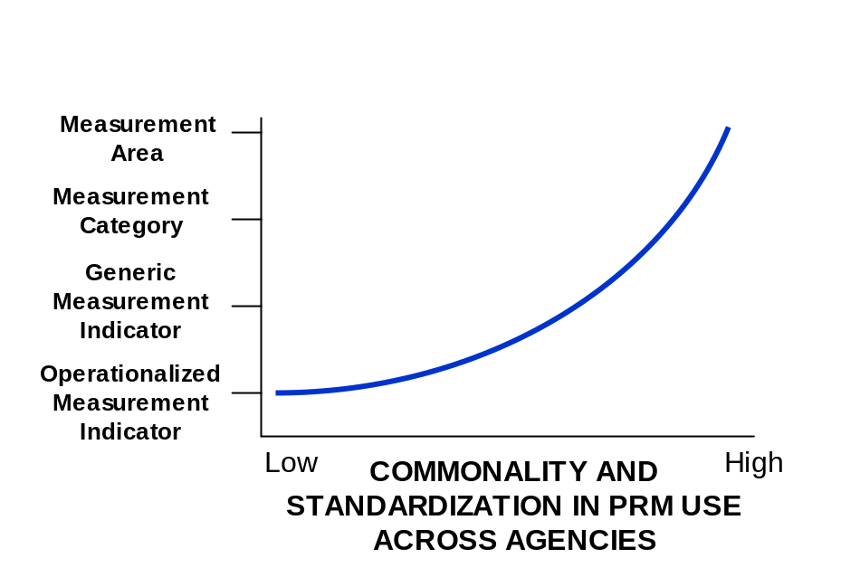
FIGURE 4: DEGREE OF COMMONALITY AND STANDARDIZATION IN PRM USE ACROSS AGENCIES

FEAMS will again be a valuable resource to examine what Indicators other agencies with similar Lines of Business, with similar customers, similar processes, or similar IT initiatives are using.
Identifying possible Customer Results Measurement Indicators that will not require unwarranted data collection burden can be a challenge. One accepted way to meet this challenge is to partner with other organizations. For example, the American Customer Satisfaction Index (ACSI), a partnership between the University of Michigan and American Society for Quality, helps federal agencies track annual trends in customer satisfaction. In its 2002 survey, ACSI asked citizens about a number of federal agencies and programs and several government Web sites, which scored higher than the average for private industry and news and information sites.
Canada has developed a Common Measurement Tool (CMT) to measure client satisfaction. The CMT provides public organizations with standard questions and measurement scales to use when surveying clients. This allows benchmarking of progress over time and comparisons to other organizations within the same business line. The CMT is structured around five key elements: client expectations, perceptions of the service experience, satisfaction levels, levels of importance, and priorities for service improvements.

The plans and reports that agencies produce to comply with the Government Paperwork Elimination Act (GPEA) can be useful resources as well. These plans identify priority business processes that have been or can be improved through technology. The plans also should identify the customers of each of these processes. This documentation can help identify the processes and customers an IT initiative contributes to.
Finally, the pre-determined goals for the IT initiative and the program it supports should play a significant role when determining which PRM Measurement Indicators could possibly be used.
PRM Phase I.2.B - Select Appropriate PRM Measurement Indicators
According to OMB’s guidance on conducting PART assessments, the key to assessing program effectiveness is measuring the right things. PART guidance notes that performance measures should reflect a sense of priorities, and should reflect both outcomes and outputs.
Cities across Iowa participate in the Citizen-Initiated Performance Assessment (CIPA) project. The project helps cities assess performance from a citizen’s perspective through electronic surveys, citizen committees, focus groups, and town meetings. Citizens Performance Teams suggest performance measures for key services. For example, citizens suggested that all emergency medical services include response time measures such as the “time of action,” which is the time from a citizen’s initial call until first action is taken

It is against this backdrop that PRM Measurement Indicators can be selected. After identifying and operationalizing the range of possible PRM Indicators, it is then important to apply criteria to both individual Measurement Indicators and the entire list to ensure that the appropriate set—or “vital few”—are selected. The exact number of PRM Indicators will vary depending on many factors, including the current data available and the size and scope of the IT initiative.
For FY 2005, OMB Circular A-11 requires that at least one operationalized Measurement Indicator be provided for each DME IT initiative in the (1) Mission and Business Results, (2) Customer Results, (3) Processes and Activities, and (4) Technology Measurement Areas. Agencies may choose to select and use a greater number of Measurement Indicators as they see fit.
Key criteria for individual Measurement Indicators could include:
Informative - Would the Indicator help articulate success for the initiative and the programs it supports? Would the Indicator demonstrate progress towards goals, closing performance gaps, and achieving critical results?
Feasible – What data is currently being collected and available? Would the burden or cost of collecting new data for the Indicator be reasonable considering how informative it would be for managers and decision-makers?
Key criteria for the entire list of Measurement Indicators could include:
Manageable - Is the entire list of Indicators pared down to the "vital few" measures that can help drive improvement and characterize success?
Complete - Does the entire list of Indicators collectively provide an accurate and broad enough "snapshot" of performance? Could the list be further cascaded or supplemented with additional Indicators to provide relevant information to the public, decision-makers, and managers? Does the list track progress towards key performance gaps or constraints identified in I.1.A?
Finally, the point of performance measurement is to reduce uncertainty—not completely eliminate it. This means that particularly in the early years of PRM implementation agencies will not have perfect measures. PRM implementation is not about perfect measures, but better measures that reduce uncertainty for project managers and key decision-makers. This is an important point to keep in mind when deciding which PRM Measurement Indicators to use.
PRM Phase I.2.C. - Define Selected PRM Operationalized Measurement Indicators
After applying the criteria in 1.2.B, the selected PRM indicators then need to be further defined and assessed. This task is critical to ensuring that data will truly be available to track progress towards the indicator and that someone has been given the responsibility to collect this data on a regular basis. Key aspects about each Measurement Indicator should be considered as shown below:
How exactly will the Measurement Indicator be calculated?
What are the data source(s) that will be used?
What other federal or private sector organizations currently collect similar data and can that can be leveraged?
When will the data first be available and then actually collected?
How often will data be collected thereafter?
Who is responsible for collecting this data?

PRM PHASE II - EXPLORE AND DEFINE IMPROVEMENTS

This section provides information on how agencies can conduct analysis consistent with the PRM framework to drive performance improvement.

PRM Phase II.1 - Conduct Baseline Analysis
A baseline is a quantifiable point from which to begin an effort and from which change can be measured and documented. Conducting baseline analysis involves setting a reference point from which improvement targets will be set and progress measured. Baseline analysis also includes assessing the current capabilities that are associated with the initiative. This is typically described as an agency’s “status quo” or “current state” environment.
This step can consist of at least two key tasks:
PRM Phase II.1.A - Baseline performance against chosen PRM Measurement Indicators
For each PRM Indicator identified in Phase I it is important to set a baseline. This can be done using current data or previous data that coincides with when the initiative began. There are multiple ways in which this baseline performance can be identified:
Assess current performance against chosen PRM Indicators. For an IT initiative, the performance of the existing legacy IT system (if there is one) can be identified. The initiative’s current contribution to outputs and outcomes can then also be assessed.
Benchmark current performance of other, similar organizations. If assessing current performance of the initiative and/or agency is too time-consuming or not possible, other initiatives, agencies, or private sector organizations with similar characteristics can be used to approximate what current performance might be.
Use initial requirements. For new programs or initiatives, the requirements for the new program or initiative can be used as a baseline.
Table 2 of the Exhibit 300 will require agencies to discuss their “baseline” for each PRM Measurement Indicator they report.
PRM Phase II.1.B - Baseline current processes and capabilities
In addition to identifying baselines for performance, it can be useful to baseline current processes and capabilities. This can begin by building from the line of sight identified in Phase I. More detailed baselining of processes and capabilities is somewhat helpful context to baseline performance but imperative when setting improvement targets and identifying improvement strategies. This process can also identify in-process Measurement Indicators that may be useful to track in addition to end-process Measurement Indicators that agencies might report to OMB in the Exhibit 300. Figure 5 on the following page shows how the line of sight identified in Phase I can be expanded.
FIGURE 15 EXPANDED LINE OF SIGHT ANALYSIS TO SUPPORT PROCESS BASELINES
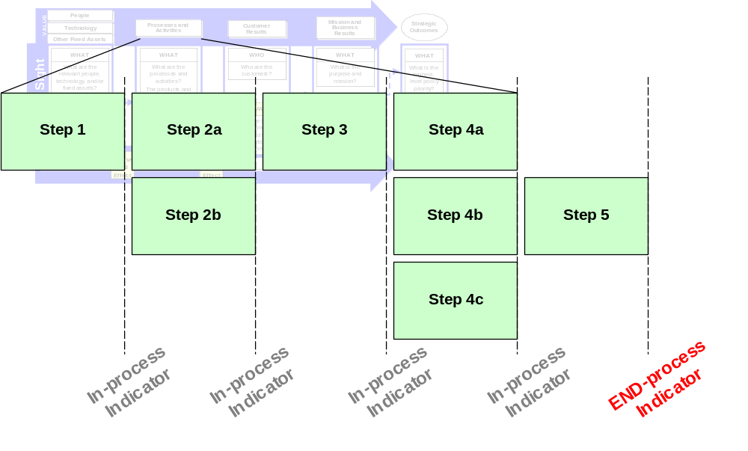

To the extent that similar sources of information will be used while baselining performance, those sources should also be used to baseline current processes and capabilities.
Processes can also be baselined through process-mapping or information-flow analysis. Capabilities can be baselined through conducting inventories of the existing people, technology, and other fixed assets that contribute to the relevant outputs and outcomes. In addition to simply identifying these capabilities, specific attributes can also be assessed—such as the skills and competencies of key staff.
PRM POINT: An agency’s Enterprise Architecture can provide valuable information about current processes and capabilities. This can be leveraged and expanded upon when baselining existing processes and capabilities.
A number of existing disciplines suggest methodologies to baseline processes and capabilities. These include Business Process Re-engineering and the Theory of Constraints. The Theory of Constraints, for example, focuses on identifying the existing aspect of the process or capabilities—in other words a “constraint”—that if changed or removed would result in the most significant improvement in performance.
Importantly, the integration of the FEA reference models becomes crucial during this step. For example, baselining IT capabilities against the SRM and TRM will provide important information. This integration is critical when seeking to use FEAMS to identify other federal agencies that can serve as collaborative partners, for example to borrow or re-use service components.

PRM Phase II.2 - Set Improvement Targets
Once the relevant baselines are established, the next step is to use that context along with some additional information to set performance targets for each PRM Measurement Indicator identified. Performance targets are quantifiable estimates or expected results bound to a given time period. It is against these targets that performance improvement will be measured. Stated otherwise, target setting provides the road map for performance improvement. Successfully setting improvement targets requires taking a short and long-term perspective that allows annual progress to be assessed in the context of a longer-term vision.
This step can consist of at least two key tasks:

PRM Phase II.2.A - Collect relevant data
Improvement targets must be set in the context of the requirements or change agenda of the Congress, the Administration, and agency. In addition, customer feedback, baselines, historical data, benchmarks, and a variety of other information may be useful context when setting targets. Some of this information may have been identified in Phase I, and may include:
Directives from Congress, the Administration, and the Agency – The requirements or priorities that directly or indirectly affect the initiative. These can include legislative mandates, other Congressional directives, GAO or Inspector General recommendations, the OMB scorecard, agency Strategic and Annual Plans, or any other documents that may suggest improvements or specific levels of performance that are required.
Customer Feedback – What customers say, through a variety of forums, about the current level of performance and how it could be improved. Targeted sampling surveys, focus groups, literature, and third-party research are all ways to solicit customer feedback.
Benchmarking – The process of rating an organization’s processes, products, and performance against high-performers. Benchmarking involves seeking the “best-in-class” performers within and outside the organization, then learning from them what they do well, why they do it, and how they accomplish it. It is imperative to use standardized criteria (e.g. size, scope, mission) to identify organizations that may serve as appropriate benchmark partners. FEAMS can again be a useful resource to help agencies identify other federal agencies that may serve as suitable benchmarks.
The Department of Defense Financial Management Modernization Program is building its financial management enterprise architecture. One of the steps it took early on was to propose high-level target business processes. These proposed processes were benchmarked from leading practices DOD identified from other organizations’ financial management processes. The initial analysis was not bounded by legal or regulatory constraints to ensure as much “out of the box” thinking as possible.

Baselines and Trends – Current and/or historical performance data in the relevant areas of performance. To some extent, this information may be useful in projecting the range of possible improvement targets for the future. This information must be considered in the context of the factors that contributed to the trends and whether or not those factors will still be relevant in the future.
PRM Phase II.2.B - Identify long-term and annual targets
Once the relevant data has been collected, performance targets should be set for each PRM Indicator. GPRA and the PART both emphasize the importance of long-term and annual improvement targets. More broadly, long-term and annual targets are important because they provide insight into what the long-term vision is—as well as how progress towards that vision will be tracked along the way. Generally, long-term targets are three to five years away.
Particularly early in the IT lifecycle, targets will be estimates. General directions of improvement or specific ranges are usually most realistic and these can be refined during the IT lifecycle as more information is learned about exactly what the IT initiative will be.
Targets should be set using a collaborative approach driven by leadership’s vision for improvement. Within these parameters, experience, perspective, and expertise should be leveraged at all levels of the organization—in particular from front-line employees who have critical insight into what is truly possible to achieve. This type of collaborative approach improves the chance that the relevant individuals will take ownership and be willing to be held accountable for progress. This approach also improves the chances the targets will be effective in driving improvements. Generally, useful targets meet some or all of the following criteria:
Specific, in that they focus attention on exactly what level of performance is expected;
Clarifying, in that they help executives, managers, and front-line employees understand priorities and set strategies and manage resources accordingly; and
Achievable, yet challenging, in that they “stretch” the organization to improve but are realistic enough to be attained. The targets should be realistic but still spur improvement.
Table 2 of the Exhibit 300 will require agencies to discuss their “planned improvements to the baseline” for each PRM Measurement Indicator they report.

PRM Phase II.3 - Identify, Select, and Propose Improvements
This step involves measuring the magnitude of the “gap” between the baseline and targets identified in the previous steps. To close this gap, one or a series of improvement strategies are generally needed. These strategies may span or affect any or all of the areas of the PRM. For example, a new or enhanced IT initiative may be needed, staff may need to be trained in a new skill area, and/or a more sweeping set of changes to the existing process may be the only way to achieve the improvement targets set.
This step can consist of at least three key tasks:
PRM Phase II.3.1 - Identify potential improvement strategies
There are many approaches to identify the potential range of improvement strategies. These include simple brainstorming sessions involving key staff and stakeholders to leveraging the bechmarking analysis performed in II.2.A to identify how the “best-in-class” achieve such high levels of performance. Regardless, the strategies identified should not be constrained (at least initially) and span the entire “line of sight” identified in Phase I. This should include innovative new thinking about ways to partner with other federal agencies, state and local governments, non-profit organization, or other members of the “value chain” to achieve the performance targets.
The U.S. Department of Labor’s E-Government Strategic Plan includes an approach to take a customer-centric view of how improvements could be made. The approach emphasizes identifying “value partners” that may be in other federal agencies, state or local governments, foreign governments, or other organizations. These partners can then collaborate to identify the most effective and efficient way to delivery products and services to the customer.

Once this universe of potential improvements is identified, the key aspects of each improvement strategy should be described in the context of consistently applied and transparent criteria. These criteria can include feasibility, benefit or value, cost, risk, and timing or payoff period. This will provide a standard backdrop against which to select an improvement strategy.
Once again FEAMS can prove valuable during this step. Agencies can use the tool to identify other agencies that can be partners for improvement. For example, an agency conducting a similar Line of Business or Sub-function may have or be developing components within a Service Domain that would be an efficient strategy to achieve performance targets.
PRM Phase II.3.2 - Select desired improvement strategy
There are a variety of ways to select an improvement strategy (or strategies). Regardless, the standardized criteria identified in the previous step should be used as the primary means to choose one of the strategies identified. Ideally, these criteria should be weighted based on their priority to the organization. Each improvement strategy should then be “scored” against this set of weighted criteria. Traditional business case development practices often refer to this as an “Alternatives Analysis.” At any point in this process, the effect of a desired improvement strategy on the existing environment can be projected using a modeling or scenario-based software.
In 2002, the CIO Council identified the Value Measurement Methodology as a best practice framework to among other things, prioritize and select improvements. The methodology includes five ways to categorize the value of an IT initiative. This value is considered along with the initiative’s potential risk and cost. Agencies then weight each of these areas based on their importance to their unique environment. Analysts then score each improvement strategy using these weightings. SSA and GSA are among the agencies that have used this framework.

The specific strategy selected may determine whether the improvement targets set earlier are truly feasible. It is critical at this stage to revisit the improvement targets and ensure that the selected improvement strategies provide a reasonable chance of achieving the targets.

PRM Phase II.3.3 - Propose improvement strategy to agency, OMB, Congress, and other stakeholders
Once the desired improvement strategy has been selected, that strategy and its benefits, cost, and risks must be approved. Depending on the specific environment, documents must be completed within an agency, which then may be shared with OMB, and then ultimately the Congress or other key stakeholders, such as unions. Though there are a variety of formal and informal structures through which this can occur, the budget process is generally where decision-makers assess whether the improvement strategy is appropriate and will be approved. For example, GPRA and budget proposals agencies submit to OMB generally provide some details on what improvements are needed, how much they will cost, and how the agency will make them.
PRM POINT: For DME IT initiatives in FY 2005, the Operationalized Measurement Indicators selected must be identified in Table 2 of Section I.C of the Exhibit 300. Additionally, some of the suggested PRM process can also be valuable when completing the Justification, Alternatives Analysis, and Risk Inventory and Assessment sections of the Exhibit.
Improvements that involve major IT initiatives require that an Exhibit 300 be produced and submitted to OMB for approval. The specific requirements for the Exhibit 300 are outlined each year in OMB Circular A-11. Appendix C of this release document provides detailed information about how to use the PRM to complete Section I.C. in the Exhibit 300 for IT initiatives seeking DME funding in FY 2005.

PRM PHASE III - MEASURE PROGRESS
At some point, the planning is complete and approvals have been given. It is time to begin implementing improvements. As with all the preceding phases, the exact timeframes for this phase will vary significantly depending on the magnitude of improvement needed and the size and scope of the initiative. Nevertheless, key steps within this phase could include:

PRM Phase III.1 - Implement improvements
Though the time for implementation has arrived, it is still necessary to follow existing agency-level or OMB processes. These include the IT CPIC requirements identified in OMB Circulars A-11 and A-130. Within this framework many agencies have a variety of unique processes and procedures to meet these requirements. However, key aspects include:
Robust program and project management planning and monitoring throughout the IT lifecycle;
Continued collaboration and involvement of key business stakeholders and customers as appropriate; and
Continued monitoring of the external environment to ensure the planned improvements are still viable given recent developments.

PRM Phase III.2 - Track progress toward improvement targets
Within the relevant processes, again usually the IT CPIC process, the work done in earlier phases to apply the PRM will begin to yield benefits. The improvement targets set against each relevant PRM Indicator can now serve as the measuring stick for progress. Progress towards some input or output Indicators may be useful on a weekly, monthly, or quarterly basis. Progress towards outcome Indicators may only be available on an annual or bi-annual basis. Similarly, different audiences will need to track progress on different timeframes. IT project managers may wish to see weekly updates while agency CIOs or OMB will see quarterly or annual updates.
SSM Health Care, a not-for-profit health system based in St. Louis Missouri, won the prestigious Malcom Baldrige National Quality Award in 2002. Part of their quality and performance achievements include using an automated system to make clinical, financial, operational, customer, and market performance information available to all its regional health care sites. SSMHC makes this data available to physicians from any location through personal computers, PDAs, pagers, and fax machines.

In particular, progress towards PRM Indicators may be useful if the program the IT initiative supports is subject to PART. More specifically, OMB examiners and agency officials conducting PART assessments may find the information gained from tracking progress towards PRM Measurement Indicators useful. This will be especially true when answering questions the Strategic Planning and Program Results sections of the PART assessment tool.
PRM POINT: The performance information created when tracking progress towards PRM Measurement can be useful input to agency-level activities during the Select, Control, and Evaluate phases of the IT CPIC process. Progress can be tracked, for example, quarterly during control reviews.
Many E-Government initiatives managed by state governments are tracking progress towards improvement targets. Some of these have been recognized by the National Association of State Chief Information Officers (NASCIO), including:
The Missouri E-Grants project, which reported an 86 percent reduction in the time to process grant applications;
The District of Columbia Business Resource Center, which reported annual cost savings of $1.8 million; and
The Massachusetts Educator Licensure and Recruitment Initiative, which reported a six-month decrease in the licensing process and $2.5 million in additional annual revenue.

PRM PHASE IV - USE PERFORMANCE INFORMATION
One of the main purposes of the PRM is to produce enhanced performance information to improve daily and strategic decision-making. Once collected during Phase III, the performance information facilitated by the PRM can be used in targeted circumstances to drive more rigorous analysis to support decision-making. This phase is the most important of the suggested process to use the PRM.
Key steps within this phase could include:

PRM Phase IV.1 - Evaluate progress
The information provided by tracking progress towards PRM Indicators in Phase III will only provide a point-in-time “snapshot” of performance. Agencies at times will wish to use this information as a starting point for more detailed analysis. This analysis is often referred to as program evaluation or root cause analysis. This analysis is also an area in which agencies generally have weak or non-existent capacity, but is none-the-less essential to truly improving performance.
FedEx uses performance information daily to evaluate progress. Fed Ex holds daily “failure analysis” meetings every morning to analyze and review each delivery failure from the night before. This constant feedback and analysis allows immediate corrective action on individual vehicles that may need attention. This process also allows FedEx to identify any trends that may lead to larger delivery problems and costlier maintenance requirements.

The IT CPIC process’ “Evaluate” phase generally includes Post Implementation Reviews (PIR). These PIRs are detailed assessments of, among other things, whether the IT initiative actually produced its intended benefits. For example, an IT initiative may have used the PRM to project it would contribute to improvements in productivity and efficiency for the process it supports. After the IT initiative has been implemented and enough time has passed for it to actually impact the process, a PIR would seek to determine whether it actually did make the contribution as planned. This can be assessed through more detailed performance measurement, user surveys, and comparing process performance before and after the initiative was implemented.
PRM POINT: OMB budget examiners and agency officials can use the PRM to evaluate cross-agency progress during PART assessments. More specifically, the performance of agencies within the same BRM Sub-function can be compared through the PRM framework so higher-scoring programs can share best practices with lower-scoring programs.
Using performance information in this way will require a major transformation towards a performance-driven and evaluation culture. Improvements in data quality, analytic expertise, and collaborative partnerships will also need to occur for performance information to be used to improve performance and management decision-making.
Eventually, it is envisioned that the PRM framework could be used to create a “performance dashboard” to monitor the critical areas of performance—and more importantly identify starting points for further analysis to determine what strategies need to be changed to achieve even higher levels of performance.
Figure 6 below shows an example performance dashboard using the PRM.
FIGURE 6: CONCEPTUAL PRM “DASHBOARD” TO EVALUATE PROGRESS
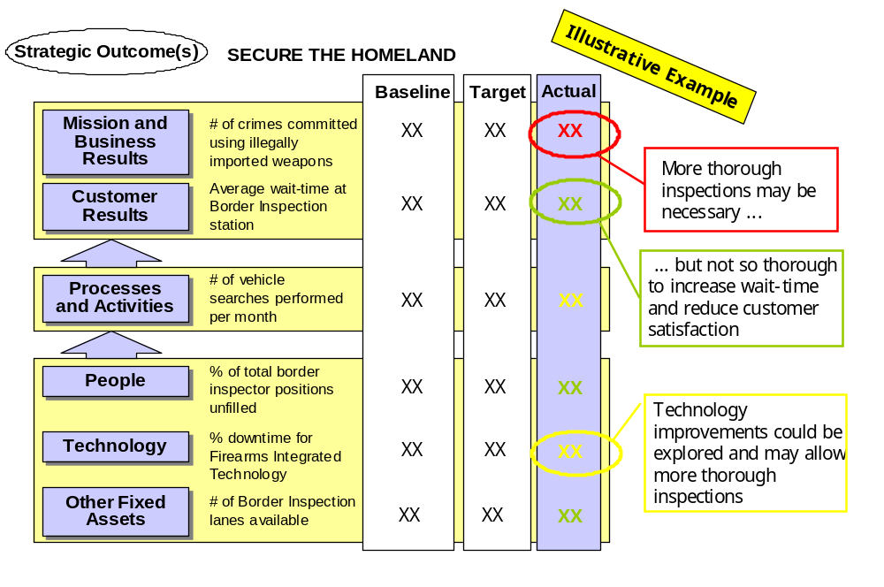

PRM Phase IV.2 - Inform IT project and program management
Building from the concept of a “performance dashboard,” there are times when either tracking progress towards Measurement Indicators or conducting more detailed evaluations holds important lessons for project and program management. To the extent reasonable, this performance information should be shared with project and program managers.
These managers and at times OMB and Congress may wish to use this information to enhance their future planning and resource allocation decisions.
After conducting such evaluations, IT initiatives can begin the PRM process again. This may involve identifying new PRM Measurement Indicators in Phase I or identifying new improvement targets or strategies in Phase II. The important point is to use the information provided by progress towards PRM Indicators to make better decisions and as necessary assess and re-assess the path forward.
Based on lessons learned and further outreach within OMB and to key councils and agencies, the FEA-PMO will refine the suggested PRM process as needed in PRM Version 2.0.

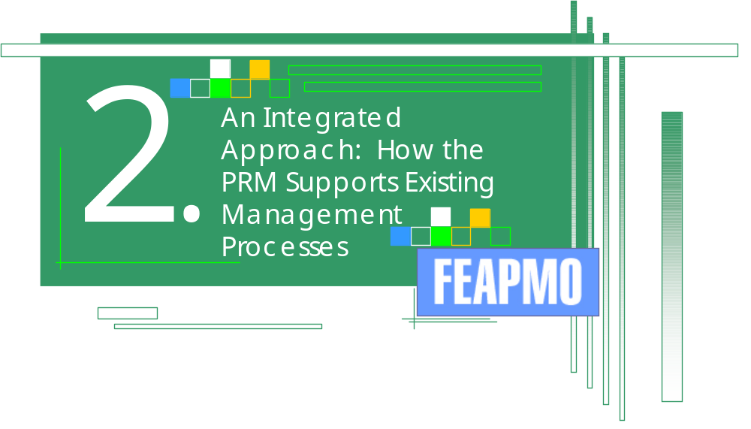

2. Using the PRM Within Existing Management Processes
This section provides an overview of how the suggested PRM process described in Section 1 is consistent with and reinforces other existing management processes.
Though the PRM is being applied to IT, its principles and process steps require a business and program-driven approach. By extension, this means that the PRM has relevant intersections with other important management processes. The “PRM Points” in the previous section identify some of these intersections. The PRM’s most important linkages with other management processes are highlighted below.

Budget
Key intersections of the PRM and the information it can help produce and the existing budget formulation and executive process include:
Help articulate the value of proposed IT improvements to program performance in budget justification documents;
Help identify and explore improvement strategies to propose in budget justifications; and
Use progress towards Operationalized PRM Measurement Indicators to inform budget decisions.

Government Performance and Results Act
Key intersections of the PRM and the information it can help produce and the existing GPRA cycle of strategic planning and reporting include:
Goals or priorities in Strategic Plans can inform and drive the Mission and Business Results, Customer Results, and at times Process and Activity Measurement Indicators that agencies “operationalize” through the PRM;
The improvement strategies identified to achieve performance targets can be informed by and complement those identified in Accountability Reports; and
Progress towards relevant PRM Measurement Indicators can be included in Accountability Reports.

Program Assessment Rating Tool
Key intersections with the PRM and the information it can help produce and the PART cycle of assessments and making improvements in response to those assessments include:
Lower scoring programs can use the PRM to identify Measurement Indicators to help drive improvement called for in PART Assessments;
Progress towards operationalized PRM Measurement Indicators can provide additional information to allow more robust Assessments in the Strategic Planning and Program Results sections. This is particularly true when determining the extent to which IT is contributing to improved program performance and related IT funding decisions;
Assessment findings can help determine which PRM Measurement Indicators and targets are used; and
Progress towards PRM Measurement Indicators in common areas can help OMB and agencies compare the performance of programs with similar missions. These programs will be in the same BRM Sub-function, and can be used to help lower-scoring PART programs learn best practices or collaborate with higher-scoring programs.

IT Capital Planning and Investment Control
Key intersections of the PRM and the information it can help produce and the federal and agency-level IT CPIC cycle of Select, Control, and Evaluate include:
Identify Measurement Indicators to help select the appropriate IT investments and request funding for them in Exhibit 300s;
Progress towards PRM Indicators can inform agency-level IT reviews; and
Progress towards PRM Indicators can be the starting point for more detailed agency-level Post Implementation Reviews.

Enterprise Architecture
Key intersections of the PRM and the information it can help produce and the EA process of baselines, target architectures, and transition or migration plans include:
Conducting baseline analysis can inform the completion of Baseline Architectures; and
The Target Architecture can help drive and identify improvement strategies chosen to meet target levels of performance for the appropriate PRM Measurement Indicators.
Figure 7 on the following page summarizes these intersections.
FIGURE 7: KEY INTERSECTIONS OF THE PRM AND OTHER MANAGEMENT PROCESSES
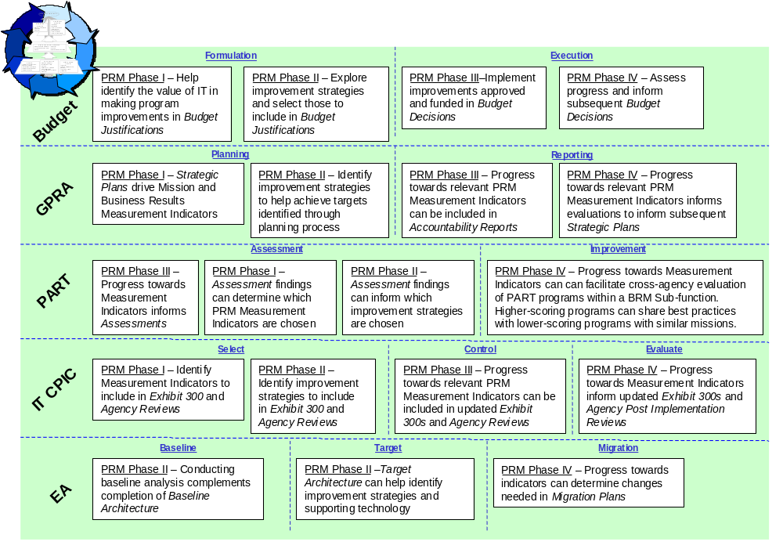

Based on lessons learned and further outreach within OMB and to key councils and agencies, the FEA-PMO will refine the suggested PRM process and its intersections with other processes as needed in PRM Version 2.0

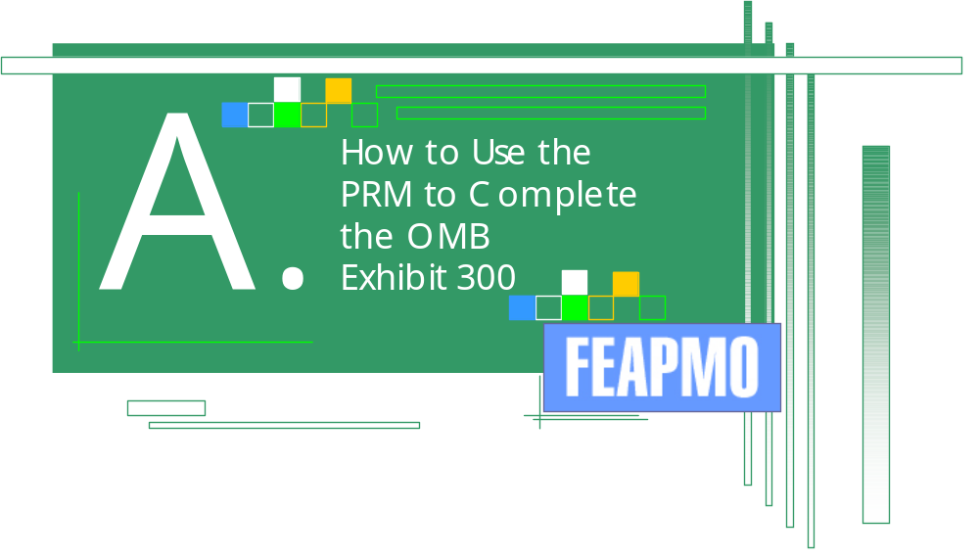

Appendix A: How to Use the PRM to Complete the OMB Exhibit 300
This Appendix provides detailed guidance on how to use the PRM when completing the Exhibit 300 portion of OMB Circular A-11.

A-11 REQUIRES AGENCIES TO USE THE PRM FOR MAJOR IT INITIATIVES THAT ARE DME IN FY 2005
The FY 2005 OMB Circular A-11, which when released can be found at: www.whitehouse.gov/omb/circulars/index.html, requires that all major IT initiatives that are development, modernization, or enhancement (DME) projects align with the FEA Performance Reference Model (PRM). Section I.C of the Exhibit 300 required for all major IT initiatives states:
“All new development, modernization, and enhancement IT investments must use Table 2 below for 2005 and beyond and are required to use the FEA Performance Reference Model. PRM Version 1.0, available at www.feapmo.gov, includes detailed guidance about how to incorporate PRM Indicators into the performance goals and measures table below. Please use the table below and the PRM to identify the performance information that pertains to the major IT Investment.” – OMB Circular A-11

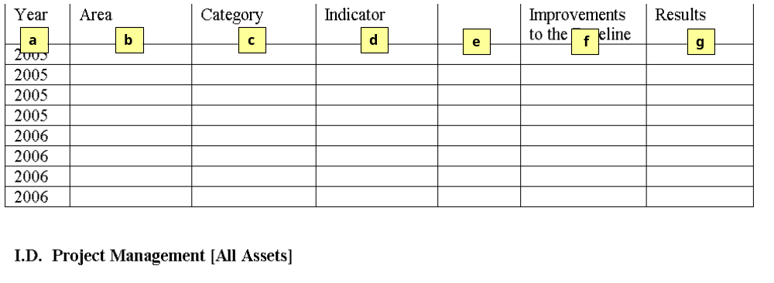
Table 2 from Exhibit 300, Section I.C. Performance Goals and Measures is shown below. The table consists of seven columns and includes specific linkages to the PRM.

The definitions for what is expected in each column of the above table are:

a) Fiscal Year – Agencies are to indicate in which fiscal year the initiative plans to use a particular Measurement Indicator.

b) Measurement Area – Agencies should use the PRM to determine the areas in which they will be measuring performance. For FY 2005, these must include Mission and Business Results, Customer Results, Processes and Activities, and Technology.

c) Measurement Category – Agencies should use the PRM to determine the category in which they will be measuring performance. These must correspond to the appropriate Measurement Area provided in the preceding column.

d) Measurement Indicator – Agencies should use the PRM to determine the Operationalized Measurement Indicator for which they will be measuring performance. These must correspond to the appropriate Measurement Category provided in the preceding column. Each of these Measurement Indicators should be tailored or “operationalized” to the agencies’ specific environment.

e) Baseline – Agencies should provide the relevant baseline information for the “Operationalized” Indicator provided in the preceding column. Baselines generally stay the same across fiscal years unless OMB approves a change to the baseline. See section III of this release document for more information on conducting baseline analysis.

f) Planned Improvements to the Baseline – Agencies should provide the relevant performance target for the “Operationalized” Measurement Indicator for the appropriate fiscal year. These may, but will not always, change over time. See section III of this release document for more information on setting performance targets.

g) Actual Results – Agencies should provide the most current information they have to demonstrate progress consistent with the “Operationalized” Measurement Indicator. See section III of this release document for more information on collecting and reporting actual performance information.

Again, the only IT investments required to use the PRM for FY 2005 and beyond are development, modernization, and enhancement initiatives. This generally will mean that columns “f” and “g” may not be affected in the early years of the initiative. Consequently, important project-related milestones and performance measures that will be critical to driving the early phases of these types of initiatives should be identified under section I.H.2 of the Exhibit 300 that discusses important project-related tasks and milestones.

AGENCIES CAN EASILY INCORPORATE THE PRM INTO EXHIBIT 300 I.C, TABLE 2

For each fiscal year, agencies must identify performance information for their major IT investments in four Measurement Areas of the PRM: (1) Mission and Business Results, (2) Customer Results, (3) Processes and Activities, and (4) Technology. Identifying this performance information is critical so that agencies and OMB can understand the full “line of sight” from the proposed IT to outputs and outcomes.
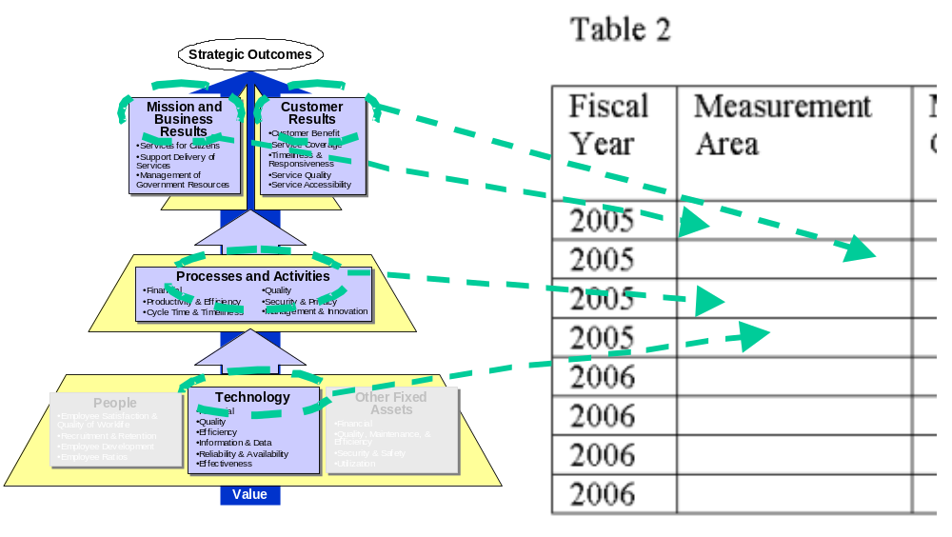

Identifying Mission and Business Results and Customer Results will generally require coordination with agency budget and planning staff. Agency Strategic Plans, Performance Plans, and Performance Reports will be important resources for agencies to use and ensure they are reporting consistent measures. Generally, the IT investment will be contributing to improvements in these areas and simply identify measures already in use. As mentioned in Section I, the primary Business Reference Model alignment already identified should serve as the starting point for the Mission and Business Results Measurement Area.

Within each of the four Measurement Areas required for FY 2005, agencies need to then insert the Measurement Category and Measurement Indicator in the next two columns to the right. This is shown below. The Measurement Indicator must be the Operationalized Measurement Indicator that fits the agency’s specific environment. Sections II and III of this release document provide more information on Operationalized Measurement Indicators. If agencies believe their project can benefit from using an Indicator not identified in the PRM, they can use “Other” as needed. The FEA-PMO will review all “Other” Indicators during OMB passback review and refine the PRM as appropriate.

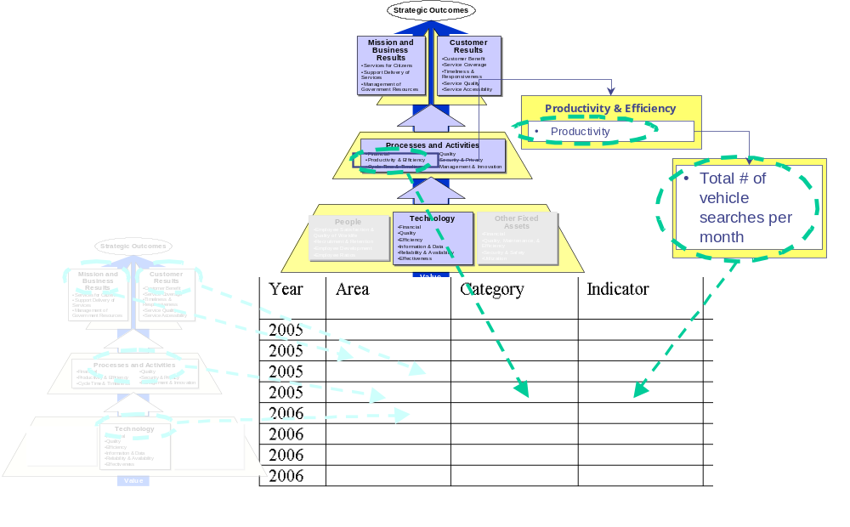

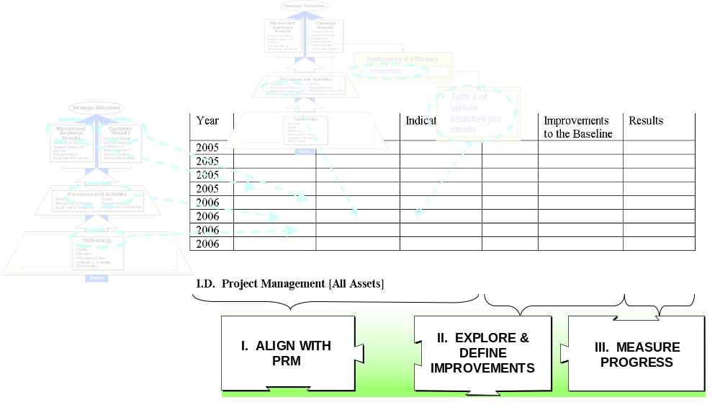
The remaining three columns of the table, though not explicitly addressed in the PRM, are consistent with Phases II and III of the suggested PRM process discussed in section III of this release document. This is where actual data will be provided—and used to improve decision-making and performance.

Examples of IT Investments Using the PRM to Complete Section I.C, Table 2

Below are three examples of how IT investments could complete Section I.C of the Exhibit 300. Note that no baseline, planned improvement, or target data is provided. This is because these examples are designed to simply illustrate how the PRM structure can be applied to a variety of investments.

Example Table 2 for IRS Free Filing.
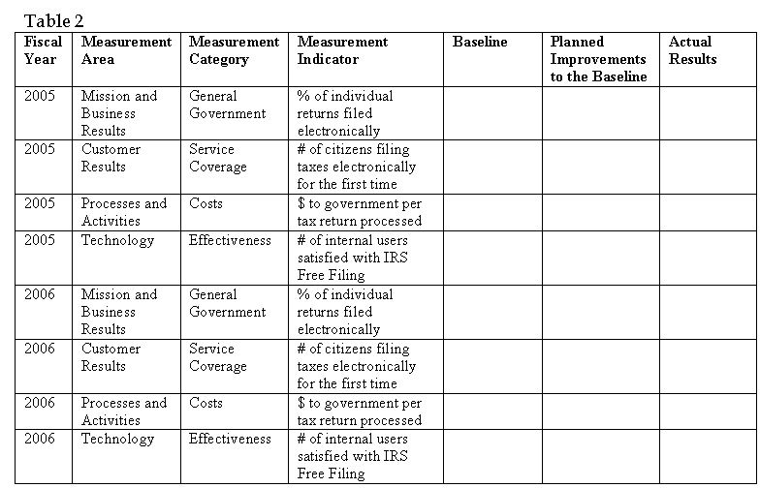

Example Table 2 for IT initiative supporting a grants process (for FY 2005 only, but should be repeated as needed in future fiscal years).
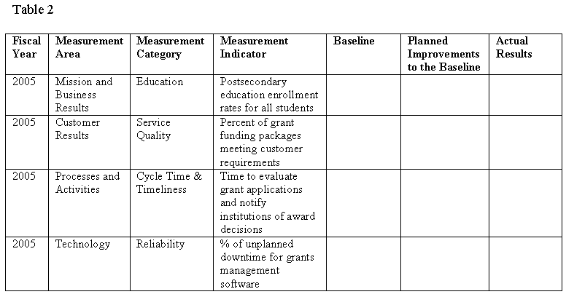

Example Table 2 for Enterprise Architecture initiative (for FY 2005 only, but should be repeated as needed in future fiscal years).
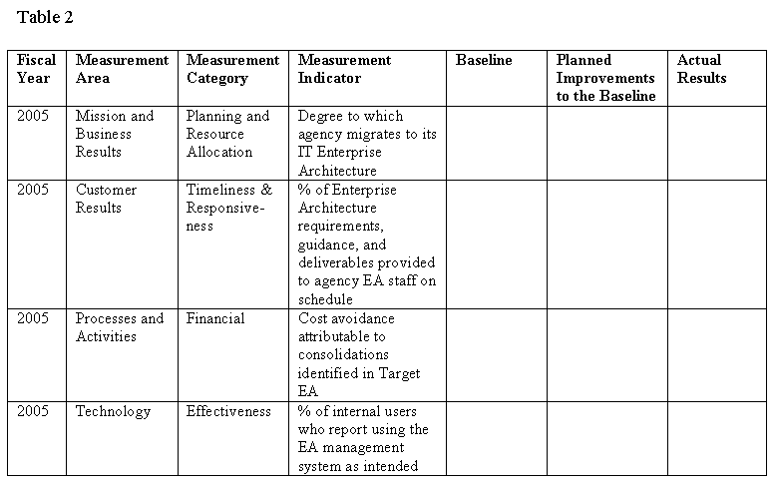

“Completing the Program Assessment Rating Tool (PART) for the FY 2005 Review Process,” Budget Procedures Memorandum No. 861. U.S. Office of Management and Budget, May 5, 2003.
“The Theory of Constraints and its Thinking Processes,” The Goldratt Institute. 2001.
“High Payoff in Electronic Government: Measuring the Return on E-Government Investments,” Intergovernmental Advisory Board. March 31, 2003.
“Performance Budgeting: Current Developments and Future Prospects,” U.S. General Accounting Office. April 1, 2003.
“Program Evaluation: An Evaluation Culture and Collaborative Partnerships Help Build Agency Capacity,” U.S. General Accounting Office. May 2003.

