Avionics Health Management

Michael D. Watson, Kosta Varnavas, Clint Patrick, Carl S. Byington, Savio Chau, Ron Hodge, and Edmund C. Baroth

Avionics Overview

Avionics consists of the components necessary to manage the operation of a flight vehicle and supply electrical energy to the vehicle systems. Flight vehicles fall into two broad and overlapping categories: aircraft at any altitudes (generally below 70,000 feet) and spacecraft traveling anywhere from low earth orbit (LEO) to interstellar space. Although the environments are different for these two flight categories, the functions and technologies are generally similar. Avionics consists of 6 basic components, of which there may be multiple instantiations depending on the application: The flight computer; data networks or data busses; guidance, navigation, and control (GN&C) system; communications and tracking system; electrical power system (EPS); software that executes on the hardware components; and sensors within all vehicle subsystems. These avionics components are then integrated architecturally to produce a functioning avionics system. This integration can be either loose or tight depending on the architectural concept.

Avionics Components

Flight computers provide the main processing for management algorithms on the flight vehicle. They host a variety of software including timeline management, caution and warning message processing and response, display of information to the crew, downlink of information, receipt of commands from the crew or ground centers, command generation for automatic responses, command transmission to other components, command execution, and data storage and management. These functions are generally timeline driven and react to errors and failures as opposed to proactively managing system error states. Thus, current state of the art is for automatic systems rather than intelligent systems.

As vehicles become more intelligent, flight computers are beginning to host artificial intelligence algorithms that can infer vehicle conditions and make decisions much more quickly than ground-based decisions and more proactively than timeline driven systems. Vehicles are being made progressively more intelligent, particularly in error and fault management. These vehicles host diagnostic routines that determine the cause of system failures, thus improving vehicle safety and maintainability. The diagnostic routines run on a flight processor, sometimes with the control software and sometimes on a separate flight processor depending on the focus of the diagnostic application. Maintenance applications tend to be hosted on separate flight processors, while diagnostics affecting the vehicle control loops tend to run on the main flight control processor.

The flight processors are connected to vehicle systems through a data network or data bus. Data busses have been the primary interconnection medium in the industry since the first flight computer was added to a flight vehicle. These early data busses primarily supported data between systems with audio and video being transmitted through analog networks. More recently, however, audio and video are being digitally encoded and transmitted over the data busses as well causing increase data volumes. As data volumes increase, data networks are becoming more prevalent. The choice of architecture depends on the application and is driven by considerations of latency, determinism, reliability, bandwidth, and environmental tolerances. Data networks or busses are critical to health management systems, as they provide the means to reliably communicate health data and responses across the vehicle. Typical data network standards include Ethernet (IEEE 802.3), and Time-Triggered Protocol. Typical data bus standards include Firewire (IEEE-1394), MIL-STD-1553/1773, CAN bus, RS-422, RS-485, etc. Each of these network and bus standards specifies physical media for the data transmission. For avionics systems this is typically shielded twisted-pair copper wire. Optical standards are also becoming prevalent including Fiber Distributed Data Interface (FDDI) and Fibrechannel.

The software that executes on these systems provides telemetry and command responses for various conditions and states on the vehicles. Software encodes the basic control algorithms, health management algorithms, communication algorithms, etc., to enable the vehicle to convert data into information and take appropriate responsive action. Aviation and space systems today are primarily timeline driven systems with humans in the cockpit or on the ground providing the intelligence to deal with complex anomalies. Intelligence functions, such as diagnostics, prognostics, and decision executives are starting to emerge. These functions are primarily implemented in software and provide the vehicles a broader response to unexpected events.

One of the main components connected through the data network or bus is the Guidance, Navigation, and Control (GN&C) system. GN&C provides the capability to determine the vehicle’s flight path based on destination and current location; the capability to determine the vehicle’s current velocity, attitude, and heading; and the capability to generate and send commands to the flight controls to execute the desired flight path and make corrections due to deviations. Systems typically have a separate box containing three gyroscopes (one for each rotational axis) and three accelerometers (one for each translational axis) to sense the vehicle’s rotational and linear velocities. The box also contains a GPS receiver (aircraft or LEO spacecraft) or a star tracker (interplanetary or interstellar spacecraft) to determine the vehicle’s position. GN&C systems also include altimeters to determine altitude. The flight processor generally hosts algorithms that use velocity and position data to determine vehicle position, orientation, and heading, and then to generate flight control commands.

Another component is the Communications and Tracking (C&T) system. This system provides for communications with ground stations and other vehicles. Telemetry is sent, along with audio and video data, via the C&T system. Similarly commands, audio, and video are received from ground stations or other vehicles.

Sensors are connected to the flight processor(s) through data networks and busses. The sensors are contained in all vehicle systems, subsystems, and components, providing a variety of information including operational performance and health information. Sensors determine a variety of information including pressures, temperatures, stress, strain, valve positions, fuel levels, etc. Sensors also include flight radars used to detect and monitor storm systems for aircraft or orbital debris for spacecraft, for example.

All vehicle systems are provided electrical energy through the Electrical Power System (EPS). This system provides for generation, storage, distribution, and management of electrical power. Power generation methods include solar cells, fuel cells, Radioisotope Thermal Generators (RTG), and nuclear reactors. Power storage includes batteries, capacitors, and flywheels. Power Management and Distribution (PMAD) includes the power distribution network, power conversion, and management of power components. Flight systems are typically direct current (DC) 28 Volts (V) DC is a standard) and are stepped up or down to meet higher or lower power voltage requirements.

Avionics Architectures

There are two architectural models used to implement avionic systems: Federated Systems and Modular Integrated Systems. Federated systems are the traditional architectural approach and are comprised of a set of integrated, but dissimilar avionics components. Each avionics component is an independent unit possibly made by different manufacturers, and with potentially varying technology. Diagnostic capabilities are provided at the component (i.e., box) level by the manufacturers. Each manufacturer provides diagnostic capability for each component in the form of a Built In Test (BIT), automated test equipment (ATE), and test program sets (TPS). In addition, separate interactive electronic technical manuals (IETMs) may or may not be provided. All of the independent LRUs are expected to function side by side in a largely autonomous fashion to provide the total system functionality required to fulfill the vehicle’s mission. Since each box is considered independent of all others, health management is performed individually and integrated vehicle health management is often not considered.

Modular Integrated Systems is an emerging design approach that seeks to maximize the benefits of system interconnectivity gained by providing common interfaces to components in the avionics systems. Avionics components are integrated into a system with common interfaces, communication protocols, etc. This approach takes a strong integrated vehicle view of health management for the avionics system. Military examples include the F-22 Advanced Tactical Fighter, the F-35 Joint Strike Fighter, and the RAH-66 Comanche helicopter. Many benefits are provided in these designs such as: system redundancy, situational awareness, real time diagnosis, and dynamic reconfiguration. In short, they are designed with more consideration of the overall system and its dynamics [1]. Integration is achieved at various levels in these approaches through architectures ranging from benign message passing on a bus, where the failure of one LRU simply means that results won’t be completely accurate, to complete level integration where a global controller (software, hardware, or a combination of both) assembles all data for manipulation and display [2,3].

Avionics Technology

Avionics components are primarily electronic systems but also include key radio frequency (e.g., communications and radar), optical (e.g., optical gyroscopes and optical data networks), and Micro Electro Mechanical Systems (MEMS) (e.g., MEMS gyroscopes and various sensor types) components.

Analog electronics are important in numerous components. GN&C uses analog electronics in laser drive modules (optical gyroscopes) and MEMS drive and read electronics (MEMS gyroscopes and accelerometers). For ring laser gyroscopes, accurate thermal stability is key for wavelength stability and system performance. MEMS devices have both thermal and pressure stability sensitivities. Analog control circuitry is utilized to maintain tight control of these parameters. Analog electronics are crucial in numerous sensors using voltage or current to read physical changes. Examples include Resistive Temperature Devices (RTD), thermocouples, capacitive sensors, and inductive sensors. EPS uses analog electronics for power conditioning hardware.

Digital electronics are important in all avionics components. Microprocessors, digital control logic, programmable and reprogrammable devices, and other forms of discrete logic are ubiquitous. Flight processors, data networks, and data busses are predominantly digital. GN&C systems contain processors to perform calibration and engineering unit conversion of sensor data. C&T systems use digital logic to communicate across data networks and busses to flight processors. C&T also applies digital electronics in control and management of its components, as does EPS. Sensor applications contain digital logic for smart sensors, providing embedded network communications, self-calibration, fault detection, and embedded engineering unit conversion.

Radio frequency (RF) electronics are important in GN&C and C&T components, wireless sensor applications and weather. GN&C applies RF electronics to receive Global Positioning System (GPS) reference signals for GPS-based sensors. C&T is the main application of RF electronics for vehicle external communications and radar systems. Wireless sensors also employ RF electronics to transmit data and receive commands.

Optical systems are found in Ring Laser Gyroscopes (RLG) and optical data networks. Some sensors also employ optical techniques. Optical systems are strongly driven by thermal stability considerations to maintain optical wavelength stability.

MEMS are also employed in low-accuracy gyroscopes and various sensor applications. MEMS are strongly driven by pressure and temperature considerations. For resonating devices used in motion sensors, pressure levels must generally be maintained at a low level to prevent damping sensor responses. Thermal considerations are also important since thermal gradients can induce stress deformations in all types of MEMS sensors. In addition, unique design aspects can lead to other considerations depending on what is being sensed and what physical relationship is being used to make the measurement.

Electrical, Electronic, and Electromechanical (EEE) Parts Qualification

Avionics parts are graded based on their application environment. These are broken down into four categories: Commercial, Industrial, Military, and Space. Table 1 summarizes these part grades. Health management is strongly affected by and also strongly affects parts selection. As the parts reliability improves, health management techniques focus more on detection and recovery of design or operational errors. As the parts reliability decreases, manufacturing errors, material faults, and environmental susceptibility become more prevalent. However, proactive avionics health management also improves part reliability so that an effective avionics health management system may allow lower parts grades (allowing lower costs) to meet higher reliability applications. This will be an application-specific decision but holds great promise for improving system reliability and reduced implementation costs.

Table I – EEE Parts Grade Description
Grade | Summary | Reliability | MTBF | Cost | Typical Use
Space | "Space" quality class qualified parts, or equivalent. | Highest | Longest | Very High | Human and/or long duration space flight
Military | "Full Military" quality class qualified parts, or equivalent. | Very High | Very Long | High | Space flight, Military Aviation, Commercial Aviation, or critical ground support equipment
Industrial | "Low Military" quality class parts, and Vendor Hi-Rel or equivalent. | High | Long | Moderate | Space flight experiments, Commercial Aviation, and ground support
Commercial | “Commercial" quality class parts. No qualification required. | Variable | Variable | Low | Aviation flight experiments and ground support

Commercial Grade

Commercial Grade EEE parts typically meet vendor standards for high reliability or commercial market place reliability, but have not been independently verified. These parts meet the requirements for the ground environments are suitable for avionics where high reliability is not a primary factor, the mission is not critical or a repeat mission (to replace a failed mission) is possible. The duration of an operation would typically not be lengthy (a few hours). These systems are accessible for repair and repair is an acceptable response to a failure. This is a typical choice for aviation flight experiments and ground support equipment.

Industrial Grade

Industrial Grade EEE parts typically meet standards for high reliability, but there may be significant exceptions and they may not have been independently verified. These parts meet the requirements for the aviation environments and are suitable for equipment where high reliability is desired, but is not mandatory. These parts can be counted on for long term continuous operations. Down time for repair during the operation is not desirable, but repair is possible. The systems are counted on to work, but system failures can be tolerated so that redundancy is not required. The application could be space flight experiments, commercial aviation, or ground support equipment.

Military Grade

Military Grade EEE parts typically meet rigorous (but not the highest) industry reliability standards, and have been subjected to independent verification. These parts meet requirements for the aviation environments and are suitable for equipment that requires high reliability, but for which a low risk of failure can be tolerated to meet cost constraints. Space missions of 1 to 5 years duration may also use Military Grade parts with proper radiation shielding and thermal control. Down time for repair during the operation is not desirable, but repair is possible. The systems are counted on to work and redundancy is necessary at the component level for all primary objectives. Higher risk tolerances may make single string design acceptable. The application usually is space flight equipment, military aviation, commercial, or critical ground support equipment.

Space Grade

Space Grade EEE parts typically meet the highest reliability standards, and have been subjected to independent verification. These parts meet requirements for operation in the space environments and are suitable for equipment requiring maximum feasible reliability because of critical mission objectives and safety. The related project typically would have high visibility and could involve objectives which may be difficult to repeat in another mission. Space missions of 5 years or longer or with human dependency require Space Grade parts. These parts are counted on to work for long durations without failure and repair during the mission is not a practical or desirable option. The mission requires complete functional or block redundancy. The applications are human space flight and long duration space flight.

Environments

Environments are a strong external influence on avionics health. Several environmental parameters affect system health in three main categories of environments encountered. The environmental parameters exist in all environment categories, but their impact on avionics health can be significantly different. The three main environment categories are: ground, aviation, and space. Much has been documented in the literature on various environments. Several references are included for the interested reader [4 – 20].

Environmental Parameters

The environmental parameters strongly drive the operation failure modes of the avionics components. In some cases, the device environments are actively controlled to maintain a proper operating environment. This control creates a dependency on other systems such as thermal management, which are required to maintain the avionics operating environment. The following summarizes the main environmental parameters related to avionics.
Temperature

Temperature affects all types of avionics devices. Operating ranges vary, but standard military specifications are -55 C to 85 C. Most electronics and MEMS are designed to operate in these ranges. Moving outside of the ranges leads to device failures. Systems where high or low temperature limits are exceeded require active cooling and heating to maintain the operating environment. Systems can work great at room temperature but timings can change significantly when the temperature increases or decreases significantly. Optical devices can require extremely tight active temperature control (e.g., within 1 C) to maintain wavelength stability and device performance. This generally requires active temperature control using devices such as Thermal Electric Coolers (TEC) embedded with the optical sources. Failure of temperature control can quickly lead to avionics component failures.

Pressure

Pressure is generally a concern, particularly at low pressure. As the pressure decreases, systems must be designed to prevent electric corona discharges. Such discharges can lead to severe damage to avionics components. Pressure is also a concern for some MEMS devices that require vacuum conditions. Increased pressure on these systems due to leaks results in damping of the MEMS system oscillations. This damping degrades and can terminate the device sensitivity.

Shock/Vibration

Shock and vibration are very application dependent. Avionics are generally tested to ensure the application shock levels and vibration magnitudes/frequencies are survivable. Avionics components packaging including chip mounting is critical to meet the application requirements. Failure of mounting and connectors can cause complete loss of the component capabilities. Space launch vehicles create the most severe vibration environments. Military missiles have the most severe shock environments. Helicopters in general also have high vibration environments.

Humidity

Humidity is a concern for applications working in high humidity environment such as tropical climates. Water in the system can create shorts, damaging components. Salt water environments are also highly corrosive to avionics packaging due to the salt contained in the water vapor.

Radiation

Radiation is a key environmental parameter found naturally in space. Most terrestrial avionics systems cannot survive radiation doses due to system latch-ups and single event upsets. Operating in a radiation environment requires materials and designs that will not latch-up and which minimize or eliminate the possibility of upsets. Often, component packaging can aid in this area by shielding electronics from the radiation. However, this reduces but does not eliminate the exposure.

Electrical

The electrical environment deals with electromagnetic interference (EMI) and lightning. EMI can be either natural or produced by the system. All electrical systems’ leads and wires are antennas in some form. Thus, they all will transmit and receive signals. Avionics systems design must carefully address the Electro Magnetic Compatibility (EMC) of devices. This is often done by shielding of wires and packaging, placement of wiring, and elimination of component features that lead to transmission effects. This is particularly important with C&T systems as they must transmit high powered signals without interfering with other flight systems. Lighting strikes are a significant threat to flight avionics. Thus, flight systems require grounding systems that can divert large currents away from avionics components.

Dust

Dust is a key concern for particulate contamination which leads to shorts. Particles as small as 100 nm can create shorts in modern integrated circuit chips. There are two concerns for dust: dust left inside components as a result of manufacturing processes and dust from planetary environments. For industrial or aviation applications, dust must be removed or prevented from contaminating electrical connections. Dust particles can create shorts between electrical leads. For space applications, all component surfaces must be dust free as the dust floats. Dust from any surface can float to an electrical contact and create a short during flight. Avionic systems which operate in dust environments require tight seals to keep out the small particles which are generally very challenging. Active detection and mitigation techniques would greatly benefit avionics in high dust environments but have not been pursued.

Ground Environments

For avionics, the ground environment consists of the depot, air fields, and launch sites. The ground environment has a variety of considerations not found in aviation or space environments. Temperatures range over the full military specifications depending on locations. Pressure is fairly constant at 1 atmosphere. Shock and vibration are generally only a concern during flight operations, but some transport conditions require monitoring to ensure damage has not been induced in components. Humidity is primarily a concern at ground sites, particularly those in tropical environments such as launch sites. Radiation is not a primary concern for ground environments as the Earth’s magnetic field and atmosphere provide adequate shielding of the planetary surface. EMI is a concern not only from on-board systems, but also other sources such as local radio transmitters, radar, etc. Lightning is not a significant concern for ground systems and can generally be protected by an earth grounded lightning rod. Dust is also a concern at ground sites. Avionics are generally protected at these sites through the packaging and generally only exposed in clean environments.

Aviation

The aviation environment is generally defined from sea level to 70,000 feet. Temperature ranges across the full military specification and generally gets colder with increasing altitude. Similarly, pressure drops with altitude but is still sufficient below 70,000 feet to not cause concern for corona discharge. Shock and vibration are more prevalent during flight conditions and are very dependent on the vehicle. Humidity is not generally a concern when flying at altitude, but condensation is a concern with temperature changes. Radiation is not a particular concern in the aviation environment as the Earth’s magnetic field and atmosphere are still providing good shielding levels. EMI is primarily an on-board system concern. Lighting is a major concern and systems must be capable of safe recovery or landing after lightning strikes. Dust is not a concern in flight.

Space

The space environment captures a wide range of conditions. Temperature control is strongly affected by the absence of convection. This leads to the need to cool or heat avionics through either direct radiation or conduction. This often leads to challenging thermal management requirements when flying avionics components designed for aviation environments. Pressure varies depending on the location of the avionics. In the crew cabin, pressure is similar to the aviation environments. For components outside the crew cabin or on robotic vehicles, vacuum conditions are encountered. This requires component designs to address corona discharge and presents another limitation to applying aviation environment components for space applications. Shock and vibration are extreme during launch and ascent of the space vehicle. High g levels are often encountered and vibration magnitudes can be large. Humidity is not a concern in the space environment, but radiation is a strong concern for space. Low Earth Orbit (LEO) is the most benign space environment while medium earth orbit (MEO) is the most significant (upwards to 100 Mrad –si annual dose rates). Interplanetary space has a smaller radiation environment than MEO. Operation around other planets, however, can lead to environment similar to or worse than MEO depending on the planetary atmosphere and magnetic fields. EMI is primarily an on-board system concern. Lightning is a major concern and the avionics must remain operational in the presence of lightning strikes. Dust is not a concern in space, but is a major issue if dust from manufacturing on Earth contaminates inside the spacecraft and floats, potentially shorting out electronic components. It is also significant in other planetary environments such as on the Moon and Mars.

Failure Sources

Several error sources affect avionics components and systems. These originate during design and manufacturing or due to the external environment. Errors occurring during design and manufacturing include design errors, material defects, and fabrication errors. Faults and errors are also induced by the environment in which the system operates as discussed in the previous section. Various testing standards have been developed to detect design and manufacturing errors and will be discussed in section below.

Design Faults

Numerous causes are responsible for design faults from the actual design stage all the way through layout and even manufacturing. Design faults can be significantly reduced by the right combination of simulations, intensive checking at each stage of the design cycle and board, and system level testing to uncover any problems. This includes environmental testing to root out problems that may occur only under special conditions. Environmental testing can catch design errors that will occur at the extreme ranges of operation. Testing such as temperature cycling can detect timing issues that are temperature dependant.

Material Defects

Often material defects are caused by manufacturing processes. These defects are often unknown by the users. However, good environmental testing expose these defects. Also, significant parts qualification and inspection can often reveal material defects. For example, many flight components are x-rayed, which can reveal many material defects. Proper inspections and environmental testing are important for unearthing possible defects and errors at different stages of the development cycle.

Fabrication Faults

These faults are associated with problems in doping, metal deposition, and etching at the chip level, soldering and component placement at the board level. Good visual inspection along with thorough lab testing and environmental testing can reveal problems. Also, particle impact noise detection (PIND) testing can reveal fabrication errors such as loose solder balls and components. PIND testing can also reveal particle contamination that exists within the component.

External Effects

External effects include environmental parameters and electrical surges. Environmental monitoring is done in some cases to detect if environmental operating ranges are exceeded. Parameters measured depend on the device. Temperature is generally measured, especially for optical components, to maintain device control. Pressure is not normally measured directly for the avionics, but it is measured for the crew cabin maintenance and aeronautical flight conditions. These measurements, however, could be applied by an avionics health management system when external pressures are crucial to avionics performance. MEMS devices require internal pressure sensing. This is often done by monitoring the resonant frequency of a reference component. Shock and vibration are generally measured at the vehicle level, if at all, and would have to be incorporated into an avionics health management system. Humidity is generally not monitored on vehicles, requiring additional sensors for health management. Radiation events are not directly monitored but are counted indirectly through the number of processor upsets that occur. This is not proactive and provides only indirect post failure data for health management evaluation. Electrical events are generally designed out and tested for compliance as feasible. There is not direct monitoring currently employed for an avionics health management system to gather information on electrical events. Dust is not monitored in flight. This is another area that requires new sensors and techniques to implement proactive health management.

Current Avionics Health Management Techniques

Current health management approaches utilize various electronics error detection and testing techniques at the component level. These techniques include Built In Test/Built In System Test (BIT/BIST), Error Detection and Correction (EDAC), and Boundary Scan and Module Test and Maintenance (MTM) bus. These techniques address errors and failures at the chip and board level. Voting techniques are also employed to detect errors at the board and box level. Across the integrated avionics system, various techniques are also being developed to detect system-level errors that occur between components as opposed to within the components. These approaches can be summarized by three levels of testing.

Component Level: Testing of the internal circuits of components.
Board Level: Testing the connectivity between components.
System Level: Testing to identify failed boards.

The electronics used in avionics components are highly integrated devices. It is commonplace that a single (Application Specific Integrated Circuit (ASIC)or Field Programmable Gate Array (FPGA)contains millions of gates. A problem associated with this high-level of integration is the packaging and Input/Output (I/O) pins of the integrated circuits. A large ASIC can have over 500 pins. The pins are extremely refined and closely spaced. Worse yet, some packaging technologies such as flip-chip bonding hides all the I/O pins. These packaging techniques make the probing of pins and signal lines during integration impractical. To enable testing of these highly-integrated electronics during system integration and test, techniques have to be incorporated into the design at all levels of the system.

Within a component, two types of failures affect the health of vehicle avionics: random failure and component life limitation failure. The random failure is mainly caused by either premature failure of components or by environmental factors. Short duration missions (< 10 years) usually are dominated by this failure type. Life limitation failures are more common on longer missions, and are factors for outer Solar System missions.

Built In Test (BIT)/Built In System Test (BIST)

There are two important testing techniques at the component level: Built-in-test (BIT) (i.e., scan design) and built-in-self-test (BIST)

The main idea of scan design is to provide access to the combinational logic circuits that are surrounded by registers. If a piece of combinational logic is directly connected to the primary inputs and outputs of a chip, it can easily be tested because when a test vector is applied to the primary input, the output can be observed immediately and then compared with the expected output. On the other hand, if the combinational logic circuit is surrounded by embedded registers, it is very difficult to set the input registers of the circuit to the desired test vector or observe the value of the output registers of the circuit. BIT links all the registers on the chip to form a single shift register in the test mode, so that the desired test vectors can be shifted into the inputs of the circuit and the test output can be shifted out. In other words, this technique converts the embedded register to virtual primary inputs and primary outputs of the circuit.

While the BIT can improve the controllability and observability of embedded combinational circuits, it has to generate the test vectors. As the ASIC/FPGA have become more complex, test vector generation has turned into a difficult, lengthy, and labor intensive task. To solve this problem, built-in-self-test (BIST) techniques can be employed.

BIST can generate a sequence of test vectors pseudo-randomly with a simple Linear-Feedback-Shift-Register (LFSR). An example of LFSR is shown in Figure 1, where the feedback connection is determined by a polynomial in the form of a_{n}X^{n} + a_{n-1}X^{n-1}+ a_{n-2}X^{n-2}…+ a₁X¹+ a₀X⁰. The order of each term corresponds to the position in the LFSR, and the coefficient a has a value of either 1 or 0. If the coefficient of a term has the value of 1, then a feedback connection is added to the bit corresponding to the order of that term. Hence, the polynomial of the LFSR in Figure 1 is

0⋅X¹⁵+0⋅X¹⁴+0⋅X¹³+0⋅X¹²+0⋅X¹¹+0⋅X¹⁰+0⋅X⁹+0⋅X⁸+0⋅X⁷+0⋅X⁶+1⋅X⁵+0⋅X⁴+1⋅X³+1⋅X²+0⋅X¹+0⋅X⁰
= X⁵+X³+X²

To generate pseudo-random patterns, the LFSR is reset and initialized to a seed value. Then, the content of the shift register is shifted one bit to the right in each clock cycle. Through the feedback connections, a new pattern is generated in the shift register. The output of each bit in the register is applied to the circuit-under-test.
To Circuit-under-test

1
1
0
0
1
1
1
1
0
0
0
1
0
1
1
0
xor
xor
xor

Figure 1: Linear Feedback Shift Register

After the test pattern is applied to the circuit-under-test, a test result is generated at the output of the circuit. All the test results generated in each clock can be accumulated into a single signature using a signature analyzer, which is a LFSR used in a reverse manner (see Figure 2). At the end of the test, the content of the LFSR, which is the final signature, can be compared with an expected signature.

Figure 2: Signature Analyzer
From Circuit-under-test
1
1
0
0
1
1
1
1
0
0
0
1
0
1
1
0
xor
xor
xor

Error Detection and Correction (EDAC)

EDAC is a method of detecting bit errors in memory systems or transmission systems and correcting them. There are many techniques for error detection applied normally to serial transmissions but can also be applied to some parallel systems. Correction of detected errors has fewer options. For error detection and correction of parallel memory systems additional memory bits are used to implement Hamming codes. These additional bits and coding methods are used to determine when a single or double bit error has occurred in the memory system. These codes can even correct single bit errors in real time in the memory system. EDAC can be used for real-time error detection without having to bring the board off line.

For serial transmission systems, there are many techniques for detecting errors in the transmission. One popular method used in Ethernet systems and others is CRC, or cyclic redundancy checking. This basically uses the data in the packet to calculate a 16 or 32 bit value. This CRC value is unique to the calculation method chosen and the data in the packet. This 16 or 32 bit CRC value is transmitted at the end of the data packet. On the receiving side, the CRC is recalculated using the data received and is compared to the CRC value in the packet. Any mis-compares will alert the system to an error.

Boundary Scan

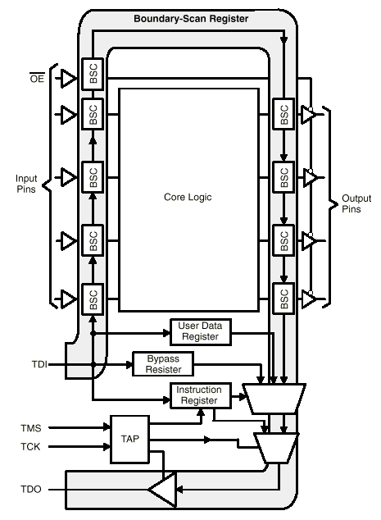
The most important test techniques at the board level use the boundary scan design. The most widely supported scan design is the boundary scan developed by the Joint Test Action Group (JTAG), which has been standardized as the IEEE 1149.1 standard [1]. The IEEE 1149.1 design is shown in Figure 3.
Figure 3: Boundary Scan

JTAG standards define a serial interface that many large chips such as microprocessors and FPGA’s have that allow programming and testing of internal data paths without having to remove boards. There are many advantages to using JTAG:

- Test populated boards for soldering faults (open, shorts)
- Test populated boards for Printed Circuit Board (PCB) construction faults (cut traces, cracked vias)
- Test hidden solder joints (Ball Grid Arrays)
- Program/Test memories in-circuit
- Simpler parts lists – no need for unique part numbers for pre-programmed devices
- Fewer errors from loading a part in the wrong location
- Verify a memory image in-circuit
- Tests run very quickly and test hardware compatible with thermal chambers will allow several test iterations during temperature cycling tests
- Supports connecting JTAG chains between boards (test entire box)
- Supports some level of in-circuit integrated circuit (IC) test.
- Pin drivers are used so electrostatic discharge (ESD) damage can usually be detected

The key feature of the IEEE 1149.1 standard is a simple four-signal test interface comprised of the Test Data In (TDI) signal, the Test Data Out (TDO) signal, the Test Clock (TCK), and the Test Mode Select (TMS) signal. The TMS is used to set up the operation of the boundary scan operations.

The architecture of the IEEE 1149.A consists of an instruction register, a bypass register, a boundary-scan register (highlighted), an optional user data register(s), and a test interface referred to as the test access port (TAP). The boundary-scan register is located at the input/output boundary of the chip and is made up of a series of boundary-scan cells (BSC). The boundary-scan register is disabled in normal operation. In test mode, all the boundary-scan cells are linked together to from the serial boundary-scan register. Test data is shifted (or “scanned”) into the boundary-scan register through the TDI pin and shifted out through the TDO pin. The TAP is used to set up the test mode, load the instruction register, and control the data scan according to the TMS input.

To test the board, all the boundary-scan registers in the chips are chained together. A test pattern is shifted into the boundary-scan register chain. Then, the board is switched back to normal mode for one clock; the contents of the boundary-scan register are shifted out afterwards. If the connectivity between chips has no defects, the test pattern in the boundary-scan cells at the output pins of the chips should be registered by the boundary-scan cells at the input pins of its immediate downstream neighbor. Otherwise, the connectivity defect will be detected after the contents of the boundary-scan register chain is shifted out and compared with the expected pattern. This is depicted in Figure 4.

TDI
TAP

Chip #1
Core
Logic
TDO
0
0
0
0
0
0
0
0
0
0
0
0
0
0
0
1
0
1
0
1
1
0
1
TDI
TAP

Chip #1
Core
Logic
TDO
0
0
0
0
0
0
0
0
0
0
0
0
0
0
0
0
0
0
0
0
0
0
0
TDI
TAP

Chip #1
Core
Logic
TDO
0
0
0
0
0
0
0
0
0
0
0
0
0
0
0
1
0
1
0
1
1
0
1
TDI
TAP

Chip #1
Core
Logic
TDO
0
0
0
0
0
0
0
1
0
1
0
1
1
0
1
0
0
0
0
0
0
0
0
After Test Pattern Is Scanned In
After One Clock in Normal Mode
Figure 4: Board Testing with Boundary Scan

Normally, boundary scan testing or programming is done when the board is not running application software. The boundary scan software takes over although the application software can be loaded and run using the JTAG interface. Thus, this type of testing is generally done during manufacturing and maintenance testing. Current boundary scan techniques thus are useful for offline testing, but do not support real-time fault detection or diagnosis. Real-time capabilities could be developed, but would represent a significant update to the JTAG standards.

Voting

Current fault-tolerant designs employ fault detection techniques such as error-correcting codes, duplicate-and-compare, and multiple modular redundancies. These techniques can detect random failures very effectively.

Error-correcting codes often not only reveal an error, but also automatically make repairs. A simple example of a purely error-detecting technique is bit parity in serial data communication, where an additional transmitted bit indicates whether the number of ‘1’ bits sent was odd or even. An incorrect recheck on the receiving end triggers the recovery method of choice. An example of an actual error-correcting code involves transmission of three copies of each data element, with a voting scheme at the receiving end to choose the data pattern that survived in at least two of three cases as the output. Of course, much more complex and capable techniques exist.

Duplicate-and-compare and multiple-redundant techniques are primarily different from error-correcting codes in the areas of their application. Error-correcting codes typically apply to data transmission, while the other techniques usually apply to general hardware performance. In these cases, if the behavior of an element can be replicated elsewhere and the additional set of results compared to the primary results, some judgment of the quality of the primary results may be made.

Multiple-redundant systems go to the extent of actually copying the hardware set associated with an element any number of times, as required to guarantee a desired level of reliability. Each element then has that number of results to compare in order to produce the most correct result, and also to judge the health of the copies that repeatedly produce unacceptable results.

It is important to note here that whenever there is replication of elements, it may be advisable to produce at least one completely different copy, in terms of software or hardware, or both. Design errors will replicate along with copies of elements, so that common failures could go completely undetected, resulting in catastrophe.

In any of these schemes, some form of judgment must be made to determine what to do with the output or outputs. In the simplest example made, a parity checker is put in the data stream on a serial communication receiver; in more complex cases, a voting scheme or other decision-making algorithm must be implemented.

Idle Data Pattern Diagnosis

Idle data pattern testing is normally done on serial channels of any kind. Some serial protocols such as Ethernet and others have an idle pattern that is continuous even when actual data is not being transmitted. The idle pattern is still subjected to cyclic redundancy testing on some systems. Even if no CRC is performed on it, just knowing the idle data pattern can allow the receiver to constantly monitor for any errors in transmission. If the idle pattern stops, and the following pattern does not match any type of data packet then the system will know that an error has taken place and can take appropriate action. This is another test that can be done without taking the system off line and with very little additional hardware or software overhead.

Input Protection

Fault containment is an important capability for avionics components. One means of preventing failure propagation is to build into an electronic system a means of protecting the circuitry from damaging stimuli. A number of electronic components come with a mixture of the following technologies already on board, while others must be supplemented. These techniques where developed to protect the inputs of electronics and are often termed “input protection” rather than “fault containment”.

Many electronic devices and systems incorporate voltage and current protection into their design. A basic approach is to limit response of inputs to just under the full range of the power supply, and block or bleed off to ground any excess stimulus. Since most electronic outputs are designed as high-impedance, there is usually little need to heavily protect outputs; in the case that concern exists for a specific circuit, similar measures may be taken to limit or bleed off overly high stimuli fed back from the inputs of downstream circuits.

Surge suppression is a similar concept, with slightly different considerations. Over stimulus in this case comes from less predictable sources, such as lightning strikes or electromagnetic interference (EMI). Combating this usually involves inclusion of excess capacitance into circuitry wherever possible, a technique so common that it is found in household surge suppressors. In extreme cases, a cable may be intentionally kinked and placed near a good ground prior to entry into a vulnerable system; the high-frequency pulses usually associated with surges are less likely to be able to negotiate a hard turn, and will be bled off across the gap to ground.

Very often, power conversion components themselves are reasonably well-isolated from the outside world, thus removing one more layer of concern from designers’ minds. It is encouraging to note that many more options now exist for power conversion and conditioning closer to supplied components – either at the inputs to individual boards, or even built into a microelectronic device.

Decoupling is a further method of isolation for input and output protection of circuits. Digital decoupling is accomplished much more readily than analog decoupling, simply because digital signals have much less stringent requirements for transmission of the exact electronic information encoded. One of the most effective ways to accomplish this is to use optical isolators. These ingenious devices have light-emitting diodes (LEDs) and light-sensitive photodiodes paired to replicate an input ‘1’ or ‘0’ level by an on or off condition of the LED received at the photodiode; however, there is no need to electrically connect the two circuits together, even on the ground side, so that they can be completely separate electronic entities.

Analog signals are more difficult to isolate. Transformer coupling is one means that is reasonably effective. This works for digital systems also, but has fallen out of favor, primarily because of the cost, bulk and difficulty of implementation compared to optical isolation. Analog optical interconnection systems exist, of course, but also are quite expensive, and introduce inherent errors into the system.

Module Test and Maintenance (MTM) Bus

When components are assembled on boards, boards into subsystems, and subsystems into systems, a hierarchy of test buses is needed to retain access to the design-for-testability features. The Module Test and Maintenance (MTM) Bus specified in the IEEE 1149.5 standard is developed to meet the requirements of such a bus hierarchy. The MTM Bus provides subsystem test control access or external test equipment access to test features on modules within a system.

The MTM Bus is a backplane serial test bus intended to be used with on-board test buses such as the IEEE 1149.1 Bus. The relationship between the MTM Bus and the IEEE 1149.1 buses is shown in Figure 5.
Test Bus
Interface
Bus Transceiver
MTM Bus
IEEE 1149.1 Test Bus
Other Board-Level Test Bus
Figure 5: MTM Bus and Board-Level Test Buses

The MTM Bus is a synchronous, serial, backplane bus comprised of four required signals and an optional fifth signal. This is shown in Figure 6. The bus is designed to have a single bus master module that can communicate with up to 250 individually addressable slave modules. Each master or slave module can be a board or subsystem. The bus mastership can be transferred to backup masters in fault-tolerant configurations of the bus. The MTM Bus also adopts a multi-drop topology. The addressing capability of the MTM Bus allows the master to address and communicate with one, a subset, or all of the slave modules on the bus.

MTM Bus Master
MTM Bus Master
MTM Bus Master
Master Data (MMD)
Slave Data (MSD)
Pause Request (MPR)
Control (MCTL)
Clock (MCK)
Clock Source
Figure 6: MTM Bus Signals

The MTM Bus master communicates with the slaves using messages that consist of a series of packet transfers. A message consists of a HEADER packet, an optional ACKNOWLEDGE / PACKET COUNT packet, and a variable number of DATA packets. Figure 7 depicts the message protocol between the master and a single slave. If multiple slaves are addressed, the ACKNOWLEDGE packet will not be sent by the slaves. The number of DATA packets to be transferred is dependent upon the type of command contained within the HEADER packet. More details about the MTM Bus can be found in [2].

Master Module Packets
Slave Module Packets
HEADER
PACKET COUNT
1ST Master Module Data
2nd Master Module Data
n^{th} Master Module Data
ACKNOWLEDGE
1ST Slave Module Data
2nd Slave Module Data
n^{th} Slave Module Data
Figure 7: MTM Protocol for Single Slave Module

Intelligent Sensors and Actuators

Intelligent sensors hold great promise for application in sensor and actuator (i.e. transducers) system health management. Intelligent sensors are an emerging technology which is addressed by the IEEE 1451 Standard for a Smart Transducer Interface for Sensors and Actuators. Intelligent transducers include analog to digital conversion, direct interfaces to the vehicle network or bus, and provide Transducer Electronic Data Sheets (TEDS) that provide transducer type, operation parameters, and attributes [21]. This allows the sensor to operate as a network or bus element without the need for a multiplexer/de-multiplexer (MDM). Intelligent transducers can also provide calibration, engineering unit conversion, electrical power, and timing synchronization. TEDS also support diagnostics in the form of self checks by the sensor to maintain health. Recently, a Health Electronic Data Sheet (HEDS) has been developed which provides data on a transducer’s health. [22] Thus, the sensor is able to monitor and detect anomalous behavior internally and provide this information in a readable format for the flight processor to act upon.

Avionics Systems

At the system level, health management approaches currently focus on maintenance of systems. As discussed above, health management benefits greatly from the Modular Integrated Systems approach as opposed to the Federated Systems approach. The field is diverse. Opportunities to integrate an embedded avionics system are numerous. Some of the earliest opportunities may come in the arena of legacy system upgrades. Federated components operating together within an aircraft share many common bonds and can affect each other in ways that can be detected globally. Power systems, data busses, environmental factors, and wiring infrastructures are examples of some of these common bonds. The interactions among these factors create confounding issues to diagnostic systems that are not accounted for in component built-in-tests or at any other level of the maintenance infrastructure. From a global perspective this Modular Integrated “systems” relationship can provide a large opportunity to collect evidence that can be used to diagnose faults and predict failures. Rather than confounding, these relationships can be used to an avionics health management system’s advantage to lower the total life cycle cost (LCC) associated with the avionics system.

A key in implementing avionic system health management is the architectural standard. These standards focus on the abstraction of system knowledge which can be defined at 3 levels: data, information, and knowledge. System data is the basic bits (ones and zeros) defining system states and conditions. Converting this data requires information on what parameter is being measured in what context or environment. Converting data to this level produces information about the system. This information provides a logical understanding of the current system states and conditions. Understanding the implications of this information requires knowledge about system functions and operations. Understanding the information in the context of these functions and operations coverts information into system knowledge.

An open data architecture facilitates information continuity throughout the avionics health management system by encapsulating a standard of what information will be represented by the information stream and a standardized meta-data description of what the individual data elements represent. Two examples of open systems approaches are IEEE 1232, Artificial Intelligence Exchange and Service Tie to All Test Environments (AI-ESTATE), and Open System Architecture-Condition Based Maintenance (OSA-CBM). The Automatic Test Meta Language (ATML) working group is exploring the development of an Extensible Mark-up Language (XML) standard for automated test equipment (ATE). Currently available OSA-CBM protocols describe an open standard for data collection, condition monitoring and maintenance information exchange. OSA-CBM describes the exchange of information from data collection to manipulation, diagnostic reasoning and health assessment. Modalities described by OSA-CBM include XML, Common Object Request Broker Architecture (CORBA) and Component Object Model/Distributed Component Object Model (COM/DCOM) [9]. Important standards, such as ATML, Open System Architecture for Enterprise Application Integration (OSA-EAI) and Predictive Model Markup Language (PMML) are also being examined by several researchers.

The overall architectural approach chosen should support continual learning, system assessment, and discovery of hidden patterns at each level. Discovered knowledge manifests the greatest possible usefulness at the logistics level where data from individual units, installed in individual systems, merges with other units installed on systems from other vehicles (when working with a fleet of vehicles), organizational units, and service branches for macro level mining. More effective avionics troubleshooting and diagnosis begins onboard with a system level perspective [1, 2] and greater capture and utilization of available data. Time stamp, system power parameters, temperature, vibration, and BIT error code, design logic of BIT errors, reliability, life history, and logistics are a few examples of useful evidence sources. In some applications, all of this information is analyzed by a diagnostic algorithm. Rule-Based and Model-Based Reasoners are currently the most mature in diagnostic applications. Figure 1 illustrates the basic inputs to diagnostic reasoner analyzing avionic system data.

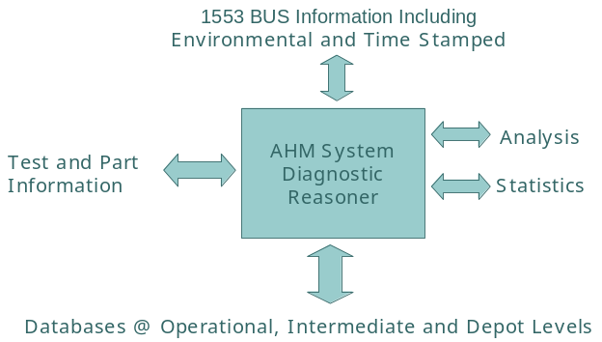
Figure 1: Diagnostic Reasoner Interactions

Avionic systems have a variety of error sources as discussed in the previous paragraphs. Diagnostic systems seek to detect these errors in order for flight systems or ground maintenance systems to respond appropriately. The types of problems that may be encountered in avionics components from an observable perspective is summarized below.

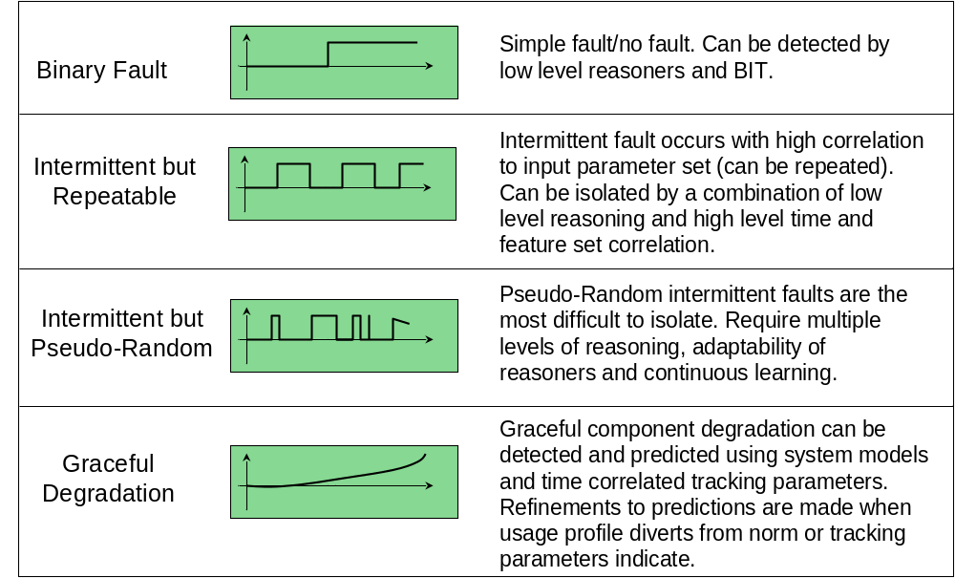

Figure 2: Avionics System Error Types
Prognostics are important to detect failures prior to their occurrence. This is an area in need of much research and development for avionics systems. One approach for prognostics considers fault features that can be identified either discretely or over time. Feature-based diagnostics and prognostics can be implemented for electronic systems by identifying key prognostic features that correlate with failure progression. Once these features are obtained, they can be tracked and trended over the systems life and compared with model-based useful-life-remaining estimates to provide corroborative evidence of a degrading or failing condition. Such an automated avionics health management system can be implemented using a feature driven artificial intelligence-based approach. With examples of good, bad, and unknown feature sets, classifiers can be developed using an array of techniques from straightforward statistical methods to artificial intelligence methods such as neural networks and fuzzy logic systems. For a prognostics implementation, the automated reasoning algorithm can be trained on evidenced features that progress through a failure. In such cases, the probability of failure as defined by some measure of the “ground truth” is used to train the predictive algorithm based on the input features and desired output prediction. In the case of a neural network, the network automatically adjusts its weights and thresholds based on the relationships it sees between the probability of failure curve and the correlated feature magnitudes.

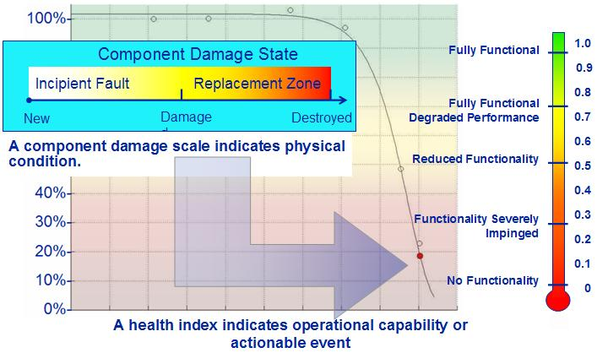
Figure 3: Avionics Fault Progression

From a ground maintenance standpoint, information processing and reasoner software technology provide a means to more effectively transition towards 2-level maintenance strategies. Figure 4 depicts some of the attributes that could be accommodated from the current 3-level approach. The intermediate process could be better supported with this concept, or if the associated process changes were adopted, many of the intermediate functions could be transitioned to the operational (i.e., on board) and depot capabilities.

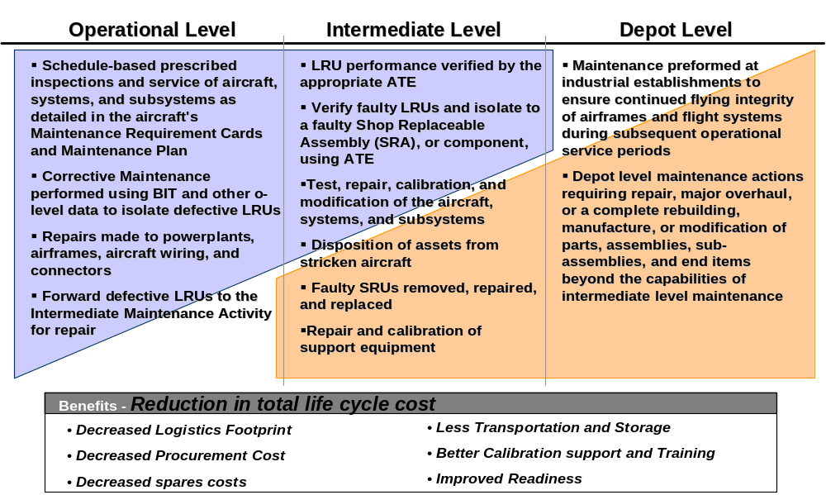
Figure 4: Aircraft Maintenance Levels

Advanced reasoning, enabled by the captured data and integrated with the depot repair process, can decrease repair times and reduce overall costs. Advanced reasoning can also enable systems to respond proactively to problems in flight maintaining vehicle operational integrity under adverse conditions. On the ground, capture of maintenance data throughout all levels of repair will provide the foundation for better future system design and advanced implementation of prognostics through a better understanding of avionics failures.

Avionics Health Management Requirements

Requirements for health management vary greatly with the application, application environment, and human health and safety dependencies. There are three main environments that need to be considered: Industrial, Aviation, and Space.

Industrial grade systems are characterized by harsh temperature, corrosive, high pressure environments. Failures of these systems generally result in the loss of system functions. There is some potential for impact to human safety, but this is application-specific.

Aviation grade systems are characterized by harsh temperature, corrosive, low and high pressure environments. Failure of these systems is more crucial than for industrial systems and can lead to a loss of vehicle. Thus, there is a need for the system to be able to safely return to base or land after a critical failure. Human safety is dependent on these systems and loss of vehicle can lead to loss of human life. Thus, failures require more stringent management and avoiding a failure through prognostic applications greatly enhances vehicle reliability and human safety.

Space grade systems are characterized by harsh temperatures, vacuum, space radiation, solar ultra-violet (UV), atomic oxygen (LEO), micro-gravity environment. Failures of these systems are even more crucial than for aviation systems, due to limited or complete inability to recover a failed vehicle. Thus, space vehicles must operate in the presence of multiple failures. Abort modes are generally limited and failures must be detected to enable abort mode activation in a timely fashion. Prognostics are important for operation of space vehicles from LEO to interstellar space. Crewed-vehicle health directly impacts human health and safety.

As can be seen from the different types of systems, human health and safety dependence varies with type and application. Human health and safety dependence can be characterized by human interaction with the system and human dependence on the system for survivability. The most critical systems are those in which human survivability is dependent. Space and high-altitude aircraft applications are a key example of this dependence. In these applications vehicle systems are depended upon to maintain human health and safety. Failure of these systems leads to a loss of human life (loss of crew). Low altitude aircraft have a less stringent dependence, but still have impacts on human health and safety depending on the ability to safely land. There are systems in which no dependence exists for human health and safety. Robotic spacecraft, Unmanned Aerial Vehicles (UAV), and industrial plant operations are examples of this non-dependence.

Proactive Health Management and Recovery

Conventional health management techniques focus heavily on reactive rather than predictive behavior. The ability to predict problems that might be encountered, and to adapt for problems which were not necessarily anticipated, becomes far more crucial as human survivability dependence, mission expectations, and timelines increase. Knowledge of impending, developing and extant failures before they impact vehicle health is far more critical than reactive responses.

Also, while dual-, triple-, or even quad-redundant techniques are commonly effective for relatively short missions, they may not be suitable for long-duration missions since they are not very efficient in utilizing redundant components. For example, in dual-string architectures which are not cross-strapped, when elements in both strings have failed, the system fails. It is impossible to use other components in the system to resurrect it even though they are still functioning properly, because they are simply incapable of performing the failed pair’s tasks. In addition, component life becomes critical for ultra-long-life missions (i.e., a decade or more). Since the predominant failure mode in an ultra-long-life system is component life, all active components in the system will approach end of life conditions by the end of the mission. Therefore, conventional fault-tolerant techniques would require many more redundant components to come on-line later in the mission to maintain system reliability. Proactive health management combined with recovery options is necessary to make sure the system can function reliably through the end of the mission.

Error and Fault Detection

Real Time Logic Checking

This involves integrating test patterns in the data or in the downtime between data sets to test for known conditions. For instance if you wanted to check the logic controlling the memory and the memory itself, a known data pattern could be written to and read from a block of memory at specific time intervals. A known pattern could uncover bit errors and highlight potential logic faults. This could be incorporated into live real time running hardware. In depth testing, of every memory location and bit would require off-line testing.

Vector Testing

Vector testing refers to certain bit patterns or vectors that can be used to diagnose the health of a logic circuit. By using a known vector in a memory test then you can write and read it and compare the two to uncover any problems. Applied to a unique logic circuit, applying a vector will result in a specific output. By analyzing the output and comparing it to what the output should be, errors can be uncovered.

Idle Data Pattern Diagnosis

In many communications systems, even though actual data is not being sent, an idle pattern is constantly sent back and forth. In some systems, the idle pattern itself is an indication of channel health. If the idle data pattern changes and is incorrect, this is detected on the receiving side and appropriate actions are taken.

Ground Plane Frequency Diagnosis

This is a very complicated technique that would rarely justify the added complexity and cost. This would entail monitoring the ground plane by digitizing the signal on it looking for frequency patterns that could determine a problem on the board. To do this would require Analog-to-Digital (A/D) circuits for data acquisition and a digital signal processor to run algorithms on the data to determine the health of the system. This may be worthwhile at the system level cause the amount of electronics necessary to accomplish this could take up half a 6U card (the Versa Module Eurocard (VME) specifications, IEEE 1014, define a 6U card as 233mm x 160 mm).

Recovery

Most computer systems provide some means for detecting and recovering from system failure of a non-catastrophic nature. Usually, this is effective for situations involving software errors and intermittent, random crashes, rather than permanent damage to hardware. Reset techniques vary from manual to automatic watchdog timers depending on the application and safety criticality. For permanent hardware faults, current systems depend on redundancy. Redundancy works well as long as there are no common-cause failures (i.e., failures which will occur in all hardware or software versions of the same type give the same set of conditions). Concerns of these types of failures have led to concepts such as Backup Flight Software (BFS) which use dissimilar software and/or hardware to protect against common cause errors. BFS requires a complete duplication of the flight system and is extremely costly. Systems that implement BFS usually have high human survivability dependence. The Space Shuttle Orbiter is an example of such a system that has implemented BFS, although the BFS capability has never been required in flight. Reconfigurable computing is an emerging field that offers greatly improved flexibility for hardware failure recoveries. It provides an economical solution to hardware failures and also provides a level of protection against common cause failures as the hardware can be configured in an alternative architecture to correct for failures.

Reset

A manual hardware reset – or hard reboot – is very effective for random errors (i.e., not repeatable such as a Single Event Upset) in the event a detectable system failure has occurred. But that is not a remotely automatic or timely safeguard. Watchdog timers and related techniques are often a reasonably effective and fast way to capture and respond to major crashes. The usual scheme for this utilizes a dedicated counter in hardware constantly counting down, and some means in hardware or software run-streams of resetting the counter periodically; if the counter times out because it has not been reset, a reboot cycle is automatically generated.

Redundant element management

To permanently recover from a failure, some form of redundancy is usually required. Identical redundant elements may be running in parallel with the active elements, so that they can quickly take over if active components fail. However, this approach is expensive, since all the major components must be duplicated, and it leaves the backup elements vulnerable to life-limitation failures. Other methods leave backup elements in standby or offline entirely.

Another more cost-effective approach requires that each element in the system be able to perform different tasks, reducing duplication. In the event that a component fails, its function will be reassigned to other healthy components, provided the healthy components can handle additional workload. This approach is suitable for systems in which the key components are computing elements such as processors or controllers. To fully realize the functional reassignment, all the computing elements must be symmetrical; that is, they should have the same computing capability, memory size, and I/O interfaces. State information must be exchanged frequently to ensure that operations of a failed element can be taken over quickly.

A more efficient approach to utilize redundant components is to use a generic function block (GFB) approach. An avionics architecture can include a few spare GFBs as identical redundant components. These are not committed to any function at launch, but can be reconfigured later as needed. If any component fails, one of the GFBs can be configured to replace it. One GFB can replace multiple types of components, so the spacecraft does not have to stockpile many types of redundant components. With the advances in FPGA technologies, it is relatively easy to implement GFBs.

Reconfigurable Computing

Reconfigurable computing lately seems to be coming into its own. In whatever form this technology takes, it is first and foremost capable of being partially or completely changed as needed. This may be as simple as replacing operational software, or can include the capability to modify behavior or order of input and output pins. Ultimately, this will be accomplished without significant interruption of system activity – or even between system clock cycles, with no detectable transition artifact.

In addition to being reconfigurable, these systems typically have massively parallel computing capabilities. Benefits of this include much higher processing speed; orders-of-magnitude speedup over individual serial processing has been demonstrated. Distribution of critical functionality makes a system less prone to the devastating effects of radiation and electromagnetic interference, and the ability to reconfigure if such an event occurs allows the possibility to circumvent residual hardware damage.

In the manual context, reconfigurable computing is already very much a reality. During a mission, ground operators or flight crew commonly command a vehicle to upload and install new software or firmware. In fact, the scheme above for GFBs is amenable to this technique. However, it is far more effective and timely to provide automated means of this transition, especially in the presence of capable fault-detection algorithms.

One challenge of in-flight reconfiguration is the verification of the newly reconfigured FPGA block. If the newly configured FPGA is to perform non-critical functions, then its I/O pins can be activated by a hardware command so that it can start to receive inputs and produce output signals. Operators can optionally read out and verify configuration of the FPGA before it is activated. If a newly-configured FPGA is to perform a critical function, then a more carefully staged upgrade procedure should be used. In most cases, the critical function will have already been implemented somewhere on the spacecraft, and can be used as a reference. The newly-configured FPGA will first be put into an observation mode, in which all inputs are received and functions executed, but outputs do not take effect. Instead, they are used to compare with outputs of the old implementation; by this means, most functions of the FPGA can be verified except for differences between the old and new implementations.

The newly-configured FPGA can be promoted to the active role when all of its functions are verified. The old implementation can first be put into backup mode in case the new FPGA fails unexpectedly, and then retired from the system when the new FPGA has been operating flawlessly for some time.

If a newly-configured FPGA is to implement a new untested critical function, then its operation should be verified by on-board simulation, where the FPGA will receive real inputs and execute the critical function without active output control. The advantage of on-board simulation over ground-based simulation is that inputs are much more realistic. After operation of the new FPGA is fully verified, outputs of the FPGA can begin active operation.

To make such planned improvements proactive and timely, human intervention must be minimized. Automating these processes allows the ob-board systems to responds quickly. This is especially important during critical operations or for human interplanetary missions where the light-time latency can be significant. Operations costs can also be greatly reduced by automation by reducing the manual time required to reprogram the FPGA.

An additional aspect of reconfigurable, massively parallel computing is its suitability for hardware implementation of neural networks, genetic algorithms, and other forms of advanced computer decision-making technology. Recent developments in these arts have yielded impressive and encouraging results. The day when computers can self-diagnose, design repair procedures, and implement them safely and effectively may thus be closer than many expect.

Summary

Avionics is comprised of a complex set of electronic, optical, and MEMS technologies. These components have characteristic failures that are generally tested for during manufacturing or maintenance, but which are not tested for in flight operational modes. The vehicle operational environment is a large source of potential errors for an avionics system. Environmental parameters are monitored at various levels from the vehicle level to the component level to the individual device level. This monitoring is not consistent across components and is driven primarily by component performance considerations. Avionics components have traditionally been integrated in loosely federated systems architectures that do not account well for component interactions. Emerging Modular Integrated System (MIS) architectures address the component interactions at all levels and provide a more robust framework for avionics health management at the system level. These concepts are emerging and hold great promise to increase the reliability of avionics components. Recovery techniques are currently implemented through redundant components and systems. Reconfigurable computer applications hold great promise to increase in-flight system failure recovery and flexibility. There are many fruitful areas of research and development that are required to enable a fully proactive Avionics Health Management System. As this work evolves, the benefits to the aerospace industry will be substantial.

