Tropical Cyclone Report
Tropical Storm Fay
(AL062008)
15-26 August 2008

Stacy R. Stewart and John L. Beven II
National Hurricane Center
8 February 2009

Fay was a long-lived tropical storm that made eight landfalls – including a record four landfalls in Florida – and produced torrential rainfall that caused extensive floods across the Dominican Republic, Haiti, Cuba, and Florida.

- Synoptic History

The tropical wave that spawned Fay emerged off the African coast on 6 August 2008. During its rapid west-northwestward trek across the tropical Atlantic Ocean, the wave was accompanied by limited thunderstorm activity. However, by 14 August, the wave’s forward speed had decreased from 20-25 kt down to 10-15 kt, which may have contributed to the increase in convective activity and organization that ensued later that day. Later that day, the tropical wave turned westward, and surface observations and QuikSCAT satellite-derived wind data indicated a well-defined low pressure system had formed along the wave axis. However, the low-level circulation center moved due west along the southern coast of Puerto Rico, which inhibited development due to interaction with the mountainous terrain on the island. By early 15 August, the circulation center of the disturbance had moved over the waters of the Mona Passage, and convective organization again increased. Dvorak satellite classification increased to T2.0, and it is estimated that a tropical depression formed at 1200 UTC 15 August just west of the northwestern tip of Puerto Rico. The “best track” chart of the tropical cyclone’s path is given in Fig. 1. The best track positions and intensities are listed in Table 1, with the wind and pressure histories shown in Figs. 2 and 3, respectively.

Under the influence of a strong subtropical ridge located to the north, the depression moved westward across the Mona Passage and made landfall near El Cabo, Dominican Republic at 1430 UTC 15 August. Despite being over land, the system became a tropical storm around 1800 UTC based on flight-level wind information obtained from Air Force Reserve Unit and NOAA reconnaissance aircraft. Despite traversing the mountainous southern portion of the Dominican Republic and Haiti, Fay remained a tropical storm as indicated by wind data from reconnaissance aircraft and ships. The cyclone continued its westward trek and made landfall along the eastern end of Gonavé Island, Haiti at 1145 UTC 16 August. After Fay moved over the Windward Passage later that day, the cyclone turned west-northwestward and strengthened slightly under a favorable upper-level wind flow pattern, before it made landfall along the south-central coast of Cuba about 20 n mi east of Cabo Cruz near 0900 UTC 17 August. Early on 18 August, Fay turned toward the northwest still at 45-kt intensity, and made landfall 20 n mi west of Cienfuegos, Cuba around 0700 UTC. After crossing over Cuba, Fay emerged over the Straits of Florida around 1200 UTC that day and encountered moderate southwesterly vertical wind shear and dry mid-level air, which inhibited significant strengthening. It made landfall near Key West, Florida at 2030 UTC.

After passing north of Key West over the warm waters of Florida Bay, data from land-based Doppler radars and reconnaissance aircraft indicated Fay was becoming better organized as the vertical wind shear began to decrease. The storm made landfall along the southwestern Florida coast between Cape Romano and Everglades City at 0845 UTC 19 August with 55 kt winds. Shortly after landfall, a well-defined eye feature developed in both satellite and radar imagery, possibly due to the decreasing wind shear and increasing low-level frictional convergence. Despite land interaction over South Florida, Fay strengthened slightly and it is estimated that its peak intensity of 60 kt was achieved around 1800 UTC that same day when the center was near the western end of Lake Okeechobee. The eye feature remained apparent in radar imagery (Fig. 4) from 0929 UTC 19 August until 0212 UTC 20 August. Thereafter, Fay steadily weakened until the center reached the Atlantic waters off the east-central Florida coast late that day. Steering currents weakened on 21 August as a broad mid-level trough eroded the western portion of the subtropical ridge across Florida. This broad flow pattern caused Fay to turn northward and slow to a forward speed of 3-4 kt, as the cyclone skirted the coastal region near Cape Canaveral. Convective bands to develop and persist inland over east-central Florida in regions of enhanced frictional convergence and the slow forward speed of Fay allowed heavy rain elements to ‘train’ across the same areas for several hours. This ‘train echo’ effect led to the widespread heavy rainfall in excess of 20 in to occur in Brevard County, Florida (Table 3).

As the mid-level trough that initially weakened the subtropical ridge lifted out to the north, the ridge to the north of Fay built westward across the southeastern United States causing the tropical storm to turn westward late on 21 August. Fay made its third Florida landfall near Flagler Beach at around 1900 UTC 21 August. A general westward motion was maintained across the northern Florida peninsula and cyclone emerged over the extreme northeastern Gulf of Mexico late on 22 August. Fay made its fourth and final Florida landfall – and eighth overall landfall - just southwest of Carrabelle in the Florida panhandle around 0615 UTC 23 August. The storm turned toward the west-northwest shortly thereafter and weakened to a depression by 0000 UTC 24 August northeast of Pensacola. Fay meandered slowly northwestward across southwestern Alabama early on 24 August and then turned southwestward over southeastern Mississippi later that day before briefly stalling near McComb, Mississippi around 0000 UTC 25 August.

A mid-level trough pushed south and eastward from the central Plains. This caused the depression to steadily lift out to the northeast across eastern Mississippi, northern Alabama, and extreme southeastern Tennessee on 25-27 August. Fay merged with an old frontal boundary and became an extratropical low pressure system around 0600 UTC 27 August over eastern Tennessee northeast of Chattanooga. The extratropical low continued to move northeastward, where it was absorbed by a larger extratropical low over eastern Kentucky by 0600 UTC 28 August.

- Meteorological Statistics

Observations in Fay (Figs. 2 and 3) include satellite-based Dvorak technique intensity estimates from the Tropical Analysis and Forecast Branch (TAFB) and the Satellite Analysis Branch (SAB). Data and imagery from NOAA polar-orbiting satellites, the NASA Tropical Rainfall Measuring Mission (TRMM), the NASA QuikSCAT, and Defense Meteorological Satellite Program (DMSP) satellites, among others, were also useful in tracking Fay. Ship reports of winds of tropical storm force associated with Fay are given in Table 2, and selected surface observations from land stations and data buoys are given in Table 3.

The estimated peak intensity of 60 kt at 1800 UTC 19 August is based on a combination of NOAA Doppler weather radar data from Weather Forecast Offices (WFO) Melbourne (KMLB), Miami (KAMX), and Key West (KBYX), Florida, and also from South Florida Water Management District (SFWMD) surface observations over western Lake Okeechobee. As the eye of Fay moved northeastward across the wetlands of the Florida Everglades toward Lake Okeechobee, Doppler velocity values ranging from 63 kt to 69 kt, accompanied by isolated peak values of 70 kt to 75 kt, were observed between altitudes ranging from 6,800 ft up to 20,000 ft. These velocities composed a nearly continuous elliptical data region approximately 4 n mi wide by 10 n mi long. Although these winds were observed mostly over the Everglades, the leading edge of Fay’s eyewall emerged over the waters of western Lake Okeechobee at approximately 1645 UTC. The mean Doppler velocity values noted within a 2,000-ft layer centered at an altitude of 9,000 ft (roughly 700 mb) was 66 kt. Using the 0.90 reduction factor derived for aircraft data on the Doppler velocities yields a surface wind estimate of 59 kt. In addition, at 1745 UTC, a 15-minute average wind speed of 51 kt was measured at a height of 8 m by a SFWMD mesonet station (L005; Table 3) located in the western portion of Lake Okeechobee. Applying appropriate time and height conversion factors yields estimated 56-59 kt 1-minute average winds at 10 m. (Note: this methodology is similar to that used to adjust observed wind speeds over Lake Okeechobee during Hurricane Wilma in 2005). Based on this data and the Doppler radar velocity data, a peak intensity of 60 kt over the open water of western Lake Okeechobee seems reasonable and is supported by a 54-kt wind speed that was observed inland at Moore Haven, Florida, located south of the western end of Lake Okeechobee.
Heavy rainfall was the most notable hazard caused by Tropical Storm Fay. As the pre-Fay disturbance moved across Puerto Rico and the Virgin Islands, the San Juan NOAA Doppler radar indicated one-hour rainfall rates locally as much as 4 in h⁻¹. However, due to the relatively fast forward speed of the disturbance, only localized flooding was reported. The most notable flood report was a rise of 2 ft above flood stage on the Rio Fajardo. The flooding caused Route 3, a major highway in Fajardo province to be closed. In contrast to the devastating floods that occurred in Hispaniola, Cuba, and Florida, the rainfall caused by the pre-Fay disturbance was beneficial for Puerto Rico, Culebra, Vieques, and the U.S. Virgin Islands since those areas had been experiencing one of the driest summers on record. Water levels in reservoirs had been running low and water restrictions were about to be implemented. Fay’s motion across the northern Caribbean Sea produced prolonged heavy rain events in Hispaniola and Cuba. News reports indicate that floods devastated the Haitian island of Gonavé. The saturated ground conditions created by the heavy rains from Fay set the stage for an even greater flood devastation and resultant loss of life caused by heavy rains produced by Hurricanes Gustav, Hanna, and Ike that traversed Haiti during the ensuing two weeks. In the Dominican Republic, rainfall totals exceeding 7-10 in occurred primarily over the southern half of the country. Similarly, numerous stations in Cuba received more than 10 in of rainfall. Agabama, located in central Cuba, reported the greatest rainfall total with 18.23 in. Over the United States (Figs. 5 and 6), the heaviest rainfall occurred across Florida and southern Georgia. Extreme rainfall maxima of 27.65 in and 27.50 in were measured near Melbourne, Florida and Thomasville, Georgia, respectively (Table 3). Melbourne, Florida broke a 50-year old record for a rainfall event. There were numerous rainfall reports of more than 20 in reported across east-central Florida and amounts in excess of 10 in were common elsewhere across the central and northern Florida, southwestern Georgia, and southeastern Alabama. Although significant floods occurred across east-central Florida, the runoff from that rainfall into the Kissimmee River Valley, as well as the rain that fell directly into Lake Okeechobee, helped to re-charge the lake reservoir. Fay’s traversal of southern and central Florida resulted in a beneficial 4-ft rise in the water level of Lake Okeechobee – the primary water source for South Florida – in less than one week.
Storm surge and associated effects from Fay were relatively minimal. Most storm surge heights were generally 1-2 ft above NGVD along the South Florida coast, with up to 3-5 ft reported in the Everglades City area. Higher surge values of 2-4 ft were observed along the northeastern Florida coast where Fay’s slow forward speed during 20-22 August created a prolonged onshore southeasterly flow from the Atlantic Ocean. The combination of storm surge and wave action caused some moderate beach erosion in the Florida Keys, and also along the South Florida coastline from Collier County south and eastward to Palm Beach County. However, mostly minor beach erosion was reported elsewhere along the Florida coast.
Tropical Storm Fay was a fairly prolific tornado-generator in the United States, producing a total of 81 tornadoes across five states: 19 in Florida, 17 in Georgia, 16 in North Carolina, 15 in Alabama, and 14 in South Carolina. The overwhelming majority of the tornadoes were categorized as having EF0 intensity. A few tornadoes were classified at EF1 to EF2 intensity. Early on 19 August, an EF2 tornado moved across Wellington, Florida in western Palm Beach County and damaged an equine clinic and other buildings causing an estimated $1.25 million in damages. Later that day, an EF1 tornado struck a manufactured housing community in Barefoot Bay, Florida and damaged 59 residences – 9 of which were declared uninhabitable after the event. An outbreak of 28 tornadoes occurred on 26 August across central and northern Georgia and western South Carolina. One of those tornadoes cut a path approximately 2 km long by 100 m wide through Commerce, Georgia, injuring 2 people and damaging numerous trees and mobile homes. Also, two elementary schools were damaged by a tornado in Oakwood and Gainesville, Georgia, but no one in the school at the time of the incident was injured.

- Casualty and Damage Statistics

Thirteen deaths have been attributed directly to Fay: 5 in the Dominican Republic, 5 in Florida, and 3 in Haiti. There were also 8 indirect deaths that were mainly due to auto accidents caused by hydroplaning on wet roads. The deaths in the Dominican Republic occurred when vehicles were swept off roads by flood waters, and the deaths in Haiti occurred when a bus tried to cross the flood-swollen Rivere Glace and was swept away.

Damage was primarily caused by rainfall-induced floods that affected mainly residential structures across the Dominican Republic, Haiti, and Florida. There were no reports of major damage or casualties in Cuba. Homes, personal property, and motor vehicles were the primary damage losses in the United States. The government of the Dominican Republic reported that more than 2,400 homes were damaged or destroyed by wind and flood waters in that country. Media reports indicate that extensive and devastating floods ravaged Haiti, especially on the island of Gonavé. In Florida, wind damage was confined to mostly downed trees and power lines, plus minor roof damage to homes. Although flooding was extensive across portions of east-central Florida, in particular in Brevard County, most of the heavy rain and floods occurred in the western part of the county that is more rural. The heavy rainfall resulted in more than 15,000 homes being flooded and more than 93,000 homes lost electrical utilities in the state due to strong gusty winds.

The amount of total insured damage compiled by the Property Claim Services of the Insurance Services Office, Inc., is $245 million. This includes $195 million in Florida, $25 million in Georgia, and $25 million in Alabama. Flood damage losses reported by the National Flood Insurance Program were about $36 million. Using a doubling of insured losses to obtain the total damage gives an estimate of Fay’s damage in the United States of about $560 million.

- Forecast and Warning Critique

The genesis of Fay was well forecast. The incipient disturbance was first noted in the Tropical Weather Outlook (TWO) issued at 0600 UTC 10 August. The possibility of a tropical depression developing was first mentioned in the 0000 UTC 11 August TWO – 114 h before genesis occurred. The long genesis lead time was primarily due to a period of hostile upper-level winds. The experimental genesis forecasts were in the “high” (> 50% probability) category 30 h prior to genesis.

A verification of official and guidance model track forecasts is given in Table 3. Average official track errors for Fay were 23, 31, 46, 62, 102, 145, and 221 n mi for the 12, 24, and 36 h forecasts, respectively. The number of forecasts ranged from 34 at 12 h to 26 at 120 h. The official forecast (OFCL) errors are significantly lower than the average long-term official track errors at all times (Table 2), and essentially outperformed all but the interpolated ECMWF (EMXI) and GFS (GFSI) models at all forecast times.

Average official intensity errors were 4, 8, 9, 10, 10, 12, and 13 kt for the 12, 24, 36, 48, 72, 96, and 120 h forecasts, respectively (Table 4). For comparison, the average long-term official intensity errors are 7, 10, 12, 14, 18, 20, and 22 kt, respectively. These errors are lower than average at all forecast periods despite Fay being forecast to briefly reach hurricane status, which never materialized. The statistical dynamical models DSHP and LGEM had average intensity errors near or lower than the official forecasts, as did the consensus models ICON and IVCN.

Watches and warnings associated with Fay are given in Table 6.

Acknowledgements

Much of the data for this report was supplied by the National Weather Service WFOs in San Juan, PR, and in Key West, Miami, Tampa, Melbourne, Jacksonville, and Tallahassee FL, as well as by the Meteorological Services of the Dominican Republic, Haiti, Cuba, and the Bahamas. Additional data was provided by the University of South Florida Coastal Ocean Monitoring and Prediction System (COMPS) and the Florida Automated Weather Network (FAWN). NOAA buoy and C-MAN data were provided by the National Data Buoy Center. NOS data were provided by the NOAA National Ocean Service. Remote Automated Weather Stations (RAWS) data were provided by the National Interagency Fire Center. United States Geological Survey (USGS) data were provided by the NWISWeb web site. Some surface observational data were obtained from the South Florida Water Management District (SFWMD) mesonet. Supplementary rainfall data and portions of the remnant low track were provided by the Hydrometeorological Prediction Center (HPC). NHC Senior Hurricane Specialist, Lixion Avila, and TAFB meteorologists, Jessica Schauer-Clark, Gladys Rubio, and Todd Kimberlain, assisted with the collection of meteorological data from the Dominican Republic, NOAA HPC, Cuba, and Haiti, respectively. Hurricane Specialist, NHC Hurricane Specialist, Dan Brown, assisted with the production of the new GIS-based best track map.

Table 1. Best track for Tropical Storm Fay, 15-26 August 2008.
Date/Time  (UTC) | Latitude  (°N) | Longitude  (°W) | Pressure  (mb) | Wind Speed  (kt) | Stage
15 / 1200 | 18.4 | 67.4 | 1011 | 30 | tropical depression
15 / 1800 | 18.5 | 68.8 | 1009 | 35 | tropical storm
16 / 0000 | 18.6 | 70.2 | 1008 | 40 | "
16 / 0600 | 18.7 | 71.4 | 1008 | 40 | "
16 / 1200 | 18.8 | 72.9 | 1007 | 40 | "
16 / 1800 | 19.1 | 74.6 | 1007 | 40 | "
17 / 0000 | 19.3 | 75.7 | 1005 | 45 | "
17 / 0600 | 19.6 | 76.8 | 1004 | 45 | "
17 / 1200 | 20.1 | 78.0 | 1003 | 45 | "
17 / 1800 | 20.7 | 79.6 | 1006 | 45 | "
18 / 0000 | 21.1 | 80.3 | 1001 | 45 | "
18 / 0600 | 21.9 | 80.8 | 1003 | 45 | "
18 / 1200 | 23.2 | 81.2 | 1002 | 50 | "
18 / 1800 | 24.3 | 81.7 | 1000 | 50 | "
19 / 0000 | 25.0 | 81.9 | 997 | 50 | "
19 / 0600 | 25.5 | 81.8 | 994 | 55 | "
19 / 1200 | 26.4 | 81.4 | 988 | 55 | "
19 / 1800 | 27.0 | 81.1 | 986 | 60 | "
20 / 0000 | 27.5 | 80.9 | 988 | 55 | "
20 / 0600 | 28.0 | 80.6 | 992 | 50 | "
20 / 1200 | 28.4 | 80.6 | 994 | 45 | "
20 / 1800 | 28.7 | 80.6 | 997 | 45 | "
21 / 0000 | 28.9 | 80.5 | 993 | 50 | "
21 / 0600 | 29.1 | 80.7 | 993 | 50 | "
21 / 1200 | 29.2 | 80.7 | 993 | 50 | "
21 / 1800 | 29.3 | 81.0 | 993 | 55 | "
22 / 0000 | 29.3 | 81.2 | 994 | 50 | "
22 / 0600 | 29.5 | 81.9 | 995 | 50 | "
22 / 1200 | 29.6 | 82.4 | 996 | 45 | "
22 / 1800 | 29.8 | 83.0 | 997 | 40 | "
23 / 0000 | 29.7 | 83.8 | 996 | 45 | "
23 / 0600 | 29.8 | 84.7 | 997 | 45 | "
23 / 1200 | 30.0 | 85.2 | 998 | 40 | "
23 / 1800 | 30.5 | 85.9 | 999 | 40 | "
24 / 0000 | 30.8 | 86.7 | 999 | 30 | tropical depression
24 / 0600 | 31.1 | 87.7 | 999 | 30 | "
24 / 1200 | 31.8 | 88.4 | 1000 | 30 | "
24 / 1800 | 31.5 | 89.7 | 1001 | 30 | "
25 / 0000 | 31.3 | 90.0 | 1001 | 30 | "
25 / 0600 | 31.5 | 89.9 | 1002 | 30 | "
25 / 1200 | 32.0 | 89.4 | 1002 | 25 | "
25 / 1800 | 32.4 | 89.0 | 1002 | 25 | "
26 / 0000 | 32.7 | 88.6 | 1002 | 20 | "
26 / 0600 | 33.3 | 87.9 | 1003 | 20 | "
26 / 1200 | 33.9 | 87.2 | 1003 | 20 | "
26 / 1800 | 34.6 | 86.5 | 1004 | 20 | "
27 / 0000 | 34.9 | 85.8 | 1005 | 15 | "
27 / 0600 | 35.3 | 84.9 | 1006 | 15 | extratropical
27 / 1200 | 35.9 | 84.0 | 1007 | 15 | "
27 / 1800 | 36.9 | 83.6 | 1008 | 15 | "
28 / 0000 | 37.4 | 83.2 | 1009 | 15 | "
28 / 0600 | 37.7 | 82.6 | 1010 | 15 | "
28 / 1200 |  |  |  |  | dissipated
15 / 1430 | 18.5 | 68.4 | 1009 | 35 | landfall near El Cabo, Dominican Republic
16 / 1145 | 18.8 | 72.8 | 1007 | 40 | landfall along eastern Gonavé Island, Haiti
17 / 0900 | 19.9 | 77.4 | 1003 | 45 | landfall 20 n mi east of Cabo Cruz, Cuba
18 / 0700 | 22.1 | 80.8 | 1003 | 45 | landfall 20 n mi west of Cienfuegos, Cuba
18 / 2030 | 24.5 | 81.8 | 998 | 50 | landfall near Key West, FL
19 / 0845 | 25.9 | 81.6 | 991 | 55 | landfall just east of Cape Romano, FL
21 / 1900 | 29.3 | 81.1 | 993 | 55 | landfall near Flagler Beach, FL
23 / 0615 | 29.8 | 84.7 | 997 | 45 | landfall just southwest of Carrabelle, FL
19 / 1800 | 27.0 | 81.1 | 986 | 60 | minimum pressure and maximum intensity

Table 2. Selected ship and buoy reports with winds of at least 34 kt for Tropical Storm Fay, 15-26 August 2008.
Date/Time (UTC) | Ship call sign | Latitude  (°N) | Longitude  (°W) | Wind  dir/speed (kt) | Pressure  (mb)
15 / 2200 | WDB325 | 19.5 | 69.0 | 130 / 43 | 1011.0
17 / 1800 | DAQZ | 24.2 | 83.2 | 050 / 35 | 1013.0
19 / 0000 | C6FZ7 | 25.4 | 79.6 | 120 / 40 | 1008.0
19 / 0700 | C6FZ7 | 23.5 | 79.2 | 180 / 38 | 1010.1
19 / 1400 | WDD711 | 25.7 | 79.9 | 180 / 37 | 1008.0
19 / 1500 | WDD711 | 25.6 | 79.9 | 180 / 44 | 1009.0
19 / 1600 | WDD711 | 25.5 | 79.9 | 180 / 45 | 1010.0
19 / 1800 | WDD711 | 25.5 | 80.0 | 180 / 45 | 1010.0
19 / 1800 | PHJV | 26.1 | 79.6 | 200 / 41 | 1006.7
19 / 1800 | DBIP | 26.1 | 79.2 | 180 / 35 | 1010.6
20 / 0300 | PBGU | 27.5 | 79.1 | 160 / 44 | 1006.0
20 / 0300 | WJBJ | 29.9 | 80.3 | 170 / 36 | 1010.0
20 / 0400 | WBVZ | 29.3 | 78.5 | 090 / 38 | 1008.3
20 / 1820 | 41009 | 28.5 | 80.2 | 180 / 39 | 999.0
21 / 0220 | 41009 | 28.5 | 80.2 | 200 / 39 | 998.6
21 / 0320 | 41009 | 28.5 | 80.2 | 200 / 41 | 999.7
21 / 0850 | 41012 | 30.0 | 80.5 | 090 / 37 | 1002.3
21 / 1550 | 41012 | 30.0 | 80.5 | 080 / 37 | 1000.1
21 / 1650 | 41012 | 30.0 | 80.5 | 100 / 35 | 999.8
22 / 0000 | KCGH | 28.8 | 79.1 | 150 / 38 | 1007.5
22 / 0500 | WPGK | 30.0 | 80.5 | 130 / 37 | 1006.0

Table 3. Selected surface observations for Tropical Storm Fay, 15-26 August 2008.
Location | Minimum Sea Level Pressure |  | Maximum Surface  Wind Speed |  |  | Storm surge  (ft)^{c} | Storm  tide  (ft)^{d} | Total  rain  (in)
Location | Date/  time  (UTC) | Press.  (mb) | Date/  time  (UTC)ª | Sustained  (kt)^{b} | Gust  (kt) | Storm surge  (ft)^{c} | Storm  tide  (ft)^{d} | Total  rain  (in)
Dominican Republic
Azua |  |  |  |  |  |  |  | 13.94
Bani |  |  |  |  |  |  |  | 7.15
Joaquin B. Aerop. |  |  |  |  |  |  |  | 12.32
Juma Banao |  |  |  |  |  |  |  | 8.70
Las Americas Aero. |  |  | 16/0000 | 34
Pedernales |  |  |  |  |  |  |  | 11.49
Polo |  |  |  |  |  |  |  | 7.46
San Cristobal |  |  |  |  |  |  |  | 7.24
Santiago |  |  | 15/0500 | 37
Santo Domingo |  |  |  |  |  |  |  | 10.20
Yamasa |  |  |  |  |  |  |  | 9.09
Haiti
No official reports available
Cuba
Agabama |  |  |  |  |  |  |  | 18.23
Baez |  |  |  |  |  |  |  | 9.82
Caracusey |  |  |  |  |  |  |  | 10.47
Condado |  |  |  |  |  |  |  | 12.27
Falcon |  |  |  |  |  |  |  | 8.25
Fomento |  |  |  |  |  |  |  | 15.26
J. Maria Perez |  |  |  |  |  |  |  | 8.25
Placetas |  |  |  |  |  |  |  | 8.11
Trinidad |  |  |  |  |  |  |  | 10.38
Vueltas |  |  |  |  |  |  |  | 8.78
Bahamas
Freeport |  |  |  |  | 34 |  |  | 9.88
Nassau-New Providence |  |  |  |  | 38 |  |  | 4.16
United States
Alabama
Birmingham IAP-KBHM |  |  |  |  |  |  |  | 7.28
Calera |  |  |  |  |  |  |  | 9.73
Clayhatchee 5.9 E |  |  |  |  |  |  |  | 15.27
Clio 0.2 SSW |  |  |  |  |  |  |  | 10.27
Highland Home |  |  |  |  |  |  |  | 12.74
Lake Purdy 3.6 ENE |  |  |  |  |  |  |  | 10.37
Meadowbrook 1.7 NE |  |  |  |  |  |  |  | 10.50
Troy |  |  |  |  |  |  |  | 9.57
Valley 0.4 NNW |  |  |  |  |  |  |  | 11.87
Wetumpka 9.9 NNE |  |  |  |  |  |  |  | 10.81
Florida
Astor 2.0 S |  |  |  |  |  |  |  | 7.20
Big Pine Key HANDAR |  |  |  |  |  |  |  | 6.95
Boynton Beach 4 WSW |  |  |  |  |  |  |  | 9.51
Brighton-S75WX (SFWMD mesonet) |  |  | 19/1830 | 34 | 49
Cape Canaveral/Cocoa Beach |  |  |  |  |  |  |  | 19.01
Cape Canaveral 5 NE/ USAF FM 34 |  |  |  |  |  |  |  | 21.75
Cape Canaveral 5 NE/ USAF FM 34 |  |  |  |  |  |  |  | 25.01
Cape Canaveral/USAF Field Mill 21 |  |  |  |  |  |  |  | 22.83
Clermont |  |  |  |  |  |  |  | 7.54
Clewiston Airglades AP-2IS |  |  | 19/1615 | 49 | 59
Cocoa Beach/Patrick AFB-KCOF |  |  |  |  |  |  |  | 20.61
Cocoa Beach 1 N |  |  |  |  |  |  |  | 22.26
Cudjoe Key |  |  |  |  |  |  |  | 7.02
Daytona Beach AP-KDAB |  |  |  |  |  |  |  | 8.99
Deland |  |  |  |  |  |  |  | 17.77
Deltona 2.9 SE |  |  |  |  |  |  |  | 19.45
Edgewater 3.3 SE |  |  |  |  |  |  |  | 13.26
Eustis 1.2 SE |  |  |  |  |  |  |  | 15.01
Everglades City |  |  |  |  |  | 5.00 (est.)
Fernandina Beach (high tide) |  |  |  |  |  | 2.03 | 5.41
Fernandina Beach (low tide) |  |  |  |  |  | 3.96 | 1.90
Florida Gardens 1 S |  |  |  |  |  |  |  | 8.85
Ft. Lauderdale-KFLL |  |  |  |  |  |  |  | 7.12
Ft. Pierce |  |  |  |  |  |  |  | 14.70
Gainesville AP-KGNV |  |  |  |  |  |  |  | 8.25
Immokalee |  |  |  |  |  |  |  | 9.11
Harlem 6 W |  |  |  |  |  |  |  | 9.17
Hendry-STA5WX (SFWMD mesonet) |  |  | 19/1515 | 34 | 46
Hilliard 5.4 NW |  |  |  |  |  |  |  | 19.70
Hobe sound 3.9 NW |  |  |  |  |  |  |  | 14.80
Jacksonville-Downtown (seawalls) |  |  |  |  |  | 1.25
Jacksonville IAP-KJAX |  |  |  |  |  |  |  | 12.07
June Beach |  |  |  |  |  |  |  | 9.25
Key West IAP (KEYW) | 18/2209 | 998.0 | 18/1654 | 33 | 44
Labelle 1 E |  |  |  |  |  |  |  | 7.75
Leesburg |  |  |  |  |  |  |  | 5.83
Malabar 2.9 NNW |  |  |  |  |  |  |  | 17.82
Marathon AP (KMTH) | 19/0017 | 1002.0 | 18/1956 | 31 | 44
Marathon 1.7 ENE Cocorahs |  |  |  |  |  |  |  | 7.27
Mayport Bar Pilot |  |  |  |  |  | 3.06 | 4.71
Melbourne WFO |  |  |  |  |  |  |  | 19.62
Melbourne 6 NW |  |  |  |  |  |  |  | 21.88
Melbourne 7 NW |  |  |  |  |  |  |  | 20.50
Melbourne 8 NW/ Windover Farms |  |  |  |  |  |  |  | 27.65
Merritt Island 5 NNW |  |  |  |  |  |  |  | 16.93
Merritt Island 7 SSE |  |  |  |  |  |  |  | 19.58
Miami IAP-KMIA | 19/0953 | 1005.3 | 19/1656 | 28 | 39 |  |  | 4.11
Micco 4.5 NW |  |  |  |  |  |  |  | 16.26
Middle Keys (Vaca Key NOS) |  |  |  |  |  | 0.55 | 0.97
Monticello 3.6 WSW |  |  |  |  |  |  |  | 11.90
Moore Haven |  |  |  |  |  |  |  | 16.17
Moore Haven East AP-FL40 | 19/1710 | 988.0 | 19/1645 | 54 | 68
Naples |  |  |  |  |  | 1.29 | 3.51
Naples AP-KAPF | 19/0943 | 995.3 | 19/0906 | 28 | 42 |  |  | 7.96
Naples-Collier EOC |  |  | 19/1000 | 30 | 56
Okeechobee |  |  |  |  |  |  |  | 13.82
Orlando IAP-KMCO |  |  |  |  |  |  |  | 7.46
Orlando AP-KORL |  |  |  |  |  |  |  | 7.01
Ortona 2 SSW |  |  |  |  |  |  |  | 9.18
Ortona-W78S (SFWMD mesonet) |  |  | 19/1515 | 36 | 56
Palm Bay 1.0 NE |  |  |  |  |  |  |  | 21.00
Palm Shores 1.4 W |  |  |  |  |  |  |  | 21.42
Palm Shores 2.9 NW |  |  |  |  |  |  |  | 19.50
Palm Shores 4.3 NNW |  |  |  |  |  |  |  | 20.80
Plymouth |  |  |  |  |  |  |  | 13.74
Port Canaveral |  |  |  |  |  | 2.00 | 3.10
Port Canaveral 3 NNE/  USAF FM 32 |  |  |  |  |  |  |  | 21.93
Port St. Lucie 1.7 WSW |  |  |  |  |  |  |  | 12.43
Ramrod Key FKAA |  |  |  |  |  |  |  | 7.05
Saint Cloud 1.7 SSW |  |  |  |  |  |  |  | 6.63
Sanford |  |  |  |  |  |  |  | 16.77
Sanford 0.4 ENE |  |  |  |  |  |  |  | 17.38
Sanford 2 ESE |  |  |  |  |  |  |  | 18.27
San Marc -Riverside |  |  |  |  |  | 1.50 | 3.50
Satellite Beach 2 N |  |  |  |  |  |  |  | 22.87
Sebastian/Scripps Space Coast |  |  |  |  |  |  |  | 22.25
St. Marks 4 ESE |  |  |  |  |  |  |  | 17.67
Stuart |  |  |  |  |  |  |  | 15.02
Upper Keys (Jewfish Creek) |  |  |  |  |  | 0.60 | 0.10
Vero Beach AP-KVRB |  |  |  |  |  |  |  | 11.34
Vero Beach 5 W |  |  |  |  |  |  |  | 17.38
Viera |  |  |  |  |  |  |  | 20.75
Vilano Beach |  |  |  |  |  | 3.00 | 4.84
Virginia Key (Miami-Dade County) |  |  |  |  |  | 1.13 | 3.50
Wacissa 1.1 SW |  |  |  |  |  |  |  | 10.80
West Palm Beach IAP-KPBI | 19/1953 | 1003.7 | 19/0728 | 36 | 42
Georgia
Albany 1 N |  |  |  |  |  |  |  | 8.68
Blakely |  |  |  |  |  |  |  | 10.85
Bluffton 0.2 N |  |  |  |  |  |  |  | 9.35
Columbus/Fort Benning |  |  |  |  |  |  |  | 6.77
Coolidge 3.2 SSW |  |  |  |  |  |  |  | 12.03
Elmodel |  |  |  |  |  |  |  | 11.80
Fort Gaines 13 ENE |  |  |  |  |  |  |  | 8.48
Iron City 6 NE |  |  |  |  |  |  |  | 9.54
Milford |  |  |  |  |  |  |  | 10.73
Morgan 5 NW |  |  |  |  |  |  |  | 10.83
Newton 11 SW |  |  |  |  |  |  |  | 13.50
Saint Simons Island |  |  |  |  |  | 2.20 | 5.85
Savannah/Hunter AAF |  |  |  |  |  |  |  | 4.87
Thomasville |  |  |  |  |  |  |  | 27.50
Tiger 1.7 S |  |  |  |  |  |  |  | 10.00
Valdosta 9 N |  |  |  |  |  |  |  | 11.67
Kentucky
Albany |  |  |  |  |  |  |  | 1.73
Bronson 2.7 WSW |  |  |  |  |  |  |  | 1.75
Eubank 4.7 NE |  |  |  |  |  |  |  | 1.80
Lexington AP-KLEX |  |  |  |  |  |  |  | 1.78
London AP-KLOZ |  |  |  |  |  |  |  | 1.78
Scottsville 5.5 NE |  |  |  |  |  |  |  | 1.90
Louisiana
Baton Rouge/Sherwood |  |  |  |  |  |  |  | 4.49
Inniswold 4 E |  |  |  |  |  |  |  | 4.01
Millerville |  |  |  |  |  |  |  | 4.38
Shenandoah 0.8 W |  |  |  |  |  |  |  | 4.02
Zachary |  |  |  |  |  |  |  | 4.20
Mississippi
Ackerman 3 SE |  |  |  |  |  |  |  | 7.87
Crawford 5 W |  |  |  |  |  |  |  | 5.07
Damascus 1 SE |  |  |  |  |  |  |  | 6.27
Gholson 8 W |  |  |  |  |  |  |  | 5.12
Noxapater 1 N |  |  |  |  |  |  |  | 6.80
Starkville 2.5 ENE |  |  |  |  |  |  |  | 5.47
State University |  |  |  |  |  |  |  | 5.50
North Carolina
Asheville |  |  |  |  |  |  |  | 5.32
Boone 1 SE |  |  |  |  |  |  |  | 11.40
Burlington |  |  |  |  |  |  |  | 4.20
Burnsville 9.4 SE |  |  |  |  |  |  |  | 11.18
Charlotte |  |  |  |  |  |  |  | 8.66
Concord 4.9 SW |  |  |  |  |  |  |  | 10.30
Harrisburg 0.8 S |  |  |  |  |  |  |  | 10.84
Raleigh-Durham |  |  |  |  |  |  |  | 3.69
Wilmington |  |  |  |  |  |  |  | 4.53
Ohio
Lancaster |  |  |  |  |  |  |  | 1.18
Hamilton AP-KHAO |  |  |  |  |  |  |  | 2.70
South Carolina
Beaufort |  |  |  |  |  |  |  | 6.11
Charleston AP-KCHS |  |  |  |  |  |  |  | 4.07
Cleveland 8 WSW |  |  |  |  |  |  |  | 6.24
Folly Bach 2.5 SW |  |  |  |  |  |  |  | 3.96
Fort Mill 3.5 ENE |  |  |  |  |  |  |  | 6.86
Hardeeville 13 S |  |  |  |  |  |  |  | 4.25
Lake Wylie 2.3 SW |  |  |  |  |  |  |  | 9.00
Lowrys 3.6 ENE |  |  |  |  |  |  |  | 7.66
Marietta 1.8 SW |  |  |  |  |  |  |  | 5.09
Meggett 1.8 W |  |  |  |  |  |  |  | 4.97
Salem 0.1 SE |  |  |  |  |  |  |  | 4.65
Salem 3.1 WNW |  |  |  |  |  |  |  | 7.56
Walterboro 2 SW |  |  |  |  |  |  |  | 4.33
Tennessee
Carthage 0.1 W |  |  |  |  |  |  |  | 5.30
Chattanooga AP-KCHA |  |  |  |  |  |  |  | 4.41
Columbia 0.9 Se |  |  |  |  |  |  |  | 5.05
Dunlap 3.1 NW |  |  |  |  |  |  |  | 8.84
Eagleville 1 SE |  |  |  |  |  |  |  | 4.39
Fayetteville 8.8 S |  |  |  |  |  |  |  | 6.08
Graysville 0.1 NW |  |  |  |  |  |  |  | 7.43
Red Bank 3.4 NNE |  |  |  |  |  |  |  | 7.87
Signal Mountain 1.2 WSW |  |  |  |  |  |  |  | 7.75
Smyrna 4.5 SSW |  |  |  |  |  |  |  | 4.24
Virginia
Danville |  |  |  |  |  |  |  | 6.22
Charlottesville |  |  |  |  |  |  |  | 1.52
Lynchburg |  |  |  |  |  |  |  | 2.70
Roanoke AP-KROA |  |  |  |  |  |  |  | 4.51
West Virginia
Bluefield |  |  |  |  |  |  |  | 1.43
Huntington |  |  |  |  |  |  |  | 1.40
Parkersburg |  |  |  |  |  |  |  | 1.50
Wheeling |  |  |  |  |  |  |  | 1.29
C-MAN/Buoy/Marine
Everglades City, FL-KEGC |  |  | 19/1015 | 43 | 60
Flamingo, FL-KFLM |  |  | 19/0418 | 42 | 52
Fowey Rocks, FL-FWFY1 | 19/1000 | 1005.9 | 19/0400 | 43* | 62
Lake Okeechobee Central -LZ40 (SFWMD mesonet) |  |  | 19/1900 | 44# | 61
Lake Okeechobee North –L001 (SFWMD mesonet) |  |  | 19/1845 | 43# | 56
Lake Okeechobee South –L006 (SFWMD mesonet) |  |  | 19/1830 | 36# | 45
Lake Okeechobee West –L005 (SFWMD mesonet) |  |  | 19/1745 | 51# | 69
Sand Key Light, FL – SANF1 | 18/2100 | 999.5 | 18/1759 | 46@ | 62
Shell Point Beach, FL – SHPF1 |  |  | 23/1542 | 36 | 48
Sombrero Key Light, FL – SMKF1 | 19/0000 | 1000.8 | 18/1859 | 52^ | 62
ª Date/time is for sustained wind when both sustained and gust are listed.
^{b} Except as noted, sustained wind averaging periods for C-MAN and land-based ASOS reports are 2 min; buoy averaging periods are 8 min.
^{c} Storm surge is water height above normal astronomical tide level.
^{d} Storm tide is water height above National Geodetic Vertical Datum (1929 mean sea level).
* 10 min average.
# 15 min average; 8 m height.
@ 45.4 m height.
^ 48.5 m height.

Table 4. Track forecast evaluation (heterogeneous sample) Tropical Storm Fay, 15-26 August 2008. Forecast errors (n mi) are followed by the number of forecasts in parentheses. Errors smaller than the NHC official forecast are shown in boldface type.
Forecast Technique | Forecast Period (h)
Forecast Technique | 12 | 24 | 36 | 48 | 72 | 96 | 120
CLP5 | 36 (35) | 79 (35) | 139 (35) | 205 (35) | 333 (35) | 495 (31) | 604 (27)
GFNI | 36 (32) | 66 (32) | 98 (32) | 136 (32) | 240 (32) | 366 (28) | 493 (24)
GFDI | 29 (35) | 42 (35) | 58 (35) | 82 (35) | 171 (35) | 259 (31) | 402 (27)
HWFI | 27 (35) | 40 (35) | 61 (35) | 88 (35) | 164 (35) | 254 (31) | 432 (27)
NAMI | 37 (34) | 56 (34) | 75 (34) | 95 (34) | 134 (34)
COAI | 42 (24) | 85 (24) | 134 (24) | 196 (24) | 355 (15)
GFSI | 28 (35) | 37 (35) | 46 (35) | 54 (35) | 80 (35) | 121 (31) | 176 (27)
AEMI | 31 (35) | 51 (35) | 75 (35) | 97 (35) | 146 (31) | 157 (21) | 190 (16)
NGPI | 31 (31) | 59 (31) | 92 (31) | 130 (31) | 231 (31) | 366 (27) | 569 (22)
UKMI | 30 (24) | 46 (24) | 69 (24) | 86 (24) | 127 (24) | 153 (20) | 222 (16)
EGRI | 28 (32) | 45 (32) | 64 (32) | 79 (32) | 116 (32) | 143 (28) | 202 (22)
EMXI | 24 (30) | 30 (30) | 41 (30) | 53 (30) | 91 (30) | 124 (27) | 132 (24)
JGSI | 26 (32) | 41 (32) | 60 (32) | 76 (32) | 98 (32)
BAMD | 26 (35) | 49 (35) | 71 (35) | 96 (35) | 136 (35) | 168 (31) | 228 (27)
BAMM | 28 (35) | 50 (35) | 69 (35) | 87 (35) | 132 (35) | 158 (31) | 204 (27)
BAMS | 40 (33) | 68 (33) | 97 (33) | 120 (33) | 174 (33) | 226 (30) | 287 (26)
LBAR | 27 (33) | 41 (33) | 57 (33) | 79 (33) | 142 (33) | 215 (30) | 349 (26)
TCON | 23 (30) | 33 (30) | 48 (30) | 65 (30) | 121 (30) | 189 (26) | 355 (19)
TCCN | 23 (30) | 33 (30) | 47 (30) | 64 (30) | 120 (30) | 155 (26) | 233 (19)
TVCN | 23 (35) | 33 (35) | 50 (35) | 66 (35) | 115 (35) | 172 (31) | 277 (27)
TVCC | 23 (35) | 33 (35) | 49 (35) | 67 (35) | 116 (35) | 129 (31) | 178 (27)
GUNA | 23 (30) | 35 (30) | 49 (30) | 65 (30) | 117 (30) | 179 (26) | 322 (19)
CGUN | 23 (30) | 35 (30) | 49 (30) | 64 (30) | 115 (30) | 149 (26) | 207 (19)
FSSE | 24 (31) | 35 (31) | 50 (27) | 66 (19) | 91 (12) | 154 ( 8) | 229 ( 3)
OFCL | 23 (34) | 31 (34) | 46 (34) | 62 (34) | 102 (34) | 145 (30) | 221 (26)
NHC Official  (2003-2007 mean) | 34.0 (1742) | 58.2 (1574) | 82.2 (1407) | 106.2 (1254) | 154.2 (996) | 207.5 (787) | 272.5 (627)

Table 5. Intensity forecast evaluation (heterogeneous sample) for Tropical Storm Fay, 15-26 August 2008. Forecast errors (kt) are followed by the number of forecasts in parentheses. Errors smaller than the NHC official forecast are shown in boldface type.
Forecast Technique | Forecast Period (h)
Forecast Technique | 12 | 24 | 36 | 48 | 72 | 96 | 120
OCD5 | 6.4 (35) | 7.9 (35) | 7.9 (35) | 8.8 (35) | 12.9 (35) | 14.0 (31) | 12.9 (27)
GHMI | 5.5 (35) | 7.8 (35) | 10.5 (35) | 12.1 (35) | 13.0 (35) | 16.2 (31) | 14.1 (27)
GFNI | 7.4 (32) | 9.5 (32) | 16.1 (32) | 21.7 (32) | 23.1 (32) | 23.8 (28) | 18.1 (24)
HWFI | 6.0 (35) | 9.1 (35) | 11.2 (35) | 11.8 (35) | 11.9 (35) | 17.5 (31) | 18.1 (27)
LGEM | 7.6 (35) | 8.8 (35) | 8.4 (35) | 8.4 (35) | 9.9 (35) | 11.5 (31) | 10.9 (27)
DSHP | 7.3 (35) | 9.0 (35) | 8.1 (35) | 7.9 (35) | 10.2 (35) | 11.6 (31) | 10.7 (27)
FSSE | 10.6 (31) | 11.5 (31) | 13.0 (27) | 13.1 (19) | 14.3 (12) | 17.4 ( 8) | 17.7 ( 3)
ICON | 5.7 (35) | 6.8 (35) | 6.3 (35) | 5.9 (35) | 7.5 (35) | 12.8 (31) | 10.9 (27)
IVCN | 5.6 (35) | 6.2 (35) | 6.3 (35) | 7.7 (35) | 9.5 (35) | 14.7 (31) | 11.9 (27)
OFCL | 4.1 (34) | 7.8 (34) | 8.5 (34) | 9.7 (34) | 10.0 (34) | 12.2 (30) | 12.9 (26)
NHC Official  (2003-2007 mean) | 6.7  (1742) | 10.0 (1574) | 12.3 (1407) | 14.3 (1254) | 18.2 (996) | 19.7 (787) | 21.8 (627)

Table 6. Watch and warning summary for Tropical Storm Fay, 15-26 August 2008.
Date/Time (UTC) | Action |  | Location
15 / 2100 |  | Tropical Storm Watch issued |  | Holguin to Las Tunas Cuba
15 / 2100 |  | Tropical Storm Watch issued |  | Central Bahamas
15 / 2100 |  | Tropical Storm Warning issued |  | Southeast Bahamas and Turks & Caicos Islands
15 / 2100 |  | Tropical Storm Warning issued |  | Haiti north coast from Gonaives northward/Dominican Republic from Haiti border northward to San Pedro de Macoris
15 / 2100 |  | Tropical Storm Warning issued |  | Guantanamo to Granma Cuba
16 / 0000 |  | Tropical Storm Warning modified to |  | Gonaives to Haiti/ Dominican Republic border northward/ Port Au Prince to Haiti/ Dominican Republic border northward
16 / 0600 |  | Tropical Storm Warning modified to |  | Haiti/ Dominican Republic border northward to San Pedro de Macoris
16 / 0600 |  | Tropical Storm Warning issued |  | Haiti
16 / 0900 |  | Tropical Storm Warning modified to |  | Haiti/ Dominican Republic border northward to Cabo Frances Viejo
16 / 1200 |  | Tropical Storm Warning discontinued |  | Haiti/ Dominican Republic border northward to Cabo Frances Viejo
16 / 1500 |  | Tropical Storm Watch discontinued |  | Holguin to Las Tunas Cuba
16 / 1500 |  | Tropical Storm Watch issued |  | Jamaica
16 / 1500 |  | Tropical Storm Watch issued |  | Cayman Islands
16 / 1500 |  | Tropical Storm Warning modified to |  | Guantanamo to Camaguey Cuba
16 / 1500 |  | Hurricane Watch issued |  | Camaguey to Sancti Spiritus Cuba
16 / 2100 |  | Tropical Storm Warning modified to |  | Guantanamo to Sancti Spiritus Cuba
16 / 2100 |  | Tropical Storm Warning discontinued |  | Southeast Bahamas and Turks & Caicos Islands
16 / 2100 |  | Tropical Storm Warning discontinued |  | Haiti
16 / 2100 |  | Tropical Storm Warning issued |  | Port Au Prince to Haiti/ Dominican Republic border southward
16 / 2100 |  | Hurricane Watch modified to |  | Camaguey to Matanzas Cuba
17 / 0000 |  | Tropical Storm Watch discontinued |  | Cayman Islands
17 / 0000 |  | Tropical Storm Watch issued |  | Grand Cayman
17 / 0000 |  | Tropical Storm Warning issued |  | Little Cayman to Cayman Brac
17 / 0300 |  | Tropical Storm Warning discontinued |  | Port Au Prince to Haiti/ Dominican Republic border southward
17 / 0900 |  | Tropical Storm Watch issued |  | Ocean Reef to Jupiter Inlet Florida
17 / 0900 |  | Tropical Storm Watch issued |  | Lake Okeechobee Florida
17 / 0900 |  | Hurricane Watch issued |  | Dry Tortugas to Ocean Reef Florida
17 / 0900 |  | Hurricane Watch issued |  | Card Sound Bridge to Bonita Beach Florida
17 / 1200 |  | Tropical Storm Warning modified to |  | Guantanamo to La Habana Cuba
17 / 1200 |  | Hurricane Watch modified to |  | Camaguey to La Habana Cuba
17 / 1500 |  | Tropical Storm Watch discontinued |  | Central Bahamas
17 / 1500 |  | Tropical Storm Warning issued |  | Dry Tortugas to Craig Key Florida
17 / 1500 |  | Hurricane Watch modified to |  | Card Sound Bridge to Anna Maria Island Florida
17 / 1800 |  | Tropical Storm Watch discontinued |  | Jamaica
17 / 2100 |  | Tropical Storm Warning discontinued |  | Guantanamo to La Habana Cuba
17 / 2100 |  | Tropical Storm Warning issued |  | Camaguey to Isle of Youth Cuba
17 / 2100 |  | Hurricane Watch modified to |  | Card Sound Bridge to Tarpon Springs Florida
18 / 0300 |  | Tropical Storm Warning modified to |  | Dry Tortugas to Ocean Reef Florida
18 / 0900 |  | Tropical Storm Watch changed to Tropical Storm Warning |  | Lake Okeechobee Florida
18 / 0900 |  | Tropical Storm Watch modified to |  | Jupiter Inlet to Sebastian Inlet Florida
18 / 0900 |  | Tropical Storm Watch issued |  | Northwest Bahamas
18 / 0900 |  | Tropical Storm Warning issued |  | Bonita Beach to Jupiter Inlet Florida
18 / 1200 |  | Tropical Storm Watch discontinued |  | Grand Cayman
18 / 1200 |  | Tropical Storm Warning discontinued |  | Little Cayman to Cayman Brac
18 / 1500 |  | Tropical Storm Watch discontinued |  | Jupiter Inlet to Sebastian Inlet Florida
18 / 1500 |  | Tropical Storm Watch issued |  | Cocoa Beach to Fernandina Beach Florida
18 / 1500 |  | Tropical Storm Warning discontinued |  | Camaguey to Isle of Youth Cuba
18 / 1500 |  | Tropical Storm Warning discontinued |  | Bonita Beach to Jupiter Inlet Florida
18 / 1500 |  | Tropical Storm Warning issued |  | Flamingo to Cocoa Beach Florida
18 / 1500 |  | Hurricane Watch modified to |  | Card Sound Bridge to Flamingo Florida
18 / 1500 |  | Hurricane Watch discontinued |  | Camaguey to La Habana Cuba
18 / 1500 |  | Hurricane Warning issued |  | Flamingo to Anna Maria Island Florida
18 / 2100 |  | Hurricane Watch changed to Tropical Storm Warning |  | Dry Tortugas to Ocean Reef Florida
18 / 2100 |  | Tropical Storm Watch modified to |  | Flagler Beach to Fernandina Beach Florida
18 / 2100 |  | Tropical Storm Warning modified to |  | Flamingo to Flagler Beach Florida
18 / 2100 |  | Tropical Storm Warning issued |  | Anna Maria Island to Tarpon Springs Florida
18 / 2100 |  | Hurricane Watch discontinued |  | Card Sound Bridge to Flamingo Florida
19 / 0300 |  | Hurricane Watch changed to Tropical Storm Warning |  | Anna Maria Island to Tarpon Springs Florida
19 / 0900 |  | Tropical Storm Warning modified to |  | Longboat Key to Flagler Beach Florida
19 / 0900 |  | Tropical Storm Warning discontinued |  | Anna Maria Island to Tarpon Springs Florida
19 / 0900 |  | Hurricane Warning discontinued |  | All
19 / 1500 |  | Tropical Storm Watch discontinued |  | Northwest Bahamas
19 / 1500 |  | Tropical Storm Warning modified to |  | Ocean Reef to Flagler Beach Florida
19 / 1500 |  | Tropical Storm Warning modified to |  | Ocean Reef to Flagler Beach Florida
19 / 2100 |  | Tropical Storm Watch discontinued |  | Flagler Beach to Fernandina Beach Florida
19 / 2100 |  | Tropical Storm Watch issued |  | Altamaha Sound to Savannah River Georgia
19 / 2100 |  | Tropical Storm Warning modified to |  | Jupiter Inlet to Flagler Beach Florida
19 / 2100 |  | Hurricane Watch issued |  | Flagler Beach Florida to Altamaha Sound Georgia
20 / 0600 |  | Tropical Storm Warning discontinued |  | Lake Okeechobee Florida
20 / 0900 |  | Tropical Storm Warning modified to |  | Jupiter Inlet Florida to Altamaha Sound Georgia
20 / 1500 |  | Tropical Storm Warning modified to |  | Fort Pierce Florida to Altamaha Sound Georgia
20 / 1500 |  | Hurricane Watch discontinued |  | All
21 / 0300 |  | Tropical Storm Watch discontinued |  | All
21 / 0300 |  | Tropical Storm Warning modified to |  | Fort Pierce Florida to Savannah River Georgia
21 / 2100 |  | Tropical Storm Watch issued |  | Indian Pass to Suwanee River Florida
22 / 0000 |  | Tropical Storm Warning modified to |  | Sebastian Inlet Florida to Savannah River Georgia
22 / 0300 |  | Tropical Storm Watch modified to |  | Indian Pass to Destin Florida
22 / 0300 |  | Tropical Storm Warning issued |  | Aripeka to Indian Pass Florida
22 / 1500 |  | Tropical Storm Watch modified to |  | Destin to Alabama-Mississippi border
22 / 1500 |  | Tropical Storm Warning modified to |  | Flagler Beach Florida to Savannah River Georgia
22 / 1500 |  | Tropical Storm Warning modified to |  | Aripeka to Destin Florida
22 / 2100 |  | Tropical Storm Warning discontinued |  | Flagler Beach Florida to Savannah River Georgia
23 / 0300 |  | Tropical Storm Watch modified to |  | Mississippi River to Alabama-Mississippi border
23 / 0300 |  | Tropical Storm Warning discontinued |  | Aripeka to Destin Florida
23 / 0300 |  | Tropical Storm Warning issued |  | Suwanee River to Alabama-Mississippi border
23 / 0900 |  | Tropical Storm Watch discontinued |  | Mississippi River to Alabama-Mississippi border
23 / 0900 |  | Tropical Storm Watch issued |  | Pearl River Mississippi to Grand Isle Louisiana
23 / 0900 |  | Tropical Storm Warning modified to |  | Suwanee River Florida to Pearl River Mississippi
23 / 1500 |  | Tropical Storm Watch modified to |  | Mississippi River to Grand Isle Louisiana
23 / 1500 |  | Tropical Storm Warning modified to |  | Suwanee River Florida to Mississippi River
23 / 2100 |  | Tropical Storm Watch discontinued |  | All
23 / 2100 |  | Tropical Storm Warning modified to |  | Suwanee River Florida to Alabama-Mississippi border
24 / 0300 |  | Tropical Storm Warning discontinued |  | All

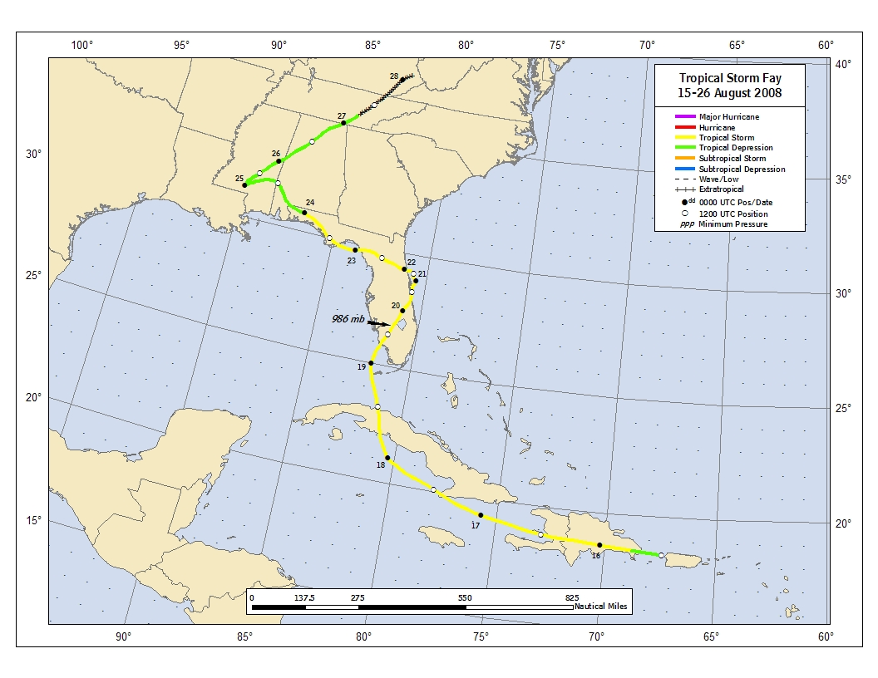
Figure 1. Best track positions for Tropical Storm Fay, 15-26 August 2008. Track positions during the inland tropical
depression and extratropical stages are based on a blend of analyses from the NOAA Hydrometeorological Prediction Center
and the National Hurricane Center.
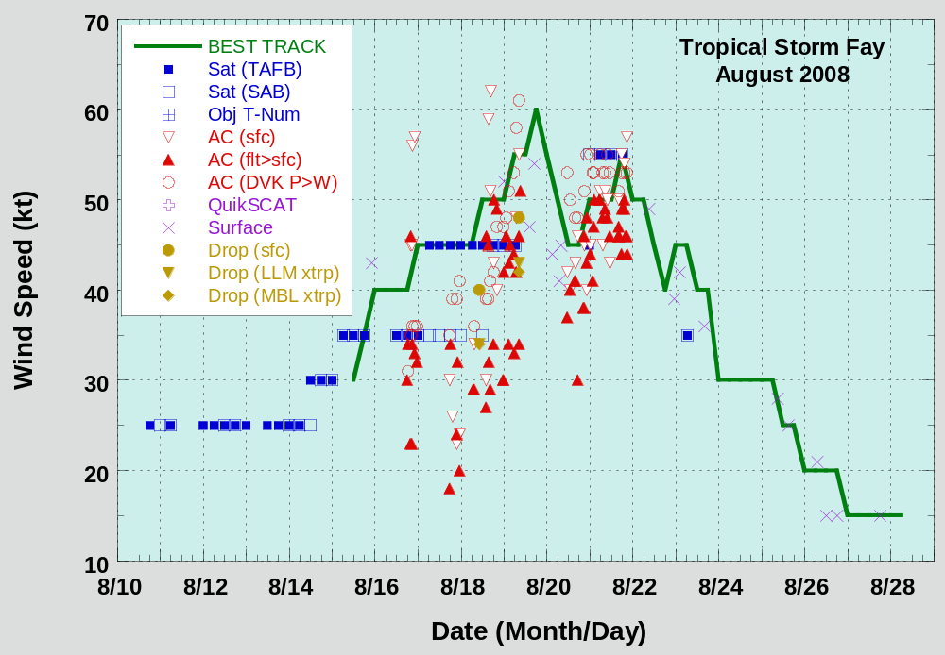
Figure 2. Selected wind observations and best track maximum sustained surface wind speed curve for Tropical Storm Fay,
15-26 August 2008. Estimates during the inland tropical depression and extratropical stages are based on a blend of analyses from the
NOAA Hydrometeorological Prediction Center and the National Hurricane Center. Dashed vertical lines correspond to 0000 UTC.
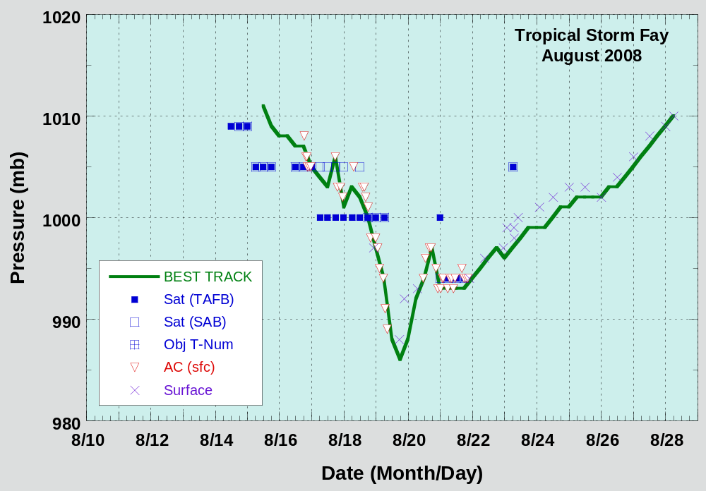
Figure 3. Selected pressure observations and best track minimum central pressure curve for Tropical Storm Fay,
15-26 August 2008. Estimates during the inland tropical depression and extratropical stages are based on a blend of analyses from the
NOAA Hydrometeorological Prediction Center and the National Hurricane Center. Dashed vertical lines correspond to 0000 UTC.
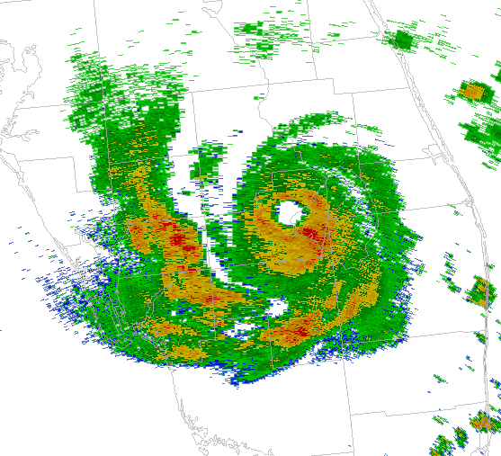
Figure 4. 1811 UTC 19 August 2008 NOAA Doppler radar reflectivity image. Tropical Storm Fay was at its peak intensity of
60 kt while the eye was skirting the northwestern portion of Lake Okeechobee, Florida. A well-defined eye feature developed at 0929
UTC 19 August 2008 – shortly after moving inland over southwestern Florida – and persisted until 0212 UTC 20 August2008. Fay
remained over land during the entire period that the eye feature was apparent in radar imagery.
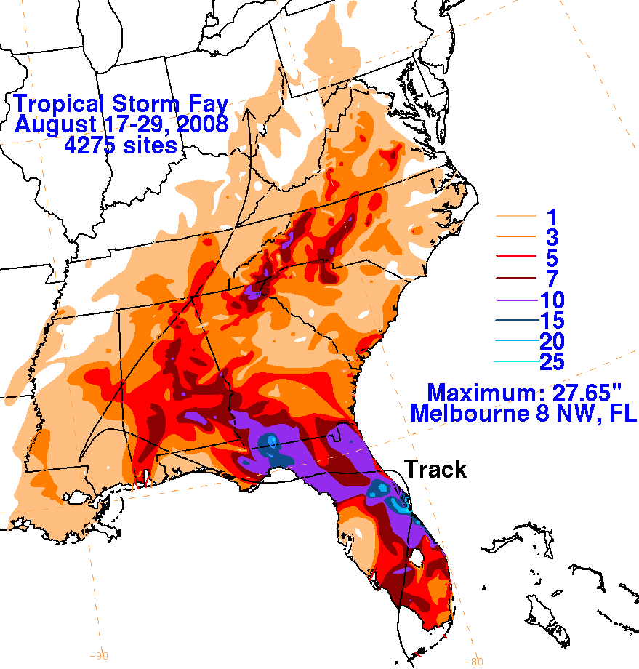
Figure 5. Rainfall totals associated with Tropical Storm Fay over the southeastern United States
(graphic courtesy of NOAA/NCEP Hydrometeorological Prediction Center).

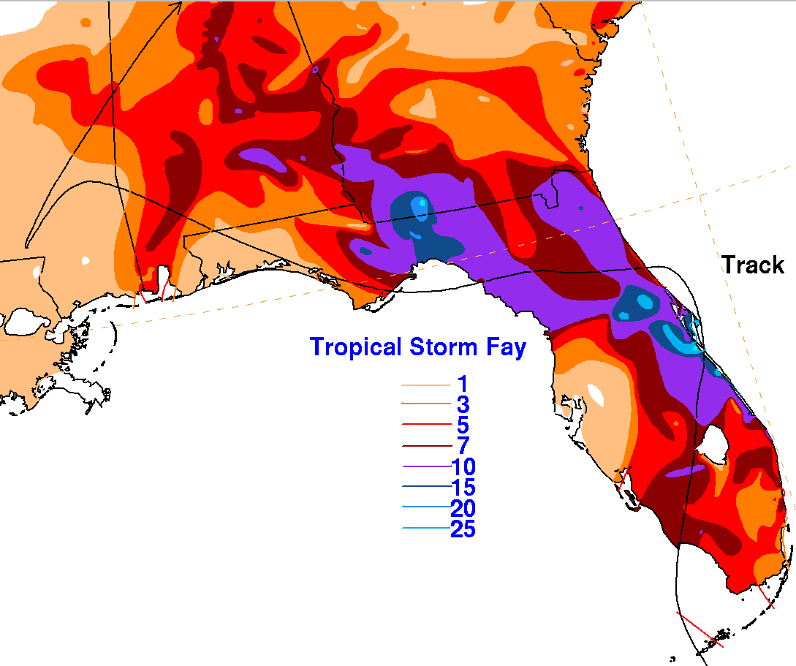
Figure 6. Rainfall totals for Tropical Storm Fay during its traverse across Florida, Georgia, and Alabama.
Rainfall maxima of 27.65 in and 27.50 in occurred 8 n mi northwest of Melbourne, FL and at Thomasville, GA,
respectively (graphic courtesy of NOAA/NCEP Hydrometeorological Prediction Center).

A digital record of the complete best track, including wind radii, can be found on line at ftp://ftp.nhc.noaa.gov/atcf. Data for the current year’s storms are located in the btk directory, while previous years’ data are located in the archive directory.

