USDA Foreign Agricultural Service
GAIN Report

Global Agriculture Information Network
Template Version 2.09

Voluntary Report - public distribution
Date: 5/26/2006
GAIN Report Number: BR6007
BR6007
Brazil
Market Development Reports
Diet & Light Products in Brazil
2006

Approved by:
Morgan Perkins, Director
U.S. AGRICULTURAL TRADE OFFICER
Prepared by:
Fabiana Fonseca, Agricultural Marketing Specialist

Report Highlights:
Brazilian consumers are beginning to reappraise their diets as health and nutritional values develop. In 2005, sale of diet and light products increased 17 percent. The local industry is responding to this trend but the variety of products offered to consumers is below expectations. US companies may find a new segment to explore.

Includes PSD Changes: No
Includes Trade Matrix: No
Unscheduled Report
Sao Paulo [BR3]
[BR]

I. Market for Diet and Light Products

Traditional foods –such as rice and beans - are losing their importance in Brazilian dining. According to the Ministry of Health (MS), the consumption of beans, for instance, has decreased 31 percent in the last 30 years and the downward trend continues. Changes in eating habits are also observable in decreasing consumption of vegetables and fish: Consumption of these items has fallen by 19 percent and 50 percent, respectively, over that period. Brazilians have broader access to processed products but the quality of what they are eaten has deteriorated. In the same 30-year period, consumption of industrialized food products grew 82 percent.

Consumption of processed products is unlikely to decline. However, the number of consumers trying to compensate the lack of healthy eating habits is also growing. According to the Brazilian Food Industry Association for Diet and Functional Products (Abiad), the market for products containing less fat, less cholesterol, less additives, etc, is growing. Fitness awareness, improved knowledge of proper dietary patterns, and the desire to prevent illness by eating properly are a few of the motivations leading Brazilian consumers to change their behavior. Sales of diet and light products are benefiting from this trend.

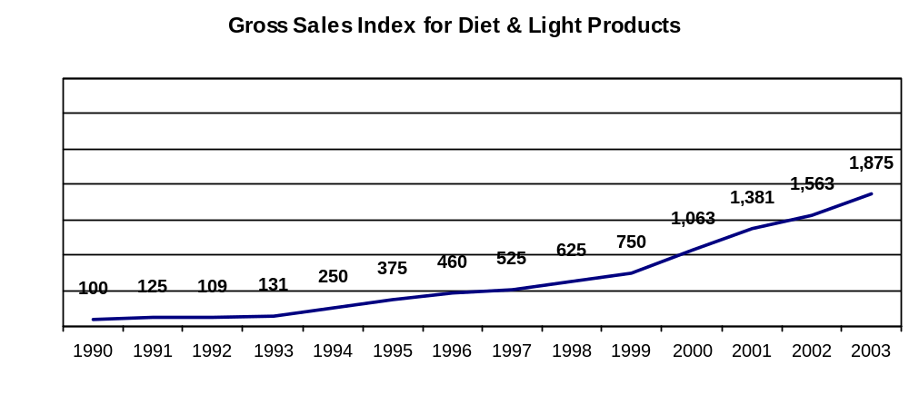
Source: Abiad

To capitalize of this trend the Brazilian food industry has broadened product lines and launched new brands. According to a recent study conducted by AC Nielsen and published by the Brazilian Supermarket Association (Abras), brands of healthy products are gaining market share. This research demonstrates that sales of this “healthy” foods increased 17 percent in 2005.

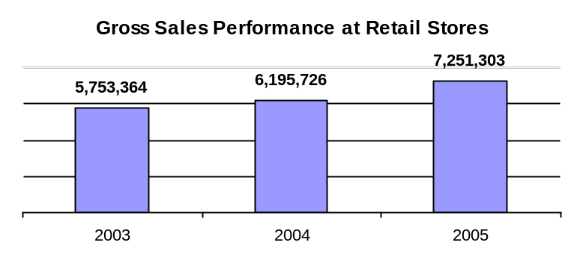

Source: AC Nielsen

Large retail stores (10 check-outs and plus) accounted for more than 50 percent of healthy products sales. However, small stores (less than 10 check-outs) have shown growth as well, as indicated on the table below.

Where are Healthy Products Sold?  Sales by Store Size (% total “healthy” food sales) |  |  |  | Year to year increase in sales of Healthy Products (% total sales)
 | 2003 | 2004 | 2005 | Δ 2003 to 2004 | Δ 2004 to 2005
Over 20 check-outs | 30.7 | 29.0 | 29.5 | 1.7 | 15.7
From 10 to 19 check-outs | 26.7 | 26.5 | 25.1 | 6.8 | 21.3
From 5 to 10 check-outs | 14.7 | 14.8 | 15.4 | 8.5 | 21.3
From 1 to 4 check-outs | 15.7 | 16.9 | 17.5 | 15.6 | 10.7
Traditional | 12.2 | 12.8 | 12.5 | 13.2 | 19.0

Source: AC Nielsen

II. Consumption Patterns

Brazilian consumers tend to follow Europeans on eating habits. Researchers (such as Glaucia Pastore from the University of Campinas (Unicamp), Sao Paulo) claim that Brazilians are more receptive to functional foods than to supplements. During interviews conducted by AC Nielsen to find out why consumers purchase healthy products, four major motivational factors were revealed. Fifty-two percent of individuals responded they are becoming more health conscious (mainly those from 30 to 45 years old and from 46 to 60 years old). For 13 percent medical reasons are a key factor. Consumers for whom weight control is the bottom line represented 12 percent, while those seeking “well-being” encompassed another 12 percent. “Self-image” orientation is responsible for 6 percent of purchases and “self-satisfaction” another 4 percent. One percent of consumers buy diet and light products out of curiosity.

Today, sales of healthy products are mainly concentrated in the most affluent areas of the country, in particular the state of Sao Paulo (41 percent of total sales) and Southern Brazil (Santa Catarina, Parana and Rio Grande do Sul), which accounts for 18 percent of sales volume. For these markets, hot products categories include: chocolate (powder), sweeteners, olive oil, soy beverages, cake mixes, instant cappucino, tea, spirits/sodas, yogurt, fruit juices, bread, jello, cereal bars, juices (powder), milk, cheese, soups, breakfast cereals and ready-to-eat meals (frozen).

III. Legislation

According to Brazilian parameters diet and light products are defined as follows:
Diet: food products for consumers with dietary restrictions. “Diet” also means products with no sugar.
Light: food products with at least 25 percent less calories or other nutrient(s) compared to the regular version.

Diet and Light products are under the regulation of the Ministry of Health (ANVISA). All local food products claiming to have special functions are subject to ANVISA’s prior authorization. In addition, such products should be registered by the same government agency. The importer must prepare and file a request and obtain approval before importation (for more information on labeling, packaging and ingredients, please see FAIRS report).

The specific legislation on this topic include:
- Decree #38, January 13th, 1998
- Decree SVS/MS #27, January 13th, 1998
- Decree SVS/MS #29, January 13th, 1998
- Decree SVS/MS #30, January 13th, 1998
- Decree SVS/MS #222, March 24th, 1998
- Resolution #449, September 9th, 1999
- Resolution #18/1999

IV. Market for US products

US companies may benefit from the narrow variety of products offered by local industry, as Brazilian production of healthy foods is still shaping-up. In general, consumers of healthy foods are not a segment that drives Brazilian food processors to launch a significant range of food and beverage items in the short run, which demands significant investment on clinical and scientific investigations. This opens substantial opportunities for imported products. To illustrate: after the findings of a research pointing to a 30 million potential consumers for the product, the multinational Danone introduced the yogurt Activia in Brazil just one year ago. The same item had been present on the French market for 20 years, but no comparable product had been available in Brazil. US companies may find room to compete in this segment due the slow response of the food industry versus the increasing demand from this specific consumer.

V. Post Contact

Please do not hesitate to contact the offices below for questions or comments regarding this report or require assistance to export processed food products into Brazil:

U.S. Agricultural Trade Office (ATO)
U.S. Consulate General
Rua Henri Dunant, 700
04709-110 Sao Paulo - SP
Tel: (55 11) 5186-7400
Fax: (55 11) 5186-7499
E-mail: atosaopaulo@usda.gov
atobrazil@usdabrazil.org.br

Office of Agricultural Affairs (OAA)
U.S. Embassy
Av. das Nacoes, quadra 801, lote 3
70403-900 Brasilia - DF
Tel: (55 61) 3312-7000
Fax: (55 61) 3312-7659
E-mail: agbrasilia@usda.gov

