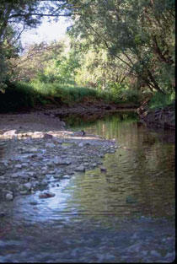
Milwaukee Road Redevelopment

Developer/Sponsor:
Menomonee Valley Partnership, Inc., City of Milwaukee, Went Associates, Solomon/WRT, HNTB
Other Contributors:
Menomonee Valley Business Improvement District, Menomonee Valley Business Association, City of Milwaukee Department of City Development, Milwaukee County Economic and Community Development Division, Milwaukee Economic Development Corporation, Sixteenth Street Community Health Clinic, Forest County Potawatomi Community, WE Energies, Friends of the Hank Aaron State Trail
Status: Under Construction 1996-2010

Aim:
Developers aim to restore 200 acres of Milwaukee Road to its former glory as one of the main industrial centers—with a few alterations. Each building will comply with the Sustainable Design Guidelines set forth by the City of Milwaukee and Menomonee Valley Partnership (MVP), to promote energy efficient “green” facilities. Included in the redevelopment will be 70 acres of green space that re-establish Milwaukee Road’s previous ecosystems and protect them from further damage. In addition to considering environmental aspects developers will contribute to the community and economy by selling parcels to companies offering the most family-supportive jobs. Family supportive jobs entail high wages and health benefits. Upon completion, city officials estimate 1,830 new jobs will be created.
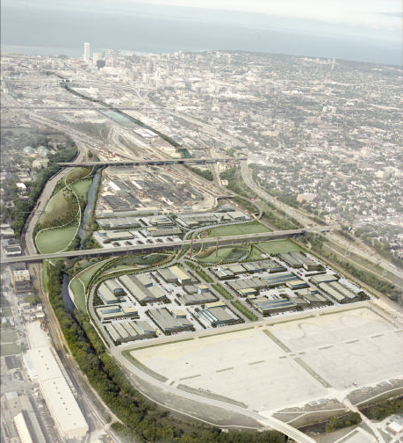
“A revitalized Valley at the Center of Milwaukee; economically with strong companies and jobs near workers’ homes, geographically with renewed ties to the surrounding city, ecologically with healthy waterways and greenspace, and culturally with firm roots in its past and a role in histories to come.”—Aim of Milwaukee Road Redevelopment

Project Description:
The Milwaukee Road is an extensive brownfield redevelopment project incorporating green technology and economic stimulation through job creation. The Menomonee River Valley consists of 1,500 acres and drains into a watershed, ultimately ending up in Lake Michigan. Previously the site was home to the first railroad between Wisconsin and Minnesota, known as the Milwaukee Road, and the subsequent locomotive and rail car repair shops inhabiting what is currently the Milwaukee Road Shop Site. In 1985, after 106 years of service, the railroad declared bankruptcy; the surrounding industries declined and the land became vacant. Rebuilding on the site was postponed because the land was considered a brownfield. Stigmas associated with brownfields delay redevelopment because of the fear of contamination and safety of rebuilding, as well as the costs of clean up. However, in 2002, after conclusive findings of mostly minor contamination from in-depth investigations, redevelopment commenced. The project itself is divided into three sections beginning with the West End, which extends from the Menomonee River to 27th Street, Central Valley beginning at 27th Street and ending at the I-94/I-43, and finally the East End starting at the I-94/I-43 and ending near Downtown Milwaukee.

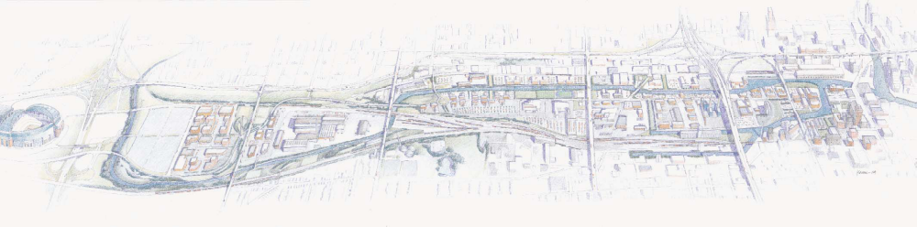
West End
Central Valley
East
End
Downtown
Milwaukee
Menomonee
River
35th Street
27th Street
16th Street
I-94/I-43
West End:
Consisting of 70-acres designated for light industry and 70-arces for a community park the West End is a premier location for development. The 70-acres reserved for a community park will be sectioned into three separate parks, namely, Chimney Park, River Lawn, and Airline Yards. The 70 acres allotted for light industry have yet to be sold completely, however Palermo has committed to constructing their manufacturing plant in the West End of the Menomonee River Valley.

Chimney Park pays homage to the history of Milwaukee Road with the placement of two Chimney Stacks as the focal points of the park. The park provides visitors with three soccer fields, two basketball courts, four handball courts, picnic areas, a playground, a skate park, and a sand volleyball court. A community gathering space consisting of a multipurpose indoors meeting space and basic facilities will also be built. To facilitate surrounding industrial buildings there will be naturalized stormwater management in the form of wetlands, ponds and meadows. There will also be a swamp forest reconstructed to restore the habitat and assist in additional stormwater management needs. In total there will be nine acres of stormwater management within Chimney Park.

River Lawn gives visitors access to the Menomonee River for kayaking and canoeing. These access points were constructed to provide flood control and improve habitats along the banks. Builders integrated limestone walls into the landscape along the rivers to both protect and provide seating for visitors. A network of trails both for walking and bicycling are found at River Lawn as well.

Airline Yards is 23 acres and possesses 2,600 feet of riverbank. This park represents the definitive attempt to restore the natural habitats and environment found in the Menomonee Valley prior to human contact. As a result three large mounds, reminiscent of the glacial drumlins once populating this area, are located within Airline Yards. These mounds were constructed using debris collected from the Milwaukee Shops site, filled in, and then covered with native foliage. The landscaping of the park includes a variety of environments including savannah, upland prairies, riparian forest, wetlands, bluffs, and meadows. Easy access points to the river are also provided for visitors as well as a network of trails, and athletic fields.

Palermo Villa Inc., the nations second fastest frozen pizza manufacturer, is the first business to purchase land at the Milwaukee Shops site. They will construct a manufacturing plant on 14 acres to consolidate their facilities in both Milwaukee and Illinois. Palermo will bring approximately 190 new jobs with substantial wages to the Menomonee Valley. As per agreement Palermo will construct its new plant in accordance with the Sustainable Design Guidelines.

Central Valley:
The Central Valley is composed of the Stockyards parcels. These sections of land will be sold to “high-quality, high-yield” industries.

In 2003 The Sigma Group relocated their 28,600 square foot headquarters to demonstrate that safe relocation on a brownfield is possible. The Sigma Group Environmental Headquarters adheres to the Sustainable Design Guidelines making it energy efficient and environmentally friendly. They are currently studying the environmental effects of their headquarters in order to quantify the impact. (For Information on Sigma Impact Study Click Here [http://epic.cuir.uwm.edu/mvbi/pdfs/sigma_impact_report.pd])

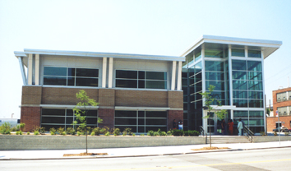
The 40,000 square foot Potawatomi Administration Building is also reconstructed within Central Valley. This building houses the Potawatomi Casino’s human resource department, the marketing department and the tribe’s legal department, as well as The Forest County Potawatomi Community Foundation. This exemplary building incorporates many green components compliant with the Sustainable Design Guidelines. In addition to being environmentally cognoscente, developers of the Potawatomi Administration Building purchased locally made products in order to contribute to the economy while saving money on shipping expenditures.
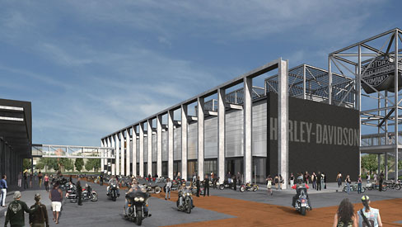
East End:
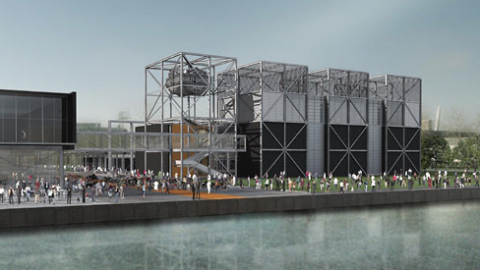
The highlight of the East End is the Harley-Davidson Museum. The project will consist of three separate buildings totaling 130,000 square feet. The first will house the museum, the second annex and archives, and the third will contain a restaurant, café, retail shops, and a special events facility. Another phase will be constructed at a later date to provide offices for Harley-Davidson employees. The $95 million dollar development will offer 70 permanent full-time jobs to residents and approximately 350 temporary construction jobs. In addition to contributing to the economy, the developers will also improve the environment. Harley-Davidson has committed to abide by the Sustainable Design Guidelines. (For more information on the Harley-Davidson Museum Click Here [www.h-dmuseum.com])
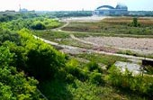
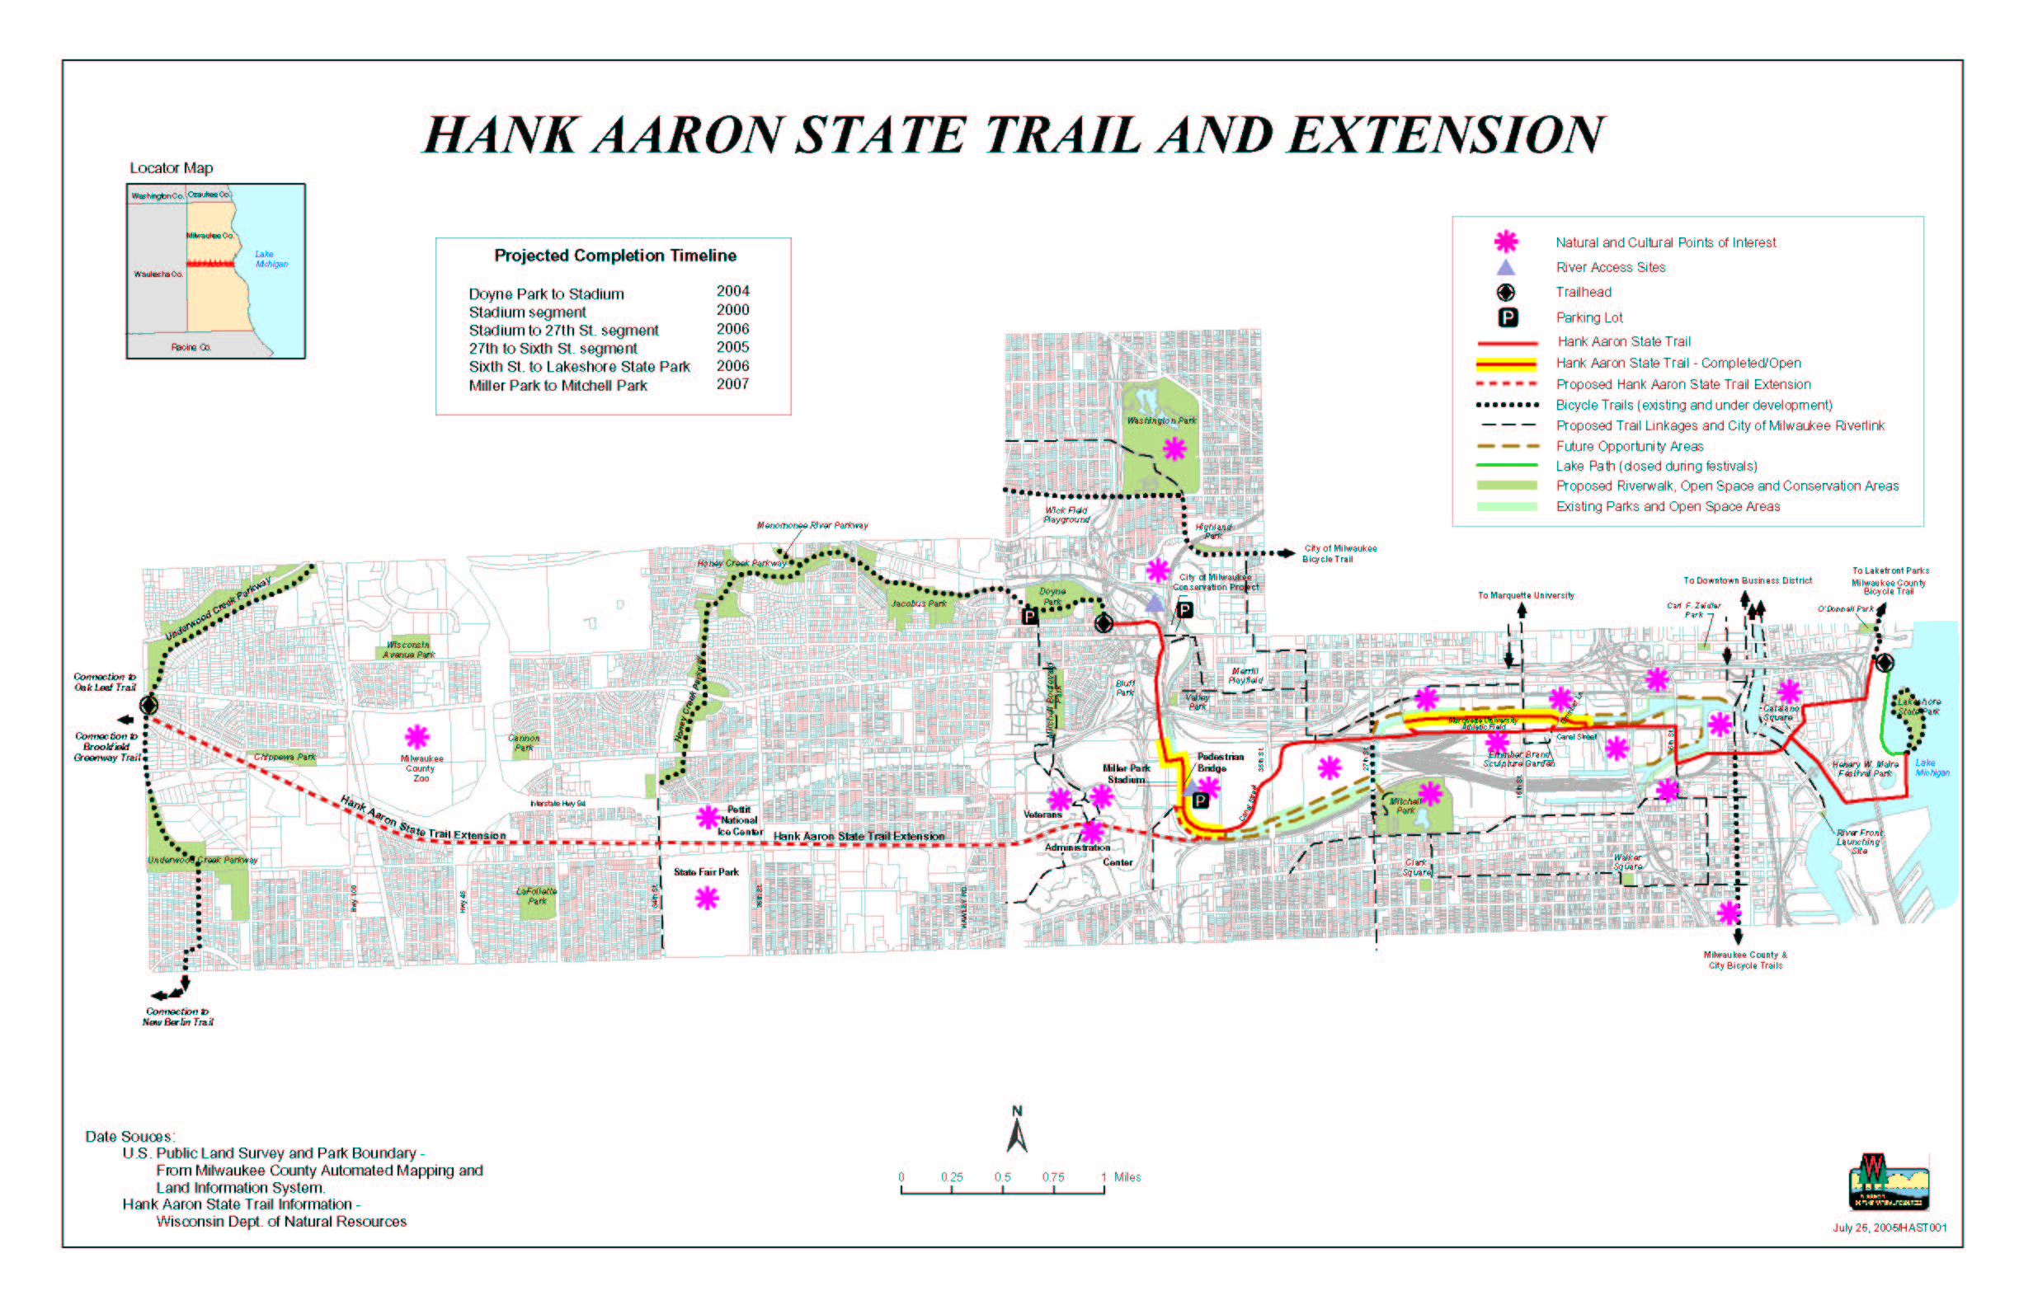
The Hank Aaron Trail, once extensions are finished, will be seven miles in length. It will connect with the Oak Leaf Trail, and will traverse the entire county of Milwaukee. The trail will take bicyclists and hikers through the Menomonee Valley as well as the historic districts surrounding the valley and other notable attractions. The Friends of the Hank Aaron Trail are committed to restoring the natural environment that was once present in the Valley along the trail. In order to re-establish the prairie environment The Friends of the Hank Aaron Trail are using controlled fires, mowing, seeding native plants, and removing aggressive non-native plant species. (For more information on the Hank Aaron Trail Click Here [http://www.hankaaronstatetrail.org/])

Green Components:
The Sigma Group Headquarters:
- Extensive Natural Day Lighting—12% decrease in lighting expenditures compared to previous location, 85% Increase in Natural Day Lighting
- Creation of 59,240 feet of Tree Canopy
- 14% Reduction in storm Water Run-off
- 36% Increase in Green Space
- Low Flow Drainage Fixtures
- 100% Reduction in Salt, Fertilizer, and Pesticides
- Capped/Removed Polynuclear Aromatic Hydrocarbon (PAH) contaminated soil
- High Efficiency HVAC roof Top Unit
- Baseboard Electrical Units
- High Efficiency Gas-filled Rotary Unit (Heating)
- Native Planting, Eradicating Non-native Plants
- Passive Methane Venting System

The Potawatomi Administration Building:
- Recycled Brick and Carpeting
- Recycled Materials from casino construction
- Exterior Sunshade
- Grass Roof
- High Efficiency Lighting Fixtures
- Optimal use of Natural Lighting
- 3 40-ton HVAC units

Harley Davidson Museum:
- Reflective Roof (Heat Absorption)
- Permeable Pavement
- Lawns, Terraces, Native Plantings, Native Trees
- Creation of Green Space

For other green components that will be found in future buildings constructed in Menomonee Valley click here (Sustainable Guidelines Website http://design.renewthevalley.org/images/pdf/GuidelinesPrintable.pdf)

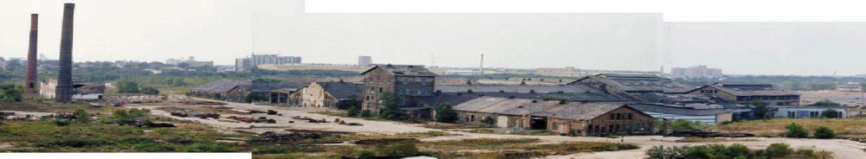
Environmental Complications and Solutions:
The Menomonee Valley is a brownfield and required intensive environmental investigations in order to ascertain the state of the valley and the safety of redevelopment on the site. Studies were conducted on Flood Plain, Soil Contamination, Air Quality, Groundwater, and Stormwater Management, each one of these required mitigation efforts to bring the redevelopment into compliance with both State and Federal standards. The majority of the test and evaluations done to ensure conformity to codes and regulations has been performed by the Menomonee Valley Benchmark Initiative (MVBI). MVBI has identified and grouped 50 indicators, and will observe them in five-year intervals.

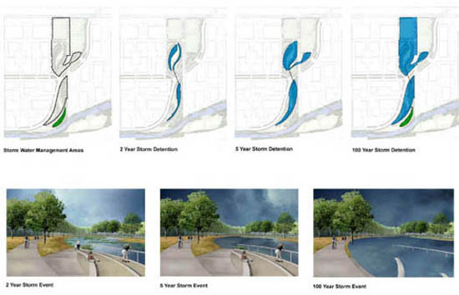
Flood Plain:
The Southeast Wisconsin Regional Planning Commission (SEWRPC) conducted a preliminary analysis of the flood plains, specifically at the Milwaukee Road Shops redevelopment site and Airline Yards site. The study found that the Shop site needed to be raised, but the Airline Yards development was for the most part excluded from the flood plain, negating the need for flood plain mitigation. SEWRPC also determined that the Shop site must withstand a 2,000 cubic feet per second flow in a 100-year old flood event. The Milwaukee Zoning Code also demands that the building floor be two feet above the regular flood elevation as well as any area within 15 feet of the building. Mitigation efforts began as eight feet of fill, transferred from the Marquette Interchange, were added to the Shop site. Restoring the natural environment is also an important measure that will contribute to the decrease in flooding. Another core component is the Hydraulic Modeling system. The USGS conducted a study of the flow systems present in the Menomonee Valley in order to determine the destination and effects of recharge in the valley. With this strategy the applicable 100 acres would have no surface water discharge. Developers maintain that the Shop site will be ready for construction in late 2006, early 2007 after the fill settles.
Left: Storm Events, 2 year, 5 year, and 100 year (top to bottom)

Right: Storm Water Management Area, 2 year, 5 year, and 100 year Storm Detention (top to bottom)

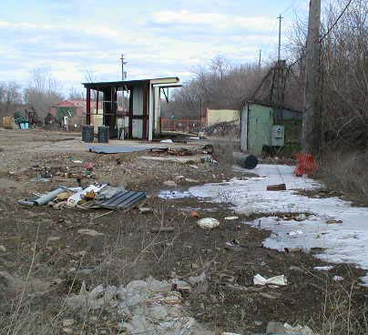
Soil Contamination:


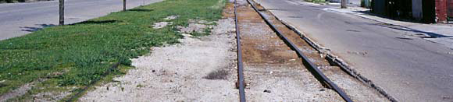
Soil Contamination poses a potentially dangerous threat throughout the valley due to the history of the site. Prior construction the site was a wetland and then a railroad and industrial center. Because of peat moss deposits and the wetlands, methane gas is a risk across the valley. The railroads and industries have left relic structures including floor slabs, sewers and foundations, causing a risk for heavy metal and Polynuclear Aromatic Hydrocarbon contamination. As a result the redevelopment site has gone through extensive testing and geotechnical evaluations. In order to impede any further damage, developers have buried contaminated soil under several feet of fill, and severely contaminated soil was extricated to another location. A designated onsite placement area for contaminated soil will be created for future projects. Engineering and institutional controls for future developments include a long-term, right-of-entry agreement giving the city access to groundwater monitoring, sampling, and NAPL collection trench sampling ports and a mandatory two foot thick clean soil cover or pavement cover. In addition, methane mitigation is mandatory and is the responsibility of the developer; recommendations for methane mitigation include passive methane/soil gas collection systems.

Air Quality:
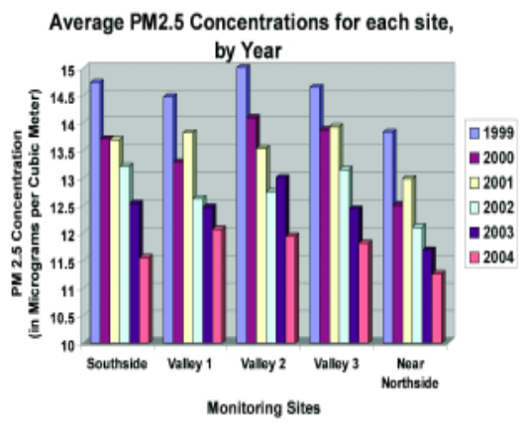
Menomonee Valley is centrally located in a metropolitan area, and while that holds many industrial benefits the air quality can be greatly compromised because of the placement of highways through the valley as well as its location near downtown Milwaukee. The MVBI is monitoring both mobile and non-mobile emissions to determine the severity of impact on the air quality at the site of the redevelopment project. In addition to monitoring the Fine Particulate Matter (PM2.5), MVBI is monitoring five prevalent air toxins; Formaldehyde, Acetaldehyde, Benzene, 1,3-Butadiene, and PCBs, and both one hour and eight hour ozone concentrations.

The PM2.5 are being recorded every third calendar day by the Wisconsin Department of Natural Resources in various locations across the valley. These PM2.5 pose a significant threat to humans, once they are inhaled they are imbedded into the deep lunge tissue causing respiratory problems and a variety of health issues. The National Ambient Air Quality Standards set the average annual concentrations below 15ug/m3, and average 24-hour concentrations no greater than 65ug/m3. Over the past six years the amount of PM2.5s is declining rapidly and falls within the federal standards.
EPA Recommendations
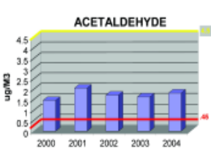
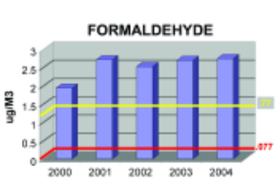
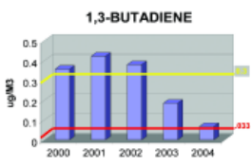
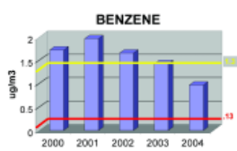
Fifty-six toxic compounds are presently being monitored at Menomonee Valley. Of the fifty-six, Formaldehyde, Acetaldehyde, Benzene, 1,3-Butadiene, and PCBs have been assessed as the highest health risk. These compounds are known to be possible carcinogens, causing various other health conditions, and have a negative effect on the environment. These toxins
Yellow Line: 1 in 1,000,000
Red Line: 1 in 100,000
Yellow Line: 1 in 1,000,000
Red Line: 1 in 100,000
Toxic Compounds | (cancer risk)  1 in 100,000 | 1 in 1,000,000
Acetaldehyde | .45ug/m3 | 4.5ug/m3
Formaldehyde | .077ug/m3 | .77ug/m3
1,3-Butadiene | .3ug/m3 | .033ug/m3
Benzene | 1.3ug/m3 | .13ug/m3

were observed from 2000-2004 at Valley 1, located at 1337 S. Cesar Chavez Drive. As no National Ambient Air Quality Standards address toxic compounds the Environmental Protection Agency standards were applied (see table). Of the five compounds only 1,3-Butadiene is below the standard. PCBs in 2004 finally declined, falling below the Environmental Protection Agency’s annual average of 0.45ng/m3. In all prior years (2000-2003), the average of PCBs at Valley 1 exceeded the Environmental Protection Agency’s recommended maximum average.

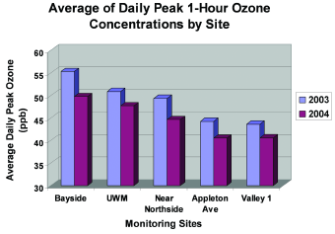
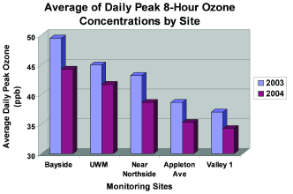
The final component that the MVBI recorded was the one hour and eight hour ozone concentrations. The National Ambient Air Quality Standards establish that the average one-hour ozone concentration cannot exceed 124 ppb (parts per billion) and the average eight-hour ozone concentration cannot exceed 84 ppb. Observations took place at Valley 1 and hourly readings were recorded; the greatest reading of the day is termed the daily peak 1-hour ozone concentration. The average daily peak 1-hour ozone concentrations were well below the standards and were considerably lower in 2004 than in 2003. The eight-hour ozone standard is the federal government standard that replaced the 1-hour ozone standard. Likewise, the average daily peak 8-hour ozone concentration was significantly lower than the 84ppb standard. The highest readings in close proximity to the valley were 74ppb and 82ppb, still below the federal standard.

Groundwater:
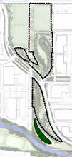
The groundwater within the Menomonee Valley was examined meticulously by the City of Milwaukee and USGS from 1999-2001. The study was divided into separate parts, the first studying the location and flow of the groundwater through the valley, and the second determined the extent of contamination through chemical sampling (It is important to note that the final location of all surface water was impossible to determine conclusively because of the history of the site and the various waterways). Studies determined that there were two main receptors for shallow groundwater; the Deep Tunnel System and the Menomonee River, flowing into Lake Michigan. For surface water within 100 feet of river or canals, the final destination was not conclusive. Nevertheless, the approximate time for groundwater to travel from the valley to the Deep Tunnel System is 250 years, which is a substantial amount of time allowing for elimination of contaminants through natural mechanisms. In the event that contaminates are not completely dissolved, all water from the Deep Tunnel System is directed to the Jones Island Treatment Plant. The USGS confirmed that there was little cross flow between properties, negating the potential for widespread groundwater contamination. However, some site-specific contamination was present and can be handled on a case-by-case basis with the assistance of the Wisconsin Department of Natural Resources (WDNR). Typically mitigation measures such as removing the effected soil and monitoring for 1-2 years should rectify the situation.
SMA 1
SMA 2
Swamp Forest
(For more information regarding the groundwater study click here [http://www.renewthevalley.org/files/pdf/epareport.pdf])

Stormwater Management:
The Menomonee Valley stormwater management stratagem is founded on natural means. Developers are restoring wetlands and green space once prevalent in the valley and incorporating stormwater management into parks. There will be two main stormwater management areas and a Swamp Forest to accommodate stormwater from the surrounding developments. These three areas will treat stormwater in three steps. First, all water will be collected and transferred through a system of pipes where it will accumulate in small pools of water. Second, stormwater will
disperse across the shallow wetland meadows and will infiltrate through crushed pieces of concrete (this layer is known as an ‘infiltration gallery’). The stormwater will then be distributed to the Swamp Forest where the natural vegetation will remove contaminants. In order to decrease the actual amount of stormwater, builders must limit the number of impervious surfaces. By promoting permeable surfaces infiltration of stormwater will be amplified. Builders are also being urged to increase canopy coverage on their property, which will in turn contribute to the reduction of stormwater.

(For more information on MVBI Click Here [http://epic.cuir.uwm.edu/mvbi/other_docs.htm])
(For more information on the Master Land Use Plan Click Here [http://www.renewthevalley.org/files/pdf/MVIC%20-%20Master%20Use%20Plan%20-%20RACM%20Adopted.pdf])

Financial Structure

Section 108 $10,000,000
BEDI $2,000,000
EPA Clean Up Grant $200,000
EDA BCR Loan Fund $1,125,000
HUD Neighborhood Grant $1,950,000
DNR SUDA Grant $837,000
WI Commerce Grant $1,250,000
Redevelopment Authority Loan $6,475,000

Total: $23,837,000

