PROCESSING MATERIALS, DEVICES AND DIAGNOSTICS FOR THIN FILM PHOTOVOLTAICS:
FUNDAMENTAL AND MANUFACTURABILITY ISSUES

Annual Report
to
National Renewable Energy Laboratory
under
Subcontract No. ADJ-1-30630-12
9/05/02 to 9/04/03


Institute of Energy Conversion
United States Department of Energy
University Center of Excellence

For Photovoltaic Research and Education
(National Renewable Energy Laboratory)

Annual Report
to
National Renewable Energy Laboratory
under
Subcontract No. ADJ-1-3-630-12
9/05/02-9/04/03

R. W. Birkmire, W. N. Shafarman, E. Eser,
S. S. Hegedus, B. E. McCandless, R. Aparicio, K. D. Dobson

Institute of Energy Conversion
University of Delaware

United States Department of Energy
University Center of Excellence
For Photovoltaic Research and Education
(National Renewable Energy Laboratory)

Newark, Delaware 19716-3820

SUMMARY

CdTe/CdS based solar cells

Investigations of the dynamics of CdTe etching have continued. Variable Angle Spectroscopic Ellipsometry (VASE) has shown that bromine-methanol (BM) etching to be consistent and very reproducible. BM polishing of CdTe will be used for sample preparation for a systematic investigation of nitric-phosphoric (NP) etching of CdTe, to accurately determine Te thickness.

A number of devices, contacted with Cu-containing graphite paste, were prepared to monitor the effects of different etch treatments on cell performance and stability. Devices processed from Br₂-based etches of high viscosity, and hence extremely thin Te-rich surface films, were found to shunt within a few hours of processing, due to the inability of the thin Te to getter Cu. Devices processed using NP etches of different times, and contacted with Cu-containing graphite paste, initially all showed similar performance. Following stressing, no decrease of V_{OC} or J_{SC} was observed, however, the R_{OC} of devices that had received shorter NP etches had significantly increased, while longer etched samples showed very little change in R_{OC}. These changes are indicative of back contact degradation and again suggest that devices with back contacts processed with thicker Te components will exhibit improved stability due to improved Cu gettering and compensation of other chemical changes.

The chemistry of Cu with Te-rich CdTe surfaces, prepared by different etch treatments, was investigated. The Cu was supplied from graphite paste contacts. Differences in the copper telluride product were observed, dependent on etch type and chemical nature of Cu. The thicker Te-rich layer formed by NP etching results in a higher degree of the CuTe phase, on reaction with Cu-powder or Cu salts in the graphite paste, compared to BM etching. CuCl and CuI appear to form Cu_{2-x}Te on BM etched CdTe, while Cu powder forms CuTe. Initial results were complicated by the presence of residual crystalline graphite from the paste, however this residue can be easily removed.

Effects of stressing cell components and completed devices in conditions of varying humidity were monitored. TeO₂ and CdTeO₃ were found to be formed at lower humidities on CdTe, while the formation of amorphous hydroxide, oxide or hydrate phases are more likely at higher humidities. The IEC back contact appears to be stable at higher humidities, but is oxidized to TeO₂ at low humidity. This suggests that copper tellurides are more susceptible to oxidation by atmospheric oxygen. However, despite the extensive chemical changes observed, device performance was almost unaffected. In contrast, First Solar devices showed significant degradation. The robustness of the IEC back contacts is proposed to be due to the thick, 100 nm, Te film present in the back contact, which compensates chemical changes to the contact.

High efficiency CdTe/CdS devices require a robust and durable thin CdS film, which maintains a continuous layer for uniform junction formation. We investigated the relationship between device processing, materials properties and device performance for cells with CdS films deposited by chemical surface deposition (CSD), which produces conformal ultra-thin CdS films with low particulate density and high utilization of Cd species. In CSD, a solution at ambient temperature is applied to a pre-heated glass/TCO substrate. Film deposition proceeds by heterogeneous nucleation at the surface as heat is transferred to the solution. Heat loss from the solution to the ambient helps maintain conditions favorable for film growth over the time needed typically ~ 5 min. The focus has been on establishing and understanding baseline processing procedures for the CdS/TCO superstrates and post-deposition procedures for completed CdTe/CdS structures. The processing variables investigated here for CdS/TCO were time and temperature of the CdCl₂ treatment given to the CSD CdS prior to CdTe deposition and use of a high temperature anneal (HTA) step. Measurements of a film 90 nm thick CdS films on Ga₂O₃/SnO₂/glass before and after vapor CdCl₂ treatment at 430°C shows significant recrystallization based on sharpening of the transmission band-edge and sharpening of diffraction peaks (GIXRD). It was found that CdS films grown on Ga₂O₃ have larger grain size than those on glass.

Having established that CdCl₂ treatments change the CdS properties, we optimized the device performance by varying CdCl₂ temperatures (350-430°C) and times (5-20 minutes). In general, efficiency improved with increasing the temperature and time. Therefore, a temperature of 430°C and time of 20 min was selected for CdS treatment in subsequent studies.

Since the CdS is deposited from a Cl based-solution, it was possible that a HTA would be sufficient to activate the CdS grain growth against further interdiffusion, thus, eliminating the need for a separate CdCl₂ treatment of the CdS. Devices were made with and without the HTA and CdCl₂ treatments to CdS prior to CdTe deposition. The CdS CdCl₂ treatment was at 430°C for 20 min and the HTA was at 550° for 30 min in Ar. Also included in this study were substrates of glass/SnO₂/CdS from First Solar. They did not receive any treatments since the CdS was deposited at high temperature. J-V results showed that cells with the CdS HTA alone or in combination with CdCl₂ had reduced FF. The best cell on three identically processed pieces with CdCl₂ only (no CdS HTA) ranged from 10-11%. Yields were better than 75%. Cells with HTA had 9-10% efficiency. Devices on First Solar CdS had similar V_{OC} and FF to cells on CSD CdS. We conclude that our CSD CdS is not a major limitation to higher V_{OC} or yield at this time providing it has a CdCl₂ pre-treatment.

We are continuing to investigate the relationship between CdTe deposition and film properties for cells with CdTe deposited at a high rate on moving substrates by vapor transport (VT). The VT deposition process is similar but not identical to that used at First Solar. The influence of He and O₂ flow rate (2% O₂/He) and pressure during the CdTe growth was investigated using AFM, GIXRD and contact wetting angle. As compared to the baseline run, increasing the total flow of helium through the source, results in a substantial decrease in grain size. Decreasing the total flow of He yields slightly larger, more densely packed CdTe grains. Increasing the ratio of helium to oxygen by two, results in larger less densely packed grains. Device results from these runs are pending.

The relation between device processing and device performance for cells with VT CdTe deposited at a high rate on moving substrates has focused on establishing and understanding baseline processing for the post-deposition procedures of completed CdTe/CdS structures. For the CdTe/CdS post-deposition treatments, the time and temperature of the CdCl₂ treatment, use of a HTA prior to CdCl₂ treatment, and spacing between the CdCl₂ plate and CdTe surface were investigated. Following deposition of a ~4 µm CdTe layer at 550°C in a single 6 minute pass in He/O₂ at 20 T, pieces receive a HTA and/or CdCl₂ treatment. Contact processing consists of a BDH etch then loading the samples into the evaporator for the layered back contact structure of 50 nm Te, 30 nm Cu, 50 nm Au. Post-contacting annealing was investigated, and a 30 minute anneal in Ar at 190°C was found to be optimum.

The time and ambient of the CdCl₂ treatment at 430°C of the completed CdS/CdTe structure was varied from 0 to 60 minutes in either dry or moist air. It was found that the HTA by itself (no CdCl₂ treatment) accomplished the same enhancement in performance, to ~8% efficiency, as the optimum CdCl₂ treatment in this experiment. A device with neither HTA nor CdCl₂ had poor FF and poor collection from the CdTe. There was no clear difference in device performance between dry or moist air during the CdCl₂ treatment, suggesting the BDH treatment rendered the CdTe surfaces equally clean in both cases. However, before BDH there were differences in the type of oxides detected by GIXRD and in the surface energy determined by the contact-wetting angle.

It has been shown that O₂ is critical for the CdCl₂ treatment to achieve full impact on the device. This leads to concerns about sufficient circulation and replenishment of the O₂ ambient during the CdCl₂ treatment in a static system. Humidity and exposure to high temperatures in presence of air can lead to oxide formation on the CdCl₂ source plate, leading to concern about their reuse. To study these variables, the spacing between the CdCl₂ plate and the substrate was varied during the CdCl₂ treatment. Increasing the distance would increase the availability of O₂ at the CdTe surface. Cells made with fresh plates included those with 0 and 6X spacing where X is our standard spacing of ~0.6 mm. After being used for treating the cells with no spacing, the CdCl₂ plate was re-used for treating with 2X spacing. It was found that the largest spacing (6X) was best, demonstrating that the delivery of O₂ and CdCl₂ are essential to obtaining good device performance. Devices processed with used CdCl₂ plates had much lower efficiency and/or severe retrace instability. Following this result, fresh CdCl₂ plates were used for every treatment. The best device from this series was VT85.33-01, having V_{OC}=0.749 V, J_{SC}=22.9 mA/cm², FF=65.2%, and eff.=11.2%.

CuInSe₂-based Solar Cells

Development of the roll-to-roll deposition of CIGS on polyimide web focused on film cracking and / low adhesion with specific effort on finding a correlation with the Mo deposition process. Mo films were deposited onto two types of Upilex (S and SG) with and without oxygen plasma treatment and at different temperatures and gas pressures but CIGS film cracking and adhesion were found to be insensitive to these variations. A number of changes were made to the CIGS roll-to-roll deposition system to improve its robustness and reproductibility. In this respect, a new Se source design now allows the control of the surface temperature of the liquid Se source. Shielding of the thermocouple extension wires made possible the temperature control of the source effusion rates, which is more robust than the Atomic Absorption Spectroscopy control.

Work on CIS-based devices with increased V_{oc} focused on adhesion and material and device performance of Al containing alloys, and on S diffusion into CIS and CIGS films. Al alloy films have been deposited by 1-step (constant flux), 2-step (Al-rich flax followed by Cu-free flux), and 3-step (Cu-free flux at low temperatures followed by only Cu flux and then Cu-free flux at higher temperatures processes. Going from 1-step to 3-step processes grain size was found to increase. Film adhesion was similar for 1-step and 2-step processes, but much worse for the films prepared by the 3-step process. Device results showed similar efficiencies for 1-step and 2-step processes, decreasing with increasing Al content. Films prepared by the 3-step process could not be made into devices except for the lowest Al content films due to the poor adhesion. QE data showed increasing voltage dependent collection with increasing Al content, i.e. increasing bandgap.

Characterization of the physical vapor deposited films on Cu, Al and Se to form the ternary CuAlSe₂ showed different structure depending on the ratio of Se flux R_{SE} to total metal flux R_{M}. R_{SE}/R_{M} 910 gives mixed phases of Cu-Al inter-metallic phases plus Al₂Se₃ to CuAlSe₂ + Cu₂Se going through single-phase CuAlSe₂ depending on the Cu/Al ratio. For R_{SE}/R_{M} >10 the structure is a mixture of CuAlSe₂ and a new phase β-CuAlSe₂.

In the area of fundamental studies, alternative emitter layer materials and processes were evaluated and optical properties and electronic transitions in Cu(InGa)Se₂ films were determined through spectroscopic ellipsometry. Air annealed chemical bath deposited ZnS films to form mixed sulfide-oxide layers were characterized both optically and structurally. While bandgap decreases with air anneal intensity, glancing angle incidence XRD does not indicate any sulfide-oxide alloy formation. Devices made with the ZnS window layer do not show any correlation between efficiency and air-anneal time. CdS layers formed by chemical surface deposition method were evaluated for their potential in Cu(InGa)Se₂ based devices. The process is highly desirable from a manufacturing point of view, since it has high utilization rate and low waste; devices made with CdS deposited by this process demonstrated high efficiencies showing the expected promise.

Optical constants of polycrystalline thin film CuIn_{1-x}Ga_{x}Se₂ alloys with Ga/(Ga+In) ratios from 0 to 1 have been determined by spectroscopic ellipsometry over an energy range from 0.75 to 4.6eV. CuIn_{1-x}Ga_{x}Se₂ films were deposited simultaneous thermal evaporation of elemental copper, indium, gallium and selenium. X-ray diffraction measurements show that the CuIn_{1-x}Ga_{x}Se₂ films are single phase. Due to their high surface roughness, the films are generally not suitable for ellipsometer measurements. An innovative method was developed in which spectroscopic ellipsometer measurements were carried out on the reverse side of the CuIn_{1-x}Ga_{x}Se₂ Films immediately after peeling them from the Mo-coated soda lime glass substrates. A detailed description of multilayer optical modeling of ellipsometric data, generic to ternary chalcopyrite films, is presented. Accurate values of the refractive index and extinction coefficient were obtained and the effects of varying Ga concentration on the electronic transition were determined

Si-BASED SOLAR CELLS

The grain size enhancement of HWCVD Si films deposited on Al layers has been investigated in two temperature regimes. These regimes are determined by the eutectic temperature of 575°C in the Si-Al system. With the formation of a liquid phase above the eutectic temperature, a different mechanism is expected to govern the grain enhancement process compared to that expected below this temperature where the Si-Al mixture remains in the solid state. This report describes the results obtained for depositions of HWCVD Si films on Al layers at 430°C and 600°C.

Aluminum layers with thickness varying from 0.01 to 1.0 μm were deposited onto Corning 7059 type glass substrates using electron-beam evaporation. Silicon layers were subsequently deposited onto the Al coated samples in the HWCVD system. Silane was used as the source gas with no hydrogen dilution. Silicon layer depositions were carried out at a substrate temperature of 430°C and 600°C, filament temperature of 1850°C and pressure of 25 mTorr. The films were deposited at two different growth rates of 1.0 and 5.0 μm/hr, which were attained by varying the silane flow rate from 4.5 to 22.5 sccm, respectively. Films with thickness values of 2 and 5 μm were deposited with deposition times corresponding to 24 min and 5 hrs, respectively.

For deposition at 430°C, Raman spectroscopy and XRD showed Si films deposited on Al had random orientation and higher degree of crystallization compared to films deposited on glass. The crystalline Si Raman profile of films deposited on glass had a typical tail extending toward lower wavenumbers indicative of a-Si and nanocrystalline Si phases. In contrast, films deposited on Al, had profiles similar to those obtained for c-Si. For 2 μm thick films grown at 1 μm/hr, the average grain size and crystalline fraction increases with decreasing Si/Al ratio. The maximum average grain size of 200 nm was achieved with a Si/Al ratio of 2. As the growth rate is increased from 1 to 5 μm/hr, the average grain size and crystalline fraction decreases at a constant Si/Al ratio. AFM analysis revealed that some areas on the film surface are covered with small particles, 10-50 nm in diameter. It is speculated that these features are individual grains, which do not extend throughout the bulk of the Si film. TEM analysis found heterogeneous structure of several large grains but mostly nano-crystalline regions. These two crystalline regions can be found either side by side on the Al layer or as layers with one evolving from the other. It is speculated that the presence of the nano-crystalline phase indicates an incomplete grain enhancement process and that the effect of lower growth rate for given film thickness is to increase the interaction time between the layers. The poly-Si does not form a continuous layer. The bulk of the films also contain Al. Al layer inversion is incomplete, perhaps due to insufficient interaction time between the Si and the Al layer. For 5.0 μm thick samples the average grain size varied between 40 and 70 nm, and the crystalline fraction did not change significantly with the growth rate. The decrease in grain size for Si films with 5 μm thickness may be due to the existence of a limiting thickness beyond which the Al ceases to have an effect on the growth process. If this hypothesis is correct, the film evolves from a large grain to a nanocrystalline grain microstructure as seen on films deposited on glass.

Si films deposited at 600°C exhibit larger average grain size as measured by XRD peak broadening. This contrast is more pronounced as the growth rate and Si film thickness increases. However, all films were non-homogeneous in terms of morphology and composition perhaps as a result of poor wetting of the Al layer on the 7059 glass at 600°C or alternatively due to segregation of the liquid phase forming at the eutectic composition. On average, the crystalline volume fraction of films deposited at 600°C is similar to those deposited at 430°C.

Fabrication of p-i-n solar cells with all PECVD µc-Si layers was investigated on glass/SnO₂ substrates. The 2.0 µm i-layer was deposited for 9 hours. No ZnO or a-Si buffer layers or any other transitional layers were incorporated. Device performance was very poor, with V_{OC}=0.2V and efficiency <1%. CV and QE measurements suggested a relatively high defect density and low barrier height. The µc-Si devices have substantially more absorption below the a-Si absorption edge confirming that their structure is between a-Si and c-Si.

Thin film Si n-i-p solar cells were fabricated on n-doped c-Si substrates using PECVD and HWCVD microcrystalline i-layers. No metal induced crystallization was utilized. The structure of the devices was Ag-Pd-Ti/n⁺-cSi/(PECVD or HWCVD) i-μcSi/PECVD p-μcSi/ITO/Ni-Al. The n+ wafer substrates served as the n-layer in the p-i-n cells. In addition, diagnostic n-p devices were fabricated by depositing PECVD p-μcSi emitter layers directly onto the n⁺-c-Si substrates. Identical n-i-p and n-p devices were also fabricated which incorporated a 30 nm a-Si buffer layer between the p-layer and i-layer or n+ c-Si. The performance of all solar cell devices was quite poor. All cells with a HW or GD i-layer absorber had less than 1% efficiency although many had well formed diode characteristics in light and dark.

Both n-i-p and n+/p+ cells using GD and HW µc-Si absorber i-layers have produced cells with poor photo-carrier collection and high recombination. The a-Si buffer layer increases V_{OC} but reduces J_{SC} and FF in both n-i -p and n+/p+ cells. No first-order differences were seen between devices the HW or GD µc-Si layers. n+/p+ cells with the a-Si buffer achieved V_{OC}=0.62 V but with very poor J_{SC} and FF.

Previously, standard a-Si p-i-n devices routinely achieved FF=70% while recently FF has been limited to 50-60%. QE measurements indicated poorhole collection from the i-layer. The most likely cause is donor-like impurities such as P or O, which reduce the lifetime of the hole. Considerable effort was made in cleaning or modifying the PECVD deposition system to eliminate possible sources of O or P. None of these changes resulted in a higher FF. Select samples were sent to NREL for SIMS analysis. Since our PECVD reactor is a single chamber system, a major concern in both a-Si and µc-Si devices is the P and B cross-contamination. Results showed that P and B are quite low in PECVD and HWCVD a-Si films and devices. Some recent devices have had B concentrations of 10¹⁸ cm⁻³ in the p-layer while P was 10 times higher. This suggests our burying layer is not effective anymore in preventing P cross-contamination. Consequently, a new burying procedure is being implemented. For PECVD or HWCVD µc-Si devices, the concentration of O, N and C are several orders of magnitude higher than those in the a-Si cell and the c-Si wafer, as is reported by others. These impurities in the HWCVD samples have a concentration gradient, which decreases from the top surface and level off to a constant bulk concentration at approximately one micron into the film. It is speculated that the lower H content in HWCVD films combined with the excessive number of grain boundaries and film porosity may facilitate contaminant penetration into the films.

Boron doped HWCVD films were deposited and characterized. Films were polycrystalline with typical (220) preferred orientation. Crystalline fraction was 75 to 90%. A dependence of conductivity with dopant gas concentration and film thickness was found. For submicron films, conductivies were constant at 10⁻⁶ S/cm for B₂H₆/SiH₄ <10⁻³. At B₂H₆/SiH₄ =10⁻², the conductivity reached 10⁻³ S/cm. For films with thickness > 2 μm and B₂H₆/SiH₄ =10⁻², the conductivity further increased to 10⁻¹ S/cm. The effect of thickness on conductivity points to a change in microstructure as the film thickness increases. This hypothesis is corroborated by activation energy data, which indicates a change in mobility with thickness. Future work will include a determination of the effects of film microstructure and dopant gas concentration on film conductivity.

DIAGNOSTICS

Contact wetting angle, ellipsometry and glancing incidence x-ray diffraction are surface sensitive technique methods that are under investigation as diagnostic tools for thin-film processing. An apparatus for carrying out contact angle measurements was constructed and wetting angle measurements are being carried out on different types of samples to determine the sensitivity to changes in surface energy arising from thin-film processing. Ellipsometry is being developed to determine film composition in multi-layer thin-film structures such as treated CdTe surfaces. Glancing x-ray diffraction is being developed to determine residual stress in thin films and the thickness of surface layers obtained on CdTe films under different post-deposition processing conditions and to evaluate residual stress in as-deposited Mo films.

LIST OF CONTRIBUTORS

PRINCIPAL INVESTIGATORS

Roger Aparicio
Robert W. Birkmire
Kevin D. Dobson
Erten Eser
Steven S. Hegedus
Brian E. McCandless
William N. Shafarman

RESEARCHERS

Wayne A. Buchanan

VISITING PROFESSIONALS

Vivian Alberts, Rand Afrikaans Univ., S. Africa

POST-DOCTORAL FELLOWS/
LIMITED TERM RESEARCHER

Estela Calixto-Rodriguez
Mario Gossla
Greg Hanket
Sylvain Marsillac
Takashi Minemoto
Puthar Devassey Paulson
Sergey Rykov
Baosheng Sang
Udai Singh

TECHNICAL SUPPORT
Joshua Cadoret
Vicky DiNetta
Ronald Dozier
Shannon Fields
Kevin Hart
Thomas Hughes-Lampros
GRADUATE STUDENTS
Darshini Desai
Ozgenc Ebil
Moses Haimbodi
Toby Junker
Jochen Titus
Mike Zellner

STUDENTS

Michael Angelo
John Dellose
Jeffrey Doody
Jonathan Frey
Scott Kominsky
Mary Kondos
Kunal Modi
Laura Robinson
Daniel Ryan

DOCUMENT PREPARATION

Steven S. Hegedus
L. Bonnie Johnston

TABLE OF CONTENTS
SUMMARY III
LIST OF CONTRIBUTORS X
TABLE OF CONTENTS XII
LIST OF FIGURES XIV
1 Objectives 3
1.1 CdTe/CdSe-based Solar Cells 3
1.2 CuInSe₂-based Solar Cells 4
1.3 Si-based Solar Cells 4
1.4 In-line Diagnostics 5
1.5 Training and Education 5
1.6 Publications 5
1.7 Organization of the Report 6
2 CdTe/CdS-BASED SOLAR CELLS 7
2.1 CdTe Surface Chemistry 7
2.1.1 Effects of CdTe Etching on Device Performance 7
2.1.2 Formation of Copper Tellurides on Etched CdTe Surfaces 10
2.2 Contacts and Stability 12
2.2.1 Systematic investigation of effects of humidity on CdTe devices and components 12
2.2.2 Effects of Humidity during Post-Deposition Processing 18
2.2.3 Transparent Contacts 21
2.2.4 High throughput VT CdTe characterization and deposition studies 22
2.2.5 Device results and process studies of high throughput VT CdTe 24
2.4 Improving CdTe/CdS Solar Cell Performance 29
2.4.1 Alternative CdS Deposition 29
2.4.2 Optimization of CSD CdS 37
2.4.3 Microscale Junction Analysis 42
2.4.4 CdTe Conductivity and Alternative Treatments 45
2.4.5 Effects of Cu as an impurity in CdS 47
2.5 National CdTe Team Activity and Collaborations 52
3 CuInSe₂-BASED SOLAR CELLS 53
3.1 In-line deposition Introduction 53
3.1.1 Cracking and Adhesion 54
3.1.2 System Improvements 54
3.2 CuInSe₂-based Devices with Increased V_{oc} 57
3.2.1 Cu(InAl)Se₂ Solar Cells 57
3.2.2 Experimental Procedures for Cu(InAl)Se₂ 58
3.2.3 Results: Material Characterization 59
3.2.4 Results: Cu(InAl)Se₂ Solar Cells 62
3.2.5 Cu(InAl)Se₂ Device Characterization 63
3.2.5 Cu(InAl)Se₂ Discussion And Conclusions 65
3.2.6 CuAlSe₂ Deposition and Characterization 66
3.2.7 Sulfur Diffusion in Cu(InGa)Se₂ 67
3.3. Fundamental Interface and Material Characterization 72
3.3.1 Emitter Layer Deposition and Junction Characterization 72
3.3.2 Alternative CdS Deposition 76
3.3.3 Cu(InGa)Se₂ Optical Characterization 77
3.3.4 Ellipsometry Measurement Strategy 78
3.3.5 Optical Modeling 79
3.3.6 Cu(InGa)Se₂ Ellipsometry: Results And Discussion 84
3.3.7 Cu(InGa)Se₂ Ellipsometry: Conclusions 94
3.3.8 Team Activities and Collaboration 95
4 SI BASED SOLAR CELLS 97
4.1 Fabrication of Large Grain Si Films 97
4.1.1 Grain size enhancement of HWCVD Si films at 430°C. 97
4.1.2 Grain size enhancement of HWCVD Si films at 600°C. 102
4.2 Solar Cell Development 104
4.2.1 Microcrystalline p-i-n solar cell by PECVD 104
4.2.2 Solar Cells with µc-Si HWCVD or PECVD i-layers 105
4.2.3 Impurities in PECVD and HW films and devices 108
4.2.4 Boron doped HWCVD Si films 112
4.2.5 National Thin Si Team Activities 115
5 DIAGNOSTICS 116
5.1. Contact Wetting Angle 116
5.2 Ellipsometry 120
5.3 Glancing Incidence X-Ray Diffraction 121
6 ABSTRACT 124
7 REFERENCES 127

LIST OF FIGURES

Figure 1. Plot of R_{oc}, before and after stressing at 85°C in air and in the dark, vs. etch time for devices that received NP etching during back contact processing. The R_{oc} values, before and after stress, for the device etched in 0.05% Br₂/methanol are also shown. 9
Figure 2. GIXRD plot, at 2° incidence, of a 60 sec NP etched CdTe film obtained, following removal of a Cu powder/graphite paste contact. 11
Figure 3. Schematic diagram of apparatus for humid stress experiment. 14
Figure 4. GIXRD plots of Canrom CdTe following stress at 80°C in 15
Figure 5. GIXRD plots of BDH etched IEC CdTe following 15
Figure 6. GIXRD plots of non-annealed 50 nm Au/30 nm Cu/50 nm Te 16
Figure 7. XRD scans of CdCl₂ powder re-measured during exposure to humid air. 19
Figure 8. GIXRD scans of VT CdTe surface after vapor CdCl₂ treatment 20
Figure 9. GIXRD scans of VT CdTe surface after vapor CdCl₂ treatment 20
Figure 10. GIXRD pattern of ZnTe:Cu/CdTe/CdS/TEC-15 22
Figure 11. AFM image of VT86 24
Figure 12. AFM image of VT87 24
Figure 13. AFM image of VT88 24
Figure 14. AFM of VT89 24
Figure 15. Dependence of efficiency on the time of the CdCl₂ treatment 26
Figure 16. QE at 0V for devices from VT85 with 2 values CdCl₂ 27
Figure 17. Light and dark J-V curve on VT85.33-5. 28
Figure 18. Scatter plot of QE at 450 nm vs V_{oc} for 40 CdTe devices. 29
Figure 19. Schematic view of CSD deposition of CdS films. 30
Figure 20. Solution surface temperature versus time for 33
Figure 21. Tapping AFM images of 20 nm thick CSD CdS films deposited 34
Figure 22. GIXRD pattern of 50 nm thick CSD film 35
Figure 23. Normalized optical transmission of Corning 7059 borosilicate glass, 36
Figure 24. Normalized optical transmission, T/(1-R), of window layer used in VT cells. 38
Figure 25. AFM scans of CSD CdS film: as-deposited (left) 39
Figure 26. Effect of CdCl₂ treatment time of CdS layers on 40
Figure 27. QE of 4 pieces from VT 84 as described in Table 13. 42
Figure 28. Schematic diagram (not to scale) of taper mounted 43
Figure 29. Schematic of solar cell mounted in epoxy at an angle, exposing the junction. 44
Figure 30. Tapping AFM image of the CdTe-CdS interface region 44
Figure 31. AQE of IEC CdS/CdTe device at +0.6 V bias with 4 bias light conditions 48
Figure 32. Ratio of AQE with red bias to AQE with white bias for various CdS/CdTe devices plus one CdTe device without CdS. Data from First Solar divided by 10. 48
Figure 33. Ratio of AQE near V_{MP} with red light to white light for 49
Figure 34. AQE of IEC device with red bias at various chopping frequency. 50
Figure 35. Ratio of AQE with blue bias to no bias for same devices as Figure 32. 50
Figure 36. Cracking of Mo/CIGS structure on Upilex substrate; 53
Figure 37. Source layout in the CIGS in-line deposition system. 55
Figure 38. Temperature of the sources and of the Se branches during a CIGS run where heaters were properly sequenced during heat-up and cool-down to keep Se source temperature the lowest. Right hand scale shows temperature 56
Figure 39. Differences in grain size and morphology with different 60
Figure 40. Load needed to remove a stud epoxied to a 62
Figure 41. Light and dark J-V curves with Cu(InAl)Se₂ 64
Figure 42. QE curves of devices in Figure 38. Solid lines were 64
Figure 43. Ratio of QE(-1V) / QE(0V) showing increased 65
Figure 44. SEM images of CuInSe₂ crystals after sulfur reaction. 68
Figure 45. AES depth profiles of the relative S content y measured on crystals sulfurized for 1 hour and 9 hours, respectively. The x-axis shows the sputter depth divided by the square root of the sulfurization time. The fact that both curves agree in this graph confirms that the S distribution in the crystals was shaped by one-dimensional diffusion. 70
Figure 46. D_{l} as a function of y in CuIn(Se_{1-y}S_{y})₂, calculated, with the help of the Boltzmann-Matano method, from the AES depth profile of the crystal sulfurized 71
Figure 47. Comparison of the AES depth profile measured on 71
Figure 48. Normalized transmissions of CBD ZnS film with various air 73
Figure 49. Bandgap determination from (αE)² versus E for the 74
Figure 50. GXRD patterns: 1) as deposited ZnS/Mo; 2) air annealed 75
Figure 51. Sample structure and optical model 81
Figure 52. Schematic diagram showing how the crystal field 82
Figure 53. The ε₂ spectrum for the CuInSe₂ thin film along with the 86
Figure 54. Initial spectrum (dashed line) for a typical CuIn_{1-x}Ga_{x}Se₂ 87
Figure 55. Measurement and fit of the ellipsometry parameters 88
Figure 56. Second derivatives of the ε₂ spectrum for a CuInSe₂ film 90
Figure 57. Index of refraction (a) and extinction coefficient 90
Figure 58. Second derivative of the ε₂ spectra for CuIn_{1-x}Ga_{x}Se₂ films 91
Figure 59. Variation in the fundamental absorption transitions 91
Figure 60. Variation in the Δ_{cf} and Δ_{so} of CuIn_{1-x}Ga_{x}Se₂ films with x. 95
Figure 61. Variation in the higher energy transitions of CuIn_{1-x}Ga_{x}Se₂ films with x. 96
Figure 62. XRD pattern of poly-Si on glass, and poly-Si on Al coated glass. 98
Figure 63. Comparison of Raman spectra of c-Si, poly-Si on glass, 99
Figure 64. AFM image of the surface of a 2 μm thick poly-Si film deposited Al. 100
Figure 65. XTEM image of 2 μm thick poly-Si film on Al coated glass. 101
Figure 66. SEM planar image after etching Si film deposited on Al. 101
Figure 67. Optical micrograph of back surface of Si film deposited on Al. 101
Figure 68. Planar SEM/EDS of Si film deposited on Al at 600°C. 103
Figure 69. Raman profiles of Al rich regions in films deposited at 600°C. 103
Figure 70. Log QE vs energy for a-Si, µc-Si and c-Si devices. 104
Figure 71. Light and dark JV curves for n+-p+ cells GD41015-21 107
Figure 72. QE at 0V, dark for 4 devices. 108
Figure 73. QE ratios comparing forward bias to 0V on two devices 109
Figure 74. Log QE plots showing increased midgap 109
Figure 75. XRD pattern of B-doped HWCVD μc-Si film. 113
Figure 76. Raman spectra of B-doped HWCVD μc-Si film. 113
Figure 77. Deionized water droplet on the surface of VT CdTe. 118

LIST OF TABLES

Table 1. Solvents used to monitor effect of changing Br₂ etch solution viscosity 7
Table 2. Sample set for humid stress experiment 13
Table 3. Humidity conditions for each control agent at 80°C. 13
Table 4. J-V data for Au/Cu/Te contacted IEC devices with CdTe made by vapor transport, before and after stress at 80°C in various humidities for 500 hrs. 17
Table 5. J-V data for First Solar devices before and after stress at 80°C in various humidities for 500 hrs. 18
Table 6. Key deposition parameters used in depositing VT CdTe films 23
Table 7. Effect of gas flow on thickness and growth rate of VT CdTe films. All other parameters were as listed for baseline films in Table 6. VT86 was deposited at baseline conditions. 23
Table 8. Efficiency and yield of pieces with different spacing of CdCl₂ plate and 27
Table 9. Time to complete reaction. 31
Table 10. CdS thickness (nm) for different substrate temperatures and Cd⁺⁺ concentration. 32
Table 11. Utilization of Cd⁺⁺ (%) 33
Table 12. CdTe/CdS device J-V results. 37
Table 13. Performance of best cell-on-pieces from VT 84 having differently treated CdS. Samples CdS from FS included. Yield based on shunting and low FF of 8 cells per piece. 41
Table 14. Conductivity results for treated CdTe films. 46
Table 15. Cu(InAl)Se₂ device parameters for films with E_{g} = 1.1 to 1.5 deposited with different processes. With the 3-step process films with E_{g} > 1.1 did not adhere during device processing. 63
Table 16. Energy Bandgap of CBD ZnS and sputtered ZnO 73
Table 17. Summary of device results with different annealing times for Cu(InGa)Se₂ cells with CBD ZnS. Results include the best cell and average of 6 cells on each piece. 76
Table 18. Cu(InGa)Se₂/CdS device results using chemical surface deposition for the CdS. 77
Table 19. EDS data of Cu(In_{1-x}Ga_{x})Se₂ films used for the SE analysis. 85
Table 20. Comparison of orientation parameter, roughness data from 85
Table 21. Oscillator energies corresponds to the electronic transitions with varying Ga/(Ga+In) ratio. 88
Table 22. Optical constants n and k for Cu(InGa)Se₂ with varying x. 92
Table 23. Variation in the electronic transition energies with Ga/(Ga+In) ratio obtained from Figure 59. 93
Table 24. Properties of films deposited at 430°C. 100
Table 25. Properties of films Deposited at 600°C. 102
Table 26. Si i-layer deposition conditions. 105
Table 27. Undoped a-Si buffer and Si p-layer deposition conditions. 106
Table 28. Device structures and JV data. 106
Table 29. JV results from n+-p+ cells having no GD or HW absorber. 106
Table 30. Summary of SIMS for IEC Si layers and devices. 111
Table 31. B-doped Si film deposition conditions. 112
Table 32. Conductivity of B-doped Si films deposited at 200 mT. 114
Table 33. Deposition conditions and film properties of B-doped Si films. 115
Table 34. Properties of contact liquids 117
Table 35. Contact wetting angle and surface energy for Cu(InGa)Se₂ films. 119
Table 36. GIXRD and contact angle results for CdTe surfaces at different stages of post-deposition processing. Samples marked with (*) are the same specimen. 120
Table 37. Mass absorption coefficient (μ/ρ) and sampling depth (τ) for 1° incident beam angle and different x-ray sources for thin-film photovoltaic absorber layer materials. 123

1 Objectives

The primary objectives of this Institute of Energy Conversion (IEC) research are specific to the 3 types of thin film solar cells currently under commercial interest. In addition, generic process diagnostic and control tools will be developed.

1.1 CdTe/CdSe-based Solar Cells

The CdTe effort will address increased voltage and stability, the development of an in-line CdTe process to implement high rate and high throughput deposition on a moving substrate, and fundamental studies of CdTe surface chemistry. To meet these objectives, IEC will:

- Separate and quantify the effect on V_{OC} of high resistance (HR) buffer layers such as Ga₂O₃ and In₂O₃ and widening the CdS window layer bandgap with Zn.

- Develop and apply a transparent back contact to CdTe to probe back contact junction formation and degradation.

- Evaluate methods for increasing V_{OC} by reducing space charge recombination.

- Improve the stability of CdTe devices by developing alternative processing steps to ‘stabilize’ the junction and contact; and to compare the effects of well-controlled stress conditions on CdTe solar cells by performing detailed device analysis and relating results to differences in fabrication.

- Develop the fundamental understanding needed for high throughput CdTe module fabrication by controlling high rate delivery of Cd and Te species to the moving substrate surface.

- Develop rapid and reproducible post-deposition processing alternatives to the current CdCl₂ vapor treatment.

- Determine fundamental understanding of etching and wet processing steps on CdTe surfaces

- Determine relation between the contact processing and CdTe surface chemistry, and the device performance and stability especially as applies to First Solar devices.

1.2 CuInSe₂-based Solar Cells

The CuInSe₂-based effort will characterize fundamental properties of interfaces in CuInSe₂-based solar cells, develop approaches to improving V_{OC} including alloying with S and Al, and will also include the development of an in-line process for deposition on a moving substrate. To meet these objectives, IEC will:

- Develop the in-line deposition of Cu(InGa)Se₂ films from stationary elemental evaporation sources onto moving rigid (Mo coated glass) and flexible (Mo coated polyimide) substrates at rates commensurate with commercial manufacturing.

- Determine the relationship of the film properties, both compositional and structural, to the solar cell performance with particular emphasis on the effect of complex band-gap profiles due to the depth distribution of Ga and In and incorporation of Na.

- Increase the operating voltage by increasing the bandgap, E_{g}, in the absorber layer or in the space charge region using Cu(InAl)Se₂ alloys.

- Investigate the feasibility of controlled p–type doping of the Cu(InGa)Se₂ or Cu(InAl)Se₂ absorber layers to increase V_{OC}.

- Provide a fundamental understanding of surface reactions and interface chemistry in the fabrication of CIGS devices using atomic level surface characterization techniques to study the Mo surface, Mo/ Cu(InGa)Se₂ interface, the free Cu(InGa)Se₂ surface and Cu(InGa)Se₂/CdS interface.

- Determine reaction pathways for the formation of Cu(InGa)Se₂ and Cu(InGa)(SeS)₂ on H₂Se/H₂S time-temperature-gas concentration profiles using sputtered Cu/Ga/In precursors.

- Fabricate devices with CdS, ZnS, and CdZnS buffer layers and CuInSe₂ with Ga, S, and/or Al alloy absorber layers in order to characterize the effect buffer layers on device behavior and fundamental interface properties.

1.3 Si-based Solar Cells

The Si-based effort will focus on developing a process for fabricating polycrystalline Si solar cells and materials at low temperatures on low cost substrates as well as the use of microcrystalline Si layers in solar cells. To meet these objectives, IEC will:

- Develop in-situ and/or post-deposition methods such as metal induced crystallization (MIC) to produce HWCVD deposited Si films and devices with grains in the micrometer range.

- Investigate various forms of Eutectic Promoted Deposition (EPD) where very thin metal layers deposited on glass substrates are briefly heated above the metal-Si eutectic as the HWCVD Si deposition proceeds leading to precipitation of Si from the supersaturated liquid solution.

- Investigate the feasibility of layer-by-layer deposition (LBL) to create thin Si seed layers in-situ to enhance nucleation of larger grains during subsequent growth.

- Develop all HWCVD p n junction devices by developing HWCVD emitter layers on large grain HWCVD absorbers.

- Complete work already underway of incorporating two-phase µc-Si(H, O, C) PECVD p-layers into superstrate p-i-n solar cells with a-Si i-layers to increase V_{oc} and blue response.

1.4 In-line Diagnostics

The in-line process diagnostic effort will develop diagnostic tools needed for process control and the associated quantitative models that link sensor outputs to process variables and material properties. To meet these objectives, IEC will:

- Understand the fundamentals of thin film growth and identification of critical properties that lead to efficient solar cells, i.e., product specifications.

- Identifying process parameters, to which film properties are sensitive, i.e., process determinants.

- Develop robust, reliable and fast-response sensor equipment for in-situ applications in deposition reactors.

- Develop quantitative models that relate sensor output to process determinants and film properties for use in model based process control, i.e., intelligent process control.

1.5 Training and Education

During the period of this subcontract (August 24, 1902 to August 23, 2003) IEC provided training and education for the following: one visiting professionals; nine post-doctoral fellows; six graduate students; and nine undergraduate students. One of our visiting professionals was a Fulbright scholar. Names are given in the list of contributors.

1.6 Publications

As a result of research performed under this contract, IEC published 21 papers.

1.7 Organization of the Report

This report is organized into four technical sections: CdTe-based solar cells, CuInSe₂-based solar cells, Si-based solar cells, and diagnostics. Each section describes the progress made at IEC in addressing the critical issues discussed above during the 12-months period of this contract.

2 CdTe/CdS-BASED SOLAR CELLS

2.1 CdTe Surface Chemistry

2.1.1 Effects of CdTe Etching on Device Performance

Investigations of the dynamics of CdTe etching continued. Currently we are attempting to systematically obtain accurate thicknesses, using VASE, of Te films produced by NP etching. VASE measurements and modeling are complicated by surface roughness effects, which are enhanced by NP grain boundary (GB) etching. To minimize these effects the CdTe samples have been chemically polished, by etching in 0.05% bromine methanol for 60 sec. VASE has shown BM etching to be very consistent and reproducible, giving very similar surfaces on CdTe films from different batches and of different ages. This is a very important result, which allows confidence in the nature of the surface prior to the NP etch. The presence of the BM generated thin Te-rich surface does not appear to affect the reactivity of the NP etch with CdTe. The pieces described above will also be systematically analyzed using other surface sensitive techniques, and will be compared to unpolished samples, to further understand the chemistry of CdTe and Te during NP etching.

In the previous annual report , a new set of experiments was described where the effects of changing the viscosity of Br₂-based etches on CdTe morphology were investigated. Increasing etch solution viscosity was monitored in order to examine the potential for developing wet-chemical approaches to produce Te-rich CdTe surfaces without significant GB etching. Br₂ etches were prepared with a series of solvents of different viscosities (see Table 1). It was shown that CdTe surfaces were smoothed following etching for 10 sec in each of the ∼0.1% Br₂/solvent solutions. As expected, surface roughness decreased with decreasing viscosity. All solutions etched the CdTe surface to some degree, however little difference in surface roughness was observed following etching in solutions of viscosity > ∼20 mPa s.

Table 1. Solvents used to monitor effect of changing Br₂ etch solution viscosity

Solvent | Viscosity (25°C) /mPa s | Device No.
methanol | 0.5 | VT58-321
1-butanol | 2.5 | VT58-322
2-ethyl-1-hexanol | 6.3 | VT58-331
1-decanol | 10.9 | VT58-432
ethylene glycol | 16.1 | VT58-332
diethylene glycol | 30.2 | VT58-422
propylene glycol | 40.4 | VT58-421
glycerol | 930 | VT58-431

A series of CdTe devices were processed with etching for 20 sec in ∼0.05% Br₂ solutions of each of the solvents in Table 1. Previous experiments investigating the effect of different HNO₃/H₃PO₄ (NP) etches on device performance, found that for treatments which produce low amounts of surface-Te, preparing the back contact by deposition of 10 nm Cu films followed by application of graphite paste resulted in significant device shunting, most likely due to an excess of Cu. To avoid this problem for these Br₂-etched devices, contacts were prepared using graphite paste containing Cu-powder. It is postulated that the Te layer would react only with stoichiometric levels of Cu and diffusion of excess Cu from the contact paste into the cell structure would be slowed.

The devices were contacted with graphite paste containing ∼6% w/w Cu powder and annealed at 200°C in Ar(g) for 30 min. Immediately following processing, all devices were alive and showed similar J-V behavior. J-V characteristics were, however, generally poor, e.g. V_{oc}∼700 mV, J_{sc}∼15 mA cm⁻² and efficiency∼6.5%. This is not unexpected as back contact processing was not optimized for the etch treatments. We also note V_{oc}∼700 mV has been obtained for other CdTe devices contacted with Cu-containing graphite paste in our laboratory. FF of the cells were reasonable, ∼55-60%, though the FF of the device etched in Br₂/2-ethyl-1-hexanol was <50% due to high R_{oc}. Following resting overnight, the devices etched in 1-decanol, diethylene glycol, propylene glycol and glycerol solutions, i.e. generally the higher viscosity solvents, were found to have become highly shunted or completely shorted. The J-V characteristics of the other devices were unchanged. This observation highlights the very fast GB diffusion dynamics of Cu in CdTe films. High viscosity Br₂ etches are expected to produce thinner Te layers than the less viscous etches over the same treatment time. The thinner films will react quickly with Cu but will not prevent or significantly slow diffusion of excess Cu. Further experiments are planned to optimize the Br₂ etches, including etch time and solution concentrations at different viscosities. Effects of longer etch times on GB integrity and device performance will also be monitored.

For comparison, a series of CdTe/CdS devices were processed following etching in NP for 20, 30, 45, 60 sec and multiple etches of 3x20s and 2x30s and one device received a 20 sec ∼0.05% BM etch. Devices were completed with graphite pastes containing ∼6% w/w Cu powder and the contacts were annealed for 30 min at 200°C in an Ar(g) atmosphere. All the completed devices again showed similar J-V characteristics V_{oc} ∼700 mV, J_{sc} ∼ 15 mA cm⁻², fill factor ∼55-60% and efficiency ∼ 6-6.5%, which again are consistent with other devices prepared with this paste. R_{oc} was also similar for each of the single-NP and -BM etched devices (Figure 1), and was slightly higher for devices receiving shorter NP etch. The BM etched device had a R_{oc} similar to the devices etched for 45 and 60 sec in NP.

These devices were stressed in air at 85°C in the dark and were removed for J-V testing every 7 – 10 days. Monitoring of the stressed devices during the first 30-40 days showed that very little degradation occurred in any of the cells. Following 50 days stress, some degradation was observed in the devices that had received shorter NP etches. The degradation was the result of an increase in R_{oc} (Figure 1), as no V_{oc} or J_{sc} losses, or rollover were observed for any piece. The device which received a 60 sec NP etch showed only a very slight increase in R_{oc}, while the BM etched device exhibited a significant increase in R_{oc}, though less than that observed for the 20 sec NP-etched sample.

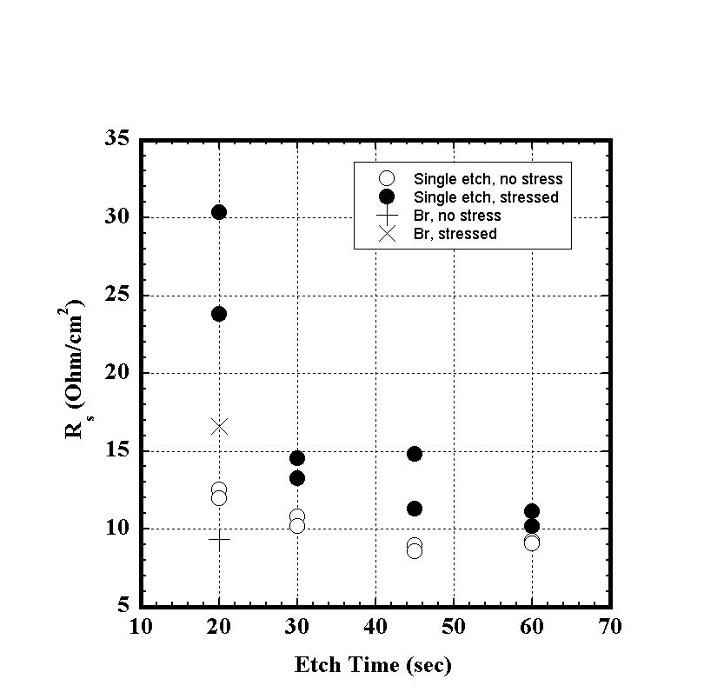
R_{oc} (Ohms/cm²)
Figure 1. Plot of R_{oc}, before and after stressing at 85°C in air and in the dark, vs. etch time for devices that received NP etching during back contact processing. The R_{oc} values, before and after stress, for the device etched in 0.05% Br₂/methanol are also shown.

The cells that received multiple etches in NP exhibited similar initial J-V behavior to the single etched batch, though the 2x30 sec etched device was slightly superior. As with the single etched devices, little degradation was observed following stress, except for an increase in R_{oc}. Interestingly, the device which received 3x20 sec NP etches showed a significant increase in R_{oc}, similar to the device which received a single 20 sec etch, while the 2x30 sec etched cell showed an R_{oc} increase similar to the 30 sec and 45 sec etched pieces. In the previous annual report, it was shown that multiple NP etches of 20 sec, with the film being removed prior to the signature bubbling at 20-25 sec immersion, showed only small additional Te formation with each subsequent etch, with the Te thickness plateauing following 6-7 immersions. At this point the amount of Te generated was still significantly less than that produced by a single 30 sec NP etch. Subsequent 30 sec etches continue to produce more Te following 2-3 immersions, before the Te begins to be consumed by the solution with further etching. Therefore, we can assume that the 3x20 sec and 2x30 sec NP etched cells had Te-rich surface films similar in thickness to the 20 sec and 45 sec NP etched devices, respectively. This was qualitatively confirmed by GIXRD.

The action of NP etches on CdTe is known to produce Te-rich films of ∼50-100 nm thickness, along with significant etching and widening of the GBs. By comparison, BM etching produces Te-rich films of only a few angstroms in thickness. A longer NP etch is expected to produce a thicker Te film, but also a higher degree of GB etching. Extensive etching of GBs may influence the diffusivity of Cu and other impurities throughout the device. However, the observed device results indicate that the mild cell degradation observed in this study was due to back contact effects, i.e. R_{OC} increase, and only occurred for devices within thinner Te-rich layers or that received shorter etches. We suggest that completed cells processed with back contacts containing thicker Te layers may improve contact and device stability. Thicker Te layers, coupled with the affinity of Te for Cu, would attenuate the escape of Cu from the Cu_{2-x}Te back contact region. That is, Te may getter Cu and slows its release into the CdTe film. Eventually significant Cu would be expected to diffuse from the Te layer and diffuse through the cell, however, the overall rate of Cu diffusion would be significantly slowed and thus maintain a ‘copper telluride’ back contact for a longer period of time. The phase of ‘copper telluride’ is not clear, however we suggest that a Cu-poor ‘copper telluride’ phase is likely to be a more favorable back contact than pure Te. As also discussed Section 2.2, thicker Te contacts are also likely to compensate oxidation and other chemical changes occurring at the back contact during stress.

2.1.2 Formation of Copper Tellurides on Etched CdTe Surfaces

The formation of copper tellurides on wet chemical etched CdTe surfaces during back contacting has been monitored. Similar experiments have been carried out at IEC in the past; however, these measurements were carried out using deposited Cu and Te films of stoichiometric thicknesses. In this work, copper telluride contacts were prepared by coating etched CdTe surfaces with Cu-containing graphite pastes. GIXRD was used to monitor the resultant surface products.

The CdTe surfaces were etched with either NP or 0.1% BM. The etched surfaces were coated with graphite paste containing ~6% w/w Cu, CuCl or CuI powders. The contacts were annealed at 200°C in Ar(g) for 30 min. For GIXRD measurements, the graphite films were removed by sonication in acetone. A purple-tinge was noted on the CdTe surface of some samples, from both NP and BM etched, following removal of the graphite contact.

GIXRD confirmed that etching of CdTe in BM for 20 sec or in NP for 60 sec, removes oxides from the film surface. Both etches are known to produce Te-rich surface films. Crystalline Te is detected with GIXRD following NP etching. BM etching, however, produces a very thin and amorphous Te-rich surface and no Te is observed with GIXRD.

Figure 2 shows the 22 – 34.5° region of the GIXRD plot, at 2° incident angle, of a 60 sec NP etched CdTe film following removal of the Cu powder/graphite paste back contact. The CdTe 111 and Te 101 peaks are present at 23.7° and 27.6°, respectively. A series of new peaks have emerged at 25.3°, 26.7°, 31.2° and 33.9°. GIXRD of CdTe samples contacted with Cu powder/graphite paste following 20 sec BM etching (not shown), though lacking the Te reflection, showed similar peaks. However, the peaks were very weak in comparison to the NP etched sample, except for the 26.7° reflection, which was of similar intensity to that peak in Figure 2. The 25.3° reflection is also now a doublet with a slightly more intense peak at 25.7°.

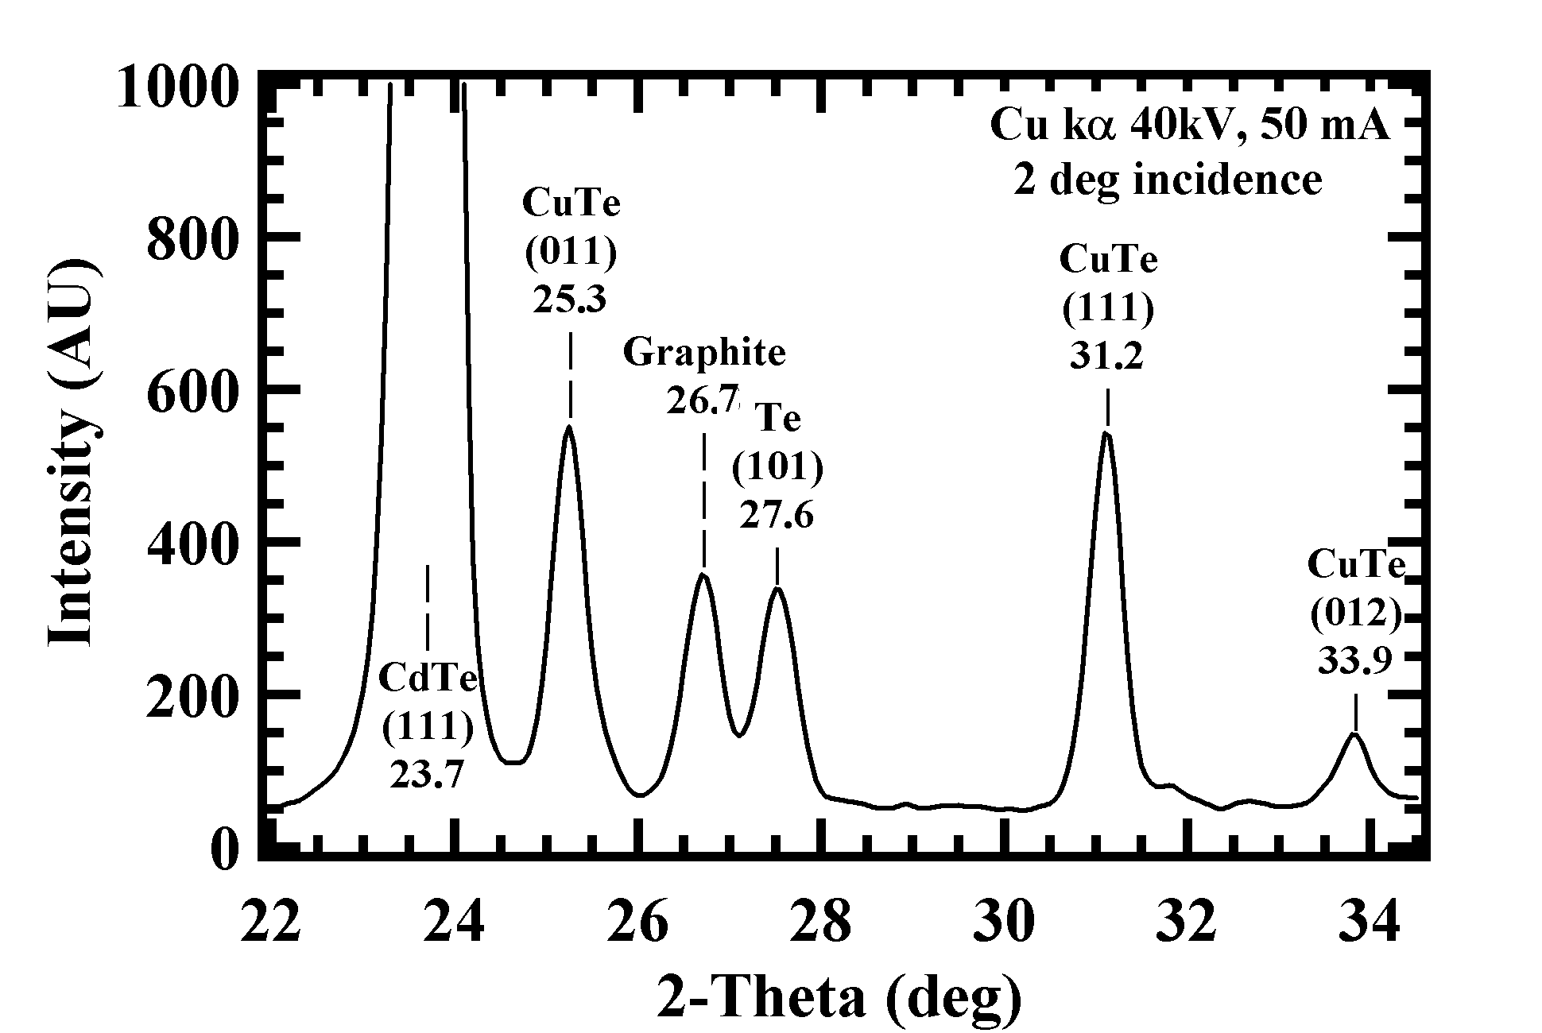

Figure 2. GIXRD plot, at 2° incidence, of a 60 sec NP etched CdTe film obtained, following removal of a Cu powder/graphite paste contact.

The peaks at 25.3°, 31.2° and 33.9° can be assigned to the formation of a CuTe (JPCDS 22-0252) phase on both the NP and BM etch surfaces. The 25.7° reflection from the BM etched sample may also be due to CuTe. This phase is clearly the dominant product on the NP etched surface and contradicts previous work of back-contacts prepared from stoichiometric Te and Cu films where formation of the Cu_{2-x}Te phase was observed. This is not unexpected due to the greater amount of Te generated by NP etching coupled with the slow release of Cu from the graphite paste. The weaker intensity of the reflections on the BM etched surface may be expected due to the thinner Te-rich surface film. The peak at 26.7° could be assigned to a Cu₃Te₂-related phase, however, the relative intensity of the peak was found to be inconsistent between different samples and the intensity was found to decrease with further sonication of films. This could indicate that the Cu₃Te₂ phase, if present, may not adhere well to the CdTe surface, however, the GIXRD spectrum of a graphite paste film, dried on glass, shows graphite to have a single strong reflection centered at 26.6°. Therefore, we can assume that this peak in the GIXRD plots of the CdTe films is most likely due to residual graphite remaining on the surface.

The residues of the carbon contact remaining after the sonication step were found to be removed by wiping the surfaces of the CdTe films with a Q-tip soaked in acetone. GIXRD measurements showed, for both BM and NP etched samples, the graphite peak is removed leaving a single peak centered at 26.95°. The assignment of this peak is unclear. A phase of Cu₃Te₂ is possible, as is a Cu₃Te₄ phase. Either of these phases could account for the purple-tinge observed on the surface of some of these samples

To investigate the reactivity of different forms of Cu in the back contact paste towards CdTe surfaces, etched films were contacted with graphite paste containing CuCl and CuI powders. On 20s BM etched CdTe, both powders produced only very weak peaks at 26.6°, due to graphite, and 27.6°, which is most likely due to the formation of a small amount of Cu_{2-x}Te rather than crystalline Te. A 60 sec NP etched CdTe surface contacted with CuCl-containing graphite paste showed peaks due to CuTe, at 25.2° and 31.1°, crystalline Te and graphite. Again, CuTe is the dominant phase produced on NP etched CdTe.

These results indicate that different copper telluride phases can be produced during the back contacting process, depending on the chemical state of Cu, the nature of application and the CdTe surface preparation. These results also suggest that significant levels of Cu_{2-x}Te may not be required to produce quality back contacts to CdTe/CdS cells, and that any copper telluride phase could produce a reasonable back contact. However, it is likely that certain copper telluride phases may be superior to others and produce better performing devices. The nature of the Cu + Te reaction requires further investigation to confirm conditions required for the formation of the various copper telluride phases, which can then be correlated to different back contacting processes and to device performance.

2.2 Contacts and Stability

2.2.1 Systematic investigation of effects of humidity on CdTe devices and components

A number of films of device components and completed devices were selected and stressed over a range of constant humidities at an elevated temperature of 80°C. Table 2 shows a list of the samples selected for this study. Films were selected from different sources and from different modes of deposition. The Au/Cu/Te films duplicate the IEC device back contacts, and consist of 50 nm Au/30 nm Cu/ 50 nm Te. The IEC devices were etched with Br₂-dichromate-hydrazine (BDH), giving ~50 nm Te surface film, prior to deposition of the dot Au/Cu/Te contacts (0.07 cm² diameter). The contacted devices received a 30 min anneal in Ar(g) at 190°C, while the Au/Cu/Te films were not annealed. The First Solar cells are standard ‘dot’ devices with contacts evaporated through a mask. Both types of devices were completed with In solder at the front contact.

Table 2. Sample set for humid stress experiment

IEC | First Solar | Canrom
Bare VT CdTe (CdCl₂) | Bare FS VT CdTe (CdCl₂) | Bare CdTe (no CdCl₂)
Bare PVD CdTe (CdCl₂) | BDH etched CdTe
Bare PVD CdS | Bare CSS CdS
Bare CSD CdS | VT CdTe ‘dot’ cell (In solder)
Au/Cu/Te/glass (no anneal)
VT CdTe cell
(Au/Cu/Te contact, In solder)

Humidity was controlled by storing the samples in a sealed vessel over saturated solutions of various salts. This is a well-known method for easy and inexpensive humidity control. Tables listing humidity with temperature for different salt solutions are available. Table 3 shows the salts and humidities, including saturation pressure and concentration of H₂O vapor in the vessel atmosphere. For the ∼0% and 100% humidities, the samples were stored over Drierite pieces (anhydrous CaSO₄) and pure H₂O, respectively. Figure 3 shows the apparatus set-up used. The samples were stored in a sealed tube with a check valve to prevent over-pressure. Vials of the salt solutions were placed at the base of the tube. Significant amounts of the respective salts were added to the vials to ensure the solutions remained saturated throughout the experiment. The ∼0% humidity samples were stored in a desiccator. The conditions on loading were 22°C with 45% relative humidity. The tubes and desiccator were placed in an oven and the check valves were closed after 30 min. The vials were occasionally monitored to ensure that the excess salt did not dissolve. Samples were stressed for 500 hrs. A control set of samples was stored in ambient room air, ∼25°C at ∼30% humidity, through this time.

Table 3. Humidity conditions for each control agent at 80°C.

Humidity Control Agent | Drierite | Sat.  LiCl | Sat.  NaBr | Sat.  KBr | H₂O | Room air (control, ~25°C)
Rel. humid% | 0.0017 | 10.1 | 51.4 | 79 | 100 | ∼30
P_{sat} (Torr) | 0.006 | 37 | 182 | 280 | 355
[H₂O] (g/L) | 0.005 mg/L | 0.03 | 0.15 | 0.23 | 0.29 | ∼ 0.025

Check valve
Samples
Sat. soln
Salt
Figure 3. Schematic diagram of apparatus for humid stress experiment.

Following stressing, samples were removed and observed. Most pieces show no visible changes, except for some CdTe pieces, which showed darkening in drier atmospheres, and the Au/Cu/Te films and Au/Cu/Te contacts on IEC devices, which became cloudy in the drier atmospheres.

Figure 4 shows the GIXRD patterns obtained from Canrom CdTe at different humidities. These CdTe samples had not received CdCl₂ treatment. From the figure it can be seen that TeO₂ had formed on the sample that had been in the driest conditions, but no products are observed in the wetter conditions or on the control piece. It would be expected that surface species are very likely to form in the more humid systems, therefore, we may assume that any products formed in these conditions are likely to be amorphous Cd-Te oxide hydroxides or hydrates. Amorphous species would not be detected with GIXRD. First Solar and IEC CdTe that had received CdCl₂ treatments (not shown) showed the expected presence of ∼1500 Å CdO over all humidities, including the control. However, significant levels of CdTeO₃ were present only on the ∼0% and 10% humidities and control pieces, suggesting that this phase becomes hydrated and amorphous in the wetter conditions. The control BDH etched IEC CdTe shows a crystalline Te peak (see Figure 5.) After stressing in dry conditions, a large surface TeO₂ component is observed. However, the samples stressed in humidities of >0% show no TeO₂ and only very weak diffuse Te peaks. This observation strongly suggests that amorphous Te hydroxides or hydrates are formed during humid stressing.

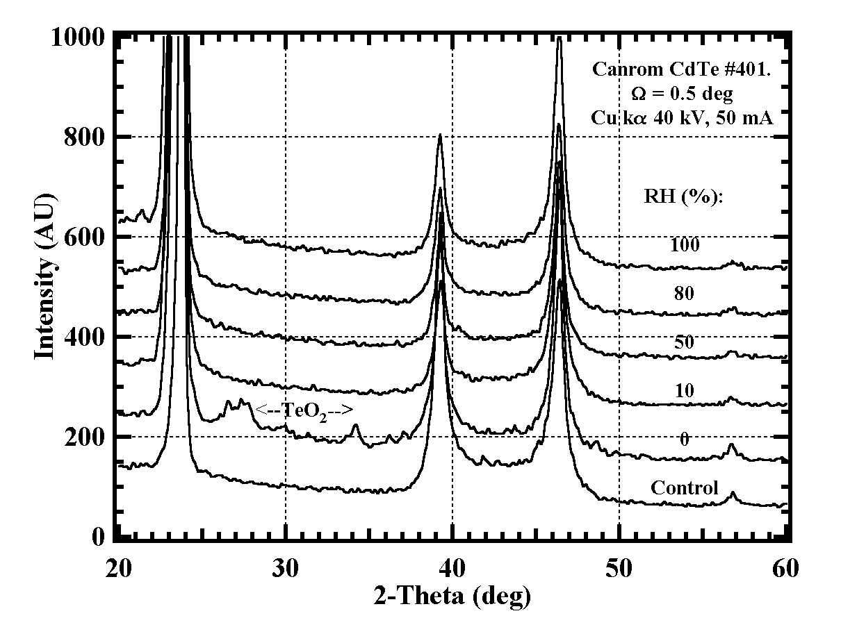
Figure 4. GIXRD plots of Canrom CdTe following stress at 80°C in
various humidities for 500 hrs.

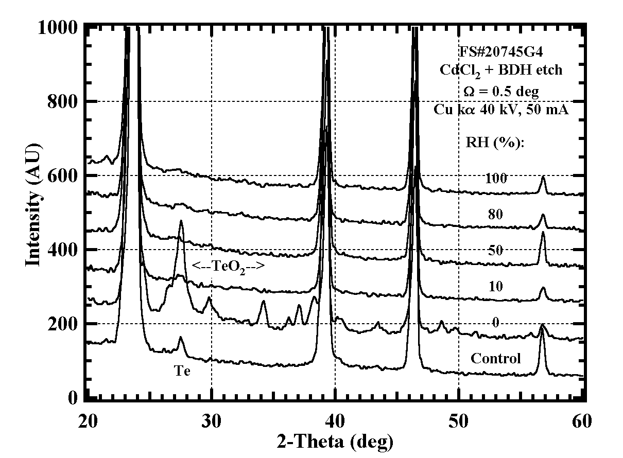
Figure 5. GIXRD plots of BDH etched IEC CdTe following
stress at 80°C in various humidities for 500 hrs.

GIXRD analysis of the stressed IEC CSD CdS (not shown,) showed the presence of CdO on all pieces, including the control, except for the sample that had received stress at 100% humidity. The amount of CdO detected generally decreased with increasing humidity stress levels. These results suggest that CdO is formed on CSD CdS during growth, as indicated by its presence on the control piece. However, with stress in higher humidities, consistent with CdTe, it is suggested that the surface oxides are converted to amorphous hydroxides or oxide hydrates.

Figure 6 shows the GIXRD patterns of the non-annealed Au/Cu/Te films following humid stress. The control piece shows the presence of Cu_{2-x}Te, Cu₃Te₂ etc. and the Au film. Stressing at higher humidity shows some changes in the composition of the copper telluride film, which can be attributed to the films being slowly annealed at the elevated temperature. At ∼0% humidity, however, the Au/Cu/Te film has almost completely converted to TeO₂, which results in the films becoming cloudy, and highlights O₂ corrosion of the copper telluride back contact. This suggests that Cu_{2-x}Te is either resistant to H₂O oxidation or that H₂O oxidation dominates over O₂ oxidation but is self-limiting, corroding only the grain surfaces and not the entire film.

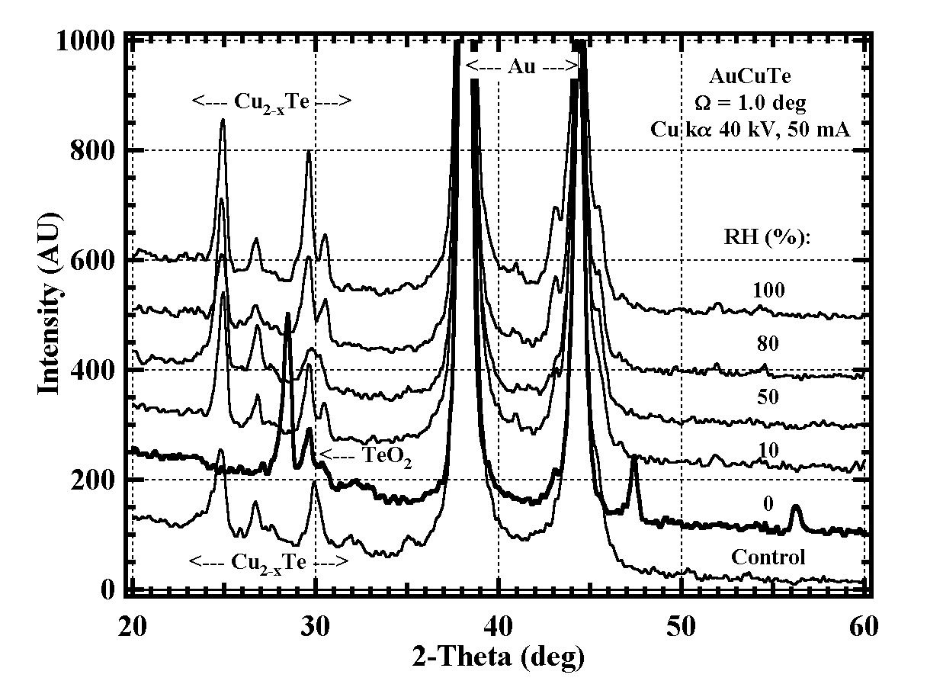

Figure 6. GIXRD plots of non-annealed 50 nm Au/30 nm Cu/50 nm Te
films following stress at 80°C in various humidities for 500 hrs.

GIXRD patterns of the completed IEC cells (not shown) showed similar behavior to the Au/Cu/Te films. These devices received a BDH etch before deposition of Au/Cu/Te dots. The GIXRD results showed that the Te film between the contact dots also converted to TeO₂ + Te at low humidity, and probably amorphous hydrated phases at high humidity. This may suggest that Te is slightly more resistant to O₂ stress than humid stress. Table 4 shows the J-V data for the IEC devices before and after humid stress, including indications of up-down sweep retrace hysteresis, extent of light-dark crossover (XOVR) and forward bias curvature. Despite the extensive changes observed in the chemistry of the Au/Cu/Te films and back contacts, the IEC devices show very stable electrical behavior, with no significant changes in performance following stress at all humidities. Only a slight, 5-20 mV, decrease in V_{oc} is observed.

Table 4. J-V data for Au/Cu/Te contacted IEC devices with CdTe made by vapor transport, before and after stress at 80°C in various humidities for 500 hrs.

Sample | Condition | T | RH% | V_{oc} | J_{sc} | FF | Eff | R_{oc} | G_{sc} | Light  retrace  hysteresis | Dark  retrace  hysteresis | Light  dark  XOVR | Fwd  bias  Curv.
VT84.43 | Initial |  |  | 743 | 20.5 | 67.0 | 10.2 | 4 | 2 | N | N | N | N
VT84.43 | Control | 25 | 30 | 732 | 20.0 | 64.6 | 9.5 | 5 | 1 | N | N | N | N
VT84.13 | Initial |  |  | 740 | 21.2 | 58.4 | 9.2 | 6 | 3 | N | N | Y | N
VT84.13 | Drierite | 85 | 0 | 736 | 22.7 | 57.1 | 9.6 | 6 | 3 | N | N | Y | N
VT84.33 | Initial |  |  | 748 | 22.4 | 65.1 | 11 | 4 | 1 | N | N | Y | N
VT84.33 | LiCl | 85 | 10.5 | 740 | 21.8 | 63.6 | 10.2 | 5 | 2 | N | N | Y | N
VT84.23 | Initial |  |  | 738 | 23.2 | 64.2 | 11 | 5 | 2 | N | N | Y | N
VT84.23 | NaBr | 85 | 51.4 | 725 | 22.3 | 60.6 | 9.7 | 6 | 2 | N | N | Y | N
VT84.32 | Initial |  |  | 742 | 21.9 | 61.9 | 10.1 | 5 | 3 | N | N | Y | N
VT84.32 | KBr | 85 | 79 | 721 | 19.6 | 60.2 | 8.5 | 6 | 3 | N | N | Y | N
VT84.22 | Initial |  |  | 702 | 22.6 | 59.5 | 9.4 | 6 | 2 | N | Y | Y | N
VT84.22 | H2O | 85 | 100 | 699 | 19.2 | 56.6 | 7.6 | 7.0 | 2 | N | Y | Y | N

The only changes observed in the GIXRD results of First Solar devices (not shown) was the formation of In₂O₃ on the In solder. At higher humidities, GIXRD data indicated the In₂O₃ became hydrated. No back contact materials could be detected. J-V testing of the devices before and after humid stress, showed significant changes in device performance, with increasing R_{oc} and decreasing fill factor for all stressed pieces and the control, a V_{oc} decrease of 20-40 mV for the stressed pieces and forward bias curvature for the pieces stressed at higher humidities (see Table 5). The change in device performance is not expected to be due to the formation of In₂O_{3,} as the probe would have pierced the surface oxide layer during J-V testing.

Table 5. J-V data for First Solar devices before and after stress at 80°C in various humidities for 500 hrs.

Sample | Condition | T | RH% | V_{oc} | J_{sc} | FF | Eff | R_{oc} | G_{sc} | Light  retrace  hysteresis | Dark  retrace  hysteresis | Light  dark  XOVR | Fwd  bias  Curv.
L2B.5 | Initial |  |  | 782 | 18.6 | 64.1 | 9.3 | 6 | 1 | N | N | N | N
L2B.5 | Control | 25 | 30 | 821 | 19.0 | 58.3 | 9.1 | 11 | 1 | N | N | Y | N
L2B.4 | Drierite | 85 | 0 | 750 | 17.1 | 56.1 | 7.2 | 12 | 2 | W | W | Y | N
L2B.2 | LiCl | 85 | 10.5 | 775 | 17.6 | 56.5 | 7.7 | 12 | 1 | W | W | Y | N
L2B.3 | NaBr | 85 | 51.4 | 767 | 17.6 | 55.1 | 7.4 | 12 | 1 | S | S | Y | Y
L2B.1 | Initial |  |  | 791 | 17.9 | 65.2 | 9.2 | 6 | 2 | N | N | N
L2B.1 | KBr | 85 | 79 | 755 | 17.1 | 54.2 | 7 | 14 | 2 | S | S | Y | Y
L2B.6 | H₂O | 85 | 100 | 770 | 17.6 | 57.7 | 7.8 | 11 | 1 | S | S | Y | Y

The FS devices appear less robust than the IEC devices, which showed no significant decrease in performance despite the extensive chemistry occurring in the back contact. The IEC contact contains a very large proportion, ∼100 nm, of Te, formed by a mixture of wet chemical etching and evaporation. This thick Te component may allow the device to compensate any chemical change in the contact, including oxidation and/or Cu diffusion, and maintain a favorable working contact. Likewise, we can speculate that a thick Te component would getter Cu at the back contact for a longer period of time, thus increasing the contact lifetime (see also Section 2.1. discussion). In contrast, no Te could be detected by GIXRD in the First Solar back contacts. A very thin Te component would be oxidized more easily and the contact would not adequately compensate chemical or Cu-diffusion related changes. Changes in the contact chemistry can be observed from the First Solar device results.

These experiments are continuing. All stressed pieces are yet to be analyzed by GIXRD. Subsequent techniques will be explored, e.g. XPS, FTIR, SIMS etc., to attempt to detect the presence of amorphous hydroxides and hydrates. A set of samples is currently being produced to investigate the effect of humid stress testing under illumination.

2.2.2 Effects of Humidity during Post-Deposition Processing

For post-deposition processing of cells using VT CdTe and CSD CdS, the ambient condition during vapor CdCl₂ treatment exerts a strong effect on the surface chemistry, which is expected to affect bulk electronic properties of the CdTe film. In particular, humidity in the treatment ambient leads to conversion of the film surface to the native oxides CdTeO₃ and CdTe₂O₅. Elevated humidity levels can arise from the ambient gas (e.g., room air) and from the CdCl₂ source itself, which is highly hygroscopic. Figure 7 is a sequence of XRD patterns acquired from coarse, 100 m, CdCl₂ powder (Alfa/Aesar 99.998% purity anhydrous CdCl₂) measured consecutively in room air. Each scan required 10 minutes for acquisition over the 2-theta range from 5 to 25 degrees. Peaks due to cadmium chloride hydrate are detected in the fresh specimen, which was exposed to air for only 10 minutes (mounting time plus 5 minutes scan time). The hydrate peak intensity increased approximately linearly with time; the peaks shift to higher angle due to expansion of the powder out of the diffractometer focal plane. For the 480 min measurement, the powder had reacted into a different, unknown, phase.

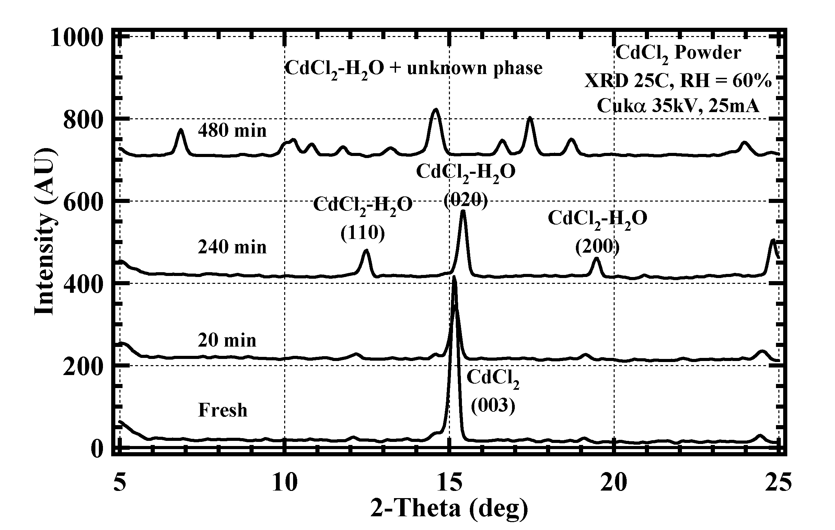

Figure 7. XRD scans of CdCl₂ powder re-measured during exposure to humid air.

During vapor CdCl₂ treatment, dehydration of the source, water desorption from the sample, and moisture content of the ambient all contributes to the total quantity of water available for reaction at the CdTe surface. GIXRD measurements of VT CdTe films made by IEC and First Solar and vapor treated at IEC show that for vapor CdCl₂ treatment in dry ambient, with [H₂O] < 0.001 mg/l, only CdO is detected on the surface. However, for treatments in ambient with [H₂O] greater than 10 mg/l, native oxides of CdTe are formed, and little or no CdO is formed. This is shown in Figures 8 and 9 below. The GIXRD scans for VT films from a single deposition treated for 15, 30 and 60 minutes at 430°C in CdCl₂ vapor at two different humidity levels. The strongest peaks are due to CdTe. In Figure 8, the peaks at 33° and 55° are CdO. The remaining peaks are the native oxide CdTeO₃. In Figure 9, no CdO is detected and all small peaks are due to CdTeO₃ and CdTe₂O₅.

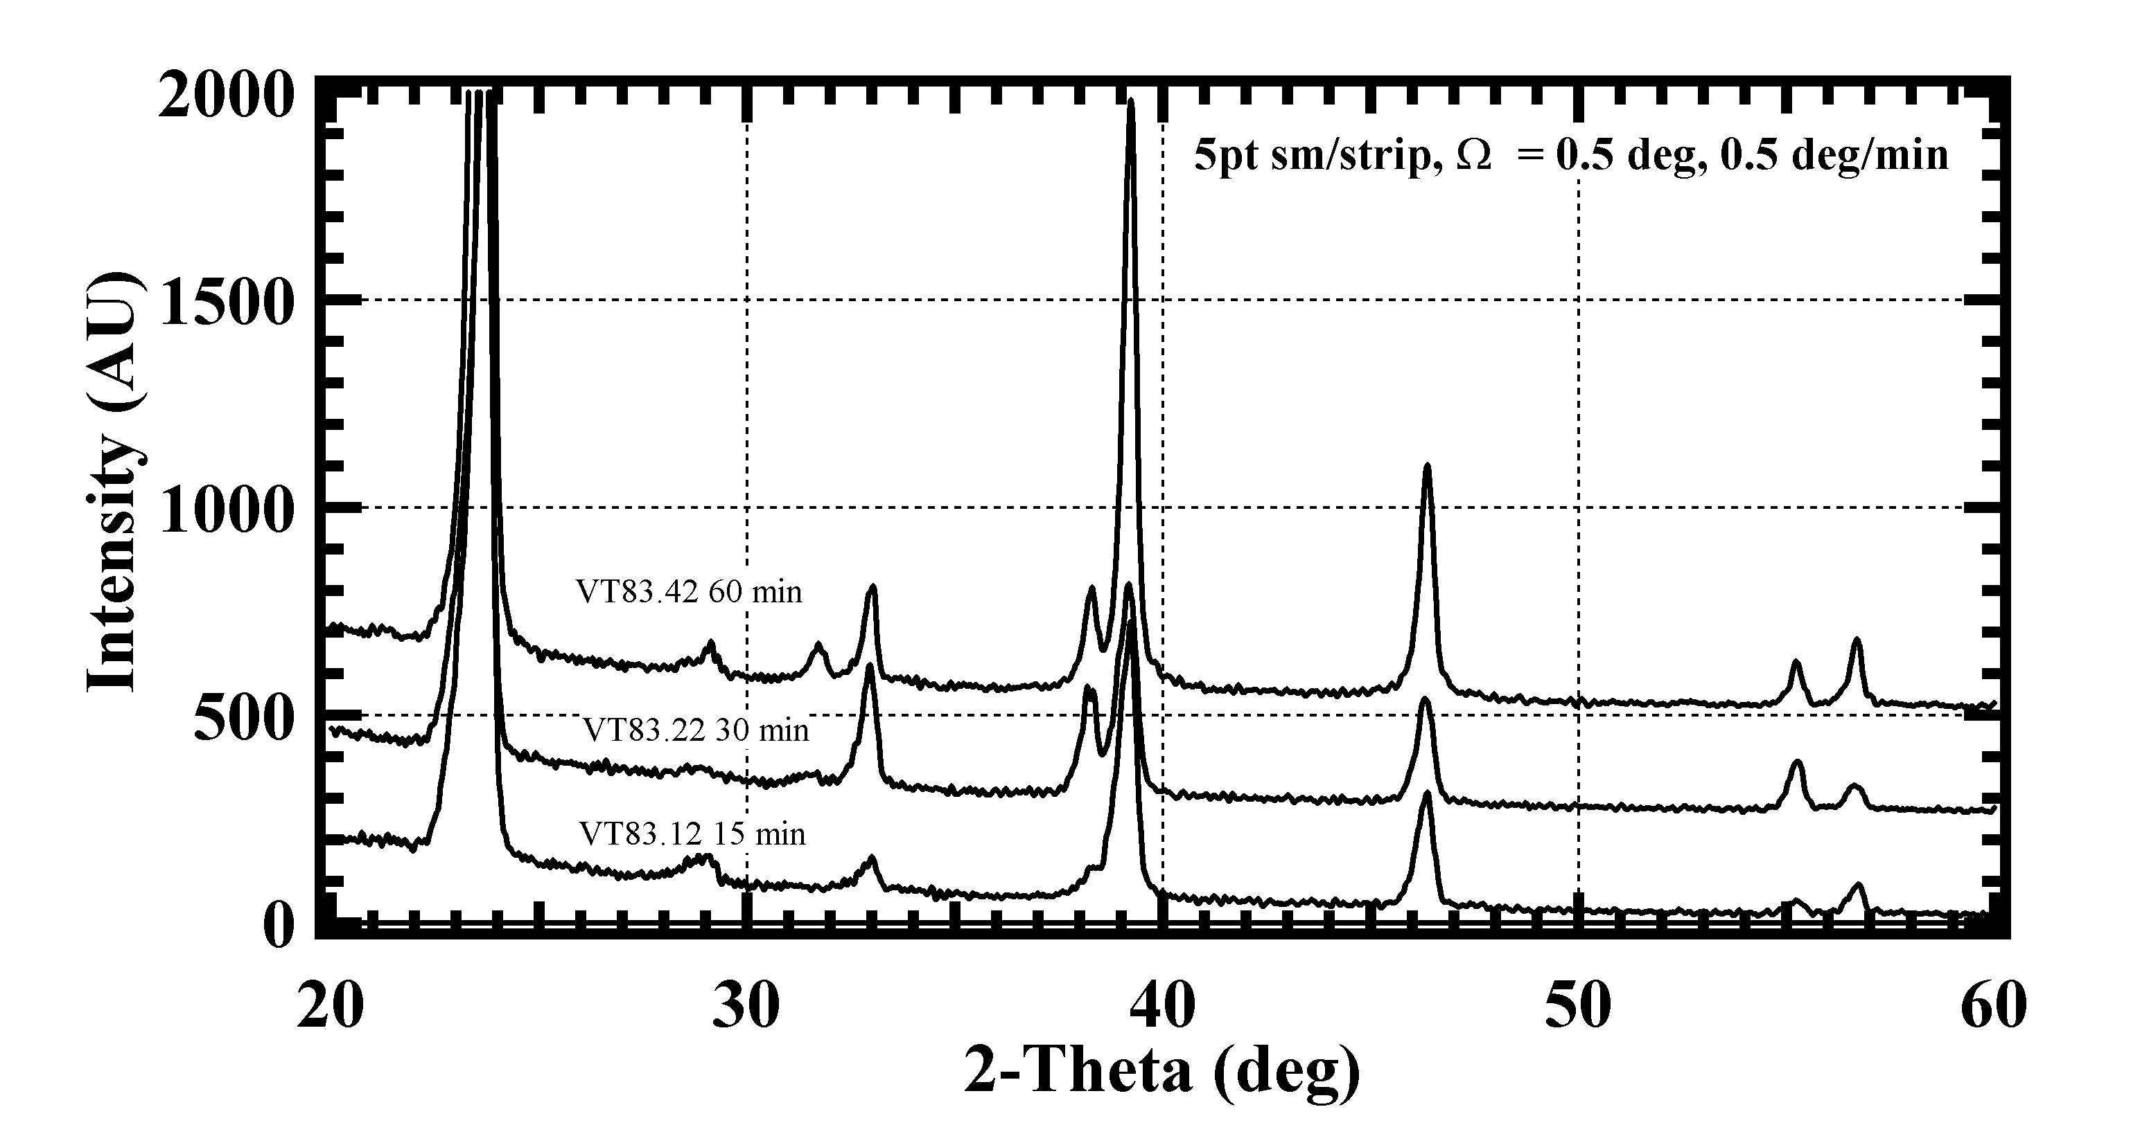

Figure 8. GIXRD scans of VT CdTe surface after vapor CdCl₂ treatment
at 430°C for the times shown in air ambient with ~10 mg/l moisture content.

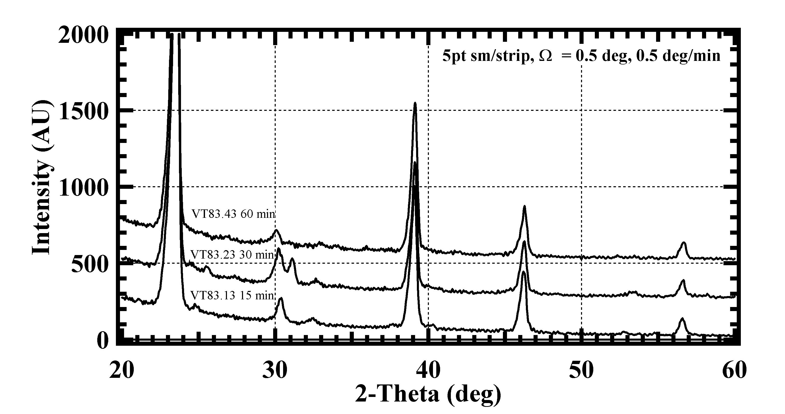

Figure 9. GIXRD scans of VT CdTe surface after vapor CdCl₂ treatment
at 430°C for the times shown in air ambient with ~10 g/l moisture content.

For the oxide CdTe₂O₅ to form, Te must be preferentially removed from the CdTe lattice, shifting the chemical equilibrium far from cadmium vacancy condition, thereby restricting the formation of acceptor complexes, and reducing p-type conductivity. We have observed the following correlation between cell performance and GIXRD data of vapor CdCl₂ treated films, drawing on measurements back to 1997: high efficiency PVD and VT cells (Eff > 11%) exhibit either no surface phase or a low quantity of CdO; low efficiency, characterized by poor V_{OC} and FF, curvature in forward bias, and re-trace hysteresis, exhibit the native oxides CdTe₂O₅ and CdTeO₃. In previous studies, similar results were found for devices processed with wet CdCl₂ treatment, and additional Cd-Cl-O phases were detected. The relative sensitivity of wet treatment to vapor treatment has not been directly evaluated, but ambient composition is expected to play a critical role in both; in the case of the wet process, this process sensitivity may depend on the ability to form a uniform CdCl₂ coating. These results suggest that it is important to minimize the humidity during CdCl₂ vapor treatment.

2.2.3 Transparent Contacts

Transparent contacts facilitate bifacial analysis of solar cells under illumination. Such analysis permits direct probing of the back contact junction and will be a critical tool for determining properties and operation of the back contact and their dependence on processing. In previous work it has been shown that Cu/ITO contacts and ZnTe: Cu films are viable candidates for this task and can be substituted directly for C ink or evaporated metal contacts routinely employed ,,.

ZnTe films containing different quantities of copper were deposited by galvanic electrodeposition on TEC-15 conductive and on First Solar CdTe/CdS solar cell structures. Two types of bath chemistry were evaluated with respect to the anion, based on sulfate and chloride. The chemical bath consisted of a pre-mixed aqueous solution containing 0.1M ZnSO₄ or ZnCl₂ and 0.001M TeO₂. The total volume was 80 mL, with 72mL of ZnSO₄ or ZnCl₂ and 8mL of TeO₂. The electrochemical cell consisted of a zinc foil anode in electrical contact with the substrate. The pH of the solution was maintained at ~ 3 by adding drops of dilute HCl or H₂SO₄.

For the initial survey, deposition was carried out in the sulfate bath varying only the temperature and the deposition time, from 50°C to 70°C and from 8 to 30 min. For pH = 2 and for depositions carried out with a stirred solution, reflective metallic films were obtained. For higher pH and unstirred solutions, orange-brown deposits were obtained. Based on the visible uniformity of the deposits and on the optical transmission spectrum, deposition temperature and time of 65°C and 20 min, respectively, in an unstirred bath at pH = 3 were adopted as the standard conditions for further experiments.

The second set of depositions was carried out to evaluate the influence of copper on the properties of the ZnTe films. This was achieved by varying the copper concentration in both sulfate and chloride baths from 0 to 5 x 10⁻⁴ M. Optical transmission was measured on samples deposited on TEC-15 substrates. The highest transmission was obtained for [Cu] ≤ 5 x 10⁻⁵ M, resulting in a loss of 2-5% transmission from 900 to 1400 nm. Based on this, films were deposited with [Cu] = 5 x 10⁻⁵ M on CdTe/CdS/TEC-15 films, after CdCl₂ treatment and BM etch. GIXRD analysis of the sample deposited in from a chloride bath shows three reflections in addition to those for CdTe (Figure 10.) Indexing these peaks suggests the presence of the hexagonal form of ZnTe. Reduction of the integrated peak area of ZnTe and CdTe provides an estimate of the ZnTe thickness, which is approximately 50nm. No additional peaks were found for the films deposited in sulfate bath, suggesting that either the deposit thickness is thinner than the detection limit (~5 nm) or is poorly crystallized.

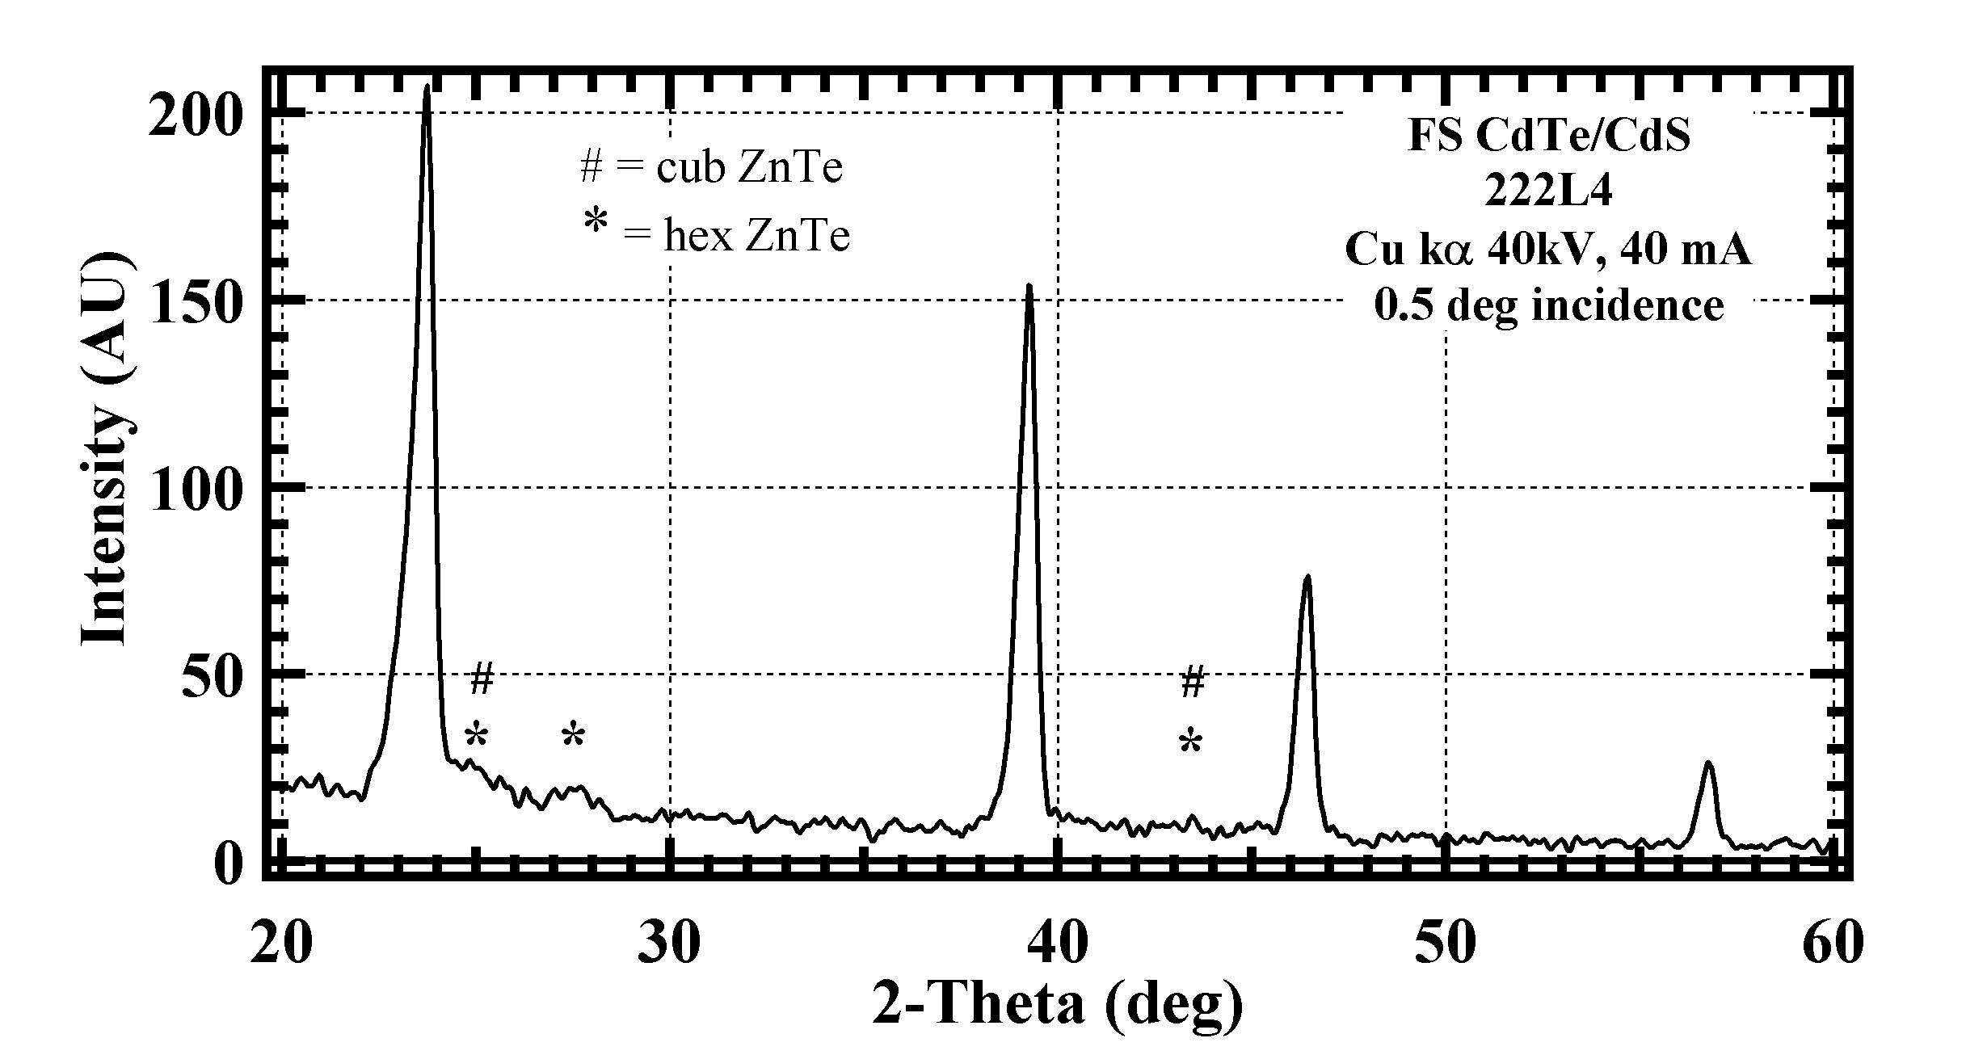

Figure 10. GIXRD pattern of ZnTe:Cu/CdTe/CdS/TEC-15
for [Cu] = 5 x 10⁻⁵ M in chloride bath.

2.2.4 High throughput VT CdTe characterization and deposition studies

IEC is continuing to investigate the relationship between CdTe deposition and film properties for cells with CdTe deposited at a high rate on moving substrates by (VT). The VT deposition process is similar, but not identical, to that used at First Solar. The influence of He and O₂ flow rate and pressure during the CdTe growth were investigated. Changes in the CdTe surface structure and chemical state were measured by AFM, GIXRD and contact wetting angle.

No modifications have been made to the original design of the system. The ceramic gas manifold was replaced when the original one developed a crack. The range of key deposition parameters and values used for baseline device evaluation are listed in Table 6.
Table 6. Key deposition parameters used in depositing VT CdTe films

Deposition condition | Experimental range | Baseline value
Substrate T (°C) | 400-550 | 500
Source T (°C) | 840-860 | 840
Pressure (T) | 20 | 20
He carrier gas flow (sccm) | 10-30 | 20
O₂ source 0.5% O₂/Helium (sccm) | 0-8 | 2
CdTe charge (grams) | 5.5-6.5 | 5.5-6.5

The majority of the CdTe depositions during this contract period were baseline depositions. These films were used to optimize device processing as discussed in Section 2.3.2.

However, one study examined the effect on CdTe grain size (as determined by AFM) of changing the flow rate of the carrier gas (Helium) while keeping the same ratio of the oxygen source gas (2% O₂/He) introduced into the reactor. We also looked at the result of doubling the ratio of He to oxygen in our baseline film. A summary of results from this study is given in Table 7. AFM images are in Figures 11-14. As compared to the baseline run (VT86) increasing the total flow of helium through the source, results in a substantial decrease in grain size (VT87). Decreasing the total flow of helium yields slightly larger, more densely packed grains (VT88). Increasing the ratio of helium to oxygen by two, results in larger less densely packed grains (VT89). Device results from these runs are awaiting resolution of problems discussed below.

Table 7. Effect of gas flow on thickness and growth rate of VT CdTe films. All other parameters were as listed for baseline films in Table 6. VT86 was deposited at baseline conditions.

Run | Helium  (sccm) | 2%O_{2/}/He (sccm) | Pressure (Torr) | Thickness  (µ) | Growth Rate  (µ/min.)
VT86 | 20 | 2 | 20 | 5.3 | 1.3
VT87 | 30 | 3 | 20 | 3.8 | 1
VT88 | 10 | 1 | 20 | 5.4 | 1.4
VT89 | 20 | 1 | 20 | 4.8 | 1.2

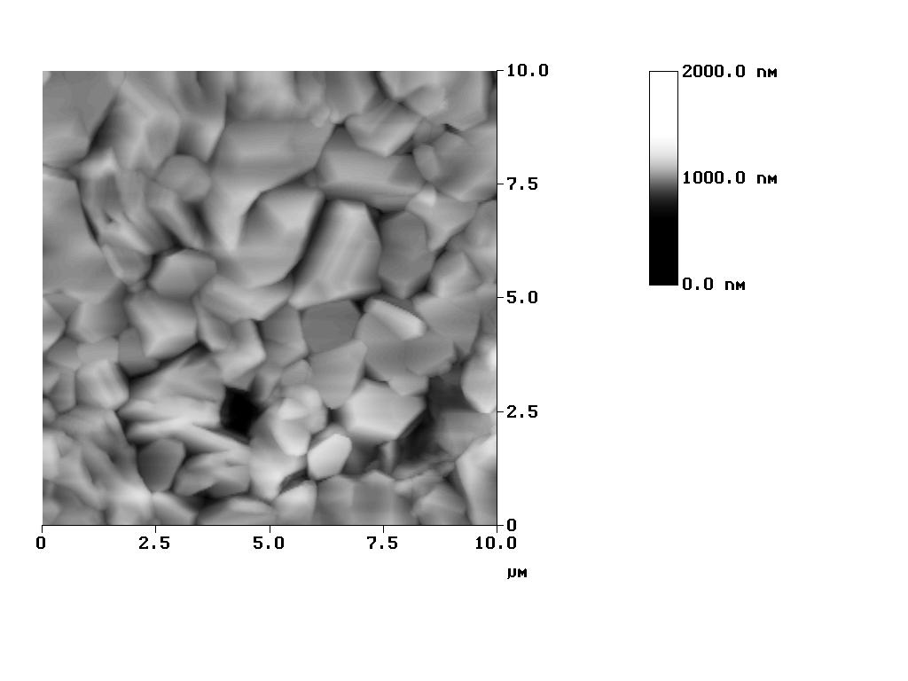 | 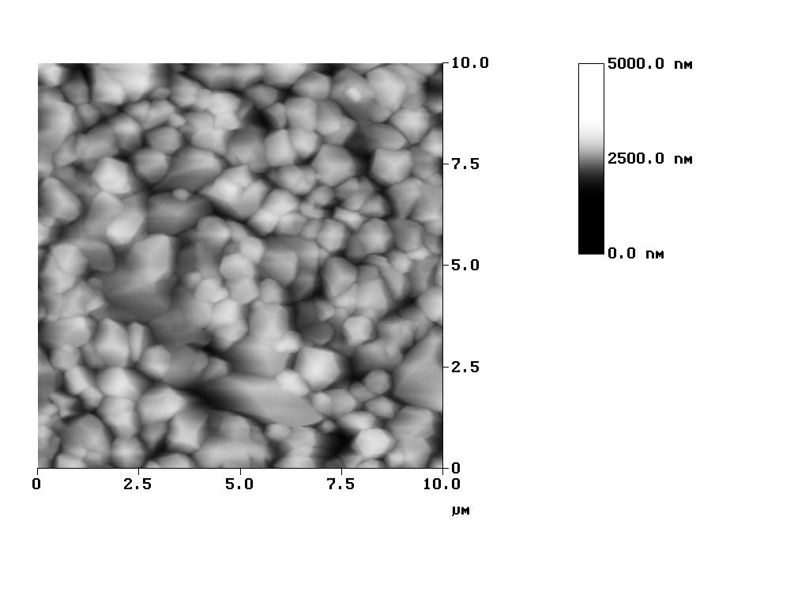
Figure 11. AFM image of VT86  (see Table 7) | Figure 12. AFM image of VT87  (see Table 7)
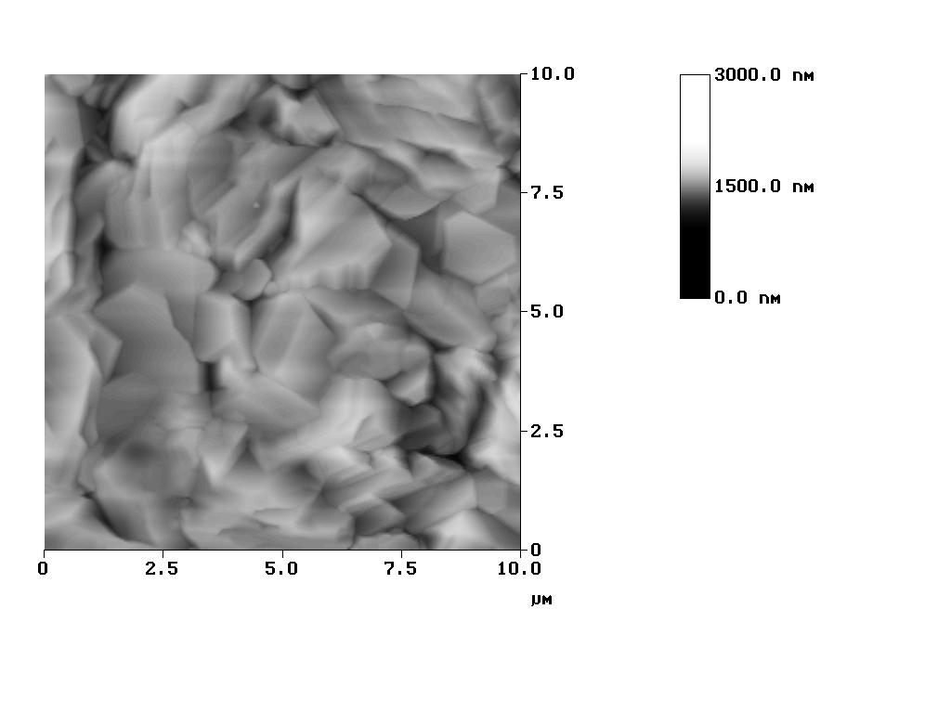 | 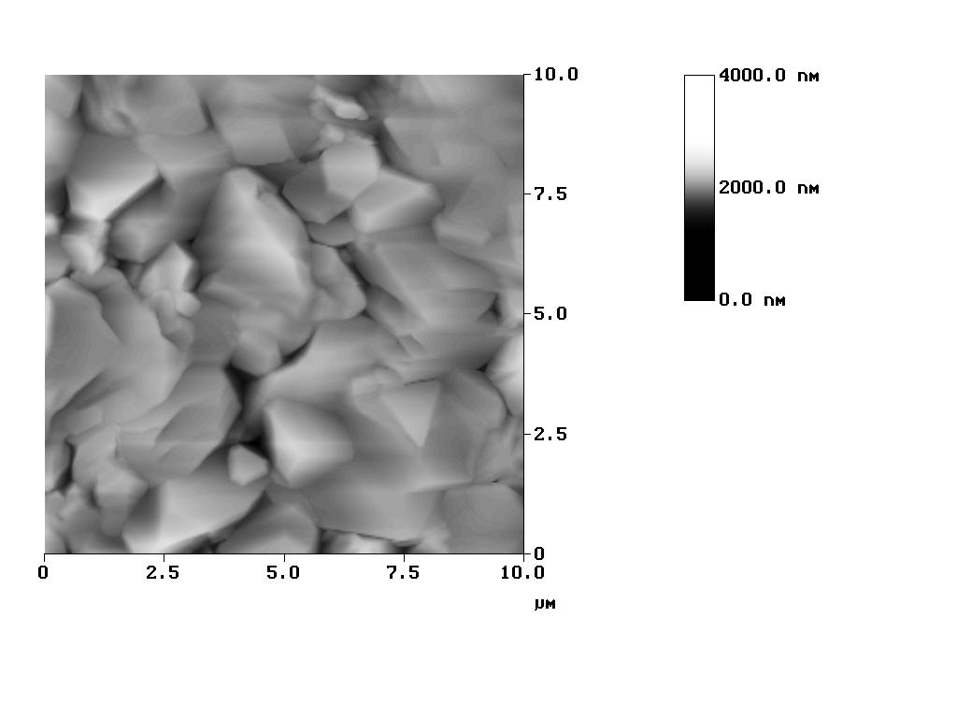
Figure 13. AFM image of VT88  (see Table 7) | Figure 14. AFM of VT89  (see Table 7)

2.2.5 Device results and process studies of high throughput VT CdTe

IEC is continuing to investigate the relationship between device processing and device performance for cells with VT CdTe deposited at a high rate on moving substrates. Focus has been on establishing and understanding baseline processing for the post-deposition procedures of completed CdTe/CdS structures. For the CdTe/CdS post-deposition treatments, the time and temperature of the CdCl₂ treatment, use of a high temperature anneal (HTA) prior to CdCl₂ treatment, and spacing between the CdCl₂ plate and CdTe surface were investigated.

Substrates were TEC-15 SnO₂ with a Ga₂O₃ high resistance buffer layer. All CdS and CdTe layers for the device results in this section were deposited under nominally identical conditions. The CdS films were deposited by CSD, which produces conformal ultra-thin CdS films with low particulate density and high utilization of Cd species and is discussed in Section 2.4.1. CdS was deposited by CSD to a thickness of ~90 nm and then received a CdCl₂ treatment at 420°C for 30 min. Following deposition of a ~4 µm CdTe layer at 550°C in a single 6 min pass in He/O₂ at 20 T, pieces receive a HTA and/or CdCl₂ treatment. Contact processed consists of a BDH etch, then loaded into the evaporator for the layered back contact structure of 50 nm Te, 30 nm Cu, 50 nm Au. Presently, we are using Cu/Au contacts evaporated through a mask since this is more repeatable, quicker, and less likely to introduce shunts than scribing around a graphite paste contact, as we have previously used. However, Cu/Au contacts typically give 20-40 mV lower V_{oc} than graphite. Post-contacting annealing was investigated, and a 30 minute anneal in Ar at 190°C was found to be optimum. All devices reported in this section received this anneal.

Run VT 83 varied the time and ambient of the CdCl₂ treatment of the completed CdS/CdTe structure at 430°C. Figure 15 shows dependence of efficiency on the time of the CdCl₂ treatment ranging from 0 to 60 minutes in either dry or moist air. All pieces received an HTA of 575°C for one hour prior to the CdCl₂ except for one piece, which received no CdCl₂ either. (A problem during the e-beam deposition of the Te layer for the contacts resulted in lower efficiency than expected, but all samples from VT 83 can be compared to each other for relative purposes). Comparing the two pieces which had no CdCl₂ treatment, it is clear that the HTA by itself accomplishes the same enhancement in performance, to ~8% efficiency, as the optimum CdCl₂ treatment in this experiment. This is the best device we have made without a CdCl₂ treatment. The QE of the device, which received neither HTA nor CdCl₂, indicated poor collection from the CdTe. There was no clear difference in device performance between dry or moist air suggesting the BDH treatment rendered the CdTe surfaces equally clean in both cases. However, before BDH there were differences in the type of oxides detected by GIXRD and in the surface energy determined by the contact-wetting angle.

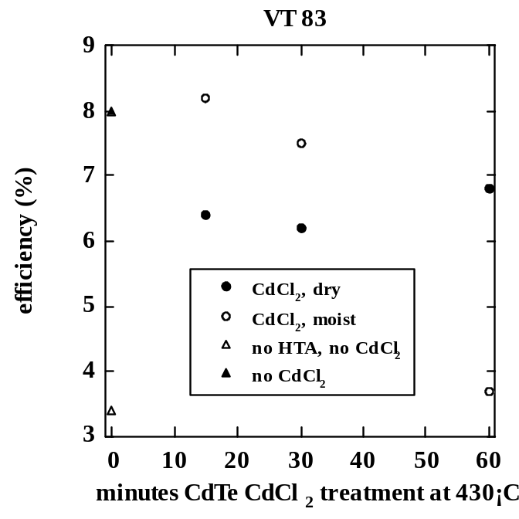

Figure 15. Dependence of efficiency on the time of the CdCl₂ treatment
ranging from 0 to 60 minutes in either dry or moist air for VT 83.

It has been shown, by IEC and others, that O₂ is critical for the CdCl₂ treatment to achieve full impact on the device. This leads to concerns about sufficient circulation and replenishment of the O₂ ambient during the CdCl₂ treatment. We have also shown that humidity and exposure to high temperatures in presence of air can lead to oxide formation on the CdCl₂, leading to concern about reusing CdCl₂ plates. In run VT 85, the spacing between the CdCl₂ plate and the substrate was varied during the CdCl₂ treatment. Since this is a static system, increasing the distance would increase the availability of O₂ at the CdTe surface. We also investigated the effect of the freshness of the plates, and the HTA in run VT85. Cells made with fresh plates included those with 0 and 6X spacing where X is our standard spacing of ~0.6 mm. After being used for treating the cells with no spacing, the CdCl₂ plate was re-used for treating with 2X spacing. The results in Table 8 show that the larger spacing was better, demonstrating that the delivery of O₂ and CdCl₂ are essential to obtaining good device performance. The HTA resulted in roughly a 2% decrease in absolute efficiency as well as lower yield. This detrimental effect of the HTA contradicts many previous results such as Figure 15. Devices processed with used CdCl₂ plates had much lower efficiency and/or severe retrace instability. Following this, fresh CdCl₂ plates were used for every treatment. Figure 16 shows the QE from the 4 devices with the fresh plate. The 33 pc, which had the largest spacing with a fresh plate and no HTA, had the highest efficiency and is the only normal QE. The other 3 show reduced CdS thickness due to interdiffusion and poor collection from the CdTe. This fall-off in collection between 600 and 850 nm is commonly seen in devices from other groups as well. A flat QE with no decrease in this region is believed to indicate maximum collection from the CdTe hence optimum processing. From these results, we concluded that an in-depth evaluation of the HTA treatment was needed.

Table 8. Efficiency and yield of pieces with different spacing of CdCl₂ plate and
HTA from run VT85. All cells on piece 22 had unstable retraces.

piece | spacing | Fresh  Plate | HTA | Efficiency  (%) | Yield
-12 | 0 | Yes | Yes | 7.5 | 3/8
-23 | 0 | Yes | No | 9.4 | 6/8
-22 | 2X | No | Yes | unstable | n/a
-43 | 2X | No | No | 3.0 | 8/8
-42 | 6X | Yes | Yes | 9.4 | 4/8
-33 | 6X | Yes | No | 11.2 | 8/8

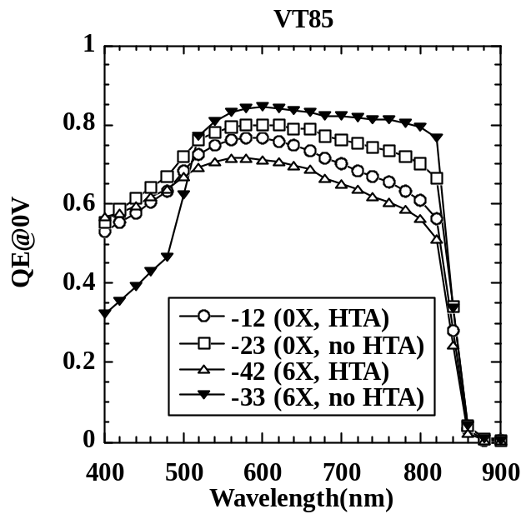

Figure 16. QE at 0V for devices from VT85 with 2 values CdCl₂
plate-to-substrate distance 0X and 6X as explained above. Devices with and
without HTA are shown, efficiency values are in Table 14.

The best device from this series was VT85.33-01. The light and dark J-V curve is shown in Figure 17, having V_{oc}=0.749 V, J_{SC}=22.9 mA/cm₂, FF=65.2%, and Eff.=11.2%. There is some light-dark crossover, which suggests that the CdS or CdTe are photoconductive. The QE is shown in Figure 16.

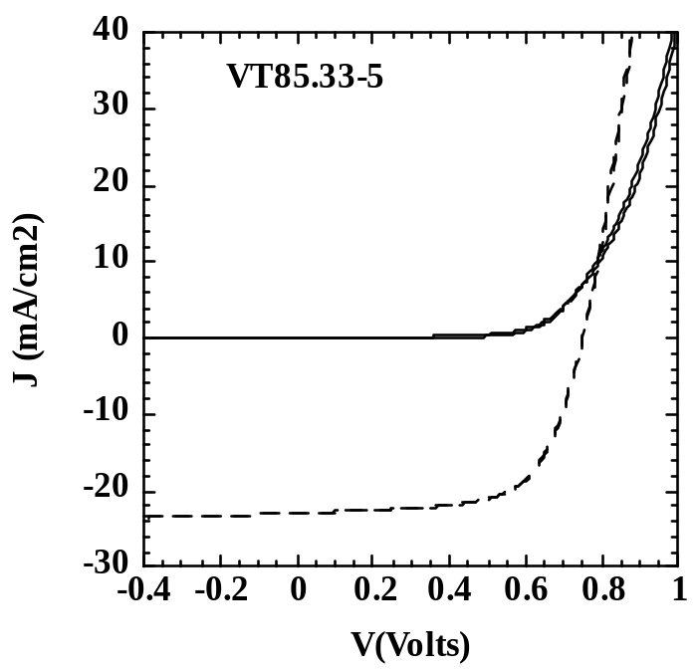

Figure 17. Light and dark J-V curve on VT85.33-5.

Several VT runs were made after VT85 to sort out the contradictory dependence on HTA, effects of gas flows during CdTe deposition, and contacting. Device performance was universally poor, with a high incidence of shunting and poor retrace stability. Various characterization methods indicated the CdTe films were dense, well-oriented, large grain, and largely pin-hole free films. Thus, bulk CdTe structural properties were not likely to be responsible. Processing of First Solar material with IEC’s CdCl₂ and contact yielded expected results of ~9% efficiency. This indicated the problem was with IEC’s CdS or CdTe deposition.

As shown above, QE data suggested significant consumption of the CdS was occurring in some devices for some process conditions. Thinning of the CdS and the resulting interdiffusion can lead to poor device performance. The QE at short wavelengths is a good indication of CdS thickness. Figure 18 is scatter plot of the V_{oc} vs the QE at 450 nm for 40 devices processed recently. There is no correlation, indicating that while there is an unacceptably large variability in the final CdS thickness, it is not responsible for the unacceptably large variability in V_{oc}.

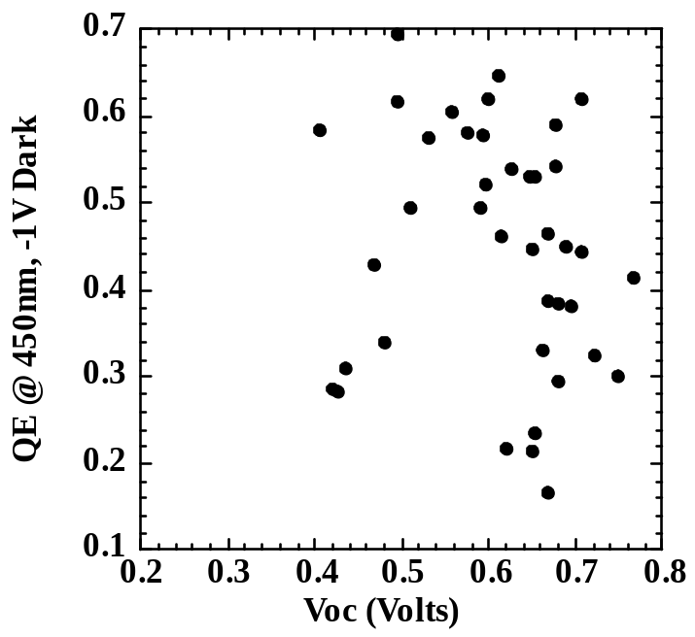

Figure 18. Scatter plot of QE at 450 nm vs V_{oc} for 40 CdTe devices.
The CdS and CdTe depositions were nominally the same for all devices
but the CdS and CdTe processing steps were different.

The filament and gas manifold were replaced. They not only were potential sources of impurities but were also aging. Device results were still poor. New runs are planned and samples are being sent to NREL for SIMS. New CdTe source material, processing of PVD CdTe as a control, different CdS (not CSD), and other comparisons will help identify the source of this new problem. This new source of irreproducibility, shunting and poor device results prevented IEC from establishing a high throughput process with a 12% baseline process as planned for this year.

2.4 Improving CdTe/CdS Solar Cell Performance

2.4.1 Alternative CdS Deposition

Optimizing the current density in heterojunction solar cells using CdS window layers requires minimizing the CdS film thickness to reduce optical absorption losses for photons at λ< 500 nm. To ensure spatially uniform device operation, the CdS film must be continuous and dense and robust to subsequent device processing. A widely employed technique for fabricating ultra-thin and dense CdS films, from 30 to 100 nm, is chemical bath deposition (CBD), whereby CdS films are deposited onto suitable superstrates in a bath containing cadmium and sulfur species .

In CBD processing, the heat required to promote the chemical reaction is delivered from the bath to the sample surface, producing both heterogeneous CdS nucleation at the surface and homogeneous CdS formation in the bath. The reaction is enhanced at the hottest region of the bath. Thus, for baths heated by thermal jacket or water bath, significant CdS deposition also occurs on the vessel walls, and for baths heated with an immersion heater, significant deposition occurs on the heating element. In addition, the bath must be vigorously stirred to ensure uniform thermal and chemical mixing and to minimize adhesion of homogeneously nucleated CdS particulates to the growing film surface. Finally, the disproportionate volumes of the bath and that required forming the desired CdS film leads to a high proportion of cadmium-containing waste. Efforts have been undertaken by various groups to minimize the bath-to-surface volume with the use of cover plates , but a clear path for combining large area deposition with high utilization and growth rate for high conversion efficiencies has not been demonstrated.

The CSD technique presented here overcomes these limitations, using the sample surface as the heat source and utilizing the solution surface tension to minimize the applied liquid volume. The combination of heat delivery at the surface with low solution volume results in high cadmium species utilization. The CSD technique, properties of CdS films, and device results for high efficiency superstrate CdTe/CdS and substrate CuInGaSe₂/CdS solar cells made using CSD CdS window layers, have been presented recently (3rd WCPSEC.)

In CSD, a solution at ambient temperature containing the desired reactants is applied to a pre-heated surface, as shown in Figure 19. Film deposition occurs by heterogeneous nucleation at the surface as heat is transferred into the applied solution. Heterogeneous nucleation is favored over homogeneous precipitation by thermally enhanced reactivity at the warmer growth surface, resulting in a high fraction of cadmium product in the film and, depending on the substrate, heteroepitaxial film growth. Heat loss from the solution to the ambient helps maintain favorable conditions for hetergeneous film growth in the time frame needed for film deposition, ~ 5 minutes.

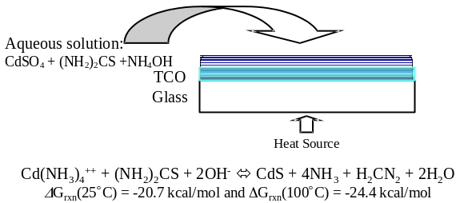

Figure 19. Schematic view of CSD deposition of CdS films.

Stock aqueous solutions of 0.015 M cadmium sulfate, CdSO₄, 1.5 M thiourea, CS(NH₂)₂, and 14.28 M ammonium hydroxide, NH₄OH, were placed in titrating burets for volumetric dispensation. The solutions were dispensed into a mixing beaker with deionized water to form the working solution, at a temperature of 25ºC. The volumetric proportions were 2.2 ml CS(NH₂)₂ and 2.8 ml NH₄OH, with CdSO₄ and water adjusted to control the Cd⁺⁺ concentration. The starting pH of the working solution is ~11.5. Borosilicate glass substrates coated with ITO were placed under a glass cover on a heated plate at temperatures of 55ºC, 65ºC, 75ºC, 85ºC, and 95°C, and allowed to heat for 10 minutes prior to application of the solution. A volume of 0.36 ml of working solution per square inch was applied to the surface of each substrate. For [Cd⁺⁺] = 3 mM, this volume contains sufficient Cd to form CdS films ~50 nm thick. At the end of the prescribed reaction times, ranging from 2-6 min, residual solution was transferred from each sample surface to a waste beaker. The coated substrates were rinsed in flowing de-ionized water and dried under a forced Ar gas stream. The time to complete the reaction was determined by visual inspection of the growth process and varied with temperature for fixed total quantity of solution is shown in Table 9.

Table 9. Time to complete reaction.

Substrate Temp  (ºC) | Saturation Time  (min)
95 | 2
85 | 2
75 | 3
65 | 5
55 | 6

CdS film thickness was determined by optical absorption and step profilometry and was correlated to optical transmission for λ< 500 nm, allowing ~1 nm precision in comparative analysis. Using the reaction times shown in Table 9, films were deposited at different temperatures and Cd species concentrations (Table 10). At a fixed substrate temperature, thickness increased with total Cd⁺⁺ concentration until saturation. This limit arises from loss of ammonia species and stalling of the reaction as the temperature of the applied solution rises. The remaining Cd can exist as dissolved Cd⁺⁺ or suspended as sulfide or hydroxide product.

Table 10. CdS thickness (nm) for different substrate temperatures and Cd⁺⁺ concentration.

 | [Cd⁺⁺] (mM)
T (ºC) | 1.5 | 2.0 | 3.0 | 4.0 | 5.0
55 | 7
65 | 16 |  |  | 38
75 | 23 | 31 | 42 | 40 | 43
85 | 23 |  | 50 | 42
95 | 24 |  |  | 31

The maximum film thickness and deposition rate were 50 nm and 25 nm/min, respectively, obtained with 3 mM Cd⁺⁺ at 85ºC. The reaction saturation times (Table 9), which restrict the thickness and growth rate range, represent a combination of processes: 1) heat transfer and heterogeneous reaction at the substrate surface, 2) heat transfer to the solution resulting in ammonia loss, and 3) heat transfer to the solution and homogeneous reaction.

A steady state model was developed to provide guidance in understanding heat transfer from the heating source to the solution. For this, the liquid film was assumed to act as a boundary layer for conductive heat transport from the glass to the ambient, with constant power being supplied to the substrate. The temperature-time profile for the solution surface is shown in Figure 20 for different initial substrate temperatures. For a substrate temperature of 80°C maintained at the hot-plate interface and an ambient temperature of 25°C, the estimated steady state glass surface temperature is 78°C and the liquid surface temperature is 76°C. The solution surface heats rapidly, reaching 70°C in ~1 min and thereafter increases slowly to the steady state temperature, after ~13 min. The time needed to complete the chemical reaction (Table 9) is always greater than the time needed to raise the solution surface temperature (Figure 20), indicating that a significant fraction of the reaction time is spent at conditions where homogeneous growth and ammonia loss are favorable. This is expected to impact the utilization of Cd species in the film.

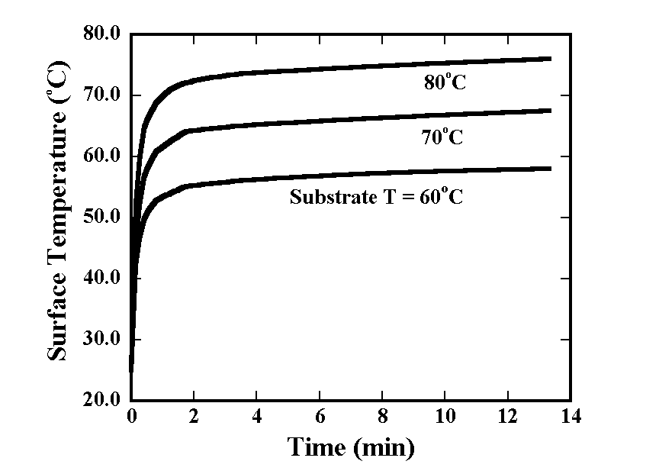

Figure 20. Solution surface temperature versus time for
three initial substrate temperatures and constant applied power.

Utilization of Cd species was calculated by mass balance from the applied solution to thickness of the deposited CdS film (Table 11) and was verified in selected cases using atomic absorption spectroscopy of the remaining surface solution. Cd species utilization was >80% for cadmium ion concentrations from 1.5 to 3 mM and increased with reaction temperature. The loss in utilization at high Cd⁺⁺ concentration is attributed to the loss in ammonia needed to complex the Cd and may be recoverable by encapsulating the solution surface during reaction.

Table 11. Utilization of Cd⁺⁺ (%)

 | [Cd⁺⁺] (mM)
T (ºC) | 1.5 | 2.0 | 3.0 | 4.0 | 5.0
55 | 28
65 | 65 |  |  | 56
75 | 90 | 85 | 84 | 58 | 51
85 | 92 |  | 100 | 60
95 | 94 |  |  | 45

Additional CdS film thickness is easily obtained by performing multiple coatings. For depositions carried out at 65ºC and 80ºC, we verified that the obtained thickness increased linearly with the number of coatings for up to 4 coatings. We have used the CSD method to deposit CdS films with ± 1 nm thickness uniformity on glass substrates up to 15 cm x 15 cm -± 1 nm size, limited only by the ability to heat the substrate uniformly, demonstrating the feasibility of CSD for large area coverage. For large areas, different solution dispensation methods such as spraying could be effectively utilized, since the applied volumes are small and adhere to the substrate by surface tension, allowing deposition in face-up or facedown configurations. The technique is adaptable for utilizing residual heat from prior processing steps in cell or module manufacturing and is amenable for flexible substrates and roll-to-roll operation. We have successfully used the CSD technique to deposit ZnS and CdZnS films and are presently investigating the deposition of other buffer layers for thin-film heterojunction solar cell processing.

CdS films deposited on ITO-coated borosilicate substrates were analyzed for growth habit, crystallinity, and optical transmission. Surface morphology was characterized using a Digital Instruments Dimension 3100 AFM in tapping mode with etched silicon tips. Figure 21 compares 1 μm x 1 μm AFM scans of CSD CdS films deposited at ~70°C on recrystallized ITO and ITO coated with In₂O₃. The substrates had lateral grain sizes of 10 nm and 100 nm, respectively. The root-mean square roughness and grain sizes measured in the AFM scans indicate that the CdS growth habit is conformal with the underlying substrate. Wide area surveys, 10 μm x 10 μm, showed that CSD CdS films contain less than 10⁵ adherent particulates per square cm, compared to ~10⁸ for conventional CBD CdS films. Examination by optical microscopy in transmission mode showed the fractional area of pinholes is less than 10⁻⁶, which is comparable to conventional CBD and less than for thermally evaporated CdS films.

Figure 21. Tapping AFM images of 20 nm thick CSD CdS films deposited
at 70°C on recrystallized ITO (top) and recrystallized In₂O₃/ITO (bottom).

The phase composition of CSD films was determined by GIXRD at incident beam angle, Ω = 0.5°. Figure 22 shows the pattern for a 50 nm thick CSD CdS film deposited at 70°C onto recrystallized ITO/borosilicate glass. The pattern indicates a broad peak with three components, consistent with the wurtzite phase of CdS.

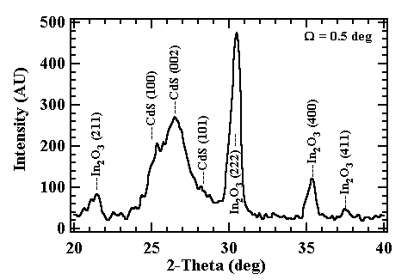

Figure 22. GIXRD pattern of 50 nm thick CSD film
deposited at 70°C on ITO/borosilicate glass substrate.

The optical transmission spectra of Corning 7059 borosilicate glass, 200 nm ITO/glass, and CSD CdS/ITO/glass, normalized for reflection, are shown in Figure 23. Transmission curves for three CdS film thicknesses, 6 nm, 20 nm and 45 nm, are shown. The CdS band edge is apparent at ~520 nm (2.4 eV). At lower wavelength, the transmission is limited by absorption in the CdS film, determined by the absorption curve and the film thickness. Above the band edge, the transmission through the structure is limited by the glass and ITO absorptivity, resulting in T/(1-R) > 90%.

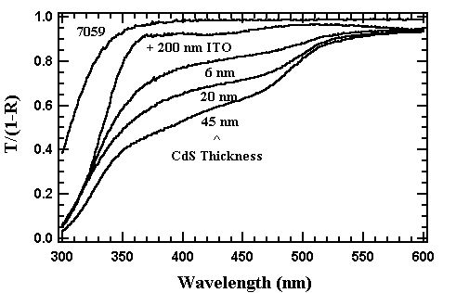

Figure 23. Normalized optical transmission of Corning 7059 borosilicate glass,
200 nm ITO/glass, and with three thicknesses of CSD CdS.

Through film electrical conductivity was measured on 50 nm thick CdS films on ITO by measuring the current-voltage characteristic between 2 mm diameter In dots and the ITO substrate. Linear behavior was obtained corresponding to conductivities of ~10⁻⁴ S/cm in the dark and ~10⁻³ S/cm at 10 mW/cm² of white light through the CdS film. Slightly higher values were obtained in cross-grain measurements of CSD CdS films deposited on glass.

CdTe/CdS devices were fabricated in a superstrate configuration using CSD CdS applied to borosilicate glass coated with transparent conductive oxides (TCO) and high resistance oxide (HR) layers. In the examples shown here, different combinations of HR/TCO/glass are shown: 1) In₂O₃/ITO/7059, 2) SnO₂/SnO₂/7059; and 3) Ga₂O₃/SnO₂/soda-lime (Pilkington TEC-15). In all cases, the HR layer thicknesses and sheet resistances were 100 nm and ~1000 Ω/sq, respectively. The CdS films were deposited by CSD at 70-80°C using the solution chemistry already described. Nominally 4 μm thick CdTe absorber layers were deposited by PVD onto stationary substrates at 0.1 μm/min at 340°C or by VT onto moving substrates at 1 μm/min at 550°C translating at 1 cm/min. The structures were annealed at 600°C in argon for 10 minutes and then treated in CdCl₂:O₂:Ar vapor at 400°C for 20 min. The back contact was fabricated by forming Cu₂Te followed by application of a contact. Current-voltage (J-V) parameters of the best cells obtained are shown in Table 12.

Table 12. CdTe/CdS device J-V results.

CdTe  Dep | HR/TCO/glass | V_{oc}  (mV) | J_{sc}  mA/cm² | FF  (%) | Eff  (%)
PVD | SnO₂/SnO₂/7059 | 790 | 25.0 | 68 | 13.4
PVD | In₂O₃/ITO/7059 | 790 | 21.8 | 70 | 12.0
VTD | Ga₂O₃/SnO₂/SL | 770 | 21.2 | 64 | 10.4

2.4.2 Optimization of CSD CdS

It is well established that while thinner CdS leads to higher J_{sc}, there can be an unacceptable decrease in V_{oc} and FF, due to degradation in the junction integrity. This can be due to formation of pinholes in the CdS or to nearly complete consumption of CdS during subsequent device processing. In both cases, the incomplete CdS layer results in formation of a high recombination SnO₂/CdTe junction, which shunts the CdS/CdTe junction in parallel, and in formation of a lower band gap CdS_{x}Te_{1-x} junction region. Thus, high efficiency devices require a robust and durable thin CdS film, which maintains a continuous layer for uniform junction formation. In this contract we investigated the relationship between device processing, materials properties and device performance for cells with CdS films deposited by CSD, which produces conformal ultra-thin CdS films with low particulate density and high utilization of Cd species . Focus has been on establishing and understanding baseline processing procedures for the CdS/TCO superstrates and post-deposition procedures for completed CdTe/CdS structures.

IEC has previously demonstrated using PVD CdS films that a CdCl₂ heat treatment of CdS prior to CdTe deposition was critical to establish high efficiency as CdS thickness decreased. This was related to minimizing Te and S interdiffusion of small grain CdS during the CdTe CdCl₂ treatment. Thus, the processing variables investigated here for CdS/TCO were time and temperature of the CdCl₂ treatment given to the CSD CdS prior to CdTe deposition. For the CdTe/CdS post-deposition treatments, the time and temperature of the CdCl₂ treatment given to the CdS/CdTe, and use of a high temperature anneal (HTA) prior to CdCl₂ treatment for both CdS and CdTe were investigated, and discussed further in Section 2.3. Substrates were TEC-15 SnO₂ with a Ga₂O₃ high resistance buffer layer. All CdS and CdTe layers were deposited under nominally identical conditions for all devices presented in this section. CdS was deposited by CSD to a thickness of ~90 nm. The CdS was given different treatments prior to CdTe deposition. Following deposition of a ~4 µm CdTe layer at 550°C in a single 6 min pass in He/O₂ at 20 T, pieces may receive a high temperature anneal (HTA) and/or CdCl₂ treatment. Contact processing consists of a BDH etch then loading into the evaporator for 50 nm Te, 30 nm Cu, 50 nm Au. Presently, we are using Cu/Au contacts evaporated through a mask since this is more repeatable than scribing around a graphite paste contact but typically leads to 20-30 mV lower V_{oc}. Samples receive a 30 minute anneal in Ar at 190°C before testing.

Figure 24 shows optical transmission data the TEC15 superstrate, TEC15 + 40 nm Ga₂O₃ high resistance layer, and a 90 nm thick CdS film before and after vapor CdCl₂ treatment at 430°C. Evidence of significant recrystallization is indicated by AFM profiles of the surface, (Figure 25) and sharpening of diffraction peaks on GIXRD patterns.

The influence of the Ga₂O₃ high resistance layer on CSD growth was studied. It was found that CdS films grown on Ga₂O₃ or In₂O₃ HR layers exhibit larger grain size than those on glass or ITO, due to the conformal growth habit and larger grains obtained in the HR films.

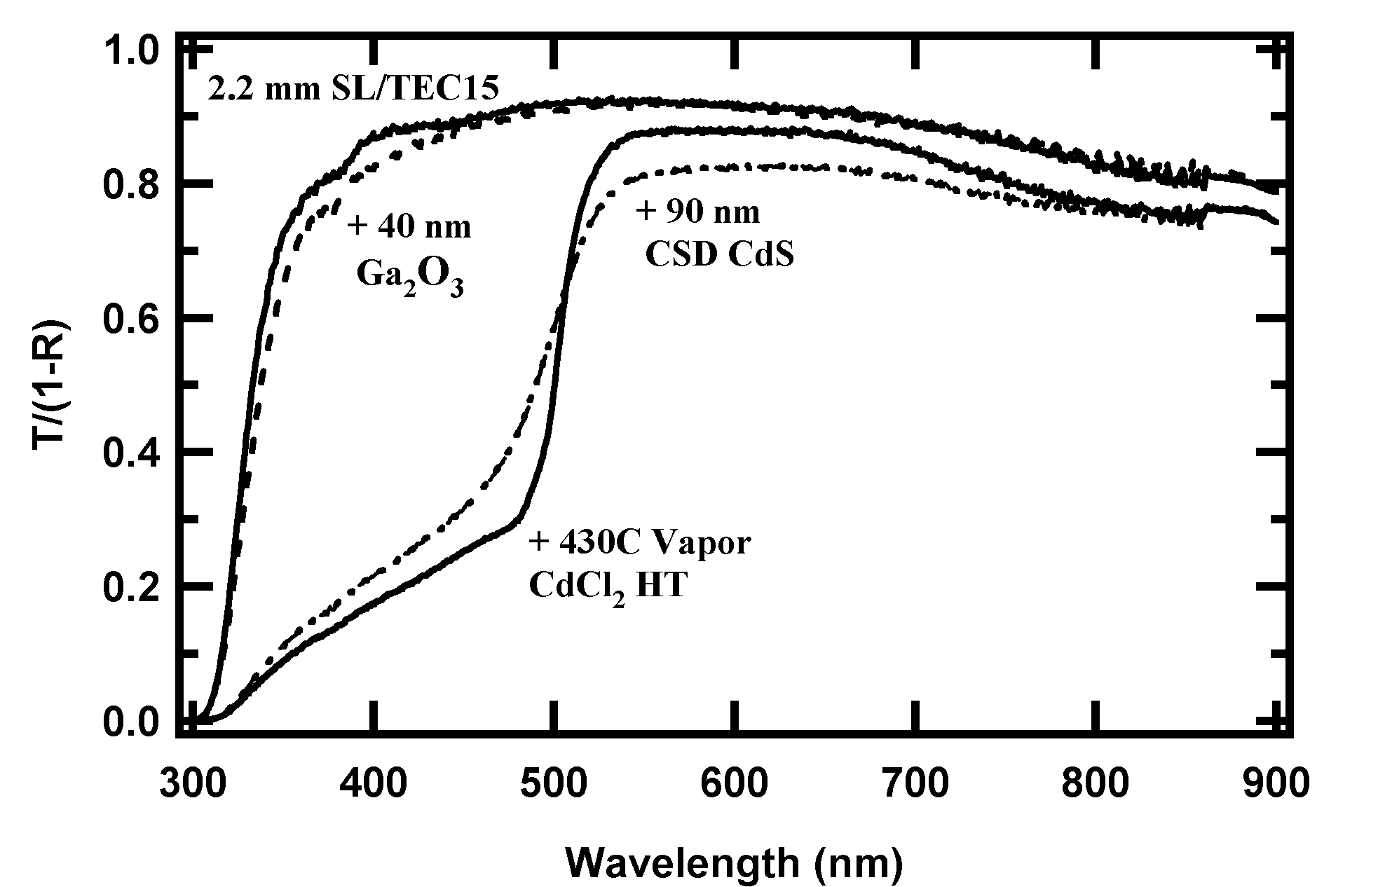

Figure 24. Normalized optical transmission, T/(1-R), of window layer used in VT cells.

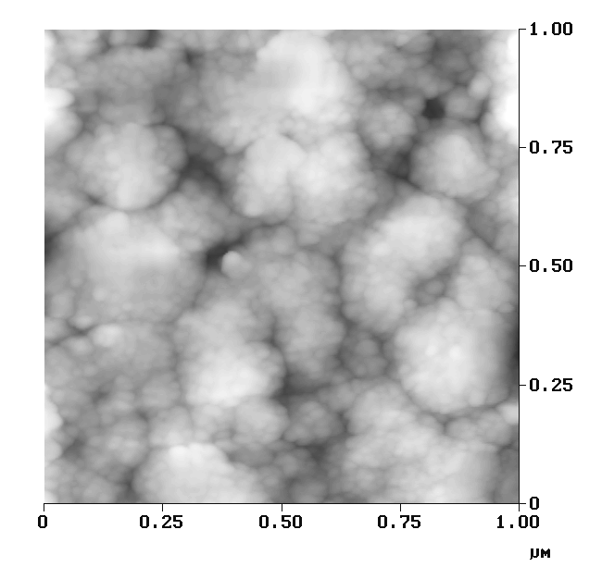
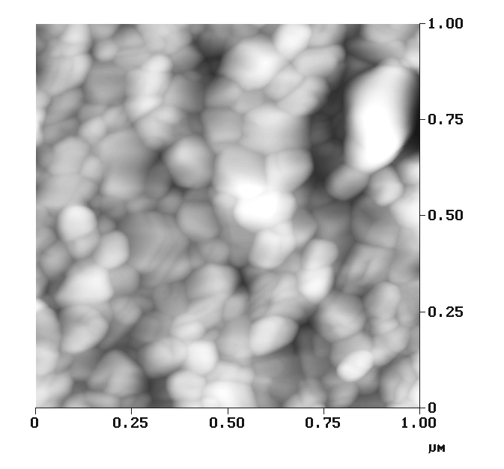
Figure 25. AFM scans of CSD CdS film: as-deposited (left)
and after vapor CdCl₂ HT at 430°C (right).

Having established how vapor CdCl₂ treatments change the CdS properties, we attempted to optimize the device performance by varying the temperature and CdCl₂ treatment time. Run VT 79 exposed identical CdS layers to CdCl₂ for various temperatures (350-430°C) and times (5-20 min). After CdTe deposition, all pieces but one received a 30 min HTA at 580°C in Ar and all received a 25 min CdCl₂ treatment at 400°C. Figure 26 shows the efficiency of the best cell per piece for various times and temperatures of the CdS treatment. In general, efficiency improved with increasing the temperature and time. Therefore, a temperature of 430°C and time of 20 min was selected for CdS treatment in subsequent studies. The lone piece, which did not receive the post-CdTe HTA, had noticeably poorer efficiency.

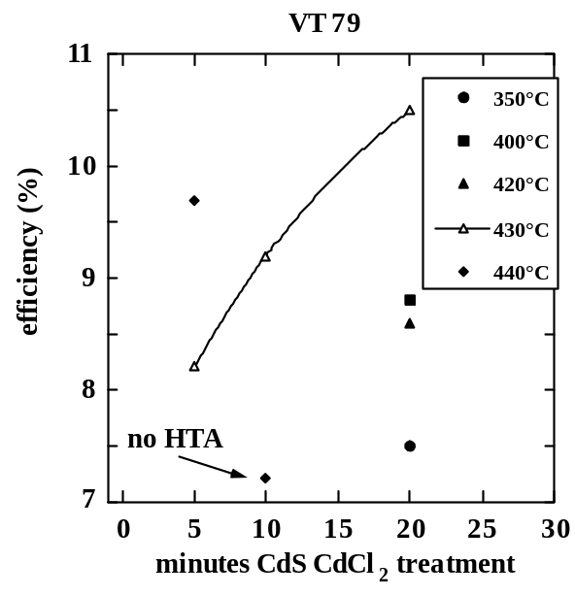

Figure 26. Effect of CdCl₂ treatment time of CdS layers on
efficiency at different temperatures from run VT 79.

Since the CdS is deposited from a Cl based-solution, it was possible that an anneal alone would be sufficient to activate the CdS grain growth against further interdiffusion, thus, eliminating the need for a separate CdCl₂ treatment of the CdS. It was decided to evaluate the application of an HTA step to only the CSD CdS layer.

Run VT 84 compared devices with and without the HTA and CdCl₂ treatments to CdS prior to CdTe deposition. The CdS CdCl₂ treatment was at 430°C for 20 min and the HTA was at 550° for 30 min in Ar. Also included in this run were two substrates of glass/SnO₂/CdS from First Solar, which did not receive any treatments since the CdS was deposited at high temperature. After CdTe deposition, all IEC pieces received a 20 min HTA at 560°C in Ar followed by a 25 min CdCl₂ treatment at 420°C in air. Table 13 lists J-V parameters and yield for this set of devices. The HTA alone or in combination with CdCl₂ yielded lower FF. The best cell on three identically processed pieces with only CdCl₂ ranged from 10-11%. Yields were better than 75%.

Devices on First Solar CdS had similar V_{oc} and FF to IEC’s VT cells. This was investigated further by analyzing the dark J-V curves from the best device on 33 (IEC CdS) and 43 (FS CdS) pieces, which had similar V_{oc} and FF. Both devices had diode factors A~2, recombination current density J_{o}~1E-5 mA/cm², and R_{S}~ 2 -cm². We conclude that IEC’s CdS is not a major limitation to higher V_{oc} or yield at this time providing it has a CdCl₂ pre-treatment.

Figure 27 shows the QE curves measured at –1V with light bias on devices from 4 pieces of VT 84 from Table 13. Below 550 nm, they fall into three groups. The FS CdS is thicker so it has a much lower transmission and QE. Devices with IEC CdS which received either HTA or CdCl₂ have QE values expected for ~90 nm of CdS. But the sample receiving both HTA and CdCl₂ treatments shows evidence of S-Te interdiffusion; i.e. the QE has increased at both short and long wavelengths compared to the other pieces. Note the rounding of the QE between 500 and 600 nm for the –13 piece (HTA without CdCl₂). This also suggests formation of CdS_{x}Te_{1-x}. Based on these results we have selected CdCl₂ at 430°C for 20 min without HTA as the standard process for device fabrication with CSD films.

In summary, device performance exhibited sensitivity to the CSD CdS treatment, similar to PVD CdS cells. The vapor CdCl₂ ambient composition during treatment of CdTe/CdS structures was shown to affect cell performance, and is attributed to the vapor concentrations of CdCl₂, O₂ and H₂O. The CdCl₂ treatment sharpens the optical transmission edge and improves crystallinity of CSD CdS films just as with PVD CdS films.

Table 13. Performance of best cell-on-pieces from VT 84 having differently treated CdS. Samples CdS from FS included. Yield based on shunting and low FF of 8 cells per piece.

Piece | CdS treatment | V_{oc}  (V) | J_{sc}  (mA/cm²) | FF  (%) | Eff.  (%) | Yield
-12 | HTA + CdCl₂ | 0.640 | 19.8 | 41.2 | 5.2 | 6/8
-13 | HTA only | 0.740 | 21.2 | 58.4 | 9.1 | 6/8
-22 | HTA only | 0.718 | 22.0 | 60.4 | 9.5 | 8/8
-23 | CdCl₂ only | 0.773 | 22.3 | 63.2 | 10.9 | 7/8
-32 | CdCl₂ only | 0.742 | 21.9 | 61.9 | 10.0 | 8/8
-33 | CdCl₂ only | 0.747 | 22.3 | 65.6 | 11.0 | 7/8
-42 | FS CdS | 0.720 | 20.5 | 63.5 | 9.4 | 7/8
-43 | FS CdS | 0.743 | 20.4 | 67.0 | 10.2 | 8/8

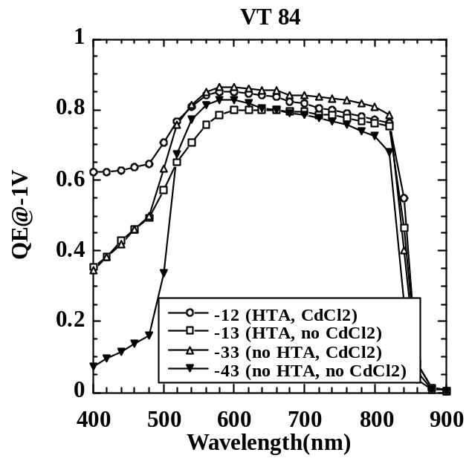

Figure 27. QE of 4 pieces from VT 84 as described in Table 13.
The 43 piece had FS CdS while the other three had IEC CdS.

2.4.3 Microscale Junction Analysis

We are investigating the use of electric, or electrostatic, force microscopy as a tool for directly measuring field profiles and carrier transport in operational thin-film CdTe/CdS solar cells. Different measurement modes are possible depending on the electrical configuration; we have elected to investigate cells in cross-section using a conductive tip to measure potential or current under different light and voltage bias conditions. Figure 28 below shows the physical and electrical configuration of the solar cell and microscope for electric field gradient imaging using interleaving. During operation, the measured voltage is obtained with respect to the morphology displacement voltage by interleaving the topological and potential measurements.

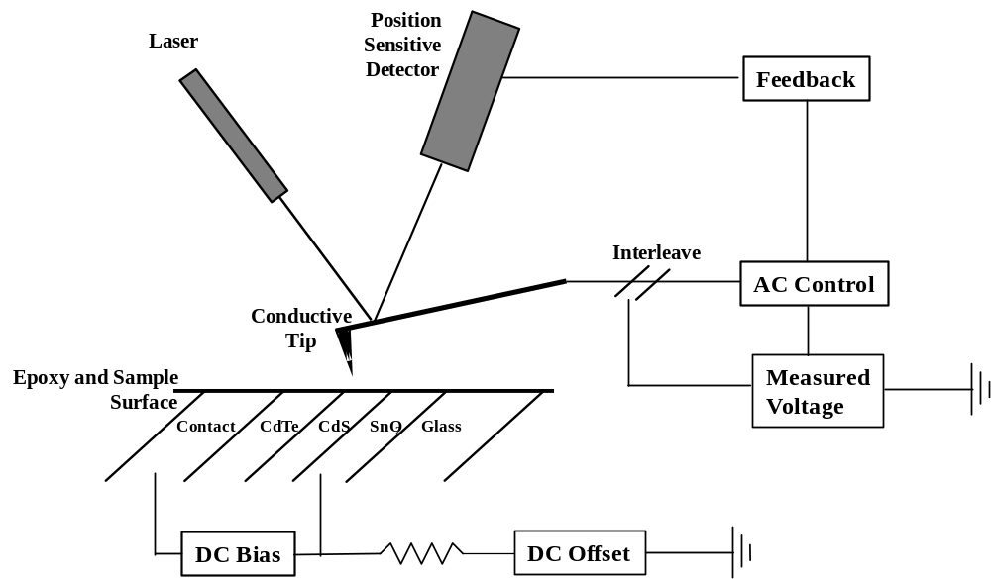

Figure 28. Schematic diagram (not to scale) of taper mounted
solar cell and microscope arrangement for potential measurement.

Electric force mode, with bias from solar cell to tip is also being used. The spatial resolution of this technique, combined with electronic models of device operation, may enable micro-scale variations to be correlated with processing variations and macro-scale device performance. For this, a method for reliably mounting and grinding and polishing electrically active CdTe/CdS cells in cross-section was developed, and a Digital Instruments Nanoscope AFM has been modified for voltage and current measurement. The completed cell structure has external electrical leads connected to each side of the junction and is mounted so that illumination bias can be provided. Figure 29 shows the sample mount configuration. Figure 30 shows a 2 m x 2 m tapping mode image of a First Solar cell polished at a 45 degree angle.

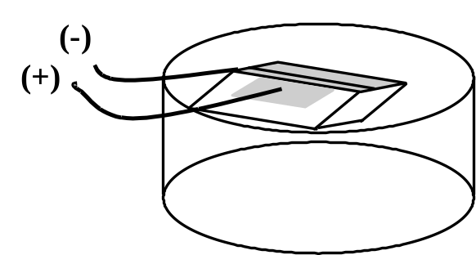

Figure 29. Schematic of solar cell mounted in epoxy at an angle, exposing the junction.

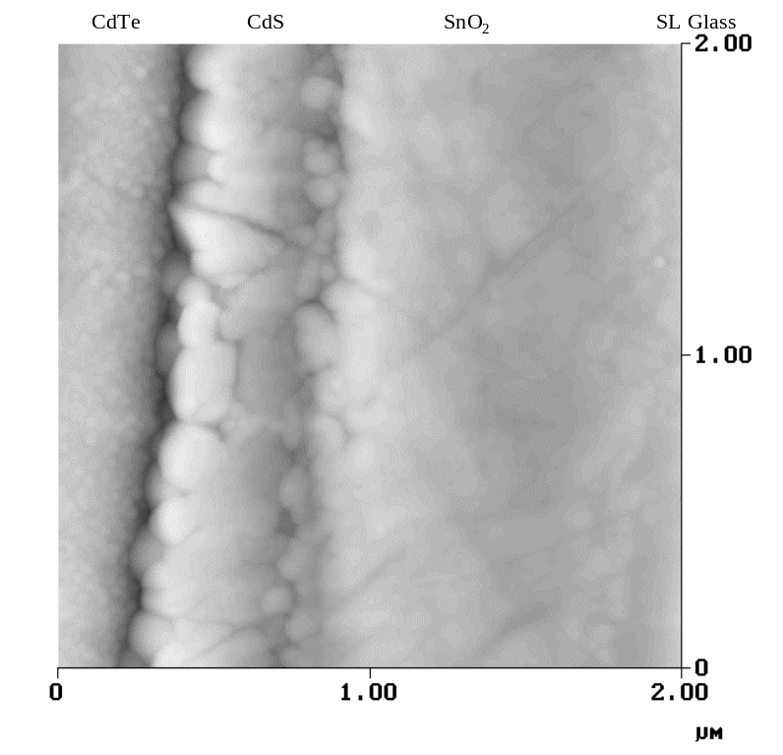

Figure 30. Tapping AFM image of the CdTe-CdS interface region
of a thin-film First Solar CdTe/CdS solar cell after mechanical polishing.

Based on J-V measurements of the cell after mounting and polishing, the fracturing, mounting and polishing process does not alter the current-voltage behavior of the cell. Furthermore, preliminary measurements made in voltage mode in the dark at forward bias show detectable contrast differences between CdS and CdTe sides of the junction. However, interpretation of the contrast in these measurements will ultimately depend on relative changes measured in systematic studies. This technique will be evaluated on cells fabricated with different post-deposition processing and before and after stress-induced changes.

2.4.4 CdTe Conductivity and Alternative Treatments

As-deposited CdTe films do not have the required electronic properties needed to obtain high quality junctions. Unlike CuInSe₂ and related materials, the extremely narrow single-phase region coupled with the high constituent element vapor pressures leads to stoichiometric deposits and low as-deposited film conductivity. Thus, post deposition treatments are needed to shift the defect equilibrium sufficiently to allow formation of acceptor complexes, which have relatively low ionization potentials. As Marfaing has shown for single crystal CdTe, a principal result of the CdCl₂ treatment in oxygen containing ambient is production of V_{Cd} via removal of lattice-bound Cd and formation of CdO . Analogous behavior may be expected in thin films, and indeed, at elevated (20 vol %) oxygen levels, CdO product is found on the surface of CdTe films treated in CdCl₂ vapor. A proposed phenomenological model for controlling CdTe conductivity via post deposition treatments is: 1) formation of V_{Cd} at the surface; 2) redistribution of the vacancies in the course of the treatment; and 3) addition of extrinsic dopant to form the desired acceptor complex. This model offers an explanation of why thin film CdTe cells made in superstrate mode give superior junction performance than those substrate mode. Experiments were conducted to explore this model, to improve our understanding of the treatments, and to find paths to more robust and controllable alternative treatments.

The initial experiment was to measure the dark and light cross-grain conductivity versus T on CdTe films from a single PVD deposition (#41184). The first round of treatments were: none; HTA ≡ Ar @550°C for 60 min; and Te vapor @550°C for 60 min. No CdCl₂ or Cu exposure was applied to this first group. Several pieces were held at each of these treatments and subsequent samples from each set will receive CdCl₂ and contact treatments as well. Two contacts were used. One piece each received a 50 nm Au contact and one piece received 50 nm Te/30 nm Cu/50 nm Au contacts. IEC’s co-planar contact mask was used, having 0.05cm spacing. Substrates were all Corning 7059 glass. Conductivity was measured as a function of temperature in the dark and then at 300K in the light. Temperature was 220 to 320 K on one set and 210K to 360K on the second set. N₂ purging was used. The voltage range was selected to give measurable currents, typically ±10, 20, 50 V.

Results are in Table 14, showing dark and light conductivity at 300K and dark conductivity activation energy. Most samples had a curved Arrhenius plot but could be approximately fit with a straight line. All samples had linear J-V relation (Ohmic) in the dark and most also in the light. A few had moderately non-Ohmic behavior in the light but best fit was used (regression coefficient of at least 0.96). Hot probe measurements were also made, using a hot tip at 250°C and a cold tip at room temperature cm as-deposited samples showed slight negative voltage –1 to –10 m V, which is consistent with intrinsic conductivity. After the anneal in Ar or Te vapor, the samples showed moderate positive voltage (+1 to +100 mV) consistent with p-type conductivity.
Table 14. Conductivity results for treated CdTe films.

Piece | Treatment | Contact | Dark cond.  (S/cm) | Light cond.  (S/cm) | Ratio  L/D | Ea  (eV)
32a | None | Au | 4E-9 | 8E-7 | 200 | 0.64
11a | Ar,550°C,60min | Au | 7E-7 | 2E-4 | 280 | n/a
21d | Te,550°C,60m | Au | 6E-7 | 9E-6 | 15 | 0.22
21c | None | Te/Cu/Au | 9E-9 | 1E-6 | 110 | 0.37
32b | Ar,550°C,60min | Te/Cu/Au | 1E-7 | 9E-5 | 900 | 0.49
11b | Te,550°C,60m | Te/Cu/Au | 7E-7 | 5E-6 | 7 | 0.21

Two clear conclusions emerge from this experiment. First, two untreated samples (32a and 21c) have the lowest dark conductivity independent of contact. Second, both samples treated in Te have the lowest photoconductive ratio, and lowest activation energy. These are consistent: the higher the Fermi level, the higher the density of gap states it resides in, so the less its position can be influenced by trapped charge. Thus, this data is consistent with the premise that Te makes CdTe more conductive. There is no clear difference between samples with Au or Te/Cu/Au contacts. In fact, 2 samples with Au contacts had more linear light J-V than those with Te/Cu/Au, which contradicts the assumption that Te/Cu is needed to give an Ohmic contact. The next step in this experiment is vapor CdCl₂ treatment of the annealed films with varying concentration of CdCl₂, oxygen and water vapor.

Alternative approaches for delivering CdCl₂ to the CdTe surface and evaluation of the process sensitivity are being investigated in part under the team activity and in-part as a critical aspect of improving the post-deposition process to improve yield and performance. For vapor CdCl₂ treatment, mathematical models of the delivery of molecular CdCl₂ species have been generated for diffusion from a packed bed of CdCl₂, for transport via carrier gas across a packed bed of CdCl₂ and for transport via carrier gas through a packed bed of CdCl₂ pellets. For the last case, momentum transfer from the carrier gas to the pellets provides an additional term to the residence-time/diffusion term, allowing relatively high CdCl₂ concentrations to be achieved at temperatures below 300°C.

Alternative treatment chemistries are also being examined to exploit the proposed model that the role of the treatment is to shift the electronic level stoichiometry of the CdTe film. ZnCl₂ and TeCl₄ are each reactive halide compounds with relatively high vapor pressures and which sublime congruently at lower temperatures than CdCl₂. The vapor treatment reactor described elsewhere is being used to expose CdTe films to controlled concentrations of these vapors at different reaction temperatures. For PVD films, grain growth has been observed using both halide species. For First Solar VT films, devices with efficiency approaching 9% were obtained using ZnCl₂ vapor.

2.4.5 Effects of Cu as an impurity in CdS

There is little direct control over the CdS electrical properties during deposition or subsequent processing in CdS/CdTe solar cells. CdS photoconductivity (PC) was investigated extensively in the 1970s with regard to Cu-related acceptor states in CdS of CdS/Cu₂S solar cells . Cu creates deep hole traps in the CdS, greatly increasing the dark resistivity, but this could be recovered with illumination. It has been shown that Cu is present in CdS of CdS/CdTe solar cells, even in special devices made without any intentional Cu layer or Cu doping . The Cu concentration in the CdS also increases after accelerated thermal and voltage bias stressing Error: Reference source not found. Several recent papers have investigated the PC in unstressed CdS/CdTe devices using AQE at far forward bias ~1.5V . We used the bias light spectrum to characterize the AQE in CdS/CdTe devices from several groups.

The CdS/CdTe devices came from BP Solar, Colorado State University (CSU), First Solar, University of Toledo (UT), and the IEC. They all had initial efficiencies of 10-12%. The devices all had some intentional Cu introduced during processing of the back contact. Two unique devices made at IEC, one without a CdS layer and one with a Cu-doped CdS layer, were included. AQE measurements were made under various filtered light bias conditions. ‘Blue’ bias light was obtained with a Corning 4-71 filter passing wavelengths below 600 nm and ‘red’ bias light was obtained with a Corning 2-58 filter passing wavelengths greater than 650 nm. The probe beam for AQE measurements was chopped at ~75 Hz unless specified. J-V measurements were also made using filtered light.

Figure 31 shows the AQE for an IEC device at +0.6 V bias with white, red, blue and no (dark) light bias. Red bias light increases the blue AQE. This enhancement was evident even at 0 V bias but smaller in magnitude. With red bias, the AQE exceeds unity below 550 nm. With blue or white bias, the AQE increases beyond 600 nm compared to the dark. Qualitatively, all CdS/CdTe devices we have examined (First Solar, BP Solar, IEC, CSU, UT) at forward bias using color bias light are relatively similar to results in this figure.

The effect of red bias light can be seen more clearly when plotted as the ratio of AQE with red bias to AQE with white bias light. Figure 32 shows this ratio for unstressed devices from the five groups. This shows the effect of eliminating blue light from the bias spectrum. To first order, all devices show qualitatively similar behavior with an enhancement in the AQE for λ<550 nm with red light. The exception is for a device made at IEC without a CdS layer (measured at 0.1 V since V_{OC} was only 0.2 V), which showed no enhancement  Many different methods of depositing the CdS, the CdTe and the contact are represented, yet they all show relatively large enhancement of the blue AQE with red bias light.

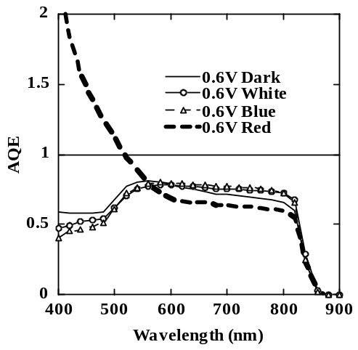

Figure 31. AQE of IEC CdS/CdTe device at +0.6 V bias with 4 bias light conditions

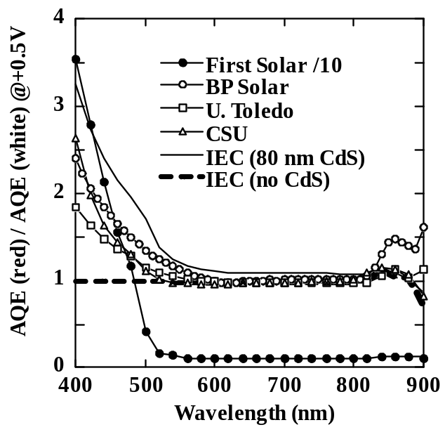

Figure 32. Ratio of AQE with red bias to AQE with white bias for various CdS/CdTe devices plus one CdTe device without CdS. Data from First Solar divided by 10.

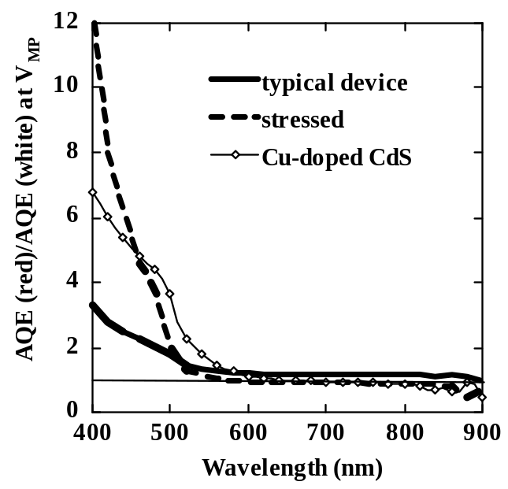

Figure 33. Ratio of AQE near V_{MP} with red light to white light for
a standard device, one with Cu-doped CdS and one after it was stressed.

IEC fabricated a device with a 0.5 nm Cu layer on the TCO before depositing the CdS. Device performance was poor: V_{OC}=0.47 V, J_{SC}=15 mA/cm², FF=30% with rollover in forward bias and leakage in reverse bias. These symptoms are also seen to a lesser degree in devices after extended stressing. (More description of the device and its performance was given in IEC’s annual report for 2002.) Figure 33 shows the ratio of AQE with red to white light bias for the device with Cu-doped CdS and one with standard CdS, both measured near their maximum power point. Deliberate Cu doping leads to greater enhancement of the blue AQE.

The AQE ratio with red to white bias of a stressed device (@V_{OC}, 30 days, 65°C, light, air) is also shown in Figure 33. The efficiency decreased from 10 to 8% after stress. The increase in AQE below 550 nm with red bias becomes even more pronounced after stress. We have seen this increase in AQE below 550 nm after stress in devices from several groups.

The effect of the chopping frequency is shown in Figure 34. The enhancement decreases with increasing frequency. At 753 Hz, the enhancement has decreased significantly; the AQE with red bias is very similar to the AQE with white bias at 73 Hz. A frequency response cut-off of ~1000 Hz at 28°C indicates that the energy of the deep state responsible for the capture or emission is ~0.55-0.60 eV from the respective band edge.

The ratio of AQE with blue bias light to no bias is shown in Figure 35 for some of the same devices as in Figure 32. There is an increase in AQE with increasing wavelength beyond 550 nm. It also increased by a factor of ~2-4 with stress and with Cu-doping of the CdS. However, the AQE with blue bias light was frequency independent.

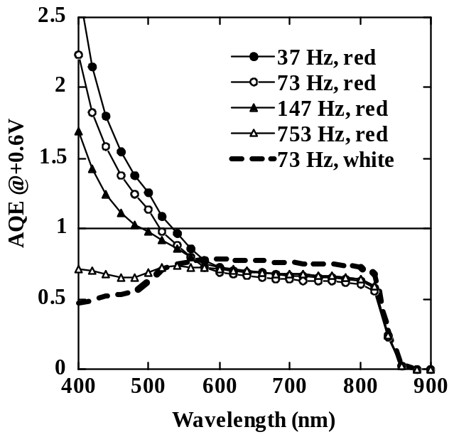

Figure 34. AQE of IEC device with red bias at various chopping frequency.
AQE with white bias light shown for comparison.

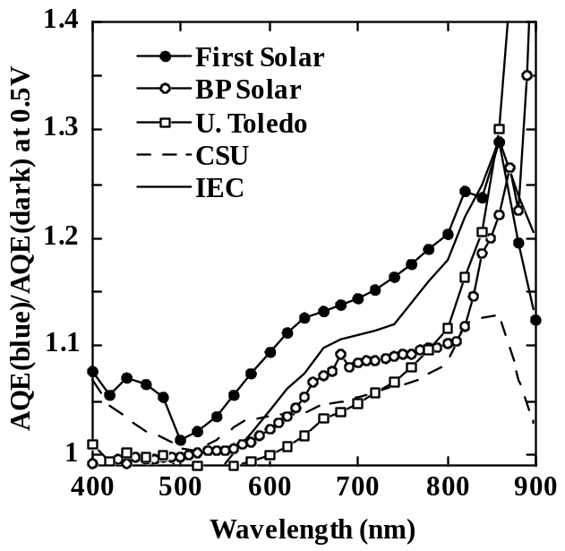

Figure 35. Ratio of AQE with blue bias to no bias for same devices as Figure 32.

These results can be self-consistently explained as follows. With blue light (above the CdS band gap), holes are preferentially trapped leading to an increase in positive space charge. This is the source of the CdS photoconductivity. Consequently, the depletion width in the CdTe must increase to maintain space charge neutrality, thus enhancing the collection of carriers in the CdTe generated by red light. Enhancement in collection from more deeply penetrating photons is consistent with the shape of Figure 35. Thus, due to photoconductive nature of CdS, any bias light containing blue photons will enable increased collection from red photons absorbed in the CdTe.

This same phenomenon is responsible for the increase in blue AQE with red bias light except now it is the blue ac chopped light which is modifying the CdS conductivity and CdTe space charge width. When the chopped light is off, the CdS conductivity is low with dark or red bias light, since there is no blue light present. When the blue chopped light is on, the CdS photoconductivity and CdTe depletion width increase as described above. In the specific case of red bias light, this enables enhanced collection of bias-light generated carriers from the CdTe in synchronization with the blue chopped light. Thus, carriers from the red bias exit the device in phase with those from the blue chopped light resulting in the appearance of collecting more than one carrier per incident blue photon. This is a form of photogating ,. There is no enhancement with dark bias because there are no bias-generated carriers to be collected from the CdTe. The AQE> with red bias was accompanied by a large increase in magnitude of the phase angle between real and imaginary components of the ac signal for λ<550 nm. Others have reported this as an indication of photoconductive gain in CdS Error: Reference source not found,Error: Reference source not found,Error: Reference source not found. There was no change in phase between white, blue or dark bias conditions.

The effect of series resistance on AQE including the impact of photoconductive layers has been used to study voltage bias dependent AQE . Based on the standard circuit model of a solar cell, a constant series resistance will cause a wavelength independent decrease in the AQE while a photoconductive resistance will give a wavelength dependent increase in the AQE. Small changes in the operating point of the device on the J-V curve result from the series resistance, which changes the current flow. The model assumes that there is no voltage dependent collection, which is valid for CdS/CIS or c-Si but not CdS/CdTe devices. The analysis of reference Error: Reference source not found is not applicable to interpret these bias light dependent measurements. We have verified that the forward biased QE of CdTe with white light is determined by the voltage dependence of the photocurrent and therefore, not likely to be determined by this resistance effect.

In summary, these results are consistent with Cu-doped photoconductive CdS whose carrier density is modulated by above-band gap (blue) light from either the ac probe or dc bias light. This is an ac effect and has little relevance to the performance of a solar cell. The CdS resistance makes an insignificant contribution to the overall series resistance of the device under white light, which restores the CdS to a highly conductive state. PC-CdS is responsible for light-dark crossover.

2.5 National CdTe Team Activity and Collaborations

Steve Hegedus and Brian McCandless attended the National Team Meeting held at NREL on October 31 and November 1, 2002. Brian presented a summary of stress degradation effects on CdTe cells using data contained in Team Minutes of meetings to 1996. Brian also presented data on effects of post processing and anneal and CdCl₂ treatment on BP Solar films. Steve presented talks on photoconductivity in CdS films and also on the effects of ambient on CdTe cells during stress treatments.

Kevin Dobson and Brian McCandless attended the National Team meeting held at NREL on July 10 and 11, 2003. Two presentations were given, detailing humidity effects during post-deposition processing and stress. IEC is represented on sub-teams, by Kevin Dobson, Steve Hegedus and Brian McCandless. Brian McCandless visited First Solar September 23, 2003. IEC has sustained regular interaction with First Solar in the analysis and development of the back contact process. This has included characterization of surfaces by GIXRD, cross-section analysis by AFM, surface energy measurements, and compositional analysis of alternative contact materials.

3 CuInSe₂-BASED SOLAR CELLS

3.1 In-line deposition Introduction

Research during this period was primarily concentrated on trying to resolve the issue of Cu(InGa)Se₂ film cracking and its adhesion to Mo in roll-to-roll deposition on Mo coated polyimide (Upilex) web. Secondarily, a number of changes have been made to the reactor and to its operation in order to improve controllability and robustness.

To a certain degree the adhesion problem has been solved by depositing a 100 to 300 Å -(Ga_{1-x}In_{x})₂Se₃ . However, film cracking, illustrated in the micrograph of Figure 36, has remained untractable. Figure 36 seems to indicate that cracks on the Cu(InGa)Se₂ film result from the cracks that are formed on the Mo film. These cracks on Mo develop in the Cu(InGa)Se₂ chamber prior the deposition of the absorber as can be surmised by the texture difference between the film just around the cracks and the film away from the cracks. If the bi-layer Mo/ Cu(InGa)Se₂ cracked after the deposition such texture difference would not have been observable. It should be emphasized that cracking of the Mo films have never been observed prior to the Cu(InGa)Se₂ deposition.

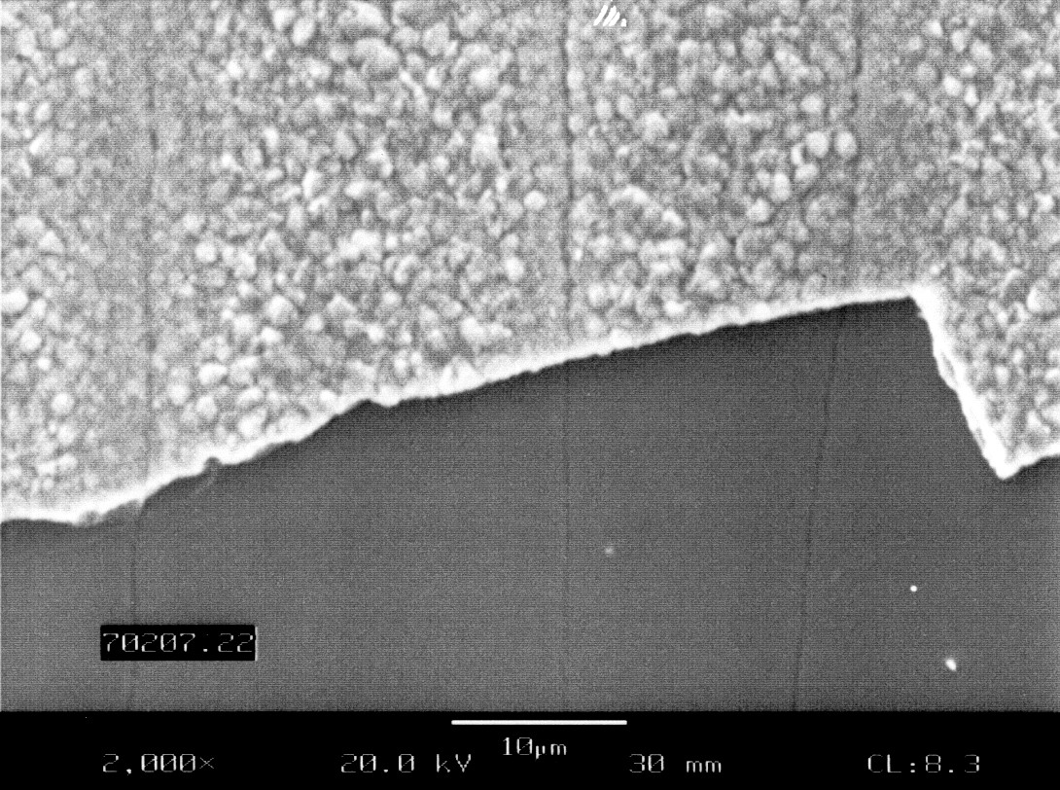

Figure 36. Cracking of Mo/CIGS structure on Upilex substrate;
Note the cracks on the Mo film imaged on the Cu(InGa)Se₂ film.

Based on these observations, the main approach used to investigate film cracking was to deposit Cu(InGa)Se₂ films on Mo deposited under different conditions and on different substrates at the facilities of Techni-Met, Inc., in Windsor, Connecticut. The cracking was evaluated by visual observation and the adhesion by the 40 oz/inch tape test. The parameters that were varied during Mo depositions were substrate temperature, sputtering pressure both influencing film stress. Two types of Upilex substrate were evaluated: Upilex S and Upilex SG, the latter providing better adhesion to metal films, according the manufacturer. These substrates were used as is or after a surface conditioning oxygen plasma treatment. The web was either cooled by a backing drum chilled to 12°C or its temperature was not actively controlled and reached closed to 100°C from the effect of the sputtering plasma. In addition to testing Upilex substrates coated with Mo deposited at different conditions, the effect of the web tension during Cu(InGa)Se₂ deposition was also evaluated.

3.1.1 Cracking and Adhesion

A number of Upilex/Mo substrates were evaluated in terms of cracking propensity during CuInGaSe₂ deposition and Mo/CuInGaSe₂ adhesion. All the samples evaluated showed some degree of cracking. The CuInGaSe₂ adhesion was found to be variable, being acceptable in some cases i.e.; less than 10% film removal with the 40 oz/inch tape, and heavy flaking in the others.

There was no correlation between any Mo sputtering parameters and the level of cracking or adhesion. This was the case for both Upilex S and Upilex SG. Oxygen plasma treatment of the Upilex surface prior to Mo deposition didn't result in any measurable effect. The lack of correlation was also observed between cracking and adhesion; and the web tension during the CuInGaSe₂ deposition for tension levels between 8 lb to slightly less than 2 lb for 6" wide web used. Investigation in this area is continuing with the focus on both the Mo film and the process of deposition of the CuInGaSe₂ film.

3.1.2 System Improvements

The system's Cu and In sources had been initially operating by Atomic Absorption Spectroscopy (AAS) control while thermocouples (TC) were used only for monitoring purposes. It was decided to operate these sources by TC control and use AAS as the monitoring tool in order to better understand the systems operational characteristics and also judge the reproducibility under TC control. Under AAS control reproducibility was marginally acceptable as the alignment of the units' optical components were found to require frequent adjustments. The initial TC control experiments showed large fluctuations in the power delivered to the Cu source, which operates at a temperature of around 1380°C, considerably higher than the other sources. These power fluctuations in effect rendered the system uncontrollable. Considerable amount of time was spent to trace the cause of the problem that was traced to the noise in the TC extension wires that National Instrument Field Point system was not able to filter. As a result all the source TC extension wires were replaced by shielded wiring and the shields were connected to the floating ground of the Field Point modules. Tests with the new wiring system didn't display any power fluctuations resulting in proper source control.

Following the shielding of TC extension wiring, the system went through some testing since it has also undergone a number of changes and parts replacements. As a result of these tests it became apparent that the TC control of the sources with AAS monitoring was found to give better reproducibility and robustness. However, since a switch was made from naked TCs to Ta sheathed TCs an offset existed between the readout and actual temperature. In the case of Cu source, this offset was determined by observing the temperature plateau during the cool down, which corresponds to the solidification point of Cu i.e. 1085°C. For the Ga and In sources the offsets were determined experimentally by measuring the film composition and estimating from it the adjustment to the source temperatures as obtained from the effusion model of the system.

Another problem observed during the operation of the system was the controllability of the Se sparger in that at operational temperatures Se sparger heater power supply was found to draw only 1% power. This indicated that Se source was primarily heated by radiation from other heat sources in the system. In order to remedy this situation various heat shielding schemes have been tried. As a result, Se source temperature was reduced to 320°C from 360°C without any change in the film composition and structure.

There was, however, a need to make Se effusion a totally independent and controllable parameter. The Se sparger system consists of a source bottle heated by an electrical heater, a main manifold and four branches with two effusion holes each (Figure 37) along the sides of the Cu, Ga and In sources.

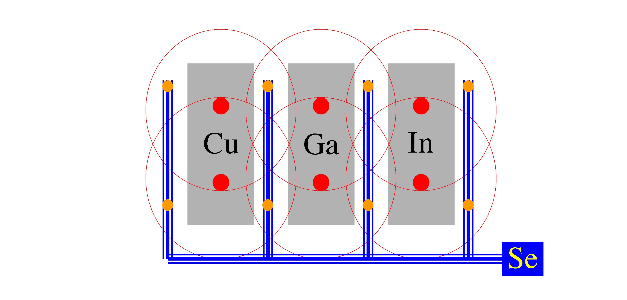

Figure 37. Source layout in the CIGS in-line deposition system.

The primary issue was the control of the surface temperature of the Se melt in the source bottle. Since Se source receives substantial amount of heat from Cu, Ga and In sources a heat shield was installed between these sources and the Se bottle. There is however heat coming into the Se bottle by conduction from the manifold. This heat source along with the spiral electric heater placed towards the top of the Se bottle; create a temperature gradient in the Se source. Se temperature is the highest at the top where the manifold is attached, and the coldest at the bottom of the source. Under these circumstances as Se is used up the level goes down and since the control thermocouple immersed into the melt is stationary, it indicates the true surface temperature only when the melt level is at the same level as the thermocouple tip. This problem was solved my using a 0.01" OD inconel sheeted thermocouple attached to a graphite ring placed inside the source with a certain amount of slack on the thermocouple. During the operation the graphite ring floats over the melt, and since the thermocouple is thin, as the melt level changes graphite ring stays floating over the melt and the thermocouple always give the surface temperature as long as there is source material in the bottle.

Another problem with controlling Se flux onto the substrate was that Se was found to condense in the branches during start-up and/or cool-down creating secondary uncontrolled sources. This problem was solved by carefully monitoring the temperature of all the source shields, Se branches and Se source bottle and making sure that branches between the metal sources is always hotter than the Se source. Under these circumstances Se will always condense into the source not in the branches. This was achieved by properly sequencing the temperatures during heat-up and cool-down. Figure 38 shows the relevant temperatures during a run as a function of time in which the proper sequencing allowed the Se source to be the coolest point at all times. The efficacy of this scheme was verified by depositing just Cu right after a CIGS deposition. No Cu-Se compounds were observed in the resulting film indicating that no condensation was present in the Se branches.

Figure 38. Temperature of the sources and of the Se branches during a CIGS run where heaters were properly sequenced during heat-up and cool-down to keep Se source temperature the lowest. Right hand scale shows temperature
of the Cu, Ga and In sources.

3.2 CuInSe₂-based Devices with Increased V_{oc}

The goal of the sub-task on increased V_{oc} is to provide the understanding of materials and processing requirements to increase the operating voltage of CuInSe₂-based solar cells. This can directly improve the performance of thin film modules. The first part of this sub-task has focused on the growth of Cu(InAl)Se₂ films with a specific objectives to improve the adhesion of Cu(InAl)Se₂ on glass/Mo substrates, and determine the effects of increasing relative Al content and bandgap on material and device properties. A second part of this work is to develop a fundamental understanding of the diffusion of S into CuInSe₂ or Cu(InGa)Se₂ films which could also be used to increase V_{oc}.

3.2.1 Cu(InAl)Se₂ Solar Cells

Significant effort has been devoted to developing high efficiency CuInSe₂-alloy based solar cells with increasing absorber layer bandgap (E_{g}). This is primarily motivated by the expectation that the resultant increase in voltage and decrease in current under normal operating conditions can be used to reduce losses in the TCO layers or to increase interconnect spacing, yielding higher module efficiency. In addition, the output of wider bandgap cells and modules should have a reduced temperature coefficient resulting in improved performance under actual operating conditions. Finally, alloys with E_{g} > 1.5 eV may enable these materials to be used as the wide bandgap top cell in a multijunction solar cell.

Substantial effort continues with CuInSe₂-based alloys using Ga and/or S to increase the bandgap but the efficiency of devices with E_{g} > 1.3 eV is reduced by a degradation of the electronic properties of the absorber layer leading to losses in FF and V_{OC} . We have previously reported on thin film solar cells using Cu(InAl)Se₂ In this alloy system, the bandgap can be continuously varied from 1.0 to 2.7 eV as x ≡ Al/(In+Al) is increased from 0 to 1. Cu(InAl)Se₂ films have lower relative alloy concentration than Cu(InGa)Se₂ or CuIn(SeS)₂ films with comparable bandgap and, as illustrated in Figure 39, smaller change in lattice parameter.

Cu(InAl)Se₂ films were deposited by multisource elemental co-evaporation onto Mo-coated soda lime glass substrates. Poor adhesion at the Mo/Cu(InAl)Se₂ interface was identified as a critical issue Error: Reference source not found and was substantially improved by incorporating a thin, ~ 5 nm, Ga layer sputtered onto the Mo film prior to the Cu(InAl)Se₂ deposition30. With better adhesion, films could be deposited at T_{SS} = 530°C resulting in higher efficiency cells. Most notably, with Al/(In+Al) = 0.13 and E_{g} = 1.16 eV, a cell with 16.9% efficiency was demonstrated after application of an anti-reflection layer 30. The Cu(InAl)Se₂ film structure and device characteristics were essentially indistinguishable from those with Cu(InGa)Se₂ that has Ga/(In+Ga) = 0.25 to give the same bandgap. The primary objective for exploring Cu(InAl)Se₂ based solar cells remains the potential for improved performance with wider bandgap. Two critical issues have prevented this to date. First, adhesion at the Mo/Cu(InAl)Se₂ interface is still a problem, even with the Ga seed layer, and becomes worse with higher Al content. Second, the efficiency decreases for E_{g} ≥ 1.4 eV with V_{OC} lower than with the Cu(InGa)Se₂ based devices. In this report, the effects of Cu(InAl)Se₂ deposition with different flux-temperature-time profiles on film growth and device performance are presented with emphasis on the film structure, adhesion and device performance with increasing E_{g}. In addition, device behavior as a function of Cu(InAl)Se₂ layer bandgap is characterized and compared.

3.2.2 Experimental Procedures for Cu(InAl)Se₂

Cu(InAl)Se₂ films were deposited by evaporation from Knudsen-type effusion sources for Cu, In, Al, and Se which provided elemental fluxes coincident onto radiantly heated soda lime glass/Mo or glass/Mo/Ga substrates. The sputtered Mo layers were 0.7 µm thick with the sheet resistance 0.2 Ω/sq. The 5 nm thick Ga layers were deposited directly onto the Mo in the same sputter system.

Three different flux-temperature-time profiles were used for deposition of the Cu(InAl)Se₂ films:

- A uniform 1-step process, in which all the fluxes were kept constant so there was no Cu-rich composition during the deposition and no intentional compositional gradient. The substrate temperature was kept constant at T_{SS} = 530°C.

- A 2-step process which begins with a Cu-rich Cu(InAl)Se₂ layer, with [Cu]>[In]+[Al], deposited at T_{SS} = 530°C, followed continuously by a layer containing only In, Al and Se at the same T_{SS}.

- A 3-step process which begins with a layer containing only In, Al and Se at T_{SS} = 400°C, followed continuously by a layer containing only Cu and Se at T_{SS} = 530°C, so that [Cu]>[In]+[Al], and ended by a layer containing only In, Al and Se at T_{SS} = 530°C.

All 3 processes resulted in films with Cu/(In+Al) ≈ 0.7 – 0.9 and thickness 2.0 ± 0.5 µm, deposited in ~ 1 hour. These processes were done with relative Al content varied over the approximate range 0.1 ≤ x ≤ 0.4, corresponding to 1.1 ≤ Eg ≤ 1.5 eV. Both glass/Mo and glass/Mo/Ga substrates were typically included in a single deposition.

Two additional Cu(InAl)Se₂ process modifications were made with ~ 5 nm thick In or Cu seed layers evaporated in-situ onto the Mo prior to a 1-step Cu(InAl)Se₂ deposition. In these cases, there was probably Se in these layers due to residual Se in the evaporation system. An Al interlayer was not considered, as Al at the Mo interface seems to cause the adhesion problem.

The Cu(InAl)Se₂ films are characterized by x-ray diffraction (XRD), scanning electron microscopy (SEM), and energy dispersive spectroscopy (EDS). Optical band gap was determined from the energy at which interference fringes in the reflection spectrum begin and from quantum efficiency measurements (QE) on cells. These measurements agree within ± 0.05 e V, with each other and with ellipsometry measurements on selected samples.

Poor adhesion was determined qualitatively by the delamination of the Cu(InAl)Se₂ film during processing, particularly during the CdS chemical bath deposition. Semi-quantitative adhesion measurements were also made using an Instron pull tester with a custom sample holder and coupling apparatus. This test measured the perpendicular breaking point force needed to remove a stud with area 0.5 cm² which had been epoxied to the Cu(InAl)Se₂ surface.

Solar cells were fabricated using the baseline processes developed for Cu(InGa)Se₂ devices, with structure glass/Mo/Cu(InAl)Se₂/CdS/ZnO/ITO with a Ni-Al grid and no anti-reflection layers. Cells with a total area of 0.47 cm² were defined by mechanical scribing. The devices were characterized by current-voltage (J-V) measurements under 100 mW/cm² AM1.5 illumination at 25°C, and by QE and capacitance measurements.

3.2.3 Results: Material Characterization

To compare the morphology and grain size with the 1, 2, and 3-step deposition processes, SEM cross-section images and tapping mode AFM surface topography scans are shown in Figure 36. The grain structure is smallest with the uniform process and largest with the 3-step process, similar to results obtained for Cu(InGa)Se₂ films . The Rms surface roughness determined from the AFM images were 98 nm for the 1-step process, 138 nm for the 2-step process, and 131 nm for the 3-step process. This is similar to Cu(InGa)Se₂ films where a 1-step deposition yielded smaller grains with lower Rms surface roughness than a 2-step process Error: Reference source not found

Films deposited with the thin Cu seed layer had grain size and roughness comparable to the 2-step process and with the In seed layer, the films were comparable to the 1-step process on either glass/Mo or glass/Mo/Ga substrates.

Deposition  Process | SEM cross-sectional images  (2.5 µm wide) | AFM top surface images  (10 x 10 µm)
1-step deposition |  | 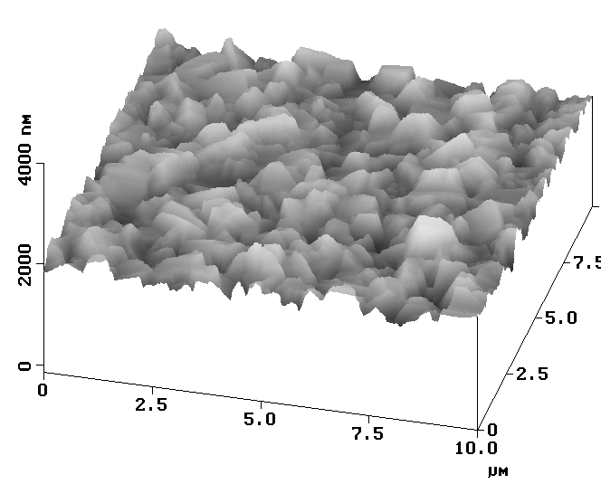
2-step deposition |  | 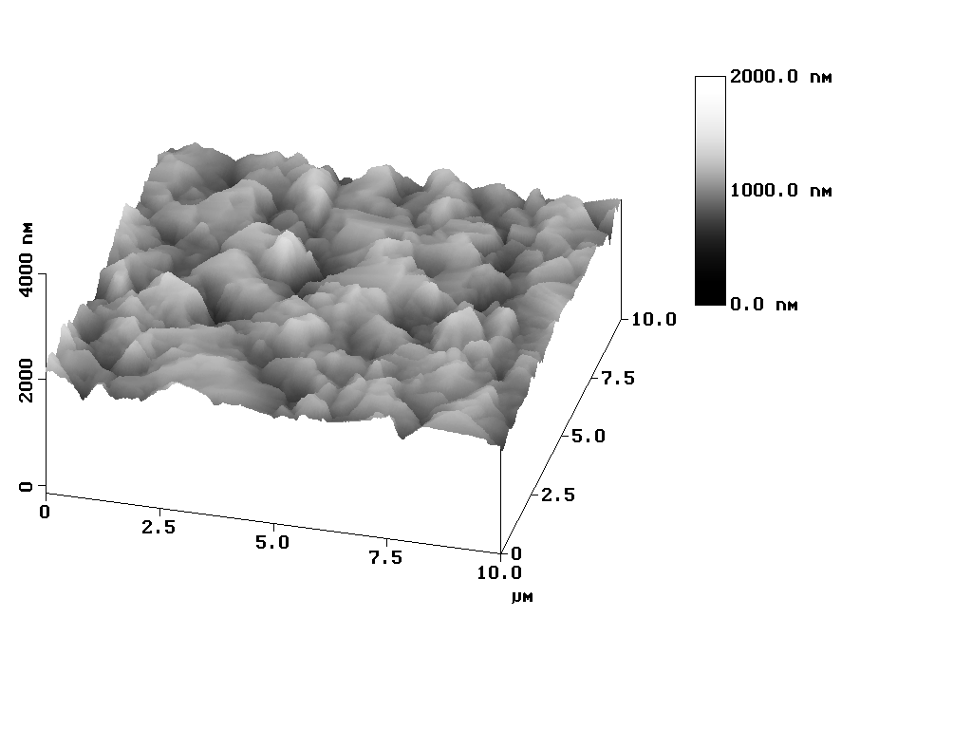
3-step deposition |  | 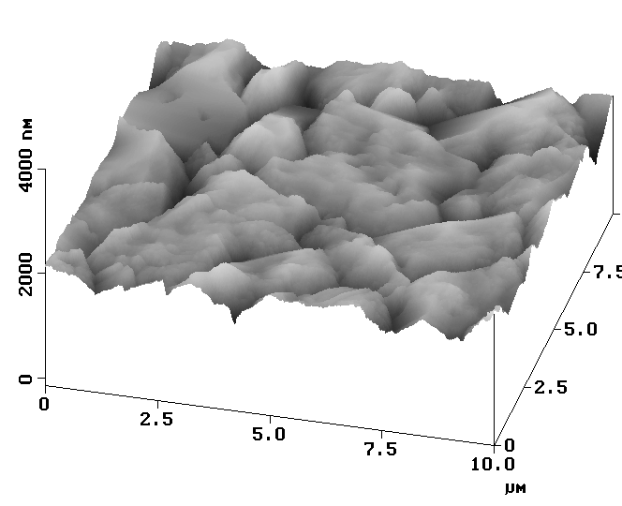

Figure 39. Differences in grain size and morphology with different
deposition processes as revealed by SEM cross-sectional images of
2.5 µm wide regions, and AFM top surface images of 10 x 10 µm regions.

XRD measurements in a standard θ-2θ configuration showed the films to vary from a strong (112) to a (220)/(204) preferred orientation. The degree of orientation of the films along the (112) direction F (112) was calculated according to the Harris method, by:

(1)

where I(hkl) is the measured intensity of the peak (h,k,l) for the film and Io(hkl) the relative powder intensity. Since no JCPDS file is available for Cu(InAl)Se_{2,} a CuInSe₂ standard was used . For a film completely (112) oriented, F(112)=1 and for a random oriented film F(112) = 0.5, since only the (112) and (220)/(204) peaks were included in the analysis. The 1 and 3-step processes each gave a range of F(112) with different samples varying from 0.3 – 0.9, ranging from slightly (220)/(204) or random to a pronounced (112) orientation. The exception was the 2-step process and films grown with the thin Cu seed layer. In these cases, all films had F(112) ≥ 0.95, i.e. they were strongly (112) oriented, indicating that the Cu seed layer had the same effect as the Cu-rich growth in the 2-step process.

Adhesion was characterized by whether or not the Cu(InAl)Se₂ films adhere during the CBD CdS deposition. This could potentially be quantified by determining the yield of samples surviving the CBD process, although to be statistically meaningful, it would require a large sample set which was not available in this work.

With the 1-step Cu(InAl)Se₂ deposition process for x ≈ 0.1 using a Ga seed layer, all films adhere through the bath. As Al content increases to x > 0.3 with this process, some samples flake off though most still adhere. Without the Ga seed layer a few films, < 30%, still adhered, but only for x ≈ 0.1. Deposition starting with a Cu seed layer provided the same improved adhesion as the Ga layer with the 1-step films. The In seed layer, however, did not provide any improvement in adhesion for deposition on glass/Mo.

The 2-step process gave no apparent improvement in adhesion with comparable results to the 1-step process, with or without the Ga seed layer.

Finally, the 3-step process had much worse adhesion than the 1 or 2-step depositions, with or without the Ga layer. Films with x = 0.1 frequently did not adhere through the CdS deposition and with x ≥ 0.3, the films never adhered and often flaked off, even as they were removed from the Cu(InAl)Se₂ deposition system.

Attempts were made to quantitatively determine adhesion using an Instron pull tester equipped with a custom sample holder and coupling apparatus. This test measures the perpendicular breaking point force needed to remove a stud with area 0.5 cm² which had been epoxied to the Cu(InAl)Se₂ surface. In most cases, the pulled stud cleanly removed the Cu(InAl)Se₂ film from the Mo. A typical plot of perpendicular load vs. time is shown in Figure 40 yielding a maximum load of 48 N. However, the force to remove the films varied from 5–30x10⁵ N/m² with little correlation to the observed adhesion in the CdS bath. This suggests that there is a large variation in the process, and the poor adhesion through the CdS process may not be simply related to the mechanical strength of the Mo/Cu(InAl)Se₂ interface The exception was the poor adhesion of films deposited using a 3-step process which begins with an In-Al-Se layer where the films pulled off with force <<5x10⁵ N/m². Films deposited with this process also rarely adhere in the CdS bath.

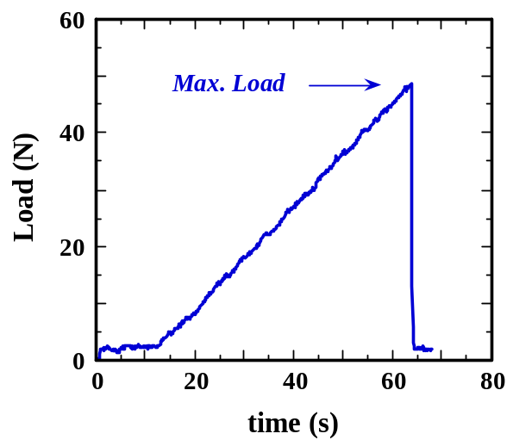

Figure 40. Load needed to remove a stud epoxied to a
Cu(InAl)Se₂ surface for measurement of adhesion.

3.2.4 Results: Cu(InAl)Se₂ Solar Cells

J-V parameters for the best cells fabricated from Cu(InAl)Se₂ using the three different flux-temperature-time profiles with E_{g} from 1.1 to 1.5 eV are summarized in Table 15. For low bandgap ≤ 1.16 eV, the device results are essentially independent of the Cu(InAl)Se₂ deposition process. For higher Al content, no cell results were obtained with the 3-step process due to the poor adhesion, while the 1 and 2-step processes gave similar device behavior. As reported previously, the decrease in efficiency was due to the lack of sufficient increase in V_{OC} and decrease in FF. It should be noted that the results in Table 1 are the best cells from a number of different depositions. The differences between J-V parameters with the different processes are most likely due to statistical variation within relatively small sample sizes, which vary between the processes.

With E_{g} ≈ 1.1 eV, devices using the Ga seed layer are compared to devices with the Cu(InAl)Se₂ deposited directly on glass/Mo in the same deposition. In each case, the J-V parameters are the same, within the typical sample-to-sample variations. Poor adhesion without the Ga layer prevented this comparison with higher bandgap. Films deposited using the Cu seed layer gave similar device performance to those with the Ga seed layer. The In seed layer was primarily used only with high bandgap and the films had poor adhesion.

Table 15. Cu(InAl)Se₂ device parameters for films with E_{g} = 1.1 to 1.5 deposited with different processes. With the 3-step process films with E_{g} > 1.1 did not adhere during device processing.

E_{g} (eV)  ± 0.05 | back  contact |   (%) | V_{OC}  (V) | J_{SC}  (mA/cm²) | FF  (%)
1-step process
1.10 | Mo/Ga | 13.0 | 0.525 | 34.8 | 71.4
1.16 | Mo/Ga | 14.9 | 0.605 | 34.3 | 71.8
1.16 | Mo | 14.1 | 0.594 | 34.5 | 68.7
1.40 | Mo/Ga | 13.4 | 0.724 | 26.9 | 69.0
1.50 | Mo/Ga | 9.9 | 0.747 | 20.1 | 65.8
2-step process
1.10 | Mo/Ga | 12.8 | 0.491 | 36.2 | 72.4
1.10 | Mo | 13.2 | 0.498 | 37.1 | 71.6
1.25 | Mo/Ga | 13.8 | 0.666 | 29.9 | 69.2
1.40 | Mo/Ga | 8.7 | 0.688 | 23.1 | 54.4
3-step process
1.10 | Mo/Ga | 12.0 | 0.547 | 33.0 | 66.5

3.2.5 Cu(InAl)Se₂ Device Characterization

The J-V curves of the three devices listed in Table 3.1 using Cu(InAl)Se₂ with E_{g} = 1.16, 1.4, and 1.5 eV deposited using the 1-step process on glass/Mo/Ga/substrates are shown in Figure 41. As previously, these devices show that V_{OC} increases slowly with E_{g}, to a maximum of only ~750 mV, as FF decreases. Also, as E_{g} increases, there is increasing cross-over of the light and dark J-V curves which can be seen in Figure 41, suggesting light induced changes in the absorber layers or at the interface, since the CdS/ZnO/ITO window layers are nominally identical in all devices.

QE measurements were used to further characterize the effect of increasing bandgap. The curves are shown in Figure 42 at both the 0V and –1V bias voltage. The difference between the voltage biases increases as E_{g} increases as shown by the ratio QE (-1V) / QE (0V) is shown in Figure 43. For the wider bandgap, this ratio increases dramatically for longer wavelength light with which an increasing fraction of the carriers are generated deeper in the absorber layer. This is a clear indication that the light-generated electrons are not collected efficiently. The QE voltage dependence is quantified by the quantity Γ_{QE} which is the ratio of the current obtained by integrating the product of QE (-1V) times the AM1.5 spectrum to that obtained from QE (0V). This is also shown in Figure 43.

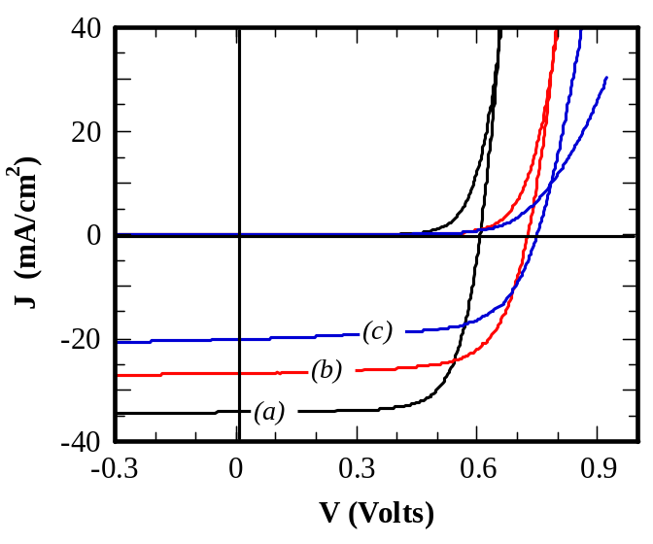

Figure 41. Light and dark J-V curves with Cu(InAl)Se₂
bandgap (a) 1.16 eV, (b) 1.4 eV, and (c) 1.5 eV.

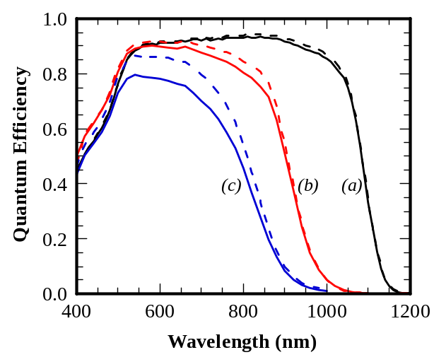

Figure 42. QE curves of devices in Figure 38. Solid lines were
measured at 0V and dashed lines at –1V.

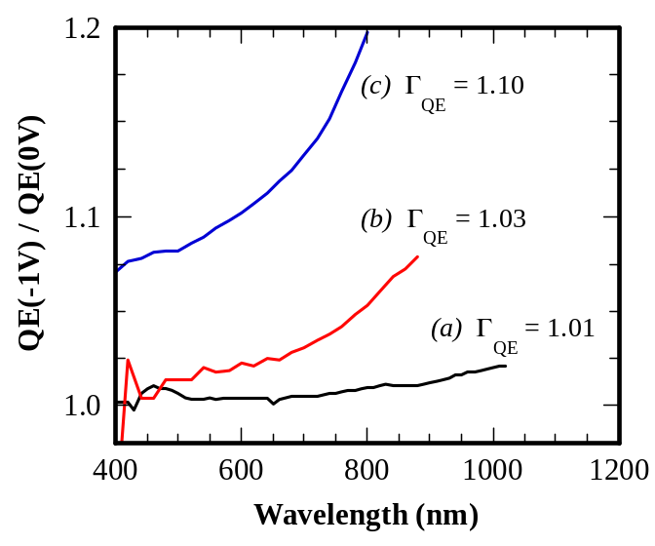
Figure 43. Ratio of QE(-1V) / QE(0V) showing increased
voltage dependence with wider bandgap.

Capacitance-voltage measurements were completed on the devices with 1.16 and 1.4 eV bandgap absorber layers. Measurements were done at frequency = 100 kHz with the devices at room temperature and used to determine the depletion width (W) at 0V, assuming that the depletion layer is in the Cu(InAl)Se₂ layer. With E_{g} = 1.16 eV, this gave W = 0.3 µm while with E_{g} = 1.4 eV, W = 0.7 µm. The increase in W with E_{g} appears to contradict the QE behavior at short wavelength where most of the light is absorbed in within ~ 0.2 µm, suggesting that many carriers are not collected, even if generated within the depletion region. More extensive characterization of the electronic properties of the Cu(InAl)Se₂ devices using transient photocapacitance spectroscopy and drive level capacitance profiling was completed in collaboration with the University of Oregon .

3.2.5 Cu(InAl)Se₂ Discussion And Conclusions

Overall, no benefits for either improved adhesion or device performance were obtained with the different Cu(InAl)Se₂ deposition processes. Both the Ga or Cu seed layers give comparable device behavior to the SL/Mo with greatly improved yield due to the better adhesion. Thus, two methods to improve adhesion, with Ga sputtered onto the Mo or Cu deposited on the Mo as the first step in the Cu(InAl)Se₂ evaporation system have been demonstrated. The Cu layer consistently gives (112) orientation and larger grain size, but the device characteristics are similar.

Devices with E_{g} ≥ 1.3 eV have decreasing efficiency and the maximum V_{OC} achieved with Cu(InAl)Se₂ remains significantly lower than should be attainable with wide bandgap Cu(InAl)Se₂ alloy based solar cells. The recombination current that controls V_{OC} and poor collection of light-generated minority carriers is likely due to differences in electronic defects. However, more fundamental characterization will be needed to determine the nature of the controlling defects.

In general, a number of issues regarding Cu(InAl)Se₂ thin film solar cells remain. For example, it has not been determined if the device structure, identical to that used for most high efficiency Cu(InGa)Se₂ cells, is optimal for Cu(InAl)Se₂ absorber layers. In particular, adhesion and electrical contact might be improved with a different contact metal. Also, it is not known if device performance, particularly with wider bandgaps; could be improved by modifying the junction formation with alternative window layer materials or processing.

The critical issues of poor adhesion and decreasing cell performance at wide bandgap must be resolved before Cu(InAl)Se₂ alloys can be considered a preferred alternative for thin film solar cells. However, there are a number of issues yet to be explored and, as with the other CuInSe₂ based alloys, there is still a lack of fundamental understanding of important aspects of the materials and devices.

3.2.6 CuAlSe₂ Deposition and Characterization

As part of the effort obtain quaternary Cu(InAl)Se₂ films by multi-source physical vapor deposition an effort was undertaken to form ternary CuAlSe₂ films with varying Cu/Al ratios to investigate the phases formed as suggested by the phase diagram in the literature.

Deposition of device quality quaternary CuIn_{1-x}Al_{x}Se₂ films as well as CuAlSe₂ thin films of varying [Cu]/[Al] ratios and thickness (1 – 4 μm) was carried out in a multi-source physical deposition system. The films were deposited on glass and molybdenum coated glass (boroscillicate and soda lime) substrates at three different substrate temperatures (T_{ss}) 350ºC, 450ºC and 530ºC. The band gap of CuIn_{1-x}Al_{x}Se₂ films was varied by controlling x, the relative amount of Al in the films. All films were analyzed by X-ray diffraction (XRD) and Energy Dispersive X-ray Spectroscopy (EDS) to determine their crystal structure and chemical composition, respectively. Some films were analyzed for their optical properties using optical spectroscopy or ellipsometry.

It was shown that for Cu-Al-Se films deposited under conditions for which R_{Se}/R_{M} < 10, where R_{Se} is the effusion rate of Se and R_{M} is the total metal effusion rate (Al + Cu) in mol/min, the resulting films contain Cu-Al intermetallics (CuAl₂, CuAl and Cu₂Al), if the [Cu]/[Al] ratios, by EDS, are less than 1.4. The specific intermetallic observed depends on the [Cu]/[Al] ratio. Several of these films also contain Al₂Se₃. Composition analysis showed that these films contain concentrations of oxygen varying from 12 to 60 at. % as the [Cu]/[Al] ratio decreases. This oxygen is postulated to come from the subsequent hydrolysis of Al_{x}Se_{y} leading to the formation of Al(OH)₃ or Al₂O₃ upon exposure to the air. For films whose composition shows [Cu]/[Al] ≤ 0.8, the phases identified vary from a mixture of α-CuAlSe₂ and Cu₂Al to a single phase of α-CuAlSe₂ and a two-phase mixture of α-CuAlSe₂ and Cu₂Se. The oxygen content in films containing CuAlSe₂ and Cu₂Se is at most 6 at %.

For Cu-Al-Se films deposited under conditions for which R_{Se}/R_{M} > 10, with
[Cu]/[Al] <0.8, the resulting films are a mixture of what seems to be a new structure labeled β-Cu_{x}Al_{y}Se_{2,} and α-CuAlSe₂. In these films β-CuAlSe₂, is clearly the dominant phase. These films have optical properties similar to those of α-CuAlSe₂ obtained from the literature. For films whose composition shows 0.8 < [Cu]/[Al] < 1.1, the phases identified go through a transition from β-Cu_{x}Al_{y}Se₂ being the dominant phase to αCuAlSe₂ being the dominant phase. At [Cu]/[Al] ~ 1.0, the phases are approximately equal. As [Cu]/[Al] > 1.1, the films are a two-phase mixture of α-CuAlSe₂ and Cu₂Se. The oxygen content in all of these films varies between 1 - 3 at %. Based on the Cu-Se, Al-Se, Cu-Al binary and the Cu₂Se-Al₂Se₃ pseudo-binary phase diagrams, a phenomenological film growth mechanism was developed to explain these results. The results suggested that the film growth kinetics is controlled by rapid kinetics of Cu₂Se formation and also by the difficulty of selenizing Al for Se delivery such that
R_{Se}/R_{M} < 10.

3.2.7 Sulfur Diffusion in Cu(InGa)Se₂

The efficiency of state-of-the-art CuInSe₂-based solar cells is limited by recombination through defects in the space charge region, which leads to high values of the diode current . Post-deposition sulfurization of CuInSe₂-based absorber layers promises to reduce this recombination process by increasing the bandgap, and therefore the activation energy for recombination, in the space charge region . This work is aimed at a quantitative understanding of the transport of S into CuInSe₂ during post-deposition sulfurization to enable controlled bandgap modification. Initially, this effort has focused on diffusion of S into CuInSe₂, with no Ga, during reaction in H₂S.

Sulfur reaction was done in an atmospheric pressure reactor capable of supplying a mixture of Ar and H₂S to samples sitting in its hot zone. Typical reaction conditions were a 1 hour anneal at 575 ºC in 2% H₂S with balance Ar. In an effort to eliminate grain boundary and substrate effects, single-crystal samples grown by various methods were obtained and sulfurized. These crystals were grown by either vertical gradient freeze (VGF) or by the traveling heater (TH) method. During TH growth either In or CuSe were used as solvents. All crystals were polished after growth. The samples were analyzed with the use of SEM, EDS and XRD.

VGF and TH(CuSe) grown crystals remained relatively smooth after the sulfur reaction process, in contrast to TH(In) grown crystals, as seen in the SEM images in Figure 39. In addition, the TH(In) crystals incorporated substantially more S than the other crystal types. EDS on TH(In) crystals after sulfurization resulted in a S/(Se+S) value of 0.73 compared to values of ~0.04 for the other crystal types. Cross-sectional SEM images of a reacted TH(In) crystal showed a rough surface layer on top of an undisturbed crystalline bulk. XRD in Bragg-Brentano geometry featured clearly distinguished CuIn(SeS)₂ peaks, indicating that this surface layer is polycrystalline. These differences in sulfurization behavior may result from differences in the initial Se content of the various crystals.

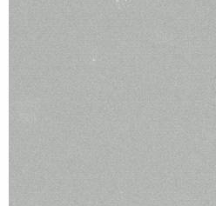 (a) VGF grown crystal

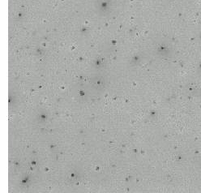 (b) TH(CuSe) grown crystal

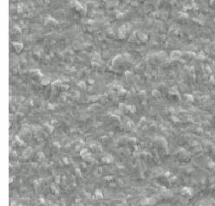 (c) a TH(In) grown crystal

Figure 44. SEM images of CuInSe₂ crystals after sulfur reaction.
The TH(In) grown crystal has formed a very rough surface compared
to the other two crystals. Each image shows a 50 x 50 µm area.

To quantitatively characterize the S diffusion, VGF CuInSe₂ crystal samples were exposed to a flowing atmosphere of 2% H₂S in balance Ar at 575°C. The resulting S distribution in the samples was measured by Auger Electron Spectroscopy (AES) depth profiling and analyzed on the basis of the thin-film diffusion model published previously . This model assumes a fast chalcogen exchange reaction at the gas-solid interface and, subsequently, lattice and grain boundary diffusion in the thin film. It is further assumed that the film structure is conserved during the sulfurization experiment. The interface reaction quickly leads to a value very close to 1 for the relative S content y=S/(S+Se) at the free surface of the film. Consequently, for the analysis of the diffusion problem at the free film surface a constant concentration boundary condition of y_{s} =1 is assumed. The only fitting parameters in this model are the values of the lattice and the grain boundary diffusion coefficients, D_{l} and D_{b}, respectively. Further, it was assumed that this process could be treated like interdiffusion in a binary system, despite the fact that four elements (Cu, In, Se, S) were present. Generally, the lattice diffusion coefficient D_{l} governing interdiffusion in a binary diffusion couple is a function of composition y. Its concentration dependence can only be determined from experiments with one-dimensional diffusion geometry. Therefore, D_{l}(y) was obtained from experiments done on bulk crystalline samples rather than on films.

Three polished VGF crystals were sulfurized for 1, 4 and 9 hr, respectively. After sulfurization only the one-hour and the nine-hour sample featured regions that were smooth enough for quantitative analysis. AES depth profiles were measured on these regions and used to confirm that the S distribution in the crystals could be described as a one-dimensional diffusion problem. Profiles created by one-dimensional diffusion for various diffusion times agree with each other when presented as concentration versus sputter depth divided by the square root of the diffusion time . The measured y profiles are presented in this way in Figure 45, and the curves agree reasonably well. The very slight disagreement could be the result of subtle surface imperfections that affected the diffusion geometry more strongly in the shallower one-hour profile. This result was crucial since it provided a self-consistency justification of treating the interdiffusion of S and Se in CuIn(Se_{1-y}S_{y})₂ as binary interdiffusion.

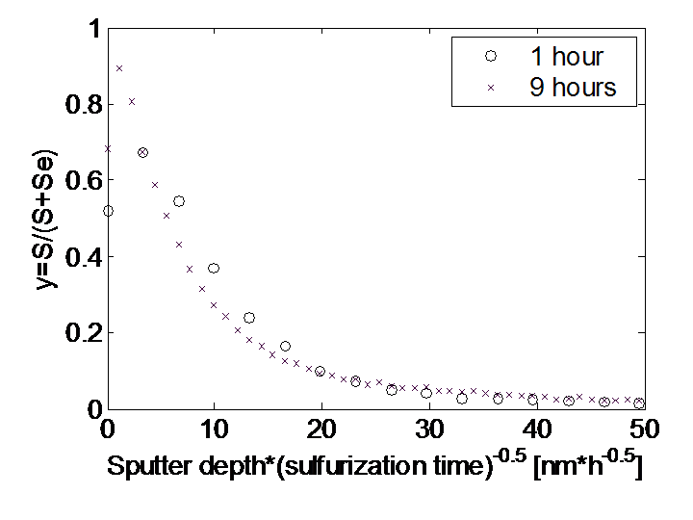
Figure 45. AES depth profiles of the relative S content y measured on crystals sulfurized for 1 hour and 9 hours, respectively. The x-axis shows the sputter depth divided by the square root of the sulfurization time. The fact that both curves agree in this graph confirms that the S distribution in the crystals was shaped by one-dimensional diffusion.

For the determination of D_{l} as a function of y, the better resolved nine-hour profile was used. In Figure 46, this data is shown after a Boltzmann-Matano transformation Error: Reference source not found. The function D_{l}(y) has a value between 1 and 2 times 10⁻¹⁶ cm²s⁻¹ for y>0.4 and increases significantly only for y values smaller than 0.3. For y values below 0.1 the data is very noisy. Figure 46 also includes a parameterized approximation to the experimental data points given by:

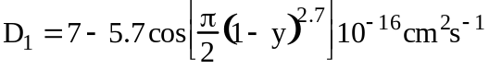 (2)

A reverse Boltzmann-Matano transformation of this curve provides a good fit to the experimental depth profile as shown in Figure 47, clearly better than the agreement with any of the curves generated with a constant value of D_{l}. Comparison with modeled curves generated with the use of a constant value for D_{l} shows that the increase towards lower values of y is significant. Nevertheless, for the investigation of the S-Se interdiffusion in films, use will be made of the fact that D_{l} turned out to be almost constant over a wide range of concentrations. For diffusion in a three-dimensional geometry analytical solutions exist only in the case that D_{l} and D_{b} are constant, and those are implemented in the thin-film diffusion model. Since the concentration dependence of D_{l} was found to be limited to a narrow range of concentrations the model may still be able to approximate the situation in thin films sufficiently well. Efforts are underway to prepare sufficiently smooth CuInSe₂ films to justify the model assumptions about the diffusion geometry and the measurement procedure.
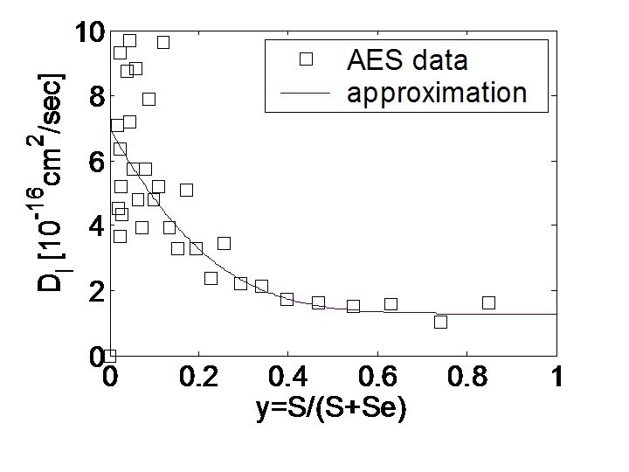
Figure 46. D_{l} as a function of y in CuIn(Se_{1-y}S_{y})₂, calculated, with the help of the Boltzmann-Matano method, from the AES depth profile of the crystal sulfurized
for 9 hours. Also shown is a parameterized approximation to this data.

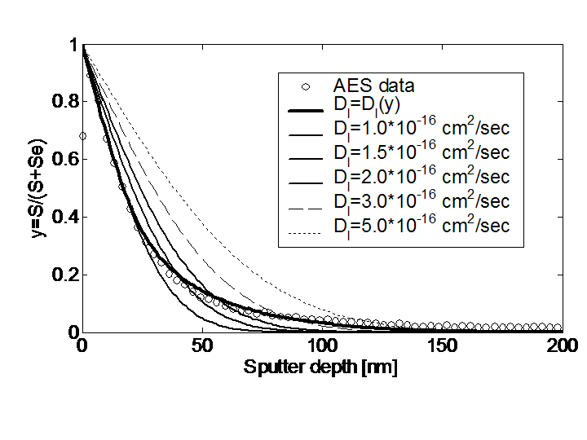
Figure 47. Comparison of the AES depth profile measured on
the nine-hour sample with various simulated curves.

3.3. Fundamental Interface and Material Characterization

3.3.1 Emitter Layer Deposition and Junction Characterization

Chemical bath deposited ZnS buffer layers have been used to form the highest efficiency Cu(InGa)Se₂-based solar cells which contain no CdS layer. However, it is difficult to explain how such high efficiencies can be obtained with a conduction band offset of over 1.2 eV between the Cu(InGa)Se₂ and ZnS. A possible explanation for the device operation is that oxygen must be incorporated in the CBD-ZnS to form Zn(OS) to decrease the conduction band offset between Cu(InGa)Se₂ and Zn(OS). The conduction band of ZnO is about 0.4 eV lower than Cu(InGa)Se_{2,}, and the change in conduction band minimum is 1.6 eV for a change in bandgap of only 0.4 eV. In practice, the high efficiency devices were annealed in air after the CBD process [1]. Typically, this anneal is done at 150°C for 30 – 60 min.

Experiments were performed to determine the effect of the annealing on the characteristics of CBD-ZnS films and Cu(InGa)Se₂/ZnS devices. A ZnS film was deposited on quartz substrates using the CBD method developed previously at IEC . This uses a bath with 25 mM ZnSO₄, 0.27M thiourea; 2.9M NH₃H₂O and temperature = 80°C. The films were sequentially annealed at 150°C or 200°C for times from 30 – 360 min and characterized by optical transmission (T) and reflection (R) measurements. The quartz substrate enables transmission measurements up to 5 eV while a soda lime glass substrate will have significant absorption for hν > 3.5 eV. Also, glancing angle XRD measurements are being completed to determine if there is a shift in lattice parameter due to oxygen incorporation in the films. Finally, devices are also being fabricated with CBD ZnS layers deposited on Cu(InGa)Se₂ and annealed for comparable conditions.

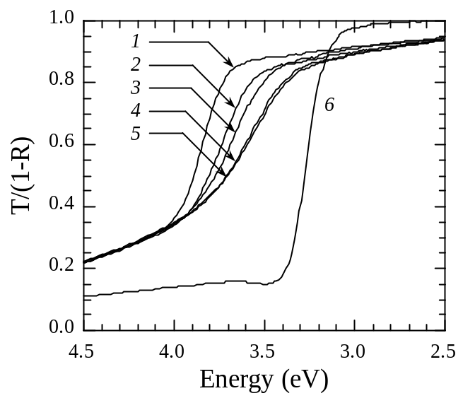

Figure 48. Normalized transmissions of CBD ZnS film with various air
annealing and a sputtered ZnO film. Labels correspond to Table 16.

Table 16. Energy Bandgap of CBD ZnS and sputtered ZnO

Sample |  | Anneal Temp  (°C) | Anneal time  (min) | Eg  (eV)
1 | CBD ZnS | As-deposited |  | 3.78
2 | CBD ZnS | 150 | 30 | 3.65
3 | CBD ZnS | 200 | 30 | 3.59
4 | CBD ZnS | 200 | 150 | 3.49
5 | CBD ZnS | 200 | 360 | 3.47
6 | Sputtered ZnO | As-deposited |  | 3.25

A ZnS film of 170 nm thick (measured by a Dektak profilometer) was deposited from four sequential baths. Layers used in devices were only 40 – 50 nm [45], but thicker layers were desired for film characterization. Figure 48 shows the normalized transmission, T/(1-R), of the as-deposited film and after several anneals at increasing time and temperature. T/(1-R) of a sputtered ZnO film with thickness 130 nm is also shown as a comparison. The optical bandgap of the films was calculated from the plot of (αE)² versus the incident energy, as shown in Figure 49 and the bandgaps are listed in Table 16. While this analysis assumes a uniform bandgap, the value of Eg will be that of the lowest bandgap part of a graded film. The minimum bandgap of the CBD ZnS decreased from the initial 3.78 eV to 3.47 eV with air annealing at 200°C. Further decrease down to the 3.25 eV of ZnO was not achieved with further annealing and might require higher temperature. These results suggest that ZnS(O) alloy films were formed and devices with these layers can be used to study the effect of the band alignment at the Cu(InGa)Se₂/Zn(SO) interface. XRD and device results will be completed and shown in the next report.

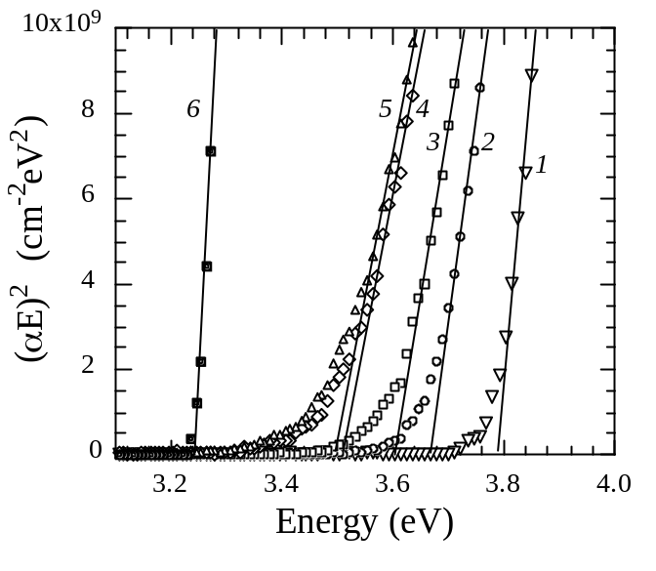

Figure 49. Bandgap determination from (αE)² versus E for the
ZnS and ZnO samples in Figure 48 with labels corresponding to Table 16.

To determine if the anneal also gave a lattice constant shift consistent with the alloying of the film, glancing incident angle XRD (GIXRD) measurements were carried out with 0.5º incident angle using Cu Ka radiation at 40 KV, 40 mA. Figure 50 shows the GIXRD patterns of 1) as deposited ZnS/Mo; 2) air annealed ZnS/Mo at 200ºC for 360 min; 3) air annealed ZnS/quartz at 200ºC for 360 min and 4) sputtered ZnO/quartz for comparison. There was no apparent change in the (111) peak position with air annealing in the XRD pattern of the CBD-ZnS films with no indication of alloying despite the change in optical transmission..

Cell results are summarized in Table 17 for Cu(InGa)Se₂/ZnS cells with 40 or 80 nm thick ZnS (single or double dip coatings) which received different anneals. In general there is no clear correlation between the anneal time and the device performance and, in fact, the best cell was obtained with no post-deposition anneal. The cells have fill factors as low as 20 % and J_{SC} as low as 5 mA/cm² due to the appearance of a inflection in the power quadrant J-V curve in some cases. This is an indication of a collection barrier, probably at the Cu(InGa)Se₂/ZnS(S_{1-x}O_{x}) interface. The lack of correlation with the annealing time and temperature is not understood.

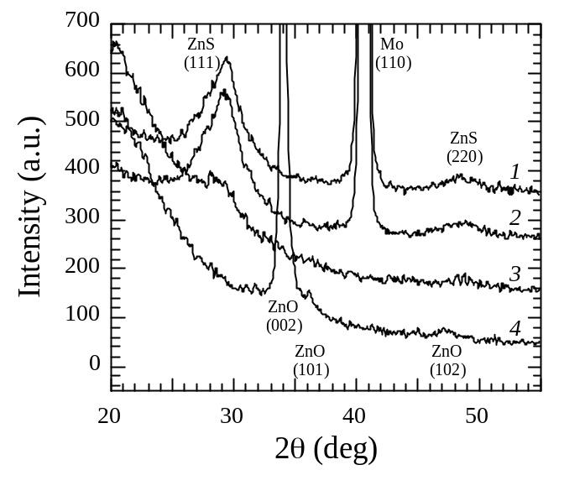

Figure 50. GXRD patterns: 1) as deposited ZnS/Mo; 2) air annealed
ZnS/Mo at 200ºC for 360 min.; 3) air annealed ZnS/quartz at 200ºC for
360 min. and 4) as sputtered ZnO/quartz.

Table 17. Summary of device results with different annealing times for Cu(InGa)Se₂ cells with CBD ZnS. Results include the best cell and average of 6 cells on each piece.

Sample | ZnS | post-dep. anneal |  | J-V | V_{OC} | J_{SC} | FF | eff
Sample | thickness  (nm) | Temp (°C) | Time (min) | test | (mV) | (mA/cm²) | (%) | (%)
33726.12 | ~40 | None |  | Best | 602 | 30.8 | 64 | 11.8
 |  |  |  | Avg | 604 | 27.7 | 43 | 7.4
33726.23 | ~40 | 150 | 30 | Best | 589 | 22.2 | 29 | 3.8
 |  |  |  | Avg | 520 | 14.0 | 27 | 2.1
33726.33 | ~40 | 200 | 30 | Best | 606 | 24.6 | 59 | 8.8
 |  |  |  | Avg | 591 | 18.2 | 48 | 5.3
33725.21 | ~40 | 200 | 150 | Best | 594 | 20.9 | 30 | 3.7
 |  |  |  | Avg | 547 | 12.6 | 26 | 1.9
33725.12 | ~80 | None |  | Best | 514 | 9.7 | 21 | 1.1
 |  |  |  | Avg | 458 | 5.0 | 22 | 0.5
33725.22 | ~80 | 150 | 30 | Best | 601 | 11.8 | 43 | 3.1
 |  |  |  | Avg | 417 | 7.7 | 31 | 1.4
33725.23 | ~80 | 200 | 30 | Best | 578 | 31.1 | 49 | 8.9
 |  |  |  | Avg | 483 | 20.3 | 33 | 3.9
33725.31 | ~80 | 200 | 150 | Best | 548 | 25.3 | 29 | 4.1
 |  |  |  | Avg | 552 | 17.3 | 25 | 2.5

3.3.2 Alternative CdS Deposition

Chemical surface deposition (CSD) of CdS films is described in section 2.4 of this report. In this process, heat from the substrate provides the energy needed for reaction at the surface, resulting in heterogeneous deposition. Deposition from an aqueous solution containing cadmium species, thiourea and ammonia yields dense conformal CdS films, with > 90% utilization of Cd species.

Cu(InGa)Se₂/CdS devices were fabricated using CSD CdS on Cu(InGa)Se₂ films . The Cu(InGa)Se₂ was deposited by elemental evaporation at 550°C and was 2 μm thick with Ga/(Ga+In) = 0.15. The CdS coating was applied to three structures consisting of soda lime glass/Mo/Cu(InGa)Se₂ from a single deposition. Sample 1 was a control sample with 40 nm CdS deposited by the baseline CBD process. Sample 2 had the CdS deposited by CSD using the following volumetric proportions: 2.8 ml of 0.015 M CdSO₄ + 2.2 ml of 1.5 M CS(NH₂)2 + 2.2 ml of 14 M NH₄OH + 15 ml of H₂O. The sample was pre-heated for 10 minutes to 80°C. Sample 3 had the CdS deposited by chemical surface deposition with two coats, 3 min each of the same solution as sample 2. Solar cell devices were completed with the sputter deposition of an Al-doped ZnO layer which was 0.5 µm thick and had sheet resistance of 20 Ω/square, followed by a Ni/Al collector grid.

Current-voltage (J-V) parameters summarized in Table 18 show that sample 3 had comparable V_{oc} and FF to the control cell. These results demonstrate that good cell efficiency can be achieved with the high utilization CdS deposition process. Further optimization of the CSD process for Cu(InGa)Se₂ solar cells will focus on the surface condition prior to deposition and optimization of the CDS conditions for maximum cell performance.

Table 18. Cu(InGa)Se₂/CdS device results using chemical surface deposition for the CdS.

Sample # | CdS  Dep | V_{OC}  (Volts) | J_{SC}  (mA/cm²) | FF  (%) | Eff  (%)
1 | CBD | 630 | 32.3s | 75.6 | 15.4
2 | CSD single | 630 | 29.6 | 64.8 | 12.2
3 | CSD double | 620 | 28.4 | 75.1 | 13.2

3.3.3 Cu(InGa)Se₂ Optical Characterization

Polycrystalline CuIn_{1-x}Ga_{x}Se₂ thin films are promising materials for photovoltaic applications. Precise knowledge of the optical properties of these films is an important factor in characterizing and modeling these solar cell devices. There is a significant amount of information available on band structure based on theoretical
calculations .

The CuIn_{1-x}Ga_{x}Se₂ alloy system has been investigated on single or polycrystalline ingots using spectroscopic ellipsometer (SE) . However, these studies do not address the possible effects of grain size and polycrystalline texture on the optical properties. SE measurements on CuIn_{1-x}Ga_{x}Se₂ films reported in the literature could not be analyzed due to the high film surface roughness and electronic transitions as a function of the Ga content were not determined . Optical transmission, reflection and absorption studies on thin film CuIn_{1-x}Ga_{x}Se₂ have generally been limited to the fundamental absorption edge or did not have sufficient sensitivity to separate the effects of spin orbit and crystal field interactions near the fundamental band gap. The spin-orbit and crystal field splittings have been determined by photoluminescence measurements of CuIn_{1-x}Ga_{x}Se₂ epitaxial films . However, there is no optical data available in the literature for polycrystalline CuIn_{1-x}Ga_{x}Se₂ thin films showing the influence of Ga content on various electronic transitions over a large spectral range. In this work, the effect of Ga on the optical properties and electronic transitions of CuIn_{1-x}Ga_{x}Se₂ polycrystalline thin films is determined.

In general, it is difficult to model and uniquely determine the optical constants from ellipsometric data on materials with high surface roughnessError: Reference source not found. This report describes a method to circumvent the problem associated with the surface roughness by peeling the films from the substrate and performing measurements on the smooth exposed film surface. In addition, a detailed spectroscopic ellipsometer measurement and modeling routine for CuIn_{1-x}Ga_{x}Se₂ polycrystalline thin films is presented. Accurate optical functions for the energy range from 0.75 to 4.6 eV are presented for films with x ≡ Ga/(In+Ga) from 0 to 1.

3.3.4 Ellipsometry Measurement Strategy

AFM measurements showed that the evaporated CuIn_{1-x}Ga_{x}Se₂ films have surface root mean square (R_{MS}) roughness on the order of 50 to 100 nm. It is almost impossible to carry out useful SE measurements because such high surface roughness will not allow the optical functions to be uniquely determined. Mechanical polishing can be used to smooth the films, but it is difficult to ensure that the grit is completely removed from the surface and grain boundaries after polishing. Chemical polishing could be another method, but etching may modify the film’s surface composition to which SE measurements are highly sensitive. Measurement through the substrate (reverse ellipsometry) is another option, provided the films were deposited on optically transparent (e.g. glass without Mo coating) substrates. However, CuIn_{1-x}Ga_{x}Se₂ deposited on a glass substrate may have different properties than material grown on a glass/Mo substrate. For example, films on a glass substrate were shown to have a much stronger (112) preferred orientation . Also, with a glass substrate, very thick (~5 mm) glass is required to avoid front reflection from the glass affecting the measurement.

An alternative way to circumvent the surface roughness is to perform the SE measurements on the reverse side of the film after peeling it from the substrate. To prepare a sample, an optically thick (>0.1μm) Mo film was first deposited on the CuIn_{1-x}Ga_{x}Se₂ film. Then an aluminum substrate was glued to the film using a fast curing epoxy. Because of the optically thick Mo, optical functions of the epoxy are not required for the optical modeling. After curing, the Mo/Glass substrate was pulled apart from the CuIn_{1-x}Ga_{x}Se₂ film, leaving the smooth and oxide free back surface of the CuIn_{1-x}Ga_{x}Se₂ film exposed for the SE measurement. In the present configuration, the original rough surface is now on the reverse side, where only higher wavelength probing light can reach. At higher wavelength, the effect of surface roughness is negligible due to the reduced scattering. For the transparent region, the ellipsometry data has contributions from the interface layer and the Mo film. These contributions were modeled with an effective medium layer, described in a later section. In addition, CuIn_{1-x}Ga_{x}Se₂ films were sufficiently thick so that optical constants in the transparent region could be determined unambiguously. Measurements and fits were carried out at three different incident angles to improve the confidence limit of the data fit in the absorbing region.

SE measurements were carried out using a J.A. Woollam variable angle spectroscopic ellipsometer (VASE). The VASE is a rotating analyzer ellipsometer equipped with an auto-retarder, which is useful in measuring the depolarization caused by surface roughness and thickness non-uniformity. Measurements were carried out at room temperature immediately after peeling with the sample under Ar flow to reduce possible surface contamination. First, VASE scans were done with varying angle to determine the pseudo-Brewster angle of the multilayer structure. For this, scans were performed at two wavelengths (500 and 1500 nm) by varying the angle of incidence from 50° to 85° in 1° steps. The angle corresponding to Δ=90 and the minimum in ψ provides the pseudo-Brewster angle for that sample . Here Δ and ψ are the ellipsometry parameters corresponding to phase and amplitude changes induced by the reflection. Then measurements were done at this angle and two additional angles selected by an empirical rule; pseudo-Brewster angle ± 5° . VASE measurements were carried out between 0.75 eV to 2 eV with an energy step of 5 meV and between 2 eV to 4.6 eV with a 12.5 meV step. A small step size in the transparent region was selected specifically to resolve the closely spaced fundamental transitions and the interference fringes. The data acquisition and modeling were performed with the help of WVASE 32™ software supplied by J. A. Woollam Company.

3.3.5 Optical Modeling

Chalcopyrite CuInSe₂ single crystals exhibit uniaxial anisotropy in their optical
properties displaying ordinary optical properties (electric field perpendicular to c-axis) and extraordinary optical properties (electric field parallel to the c-axis). For polycrystalline material, the anisotropy is a strong function of the crystallographic texture. If all the crystals have the same texture, the anisotropy of the polycrystalline material would be similar to that of a single crystal. However, if the polycrystalline material has the same probability of occurrence for all textures or is randomly structured the optical properties of the material would be isotropic. The effective dielectric function of the polycrystalline material was calculated as a tensorial average considering a medium composed of uniaxial crystals oriented in random directions . A Bruggeman effective medium calculation shows that the pseudo-dielectric function of the randomly oriented polycrystalline material resembles the ordinary component of the single crystal material

Extracting useful information from ellipsometric data begins with the construction of an optical model for the peeled CuIn_{1-x}Ga_{x}Se₂ film on Mo substrate. Figure 51 shows the structure of the CuIn_{1-x}Ga_{x}Se₂ sample and the optical model used for the SE measurement and analysis. The optical model consists of: 1) surface roughness on the peeled layer; 2) the CuIn_{1-x}Ga_{x}Se₂ film; 3) an interface layer (surface layer before peeling); and 4) the Mo layer. It had to be assumed that the optical constants of the Mo film were different from bulk optical properties. Therefore, the Mo optical constants were obtained from measurements on Mo/ CuIn_{1-x}Ga_{x}Se₂ films after depositing the >0.1 μm thick Mo film on the CuIn_{1-x}Ga_{x}Se₂ and prior to attaching the Al substrate. Optical constants of the Mo layer were then extracted from a 2-layer model consisting of a Mo bulk layer and a surface roughness layer, where the surface roughness layer is modeled using a Bruggeman effective medium approximation (EMA) consisting of Mo and a void fraction. Here it is assumed that the surface features are hemispherical in shape and the corresponding screening parameter is 0.33. Since the Mo film was optically thick, the effect of the CuIn_{1-x}Ga_{x}Se₂ substrate was not considered for this analysis.

The complex dielectric response, ε = ε₁+iε₂, is the manifestation of different interband electronic transitions resulting from the applied electric field. The relation between the energy-band structure and ε₂ can be given by Error: Reference source not found:

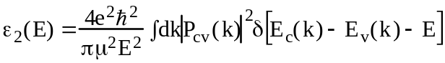 (3)

where μ is the combined density of states (DOS) mass; the Dirac δ function represents the spectral joint DOS between the valance [E_{v}(k)] and conduction [E_{c}(k)] band states differing by energy 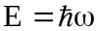 of the incident light; P_{cv}(k) is the momentum-matrix element between the valence and conduction-band states; and the integration is performed over the first Brillouin zone (BZ). Critical points (CP) correspond to the energy at which the joint DOS shows strong variations as a function of energy. In three dimensions, depending on the analytical behavior of the joint DOS, there are four types of CP’s, namely M₀, M₁, M₂ and M₃ present. The energy-band diagram for a generic I-III-VI₂ chalcopyrite structure without spin orbit interaction is shown in Ref. 45. The chalcopyrite band diagram is derived from the zinc blend (ZB) structure because of the similarity in physical properties due to its tetragonal structure .

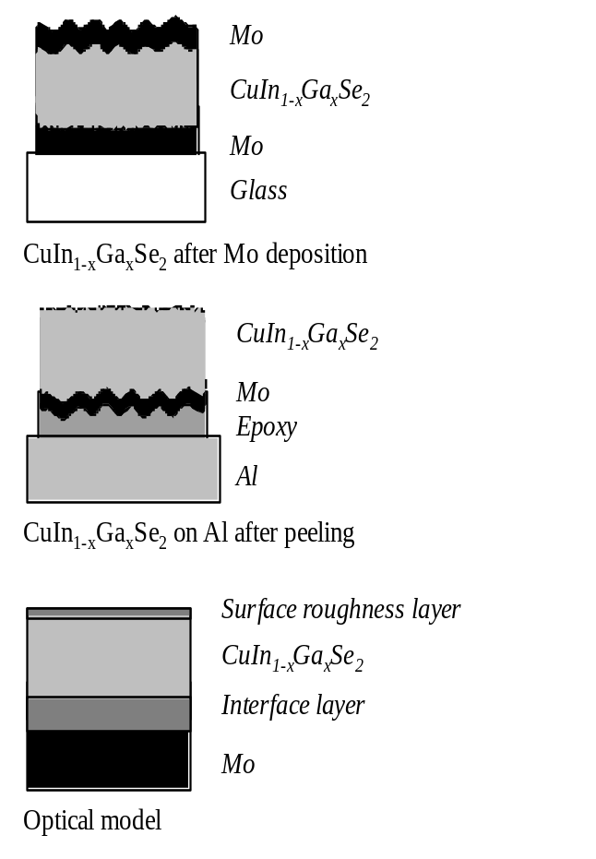
Figure 51. Sample structure and optical model
used for the SE measurement and analysis.

The valance band maximum at the BZ center is a triply degenerate state. The perturbation due to the tetragonal crystal field resulting from the change in symmetry from ZB to chalcopyrite leads to the non-degenerate states Γ₄ and doubly degenerate Γ₅. Theoretically the crystal field splitting Δ_{cf} can be calculated using the compression formula

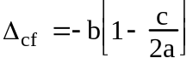 (4)

where c and a are the lattice constants and b is the deformation potential with a typical magnitude of ~1eV. Based on this relation the Δ_{cf} changes from positive for CuInSe₂ (c/2a=1.004) to negative for CuGaSe₂ (c/2a=0.9825). The doubly degenerate Γ₅ is further split by the spin-orbit interaction.

The fundamental transitions from the valence band maximum to the conduction band minimum at the Γ point are schematically shown in Figures 52 (a) and (b). Vertical solid and dashed lines indicate transitions allowed in perpendicular or parallel electric fields respectively. For a CuInSe₂-like CH structure (Figure 38a) Δ_{cf} is positive and Γ_{4v} lies below Γ_{5v.} For a CuGaSe₂-like CH structure (Figure 38b) Δ_{cf} is negative and Γ_{5v} lies below Γ_{4v.} The transitions are conventionally labeled as E₀(A), E₀(B) and E₀(C) in the order of increasing energy The ordering of the energy levels is determined from the polarization- intensity ratios. The polarization- intensity ratio for the transitions from the 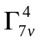and 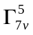valance bands to the 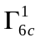conduction band are given by Error: Reference source not found

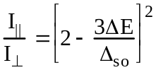 (5)

where ΔE is the separation from the totally perpendicularly polarized 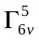→ transition. The calculated intensity ratios for ,and transitions in CuGaSe₂ crystal are 5:1, 1:4 and 1:1. Experimental determination of these intensity ratios would require measurements on single crystals with the c axis perpendicular and parallel to the incident light. In our analysis we used the analogy of the single crystal measurements and theoretical calculations to identify the different energy levels..

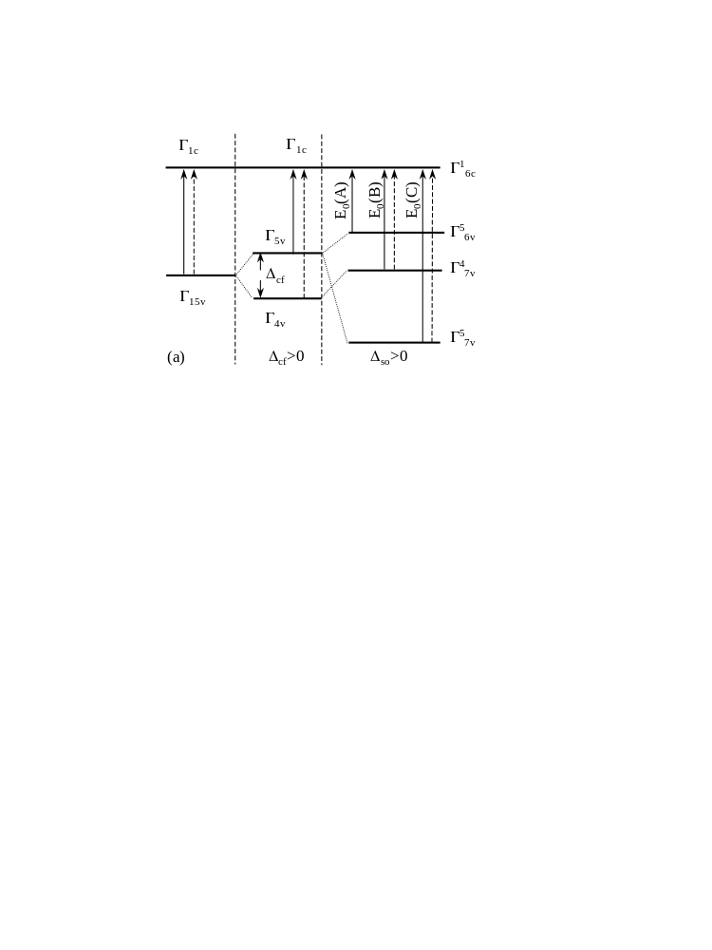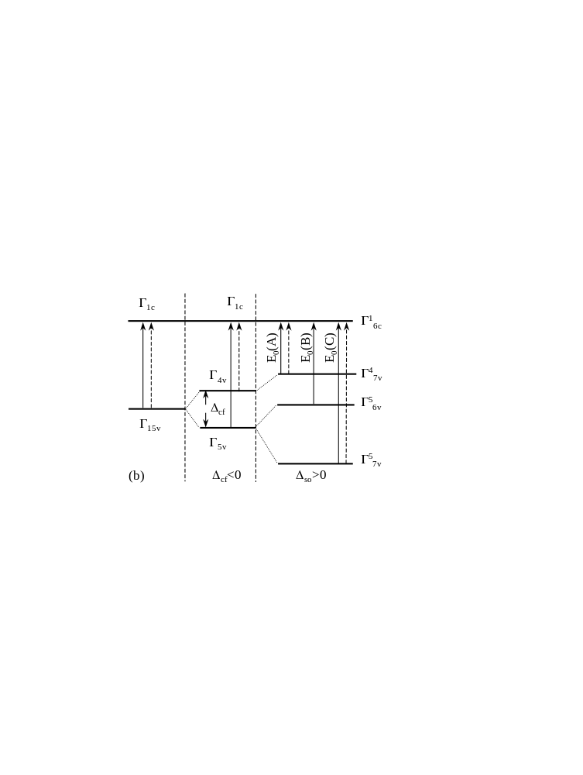

Figure 52. Schematic diagram showing how the crystal field
and spin orbit interaction leads to formation of the non-degenerate energy
levels E₀(A), E₀(B) and E₀(C) in (a) CuInSe₂ and (b) CuGaSe₂ chalcopyrite materials. Dashed and solid arrows represent optical transitions allowed
in E||c and E⊥c, respectively. Notation is from Ref. Error: Reference source not found.

Experimentally, the transition energies can be obtained from CP’s in the ₂ spectrum of the material, and are best resolved in their numerical second order derivative. The unbiased values of spin orbit splitting (i.e. spin-orbit splitting in the absence of crystal field splitting) and crystal field splitting (i.e. crystal field splitting in the absence of spin-orbit splitting) were determined using a quasi-cubic model :

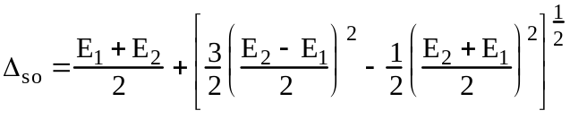 (6)
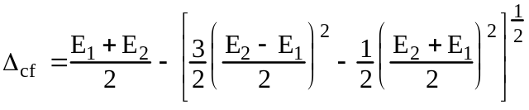 (7)

where E₁ = valance band energy – valance band energy and E₂ = valance band energy – valance band energy.

Both the surface and interface layers in the optical model for the peeled film were analyzed with an EMA model. The RMS surface roughness measured by AFM on the CuIn_{1-x}Ga_{x}Se₂ film before Mo deposition provided an estimate of the interface layer thickness. The thickness of the CuIn_{1-x}Ga_{x}Se₂ film was obtained from fitting the data in the transparent region of the spectrum using a Cauchy dispersion relation. Then the results for n in the transparent region obtained from Cauchy dispersion relation were used to perform a point-by-point fit starting from the transparent region, to extract approximate values of the optical functions. The error in the point-by-point fit, measured by a 90% confidence limit, and was determined to check the quality of the n and k data. The optical functions thus obtained are called initial spectra and are close to the bulk dielectric response of the bulk film, free of substrate, interface, and surface roughness effects.

The initial spectrum was fit with a General Oscillator model, which uses a linear summation of Kramers-Kronig (KK) consistent oscillators to describe the various optical transitions. The fundamental transitions E₀(A), E₀(B), and E₀(C) in the chalcopyrite crystal have three-dimensional M₀ CP character [44]. Three parametric Gaussian Broadened Polynomial Superposition (GBPS) semiconductor oscillators are used for simulating these transitions. The CP’s at higher energies due to transitions at Γ, N and T points in the BZ were simulated using several harmonic Lorentzean and Gaussian oscillators. The strength, broadening and positions for these oscillators were adjusted to match the initial spectrum. In the next procedure, the expected ellipsometric parameters ψ and Δ of the multilayer structure were generated using this parametric dispersion layer in the optical model. The generated data are compared with the experimental data and fit to reduce the error using the Marquardt-Levenberg algorithm . In this procedure, the thickness and refractive index of the film are slightly adjusted. Also, non-ideal features like thickness non-uniformity are introduced into the model to fit the depolarization measured using the autoretarder. The root mean square error (MSE) is used to quantify the difference between the experimental and predicted data. The MSE is calculated by:

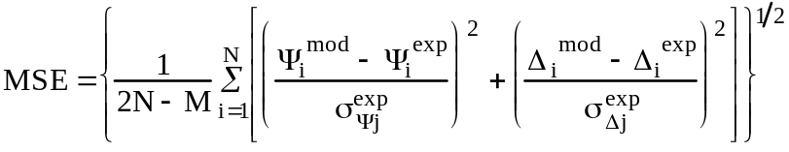 (8)
where 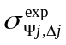 is the standard deviation in the measured ellipsometry parameters Ψ and Δ, 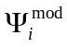and 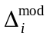are the model generated ellipsometry parameters, 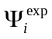and 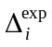 are the measured ellipsometry parameters , N is the number of measured parameters, and M is the number of fitted parameters. By using the experimental standard deviation as the weighting parameter in the fit, the contribution due to noise in the MSE is reduced significantly. The sequence of obtaining the point–by point fit, adjusting the oscillator strength and then fitting to reduce the MSE was repeated several times until a minimum value of MSE was obtained without significant parameter correlation. A good fit is obtained when MSE is close to unity.

3.3.6 Cu(InGa)Se₂ Ellipsometry: Results And Discussion

CuIn_{1-x}Ga_{x}Se₂ films peeled off of the glass/Mo substrate without significant cracking in the film. EDS measurements on the Mo substrate after removing the CuIn_{1-x}Ga_{x}Se₂ show the presence of Se. SE measurements of the Mo substrate indicate the presence of an ~8 nm thick MoSe₂ film. This MoSe₂ layer weakens the interface between the CuIn_{1-x}Ga_{x}Se₂ film and Mo/Glass substrate allowing for clean separation. The peeled CuIn_{1-x}Ga_{x}Se₂ film surface is free of MoSe₂ and x-ray photoelectron spectroscopy (XPS) measurement shows that there is no Mo present on the CuIn_{1-x}Ga_{x}Se₂ film.

XRD and EDS measurements show that the CuIn_{1-x}Ga_{x}Se₂ films are single phase throughout the whole composition range. Table 19 shows the composition of all CuIn_{1-x}Ga_{x}Se₂ films used in this work, as determined from EDS measurements. The orientation of the crystals with respect to the direction normal to the substrate plane was compared to a random powder orientation using the method of Harris for polycrystalline fiber texture analysis: . In this analysis, the orientation parameter P_{hkl} is given by:

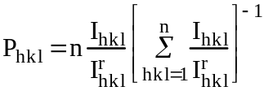 (9)

where I_{hkl} is the intensity of the reflection from the hkl plane of the film, 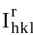 is the intensity of the reflection from the hkl plane of a reference powder sample with the same phase and n is the number of peaks included in the analysis. The films in this work were all found to have a (112) preferred orientation. A film with all the crystals oriented in the (112) direction normal to the substrate plane will have P₁₁₂ = n, a film with random grain orientation will have P₁₁₂ = 1, and a film with grains oriented in a direction other than (112) will have P₁₁₂ < 1. In this work, 5 peaks were used for the orientation analysis and the films have orientation parameter P₁₁₂ in the range 1.8 – 2.8, as listed in Table 20. This indicates that the films are neither randomly nor perfectly oriented.

Table 19. EDS data of Cu(In_{1-x}Ga_{x})Se₂ films used for the SE analysis.

Sample | Cu (%) | In (%) | Ga (%) | Se (%) | Cu/(In+Ga) | Ga/(In+Ga)
A | 25.8 | 25.2 | 0 | 49.0 | 1.02 | 0.00
B | 24.8 | 18.3 | 8.3 | 48.7 | 0.93 | 0.31
C | 24.0 | 14.9 | 12.1 | 49.0 | 0.89 | 0.45
D | 24.6 | 8.9 | 17.5 | 48.9 | 0.93 | 0.66
E | 23.7 | 0 | 27.3 | 49.0 | 0.87 | 1.00

Table 20. Comparison of orientation parameter, roughness data from
AFM and SE and fit index.

Ga/(In+Ga) | Orientation parameter (P_{hkl}) | Roughness from  AFM (nm) | Roughness from  SE (nm)
0 | 2.2 | 5.6 | 3.5
0.31 | 1.8 | 3.7 | 5.2
0.45 | 2.7 | 3.4 | 6.1
0.66 | 2.8 | 14.6 | 8.8
1.00 | 2.8 | 3.1 | 3.2

Figure 53 shows the pseudo-dielectric function measured for CuInSe₂ film along with the ordinary and extraordinary results for a single crystal reported in the literature ⁵² . The optical constants of the CuInSe₂ film are closer to the ordinary component of the single crystal optical constants. Therefore, the (112) orientation of the films does not cause a measurable change in the optical constants. To confirm this, measurements were performed on these films to determine the off-diagonal elements in the Jones matrix . The data was acquired with the polarizer set at –60°, -30°, 0, 30° and 60°. These anisotropy measurements showed that the off-diagonal elements were close to zero confirming that the optical properties are due to the ordinary component. Also, the magnitude of the ε₂ spectrum is similar to the single crystal suggesting that the films are optically dense with insignificant surface roughness and/or oxide layer. Voids, oxide layers or roughness can reduce the dielectric response of the material resulting in a decrease in this ε₂ spectrum.

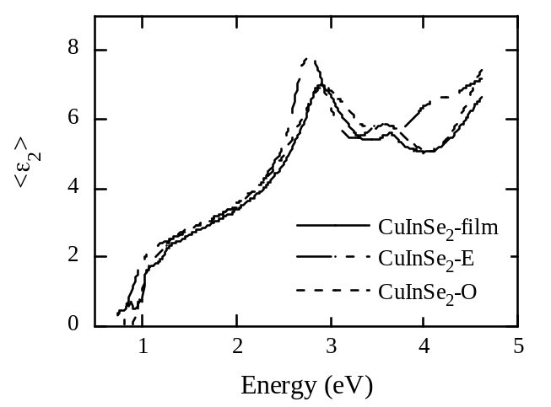

Figure 53. The ε₂ spectrum for the CuInSe₂ thin film along with the
ordinary (O) and extra-ordinary (E) ε₂ spectra for a CuInSe₂ single crystal
from Reference 45. The film shows a close match to the ordinary spectrum
from the single crystal.

Optical modeling results in best fits without significant parameter correlation. Figure 54 shows the initial spectrum for a CuIn_{0.69}Ga_{0.31}Se₂ film obtained from the point-by-point fit. The 90% confidence limit values were less than 1% of the ε₂ values so the initial spectrum gave a good representation of the bulk optical constants. The spectrum is free from the substrate effect and hence there are no interference fringes. Also shown are the different oscillators used to fit the initial spectrum. In order to fit the initial spectra accurately, more oscillators (labeled A, B, and C) than the number of the CP’s in the measurement energy range were used. This was necessitated by residual absorption due to electronic transitions at higher energies, for example E₂ (A), and also to account for possible indirect transitions . The oscillators used in this model provided a good fit for both ε₂ and its derivatives. This approach of generating the initial spectrum and subsequently fitting it with oscillators helps to resolve minor details of the ε₂ spectra that cannot be resolved by directly fitting the ellipsometry parameters. Table 38 lists the oscillator energies corresponding to the electronic transitions in the measurement energy range along with the fit index described in terms of MSE for all the films. The MSE values are close to unity for low Ga films, indicating the high quality of the fits. MSE values are slightly higher with higher Ga concentrations due to the increase in the number interference fringes associated with the band gap shift. If we restrict the fit to the absorbing region, the MSE value would be close to unity. Table 37 also shows the comparison of the surface roughness values obtained from the ellipsometry analysis and RMS roughness from AFM measurements. The measurements show the same trend in the roughness variation, although the values are slightly different. This difference may be due to differences in the measurement techniques or the sample region considered for each measurement. Figure 40(a) shows the measured results and best fit for the ellipsometric parameters Ψ and Δ measured on the CuIn_{0.69}Ga_{0.31}Se₂ film at 70° incident angle. The fit was performed at three incident angles, but the data for 65° and 75° incident angles are not shown here for clarity. The x-axis is shown in terms of wavelength to highlight the fit in the transparent region where the interference fringes dominate the spectrum. Figure 55(b) shows the measurement and fit of the depolarization for the same film at 70º incident angle. The depolarization spectrum shows interference fringes similar to the Ψ and Δ spectra, which are due to thickness non-uniformity in the film. The depolarization spectrum is modeled with 3.5% non-uniformity in the CuIn_{0.69}Ga_{0.31}Se₂ film thickness. Experimental data in the transparent region were analyzed with extra caution to separate the critical points E₀(A), E₀(B) and E₀(C) from interference fringes. Further detailed descriptions of the fit strategies are beyond the scope of this report.

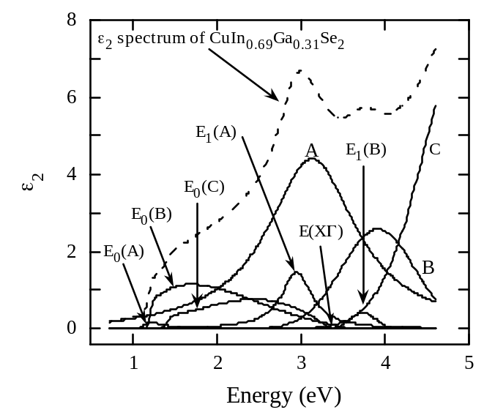
Figure 54. Initial spectrum (dashed line) for a typical CuIn_{1-x}Ga_{x}Se₂
sample obtained from the point-by-point fit. The spectrum is free from
substrate effects as is clear from the absence of interference fringes. Also
shown are the different oscillators used to fit the initial spectrum.

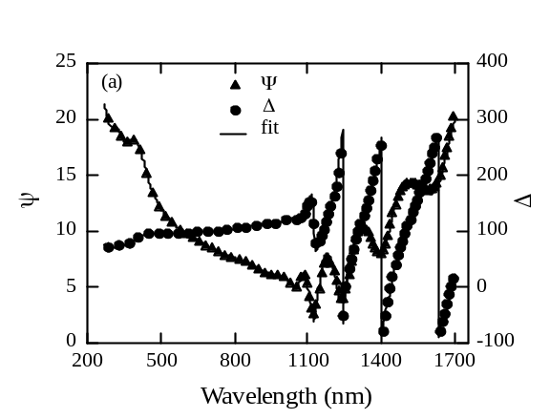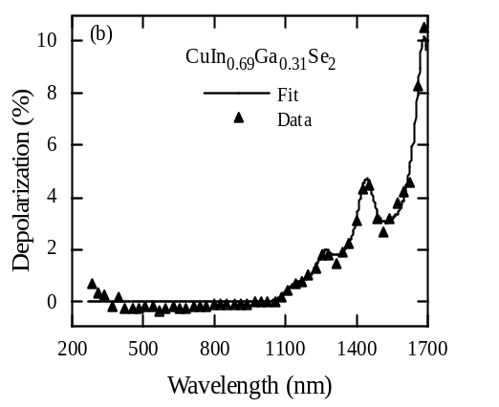

Figure 55. Measurement and fit of the ellipsometry parameters
Δ and Ψ (a),and depolarization (b) for the CuIn_{0.69}Ga_{0.31}Se₂ film
at 70º incident angle. The depolarization is modeled with 3.5% thickness
non-uniformity in the CuIn_{0.69}Ga_{0.31}Se₂ film.

Table 21. Oscillator energies corresponds to the electronic transitions with varying Ga/(Ga+In) ratio.

Ga/(In+Ga) | E₀(A)  (eV) | E₀(B)  (eV) | E₀(C)  (eV) | E₁(A)  (eV) | E (XΓ)  (eV) | E₁(B)  (eV) | MSE
0.00 |  | 1.023 | 1.247 | 2.917 | 3.187 | 3.662 | 1.0
0.31 | 1.168 | 1.208 | 1.449 | 2.965 | 3.302 | 3.746 | 1.7
0.45 | 1.280 | 1.351 | 1.599 | 3.019 | 3.345 | 3.809 | 1.6
0.66 | 1.366 | 1.457 | 1.641 | 3.066 | 3.379 | 3.917 | 2.6
1.00 | 1.689 | 1.771 | 1.976 | 3.168 | 3.528 | 4.057 | 3.0

Figure 56 shows the second derivatives of the ε₂ spectrum for the CuInSe₂ film and the ordinary component of the CuInSe₂ single crystal (ε₂) spectrum generated from n and k values in reference 45. The CP energies in the ε₂ second derivative spectrum of the CuInSe₂ film match those of the CuInSe₂ crystal. E₀(A) and E₀(B) are not resolved in either spectra so the first transitions are marked as E₀(A,B). At the same time, the spin orbit splitting is well resolved and the value Δ_{so} is 0.23eV consistent with the value reported for a bulk CuInSe₂ crystal . Higher energy interband transitions corresponding to the electronic transitions E₁(A) and E₁(B) at position N in the BZ and E(ΔX) at position T in the BZ are also visible and are shown in Figure 56. In general, the good correlation between the film and crystal CP energies confirms the integrity of the optical model used in this analysis.

Figures 57(a) and (b) show the optical constants n and k for CuIn_{1-x}Ga_{x}Se₂ films with
0 ≤ x ≤ 1. Tabulated n and k values are listed in Table 22. The n and k values are provided in 50 meV intervals over the range from 0.75eV to 2eV to resolve the spin orbit splitting, and in 100 meV intervals from 2eV to 4.6eV. In general, ellipsometry measurements are less sensitive to k values below the absorption band and published single crystal optical data is not readily available for comparison in this range. All electronic transitions shift to higher energy with increasing Ga content. The spin orbit splitting is clearly visible in the n and k spectra for the entire Ga range in the films. The crystal field splitting is not distinguishable in the optical function spectra but can be clearly seen in the second derivative of the ε₂ spectra, which is shown in Figure 58. CP energies obtained from the minima in the second derivative of the ε₂ spectra are listed in Table 23. In general, the CP energies thus obtained are consistent with the oscillator energies shown in Table 21. The crystal field splitting is not resolved in the CuInSe₂ films but becomes better resolved with increasing Ga concentrations. This can be explained by the fact that the distortion from cubic symmetry for CuInSe₂ is small compared to CuGaSe₂ so the crystal field is not significant enough to resolve the peaks at room temperature. High-resolution electro-reflectance measurements on CuInSe₂ gave Δ_{so}=0.233eV and Δ_{cf} =0.006eV at 77K [Error: Reference source not found]. Figure 59 shows the variation in E₀(A), E₀(B) and E₀(C) with Ga concentration and can be fit with a 2nd degree polynomial as shown in equations 10-12. E₀(A), for CuInSe₂ was determined using the electro-reflectance result for Δ_{cf} from the literature.

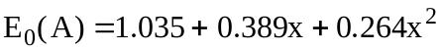 (10)
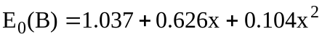 (11)
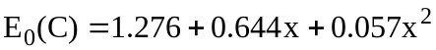 (12)

Since we assigned E₀(A) to the lowest energy level according to convention, there is no cross over between the energy levels E₀(A) and E₀(B) as one would expect from the cross over between the valance bands and 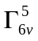 due to changes in the spin orbit splitting. As Equation 10 shows, the optical bowing parameter for the fundamental band gap is 0.264, which is slightly higher than the bowing parameter of 0.21 based on a theoretical calculation for stoichiometric material.3 However, the results based on experiments were largely scattered 42 and varied from 0.11 to 0.24 for evaporated films. This large discrepancy in the bowing parameter could be partly due to the Cu stoichiometric deviation [Error: Reference source not found].

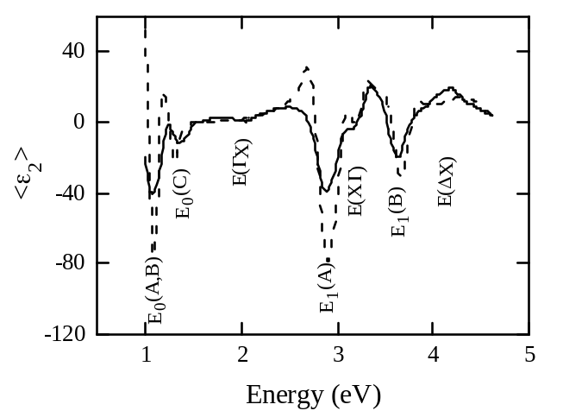

Figure 56. Second derivatives of the ε₂ spectrum for a CuInSe₂ film
(solid line) and the ordinary ε₂ spectrum of a CuInSe₂ single crystal (dashed line). Critical points correspond to minima in the spectra and are marked in the figure.

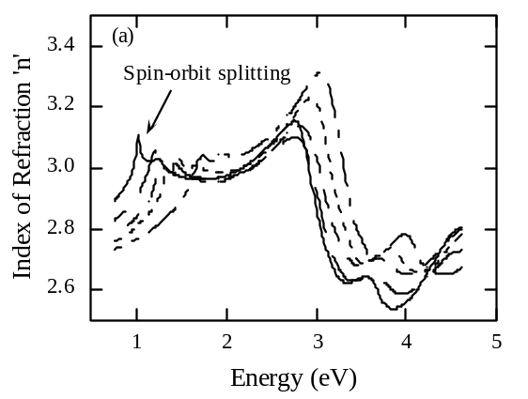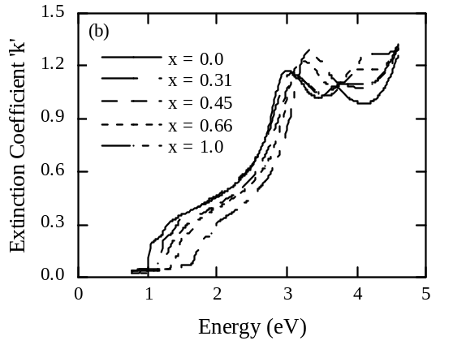

Figure 57. Index of refraction (a) and extinction coefficient
(b) spectra for CuIn_{1-x}Ga_{x}Se₂ films with varying Ga content.
The spin orbit splitting can be clearly seen.

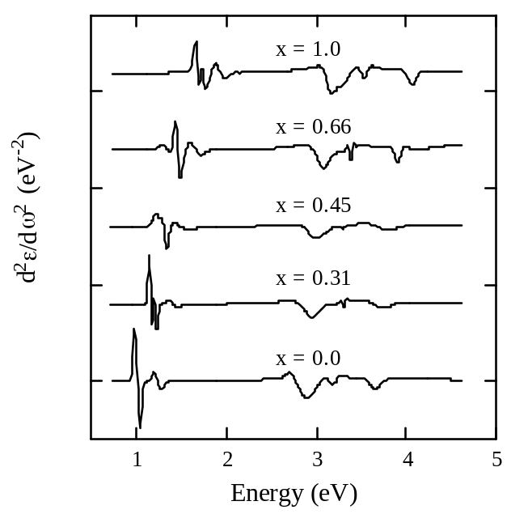

Figure 58. Second derivative of the ε₂ spectra for CuIn_{1-x}Ga_{x}Se₂ films
with varying Ga content. All electronic transitions shift towards
higher energy with increasing Ga content.

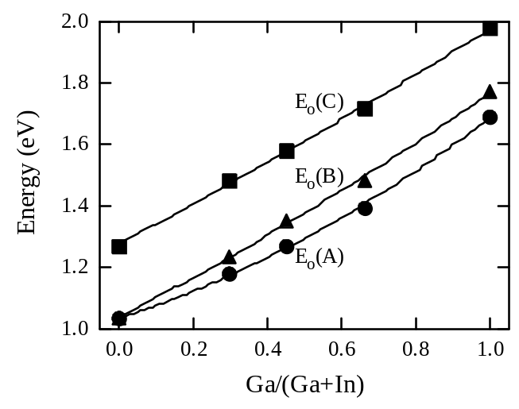

Figure 59. Variation in the fundamental absorption transitions
E₀(A), E₀(B) and E₀(C) of CuIn_{1-x}Ga_{x}Se₂ films with x.

Table 22. Optical constants n and k for Cu(InGa)Se₂ with varying x.

E  (eV) | x = 0 |  | x = 0.31 |  | x = 0.45 |  | x = 0.66 |  | x = 1.0
E  (eV) | n | k | n | k | n | k | n | k | n | k
4.60 | 2.81 | 1.26 | 2.73 | 1.33 | 2.80 | 1.30 | 2.78 | 1.32 | 2.67 | 1.30
4.50 | 2.78 | 1.16 | 2.72 | 1.24 | 2.78 | 1.22 | 2.75 | 1.26 | 2.66 | 1.28
4.40 | 2.74 | 1.08 | 2.70 | 1.17 | 2.74 | 1.16 | 2.71 | 1.20 | 2.65 | 1.27
4.30 | 2.69 | 1.02 | 2.67 | 1.12 | 2.71 | 1.12 | 2.68 | 1.18 | 2.66 | 1.27
4.20 | 2.64 | 0.99 | 2.63 | 1.09 | 2.68 | 1.10 | 2.66 | 1.18 | 2.68 | 1.27
4.10 | 2.60 | 0.99 | 2.61 | 1.08 | 2.66 | 1.09 | 2.66 | 1.18 | 2.73 | 1.26
4.00 | 2.56 | 0.99 | 2.59 | 1.08 | 2.65 | 1.09 | 2.68 | 1.18 | 2.78 | 1.20
3.90 | 2.54 | 1.02 | 2.59 | 1.09 | 2.66 | 1.10 | 2.72 | 1.17 | 2.77 | 1.13
3.80 | 2.54 | 1.05 | 2.61 | 1.10 | 2.69 | 1.09 | 2.74 | 1.12 | 2.74 | 1.11
3.70 | 2.58 | 1.08 | 2.64 | 1.08 | 2.70 | 1.06 | 2.72 | 1.09 | 2.71 | 1.12
3.60 | 2.64 | 1.06 | 2.65 | 1.05 | 2.70 | 1.03 | 2.70 | 1.09 | 2.71 | 1.16
3.50 | 2.64 | 1.03 | 2.64 | 1.04 | 2.68 | 1.04 | 2.69 | 1.13 | 2.77 | 1.22
3.40 | 2.63 | 1.02 | 2.63 | 1.05 | 2.69 | 1.06 | 2.73 | 1.18 | 2.85 | 1.27
3.30 | 2.63 | 1.06 | 2.65 | 1.10 | 2.73 | 1.10 | 2.81 | 1.22 | 3.00 | 1.29
3.20 | 2.67 | 1.11 | 2.70 | 1.13 | 2.80 | 1.13 | 2.94 | 1.23 | 3.18 | 1.20
3.10 | 2.74 | 1.15 | 2.79 | 1.16 | 2.91 | 1.13 | 3.10 | 1.17 | 3.31 | 1.02
3.00 | 2.86 | 1.18 | 2.92 | 1.14 | 3.04 | 1.06 | 3.21 | 1.01 | 3.30 | 0.84
2.90 | 3.03 | 1.12 | 3.05 | 1.04 | 3.12 | 0.94 | 3.22 | 0.85 | 3.27 | 0.71
2.80 | 3.14 | 0.96 | 3.10 | 0.91 | 3.14 | 0.80 | 3.19 | 0.73 | 3.22 | 0.62
2.70 | 3.14 | 0.80 | 3.10 | 0.79 | 3.12 | 0.70 | 3.15 | 0.64 | 3.18 | 0.55
2.60 | 3.11 | 0.71 | 3.07 | 0.71 | 3.09 | 0.62 | 3.11 | 0.58 | 3.14 | 0.50
2.50 | 3.08 | 0.64 | 3.05 | 0.64 | 3.05 | 0.57 | 3.07 | 0.53 | 3.11 | 0.46
2.40 | 3.05 | 0.58 | 3.03 | 0.59 | 3.03 | 0.52 | 3.04 | 0.50 | 3.08 | 0.42
2.30 | 3.02 | 0.54 | 3.01 | 0.55 | 3.00 | 0.49 | 3.02 | 0.47 | 3.06 | 0.39
2.20 | 3.00 | 0.51 | 2.99 | 0.52 | 2.98 | 0.46 | 3.01 | 0.44 | 3.05 | 0.36
2.10 | 2.99 | 0.48 | 2.98 | 0.49 | 2.97 | 0.43 | 2.99 | 0.42 | 3.04 | 0.34
2.00 | 2.98 | 0.46 | 2.97 | 0.47 | 2.96 | 0.41 | 2.98 | 0.39 | 3.04 | 0.31
1.95 | 2.97 | 0.45 | 2.97 | 0.45 | 2.96 | 0.40 | 2.98 | 0.38 | 3.05 | 0.28
1.90 | 2.97 | 0.43 | 2.97 | 0.44 | 2.96 | 0.39 | 2.98 | 0.37 | 3.04 | 0.24
1.85 | 2.96 | 0.42 | 2.96 | 0.43 | 2.95 | 0.38 | 2.99 | 0.36 | 3.02 | 0.23
1.80 | 2.96 | 0.41 | 2.97 | 0.42 | 2.96 | 0.37 | 2.99 | 0.35 | 3.03 | 0.22
1.75 | 2.96 | 0.40 | 2.97 | 0.40 | 2.96 | 0.35 | 3.00 | 0.33 | 3.04 | 0.18
1.70 | 2.96 | 0.39 | 2.97 | 0.39 | 2.96 | 0.34 | 3.01 | 0.31 | 3.03 | 0.14
1.65 | 2.96 | 0.38 | 2.97 | 0.38 | 2.97 | 0.33 | 3.01 | 0.28 | 2.99 | 0.08
1.60 | 2.96 | 0.37 | 2.98 | 0.37 | 2.97 | 0.31 | 3.00 | 0.26 | 2.94 | 0.07
1.55 | 2.97 | 0.36 | 2.98 | 0.36 | 2.98 | 0.29 | 3.00 | 0.24 | 2.92 | 0.07
1.50 | 2.97 | 0.35 | 3.00 | 0.34 | 2.99 | 0.27 | 3.02 | 0.22 | 2.89 | 0.06
1.45 | 2.98 | 0.34 | 3.01 | 0.32 | 2.98 | 0.24 | 3.04 | 0.16 | 2.87 | 0.06
1.40 | 2.99 | 0.33 | 3.02 | 0.28 | 2.98 | 0.22 | 2.99 | 0.11 | 2.86 | 0.06
1.35 | 3.00 | 0.32 | 3.01 | 0.26 | 3.00 | 0.20 | 2.99 | 0.09 | 2.84 | 0.05
1.30 | 3.01 | 0.30 | 3.02 | 0.24 | 3.01 | 0.15 | 2.94 | 0.04 | 2.83 | 0.05
1.25 | 3.03 | 0.27 | 3.03 | 0.21 | 2.98 | 0.09 | 2.90 | 0.04 | 2.82 | 0.05
1.20 | 3.02 | 0.24 | 3.05 | 0.15 | 2.94 | 0.06 | 2.87 | 0.04 | 2.80 | 0.04
1.15 | 3.02 | 0.22 | 3.01 | 0.08 | 2.90 | 0.05 | 2.85 | 0.04 | 2.79 | 0.04
1.10 | 3.03 | 0.21 | 2.96 | 0.06 | 2.87 | 0.05 | 2.83 | 0.03 | 2.78 | 0.04
1.05 | 3.07 | 0.18 | 2.92 | 0.05 | 2.85 | 0.04 | 2.82 | 0.03 | 2.77 | 0.04
1.00 | 3.05 | 0.05 | 2.90 | 0.05 | 2.84 | 0.04 | 2.81 | 0.03 | 2.77 | 0.03
0.95 | 2.98 | 0.04 | 2.88 | 0.05 | 2.82 | 0.04 | 2.79 | 0.03 | 2.76 | 0.03
0.90 | 2.95 | 0.04 | 2.86 | 0.04 | 2.81 | 0.03 | 2.78 | 0.03 | 2.75 | 0.03
0.85 | 2.92 | 0.04 | 2.85 | 0.04 | 2.80 | 0.03 | 2.77 | 0.02 | 2.74 | 0.03
0.80 | 2.90 | 0.04 | 2.84 | 0.04 | 2.79 | 0.03 | 2.76 | 0.02 | 2.74 | 0.03
0.75 | 2.89 | 0.03 | 2.83 | 0.03 | 2.78 | 0.03 | 2.76 | 0.02 | 2.73 | 0.02

The spin orbit splitting and crystal field splitting were determined using Equations 6 and 7 and are shown in Figure 60. The ordering of the valance band and was determined from the crystal data for similar compositions reported in the literatureError: Reference source not found. The error bars shown are the SE measurement resolution due to the energy step used for this study. The Δ_{so} shows an upward bowing and the values are consistent with other results reported in the literature . Small differences in the data could be due to the stoichiometry deviations in the samples. The negative values for Δ_{cf} are in accordance with the polarization selection rule and negative crystal field observed in the CuIn_{1-x}Ga_{x}Se₂ ternary chalcopyrites. , . The crystal field splitting shows a non-linear dependence with the Ga concentration. Vegard’s law suggests a linear variation in the c/a ratio with Ga content, which results in a linear variation in the crystal field splitting based on the compression rule as described in the Equation 4. However, the nonlinear behavior observed in the data may be caused by the fact that for Cu-based ternary chalcopyrites the crystal field splitting is not purely dependent on the tetragonal distortion41 Band structure calculations show that the optical band gap is also influenced by the anion displacement [Error: Reference source not found]. The accuracy of crystal field splitting data is limited by the sample nature; slightly textured polycrystalline films. For more accurate values, measurements on single crystal or epitaxial films are recommended.

Table 23. Variation in the electronic transition energies with Ga/(Ga+In) ratio obtained from Figure 59.

Ga/(In+Ga) | E₀(A)  (eV) | E₀(B)  (eV) | E₀(C)  (eV) | E₁(A)  (eV) | E(XΓ)  (eV) | E₁(B)  (eV)
0.00 |  | 1.03 | 1.27 | 2.91 | 3.19 | 3.66
0.31 | 1.18 | 1.23 | 1.48 | 2.96 | 3.31 | 3.74
0.45 | 1.27 | 1.35 | 1.58 | 3.02 | 3.34 | 3.84
0.66 | 1.40 | 1.49 | 1.72 | 3.07 | 3.37 | 3.91
1.00 | 1.69 | 1.77 | 1.98 | 3.17 | 3.52 | 4.06
Higher interband transitions are also visible in the ε₂ spectra. Figure 61 shows the effect of Ga variation on transitions E₁(A), E(X) and E₁(B). E(X) corresponds to the transition at the BZ center from _{5v}⁽²⁾ to _{1c}. E₁(A) and E₁(B) correspond to transitions at the edge point N in the BZ. E(ΔX), corresponding to an electronic transition at T in the BZ, is not clearly visible with all compositions.

3.3.7 Cu(InGa)Se₂ Ellipsometry: Conclusions
The surface roughness of polycrystalline CuIn_{1-x}Ga_{x}Se₂ films deposited by four-source co-evaporation made them unsuitable for SE analysis. An innovative method was developed to circumvent this problem by performing the SE measurement on the reverse side of the films after they were peeled off from the substrate. The films peeled cleanly from the substrate, probably due to the presence of MoSe₂, and smooth crack-free CuIn_{1-x}Ga_{x}Se₂ films were obtained. The presence of an optically thick Mo film, deposited prior to the peeling, made the optical modeling easier. Also RMS roughness from AFM measurements performed after Mo deposition provided an estimation of the interface layer thickness.

A detailed description of the SE measurement and multilayer modeling strategy generic to ternary chalcopyrite semiconductors was presented. The optical functions hence obtained are compared with the data reported in the literature from single /polycrystalline ingots. Optical constants measured on polycrystalline CuIn_{1-x}Ga_{x}Se₂ films were found to be similar to the ordinary component of the single crystal optical constants. A comparison of the ε₂ spectra for a CuInSe₂ film and single crystal shows that the polycrystalline nature of the film did not affect the optical constants. This indicates that the change in the path length as a result of grain boundary reflection is not significant for these films. In other words, the evaporated CuIn_{1-x}Ga_{x}Se₂ films are compact and large grained. SE measurements in the anisotropy mode show that the deviation from the random orientation did not cause any measurable anisotropy in the film.

The effect of Ga concentration on different optical transitions in the dielectric spectra was shown in detail. As the Ga concentration increases, the electronic transitions shift to higher energies consistent with the theoretical and experimental results reported in the literature. CuIn_{1-x}Ga_{x}Se₂ thin films show a triply degenerate fundamental transition consistent with the chalcopyrite band structure. The degeneracy was removed by crystal field splitting and spin-orbit interaction. CuIn_{1-x}Ga_{x}Se₂ films show negative crystal field splitting. For CuInSe₂ the crystal field splitting is negligibly small and is not measurable with room temperature SE measurements. As the Ga concentration increases, the crystal field splitting increased similar to the results reported for polycrystalline ingots in the literature. Non-linear behavior was observed, in contradiction to the linear behavior expected from Vegard's law and the compression rule. The reason for this non-linear behavior could be the anion displacement as a result of the two captions in the CuIn_{1-x}Ga_{x}Se₂ lattice. The bowing parameter for the band gap is slightly higher than the values reported in the literature based on theoretical calculation. Second order polynomial equations are presented for the Ga dependence for the fundamental electronic transitions. Tabulated values of optical constants.

3.3.8 Team Activities and Collaboration

Bill Shafarman attended the National CIS R&D Team meeting on January 30-31, 2003 where he participated in work by the Absorber Sub-team and presented a review titled “Status of Wide Bandgap CuInSe₂-based Solar Cells”. Additional team-related activity and collaboration included:

- Cu(InGa)Se₂ samples deposited at either 400°C or 550°C using either a uniform or bi-layer (Cu-rich at start) deposition process were provided to the University of Illinois for TEM characterization. A set of well characterized Cu(InGa)Se₂ films were also provided to UI for EDS standards.

- IEC fabricated devices on a set of 12 Cu(InGa)S₂ films from Florida Solar Energy Center and completed J-V and QE measurements to assist FSEC in evaluating it’s absorber layer and device fabrication processes.

- Optical constants measured by spectroscopic ellipsometry as a function of energy of Cu(InGa)Se₂ with different relative Ga content were sent to several team members for input into their modeling efforts.

- CdS and ZnO/ITO depositions were completed on several sets of samples, in a round-robin experiment with GSE and NREL, to use for characterization of GSE’s device processing and calibration of their emitter and TCO layer thicknesses.

- Collaboration with the University of Oregon on device characterization continued with focus on Cu(InAl)Se₂ devices with different bandgaps for comparison to previously characterized Cu(InGa)Se₂ devices.

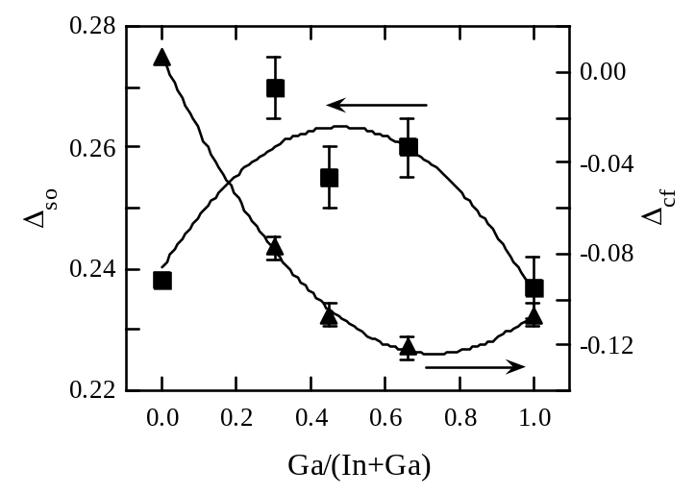
Figure 60. Variation in the Δ_{cf} and Δ_{so} of CuIn_{1-x}Ga_{x}Se₂ films with x.
The non-linear behavior of the crystal field splitting could be due
to the effect of anion displacement.
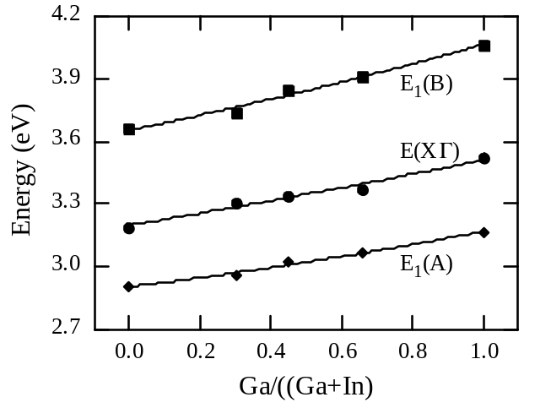
Figure 61. Variation in the higher energy transitions of CuIn_{1-x}Ga_{x}Se₂ films with x.

4 SI BASED SOLAR CELLS

4.1 Fabrication of Large Grain Si Films

The grain size enhancement of HWCVD Si films deposited on Al layers has been investigated in two temperature regimes. The eutectic temperature, 575°C, determines these regimes in the Si-Al system. With the formation of a liquid phase above the eutectic temperature, a different mechanism is expected to govern the grain enhancement process compared to that expected below this temperature where the Si-Al mixture remains in the solid state. The following sections describe the results obtained for depositions of HWCVD Si films on Al layers at 430°C and 600°C.

4.1.1 Grain size enhancement of HWCVD Si films at 430°C.
This work was published by Ebil et. al. . Aluminum layers with thickness varying from 0.01 to 1.0 μm were deposited onto Corning 7059 type glass substrates using electron-beam evaporation. Silicon layers were subsequently deposited onto the Al coated samples in the HWCVD system. Silane was used as the source gas with no hydrogen dilution. Silicon layer depositions were carried out at a substrate temperature of 430°C, filament temperature of 1850°C and a pressure of 25m Torr. The films were deposited at two different growth rates of 1.0 and 5.0 μm/hr, which were attained by varying the silane flow rate from 4.5 to 22.5 sccm, respectively. Films with thickness values of 2 and 5 μm were deposited with deposition times corresponding to 24 minutes and 5 hrs, respectively.

Figure 62 shows a comparison of typical XRD patterns of films deposited on glass and on an Al layers. All films deposited on Al had random orientation and higher degree of crystallization compared to films deposited on glass, as evidenced by the number of peaks appearing in the pattern. This observation is corroborated by Raman spectroscopy analysis, as shown in Figure 63. The crystalline Si Raman profile of films deposited on glass had a typical tail extending toward lower wavenumbers. This is indicative of a-Si and nanocrystalline Si phases being present. In contrast, films deposited on Al, had profiles similar to those obtained for c-Si. Table 24 summarizes the experimental parameter variation and film properties measured. The average grain size of the films was estimated from the broadening of the strongest Si XRD peak and the crystalline fraction (X_{c}) was calculated from the integrated areas of the Raman peaks at 520 cm⁻¹, the single-crystal mode, at 504 cm⁻¹, the nano-crystalline mode, and at 480 cm⁻¹, the amorphous mode, using the formula X_{c} = A₅₂₀/(A₅₂₀+A₅₀₄+A₄₈₀). Since the Raman measurements sample approximately the top micron of the film, it did not reflect the complete film structure for films with thickness greater than this value. The crystalline fraction for the films discussed here is, in general, the fraction of large grains, > 100 nm, to nano-crystalline size grains.

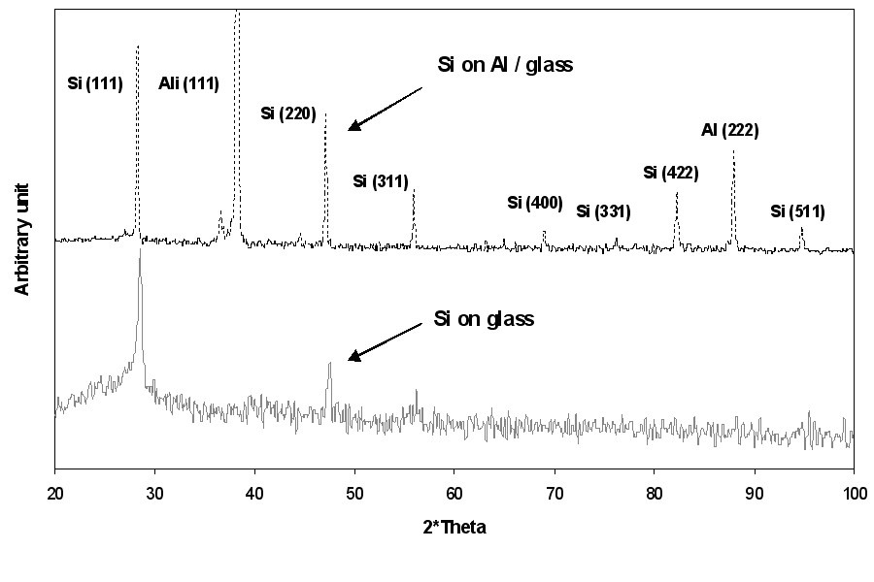
Figure 62. XRD pattern of poly-Si on glass, and poly-Si on Al coated glass.

For 2 μm thick films grown at 1 μm/hr, the average grain size and crystalline fraction increases with decreasing Si/Al ratio, i.e., with increasing Al layer thickness. For this particular set of films, the maximum average grain size of 200 nm was achieved with a Si/Al ratio of 2. It is important to mention that this maximum grain size value corresponds to the measurement limit of the XRD peak-broadening method as imposed by the instrumental function of the diffractometer used. Therefore, for films with such level of broadening, the average grain size may be larger than 200 nm. For 2 μm thick films as the growth rate is increased from 1 to 5 μm/hr, the average grain size and crystalline fraction decreases at a constant Si/Al ratio. AFM analysis revealed that some areas on the film surface are covered with small particles, 10-50 nm in diameter, as shown in Figure 64. It is speculated that these features are individual grains, which do not extend throughout the bulk of the Si film. However, these features were not found throughout the film surface, which may indicate the presence of a large grain microstructure. While AFM can only give details about the surface morphology, XRD analysis gives information about the average grain size of the bulk film. TEM analysis was carried out to investigate the microstructure of a 2 μm thick sample deposited at 1.0 μm/hr growth rate with a Si/Al ratio of 2. The cross-sectional TEM images of this sample are shown in Figure 65. Several large grains and nano-crystalline regions can be identified. These two crystalline regions can be found either side by side on the Al layer, or as layers with one evolving from the other. It is speculated that the presence of the nano-crystalline phase indicates an incomplete grain enhancement process and that the effect of lower growth rate for the given film thickness is to increase the interaction time between the layers. Glancing-angle XRD analysis showed traces of Al on the surface of
2 μm thick films. The bulk of the films also contain Al. Figure 66 is a planar SEM image of one of this film after etching with 3:3:1 HF:HNO₃:CH₃COOH solution. Clearly, two microstructures are revealed. The overlying layer corresponds to Al rich Si-Al alloy, while the underlying structure is composed of pure poly-Si. The image appears to indicate that the poly-Si does not form a continuous layer. This conclusion is corroborated by optical microscopy and Raman spectroscopy as shown in Figure 67. In this image of the back of the sample and obtained through the glass substrate, the dark areas correspond to poly-Si while the bright areas correspond to Al. It is evident that the Al layer inversion has not reached completion, perhaps due to insufficient interaction time between the Si and the Al layer. For 5.0 μm thick samples the average grain size varied between 40 and 70 nm, and the crystalline fraction did not change significantly with the growth rate. The decrease in grain size for Si films with 5 μm thickness may be due to the existence of a limiting thickness beyond which the Al ceases to have an effect on the growth process. If this hypothesis is correct, the film evolves from a large grain to a nano-crystalline grain microstructure as seen on films deposited on glass. All of the 5.0 μm thick films deposited at 5.0 μm/hr growth rate had columnar features 4-5 μm in diameter. These features were uniformly distributed throughout the sample. SEM images showed that some of these features were 3-4 μm high from the surface. Although those features looked like individual large grains, detailed SEM and AFM analysis revealed that they are actually agglomerates of much smaller crystallites, 10-50 nm in size. At 1.0 μm/hr growth rate, the columnar features were absent and the film surface appeared smoother in comparison.
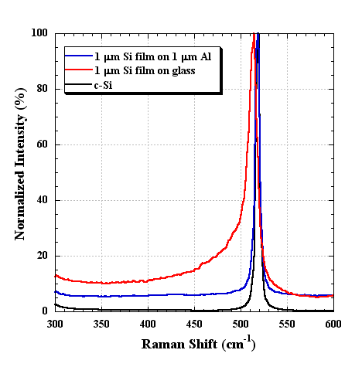
Figure 63. Comparison of Raman spectra of c-Si, poly-Si on glass,
and poly-Si on Al coated glass.
Table 24. Properties of films deposited at 430°C.

2 μm Si films | Growth rate 1 μm/hr |  |  |  | Growth rate 5 μm/hr
2 μm Si films | Thickness  Al layer  (μm) | Si/Al | Avg.  grain  size (nm) | Crystalline vol. frac. at 520 cm⁻¹  (%) | Thickness  Al layer  (μm) | Si/Al | Avg.  grain  size (nm) | Crystalline vol. frac. at 520 cm⁻¹  (%)
2 μm Si films | 0.01 | 200 | 60 | 85 | 0.01 | 200 | 40 | 65
2 μm Si films | 0.1 | 20 | 70 | 89 | 0.1 | 20 | 45 | 70
2 μm Si films | 0.5 | 4 | 100 | 96 | 0.5 | 4 | 70 | 71
2 μm Si films | 1 | 2 | 200 | 98 | 1 | 2 | 80 | 76
5 μm Si films | Growth rate 1 μm/hr |  |  |  | Growth rate 5 μm/hr
5 μm Si films | Thickness  Al layer  (μm) | Si/Al | Avg.  grain  size (nm) | Crystalline vol. frac. at 520 cm⁻¹  (%) | Thickness  Al layer  (μm) | Si/Al | Avg.  grain  size (nm) | Crystalline vol. frac. at 520 cm⁻¹  (%)
5 μm Si films | 0.01 | 500 | 40 | 77 | 0.01 | 500 | 40 | 71
5 μm Si films | 0.1 | 50 | 48 | 77 | 0.1 | 50 | 47 | 76
5 μm Si films | 0.5 | 10 | 54 | 79 | 0.5 | 10 | 66 | 73
5 μm Si films | 1 | 5 | 60 | 79 | 1 | 5 | 70 | 78
N/A = Not Applicable N/M = Not Measured

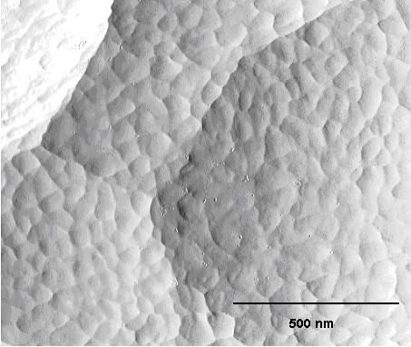

Figure 64. AFM image of the surface of a 2 μm thick poly-Si film deposited Al.

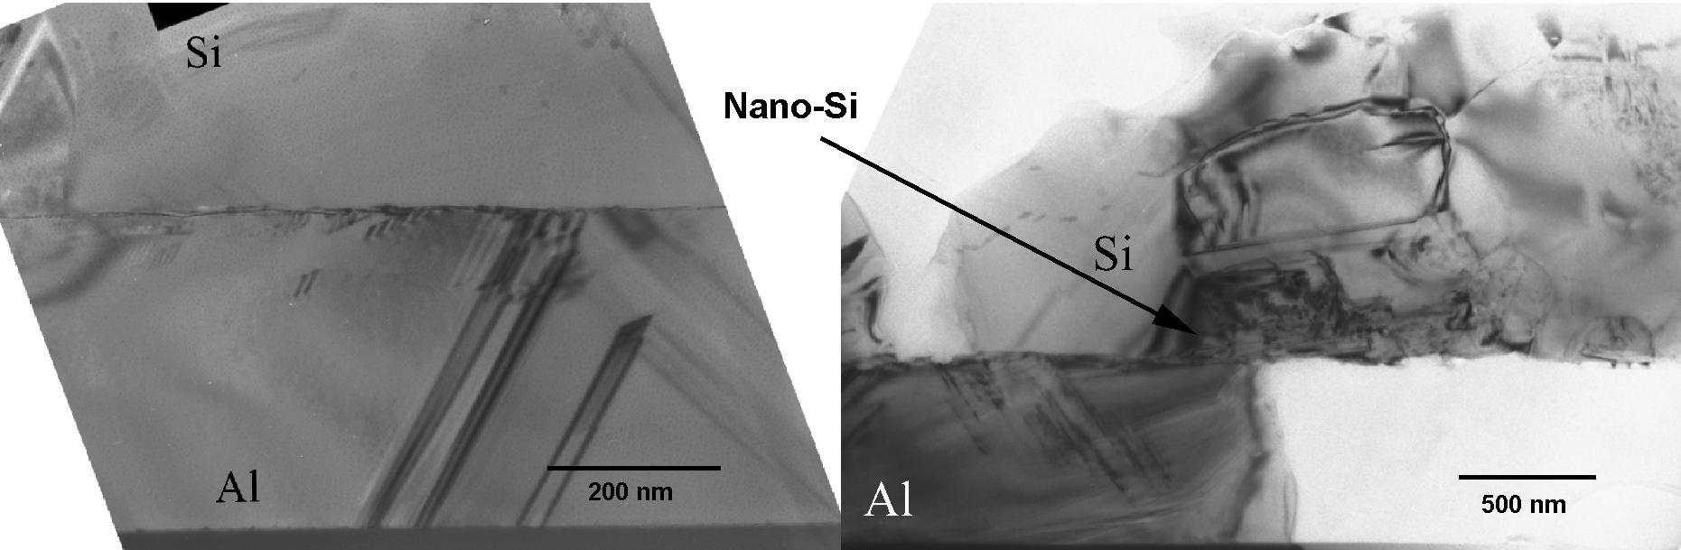

Figure 65. XTEM image of 2 μm thick poly-Si film on Al coated glass.

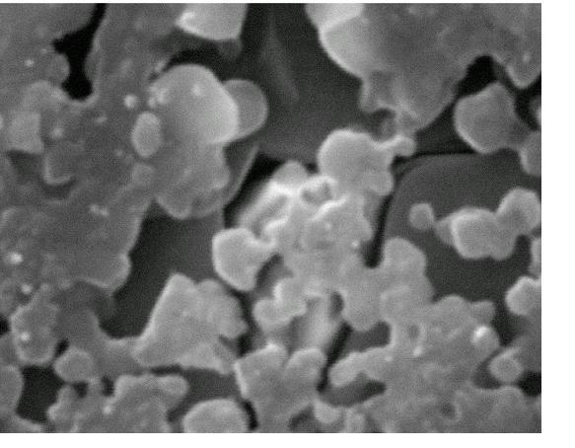
Figure 66. SEM planar image after etching Si film deposited on Al.

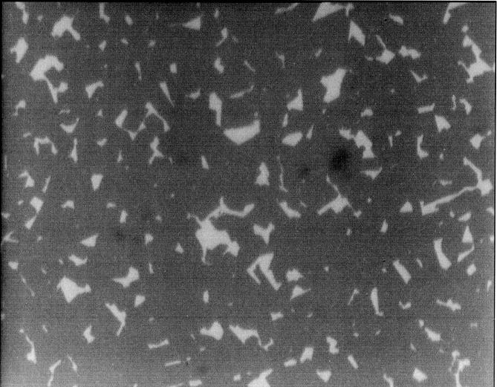

Figure 67. Optical micrograph of back surface of Si film deposited on Al.

4.1.2 Grain size enhancement of HWCVD Si films at 600°C.

The deposition of these films was carried out as described in Section 4.1.1, with the exception of the substrate temperature. Film properties as a function of deposition parameters are shown in Table 25. Compared to films deposited at 430°C, films deposited at 600°C exhibits larger average grain size as measured by XRD peak broadening. This contrast is more pronounced as the growth rate and Si film thickness increases. Only Si films with 5 μm thickness and deposited at 1.0 μm/hr showed random or (220) orientation while all others had strong (111) orientation. However, there is not enough data yet to correlate the orientation to either growth rate or film thickness. All films deposited at 600°C were non-homogeneous in terms of morphology and composition across their surface, as shown in Figure 68. As a result, the crystalline fraction reported in Table 25 is given as a range, with the larger crystalline fraction corresponding to the areas with larger Al concentration in the film. The non-homogeneity observed in these films could be the result of poor wetting of the Al layer on the 7059 glass at 600°C or alternatively due to segregation of the liquid phase forming at the eutectic composition. On average, the crystalline volume fraction of films deposited at 600°C is similar to those deposited at 430°C. However, as shown in Figure 69, the Raman profiles of regions rich in Al indicate a crystalline quality similar to that of c-Si for all films, regardless of deposition conditions.

Table 25. Properties of films Deposited at 600°C.

1 μm Si films | Growth rate 1 μm/hr |  |  |  | Growth rate 5 μm/hr
1 μm Si films | Thickness  Al layer  (μm) | Si/Al | Avg.  grain  size (nm) | Crystalline vol. frac. at 520 cm⁻¹  (%) | Thickness  Al layer  (μm) | Si/Al | Avg.  grain  size (nm) | Crystalline vol. frac. at 520 cm⁻¹  (%)
1 μm Si films | 0 | N/A | 40 | 46 | 0 | N/A | 30 | 30
1 μm Si films | 0.1 | 10 | 130 | 70-98 | 0.1 | 10 | 90 | 70-95
1 μm Si films | 0.5 | 2 | 180 | 70-98 | 0.5 | 2 | 160 | 70-95
1 μm Si films | 1 | 1 | 160 | 70-98 | 1 | 1 | 190 | 70-95
5 μm Si films | Growth rate 1 μm/hr |  |  |  | Growth rate 5 μm/hr
5 μm Si films | Thickness  Al layer  (μm) | Si/Al | Avg.  grain  size (nm) | Crystalline vol. frac. at 520 cm⁻¹  (%) | Thickness  Al layer  (μm) | Si/Al | Avg.  grain  size (nm) | Crystalline vol. frac. at 520 cm⁻¹  (%)
5 μm Si films | 0 | N/A | 36 | 45 | 0 | N/A | 40 | 40
5 μm Si films | 0.1 | 50 | 80 | 56-95 | 0.1 | 50 | N/M | 60-95
5 μm Si films | 0.5 | 10 | 130 | 56-95 | 0.5 | 10 | 110 | 60-95
5 μm Si films | 1 | 5 | 170 | 56-95 | 1 | 5 | 170 | 60-95
N/A = Not Applicable
N/M = Not Measured

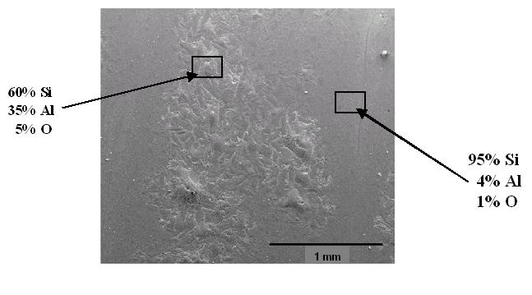
Figure 68. Planar SEM/EDS of Si film deposited on Al at 600°C.

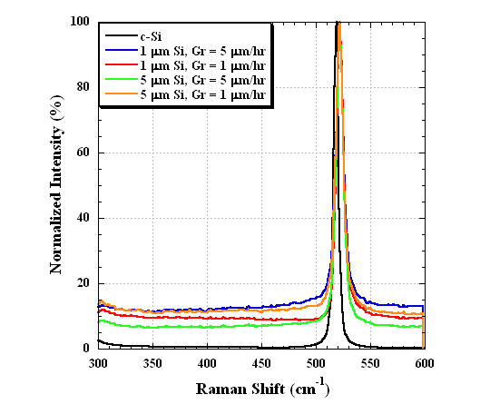

Figure 69. Raman profiles of Al rich regions in films deposited at 600°C.

4.2 Solar Cell Development

4.2.1 Microcrystalline p-i-n solar cell by PECVD

An attempt was made to fabricate p-i-n solar cells with all PECVD µc-Si layers. The device was deposited on glass/SnO₂ substrates (LOF Tec 8 and Tec 15). Conditions were nearly the same for all three layers: T=175°C (150°C for the p-layer), P=0.7 Torr (1.0 Torr for the p-layer), and flow ratio H₂/SiH₄=180 sccm/2 sccm=90. The 2.0 µm i-layer was deposited for 9 hours. No a-Si buffer layers or any other transitional layers were incorporated. Device performance was very poor, with V_{oc}=0.2V and efficiency <1%. Capacitance-voltage measurements indicated the i-layer was 2 µm thick as planned. A strong frequency dependency and unusual voltage bias dependence suggested a relatively high defect density and low barrier height. Spectral response measurements were made at 0 and –2V. The integrated photocurrent increased from 4 to 8 mA/cm² with reverse bias, confirming the poor carrier collection, in the absence of an electric field. Figure 70 shows the log QE vs energy for this device (GD41011) compared to a 10% efficient a-Si device (GD4666), a HWCVD p-i-n device with a µc-Si i-layer (HW193), and a 300 µm standard c-Si p-n cell. Both of the µc-Si devices have substantially more absorption below the a-Si absorption edge, confirming that their structure is between a-Si and c-Si.

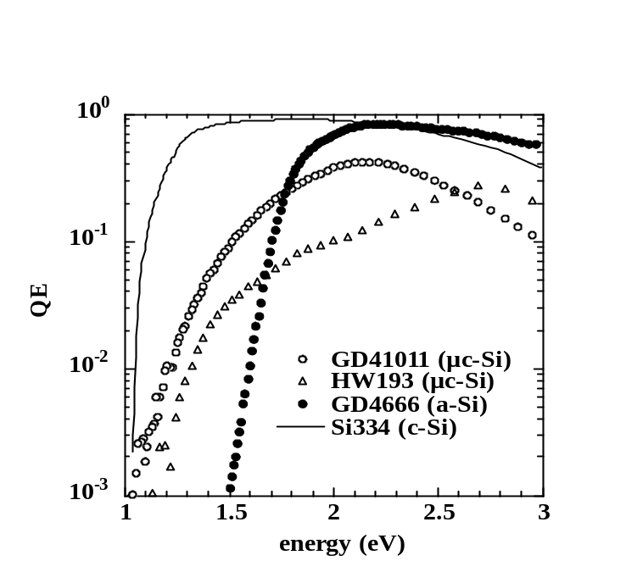

Figure 70. Log QE vs energy for a-Si, µc-Si and c-Si devices.
Data from HWCVD and PECVD µc-Si p-i-n cells is shown.

4.2.2 Solar Cells with µc-Si HWCVD or PECVD i-layers

Thin film Si n-i-p solar cells were fabricated on (100) and (111) n-doped c-Si substrates using PECVD and HWCVD microcrystalline i-layers. No metal induced crystallization was utilized. The structure of the devices was Ag-Pd-Ti/(100) or (111)n⁺-cSi/(PECVD or HWCVD) i-μcSi/PECVD p-μcSi/ITO/Ni-Al. The n+ wafer substrates served as the n-layer in the p-i-n cells. In addition, diagnostic n+-p+ devices were fabricated by depositing PECVD p-μcSi emitter layers directly onto the n⁺-c-Si substrates similar to the n+-p+ cell structure. Identical n-i-p and n+-p+ devices were also fabricated which incorporated a 30 nm a-Si buffer layer between the p-layer and i-layer or c-Si. Tables 26 and 27 summarize the deposition conditions used for the Si i-layers and the a-Si buffer and p-layers.

The performance of all solar cell devices was quite poor. In general, all cells with a HW or GD i-layer absorber had less than 1% efficiency although many had well formed diode characteristics in light and dark. The best devices were on pieces that consisted of only n+/p+ with no µc-Si HW or GD absorbers. Table 28 shows analysis of the dark JV curves on several devices. Only the Si layers are listed, all devices had same wafer metallization and ITO/grid contacts. The 30 nm intrinsic buffer layer is indicated as just a-Si. Intrinsic µc-Si absorbers indicated as HW i or GD i. W is depletion width at 0V, N is carrier density from 1/C² vs V. All devices had very low series resistance (<0.5 Ω/cm²). GD41015-21 (n+-p+ cell with no buffer) had A~2, while the others had A much greater than 2. All devices had very high J₀ indicating high recombination.

Table 26. Si i-layer deposition conditions.

Parameters | HWCVD | PECVD
Substrate temperature (°C) | 500 | 175
Pressure (mTorr) | 100 | 700
SiH₄ flow (sccm) | 9.3 | 2
H₂ flow (sccm) | 25 | 180
Wire temperature (°C) | 1850 | ----
RF power (W) | ---- | 50
Deposition time (min) | 16 | 270
Layer thickness (μm) | 1 | 1
N/M=not measured

Table 27. Undoped a-Si buffer and Si p-layer deposition conditions.

Parameters | PECVD a-Si buffer layer | PECVD p-Si layer
Substrate temperature (°C) | 150 | 150
Pressure (mTorr) | 200 | 1000
SiH₄ flow (sccm) | 20 | 2
H₂ flow (sccm) | 0 | 190
B₂H₆ flow (sccm) | 0 | 10
RF power (W) | 7 | 50
Deposition time (sec) | 108 | 240
Layer thickness (nm) | 30 | 15

Table 28. Device structures and JV data.

Piece | Structure | W (µm) | N (cm-³) | Diode  Factor A | J_{o} (mA/cm²)
GD41015-21 | n+ Si/p+ µc-Si | 0.03 | 2E18 | 2.1 | 2E-3
GD41019-21 | n+ Si/a-Si/p+ µc-Si | 0.04 | N/M | N/M | N/M
HW203-21 | n+ Si/HW i/p+ µc-Si | 0.2 | N/M | N/M | N/M
HW205-22 | n+ Si/HW i/a-Si/p+ µc-Si | 0.2 | 2E16 | N/M | N/M
GD41014-11 | n+ Si/GD i/p+ µc-Si | 0.5 | 4E16 | 2.9 | 2E-3
GD41018-21 | n+ Si/GD i/a-Si/p+ µc-Si | 0.8 | N/M | 4.6 | 5E-2

The best devices were on pieces that consisted of only n+/p+ with no µc-Si HW or GD absorbers. The JV results for these two devices are in Table 29 and the JV curves are shown in Figure 71. The a-Si buffer improves the V_{OC} but reduces the J_{SC} and FF. The increased current in reverse bias in light and dark for the device without a buffer, GD41014-21, is expected. It is due to a leaky n+/p+ tunnel junction. The thin a-Si buffer layer eliminates this high tunneling current. The highly doped n+ c-Si substrate (0.01 Ω-cm) is not expected to produce a high J_{SC} or V_{OC} due to the short diffusion length.

Table 29. JV results from n+-p+ cells having no GD or HW absorber.

Piece | Structure | V_{oc} (V) | J_{sc} (mA/cm²) | FF(%)
GD41015-21 | n+ Si/p+ µc-Si | 0.39 | 11 | 59
GD41019-21 | n+ Si/a-Si/p+ µc-Si | 0.62 | 2 | 37

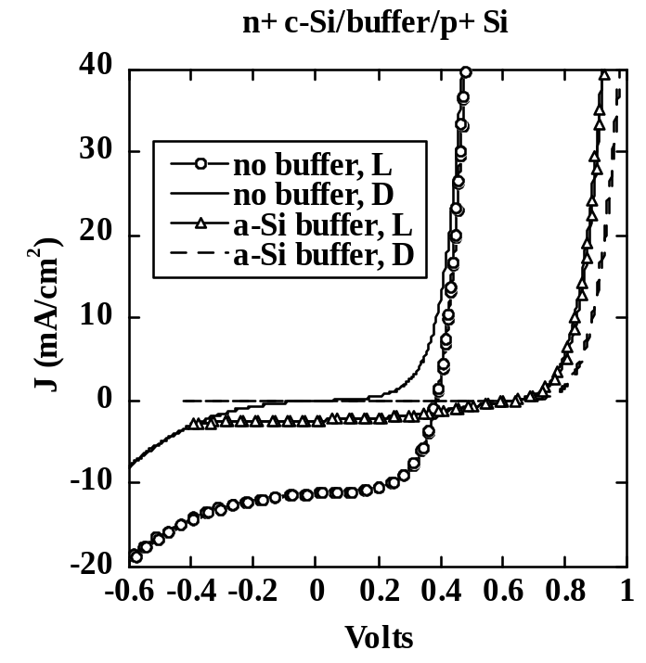

Figure 71. Light and dark JV curves for n+-p+ cells GD41015-21
and GD41019-21 showing effect of a-Si buffer.

The QE measured in the dark at 0 V is shown in Figure 72. The peaks are due to interference fringing. The n+-p+ cell (GD41015.21) response extends to 1000 nm, while the others only extend to 700-800 nm, indicating they have no photocurrent contribution from the n+ c-Si substrate. The two devices with HW or GD i-layers with buffers had identical QE curves. The GD device without the buffer had much higher QE than the one with a buffer. The capacitance was measured at 100 kHz in the dark. Results are given in Table 28. The n+-p+ cells have very small depletion widths as expected since they are highly doped on both sides. The space charge density for GD41015-21 of 2E18 cm-3 is as expected for the doping of a n-type Si wafer with a resistivity ~1E-2 Ω-cm. The HW and GD devices had comparable values of 2-4E16 cm-3.

In summary, the preliminary fabrication of n-i-p and n+-p+ cells using GD and HW µc-Si absorber i-layers has produced cells with poor photo-carrier collection and high recombination. The a-Si buffer layer increases V_{OC} but reduces J_{SC} and FF in both n-i-p and n+-p+ cells. No first-order differences were seen between devices the HW or GD µc-Si layers. The highly doped µc-Si substrate does not appear to contribute to the photo-carrier collection in the n-i-p cells. n+-p+ cells with the a-Si buffer achieved V_{OC}=0.62 V but with very poor J_{SC} and FF. The following section discusses impurity characterization of these devices in an attempt to explain their poor performance.

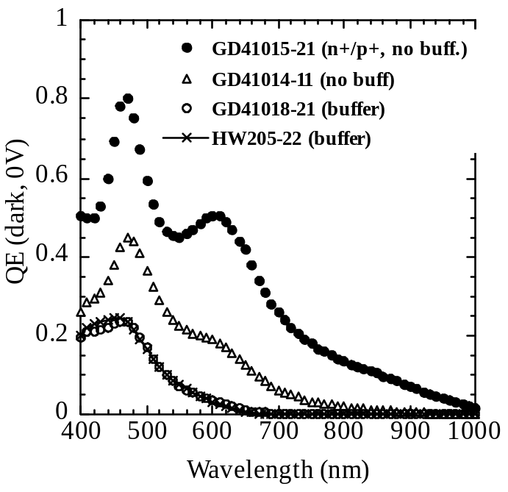

Figure 72. QE at 0V, dark for 4 devices.

4.2.3 Impurities in PECVD and HW films and devices

In the past two years, a decrease in FF has been measured from p-i-n devices deposited by PECVD. Previously, devices routinely achieved FF=70% while recently FF has been limited to 50-60%. Other device parameters were comparable (V_{OC}=0.86 V, J_{sc}=16 mA/cm²). J-V analysis indicated the low FF was not due to series resistance. The low FF was not influenced by the back contact and brands of SnO₂. QE measurements were made as a function of bias voltage to help identify the source of the low FF. Figure 73 shows the ratio of QE at 0.5V to 0V for 2 devices, one with normal FF and a recent one with low FF. This shape for the QE ratio of the low FF device is a well-known indication of poor hole collection from the i-layer; i.e. greater bias dependence at long wavelengths. The most likely cause is donor-like impurities such as P or O, which reduce the hole lifetime. The sub-bandgap QE was measured to characterize deep defects. Figure 74 shows log QE vs energy for the same two devices. The device with low FF had higher absorption at 1-1.2 eV confirming higher midgap defects.

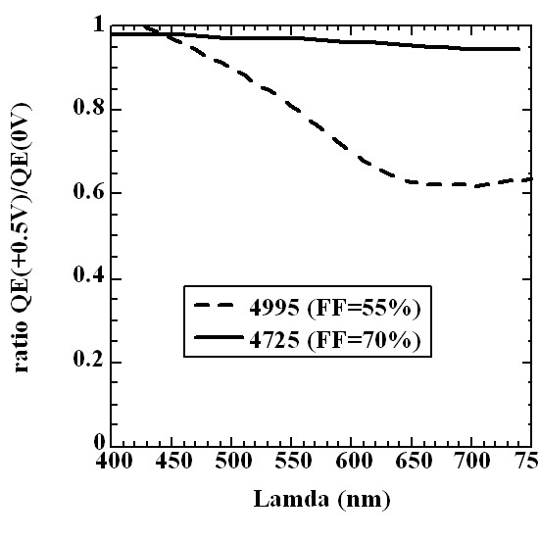
Figure 73. QE ratios comparing forward bias to 0V on two devices
showing greater bias dependence at long wavelength for device with low FF.

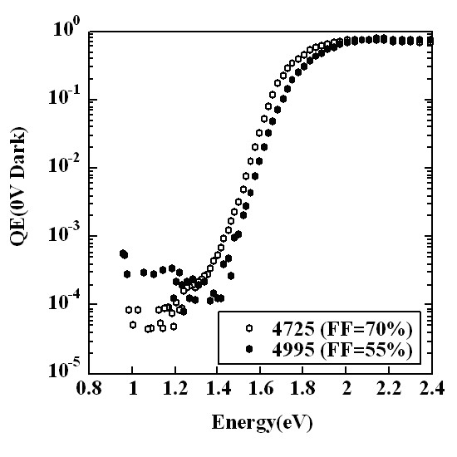

Figure 74. Log QE plots showing increased midgap
defects in device with lower FF.
The air leak-up rate into the PECVD reactor chamber was typically as low as in previous years, indicating that an external leak was not causing the problem. Considerable effort was made in cleaning the PECVD deposition chamber to eliminate deposits, which could be a source of residual O or P. Several other sources of impurities have been replaced. The silane cylinder was replaced with a new cylinder, which was assayed for purity. The internal components were replaced, made of Macor, which insulate the electrodes and substrate holder. The IR heater lamps were replaced. None of these changes resulted in a higher FF.

Select samples have been sent to NREL for SIMS over past 3 years. Results are shown in Table 30 for both a-Si and µc-Si films and devices. The first group are a-Si by PECVD, second is µc-Si p-i-n by PECVD, third group are HWCVD i-layer and p-i-n cells, and fourth group is c-Si wafer as control. Piece 4767 was a-Si p-i-n device with FF=70%. Piece 4997 was a-Si p-i-n device with FF=55%. Silane cylinder and Macor internals were replaced between 4976 and 4986. Not all elements were analyzed in every sample. Values are for the bulk i-layer distribution only, except for HW203 and HW205 where range is shown, due to significant tailing for C, O, N from the free surface. PECVD a-Si films and devices, and µc-Si film and devices have ~0.1 µm tail while HW µc-Si films have >1 µm tail, suggesting absorption of atmosphere in HW films as reported by several other groups. Most HW films sent for SIMS in 1998 and 2001 were 5-10 µm thick and also had ~1 µm tail for C, O, N but not other impurities. Since recent devices were only 1 µm as discussed in the previous section, the tail dominates the profile.

Since our PECVD reactor is a single chamber system, a major concern in both a-Si and µc-Si devices is the P and B cross-contamination. Our standard practice of depositing a contaminant burying SiC layer after all device runs containing an n-layer was developed years ago in response to serious P contamination. Table 30 shows that P and B are quite low in PECVD a-Si films and devices. P was of critical importance since Figure 73 showed that the low FF was due to a donor-like impurity. The P level in the i-layers are near those for undoped c-Si wafers. They are shown as “<10¹⁷ cm⁻³” since there was considerable noise in the SIMS profiles at these low levels. Note that several recent devices have had P concentrations higher than 10¹⁹ cm⁻³ in the p-layer. 4989 and 4997 had B concentrations of 10¹⁸ cm⁻³ in the p-layer while P was 10 times higher. This suggests our burying layer is not effective anymore in preventing cross-contamination.
A possible explanation is as follows. It has been shown by several groups including ours that H-diluted i-layer depositions are much more efficient at scavenging P compared to undiluted SiH₄ plasma. New p-layer conditions have required increasing the B₂H₆/H₂ flow by factor of 10 since the B₂H₆ source is diluted 0.2% instead of 2% as used in the past. Thus, the H₂/SiH₄ ratio in the p-layer has increased from 1.5/30 to 15/30, a tenfold increase in H dilution. This may be responsible for increased P counter-doping in the p-layer. Interestingly, the P cross-contamination does not seem to reduce the V_{oc,} as might be expected nor does P appear to contaminate the i-layer. Consequently, a new burying procedure has been implemented using an initial H plasma step to scavenge P, followed by the standard SiC step. Diagnostic device samples have been deposited following an n-layer deposition and the new burying procedure. Device and SIMS results will be reported.
Table 30. Summary of SIMS for IEC Si layers and devices.

Sample | Depo.  date | SIMS  Date | O  (at/cm³) | C  (at/cm³) | N  (at/cm³) | B  (at/cm³) | P  (at/cm³)
4764-11  a-Si layer | 02/06/98 | 05/23/01 | 6x10¹⁸ | 2x10¹⁸ | 3x10¹⁷ | N/A | <1x10¹⁷
4767-12  a-Si pin | 02/10/98 | 05/23/01 | 6x10¹⁸ | 3x10¹⁸ | 3x10¹⁷ | N/A | <1x10¹⁷
4976-22  a-Si layer | 05/01/01 | 05/23/01 | 8x10¹⁸-  3x10¹⁹ | 2x10¹⁸ | 2x10¹⁷ | N/A | N/A
4986-22  a-Si layer | 07/31/01 | 08/10/01 | 8x10¹⁸-  2x10¹⁹ | N/A | 1x10¹⁷ | N/A | N/A
4989-11  a-Si pin | 09/05/01 | 09/28/01 | 1x10¹⁹-  2x10¹⁹ | 1x10¹⁸ | 1x10¹⁷ | <1x10¹⁷ | <1x10¹⁷*
4997-21  a-Si pin | 04/25/02 | 01/14/03 | 4x10¹⁸ | 7x10¹⁷ | <1x10¹⁷ | <1x10¹⁷ | <1x10¹⁷*
41018-21  µc-Si pin | 12/02 | 01/14/03 | 5x10¹⁹ | 3x10¹⁹ | 8x10¹⁷ | <1x10¹⁷ | <1x10¹⁷
HW181-11  µc-Si layer | 03/9/01 | 04/19/01 | 2x10²⁰ | 7x10¹⁸ | 4x10¹⁷ | <1x10¹⁷ | N/A
HW203-21  µc-Si pin | 12/02 | 01/14/03 | 4x10²⁰-  2x10¹⁹ | 4x10²⁰-  1x10¹⁹ | 8x10¹⁸-  2x10¹⁸ | <1x10¹⁷ | <1x10¹⁷
HW205-22  µc-Si pin  (a-Si buffer) | 12/02 | 01/04/03 | 4x10²⁰-  3x10¹⁹ | 3x10²⁰-  1x10¹⁹ | 1x10¹⁹-  2x10¹⁸ | <1x10¹⁷ | <1x10¹⁷
c-Si wafer | N/A | 4/19/01 | 1x10¹⁸ | 5x10¹⁷ | 4x10¹⁶ | 2x10¹⁴ | 2x10¹⁶
but the P concentration was ~1x10¹⁹ in the p-layer. N/A = not available

For µc-Si device samples 41018-21, HW203-21, and HW205-22, the concentration levels of atmospheric impurities (O, N and C) are several orders of magnitude higher than those in the a-Si cell and the c-Si wafer. These impurities in the HW samples have a concentration gradient, which spans the thickness of the i-layer and decreases from the top surface. Prior SIMS analysis of HWCVD films with 5µm thickness (HW181-11) has shown a similar gradient of these impurities, which level off to a constant bulk concentration at approximately one micron into the film. Similar gradients have also been reported in the literature for HWCVD µc-Si films. In contrast, bulk concentration levels of the same impurities in PECVD a-Si and µc-Si films are reached after 0.1 µm from the surface. Impurities in the PECVD µc-Si seem to be uniform suggesting they occur during growth. It is not clear at this point where these impurities originate. However, it is important to remember that both PECVD and HWCVD i-layers are exposed to the atmosphere prior to the emitter layer deposition. In addition, it is speculated that the lower H content in HWCVD films, combined with the excessive number of grain boundaries and film porosity may facilitate contaminant penetration into the films. To test this hypothesis, µc-Si i-layers will be capped with a-Si:H and submitted for SIMS analysis. This will provide a baseline in contaminant levels to be expected from both the PECVD and HWCVD reactors. The control of oxygen incorporation into HWCVD films is a critical issue as reports in the literature indicate several orders of magnitude increase in the film conductivities as the oxygen content in the film increases .

4.2.4 Boron doped HWCVD Si films

In order to develop complete HWCVD Si devices, work was initiated on the fabrication of doped Si layers. Boron doped HWCVD films were deposited and characterized. The deposition conditions used are summarized in Table 31.

Table 31. B-doped Si film deposition conditions.

Substrate temperature (°C) | 450
Wire temperature (°C) | 1850
Pressure (mTorr) | 200
SiH₄ flow (sccm) | 4.0
B₂H₆/SiH₄ | 10⁻⁵ – 10⁻³
Deposition time (min) | 30

In addition, a set of undoped films was also deposited for comparison. For these films, the deposition conditions were similar as in Table 31, except that an additional 2 sccm of H₂ was added to the gas mixture to make up for the H₂ diluent in the B₂H₆ dopant mixture. The film thickness for all films varied from 0.56 to 0.73 m. XRD and Raman spectroscopy analysis, as seen in Figures 75 and 76 for a representative sample, shows that the films are highly crystalline and exhibit typical (220) preferential orientation. Calculation of the crystalline fraction from the Raman profiles results in values from 75 to 90%.

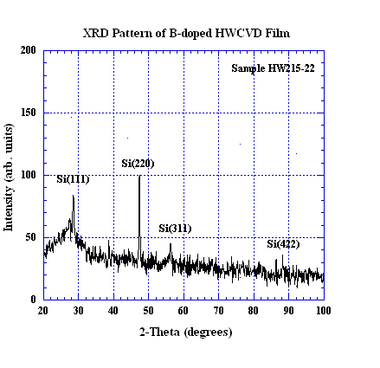

Figure 75. XRD pattern of B-doped HWCVD μc-Si film.

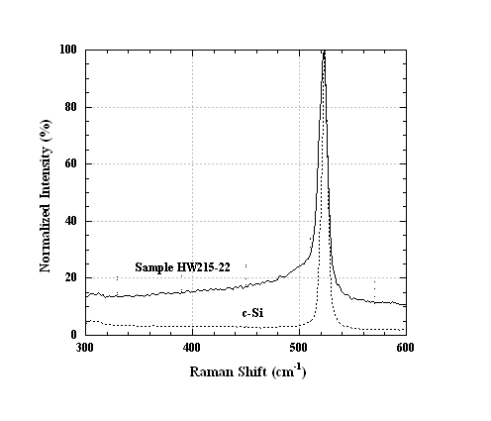

Figure 76. Raman spectra of B-doped HWCVD μc-Si film.

Values of the room temperature light and dark conductivity measured by the 4-point probe method as a function of the B₂H₆/SiH₄ in the gas phase are summarized in Table 32. The invariance of conductivity with dopant gas concentration indicates poor incorporation of B from the gas phase at the conditions used. Previous experiments carried out at P = 500 mTorr and B₂H₆/SiH₄ = 1x10⁻³ with other parameters similar to those in Table 24 yielded films with conductivities of ~ 10⁻² S/cm. However, the films had a significant thickness gradient along the direction of flow due to the high pressure. A pressure of 200 mTorr was used for this study to achieve greater uniformity. Although an extensive study of B-doping by B₂H₆ has not been carried out, it is difficult to rationalize how changes in pressure would affect the incorporation of B into the films. Alternatively, it is possible that a change in microstructure across the thickness of the films leads to differences in the overall conductivity of the films. The samples deposited at P = 500 mTorr had a thickness of 4 m, a factor of 8 greater in thickness compared to the films in this study. To determine the factors affecting conductivity, a second set of B-doped films was deposited and their properties compared to those of the samples in Table 32. Deposition conditions and film properties for this sample set are given in Table 33. Comparison of sample HW223-11 in Table 33 and the samples in Table 32 clearly indicates that the deposition pressure does not play a role in affecting the film conductivity. For submicron films, the conductivity changes 3 orders of magnitude by changing the B₂H₆/SiH₄ from 10⁻³ to 10⁻² as seen between sample HW226-11, and the samples in Table 32. Furthermore, if the film thickness is increased by a factor of 3 while keeping other conditions constant (see samples HW226-11 and HW227-11), the conductivity increases another 2 orders of magnitude. The fact that the activation energy of both of these samples is the same, indicates an increase in mobility with thickness. The reasons for this dependence are not clear, however, a possible explanation is the existence of a highly defective or amorphous incubation layer in the initial stages of growth. Separating the effects of dopant gas concentration and film microstructure on the film conductivity will be an area of focus in future work.

Table 32. Conductivity of B-doped Si films deposited at 200 mT.

Sample # | B₂H₆/SiH₄ | Dark Cond. (S/cm) | Photo Cond. (S/cm)
HW212-21 | 0 | 1.1x10⁻⁶ | 1.6x10⁻⁶
HW215-21 | 1x10⁻⁵ | 3.5x10⁻⁶ | 2.0x10⁻⁶
HW216-21 | 1x10⁻⁴ | 2.4x10⁻⁶ | 2.3x10⁻⁶
HW217-21 | 1x10⁻³ | 1.7x10⁻⁶ | 1.8x10⁻⁶

Table 33. Deposition conditions and film properties of B-doped Si films.

Sample # | Thickness  (m) | Deposition Conditions | Conductivity  (S/cm) | Activation  Energy  (eV)*
HW120-22 | 4.0 | P =500 mTorr  B₂H₆/SiH₄ = 1.7x10⁻³  F_{SiH4} = 12 sccm  T_{f} = 1815 ºC  T_{s} = 450 ºC  Gr = 3.3 m/hr | Dark=2.7E-2  Photo=same | 0.072
HW223-11 | 1.5 | P =500 mTorr  B₂H₆/SiH₄ = 1.0x10⁻³  F_{SiH4} = 4 sccm  T_{f} = 1850 ºC  T_{s} = 450 ºC  Gr = 3.0 m/hr | Dark=1.E-6  Photo=same | 0.088
HW226-11 | 0.8 | P =200 mTorr  B₂H₆/SiH₄ = 1.0x10⁻²  F_{SiH4} = 3 sccm  T_{f} = 1850 ºC  T_{s} = 450 ºC  Gr = 1.2 m/hr | Dark=1.5E-3  Photo=same | 0.041
HW227-11 | 2.5 | P =200 mTorr  B₂H₆/SiH₄ = 1.0x10⁻²  F_{SiH4} = 3 sccm  T_{f} = 1850 ºC  T_{s} = 450 ºC  Gr = 1.2 m/hr | Dark=1.1E-1  Photo=same | 0.040

*all films had curved Arrhenius plots over 213 to 373K, Ea from fit only 213-293 K

4.2.5 National Thin Si Team Activities

Robert Birkmire attended the National Thin Film Si Team Meeting held on January 10. 2003. Bob gave a presentation on the growth and characterization of HWCVD Si films on Al coated glass. Rogert Aparicio attended the National Thin Film Si Team Meeting on August 8, 2003. Roger gave a presentation on the grain enhancement of Si films by aluminum induced crystallization approaches.

DIAGNOSTICS

5.1. Contact Wetting Angle

The use of contact wetting angle between a film surface and a liquid is being investigated as a diagnostic tool for thin-film photovoltaic fabrication. The terminating surface of a solid contains excess free energy compared to the bulk, arising in part from greater molecular disorder where the bulk lattice is terminated. This excess free energy is not easily measured by direct means but is manifest in the contact angle of liquids in contact with the surface. The free energy of the solid in air (SV) is related to the contact angle () and the free energies of the solid to liquid (SL) and the liquid to air (LV) through Young’s equation :

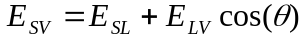 (13)

By employing fluids with different viscosity and surface tension, the equation can be solved simultaneously for the free energy of the solid to air. For specular materials, performing these measurements on a tilted plane reveals contact angle hysteresis between the leading and trailing edges of the droplet, which provides quantitative information relating to surface chemistry . Application of a voltage across the droplet and the solid allows the contact angle to be modified; such electro-wetting manipulation of the liquid allows determination of interfacial free energy and hence the solid to air free energy . These techniques are most valuable when used to measure relative differences in similar specimens.

Contact wetting angle measurements of water on CdTe films at different stages of processing are correlated with surface phase composition. Polar and dispersive components of the surface energy on Cu(InGa)Se₂ films with different composition are determined. Reduction techniques were implemented to give surface adhesive energy of the liquid to the film and surface energy of the film.

For measurement of the wettability of liquid on a solid surface, a useful comparative quantity is the adhesive energy, E_{ad}, expressed in terms of the liquids surface tension and the contact angle:

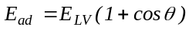 (14)

As the wettability of a liquid on a solid surface decreases, the contact angle increases,  → 90 cos()→ 0, and E_{ad} → E_{LV}. In this case, the adhesive energy approaches the surface tension at the liquid-vapor interface. As the wettability further decreases,   90 and cos() < 0. In this case the adhesive energy is less than the liquid-vapor energy and the droplet will be poorly adhered to the surface. As the wettability increases, the contact angle decreases,  → 0 cos()→ 1, and E_{ad}  E_{LV}.

Since the solid-vapor energy is a fixed property, decreasing contact angle implies a decrease in the solid-liquid interface energy, E_{SL}→ 0. The Zisman method of surface energy determination relies on measurement of the contact angle using different fluids and plotting cos() versus E_{LV}. Extrapolation to cos() = 1 yields the surface energy of the solid. Table 5.1 lists the properties of contact liquids.

Table 34. Properties of contact liquids

Name | Formula | T_{b}  (°C) | E_{LV}  (dynes/cm)
Acetophenone | C₆H₅COCH₃ | 203 | 39.8
Ethylene Glycol | HOCH₂CH₂OH | 198 | 47.7
Methylene Iodide | CH₂I₂ | 182 | 50.8
Formamide | HCONH₂ | 111 | 58.2
Water | H₂O | 100 | 73.0

The Zisman method was evaluated this year for Cu(InGa)Se₂ and (CdZn)Te alloys, with the result that the extrapolation method is too inaccurate to achieve a reasonable degree of accuracy or repeatability. This is because the method is best suited for liquids with low fraction of polar energy. The total free surface energy consists of both polar and London dispersive components:

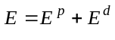 (15)

The components are different for different fluids and can result in non-linear behavior on a Zisman plot of cos() versus E_{LV}. The polar component, E^{d}, arises from permanent dipoles, induced dipoles and hydrogen bonding. The London dispersion force component of the surface free energy, E^{p}, arises from interactions between fluctuating electronic dipoles with induced dipoles. A simple rule of thumb is that a low energy liquid such as acetophenone will wet and strongly adhere to a high energy solid such as stannic oxide. This rule holds only if the intermolecular forces in both solid and liquid can interact. The rule breaks down, however, when the the force interaction is restricted, such as observed for water on oxide-free high energy metals. In our studies, we intended to utilize water for routine analysis. Thus, a more detailed reduction process was needed.

A more quantitative assessment can be obtained using two or more liquids by the harmonic mean method in which the polar and dispersive components of the solid, 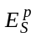 and 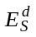, are determined. For liquid 1, we have 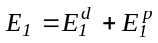 and for liquid 2, 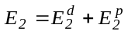:

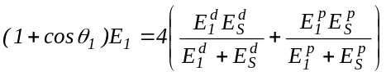 (16a)

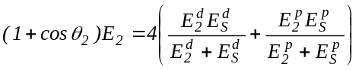 (16b)

Equations 16a and 16b can be solved simultaneously for the solid surface energy components and , given the contact angles and corresponding polar and dispersive energies of the two fluids. The polar fraction of the surface energy is represented as x_{p}.

An apparatus for routine measurement of contact angle under standard conditions was constructed and software for reducing wetting angle to adhesive energy and solid surface energy was developed. Contact angle is measured at room temperature (20-25°C) and atmospheric pressure using a horizontal microscope at ~20X magnification, fitted with a protractor reticle and x-y-z motion stage. A CCD camera is used to photograph the drop at 20-100X as shown in Figure 77. Using the in-field protractor or the on-screen protractor tool, contact angle can be determined with a precision of ±1°. The fluids used for the present work were deionized water and deionized formamide. For each sample and fluid, the contact angle of the left and right side of 5 different drops were measured and the average taken. Each drop was dispensed from a capillary pipette with a volume of 0.05 cm³. Prior to measuring the contact angle, each drop was allowed to reach equilibrium with the surface for >10s. The samples were rinsed in isopropanol (IPA) and dried under argon prior to contact angle measurement.

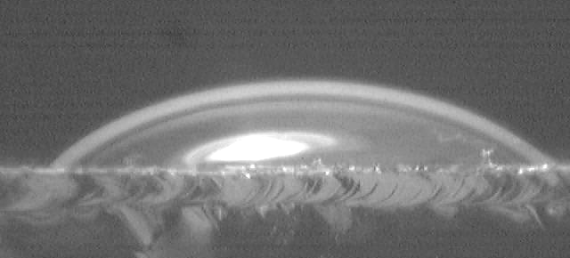

Figure 77. Deionized water droplet on the surface of VT CdTe.

Surface energy analysis has been carried out on Cu(InGa)Se₂ films deposited with similar Cu composition but different Ga content, all with a final thermal step at 550°C (Table 5.2). The average contact angles of water (x_{p} = 0.32) and formamide (x_{p} = 0.70) were determined for the left and right sides of 3 drops. From the contact angle results, it is apparent that water wets samples with Ga better than samples without, while the wetting of formamide was unaffected by composition. Using the Zisman analysis method, a surface energy of 55 dyn/cm was determined for all samples. However, the results using the harmonic mean analysis indicates a similar dispersive component for all samples but higher polar component for samples with Ga. This preliminary result suggests that the polar component of the surface energy in Cu(InGa)Se₂ films may be influenced by Ga concentration. A more detailed study of this dependence is planned.

Table 35. Contact wetting angle and surface energy for Cu(InGa)Se₂ films.

Sample | Cu/(III) | Ga/(III) | θ_{water} | θ_{formamide} | E^{p}  (dyn/cm) | E^{d}  (dyn/cm) | E_{SV}  (dyn/cm)
33696.21 | 0.82 | 0 | 43 | 14 | 29 | 31 | 60
33690.21 | 0.75 | 0.30 | 26 | 13 | 40 | 27 | 67
33708.21 | 0.77 | 0.31 | 18 | 14 | 45 | 25 | 70

VT CdTe films supplied by First Solar as part of team activity were analyzed by GIXRD and contact angle at different stages of post-deposition processing. The GIXRD measurements were made on a Rigaku D/Max 2500 instrument with CuKα x-rays at 40 kV and 50 mA, with incident beam angle at 0.5°, sampling an average depth of ~60 nm. The contact angle measurements of deionized water drops on the CdTe surface were carried out at room temperature (20-25°C) and pressure using a horizontal microscope at ~20X, fitted with a protractor reticle and x-y-z motion stage. The contact angle was determined with a precision of ±2°. For each sample, the contact angle of the left and right side of 6 different drops were measured and the average taken. Each drop has a volume of ~0.05 cm³ and was dispensed from a capillary pipette situated 2 cm above the level film specimen. Prior to measuring the contact angle, each drop was allowed to reach equilibrium with the surface for >10 s. The films were rinsed in isopropanol (IPA) and dried under argon prior to contact angle measurement.

The GIXRD and contact angle data are listed in Table 36. For as-received VTCdTe films, only CdTe phase was found and the contact angle was typically >70°. Annealing the film in dry air at 600°C, with water concentration less than 0.01 mg/L, caused insignificant change in surface properties. Performing a CdCl₂ vapor treatment at 430°C in dry air produced CdO phase, detectable after 30 minutes of treatment, as has been reported in previous studies . However, an increase in wetting was detected after only 15 min. Similar adhesion was found for both 15 and 30 min treatments, suggesting, that the CdO phase is present in both cases, but is thinner than the GIXRD detection limit for the 15 min case. For CdCl₂ treatment carried out in moist room air, with water concentration ~0.01 g/L, the native oxides CdTeO₃ and CdTe₂O₅ were found, and no CdO was detected. The proportion of CdTe₂O₅ increased with time, further reducing the adhesion. For the sample vapor CdCl₂ treated in dry air, the three-step BDH etch was used to produce a Te layer, as shown by the GIXRD result. This significantly reduced the wetting. After 30 min resting in room air, re-rinsed with IPA, and analyzed, the wettting increased, suggesting the formation of Te oxides too thin for GIXRD detection. This result is qualitatively similar to that reported earlier for ellipsometric changes on Te surfaces produced by NP etching . These relative measurements provide a sensitive means to monitor changes in CdTe surface condition.

Table 36. GIXRD and contact angle results for CdTe surfaces at different stages of post-deposition processing. Samples marked with (*) are the same specimen.

Processing  Stage | Conditions | Surface Phases  from  GIXRD | Contact Angle  for H₂O  (±2 degrees) | Adhesive Energy  for H₂O  (±2 dyn/cm)
As -Received |  | CdTe | 80 | 86
Dry Air Anneal | 600C, 20 min | + CdTeO₃ | 70 | 98
CdCl₂+Dry Air | 430C, 15 min | CdTe | 30 | 136
*CdCl₂+Dry Air | 430C, 30 min | + CdO | 25 | 140
CdCl₂+Moist Air | 430C, 15 min | + CdTeO₃ | 35 | 132
CdCl₂+Moist Air | 430C, 30 min | + CdTeO₃, CdTe₂O₅ | 45 | 124
CdCl₂+Moist Air | 430C, 60 min | + CdTeO₃, CdTe₂O₅ | 55 | 114
*BDH etch | immediately | Te | 60 | 110
*BDH etch | 0.5 hr after | Te | 40 | 130

5.2 Ellipsometry

Ellipsometry measures the complex p- and s- components of reflectance from a specimen, in contrast to simply measuring the intensity ratio of a reflected beam to the incident beam as in conventional reflectometry. This is shown in the fundamental equation governing the ellipsometry:

tan Ψe^{iΔ} =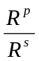, (17)

where R^{p} and R^{s} are the total complex reflection coefficients for the p- and s-waves, respectively. The parameter Ψ corresponds to the magnitude ratio of the total reflection coefficient and Δ is the phase shift in p- and s- waves due to the reflection process: Collectively they are known as the ellipsometry parameters. Ellipsometry measures Ψ and Δ and allows extraction of useful quantities such as thickness and optical constants (n and k) in multi-layer structures using detailed optical models. The knowledge of the polarization state of the incident light as well as the reflected light are required for the unique determination Ψ and Δ. Thus an ellipsometer consists of a light source, polarizer to fix the polarization of the incident light, analyzer to measure the polarization state of the reflected light and a detector. With these preliminary components, the ellipsometer can be configured in a large number of modes; null, rotation analyzer, rotation polarizer and polarization modulation.

Ellipsometry measurements were carried out on a J. A. Woollam VASE system from 0.725 eV to 4.6 eV at intervals of 0.025 eV on single-phase Cd_{1-x}Zn_{x}Te films deposited on CdS/ITO/glass substrate using co-evaporation from CdTe and ZnTe sources. The VASE measurements were carried out at room temperature under flowing Ar. A multilayer model was developed to quantify the Cd_{1-x}Zn_{x}Te films in device structures, and the optical constants were obtained from the best–fit. The accuracy of the data and fit strategy was independently verified by comparing the normal transmission data generated from the optical model with the measured normal transmission. The optical data for Cd_{1-x}Zn_{x}Te films is comparable to crystal data reported in the literature. The compositional dependence of the various electronic transitions in the Cd_{1-x}Zn_{x}Te films were fitted with second order polynomial equations, and a semiconductor alloy model was developed using the optical constants obtained from the Cd_{1-x}Zn_{x}Te films with different Zn alloy composition. This alloy model has allowed the Zn alloy composition to be accurately determined in unknown specimens in films prepared by IEC and at the University of Toledo, deposited by PVD and rf sputtering.

5.3 Glancing Incidence X-Ray Diffraction

X-ray diffraction (XRD) is a powerful yet non-destructive analysis tool that provides quantitative information on the crystalline phases in thin films and thin-film structures. With a suitable choice of x-ray source and optical geometry, XRD analysis can be applied to a wide range of polycrystalline and microcrystalline materials used for photovoltaics. When used in conjunction with chemical analyses, a detailed description of thin-film structures can be developed. For in-situ diagnostics, XRD methods can provide a wealth of information on materials systems where multiple phases are present or where the lattice parameter distribution is coupled to deposition parameters.

The diffraction intensity pattern for monochromatic x-rays as a function of the diffraction angle defined by 2θ = θ_{i} + θ_{d} contains two primary pieces of information: 1) The overall pattern of diffracted peak positions represents the instrument-transform of the family of lattice plane spacing, which is relates to the specific crystalline phases present; 2) Individual line profiles contain the instrument-transformed distribution of d-spacings at that crystallographic <hkl> direction, which in-turn is related to compositional or structural distortions of the assemblage of atoms in that plane. Thus, XRD analysis consists of decoupling instrumental effects (geometry and optical aberrations) from specimen-related effects (phases, and properties thereof).

Two optical configurations that are routinely applied for thin film XRD analysis derive from parafocusing cameras: symmetric Bragg-Brentano geometry and asymmetric Seeman-Bohlin geometry. In either optical configuration, the x-ray source intensity and angular dispersion are fixed by the take-off angle from the x-ray source to the entrance slit. The angular intensity distribution obtained on the detector arc represents the convolution of the optical transformation function (instrument function) with the specimen lattice distortion function. The symmetric condition, θ_{i} = θ_{d}, constrains the measurement to lattice planes parallel to the specimen plane, and the specimen is equidistant from source and detector. The asymmetric condition, with θ_{i} ≠ θ_{d} and using fixed incident beam angle, constrains the measurement to populations of lattice planes that are tilted with respect to the specimen plane. Asymmetric measurements made with low incident beam angles are referred to as glancing incidence x-ray diffraction (GIXRD). In either symmetric or asymmetric diffraction, the minimum angle for diffraction from a specular specimen is governed by the critical angle, θ_{c}, for total external reflection, which for CuKα radiation, is θ_{c} ~ 0.2 for Si and θ_{c} ~ 0.3 for CdTe and CuInSe₂. A more complete analysis of the evanescent and reflected waves allows quantitative properties of multi-layer thin-film stacks to be determined from glancing-incidence diffraction measurements.

The symmetric geometry is the most commonly encountered configuration in commercially available XRD powder diffraction systems. The diffraction depth depends on the mass absorption coefficient (μ/ρ), which in turn depends on the x-ray energy and chemical composition of the phase, causing low-index {hkl} planes (large d-spacing, low 2θ) to be diffracted from near the powder surface, while high-index planes (low d-spacing, high 2θ) are diffracted from deeper in the specimen.

Quantitative powder diffraction analysis relies on homogeneous distribution and random orientation of the particulates, so that the diffracted intensity distribution received at the detector is governed only by the pure scattering properties of each {hkl} reflection of each phase, and by the diffractometer instrument function. The detection limit of a trace phase in a majority phase matrix depends on the scattering properties of the phases; for similarly scattering phases, the detection limit for symmetric XRD powder diffraction is ~0.5 wt%. The measured volume fraction of surface layers can be enhanced by using GIXRD measurements; utilizing the surface mass absorption coefficient to constrain the sampling depth. Table 35 lists mass absorption coefficients and sampling depths for different thin-film photovoltaic absorber layers and Mo, Cu and Cr radiation for incident beam angle of 1 degree.

Table 37. Mass absorption coefficient (μ/ρ) and sampling depth (τ) for 1° incident beam angle and different x-ray sources for thin-film photovoltaic absorber layer materials.

Mo Kα (0.017 MeV) | CdTe | CuInSe₂ | α-Si
μ/ρ (cm²/g) | 35 | 69 | 8
τ (μm) @ θ_{i} = 1° | 0.85 | 0.44 | 11.5
Cu Kα (0.008 MeV) | CdTe | CuInSe₂ | α-Si
μ/ρ (cm²/g) | 260 | 130 | 50
τ (μm) @ θ_{i} = 1° | 0.12 | 0.23 | 1.8
Cr Kα (0.0054 MeV) | CdTe | CuInSe₂ | α-Si
μ/ρ (cm²/g) | 820 | 385 | 210
τ (μm) @ θ_{i} = 1° | 0.03 | 0.08 | 0.44

GIXRD analysis of crystalline surface phases in CdTe solar cells has been correlated with device behavior for different post-deposition processing conditions. Air heat treatment of CdTe films forms the native oxide CdTeO₃, while treatment in CdCl₂/air vapor forms CdTeO₃ and CdO. The phases can exist as surface layers or, in some instances, as penetrating phases. To first order, with the assumption that the phases are randomly oriented, the presence of a surface phase, A, on a substrate phase, B, can be determined by evaluation of the intensity ratios for phases A and B at different incident beam angle. The intensity ratios can be modeled using the phase scattering properties and geometrical configuration. GIXRD measurements have further shown that etching removes surface oxides and forms crystalline Te. GIXRD is also being used to investigate changes in composition in Cu(InGa)Se₂ films, by compating the lattice parameter distributions obtained at different incident beam angles, hence different sampling depths.

In addition to phase information, GIXRD measurements are being routinely used to determine through-film stress in as-deposited Mo films and in CdTe films at different stages of processing. Analysis consists of accurately determining the lattice parameter from GIXRD measurements made at different incident beam angles spanning several (3-9) hkl reflections. The shift in lattice parameters is transformed through the strain coefficient tensor for the given material to give the residual force in the plane of the film as a function of the depth. At present, a series of sputtered Mo films deposited at fixed power but different pressures have been fabricated and measured. Also, IEC PVD and VT CdTe/CdS films and First Solar VT CdTe/CdS films have been measured after different thermal processing steps and after surface etching. Full analysis of the data is being carried out.

ABSTRACT

This report describes results achieved during phase II of a three-phase subcontract to develop and understand thin film solar cell technology associated to CuInSe₂ and related alloys, a-Si and its alloys and CdTe. Modules based on all these thin films are promising candidates to meet DOE long-range efficiency, reliability and manufacturing cost goals. The critical issues being addressed under this program are intended to provide the science and engineering basis for the development of viable commercial processes and to improve module performance. The generic research issues addressed are: 1) quantitative analysis of processing steps to provide information for efficient commercial scale equipment design and operation; 20 device characterization relating the device performance to materials properties and process conditions; 3) development of alloy materials with different bandgaps to allow improved device structures for stability and compatibility with module design; 4) development of improved window/heterojunction layers and contacts to improve device performance and reliability; and 5) evaluation of cell stability with respect to illumination, temperature and ambient and with respect to device structure and module encapsulation.

7 REFERENCES

R. W. Birkmire, J. E. Phillips, W. N. Shafarman, E. Eser, S. S. Hegedus, B. E. McCandless, R. Aparicio, and K. D. Dobson, NREL Final Report 2002.
R. W. Birkmire, B. E. McCandless and W. N. Shafarman, Solar Cells 23 (1988) 115-126.
A. Mondal, B. E. McCandless and R. W. Birkmire, Solar Energy Materials and Solar Cells, Vol. 26, No. 3 (1992) 181-188.
A. Mondal, T. K. Chaudhuri, P. Pramanik, Sol. Energy Materials, 7 (1983) 431-438.
T. L. Chu, S. S. Chu, N. Schultz, C. Wang, C. Q. Wu, J. Electrochem. Soc., 139 (9) (1992) 2443-2446.
P. K. Nair, V. M. Garcia, O. Gomez-Daza, M. T. S. Nair, Semicond. Sci. Technol. 16 (2001) 855-863.
B. E. McCandless and W. N. Shafarman, United States Patent 6,537,845, Mar. 25, 2003.
B. E. McCandless, W. N. Shafarman US Patent 6, 537, 845 issued March 2003.
B. E. McCandless, S. S. Hegedus, Proc. 22nd IEEE PVSC, (1991) 967-972.
Y. Marfaing, Thin Solid Films, 387 (2001) 123-128.
B. E. McCandless, United States Patent 6,251,701, Jun. 26, 2001.
A. Rothwarf, Solar Cells 2, 115-1140 (1980).
A. Fahrenbruch, R. Bube, “Fundamental of Solar Cells”, Academic Press, New York Chapter 10 (1983).
S. Asher, F. Hassoon, T. Gessert, M. Young, P. Sheldon, J. Hiltner, J. Sites, Proc. 28th IEEE Photovoltaic Spec. Conf., 478-482 (2000).
I. Visoly-Fisher, K. D. Dobson, J. Nair, E. Bezalel, G. Hodes and D. Cahen, Adv. Functional Materials 13, 289 – 299 (2003).
G. Agostinelli, D. Batzner, E. Dunlop, Proc. 17th Euro. Photovoltaic Solar Energy Conf., 1254-1257 (2001).
M. Kontges et al., Thin Solid Films 403-404, 280-286 (2002).
G. Agostinelli, D. Batzner, M. Burgelman, Proc. 29th IEEE Photovoltaic Spec. Conf.,744-747 (2002).
J. Hou, S. Fonash, Appl. Phys. Lett. 61, 186-188 (1992).
P. Chatterjee, J. Appl. Phys. 75 1093-1097 (1993).
J. Sites, H. Tavakolian, R. Sasala, Solar Cells 29, 39-48 (1990).
W.N. Shafarman, R. Klenk, B.E. McCandless, J. Appl. Phys. 79, 7324 (1996).
U. Rau and H. Schock, Appl. Phys. A 69, 131 (1999).
P.D. Paulson, M.W. Haimbodi, S. Marsillac, R.W. Birkmire and W.N. Shafarman, J. Appl. Phys. 91, 10153 (2002).
W. N. Shafarman, S. Marsillac, P. D. Paulson, M. W. Haimbodi, T. Minemoto, and R. W. Birkmire, Proc. 29th IEEE PVSC, 519 (2002).
S. Marsillac, P.D. Paulson, M.W. Haimbodi, R.W. Birkmire and W.N. Shafarman, Appl. Phys. Lett. 81, 1350 (2002).
W.N. Shafarman and J. Zhu, Mat. Res. Soc. Symp. Proc. 668, H2.3 (2001).
J.R. Tuttle, M. Contreras, M. H. Bode, D. Niles, D.S. Albin, R. Matson, A.M. Gabor, A. Tennant, A. Duda and R. Noufi, J. Appl. Phys. 77 (1), 153 (1995).
International Center for Diffraction Data, ICDD PDF-2 Database, 1996.
J.T. Heath, J.D. Cohen, and W.N. Shafarman, presented at MRS Spring Meeting Symposium B, San Francisco (2003).
B.V. Korzoun, L. Makovetskaya, V. Savchuk, V. Rubtsov, G. Popelnyuk, and A. Chernyakova, J. Electr. Mat. 24, 903, (1995).
J. E. Phillips, R. W. Birkmire, B. E. McCandless, P. V. Meyers, and W. N. Shafarman, Physica Status Solidi B 194, 31-39 (1996).
W. Stetter, V. Probst, H. Vogt, W. Riedl, M. Wendl, H. Calwer, S. Zweigart, K.-D. Ufert, B. Freienstein, and F. H. Karg, Proceedings of the 16th European Photovoltaic Solar Energy Conference, 783-786, (2000).
T. Nakada, H. Ohbo, T. Watanabe, H. Nakazawa, M. Matsui, and A. Kunioka, Solar Energy Materials and Solar Cells 49, 285-290 (1997).
M. Engelmann, B. E. McCandless, and R. W. Birkmire, Thin Solid Films 387, 14-17 (2001).
P. Shewmon, in Diffusion in Solids, 2nd ed. (1989), p. 34-37.
T. Nakada and M. Mizutani, Jpn. J. Appl. Phys. 41, L165 (2002).
D. Schmid, R. Ruckh, F. Grunwald and H. W. Schock, J. Appl. Phys. 76, 2909 (1993).
B. Sang, W. N. Shafarman, and R. W. Birkmire, Proc. 29th IEEE PVSC, 632 (2002).
B. E. McCandless and W. N. Shafarman, United States Patent 6,537,845, Mar. 25, 2003.
J. E. Jaffe and Alex Zunger, Phys. Rev. B 28, 5822, (1983).
S.B. Zhang, Su-Huai Wei and Alex Zunger, Phys. Rev. B 57, 9642, (1998).
Su-Huai Wei and Alex Zunger, J. Appl. Phys. 78, 3846, (1995).
M.I. Alonso, M. Garriga, C.A. Durante Rincón, E. Hernández and M. León, Appl. Phys. A 74, 659, (2002).
T. Kawashima, S. Adachi, H. Miyake and K. Sugiyama, J. Appl. Phys. 84, 5202, (1998).
M.I. Alonso, K. Wakita, J. Pascual, M. Garriga and N. Yamamoto, Phys. Rev. B 63, 075203 (2001).
A.M. Hermann, C. Gonzalez, P.A. Ramakrishnan, D. Balzar, N. Popa, P. Rice, C.H. Marshall, J.N. Hilfiker, T. Tiwald, P.J. Sebastian, M.E. Calixto and R.N. Bhattacharya, Sol. Energy Mater. Sol. Cells 70, 245 (2001).
A.M. Hermann, C. Gonzalez, P.A. Ramakrishnan, D. Balzar, C.H. Marshall, J.N. Hilfiker and T. Tiwald, Thin Solid Films, 387, 54 (2001)
V.V. Kindyak, A. S. Kindyak, V. F. Gremenok and I. A. Victorov, Thin Solid Films, 293, 75 (1997)
P. Guha, S. N. Kundu, S. Chaudhuri and A. K. Pal, Materials Chem. and Phys, 74, 192 (2002)
S. Shirakata, S. Chichibu, H. Miyake and K. Sugiyama, J. Appl. Phys. 87, 7294 (2000).
J. Hedström, H. Ohlsen, M. Bodegård, A. Kylner, L. Stolt, D. Hariskos, M. Ruckh, and H. Schock, Proc. 23rd IEEE PVSC, 364 (1993).
J. A. Wollam, B. Johs, C. M. Herzinger, J. Hilfiker, R. Synowicki and C. L. Bungay, SPIE Proceedings, CR72 (1999).
Guide to using WVASE32®, software for VASE, J.A. Woollam.
S. Adach “Optical properties of Crystalline and Amorphous Semiconductors” Kluwer Academic Publishers, Boston, 18, (1999).
D.Stroud, Phys. Rev. B 12, 3368 (1975).
M.I. Alonso, M. Garriga, C.A. Durante Rincón and M.M. León, J. Appl. Phys. 88, 5796,(2000).
J.Camassel, L. Artus and J. Pascual, Phys. Rev. B 40, 5717, (1990).
B. Tell and P. M. Bridenbaugh, Phys. Rev. B, 12, 3330, (1975)
S. Chichibu, T. Mizutani, K. Murakami, T. Kurafuji, H. Nakanishi, S. Niki, P. J. Fons and A. Yamada, J. Appl. Phys. 83, 3678, (1998).
J. J. Hopfield, J.Phys.Chem.Solids, 15, 97 (1960).
C. M. Herzinger and B. Johs, U.S. Patent No. 5,796, 983, issued August 18, 1998, “Dielectric Function Parametric Model and Method of Use.”
D.W. Marquardt, Journal of Soc. Indust. Applied Mathematics 11, 431, (1963).
G. B. Harris, Philos. Mag.,43, 113 (1952).
G. E. Jellison, Jr. Thin Solid Films 313-314, 33 (1998).
T. Holden, P. Ram, F. H. Pollak, J. L. Freeouf, B. X. Yang, M. C. Tamargo, Physical Review B 56, 4037 (1997).
H.Newman, Solar Cells 16, 317, (1986)
B. Dimmler, H. Dittrich, R. Menner and H. W Schock, Proceedings of the 19th IEEE PVSC 1454, (1987).
D.S. Albin, J. J. Carapella, J. R. Tuttle and R. Noufi, Mater. Res. Soc. Symp. Proc. 228, 267, (1991).
C. A. Durante Rincón, E. Hernández, M. I. Alonso, M. Garriga, S. M. Wasim, C Rincón and M. León, Material Chem. and Phys. 70, 300,(2001).
J. L Shay, E. Buehler and J. H Wernick, Phys. Rev. Let. 24, 1301,(1970).
J. E. Jaffe and A. Zunger, Phys. Rev. B 27, 5176 (1983).
O. Ebil, R. Aparicio, S. Hazra, R. Birkmire and E. Sutter, Proc. 2nd Int. Conf. Cat- CVD Process, 2002, pp. 120.
J. Rath, K. Feenstra, C van der Werf, Z Hartman, R. Schropp Proc. 2nd World Conf. And Exhibition on PV Solar Energy Conversion, 1998, 1665-1668
M. Schubert, K. Bruggeman, G. Bilger, A. Herzenberger Proc. 2nd World Conf. And Exhibition on PV Solar Energy Conversion, 1998
P. Torres, et al Appl. Phys. Lett. 69, 1996 1373-1375
T. Young, Phil. Trans. R. Soc. London, 9, (1805) 255-.
J. S. Kim, R. H. Friend, F. Caciali, J. Appl. Phys., 86 (5) (1999) 2774
M. G. Lippmann, Ann. Chim. Phys., 5, (1875) 494
B. E. McCandless, San Francisco MRS Symp. Proc., 668 (2001).
K. D. Dobson, P. D. Paulson, B. E. McCandless, R. W. Birkmire, Presented at Spring 2003 MRS Conference, San Francisco MRS Symp. Proc. 763, 107 (2003)..
B. E. McCandless, S. S. Hegedus, R. W. Birkmire, D. Cunningham, Thin Solid Films, 431-432 (2003) 249-256.

