Self-Bunching of a Coasting Beam in the Accumulator
ProtonPlan2-doc-198
Dave McGinnis
February 4, 2007

Beam Admittance of a Coasting Beam
The first part of this note is almost a direct copy of Sacherer’s formulation. Assume that the cavity is located azimuthally φ in the ring. The single particle equations of motion are:
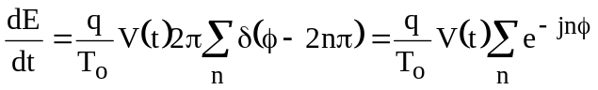 (1)
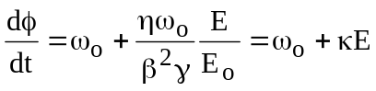 (2)
For a distribution of particles ψ(φ,E,t) in φ-E phase space, the continuity equation is:
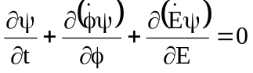 (3)
Reduces to the Vlasov equation
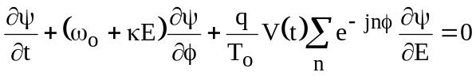 (4)
If the voltage is small, we can break the solution into a stationary solution plus a small perturbation:
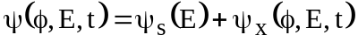 (5)
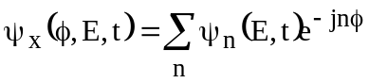 (6)
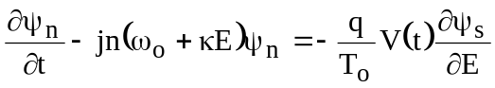 (7)
Assume that the voltage is a sine wave. For small perturbations, the density modulation will also be a sine wave:
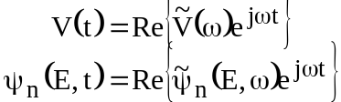 (8)
The amplitude of the density modulation is:
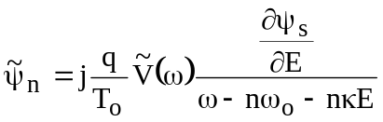 (9)
The distribution density is normalized to unity:

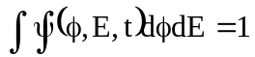 (10)
The beam current is ω_{o} times the charge per radian
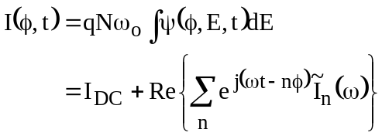 (11)
where
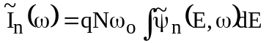 (12)
At the location φ=0, the admittance of the beam at frequency ω is:
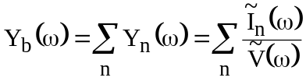 (13)
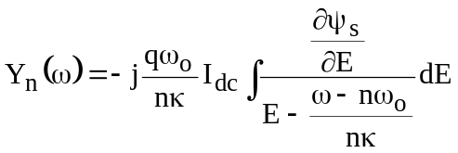 (14)
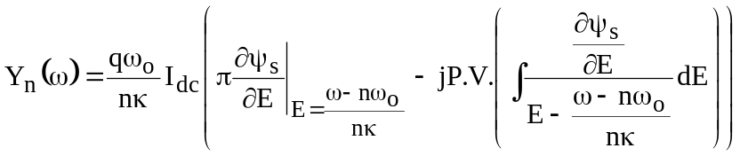 (15)
Beam Stability
If the energy spread is not large then Y_{n} is the beam impedance around the frequency ω~nω_{o}. If there is a narrowband impedance in the ring, Z_{cav}, the a current modulation of the beam will produce a voltage:
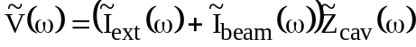 (16)
In turn, the voltage will modulate the current:
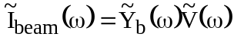 (17)
The modulation voltage becomes
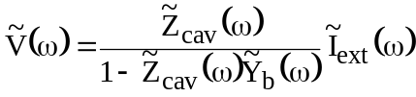 (18)
which is stable for
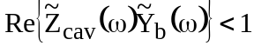 (19)
The impedance of a cavity is given as:
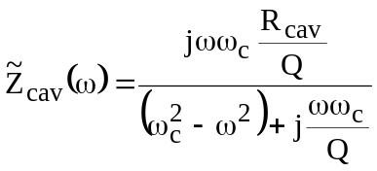 (20)
If the cavity resonant frequency is centered on harmonic n (ω_{c}=nω_{o}) and the cavity bandwidth is much larger than the frequency spread of the beam then:
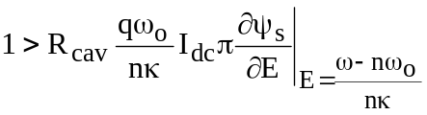 (21)
Assume that the distribution function is Gaussian:
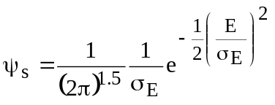 (22)
Where σ_{E} can be determined from the 95% momentum spread:
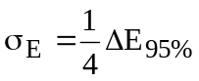 (23)
The gradient of the distribution is:
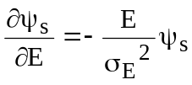 (24)
Which has a maximum at E=-σ_{E} of:
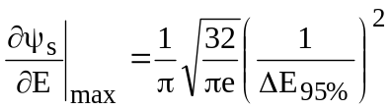 (25)
The limit on cavity impedance becomes
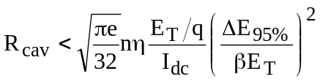 (26)
Numerical Examples
The Accumulator 53 MHz RF system (h=84) that is used to decelerate the injected beam for momentum stacking consists of two cavities with an average Q of 176 and an R/Q of 164Ω. For the present Accumulator stacking lattice used for Run II, η=0.010 (at the core orbit), γ=9.38, E_{T}=8850MeV, f_{o}=628930Hz. At an intensity of 100x10¹⁰ particles, a guassian distribution for the momentum spread will be stable if the 95% momentum spread is greater than 11.1MeV for a cavity impedance of 57 kΩ (2 x 164Ω x 176). A 95% momentum spread of 11.1MeV corresponds to a fundamental frequency width (Δf_{o}) of 7.9Hz. The beam admittance at h=84 is shown in Figure 1. The Nyquist plot is shown in Figure 2.
For an intensity of 3 x 4.7x10¹² which is the projected intensity for three Booster batches injected into the Accumulator for SNUMI, the beam current, I_{dc,} is 1.42A. For SNUMI, the Accumulator lattice would have an η of 0.023. If the Booster 53 MHz bucket longitudinal emittance is 0.08 e-sec and the momentum stacking dilution in the Accumulator has a dilution of 25% , then the Accumulator longitudinal emittance would be 84 x 0.300 eV-sec which corresponds to a 95% momentum spread of 15.9MeV. The beam admittance plot is shown in Figure 3. The Nyquist plot for a cavity impedance of 57 kΩ (2 x 164Ω x 176) is shown in Figure 4.

RF Feedback
The Nyquist plot in Figure 4 is clearly unstable by a factor of three. The beam can be made stable by reducing the impedance of the cavities. Using RF feedback will reduce the cavity impedance as seen by the beam without increasing the power required by the cavity power amplifier. Assume that the cavity is a current to voltage transformer:
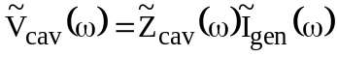 (27)
Assume that a portion of the cavity voltage is tapped from the cavity and fed back into the input of the cavity:
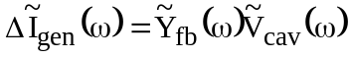 (28)
where the gain of the feedback loop is scaled to the cavity impedance:
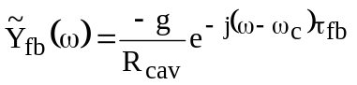 (29)
where g is a scaleable gain and τ_{fb} is the delay of the feedback loop. The effective cavity impedance seen by the beam is:
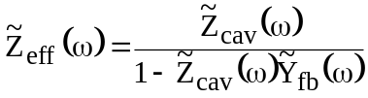 (30)
It can be shown empirically that the RF feedback loop will be stable if:
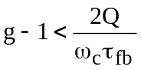 (31)
Figure 5 shows the Nyquist plot if an RF feedback gain of 5 (14dB) is used. The maximum delay for a feedback gain of 5 is about 280nS. In Figure 5, a delay of 150nS was used which decreases the stability at other revolution lines. However there is about a factor of two stability margin for all revolution lines.

Tracking
The previous formulas were tested with a tracking program. Each particle is assigned a phase with respect to the RF phase, φ_{RFp}. The applied RF voltage changes the energy of each particle p by the amount
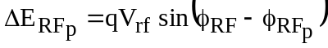 (32)
where q is the charge of the macro-particle. The energy change for each particle p due to beam loading
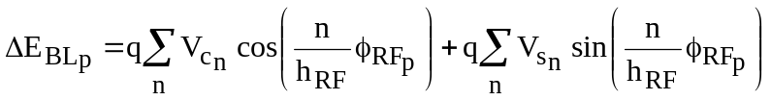 (33)
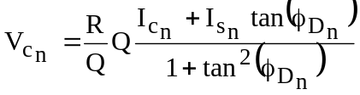 (34)
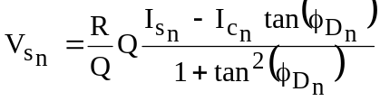 (35)
where:
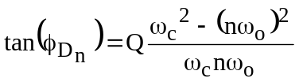 (36)
where ω_{c} is the resonant frequency of the cavity. The Fourier components of the beam current are determined from:
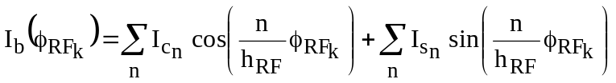 (37)
where I_{b} is the instantaneous beam current at the particle k with a phase coordinate φ_{RFk}

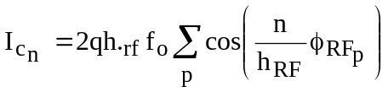 (38)
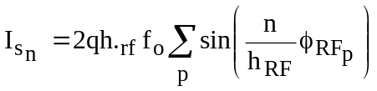 (39)
because phase coordinate in this tracking algorithm is referenced to the RF bucket, the coefficients I_{cn}, I_{sn} are non-zero only if the ratio of n/h_{rf} is an integer.
During one turn, the change in energy coordinate of the each particle advances by:
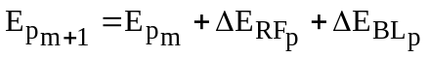 (40)
The phase coordinate of particle p advances by:
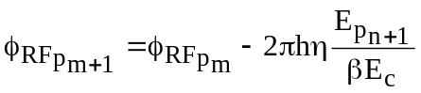 (41)
The phase coordinate is then referenced back to the center of the RF bucket.
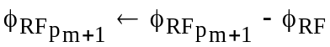 (42)
The phase of the RF bucket then advances by:
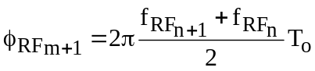 (43)
The results of a tracking simulation for a guassian distribution with a 95% momentum width of 15.89 MeV, a beam current of 1.41A, and η= 0.023, γ=9.38, E_{T}=8850MeV, f_{o}=628930Hz is shown in Figure 6. The impedance used in the tracking simulation is 57 kΩ (2 x 164Ω x 176) which corresponds to the Nyquist plot of Figure 4. The simulation shown in Figure 6 clearly shows self-bunching of the distribution.
Figure 7 shows the result of a tracking simulation with the cavity impedance of 23.1kΩ which corresponds to an RF feedback gain of 8dB. An impedance of 23.1kΩ is just on the edge of stability. The tracking simulation shows a small amount of self-bunching. Figure 8 shows the result of a tracking simulation with the cavity impedance of 11.6kΩ which corresponds to an RF feedback gain of 14dB. An impedance of 11.6kΩ is has a factor of two stability margin and Figure 8 shows no sign of self bunching.
Figure 9 shows the tracking simulation results for an impedance of 11.6kΩ but with a rectangular momentum distribution. As Equation 15 suggests, even though the peak density is less for the rectangular momentum distribution, the simulation shows bunching at the edge of the distribution where the slope of the distribution is the greatest.

Conclusion
For the projected SNUMI intensity of 14.1x10¹² particles in the Accumulator at a 95% momentum spread of 15.9MeV, and an RF feedback gain of 14dB, the beam should be stable with a factor of two margin. This result can be tested by cooling 100mA of antiproton beam on the stacking lattice (η=0.10) to a frequency width of 7.9 Hz.
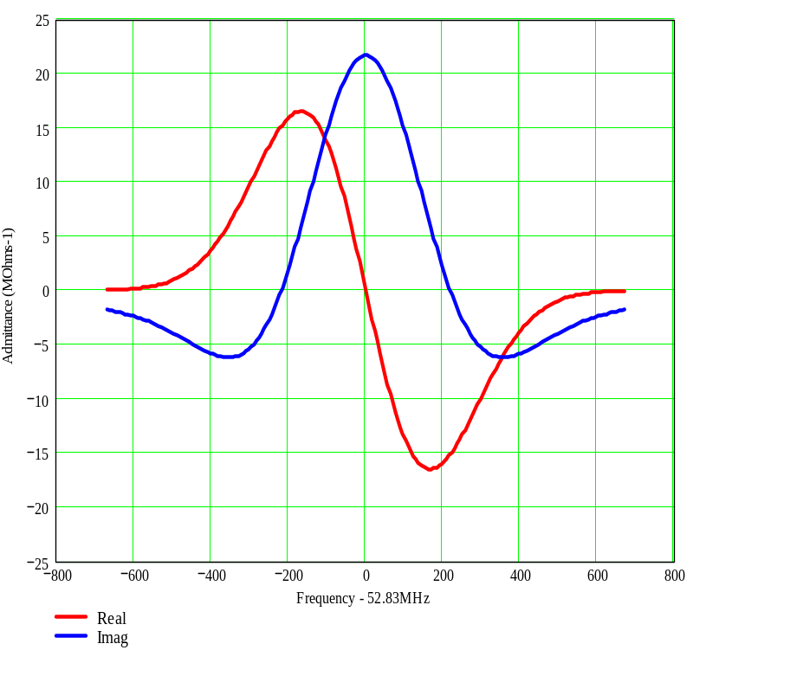
Figure 1. Accumulator beam admittance at h=84 for η=0.010, ΔE_{95%}=11.1MeV, I_{dc}=100mA
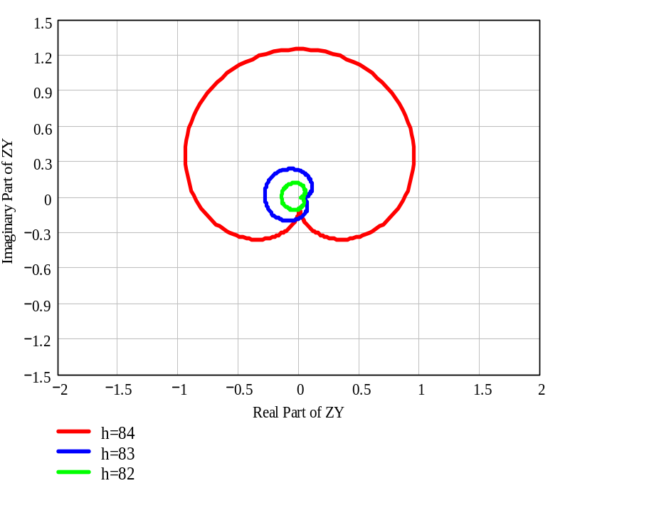
Figure 2. Nyquist Plot at near h=84 for η=0.010, ΔE_{95%}=11.1MeV, I_{dc}=100mA , 2 cavities with an R/Q of 164Ω and a Q of 176.
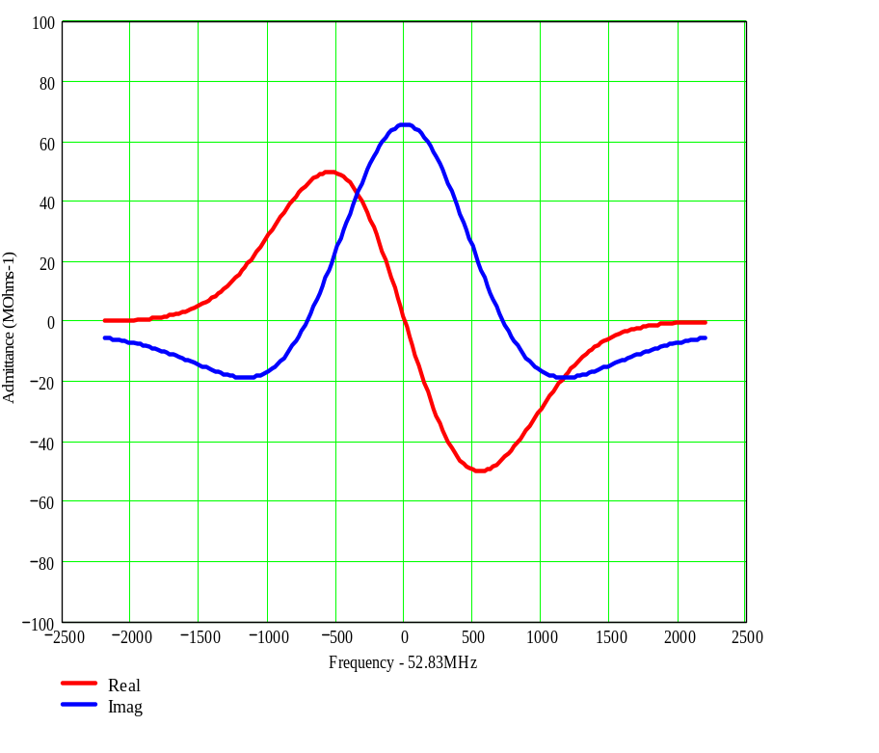
Figure 3. Accumulator beam admittance at h=84 for η=0.023, ΔE_{95%}=15.9MeV, I_{dc}=1410mA
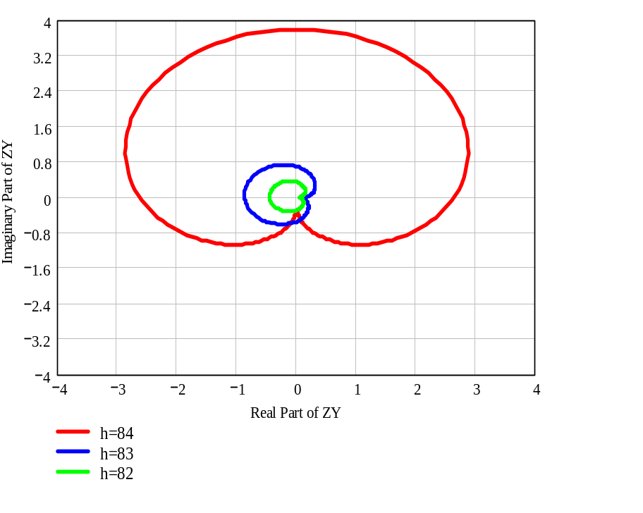
Figure 4. Nyquist Plot at near h=84 for η=0.023, ΔE_{95%}=15.9MeV, I_{dc}=1410mA , 2 cavities with an R/Q of 164Ω and a Q of 176.
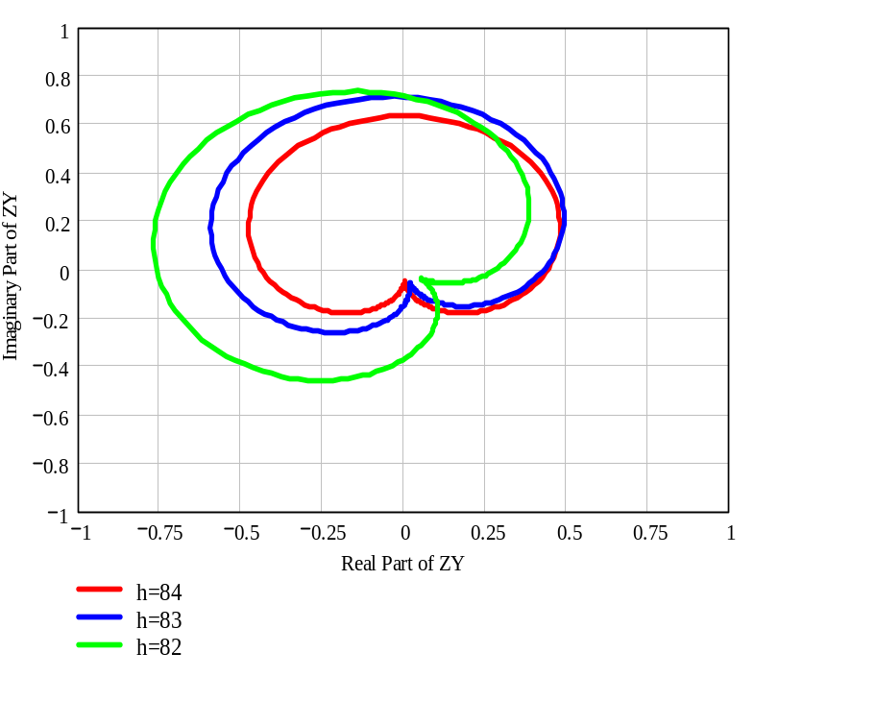
Figure 5. Nyquist Plot at near h=84 for η=0.023, ΔE_{95%}=15.9MeV, I_{dc}=1410mA , 2 cavities with an R/Q of 164Ω and a Q of 176 and a feedback gain of 5 with a delay of 150nS.
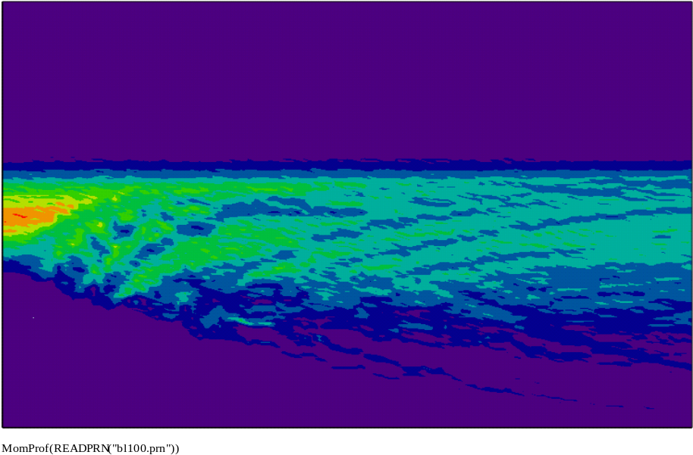
Figure 6. Tracking simulation for a guassian distribution with a 95 % momentum width of 15.89 MeV, a beam current of 1.41A, η= 0.023, γ=9.38, E_{T}=8850MeV, f_{o}=628930Hz, and R=57 kΩ (2 x 164Ω x 176). The vertical axis is the momentum distribution, the horizontal access is time in the simulation. The duration of the simulation is 33mS.
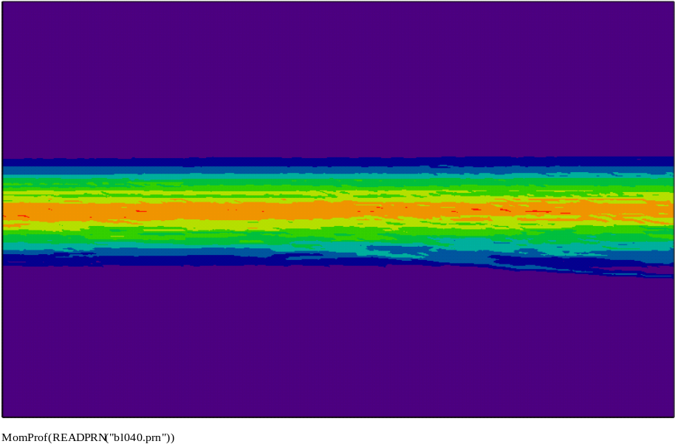
Figure 7. Tracking simulation using the same parameters as shown in Figure 6 except for cavity impedance of 23.1kΩ. The vertical axis is the momentum distribution, the horizontal access is time in the simulation. The duration of the simulation is 33mS.

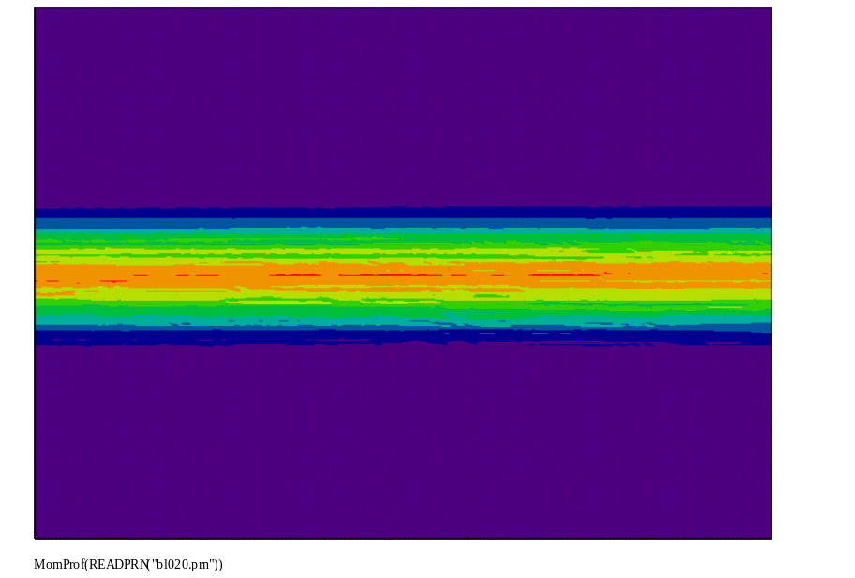
Figure 8. Tracking simulation using the same parameters as shown in Figure 6 except for cavity impedance of 11.6kΩ. The vertical axis is the momentum distribution, the horizontal access is time in the simulation. The duration of the simulation is 33mS.
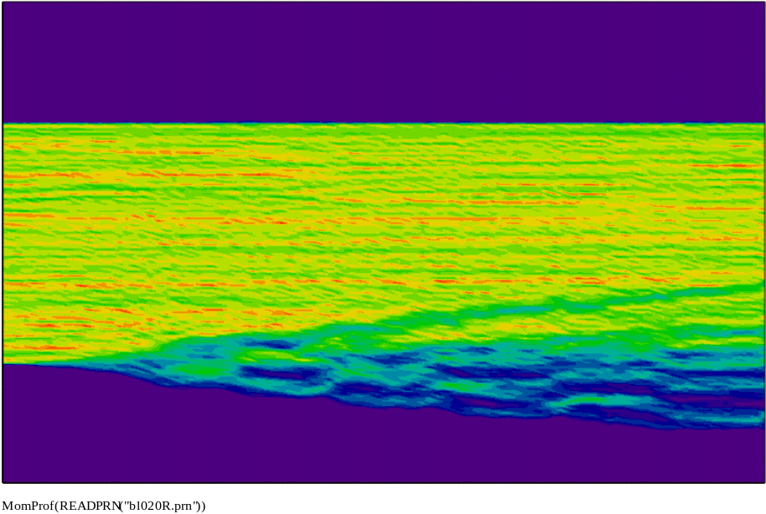
Figure 9. Tracking simulation using the same parameters as Figure 8 except the momentum distribution is rectangular. The cavity impedance of 11.6kΩ. The vertical axis is the momentum distribution, the horizontal access is time in the simulation. The duration of the simulation is 33mS.

“Stochastic Cooling Theory”, F. Sacherer, CERN-ISR-TH/78-11
“ARF1 Final Amp”, R. Pasquinelli, Pbar Note 478, May 23, 1988
“A 2 MegaWatt Multi-Stage Proton Accumulator”, D. McGinnis, Beams Document 1782, Nov. 2005

