

NASA.gov Editorial Guidelines
Version 2.2

Revised 2004/09/27

Executive Summary

Introduction

The following Editorial Guidelines have been developed for NASA.gov to help ensure that the most compelling NASA content is showcased on the portal, and that a consistent voice and textual and grammar style is used throughout its many pages.

NASA.gov is a publication, and like any magazine, in order to effectively communicate to target audiences, standards need to be in place that ensure those audiences are being spoken to in a consistent manner. Users have needs for NASA information, and guidelines help ensure that the most compelling and relevant content to answer those needs is published.

Format

The following pages outline the Vision, Mission and Audience of NASA.gov; Textual Style and Voice Guidelines; and detailed Best Practices for each landing page on the portal.

Content Creators should refer to the Textual Style and Voice Guidelines and audience information during the authoring process to ensure that editorial style is consistent with other published content items on NASA.gov.

NASA Editorial Board Members should familiarize themselves with the content of this document in detail, but Section Editors will also be able to refer to Best Practices for their individual landing pages of responsibility.

These Best Practices outline the original intentions behind the development of the thematic sections, provide examples of ideal content for the different content fields on Section Editor pages of responsibility and offer suggested timelines for how long content should remain on portal landing pages before being archived.

Contents

Page

1.0 Vision, Mission and Audience 5
  - NASA’s Vision for the Future 5
  - NASA’s Mission 5
  - Vision, Mission and NASA.gov 5
  - Audience 5
1.4.1 General Public 6
1.4.2 Kids 7
1.4.3 Students 7
1.4.4 Educators 7
1.4.5 Media and Press 8

- Textual Style and Voice 9
2.1 Introduction 9
2.2 NASA Editorial Style 9
2.2.1 Spelling, grammar, style and usage 9
2.2.2 Headlines and subheads 9
2.2.3 Spelling and usage exceptions and common mistakes 10
2.2.4 Calls to action 11
2.3 The Voice of NASA 11
2.3.1 Tone and style summary 11
2.3.2 Writing to NASA's audiences 11
2.4 Writing for the Web 14
2.4.1 Why writing for online audiences differs from other mediums 14
2.4.2 Best practices of Web writing 14
2.4.3 How to write concise copy 15
2.4.4 Consistency 15
2.4.5 Intuitive organization and scannability 15
2.4.6 How to write scannable copy 16

3.0 Best Practices – Overview 17
3.1 Home Page 18
3.1.1 Promotional Banners 18
3.1.2 Vision Segment Features 18
3.1.3 What’s New at NASA 19
3.1.4 NASA Events 20
3.1.5 Multimedia Features 21
3.2 Global Nav – About NASA 22
3.2.1 Highlights (Landing Page) 22
3.2.2 Career Resources (Left Nav) 23
3.2.3 Business Opportunities (Left Nav) 23
3.2.4 Research Opportunities (Left Nav) 24
3.2.5 Budget Information (Left Nav) 24
3.2.6 Speakers Bureau 25
3.2.7 Visiting NASA 25
3.2.8 Contact NASA 26
3.3 Global Nav – News and Events 27
3.3.1 This Week’s Highlights 27
3.3.2 Launches and Dockings 28
3.3.3 Special Events 29
3.3.4 Visiting NASA 29
3.3.5 Agency News 30
3.3.6 Mission News 31
3.3.7 Research News 31
3.3.8 News Archive 32
3.4 Global Nav – Multimedia 33
3.4.1 Multimedia Highlights 33
3.4.2 Image Gallery 34
3.4.3 Video Gallery 34
3.4.4 Interactive Features 35
3.4.5 NASA TV 35
3.4.6 Art Gallery 35
3.5 Global Nav – Missions 36
3.5.1 Missions Highlights 36
3.5.2 NASA Missions Timeline 37
3.5.3 Shuttle and Station 38
3.5.4 Looking at Earth 38
3.5.5 Exploring our Solar System 39
3.5.6 Space Science and Technology 40
3.5.7 Deep Space Missions 40
3.5.8 Research Aircraft 41
3.6 Global Nav – Popular Topics/MyNASA 42
3.7 Vision Segments – Life on Earth 43
3.7.1 Life on Earth Main Features 43
3.7.2 In Everyday Life 44
3.7.3 Looking at Earth 45
3.7.4 The Environment 45
3.7.5 New Technologies 46
3.7.6 Living Things 46
3.7.7 Improving Flight 47
3.8 Vision Segments – Humans in Space 48
3.8.1 Humans in Space Main Features 48
3.8.2 Preparing for Space Travel 49
3.8.3 Getting to Space 50
3.8.4 Living in Space 50
3.8.5 Working in Space 51
3.8.6 Traveling in Space 51
3.9 Vision Segments – Exploring the Universe 53
3.9.1 Exploring the Universe Main Features 53
3.9.2 Our Solar System 54
3.9.3 Stars and Galaxies 55
3.9.4 Watch the Skies 55
3.9.5 New Worlds 56
3.9.6 Robotic Explorers 56
3.10 Audience Nav – For Kids 58
3.10.1 For Kids Main 58
3.10.2 Games 59
3.10.3 Activities 59
3.10.4 Cartoons 60
3.11 Audience Nav – For Students 61
3.11.1 For Students Main 61
3.11.2 Homework Help/Research Assistance 62
3.11.3 Internet Resources 63
3.11.4 Multimedia Resources 63
3.11.5 NASA Learning Opportunities 63
3.11.6 Career Information 63
3.11.7 Contacts for Students 63
3.12 Audience Nav – For Educators 64
3.12.1 For Educators Main 64
3.12.2 Learning Resources 65
3.12.3 Internet Resources 66
3.12.4 Multimedia Resources 66
3.12.5 Contacts for Educators 66
3.12.6 Professional Development/Fellowships and Grants 66
3.12.7 Student Opportunities 66
3.13 Audience Nav – For Media and Press 67
3.13.1 For Media and Press Main 67
3.13.2 Press Release Archive 68
3.13.3 Press Kits 68
3.13.4 Fact Sheets 69
3.13.5 Images 69
3.13.6 Multimedia Resources 69
3.13.7 Speeches 69
3.13.8 Press Contacts 69
1.0 Vision, Mission and Audience

1.1 NASA’s Vision for the Future

- To improve life here
- To extend life to there
- To find life beyond

1.2 NASA’s Mission

- To understand and protect our home planet
- To explore the Universe and search for life
- To inspire the next generation of explorers…as only NASA can

1.3 Vision, Mission and NASA.gov

In order to promote NASA’s importance to the lives of everyday Americans, it is essential to engage them via a visitor-centric, streamlined portal that showcases the best content NASA has to offer. In the portal’s development, three key objectives (inspire, inform and involve) have formed the centerpiece of the NASA.gov vision, as it supports the Agency’s mandate:

Inspire

- Transport visitors into a rich, engaging environment where they can experience the emotion, vision and imagination of NASA through interactive presentations and multimedia
- Encourage wonder about the vastness of the universe and awe about our ability to explore it
- Communicate NASA’s vision of the future dramatically

Inform

- Encourage a journey of personal discovery and learning for all who come to NASA.gov through educational content, tools and information
- Effectively convey NASA’s mission and what NASA is today
- Present timely, relevant and engaging content

Involve

- Ultimately, reach out to enthusiasts, cultivate their interest in NASA and encourage them to become involved advocates
- Create a sense of ownership with users through personalization

1.4 Audience

NASA has identified the following key target audiences for NASA.gov:

- The general public looking for general information on NASA subjects; seeking information on visiting NASA facilities or seeing a launch; or following up on NASA stories they have heard about in the news.

- Teachers looking for resource materials (lesson plans and curricula).

- Students looking for “homework help” on NASA-specific or general science and engineering topics, as well as for opportunities to become involved with the Agency.

- Kids, generally elementary school or younger, who are looking for inspiration and engagement, as much as for information.

- News media seeking information on a specific topic, in advance of and/or following up on a NASA story. Their greatest concerns are clear information organization, effective search/browse capability, and fast, assured access.

For the purpose of these Editorial Guidelines, results from the following sources have been used to provide a preliminary determination of target audience needs:

- Critical Mass User Research conducted in November/2002 in response to the NASA.gov RFP

- NASA.gov Website Effectiveness Testing conducted by the Usability Sciences Corporation in February/2003

- Space Science Media Needs of Science Center Professionals, funded by NASA’s Office of Space Science, and published December/2002

- NASA.gov most popular search terms

Identification of target audiences is an ongoing process. While these target audiences have been identified by NASA, continuous effort is needed to foster understanding of evolving requirements. In better understanding specific user needs, further target audiences will also evolve.

1.4.1 General Public

Key goals:

- Catching up on NASA current affairs and projects
- Being entertained by interactivity, visuals and interesting and unbiased content
- Feeding curiosity
- Passing time
- Locating important public information quickly and easily

Requirements

- Interface must be easy to navigate and intuitive
- Content should be organized by subject and overall principles

Desired content
- News and events
- General Agency information
- General interest in specific topics (for example space exploration or satellite imaging)
- Rich media and engaging visuals

1.4.2 Kids

Key goals

- Have fun individually or with family
- Learn more about personal interests
- To be engaged, without necessarily realizing it
- Spend time on familiar web sites

Requirements

- To find rich media or visually engaging content quickly and easily
- To find content with or without the assistance of a parent

Desired content:

- Educational games
- Engaging multimedia and visuals
- Educational activities
- Uninterested in numerous and/or technical links, or content that needs to be “applied for”
- Turned off by multiple open windows
- Need to be spoken to in voice/vocabulary that is understandable

1.4.3 Students

Key goals

- Be entertained by interactivity, visuals and grade-level focused content that speaks with an intelligent voice
- Conduct research in the context of both schoolwork and personal interests
- Find career preparation and development information

Requirements

- Perform topic specific searches for the purpose of research
- Browse informally
- Discover new and interesting subjects
- Find career-related information

Desired content

- Student-focused pages for homework assistance
- General interest content pertaining to specific topics
- Career information
- Rich media and engaging visuals
- Focused on an audience of their specific age group/grade level

1.4.3 Educators

Key goals

- Provide a fun educational atmosphere for students
- Provide information to support theme-based education in the classroom
- Satisfy student curiosity and questions
- Find curriculum and activities suitable for specific grade levels

Requirements

- Age appropriate classroom materials
- Visually rich resources

Desired content

- Curricula and lesson plans developed for specific student grade levels
- Specific curricula and lesson plans which include feedback from educators who have already used them in the classroom
- Engaging features which allow students to interact, speak with and ask questions of “experts”
- Simple, navigable and engaging rich media and visual-oriented content for use in the classroom
- High resolution imagery for reproduction in the classroom

1.4.4 Media and Press

Key goals

- To present facts in an article, and not just be the voice for a particular organization or initiative
- Need human beings to talk to in order to carry out professional tasks
- To properly research, need proper background information before commencing to write, and access to information when fact-checking work
- Information must be accurate and timely

Requirements

- To identify timely and topical stories
- Contact NASA media officials
- Locate common media resources
- Locate background information

Desired content

- Press releases
- Backgrounders
- Fact sheets
- Public affairs contact lists
- Dynamic search
- Press kits
- Image galleries

2.0 Textual Style and Voice

2.1 Introduction

Purpose

Why use Editorial Guidelines for NASA.gov? In a word, consistency.

NASA.gov is our organization's best channel for communicating with the public. Through the portal we have the opportunity to not only share information, but to convey the inspirational qualities of NASA and connect with people—American and international—on a whole new level.

NASA.gov is a dynamic extension of the Agency and should provide a NASA experience that is both satisfying and rewarding to its users. As we streamline our Web content into this unified portal it is essential that we use this guide as a point of reference to ensure a consistent voice and style across the entire NASA online network.

2.2 NASA Editorial Style

2.2.1 Spelling, grammar, style and usage

Editorial style for all NASA communications is based on Associated Press style. For any concerns regarding spelling, grammar, style or usage consult the following publications. In some cases these guides may disagree with one another. The AP Stylebook should be regarded as the overriding authority on anything not established in this document.

The Associated Press Stylebook and Briefing on Media Law. Perseus Publishing, Cambridge, MA.
Webster's New World Dictionary, Fourth Edition, Hungry Minds, Inc., New York, NY.
The Chicago Manual of Style, 14th Edition. University of Chicago Press, Chicago, IL.

2.2.2 Headlines and subheads

Headlines and subheads can afford to be witty in print, but with online readers preferring to scan text rather than read it entirely, it is important that your headers are clear and accurate.

NASA.gov headers and subheads and Promotional Titles follow title case, according to the AP Stylebook:

Composition titles: Capitalize the principal words, including prepositions and conjunctions of four or more letters. Capitalize an article -- the, a, an -- or words of fewer than four letters if it is the first or last word in a title.

Uppercase
Part of Speech | Description | Examples
noun | person, place, thing, state, quality | Sean O'Keefe, Washington, Space Shuttle, Liquid, Weightless
pronoun | replacement or substitute for a noun | Her, Them, There, It, Some
adjective | modifier of a noun | Fast, Bright, New, Funny
verb | action | View, Click, Fly, Launch
adverb | modifier or a verb | Quickly, Flatly, Poorly, Sadly
subordinating conjunction | introducer of a subordinate clause | If, Because, As, That

Lowercase
Part of Speech | Description | Examples
article | introducer of a noun | a, an, the, this, any, every
coordinating conjunction | joiner of grammatical elements | and, but, or, for, nor
preposition | expresser of spatial, temporal or other relationship | in, on, between, through, under, before, during

Captions:
- Image captions must appear for all images.
- They should not be longer than the image itself.
- All captions must begin with either
  - Image to right:
  - Image to left:
- All captions must end with “Credit:” even if the credit just says “Credit: NASA”
- Side by side images are permitted for comparison purposes. These images are to be placed in a table.

Bylines:
- Writers may add their names in the credit field
- Format:
<strong>Name<br />
NASA’s ….. Center</strong>
- NASA Center is to be listed. Writer’s name and e-mail address is optional.

Leader Sentences:
- General Guideline: leader sentences should not be longer than 6 lines for Related Multimedia. Those six lines will include the link line and the promo title.
- For Feature promo titles/leader sentences we should not be exceeding 4 lines including the link line.
- “+ Read More” (now the default for detail pages) is to be used for features;
“+ View Feature” for images or multimedia
- There should be appropriate punctuation at the end of all leader sentences.

General Guidelines:
- Date is to be included for all feature and/or promotional documents created.
- Thumbnails are to be 64 x 48 in size and aligned to “bottom.”
- Alt tags should not be the same as the caption.
- The ampersand should only be used when part of a company’s formal name.

2.2.3 Spelling and usage exceptions and common mistakes

NASA copy generally follows Associated Press style. The following list contains exceptions and commonly misused words and terms.

Administrator (not administrator when referring to the head of NASA, even when not using his/her name after)

bullets/lists
Do not use final punctuation in bulleted lists. Try and keep each bullet to only one sentence in length.

dashes
For Web text: Don't use em dashes online; substitute en dashes with spaces around them instead. Use en dashes and hyphens the same as you would in for-print text.

For e-mail text: Substitute a hyphen with spaces around it for both the em dash and en dash.

e-mail (not Email, E-mail or email)

home page (two words, no caps)

International Space Station (capitalized as a proper noun)

Internet (not internet)

log in, log-in
Not login. As a verb, two words. As an adjective, hyphenated.
Please log in to your account.
Welcome to the log-in page.

Space Shuttle (not space shuttle)

Web site (not website or web site)

Moon and Sun
capitalize when referring specifically to the celestial bodies themselves, e.g.,
Apollo 11 landed on the Moon. (vs. “NASA discovers new moon of Saturn")
Scientists got their closest-ever ultraviolet look at the Sun from space.

Use of Metric Terms

The Portal follows the same Metric use policy as is employed by NASA HQ Public Affairs for press releases:

- Include metric terms when relevant

- Use metric terms on first reference when they are the primary form in which the source of a story provided statistics. Follow the metric units with equivalents in the terms more widely known in the United States. The imperial equivalent should be in parentheses after the metric figure. Use AP style for conversions (see pp. 159-160 in SP Stylebook 2003).

- There is no need to provide imperial equivalents if the metric standard has become more widely known. For example, most Americans are familiar with 2-liter soft drink measurements. There is no reason to convert to imperial ounces.

- If a mission uses imperial measurements, there is no need to provide a metric conversion, unless the conversion more clearly articulates the thought.

2.2.4 Calls to action

Calls to action are snippets of linked text asking a user to carry out an action. They should be specific, direct and active. Use the same casing as you would for headlines and subheads (first word, proper nouns and acronyms).

Suggested calls to action
+Read more
+View image
+Watch video
+Learn more
+Visit Web site
+Go to Mars (for kids)
+Play game (for kids)

Poor calls to action
+Click here
+View feature
+Information here
+More

2.3 The Voice of NASA

NASA is unique. Our organization has built its reputation on awe-inspiring events, discoveries and technological advancements.

The key messages for NASA's Web initiatives center on innovation, movement towards the future, science and technology, and empowering humanity. NASA's Vision—improve life here, extend life to there and find life beyond—as well as the objectives of the NASA.gov portal—inspire, inform and involve—support these messages, as should the copy tone, voice and style.

2.3.1 Tone and style summary

Tone | Style
direct  trustworthy  knowledgeable  innovative  inspirational | use the active voice  opt for verbs over noun phrases (e.g., "consider," not "take into consideration")  avoid industry-specific jargon where possible  clear, specific and strong calls to action (e.g., "Read more," "Visit site," "Watch video"

2.3.2 Writing to NASA's audiences

General Public

Profile

- Looking for information on NASA current affairs
- Want to be entertained by interactivity, visuals and interesting content

Copy objectives

- To inform
- Deliver clear, accurate and up-to-date NASA news and features
- Show NASA.gov as the authority for finding information on the agency, as well as space and space-related information

Copy guidelines

- 8th-9th grade reading level
- Simple and straightforward, not overly technical

Kids

Profile

- Young and curious
- Want to play games and be entertained

Copy objectives

- To inspire
- Educate while entertaining

Copy guidelines

- No higher than a 3rd grade reading level
- Light, fun and exciting
- Calls to action: "Go to Mars!," "Play game," "Learn more"

Students

Profile

- Want to be entertained by interactivity, visuals and interesting, youth-focused content
- Want to research for school and personal interests
- May be looking for career and development information

Copy objectives

- To educate
- Deliver interesting and useful information on a wide variety of NASA, Earth, space and technology related topics

Copy guidelines

- Grade-level specific reading level depending on audience sub-section
- Specific and accurate

Students (Post Graduate)

Profile

- Want to be entertained by interactivity, visuals and interesting, research-focused content
- Want to research for school and personal interests
- May be looking for career and development information

Copy objectives

- To educate
- Deliver interesting and useful information on a wide variety of NASA, Earth, space and technology-related topics

Copy guidelines

- 8th-10th grade reading level
- Specific and accurate

Educators

Profile

- Want to find information and activities that can be transferred to a classroom environment (for their specific level)
- Looking to satisfy student questions and curiosity and stay educated on current space-related happenings

Copy objectives

- To educate
- Deliver interesting and useful information on a wide variety of NASA, Earth, space and technology-related topics

Copy guidelines

- 8th-9th grade reading level
- Specific and accurate
- Conversational and helpful

Media and Press

Profile

- Want information to produce articles or reports
- Looking to conduct research and fact-checking

Copy objectives

- To inform
- Deliver clear and accurate information on NASA and NASA-related news and events

Copy guidelines

- 8th-9th grade reading level
- Specific and accurate
- Clear and detailed

2.4 Writing for the Web

2.4.1 Why writing for online audiences differs from other mediums

When writing for an online audience you are doing more than just delivering content to the user, you are impacting their experience with NASA.gov and NASA in general. It is important that you write in a way that draws users into the content and conveys an accurate and consistent NASA message, while still providing needed information.

The Web medium is very different from print. At the very least, reading text from a screen is far more difficult than reading from paper. More than that, the very nature of the Web—active clicking and moving around from page to page and site to site—fosters an environment of impatience; users want information quickly and easily or they will simply go to another source to get it.

Jakob Nielsen, a leading authority on Web usability, says users read 25 percent slower from a computer monitor and 79 percent of Web users have a tendency to scan Web pages as opposed to reading text word-by-word. "Skimming instead of reading is a fact of the Web," writes Nielsen, "it's been confirmed by countless usability studies."

2.4.2 Best practices of Web writing

Clarity

Clear writing makes for easier reading and reduces the possibility of miscommunication. When writing your copy two things you should avoid are confusion and wasted time for your readers. Make certain all ambiguities, no matter how insignificant they may seem, are eliminated from your text.

Accuracy

Given the complex nature of much of what NASA does, it is important to keep all of your content accurate. Even the smallest typo or factual error can create confusion for your readers.

Relevance

Does everything in your article need to be there? Irrelevant information just adds to the length of your copy without making any contribution to the information your reader is looking for. When writing, speak directly to your audience and give them information that is both useful and informative. These are real people with specific needs and uses for NASA.gov. One way to get a clear indication of whether or not you are effectively writing to your audience is to pay close attention to any feedback e-mail generated through the site.

Concision

Given the extra strain of reading text from a computer monitor you should always aim to write about 50 percent less than you would for a print piece. Delete any and all unnecessary words from your copy, then go back and see if you can cut any more. Eliminate anything that doesn't need to be there. This will reduce the size of your text and the amount of user scrolling. Overall, the information will be easier for users to scan and digest leading to a better online experience.

2.4.3 How to write concise copy

Avoid buzzwords and industry-specific jargon.

Don't use a long word when a short word will do.
Instead of utilize, use use.
Instead of terminate, use end.

Use compact substitutes for wordy phrases.
Instead of in a timely manner, use promptly.
Instead of in view of the fact that, use because.
Instead of is equipped with, use has.

Omit needless words.
Instead of the question as to whether, use whether.
Instead of he is a man who, use he.

Avoid redundant expressions.
Instead of red in color, use red.
Instead of the exact same, use the same.
Instead of end result, use result.
Instead of preexisting, use existing.

2.4.4 Consistency

Consistency is key to a rewarding user experience. This is why formal style guides are so important, so you never use "website" instead of "Web site," or worse, so you never use both.

2.4.5 Intuitive organization and scannability

Present you essential information first. Put your "who," "what," "when," "where," "why" and "how" in the first paragraph. Present the key points of an article first and get into specific details later. Also, keep your sentences and paragraphs short and try and stick to one idea per paragraph. As users scan they will miss a lot of information if it is buried deep in the text.

2.4.6 How to write scannable copy

- Use subheads to give users a quick overview of what's on the page
- Use bullet points for parallel words, phrases and clauses
- Keep your sentences short (this doesn't mean you can't use complex or compound sentences, just make sure your longer sentences are justifiable)
- Use transition words, especially coordinating conjunctions (yes, it is okay to start a sentence with "and" or "but"), but use conjunctive adverbs (i.e., "however," "nevertheless") sparingly
- Always include captions for images, even if the text on the page already explains them

3.0 Best Practices

Overview

NASA’s online content is as rich, compelling and informative as that of any online publication or federal agency. The Agency’s missions and projects capture the imaginations of us all, and content exists across the NASA network that does the same. It’s a question of bringing that content directly to the general public and target audiences via NASA.gov, having clearly defined audience requirements in mind, as well as defined subject matter expertise on what NASA content is, in fact, the most compelling to those audiences.

The spectrum of content available across the NASA network of over 3,000 web sites is both vast and varied. Some, while technically important to a small and focused audience, is of little use to a broader public. Some, while perhaps important to multiple internal stakeholders at NASA, should not be disseminated to broader target audience segments. Some, while of interest to one target audience, would be of little use to another.

It is crucial to remember that the vision of NASA.gov is to inspire, inform and involve the greater public, and to reinforce the status of the Agency in their eyes. To do so, subject matter and editorial sense need to be taken into account at every point of the content lifecycle. NASA.gov, in many ways, is like the Agency’s online magazine, and if visitors aren’t immediately inspired, informed or involved, subscriptions will be canceled.

The following pages outline each landing page and specific content fields therein, and speak to the ideal content types we feel best address audience needs, and best represent NASA.

3.1 Best Practices - Home Page

3.1.1 Home Page – Promotional Banners

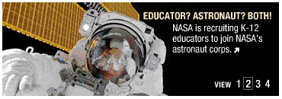
Figure 3.1.1 Home Page Banner Example

Objective
Effectively showcase the most relevant and timely initiatives and breaking news from NASA.

Description
Three esthetically-designed, revolving Flash banners.

Content Examples
Link to the Educator Astronaut Web site, Link to the Columbia Disaster microsite, Multimedia piece outlining NASA’s mission

Update Frequency
Will vary depending on initiative/program length and ongoing relevance of content. Due to the important nature of the content being provided, banners should be available for a minimum of two weeks.

3.1.2 Home Page – Vision Segment Features

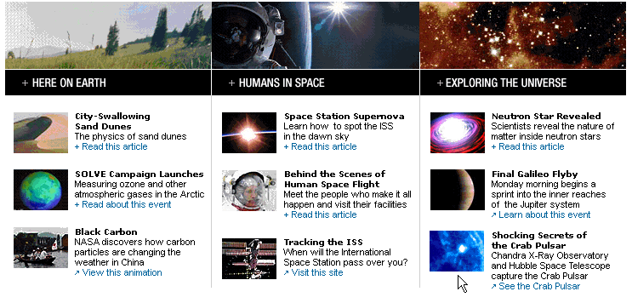
Figure 3.1.2 Home Page Features Example (Note: Here on Earth is now Life on Earth)

Objective

To educate, promote, inform and inspire with NASA’s best feature content, divided by Vision-related themes: Life on Earth, Humans in Space and Exploring the Universe.

Description
Nine revolving Features (most recent at the top of each column) showcasing timely and in-depth and important initiatives/accomplishments of NASA. Content should be either a detailed article with multiple high quality visuals or accompanying multimedia, an engaging multimedia feature, an interactive tool or a recent image release. Content should not be limited to press releases or news. Topics will be diverse, ranging from earth science to International Space Station research to Hubble telescope image releases. When a new feature is added, the most dated item will move to the Features bucket of its respective Vision Segment landing page: Life on Earth, Humans in Space or Exploring the Universe.

Content Examples
Shuttle Endeavour animated video, Multimedia Schematics of Future Scramjet, Neutron Star Revealed feature article

Update Frequency
Features are fed by deeper-level NASA.gov pages. As such, they will be updated regularly. A feature should still be available on the home page for a minimum of three days before returning to its Vision Segment landing page, and then its Vision Segment Feature Archive.

3.1.3 Home Page – What’s New at NASA

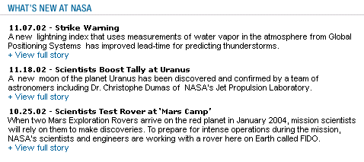
Figure 3.1.3 Home Page News Example

Objective
Provision of important ‘quick-hit’ news items.

Description
Four revolving text-heavy news items or press releases (most recent at the top). Content must be of prime importance and timely. When a new news item is added, the most dated will move to the News Archive.

Content Examples
Scientists test rover at Mars camp, NASA 2003 budget announced

Update Frequency
As needed: Possibly several times a day.

3.1.4 Home Page – NASA Events

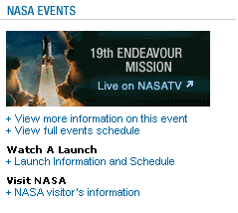
Figure 3.1.4 Home Page Events Example

Objective
To clearly communicate to NASA’s audiences about upcoming events of importance.

Description
Revolving and timely currently occurring or upcoming events…often related to NASA missions. Upcoming shuttle/mission launches etc. will often be featured and promoted here.

Content Examples
19th Endeavour Mission (Live on NASA TV)

Update Frequency
Event promotion should be available for a minimum of one week, and no longer than one month before being replaced.

3.1.5 Home Page – Multimedia Features

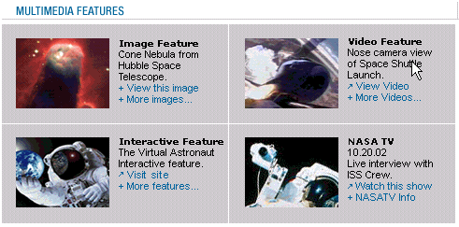
Figure 3.1.5 Home Page Multimedia Features Example

Objective
To inspire NASA’s audiences with the most compelling multimedia pieces from across NASA’s spectrum of Web sites.

Description
Revolving and timely image, video and interactive features. The bottom right-hand content field will be a constant link to an upcoming NASA TV broadcast.

Content Examples
Cone Nebula image from the Hubble Space Telescope, Nose view of Shuttle launch video feature, The Virtual Astronaut interactive feature, Live interview with the ISS crew on NASA TV

Update Frequency
Image features will be the most frequently updated, but should be available at a minimum for one day, and at a maximum for one week.

Video features should remain on the home page for a minimum of three days and a maximum of two weeks.

Interactive features should be available for a minimum of one week, and a maximum of one month.

NASA TV must be updated as soon as the particular broadcast being promoted has expired.

3.2 Best Practices – Global Nav – About NASA

3.2.1 About NASA Highlights (Landing Page)

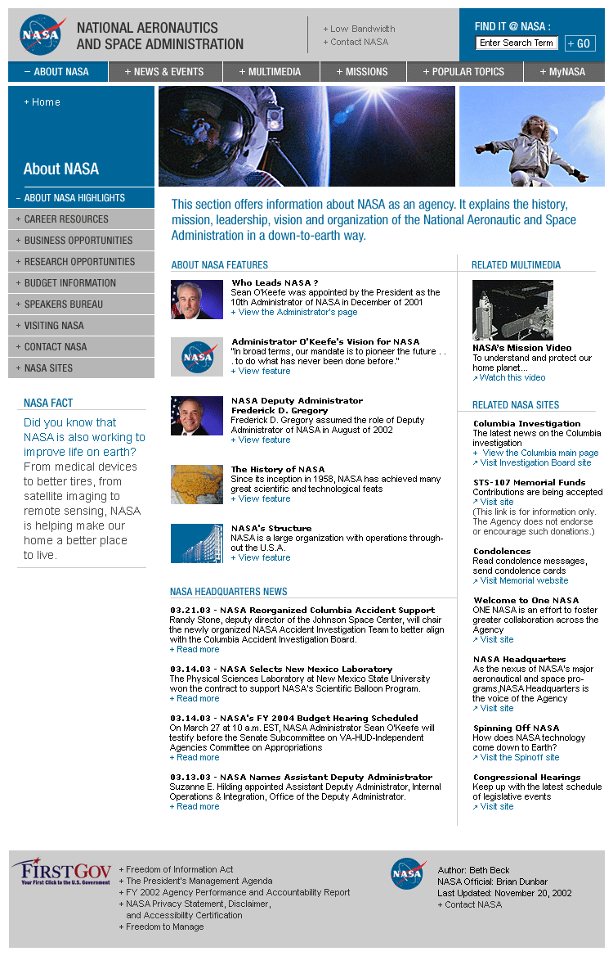
Figure 3.2.1 About NASA Landing Page Example

Objective
To outline NASA’s organizational goals and detail Agency activities. To provide the latest news about NASA Headquarters initiatives.

Description
Two Promotional Banners will highlight timely Agency news or initiatives.

Five static Features will reinforce and educate about NASA’s leadership, vision, structure and history.

Three Headquarters News items (press releases) will detail the latest news from NASA Headquarters.

Two Related Multimedia features will directly correspond to Promotional Banners, Features or News items.

Two Related NASA Sites will provide supplemental information to Banners, Features or News items.

Content Examples
Banners: Space Shuttle Columbia - The latest on the investigation

Five static Features address NASA’s leadership (bios of the Administrator and Deputy Administrator), vision (Administrator O’Keefe’s vision for NASA), structure (NASA’s structure) and history (The history of NASA).

Headquarters News: “Small business awarded multi-million dollar contract” press release

Related Multimedia: NASA mission video

Related NASA Sites: Welcome to OneNASA

Update Frequency
Promotional Banners should be available for a minimum of two weeks.

The five Features are standing content items that will only change with major organizational changes/initiatives.

Related Multimedia and Related NASA Sites should be available on the page for a minimum of one week, and no longer than five weeks before being archived.

NASA Fact should be updated on a monthly basis.

3.2.2 About NASA – Career Resources (Left Nav)

Objective
To provide the information needed to inspire and involve NASA’s next generation of explorers.

Description
Single detail page providing descriptive text and links to sources of NASA career information.

Content Examples
Detail page with text and hyperlinks: to the NASA Jobs page for example

NASA Fact: Trivia or fact pertaining to NASA careers and employment

Update Frequency
As needed. When any new online career resources are developed they should be made available on this page.

NASA Fact should be updated on a monthly basis.

3.2.3 About NASA – Business Opportunities (Left Nav)

Objective
To provide detailed information on how businesses can work with NASA.

Description
Single detail page providing descriptive text and links to sources of information on how businesses can work with NASA, from bidding on contracts to stimulating investment in new markets and technologies.

Content Examples
Detail page with text and hyperlinks: to the NASA Commercial Technology Program page for example

NASA Fact: Trivia or fact pertaining to doing business with NASA

Update Frequency
As needed. When any new online business opportunity content is produced, it should be made available from this page.

NASA Fact should be updated on a monthly basis.

3.2.4 About NASA – Research Opportunities (Left Nav)

Objective
To provide detailed information on how researchers can become involved with NASA.

Description
Single detail page providing descriptive text and links to sources of information on how researchers can work with NASA, from specific research opportunities currently available to how researchers can submit unsolicited proposals.

Content Examples
Detail page with text and hyperlinks: to the NASA Headquarters Research Opportunities page for example

NASA Fact: Trivia or fact pertaining to NASA research

Update Frequency
As needed. When any new online business opportunity content is produced, it should be made available from this page.

NASA Fact should be updated on a monthly basis.

3.2.5 About NASA – Budget Information (Left Nav)

Objective
To provide information on past, present and future NASA budgets.

Description
Single detail page providing descriptive text and links to specific NASA budget documentation.

Content Examples
Introductory text and hyperlinks: to NASA’s FY 2004 Budget for example

NASA Fact: Trivia or fact pertaining to NASA’s budget

Update Frequency
As needed. When any new budget documentation or information is produced, it should be made available from this page.

NASA Fact should be updated on a monthly basis.

3.2.6 About NASA – Speakers Bureau (Left Nav)

Objective
To promote the program that supplies NASA speakers to conferences and events.

Description
Single detail page providing introductory text and nationwide contact information for requesting speakers.

Content Examples
Detail page with informative text, contact information and e-mail links

NASA Fact: Trivia or fact pertaining to NASA speakers or employees

Update Frequency
As needed. When any new Speakers Bureau contact information is produced, it should be made available from this page.

NASA Fact should be updated on a monthly basis.

3.2.7 About NASA – Visiting NASA (Left Nav)

Objective
To provide the general public with the information they need to personally visit one of the NASA centers or Headquarters.

Description
Single detail page providing general visiting information, as well as descriptions, contacts and hyperlinks for each center that offers tours to visitors.

Content Examples
Detail page with informative text, contact information and hyperlinks to center Web site visitor information

NASA Fact: Trivia or fact pertaining to NASA Headquarters, centers, tours or visitors. For example, “XX number of visitors toured the Johnson Space Center in 2002.”

Update Frequency
As needed. When any new contact information is produced, it should be made available from this page.

NASA Fact should be updated on a monthly basis.

3.2.8 About NASA – NASA Sites (Left Nav)

Objective
To provide one-stop content for finding an individual enterprise or center home page, or further NASA content that exists outside of the NASA.gov portal.

Description
Single detail page with descriptive text and hyperlinks to NASA enterprise, center and specific subject matter Web sites.

Content Examples
Detail page with informative text, contact information and hyperlinks to center Web sites and sites with specific subject matter: Ames Research Center home page, Space Shuttle Columbia home page, etc.

NASA Fact: Trivia or fact pertaining to the NASA Web. For example, “On Feb. 1 NASA.gov received XX hits.”

Update Frequency
As needed. When published information changes or new Web sites are launched, they should be made available from this page.

NASA Fact should be updated on a monthly basis.

3.3 Best Practices – Global Nav – News and Events

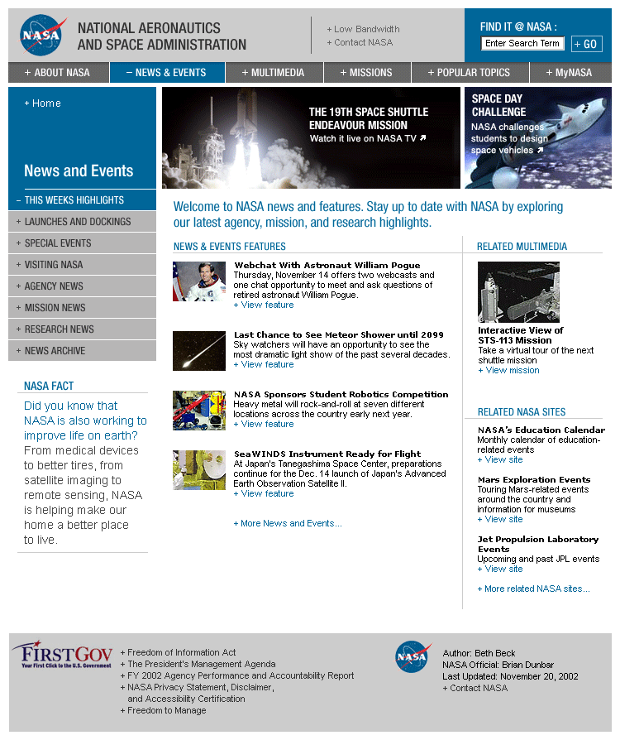
Figure 3.3.1 News and Events Landing Page Example

3.3.1 This Week’s Highlights (News and Events Landing Page)

Objective
Highlight NASA’s latest news and accomplishments, as well as important upcoming/ongoing events and activities.

Description
Two Promotional Banners highlight the latest and greatest events/news/accomplishments at NASA.

Seven revolving Features (most recent at the top) showcase timely (recent newsworthy content) and in-depth and important initiatives/accomplishments or ongoing/upcoming events. Content must be a press release, detailed article with multiple high quality visuals or accompanying multimedia, an engaging multimedia feature, an interactive tool or a recent image release. When a new feature is added, the most dated item will move to a News and Events Feature Archive.

Two Related Multimedia items (most recent at the top) will directly relate to one of the published features or banners. When a new multimedia item is added, the most dated multimedia piece will move to a News and Events Related Multimedia Archive.

Three Related NASA Sites (most recent at the top) will provide hyperlinks to NASA Web sites that directly relate to one of the published features or banners. When a new Related Site is added, the most dated will move to a News and Events Related Sites Archive.

NASA Fact will highlight a little-known piece of trivia or fact about recent NASA news/events.

Content Examples
Promotional Banners: The 19th Space Shuttle Endeavour mission

Features: “NASA sponsors student robotics competition” feature article

Related Multimedia: Interactive view of the upcoming Endeavour mission

Related NASA Sites: Space Shuttle Endeavour photo gallery

NASA Fact: “Since its first launch, the Space Shuttle Endeavour has traveled XX kilometers (XX miles).”

Update Frequency
Promotional Banners should be available for a minimum of two weeks.

Features, Related Multimedia and Related NASA Sites should be available on the page for a minimum of one week, and no longer than five weeks before being archived.

NASA Fact should be updated on a monthly basis.

3.3.2 News and Events – Launches (Left Nav)

Objective
Detail upcoming NASA launches.

Description
Five revolving Features (most recent at the top) showcase timely (recent newsworthy content) and important launches and dockings. Content must be a press release, detailed article with multiple high quality visuals or accompanying multimedia, an engaging multimedia feature, an interactive tool or a recent image release. When a new feature is added, the most dated item will move to a Launches Feature Archive.

Two Related Multimedia items (most recent at the top) will directly relate to one of the published features. When a new multimedia item is added, the most dated multimedia piece will move to a Launches Related Multimedia Archive.

Three Related NASA Sites (most recent at the top) will provide hyperlinks to NASA Web sites that directly relate to one of the published features. When a new Related Site is added, the most dated will move to a Launches Related Sites Archive.

NASA Fact will highlight a little-known piece of trivia or fact about NASA launches.

Content Examples
Features: “Soyuz launch: a new crew for the ISS” feature article

Related Multimedia: Soyuz launch Webcast: Live on NASA TV

Related NASA Sites: Space Shuttle Endeavour photo gallery

NASA Fact: “Since its inception, NASA has launched XX missions.”

Update Frequency
Features, Related Multimedia and Related NASA Sites should be available on the page for a minimum of one week, and no longer than eight weeks before being archived.

NASA Fact should be updated on a monthly basis.

3.3.3 News and Events – Special Events (Left Nav)

Objective
Detail upcoming and ongoing NASA special events of importance.

Description
Five revolving Features (most recent at the top) showcase timely (recent newsworthy content) and important events. Content must be a press release, detailed article with multiple high quality visuals or accompanying multimedia, an engaging multimedia feature, an interactive tool or a recent image release. When a new feature is added, the most dated item will move to a Special Events Feature Archive.

Two Related Multimedia items (most recent at the top) will directly relate to one of the published features. When a new multimedia item is added, the most dated multimedia piece will move to a Special Events Related Multimedia Archive.

Three Related NASA Sites (most recent at the top) will provide hyperlinks to NASA Web sites that directly relate to one of the published features. When a new Related Site is added, the most dated will move to a Special Events Related NASA Sites Archive.

NASA Fact will highlight a little-known piece of trivia or fact about one of the published Special Events specifically, or NASA events in general.

Content Examples
Features: “Pioneer NASA spacecraft celebrates 20 years of service” feature article

Related Multimedia: Pioneer video

Related NASA Sites: Pioneer Mission home page

NASA Fact: “Pioneer 4 was tracked to a distance of 655,000 kilometers (407,000 miles) from Earth, a record at that time.”

Update Frequency
Features, Related Multimedia and Related NASA Sites should be available on the page for a minimum of one week, and no longer than eight weeks before being archived.

NASA Fact should be updated on a monthly basis.

3.3.4 News and Events – Visiting NASA (Left Nav) (Note: same content as About NASA – Visiting NASA)

Objective
To provide the general public with the information they need to personally visit one of the NASA centers or Headquarters.

Description
Single detail page providing general visitors information, as well as descriptions, contacts and hyperlinks for each center that offers tours to visitors.

Content Examples
Detail page with informative text, contact information and hyperlinks to center Web site visitor information.

NASA Fact: Trivia or fact pertaining to NASA Headquarters, centers, tours or visitors. For example, “XX number of visitors toured the Johnson Space Center in 2002.”

Update Frequency
As needed. When any new contact information is produced, it should be made available from this page.

NASA Fact should be updated on a monthly basis.

3.3.5 News and Events – Agency News (Left Nav)

Objective
To outline NASA’s organizational goals and detail Agency activities. To provide the latest news about NASA Headquarters initiatives.

Description
Five revolving Features (most recent at the top) showcase timely Agency news (recent newsworthy content). Content must be a press release, detailed article with multiple high quality visuals or accompanying multimedia, an engaging multimedia feature, an interactive tool or a recent image release. When a new feature is added, the most dated item will move to an Agency News Feature Archive.

Two Related Multimedia items (most recent at the top) will directly relate to one of the published features. When a new multimedia item is added, the most dated multimedia piece will move to an Agency News Related Multimedia Archive.

Three Related NASA Sites (most recent at the top) will provide hyperlinks to NASA Web sites that directly relate to one of the published features, or NASA news in general. When a new Related NASA Site is added, the most dated will move to an Agency News Archive.

NASA Fact will highlight a little-known piece of trivia or fact about NASA or one of the published features.

Content Examples
Features: “Columbia sensor diagrams presented to Columbia Accident Investigation Board” feature article

Related Multimedia: NASA mission video

Related NASA Sites: Welcome to OneNASA

Update Frequency
Features, Related Multimedia and Related NASA Sites should be available on the page for a minimum of one week, and no longer than six weeks before being archived.

NASA Fact should be updated on a monthly basis.

3.3.6 News and Events – Mission News (Left Nav) (Note: content for this page will be fed by NASA.gov’s Missions section)

Objective
To highlight and publish the latest NASA mission news.

Description
Five revolving Features (most recent at the top) showcase timely mission news (recent newsworthy content). Content must be a press release, a detailed article with multiple high quality visuals or accompanying multimedia, an engaging multimedia feature, an interactive tool or a recent image release. When a new feature is added, the most dated item will move to a Mission News Feature Archive.

Two Related Multimedia (most recent at the top) items will directly relate to one of the published features. When a new multimedia item is added, the most dated multimedia piece will move to a Mission News Related Multimedia Archive.

Three Related NASA Sites (most recent at the top) will provide hyperlinks to NASA Web sites that directly relate to one of the published features or banners or NASA missions in general. When a new Related NASA Site is added, the most dated will move to a Mission News Related NASA Sites Archive.

NASA Fact will highlight a little-known piece of trivia or fact about a NASA mission.

Content Examples
Features: “Milky Way stars in cosmic reality show” feature article

Related Multimedia: Virtual Mars

Related NASA Sites: Mars Exploration Web site

NASA Fact: “Over the two years of the continual habitation of the ISS, its size has increased by more than 90,718 kilograms (200,000 pounds).”

Update Frequency
Features, Related Multimedia and Related NASA Sites should be available on the page for a minimum of three days, and no longer than five weeks before being archived.

NASA Fact should be updated on a monthly basis.

3.3.7 News and Events – Research News (Left Nav)

Objective
To highlight and publish the latest NASA news pertaining to research.

Description
Five revolving Features (most recent at the top) showcase research news (recent newsworthy content). Content must be a press release, detailed article with multiple high quality visuals or accompanying multimedia, an engaging multimedia release, an interactive tool or a recent image release. When a new feature is added, the most dated item will move to a Research News Feature Archive.

Two Related Multimedia (most recent at the top) items will directly relate to one of the published features. When a new multimedia item is added, the most dated multimedia piece will move to a Research News Related Multimedia Archive.

Three Related NASA Sites (most recent at the top) will provide hyperlinks to NASA Web sites that directly relate to one of the published features, or NASA research in general. When a new Related Site is added, the most dated will move to a Research News Related Sites Archive.

NASA Fact will highlight a little-known piece of trivia or fact about NASA research.

Content Examples
Features: “Hubble watches light from erupting star” feature article

Related Multimedia: Star V838 Mon expands video

Related NASA Sites: Hubble Space Telescope home page

NASA Fact: “There are 80-plus research experiments planned for the STS-107 mission.”

Update Frequency
Features, Related Multimedia and Related NASA Sites should be available on the page for a minimum of one week, and no longer than eight weeks before being archived.

NASA Fact should be updated on a monthly basis.

3.3.8 News and Events – News Archive (Left Nav)

Objective
To provide access to NASA’s wealth of news releases and information.

Description
Detail page providing access to NASA’s news archive, with news organized by year and month of release.

3.4 Best Practices – Global Nav – Multimedia

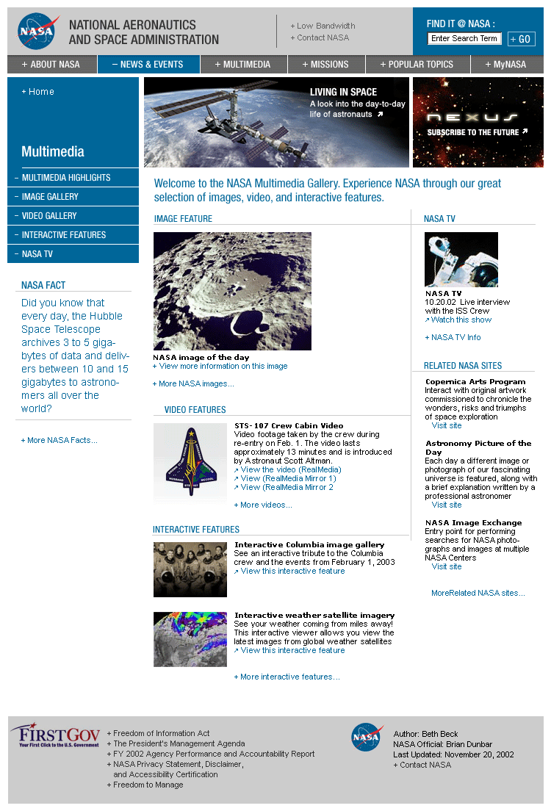
Figure 3.4.1 Multimedia Landing Page Example

3.4.1 Multimedia Highlights (Landing Page)

Objective
Transport visitors into a rich, engaging environment where they can experience the emotion, vision and imagination of NASA through interactive presentations and multimedia.

Description
Two Promotional Banners highlight the latest and greatest multimedia content being produced by NASA.

The Features content bucket highlights single features for Image Feature, Video Feature and Interactive Feature. When updated, these features will move to the Image, Video and Interactive Galleries respectively.

The NASA TV content field is a standing link to NASA TV, with a specific upcoming broadcast detailed.

Related NASA Sites provides links to three NASA Sites (most recent at the top) with compelling images or multimedia content. When updated the most dated will move to a Multimedia Related NASA Sites archive.

NASA Fact will highlight a little-known piece of trivia or fact about NASA Multimedia production or imaging.

Content Examples
Promotional Banners: Living in Space interactive feature

Image Feature: “Saharan dust off of West Africa” image

Video Feature: “Video footage of Iraqi oil fires from space”

Interactive Feature: “Interactive Columbia Image Gallery”

NASA TV: “Live interview with the ISS crew” broadcast

Related NASA Sites: The NASA Image Exchange

NASA Fact: “Every day the Hubble Space Telescope archives 3 to 5 gigabytes of data and delivers between 10 to 15 gigabytes to astronomers all over the world.”

Update Frequency
Promotional Banners should be available for a minimum of two weeks.

The Image Feature should be updated daily.

Video and Interactive Features should be available for a minimum of one week and no longer than four weeks.

Related NASA Sites should be available on the page for a minimum of one week, and no longer than five weeks before being archived.

NASA Fact should be updated on a monthly basis.

3.4.2 Multimedia – Image Gallery (Left Nav)

Description
Standing gallery of archived image features from the Multimedia Landing Page.

NASA Fact will highlight a little-known piece of trivia or fact about NASA Multimedia production or imaging.

3.4.3 Multimedia – Video Gallery (Left Nav)

Description
Standing gallery of archived video features from the Multimedia Landing Page.

NASA Fact will highlight a little-known piece of trivia or fact about NASA Multimedia production or imaging.

3.4.4 Multimedia – Interactive Features (Left Nav)

Description
Standing gallery of archived interactive features from the Multimedia Landing Page.

NASA Fact will highlight a little-known piece of trivia or fact about NASA Multimedia production or imaging.

3.4.5 Multimedia – NASA TV (Left Nav)

Objective
To provide immediate access to NASA TV programming.

Description
Detail page containing introductory text for NASA TV, as well as descriptions of programming of interest, and hyperlinks for further information.

NASA Fact will highlight a little-known piece of trivia or fact about NASA Multimedia production or imaging.

Update Frequency
As needed, depending on NASA TV programming and schedule changes.

3.4.6 Multimedia – Art Gallery (Left Nav)

Objective
To showcase the most compelling work being completed by the NASA Art Program and other artists capturing NASA’s work in paintings, drawings and other media.

Description
Archive style gallery of art-related images.

NASA Fact will highlight a little-known piece of trivia or fact about NASA Multimedia production or imaging.

Content Examples
“SIRTF and the Milky Way: an artist’s concept”

Update Frequency
A new image should be added at least every two weeks.

3.5 Best Practices – Global Nav – Missions

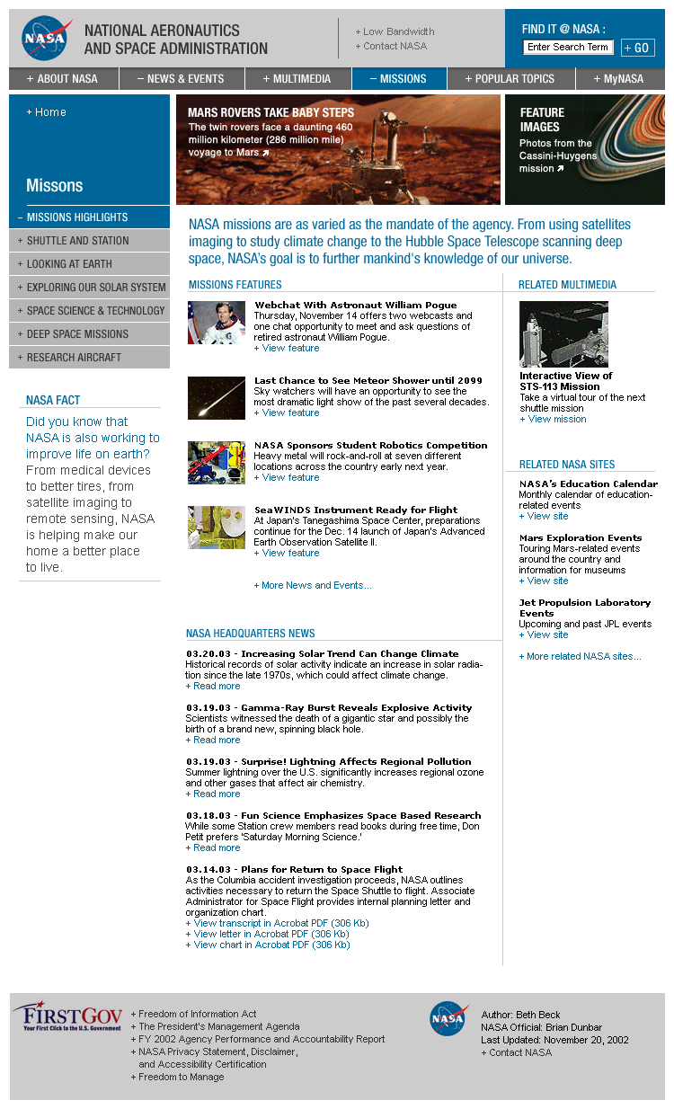
Figure 3.5.1 Missions Landing Page Example (Note: NASA Headquarters News should read NASA Missions News)

3.5.1 Missions Highlights (Landing Page)

Objective
To capture the depth and breadth of NASA’s many missions for users.

Description
Two Promotional Banners highlight the biggest events/news/accomplishments related to NASA missions.

Five revolving Features (most recent at the top) showcase timely (recent newsworthy content) and in-depth and important initiatives/accomplishments as related to NASA missions. Content must be either a detailed article with multiple high quality visuals or accompanying multimedia, an engaging multimedia feature, an interactive tool or a recent image release. Content should not be limited to press releases or news. When a new feature is added, the most dated item will move to a NASA Missions Feature Archive.

Three Missions News items (press releases, most recent at the top) will detail the latest news about NASA Missions.

Two Related Multimedia items (most recent at the top) will showcase the most engaging Missions multimedia content available. When a new multimedia item is added, the most dated multimedia piece will move to a Missions Related Multimedia Archive.

Three Related NASA Sites (most recent at the top) will provide links to NASA sites directly pertaining to NASA missions. When a new related site is added, the most dated item will move to a Missions Related NASA Sites Archive.

NASA Fact will highlight a little-known piece of trivia or fact about NASA missions.

Content Examples
Promotional Banners: “Mars Rovers take baby steps” link to Mars Exploration

Features: “Looking at Earth: The Terra Satellite is helping us to understand how our planet is changing” feature article

Missions News: “Techs search for oxygen leak source in Endeavour” press release

Related Multimedia: Solar System Simulator

Related NASA Sites: Columbia home page

NASA Fact: “With over 100 launches, space shuttle missions have now carried over 300 passengers and 1.36 million kg (3 million pounds) of cargo into orbit.”

Update Frequency
Promotional Banners should be available for a minimum of two weeks.

Features, Related Multimedia and Related NASA Sites should be available on the page for a minimum of one week, and no longer than six weeks before being archived.

NASA Missions News will be updated frequently, possibly daily.

NASA Fact should be updated on a monthly basis.

3.5.2 Missions – NASA Missions Timeline (Left Nav)

Objective
To provide an historical, current and future timeline of NASA’s important missions to users.

Description
Graphical detail page providing a timeline of NASA missions.

NASA Fact will highlight a little-known piece of trivia or fact about NASA missions.

Update Frequency
As needed, when new relevant missions are launched, or timelines/schedules are adjusted.

NASA Fact should be updated on a monthly basis.

3.5.3 Missions – Shuttle and Station (Left Nav)

Objective
To highlight the most compelling NASA content in relation to Space Shuttle and ISS missions.

Description
Five revolving Features (most recent at the top) showcase timely (recent newsworthy content) and in-depth and important initiatives/accomplishments as related to NASA Shuttle and ISS missions. Content must be either a detailed article with multiple high quality visuals or accompanying multimedia, an engaging multimedia feature, an interactive tool or a recent image release. . Content should not be limited to press releases or news. When a new feature is added, the most dated item will move to a Shuttle and Station Feature Archive.

Two Related Multimedia (most recent at the top) items will showcase the most engaging Shuttle and Station multimedia content available. They will preferably directly relate to one of the published features. When a new multimedia item is added, the most dated multimedia piece will move to a Shuttle and Station Related Multimedia Archive.

NASA Fact will highlight a little-known piece of trivia or fact about Shuttle missions or the ISS.

Content Examples
Features: “Tracking the ISS: When will the station pass over you?” interactive tool

Related Multimedia: STS-107 Videos

NASA Fact: “With over 100 launches, space shuttle missions have now carried over 300 passengers and 1.36 million kg (3 million pounds) of cargo into orbit.”

Update Frequency
Promotional Banners should be available for a minimum of two weeks.

Features and Related Multimedia should be available on this page for a minimum of one week, and no longer than eight weeks before being archived.

NASA Fact should be updated on a monthly basis.

3.5.4 Missions – Looking at Earth (Left Nav)

Objective
To showcase NASA’s remote sensing and satellite imaging missions.

Description
Five revolving Features (most recent at the top) will provide content publicizing NASA’s missions that strive to better understand our home planet. When a new feature is added, the most dated item will move to the Missions Looking at Earth Feature Archive.

Two Related Multimedia items (most recent at the top) will directly relate to one of the published features. When a new multimedia piece is added, the most dated item will move to the Missions Looking at Earth Related Multimedia Archive.

NASA Fact will highlight a little-known piece of trivia or fact about NASA remote sensing and satellite imaging work, or about our planet in general.

Content Examples
Features: “Black carbon: NASA discovers how carbon particles are changing the weather in China” feature article

Related Multimedia: “The Adventures of Echo the Bat” remote sensing multimedia

NASA Fact: “Without a protective upper-level ozone layer, there would be no life on Earth.”

Update Frequency
A new Feature and Related Multimedia piece should be added at least every two weeks. Features should be available on this page for a minimum of one week.

NASA Fact should be updated on a monthly basis.

3.5.5 Missions – Exploring our Solar System (Left Nav)

Objective
To showcase NASA missions that strive to better understand our solar system.

Description
Five revolving Features (most recent at the top) will provide content publicizing NASA’s missions that strive to better understand our solar system. When a new feature is added, the most dated item will move to the Missions Exploring Our Solar System Feature Archive.

Two Related Multimedia items (most recent at the top) will directly relate to one of the published features, or to the solar system in general. When a new multimedia piece is added, the most dated item will move to the Missions Exploring Our Solar System Related Multimedia Archive.

NASA Fact will highlight a little-known piece of trivia or fact about NASA missions that explore our solar system.

Content Examples
Features: “Exploring Jupiter’s great dark spot” feature article

Related Multimedia: “Mars Exploration Rover videos”

NASA Fact: “Our sun is almost XX times larger than Earth.”

Update Frequency
A new Feature and Related Multimedia piece should be added at least every three weeks. Features should be available on this page for a minimum of one week.

NASA Fact should be updated on a monthly basis.

3.5.6 Missions – Space Science and Technology (Left Nav)

Objective
To showcase the technology that makes NASA missions possible.

Description
Five revolving Features (most recent at the top) will provide content that educates about the technology behind NASA missions. When a new feature is added, the most dated item will move to the Space Science and Technology Feature Archive.

Two Related Multimedia items (most recent at the top) will directly relate to one of the published features. When a new multimedia piece is added, the most dated item will move to the Missions Space Science and Technology Related Multimedia Archive.

NASA Fact will highlight a little-known piece of trivia or fact about the technology behind NASA missions.

Content Examples
Features: “A search for habitable planets: Technology behind the Kepler mission” feature article

Related Multimedia: “Seeing the early solar system: Images from the Dawn mission will use new technology to look back in time” gallery

NASA Fact: “By using infrared technology, the Space Infrared Telescope Facility will help us better understand how planets are formed.”

Update Frequency
A new Feature and Related Multimedia piece should be added at least every three weeks. Features should be available on this page for a minimum of one week.

NASA Fact should be updated on a monthly basis.

3.5.7 Missions – Deep Space Missions (Left Nav)

Objective
To highlight and inform users about NASA’s missions that study our universe.

Description
Five revolving Features (most recent at the top) will provide content that about NASA’s deep space missions. When a new feature is added, the most dated item will move to the Deep Space Missions Feature Archive.

Two Related Multimedia items (most recent at the top) will directly relate to one of the published features. When a new multimedia piece is added, the most dated item will move to the Deep Space Missions Related Multimedia Archive.

NASA Fact will highlight a little-known piece of trivia or fact about NASA’s deep space missions.

Content Examples
Features: “Gamma ray burst reveals explosive activity” feature article

Related Multimedia: Hubble Space Telescope image gallery

NASA Fact: “By using infrared technology, the Space Infrared Telescope Facility will help us better understand how planets are formed.”

Update Frequency
A new Feature and Related Multimedia piece should be added at least every three weeks. Features should be available on this page for a minimum of one week.

NASA Fact should be updated on a monthly basis.

3.5.8 Missions – Research Aircraft (Left Nav)

Objective
To highlight and inform users about NASA’s aeronautics and research aircraft missions.

Description
Five revolving Features (most recent at the top) will provide content about NASA’s research aircraft missions. When a new feature is added, the most dated item will move to the Missions Research Aircraft Feature Archive.

Two Related Multimedia items will directly relate to one of the published features. When a new multimedia piece is added, the most dated item will move to the Missions Research Aircraft Related Multimedia Archive.

NASA Fact will highlight a little-known piece of trivia or fact about NASA Research Aircraft.

Content Examples
Features: “NASA research aircraft searches Columbia’s path for debris” feature article

Related Multimedia: “Eagle morphs into advanced concept vehicle” video

NASA Fact: “In 1957 the Short SC.1 VTOL Research Aircraft made its first flight powered by five Rolls Royce RB.108 turbojets.”

Update Frequency
A new Feature and Related Multimedia piece should be added at least every three weeks. Features should be available on this page for a minimum of one week.

NASA Fact should be updated on a monthly basis.

3.6 Best Practices – Global Nav – Popular Topics/MyNASA

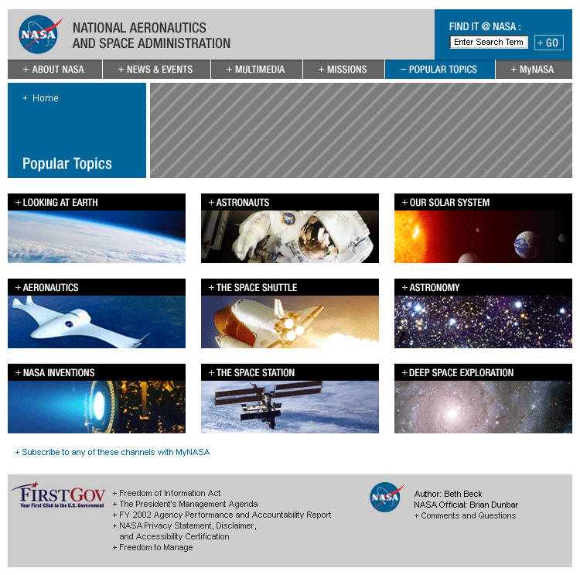
Popular Topics Landing Page Example.

Objective
To allow users to customize their access to NASA online content.

Description
Powered by the Content Management System, Popular Topics and MyNASA have direct correlations content-wise, with topics, or channels, being linked across the two sections. The CMS will feed content to the channels and topics chosen for representation.

3.7 Best Practices – Vision Segments – Life on Earth

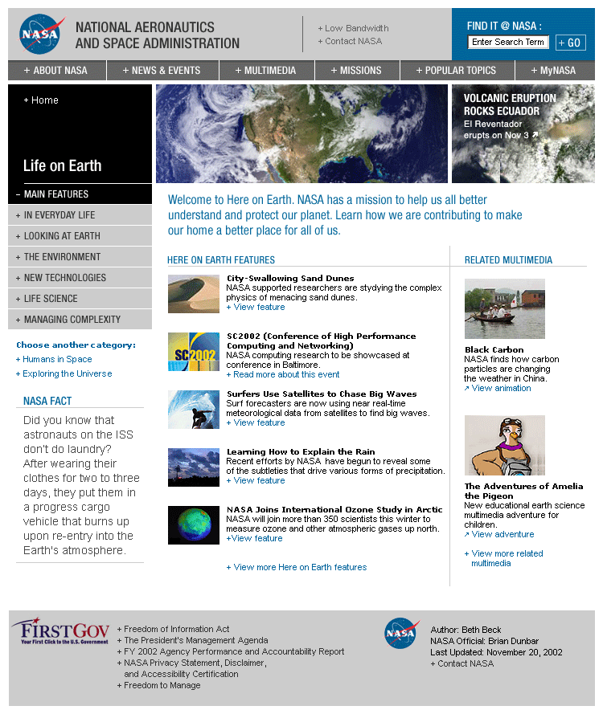
Figure 3.7.1 Life on Earth Landing Page Example (Note: There have been left navigation changes. Please refer to the detailed descriptions below for left navigation pages.)

3.7.1 Life on Earth Main Features (Landing Page)

Objective
To capture the depth and breadth of NASA’s earth-based and earth-focused activities.

Description
Two Promotional Banners highlight the biggest events/news/accomplishments related to NASA’s earth-based and earth-focused programs.

Five revolving Features (most recent at the top) showcase timely (recent newsworthy content) and in-depth and important initiatives/accomplishments as related to the “Improve Life Here” component of NASA’s vision. Content must be either a detailed article with multiple high quality visuals or accompanying multimedia, an engaging multimedia feature, an interactive tool or a recent image release. Content should not be limited to press releases or news. When a new feature is added, the most dated item will move to a Life on Earth Feature Archive.

Two Related Multimedia items (most recent at the top) will showcase the most engaging earth-focused multimedia content available, and can directly relate to one of the published banners or features. When a new multimedia item is added, the most dated multimedia piece will move to a Life on Earth Related Multimedia Archive.

NASA Fact will highlight a little-known piece of trivia about our planet or NASA’s work under the “Improve Life Here” vision.

Content Examples
Promotional Banners: Satellite image release of volcanic eruption in Ecuador

Features: “NASA joins international ozone study in the Arctic” feature article

Related Multimedia: Multimedia schematics of future scramjet

NASA Fact: “Without an upper-level protective ozone layer, there would be no life on Earth.”

Update Frequency
Promotional Banners should be available for a minimum of two weeks.

Features and Related Multimedia should be available on the page for a minimum of one week, and no longer than five weeks before being archived.

NASA Fact should be updated on a monthly basis.

3.7.2 Life on Earth – In Everyday Life (Left Nav)

Objective
To highlight content that educates users about the impact NASA has had, and is having, on our day-to-day lives.

Description
Five revolving Features (most recent at the top) with content that showcases NASA’s impact on our lives (inventions for example). Content must be either a detailed article with multiple high quality visuals or accompanying multimedia, an engaging multimedia feature, an interactive tool or a recent image release. Content should not be limited to press releases or news. When a new feature is added, the most dated item will move to the In Everyday Life Feature Archive.

Two Related Multimedia items (most recent at the top) will showcase the most engaging work NASA is doing, or has done, in terms of inventions and technologies being used around the world. Multimedia will directly relate to one of the published features. When a new multimedia piece is added, the most dated item will move to an In Everyday Life Related Multimedia Archive.

NASA Fact will highlight a little-known piece of trivia or fact about NASA’s accomplishments in making our lives easier.

Content Examples
Feature: “NASA scientists have invented new video technology” feature article

Related Multimedia: “Focus on this!: Video stabilization technology” video release

NASA Fact: “The smoke detector was invented by NASA scientists.”

Update Frequency
A new Feature and Related Multimedia piece should be added at least every three weeks. Features should be available on this page for a minimum of two weeks.

NASA Fact should be updated on a monthly basis.

3.7.3 Life on Earth – Looking at Earth (Left Nav)

Objective
To showcase research efforts and results in remote sensing and satellite imaging.

Description
Five revolving Features (most recent at the top) with content publicizing NASA’s efforts to look at and better understand our home planet. When a new feature is added, the most dated item will move to the Looking at Earth Feature Archive.

Two Related Multimedia (most recent at the top) items will directly relate to one of the published features or satellite imaging and remote sensing in general. When a new multimedia piece is added, the most dated item will move to the Looking at Earth Related Multimedia Archive.

NASA Fact will highlight a little-known piece of trivia or fact about NASA remote sensing and satellite imaging work, or about our planet in general.

Content Examples
Feature: “Finding fossils from space” feature article

Related Multimedia: “Visible Earth” gallery

Update Frequency
A new Feature and Related Multimedia piece should be added at least every three weeks. Features should be available on this page for a minimum of two weeks.

NASA Fact should be updated on a monthly basis.

3.7.4 Life on Earth – The Environment (Left Nav)

Objective
To showcase NASA’s research efforts to better understand our environment and to educate users about how Earth is being affected by human habitation.

Description
Five revolving Features (most recent at the top) about NASA’s efforts to look at and better understand our environment. When a new feature is added, the most dated item will move to The Environment Feature Archive.

Two Related Multimedia items (most recent at the top) will directly relate to one of the published features or the Environment in general. When a new multimedia piece is added, the most dated item will move to The Environment Related Multimedia Archive.

NASA Fact will highlight a little-known piece of trivia or fact about Earth’s environment and NASA’s efforts to better understand it.

Content Examples
Feature: “Black carbon: NASA discovers how carbon particles are changing the weather in China” feature article

Related Multimedia: Visible Earth gallery

NASA Fact: “Without a protective upper-level ozone layer, there would be no life on Earth.”

Update Frequency
A new Feature and Related Multimedia piece should be added at least every three weeks. Features should be available on this page for a minimum of two weeks.

NASA Fact should be updated on a monthly basis.

3.7.5 Life on Earth – New Technologies (Left Nav)

Objective
To showcase and educate users about NASA’s work on new technology development.

Description
Five revolving Features (most recent at the top) about NASA’s research and development of new technologies. When a new feature is added, the most dated item will move to a New Technologies Feature Archive.

Two Related Multimedia items (most recent at the top) will directly relate to one of the published features. When a new multimedia piece is added, the most dated item will move to a New Technologies Related Multimedia Archive.

NASA Fact will highlight a little-known piece of trivia or fact about NASA technology development.

Content Examples
Feature: “Students and robots converge on Cleveland to compete” feature article about the Buckeye Regional FIRST Robotics competition

Related Multimedia: “Robot of the week” image

Update Frequency
A new Feature and Related Multimedia piece should be added at least every three weeks. Features should be available on this page for a minimum of two weeks.

NASA Fact should be updated on a monthly basis.

3.7.6 Life on Earth – Living Things (Left Nav)

Objective
To highlight and educate users about NASA’s physical and biological sciences research.

Description
Five revolving Features (most recent at the top) about NASA’s physical and biological sciences research. When a new feature is added, the most dated item will move to a Living Things Feature Archive.

Two Related Multimedia items will directly relate to one of the published features, or to Living Things in general. When a new multimedia piece is added, the most dated item will move to a Living Things Related Multimedia Archive.

NASA Fact will highlight a little-known piece of trivia or fact about Living Things, or NASA’s work to better understand them.

Content Examples
Feature: “Better bone implants” feature article

Related Multimedia: “Fetal heart monitor” video

NASA Fact: “Adults have 160,000 kilometers (100,000 miles) of blood vessels, children have 96,000 kilometers (60,000 miles).”

Update Frequency
A new Feature and Related Multimedia piece should be added at least every three weeks. Features should be available on this page for a minimum of two weeks.

NASA Fact should be updated on a monthly basis.

3.7.7 Life on Earth – Improving Flight (Left Nav)

Objective
To highlight and educate users about NASA’s aeronautics research and projects and the Agency’s efforts to improve flight safety worldwide.

Description
Five revolving Features (most recent at the top) about aeronautics and flight research. When a new feature is added, the most dated item will move to an Improving Flight Feature Archive.

Two Related Multimedia items (most recent at the top) will directly relate to one of the published features, or to aeronautics in general. When a new multimedia piece is added, the most dated item will move to an Improving Flight Related Multimedia Archive.

NASA Fact will highlight a little-known piece of trivia or fact about flight in general, or NASA’s work more specifically.

Content Examples
Feature: “Active Aerolastic Wing project team explores new technologies” feature article

Related Multimedia: “Eagle morphs into advanced concept vehicle” video

NASA Fact: “In 1957 the Short SC.1 VTOL Research Aircraft made its first flight powered by five Rolls Royce RB.108 turbojets.”

Update Frequency
A new Feature and Related Multimedia piece should be added at least every three weeks. Features should be available on this page for a minimum of two weeks.

NASA Fact should be updated on a monthly basis.

3.8 Best Practices – Vision Segments – Humans in Space

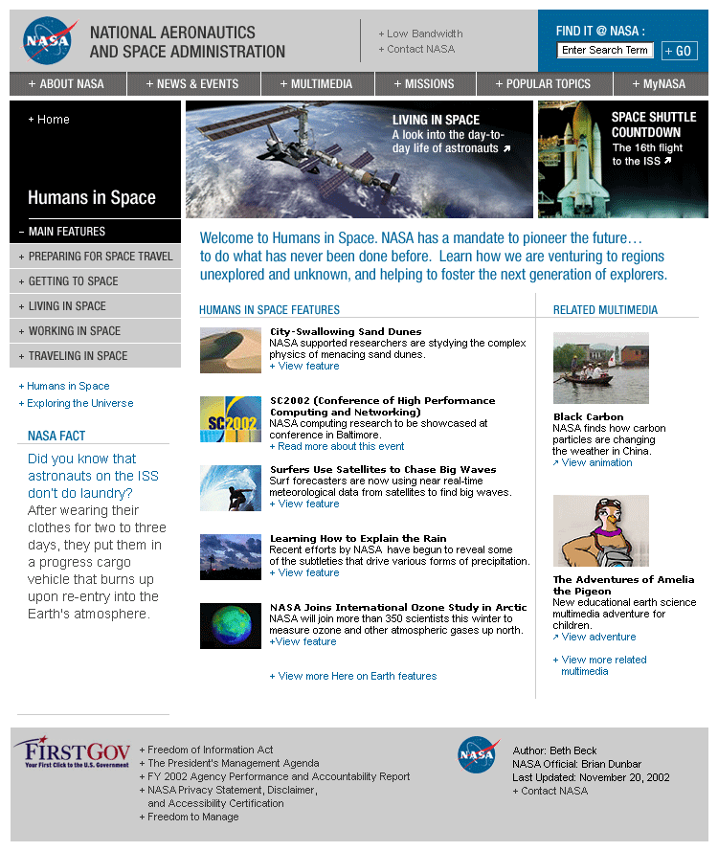
Figure 3.8.1 Humans in Space Landing Page Example

3.8.1 Humans in Space Main Features (Landing Page)

Objective
To capture the depth and breadth of NASA’s human-driven space exploration activities.

Description
Two Promotional Banners highlight the biggest events/news/accomplishments related to NASA’s space exploration programs involving humans.

Five revolving Features (most recent at the top) showcase timely (recent newsworthy content) and in-depth and important initiatives/accomplishments as related to the “Extend Life to There” component of NASA’s vision. Content must be either a detailed article with multiple high quality visuals or accompanying multimedia, an engaging multimedia piece, an interactive tool or a recent image release. Content should not be limited to press releases or news. When a new feature is added, the most dated item will move to a Humans in Space Feature Archive.

Two Related Multimedia items (most recent at the top) will showcase the most engaging space exploration multimedia content available, and can directly relate to one of the published banners or features. When a new multimedia item is added, the most dated multimedia piece will move to a Humans in Space Related Multimedia Archive.

NASA Fact will highlight a little-known piece of trivia or fact about NASA’s work under the “Extend Life to There” vision.

Content Examples
Promotional Banners: “Track the ISS in the night sky” interactive tool

Features: “How astronauts get along” feature article

Related Multimedia: STS-113 gallery of pre-flight animated videos

NASA Fact: “Astronauts on the ISS don’t do laundry…”

Update Frequency
Promotional Banners should be available for a minimum of two weeks.

Features and Related Multimedia should be available on the page for a minimum of one week, and no longer than five weeks before being archived.

NASA Fact should be updated on a monthly basis.

3.8.2 Humans in Space – Preparing for Space Travel (Left Nav)

Objective
To highlight content that educates users about the research and preparations that are needed prior to liftoff.

Description
Five revolving Features (most recent at the top) with content about earth-based preparations needed for space travel. Content must be either a detailed article with multiple high quality visuals or accompanying multimedia, an engaging multimedia feature, an image release or an interactive tool. Content should not be limited to press releases or news. When a new feature is added, the most dated item will move to the Preparing for Space Travel Feature Archive.

Two Related Multimedia items (most recent at the top) will highlight interactive or visual content about earth-based preparations needed for space travel, and can directly relate to one of the published features. When a new multimedia piece is added, the most dated item will move to a Preparing for Space Travel Related Multimedia Archive.

NASA Fact will highlight a little-known piece of trivia or fact about preparing for space travel.

Content Examples
Feature: “Baseline Data Collection Facility” feature article

Related Multimedia: “STS-101 crew trains with new ‘glass cockpit’” video release

NASA Fact: “In 1959 the first astronauts were selected from 500 applicants.”

Update Frequency
A new Feature and Related Multimedia piece should be added at least every three weeks. Features should be available on this page for a minimum of two weeks.

NASA Fact should be updated on a monthly basis.

3.8.3 Humans in Space – Getting to Space (Left Nav)

Objective
To highlight content that educates users about expendable launch vehicles launched by NASA, and their role in getting humans to space.

Description
Five revolving Features (most recent at the top) with content about non-human launches to space that support NASA’s “Extend Life to There” vision. Content must be either a detailed article with multiple high quality visuals or accompanying multimedia, an engaging multimedia feature, an image release or an interactive tool. Content should not be limited to press releases or news. When a new feature is added, the most dated item will move to the Getting to Space Feature Archive.

Two Related Multimedia items (most recent at the top) will highlight interactive or visual content about non-human launches, and can directly relate to one of the published features. When a new multimedia piece is added, the most dated item will move to a Getting to Space Related Multimedia Archive.

NASA Fact will highlight a little-known piece of trivia or fact about getting to space.

Content Examples
Feature: “Final ISS truss shipment to launch” feature article

Related Multimedia: “The Zvezda Service Module launch” video release

Update Frequency
A new Feature and Related Multimedia piece should be added at least every three weeks. Features should be available on this page for a minimum of two weeks.

NASA Fact should be updated on a monthly basis.

3.8.4 Humans in Space – Living in Space (Left Nav)

Objective
To highlight content that educates users about life aboard the International Space Station, and future efforts to live in space.

Description
Five revolving Features (most recent at the top) with content about life aboard the ISS and directly related to the “Extend Life to There” vision. Content must be either a detailed article with multiple high quality visuals or accompanying multimedia, an engaging multimedia piece, an image release or an interactive tool. Content should not be limited to press releases or news. When a new feature is added, the most dated item will move to the Living in Space Feature Archive.

Two Related Multimedia items (most recent at the top) will highlight interactive or visual content about life aboard the ISS or future life in space, and can directly relate to one of the published features. When a new multimedia piece is added, the most dated item will move to a Living in Space Related Multimedia Archive.

NASA Fact will highlight a little-known piece of trivia or fact about living in space.

Content Examples
Feature: “ISS crewmembers use Ham radio to talk with people on earth” feature article

Related Multimedia: “See how astronauts eat in space” video

NASA Fact: “Astronauts on the ISS don’t do laundry…”

Update Frequency
A new Feature and Related Multimedia piece should be added at least every three weeks. Features should be available on this page for a minimum of two weeks.

NASA Fact should be updated on a monthly basis.

3.8.5 Humans in Space – Working in Space (Left Nav)

Objective
To highlight content that educates users about working in space, from research conducted on the Shuttle to operations at the International Space Station.

Description
Five revolving Features (most recent at the top) with content about working in space and directly related to the “Extend Life to There” vision. Content must be either a detailed article with multiple high quality visuals or accompanying multimedia, an engaging multimedia piece, an image release or an interactive tool. Content should not be limited to press releases or news. When a new feature is added, the most dated item will move to the Working in Space Feature Archive.

Two Related Multimedia items (most recent at the top) will highlight interactive or visual content about the work being conducted on board the ISS or Shuttle, and can directly relate to one of the published features. When a new multimedia piece is added, the most dated item will move to a Working in Space Related Multimedia Archive.

NASA Fact will highlight a little-known piece of trivia or fact about working in space.

Content Examples
Feature: “Expedition Six crew to conduct space walk” feature article

Related Multimedia: “Space Station Science Image of the Day” video

NASA Fact: “Astronauts on the ISS don’t do laundry…”

Update Frequency
A new Feature and Related Multimedia piece should be added at least every three weeks. Features should be available on this page for a minimum of two weeks.

NASA Fact should be updated on a monthly basis.

3.8.6 Humans in Space – Traveling in Space (Left Nav)

Objective
To highlight content that educates users about space travel, with a primary focus on shuttle missions.

Description
Five revolving Features (most recent at the top) with content about traveling in space, as directly related to the “Extend Life to There” vision. Content must be either a detailed article with multiple high quality visuals or accompanying multimedia, an engaging multimedia piece, an image release or an interactive tool. When a new feature is added, the most dated item will move to the Traveling in Space Feature Archive.

Two Related Multimedia items (most recent at the top) will highlight interactive or visual content about traveling in space and shuttle missions, and can directly relate to one of the published features. When a new multimedia piece is added, the most dated item will move to a Traveling in Space Related Multimedia Archive.

NASA Fact will highlight a little-known piece of trivia or fact about traveling in space.

Content Examples
Feature: “19th Shuttle Endeavour mission set to launch” feature article

Related Multimedia: “Shuttle Endeavour launch: Live on NASA TV” Webcast

NASA Fact: “With over 100 launches, space shuttle missions have now carried over 300 passengers and 1.36 million kg (3 million pounds) of cargo into orbit.”

Update Frequency
A new Feature and Related Multimedia piece should be added at least every three weeks. Features should be available on this page for a minimum of two weeks.

NASA Fact should be updated on a monthly basis.

3.9 Best Practices – Vision Segments – Exploring the Universe

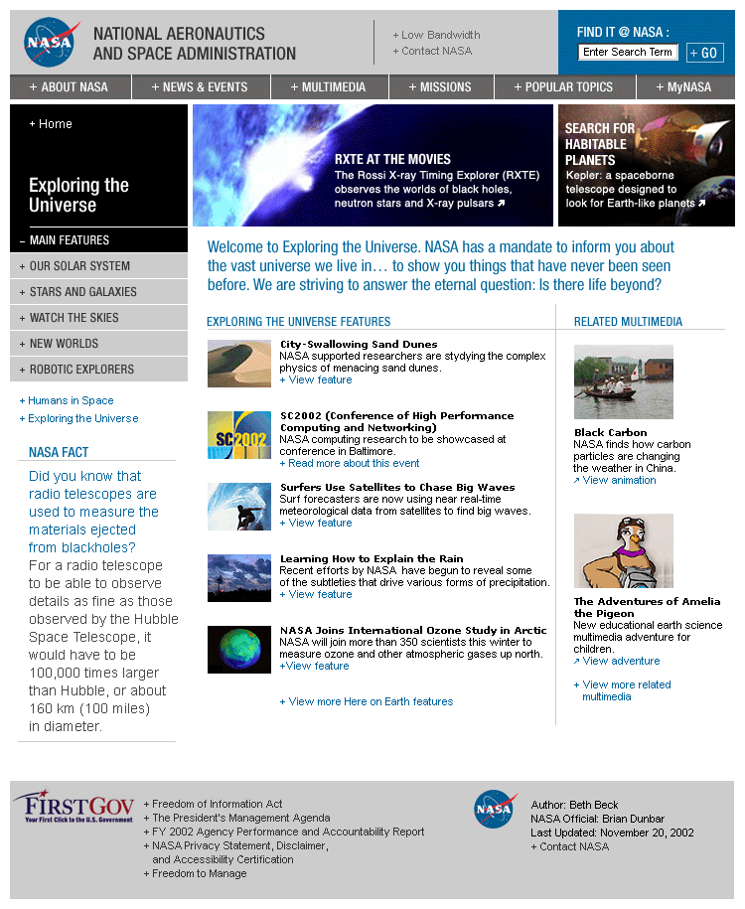
Figure 3.9.1 Exploring the Universe Landing Page Example

3.9.1 Exploring the Universe Main Features (Landing Page)

Objective
To capture the depth and breadth of NASA’s space exploration programs and activities.

Description
Two Promotional Banners highlight the biggest events/news/accomplishments related to NASA’s space exploration programs.

Five revolving Features (most recent at the top) showcase timely (recent newsworthy content) and in-depth and important initiatives/accomplishments as related to the “Find Life Beyond” component of NASA’s vision. Content must be either a detailed article with multiple high quality visuals or accompanying multimedia, an engaging multimedia piece, an interactive tool or a recent image release. Content should not be limited to press releases or news. When a new feature is added, the most dated item will move to an Exploring the Universe Feature Archive.

Two Related Multimedia items (most recent at the top) will showcase the most engaging space exploration multimedia content available, and can directly relate to one of the published banners or features. When a new multimedia item is added, the most dated multimedia piece will move to an Exploring the Universe Related Multimedia Archive.

NASA Fact will highlight a little-known piece of trivia or fact about space exploration.

Content Examples
Promotional Banners: “Mars Rovers take baby steps” feature

Features: “Neutron star revealed” feature article

Related Multimedia: Solar System Simulator

NASA Fact: “Radio telescopes can be used to measure the materials ejected from black holes…”

Update Frequency
Promotional Banners should be available for a minimum of two weeks.

Features and Related Multimedia should be available on the page for a minimum of one week, and no longer than five weeks before being archived.

NASA Fact should be updated on a monthly basis.

3.9.2 Exploring the Universe – Our Solar System (Left Nav)

Objective
To highlight NASA content about our solar system, and the Agency’s efforts to better understand our own neighborhood.

Description
Five revolving Features (most recent at the top) about our solar system. Content must be either a detailed article with multiple high quality visuals or accompanying multimedia, an engaging multimedia piece, an image release or an interactive tool. Content should not be limited to press releases or news. When a new feature is added, the most dated item will move to the Our Solar System Feature Archive.

Two Related Multimedia items (most recent at the top) will highlight interactive or visual content about our solar system, and can directly relate to one of the published features. When a new multimedia piece is added, the most dated item will move to an Our Solar System Related Multimedia Archive.

NASA Fact will highlight a little-known piece of trivia or fact about our solar system.

Content Examples
Feature: “Mars Rovers take baby steps” feature article

Related Multimedia: Solar System Simulator

NASA Fact: “It takes 12 Earth years for Mars to make one orbit around the sun.”

Update Frequency
A new Feature and Related Multimedia piece should be added at least every three weeks. Features should be available on this page for a minimum of two weeks.

NASA Fact should be updated on a monthly basis.

3.9.3 Exploring the Universe – Stars and Galaxies (Left Nav)

Objective
To highlight NASA content about stars and galaxies, and the Agency’s deep space research programs.

Description
Five revolving Features (most recent at the top) about stars and galaxies. Content must be either a detailed article with multiple high quality visuals or accompanying multimedia (not just a press release), an image release or an interactive tool. When a new feature is added, the most dated item will move to the Stars and Galaxies Feature Archive.

Two Related Multimedia items (most recent at the top) will highlight interactive or visual content about stars and galaxies, and can directly relate to one of the published features. When a new multimedia piece is added, the most dated item will move to a Stars and Galaxies Related Multimedia Archive.

NASA Fact will highlight a little-known piece of trivia or fact about stars and galaxies.

Content Examples
Feature: “Neutron star revealed” feature article

Related Multimedia: Animation of a star expanding into a red super giant

Update Frequency
A new Feature and Related Multimedia piece should be added at least every three weeks. Features should be available on this page for a minimum of two weeks.

NASA Fact should be updated on a monthly basis.

3.9.4 Exploring the Universe – Watch the Skies (Left Nav)

Objective
To highlight NASA astronomy content, and aspects of our universe that can be seen just by looking up.

Description
Five revolving Features (most recent at the top) about astronomy. Content must be either a detailed article with multiple high quality visuals or accompanying multimedia (not just a press release), an image release or an interactive tool. When a new feature is added, the most dated item will move to the Watch the Skies Feature Archive.

Two Related Multimedia items (most recent at the top) will highlight interactive or visual content about exploration of the universe from Earth, and can directly relate to one of the published features. When a new multimedia piece is added, the most dated item will move to a Watch the Skies Related Multimedia Archive.

NASA Fact will highlight a little-known piece of trivia or fact about astronomy.

Content Examples
Feature: “Jaw-dropping Leonids” feature article

Related Multimedia: “Track the ISS in the night sky” interactive tool

NASA Fact: “During an official ‘meteor storm’ an observer can view 1,000 or more meteors in one hour.”

Update Frequency
A new Feature and Related Multimedia piece should be added at least every three weeks. Features should be available on this page for a minimum of two weeks.

NASA Fact should be updated on a monthly basis.

3.9.5 Exploring the Universe – New Worlds (Left Nav)

Objective
To publicize NASA’s efforts and research behind the search for Earth-like, or possibly life-supporting, planets in the universe.

Description
Five revolving Features (most recent at the top) about the search for new worlds in the universe. Content must be either a detailed article with multiple high quality visuals or accompanying multimedia (not just a press release), an image release or an interactive tool. When a new feature is added, the most dated item will move to the New Worlds Feature Archive.

Two Related Multimedia items (most recent at the top) will highlight interactive or visual content about the search for new worlds, and can directly relate to one of the published features. When a new multimedia piece is added, the most dated item will move to a New Worlds Related Multimedia Archive.

NASA Fact will highlight a little-known piece of trivia or fact about Earth and possible life-supporting planets in the universe.

Content Examples
Feature: “Building planets in cyberspace” feature article

Related Multimedia: “Planet Quest” interactive gallery

NASA Fact: “Over the next 15 years NASA is embarking on a bold series of missions to find and characterize new worlds.”

Update Frequency
A new Feature and Related Multimedia piece should be added at least every three weeks. Features should be available on this page for a minimum of two weeks.

NASA Fact should be updated on a monthly basis.

3.9.6 Exploring the Universe – Robotic Explorers (Left Nav)

Objective
To provide content and insight into how robots are helping us to explore the universe, and how far they might take us in the future.

Description
Five revolving Features (most recent at the top) about the role of robotics in helping us to explore the universe. Content must be either a detailed article with multiple high quality visuals or accompanying multimedia (not just a press release), an image release or an interactive tool. When a new feature is added, the most dated item will move to the Robotic Explorers Feature Archive.

Two Related Multimedia items (most recent at the top) will highlight interactive or visual content about NASA’s robotic explorers, and can directly relate to one of the published features. When a new multimedia piece is added, the most dated item will move to a Robotic Explorers Related Multimedia Archive.

NASA Fact will highlight a little-known piece of trivia or fact about NASA robotics, and the use of robots for exploration.

Content Examples
Feature: “Mars Rovers take baby steps” feature article

Related Multimedia: “3D Mars Rover Game” interactive game

Update Frequency
A new Feature and Related Multimedia piece should be added at least every three weeks. Features should be available on this page for a minimum of two weeks.

NASA Fact should be updated on a monthly basis.

3. 10 Best Practices – Audience Segment – For Kids Landing Page

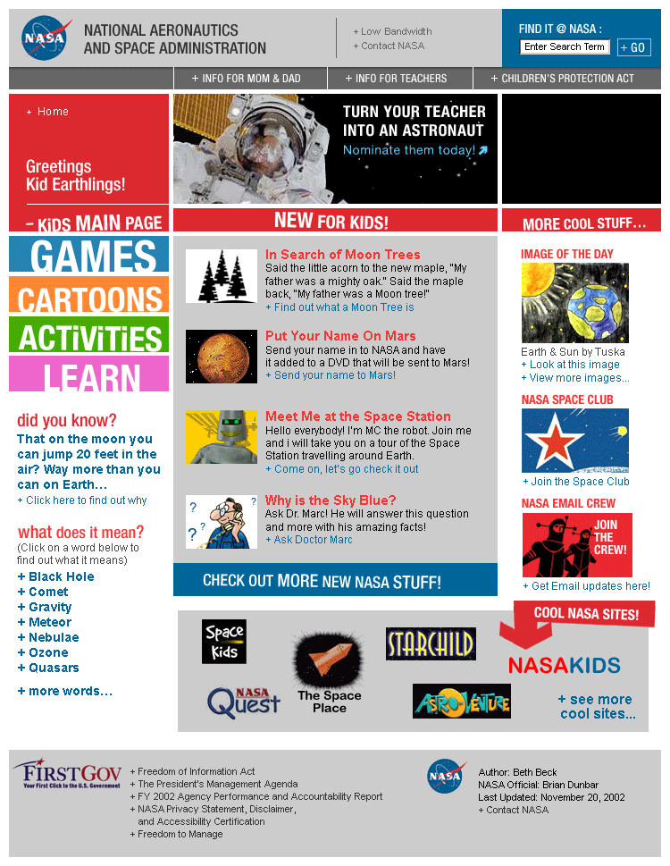
Figure 3.10.1 For Kids Landing Page Example (Note: There have been left navigation changes. Please refer to the detailed descriptions below for left navigation pages.)

3.10.1 For Kids Main (Landing Page)

Objective
Inspire and engage kids, generally elementary school or younger, as well as older audiences, with content that is both informative and fun.

Description
Two Promotional Banners highlight major NASA initiatives in a manner that is accessible by children, as well as the most compelling and fun NASA content.

New for Kids has four revolving Features (most recent at the top) showcasing fun and engaging child-focused content. Content must be written in a manner accessible by young children and include colorful visuals or accompanying multimedia or games. When a new feature is added, the most dated item will move to a For Kids Feature Archive.

More Cool Stuff will highlight the most engaging multimedia content available for kids, and can directly relate to one of the published banners or features. When a new multimedia item is added, the most dated multimedia piece will move to More Cool Stuff Archive.

Cool NASA Sites will provide links to other NASA sites just for kids.

NASA Fact will highlight a little-known piece of trivia or fact about our universe or NASA’s activities, and will be written in a manner comprehensible by young children.

Content Examples
Promotional Banners: “Nominate your teacher to be an Educator Astronaut!”

New for Kids: “How a space toilet is different” video feature

More Cool Stuff: “The Adventures of Amelia the Pigeon” interactive story

Cool NASA Sites: Amazing Space Galaxy Trading Cards

NASA Fact: “On the moon you can jump 20 feet in the air….”

Update Frequency
Promotional Banners should be available for a minimum of two weeks.

New for Kids Features, More Cool Stuff and Cool NASA Sites should be available on the page for a minimum of one week, and no longer than five weeks before being archived.

NASA Fact should be updated on a monthly basis.

3.10.2 For Kids – Games (Left Nav)

Objective
Compel children with interactive games that educate as much as they engage.

Description
Five featured games. When a new game is added, the most dated game will move to a Games Archive.

Content Examples
Mars 3D Rover Game

Update Frequency
Dependent on the production and availability of game content. One new game a month should be added here. When added, the most dated game will move to a Games Archive.

3.10.3 For Kids – Activities (Left Nav)

Objective
Promote interactivity with children through educational activities.

Description
Five featured activities. When a new activity is added, the most dated activity will move to an Activities Archive.

Content Examples
“Launch a rocket from a spinning planet” activity

Update Frequency
A new activity should be added at least every three weeks. Activities should be available on this page for a minimum of one week.

3.10.4 For Kids – Cartoons (Left Nav)

Objective
Compel children with through colorful visuals, animated stories and video.

Description
Five featured art-focused activities, illustrated/narrated stories and videos. When a new feature is added, the most dated will move to an Art and Stories Archive.

Content Examples
Robin Whirlybird’s Rotorcraft Adventures animated story.

Update Frequency
Dependent on the production and availability of Art and Stories content. One new feature should be added every three weeks here. When added, the most dated item will move to an Art and Stories Archive.

3.11 Best Practices – Audience Segment – For Students

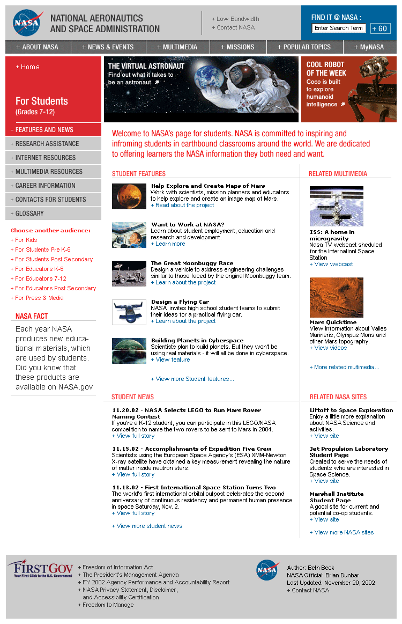
Figure 3.11.1 For Students Landing Page Example

The For Students Section is further subdivided into the K-4, 5-8, 9-12 and Post Secondary grade levels. Each of these age groups has a section with individual content that is authored specifically for those age groups, but navigation, aside for the few exceptions noted below, remains standard throughout the four different sections.

3.11.1 For Students Main Features (Landing Page)

Objective
Meet the needs of students looking for “homework help” on NASA-specific or general science and engineering topics, as well as for content relating to personal interests and for opportunities to become involved with the Agency.

Description
Two Promotional Banners highlight major NASA initiatives in a manner that is accessible by students, as well as compelling subject matter content specific to certain grade levels.

Five revolving Features (most recent at the top) showcase timely (recent newsworthy content) written for the section’s specific age group, or provide fun age appropriate activities. Content must be either an article with multiple high quality visuals or accompanying multimedia (not just a press release), an interactive tool, or an engaging activity. When a new feature is added, the most dated item will move to a For Students (specific grade level) Feature Archive.

Student News will provide three student-focused press releases (most recent at the top).

Two Related Multimedia items (most recent at the top) will showcase the most engaging multimedia content appropriate for students that is available, and can directly relate to one of the published banners or features. When a new multimedia item is added, the most dated multimedia piece will move to a For Students (specific grade level) Related Multimedia Archive.

Related NASA Sites (most recent at the top) will provide links to three NASA sites of interest to students. When a new site is added, the most dated will move to a For Students Related NASA Sites Archive.

NASA Fact will highlight a little-known piece of trivia or fact about science in general, or NASA’s activities specifically, in a manner appropriate for the section grade level it resides on.

Content Examples
Promotional Banners: NASA Apprenticeship Program link

Features: “Mars Imaging Project: Help create an image map of Mars”

Student News: “NASA shares vision of future with local students” press release

Related Multimedia: “Robot warriors: Tune into the FIRST Robotics regional competitions” Webcast

Related NASA Sites: “NASA Explores”

NASA Fact: “Radiation levels encountered by the Voyager spacecraft at Jupiter was 1,000 times the lethal level for a human.”

Update Frequency
Promotional Banners should be available for a minimum of two weeks.

Features, Related Multimedia and Related NASA Sites should be available on the page for a minimum of one week, and no longer than six weeks before being archived.

Student News will change frequently, possibly daily.

NASA Fact should be updated on a monthly basis.

3.11.2 For Students – Homework Help (Left Nav) (Note: This section is labeled Research Assistance in the Post Secondary student section)

Description
Detail page outlining how to use NASA.gov to search for homework help/research assistance on specific questions/subjects, and links to primary sources of homework/research information.

3.11.3 For Students – Internet Resources (Left Nav) (Note: this section is labeled “Internet” for the K-4 sub-section)

Description
Direct link to individual Related Sites Archive Pages for the four audiences segmented by grade level.

3.11.4 For Students – Multimedia Resources (Left Nav) (Note: this section is labeled “Multimedia” for the K-4 sub-section)

Description
Direct link to individual Related Multimedia Archive Pages for the four audiences segmented by grade level.

3.11.5 For Students – NASA Learning Opportunities (Left Nav) (Note: this section is labeled “Learning” for the K-4 sub-section)

Description
Five features (most recent at the top) outlining learning opportunities for students with NASA. When a new feature is added, the most dated moves to a NASA Learning Opportunities Archive, specific to the section’s individual grade level.

Content Examples
“The 10th Annual Great Moonbuggy Competition” feature article

Update Frequency
A new Learning Opportunity Feature should be added every two weeks, depending on the availability of such programs.

3.11.6 For Students – Career Information (Left Nav) (Note: This left navigation item does exist for students in the K-4 section)

Description
Single detail page providing introductory text, descriptions and links to NASA online career-focused content.

3.11.7 For Students – Contacts for Students (Left Nav) (Note: this section is labeled “Contact NASA” for the K-4 sub-section)

Description
Single detail page with introductory text that provides NASA center contact information throughout the county for students.

3.12 Best Practices – Audience Segment – For Educators

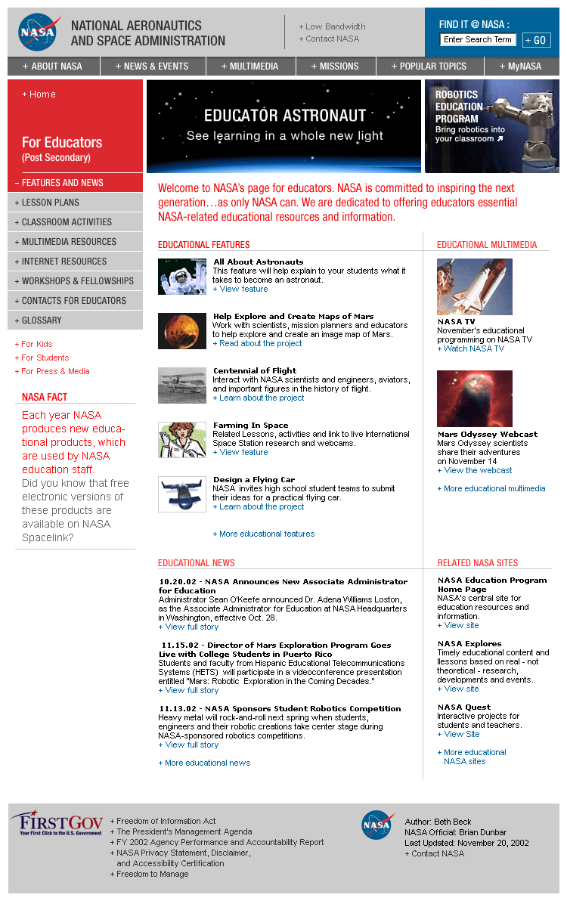
Figure 3.12.1 For Educators Landing Page Example

The For Educators Section is further subdivided into the K-4, 5-8, 9-12 and Post Secondary grade levels. Each of these sections has individual content that is authored specifically for educators with students from those age groups. Navigation, aside for the one exception noted below, remains standard throughout the four different sections.

3.12.1 For Educators Main Features (Landing Page)

Objective
Meet the needs of educators looking for resource materials on NASA-specific or general science and engineering topics, as well as for content that will inspire their students.

Description
Two Promotional Banners highlight major NASA education initiatives, as well as compelling subject matter content specific to certain grade levels.

Five revolving Features (most recent at the top) showcase timely (recent newsworthy content) focused on educators of the section’s specific grade level, or provide fun age appropriate activities. Content must be either an article with multiple high quality visuals or accompanying multimedia (not just a press release), an interactive tool, an engaging activity or a detailed lesson plan. When a new feature is added, the most dated item will move to a For Educators (specific grade level) Feature Archive.

Educator News will provide three educator-focused press releases.

Two Related Multimedia items (most recent at the top) will showcase the most engaging multimedia content appropriate for educators/students that is available, and can directly relate to one of the published banners or features. When a new multimedia item is added, the most dated multimedia piece will move to a For Educators (specific grade level) Related Multimedia Archive.

Related NASA Sites will provide links to three NASA sites (most recent at the top) of interest to educators. When a new site is added, the most dated will move to a For Educators Related NASA Sites Archive.

NASA Fact will highlight a little-known piece of trivia or fact about science or education in general, or NASA’s activities specifically, in a manner appropriate for the section grade level it resides on.

Content Examples
Promotional Banners: “Educator Astronaut: See how you can be an astronaut”

Features: “It’s time for FIRST and Botball robotics competitions” feature article

Educator News: “NASA shares vision of the future with local students” press release

Related Multimedia: “The NASA SciFiles: Turn your classroom detectives into seismologists” broadcast

Related NASA Sites: “NASA Educational Products” Web site

NASA Fact: “NASA has Educator Resource Centers across the country that provide free education materials, workshops and more.”

Update Frequency
Promotional Banners should be available for a minimum of two weeks.

Features, Related Multimedia and Related NASA Sites should be available on the page for a minimum of one week, and no longer than six weeks before being archived.

Educator News will change frequently, possibly daily.

NASA Fact should be updated on a monthly basis.

3.12.2 For Educators – Learning Resources (Left Nav)

Description
Five features providing specific curricula, lesson plans or classroom activities. When a new feature is added, the most dated moves to a Learning Resources Archive, specific to the section’s individual grade level.

Content Examples
“Now that’s a long distance call” feature article with grade-specific lessons

Update Frequency
A new Learning Resource Feature should be added every week.

3.12.3 For Educators – Internet Resources (Left Nav)

Description
Direct link to individual Related Sites Archive Pages for the four audiences segmented by grade level.

3.12.4 For Educators – Multimedia Resources (Left Nav)

Description
Direct link to individual Related Multimedia Archive Pages for the four audiences segmented by grade level.

3.12.5 For Educators – Contacts for Educators (Left Nav)

Description
Single detail page with introductory text that provides NASA center contact information throughout the county for educators.

3.12.6 For Educators – Professional Development (Left Nav)
Note: This category is labeled Fellowships and Grants in the Post Secondary section.

Description
Detail page with introductory text and descriptions and hyperlinks to NASA Education professional development and Fellowship and Grant content.

3.12.7 For Educators – Student Opportunities

Description
A direct link to the correlating grade level Learning Opportunities page in the For Students section.

3.13 Best Practices – Audience Segment – For Media and Press

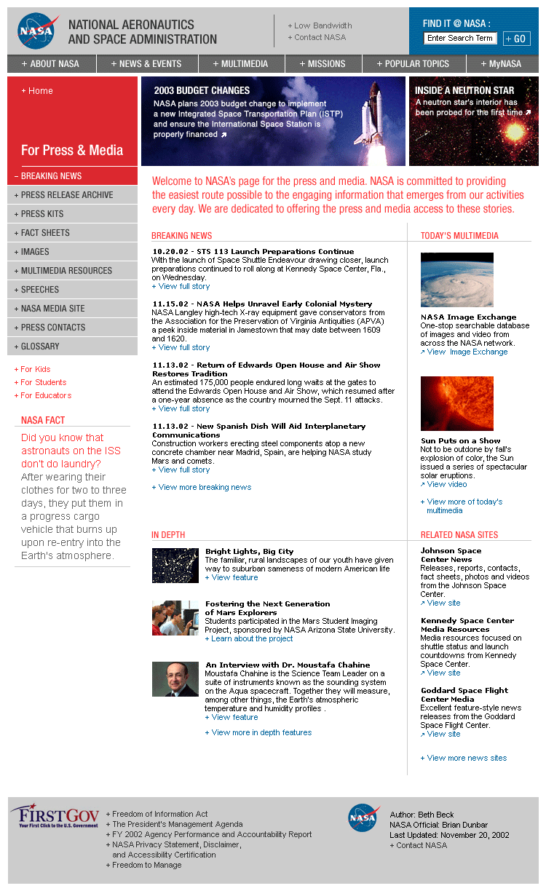
Figure 3.13.1 For Media and Press Landing Page (Note: There have been left navigation changes. Please refer to the detailed descriptions below for left navigation pages.)

3.13.1 For Media and Press Breaking News (Landing Page)

Objective
To provide the necessary resources to the Media and Press seeking information on a specific topic, in advance of and/or following up on a NASA story.

Description
Two Promotional Banners highlight the biggest events/news from NASA, as well as compelling resources for the Media and Press.

Five revolving Breaking News items (most recent at the top) showcase the latest news releases from the Agency. When a new release is added, the most dated item will move to the News Archive.

Three In-Depth Features (most recent at the top) offer a more intuitive look at NASA news. Content must be either an article with multiple high quality visuals or accompanying multimedia (not just a press release). When a new Feature is added, the most dated item will move to an In-Depth Archive.

Two Related Multimedia items (most recent at the top) will showcase the most engaging multimedia content appropriate for the Media and Press that is available, and can directly relate to one of the published banners or features. When a new multimedia item is added, the most dated multimedia piece will move to a Media and Press Related Multimedia Archive.

Related NASA Sites will provide links to three NASA sites (most recent at the top) of interest to the Media and Press. When a new site is added, the most dated will move to a Media and Press Related NASA Sites Archive.

NASA Fact will highlight a little-known piece of trivia or fact about recent NASA news, or about the resources the Agency has in place for the Media and Press.

Content Examples
Promotional Banners: “Space Shuttle Columbia: The latest on the investigation”

Breaking News: “$135 million awarded to continue Space Launch Initiative work” press release

In-Depth: “Looking for a planet? Search NASA’s Planetary Photojournal” feature

Related Multimedia: “Sun puts on a show” video of solar eruptions

Related NASA Sites: “Kennedy Space Center media resources”

NASA Fact: “Reporters can participate in most press conferences from any NASA center. Check the NASA TV schedule of breaking news events for the latest.”

Update Frequency
Promotional Banners should be available for a minimum of two weeks.

Breaking News will be updated frequently, possibly several times a day. When a new piece is added, the most dated will move to the Press Release Archive.

In-Depth, Related Multimedia and Related NASA Sites should be available on the page for a minimum of one week, and no longer than six weeks before being archived.

NASA Fact should be updated on a monthly basis.

3.13.2 For Media and Press – Press Release Archive (Left Nav)

Detail page with archived press releases. Press releases should be categorized by month and year of release.

3.13.3 Press Kits (Left Nav)

Detail page with archived press kits. Press kits should be made available by month and year of release.

3.13.4 For Media and Press – Fact Sheets (Left Nav)

Detail page with archived fact sheets. Fact sheets should be categorized and made available by month and year of release.

3.13.5 For Media and Press – Images (Left Nav)

Direct link to the NASA.gov Image Gallery.
3.13.6 For Media and Press – Multimedia Resources (Left Nav)

Direct link to the Media and Press Related Multimedia Archive Page.

3.13.7 For Media and Press – Speeches (Left Nav)

Detail page with archived speeches. Speeches should be categorized and made available by month and year.

3.13.8 For Media and Press – Press Contacts

Detail page with NASA contacts for the Media and Press, at Headquarters and centers around the country

