Resources Available
From the Office of
Laboratory Animal Welfare

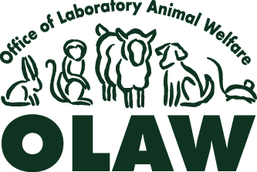

To request an item, send email to olaw@od.nih.gov . Your email should include your name, the title of the resource you want and a complete address. We will send the resource to the address you provide.

Users may request multiple copies of the following publications. Please specify the number of copies that you are requesting. If no quantity is specified, we will assume that your request is for one copy.
- PHS Policy on Humane Care and Use of Laboratory Animals, 2002
- What Investigators Need to Know About the Care and Use of Laboratory Animals, NIH Pub No. 06-6009

Users may request only one copy of the following resources:
- Guide for the Care and Use of Laboratory Animals, 1966, NRC
- ARENA/OLAW IACUC Guidebook, 2nd Edition, 2002
- Guidelines for the Care and Use of Mammals in Neuroscience and Behavorial Research, National Research Council [hard copy or CD]
- Resource Book for the Design of Animal Exercise Protocols, 2006, American Physiological Society
- Enrichment for Nonhuman Primates, 2005. Series of six books. Single copies of the set or single copies of individual books are available from OLAW.
  - Baboons, NIH Pub No. 05-5745
  - Capuchins, NIH Pub No. 05-5746
  - Chimpanzees, NIH Pub No. 05-5748
  - Macaques, NIH Pub No. 05-5744
  - Marmosets and Tamarins, NIH Pub No. 05-5747
  - Squirrel Monkeys, NIH Pub No. 05-5749
- Working Safely with Nonhuman Primates (CD)
- Working with the Laboratory Dog (CD)
- Training in Survival Rodent Surgery (CD)

Additional copies and foreign language versions may be purchased from http://www.nap.edu
Additional copies may be purchased from http://www.nap.edu
Additional copies may be purchased from http://www.the-aps.org/store/
Additional sets may be purchased from http://bookstore.gpo.gov (stock No. 017-040-0059-8)

