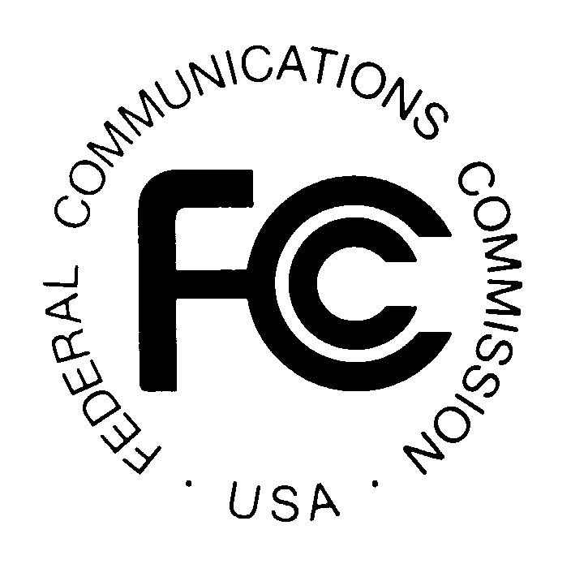PUBLIC NOTICE

News media information 202 / 418-0500
Fax-On-Demand 202 / 418-2830
TTY 202 / 418-2555
Internet: http://www.fcc.gov
ftp.fcc.gov

Federal Communications Commission
445 12th St., S.W.
Washington, D.C. 20554

REPORT NO: 0015 SPECIAL RELIEF AND SHOW CAUSE PETITIONS OCTOBER 5, 2001

Portions of this Public Notice have been produced by the Cable Services Bureau’s computer-based Data Management systems.
This Public Notice is intended to list only special relief requests, petitions for order to show cause and related petitions for reconsideration
or applications for review.

Parties seeking special relief are advised that such requests must be initiated through the special relief provisions of Section 76.7 of the Rules.
Many of these filings are subject to the pleading cycle rules set forth in Section 76.7, while others have their own pleading cycle relative to
the particular rule involved. Comments or oppositions concerning must carry complaints must be submitted within 20 days after the date of this
Notice, pursuant to Section 76.7(b)(1) . The time for filing replies is within 10 days after the opposition is submitted (see Section 76.7(c)(3) and
relevant rule sections).

Files containing these petitions can be reviewed in the Commissions Reference Information Center, CY-Level, 445 12th Street, SW Washington, DC 20554. The letter code following a CSR Number refers to the particular subject of the petition. Those currently in use are: A – ADI/DMA; M – must carry; E – effective competition; C – retransmission consent; P – program access; R – rate regulation; F – rate freeze; L – commercial leased access;
Z – technical; S – significantly viewed; N – nonduplication/syndicated exclusivity/sports deletion; D – small system definition; O – otard; and X – cross ownership. If no letter appears after the CSR number, the petition is considered to be in the miscellaneous category. Show cause petitions do not
have letter codes.

It is requested that all responses or statements refer to the CSR number assigned to the petition.

For further information about this Public Notice contact the Cable Services Bureau at (202) 418-7200.

REPORT NO: 0015 SPECIAL RELIEF AND SHOW CAUSE PETITIONS OCTOBER 5, 2001

CSR Number Petitioner Respondent Special Relief Request Communities Code

CSR-5744-M Christian Television of Echostar Communications West Palm Beach, Ft. Pierce, FL No Code Palm Beach County, Inc. Corp.
(WFGC-(TV)

CSR-5745-M Christian Television Network, Inc. Echostar Communications Nashville, TN No Code
(WHTN(TV)) Corp.

CSR-5746-M Christian Television Corporation Echostar Communications Tampa, St. Petersburg, No Code (WCLF-TV) Corp. Sarasota, FL

CSR-5747-M Good Life Broadcasting, Inc. Echostar Communications Orlando, Daytona Beach, No Code (WLCB-TV) Corp. Melbourne, FL

CSR-5748-M Good Life Broadcasting, Inc. Echostar Communications Orlando, Daytona Beach, No Code (WTGL-TV) Corp. Melbourne, FL

CSR-5749-M Entravision Holdings, LLC DirecTV, Inc. Washington, DC No Code
(WJAL(TV))

CSR-5750-M West Virginia Educational Echostar Communications Pittsburgh, PA No Code Broadcasting Authority Corp.
(WNPB-TV)

CSR-5751-M Brunson Communications, Echostar Communications Philadelphia, PA No Code Inc. Corp.
(WGTW)

CSR-5752-M Entravision Holdings, LLC DirecTV, Inc. Orlando, FL No Code
(WVEN(TV))

CSR-5753-M KVMD Acquisition Corp. DirecTV, Inc. Los Angeles, CA No Code

REPORT NO: 0015 SPECIAL RELIEF AND SHOW CAUSE PETITIONS OCTOBER 5, 2001

CSR Number Petitioner Respondent Special Relief Request Communities Code

CSR-5754-M LESEA Broadcasting Corporation Echostar Communications Denver, CO No Code (KWHD(TV)) Corp.

CSR-5755-M LESEA Broadcasting Corporation Echostar Communications Indianapolis, IN No Code
(WHMB-TV) Corp.

CSR-5756-A Frontier Vision Operating WYDN-TV Gloucester and Amesbury, No Code
Partners L.P. d/b/a MA et al.
Adelphia Cable Communications

REPORT NO: 0015 SPECIAL RELIEF AND SHOW CAUSE PETITIONS OCTOBER 5, 2001

CSR Number Applicant Community Type Date Code

CSR-5690-M Ranchos Palos Moorpark, CA et al Partial Recon. 9/27/01 No Code
Verdes Broadcasters
(KRPA)

CSR-5692-M Ranchos Palos Sun City & Ridgecrest, CA Recon. 9/26/01 No Code
Verdes Broadcasters
(KRPA)

-FCC-

