ZOMETA® (Zoledronic acid for injection)

ONCOLOGIC DRUGS ADVISORY COMMITTEE
BRIEFING DOCUMENT

Date of Meeting: January 31, 2002

NDA # 21-386
Treatment of bone metastases

Version: Final

Release date: January 3, 2002

AVAILABLE FOR PUBLIC DISCLOSURE WITHOUT REDACTION.
Summary
Many forms of cancer can originate in or metastasize to bone. Cancers that involve bone can cause a variety of skeletal problems for patients, ranging from pain to fractures to spinal cord compression. The majority of patients living with bone metastases have breast cancer or prostate cancer (since these cancers are common in our population, frequently metastasize to bone, and are often associated with a relatively longer survival than other cancers following metastasis to bone). Other cancers associated with frequent metastasis to bone include lung cancers, renal cancer, melanoma and thyroid cancer. Bone complications are also common in patients with multiple myeloma, a hematologic malignancy that originates in bone. In the US, it is thought that over 250,000 patients are living with bone metastasis at any time.
Damage to bone by cancer can result from direct effects of tumor growth (replacing/weakening the bone and/or compromising adjacent structures) and from indirect effects mediated by factors released by the tumor (which may promote osteoclast resorption of bone or abnormal bone growth/remodeling). Effective systemic anticancer treatments can control tumor growth which, for a time, may stem the bony destruction with improvement in related signs and symptoms. Unfortunately, many types of cancer that involve bone are poorly responsive to current antineoplastic treatments. Patients with this diagnosis may often suffer from morbid skeletal events, requiring palliative treatments such as pain medication, radiation therapy, or surgery. These palliative treatments have their own limitations and potential for adverse consequences, and patients may be left with significant disability and loss of mobility and independence
An alternative approach to control bone damage due to cancer has been to utilize intravenous bisphosphonate therapy to block tumor-stimulated osteoclast activity. Aredia® (pamidronate disodium for injection) is marketed for treatment of patients with multiple myeloma or breast cancer metastatic to bone, where it has been shown to delay or reduce the occurrence of skeletal-related morbid events. The utility of bisphosphonate treatment in reducing skeletal-related morbid events in patients with other forms of cancer has not previously been established, and there is no U.S.-approved bisphosphonate treatment for these patients. In particular, prospective studies in prostate cancer failed to detect a beneficial effect of Aredia on skeletal-related events (1). It is nonetheless anticipated that effective inhibition of osteoclast activity should have beneficial effects regardless of tumor type, since excessive osteoclast activity plays a central role in the pathophysiology of all (osteolytic, mixed, and osteoblastic) malignant bone lesions. The magnitude of the observed benefit, however, may depend on many factors, including the potency of the bisphosphonate, the types and levels of osteoclast-activating factors elaborated by different tumor types, and the biology of the patient’s disease in other tissues (with competing causes of early morbidity/mortality in patients with rapid disease progression in other tissues).
Intravenous bisphosphonates are generally well tolerated and can be administered safely to patients with a variety of advanced tumor types. The most commonly noted side effect is a transient flu-like syndrome characterized by fever, arthralgias, myalgias, and chills. Nausea, fatigue, and headache are among the other more common adverse events. Bisphosphonate administration may also be associated with impairment of renal function, a complication that may be related to complexes between bisphosphonate and minerals in the kidneys. Elevation of serum creatinine and (rarely) renal failure may occur in some patients. Risk factors are believed to include insufficient hydration of the patient, rapid infusion, and higher bisphosphonate dosages.
ZOMETA (Zometa for infusion, Novartis Pharmaceuticals Corporation, East Hanover, NJ) is a new-generation bisphosphonate that was selected for clinical development based on its high pharmacological potency. In previous clinical trials, Zometa has been shown to be superior to Aredia in the treatment of hypercalcemia of malignancy, providing a higher response rate and longer response duration. Zometa is registered worldwide for this indication (2,3).
The Zometa clinical development program is the largest and most comprehensive bisphosphonate clinical trial program conducted to date in patients with malignancies involving the skeletal system. The study designs and clinical endpoints were discussed with the FDA prior to the start of the clinical trials discussed The clinical trials reported in this application evaluated Zometa versus Aredia in patients with multiple myeloma or breast cancer metastatic to bone (study 010). Zometa was compared with placebo in patients with prostate cancer (study 039) and lung cancer or other solid tumors (study 011) metastatic to bone. The study data are consistent in demonstrating a clinical benefit for Zometa in delaying and reducing the occurrence of skeletal related events (SREs) for the broad range of tumor types studied. The primary analyses compared the proportions of patients who experienced any SRE in the respective arms of each study. Analyses of the time to first SRE and recurrence rate of SREs over time on study (secondary analyses of this primary endpoint) provided further support for Zometa effectiveness across all tumor types studied.
Overall, no significant efficacy differences were observed between 4 mg and 8 mg Zometa doses in these studies, suggesting that the 4 mg dose is sufficient to provide maximal effectiveness. Renal safety concerns resulted in a decision to increase the Zometa administration time from 5 minutes (in the original study protocols) to 15 minutes. Over the course of these studies, the 8 mg dose was associated with an increased incidence of creatinine elevations, and in the later stages of this research all 8 mg Zometa patients were converted to the 4 mg dose. The safety profile of Zometa 4 mg administered over 15 minutes is comparable to that of Aredia. The incidence of serum creatinine elevations in patients receiving Zometa 4 mg over 15 minutes was similar to that seen with administration of Aredia 90 mg over 2 hours in breast cancer and multiple myeloma patients and was similar to that seen with placebo in prostate cancer patients. It was only slightly greater than that seen with placebo in the other solid tumor patients. Finally a practical benefit associated with Zometa is the short 15 minute infusion time compared with the 2-4 hours required to administer Aredia to breast cancer or multiple myeloma patients.
In conclusion, the studies provided in this application demonstrate the safety and effectiveness of Zometa 4 mg infused over 15 minutes (repeated at 3-4 week intervals) to delay or reduce the occurrence of skeletal-related events in patients with cancer metastatic to bone or multiple myeloma. The results were consistent in that both Zometa treatment arms in all three protocols reduced the proportion of patients having at least one SRE. This reflects the benefit patients receive by having a longer initial period free of skeletal complications, and by having fewer additional complications over time.

Table of Contents
1 Background 10
1.1 Clinical consequence of skeletal related events 10
1.2 Pathophysiology 10
1.3 Overview of Zometa 11
2 Clinical Pharmacokinetics and Metabolism 12
2.1. Clinical pharmacology studies 12
2.2. Metabolism and drug-drug interactions 14
2.3. Pharmacokinetics in renal impairment 14
3 Use in Hypercalcemia of Malignancy 15
3.1 Efficacy in HCM 15
3.2 Safety in HCM 15
4 Phase II Trial in treatment of bone metastases 15
4.1 Efficacy 16
4.2 Safety 16
5 Phase III Trials 16
5.1 Study Design 16
5.2 Breast cancer and multiple myeloma – Aredia-controlled trial (010) 25
5.2.1 Patient disposition 25
5.2.2 Demographics and disease characteristics 25
5.2.3 Primary efficacy analysis 27
5.2.4 Secondary skeletal endpoints analyses 28
5.2.5 Analysis of Other Endpoints 30
5.2.6 Survival 32
5.2.7 Efficacy Summary (breast cancer / multiple myeloma) 33
5.3 Prostate Cancer – Placebo-controlled trial (039) 34
5.3.1 Patient Disposition 34
5.3.2 Demographic and Disease Characteristics 35
5.3.3 Primary efficacy analysis 36
5.3.4 Secondary skeletal endpoint analyses 37
5.3.5 Analyses of Other Endpoints 39
5.3.6 Survival 40
5.3.7 Efficacy Summary (prostate study) 41
5.4 Lung Cancer and Other Solid Tumors – Placebo-Controlled Trial (011) 43
5.4.1 Patient Disposition 43
5.4.2 Demographics and Disease Characteristics 43
5.4.3 Primary efficacy analysis 45
5.4.4 Secondary skeletal endpoint analyses 46
5.4.5 Analyses of Other Endpoints 49
5.4.7 Efficacy Summary (other solid tumors) 51
6 Phase III Studies – Safety 53
6.1 Adverse Events 53
6.1.1 Overall Incidence in Phase II/III bone metastases studies 53
6.1.2 Grade 3 and 4 Adverse Events 54
6.1.3 Serious Adverse Events 56
6.2 NCI Grade 3 and 4 Laboratory Abnormalities 56
6.3 Renal Effects 58
6.3.1 Renal Adverse Events in Phase II/III Bone Metastases Studies 58
6.3.4 Grade 3 and 4 Creatinine Values 60
6.3.5 Renal Function Deterioration – Advisory Board Criteria 61
6.3.6 Time to Creatinine Increase 62
6.4 Deaths 67
6.4.1 Primary Cause of Death 67
7. Summary of Safety 68
8. Summary of Effectiveness 68
9. Benefit-Risk Assessment 71
10. Overall Conclusion 72
11. References 73
ATTACHMENT 1: COMPOSITION OF DATA SAFETY MONITORING BOARD (DSMB) 75
ATTACHMENT 2: COMPOSITION OF RENAL ADVISORY BOARD (RAB) 76
ATTACHMENT 3: 77
PROPOSED ZOMETA LABELING (including HCM) 77

List of tables
Table 2-1. Human pharmacokinetic studies 12
Table 5-1. Overview of Phase III studies 17
Table 5-2. Efficacy parameters used in Phase III studies 20
Table 5-3. Patient disposition by treatment group, Aredia-controlled trial 25
Table 5-4. Baseline demographic characteristics – Aredia-controlled trial – ITT population 26
Table 5-5. Baseline disease characteristics of multiple myeloma patients 26
Table 5-6. Baseline disease characteristics of breast cancer patients 27
Table 5-7. Proportion of patients with SREs, multiple myeloma and breast cancer 28
Table 5-8. Time to the first SRE up to Month 13 (Median and hazard ratio), multiple myeloma and breast cancer 29
Table 5-9. Multiple-event analysis of time to SRE up to Month 13, multiple myeloma and breast cancer (010) 30
Table 5-10. Mean/Median changes from baseline in quality of life scores at Month 13 by treatment group 31
Table 5-11. Time to progression of disease up to Month 13, multiple myeloma and breast cancer 31
Table 5-12. Best bone lesion response up to Month 13, multiple myeloma and breast cancer 32
Table 5-13. Summary of median survival (days) by stratum and treatment group 32
Table 5-14. Summary of analysis of skeletal related events in Study 010 (Breast Cancer and Multiple Myeloma) 34
Table 5-15. Patient disposition – prostate cancer study 35
Table 5-16 Demographics in prostate cancer patients – ITT population 35
Table 5-17. Baseline characteristics in prostate cancer patients (ITT population) 36
Table 5-18. Proportion of patients with prostate cancer with an SRE up to Month 15 37
Table 5-19. Time to the first SRE up to Month 15 in prostate cancer patients 38
Table 5-20. Skeletal morbidity rate (risk set definition) of any SRE (-HCM) up to Month 15 38
Table 5-21. Multiple-event analysis of time to SRE up to Month 15 in prostate cancer patients (039) 39
Table 5-22. Summary of time to progression of disease at Month 15 in prostate cancer patients 40
Table 5-23. Frequency distribution of best response by treatment group 40
Table 5-24. Summary of median survival (days) by stratum and treatment group 41
Table 5-25. Summary of analysis of skeletal related events in Study 039 (Prostate cancer) 42
Table 5-26. Patient disposition, lung cancer and other solid tumors (011) 43
Table 5-27. Demographic characteristics by treatment group, Study 011 (ITT population) 44
Table 5-28. Baseline disease characteristics in patients with lung cancer or other solid tumors (011) 45
Table 5-29. Proportion of patients with lung cancer or other solid tumors having any SRE (011) 46
Table 5-30. Time to first SRE in patients with lung cancer and other solid tumors (011) 47
Table 5-31. Skeletal morbidity rate of any SRE in patients with lung cancer and other solid tumors (011) 48
Table 5-32. Proportion of patients with lung cancer or other solid tumors having any SRE (+HCM) 48
Table 5-33. Multiple-event analysis of time to SRE up to Month 9 in patients with lung cancer and other solid tumors (011) 49
Table 5-34. Time to progression of disease in patients with lung cancer and other solid tumors (011) 50
Table 5-35. Frequency distribution of best bone lesion response (011) 50
Table 5-36. Summary of median survival (days) by stratum and treatment group 51
Table 5-37. Summary of analysis of skeletal related events in Study 011 (Lung cancer and other solid tumors) 52
Table 6-1. No. (%) of patients with most frequent adverse events (≥ 15%) – Phase II/III studies 54
Table 6-2. No. (%) of patients with grade 3 or 4 AEs (≥ 5%) – Phase II/III studies 55
Table 6-3. No (%) of patients with SAEs (≥ 5%) – Phase II/III Studies 56
Table 6-4. No. (%) of patients with grade 3 or 4 serum chemistry values – Phase II/III studies 57
Table 6-5. No. (%) of patients with grade 3 or 4 hematology laboratory abnormalities – Phase II/III bone metastases studies 58
Table 6-6. No. (%) of patients with AEs (≥ 1%) of the renal and urinary system – pre-15-minute infusion amendment 59
Table 6-7. No. (%) of patients with AEs (≥ 1%) of the renal and urinary system – post-15-minute infusion patients 60
Table 6-8. No. (%) of patients with grade 3 or 4 serum creatinine values pre- and post-15-minute infusion amendment – Phase II/III bone metastases studies 61
Table 6-9. No. (%) of patients with notable serum creatinine values pre- and post-15-minute infusion amendment – Phase II/III bone metastases studies 62
Table 6-11. Primary causes of death (by body system) in Phase II/III studies 67
Table 8-1. Proportion of patients with one or more SREs (Phase III trials, primary analyses) 69
Table 8-2. Median Time to first SRE (Phase III trials) 69
Table 8-3. Skeletal Morbidity Rate (rate of SREs over time, Phase III studies) 70
Table 8-4. Risk ratios compared to control, Multiple Event Analyses of SREs (Phase III studies) 70

List of figures
Figure 2-1. Mean Zometa plasma concentrations over 4 hours (left panel) and 24 hours (right panel) 13
Figure 2-2. Relationship between the renal clearance of Zometa (Clr) and creatinine clearance (CLcr) in 64 patients in 3 clinical pharmacology studies 14
Figure 5-1 Individual SREs in breast/myeloma patients 28
Figure 5.2 Mean skeletal morbidity rate by treatment group 29
Figure 5-3. Kaplan-Meier curve of survival by treatment group 33
Figure 5-4. Individual SREs in patients with prostate cancer 37
Figure 5-5. Kaplan-Meier curve of survival by treatment group 41
Figure 5-6. Individual SREs in patients with lung cancer or other solid tumors 47
Figure 5-7. Kaplan-Meier curve for survival by treatment group 51
Figure 6-1. Kaplan-Meier curve for time to the first renal function deterioration by treatment group for the pre 15-minute infusion Amendment patients (Protocol 010, Safety evaluable patients) 64
Figure 6-2. Kaplan-Meier curve for time to the first renal function deterioration by treatment group for the post 15-minute infusion Amendment patients (Protocol 010, Safety evaluable patients) 64
Figure 6-3. Kaplan-Meier curve for time to the first renal function deterioration by treatment group for the pre 15-minute infusion Amendment patients (Protocol 011, Safety evaluable patients) 65
Figure 6-4. Kaplan-Meier curve for time to the first renal function deterioration by treatment group for the post 15-minute infusion Amendment patients (Protocol 011, Safety evaluable patients) 65
Figure 6-5. Kaplan-Meier curve for time to the first renal function deterioration by treatment group for the pre 15-minute infusion Amendment patients (Protocol 039, Safety evaluable patients) 66
Figure 6-6. Kaplan-Meier curve for time to the first renal function deterioration by treatment group for the post 15-minute infusion Amendment patients (Protocol 039, Safety evaluable patients) 66

Glossary of Abbreviations and Definition of Terms

AE | Adverse Event
ANCOVA | Analysis of covariance
ANOVA | Analysis of variance
b.i.d. | Bis in diem/Twice daily
BMD | Bone mineral density
BP | Bisphosphonate
BPI | Brief Pain Inventory (composite score)
CMH | Cochran-Mantel Haenszel
CR | Complete response
CRF | Case report form
DSMB | Drug Safety Monitoring Board
ECOG | Eastern Cooperative Oncology Group
FACT-G | Functional Assessment of Cancer Therapy-General
GLM | General linear model
HCM | Hypercalcemia of malignancy (also known as TIH)
IEC | Independent Ethics Committee
IMN | International Medical Nomenclature
IRB | Institutional Review Board
ISE | Integrated Summary of Efficacy
ISS | Integrated Summary of Safety
ITT | Intent-to-treat (population)
i.v. | intravenous
KM | Kaplan-Meier
NDA | New Drug Application
NSLC | Non - small cell lung cancer
o.d. | Omni die/once per day
OST | Other solid tumor
pam | Pamidronate (Aredia)
p.o. | Per os/by mouth/orally
PSA | Prostate specific antigen
QOL | Quality of life
RAB | Renal Advisory Board
SAE | Serious Adverse Event
SMR | Skeletal-morbidity rate
SOP | Standard operating procedures
S.D. | Standard deviation
SRE | Skeletal-related event
SRE (- HCM) | Skeletal-related events excluding HCM
SRE (+ HCM) | Skeletal-related events including HCM
TIH | Tumor-induced hypercalcemia (also known as HCM)
WHO | World Health Organization
ZOL | Zometa (ZOMETA)

1 Background

1.1 Clinical consequence of skeletal related events
In patients with advanced cancer, the events defined as Skeletal Related Events (SREs) are the clinical complications of bone metastases. The time that is necessary to treat these complications and the additional pain and suffering subtract from the time in which a patient can live free from symptoms and independent of additional medical care.
Many SREs are related to pathological fractures. A pathological fracture can occur in bone that has been eroded by a bone metastasis, to the point that a slight trauma is sufficient to break the bone, cause pain, loss of mobility and the need for possible surgical intervention. If the metastasis has eroded into the structure of a vertebra, the vertebral body may collapse. The resulting tissue mass may bulge inward, into the spinal canal, and compress the spinal cord, leading to paralysis below the level of the fracture, a devastating complication. Fractures are generally painful and require analgesic medication to treat pain. Pathological fractures will not heal spontaneously when immobilized, unlike traumatic fractures. Therefore, most patients will require additional procedures, such as orthopedic surgery, for curettage of the malignant tissue and to insert a metallic rod or plate to immobilize the bone and reduce pain.
A course of radiotherapy may be administered as part of the treatment of a pathological fracture. Localized radiotherapy may eradicate the tumor tissue in a bone metastasis and is used to prevent pathological fractures, including the collapse of a vertebra, when a significant amount of bone has been destroyed by cancer. Radiotherapy is also used to treat bone pain due to bone metastases, but frequently entails daily visits to a radiotherapy department for two to three weeks. The need to undergo radiotherapy is therefore a significant burden on a patient. Radiotherapy itself may lead to osteopenia with the increased risk of new fractures.
Hypercalcemia of malignancy is often a late complication of cancer. Symptoms include nausea, vomiting, dehydration, weakness and coma, culminating in death. Emergency treatment at a clinic is required, which again subtracts from the time a patient has free from the need for additional medical care. Finally, even though a change in antineoplastic therapy to treat bone pain appears to be of lesser significance compared to other SREs, it means to the patient that their cancer is advancing and may have a large psychological impact.
Each of these SREs is a serious debilitating event to anyone with cancer, threatening their independence and requiring additional medical treatment. Psychologically, an SRE is another reminder to the patient of the fact that she or he must deal with cancer. The ability to postpone any of these events leads to a longer time for the patient to be free from the complications of bone metastases, which together with the reduction in the rate of subsequent events, results in a lower proportion of patients suffering from these SREs.

1.2 Pathophysiology
The osteoclast is thought to be the final common pathway in the pathophysiology of bone metastases. Osteoclasts are specialized bone cells which erode mineralized bone by secreting acids and lysosomal enzymes. The lytic bone destruction associated with malignancy develops because tumor cells synthesize and release soluble factors that stimulate osteoclasts to resorb bone (4,5,6). The osteoclastic activating factors released by tumor cells include parathyroid hormone-related peptide (PTHrP), growth factors, and cytokines (7-10). The activation of osteoclasts is revealed by the increase in urinary NTX/creatinine ratio seen in patients with osteolytic bone metastases. The same assay reveals that the highest levels of osteoclast activation occur in prostate cancer patients who have predominantly osteoblastic bone metastases(11).
In patients with malignant bone lesions, the activation of osteoclasts results in disruption of normal bone remodeling so that the equilibrium between bone resorption and bone formation is shifted towards increased bone resorption. Thus, the predominant role of the osteoclast in the pathogenesis of bone destruction and the inhibitory effects of bisphosphonates on osteoclast function have formed the rationale for the use of bisphosphonates in the treatment of osteolytic bone metastases. The common role, regardless of tumor type, of osteoclasts as mediators of bone destruction in metastatic skeletal disease is indicated by the effectiveness of bisphosphonates in the therapy of hypercalcemia of malignancy arising from any type of cancer (12-16).
Bisphosphonates are effective inhibitors of bone resorption, and have the potential to delay or reduce the occurrence of SREs in patients with malignant bone lesions. Aredia® (pamidronate), given in addition to standard anticancer therapy, is the only bisphosphonate currently approved in the United States (U.S.) for the treatment of patients with multiple myeloma or bone metastases from breast cancer. Studies which established the current standard of care have shown that therapy with the bisphosphonate pamidronate (Aredia®) combined with anti-neoplastic therapy significantly reduces the proportion of patients having skeletal complications due to the lytic bone disease associated with multiple myeloma and breast cancer compared to anti-neoplastic therapy alone (17,18). The new Zometa trials reported here have improved on the clinical and statistical methodologies that had been employed in the original phase III program demonstrating the efficacy of Aredia in breast cancer and multiple myeloma. For example the methodology for assessment of skeletal related events was more conservative than in the Aredia program, taking into account newer statistical insights which avoid overcounting events.
The established safety profile of intravenous bisphosphonates includes transient acute phase reactions (fever, arthralgias, myalgias, lymphopenia), injection site reactions (erythema, swelling, and/or induration), and renal insufficiency (19,20,21).

1.3 Overview of Zometa
Zometa is a third generation bisphosphonate, 2-(imidazol-l-yl-hydroxyethane-1, 1-bisphosphonic acid), characterized by a side chain consisting of an imidazole ring group. Zometa, a more potent inhibitor of osteoclasts than earlier bisphosphonates, has the largest in vitro therapeutic ratio between the desired inhibition of bone resorption and the unwanted inhibition of normal mineralization of all the bisphosphonates. It can be infused over a shorter time (15 minutes rather than 2 hours) than Aredia. Zometa is approved worldwide for treatment of hypercalcemia of malignancy; in the U.S., the NDA for this use of Zometa was approved on August 20, 2001 [see Attachment 3, Proposed Product Labeling for Zometa® (including HCM)].
This briefing document presents the results of an extensive program of clinical pharmacology, phase II, and phase III trials, which have examined the use of Zometa as a treatment for patients with myeloma or with bone metastases due to a broad range of cancer types. These data provide the basis of a supplemental NDA for the use of Zometa in a new indication, treatment of patients with myeloma or with cancer metastatic to bone.

2 Clinical Pharmacokinetics and Metabolism

2.1. Clinical pharmacology studies
The pharmacokinetics of Zometa were derived from plasma and urine Zometa concentrations determined by specific radioimmunoassay in 64 cancer patients with bone metastases in three studies, J001, CZOL446D 0503, and CZOL446E 0506 (Table 2-1).

Table 2-1. Human pharmacokinetic studies
Study | Study Objective | Zometa doses | Pharmacokinetic evaluations
J001  (Japan) | PK/PD in patients with bone metastases | 2 mg, 5 min.  4 mg, 5 min.  8 mg, 5 min. | Plasma and quantitative urine sampling 0-48 h post dose on day 1 (1st infusion).
CZOL446D 0503  (USA) | PK/PD in patients with bone metastases | 4 mg, 5 min.  4 mg, 15 min.  8 mg, 15 min.  16 mg, 15 min. | Plasma and quantitative urine sampling 0-24 h post dose on days 1, 29, and 57 (1st, 2nd, 3rd infusion); blood and spot urine days 8, 15, 29 post dose.
CZOL446E 0506  (USA and Canada) | PK/PD in patients with bone metastases and differing degrees of renal function  ADME in patients with normal renal function | 4 mg, 15 min. | Plasma and quantitative urine sampling 0-72 h post dose day 1 (1st inf.), and 0-24 h post dose days 29 and 57 (2nd and 3rd inf.); blood and spot urine days 8, 15, 36, 43, 64, 71, and 85.  ¹⁴C-Zometa plasma, blood, and urine samples were obtained on days 1, 2,3, 8, 15, 29, 36, 43, 57, 64, 71, and 85.

The pharmacokinetics of Zometa were consistent across the three studies, demonstrating an overall pattern similar to that of other bisphosphonates. After initiating the infusion of Zometa, the plasma concentrations of drug rapidly increased, achieving their peak at the end of the infusion period, followed by a rapid, multiphasic decline to <1% of peak after 24 hours post end infusion. The rapid decline of Zometa plasma concentrations is illustrated in Figure 2-1, which shows the mean concentration data after a single 4 mg dose infused over 15 minutes, in three groups of cancer patients with normal, mild, and moderate to severe renal impairment (study CZOL446 0506).

Figure 2-1. Mean Zometa plasma concentrations over 4 hours (left panel) and 24 hours (right panel)
Cartesian plot showing rapid decline of Zometa early post infusion | Semi-logarithmic plot showing prolonged low concentrations at later timepoints
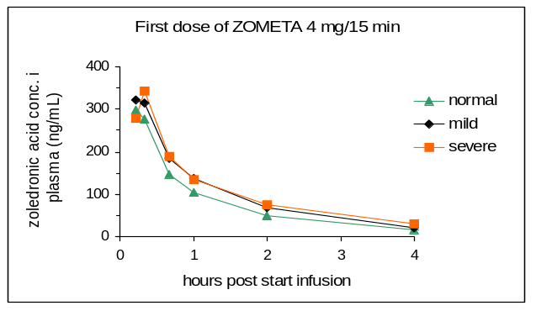 | 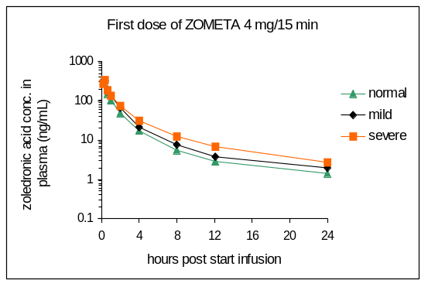
After the steep, about 100-fold decline in the plasma concentration within the first 24 hours post-drug administration, which is characterized by population half-lives of t_{½α} = 0.24 hours and t_{½β} = 1.87 hours, there was a long period of detectable Zometa in plasma characterized by t_{½γ} = 146 hours. This pattern of early and rapid decline in plasma drug concentration, followed by a prolonged period of very low concentrations results from the injected drug either rapidly binding to osseous tissue or being removed by renal excretion. The very low Zometa concentrations in plasma at later timepoints presumably represent the small amounts of drug continually released from bone into the systemic circulation during the remodeling process.
The pharmacokinetics of Zometa assessed by AUC_{(0-24h)} were dose proportional within the dose range of 2 to 16 mg. The accumulation of Zometa following the repetitive 28-day dosing schedule was low. There was no evidence of dose or cycle effect on accumulation properties of Zometa over the three administrations of Zometa studied. Increasing the infusion period from 5 minutes to 15 minutes had no statistically significant effect on the drug exposure (area under the plasma concentration vs. time curve), but as expected lowered the peak Zometa concentration by about 30% (CZOL446D 0503).
Generally, between 10% to 65% of Zometa is excreted in urine within 24 hours post infusion. Based on the average (±s.d.) estimate from all 64 patients evaluated in the clinical pharmacology studies, a total of 39 ± 16% of the administered dose is excreted in the urine within 24 hours. The remainder is retained in the body, subject to slow release from bone governed by the rate of bone remodeling.
The renal clearance of Zometa is significantly positively correlated and proportional to the creatinine clearance, as would be expected for this renally excreted drug (see Figure 2-2).

Figure 2-2. Relationship between the renal clearance of Zometa (Clr) and creatinine clearance (CLcr) in 64 patients in 3 clinical pharmacology studies
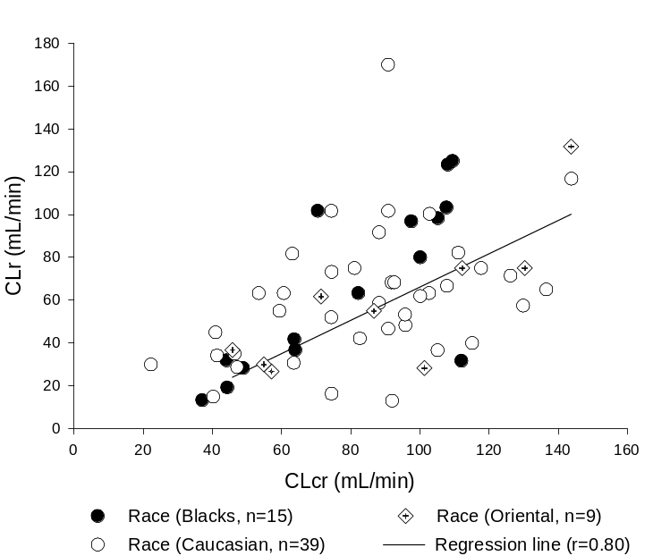As

2.2. Metabolism and drug-drug interactions
Data from a study using ¹⁴C labeled Zometa (4 patients in CZOL446E 0506) showed that Zometa is not metabolized and is eliminated by renal excretion.
No specific clinical drug-drug interaction studies have been conducted with Zometa. Since Zometa is not metabolized in humans and the drug was found to have little or no capacity as a direct acting and/or irreversible metabolism-dependent inhibitor of P450 enzymes in vitro, Zometa is unlikely to reduce the metabolic clearance of drugs of drugs which are metabolized via the cytochrome P-450 enzyme systems.
Zometa is not highly bound to human plasma proteins (56% bound) and binding is concentration independent. Therefore, interactions resulting from displacement of highly protein-bound drugs are unlikely.

2.3. Pharmacokinetics in renal impairment
There are no relevant differences in exposure to Zometa between renally impaired patients and patients with normal renal function (study CZOL446E 0506), evidenced by similar concentration versus time profiles in plasma (see Fig. 2-1), and no changes in the ratio of renal clearance to creatinine clearance. In patients mild renal impairment, and moderate to severe renal impairment, the AUC_{(0-24h)} was increased by 26-37%, and 27-41%, respectively. Cmax was increased by 11-15% and 0-17%, respectively, compared to patients with normal renal function. The increases in AUC and Cmax were the same after the first, or after subsequent doses (every 28 days) of Zometa. The small increase in systemic exposure, and lack of accumulation of drug with multiple doses irrespective of renal function, suggest that dose adjustments of Zometa in mild (Cl_{cr}=50-80mL/min) and moderate renal impairment (Cl_{cr}=30-50mL/min) are not necessary. As only limited data are available in severe renal impairment (creatinine clearance <30 mL/min), no dosing recommendations are possible for this population.

3 Use in Hypercalcemia of Malignancy
Two identical multicenter, randomized, double-blind, double-dummy studies of Zometa 4 mg or 8 mg given as a 5-minute intravenous infusion or pamidronate 90 mg given as a 2-hour intravenous infusion were conducted in 287 patients with hypercalcemia of malignancy (HCM). This was the largest HCM clinical program ever done.
In these studies, HCM was defined as a corrected serum calcium (CSC) concentration of ≥ 12.0 mg/dL (3.00 mmol/L). The primary efficacy variable was the proportion of patients having a complete response, defined as the lowering of the CSC to ≤ 10.8 mg/dL (2.70 mmol/L) within 10 days after drug infusion.

3.1 Efficacy in HCM
The two multicenter HCM studies were combined in a pre-planned analysis to assess the effects of Zometa versus those of pamidronate. The proportions of patients that had normalization of corrected serum calcium by Day 10 were 88% and 70% for Zometa 4 mg and pamidronate 90 mg, respectively (P=0.002). Median time to relapse of HCM was significantly longer with Zometa 4 mg vs pamidronate 90 mg (30 vs 17 days P<0.001). Thus Zometa is superior to pamidronate in the treatment of HCM, in the normalization of serum calcium and time to relapse. These endpoints are clinically meaningful in that more patients will recover quickly and early relapse is less likely. In these studies, no additional efficacy benefit was seen for Zometa 8 mg over Zometa 4 mg.

3.2 Safety in HCM
Adverse reactions to Zometa® (Zoledronic acid for injection) in these trials were usually mild and transient and similar to those reported for other bisphosphonates. Intravenous administration has been most commonly associated with fever. Occasionally, patients experience a flu-like syndrome consisting of fever, chills, bone pain and/or arthralgias, and myalgias. Gastrointestinal reactions such as nausea and vomiting have been reported following intravenous infusion of Zometa. Local reactions at the infusion site, such as redness or swelling, were observed infrequently. In most cases, no specific treatment was required and the symptoms subsided after 24-48 hours.
Grade 3 or 4 creatinine values were reported in 2 (2.3%), 5 (5.2%), and 4 (4.0%) of patients in the Zometa 4 mg, Zometa 8 mg, and Aredia 90 mg groups, respectively.

4 Phase II Trial in treatment of bone metastases
A phase II dose ranging trial was performed. This study was a randomized, double-blind, double dummy, parallel group trial in 280 patients aged at least 18 years with metastatic breast cancer or multiple myeloma with at least one osteolytic lesion (confirmed on plain film X-ray). For patients with multiple myeloma, the study eligibility criteria specified that patients must have had a previous skeletal event or must have experienced failure of first-line chemotherapy. All patients had to have ECOG performance scores of 0, 1 or 2. Patients received either 0.4 mg, 2 mg, or 4 mg Zometa administered as 5-minute infusions, or Aredia 90 mg given as a 2-hour i.v. infusion every 3-4 weeks for 9 months.

5 Efficacy
The primary efficacy endpoint was the proportion of patients receiving radiation to bone. This endpoint was selected based on data from the pamidronate breast cancer and multiple myeloma studies. Radiation therapy to bone was consistently affected in the pamidronate treatment arms in these studies. This consistent efficacy effects was seen throughout the course of these trials. The secondary parameters used in this trial were similar to the primary and secondary endpoints (proportion of patients with SREs, time to first SRE and rate of SREs/time). This study is part of an overall Zometa clinical trial program culminating in larger Phase III trials in cancer patients with metastatic bone disease. Of the three Zometa doses evaluated here, 0.4 mg was clearly ineffective compared with Zometa at doses of 2.0 mg to 4.0 mg and pamidronate at 90 mg. Although results for the primary efficacy criterion were similar for the 2.0- and 4.0-mg doses of Zometa, several trends in the secondary efficacy parameters favor the 4.0-mg Zometa dose. Skeletal events as a whole and pathologic fractures occurred slightly less frequently in patients treated with 4.0 mg than 2.0 mg Zometa. The 4.0-mg Zometa group was the only one in which no patient developed hypercalcemia during the 10 months of the study. Also, time to the first skeletal event was almost 2 months longer for patients in the 2.0-mg group. Although this trial was not designed to detect statistically significant differences between treatment groups, these data suggest that, assuming similar safety profiles, the 4.0-mg dose was the better choice for confirmatory Phase III trials.

6 Safety
The nature and frequency of commonly reported adverse events (≥15% of patients) were similar for the Zometa and Aredia treatment groups. The incidence of renal adverse events was low and was similar for the Zometa and Aredia treatment groups. The percentage of patients experiencing injection site reactions with the 5-minute Zometa infusion was slightly lower than that with that 2-hour Aredia infusion. The overall reporting of eye-related adverse events was low (12.5%) and was similar in all the treatment groups. Conjunctivitis occurred more frequently in the Aredia and Zometa 0.4 mg groups than in the Zometa 2.0 and 4.0 mg groups. The incidence of hypocalcemia and other metabolic or electrolyte abnormalities was low and similar in the treatment groups.

7 Phase III Trials

8 Study Design
Three pivotal phase III Zometa trials (2 placebo- and 1 pamidronate-controlled) were performed (Table 5-1). The primary analysis for these trials was the proportion of patients having at least one skeletal-related event (SRE). This trial design has been shown to be effective in the phase III Aredia development program. Secondary analyses of the primary SRE endpoint included time to first SRE, skeletal morbidity rate (SMR, the number of events divided by the time on trial), and multiple event analysis of time to each SRE (Anderson-Gill). Both the proportion of patients having at least one SRE and the time to first SRE are conservative endpoints which only take into account the information of the first event. The SMR and Anderson-Gill analyses also utilize information on subsequent events, in cases where patients had more than one event over the course of their study participation, and thus help to evaluate the longer-term effects of treatment with the study drug.

Table 5-1. Overview of Phase III studies
Study  No. | No. of  Patients | Treatment Duration | Zometa  dose | Control | Patient population
010 | 1648 | 13 months | 4 and 8* mg Q3 - 4weeks | Aredia 90 mg Q3 - 4 weeks | Multiple myeloma or metastatic breast cancer
039 | 643 | 15 months | 4 and 8* mg Q3 weeks | Placebo | Metastatic prostate cancer
011 | 773 | 9 months | 4 and 8* mg Q3 weeks | Placebo | Metastatic solid tumor other than breast or prostate cancer
*All patients on 8 mg Zometa were switched to 4 mg following a protocol amendment
The different study durations were based both on the skeletal related event analysis of previous pamidronate trials and the estimated survival of the cancer population being investigated.

Study Histories
In the original pivotal study protocols, patients were to be randomized to either of two Zometa doses, 4 mg or 8 mg, administered as 5-minute i.v. infusions. Following a protocol amendment issued in June 1999 by Novartis, the infusion time was increased to 15 minutes, and the volume increased from 50 mL to 100 mL. Following protocol amendments issued in June 2000, all patients on 8 mg were switched to 4 mg, and monitoring of serum creatinine was initiated. These latter amendments were made on the suggestion of a Data Safety Monitoring Board (DSMB) and Renal Advisory Board (RAB) appointed to monitor overall and renal safety. Throughout this document, any treatment group that was originally assigned to treatment with 8 mg Zometa but later was switched to 4 mg following the protocol amendments is referred to as an 8/4 mg group.
Due to the higher incidence of renal adverse events observed in the Zometa 8 mg group at the time of the amendment (reduce 8 mg to 4 mg) and the inhomogeneity of the treatment duration in the Zometa 8/4 mg group, Novartis made the decision that the Zometa 8/4 mg will not be part of the application for the indication as documented in the amendment. However, analysis results of the Zometa 8/4 mg will be included in the presentation for the completeness of the study results.

Entry Criteria
Entry criteria were generally similar across the 3 trials, except for tumor-specific considerations.

Aredia- controlled trial
Study 010 was a randomized, double-blind, double-dummy, multicenter, parallel-group Phase III study in 1648 patients. Patients had multiple myeloma with at least one osteolytic bone lesion or breast cancer with at least one bone metastasis, and were receiving anti-cancer therapy. Breast cancer patients receiving hormonal therapy had to be using first- or second-line hormonal therapy. Patients had an ECOG performance status of 0, 1, or 2, and no significant hepatic, renal or cardiac impairment, hypercalcemia, brain metastases, or lymphangitic lung metastases (breast cancer patients).

Placebo-controlled trials
Study 039 was a randomized, double-blind, multicenter, parallel-group, placebo-controlled, Phase III study in 643 patients with bone metastases due to prostate cancer. Patients had biochemical evidence (rising serum PSA concentration) of disease progression despite hormonal therapy, and an ECOG performance status of 0, 1 or 2. Patients who had received, or were receiving, cytotoxic chemotherapy, or who had radiation therapy within 3 months prior to entry were excluded, as were those who had bone pain requiring strong narcotics. Patients with hypercalcemia, significant renal or cardiac impairment, or a history of other cancers within the previous 5 years were also excluded.
Study 011 was a randomized, double-blind, multicenter, parallel-group, placebo-controlled, Phase III study in 773 patients with bone metastases from solid tumors other than breast or prostate cancers. Patients had to have ECOG scores of 0, 1 or 2; those with ECOG scores of 2 had to have bone metastases diagnosed within 6 weeks of study entry. Patients were excluded for significant hepatic, renal or cardiac impairment, hypercalcemia, or symptomatic brain metastases.

Randomization Procedures: treatment assignments and blinding
Randomization procedures were the same for all three double-blind trials. The pharmacist, who was the only unblinded person during the studies, was provided with allocation cards linking the randomization number with the treatment group and was responsible for maintaining the blind at each center. Emergency drug codes were also supplied to the investigator and kept on file at Novartis in Clinical Safety and Epidemiology (CS&E). The randomization scheme was performed by Novartis Drug Supply management using a validated system that automates the random assignment of treatment groups to randomization numbers. The randomization scheme was then reviewed by Quality Management Biostatistics and locked by them after approval.
In the placebo-controlled trials, patients were randomized to treatment with Zometa 4 mg, Zometa 8 mg, or placebo every 3 weeks for 15 months in the prostate cancer study and 9 months in the study of other solid tumors. Following a protocol amendment (dated June 24 and 25, 1999 for 039 and 011, respectively), the infusion time was increased from 5 to 15 minutes and infusate volume increased from 50 to 100 mL. In another protocol amendment (dated June 7, 2000), all patients on 8 mg Zometa were switched to 4 mg and creatinine monitoring was instituted.
In the prostate cancer study, patients were stratified into two groups: patients with no metastatic disease present at the time of the initial diagnosis of prostate cancer (TMN stage MX or MO) and patients with metastatic disease present at initial diagnosis (stage D2 disease or TMN Stage M1). Per protocol, all patients had bone metastases at study entry. In the study of other solid tumors, patients were also stratified into two groups: patients with lung cancer and patients with all other cancers.
In the study in patients with breast cancer or multiple myeloma, patients were randomized to Zometa 4 mg, Zometa 8 mg or Aredia 90 mg every 3-4 weeks for 12 months. Following a protocol amendment dated June 25, 1999, the infusion time for Zometa or matching double-dummy placebo was increased from 5 to 15 minutes and infusate volume was increased from 50 to 100 mL. To maintain blinding, Zometa was infused in a total volume of 100 mL, followed by 250 mL of normal saline given over 2 hours. Aredia was administered as a 2-hour i.v. infusion in a total volume of 250 mL, preceded by a 100 mL 15-minute normal saline infusion. Following a protocol amendment dated June 7, 2000, all patients on 8 mg Zometa were switched to 4 mg and creatinine monitoring was instituted. Patients were stratified into three groups: Stage III multiple myeloma patients, Stage IV breast cancer patients receiving chemotherapy with or without combination hormonal therapy, and Stage IV breast cancer patients receiving first-line or second-line hormonal therapy for metastatic disease at the time of randomization.
Treatment Administration: Study Drug
Zometa was packaged in open-label fashion and shipped to the pharmacist at each center. Medication labels complied with the legal requirements of each country and printed in the local language. Zometa was supplied in 4mg lyophilized vials. The pharmacist was responsible for the preparation of study drug. Zometa 4 or 8 mg was given in 100 mL of normal saline and administered by intravenous infusion.
Efficacy Endpoints and Statistical Analysis
All efficacy analyses reported here were performed on intent-to-treat (ITT) populations. The three pivotal studies utilized a common primary efficacy endpoint, the proportion of patients with at least one skeletal-related event (SRE), which had been demonstrated to be a relevant parameter in the phase III Aredia trials. These studies also shared most secondary efficacy parameters.

Table 5-2. Efficacy parameters used in Phase III studies
Primary | Major Secondary
Proportion of patients having at least one SRE (exclusive of HCM) | Skeletal: Proportion of patients having at least one SRE including HCM, time to first SRE, SMR, proportion of patients with each SRE, bone biochemical markers¹, bone mineral density²  Quality of Life: Changes from baseline in pain score (BPI), analgesic score, ECOG performance score, quality of life (FACT-G and EURO QOL-5D³)  Cancer: Time to progression of bone lesions, time to progression of disease, best response of bone lesions
SRE: skeletal-related events; SMR: skeletal morbidity rate; BPI: basic pain inventory composite score
¹ In breast cancer/multiple myeloma study, some biochemical markers were only evaluated in selected US/Canadian centers
² In prostate cancer study and selected US/Canadian centers in breast cancer/multiple myeloma study only
³ In prostate cancer study only

Skeletal related events (SREs) were defined as follows:
Radiation therapy to bone including irradiation of bone to palliate painful lesions, to treat or prevent a pathologic fracture, to treat or prevent a spinal cord compression, and the use of i.v. strontium-89 (or other radioisotopes) to treat metastatic bone pain.
Surgery to bone, including surgical procedures performed to set or stabilize pathologic fractures or areas of spinal cord compression, or to prevent an imminent pathologic bone fracture or spinal cord compression.
Pathologic bone fractures were defined as bone fractures (vertebral and non-vertebral) which occurred spontaneously or resulted from trivial trauma and documented via radiographs. Each pathologic fracture was to be documented by a plain X-ray film. A new vertebral compression fracture was defined as a decrease in total, anterior or posterior vertebral height of ≥ 25% from baseline. Vertebral compression fractures and non-vertebral fractures were evaluated by a central radiologist who was not aware of the treatment regimens.
Spinal cord compression occurs due to impingement of tumor on the spinal cord, and is associated with neurologic impairment or back pain. If spinal cord compression was associated with one or more vertebral compression fractures, each fracture was recorded as an SRE, in addition to the spinal cord compression itself.
Change of antineoplastic therapy to treat bone pain included any change of anticancer agents (to a different hormonal regimen or to a cytotoxic chemotherapy regimen) to palliate bone pain. This was only included as an SRE in the study in prostate cancer patients where changes in antineoplastic therapy maybe more commonly used to achieve bone pain relief. An alteration of analgesic medication for bone pain was captured as an analgesic score and was not recorded as an SRE in any study.
Hypercalcemia of malignancy (HCM) also termed tumor-induced hypercalcemia (TIH), was included as an SRE for some secondary efficacy analyses. HCM/TIH was defined as a corrected serum calcium level of ≥ 3.00 mmol/L (12.0 mg/dL) or a lower level of hypercalcemia which was symptomatic and required active treatment other than rehydration.

Other skeletal assessments (data not shown):
Biochemical markers of bone resorption and formation were measured by a central laboratory (Mayo Medical Laboratories) in the pivotal studies (in study 010, US/Canadian centers only):
- Urinary N-telopeptide/creatinine ratio
- Urinary pyridinoline/creatinine ratio
- Urinary deoxypyridinoline/creatinine ratio
- Serum bone alkaline phosphatase
- Serum PTH

Bone mineral density (BMD) was determined in studies 010 (breast cancer and multiple myeloma patients) and 039 (prostate cancer patients) by dual-energy X-ray absorptiometry (DEXA). Scanning sites were the AP lumbar spine (L2-L4), the proximal femur (neck, trochanteric region and Ward’s triangle) and the non-dominant forearm. Total body bone mineral density was also calculated.

Analysis of primary endpoint and other skeletal endpoints
A placebo group was not utilized in the breast/multiple myeloma study, since Aredia has previously been shown to significantly delay or reduce the incidence of skeletal-related morbid events in these patients. If Zometa and Aredia were equal in effectiveness, statistical power calculations indicated that the planned study enrollment (1600 patients) would have had power to exclude an 8% or greater inferiority for Zometa in the proportion of patients experiencing an SRE (the primary study endpoint), compared with anticipated beneficial treatment effect of 13.5% for Aredia (based on historical data). The study results revealed a small difference in the proportion of patients experiencing an SRE, favoring Zometa 4 mg, and the lower confidence bound for this comparison with Aredia was 3.9% (indicating that Zometa was at least within 3.9% of the effectiveness seen with Aredia as measured by this statistic). For the placebo-controlled studies (prostate cancer; solid tumors other than breast/prostate), the proportion of patients with at least one SRE was compared between groups using a Cochran-Mantel-Haenszel (CMH) test.
The proportion of patients having any SRE (including HCM) and the proportion of patients having each individual type of SRE were analyzed as described above for the primary variable.
Time to first SRE was compared between treatment groups using survival analysis, including Kaplan-Meier product-limit estimates of the ‘survival functions’, the log-rank test, and Cox regression stratified by the stratum. The Anderson-Gill approach was used to analyze the time from randomization to each occurrence of the events (multiple event analysis). The information of each patient from the study entry to the end of the follow-up was fully utilized in the Anderson-Gill approach to estimate the rate of recurrence over the course of the study and the test was aimed in detecting whether one group of study subjects had a higher recurrence rate than the other group. The difference between the time to the first event analysis and the Anderson-Gill approach is that the former ignores the information after the occurrence of the first event (the number of events and the time when each of these recurrent events occurs) and the latter utilizes the information ignored by the former.
The SMR was defined as the number of SREs divided by the time at risk in years, counted from the randomization date with every counted event followed by a 20-day period during which no SRE experienced by the patient would be counted, nor the time be counted as at risk. This was a more conservative approach than was used in the phase III Aredia program, where all events were counted. If a patient had no SRE, the whole study period was counted as at risk. The SMRs were compared between treatment groups using a CMH test.
The same definition in counting the number of events and the time at risk as defined in SMR was used in the Anderson-Gill approach. In the case where patients did not experience any SRE, the SMR analysis made no distinction for the length of follow up of each patient (i.e. SMR had a value of 0) while the Anderson-Gill approach takes this into account of the length of the follow-up.

Analysis of Quality of Life parameters
Pain was measured by the Brief Pain Inventory (BPI) composite score, which was derived from items 3 to 6 from the BPI. Changes from baseline in BPI composite score were compared between treatment groups using analysis of covariance (ANCOVA) with baseline value as a covariate and stratum and treatment group as factors at 3, 6, 9, etc. months.
Analgesic score captured the use of pain medication in a five-point ordinal scale ranging from 0 (no analgesics used) to 4 (strong narcotics, e.g. morphine or hydromorphone, used). Change from baseline in analgesic score was compared between treatment groups using the stratified Cochran-Mantel-Haenszel test with modified ridit scores at 3, 6, 9 etc., months. Within-treatment differences from baseline were analyzed using the Wilcoxon signed-rank test.
ECOG performance scores measured performance on a five-point ordinal scale from 0 (fully active and able to carry out all pre-disease performance without restriction to 4 (completely disabled, cannot carry on any self care and totally confined to bed or chair).Changes from baseline in performance status were compared between treatment groups using the stratified Cochran-Mantel-Haenszel test with modified ridit scores at 3, 6, 9, etc., months. Within-treatment differences from baseline were analyzed using the Wilcoxon signed-rank test.
Two quality of life instruments were used: FACT-G (in all three studies) and EURO QOL EQ-5D (in the prostate cancer study only). FACT-G (version 4) uses a questionnaire with four subscales: physical well-being, social/family well-being, emotional well-being and functional well-being. The sum of these provides the total score. EURO QOL EQ-5D uses a questionnaire with 6 dimensions: mobility, self-care, usual activities, pain/discomfort, anxiety/depression, and overall health state. Changes from baseline in FACT-G total scores and the four subscales were analyzed using ANCOVA with baseline value as covariate and disease as a factor. Changes in EURO QOL scores were analyzed as for FACT-G.

Analysis of Other Disease Parameters
Progression of bone lesions was defined in the protocols as the appearance of new osteolytic or osteoblastic lesions, and/or a significant increase in the size of one or more existing osteolytic or osteoblastic lesions. For ‘measurable’ lesions (those with greatest diameter >2 cm), progression was defined as an increase of >25% in the lytic or blastic area as measured by the product of the greatest diameter and the diameter perpendicular to the greatest diameter. For ‘evaluable’ lesions (defined as those with <2 cm greatest diameter), progression was defined as a linear increase of 1 cm or more in the unidimensional measurement. Time to progression of disease was compared between the treatment groups using survival analysis methods, including Kaplan-Meier product-limit estimates of the ‘survival functions’, the log-rank test, and Cox regression stratified by the stratum.
Time to progression of disease was analyzed using the same method used for time to progression of bone lesions.
Objective response of bone lesions, on the basis of radiologic evidence, was determined as follows:
- Complete response, i.e. resolution of all osteoblastic lesions and complete recalcification of all osteolytic lesions.
- Partial response, i.e. resolution of some but not all osteoblastic lesions or decreased size of one or more osteoblastic lesions (for ‘measurable’ lesions a decrease of ≥ 50% in blastic area, for ‘evaluable’ lesions a decrease of ≥ 30% of the unidimensional measurement) or at least partial recalcification of one or more osteolytic lesions and no appearance of new osteolytic or osteoblastic lesions or progression of existing osteolytic or osteoblastic lesions.
- No change, i.e. no change in number or size of osteoblastic lesion, no evidence of recalcification of, or change in number or size of, osteolytic lesions.
- Progressive disease, defined as above in the description of time to progression of bone lesions.
- Not evaluable.
The best response of objective bone lesion response was summarized by treatment group.

All skeletal X-rays and bone scans from the patients in the three pivotal trials were read by a central radiologist who was blinded to the patient’s treatment assignment.

Sample Size and Power Considerations
Aredia-controlled trial
A placebo group was not utilized in this study, since Aredia has previously been shown to significantly delay or reduce the incidence of skeletal-related morbid events in these patients. If Zometa and Aredia were equal in effectiveness, statistical power calculations indicated that the planned study enrollment (1600 patients) would have had power to exclude an 8% or greater inferiority for Zometa in the proportion of patients experiencing an SRE (the primary study endpoint), compared with anticipated beneficial treatment effect of 13.5% for Aredia (based on historical data). The study results revealed a small difference in the proportion of patients experiencing an SRE, favoring Zometa 4 mg, and the lower confidence bound for this comparison with Aredia was 3.7% (indicating that Zometa was at least within 3.7% of the effectiveness seen with Aredia as measured by this statistic).

Placebo controlled trials
The studies in lung cancer or other solid tumors and in prostate cancer were designed to have 80% power which allowed to detect a 14% and a 16% difference in the proportion of patients reporting any “skeletal-related episode” (during the first nine and the first fifteen months of treatment) between the two Zometa dose levels (4-mg and 8-mg) and placebo, respectively. The sample size for both protocols were calculated using the Bonferroni’s adjustment formula.
For the prostate cancer study, based on the Bonferroni’s adjustment, the sample size calculation assumed a 40% incidence rate on placebo treatment; a 24% incidence rate on either dose level of Zometa, with an overall Type I error rate of 0.05 (two-sided). The total sample size was determined to be 519 patients (173 on each arm). It was recommended that 550 patients be enrolled to allow for 5% noise due to the inclusion of the intent-to-treat patient population.
For the lung cancer and other solid tumors study, the sample size was calculated, assuming a 38% incidence rate on placebo; a 24% incidence rate on either dose level of Zometa, with an overall Type I error rate of 0.05 (two-sided). The total sample size was determined to be 663 patients (221 on each arm). Therefore, it was recommended that 700 patients be enrolled in order to allow for the 5% noise from the inclusion of the intent-to-treat patient population.
To determine the final patient accrual number, patient drop-out and SRE rates were monitored on an ongoing basis using blinded data. In the study in lung cancer and other solid tumors, there was a higher than expected drop-out rate (40%) and a lower than expected SRE rate (<30%) in the first 400 randomized patients. Therefore, there was a need to increase the sample size to achieve the established 80% power. Amendment 4, effective 16-Feb-2000, increased the sample size from 600 to 700 patients. There was no need to increase the sample size in the prostate cancer study.

9 Breast cancer and multiple myeloma – Aredia-controlled trial (010)

10 Patient disposition
A total of 1648 patients were randomized between 16-October-1998 and 18-December-1999 at 248 centers in 20 countries including centers in North and South America, Europe, South Africa, the Middle East, and Australia and New Zealand. The intent-to-treat (ITT) population excluded eight patients from one center because of GCP/ICH violations.

Table 5-3. Patient disposition by treatment group, Aredia-controlled trial
Number of patients | Zometa 4 mg  N = 564 | Zometa 8/4 mg  N = 526 | Aredia 90 mg  N = 558
Randomized  Included in efficacy analysis (ITT) | 564  561 | 526  524 | 558  555
Multiple myeloma | 183 (32.4%) | 160 (30.4%) | 167 (29.9%)
Breast cancer with chemotherapy | 178 (31.6%) | 172 (32.7%) | 181 (32.4%)
Breast cancer with hormonal therapy | 200 (35.5%) | 192 (36.5%) | 207 (37.1%)
Completed 12 months | 353 (62.9%) | 313 (59.7%) | 337 (60.7%)
Discontinued prematurely from ITT n (%) | 208 (37.1%) | 211 (40.3%) | 218 (39.3%)
Adverse events | 57 (10.2%) | 70 (13.4%) | 51 (9.2%)
Abnormal laboratory values | 6 (1.1%) | 3 (0.6%) | 4 (0.7%)
Abnormal test procedure results | 0 (0.0%) | 2 (0.4%) | 2 (0.4%)
Unsatisfactory therapeutic effect | 18 (3.2%) | 18 (3.4%) | 22 (4.0%)
Condition no longer requires study drug | 6 (1.1%) | 7 (1.3%) | 8 (1.4%)
Protocol violation | 6 (1.1%) | 4 (0.8%) | 4 (0.7%)
Withdrew consent | 47 (8.4%) | 45 (8.6%) | 56 (10.1%)
Lost to follow-up | 3 (0.5%) | 4 (0.8%) | 3 (0.5%)
Administrative problems | 5 (0.9%) | 2 (0.4%) | 4 (0.7%)
Death | 60 (10.7%) | 56 (10.7%) | 64 (11.5%)

11 Demographics and disease characteristics
The majority of patients in all treatment groups in the breast cancer/multiple myeloma study were female and Caucasian, with a mean age of 59 to 60 years (see Table 5-4 below).

Table 5-4. Baseline demographic characteristics – Aredia-controlled trial – ITT population
 | Zometa 4 mg  N=561 | Zometa 8/4 mg  N=524 | Aredia 90 mg  N=555
Age (years)
Mean ± SD | 59.7 ± 12.00 | 58.9 ± 12.32 | 58.7 ± 12.66
Sex – n (%)
Male | 104 (18.5) | 96 (18.3) | 92 (16.6)
Female | 457 (81.5) | 428 (81.7) | 463 (83.4)
Race – n (%)
Caucasian | 493 (87.9) | 443 (84.5) | 484 (87.2)
Black | 34 (6.1) | 42 (8.0) | 43 (7.7)
Other | 34 (6.1) | 39 (7.4) | 28 (5.0)
Weight (kg)
N | 536 | 504 | 538
Mean ± SD | 72.7 ± 16.43 | 72.9 ± 16.20 | 73.5 ± 16.43
Median | 70.2 | 70.7 | 72.0
ECOG performance status - n (%)
ECOG 0-1 | 474 (84.5) | 428 (81.7) | 436 (78.6)
ECOG 2 | 86 (15.3) | 95 (18.1) | 116 (20.9)
Missing | 1 (0.2) | 1 (0.2) | 3 (0.5)

Other baseline characteristics are presented by tumor type (multiple myeloma or breast cancer patients) in the tables below.

Table 5-5. Baseline disease characteristics of multiple myeloma patients
 | Zometa 4 mg | Zometa 8/4 mg | Aredia 90 mg
Disease characteristic | N=186 | N=160 | N=167
Previous SRE
Yes | 150 (80.6%) | 130 (81.3%) | 136 (81.4%)
Time from initial cancer diagnosis to Visit 2 (months, mean ± SD)*  Visit 2 (months, median ± SD)* | 18.3 ± 32.28 | 13.6 ± 22.30 | 17.3 ± 28.54
Baseline serum creatinine
Normal (<1.4 mg/dL) | 147 (79.0%) | 127 (79.4%) | 145 (86.8%)
Abnormal (≥1.4 mg/dL) | 36 (19.4%) | 32 (20.0%) | 22 (13.2%)
Missing | 3 (1.6%) | 1 (0.6%) | 0 (0.0%)
* 28 days in a month.

Table 5-6. Baseline disease characteristics of breast cancer patients
 | Zometa 4 mg | Zometa 8/4 mg | Aredia 90 mg
 | N=377 | N=364 | N=389
First-line anti-neoplastic therapy | 161 (42.7%) | 180 (49.5%) | 182 (46.8%)
Previous SRE | 232 (61.5%) | 207 (56.9%) | 244 (62.7%)
Site of metastases:
Bone | 377 (100%) | 364 (100%) | 389 (100%)
Liver | 82 (21.8%) | 69 (19.0%) | 97 (24.9%)
Lung | 69 (18.3%) | 81 (22.3%) | 80 (20.6%)
Brain | 6 (1.6%) | 5 (1.4%) | 9 (2.3%)
` Other | 82 (21.8%) | 76 (20.9%) | 97 (24.9%)
Time from initial cancer diagnosis to Visit 2 (months, mean ± SD)* | 78.6 ± 67.19 | 79.1± 74.89 | 71.9 ± 63.69
Time from initial cancer diagnosis to 1st metastasis (months, mean ±SD)** | 57.0 ± 57.40 | 60.4± 65.83 | 54.4 ± 57.73
Time from 1st bone metastasis to Visit 2 (months, mean ±SD)* | 17.5 ± 33.85 | 14.1± 22.87 | 12.6 ± 21.68
Baseline serum creatinine
Normal (<1.4 mg/dL) | 364 (96.6%) | 348 (95.6%) | 369 (94.9%)
Abnormal (≥1.4 mg/dL) | 11 (2.9%) | 11 (3.0%) | 15(3.9%)
Missing | 2 (0.5%) | 5 (1.4%) | 5 (1.3%)
* 28 days in a month
** Time from initial diagnosis of cancer to bone metastases or 1st metastatic disease is assigned to 0 when metastatic disease occurred before initial cancer diagnosis.

Primary efficacy analysis
The primary efficacy analysis in this study was aimed to demonstrate non-inferiority of the selected Zometa doses to 90 mg Aredia in the proportion of patients with SREs (where hypercalcemia would not be considered an SRE). The non-inferiority margin was prospectively defined as 8%. This criterion was met by both the Zometa groups (Table 5-7 below). This table shows that the lower bound was 3.7% for the 4 mg group, and 5.8% for the 8/4 group, indicating that the predefined non-inferiority criteria were substantially exceeded. In the analysis of proportion of patients with SREs including hypercalcemia, a similar result was seen.

Table 5-7. Proportion of patients with SREs, multiple myeloma and breast cancer
 |  | 95% C.I. for the difference
 | Proportion | Zometa 4 mg | Zometa 8/4 mg
Excluding TIH
Aredia 90 mg | 257/555 (46%) | (-7.9%, 3.7%) | (-6.1%, 5.8%)
Zometa 4 mg | 248/561 (44%) | - | (-3.9%, 7.9%)
Zometa 8/4 mg | 242/524 (46%) | - | -

5.2.4 Secondary skeletal endpoints analyses

Proportion of patients with each type of SRE
The proportion of patients receiving radiation therapy to bone was significantly lower for patients in the Zometa 4 mg group than for patients in the Aredia 90 mg group (p=0.031).
The proportion of patients with a pathological fracture, vertebral or non-vertebral, was comparable for all treatment groups. Spinal cord compression, surgery to bone, and hypercalcemia (not shown) occurred for a small and comparable percentage of patients in each treatment group.

Figure 5-1 Individual SREs in breast/myeloma patients
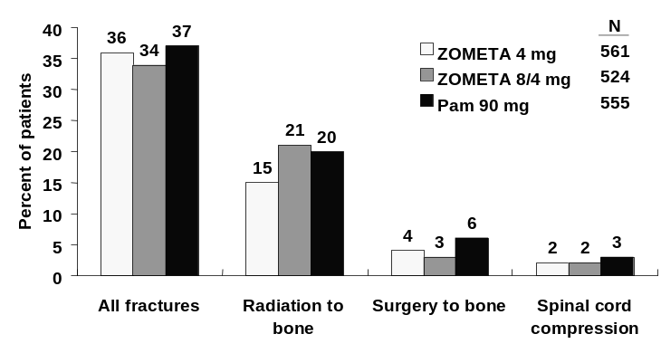

Time to first skeletal-related event
The median time to the first occurrence of a SRE and the event rate at day 364 was similar for patients in all treatment groups (see Table 5-8 below). The upper limit of the 95% CI for the hazard ratio for the 4 mg group is 1.090, with the hazard ratio of 0.915, indicates that Zometa 4 mg is likely to influence the time to first SRE at least as strongly as Aredia.

Table 5-8. Time to the first SRE up to Month 13 (Median and hazard ratio), multiple myeloma and breast cancer
 |  |  | Zometa 4 mg v.s. |  | Zometa 8/4 mg v.s.
 | N | Median  (days) | Hazard ratio* | 95% CI for Hazard ratio | Hazard ratio* | 95% CI for Hazard ratio
Aredia 90 mg | 555 | 363 | 0.915 | (0.786, 1.090) | 0.994 | (0.834, 1.185)
Zometa 4 mg | 561 | 373 | - | - | 1.087 | (0.910, 1.299)
Zometa 8/4 mg | 524 | 353 | - | - | - | -
* Hazard ratio is the ratio of column versus row. The hazard ratio and the 95% C.I. are from Cox-regression for the pairwise comparison of the time to the first event.
B. Time to the first SRE up to Month 13, multiple myeloma and breast cancer

Skeletal morbidity rate
The mean SMR of all SREs up to Month 13 was lower for patients in the Zometa 4 mg and Zometa 8/4 mg groups than in the Aredia 90 mg group, but the differences were not statistically significant.

Figure 5.2 Mean skeletal morbidity rate by treatment group
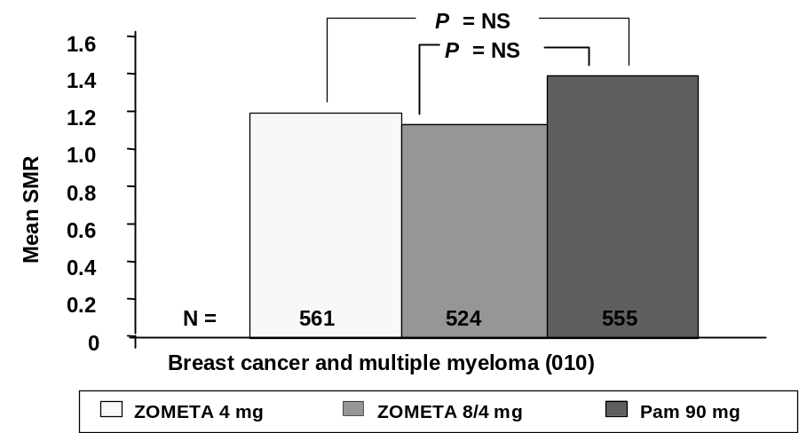
Multiple event analysis of all SREs
The analysis results of multiple events analysis of all SRE (-HCM), using Anderson and Gill’s approach, showed that there was a trend toward statistical significance (p=0.155), favoring Zometa 4 mg over Aredia 90 mg
The difference seen between the SMR analysis and the multiple event analysis was partially due to patients experiencing no events during the study. In the case of the SMR analysis, all patients contributed equal information regardless of a patient’s duration in the study, whereas the multiple event analysis took into account the length of stay in the study.

Table 5-9. Multiple-event analysis of time to SRE up to Month 13, multiple myeloma and breast cancer (010)
 | Zometa 4 mg v.s. |  |  |  | Zometa 8/4 mg v.s.
 | Hazard ratio* | 95% CI for Hazard ratio | P-value |  | Hazard ratio* | 95% CI for Hazard ratio | P-value
Aredia 90 mg | 0.885 | (0.748, 1.047) | 0.155 |  | 0.910 | (0.768, 1.079) | 0.277
Zometa 4 mg |  |  |  |  | 1.025 | (0.863, 1.218) | 0.775
* Hazard ratio is the ratio of column versus row. Hazard ratios and p-values are from Anderson-Gill approach for time to multiple events
P-value and the 95% C.I. are computed using the robust variance estimate

5.2.5 Analysis of Other Endpoints

Pain
The change from baseline in mean BPI was compared between treatment groups at Months 3, 6, 9 and 13. The composite pain score was decreased for all treatment groups at each analysis time point. The mean change from baseline in BPI composite pain scores was comparable between the treatment groups at Month 13, regardless of whether the patient had pain at baseline or not. For the patient population as a whole and for the patients with pain at baseline, the BPI score decreased slightly over the period of the trial, in spite of the fact that many patients experienced progressive disease.
Analgesics
Analgesic scores ranged from 0 to 4, higher scores indicate that stronger analgesics were used. The mean change from baseline in analgesic score decreased at Month 3 and remained lower up to Month 13 for the three treatment groups. There was no statistically significant difference between any treatment groups in the change from baseline in analgesic score.
ECOG performance status
The mean change from baseline in ECOG score increased from baseline to Month 13 for all three treatment groups. There was no statistically significant difference between any treatment groups in the change from baseline in ECOG score. However, the within treatment change from baseline in ECOG score was statistically significant in all treatment groups.
Quality of Life (FACT-G)
The FACT-G total score is the sum of four subscales, with a maximum possible score of 108. An increase in the score from baseline indicated improvement. The mean increase from baseline in the FACT-G total score was statistically significant between Zometa 8/4 mg and Aredia 90 mg compared with Zometa 4 mg. The mean change from baseline was similar for Zometa 4 mg and Aredia 90 mg in the physical and emotional subscales. There was a significant difference in the mean change from baseline in the functional and social subscales, with Aredia 90 mg showing a greater increase than Zometa 4 mg. These small changes however, were not clinically meaningful.

Table 5-10. Mean/Median changes from baseline in quality of life scores at Month 13 by treatment group
 | Zometa 4 mg | Zometa 8/4 mg | Aredia 90 mg
 | N=561 | N=524 | N=555
in FACT-G total score  Total no. of patients *  Baseline  Mean ± SD  Change from baseline  Mean ± SD  Median | 446  76.2 ± 16.3  0.5 ± 14.9  0.3 | 418  75.0 ± 16.9  3.1 ± 14.9  3.0 | 445  76.9 ± 15.8  2.1 ± 15.6  2.0
* Number of patients who had a non-missing score at both baseline and Month 13 with last observation carried forward.
Time to progression of disease
There was no pairwise statistically significant difference in time to progression of bone metastases or in time to overall disease progression between the two treatment groups.

Table 5-11. Time to progression of disease up to Month 13, multiple myeloma and breast cancer
 | Zometa 4 mg | Zometa 8/4 mg | Aredia 90 mg
 | N=561 | N=524 | N=555
Time to progression of bone lesions  Event rate at day 364  Median (days) | 61.5%  179.0 | 62.9%  175.0 | 62.4%  171.0
Time to progression of disease  Event rate at day 364  Median (days) | 72.0%  134.0 | 71.6%  125.0 | 74.9%  111.0
Event rate and median are derived from KM estimate.
Objective bone lesion response
The best bone lesion response rates were similar for all treatment groups (see Table 5-12 on next page).

Table 5-12. Best bone lesion response up to Month 13, multiple myeloma and breast cancer
 | Zometa 4 mg | Zometa 8/4 mg | Aredia 90 mg
 | N=561 | N=524 | N=555
Best bone lesion response  Complete response  Partial response  Stable disease  Progression  Not evaluable | 0 (0%)  98 (17%)  170 (30%)  222 (40%)  71 (13%) | 0 (0%)  77 (15%)  164 (31%)  219 (42%)  64 (12%) | 0 (0%)  102 (18%)  154 (28%)  238 (43%)  61 (11%)

5.2.6 Survival
The following survival analysis has been updated to include all data available from the ongoing extensions up to October 26, 2001. Median survival is provided in Table 5-13 and Kaplan-Meier curve of survival is provided in Figure 5-3 below.
In Study 010, median survival has been reached for all treatment groups in the strata of breast cancer with hormonal therapy of study entry. Median survival has not been reached for any treatment group in the multiple myeloma strata. There are no significant differences in survival between Zometa 4 mg and pamidronate in study 010, either in each individual stratum or the total.

Table 5-13. Summary of median survival (days) by stratum and treatment group
 | Zometa  4 mg | Zometa  8/4 mg | Aredia  90 mg
Stratum
Multiple myeloma | NR | NR | NR
Breast cancer chemotherapy | 570.0 | 637.0 | 640.0
Breast cancer hormonal | 806.0 | 910.0 | 868.0
Total | 838.0 | 830.0 | 811.0

Figure 5-3. Kaplan-Meier curve of survival by treatment group
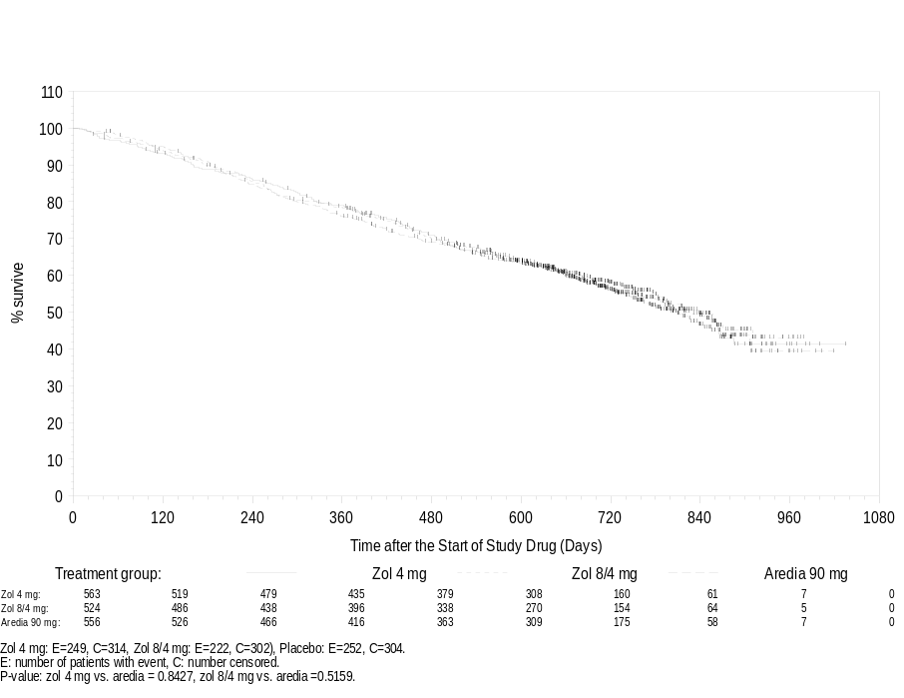

5.2.7 Efficacy Summary (breast cancer / multiple myeloma)
In the Zometa clinical trials program, Study 010 was designed to evaluate whether Zometa provides the level of benefit seen with Aredia in patients with multiple myeloma or bone metastases from breast cancer. A placebo group was not utilized in this study, since Aredia has previously been shown to significantly delay or reduce the incidence of skeletal-related morbid events in these patients. If Zometa and Aredia were equal in effectiveness, statistical power calculations indicated that the planned study enrollment (1600 patients) would have had power to exclude an 8% or greater inferiority for Zometa in the proportion of patients experiencing an SRE (the primary study endpoint), compared with an anticipated beneficial treatment effect of 13.5% for Aredia (based on historical data). The study results revealed a small difference in the proportion of patients experiencing an SRE, favoring Zometa 4 mg, and the lower confidence bound for this comparison with Aredia was 3.7% (indicating that Zometa was at least within 3.7 % of the effectiveness seen with Aredia as measured by this statistic).
Other analyses of skeletal related events, as noted in the study protocol statistical plan, considered (1) the time to first SRE, (2) the rate of SREs over time (Skeletal Morbidity Rate, SMR), and (3) Multiple Event Analysis (Anderson-Gill methodology was used). These analyses complement the analysis of proportion of patients experiencing an SRE, and provide useful further information regarding the comparative patient benefits of Zometa and Aredia (a drug that is known to provide substantial benefit in this population). The results of these analyses are provided in table 5-14, below.
Hazard ratios show comparable efficacy for Zometa 4 mg and 8/4 mg to pamidronate.

Table 5-14. Summary of analysis of skeletal related events in Study 010 (Breast Cancer and Multiple Myeloma)
 | Proportion with SRE | Time to First SRE  (Hazard ratio) | Mean Skeletal Morbidity Rate | Multiple Event analysis  (Hazard ratio)
Zometa 4 mg | 248/561 (44%) | 0.915 | 1.13 | 0.885
Zometa 8/4 mg | 242/524 (46%) | 0.994 | 1.08 | 0.910
Aredia | 257/555 (46%) | - | 1.40 | -
Hazard ratio were Zometa treatment groups versus Aredia treatment group.
While the results do not demonstrate any statistically significant differences among the treatment groups, it is interesting to note that all of these analyses of skeletal-related morbid events were consistent in showing similar to slightly better results for both Zometa study arms compared to the Aredia study arm. Based on evaluations of the historical data from placebo-controlled studies of Aredia, and the features of the patients enrolled in study 010 (data not shown), it is anticipated that Aredia had substantial benefit for patients in study 010, and thus the similar findings with Zometa reliably establish the effectiveness of Zometa in this population.

5.3 Prostate Cancer – Placebo-controlled trial (039)

5.3.1 Patient Disposition
This trial was designed with a placebo control, because no bisphosphonate, including the clinically effective bisphosphonate Aredia, has demonstrated efficacy in clinical trials in this population. A total of 643 prostate cancer patients with a history of bone metastases were randomized: 214 patients in the Zometa 4 mg group, 221 patients in the Zometa 8/4 mg group, and 208 patients in the placebo group. These patients were randomized between 22-June-1998 and 10-November-1999 at one of 136 centers in 17 countries including centers in North and South America, Europe, and Australia and New Zealand.

Table 5-15. Patient disposition – prostate cancer study
Number of patients | Zometa  4 mg  N=214 | Zometa  8/4 mg  N=221 | Placebo  N=208
Randomized  Included in efficacy analysis | 214  214 | 221  221 | 208  208
Completed 15 months | 81(37.9%) | 62(28.1%) | 65(31.3%)
Reason for discontinuation
Adverse events | 38 (17.8%) | 44 (19.9%) | 29 (13.9%)
Abnormal laboratory values | 3 (1.4%) | 5 (2.3%) | 2 (1.0%)
Abnormal test procedure results | 1 (0.5%) | 0 (0.0%) | 0 (0.0%)
Unsatisfactory therapeutic effect | 19 (8.9%) | 17 (7.7%) | 34 (16.3%)
Condition no longer required study drug | 1 (0.5%) | 3 (1.4%) | 3 (1.4%)
Protocol violation | 1 (0.5%) | 0 (0.0%) | 0 (0.0%)
Withdrew consent | 41 (19.2%) | 50 (22.6%) | 35(16.8%)
Lost to follow-up | 4 (1.9%) | 0 (0.0%) | 5 (2.4%)
Administrative problems | 0 (0.0%) | 0 (0.0%) | 3 (1.4%)
Death | 25 (11.7%) | 40(18.1%) | 32 (15.4%)

5.3.2 Demographic and Disease Characteristics
Baseline patient demographics were generally comparable for all treatment groups. Most of the randomized patients were > 60 years of age.

Table 5-16 Demographics in prostate cancer patients – ITT population
 | Zometa 4 mg | Zometa 8/4 mg | Placebo
Demographic variable | (N=214) | (N=221) | (N=208)
Age (years)
Mean ± S.D. | 71.8 ± 7.92 | 71.2 ± 7.99 | 72.2 ± 7.89
Range | 45 - 90 | 43 - 90 | 37 - 90
> 60 | 195 ( 91.1) | 202 ( 91.4) | 193 ( 92.8)
Race n (%) patients
Caucasian | 178 (83.2%) | 186 (84.2%) | 172 (82.7%)
Black | 24 (11.2%) | 19 (8.6%) | 19 (9.1%)
Other | 12 (5.6%) | 16 (7.2%) | 17 (8.2%)
Weight (kg)
Mean ± S.D. | 82.8 ± 14.16 | 82.1 ± 14.44 | 83.4 ± 16.08
Range | 40 - 120 | 46 - 126 | 43 - 138
Treatment groups were also comparable with respect to baseline quality of life variables, and disease characteristics, with some minor exceptions. Median baseline serum PSA was higher in both Zometa groups than in the placebo group. Also, the BPI composite pain score and proportion of patients with pain at baseline were higher in the Zometa 8/4 mg group than in the other two groups.

Table 5-17. Baseline characteristics in prostate cancer patients (ITT population)
 | Zometa 4 mg | Zometa 8/4 mg | Placebo
Total number of patients | 214 | 221 | 208
Previous SRE | 66 (30.8) | 71 (32.1) | 78 (37.5)
Time since initial diagnosis of cancer (months, mean) | 62.5 | 67.6 | 66.6
Time since bone metastasis (months, mean) | 23.5 | 25.8 | 28.4
PSA (ng/dl)
mean ± S.D. | 276.5 ± 737.1 | 350.9 ± 1148.9 | 211.1 ± 464.9
median | 81.7 | 88.2 | 61.0
ECOG status n (%)
0-1 | 197 ( 92.1) | 199 ( 91.3) | 190 ( 91.3)
≥2 | 17 ( 7.9) | 19 ( 8.7) | 18 ( 8.7)
BPI composite pain score
N | 193 | 199 | 191
Mean ±SD | 2.0 ± 1.98 | 2.5 ± 2.10 | 2.1 ± 2.04
Median | 1.8 | 2.3 | 1.8
Analgesic score
0 | 94 ( 43.9) | 73 ( 33.0) | 77 ( 37.0)
1 | 69 ( 32.2) | 84 ( 38.0) | 77 ( 37.0)
2 | 9 ( 4.2) | 11 ( 5.0) | 9 ( 4.3)
3 | 40 ( 18.7) | 48 ( 21.7) | 41 ( 19.7)
4 | 2 ( 0.9) | 3 ( 1.4) | 3 ( 1.4)
FACT-G total score
N | 193 | 193 | 187
Mean ±SD | 81.0 ± 15.30 | 81.4 ± 13.76 | 82.2 ± 14.57
Median | 82.5 | 82.2 | 82.8
Baseline creatinine
< 1.4 mg/dL | 173 (80.8) | 170 (76.9) | 170 (81.7)
≥ 1.4 mg/dL | 41 (19.2) | 48 (21.7) | 33 (15.9)

Primary efficacy analysis
The proportion of patients having any SRE in the Zometa 4 mg group was significantly smaller than that in the placebo group (Table 5-18). The Zometa 8/4 mg group also had a smaller proportion of patients with SREs than the placebo group, but the difference did not reach statistical significance. There was also no statistically significant difference between the two Zometa groups for this comparison. There were two patients who had HCM during the study, but each had other SREs and was thus counted in the SRE (-HCM) analysis. Hence the proportion of patients with prostate cancer having any SRE (-HCM) is identical to the proportion of patients having any SRE (+HCM).

Table 5-18. Proportion of patients with prostate cancer with an SRE up to Month 15
 |  | 95% C.I. and P-value for the difference
Treatment | Proportion | Zometa 4 mg |  | Zometa 8/4 mg
Placebo | 92/208 (44%) | (- 20.3%,- 1.8%), p = 0.021 | (- 15.1%,3.6%),p = 0.222
Zometa 4 mg | 71/214 (33%) | - |  | (- 3.7%, 14.3%),p = 0.255
Zometa 8/4 mg | 85/221 (38%) | - |  | -
Proportion = (no. of patients with the event)/(total no. in the group) up to Month 15;
Confidence interval for the difference (treatment labeled in the column minus row) of percent of patients with events.
P-values are based on stratified Cochran-Mantel-Haenszel test for the proportion.

5.3.4 Secondary skeletal endpoint analyses
Proportion of patients with individual skeletal-related events
The proportion of patients having each type of SRE was lower in the Zometa 4 mg group and Zometa 8/4 mg group than in the placebo group except for the change of antineoplastic therapy (Figure 5-4). The difference in the proportion of patients with a pathological fracture between the Zometa 4 mg group and the placebo group was statistically significant (p=0.015).

Figure 5-4. Individual SREs in patients with prostate cancer
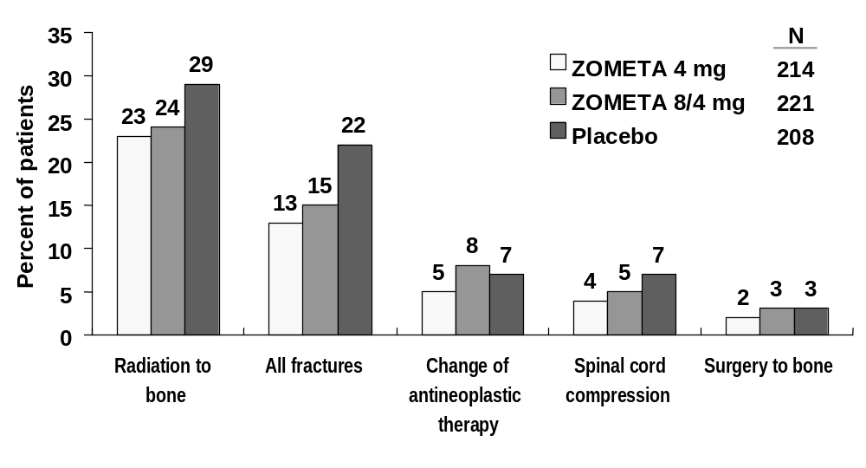

Time to first skeletal-related event
The difference in time to the first occurrence of any SRE between the Zometa 4 mg group and the placebo group was statistically significant. For Zometa 4 mg treatment group, the median time to the first occurrence of a SRE was not reached, but it was at least 420 days (the estimated event rate was less than 50% on day 420), while the median time in the placebo group was 321 days. Hence the median time to the first occurrence of a SRE for the Zometa 4 mg group was increased by at least 99 days compared to the patients in the placebo group.
The times to the first SRE (-HCM) and the first SRE (+HCM) are identical in this study as hypercalcemia was not the first SRE for the two patients who had hypercalcemia.

Table 5-19. Time to the first SRE up to Month 15 in prostate cancer patients
 |  |  |  |  | P-values for the between treatment comparison
 | N | Event rate  at day 420 | 25% Quartile  (days) | Median  (days) | Zometa  4 mg | Zometa  8/4 mg
Placebo | 208 | 57.19% | 122 | 321 | 0.011 | 0.491
Zometa 4 mg | 214 | 44.87% | 182 | Not Reached | - | 0.059
Zometa 8/4 mg | 221 | 53.17% | 127 | 363 | - | -
P-values are from the log-rank test for comparing the distribution of time to the event.
For stratum =total, the p-values are from Cox-regression with factor treatment, stratified by the strata. Event rate is the Kaplan Meier estimate of the event rate at day 420.
Event rate, Median and 25%quartile are derived from KM estimate.
Skeletal morbidity rate
The skeletal morbidity rate up to Month 15 was lower for patients in the Zometa 4 mg and Zometa 8/4 mg groups than in the placebo group (Table 5-20). The difference in the SMR between the Zometa 4 mg group and the placebo group was statistically significant.

Table 5-20. Skeletal morbidity rate (risk set definition) of any SRE (-HCM) up to Month 15
 |  | Skeletal morbidity rates  (no. of events per year) |  | p-values for the between treatment comparison
 | N | Mean ± SD | Median | Zometa 4 mg | Zometa 8/4 mg
Placebo | 208 | 1.49 ± 3.336 | 0.00 | 0.006 | 0.143
Zometa 4 mg | 214 | 0.80 ± 1.703 | 0.00 | - | 0.191
Zometa 8/4 mg | 221 | 1.06 ± 2.193 | 0.00 | - | -
Skeletal morbidity rate (risk set definition) is the number of SREs divided by the time at risk in years, counted from the date of randomization, with every counted event followed by a 20 day period during which any SRE experienced by the patient would not be counted, nor would the patient be counted as at risk. For patients with no SRE, the whole study period was counted as at risk.

Multiple event analysis of SREs
For SRE (-HCM), there was a statistically significant difference between the Zometa group and the placebo group in the time to multiple occurrence of the event in favor of the Zometa 4 mg group (p=0.004). See Table 5-21 below.

Table 5-21. Multiple-event analysis of time to SRE up to Month 15 in prostate cancer patients (039)
 | Zometa 4 mg v.s. |  |  |  | Zometa 8/4 mg v.s.
 | Hazard ratio* | 95% CI for Hazard ratio | P-value |  | Hazard ratio* | 95% CI for Hazard ratio | P-value
Placebo | 0.643 | (0.476, 0.870) | 0.004 |  | 0.847 | (0.640, 1.122) | 0.247
Zometa 4 mg |  |  |  |  | 1.318 | (0.966, 1.798) | 0.081
* Hazard ratio is the ratio of column versus row. Hazard ratios and p-values are from Anderson-Gill approach for time to multiple events
P-value and the 95% C.I. are computed using the robust variance estimate

5.3.5 Analyses of Other Endpoints

Pain
Overall, the mean BPI composite pain score increased from baseline to Month 15 for all three treatment groups. However, the difference in favor of Zometa between the BPI composite pain scores of both of the Zometa 4 mg and Zometa 8/4 mg groups and the placebo group at months 3 (p= 0.003 and p= 0.003, respectively) and 9 (p=0.030 and p=0.014, respectively) was statistically significant. The difference in favor of Zometa was also statistically significant between the 8/4 mg group and the placebo group at several other time points.

Analgesics
The mean analgesic score increased from baseline to Month 15 for all three treatment groups. The difference in analgesic score from baseline for the total of all patients was either similar for all three treatment groups or the placebo group had a slightly higher score than the two Zometa groups at all timepoints.

Performance status (ECOG)
The mean ECOG score increased from baseline to Month 15 for all three treatment groups. Overall, there was no statistically significant difference between any treatment groups in the change from baseline in ECOG score.

Quality of life (FACT-G)
The total score for FACT-G is the sum of the physical, functional, social and emotional subscales. The EQ-D5 questionnaire consists of the EURO QOL-5D score and the EURO QOL-5D thermometer. An increase in the score from baseline indicates improvement while a negative number indicates worsening.
At Month 15 there was some improvement in the FACT-G social subscale score and the EURO QOL-5D score for all treatment groups, but there were no statistically significant differences between treatment groups for any of the quality of life scores.

Time to Progression
There was no statistically significant difference between treatment groups in the distribution of time to progression of bone metastases or in the distribution of time to overall disease progression.

Table 5-22. Summary of time to progression of disease at Month 15 in prostate cancer patients
 | Zometa 4 mg | Zometa 8/4 mg | Placebo
 | N= 214 | N= 221 | N= 208
Time to progression of bone lesions  Median (days)  P-value: vs Placebo  P-value: vs Zometa 4mg | 92.0  0.275  - | 89.0  0.710  0.342 | 87.0  -  -
Time to progression of disease  Median (days)  P-value: vs Placebo  P-value: vs Zometa 4mg | 84.0  0.771  - | 84.0  0.408  0.275 | 84.0  -  -
Note: Stratified log-rank test is used for the between treatment comparison. The median is derived from KM estimate.

Objective bone lesion response
No patients achieved complete response during the study. In both Zometa treatment groups, a higher percentage of patients had no change in bone lesions while a lower percentage had progression of bone lesions compared with patients in the placebo group.

Table 5-23. Frequency distribution of best response by treatment group
 | Zometa 4 mg | Zometa 8/4 mg | Placebo
 | N=214 | N=221 | N=208
Best bone lesion response  Complete response  Partial response  No change  Progression  Not evaluable | 0 (0%)  9 (4%)  47 (22%)  118 (55%)  40 (1 9%) | 0 (0%)  6 (3%)  46 (21%)  123 (56%)  46 (21%) | 0 (0%)  8 (4%)  35 (17%)  132 (63%)  33 (16%)

5.3.6 Survival
The following survival analysis has been updated to include all data available from the ongoing extensions up to October 26, 2001. Median survival is provided in Table 5-24 and Kaplan-Meier curve of survival is provided in Figure 5-5 below.

Table 5-24. Summary of median survival (days) by stratum and treatment group
 | Zometa  4 mg | Zometa  8/4 mg | Placebo
Stratum
No metastases at initial diagnosis | 515.0 | 419.0 | 471.0
Metastases at initial diagnosis | 646.0 | 377.0 | 466.0
Total | 563.0 | 418.0 | 469.0

Figure 5-5. Kaplan-Meier curve of survival by treatment group
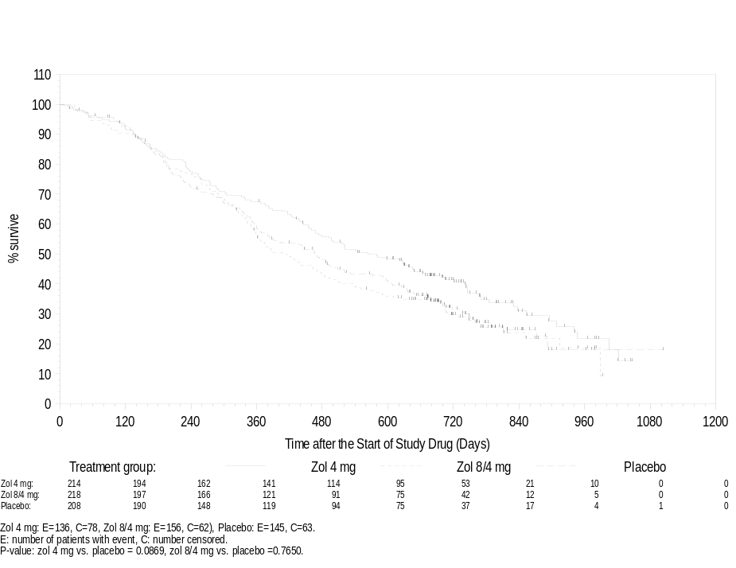

5.3.7 Efficacy Summary (prostate study)
The primary efficacy variable was compared between the 4 mg Zometa treatment group and placebo using a stratified Cochran-Mantel-Haenszel test with modified ridit scores.
For time to the first SRE (-HCM) and each type of SRE, survival analysis methods, including Kaplan-Meier product-limit estimates of the “survival functions”, and the Cox regression stratified with the stratum were used to assess the effectiveness of Zometa 4 mg in prolonging the time to the first event.
For skeletal morbidity rate of SRE (-HCM), SRE (+HCM), and each type of SREs, stratified Cochran-Mantel-Haenzsel with modified ridit scores were used to assess the difference between the Zometa 4 mg and the placebo
Zometa 4 mg given as a 15-minute infusion every 3 weeks in addition to standard antineoplastic therapy was significantly more effective than placebo in treatment of bone metastases in patients with prostate cancer (see Table 5-25 below):
- the proportion of patients having skeletal-related events was significantly lower with Zometa 4 mg than with placebo
- the time to the first skeletal-related event was significantly longer with Zometa 4 mg than with placebo
- the skeletal morbidity rate was significantly lower with Zometa 4 mg than with placebo
- hazard ratio for SRE recurrent rates favored Zometa 4 mg over placebo
- the proportion of patients with individual types of SREs and the SMR for each SRE was lower with Zometa compared with placebo
- patients treated with Zometa had a smaller increase in bone pain than patients receiving placebo, with little between group difference in analgesic score, in spite of similar deterioration of performance status in the three treatment groups

Table 5-25. Summary of analysis of skeletal related events in Study 039 (Prostate cancer)
 | Proportion with SRE | Time to First SRE (Event Rate)  Day 420 | Skeletal Morbidity Rate | SRE Recurrence (Anderson-Gill)  (Hazard ratio)
Zometa 4 mg | 71/214 (33%)* | 44.87%* | .80* | 0.643*
Zometa 8/4 mg | 85/221 (38%) | 53.17% | 1.06 | 0.847
Placebo | 92/208 (44%) | 57.19% | 1.49 | -
*P<0.05 Zometa 4 mg vs. Placebo.

5.4 Lung Cancer and Other Solid Tumors – Placebo-Controlled Trial (011)

5.4.1 Patient Disposition
All 773 patients randomized to treatment were included in the analysis of efficacy (ITT population). Approximately one quarter of patients completed 9 months of treatment, and the percentage of patients who discontinued was similar for all treatment groups. Adverse events and death were the most frequent reasons for discontinuation, followed by withdrawal of consent.

Table 5-26. Patient disposition, lung cancer and other solid tumors (011)
Number of patients | Zometa 4 mg  N=257 | Zometa 8/4 mg  N=266 | Placebo  N=250
Randomized  Included in efficacy analysis | 257  257 | 266  266 | 250  250
Lung cancer | 134 (52.1%) | 139 (52.3%) | 130 (52.0%)
Other | 123 (47.9%) | 127 (47.7%) | 120 (48.0%)
Completed 9 months | 68 (26.5%) | 65 (24.4%) | 63 (25.2%)
Discontinued prematurely | 189 (73.5%) | 201 (75.6%) | 187 (74.8%)
Adverse events | 49 (19.1%) | 65 (24.4%) | 52 (20.8%)
Abnormal laboratory values | 0 (0.0%) | 4 (1.5%) | 2 (0.8%)
Abnormal test procedure results | 0 (0.0%) | 1 (0.4%) | 0 (0.0%)
Unsatisfactory therapeutic effect | 18 (7.0%) | 14 (5.3%) | 20 (8.0%)
Condition no longer requires study drug | 2 (0.8%) | 1 (0.4%) | 4 (1.6%)
Protocol violation | 4 (1.6%) | 0 (0.0%) | 0 (0.0%)
Withdrew consent | 46 (17.9%) | 36 (13.5%) | 40 (16.8%)
Lost to follow-up | 2 (0.8%) | 4 (1.5%) | 0 (0.0%)
Administrative problems | 1 (0.4%) | 1 (0.4%) | 1 (0.4%)
Death | 66 (25.7%) | 75 (28.2%) | 66 (26.4%)
Not stated | 1 (0.4%) | 0 (0.0%) | 0 (0.0%)

5.4.2 Demographics and Disease Characteristics
Baseline demographics in patients with lung cancer or other solid tumors were comparable for all three treatment groups, with the population being predominantly male and Caucasian. The treatment groups were also comparable with respect to baseline disease specific characteristics and prognostic factors.

Table 5-27. Demographic characteristics by treatment group, Study 011 (ITT population)
 | Zometa 4 mg | Zometa 8/4 mg | Placebo
Demographic variable | (N=257) | (N=266) | (N=250)
Age (years)
Mean ± S.D. | 62.2 ± 10.58 | 60.8 ± 10.44 | 62.3 ± 10.82
Range | 25 - 88 | 28 - 84 | 25 - 86
Sex n (%)
Male | 160 (62.3%) | 186 (69.9%) | 162 (64.8%)
Female | 97 (37.7%) | 80 (30.1%) | 88 (35.2%)
Race n (%) patients
Caucasian | 229(89.1%) | 238(89.5%) | 226(90.4%)
Black | 15(5.8%) | 15(5.6%) | 12(4.8%)
Other | 13(5.1%) | 13(4.9%) | 12(4.8%)
Weight (kg)
Mean ± S.D. | 72.7 ± 15.18 | 74.3 ± 16.91 | 71.6 ± 15.99
Range | 41 - 141 | 33 - 136 | 33 - 152

The treatment groups were comparable for disease characteristics. Approximately half of all patents had lung cancer and between 65 and 72% of patients had experienced a prior SRE.

Table 5-28. Baseline disease characteristics in patients with lung cancer or other solid tumors (011)
 | Zometa 4 mg | Zometa 8/4 mg | Placebo
Disease specific variables | (N=257) | (N=266) | (N=250)
Cancer type (n, %)
Lung | 126 (49.0%) | 134 (50.4%) | 126 (50.4%)
Renal cell carcinoma | 27 (10.5%) | 28 (10.5%) | 19 (7.6%)
Cancer unknown primary | 15 (5.8%) | 14 (5.3%) | 14 (5.6%)
Head and neck | 6 (2.3%) | 7 (2.6%) | 4 (1.6%)
Thyroid | 2 (0.8%) | 5 (1.9%) | 4 (1.6%)
Other | 81 (31.5%) | 78 (29.3%) | 83 (33.2%)
Metastases other than bone to visit 2  Lung  Liver  Brain  Pleura | 12 (4.7%)  17 (6.7%)  14 (5.5%)  7 (2.8%) | 12 (4.5%)  14 (5.3%)  8 (3.0%)  9 (3.4%) | 11 (4.5%)  16(6.5%)  4 (1.6%)  5 (2.0%)
Time since bone metastases  Mean ± S.D.  Median | 4.7 ± 7.65  1.6 | 4.9 ± 7.89  1.8 | 5.0 ± 9.47  1.8
Prior chemotherapy (n (%)) | 209 (81.3%) | 212 (79.7%) | 199 (79.6%)
Prior SRE n (%) patients | 167 (65.0%) | 180 (67.7%) | 180 (72.0%)
Bone alkaline phosphatase  Mean ± S.D.  Median | 276.1 ± 457.2  168.5 | 212.1 ± 210.5  149.0 | 242.2 ± 284.9  162.0
* Small cell lung cancer patients are included in category noted as “other”)

5.4.3 Primary efficacy analysis
The proportion of patients with lung cancer or other solid tumors experiencing at least one SRE was smaller for both Zometa dose groups than those treated with placebo for the overall ITT population and both tumor type strata. This difference was statistically significant for the Zometa 8/4 mg group at 9 months for the overall ITT population. There was no statistically significant difference between the Zometa treatment groups.

Table 5-29. Proportion of patients with lung cancer or other solid tumors having any SRE (011)
 |  | 95% C.I. and P-value for the difference
 | Proportion | Zometa 4 mg | Zometa 8/4 mg
Lung cancer
Placebo | 59/130 (45%) | (-15.6%, 8.4%), p=0.557 | (-23.3%, 0.1%), p=0.053
Zometa 4 mg | 56/134 (42%) | - | (-19.5%, 3.5%), p=0.175
Zometa 8/4 mg | 47/139 (34%) | - | -
Other solid tumors
Placebo | 52/120 (43%) | (-22.2%, 2.2%), p=0.110 | (-20.1%, 4.3%), p=0.205
Zometa 4 mg | 41/123 (33%) | - | (-9.7%, 13.9%), p=0.727
Zometa 8/4 mg | 45/127 (35%) | - | -
Total
Placebo | 111/250 (44%) | (-15.2%, 1.9%), p=0.127 | (-18.2%,-1.4%), p=0.023
Zometa 4 mg | 97/257 (38%) | - | (-11.4%, 5.1%), p=0.452
Zometa 8/4 mg | 92/266 (35%) | - | -
Confidence interval for the difference (treatment labeled in the column minus row ) of percent of patients with events. Stratified Cochran-Mantel-Haenszel test for the proportion was used for between treatment group comparisons.

Secondary skeletal endpoint analyses
Proportion of patients having any SRE, including hypercalcemia
Unlike the studies in breast cancer/multiple myeloma or prostate cancer, inclusion of hypercalcemia of malignancy as an SRE had a substantial effect on the outcome of the analysis of the proportion of patients having SREs. The proportions of patients with SREs including HCM were significantly lower in both the Zometa 4 mg and 8/4 mg groups than for placebo. This positive outcome represents the real clinical relevance of Zometa treatment in this population, since HCM is an important SRE for these patients.
Proportion of patients with individual SREs
The proportion of patients experiencing each specific SRE was lower for both Zometa groups than for placebo, except for surgery to bone. The difference versus placebo achieved statistical significance for hypercalcemia in both Zometa groups, and for pathologic fractures and vertebral fractures for the 8/4 mg group.

Figure 5-6. Individual SREs in patients with lung cancer or other solid tumors
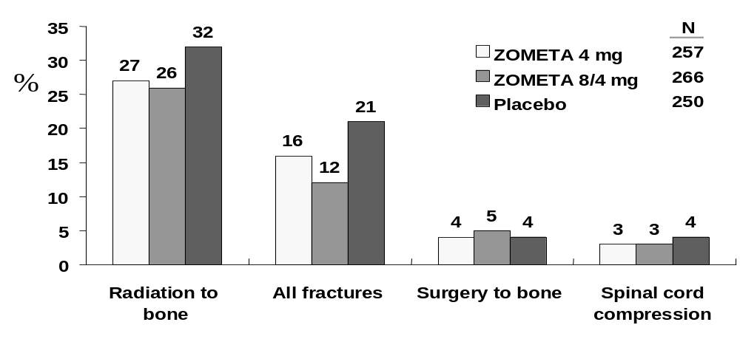

Time to first SRE
Median time to first occurrence of an SRE was longer for patients treated with Zometa than placebo. The difference versus placebo was statistically significant for both Zometa groups.

Table 5-30. Time to first SRE in patients with lung cancer and other solid tumors (011)
 | Excluding HCM |  |  | Including HCM
 | Zometa 4 mg | Zometa  8/4 mg | Placebo | Zometa  4 mg | Zometa  8/4 mg | Placebo
 | (N=257) | (N=266) | (N=250) | (N=257) | (N=266) | (N=250)
Time to first SRE (days)
Median¹ | 230 | 219 | 163 | 230 | 219 | 155
Event rate¹ | 52.7% | 52.9% | 63.2% | 52.7% | 53.1% | 65.7%
P value² vs placebo | 0.023 | 0.034 | - | 0.007 | 0.013 | -
P value² vs Zometa 4 mg | - | 0.969 | - | - | 0.913 | -
¹ Median and event rate were derived from KM estimate. Event rates were calculated at day 252 for study 011.
² Stratified Cochran-Mantel-Haenszel test with modified ridit score was used for the between treatment group comparisons.
The mean SMR of any SRE (excluding HCM) was statistically significantly lower for the Zometa 8/4 mg group than the placebo group. For any SRE including HCM, mean SMR was statistically significantly lower for both Zometa treatment groups than the placebo group.

Table 5-31. Skeletal morbidity rate of any SRE in patients with lung cancer and other solid tumors (011)
 | Excluding HCM |  |  | Including HCM
 | Zometa 4 mg | Zometa  8/4 mg | Placebo | Zometa  4 mg | Zometa  8/4 mg | Placebo
 | (N=257) | (N=266) | (N=250) | (N=257) | (N=266) | (N=250)
Skeletal morbidity rate
Mean | 2.24 | 1.55 | 2.52 | 2.24 | 1.59 | 2.73
SD | 9.12 | 3.80 | 5.12 | 9.12 | 3.84 | 5.29
P value¹ vs placebo | 0.069 | 0.005 | - | 0.017 | 0.001 | -
P value¹ vs Zometa 4 mg | - | 0.309 | - | - | 0.372 | -
¹ Stratified Cox regression with factor treatment group was used for the between treatment group comparisons.

Table 5-32. Proportion of patients with lung cancer or other solid tumors having any SRE (+HCM)
 |  | 95% C.I. and P-value for the difference
 | Proportion | Zometa 4 mg | Zometa 8/4 mg
Lung cancer
Placebo | 62/130 (48%) | (-17.9%, 6.1%), p=0.336 | (-24.9%,-1.4%), p=0.029
Zometa 4 mg | 56/134 (42%) | - | (-18.8%, 4.3%), p=0.218
Zometa 8/4 mg | 48/139 (35%) | - | -
Other solid tumors
Placebo | 55/120 (46%) | (-24.8%, -0.2%), p=0.047 | (-22.6%, 1.8%), p=0.097
Zometa 4 mg | 41/123 (33%) | - | (-9.7%, 13.9%), p=0.727
Zometa 8/4 mg | 45/127 (35%) | - | -
Total
Placebo | 117/250 (47%) | (-17.7%, -0.5%), p=0.039 | (-20.3%,-3.4%), p=0.006
Zometa 4 mg | 97/257 (38%) | - | (-11.0%, 5.5%), p=0.508
Zometa 8/4 mg | 93/266 (35%) | - | -
Confidence interval for the difference (treatment labeled in the column minus row ) of percent of patients with events. Stratified Cochran-Mantel-Haenszel test for the proportion was used for between treatment group comparisons.
Multiple events analysis
For SREs excluding HCM, there was a statistically significant difference between the Zometa 4 mg group and the placebo group in the time to multiple occurrences of the event in favor of the Zometa 4 mg group for all strata together (p=0.017). The difference between the Zometa 4 mg group and the placebo group in the lung cancer patients was approaching statistical significance (p=0.061) in favor of Zometa 4 mg as well. Overall, the effect of Zometa 4 mg versus placebo on the recurrence of SRE were comparable in both lung cancer patients and other solid tumors patients.

Table 5-33. Multiple-event analysis of time to SRE up to Month 9 in patients with lung cancer and other solid tumors (011)
 | Zometa 4 mg v.s. |  |  |  | Zometa 8/4 mg v.s.
 | Hazard ratio* | 95% CI for Hazard ratio | P-value |  | Hazard ratio* | 95% CI for Hazard ratio | P-value
Lung cancer
Placebo | 0.729 | (0.524, 1.015) | 0.061 |  | 0.530 | (0.377, 0.745) | <0.001
Zometa 4 mg | - |  | - |  | 0.719 | (0.512, 1.010) | 0.057
Other solid tumors
Placebo | 0.737 | (0.493, 1.101) | 0.136 |  | 0.886 | (0.605, 1.298) | 0.534
Zometa 4 mg | - |  | - |  | 1.210 | (0.806, 1.816) | 0.358
Total
Placebo | 0.732 | (0.567, 0.946) | 0.017 |  | 0.687 | (0.531, 0.890) | 0.004
Zometa 4 mg |  |  |  |  | 0.929 | (0.713, 1.210) | 0.586
* Hazard ratio is the ratio of column versus row. Hazard ratios and p-values are from Anderson-Gill approach for time to multiple events
P-value and the 95% C.I. are computed using the robust variance estimate

5.4.5 Analyses of Other Endpoints

Pain
The change from baseline in mean BPI pain score was not significantly different between treatment groups. There was a small increase in overall BPI composite scores in each group, but the increase was lower in the Zometa 4 mg group than the other groups. For patients with pain at baseline a slight decrease was seen for the Zometa 4 mg group.

Analgesics
The mean analgesic score increased from baseline to Month 9 for all treatment groups, but the changes from baseline showed no statistically significant differences between treatments at Month 9.

ECOG performance status
Mean ECOG score increased from baseline to Month 9 for all three treatment groups. There was no statistically significant difference between any treatment groups in the change from baseline in ECOG score.

Time to Progression
Median time to progression of bone lesions and time to progression of disease were longer in the Zometa groups than the placebo group. This difference was statistically significant for the 8/4 mg group.

Table 5-34. Time to progression of disease in patients with lung cancer and other solid tumors (011)
 | Zometa 4 mg | Zometa 8/4 mg | Placebo
 | (N =257) | (N =266) | (N =250)
Time to progression, bone lesions
Median¹  Event rate¹  P-value² vs placebo  P-value² vs Zometa 4 mg | 145.0  62.8%  0.34  - | 238.0  50.8%  0.009  0.065 | 109.0  64.1%  -  -
Time to disease progression
Median¹  Event rate¹  P-value² vs placebo  P-value² vs Zometa 4 mg | 89.0  86.4%  0.117  - | 91.0  81.4%  0.010  0.269 | 84.0  90.1%  -  -
¹ Median and event rate were derived from KM estimate. Event rates were calculated at day 252.
² Stratified Cox regression with factor treatment group was used for the between treatment group comparisons.

Best bone lesion response
More patients in the Zometa groups than in the placebo group had partial response.

Table 5-35. Frequency distribution of best bone lesion response (011)
 | Zometa 4 mg | Zometa 8/4 mg | Placebo
n (%) patients | (N =257) | (N =266) | (N =250)
Complete response  Partial response  Stable disease  Progression  Unknown | 0  21 (8%)  55 (21%)  86 (33%)  95 (37%) | 0  27 (10%)  51 (19%)  75 (28%)  113 (42%) | 0  11 (4%)  49 (20%)  90 (36%)  100 (40%)

Survival
The following survival analysis has been updated to include all data available from the ongoing extensions up to October 26, 2001. Median survival is provided in Table 5-36 and Kaplan-Meier curve of survival is provided in Figure 5-7 below.

Table 5-36. Summary of median survival (days) by stratum and treatment group
 | Zometa  4 mg | Zometa  8/4 mg | Placebo
Stratum
Lung cancer | 199.5 | 181.0 | 155.0
Other solid tumors | 212.0 | 213.0 | 192.0
Total | 202.5 | 189.0 | 183.0

Figure 5-7. Kaplan-Meier curve for survival by treatment group
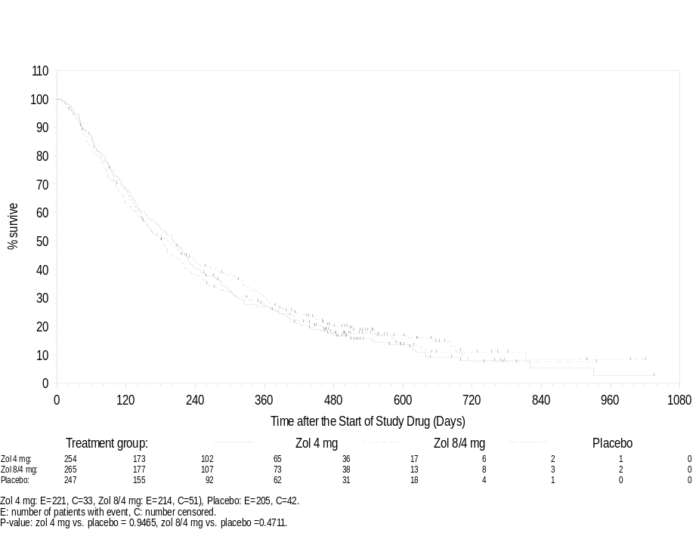

5.4.7 Efficacy Summary (other solid tumors)
The primary efficacy variable was compared between the mg Zometa treatment group and placebo using a stratified Cochran-Mantel-Haenszel test with modified ridit scores.
For time to the first SRE (-HCM) and each type of SRE, survival analysis methods, including Kaplan-Meier product-limit estimates of the “survival functions”, and the Cox regression stratified with the stratum were used to assess the effectiveness of Zometa 4 mg in prolonging the time to the first event.
For skeletal morbidity rate of SRE (-HCM), SRE (+HCM), and each type of SREs, stratified Cochran-Mantel-Haenzsel with modified ridit scores were used to assess the difference between the Zometa 4 mg and the placebo.
Zometa 4 mg given as a 15-minute infusion every 3 weeks in addition to standard antineoplastic therapy was significantly more effective than placebo in treatment of bone metastases in patients solid tumors other than prostate and breast cancer (see Table 5-37).
Proportion of patients having any SRE excluding HCM, up to Month 9. Both Zometa treatment arms had a lower proportion of SREs (-HCM) than the placebo group. The difference between the Zometa 4 mg group and the placebo group was not statistically significant. The difference between the Zometa 8/4 mg group and the placebo group was statistically significant
Proportion of patients with any SRE including HCM: the Zometa 4 mg group had a statistically significantly lower proportion than the placebo: 38% versus 47%, respectively, p=0.039.
Time to the first SRE (excluding HCM): the Zometa 4 mg treatment delayed the time to first SRE by 67 days as compared to placebo, p=0.023.
The hazard ratio for SRE recurrent rates favored Zometa 4 mg over placebo.

Table 5-37. Summary of analysis of skeletal related events in Study 011 (Lung cancer and other solid tumors)
 | Proportion with SRE | Time to First SRE (Event Rate)  Day 252) | Skeletal Morbidity Rate | SRE Recurrence (Anderson-Gill)  (Hazard ratio)
Zometa 4 mg | 97/257 (38%) | 52.7%* | 2.24 | 0.732*
Zometa 8/4 mg | 92/266 (35%)** | 52.9%** | 1.55** | 0.687**
Placebo | 111/250 (44%) | 63.2%- | 2.52 | -
*P<0.05 Zometa 4mg vs. Placebo
**P<0.05 Zometa 8/4mg vs. Placebo

12 Phase III Studies – Safety
All safety data in this section is taken from the 120 day safety update and therefore reflects updated pooled data from phase II and phase III data plus extension patients up to August 15, 2001, except for survival, which includes all data up to October 26, 2001, and creatinine data, which includes all data up to October 24,2001.

6.1 Adverse Events

6.1.1 Overall Incidence in Phase II/III bone metastases studies
The adverse events (AEs) occurring during the studies were generally of a type and frequency expected in patients with cancer and bone metastases undergoing antineoplastic therapy. Most AEs occurred at a similar rate across treatment groups. Exceptions were nausea, fatigue, vomiting, pyrexia, diarrhea, myalgia, cough, arthralgia, back pain, depression and headache which occurred more frequently in the Zometa 4 mg, Zometa 8/4 mg, and Aredia groups than in the placebo group. These types of AEs can generally be managed clinically and are usually not serious in nature. Except for pyrexia and fatigue, the difference in proportions of patients with any particular AE in the Zometa 4 mg group and the placebo group did not exceed 10%. Pyrexia, myalgia, and gastrointestinal side effects have been previously reported with bisphosphonate therapy. Fatigue and cough, as well as headache, were most common in the Aredia group and least common in the placebo group, with intermediate frequencies in the Zometa 4 mg and 8/4 mg groups. Since the Aredia and placebo groups include patients with different tumor types and different antineoplastic therapies, a disease rather than a drug relationship is likely for events showing this type of frequency distribution.

Table 6-1. No. (%) of patients with most frequent adverse events (≥ 15%) – Phase II/III studies
 | Zometa < 4 mg | Zometa 4 mg | Zometa 8/4 mg | Aredia 90 mg | Placebo
 | n (%) | n (%) | n (%) | n (%) | n (%)
Patients studied
Total no. of patients studied | 145 (100) | 1099 (100) | 1007 (100) | 631 (100) | 455 (100)
Total no. of patients with an AE | 145 (100) | 1083 (98.5) | 998 (99.1) | 623 (98.7) | 445 (97.8)
Adverse events
(preferred term)
Bone pain | 75 (51.7) | 603 (54.9) | 566 (56.2) | 360 (57.1) | 282 (62.0)
Nausea | 62 (42.8) | 513 (46.7) | 499 (49.6) | 301 (47.7) | 171 (37.6)
Fatigue | 37 (25.5) | 433 (39.4) | 368 (36.5) | 273 (43.3) | 129 (28.4)
Vomiting NOS | 36 (24.8) | 362 (32.9) | 333 (33.1) | 207 (32.8) | 121 (26.6)
Pyrexia | 40 (27.6) | 346 (31.5) | 321 (31.9) | 187 (29.6) | 88 (19.3)
Anaemia NOS | 31 (21.4) | 368 (33.5) | 337 (33.5) | 197 (31.2) | 128 (28.1)
Constipation | 27 (18.6) | 344 (31.3) | 315 (31.3) | 182 (28.8) | 173 (38.0)
Dyspnoea NOS | 17 (11.7) | 298 (27.1) | 269 (26.7) | 172 (27.3) | 106 (23.3)
Diarrhoea NOS | 29 (20.0) | 268 (24.4) | 255 (25.3) | 185 (29.3) | 83 (18.2)
Myalgia | 35 (24.1) | 252 (22.9) | 232 (23.0) | 168 (26.6) | 74 (16.3)
Weakness | 20 (13.8) | 262 (23.8) | 230 (22.8) | 126 (20.0) | 114 (25.1)
Anorexia | 13 (9.0) | 247 (22.5) | 219 (21.7) | 93 (14.7) | 104 (22.9)
Cough | 23 (15.9) | 239 (21.7) | 195 (19.4) | 150 (23.8) | 64 (14.1)
Oedema lower limb | 22 (15.2) | 232 (21.1) | 205 (20.4) | 133 (21.1) | 84 (18.5)
Arthralgia | 23 (15.9) | 238 (21.7) | 207 (20.6) | 149 (23.6) | 70 (15.4)
Headache | 29 (20.0) | 218 (19.8) | 196 (19.5) | 170 (26.9) | 50 (11.0)
Malignant neoplasm aggravated | 19 (13.1) | 217 (19.7) | 194 (19.3) | 102 (16.2) | 88 (19.3)
Dizziness (exc vertigo) | 4 (2.8) | 185 (16.8) | 134 (13.3) | 104 (16.5) | 58 (12.7)
Insomnia NEC | 25 (17.2) | 179 (16.3) | 158 (15.7) | 130 (20.6) | 72 (15.8)
Weight decreased | 5 (3.4) | 171 (15.6) | 163 (16.2) | 55 (8.7) | 62 (13.6)
Back pain | 14 (9.7) | 168 (15.3) | 157 (15.6) | 113 (17.9) | 40 (8.8)
Depression NEC | 11 (7.6) | 156 (14.2) | 131 (13.0) | 105 (16.6) | 47 (10.3)
Pain in limb | 12 (8.3) | 156 (14.2) | 122 (12.1) | 95 (15.1) | 51 (11.2)
Upper respiratory tract infection NOS | 19 (13.1) | 110 (10.0) | 70 (7.0) | 96 (15.2) | 30 (6.6)
NOS: Not otherwise specified NEC: Not elsewhere classified

6.1.2 Grade 3 and 4 Adverse Events
Grade 3 and 4 AEs reported in ≥ 5% (grade 3 and 4 combined) of patients in any treatment group are presented below. The incidence of any grade 3 and 4 AEs and the incidence of each type of grade 3 and 4 AE were generally similar across treatment groups. An exception was grade 3 and 4 bone pain, which was experienced more frequently by patients in the placebo group than in the bisphosphonate groups. Grade 3 and 4 neutropenia and thrombocytopenia AEs were slightly more common in the bisphosphonate groups than in the placebo group.

Table 6-2. No. (%) of patients with grade 3 or 4 AEs (≥ 5%) – Phase II/III studies
 | Zometa  < 4 mg | Zometa  4 mg | Zometa 8/4 mg | Aredia  90 mg | Placebo
 | n (%) | n (%) | n (%) | n (%) | n (%)
Patients studied
Total no. of patients studied | 145 (100) | 1099 (100) | 1007 (100) | 631 (100) | 455 (100)
No. with grade 3 AEs | 46 (31.7) | 417 (37.9) | 377 (37.4) | 242 (38.4) | 185 (40.7)
No. with grade 4 AEs | 31 (21.4) | 396 (36.0) | 377 (37.4) | 210 (33.3) | 169 (37.1)
AE (preferred term)
Anaemia
Grade 3 | 9 (6.2) | 114 (10.4) | 86 (8.5) | 55 (8.7) | 37 (8.1)
Grade 4 | 3 (2.1) | 26 (2.4) | 18 (1.8) | 17 (2.7) | 5 (1.1)
Neutropenia
Grade 3 | 5 (3.4) | 49 (4.5) | 45 (4.5) | 32 (5.1) | 11 (2.4)
Grade 4 | 5 (3.4) | 27 (2.5) | 33 (3.3) | 28 (4.4) | 9 (2.0)
Thrombocytopenia
Grade 3 | 1 (0.7) | 38 (3.5) | 38 (3.8) | 18 (2.9) | 7 (1.5)
Grade 4 | 7 (4.8) | 18 (1.6) | 16 (1.6) | 12 (2.2) | 0 (0.0)
Nausea
Grade 3 | 5 (3.4) | 75 (6.8) | 59 (5.9) | 35 (5.5) | 18 (4.0)
Grade 4 | 0 (0.0) | 7 (0.6) | 11 (1.1) | 4 (0.6) | 4 (0.9)
Vomiting
Grade 3 | 4 (2.8) | 62 (5.6) | 52 (5.2) | 29 (4.6) | 20 (4.4)
Grade 4 | 1 (0.7) | 8 (0.7) | 11 (1.1) | 6 (1.0) | 5 (1.1)
Weakness
Grade 3 | 6 (4.1) | 63 (5.7) | 61 (6.1) | 21 (3.3) | 35 (7.7)
Grade 4 | 0 (0.0) | 11 (1.0) | 7 (0.7) | 6 (1.0) | 7 (1.5)
Fatigue
Grade 3 | 9 (6.2) | 64 (5.8) | 51 (5.1) | 27 (4.3) | 19 (4.2)
Grade 4 | 0 (0.0) | 9 (0.8) | 1 (0.1) | 3 (0.5) | 0 (0.0)
Pneumonia
Grade 3 | 4 (2.8) | 33 (3.0) | 33 (3.3) | 26 (4.1) | 14 (3.1)
Grade 4 | 2 (1.4) | 21 (1.9) | 21 (2.1) | 12 (1.9) | 10 (2.2)
Dehydration
Grade 3 | 1 (0.7) | 51 (4.6) | 49 (4.9) | 22 (3.5) | 12 (2.6)
Grade 4 | 0 (0.0) | 14 (1.3) | 12 (1.2) | 2 (0.3) | 8 (1.8)
Bone pain
Grade 3 | 22 (15.2) | 170 (15.5) | 179 (17.8) | 90 (14.3) | 120 (26.4)
Grade 4 | 4 (2.8) | 20 (1.8) | 20 (2.0) | 12 (1.9) | 20 (4.4)
Malignant neoplasm aggravated
Grade 3 | 5 (3.4) | 72 (6.6) | 56 (5.6) | 31 (4.9) | 30 (6.6)
Grade 4 | 10 (6.9) | 93 (8.5) | 89 (8.8) | 33 (5.2) | 42 (9.2)
Dyspnoea
Grade 3 | 3 (2.1) | 79 (7.2) | 79 (7.8) | 40 (6.3) | 34 (7.5)
Grade 4 | 1 (0.7) | 23 (2.1) | 19 (1.9) | 14 (2.2) | 11 (2.4)

Serious Adverse Events
The most frequently (≥ 5% in any treatment group) reported SAEs are summarized below. The types of SAEs observed were similar in nature to the most frequently reported AEs (regardless of severity) overall, except that progression of cancer (preferred term: malignant neoplasm aggravated) was the most common serious event.
Only a small proportion of SAEs were suspected to be drug-related. The proportion of patients with SAEs suspected to be study-drug related was highest (5.0%) in the Zometa 8/4 mg group, primarily due to the higher incidence of acute renal failure suspected to be drug-related (1.7%) in this group.

Table 6-3. No (%) of patients with SAEs (≥ 5%) – Phase II/III Studies
 | Zometa  < 4 mg | Zometa  4 mg | Zometa  8/4 mg | Aredia  90 mg | Placebo
 | n (%) | n (%) | n (%) | n (%) | n (%)
Patients studied
Total no. of patients | 145 (100) | 1099 (100) | 1007 (100) | 631 (100) | 455 (100)
Total no. of patients with any SAE | 59 (40.7) | 652 (59.3) | 624 (62.0) | 340 (53.9) | 293 (64.4)
Serious adverse events (preferred term)
Malignant neoplasm  aggravated | 10 (6.9) | 141 (12.8) | 122 (12.1) | 52 (8.2) | 58 (12.7)
Pyrexia | 8 (5.5) | 78 (7.1) | 66 (6.6) | 48 (7.6) | 17 (3.7)
Anaemia NOS | 7 (4.8) | 74 (6.7) | 43 (4.3) | 25 (4.0) | 18 (4.0)
Dehydration | 3 (2.1) | 72 (6.6) | 64 (6.4) | 24 (3.8) | 25 (5.5)
Bone pain | 7 (4.8) | 68 (6.2) | 69 (6.9) | 35 (5.5) | 62 (13.6)
Dyspnoea NOS | 5 (3.4) | 69 (6.3) | 62 (6.2) | 42 (6.7) | 32 (7.0)
Nausea | 2 (1.4) | 58 (5.3) | 54 (5.4) | 22 (3.5) | 20 (4.4)
Pneumonia NOS | 7 (4.8) | 57 (5.2) | 59 (5.9) | 38 (6.0) | 27 (5.9)
Vomiting | 2 (1.4) | 57 (5.2) | 58 (5.8) | 29 (4.6) | 22 (4.8)
Weakness | 2 (1.4) | 49 (4.5) | 41 (4.1) | 17 (2.7) | 30 (6.6)
Preferred terms are sorted in descending frequency, as reported in the Zometa 4 mg column.

6.2 NCI Grade 3 and 4 Laboratory Abnormalities
The tables below summarize grade 3 and 4 abnormalities for selected chemistry tests other than creatinine and for hematology tests. Few patients had grade 3 or 4 hypomagnesemia (N = 8) or hypernatremia (N = 4), so these tests are not included.

Table 6-4. No. (%) of patients with grade 3 or 4 serum chemistry values – Phase II/III studies
 | Zometa  < 4 mg | Zometa  4 mg | Zometa  8/4 mg | Aredia  90 mg | Placebo
 | n (%) | n (%) | n (%) | n (%) | n (%)
Chemistry test
Hypophosphatemia | N=144 | N=1041 | N=945 | N=611 | N=415
Grade 3 | 16 (11.1) | 124 (11.9) | 167 (17.7) | 47 (7.7) | 14 (3.4)
Grade 4 | 1 (0.7) | 6 (0.6) | 5 (0.5) | 0 (0.0) | 1 (0.2)
Hyperphosphatemia | N=144 | N=1041 | N=945 | N=611 | N=415
Grade 3 | 8 (5.6) | 11 (1.1) | 7 (0.7) | 16 (2.6) | 3 (0.7)
Grade 4 | 3 (2.1) | 15 (1.4) | 5 (0.5) | 15 (2.5) | 1 (0.2)
Hypocalcemia | N=144 | N=1041 | N=946 | N=610 | N=415
Grade 3 | 0 (0.0) | 7 (0.7) | 10 (1.1) | 5 (0.8) | 0 (0.0)
Grade 4 | 1 (0.7) | 7 (0.7) | 1 (0.1) | 3 (0.5) | 1 (0.2)
Hypercalcemia | N=144 | N=1041 | N=946 | N=610 | N=415
Grade 3 | 1 (0.7) | 4 (0.4) | 5 (0.5) | 5 (0.8) | 4 (1.0)
Grade 4 | 2 (1.4) | 1 (0.1) | 3 (0.3) | 5 (0.8) | 1 (0.2)
Hyponatremia | N=144 | N=1039 | N=946 | N=610 | N=415
Grade 3 | 6 (4.2) | 74 (7.1) | 54 (5.7) | 32 (5.2) | 22 (5.3)
Grade 4 | 0 (0.0) | 2 (0.2) | 3 (0.3) | 1 (0.2) | 1 (0.2)
Hypokalemia | N=144 | N=1037 | N=945 | N=610 | N=415
Grade 3 | 3 (2.1) | 51 (4.9) | 71 (7.5) | 25 (4.1) | 10 (2.4)
Grade 4 | 1 (0.7) | 8 (0.8) | 15 (1.6) | 4 (0.7) | 2 (0.5)
Hyperkalemia | N=144 | N=1037 | N=945 | N=610 | N=415
Grade 3 | 10 (6.9) | 33 (3.2) | 18 (1.9) | 18 (3.0) | 8 (1.9)
Grade 4 | 5 (3.5) | 33 (3.2) | 12 (1.3) | 14 (2.3) | 9 (2.2)
Hypermagnesemia | N=144 | N=1039 | N=945 | N=609 | N=415
Grade 3 | 1 (0.7) | 20 (1.9) | 20 (2.1) | 3 (0.5) | 8 (1.9)
Grade 4 | 0 (0.0) | 0 (0.0) | 2 (0.2) | 0 (0.0) | 2 (0.5)
Alkaline phosphatase | N=144 | N=1033 | N=935 | N=609 | N=414
Grade 3 | 15 (10.4) | 91 (8.8) | 102 (10.9) | 32 (5.3) | 67 (16.2)
Grade 4 | 1 (0.7) | 3 (0.3) | 4 (0.4) | 0 (0.0) | 6 (1.5)
SGOT | N=144 | N=1040 | N=946 | N=611 | N=415
Grade 3 | 14 (9.7) | 58 (5.6) | 51 (5.4) | 31 (5.1) | 18 (4.3)
Grade 4 | 1 (0.7) | 3 (0.3) | 2 (0.2) | 5 (0.8) | 2 (0.5)
SGPT | N=144 | N=1041 | N=946 | N=611 | N=415
Grade 3 | 13 (9.0) | 35 (3.4) | 27 (2.9) | 34 (5.6) | 5 (1.2)
Grade 4 | 0 (0.0) | 3 (0.3) | 1 (0.1) | 0 (0.0) | 1 (0.2)
Total bilirubin | N=144 | N=1039 | N=946 | N=611 | N=414
Grade 3 | 5 (3.5) | 7 (0.7) | 5 (0.5) | 9 (1.5) | 4 (1.0)
Grade 4 | 1 (0.7) | 0 (0.0) | 1 (0.1) | 3 (0.5) | 2 (0.5)

Table 6-5. No. (%) of patients with grade 3 or 4 hematology laboratory abnormalities – Phase II/III bone metastases studies
 | Zometa  <4 mg | Zometa  4 mg | Zometa 8/4 mg | Aredia  90 mg | Placebo
Hematology test | n (%) | n (%) | n (%) | n (%) | n (%)
Hemoglobin | N=143 | N=1022 | N=931 | N=601 | N=408
Grade 3 | 11 (7.7) | 64 (6.3) | 52 (5.6) | 32 (5.3) | 14 (3.4)
Grade 4 | 5 (3.5) | 13 (1.3) | 13 (1.4) | 8 (1.3) | 2 (0.5)
WBC Count | N=143 | N=1021 | N=925 | N=600 | N=408
Grade 3 | 21 (14.7) | 79 (7.7) | 60 (6.5) | 59 (9.8) | 20 (4.9)
Grade 4 | 5 (3.5) | 14 (1.4) | 8 (0.9) | 13 (2.2) | 0 (0.0)
Absolute neutrophil count | N=137 | N=995 | N=906 | N=580 | N=399
Grade 3 | 18 (13.1) | 74 (7.4) | 51 (5.6) | 56 (9.7) | 18 (4.5)
Grade 4 | 11 (8.0) | 38 (3.8) | 27 (3.0) | 24 (4.1) | 10 (2.5)
Absolute lymphocyte ct. | N=143 | N=1015 | N=922 | N=591 | N=406
Grade 3 | 48 (33.6) | 262 (25.8) | 233 (25.3) | 179 (30.3) | 93 (22.9)
Grade 4 | 0 (0.0) | 0 (0.0) | 0 (0.0) | 0 (0.0) | 0 (0.0)
Platelet count | N=143 | N=1015 | N=925 | N=600 | N=408
Grade 3 | 16 (11.2) | 53 (5.2) | 31 (3.4) | 29 (4.8) | 9 (2.2)
Grade 4 | 1 (0.7) | 2 (0.2) | 2 (0.2) | 1 (0.2) | 0 (0.0)

Renal Effects

6.3.1 Renal Adverse Events in Phase II/III Bone Metastases Studies
Renal AEs overall and renal impairment, acute renal failure, increased blood creatinine, hematuria, and oliguria increased with increasing dose of Zometa, and occurred more frequently in the Zometa 8/4 mg group than in the Aredia or placebo groups. The placebo group also had a high (25.7%) incidence of renal and urinary AEs overall, and certain renal AEs (urinary frequency, hematuria, urinary retention, obstructive uropathy, hematuria present, urinary tract disorder, and difficulty in micturition) occurred in a greater proportion of placebo patients than other patients. Because the placebo group contains a disproportionate percentage (45.7%) of patients with prostate cancer, these AEs are likely to be disease-related. The frequency of renal adverse events is presented for two groups of patients, those who received at least one 5-minute infusion (pre-15 minute infusion amendment) and those who were randomized after the amendment.

Table 6-6. No. (%) of patients with AEs (≥ 1%) of the renal and urinary system – pre-15-minute infusion amendment
 | Zometa  < 4 mg | Zometa  4 mg | Zometa 8/4 mg | Aredia 90 mg | Placebo
 | n (%) | n (%) | n (%) | n (%) | n (%)
Patients studied
Total no. of patients studied | 145 (100) | 535 (100) | 437 (100) | 358 (100) | 187 (100)
Total no. of patients with a renal or urinary AE | 10 (6.9) | 120 (22.4) | 129 (29.5) | 49 (13.7) | 48 (25.7)
Adverse events (preferred term)
Urinary frequency | 0 (0.0) | 23 (4.3) | 21 (4.8) | 6 (1.7) | 10 (5.3)
Renal impairment NOS | 1 (0.7) | 20 (3.7) | 22 (5.0) | 5 (1.4) | 5 (2.7)
Renal failure acute | 2 (1.4) | 19 (3.6) | 24 (5.5) | 10 (2.8) | 4 (2.1)
Blood creatinine increased | 0 (0.0) | 21 (3.9) | 23 (5.3) | 14 (3.9) | 3 (1.6)
Haematuria | 0 (0.0) | 19 (3.6) | 27 (6.2) | 5 (1.4) | 14 (7.5)
Urinary retention | 0 (0.0) | 11 (2.1) | 23 (5.3) | 3 (0.8) | 14 (7.5)
Hydronephrosis | 0 (0.0) | 9 (1.7) | 8 (1.8) | 6 (1.7) | 3 (1.6)
Oliguria | 0 (0.0) | 6 (1.1) | 9 (2.1) | 2 (0.6) | 0 (0.0)
Renal failure NOS | 1 (0.7) | 6 (1.1) | 4 (0.9) | 1 (0.3) | 1 (0.5)
Renal failure chronic | 1 (0.7) | 6 (1.1) | 3 (0.7) | 0 (0.0) | 1 (0.5)
Calculus renal NOS | 1 (0.7) | 5 (0.9) | 5 (1.1) | 0 (0.0) | 0 (0.0)
Obstructive uropathy | 2 (1.4) | 6 (1.1) | 6 (1.4) | 1 (0.3) | 6 (3.2)
Haematuria present | 0 (0.0) | 3 (0.6) | 7 (1.6) | 1 (0.3) | 5 (2.7)
Urinary tract disorder NOS | 0 (0.0) | 4 (0.7) | 0 (0.0) | 0 (0.0) | 3 (1.6)
Difficulty in micturition | 0 (0.0) | 2 (0.4) | 2 (0.5) | 1 (0.3) | 3 (1.6)
Pyelonephritis NOS | 3 (2.1) | 2 (0.4) | 0 (0.0) | 2 (0.6) | 1 (0.5)
Post-15-minute infusion amendment, the overall incidence of renal or urinary AEs decreased in the Zometa 8/4 mg compared with the incidence pre-15-minute infusion. Renal impairment, increased blood creatinine, and acute renal failure were slightly more common in the Zometa 4 mg group than in the Aredia or placebo groups.

Table 6-7. No. (%) of patients with AEs (≥ 1%) of the renal and urinary system – post-15-minute infusion patients
 | Zometa  4 mg | Zometa 8/4 mg | Aredia 90 mg | Placebo
 | n (%) | n (%) | n (%) | n (%)
Patients studied
Total no. of patients studied | 564 (100) | 570 (100) | 273 (100) | 268 (100)
Total no. of patients with a renal or urinary AE | 108 (19.1) | 120 (21.1) | 43 (15.8) | 52 (19.4)
Adverse events (preferred term)
Haematuria | 30 (5.3) | 22 (3.9) | 7 (2.6) | 18 (6.7)
Renal impairment NOS | 18 (3.2) | 19 (3.3) | 6 (2.2) | 5 (1.9)
Urinary frequency | 18 (3.2) | 15 (2.6) | 5 (1.8) | 7 (2.6)
Blood creatinine increased | 19 (3.4) | 26 (4.6) | 7 (2.6) | 5 (1.9)
Urinary retention | 13 (2.3) | 21 (3.7) | 3 (1.1) | 12 (4.5)
Renal failure acute | 13 (2.3) | 25 (4.4) | 2 (0.7) | 3 (1.1)
Haematuria present | 6 (1.1) | 5 (0.9) | 0 (0.0) | 2 (0.7)
Urinary tract disorder NOS | 5 (0.9) | 3 (0.5) | 3 (1.1) | 1 (0.4)
Hydronephrosis | 5 (0.9) | 11 (1.9) | 0 (0.0) | 3 (1.1)
Oliguria | 2 (0.4) | 6 (1.1) | 1 (0.4) | 2 (0.7)
Hyperuricaemia | 1 (0.2) | 1 (0.2) | 7 (2.6) | 3 (1.1)
Obstructive uropathy | 4 (0.7) | 7 (1.2) | 3 (1.1) | 1 (0.4)
Renal failure NOS | 4 (0.7) | 4 (0.7) | 3 (1.1) | 2 (0.7)
Difficulty in micturition | 0 (0.0) | 2 (0.4) | 0 (0.0) | 5 (1.9)
Micturition urgency | 3 (0.5) | 1 (0.2) | 3 (1.1) | 3 (1.1)
NOS: not otherwise specified

Grade 3 and 4 Creatinine Values
For creatinine values only, all available results, including those from the extension studies [007E, 010E, 011E, 039 (phase 2)] up to October 24, 2001 and those performed by local laboratories at other times than specified in the protocol, are included. The frequency of post-baseline grade 3 or 4 creatinine values in the Zometa 4 mg post-15 minute infusion amendment population was similar to both the Aredia and placebo groups who received the 15 minutes infusion.

Table 6-8. No. (%) of patients with grade 3 or 4 serum creatinine values pre- and post-15-minute infusion amendment – Phase II/III bone metastases studies
 | Zometa  < 4 mg | Zometa  4 mg | Zometa  8/4 mg | Aredia  90 mg | Placebo
 | n (%) | n (%) | n (%) | n (%) | n (%)
Pre-15-minute infusion amendment
No. of patients | 144 | 513 | 416 | 344 | 175
Baseline
Grade 3 | 0 (0.0) | 0 (0.0) | 1 (0.24) | 0 (0.0) | 0 (0.0)
Grade 4 | 0 (0.0) | 0 (0.0) | 0 (0.0) | 0 (0.0) | 0 (0.0)
Post-baseline
Grade 3 | 2 (1.39) | 9 (1.75) | 5 (1.20) | 4 (1.16) | 2 (1.14)
Grade 4 | 0 (0.0) | 1 (0.19) | 2 (0.48) | 0 (0.0) | 0 (0.0)
Post-15-minute infusion amendment
No. of patients | 0 | 529 | 531 | 268 | 241
Baseline
Grade 3 | - | 0 (0.0) | 0 (0.0) | 0 (0.0) | 0 (0.0)
Grade 4 | - | 0 (0.0) | 0 (0.0) | 0 (0.0) | 0 (0.0)
Post-baseline
Grade 3 | - | 7 (1.32) | 10 (1.88) | 4 (1.49) | 4 (1.66)
Grade 4 | - | 2 (0.38) | 1 (0.19) | 1 (0.37) | 0 (0.0)

6.3.5 Renal Function Deterioration – Advisory Board Criteria
In another analysis of renal function, the following criteria determined by the Renal Advisory Board were used to define post-baseline renal function deterioration:
- For patients with a baseline serum creatinine < 1.4 mg/dL, an increase of 0.5 mg/dL above baseline, or
- For patients with a baseline serum creatinine ≥ 1.4 mg/dL, an increase of 1.0 mg/dL above baseline, or
- Any doubling of the baseline serum creatinine.
As shown in the tables below, a dose relationship was observed with respect to the Zometa 4 mg and 8/4 mg groups both pre- and post-15-minute infusion. In both groups most of the increase was in the patients with normal renal function at baseline. Both the Aredia and placebo groups showed an increase in the number of patients experiencing renal function deterioration in the post-15 minute group, and in both groups the increase was in patients with a normal serum creatinine at baseline. Post 15-minute infusion patients in the Zometa 8/4 mg group continued to have the highest incidence of renal function deterioration (17.5%). Patients in the Zometa 4 mg group had a slightly higher incidence of such events than patients in the Aredia group (11.7% versus 9.3%).

Table 6-9. No. (%) of patients with notable serum creatinine values pre- and post-15-minute infusion amendment – Phase II/III bone metastases studies
 | Zometa < 4 mg | Zometa 4 mg | Zometa 8/4 mg | Aredia 90 mg | Placebo
Baseline serum creatinine | n (%) | n (%) | n (%) | n (%) | n (%)
Pre-15-minute infusion amendment
Normal
No of patients | 134 | 456 | 363 | 326 | 149
No. with renal function deterioration | 22 (16.4) | 67 (14.7) | 81 (22.3) | 25 (7.7) | 14 (9.4)
Abnormal
No of patients | 10 | 57 | 53 | 18 | 26
No. with renal function deterioration | 4 (40.0) | 17 (29.8) | 17 (32.1) | 1 (5.6) | 1 (3.8)
Total
No of patients | 144 | 513 | 416 | 344 | 175
No. with renal function deterioration | 26 (18.1) | 84 (16.4) | 98 (23.6) | 26 (7.6) | 15 (8.6)
Post-15-minute infusion amendment
Normal
No of patients | N/A | 482 | 470 | 246 | 211
No. with renal function deterioration | N/A | 55 (11.4) | 80 (17.0) | 23 (9.3) | 18 (8.5)
Abnormal
No of patients | N/A | 47 | 61 | 22 | 30
No. with renal function deterioration | N/A | 7 (14.9) | 13 (21.3) | 2 (9.1) | 3 (10.0)
Total
No of patients | N/A | 529 | 531 | 268 | 241
No. with renal function deterioration | N/A | 62 (11.7) | 93 (17.5) | 25 (9.3) | 21 (8.7)
Note: Patients receiving < 4 mg Zometa only received 5-minute infusions and are therefore not included in the post-15-minute infusion analysis.

6.3.6 Time to Creatinine Increase
Time to the first renal function deterioration was analyzed in the Phase III studies using Cox regression with stratum as the stratified variable and treatment group as the factor.
Risk ratios for time to the first renal function deterioration analysis were calculated in each study. A risk ratio of 1 indicated no difference between 2 treatment groups and a risk ratio greater than 1 indicated a higher risk for the test group versus the reference group.
In Study 010, for patients who were randomized after the 15-minute infusion Amendment date, the risk ratio was 0.984 up to month 13 between the Zometa 4 mg group and the pamidronate 90 mg group. The risk ratio calculated up to month 19 is 1.012. This indicates that the risk to the first renal function deterioration has remained comparable for patients in the Zometa 4 mg and pamidronate 90 mg groups.
In Study 011, for patients who were randomized after the 15-minute infusion Amendment date, the risk ratio was 1.571 up to month 9 between the Zometa 4 mg group and the placebo group, indicating that the risk of renal function deterioration was higher for the Zometa 4 mg group, although the p-value was not statistically significant. The risk ratio calculated up to month 15 between the Zometa 4 mg group and the placebo group was 1.587, and the p- value remained not statistically significant. Therefore, the risk of renal deterioration in the 4 mg group is unchanged.
In Study 039, for patients who were randomized after the 15-minute infusion amendment date, the risk ratio was 1.066 up to month 15 between the Zometa 4 mg group and the placebo group, indicating that the risk to the first renal function deterioration was comparable for the patients in these two groups. The risk ratio up to month 21 between the same two groups was 1.107, indicating that the risk to first renal function deterioration remains comparable between them.
The Kaplan-Meier curves (pre and post 15 minute amendment) for the breast cancer/multiple myeloma (010), other solid tumors (011), and prostate studies are shown below:

Figure 6-1. Kaplan-Meier curve for time to the first renal function deterioration by treatment group for the pre 15-minute infusion Amendment patients (Protocol 010, Safety evaluable patients)
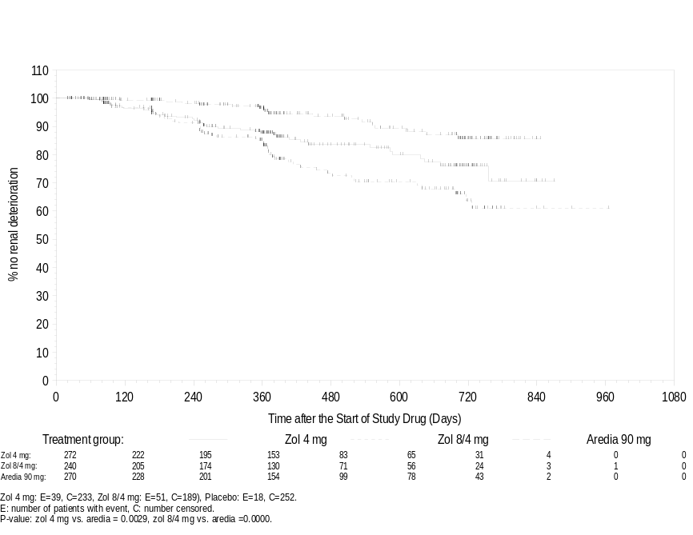

Figure 6-2. Kaplan-Meier curve for time to the first renal function deterioration by treatment group for the post 15-minute infusion Amendment patients (Protocol 010, Safety evaluable patients)
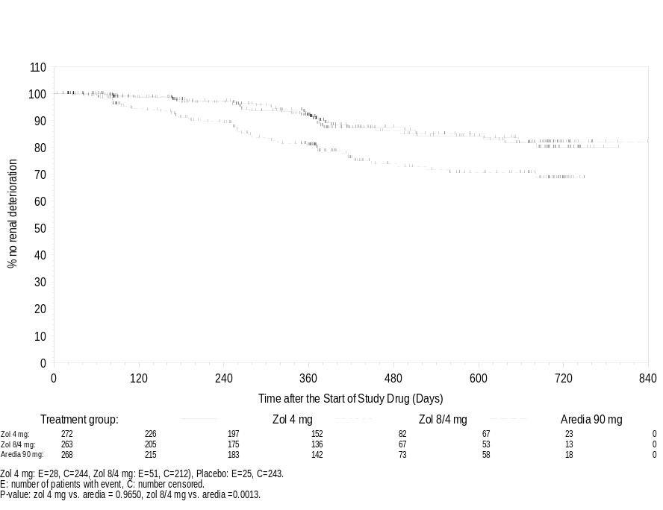

Figure 6-3. Kaplan-Meier curve for time to the first renal function deterioration by treatment group for the pre 15-minute infusion Amendment patients (Protocol 011, Safety evaluable patients)

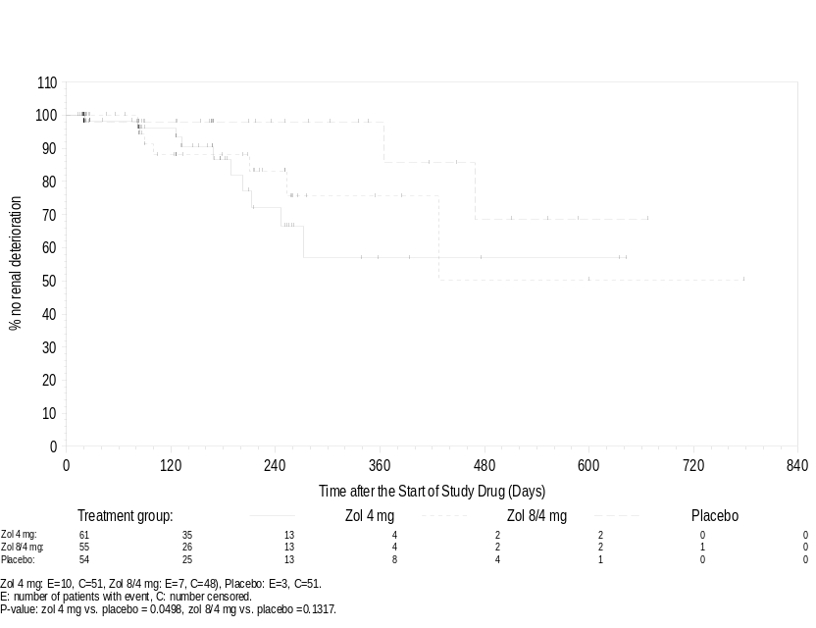

Figure 6-4. Kaplan-Meier curve for time to the first renal function deterioration by treatment group for the post 15-minute infusion Amendment patients (Protocol 011, Safety evaluable patients)

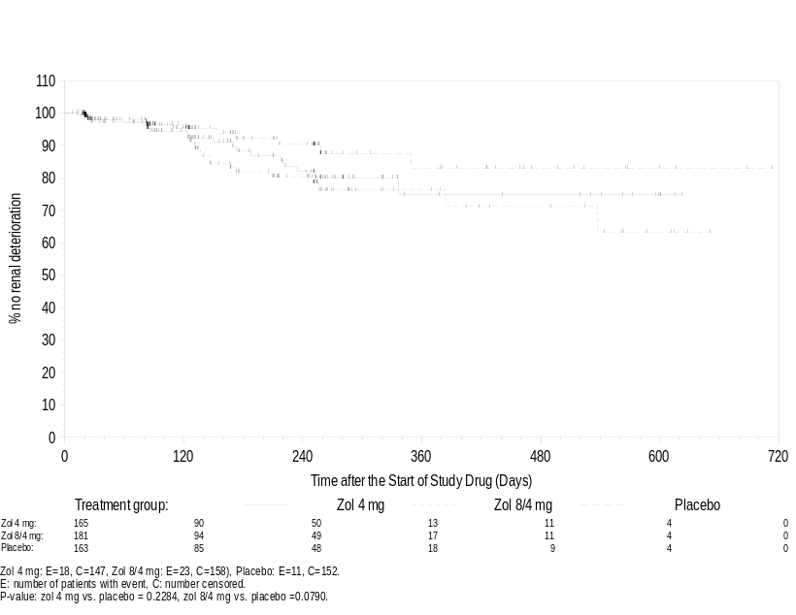

Figure 6-5. Kaplan-Meier curve for time to the first renal function deterioration by treatment group for the pre 15-minute infusion Amendment patients (Protocol 039, Safety evaluable patients)
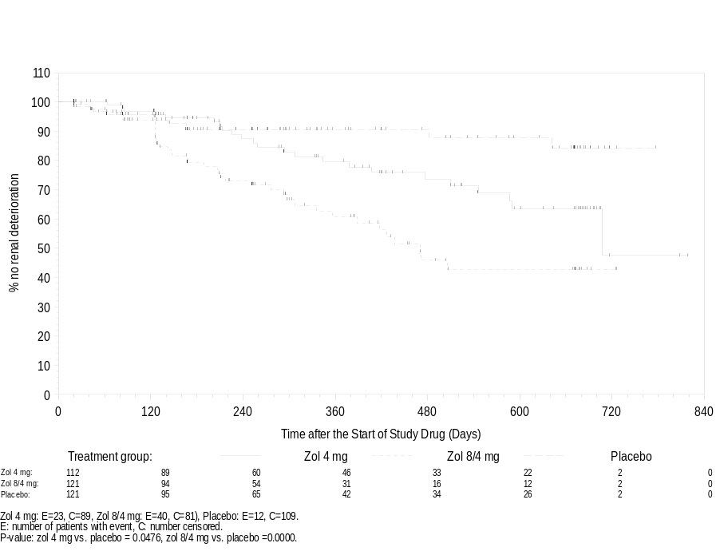

Figure 6-6. Kaplan-Meier curve for time to the first renal function deterioration by treatment group for the post 15-minute infusion Amendment patients (Protocol 039, Safety evaluable patients)
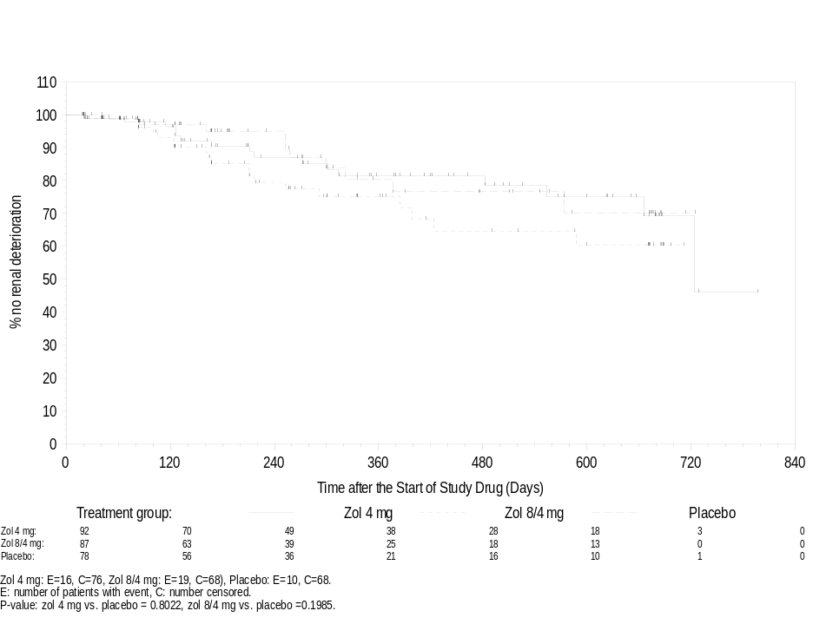

6.4 Deaths

6.4.1 Primary Cause of Death
The proportion of patients who died was highest (29.7%) in the placebo group. The Zometa < 4 mg group and the Aredia group had the lowest proportions of patients who died (9.7% and 16.6%, respectively). These were the only two treatment groups that only had patients with breast cancer and multiple myeloma. The proportions of patients who died in the Zometa 4 mg (22.7%) and 8/4 mg (24.0%) groups fell between the proportions in the Aredia and placebo groups. This pattern reflects the differences in tumor types in the different treatment groups.
The primary causes of death are presented by body system and treatment group in the following table.

Table 6-11. Primary causes of death (by body system) in Phase II/III studies
 | Zol  < 4 mg |  | Zol  4 mg |  | Zol  8/4 mg |  | Aredia  90 mg |  | Placebo
 |  | n (%) |  | n (%) |  | n (%) |  | n (%) |  | n (%)
Patients studied
Total no. of patients studied |  | 145 (100) |  | 1099 (100) |  | 1007 (100) |  | 631 (100) |  | 455 (100)
No. of patients who diedª |  | 14 (9.7) |  | 250 (22.7) |  | 242 (24.0) |  | 105 (16.6) |  | 135 (29.7)
Body system
Incomplete code^{b} |  | 0 (0.0) |  | 54 (4.9) |  | 47 (4.7) |  | 14 (2.2) |  | 20 (4.4)
Blood/lymphatic |  | 0 (0.0) |  | 0 (0.0) |  | 1 (0.1) |  | 0 (0.0) |  | 0 (0.0)
Cardiac |  | 1 (0.7) |  | 20 (1.8) |  | 20 (2.0) |  | 9 (1.4) |  | 11 (2.4)
Gastrointestinal |  | 0 (0.0) |  | 2 (0.2) |  | 4 (0.4) |  | 1 (0.2) |  | 2 (0.4)
General disorders/administration site |  | 1 (0.7) |  | 11 (1.0) |  | 7 (0.7) |  | 5 (0.8) |  | 6 (1.3)
Hepatobiliary |  | 0 (0.0) |  | 3 (0.3) |  | 2 (0.2) |  | 0 (0.0) |  | 0 (0.0)
Infections/infestations |  | 2 (1.4) |  | 21 (1.9) |  | 16 (1.6) |  | 12 (1.9) |  | 8 (1.8)
Injury/poisoning |  | 0 (0.0) |  | 0 (0.0) |  | 1 (0.1) |  | 0 (0.0) |  | 1 (0.2)
Metabolism/nutrition |  | 0 (0.0) |  | 0 (0.0) |  | 2 (0.2) |  | 0 (0.0) |  | 1 (0.2)
Musculoskeletal/  connective tissue/bone |  | 0 (0.0) |  | 1 (0.1) |  | 0 (0.0) |  | 0 (0.0) |  | 0 (0.0)
Neoplasms benign/malignant |  | 9 (6.2) |  | 106 (9.6) |  | 101 (10.0) |  | 48 (7.6) |  | 66 (14.5)
Nervous system |  | 1 (0.7) |  | 3 (0.3) |  | 6 (0.6) |  | 5 (0.8) |  | 1 (0.2)
Psychiatric |  | 0 (0.0) |  | 0 (0.0) |  | 2 (0.2) |  | 0 (0.0) |  | 1 (0.2)
Renal/urinary |  | 0 (0.0) |  | 1 (0.1) |  | 10 (1.0) |  | 0 (0.0) |  | 0 (0.0)
Respiratory/thoracic/  mediastinal |  | 0 (0.0) |  | 23 (2.1) |  | 18 (1.8) |  | 9 (1.4) |  | 13 (2.9)
Vascular |  | 0 (0.0) |  | 5 (0.5) |  | 5 (0.5) |  | 2 (0.3) |  | 5 (1.1)
ª The number of deaths includes all deaths recorded at study completion or with a death date within 28 days after study termination.
^{b} No MedDRA code of patients who died after completion of study.

7. Summary of Safety
The safety characteristics of Zometa may be summarized as follows:
- Zometa 4 mg given as an intravenous 15-minute repeated infusion every 3-4 weeks was well-tolerated in a broad target population of cancer patients with bone metastases.
- The most commonly occurring adverse events and serious adverse events in these studies, such as bone pain, nausea, fatigue, and progression of cancer, were not unexpected in patients with metastatic cancer, many of whom were receiving antineoplastic therapy.
- A dose relationship was observed for adverse events of the renal and urinary system and for renal function deterioration (based on creatinine analysis), with doses of 8 mg or higher having a higher incidence of such events.
- The incidence of creatinine elevations and more serious degrees of renal function impairment was similar for Zometa 4 mg over 15 minutes and pamidronate 90 mg over 2 hours and thus monitoring of renal functions should be similar for the two compounds.
- A minimum infusion time of 15 minutes and minimum infusate volume of 100 mL is recommended for the 4 mg dose, as faster infusion rates and more concentrated drug administration may increase the risk for renal function deterioration.
- The risk of hypophosphatemia, hypokalemia, and hypocalcemia are also dose-related. At a dose of 4 mg, however, the incidence of these electrolyte abnormalities is very low.
- Zometa, like other bisphosphonates, may be associated with the occurrence of an acute phase reaction with symptoms such as fever, chills, myalgias, and arthralgias.
- The incidence of eye abnormalities and injection site reactions appeared to be lower with Zometa than with Aredia.

8. Summary of Effectiveness
The Zometa study program in patients with malignant bone lesions was extensive in scope, enrolling over 3000 patients with multiple myeloma or with bone metastases from a broad range of cancer types. These studies have provided consistent evidence of Zometa effectiveness in delaying or reducing the occurrence of skeletal-related morbid events, in all tumor types studied. In breast cancer and multiple myeloma, Zometa was shown to be effective in comparison to pamidronate (the bisphosphonate currently approved for this use). In studies in patients with prostate cancer or solid tumors other than prostate or breast cancer, where previous bisphosphonates have not been shown to be effective, Zometa was shown to be superior to placebo in delaying or reducing the incidence of skeletal-related morbid events. The study data indicate that both 4 mg and 8 mg doses of Zometa are effective, but there is no evidence of any significant advantage in clinical effectiveness for the higher dose, indicating that maximal effectiveness is provided at the lower dose. Evidence of effectiveness is seen in prostate cancer, where osteoblastic bone lesions are more common, as well as in other malignancies where osteolytic lesions predominate. This is believed to be due to the fact that osteoclast activation, with excessive pathological bone resorption, is a central feature of all malignant bone lesions; and Zometa is highly potent in blocking the osteoclast activation associated with malignant bone lesions.
The consistency of the clinical effectiveness data is illustrated in the following tables, which briefly recapitulate the findings of analyses of Skeletal Related Events, the primary study endpoint. As noted previously, the primary analysis for each of the phase III studies compared the proportion of patients in each study arm who had an SRE over the course of their study participation. Additional analyses examined time to first SRE; rate of SREs over time (the Skeletal Morbidity Rate); and Multiple Event analyses, using Anderson-Gill methodology to evaluate SRE recurrence in patients in each study arm.

Table 8-1. Proportion of patients with one or more SREs (Phase III trials, primary analyses)
 | Study 010 | Study 039 | Study 011
 | Breast Cancer or Myeloma | Prostate Cancer | Other Solid Tumors
Zometa 4 mg | 248/561 (44%) | 71/214 (33%)* | 97/257 (38%)
Zometa 8/4 mg | 242/524 (46%) | 85/221 (38%) | 92/266 (35%)*
Aredia | 257/555 (46%)
Placebo |  | 92/208 (44%) | 111/250 (44%)
*P < 0.05, compared to placebo

Table 8-2. Median Time to first SRE (Phase III trials)
 | Study 010 | Study 039 | Study 011
 | Breast Cancer or Myeloma | Prostate Cancer | Other Solid Tumors
Zometa 4 mg | 373 | Not reached  (> 420)* | 230*
Zometa 8/4 mg | 353 | 363 | 219*
Aredia | 363
Placebo |  | 321 | 163
*P < 0.05, compared to placebo

Table 8-3. Skeletal Morbidity Rate (rate of SREs over time, Phase III studies)
 | Study 010 | Study 039 | Study 011
 | Breast Cancer or Myeloma | Prostate Cancer | Other Solid Tumors
Zometa 4 mg | 1.09 ± 2.66 | 0.80 ± 1.703* | 3.08 ± 21.1
Zometa 8/4 mg | 1.10 ± 1.99 | 1.06 ± 2.193 | 1.96 ± 6.02
Aredia | 1.50 ± 5.45
Placebo |  | 1.49 ± 3.336 | 2.74 ± 5.79
*P < 0.05; 21-day window analyses

Table 8-4. Risk ratios compared to control, Multiple Event Analyses of SREs (Phase III studies)
 | Study 010 | Study 039 | Study 011
 | Breast Cancer or Myeloma | Prostate Cancer | Other Solid Tumors
Zometa 4 mg | 0.885 | 0.643* | 0.732*
Zometa 8/4 mg | 0.910 | 0.847 | 0.687*
Aredia (control) | -
Placebo (control) |  | - | -
*P < 0.05; 21-day window analyses
The above tables demonstrate the consistency of the effectiveness findings, across these large controlled trials and across the different analyses of Skeletal Related Events. The Multiple Event (Anderson-Gill) analyses are of interest because they consider all SRE data (not just the first event) as well as all available information on SRE-free intervals in study participants, and thus may provide an especially sensitive measure of the clinical impact of treatment. These analyses provide substantial support for the effectiveness of Zometa in reducing SRE risk in the placebo-controlled studies in prostate cancer and other solid tumors, and show some suggestion of reduced risk compared to pamidronate in the active-controlled study in breast cancer and multiple myeloma. The data are consistent with the thesis that the increased potency of Zometa may translate to greater, more broad-spectrum activity (compared to other bisphosphonates) in the treatment of patients with malignant bone lesions. Zometa thus can provide an important benefit to a broad range of patients living with malignant bone lesions, reducing the frequency with which these lesions cause clinical and functional problems such as pain, disability, or loss of independence.
It is important to note that hypercalcemia of malignancy (HCM) was not included in the composite Skeletal Related Event endpoint. However, HCM is associated with a range of unpleasant and potentially dangerous symptoms, and often requires emergent hospitalization for treatment. Zometa is approved for the treatment of HCM; the current Zometa clinical study program has provided evidence that Zometa can also reduce the incidence of (i.e., prevent) HCM. Incorporation of HCM events together with SREs in analyses of these clinical studies provides further evidence of the substantial value of Zometa in these patient populations.
Finally, Zometa has the advantage that it can be administered as a 15-minute infusion, reducing the time patients must spend in health care settings (compared to the 2-4 hour infusion required for pamidronate and other bisphosphonates).
In conclusion, based on this consistent pattern of efficacy in the broad range of tumor types included in these phase III pivotal trials, treatment with Zometa 4 mg as a 15-minute intravenous infusion every 3-4 weeks can be recommended for cancer patients with multiple myeloma or with cancer metastatic to bone (regardless of tumor type).

9. Benefit-Risk Assessment
Bone metastases are associated with considerable morbidity (including pain and disability) and have a severe impact on the daily lives of patients with terminal malignant disease and a limited life expectancy. Zometa provides an effective treatment for osteolytic and osteoblastic bone metastases originating from a wide range of primary tumors, reducing the incidence of skeletal-related events (including fractures and hypercalcemia) and delaying the occurrence of such events. Of particular note, Zometa is the first bisphosphonate with demonstrated, statistically significant efficacy in reducing skeletal morbidity due to bone metastases in prostate cancer.
In a comparative study in patients with breast cancer or multiple myeloma, Zometa was shown to be of equivalent efficacy to pamidronate, the current standard of care for patients with bone metastases due to these cancers. Zometa, however, has the advantage that it can be administered as a 15-minute infusion rather than the 2-4 hour infusion required with pamidronate and other bisphosphonates.
The safety profile of 4 mg Zometa given as a 15-minute infusion, established in a development program with over 2500 patients with bone metastases who were treated with Zometa, appears to be very similar to that of 90 mg pamidronate given as a 2-hour infusion, and is generally typical of an intravenous bisphosphonate.
In conclusion, any risks of treatment with Zometa, when used as indicated in the product insert (PI), are far outweighed by the risks of skeletal morbidity resulting from untreated bone metastases, and by the benefits that treatment offers in reducing the incidence of SREs and delaying their occurrence. Zometa has the potential to play an important role in the management of osteolytic and osteoblastic bone metastases associated with a wide range of primary tumors. The proposed product labeling (PI) reflects the efficacy and safety profile of Zometa as demonstrated in the clinical development program. Approved Zometa labeling should therefore be modified to allow for the safe use of this effective product in the treatment of bone metastases associated with breast cancer, prostate cancer and other solid tumors, and osteolytic lesions of multiple myeloma in conjunction with standard antineoplastic therapy.

10. Overall Conclusion
The 4 mg dose of Zometa was consistently superior to placebo in the pivotal Phase III studies, and was equivalent to pamidronate in patients with breast cancer or multiple myeloma. The incidence of SREs (the primary efficacy variable in these studies) was statistically significantly lower than with placebo. The efficacy of Zometa was apparent across the range of primary tumor types studied (breast cancer, multiple myeloma, lung, prostate and other solid tumors). It is particularly notable that efficacy was clearly demonstrated in prostate cancer (in Study 039), in terms of fewer SREs and a considerable extension of the time to first SRE. Statistically significant efficacy in the treatment (other than pain relief) of bone metastases in prostate cancer has not previously been demonstrated with any other bisphosphonate, including pamidronate. This benefit was apparent after only 3 months of treatment. In the protocol-defined primary efficacy analysis (incidence of SREs excluding HCM) in study 011, the difference between Zometa 4 mg and placebo was not statistically significant. However, the difference was statistically significant for the incidence of SREs including HCM (a clinically important and potentially life-threatening complication), and in other secondary analyses, including the time to first SRE, and skeletal morbidity rates. Zometa 4 mg was able to delay the first SRE by a median of over 2 months compared with placebo, an important finding in a patient population with a life expectancy of 6 months or less. The efficacy of Zometa 4 mg in this study was clear despite the fact that many patients received only 4 doses.
The safety profile of Zometa as demonstrated in the clinical development program appeared similar to that of pamidronate. The overall safety profile indicates only one clinically significant safety risk, that of renal function deterioration with doses of 8 mg or higher. However, a dose of 4 mg given over 15 minutes every 3 to 4 weeks, the recommended dose and regimen for treatment of patients with cancer and bone metastases, has an acceptable risk profile with regard to effects on renal function.

11. References

1. Lipton A, Small E, Saad F, et al. The new bisphosphonate, Zometa (zoledronci acid) decreases skeletal complications in both lytic and blastic lesions: a comparision to pamidronate (abstract 34. Cancer Invest 2001:20(1):45-47.
2. NDA 21-223 Zometa (Zoledronic acid) in the treatment of hypercalcemia of malignancy, Approval date: 20-Aug –01.
3. EU TIH authorization number – EU/1/01/176/001-003: TIH approval 20-Mar-01.
4. Mundy GR, Raisz LG, Cooper RE, et al. Evidence for the secretion of an osteoclast stimulating factor in myeloma. N Engl J Med 1974; 291: 1041-1046.
5. Valentin - Opran A, Charmon SA, Meunier PJ, et al. Quantitative histology of myeloma-induced bone changes. Br J Haematol 1982; 52: 601-610.
6. Taube T, Elomaa I, Blomqvist C, et al. Histomorphometric evidence for osteoclast-mediated bone resorption in metastatic breast cancer. Bone 1994; 15: 161-166.
7. Mundy GR, Ibbotson KJ, D’Souza SM. Tumor products and the hypercalcemia of malignancy. J Clin Invest 1985; 76: 391-394.
8. Garrett JR, Durie BGM, Nedwin GE, et al. Production of lymphotoxin, a bone resorbing cytokine, by cultured human myeloma cells. N Engl J Med 1987; 317: 526-532.
9. Gozzolino F, Torcia M, Aldinacci DL, et al. Production of interleukin-1 by bone marrow myeloma cells. Blood 1989; 74: 380-387.
10. Vargas SJ, Gillespie MT, Powell GJ, et al. Localization of parathyroid hormone-related protein mRNA expression in breast cancer and metastatic lesions by in situ hybridization. J Bone Miner Res 1992; 7: 971-979.
11. Lipton A, Costa L, Ali S, Demers L. Use of bone turnover for monitoring bone metastases and response to therapy. Seminars in Oncology 2001;28 (4) Supp 11;54-59.
12. Ralston SH, Patel U, Fraser WD, et al. Comparison of three intravenous bisphosphonates in cancer-associated hypercalcemia. Lancet 1989; 2:1180-1182.
13. Thiebaud D, Jaeger PH, Jacquet AF, Burckhardt P. Dose-response in the treatment of hypercalcemia of malignancy by a single infusion of the bisphosphonate AHPrBP. J Clin Oncol 1988: 6: 762-786.
14. Body JJ, Borkowski A, Cleeren A, Bijvoet OLM. Treatment of malignancy-associated hypercalcemia with intravenous aminohydroxypropylidene diphosphonate. J Clin Oncol 1986; 4: 1177-1183.
15. Gucalp R, Ritch P, Wiernick PH, et al. Comparative study of pamidronate disodium and etidronate disodium in the treatment of cancer-related hypercalcemia. J Clin Oncol 1992; 10: 134-142.
16. Nussbaum SR, Younger J, Vandepol CJ, et al. Single-dose intravenous therapy with pamidronate for the treatment of hypercalcemia of malignancy: Comparison of 30-, 60-, and 90-mg dosages. Am J Med 1993; 297-304.
17. Berenson JR, Lichtenstein A, Porter L, et al. Efficacy of pamidronate in reducing skeletal events in patients with advanced multiple myeloma. N Engl J Med 1996; 334: 488-493.
18. Hortobagyi GN, Theriault RL, Porter L, et al. Efficacy of pamidronate in reducing skeletal complications in patients with breast cancer and lytic bone metastases. N Engl J Med 1996; 335: 1785-1791.
19. Bounameaux HM, Schifferli J, Montani JP et al. Renal failure associated with intravenous disphosphonates. Lancet, 1983; I: 471.
20. Mian M, Beghe F, Caprio A, et al. Tolerability and safety of clodronate therapy in bone diseases. Int J Clin Pharmacol Res. 1991; 11(2): 107-14.
21. Hortobagyi GN, Theriault RL, Lipton A et al. Long-term prevention of skeletal complications of metastatic breast cancer with pamidronate. Protocol 19 Aredia Breast Cancer Study Group. J Clin Oncol. 1998; 16(6): 2038-44.

ATTACHMENT 1: COMPOSITION OF DATA SAFETY MONITORING BOARD (DSMB)

Dr Tim Eisen
Senior Lecturer in Medical Oncology
University College London
Department of Oncology
91 Riding House Street
London W1P 8BT

Dr. Steve Johnston (Breast Cancer)
Senior Lecturer & Honorary Consultant Medical Oncologist
The Royal Marsden NHS Trust
Dept of Medicine (1st floor Mulbery Hse)
Fulham Rd
London SW3 6JJ

Professor John Whitehead
Medical and Pharmaceutical Statistics Research Unit
The University of Reading
PO Box 240
Earley Gate
Reading, RG6-GFN,
UK

ATTACHMENT 2: COMPOSITION OF RENAL ADVISORY BOARD (RAB)

Raimund Hirschberg, MD
Harbor-UCLA Medical Center, Box 406
1000 West Carson St
Torrance, CA 90509

William Bennett, MD
Legacy Good Samaritan Hospital
1040 NW 22nd Avenue, Suite 430
Portland, Oregon 97210

Prof. Claudio Ponticelli
Div. di Nefrologia e Dialisi
Padiglione CROFF
Ospedale Policlinico
Via Commenda, 15
20122 MILANO - ITALY

A. Ross Morton, MD
Renal Unit, Davies 2
Kingston General Hospital
Kingston, ON
K7L 2V7

ATTACHMENT 3:

PROPOSED ZOMETA LABELING (including HCM)

