REAL ESTATE REQUEST ANALYSIS
Office:
Date:
Prepared by:
Telephone:
Executive Approval:

1. DESCRIPTION OF PROJECT
Briefly describe reason for new space request.

Type Here:

2. CURRENT OFFICE LOCATION(S)
Please indicate the current location and usage of TIGTA space.

Bldg. | Floor | Room | Notes

3. DESIRED NEW GEOGRAPHIC LOCATION
Please indicate the new geographic area and justification for the location (e.g. proximity to IRS customers).

Type Here:

4. STAFFING
Please provide a listing of all authorized personnel assigned to this office. Please include job series and grades. Please also include in bold type any additional or future staffing you wish to be approved with this request.

Job Series | Position Title | Grade | # | Notes/Description

4a. OTHER STAFFING
Complete listing only if this office provides workspace for other than TIGTA personnel (example: contractors, detailees.)
Title | Quantity | Notes/Description
(i.e. Contractors) | (3) | (Summer Only)

4b. ACCOMMODATIONS REQUIREMENTS – EMPLOYEES WITH SPECIAL NEEDS
Identify special requirements for members of this staff. Note the special equipment, furnishing (and dimensions), ADP, Telecommunication and data requirements (example: TTY), and special work area space requirements (additional space is needed for employees who use wheel chairs.)

Title | # | Notes/Description

5. TIGTA SPACE STANDARDS

Space entitlement for all offices includes 30% circulation space in addition to the total space entitlement. Double click on the Excel table below and fill in the number of the employees in the yellow highlighted areas. Your space allocation will automatically calculate based on your entries.

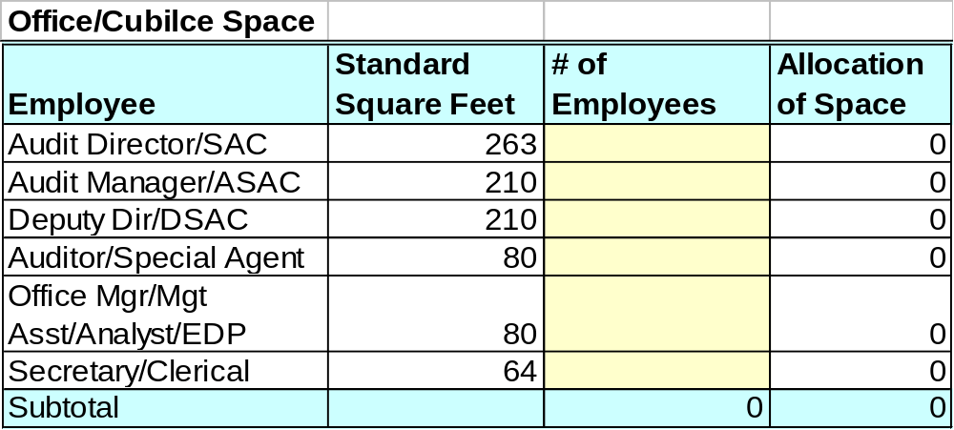
Special Use Space will be calculated by the Real Estate Analyst using the following standards.

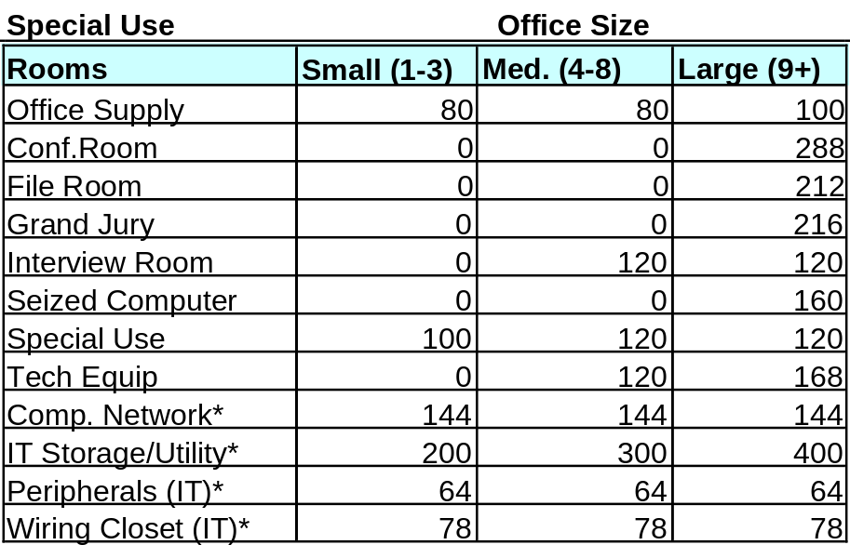
* Information Technology special use rooms are based on the number of Systems Administrators in each location, not on the number of TIGTA employees.

6b. Please describe current space holdings that exceed the standards defined above.

Type Here:

7. EQUIPMENT NEEDS
Please describe all equipment needs (e.g., fax, copier, printer etc.) Annotate if equipment needs to be purchased or if it is currently in your possession.

Type Here:

8.CONFERENCE/ INTERVIEW ROOMS
Describe requirements such as white boards, desired capacity of conference room, security needs, etc.

Requirement | Notes

9. FILING REQUIREMENTS
Describe standard & special filing equipment such as fire safes, secured files. Do not include filing or storage units, which are part of or included inside workstations. Annotate if storage units need to be purchased or if they currently exist.

Equipment | # | Notes

10. SPECIAL FLOOR LOAD REQUIREMENTS
Identify any unusual floor load requirements, such as power files (lektrievers), safes, large copy machines, central file rooms or libraries.

Type Here:

11. SPECIAL USE ROOM REQUIREMENTS
Describe any special furniture or cabinetry that you will need in the Special Use rooms.

Type Here:

12. INDICATE ANY NON-STANDARD SPACES YOU CURRENTLY HAVE
Special space houses special equipment or functions such as copier rooms, mail rooms, microfiche areas, library/reference areas, dry labs, etc. Do not include Computer rooms or special use rooms listed above. Please list each special space and its features.

Non-Standard Space | Features

13. SECURITY NEEDS
Please describe your security requirements (secure work area, bulletproof glass in reception area, cameras, etc.)

Type Here:

14. ADJACENCY REQUIREMENTS
Adjacency requirements describe those functional relationships that are best supported by locating groups or functions close together. Understanding these operational adjacencies is most important as we plan space. Please describe both internal (e.g., TIGTA or IRS functional groups) and external (e.g., U.S. Attorney or U.S. Marshall Service) groups you desire close proximity to as well as internal and external groups you desire distance from.

Type Here:

15. MOVE SCHEDULING
As groups are relocated there may be organizational issues that impact move scheduling. If your group has time-of-year constraints, or operational dependencies (groups so interdependent that moves should be scheduled together) please describe these or any other considerations that may impact move scheduling.

Type Here:

