Table of Contents

The Reports Submodule
Navigating to the Reports Submodule 2
Generating a Report 3
The Delinquency Report 4
The Resident Characteristics Report 10
The Late Reexamination and Flat Rent Annual Update Report 38
The Tenant Rent Calculation Discrepancy Report 53
The Section 8 Deconcentration Analysis Report 67
The Late Housing Quality Standard Inspection Report 75
The Newly Leased Units Report 83
Key Management Indicators Report 90
The Section Eight Management Assessment Program Indicators Report 109
The Family Self-Sufficiency Report 119
End of Participation Report 125
New Admissions Report 152
The Mobility and Portability Report 180
Budget Related Averages Report 209
Income Report 228
Changes in Income Report 252

The Reports Submodule is an application in PIC that provides analyzed Form-50058 data in several types of standard reports. Through this submodule, you can access, formulate, and download these reports at any time.
The Reports Submodule

Thirteen of the reports are summaries that aggregate information across families for whom a Form-50058 has been submitted.

- Delinquency
- Income
- Changes in Income
- SEMAP/FSS
- Key Management Indicators
- End of Participation
- Section 8 Deconcentration
- Mobility and Portability
- New Admission
- Budget Related Averages
- Resident Characteristics
- Rent and Rent Burden

Four of the reports are detailed reports that provide information on a family-by-family basis.

- Late Reexamination
- Late Housing Quality Standard
- Newly Leased Units
- Rent Calculation Discrepancy

Note: Access to these reports is determined by security clearance. If you are a PHA employee and seek access to more reports than are available to you, contact your executive director. If you are a HUD employee, contact your PIC coach.

Navigating to the Reports Submodule
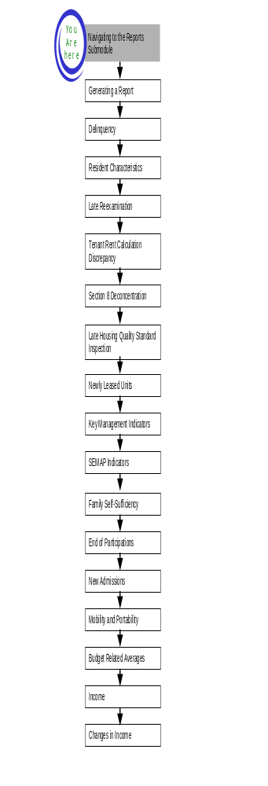
To navigate to the Reports Submodule:

Step | Action/Result
- Move your cursor over the Form-50058 button on the PIC main page. | A list of submodules is displayed (see Figure 1).
- Click the Reports link. | The Delinquency Report page is displayed. Other available reports are listed in tabs at the top of the page.

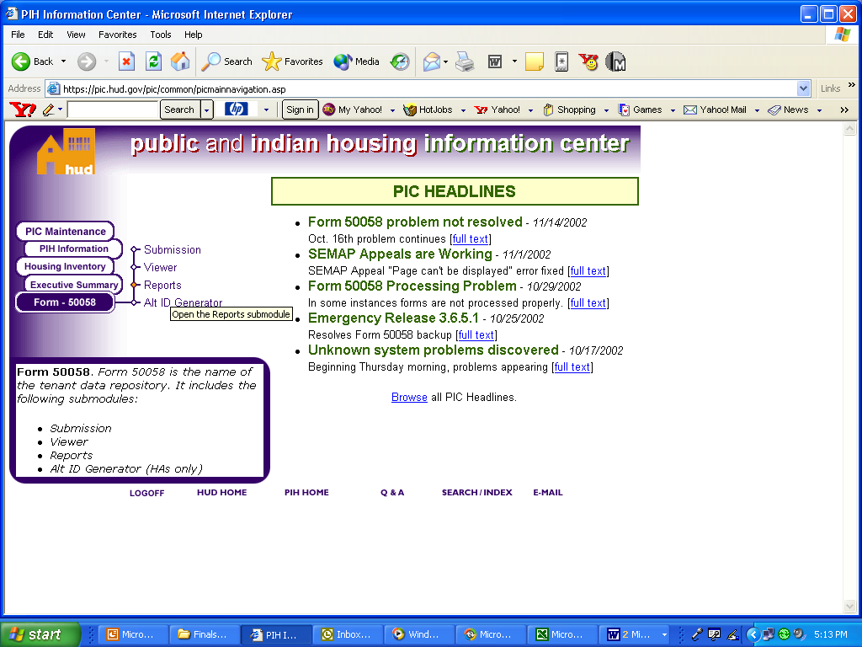
Figure 1: The PIC main page.

Generating a Report
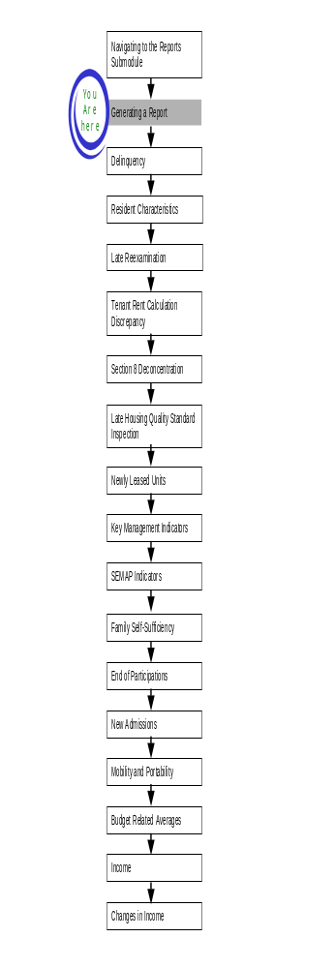

The following sections demonstrate how to generate reports after you have logged on to PIC and navigated to the Reports Submodule. A quick reference guide for this submodule is provided in Appendix C.

Each section describes the steps required to produce one of the 17 reports available in PIC (see Figure 2). Each section is accessible from tabs on the top of the Reports Submodule.

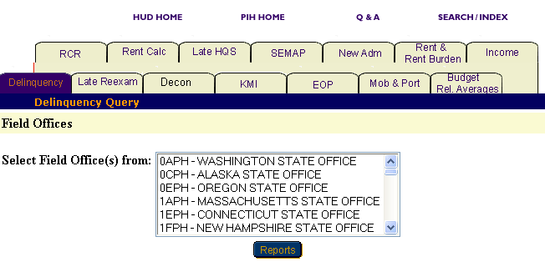

Figure 2: The Reports page with the Delinquency Report selected.

The Delinquency Report
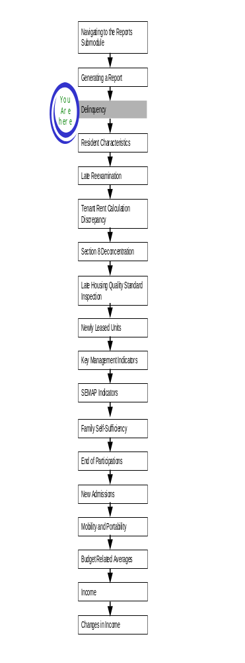
The Delinquency Report provides PHA reporting rates for Form-50058 submissions in the Public Housing, Certificates and Vouchers, and Moderate Rehabilitation programs. The report enables you to compare available and occupied units and the total number of unreported households for PHAs participating in each of these programs.

To access the Delinquency Report start page:

Step | Action/Result
- Log on to PIC. | The PIC main page is displayed.
- Move the cursor over the Form-50058 button. | A list of submodules is displayed.
- Click the Reports link. | The Delinquency Report page is displayed (see Figure 3). Other available reports are listed in tabs at the top of the page.  Note: The Delinquency Report is the default screen in the Reports Submodule.

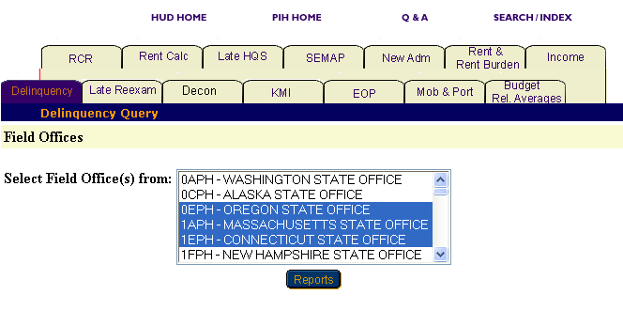
Figure 3: The Delinquency Report tab and start page.

Generating a Delinquency Report
To generate a report with the field offices you want to view:

Step | Action/Result
- Click the field office you want to research in the Select Field Office(s) from dialog box. | Note: To select more than one field office, press the CONTROL key as you click each office you want to include in the report.
- Click the button titled Reports. | PIC presents a Delinquency Report for the field office(s) selected.

Information Presented in a Delinquency Report
When you complete your selections and click the Reports button, PIC generates the Delinquency Report for the particular field office(s) selected. The selections are listed in the report heading at the top of the screen.

The heading also includes the report’s start and end dates. The end date for a Delinquency Report includes future dates within four (4) months.

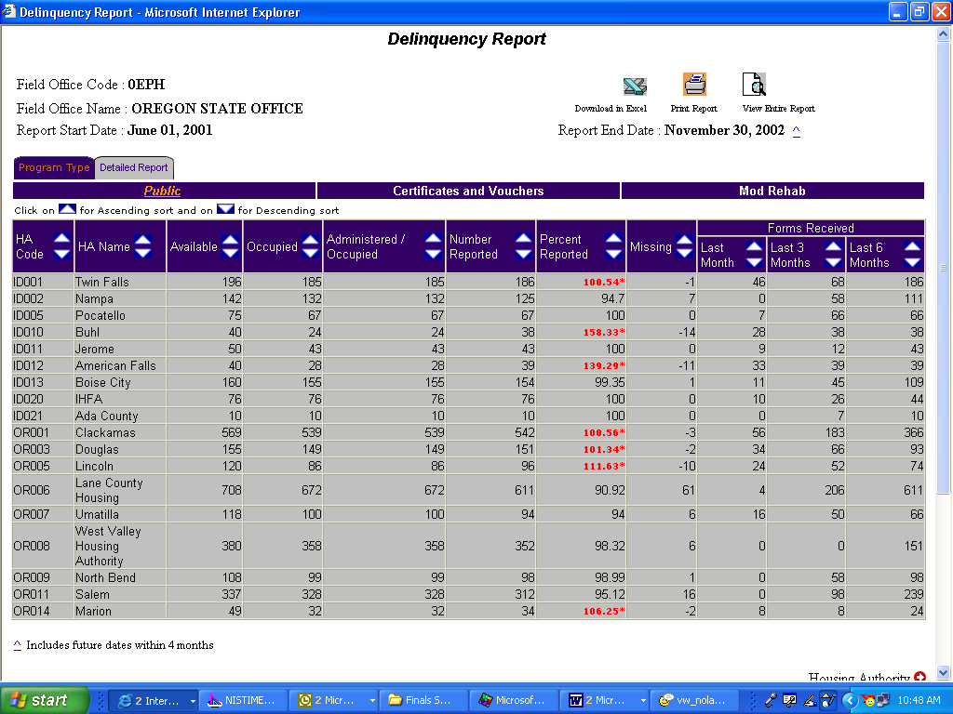
Figure 4: This graphic shows the two different tabs
available in a Delinquency Report.

Delinquency Reports can be presented in two views: Program Type or Detailed Report (see Figure 4).

- Program Type: shows the report for each program individually. The Public Housing program type is the default view.

- Detailed Report: shows a report for all programs.

To display the other programs in this view:

Step | Action/Result
- Click the Certificates and Vouchers subtab on the report page. | The report displays PHAs in the selected field office participating in the Certificate and Voucher program.
- Click the Mod Rehab subtab. | The report displays PHAs in the selected field office participating in the Moderate Rehabilitation program.

To select Detailed Report:

Step | Action/Result
- Click the tab titled Detailed Report on the top left of the report screen. | The report displays information for PHAs associated with the selected field office in all of the programs.

Note: If you have selected several field offices to include in the report, PIC displays only one field office at a time.

To view the other selected field offices:

Step | Action/Result
- Click the Field Office right-side arrow located at the bottom of the report. | The next data set is displayed.
- Click the Field Office left-side arrow to return to the data set previously viewed. | The previous data set is displayed.

You can view Delinquency Report table information in ascending or descending order by clicking the up or down arrow in any of the column you want to view.

The following table describes the information contained in a Delinquency Report.

Table | Information Presented
PHA Delinquency Report | Default screen for the Delinquency Report. It displays the following information for specific PHAs:  - HA code  - HA name  - Available units (#)  - Occupied units (#)  - Administered/Occupied Units (#)  - Number reported (#)  - Percent reported (%)  - Missing (the numerical difference between Administered/Occupied Units and the Number Reported)  - Forms Received (#)  Last month  Last 3 months  Last 6 months
Summary Information for the Field Office | Contains the following information for the entire field office selected:  - Aggregate  - Available units (#)  - Occupied units (#)  - Administered/Occupied units (#)  - Number reported (#)  - Percent reported (%)  - Missing (the numerical difference between administered/occupied units and the number reported)  - Forms Received (#)  Last month  Last 3 months  Last 6 months

Note: In a Detailed Report, the PHA Delinquency Report table also includes the program type for each PHA.
The report screen lists the first 20 PHAs in descending HA code order.

To view more PHAs associated with the field office selected:

Step | Action/Result
- Click the Housing Authority right-side arrow located just under the table (see Figure 5). | The report lists the additional PHAs.
- Click the Housing Authority left-side arrow. | The previous data set is displayed.

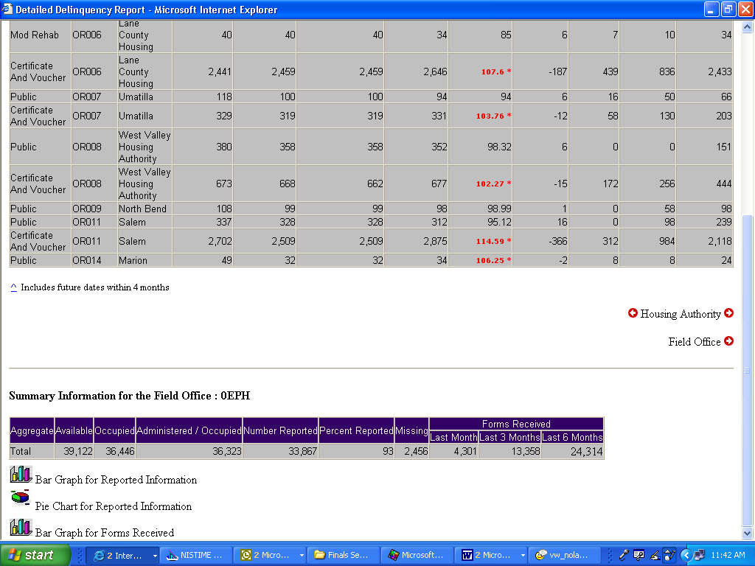
Figure 5: The Housing Authority
right-side and left-side arrows.

Two icons at the bottom of most tables (see Figure 6), are used for viewing the information in either a Pie Chart or Bar Graph form. When the icons are not visible, the information is only available in tabular form.

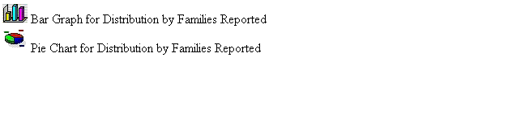
Figure 6: The icons available for displaying
table data in a Bar Graph or Pie Chart.

The Delinquency Report screen contains three options for further use of the data (see Figure 7). The options are located on the top right of the report screen.

Select one of the following options:

      - Download in Excel: The report downloads to an MS-Excel™ spreadsheet for further data manipulation.

      - Print Page: The report prints as a Web page.

Note: For the best results, print in landscape orientation.

      - View Entire Report: All report subcategory tables display together on one screen.

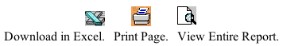
Figure 7: The options for
further use of report data.

To generate another report, repeat the process by returning to the Reports screen and selecting the tab for the report you want next. Go to the corresponding section of this user manual, and follow the steps to generate the report.

The Resident Characteristics Report
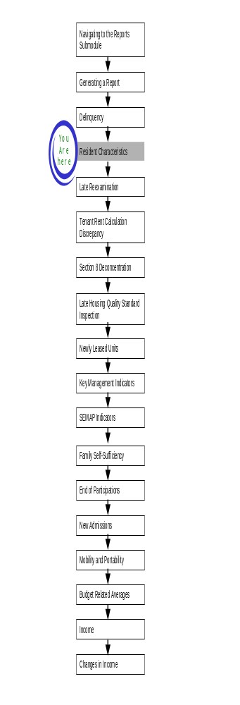
The Resident Characteristics Report (RCR) summarizes general information about families who reside in Public Housing or who receive Section 8 assistance.

To access the Resident Characteristics Report:

Step | Action/Result
1. Log on to PIC. | The PIC main page is displayed.
2. Move your cursor over the Form-50058 button. | A list of submodules is displayed.
3. Click the Reports link. | The Delinquency Report page is displayed. Other available reports are listed in tabs at the top of the page.
4. Click the RCR tab. | The Resident Characteristics Report start page displays (see Figure 8).

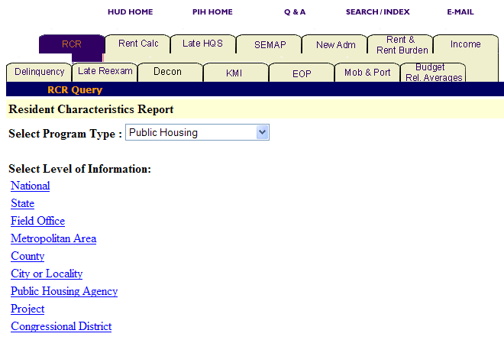
Figure 8: The RCR tab and start page.

Generating a Resident Characteristics Report

After you reach the Resident Characteristics Report start page, select the program type and level of information you want to view.

To select Resident Characteristics Report criteria:

Step | Action/Result
- Click the program type you want in the Program Type dialog box. | - Public Housing  - S8 Moderate Rehabilitation  - S8 Certificate  - S8 Voucher  - S8 Certificate and Voucher  - All Relevant Programs  Note: Public Housing is the default option for the Select Program Type dialog box.
- Click the link on the Select Level of Information list that corresponds to the level of information you want on the report. | The module formulates the rest of the criteria necessary to generate the report based on the level you select here. For example, click State when the program type you are interested in is located at that level. A dialog box containing a list of state names appears. Click the state where the program type you are interested in is located, and generate the report (see Figure 9).

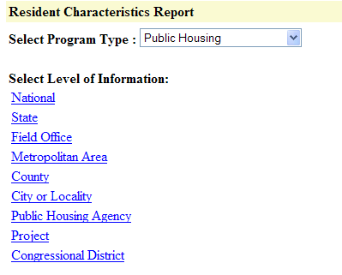
Figure 9: The Level of Information options for
the Resident Characteristics Report.

There are nine levels of information to choose from in a Resident Characteristics Report:

- National
- State
- Field Office
- Metropolitan Area
- County
- City or Locality
- Public Housing Agency
- Project
- Congressional District

Note: You may receive a data unavailable comment if you attempt to retrieve a Resident Characteristics Report for a very small HA or project. This means that data was not provided because an individual tenant could be identifiable.

The following tables outline how to generate a Resident Characteristics Report at each level:

National

Step | Action/Result
1. Click the National link in the Level of Information list. | PIC generates a Resident Characteristics Report at the national level containing aggregated data.

State

Step | Action/Result
1. Click State in the Select Level of Information list. | A Select State(s) from dialog box is displayed (see Figure 10).
2. Click the state you want from the Select State(s) from dialog box. | Note: To select more than one state, press the CONTROL key as you click each state you want to include in the report.
3. Click the Reports button. | PIC generates the Resident Characteristics Report for the state(s) selected.

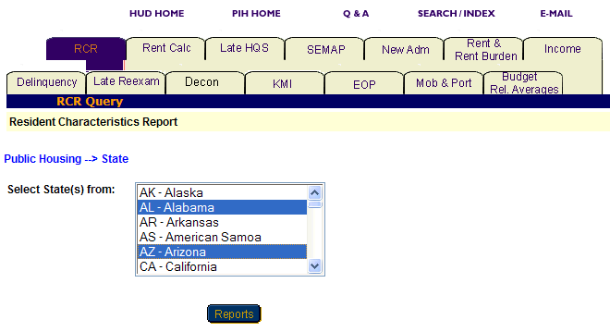
Figure 10: The Select State(s) from dialog box with two states selected.

Field Office

Step | Action/Result
1. Click Field Office on the Select Level of Information list. | A Select Field Office(s) from dialog box is displayed.
2. Click the field office(s) you want in the Select Field Office(s) from dialog box. | Note: To select more than one field office, press the CONTROL key as you click each office you want to include in the report.
3. Click the Reports button. | PIC displays the Resident Characteristics Report for the field office(s) selected.

Metropolitan Area

You have two options for generating a Resident Characteristics Report at the metropolitan area level: Within US and Within a State (see Figure 11).

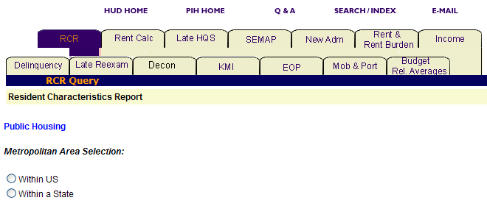
Figure 11: The Metropolitan Area Selection
levels for a Resident Characteristics Report.

Option 1: Within US

Select this option if you know the exact metropolitan area you are looking for.

Step | Action/Result
1. Click Metropolitan Area on the Select Level of Information list. | PIC displays a screen with two different options for identifying the metropolitan area: Within US and Within a State.
2. Click Within US on the Metropolitan Area Selection list. | PIC displays a Select Metro Area(s) from dialog box (see Figure 12).
3. Click the metro area you are looking for in the Select Metropolitan Area(s) from dialog box. | Note: To select more than one metro area, press the CONTROL key as you click each one you want to include in the report.
- Click the Reports button. | PIC displays a Resident Characteristics Report for each metropolitan area selected.

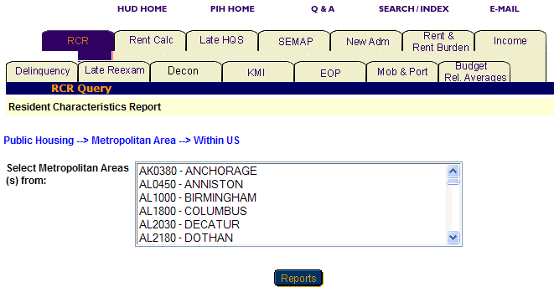
Figure 12: The Select Metropolitan Area(s) from dialog box.

Option 2: Within a State

Select this option if you know only the state the metropolitan area is in.

Step | Action/Result
1. Click Metropolitan Area on the Select Level of Information list. | PIC displays a screen with two different options for identifying the metropolitan area: Within US and Within a State.
2. Click Within a State on the Metropolitan Area Selection list. | PIC displays a Select State from dialog box.
- Click the state you want in the Select State from dialog box.
- Click the MSA button. | A Select Metropolitan Area(s) from dialog box is displayed.
- Click the metro area you are looking for in the Select Metropolitan Area(s) from dialog box. | Note: To select more than one metro area, press the CONTROL key as you click each one you want to include in the report.
- Click the Reports button. | PIC displays a Resident Characteristics Report for each metropolitan area selected within the state.

County

You have two options for generating a Resident Characteristics Report at the county level: Within a State and Within a State and Metropolitan Area (see Figure 13).

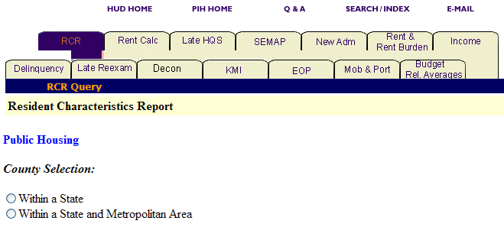
Figure 13: The County Selection Levels for a Resident Characteristics Report.

Option 1: Within a State

Select this option for the state in which the county is located.

Step | Action/Result
1. Click County on the Select Level of Information list. | PIC displays a screen with two different options for identifying the county: Within a State and Within a State and Metropolitan Area.
2. Click Within a State on the County Selection list. | PIC displays a Select State(s) from dialog box.
3. Click the state you want in the Select State(s) from dialog box.
4. Click the County button. | A Select County(s) from dialog box is displayed.
- Click the county(s) you want to include in the report. | Note: To select more than one county, press the CONTROL key as you click each one you want to include in the report.
- Click the Reports button. | PIC displays a Resident Characteristics Report for each county selected within the state.

Option 2: Within a State and Metropolitan Area

Select this option if you know the state and metropolitan area containing the county you are looking for.

Step | Action/Result
1. Click County on the Select Level of Information list. | PIC displays a screen with two different options for identifying the county: Within a State and Within a State and Metropolitan Area.
2. Click Within a State and Metropolitan Area on the County Selection list. | PIC displays a Select State(s) from dialog box.
3. Click the state you are looking for in the Select State(s) from dialog box.
- Click the MSA button. | PIC displays a Select MSA(s) from dialog box.
- Click the metropolitan area that contains the county you want.
- Click the County button. | A Select County(s) from dialog box is displayed (see Figure 5).
- Click the county(s) you want to include in the report. | Note: To select more than one county, press the CONTROL key as you click each one you want to include in the report.
- Click the Reports button. | PIC displays a Resident Characteristics Report for each county selected within the state and metropolitan area.

City or Locality

You have three options for generating a Resident Characteristics Report at the city or locality level: Within a State, Within a State and Metropolitan Area, and Within a State and County (see Figure 14).

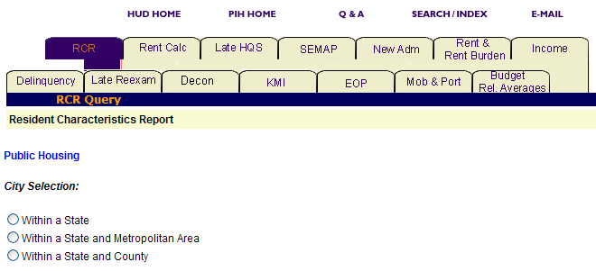
Figure 14: The City Selection levels for a Resident Characteristics Report.

Option 1: Within a State

Select this option if you know the state that contains the city you are looking for.

Step | Action
1. Click City or Locality on the Select Level of Information list. | PIC displays a screen with three different options for identifying the city or locality you are looking for: Within a State, Within a State and Metropolitan Area, and Within a State and County.
2. Click Within a State on the City Selection list. | PIC displays a Select State from dialog box.
3. Click the state that contains the city you want in the Select State from dialog box.
- Click the City button. | A Select City(s) from dialog box is displayed.
- Click the city(s) you want to include in the report. | Note: To select more than one city, press the CONTROL key as you click each one you want to include in the report (see Figure 15).
- Click the Reports button. | PIC displays a Resident Characteristics Report for each city selected within the state.

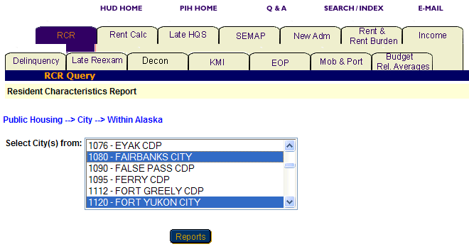
Figure 15: The Select City(s) from dialog box for the
Resident Characteristics Report with two selections.

Option 2: Within a State and Metropolitan Area

Select this option if you know the state and metropolitan area containing the city you are looking for.

Step | Action
1. Click City or Locality on the Select Level of Information list. | PIC displays a screen with three different options for identifying the city or locality you are looking for: Within a State, Within a State and Metropolitan Area, and Within State and County.
2. Click Within a State and Metropolitan Area on the City Selection list. | PIC displays a Select State(s) from dialog box.
3. Click the state you are looking for in the Select State(s) from dialog box.
4. Click the MSA button. | PIC displays a Select MSA(s) from dialog box.
5. Click the metropolitan area that contains the city you want.
- Click the City button. | A Select City(s) from dialog box is displayed.
- Click the city(s) you want included in the report. | Note: To select more than one city, press the CONTROL key as you click each one you want to include in the report.
- Click the Reports button. | PIC displays a Resident Characteristics Report for each city or locality selected within the state and metropolitan area.

Option 3: Within a State and County

Select this option if you know the state and county that contain the city you are looking for.

Step | Action/Result
1. Click City or Locality on the Select Level of Information list. | PIC displays a screen with three different options for identifying the city or locality you are looking for: Within a State, Within a State and Metropolitan Area, and Within State and County.
2. Click Within a State and County on the City Selection list. | PIC displays a Select State(s) from dialog box.
3. Click the state you are looking for in the Select State(s) from dialog box.
- Click the County button. | PIC displays a Select County(s) from dialog box.
- Click the county that contains the city you want.
- Click the City button. | A Select City(s) from dialog box is displayed.
- Click the city you want. | Note: To select more than one city, press the CONTROL key as you click each one you want to include in the report.
- Click the Reports button. | PIC displays a Resident Characteristics Report for each city or locality selected within the state and county.

Public Housing Agency

You have three options for generating a Resident Characteristics Report at the Public Housing Agency level: Within a State, Within a State and County, and Within a Field Office (see Figure 16).

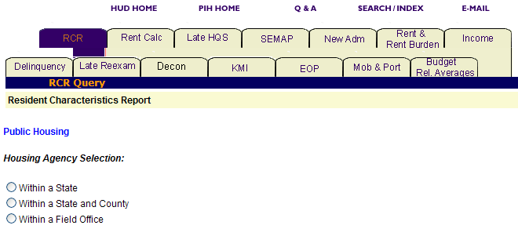
Figure 16: The Housing Agency Selection levels for a Resident Characteristics Report.

Option 1: Within a State

Select this option if you know the state in which your PHA is located.

Step | Action/Result
1. Click Public Housing Agency on the Select Level of Information list. | PIC displays a screen with three different options for identifying the Public Housing Agency: Within a State, Within a State and County, and Within a Field Office.
2. Click Within a State on the Housing Agency Selection list. | A Select State from dialog box is displayed.
3. Click the state you want in the Select State from dialog box.
- Click the HA List button. | A dialog box is displayed with a list of HAs within the state selected.
- Click the desired HA(s) in the Select HA(s) dialog box. | Note: To select more than one HA, press the CONTROL key as you click each HA you want to include in the report (see Figure 17).
- Click the Reports button. | PIC displays a Resident Characteristics Report for each PHA selected within the state.

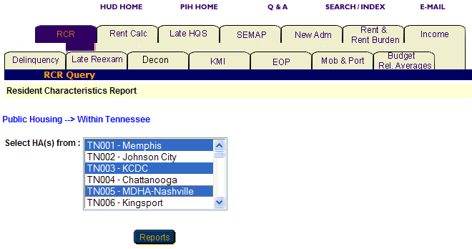
Figure 17: The Select HA(s) from dialog box for the
Resident Characteristics Report with three selections.

Option 2: Within a State and County

Select this option if you know the state and county in which your PHA is located.

Step | Action/Result
1. Click Public Housing Agency on the Select Level of Information list. | PIC displays a screen with three different options for identifying the Public Housing Agency: Within a State, Within a State and County, and Within a Field Office.
2. Click Within a State and County on the Housing Agency Selection list. | A Select State from dialog box is displayed.
3. Click the state where your PHA is located in the Select State from dialog box.
- Click the County button. | A Select County from dialog box is displayed.
- Click the county you want in the Select County from dialog box.
- Click the HA List button. | A dialog box is displayed with a list of HAs associated with the selected county.
- Click the HA(s) you want in the Select HA(s) from dialog box. | Note: To select more than one HA, press the CONTROL key as you click each HA you want to include in the report.
- Click the Reports button. | PIC displays a Resident Characteristics Report for each PHA selected within the state and county.

Option 3: Within a Field Office

Select this option if you know the field office containing the PHA you are looking for.

Step | Action/Result
1. Click Public Housing Agency on the Select Level of Information list. | PIC displays a screen with three different options for identifying the Public Housing Agency: Within a State, Within a State and County, and Within a Field Office.
2. Click Within a Field Office on the Housing Agency Selection list. | A Select Field Office from dialog box is displayed.
3. Click the field office you want in the Select Field Office from dialog box.
- Click the HA List button. | A dialog box is displayed with a list of HAs associated with the selected field office.
- Click the desired HA(s) in the Select HA(s) dialog box. | Note: To select more than one HA, press the CONTROL key as you click each HA you want to include in the report (see Figure 17).
- Click the Reports button. | PIC displays a Resident Characteristics Report for each PHA selected within the field office.
Project

You have five options to generate a Resident Characteristics Report at the project level: Within a State, Within a State and Metropolitan Area, Within a State and County, Within a State and City or Locality, and Within a Public Housing Agency (see Figure 18).

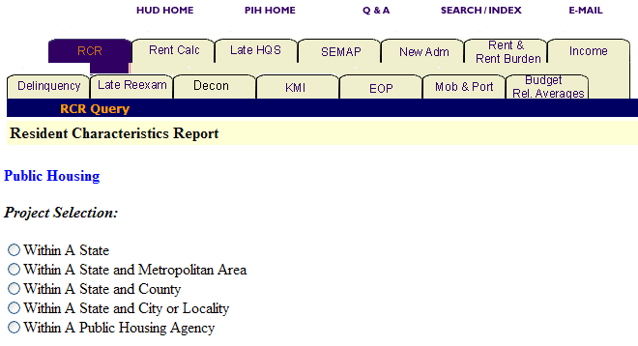
Figure 18: The Project Selection levels for a Resident Characteristics Report.

Option 1: Within a State

Select this option if you know the state containing the project you are looking for.

Step | Action/Result
1. Click Project on the Select Level of Information list. | PIC displays a screen with five different options for identifying the project: Within a State, Within a State and Metropolitan Area, Within a State and County, Within a State and City or Locality, and Within a Public Housing Agency.
2. Click Within a State on the Project Selection List. | A Select State from dialog box is displayed.
3. Click the state you want in the Select State from dialog box.
- Click the Projects button. | A dialog box is displayed with a list of projects within the selected state.
- Click the desired project(s) in the Select Projects(s) dialog box. | Note: To select more than one project, press the CONTROL key as you click each HA you want to include in the report (see Figure 19).
- Click the Reports button. | PIC displays a Resident Characteristics Report for each project selected within the state.

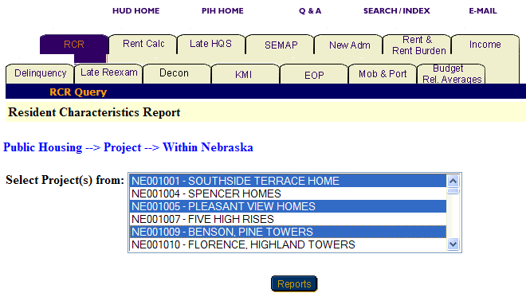
Figure 19: The Select Project(s) from dialog box for the
Resident Characteristics Report with three selections.

Option 2: Within a State and Metropolitan Area

Select this option if you know the state and metro area containing the project you are looking for.

Step | Action/Result
1. Click Project on the Select Level of Information list. | PIC displays a screen with five different options for identifying the project: Within a State, Within a State and Metropolitan Area, Within a State and County, Within a State and City or Locality, and Within a Public Housing Agency.
2. Click Within a State and Metropolitan Area on the Project Selection list. | A Select State from dialog box is displayed.
3. Click the state you want in the Select State from dialog box.
- Click the MSA button. | A Select Metro Area from dialog box is displayed.
- Click the metro area you want in the Select Metro Area from dialog box.
- Click the Projects button. | A dialog box is displayed with a list of projects within the state and metro area selected.
- Click the desired project(s) in the Select Projects(s) dialog box. | Note: To select more than one project, press the CONTROL key as you click each HA you want to include in the report.
- Click the Reports button. | PIC displays a Resident Characteristics Report for each project you selected within the state and metropolitan area.

Option 3: Within a State and County

Select this option if you know the state and county in which the project is located.

Step | Action/Result
1. Click Project on the Select Level of Information list. | PIC displays a screen with five different options for identifying the project: Within a State, Within a State and Metropolitan Area, Within a State and County, Within a State and City or Locality, and Within a Public Housing Agency.
2. Click Within a State and County on the Project Selection list. | A Select State from dialog box is displayed.
- Click the state where your project is located in the Select State from dialog box.
- Click the County button. | A Select County from dialog box is displayed.
- Click the county you want in the Select County from dialog box.
- Click the Projects button. | A dialog box is displayed with a list of projects located in the county selected.
- Click the project(s) you want in the Select Project(s) from dialog box. | Note: To select more than one project, press the CONTROL key as you click each HA you want to include in the report.
- Click the Reports button. | PIC displays a Resident Characteristics Report for each project selected within the state and county.

Option 4: Within a State and City or Locality

Select this option if you know the particular state and city in which the project you are looking for is located.

Step | Action/Result
1. Click Project on the Select Level of Information list. | PIC displays a screen with five different options for identifying the project: Within a State, Within a State and Metropolitan Area, Within a State and County, Within a State and City or Locality, and Within a Public Housing Agency.
2. Click Within a State and City or Locality on the Project Selection list. | A Select State from dialog box is displayed.
3. Click the state where your project is located in the Select State from dialog box.
- Click the City button. | A Select City(s) from dialog box is displayed.
- Click the city in the Select City(s) from dialog box.
- Click the Projects button. | A dialog box is displayed with a list of projects located in selected city.
- Click the project(s) you want in the Select Project(s) from dialog box. | Note: To select more than one project, press the CONTROL key as you click each HA you want to include in the report.
- Click the Reports button. | PIC displays a Resident Characteristics Report for each project selected within the state and city or locality.

Option 5: Within a Public Housing Agency

Select this option if you know the particular Public Housing Agency associated with the project you are looking for.

Step | Action/Result
1. Click Project on the Select Level of Information list. | PIC displays a screen with five different options for identifying the project: Within a State, Within a State and Metropolitan Area, Within a State and County, Within a State and City or Locality, and Within a Public Housing Agency.
2. Click Within a Public Housing Agency on the Project Selection list. | A Select State from dialog box is displayed.
3. Click the state where the Public Housing Agency and project you want are located in the Select State from dialog box.
- Click the HA List button. | A dialog box is displayed with a list of HAs located in the selected state.
- Click the Public Housing Agency you want in the Select HA from dialog box.
- Click the Projects button. | A Select Project(s) from dialog box is displayed for the Public Housing Agency selected within the state (see Figure 20).
- Click the project(s) you want in the Select Project(s) from dialog box. | Note: To select more than one project, press the CONTROL key as you click each HA you want to include in the report.
- Click the Reports button. | PIC displays a Resident Characteristics Report for each project selected within the state and city or locality.

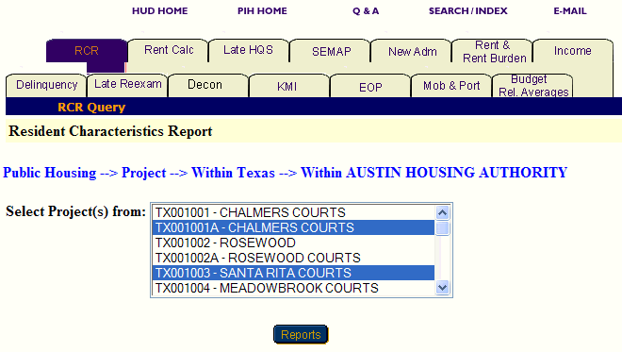
Figure 20: The Select Project(s) from dialog box for the
Resident Characteristics Report with two selections.

Congressional District

You have two options to generate an EOP Report that contains information about all the PHAs in a particular congressional district: Within US and Within a State (see Figure 21).

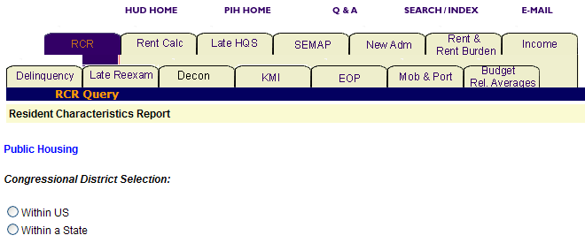
Figure 21: The Congressional District Selection
levels for a Resident Characteristics Report.
Option 1: Within US

Select this option if you know the exact congressional district you are looking for.

Step | Action/Result
1. Click Congressional District on the Select Level of Information list. | PIC displays a screen with two different options for identifying the congressional district: Within US and Within a State.
2. Click Within US on the Congressional District Selection list. | PIC displays a Select Congressional District(s) from dialog box (see Figure 22).
- Click the congressional district you want in the dialog box. | Note: To select more than one congressional district, press the CONTROL key as you click each one you want to include in the report.
- Click the Reports button. | PIC displays a Resident Characteristics Report for each congressional district selected within the US.

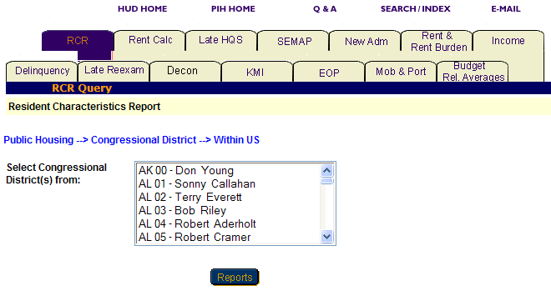
Figure 22: The Select Congressional District(s) from
dialog box for the Resident Characteristics Report.

Option 2: Within a State

Select this option if you know only the state the congressional district is in.

Step | Action/Result
1. Click Congressional District on the Select Level of Information list. | PIC displays a screen with two different options for identifying the congressional district: Within US and Within a State.
2. Click Within a State on the Congressional District Selection list. | PIC displays a Select State from dialog box.
  - Click the state you want in the Select State from dialog box.
- Click the Cong Dist button. | A Select Congressional District(s) from dialog box is displayed.
- Click the congressional district you want in the dialog box. | Note: To select more than one congressional district, press the CONTROL key as you click each one you want to include in the report.
- Click the Reports button. | PIC displays a Resident Characteristics Report for each congressional district selected within the state.

Information Presented in a Resident Characteristics Report

When you complete your selections and click the Reports button, the PIC system generates the Resident Characteristics Report for the particular program and level of information selected.

Every Resident Characteristics Report screen heading includes the following labels:

- Program type
- Level of information
- Report start date
- Report end date

Each report offers the same categories of information, which are displayed in tabs that at the top of the report. Data on the Resident Characteristics Report screen is broken down into seven tabs.
The seven tabs are as follows:

- Units
- Income
- Total Tenant Payment percentage (TTP)
- Family Status
- Member Age
- Length of Stay
- House Size

Note: Multiple data selections may be split into sets. For example, if you selected several states to be included in the report (generally more than four), some of those selections are not displayed in the first report page.

To view the information within a table:

Step | Action/Result
- Click the report tab to see the information. | The table(s) under that report tab display.
- Click the Next Set arrow located at the bottom right of the report page to view the next data set. | The next data set is displayed.
- Click the Prev Set arrow located at the bottom left of the report to return to the data set previously viewed. | The previous data set is displayed.

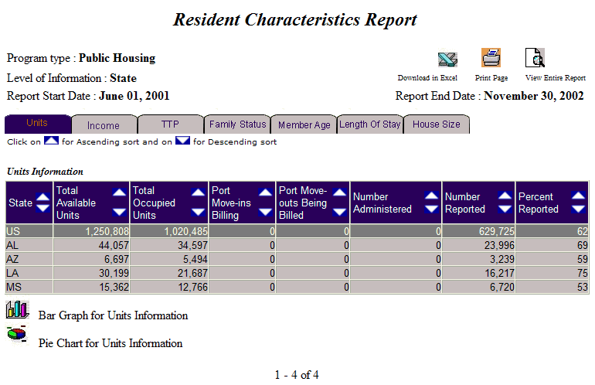
Figure 23: The Resident Characteristics Report screen.

You can view information under each tab in ascending or descending order on a report by clicking the up or down arrow in the column you want to view.

The following table describes the information contained under each tab of the Resident Characteristics Report.

Tab | Information Presented
Unit | Unit is the default screen for the Resident Characteristics Report consisting of one table reporting:  Unit information:  - Total Available Units  - Total Occupied Units  - Port Move-ins Billing  - Port Move-outs Being Billed  - Number Administered  - Number Reported  - Percentage Reported
Income | Income consists of four tables reporting:  Distribution by Income, Average Annual (%)  - Extremely Low Income, Below 30% of Median  - Very Low Income, 50% of Median  - Low Income, Below 80% of Median  - Above Low Income  - Income Limit Unavailable  Income, Average Annual ($)  - Average Annual Income  Distribution by Income (%)  - $0  - $1 - $5,000  - $5,000 - $10,000  - $10,001 - $15,000  - $15,001 - $20,000  - $20,001 - $25,000  - Above $25,000  Distribution by Source of Income (%)  - With any Wages  - With any Welfare  - With any SSI/SS/Pension  - With any other Income
TTP | Total Tenant Payment percentage (TTP) consists of four tables reporting:  Distribution by Total Tenant Payment (%)  - $0  - $1 - $25  - $26 - $50  - $51 - $100  - $101 - $200  - $201 - $350  - $351 - $500  - $501 and above  TTP Average Monthly ($)  - Average Monthly TTP  Distribution by Family Type  - Elderly, No Children, Non-Disabled  - Elderly, with Children, Non-Disabled  - Non-Elderly, No Children, Non-Disabled  - Non-Elderly, with Children, Non-Disabled  - Elderly, No Children, Disabled  - Elderly, with Children, Disabled  - Non-Elderly, No Children, Disabled  - Non-Elderly, with Children, Disabled  - All Female Headed Household with Children
Average TTP by Family Type ($)
- Elderly, No Children, Non-Disabled
- Elderly, with Children, Non-Disabled
- Non-Elderly, No Children, Non-Disabled
- Non-Elderly, with Children, Non-Disabled
- Elderly, No Children, Disabled
- Elderly, with Children, Disabled
- Non-Elderly, No Children, Disabled
- Non-Elderly, with Children, Disabled
- All Female Headed Household with Children

Family Status | Family Status consists of three tables reporting:  Distribution by Head of Household’s Race  - White Only  - Black/African American Only  - American Indiana or Alaska Native Only  - Asian Only  - Native Hawaiian/Other Pacific Islander Only  - White, American Indian/Alaska Native Only  - White, Black/African American Only  - White, Asian Only  - Other  Distribution by Head of Household’s Ethnicity (%)  - Hispanic  - Non-Hispanic  Distribution by Family Subsidy Status (%)  - Full Assistance  - Prorated Assistance
Member Age | Member Age consists of two tables reporting:  Total Number of Family Members  - Total Number of Household Members  Distribution by Household Member’s Age  - 0 – 5  - 6 – 17  - 18 – 50  - 51 – 61  - 62 – 82  - 83+
Length of Stay | Length of Stay presents one table reporting:  Distribution by Length of Stay (%)  - Moved in Past Year  - 1+ to 2 Years Ago  - 2+ to 5 Years Ago  - 5+ to 10 Years Ago  - 10+ to 20 Years Ago  - Over 20 Years Ago  - Not Reported
House Size | House Size consists of three tables reporting:  Distribution by Household Size (%)  - 1 person  - 2 persons  - 3 persons  - 4 persons  - 5 persons  - 6 persons  - 7 persons  - 8 persons  - 9 persons  - 10+ persons  Average Household Size  - Average Household Size  Distribution by Number of Bedrooms (%)  - 0 bedrooms  - 1 bedroom  - 2 bedrooms  - 3 bedrooms  - 4 bedrooms  - 5+ bedrooms

Two icons are available at the bottom of most tables, so you can view the information in either Pie Chart or Bar Graph form. When the icons are not visible, the information is only available in tabular form.

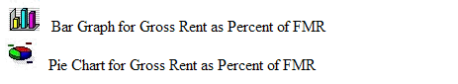
Figure 24: The icons for converting table information
into a Bar Graph or Pie Chart.
The Resident Characteristics Report screen contains three options for further use of the data. The options are located on the top right side of the report screen.

Select one of the following options:

- Download in Excel: Downloads the report to an Excel spreadsheet for further data manipulation.

- Print Page: Prints the report as a Web page.

Note: For the best results, print in landscape orientation.

- View Entire Report. All report subcategory tables display together on one screen.

Figure 25: The Options for further use
of report data.

To generate another report, repeat the process by returning to the Reports screen and selecting the tab for the next report. Refer to the corresponding section of this user manual that describes the report, and follow the steps to generate the report.

The Late Reexamination and Flat Rent Annual Update Report
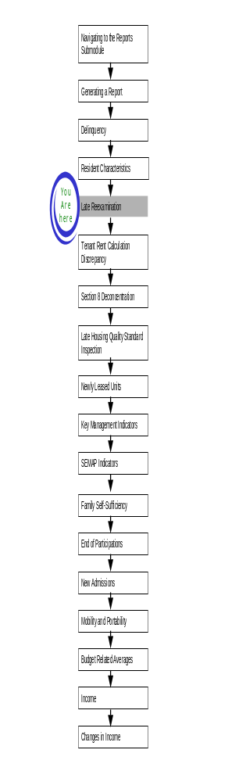
The Late Reexamination (Late Reexam) and Flat Rent Annual Update Report provides a list of families for whom the PHA did not submit a reexamination, flat rent reexamination, or flat rent annual update on time. Late Reexam also provided the projected date for the next reexamination or flat rent annual update.

To access the Late Reexam Report:

Step | Action/Result
- Log on to PIC. | The PIC main page is displayed.
- Move your cursor over the Form-50058 button. | A list of submodules is displayed.
- Click the Reports link. | The Delinquency Report page is displayed. Other available reports are listed in tabs at the top of the page.
- Click the Late Reexam tab. | The Late Reexam Report start page displays (see Figure 26).

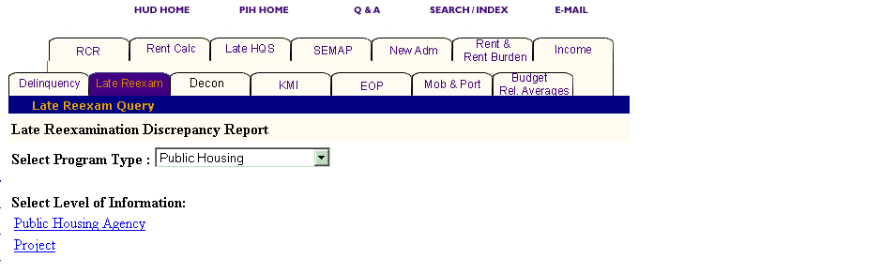
Figure26: The Late Reexam tab and start page.

Generating a Late Reexam Report

After you reach the Late Reexam Report start page, select the program and level of information to be viewed.

To select Late Reexam Report criteria:

Step | Action
- Click the program type you want in the Program Type dialog box. | - Public Housing Agency  - S8 Moderate Rehabilitation  - S8 Certificate  - S8 Voucher  - S8 Certificate and Voucher  - All Relevant Programs  Note: Public Housing is the default option for the Select Program Type dialog box.
- Click the link under Level of Information that corresponds to the level of information you want on the report. | The module formulates the rest of the criteria necessary to generate the report based on the level you select here. For example, click State when the program type you are interested in is located at that level. A dialog box containing a list of state names appears. Click the state where the program type you are interested in is located, and generate the report (see Figure 27).

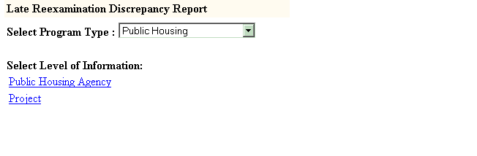
Figure 27: The Level of Information Options for the Late Reexam Report.
There are two levels of information to choose from in a Late Reexam Report (see Figure 27):

- Public Housing Agency
- Project

Depending on security clearance, users have limited access within certain levels of information. For example, if you are an HA user, you only have access to the projects associated with your housing agency.

The following tables outline how to generate a Late Reexam Report for each level.

Public Housing Agency

You have three options for generating a Late Reexam Report at the Public Housing Agency level: Within a State, Within a State and County, and Within a Field Office (see Figure 28).

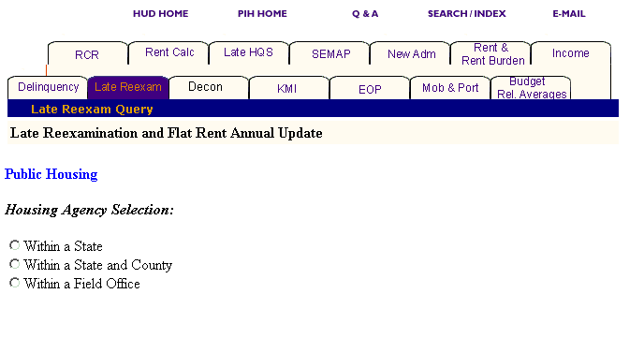
Figure 28: The Housing Agency Selection levels for a Late Reexam Report.
Option 1: Within a State

Select this option if you know the state in which your Public Housing Agency is located.

Step | Action/Result
1. Click Public Housing Agency on the Select Level of Information list. | PIC displays a screen with three different options for identifying the Public Housing Agency: Within a State, Within a State and County, and Within a Field Office.
2. Click Within a State on the Housing Agency Selection list. | A Select State from dialog box is displayed.
3. Click the state you want in the Select State from dialog box.
- Click the HA List button. | A dialog box is displayed with a list of HAs within the state selected.
5. Click the desired HA(s) in the Select HA(s) dialog box. | Note: To select more than one HA, press the CONTROL key as you click each HA you want to include in the report.
6. Click the Reports button | A Late Reexam Report is generated for each Public Housing Agency selected within the state.

Option 2: Within a State and County

Select this option for the state and county in which your PHA is located.

Step | Action/Result
1. Click Public Housing Agency on the Select Level of Information list. | PIC displays a screen with three different options for identifying the Public Housing Agency: Within a State, Within a State and County, and Within a Field Office.
2. Click Within a State and County on the Housing Agency Selection list. | A Select State from dialog box is displayed.
3. Click the state where your PHA is located in the Select State from dialog box.
- Click the County button. | A Select County from dialog box is displayed.
- Click the county you want in the Select County from dialog box.
- Click the HA List button. | A dialog box is displayed with a list of HAs associated with the county selected.
- Click the HA(s) you want in the Select HA(s) from dialog box. | Note: To select more than one HA, press the CONTROL key as you click each HA you want to include in the report.
- Click the Reports button. | A Late Reexam Report is generated for each Public Housing Agency selected.

Option 3: Within a Field Office

Select this option if you know the field office in which your PHA is located.

Step | Action/Result
1. Click Public Housing Agency on the Select Level of Information list. | PIC displays a screen with three different options for identifying the Public Housing Agency: Within a State, Within a State and County, and Within a Field Office.
2. Click Within a Field Office on the Housing Agency Selection list. | A Select Field Office from dialog box is displayed.
3. Click the field office you want in the Select Field Office from dialog box.
- Click the HA List button. | A dialog box is displayed with a list of HAs associated with the field office selected.
- Click the desired HA(s) in the Select HA(s) dialog box. | Note: To select more than one HA, press the CONTROL key as you click each HA you want to include in the report (see Figure 29).
- Click the Reports button. | A Late Reexam Report is generated for each Public Housing Agency you selected that is associated with the identified field office.

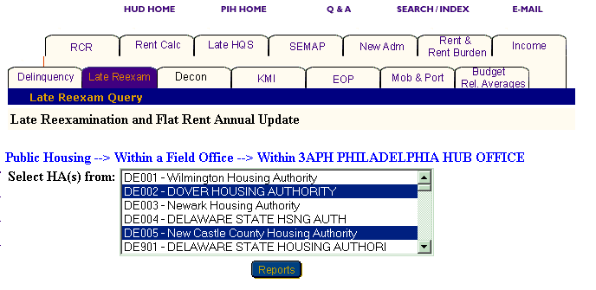
Figure 29: The Select HA(s) from dialog box with two HA(s) selected.

Project

There are five options to generate a Late Reexam Report at the project level: Within a State, Within a State and Metropolitan Area, Within a State and County, Within a State and City or Locality, and Within a State and Public Housing Agency (see Figure 30).

Note: You can only generate Late Reexam Reports for projects when Public Housing or All Relevant Program options are selected in the Select Program Type dialog box. If you select any of the Section 8 programs, a message is displayed indicating that there are no projects for Section 8.

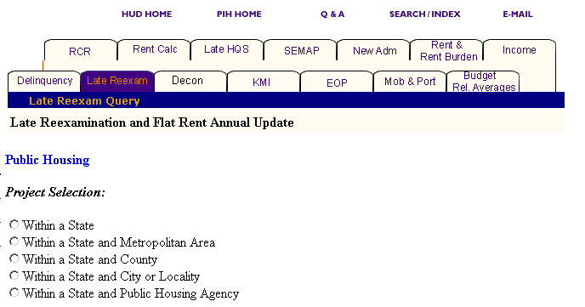
Figure 30: The Project Selection levels for a Late Reexam Report.

Option 1: Within a State

Select this option if you know the state containing the project you want.

Step | Action/Result
1. Click Project on the Select Level of Information list. | PIC displays a screen with five different options for identifying the project: Within a State, Within a State and Metropolitan Area, Within a State and County, Within a State and City or Locality, and Within a State and Public Housing Agency.
2. Click Within a State on the Project Selection List. | A Select State from dialog box is displayed.
3. Click the state you want in the Select State from dialog box.
4. Click the Projects button. | A dialog box is displayed with a list of projects within the state selected (see Figure 31).
5. Click the desired project(s) in the Select Projects(s) dialog box. | Note: To select more than one project, press the CONTROL key as you click each HA you want to include in the report.
6. Click the Reports button. | A Late Reexam Report is generated for the specific project(s) within the state selected.

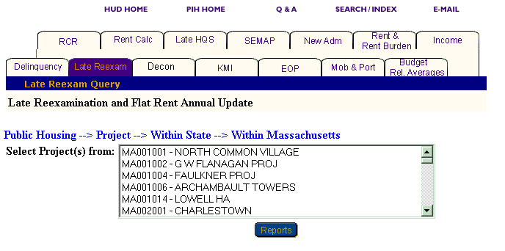
Figure 31: The Select Project(s) from dialog box for Within a State.
Option 2: Within a State and Metropolitan Area

Select this option if you know the state and metropolitan area in which your project is located.

Step | Action/Result
1. Click Project on the Select Level of Information list. | PIC displays a screen with five different options for identifying the project: Within a State, Within a State and Metropolitan Area, Within a State and County, Within a State and City or Locality, and Within a State and Public Housing Agency.
2. Click Within a State on the Project Selection list. | A Select State from dialog box is displayed.
3. Click the state you want in the Select State from dialog box.
4. Click the Projects button. | A Select Metro Area from dialog box is displayed.
5. Click the metro area you want in the Select Metro Area from dialog box. | See Figure 32.
- Click the Projects button. | A dialog box is displayed with a list of projects within the state and metro area selected.
- Click the desired project(s) in the Select Projects(s) dialog box. | Note: To select more than one project, press the CONTROL key as you click each HA you want to include in the report.
- Click the Reports button. | A Late Reexam Report displays for the project(s) selected in the state and metro area you identified.

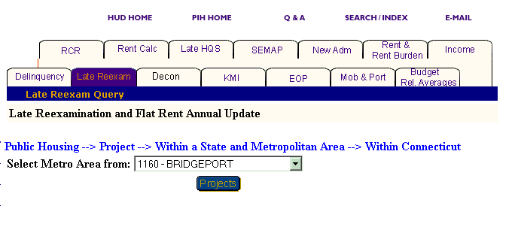
Figure 32: The Select Metro Area from dialog box.

Option 3: Within a State and County

Select this option if you know the state and county in which your project is located.

Step | Action/Result
1. Click Project on the Select Level of Information list. | PIC displays a screen with five different options for identifying the project: Within a State, Within a State and Metropolitan Area, Within a State and County, Within a State and City or Locality, and Within a State and Public Housing Agency.
2. Click Within a State and County on the Project Selection list. | A Select State from dialog box is displayed.
3. Click the state where your project is located in the Select State from dialog box.
- Click the Project button. | A Select County from dialog box is displayed.
- Click the county you want in the Select County from dialog box.
- Click the Projects button. | A dialog box is displayed with a list of project(s) located in the county selected.
- Click the project(s) you want in the Select Project(s) from dialog box. | Note: To select more than one project, press the CONTROL key as you click each HA you want to include in the report.
- Click the Reports button. | PIC displays a Late Reexam Report for the selected project(s) in the location you specified.

Option 4: Within a State and City or Locality

Select this option if you know the state and city or locality in which your project is located.

Step | Action/Result
1. Click Project on the Select Level of Information list. | PIC displays a screen with five different options for identifying the project: Within a State, Within a State and Metropolitan Area, Within a State and County, Within a State and City or Locality, and Within a State and Public Housing Agency.
2. Click Within a State and City or Locality on the Project Selection list. | A Select State from dialog box is displayed.
3. Click the state where your project is located in the Select State from dialog box.
- Click the Project button. | A Select City(s) from dialog box is displayed.
- Click the city you want in the Select City(s) from dialog box.
- Click the Projects button. | A dialog box is displayed with a list of Projects located in the selected city (see Figure 31).
- Click the project(s) you want in the Select Project(s) from dialog box. | Note: To select more than one project, press the CONTROL key as you click each HA you want to include in the report.
- Click the Reports button. | A Late Reexam Report is generated for the project(s) within the state and city you identified.

Option 5: Within a State and Public Housing Agency

Select this option if you know the Public Housing Agency in which your project is located.

Step | Action/Result
1. Click Project on the Select Level of Information list. | PIC displays a screen with five different options for identifying the project: Within a State, Within a State and Metropolitan Area, Within a State and County, Within a State and City or Locality, and Within a State and Public Housing Agency.
2. Click Within a State and Public Housing Agency on the Project Selection list. | A Select State from dialog box is displayed.
3. Click the state where the Public Housing Agency and project you want are located in the Select State from dialog box.
4. Click the Projects button. | A dialog box is displayed with a list of HAs located in the selected state.
5. Click the Public Housing Agency you want in the Select HA from dialog box.
6. Click the Projects button. | A Select Project(s) from dialog box is displayed for the Public Housing Agency selected within the state.
7. Click the project(s) you want in the Select Project(s) from dialog box. | Note: To select more than one project, press the CONTROL key as you click each HA you want to include in the report.
8. Click the Reports button. | A Late Reexam Report is generated for the identified project(s) that are associated with a particular HA.
Information Presented in a Late Reexam Report

When you complete your selections and click the Reports button, the PIC system generates the Late Reexam Report for the particular program and level of information selected.

The following items are in the heading of a Late Reexam Report:

- Program Type
- Level of Information
- HA Code
- HA Name
- Report Start Date
- Report End Date

There are two additional entries that may be displayed in the heading:

- Select HA Code is always displayed when you select more than one HA and allows you to view the data for each HA you select.
- Select Page Set is displayed when an HA you select contains more information than can be displayed on 10 pages. It allows you to select the next set of data pages for a specific HA that contain more entries than can be displayed on one page.

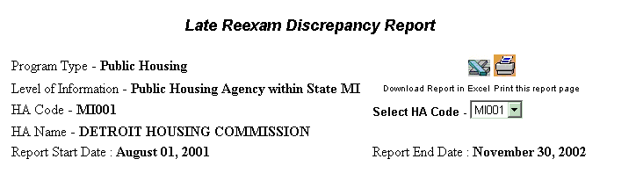
Figure 32: The Late Reexam Report heading information.

Note: The report also allows you to choose the specific page within a set of pages to view next.

To view the report for another HA code you selected:

Step | Action/Result
- Click the arrow to the right of the Select HA Code dialog box. | The list of selected HAs displays.
- Click the HA code to view next. | Data for the selected HA code displays.

To view a different page in a page set:

Step | Action/Result
- Scroll to the bottom of the report page.
- Click the number of the page to view next. | The page you selected is displayed.  Note: If the page is available, click the arrow in the red circle to move to the next page of data.

To select the next set of data pages for the report:

Step | Action/Result
- Click the arrow to the right of the Select Page Set dialog box. | The list of page sets is displayed.
- Click the page set to view. | The next set of pages is displayed beginning with  page 1.

Each Late Reexam Report offers the same information in table form with the following table headings:

- Head of Household Name
- Head of Household SSN
- Project Code
- Type Due
- Date of Last Reexam/Flat Rent Reexam/Flat Rent Annual Update
- Projected Date of Next Reexam/Flat Rent Reexam/Flat Rent Annual Update
- Months Late (Last Reexam/Flat Rent Reexam/Flat Rent Annual Update)

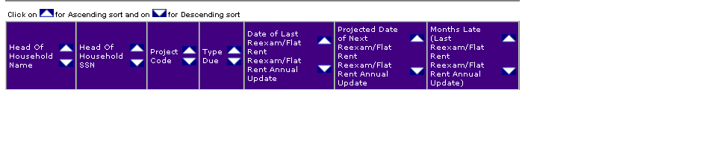
Figure 33: The Late Reexam Report column headings.

View information on a report in ascending or descending order by clicking the up or down arrow in the column to be viewed.

The Late Reexam Report screen contains two options for further use of the data. The options are located on the top right of the report screen.

Select one of the following options:

      - Download in Excel: The report downloads to an MS-Excel™ spreadsheet for further data manipulation.

      - Print Page: The report prints as a Web page.

Note: For the best results, print in landscape orientation.

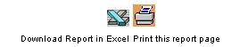
Figure 34: The options for further
use of report data.

To generate another report, repeat the process by returning to the Reports screen and selecting the tab for the next report. Refer to the corresponding section of this user manual that describes the report, and follow the steps to generate the report.

The Tenant Rent Calculation Discrepancy Report
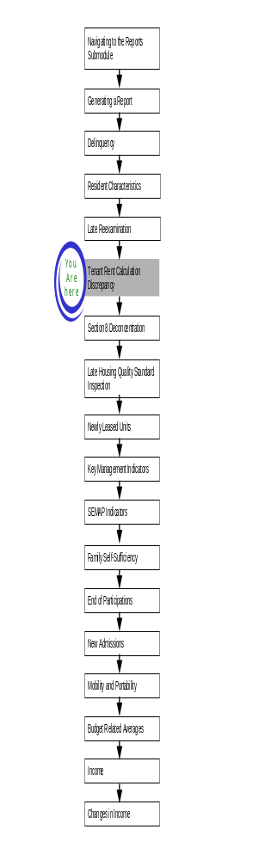
The Tenant Rent Calculation Discrepancy Report provides a list of families whose PHA-reported rent and the system-calculated rent differ by more than $10 per month.

To access the Tenant Rent Calculation Discrepancy Report:

Step | Action/Result
1. Log on to PIC. | The PIC main page is displayed.
2. Move your cursor over the Form-50058 button. | A list of submodules is displayed.
3. Click the Reports link. | The Delinquency Report page is displayed. Other available reports are listed in tabs at the top of the page.
4. Click the Rent Calc tab. | The Tenant Rent Calculation Discrepancy Report start page is displayed (see Figure 35).

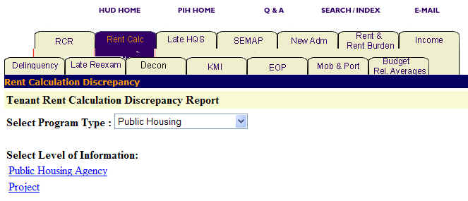
Figure 35: The Rent Calc tab and start page.

Generating a Tenant Rent Calculation Discrepancy Report

After you reach the Tenant Rent Calculation Discrepancy Report start page, you need to select the program type and level of information you want to view.

To select Tenant Rent Calculation Discrepancy Report criteria:

Step | Action/Result
1. Click the program type you want in the Program Type dialog box. | - Public Housing  - S8 Moderate Rehabilitation  - S8 Certificate  - S8 Voucher  - S8 Certificate and Voucher  - All Relevant Programs  Note: Public Housing is the default option for the Select Program Type dialog box.
2. Click the link under Level of Information that corresponds to the level of information you want on the report. | The module formulates the rest of the criteria necessary to generate the report based on the level you select here (see  Figure 36).

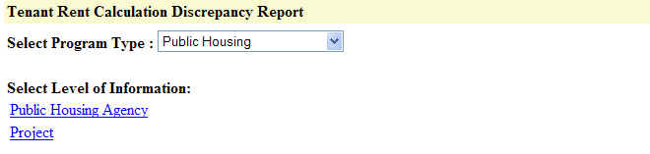
Figure 36: The Level of Information options available for the
Tenant Rent Calculation Discrepancy Report.

There are two levels of information to choose from in a Tenant Rent Calculation Discrepancy Report:

- Public Housing Agency
- Project

Depending on security clearance, users have limited access within certain levels of information. For example, if you are an HA user, you only have access to the projects associated with your housing agency.

The following tables outline how to generate a Tenant Rent Calculation Discrepancy Report at each level.

Public Housing Agency

You have three options for generating a Tenant Rent Calculation Discrepancy Report at the Public Housing Agency level: Within a State, Within a State and County, and Within a Field Office (see Figure 37).

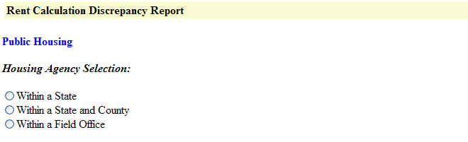
Figure 37: The Housing Agency Selection levels for a
Tenant Rent Calculation Discrepancy Report.

Option 1: Within a State

Select this option if you know the state in which your PHA is located.

Step | Action/Result
1. Click Public Housing Agency on the Select Level of Information list. | PIC displays a screen with three different options for identifying the Public Housing Agency: Within a State, Within a State and County, and Within a Field Office.
2. Click Within a State on the Housing Agency Selection list. | A Select State from dialog box appears
3. Click the state you want in the Select State from dialog box.
4. Click the HA List button. | A dialog box appears with a list of HAs within the selected state.
5. Click the desired HA(s) in the Select HA(s) dialog box. | Note: To select more than one HA, press the CONTROL key as you click each HA you want to include in the report.
- Click the Reports button. | PIC displays a Tenant Rent Recalculation Discrepancy Report for each Public Housing Agency selected within the state.

Option 2: Within a State and County

Select this option if you know the state and county in which your PHA is located.

Step | Action/Result
1. Click Public Housing Agency on the Select Level of Information list. | PIC displays a screen with three different options for identifying the Public Housing Agency: Within a State, Within a State and County, and Within a Field Office.
2. Click Within a State and County on the Housing Agency Selection list. | A Select State from dialog box appears.
3. Click the state where your PHA is located in the Select State from dialog box.
4. Click the County button. | A Select County from dialog box is displayed.
5. Click the county you want in the Select County from dialog box.

6. Click the HA List button. | A dialog box appears with a list of HAs associated with the selected county.
7. Click the HA(s) you want in the Select HA(s) from dialog box. | Note: To select more than one HA, press the CONTROL key as you click each HA you want to include in the report.
8. Click the Reports button. | PIC displays a Tenant Rent Calculation Discrepancy Report for each Public Housing Agency selected.

Option 3: Within a Field Office

Select this option if you know the field office containing the PHA you are looking for.

Step | Action/Result
1. Click Public Housing Agency on the Select Level of Information list. | PIC displays a screen with three different options for identifying the Public Housing Agency: Within a State, Within a State and County, and Within a Field Office.
2. Click Within a Field Office on the Housing Agency Selection list. | A Select Field Office from dialog box appears.
3. Click the field office you want in the Select Field Office from dialog box.
4. Click the HA List button. | A dialog box appears with a list of HAs associated with the field office you have selected.
5. Click the desired HA(s) in the Select HA(s) dialog box. | Note: To select more than one HA, press the CONTROL key as you click each HA you want to include in the report (see Figure 38).
6. Click the Reports button. | PIC displays a Tenant Rent Calculation Discrepancy Report for each Public Housing Agency you selected that is associated with the identified field office.

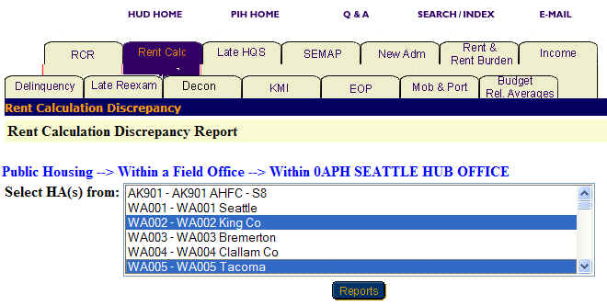
Figure 38: The Select HA(s) from dialog box with two selections.

Project

You have five options to generate a Tenant Rent Recalculation Discrepancy Report at the project level: Within a State, Within a State and Metropolitan Area, Within a State and County, Within a State and City or Locality, and Within a State and Public Housing Agency (see Figure 39).

Note: You can only generate Tenant Rent Calculation Discrepancy Reports for projects when Public Housing is selected in the Select Program Type dialog box. If you select any other program type, a message is displayed indicating that the project level is only available for Public Housing programs.

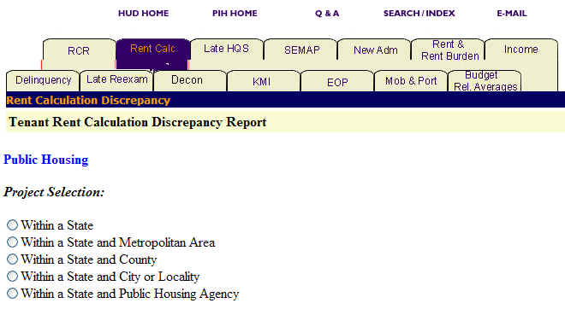
Figure 39: The Project Selection levels available for a
Tenant Rent Calculation Discrepancy Report.

Option 1: Within a State

Select this option if you know the state containing the project you are looking for.

Step | Action/Result
- Click Project on the Select Level of Information list. | PIC displays a screen with five different options for identifying the project: Within a State, Within a State and Metropolitan Area, Within a State and County, Within a State and City or Locality, and Within a State and Public Housing Agency.
- Click Within a State on the Project Selection List. | A Select State from dialog box is displayed.
- Click the state you want in the Select State from dialog box.
- Click the Projects button. | A dialog box appears with a list of projects within the state selected.
5. Click the desired project(s) in the Select Projects(s) dialog box. | Note: To select more than one project, press the CONTROL key as you click each HA you want to include in the report.
6. Click the Reports button. | PIC displays a Tenant Rent Calculation Discrepancy Report for the specific project(s) within the state selected.

Option 2: Within a State and Metropolitan Area

Select this option if you know the state and metro area containing the project you are looking for.

Step | Action/Result
1. Click Project on the Select Level of Information list. | PIC displays a screen with five different options for identifying the project: Within a State, Within a State and Metropolitan Area, Within a State and County, Within a State and City or Locality, and Within a State and Public Housing Agency.
2. Click Within a State and Metropolitan Area on the Project Selection list. | A Select State from dialog box appears.
3. Click the state you want in the Select State from dialog box.
- Click the MSA button. | A Select Metro Area from dialog box is displayed (see Figure 6).
5. Click the metro area you want in the Select Metro Area from dialog box.
6. Click the Projects button. | A dialog box appears with a list of projects within the state and metro area you have selected.
7. Click the desired project(s) in the Select Projects(s) dialog box. | Note: To select more than one project, press the CONTROL key as you click each HA you want to include in the report.
8. Click the Reports button. | PIC displays a Tenant Rent Calculation Discrepancy Report for the selected project(s).

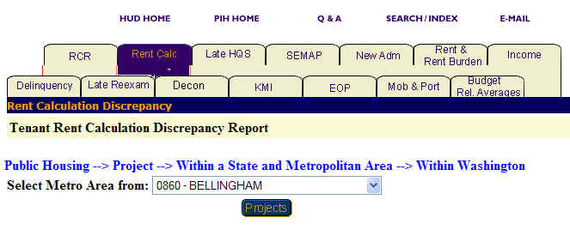
Figure 40: The Select Metro Area from dialog box.

Option 3: Within a State and County

Select this option if you know the state and county in which the project is located.

Step | Action/Result
1. Click Project on the Select Level of Information list. | PIC displays a screen with five different options for identifying the project: Within a State, Within a State and Metropolitan Area, Within a State and County, Within a State and City or Locality, and Within a State and Public Housing Agency.
2. Click Within a State and County on the Project Selection list. | A Select State from dialog box is displayed.
3. Click the state where your project is located in the Select State from dialog box.
- Click the Projects button. | A Select County from dialog box appears.
- Click the county you want in the Select County from dialog box.
- Click the Projects button. | A dialog box appears with a list of project located in the county selected.
- Click the project(s) you want in the Select Project(s) from dialog box. | Note: To select more than one project, press the CONTROL key as you click each HA you want to include in the report.
- Click the Reports button. | PIC displays a Tenant Rent Calculation Discrepancy Report for the project(s) selected.

Option 4: Within a State and City or Locality

Select this option if you know the particular state and city in which the project you are looking for is located.

Step | Action/Result
1. Click Project on the Select Level of Information list. | PIC displays a screen with five different options for identifying the project: Within a State, Within a State and Metropolitan Area, Within a State and County, Within a State and City or Locality, and Within a State and Public Housing Agency.
2. Click Within a State and City or Locality on the Project Selection list. | A Select State from dialog box is displayed.
3. Click the state where your project is located in the Select State from dialog box.
- Click the Projects button. | A Select City(s) from dialog box is displayed.
- Click the city you want in the Select City(s) from dialog box.
- Click the Projects button. | A dialog box is displayed with a list of projects located in the city selected.
- Click the project(s) you want in the Select Project(s) from dialog box. | Note: To select more than one project, press the CONTROL key as you click each HA you want to include in the report.
- Click the Reports button. | PIC displays a Tenant Rent Calculation Discrepancy Report for the selected project(s).

Option 5: Within a Public Housing Agency

Select this option if you know the particular Public Housing Agency associated with the project you are looking for.

Step | Action/Result
1. Click Project on the Select Level of Information list. | PIC displays a screen with five different options for identifying the project: Within a State, Within a State and Metropolitan Area, Within a State and County, Within a State and City or Locality, and Within a State and Public Housing Agency.
2. Click Within a Public Housing Agency on the Project Selection list. | A Select State from dialog box is displayed.
3. Click the state where the Public Housing Agency and project you want are located in the Select State from dialog box.
4. Click the Projects button. | A dialog box appears with a list of HAs located in the state selected.
5. Click the Public Housing Agency you want in the Select HA from dialog box.
6. Click the Projects button. | A Select Project(s) from dialog box is displayed for the Public Housing Agency selected within the state (see Figure 41).
7. Click the project(s) you want in the Select Project(s) from dialog box. | Note: To select more than one project, press the CONTROL key as you click each HA you want to include in the report.
8. Click the Reports button. | PIC displays a Tenant Rent Calculation Discrepancy Report for the selected project(s).

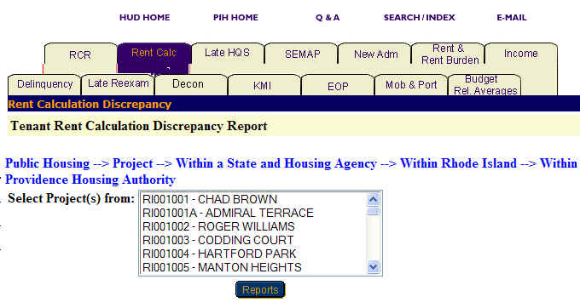
Figure 41: The Select Project(s) from dialog
box for Within a State and Public Housing Agency.

Information Presented in a Tenant Rent Calculation Discrepancy Report

When you complete your selections and click the Reports button, PIC generates the Tenant Rent Calculation Discrepancy Report for the particular program and level of information selected.

Every Tenant Rent Calculation Discrepancy Report screen heading includes:

- Program type
- Level of information
- HA code
- HA name
- Report start date
- Report end date

There are two additional entries that may appear in the heading:

- Select HA Code always appears when you select more than one HA and allows you to view the data for each HA selected.
- Select Page Set appears when a selected HA contains more information than can be displayed on 10 pages. It allows you to select the next set of data pages for a specific HA that contains more entries than can be displayed on one page.

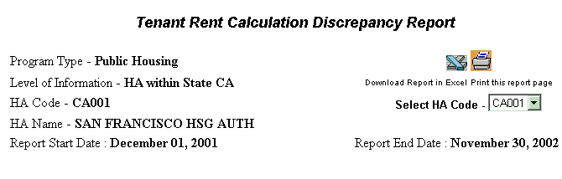
Figure 42: The Tenant Rent Calculation Discrepancy Report heading information.

Note: The report also allows you to choose the specific page within a set of pages you want to view next.

To view the report for another previously selected HA code:

Step | Action/Result
- Click the arrow to the right of the Select HA Code dialog box. | The list of selected HAs displays.
- Click the HA code to view next. | Data for the selected HA code displays.

To view a different page in a page set:

Step | Action/Result
- Scroll to the bottom of the report page.
- Click the number of the page to view next. | The page selected displays.

To select the next set of pages for the report:

Step | Action/Result
- Click the arrow to the right of the Select Page Set dialog box. | The list of page sets displays.
- Click the page set to view. | The next set of pages displays beginning with page 1.

Each Tenant Rent Calculation Report offers the same information in table form with the following headings:

- Head of Household (HOH) name
- HOH Social Security Number (SSN)
- Program
- Project Code
- Number of Family Members
- Tenant Rent ($)
  - Calculated
  - Reported
- Family Subsidy Status
- Number of Family Members eligible for Full Assistance.
- Charge ($)
  - Over
  - Under

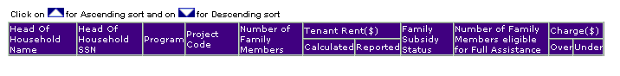
Figure 43: The Tenant Rent Calculation Discrepancy Report table headings.

View information on a report in ascending or descending order by clicking the up or down arrow in the column to be viewed.

The Tenant Rent Calculation Discrepancy Report screen also includes two options for further use of the data. The options are located on the top right of the report screen.

Select one of the following options:

- Download in Excel: Downloads the report to an Excel spreadsheet for further data manipulation.

- Print Page: Prints the report as a Web page.

Note: For the best results, print in landscape orientation.

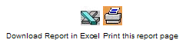
Figure 44: The options available for further
use of report data.

To generate another report, repeat the process by returning to the Reports screen and selecting the tab for the next report. Refer to the corresponding section of this user manual that describes the report, and follow the steps to generate the report.

The Section 8 Deconcentration Analysis Report
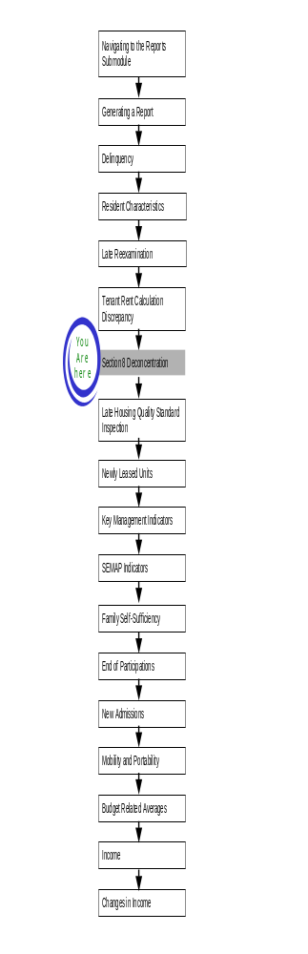
A S8 Deconcentration Analysis (Decon Analysis) Report provides HUD staff with information about families that live within Census tracts distributed by poverty rate, tenant-based and HUD-based assistance, and the number of units rented to Section 8 families.

To access the Decon Analysis Report start page:

Step | Action/Result
1. Log on to PIC. | The PIC main page is displayed.
2. Move your cursor over the Form-50058 button. | A list of submodules is displayed.
3. Click the Reports link. | The Delinquency Report page is displayed. Other available reports are listed in tabs at the top of the page.
4. Click the Decon tab. | The Decon Analysis Report start page is displayed (see Figure 45).

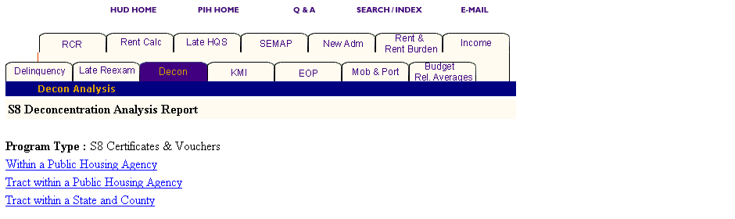
Figure 45: The Decon Analysis Report tab and start page.

Generating a Decon Analysis Report

The Decon Analysis Report provides information about families under the S8 Certificates & Vouchers program. The start page offers the following three options for locating the program you want (see Figure 46):

- Within a Public Housing Agency
- Tract within a Public Housing Agency
- Tract within a State and County

Depending on security clearance, users have limited access within certain levels of information. For example, if you are an HA user, you only have access to your own state and PHA.

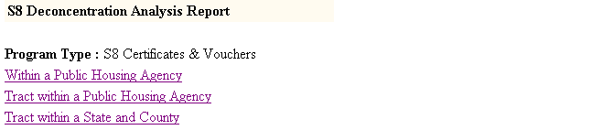
Figure 46: The Reporting options for the Decon Analysis Report.

The following tables outline how to generate the Decon Report for each option.

Option 1: Within a Public Housing Agency

Select this option if you know the particular PHA where your program is located.

Step | Action/Result
1. Click Within a Public Housing Agency beneath Program Type. | A Select State from dialog box is displayed.
2. Click the state you want in the Select State from dialog box.
3. Click the HA List button. | A dialog box appears with a list of HAs within the selected state.
4. Click the desired HA(s) in the Select HA(s) dialog box. | Note: To select more than one HA, press the CONTROL key as you click each HA you want to include in the report.
5. Click the Reports button. | A Decon Analysis Report is generated for each Public Housing Agency selected within the state.
Option 2: Tract Within a Public Housing Agency

Select this option if you know the specific tract you want within the PHA.

Step | Action/Result
1. Click Tract Within a Public Housing Agency beneath Program Type. | A Select State from dialog box is displayed.
2. Click the state you want in the Select State from dialog box.
3. Click the HA List button. | A dialog box appears with a list of HAs within the selected state.
4. Click the HA you want in the Select HA dialog box.
5. Click the Tract List button. | A dialog box appears containing a list of tracts within the area covered by the selected Public Housing Agency (see Figure 47).
6. Click the tract(s) you want in the Select Tracts dialog box. | Note: To select more than one tract, press the CONTROL key as you click each tract you want to include in the report.
7. Click the Reports button. | PIC displays the Decon Analysis Report for the tract(s) selected within a particular Public Housing Agency.

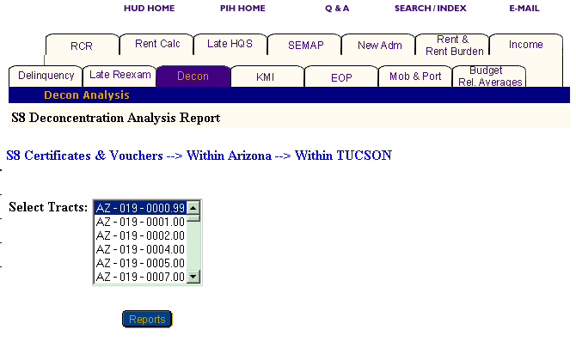
Figure 47: The Select Tract(s) dialog box.
Option 3: Tract Within a State and County

Select this option if you know the state and county in which your tract is located.

Step | Action/Result
1. Click Tract Within a State and County beneath Program Type. | A Select State from dialog box is displayed.
2. Click the state you want in the Select State from dialog box.
- Click the County button. | A Select County dialog box appears containing counties within the selected state.
- Click the county where the tract is located in the Select County dialog box. | See Figure 48.
- Click the Tract List Button. | A dialog box appears containing a list of tracts within the area covered by the Public Housing Agency you identified.
- Click the tract(s) you want in the Select Tracts dialog box. | Note: To select more than one tract, press the CONTROL key as you click each tract you want to include in the report.
- Click the Reports button. | PIC displays the Decon Analysis Report for the tract(s) selected within a particular county.

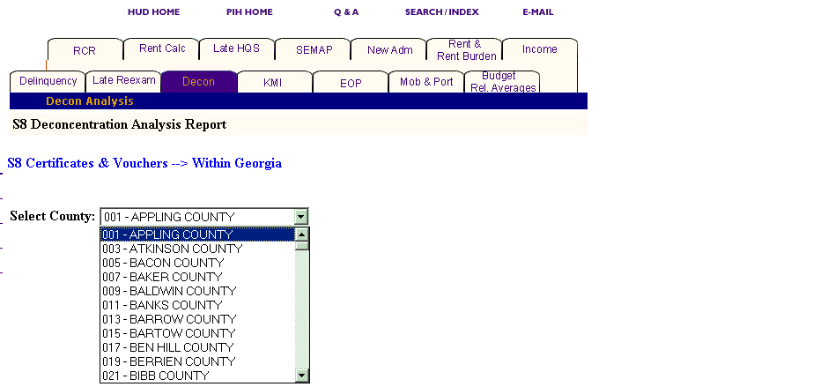
Figure 48: The Select County dialog box.

Information Presented in a Decon Analysis Report

When you complete your selections and click the Reports button, PIC generates the Decon Analysis Report for the S8 Certificates & Vouchers program at the level of information selected.

In the heading for a Decon Analysis Report are the following labels:

- Program Type
- Level of Information
- Report Start Date
- Report End Date

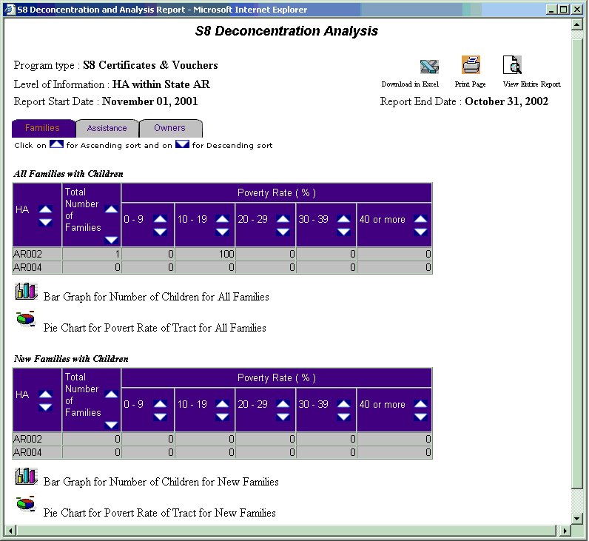
Figure 49: The Decon Analysis Report with the Families tab selected.

Each report offers the same categories of information, which display in tabs that appear at the top of the report directly beneath the heading. Some reports contain subcategories that display when you move your mouse over a tab. The Decon Analysis Report tabs contain no subcategories.

Note: Multiple data selections may be split into sets. For example, if you have selected several states to include in the report (generally more than four), some of those selections will not appear in the first report page.

To view the information within a report:

Step | Action/Result
- Click the report tab to see the information. | The table(s) under that report tab display.
2. Click the Next Set arrow located at the bottom right of the report page to view the next data set. | The next data set is displayed.
3. Click the Prev Set arrow located at the bottom left of the report to return to the data set previously viewed. | The previous data set is displayed.

You can view information in ascending or descending order on a report by clicking the up or down arrow in the column you want to view.

The following table describes the information contained under each tab of the Decon Analysis Report.

Tab | Subcategories | Information Presented
Families | None | Default screen for the Decon Analysis Report, consisting of two tables reporting:  All Families with Children  - Total Number of Families  - Poverty Rate (%)  0-9  10-19  20-29  30-39  40 or more  New Families with Children  - Total Number of Families  - Poverty Rate (%)  0-9  10-19  20-29  30-39  40 or more

Tab | Subcategories | Information Presented
Assistance | None | Assistance consists of two tables reporting:  Tenant Based Assistance  - Total Number of Families  - Tenant Based Assistance (%)  0-1  1-5  6-9  10-19  20-29  30 or more  HUD Based Assistance  - Total Number of Families  - Tenant Based Assistance (%)  0-9  10-19  20-29  30-39  40-49  50 or more
Owners | None | Owners consists of two tables reporting:  Owners for All Families with Children  - Units  1-5  6-10  11-20  21-50  51-100  Over 100  Owners for New Families with Children  - Units  1-5  6-10  11-20  21-50  51-100  Over 100

The two graph or chart icons at the bottom of most tables are available, so you can view the information in either a Pie Chart or Bar Graph form. When the two icons are not visible, the information is only available in tabular form.

Figure 50: The icons for converting table Information
to either a Bar Graph or Pie Chart.

The Decon Analysis Report screen contains three options for further use of the data. The options are located on the top right side of the report screen.

Select one of the following three options.

      - Download in Excel: The report downloads to an MS-Excel™ spreadsheet for further data manipulation.

      - Print Page: The report prints as a Web page.

Note: For the best results, print in landscape orientation.

      - View Entire Report: All report subcategory tables display together on one screen.

Figure 51: The Icons for further
use of report data.

To generate another report, repeat the process by returning to the Reports screen and selecting the tab for the report you want next. Go to the corresponding section of this user manual, and follow the steps to generate the report.

The Late Housing Quality Standard Inspection Report
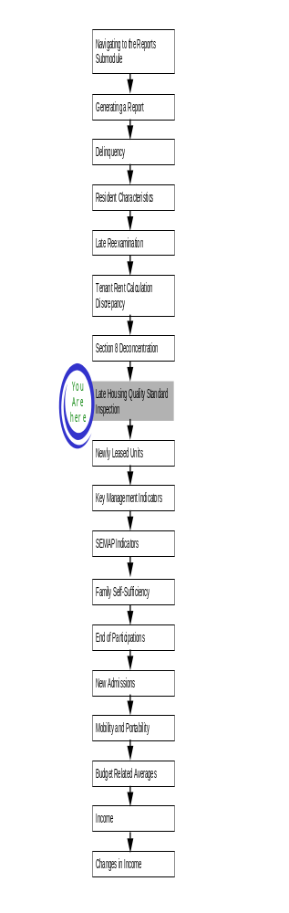
The Late Housing Quality Standard (Late HQS) Inspection Report applies to families with an HQS inspection that is three or more months overdue.

To access the Late HQS Report start page:

Step | Action/Result
1. Log on to PIC. | The PIC main page is displayed.
2. Move your cursor over the Form-50058 button. | A list of submodules is displayed.
3. Click the Reports link. | The Delinquency Report page is displayed. Other available reports are listed in tabs at the top of the page.
4. Click the Late HQS tab. | The Late HQS Report start page is displayed (see Figure 52).

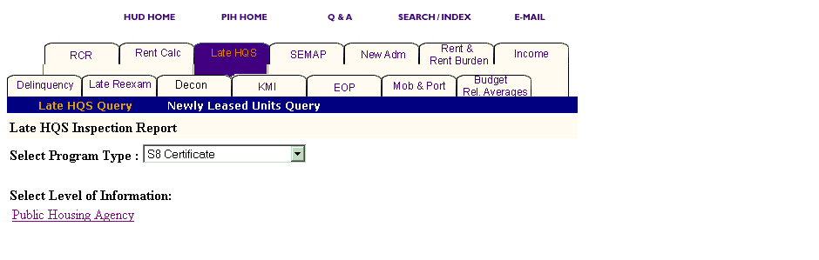
Figure 52: The Late HQS Report tab and start page.

Generating a Late HQS Report

The late HQS Report generates information for all units. After you reach the Late HQS Report start page, select the program and the level of information to be viewed.

To Select Late HQS Report criteria:

Step | Action/Result
- Click the program type you want in the Program Type dialog box. | - S8 Certificate  - S8 Voucher  - S8 Moderate Rehabilitation  - All Relevant Programs  Note: S8 Certificate is the default option for the Select Program Type dialog box.
- Click Public Housing Agency in the Select Level of Information list. | Public Housing is the only available choice on the list.

Depending on security clearance, users have limited access within certain levels of information. For example, if you are an HA user, you only have access to your own PHA.

To generate a Late HQS Report for a particular Public Housing Agency, use any of the following three options: Within a State, Within a State and County, and Within a Field Office (see Figure 53).

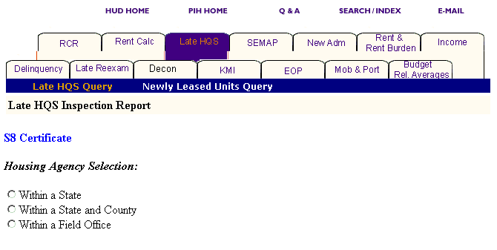
Figure 53: The Housing Agency Selections for a Late HQS Report.

Option 1: Within a State

Select this option if you know the state in which your PHA is located.

Step | Action/Result
- Click Public Housing Agency on the Select Level of Information list. | PIC displays a screen with three different options for identifying the Public Housing Agency: Within a State, Within a State and County, and Within a Field Office.
- Click Within a State on the Housing Agency Selection list. | A Select State from dialog box is displayed.
- Click the state you want in the Select State from dialog box.
4. Click the HA List button. | A dialog box is displayed with a list of HAs within the state selected.
5. Click the desired HA(s) in the Select HA(s) dialog box. | Note: To select more than one HA, press the CONTROL key as you click each HA you want to include in the report.
6. Click the Reports button. | PIC displays the Late HQS Report for each Public Housing Agency selected within the state.

Option 2: Within a State and County

Select this option if you know the state and county in which your PHA is located.

Step | Action/Result
- Click Public Housing Agency on the Select Level of Information list. | PIC displays a screen with three different options for identifying the Public Housing Agency: Within a State, Within a State and County, and Within a Field Office.
- Click Within a State and County on the Housing Agency Selection list. | A Select State from dialog box is displayed.
- Click the state where your PHA is located in the Select State from dialog box.
- Click the County button. | A Select County from dialog box is displayed (see Figure 54).
- Click the county you want in the Select County from dialog box.
- Click the HA List button. | A dialog box is displayed with a list of HAs associated with the county selected.
- Click the desired HA(s) in the Select HA(s) dialog box. | Note: To select more than one HA, press the CONTROL key as you click each HA you want to include in the report.
- Click the Reports button. | PIC displays the Late HQS Report for each Public Housing Agency selected within the state.

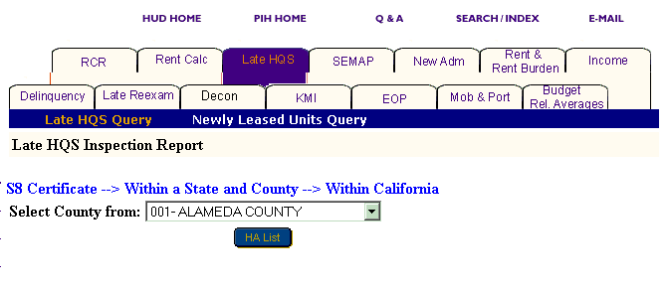
Figure 54: The Select County from dialog box.

Option 3: Within a Field Office

Select this option if you know the field office that contains the PHA you are looking for.

Step | Action/Result
- Click Public Housing Agency on the Select Level of Information list. | PIC displays a screen with three different options for identifying the Public Housing Agency: Within a State, Within a State and County, and Within a Field Office.
- Click Within a Field Office on the Housing Agency Selection list. | A Select Field Office from dialog box is displayed.
- Click the field office you want in the Select Field Office(s) from dialog box.
- Click the HA List button. | A dialog box is displayed with a list of HAs within the state selected.
- Click the desired HA(s) in the Select HA(s) dialog box. | Note: To select more than one HA, press the CONTROL key as you click each HA you want to include in the report.
- Click the Reports button. | PIC displays the Late HQS Report for each Public Housing Agency you selected within the state.

Information Presented in a Late HQS Report

When you complete your selections and click the Reports button, the PIC system generates the Late HQS Report for the particular program and level of information you identified.

The following headings are in a Late HQS Report:
- Program Type
- Level of Information
- HA Code
- HA Name
- Report Start Date
- Report End Date

There are two additional entries that may be displayed in the heading:

- Select HA Code is always displayed when you select more than one HA and allows you to view the data for each HA you select.
- Select Page Set is displayed when an HA you select contains more information than can be displayed on 10 pages. It allows you to select the next set of data pages for a specific HA that contain more entries than can be displayed on one page.

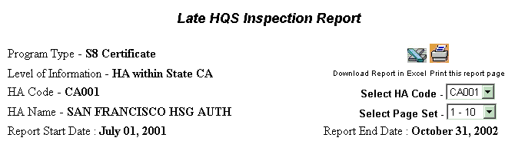
Figure 55: The Late HQS Report heading with
Select HA Code and Select Page Set options.

Note: The report also allows you to choose the specific page within a set of pages to view next.

To view the report for another HA code you selected:

Step | Action/Result
- Click the arrow to the right of the Select HA Code dialog box. | The list of selected HAs displays.
- Click the HA code to view next. | Data for the selected HA code displays.

To view a different page in a page set:

Step | Action/Result
- Scroll to the bottom of the report page.
- Click the number of the page to view next. | The selected page is displayed.

To select the next set of pages for the report:

Step | Action/Result
- Click the arrow to the right of the Select Page Set dialog box. | The list of page sets is displayed.
- Click the page set to view. | The next set of pages is displayed beginning with page 1.

Each Late HQS Report offers the same information in table form with the following table headings (see Figure 56):

- Head of Household’s Name
- Head of Household’s SSN
- Months HQS Inspection Late
- Late HQS Inspection Date

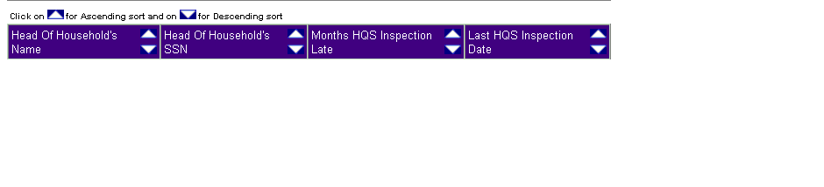
Figure 56: The Late HQS Report table headings.
View information on a report in ascending or descending order by clicking the up or down arrow in the column to be viewed.

The Late HQS Report screen contains two options for further use of the data. The options are located on the top right side of the report screen.

Select one of the following options:

      - Download in Excel: The report downloads to an MS-Excel™ spreadsheet for further data manipulation.

      - Print Page: The report prints as a Web page.

Note: For the best results, print in landscape orientation.

Figure 57: The options for further
use of report data.

The Newly Leased Units Report
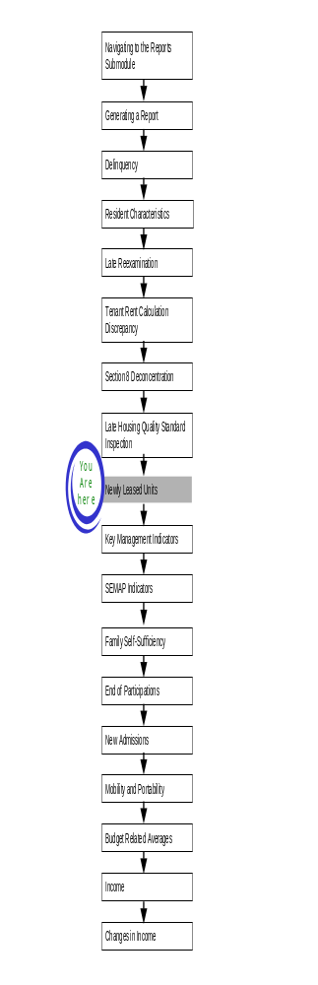
From the Late HQS Report start page you can also generate a Newly Leased Units report that generates information on newly leased units only.

To access the Late HQS Report start page:

Step | Action/Result
- Log on to PIC. | The PIC main page is displayed.
- Move your cursor over the Form-50058 button. | A list of submodules is displayed.
- Click the Reports link. | The Delinquency Report page is displayed. Other available reports are listed in tabs t the top of the page.
- Click the Late HQS tab. | The Late HQS Report start page is displayed.
- Click the Newly Leased Units subtab, located to the right of the Late HQS Query subtab. | The Newly Leased Units start page is displayed (see Figure 57).

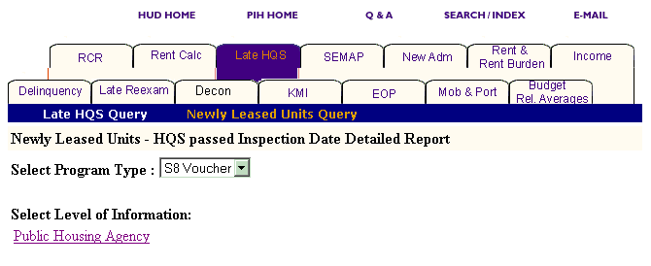
Figure 57: The Newly Leased Units Report start page.

Generating a Newly Leased Units Report

The S8 Voucher is the only program available for the Newly Leased Units Report. The start page defaults the Select Program Type to this program.

To select Newly Leased Units Report criteria:

Step | Action/Result
- Click the program type you want in the Program Type dialog box. | Note: S8 Voucher is the only program option available for the Select Program Type dialog box.
- Click Public Housing Agency in the Select Level of Information list. | Public Housing is the only available choice on the list.

Depending on security clearance, users have limited access within certain levels of information. For example, if you are an HA user, you only have access to the states, field offices, and projects associated with your housing agency.

To generate a Newly Leased Units Report for a particular Public Housing Agency, use any of the following three options: Within a State, Within a State and County, and Within a Field Office.

Option 1: Within a State

Select this option if you know the state in which your PHA is located.

Step | Action/Result
- Click Public Housing Agency on the Select Level of Information list. | PIC displays a screen with three different options for identifying the Public Housing Agency: Within a State, Within a State and County, and Within a Field Office.
- Click Within a State on the Housing Agency Selection list. | A Select State from dialog box is displayed.
- Click the state you want in the Select State from dialog box.
- Click the HA List button. | A dialog box is displayed with a list of HAs within the state selected.
- Click the desired HA(s) in the Select HA(s) dialog box. | Note: To select more than one HA, press the CONTROL key as you click each HA you want to include in the report.
- Click the Reports button. | PIC displays the Newly Leased Units Report for each Public Housing Agency selected within the state.

Option 2: Within a State and County

Select this option if you know the state and county in which your PHA is located.

Step | Action/Result
- Click Public Housing Agency on the Select Level of Information list. | PIC displays a screen with three different options for identifying the Public Housing Agency: Within a State, Within a State and County, and Within a Field Office.
- Click Within a State and County on the Housing Agency Selection list. | A Select State from dialog box is displayed.
- Click the state where your PHA is located in the Select State from dialog box.
- Click the County button. | A Select County from dialog box is displayed.
- Click the county you want in the Select County from dialog box.
- Click the HA List button. | A dialog box is displayed with a list of HAs associated with the county selected.
- Click the desired HA(s) in the Select HA(s) dialog box. | Note: To select more than one HA, press the CONTROL key as you click each HA you want to include in the report.
- Click the Reports button. | PIC displays the Newly Leased Units Report for each Public Housing Agency selected.
Option 3: Within a Field Office

Select this option if you know the field office that contains your PHA.

Step | Action/Result
- Click Public Housing Agency on the Select Level of Information list. | PIC displays a screen with three different options for identifying the Public Housing Agency: Within a State, Within a State and County, and Within a Field Office.
- Click Within a Field Office on the Housing Agency Selection list. | A Select Field Office from dialog box is displayed (see Figure 58).
- Click the field office you want in the Select Field Office(s) from dialog box.
- Click the HA List button. | A dialog box is displayed with a list of HAs within the state selected.
- Click the desired HA(s) in the Select HA(s) dialog box. | Note: To select more than one HA, press the CONTROL key as you click each HA you want to include in the report.
- Click the Reports button. | PIC displays the Newly Leased Units Report for each Public Housing Agency selected.

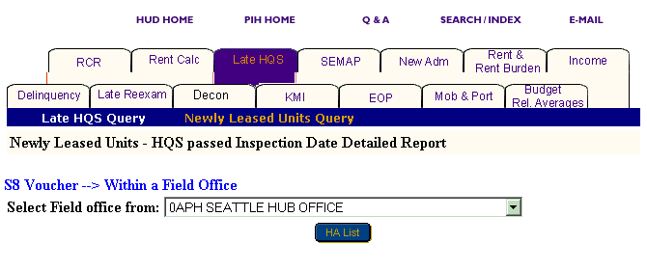
Figure 58: The Select Field office from dialog box.

Information Presented in a Newly Leased Units Report

When you complete your selections and click the Reports button, the PIC system generates the Newly Leased Units Report for the particular program and level of information you identified.

The following items are found in the heading for a Newly Leased Units Report:

- Program Type
- Level of Information
- HA Code
- HA Name
- Report Start Date
- Report End Date

There are two additional entries that may be displayed in the heading:

- Select HA Code is always displayed when you select more than one HA and allows you to view the data for each HA you select.
- Select Page Set is displayed when an HA you select contains more information than can be displayed on 10 pages. It allows you to select the next set of data pages for a specific HA.

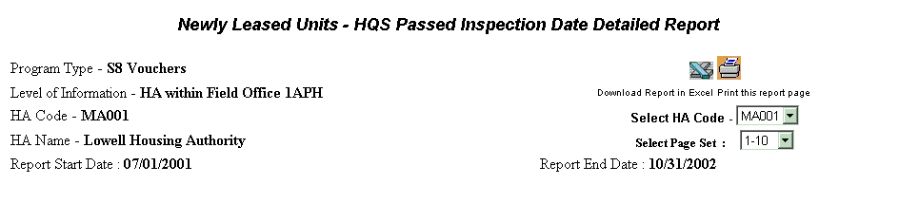
Figure 59: The Newly Leased Units Report heading with
Select HA Code and Select Page Set options.

Note: The report also allows you to choose the specific page within a set of pages to view next.

To view the report for another HA code you selected:

Step | Action/Result
- Click the arrow to the right of the Select HA Code dialog box. | The list of selected HAs displays.
- Click the HA code to view next. | Data for the selected HA code displays.

To view a different page in a page set:

Step | Action/Result
- Scroll to the bottom of the report page.
- Click the number of the page to view next. | The page you selected is displayed

To select the next set of pages for the report:

Step | Action/Result
- Click the arrow to the right of the Select Page Set dialog box. | The list of page sets is displayed
- Click the page set to view. | The next set of pages is displayed beginning with  page 1.

The following table details the information in the Newly Leased Units Report.

Table | Subcategories | Information Presented
Household Information for Selected PHAs | None | - Head of Household SSN  - Head of Household Name  - Type of Action  - Family Moving Indicator  - Effective Date  - Last Inspection Passed Date  - Passed Inspection Status
PHA Totals | None | - Status  Passed After Contract Effective (PA)  Passed Before Contract Effective (PB)  Passed At Contract Effective (PCE)  - Totals

View information on a report in ascending or descending order by clicking the up or down arrow in the column to be viewed.

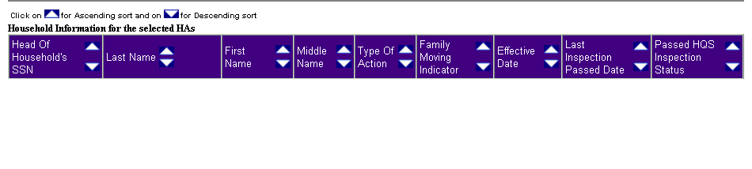
Figure 60: The Table Headings on the Household
Information for Selected PHAs table.

The Newly Leased Units screen contains two options for further use of the data. The options are located on the top right side of the report screen.

Select one of the following options:

- Download in Excel: The report downloads to an Excel spreadsheet for further data manipulation.

- Print Page: The report prints as a Web page.

Note: For the best results, print in landscape orientation.

Figure 61: The options for further
use of report data.

To generate another report, repeat the process by returning to the Reports screen and selecting the tab for the next report. Refer to the corresponding section of this user manual that describes the report, and follow the steps to generate the report.

Key Management Indicators Report
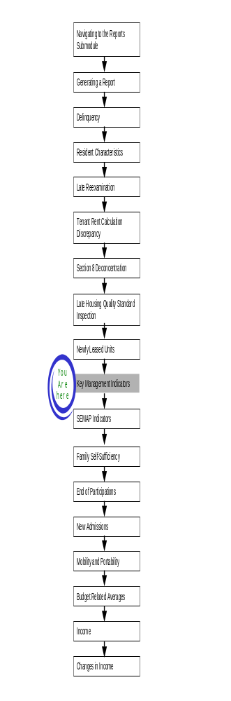
The Key Management Indicators (KMI) Report provides information on the volume of PHA activity, identifies possible discrepancies, and includes descriptive data related to PHA policies.

To access the Key Management Indicators Report:

Step | Action/Result
- Log on to PIC. | The PIC main page is displayed.
- Move your cursor over the Form-50058 button. | A list of submodules is displayed.
- Click the Reports link. | The Delinquency Report page is displayed. Other available reports are listed in tabs at the top of the page.
- Click the KMI tab. | The KMI Report start page is displayed (see Figure 62).

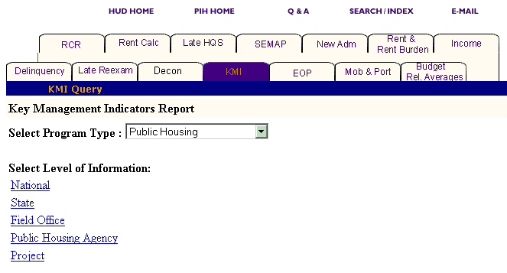
Figure 62: The KMI tab and start page.

Generating a KMI Report

After you reach the KMI Report start page, select the program and level of information to view.

To select KMI Report criteria:

Step | Action/Result
- Click the program type you want in the Program Type dialog box. | - Public Housing  - S8 Certificate  - S8 Voucher  - S8 Certificate and Voucher  - S8 Moderate Rehabilitation  - All Relevant Programs  Note: Public Housing is the default option for the Program Type dialog box.
- Click the link on the Select Level of Information list that corresponds to the level of information you want on the report. | The module formulates the rest of the criteria necessary to generate the report based on the level you select here. For example, click State when the program type you are interested in is located at that level. A dialog box containing a list of state names appears. Click the state where the program type you are interested in is located, and generate the report (see Figure 63).

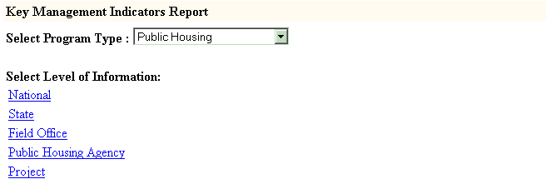
Figure 63: The Level of Information options for
the Key Management Indicators Report.

There are five levels of information to choose from in a KMI Report:

- National
- State
- Field Office
- Public Housing Agency
- Project

Depending on security level, users have limited access within certain levels of information. For example, if you are an HA user, you only have access to the states, field offices, and projects associated with you housing agency.

The following tables outline how to generate a KMI report at each level.

National

Step | Action/Result
1. Click the National link in the Level of Information list. | PIC generates a KMI Report at the national level containing aggregated data.

State

Step | Action/Result
1. Click State in the Select Level of Information list. | A Select State(s) from dialog box is displayed (see Figure 64).
2. Click the state you want from the Select State(s) from dialog box. | Note: To select more than one state, press the CONTROL key as you click each state you want to include in the report.
3. Click the Reports button. | PIC presents the KMI Report for the state(s) selected.

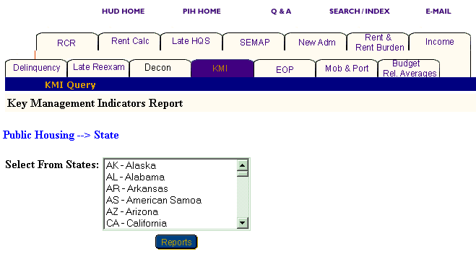
Figure 64: The Select From States dialog box.

Field Office

Step | Action/Result
1. Click Field Office on the Select Level of Information list. | A Select Field Office(s) from dialog box is displayed.
2. Click the field office(s) you want in the Select Field Office(s) from dialog box. | Note: To select more than one field office, press the CONTROL key as you click each office you want to include in the report.
3. Click the Reports button. | PIC presents the KMI Report for the field office(s) selected.

Public Housing Agency

You have three options for generating a KMI Report at the Public Housing Agency level: Within a State, Within a State and County, and Within a Field Office (see Figure 65).

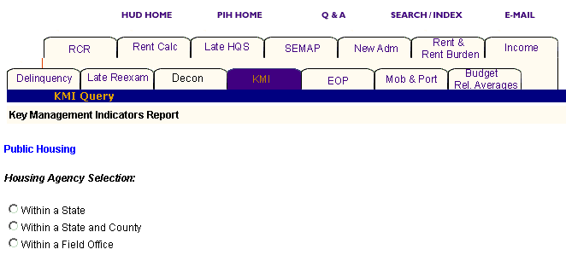
Figure 65: The Housing Agency Selection levels for a KMI Report.

Option 1: Within a State

Select this option if you know the state containing the PHA you want.

Step | Action/Result
1. Click Public Housing Agency on the Select Level of Information list. | PIC is displayed a screen with three different options for identifying the Public Housing Agency: Within a State, Within a State and County, and Within a Field Office.
2. Click Within a State on the Housing Agency Selection list. | A Select State from dialog box is displayed.
3. Click the state you want in the Select State from dialog box.
4. Click the HA List button. | A dialog box is displayed with a list of HAs within the state selected.
5. Click the desired HA(s) in the Select HA(s) dialog box. | Note: To select more than one HA, press the CONTROL key as you click each HA you want to include in the report.
6. Click the Reports button. | A KMI Report is generated for each Public Housing Agency selected within the state.

Option 2: Within a State and County

Select this option if you know the state and county in which your PHA is located.

Step | Action/Result
1. Click Public Housing Agency on the Select Level of Information list. | PIC is displayed a screen with three different options for identifying the Public Housing Agency: Within a State, Within a State and County, and Within a Field Office.
2. Click Within a State and County on the Housing Agency Selection list. | A Select State from dialog box is displayed.
3. Click the state where your PHA is located in the Select State from dialog box.
- Click the County button. | A Select County from dialog box is displayed
- Click the county you want in the Select County from dialog box.
- Click the HA List button. | A dialog box is displayed with a list of HAs associated with the county selected.
- Click the HA(s) you want in the Select HA(s) from dialog box. | Note: To select more than one HA, press the CONTROL key as you click each HA you want to include in the report.
- Click the Reports button. | A KMI Report is generated for each Public Housing Agency selected.

Option 3: Within a Field Office

Select this option if you know the field office in which the PHA you want is located.

Step | Action/Result
1. Click Public Housing Agency on the Select Level of Information list. | PIC is displayed a screen with three different options for identifying the Public Housing Agency: Within a State, Within a State and County, and Within a Field Office.
2. Click Within a Field Office on the Housing Agency Selection list. | A Select Field Office from dialog box is displayed.
3. Click the field office you want in the Select Field Office from dialog box.
- Click the HA List button. | A dialog box is displayed with a list of HAs associated with the field office selected.
- Click the desired HA(s) in the Select HA(s) dialog box. | Note: To select more than one HA, press the CONTROL key as you click each HA you want to include in the report (see Figure 66).
- Click the Reports button. | A KMI Report is generated for each Public Housing Agency selected within the state.

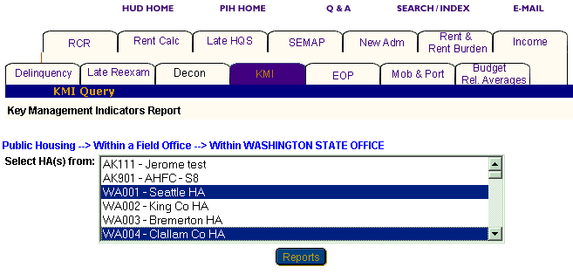
Figure 66: The Select HA(s) from dialog box with two HAs selected.
Project

You have five options to generate a KMI Report at the project level: Within a State, Within a State and Metropolitan Area, Within a State and County, Within a State and City or Locality, and Within a Public Housing Agency (see Figure 67).

Note: You can only generate KMI Reports for projects when Public Housing or All Relevant Program options are selected in the Select Program Type dialog box. If you select any of the Section 8 programs, a message is displayed indicating that there are no projects for Section 8.

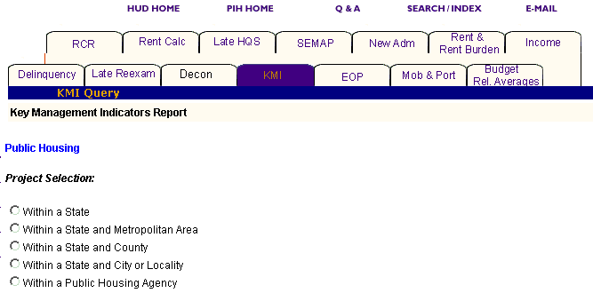
Figure 67: The Project Selection levels available for a KMI Report.

Option 1: Within a State

Select this option if you know the state containing the project you want.

Step | Action/Result
1. Click Project on the Select Level of Information list. | PIC is displayed a screen with five different options for identifying the project: Within a State, Within a State and Metropolitan Area, Within a State and County, Within a State and City or Locality, and Within a Public Housing Agency.
2. Click Within a State on the Project Selection List. | A Select State from dialog box is displayed.
3. Click the state you want in the Select State from dialog box.
- Click the Projects button. | A dialog box is displayed with a list of projects within the state selected.
- Click the desired project(s) in the Select Projects(s) dialog box. | Note: To select more than one project, press the CONTROL key as you click each HA you want to include in the report.
- Click the Reports button. | A KMI Report is generated for each project selected within the state.

Option 2: Within a State and Metropolitan Area

Select this option to produce a KMI Report for a project within a state and metropolitan area.

Step | Action/Result
1. Click Project on the Select Level of Information list. | PIC is displayed a screen with five different options for identifying the project: Within a State, Within a State and Metropolitan Area, Within a State and County, Within a State and City or Locality, and Within a Public Housing Agency.
2. Click Within a State on the Project Selection list. | A Select State from dialog box is displayed.
3. Click the state you want in the Select State from dialog box.
- Click the MSA button. | A Select Metro Area from dialog box is displayed.
- Click the metro area in the Select Metro Area from dialog box. | See Figure 68.
7. Click the Projects button. | A dialog box is displayed with a list of projects within the state and metro area selected.
8. Click the desired project(s) in the Select Projects(s) dialog box. | Note: To select more than one project, press the CONTROL key as you click each HA you want to include in the report.
9. Click the Reports button. | A KMI Report is generated for the project(s) selected within the state.

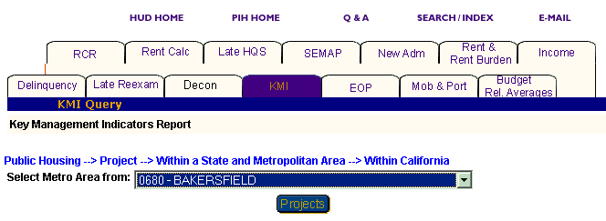
Figure 68: The Select Metro Area from dialog box.

Option 3: Within a State and County

Select this option if you know the state and county in which the project is located.

Step | Action/Result
1. Click Project on the Select Level of Information list. | PIC is displayed a screen with five different options for identifying the project: Within a State, Within a State and Metropolitan Area, Within a State and County, Within a State and City or Locality, and Within a Public Housing Agency.
2. Click Within a State and County on the Project Selection list. | A Select State from dialog box is displayed.
3. Click the state where your project is located in the Select State from dialog box.
- Click the County button. | A Select County from dialog box is displayed.
- Click the county you want in the Select County from dialog box.
- Click the Projects button. | A dialog box is displayed with a list of projects located in the county selected.
- Click the project(s) you want in the Select Project(s) from dialog box. | Note: To select more than one project, press the CONTROL key as you click each HA you want to include in the report.
- Click the Reports button. | A KMI Report is generated for the project(s) selected in the location you specified.

Option 4: Within a State and City or Locality

Select this option if you know the state and city or locality in which your project is located.

Step | Action/Result
1. Click Project on the Select Level of Information list. | PIC is displayed a screen with five different options for identifying the project: Within a State, Within a State and Metropolitan Area, Within a State and County, Within a State and City or Locality, and Within a Public Housing Agency.
2. Click Within a State and City or Locality on the Project Selection list. | A Select State from dialog box is displayed.
3. Click the state where your project is located in the Select State from dialog box.
4. Click the City button. | A Select City(s) from dialog box is displayed.
5. Click the city you want in the Select City(s) from dialog box.
6. Click the Projects button. | A dialog box is displayed with a list of projects located in the city selected (see Figure 69).
7. Click the project(s) you want in the Select Project(s) from dialog box. | Note: To select more than one project, press the CONTROL key as you click each HA you want to include in the report.
8. Click the Reports button. | A KMI Report is generated for the project(s) within the state and city you identified.

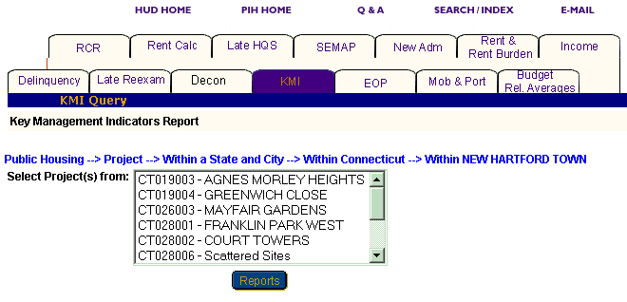
Figure 69: The Select Project(s) from
dialog box for Within a State and City or Locality.

Option 5: Within a Public Housing Agency

Select this option if you know the Public Housing Agency associated with the project you are looking for.

Step | Action/Result
1. Click Project on the Select Level of Information list. | PIC is displayed a screen with five different options for identifying the project: Within a State, Within a State and Metropolitan Area, Within a State and County, Within a State and City or Locality, and Within a Public Housing Agency.
2. Click Within a Public Housing Agency on the Project Selection list. | A Select State from dialog box is displayed.
3. Click the state where the Public Housing Agency and project you want are located in the Select State from dialog box.
- Click the HA List button. | A dialog box is displayed with a list of HAs located in the state selected.
- Click the Public Housing Agency you want in the Select HA from dialog box.
- Click the Projects button. | A Select Project(s) from dialog box is displayed for the Public Housing Agency selected within the state.
- Click the project(s) you want in the Select Project(s) from dialog box. | Note: To select more than one project, press the CONTROL key as you click each HA you want to include in the report.
- Click the Reports button. | A KMI Report is generated for the identified project(s) that are associated with a particular HA.

Information Presented in a KMI Report

When you complete your selections and click the Reports button, PIC generates the KMI Report for the particular program and level of information you selected. Each report offers the same categories of information, which are displayed in tabs at the top of the report.

Subcategories that exist for a particular tab are displayed when you point and click your mouse cursor over the tab.

Note: Multiple data selections may be split into sets. For example: if you selected several states to be included in the report (generally more than four), some of those selections are not displayed in the first report page.

To view the information within a report:

Step | Action/Result
- Move your mouse cursor to click the report tab. | Any subcategories under that tab appear.  Note: Some tabs have no subcategories. Simply click the tab to see the information it contains if no subcategories display.
- Click the subcategory to see. | Each table under that report subcategory is displayed.
- Click the Next Set arrow located at the bottom right of the report page to view the next data set. | The next data set is displayed.
- Click the Prev Set arrow located at the bottom left of the report to return to the data set previously viewed. | The previous data set is displayed.

Reports generated at the state and field office level also provide national data. Public Housing Agency and project levels provide state data.

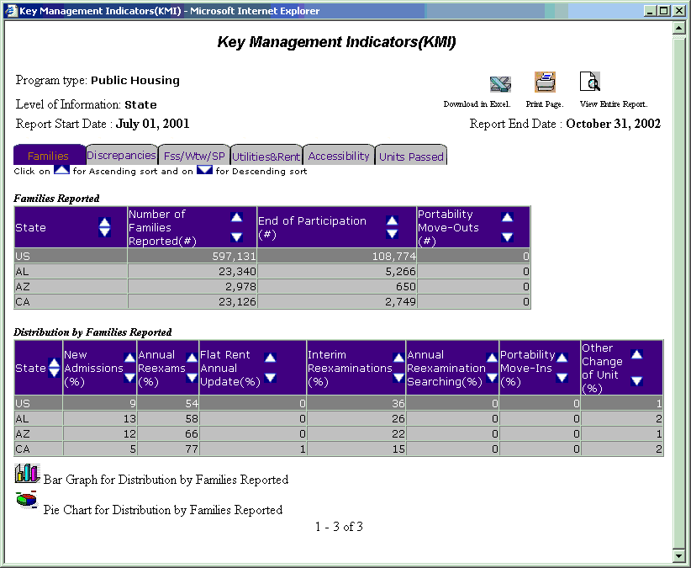
Figure 70: The tables under the Families tab of the KMI Report.

View information on a report in ascending or descending order by clicking the up or down arrow in the column to be viewed.

The following table describes the information contained under each tab and subcategory of the KMI Report.

Tab | Subcategories | Information Presented
Families | None | Default screen for the KMI Report, consisting of two tables reporting:  Families Reported:  - Number of Families Reported (#)  - End of Participation (#)  - Portability Move-outs (S8 only) (#)  Distribution of Families Reported:  - New Admissions (%)  - Annual Re-exams (%)  - Flat Rent Annual Update (%)  - Interim Re-examinations (%)  - Annual Re-examination Searching (%)  - Portability Move-Ins (%)  - Other Change of Unit (%)
Discrepancies | Rent Discrepancies | Rent Discrepancies consists of two tables reporting:  Distributions of Families with Rent Discrepancies  - Families with Rent Discrepancy (#)  - Families with Rent Discrepancy (%)  $10 (-) (%)  $11-25 (%)  $26-50 (%)  $51-100 (%)  $101-150 (%)  $150+ (%)  Family Rent for Overpayments/Underpayments  - Percent Overpaying (+) (%)  - Average Overpayment ($)  - Total Overpayment ($)  - Percent Underpaying (-) (%)  - Average Underpayment ($)  - Total Underpayment ($)
 | Other Discrepancies | Other Discrepancies consists of one table reporting:  Other Discrepancies  - Percent of Admissions of Over -Income Families (%) (S8 only)  - Percent of Over-Housed Families (%)  - Percent of Under-Housed Families (%)  - Percent of Late Re-exam (%)  - Percent of Late Flat Rent Re-exam (%)  - Percent of Late Flat Rent Annual Update  - Average Months Flat Rent Re-exam Late (#)  - Average Months Flat Rent Annual Update Late (%)  - Percent of S8 Units with HQS Inspection Overdue (%)
Family Self-Sufficiency/Welfare-to-Work Voucher/  Special Programs (Fss/Wtw/ SP) | FSS | FSS consists of one table reporting:  Family Self-sufficiency  - Families Enrolled (#)  - Families Enrolled (%)  - Completed FSS Contract (%)  - Left FSS without Completion (%)
 | Wtw (Section 8 Only) | Wtw is for Section 8 programs only and consists of one table reporting:  Number of Families Enrolled (#)
 | SP | SP consists of one table reporting:  Number of Families Enrolled (#)  - EDSS  - ROSS  - HOPE  - RSP  - PHDEP
Utilities & Rent | Utility Arrangement | Utility Arrangement consists of one table reporting:  Utility Arrangement Information:  - Percent of Families with Utility Arrangement (%)  - Average Utility Allowance ($)
 | Gross Rent (Section 8 Only) | Gross Rent is reported for Section 8 only and consists of one table reporting:  Gross Rent as Percent of FMR  - 90% of FMR or Under  - 90-100%  - 101-110%  - 111-120%  - Over 120%  - FMR Not Available
 | Rent Burden | Rent Burden consists of one table reporting:  Rent Burden as Percent of Family Adjusted Income  - 20 (%) of Adjusted Income or Under  - 21-25 (%)  - 26-30 (%)  - 31-35 (%)  - 36-40 (%)  - 41-45 (%)  - 46-50 (%)  - Over 50 (%)  - Average Rent Burden ($)  - Average Rent Burden for Flat Rent Families ($)
 | Average Flat Rent | Average Flat Rent consists of one table reporting:  - 0 Bedrooms ($)  - 1 Bedroom ($)  - 2 Bedrooms ($)  - 3 Bedrooms ($)  - 4 Bedrooms ($)  - 5+ Bedrooms ($)  - Percent Units with Flat Rent (%)
 | Average Ceiling Rent | Average Ceiling Rent consists of one table reporting:  - 0 Bedrooms ($)  - 1 Bedroom ($)  - 2 Bedrooms ($)  - 3 Bedrooms ($)  - 4 Bedrooms ($)  - 5+ Bedrooms ($)  - Percent Units with Ceiling Rent (%)
 | Minimum Rent | Minimum Rent consists of one table reporting:  Distribution of Families Subject to Minimum Rent  - $0  - $1 to $24 (%)  - At $25 (%)  - $26 to $49 (%)  - At $50 (%)  - Average Minimum Rent ($)
Accessibility | None | Accessibility consists of one table reporting:  Distribution of Families Who Received Accessibility Features  - Number of Families Requesting Accessibility Features  - Fully (%)  - Partially (%)  - Not At All (%)  - Action Pending (%)
Units Passed | None (Section 8 Only) | Units Passed is for Section 8 only and consists of one table reporting:  Units Passed HQS Inspection  - Number of Units Administered (#)  - Percent of Units Passed HQS Inspection (%)  - Number of Units Passed HQS Inspection (#)

Two icons are available at the bottom of most tables, so you can view the information in Bar Graph or Pie Chart form. When the icons are not visible, the information is only available in tabular form.

Figure 71: The icons for converting table information
into a Bar Graph or Pie Chart.

The KMI Report screen contains three options for further use of the data. The options are located on the top right of the report screen.

Select one of the following options:

      - Download in Excel: The report downloads to an MS-Excel™ spreadsheet for further data manipulation.

      - Print Page: The report prints as a Web page.

Note: For the best results, print in landscape orientation.

      - View Entire Report: All report subcategory tables display together on one screen.

Figure 72: The options for further
use of report data.

To generate another report, repeat the process by returning to the Reports screen and selecting the tab for the next report. Refer to the corresponding section of this user manual that describes the report, and follow the steps to generate the report.

The Section Eight Management Assessment Program Indicators Report
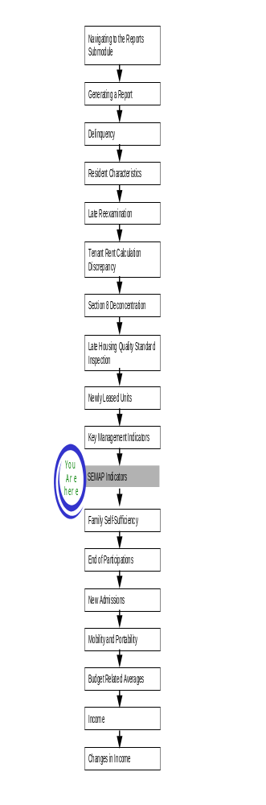
The Section Eight Management Assessment Program (SEMAP) Indicators Report is one of several inputs used to derive a score and rating for PHAs as they relate to SEMAP certification. The report presents reporting rate, discrepancy, and Family Self-Sufficiency information for selected program types and levels of information.

To access the SEMAP Indicators Report start page:

Step | Action/Result
1. Log on to PIC. | The PIC main page is displayed.
2. Move your cursor over the Form-50058 button. | A list of submodules is displayed.
3. Click the Reports link. | The Delinquency Report page is displayed. Other available reports are listed in tabs at the top of the page.
4. Click the SEMAP tab. | The SEMAP Indicators Report start page displays (see Figure 73).

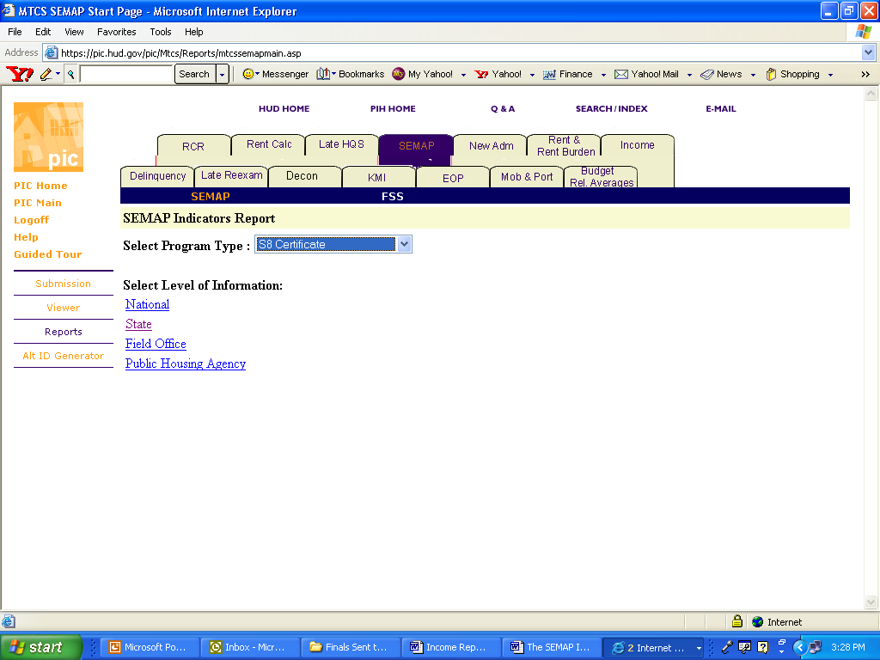
Figure 73: The SEMAP
Indicators Report tab and start page.

Generating a SEMAP Indicators Report
After you have reached the SEMAP Indicators Report start page, you need to select the program and the level of information you want to view.

To select the SEMAP Indicators Report criteria, use the following steps:

Step | Action/Result
1. Click the program type you want in the Program Type dialog box. | - S8 Certificate  - S8 Voucher  - S8 Certificate & Voucher  Note: S8 Certificate is the default option for the Program Type dialog box.
2. Click the link on the Select Level of Information list that corresponds to the level of information you want on the report. | The module formulates the rest of the criteria necessary to generate the report based on the level you select here. For example, click State when the program type you are interested in is located at that level. A dialog box containing a list of state names appears. Click the state where the program type you are interested in is located, and generate the report.

There are four levels of information to choose from in a SEMAP Indicators Report (see Figure 74):

- National
- State
- Field Office
- Public Housing Agency

Figure 74: The Level of Information options
available for the SEMAP Indicators Report.
Depending on security clearance, users have limited access within certain levels of information. For example, if you are an HA user, you only have access to the states, field offices, and public housing agencies in your jurisdiction.

The following tables outline how to generate a SEMAP Indicators Report for each level.

National

Step | Action/Result
1. Click the National link on the Select Level of Information list. | PIC generates a SEMAP Indicators Report at the national level containing aggregated data.

State

Step | Action/Result
1. Click State on the Select Level of Information list. | A Select State(s) from dialog box is displayed.
2. Click the state you want in the Select State(s) from dialog box. | Note: To select more than one state, press the CONTROL key as you click each state you want to include in the report.
3. Click the Reports button. | PIC presents the SEMAP Indicators Report for the selected state(s).

Field Office

Step | Action/Result
1. Click Field Office on the Select Level of Information list. | A Select Field Office(s) from dialog box is displayed.
2. Click the field office(s) you want in the Select Field Office(s) from dialog box (see Figure 75). | Note: To select more than one field office, press the CONTROL key as you click each office you want to include in the report.
3. Click the Reports button. | PIC presents the SEMAP Indicators Report for the field office(s) selected.

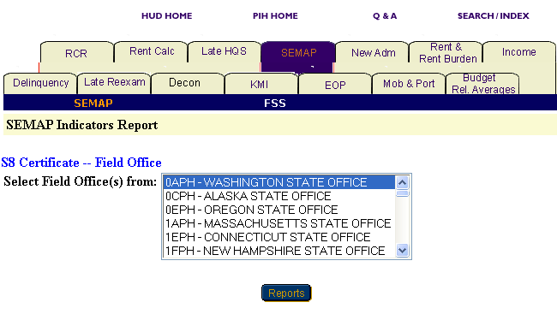
Figure 75: The Select Field Office(s) from
dialog box for the field office level of information.

Public Housing Agency

To generate a report for a particular Public Housing Agency, you have three options: Within a State, Within a State and County, or Within a Field Office (see Figure 76).

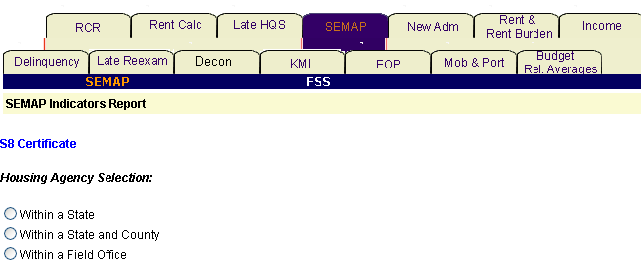
Figure 76: The Housing Agency
Selection levels for a SEMAP Indicators Report.

Option 1: Within a State

Select this option if you know the state in which your PHA is located.

Step | Action/Result
1. Click Public Housing Agency on the Select Level of Information list. | PIC displays a screen with three different options for identifying the Public Housing Agency: Within a State, Within a State and County, and Within a Field Office.
2. Click Within a State. | A Select State from dialog box is displayed.
3. Click the state you want in the Select State from dialog box.
4. Click the HA List button. | A dialog box appears with a list of HAs within the selected state.
5. Click the desired HA(s) in the Select HA(s) dialog box. | Note: To select more than one HA, press the CONTROL key as you click each HA you want to include in the report.
6. Click the Reports button. | A SEMAP Indicators Report is generated for each Public Housing Agency selected within the state.

Option 2: Within a State and County

Select this option if you know the state and county in which your PHA is located.

Step | Action/Result
1. Click Public Housing Agency on the Select Level of Information list. | PIC displays a screen with three different options for identifying the Public Housing Agency: Within a State, Within a State and County, and Within a Field Office.
2. Click Within a State and County. | A Select State from dialog box is displayed.
3. Click the state you want in the Select State from dialog box.
4. Click the County button. | A dialog box appears with a list of counties within the selected state.
5. Click the desired county in the Select County dialog box.
6. Click the HA List button. | A dialog box is displayed with a list of HAs associated with the selected county.
7. Click the HA(s) you want in the Select HAs dialog box. | Note: To select more than one HA, press the CONTROL key as you click each HA you want to include in the report.
8. Click the Reports button. | A SEMAP Indicators Report is generated for each Public Housing Agency selected.

Option 3: Within a Field Office

Select this option if you know the field office associated with the PHA you want.

Step | Action/Result
1. Click Public Housing Agency on the Select Level of Information list. | PIC displays a screen with three different options for identifying the Public Housing Agency: Within a State, Within a State and County, and Within a Field Office.
2. Click Within a Field Office. | A Select Field Office from dialog box is displayed.
3. Click the field office you want in the Select Field Office from dialog box.
- Click the HA List button. | A dialog box appears with a list of HAs associated with the selected field office.
- Click the HA(s) you want in the Select HAs dialog box (see Figure 77). | Note: To select more than one HA, press the CONTROL key as you click each HA you want to include in the report.
- Click the Reports button. | A SEMAP Indicators Report is generated for each Public Housing Agency selected.

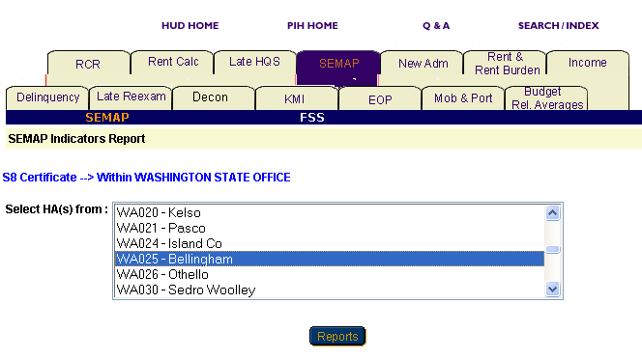
Figure 77: The Select HA(s) dialog
box for Within a Field Office.

Information Presented in a SEMAP Indicators Report
When you complete your selections and click the Reports button, PIC generates the SEMAP Indicators Report for the particular program and level of information selected. The selections are listed at the top of the report along with the report’s start and end dates.

The SEMAP Indicators Report is split into the following three sections:

  - Reporting Rate
  - Discrepancy Information
  - Family Self-Sufficiency (FSS)

The section headings are listed on tabs. Click any tab to view the corresponding report information (see Figure 78).

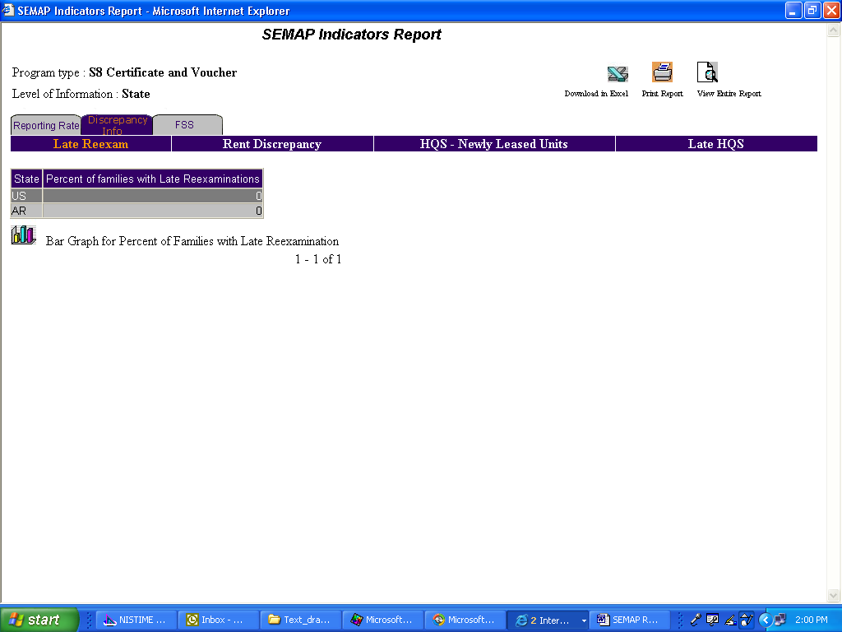
Figure 78: The Three section tabs available in a SEMAP
Indicators Report. (The Discrepancy Info tab is highlighted)
Reports generated at the state and field office level also provide national data. The Public Housing Agency level provides state data.

Where available, you can view information in ascending or descending order on a report by clicking the up or down arrow in the column you want to view.

Note: Multiple data selections may be split into sets. For example, if you selected several states to be included in the report (generally more than four), some of those selections are not displayed in the first report page. To view these data selections:

Step | Action/Result
1. Click the Next Set arrow located at the bottom right of the report page to view the next data set. | The next data set displays.
2. Click the Prev Set arrow located at the bottom left of the report to return to the data set previously viewed. | The previous data set displays.

The Discrepancy Information tab also contains four subtabs:

- Late Reexam
- Rent Discrepancy
- Housing Quality Standard (HQS) – Newly Leased Units
- Late HQS

To view one of these subtabs:

Step | Action/Result
1. Generate a report.
2. Click the Discrepancy Info tab. | The Discrepancy Info page is displayed. The subtabs are listed directly under the main tabs.
- Click the subtab you want to view.

The following table describes the information contained in the each tab and subtab of a SEMAP Indicators Report.

Tab | Subcategories | Information Presented
Reporting Rate | None | Default screen for the SEMAP Indicators Report. It consists of one table reporting:  Reporting Rate:  - Level of Information Selected  - Administered Units  - Number of Families Reported  - Percent Reported
Discrepancy Information | Late Reexam | Default screen for the Discrepancy section. It consists of one table reporting:  - Level of Information Selected  - Percent Late Reexams (%)
 | Rent Discrepancy | Consists of one table reporting:  - Level of Information Selected  - Number of Families with Rent Discrepancies (#)  - Percent of Families with Rent Discrepancies (%)
 | HQS – Newly Leased Units | Consists of one table reporting:  - Level of Information Selected  - Passed Inspection Before Contract Effective (%)  - Passed Inspection After Contract Effective (%)  - Not Reported (%)
 | Late HQS | Consists of one table reporting:  - Level of Information Selected  - Percent Late HQS Inspections (%)
Family Self-Sufficiency (FSS) |  | Consists of one table reporting:  - Level of Information Selected  - Number of Families Enrolled (#)  - Number of Families with Escrow Balances (#)  - Percent with Escrow Balances (%)
Two icons are available at the bottom of most tables (see Figure 79), so you can view the information in either Pie Chart or Bar Graph form. When the icons are not visible, the information is only available in tabular form.

Figure 79: The icons for converting table
information into a Bar Graph or Pie Chart.

The SEMAP Indicators Report screen contains three options for further use of the data (see Figure 80). The options are located on the top right side of the report screen.

Select one of the following options:

      - Download in Excel: The report downloads to an MS-Excel™ spreadsheet for further data manipulation.

      - Print Page: The report prints as a Web page.

Note: For the best results, print in landscape orientation.

      - View Entire Report: All report subcategory tables display together on one screen.

Figure 80: The Options available
for further use of report data.

To generate another report, repeat the process by returning to the Reports screen and selecting the tab for the report you want next. Refer to the corresponding section of this user manual, and follow the steps provided to generate that report.

The Family Self-Sufficiency Report
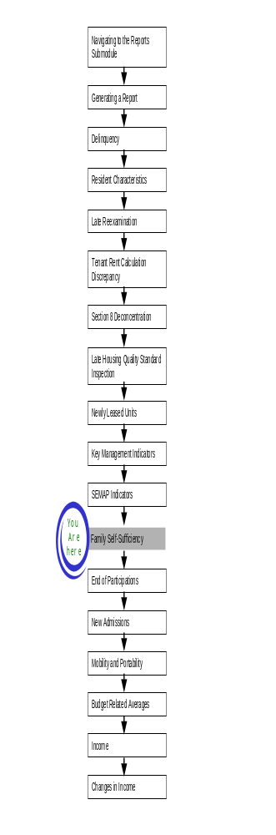
From the SEMAP Indicators Report start page, you can also generate a Family Self-Sufficiency (FSS) Report for PHAs in the S8 Certificate and Voucher Program. This report displays certain FSS data, such as number of families enrolled, number of families with escrow balances, and percent with escrow balances. This data is retrieved from the most recent FSS Addendum submission.

To access the FSS Report start page:

Step | Action/Result
- Log on to PIC. | The PIC main page is displayed.
- Move your cursor over the Form-50058 button. | A list of submodules is displayed.
- Click the Reports link. | The Delinquency Report page is displayed. Other available reports are listed in tabs at the top of the page.
- Click the SEMAP tab. | The SEMAP Indicators Report start page displays.
- Click the FSS subtab, located just to the right of the SEMAP subtab. | The FSS Report start page appears (see Figure 81).

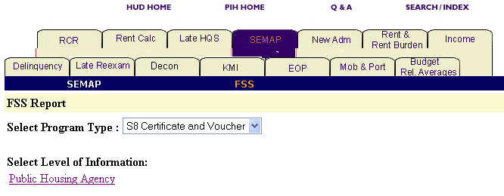
Figure 81: The FSS Report start page.

Generating an FSS Report
S8 Certificate and Voucher is the only program available for an FSS Report. The start page defaults the Select Program Type dialog box to this program. Also, Public Housing Agency is the only level of information available for an FSS Report.

Public Housing Agency

To generate an FSS Report for a PHA, you have three options for identifying where it is located: Within a State, Within a State and County, and Within a Field Office.

Depending on security clearance, users have limited access within certain levels of information. For example, if you are an HA user, your access is limited to your own housing agency.

Option 1: Within a State

Select this option if you know the state in which your PHA is located.

Step | Action/Result
1. Click Public Housing Agency on the Select Level of Information list. | PIC displays a screen with three different options for identifying the Public Housing Agency: Within a State, Within a State and County, and Within a Field Office.
2. Click Within a State. | A Select State from dialog box is displayed.
3. Click the state you want in the Select State from dialog box.
- Click the HA List button. | A dialog box appears with a list of HAs within the selected state.
- Click the desired HA(s) in the Select HA(s) dialog box. | Note: To select more than one HA, press the CONTROL key as you click each HA you want to include in the report.
- Click the Reports button. | An FSS Report is generated for each Public Housing Agency selected within the state.

Option 2: Within a State and County

Select this option if you know the state and county in which your PHA is located.

Step | Action/Result
1. Click Public Housing Agency on the Select Level of Information list. | PIC displays a screen with three different options for identifying the Public Housing Agency: Within a State, Within a State and County, and Within a Field Office.
- Click Within a State and County. | A Select State from dialog box is displayed.
- Click the state you want in the Select State from dialog box.
- Click the County button. | A dialog box appears with a list of counties within the selected state.
- Click the desired county in the Select County from dialog box
(see Figure 82).
- Click the HA List button. | A dialog box appears with a list of HAs associated with the selected county.
- Click the HA(s) you want in the Select HAs dialog box. | Note: To select more than one HA, press the CONTROL key as you click each HA you want to include in the report.
- Click the Reports button. | An FSS Report is generated for each Public Housing Agency selected.

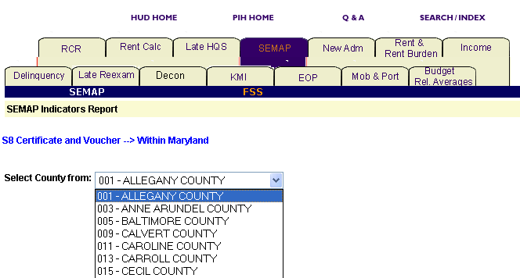
Figure 82: A list of counties from the Select Count
from screen in the Within a State and County option.

Option 3: Within a Field Office

Select this option if you know the field office associated with the PHA you want.

Step | Action/Result
1. Click Public Housing Agency on the Select Level of Information list. | PIC displays a screen with two different options for identifying the Public Housing Agency: Within a State, Within a State and County, and Within a Field Office.
2. Click Within a Field Office. | A Select Field Office from dialog box is displayed.
3. Click the field office you want in the Select Field Office from dialog box.
- Click the HA List button. | A dialog box is displayed that contains a list of HAs associated with the selected field office.
- Click the HA(s) you want in the Select HAs dialog box. | Note: To select more than one HA, press the CONTROL key as you click each HA you want to include in the report.
- Click the Reports button. | A SEMAP Indicators Report is generated for each Public Housing Agency selected.

Information Presented in an FSS Report

When you complete your selections and click the Reports button, the PIC system generates the FSS Report. The report headings list the program type, level of information, PHA selections, and the report’s start and end dates.

Each report displays information for one PHA. If you selected multiple PHAs, you can switch between them by selecting and viewing another HA Code in the Select HA Code dialog box.

An FSS report is composed of two tables, as described below:

Table | Information Presented
FSS Information for the Selected PHA(s) | One table reporting:  Individual FSS Information  - The Program Type  - SSN  - Tenant’s First Name  - Tenant’s Last Name  - FSS Report Type  - Disbursed Amount  - Account Balance Amount
Total Information for the PHA(s) | One table reporting:  Total FSS Information  - Families Enrolled  - Total Families with Escrow Balances

The FSS Report screen contains two options for further use of the data (see Figure 83). The options are located on the top right side of the report screen.

Select on of the following options:

      - Download in Excel: The report downloads to an MS-Excel™ spreadsheet for further data manipulation.

      - Print Page: The report prints as a Web page.

Note: For the best results, print in landscape orientation.

Figure 83: The options for
further use of the report data.
To generate another report, repeat the process by returning to the Reports screen and selecting the tab for the report you want next. Refer to the corresponding section of this user manual, and follow the steps provided to generate that report.

End of Participation Report
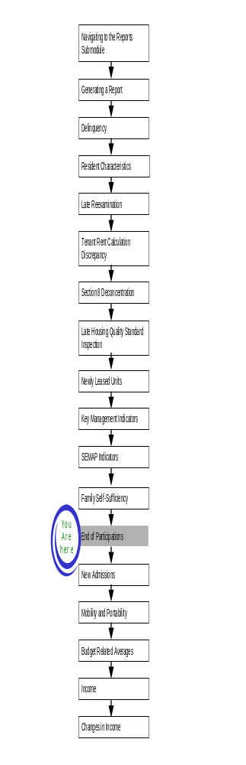
The End of Participation (EOP) Report provides demographic and income information for families who have ended their participation in an assisted housing program.

To access the End of Participation Report:

Step | Action/Result/Result
1. Log on to PIC. | The PIC main page is displayed.
2. Move your cursor over the Form-50058 button. | A list of submodules is displayed.
3. Click the Reports link. | The Delinquency Report page is displayed. Other available reports are listed in tabs at the top of the page.
4. Click the EOP tab. | The EOP Report start page displays (see Figure 84).

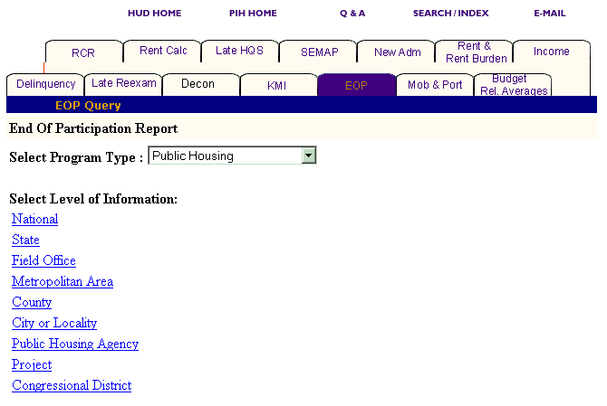
Figure 84: The EOP tab and start page.

Generating an EOP Report

After you reach the EOP start page, select the program and level of information to view.

To select EOP Report criteria:

Step | Action/Result
- Click the program type you want in the Program Type dialog box. | - Public Housing  - S8 Moderate Rehabilitation  - S8 Certificate  - S8 Voucher  - Certificate and Voucher  - All Relevant Programs  Note: Public Housing is the default option for the Select Program Type dialog box.
- Click the link under Level of Information that corresponds to the level of information you want on the report. | The module formulates the rest of the criteria necessary to generate the report based on the level you select here. For example, click State when the program type you are interested in is located at that level. A dialog box containing a list of state names appears. Click the state where the program type you are interested in is located, and generate the report (see Figure 85).

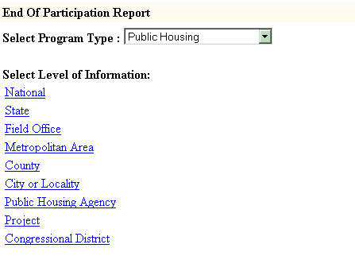
Figure 85: The Level of Information
options for the EOP Report.

There are nine levels of information to choose from in an EOP Report:

- National
- State
- Field Office
- Metropolitan Area
- County
- City or Locality
- Public Housing Agency
- Project
- Congressional District

Depending on security clearance, users have limited access within certain levels of information. For example, if you are an HA user, you only have access to the states, field offices, and projects associated with your housing agency.

The following tables outline how to generate an EOP Report at each level.

National

Step | Action/Result
1. Click the National link in the Level of Information list. | PIC generates an EOP Report at the national level containing aggregated data.
State

Step | Action/Result
1. Click State on the Select Level of Information list. | A Select State(s) from dialog box is displayed (see Figure 86).
2. Click the state you want in the Select State(s) from dialog box. | Note: To select more than one state, press the CONTROL key as you click each state you want to include in the report.
3. Click the Reports button. | PIC presents the EOP Report for the state(s) selected.

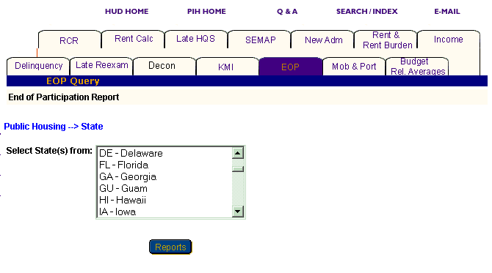
Figure 86: The Select State(s) from dialog box.

Field Office

Step | Action/Result
1. Click Field Office on the Select Level of Information list. | A Select Field Office(s) from dialog box is displayed.
2. Click the field office(s) you want in the Select Field Office(s) from dialog box. | Note: To select more than one field office, press the CONTROL key as you click each office you want to include in the report.
3. Click the Reports button. | PIC displays the EOP Report for the field office(s) selected.

Metropolitan Area

You have two options for generating an EOP Report at the metropolitan area level: Within US and Within a State.

Option 1: Within US

Select this option if you know the exact metropolitan area you are looking for.

Step | Action/Result
1. Click Metropolitan Area on the Select Level of Information list. | PIC displays a screen with two different options for identifying the metropolitan area: Within US and Within a State.
2. Click Within US on the Metropolitan Area Selection list. | PIC displays a Select Metro Area(s) from dialog box (see Figure 87).
3. Click the metro area you are looking for in the Select Metropolitan Area(s) from dialog box. | Note: To select more than one metro area, press the CONTROL key as you click each one you want to include in the report.
- Click the Reports button. | PIC presents an EOP Report for the metro area(s) selected.

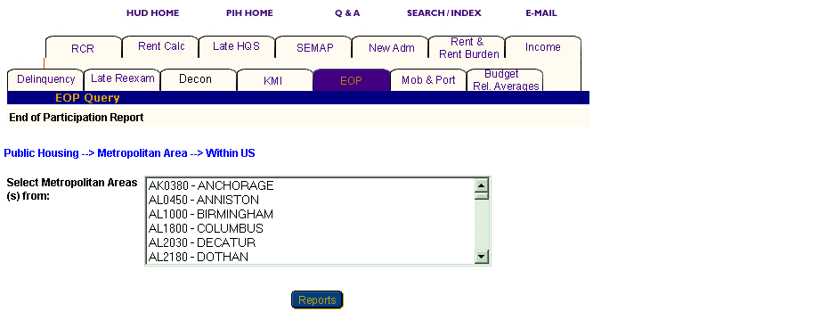
Figure 87: The Select Metropolitan Area(s) from dialog box.
Option 2: Within a State

Select this option if you know only the state the metropolitan area is in.

Step | Action/Result
1. Click Metropolitan Area on the Select Level of Information list. | PIC displays a screen with two different options for identifying the metropolitan area: Within US and Within a State.
2. Click Within a State on the Metropolitan Area Selection list. | PIC displays a Select State from dialog box.
3. Click the state you want in the Select State from dialog box.
4. Click the MSA button. | A Select Metropolitan Area(s) from dialog box is displayed.
5. Click the metro area you are looking for in the Select Metropolitan Area(s) from dialog box. | Note: To select more than one metro area, press the CONTROL key as you click each one you want to include in the report.
6. Click the Reports button. | An EOP Report is generated for the metro area(s) selected.

County

There are two options for generating an EOP Report at the county level: Within a State and Within a State and Metropolitan Area.

Option 1: Within a State

Select this option if you know only the state the county is in.

Step | Action/Result
1. Click County on the Select Level of Information list. | PIC displays a screen with two different options for identifying the county: Within a State and Within a State and Metropolitan Area.
2. Click Within a State on the County Selection list. | PIC displays a Select State(s) from dialog box.
3. Click the state you are looking for in the Select State(s) from dialog box.
4. Click the County button. | A Select County(s) from dialog box is displayed.
5. Click the county(s) you want included in the report. | Note: To select more than one county, press the CONTROL key as you click each one you want to include in the report.
6. Click the Reports button. | PIC displays an EOP Report for each county selected.

Option 2: Within a State and Metropolitan Area

Select this option if you know the state and metropolitan area containing the county you are looking for.

Step | Action/Result
1. Click County on the Select Level of Information list. | PIC displays a screen with two different options for identifying the county: Within a State and Within a State and Metropolitan Area.
2. Click Within a State and Metropolitan Area on the County Selection list. | PIC displays a Select State(s) from dialog box.
3. Click the state you are looking for in the Select State(s) from dialog box.
- Click the MSA button. | PIC displays a Select MSA(s) from dialog box.
- Click the metropolitan area that contains the county you are looking for.
- Click the County button. | A Select County(s) from dialog box is displayed (see Figure 88).
- Click the county(s) you want to include in the report. | Note: To select more than one county, press the CONTROL key as you click each one you want to include in the report.
- Click the Reports button. | PIC displays an EOP Report for each county selected.

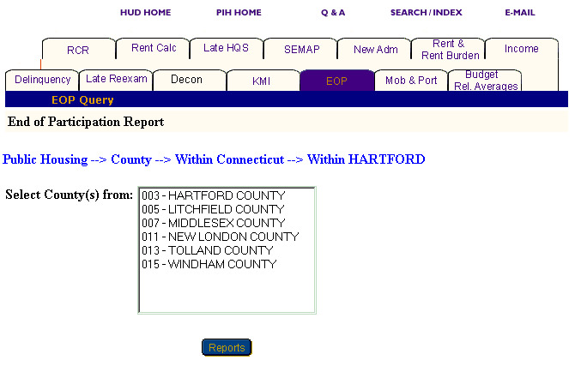
Figure 88: The Select County(s) from dialog box.

City or Locality

You have three options for generating an EOP Report at the city or locality level: Within a State, Within a State and Metropolitan Area, and Within a State and County.

Option 1: Within a State

Select this option if you know the state that contains the city you are looking for.

Step | Action/Result
1. Click City or Locality on the Select Level of Information list. | PIC displays a screen with three different options for identifying the city or locality: Within a State, Within a State and Metropolitan Area, and Within a State and County.
2. Click Within a State on the City Selection list. | PIC displays a Select State from dialog box.
3. Click the state that contains the city you want in the Select State from dialog box.
- Click the City button. | A Select City(s) from dialog box is displayed.
- Click the city(s) you want included in the report. | Note: To select more than one city, press the CONTROL key as you click each one you want to include in the report.
- Click the Reports button. | PIC displays an EOP Report for each city selected.

Option 2: Within a State and Metropolitan Area

Select this option if you know the state and metropolitan area containing the city you are looking for.

Step | Action/Result
1. Click City or Locality on the Select Level of Information list. | PIC displays a screen with three different options for identifying the city or locality: Within a State, Within a State and Metropolitan Area, and Within State and County.
2. Click Within a State and Metropolitan Area on the City Selection list. | PIC displays a Select State(s) from dialog box.
3. Click the state you are looking for in the Select State(s) from dialog box.
- Click the MSA button. | PIC displays a Select MSA(s) from dialog box.
5. Click the metropolitan area that contains the city you are looking for.
6. Click the City button. | A Select City(s) from dialog box is displayed (see Figure 89).
7. Click the city(s) you want included in the report. | Note: To select more than one city, press the CONTROL key as you click each one you want to include in the report.
8. Click the Reports button. | PIC displays an EOP Report for each city selected.

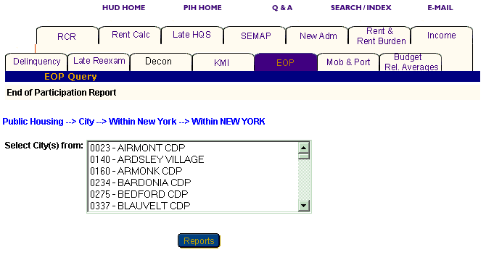
Figure 89: The Select City(s) from dialog box.

Option 3: Within a State and County

Select this option if you know the state and county that contain the city you are looking for.

Step | Action/Result
1. Click City or Locality on the Select Level of Information list. | PIC displays a screen with three different options for identifying the city or locality: Within a State, Within a State and Metropolitan Area, and Within State and County.
2. Click Within a State and County on the City Selection list. | PIC displays a Select State(s) from dialog box.
3. Click the state you are looking for in the Select State(s) from dialog box.
4. Click the County button. | PIC displays a Select County(s) from dialog box.
5. Click the county that contains the city you want.
6. Click the City button. | A Select City(s) from dialog box is displayed.
7. Click the city(s) you want included in the report. | Note: To select more than one city, press the CONTROL key as you click each one you want to include in the report.
8. Click the Reports button. | PIC displays an EOP Report for each city selected.

Public Housing Agency

You have three options for generating an EOP Report at the Public Housing Agency level: Within a State, Within a State and County, and Within a Field Office (see Figure 90).

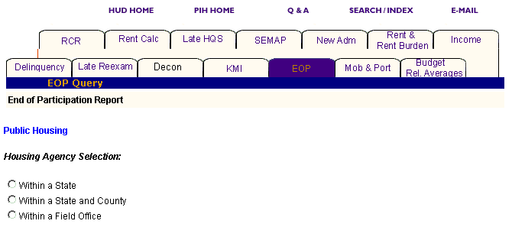
Figure 90: The Housing Agency Selection levels for an EOP Report.

Option 1: Within a State

Select this option if you know the state in which your PHA is located.

Step | Action/Result
1. Click Public Housing Agency on the Select Level of Information list. | PIC displays a screen with three different options for identifying the Public Housing Agency: Within a State, Within a State and County, and Within a Field Office.
2. Click Within a State on the Housing Agency Selection list. | A Select State from dialog box is displayed.
3. Click the state you want in the Select State from dialog box.
4. Click the HA List button. | A dialog box is displayed with a list of HAs within the state selected.
5. Click the desired HA(s) in the Select HA(s) dialog box. | Note: To select more than one HA, press the CONTROL key as you click each HA you want to include in the report.
6. Click the Reports button. | An EOP Report is generated for each Public Housing Agency selected within the state.

Option 2: Within a State and County

Select this option if you know the state and county in which your PHA is located.

Step | Action/Result
1. Click Public Housing Agency on the Select Level of Information list. | PIC displays a screen with three different options for identifying the Public Housing Agency: Within a State, Within a State and County, and Within a Field Office.
2. Click Within a State and County on the Housing Agency Selection list. | A Select State from dialog box is displayed.
3. Click the state where your PHA is located in the Select State from dialog box.
- Click the County button. | A Select County from dialog box is displayed.
- Click the county you want in the Select County from dialog box.
- Click the HA List button. | A dialog box is displayed with a list of HAs associated with the county selected (see Figure 91).
- Click the HA(s) you want in the Select HA(s) from dialog box. | Note: To select more than one HA, press the CONTROL key as you click each HA you want to include in the report.
- Click the Reports button. | An EOP Report is generated for each Public Housing Agency selected.

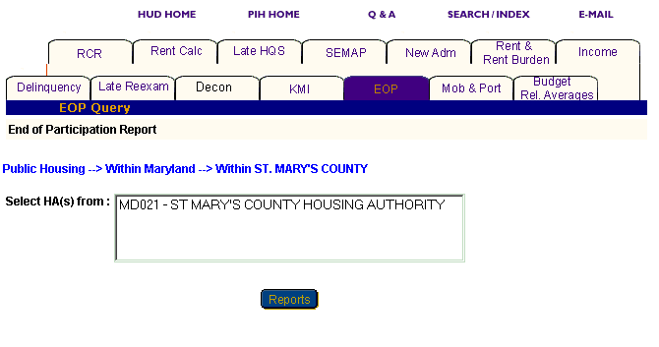
Figure 91: The Select HAs from dialog box.

Option 3: Within a Field Office

Select this option if you know the field office containing the PHA you are looking for.

Step | Action/Result
1. Click Public Housing Agency on the Select Level of Information list. | PIC displays a screen with three different options for identifying the Public Housing Agency: Within a State, Within a State and County, and Within a Field Office.
2. Click Within a Field Office on the Housing Agency Selection list. | A Select Field Office from dialog box is displayed.
3. Click the field office you want in the Select Field Office from dialog box.
- Click the HA List button. | A dialog box is displayed with a list of HAs associated with the field office selected.
- Click the desired HA(s) in the Select HA(s) dialog box. | Note: To select more than one HA, press the CONTROL key as you click each HA you want to include in the report.
- Click the Reports button. | An EOP Report is generated for each Public Housing Agency selected that is associated with the identified field office.

Project

You have five options to generate an EOP Report at the project level: Within a State, Within a State and Metropolitan Area, Within a State and County, Within a State and City or Locality, and Within a Public Housing Agency (see Figure 92).

Note: You can only generate an EOP Report for a project if you have selected Public Housing in the Select Program Type dialog box. If you select any other program, a message is displayed indicating that the project is only available for Public Housing.

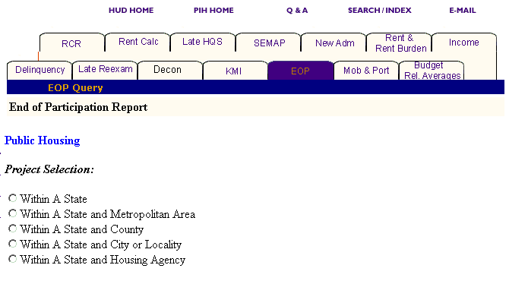
Figure 92: The Project Selection levels for an EOP Report.

Option 1: Within a State

Select this option if you know the state containing the project you are looking for.

Step | Action/Result
1. Click Project on the Select Level of Information list. | PIC displays a screen with five different options for identifying the project: Within a State, Within a State and Metropolitan Area, Within a State and County, Within a State and City or Locality, and Within a Field Office.
2. Click Within a State on the Project Selection List. | A Select State from dialog box is displayed.
3. Click the state you want in the Select State from dialog box.
4. Click the Projects button. | A dialog box is displayed with a list of projects within the state selected.
5. Click the desired project(s) in the Select Projects(s) dialog box. | Note: To select more than one project, press the CONTROL key as you click each project you want to include in the report (see Figure 93).
6. Click the Reports button. | An EOP Report is generated for each project selected within the state.

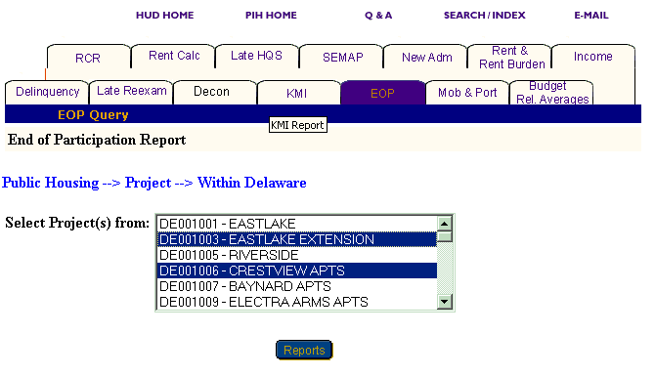
Figure 93: The Select Project(s) from dialog box with two projects selected.
Option 2: Within a State and Metropolitan Area

Select this option if you know the state and metro area containing the project you are looking for.

Step | Action/Result
1. Click Project on the Select Level of Information list. | PIC displays a screen with five different options for identifying the project: Within a State, Within a State and Metropolitan Area, Within a State and County, Within a State and City or Locality, and Within a Field Office.
2. Click Within a State on the Project Selection list. | A Select State from dialog box is displayed.
3. Click the state in the Select State from dialog box.
4. Click the MSA button. | A Select Metro Area from dialog box is displayed.
5. Click the Metro Area you want in the Select Metro Area from dialog box.
6. Click the Projects button. | A dialog box is displayed with a list of projects within the state and metro area selected.
7. Click the desired project(s) in the Select Projects(s) dialog box. | Note: To select more than one project, press the CONTROL key as you click each project you want to include in the report.
8. Click the Reports button. | An EOP Report is generated for the project(s) selected within the state and metro area.

Option 3: Within a State and County

Select this option if you know the state and county in which the project is located.

Step | Action/Result
1. Click Project on the Select Level of Information list. | PIC displays a screen with five different options for identifying the project: Within a State, Within a State and Metropolitan Area, Within a State and County, Within a State and City or Locality, and Within a Field Office.
2. Click Within a State and County on the Project Selection list. | A Select State from dialog box is displayed.
3. Click the state where your project is located in the Select State from dialog box.
- Click the County button. | A Select County from dialog box is displayed.
- Click the county you want in the Select County from dialog box.
- Click the Projects button. | A dialog box is displayed with a list of projects located in the county selected.
- Click the project(s) you want in the Select Project(s) from dialog box. | Note: To select more than one project, press the CONTROL key as you click each project you want to include in the report.
- Click the Reports button. | An EOP Report is generated for the project(s) selected in the specified location.

Option 4: Within a State and City or Locality

Select this option if you know the particular state and city in which the project you are looking for is located.

Step | Action/Result
1. Click Project on the Select Level of Information list. | PIC displays a screen with five different options for identifying the project: Within a State, Within a State and Metropolitan Area, Within a State and County, Within a State and City or Locality, and Within a Field Office.
2. Click Within a State and City or Locality on the Project Selection list. | A Select State from dialog box is displayed.
3. Click the state where your project is located in the Select State from dialog box.
- Click the City button. | A Select City(s) from dialog box is displayed.
- Click the city you want in the Select City(s) from dialog box.
- Click the Projects button. | A dialog box is displayed with a list of projects located in the city selected.
- Click the project(s) you want in the Select Project(s) from dialog box. | Note: To select more than one project, press the CONTROL key as you click each project you want to include in the report.
- Click the Reports button. | An EOP Report is generated for the project(s) within the identified state and city.

Option 5: Within a Public Housing Agency

Select this option if you know the particular Public Housing Agency associated with the project you are looking for.

Step | Action/Result
1. Click Project on the Select Level of Information list. | PIC displays a screen with five different options for identifying the project: Within a State, Within a State and Metropolitan Area, Within a State and County, Within a State and City or Locality, and Within a Field Office.
2. Click Within a Public Housing Agency on the Project Selection list. | A Select State from dialog box is displayed.
3. Click the state where the Public Housing Agency and project are located in the Select State from dialog box.
- Click the HA List button. | A dialog box is displayed with a list of HAs located in the state selected.
- Click the Public Housing Agency you want in the Select HA from dialog box.
- Click the Projects button. | A Select Project(s) from dialog box is displayed for the Public Housing Agency selected within the state.
- Click the project(s) you want in the Select Project(s) from dialog box. | Note: To select more than one project, press the CONTROL key as you click each project you want to include in the report.
- Click the Reports button. | An EOP Report is generated for the identified project(s) that are associated with a particular HA.

Congressional District

You have two options for generating an EOP Report at the congressional district level: Within US and Within a State.

Option 1: Within US

Select this option if you know the exact congressional district you are looking for.

Step | Action/Result
1. Click congressional district on the Select Level of Information list. | PIC displays a screen with two different options for identifying the congressional district: Within US and Within a State.
2. Click Within US on the Congressional District Selection list. | PIC displays a Select Congressional District(s) from dialog box (see Figure 94).
- Click the congressional district you want in the dialog box. | Note: To select more than one congressional district, press the CONTROL key as you click each one you want to include in the report.
- Click the Reports button. | An EOP Report is generated for the congressional district(s) selected.

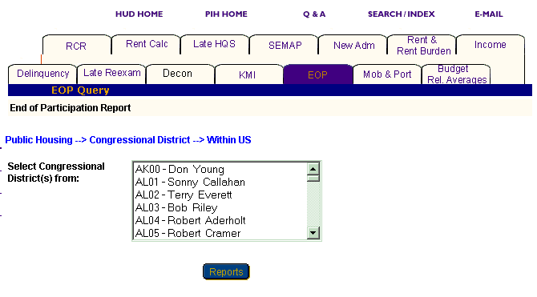
Figure 94: The Select Congressional District(s) from dialog box.

Option 2: Within a State

Select this option if you know only the state the congressional district is in.

Step | Action/Result
1. Click Congressional District on the Select Level of Information list. | PIC displays a screen with two different options for identifying the congressional district: Within US and Within a State.
2. Click Within a State on the Congressional District Selection list. | PIC displays a Select State from dialog box.
- Click the state you want in the Select State from dialog box.
- Click the Cong Dist button. | A Select Congressional District(s) from dialog box is displayed.
- Click the congressional district you want in the dialog box. | Note: To select more than one congressional district, press the CONTROL key as you click each one you want to include in the report.
- Click the Reports button. | An EOP Report is generated for the congressional district(s) selected.

Information Presented in an EOP Report

When you complete your selections and click the Reports button, the PIC system generates the EOP Report for the particular program and level of information selected. The selections are listed at the top of the report in the heading, which includes the following labels:

- Program Type
- Level of Information
- Report Start Date
- Report End Date

Each report offers the same categories of information, which display in tabs that appear at the top of the report. Some reports contain subcategories that are displayed when you point and click your mouse cursor over a tab. The EOP Report tabs contain no subcategories.

Note: Multiple data selections may be split into sets. For example, if you have selected several states to be included in the report (generally more than four), some of those selections are not displayed in the first report page.

To view the information within a report:

Step | Action/Result
- Click the report tab to see the information. | The table(s) under that report tab is displayed.
- Click the Next Set arrow located at the bottom right of the report page to view the next data set. | The next data set is displayed.
- Click the Prev Set arrow located at the bottom left of the report to return to the data set previously viewed. | The previous data set is displayed.

Reports generated at the state and field office levels also present national data. The metropolitan area, county, city or locality, Public Housing Agency, project, and congressional district levels present state data.

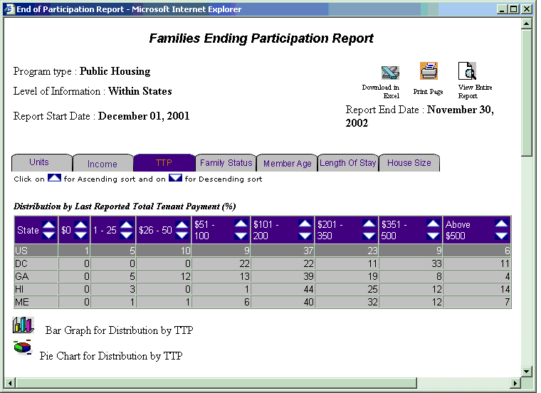
Figure 95: The EOP Report with the TTP tab selected.

View information on a report in ascending or descending order by clicking the up or down arrow in the column to be viewed.

The following table describes the information contained within each tab of the EOP Report.

Tab | Subcategories | Information Presented
Units | None | Default screen for the EOP Report, consisting of one table reporting:  - Number of End of Participations, Last 12 months  - Percent of End of Participations, Last 12 months (%)
Income | None | Income consists of four tables reporting:  Distribution by Last Reported Income, Average Annual (%)  - Extremely Low Income, Below 30% of Median  - Very Low Income, 50% of Median  - Low Income, Below 80% of Median  - Above Low Income  - Income Limit Unavailable
Income, Average Annual ($)
  - Income, Average Annual ($)

Distribution by Last Reported Income (%)
  - $0
  - $1 - $5,000
  - $5,001 - $10,000
  - $10,001 - $15,000
  - $15,001 - $20,000
  - $20,001 - $25,000
  - Above $25,000

Distribution by Last Reported Source of Income (%)
- With any Wages
- With any Welfare
- With any SSI/SS/Pension
- With any other Income

TTP | None | TTP consists of four tables reporting:  Distribution by Last Reported Total Tenant Payment (%)  - $0  - $1 - 25  - $26 - 50  - $51 - 100  - $101 - 200  - $201 - 350  - $351 - 500  - Above $500  TTP, Average Monthly ($)  - TTP Average Monthly ($)  Distribution of Last Reported Family Type (%)  - Elderly, No Children, Non-Disabled  - Elderly, No Children, Disabled  - Elderly, With Children, Non-Disabled  - Elderly, With Children, Disabled  - Non-elderly, No Children, Non-Disabled  - Non-elderly, No Children, Disabled  - Non-elderly, With Children, Non-Disabled  - Non-Elderly, With Children, Disabled  - Female Head of Household with Children  Average TTP by Last Reported Family Type ($)  - Elderly, No Children, Non-Disabled  - Elderly, No Children, Disabled  - Elderly, With Children, Non-Disabled  - Elderly, With Children, Disabled  - Non-elderly, No Children, Non-Disabled  - Non-Elderly, No Children, Disabled  - Non-Elderly, With Children, Non-Disabled  - Non-Elderly, With Children, Disabled  - Female Head of Household with Children
Family Status | None | Family status consists of three tables reporting:  Distribution by Last Reported Head of Household’s Race (%)  - White Only  - Black/African American Only  - American Indian/Alaska Native Only  - Asian Only  - Native Hawaiian/Other Pacific Islander Only  - White, American Indian/Alaska Native Only  - White, Black/African American Only  - White, Asian Only  - Other  Distribution by Last Reported Head of Household’s Ethnicity (%)  - Hispanic or Latino  - Non-Hispanic or Latino  Distribution by Last Reported Family Subsidy Status (%)  - Full Subsidy  - Prorate Subsidy
Member Age | None | Member Age consists of two tables reporting:  Total Number of Last Reported Household Members (#)  - Total Number of Last Reported Household Members (#)  Distribution by Last Reported Household Member’s Age (%)  - 0-5  - 6-17  - 18-50  - 51-61  - 62-82  - 83 or above
Length of Stay | None | Length of Stay consists of one table reporting:  Distribution by Length of Stay (%)  - Moved in, Past Year  - 1 - 2 years  - 2 - 5 years  - 5 - 10 years  - 10 - 20 years  - Over 20 years  - Not Reported
House Size | None | House Size consists of three tables reporting:  Distribution by Last Reported Household Size  - 1 person  - 2 persons  - 3 persons  - 4 persons  - 5 persons  - 6 persons  - 7 persons  - 8 persons  - 9 persons  - Over 10 persons  Average Last Reported Household Size  - Average Last Reported Household Size  Distribution by Number of Bedrooms (%)  - 0 Bedrooms  - 1 Bedroom  - 2 Bedrooms  - 3 Bedrooms  - 4 Bedrooms  - 5 or more

Two icons are available at the bottom of most tables, so you can view the information in either Pie Chart or Bar Graph form. When the icons are not visible, the information is only available in tabular form.

Figure 96: The icons for converting table
information into Bar Graph or Pie Chart form.

The EOP Report screen contains three options for further use of the data. The options are located on the top right side of the report screen.

Select one of the following options:

- Download in Excel: The report downloads to an Excel spreadsheet for further data manipulation.

- Print Page: The report prints as a Web page.

Note: For the best results, print in landscape orientation.

- View Entire Report: All report subcategory tables display together on one screen.

Figure 97: The Options for
further use of report data.

To generate another report, repeat the process by returning to the Reports screen and selecting the tab for the next report. Refer to the corresponding section of this user manual that describes the report, and follow the steps to generate the report.

New Admissions Report
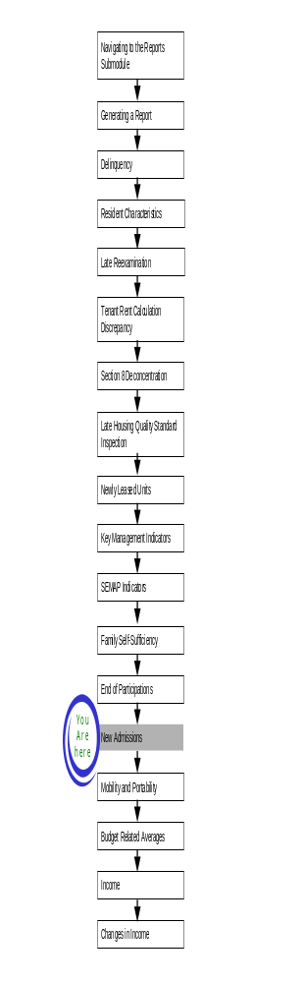
The New Admissions Report provides demographic and income information for admitted households. This report includes information on the average housing wait time sorted by: race, ethnicity, and household type.

To access the New Admissions Report:

Step | Action/Result
1. Log on to PIC. | The PIC main page is displayed.
2. Move your cursor over the Form-50058 button. | A list of submodules is displayed.
3. Click the Reports link. | The Delinquency Report page is displayed. Other available reports are listed in tabs at the top of the page.
4. Click the New Adm tab. | The New Adm Report start page displays (see Figure 98).

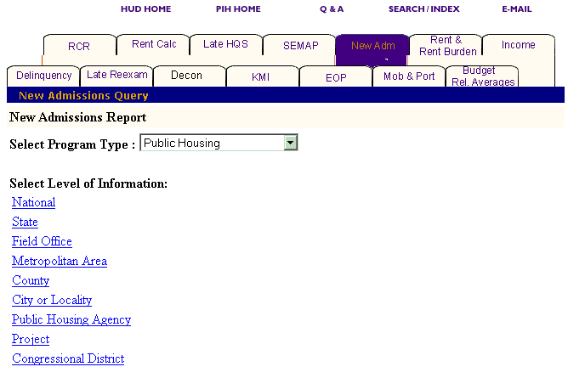
Figure 98: The New Admissions Report tab and start page.
Generating a New Admissions Report

After you reach the New Admissions Report start page, select the program and level of information to view.

To select New Admissions Report criteria:

Step | Action/Result
1. Click the program type in the Program Type dialog box. | - Public Housing  - S8 Moderate  - Rehabilitation  - S8 Certificate  - S8 Voucher  - All Relevant Programs  Note: Public Housing is the default option for the Select Program Type dialog box.
2. Click the link on the Select Level of Information list that corresponds to the level of information you want on the report. | The module formulates the rest of the criteria necessary to generate the report based on the level you select here. For example, click State when the program type you are interested in is located at that level. A dialog box containing a list of state names appears. Click the state where the program type you are interested in is located, and generate the report (see Figure 99).

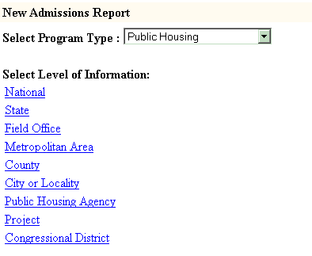
Figure 99: The Level of Information
options
for the New Admissions Report.
There are nine levels of information to choose from in a New Admissions Report:

- National
- State
- Field Office
- Metropolitan Area
- County
- City or Locality
- Public Housing Agency
- Project
- Congressional District

Depending on security clearance, users have limited access within certain levels of information. For example, if you are an HA user, you only have access to the states, field offices, and projects associated with your housing agency.

The following tables outline how to generate a New Admission report at each level.

National

Step | Action/Result
1. Click the National link in the Level of Information list. | PIC generates a New Admissions Report at the national level containing aggregated data.

State

Step | Action/Result
1. Click State in the Select Level of Information list. | A Select State(s) from dialog box is displayed (see Figure 100).
2. Click the state you want from the Select State(s) from dialog box. | Note: To select more than one state, press the CONTROL key as you click each state you want to include in the report.
3. Click the Reports button. | PIC presents the Budget Related Averages Report for the selected state(s).

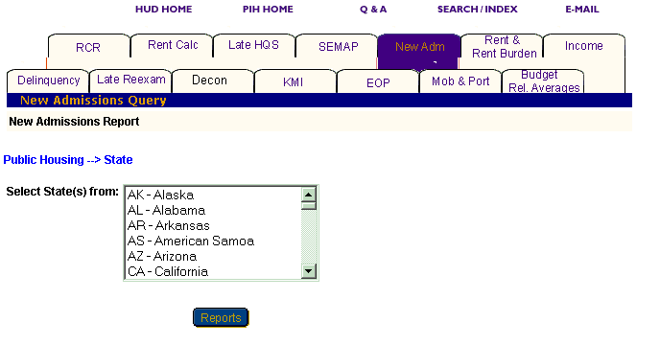
Figure 100: The Select State(s) from dialog box.

Field Office

Step | Action/Result
1. Click Field Office on the Select Level of Information list. | A Select Field Office(s) from dialog box is displayed.
2. Click the field office(s) you want in the Select Field Office(s) from dialog box. | Note: To select more than one field office, press the CONTROL key as you click each office you want to include in the report.
3. Click the Reports button. | PIC displays the New Admissions Report for the selected field office(s).

Metropolitan Area

You have two options for generating a New Admissions Report at the Metropolitan Area level: Within US and Within a State.

Option 1: Within US

Select this option if you know the exact metropolitan area you are looking for.

Step | Action/Result
1. Click Metropolitan Area on the Select Level of Information list. | PIC displays a screen with two different options for identifying the metropolitan area: Within US and Within a State.
2. Click Within US on the Metropolitan Area Selection list. | PIC displays a Select Metro Area(s) from dialog box (see Figure 101).
3. Click the metro area you are looking for in the Select Metropolitan Area(s) from dialog box. | Note: To select more than one metro area, press the CONTROL key as you click each one you want to include in the report.
- Click the Reports button. | PIC presents a New Admissions Report for the selected metro area(s).

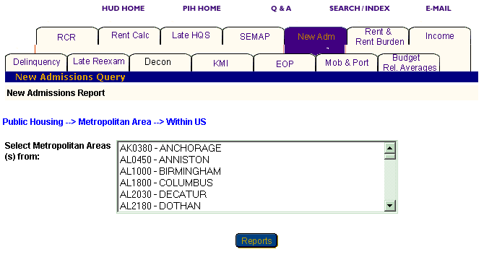
Figure 101: The Select Metropolitan Area(s) from dialog box.

Option 2: Within a State

Select this option if you know only the state the metropolitan area is in.

Step | Action/Results
1. Click Metropolitan Area on the Select Level of Information list. | PIC displays a screen with two different options for identifying the metropolitan area: Within US and Within a State.
2. Click Within a State on the Metropolitan Area Selection list. | PIC displays a Select State from dialog box.
- Click the state you want in the Select State from dialog box.
- Click the MSA button. | A Select Metropolitan Area(s) from dialog box is displayed.
- Click the metro area you are looking for in the Select Metropolitan Area(s) from dialog box. | Note: To select more than one metro area, press the CONTROL key as you click each one you want to include in the report.
- Click the Reports button. | A New Admissions Report is generated for the selected metro area(s).

County

You have two options for generating a New Admissions Report at the county level: Within a State and Within a State and Metropolitan Area.

Option 1: Within a State

Select this option if you know only the state the county is in.

Step | Action/Result
1. Click County on the Select Level of Information list. | PIC displays a screen with two different options for identifying the county: Within a State and Within a State and Metropolitan Area.
2. Click Within a State on the Metropolitan Area Selection list. | PIC displays a Select State(s) from dialog box.
3. Click the state you are looking for in the Select State(s) from dialog box.
- Click the County button. | A Select County(s) from dialog box is displayed.
- Click the county(s) you want included in the report. | Note: To select more than one county, press the CONTROL key as you click each one you want to include in the report.
- Click the Reports button. | PIC displays a New Admissions Report for the selected county(s).

Option 2: Within a State and Metropolitan Area

Select this option if you know the state and metropolitan area containing the county you are looking for.

Step | Action/Result
1. Click County on the Select Level of Information list. | PIC displays a screen with two different options for identifying the county: Within a State and Within a State and Metropolitan Area.
2. Click Within a State and Metropolitan Area on the County Selection list. | PIC displays a Select State(s) from dialog box.
3. Click the state you are looking for in the Select State(s) from dialog box.
- Click the MSA button. | PIC displays a Select MSA(s) from dialog box.
- Click the metropolitan area that contains the county you want.
- Click the County button. | A Select County(s) from dialog box is displayed (see Figure 102).
- Click the county(s) you want included in the report. | Note: To select more than one county, press the CONTROL key as you click each one you want to include in the report.
- Click the Reports button. | PIC displays a New Admissions Report for the selected county(s).

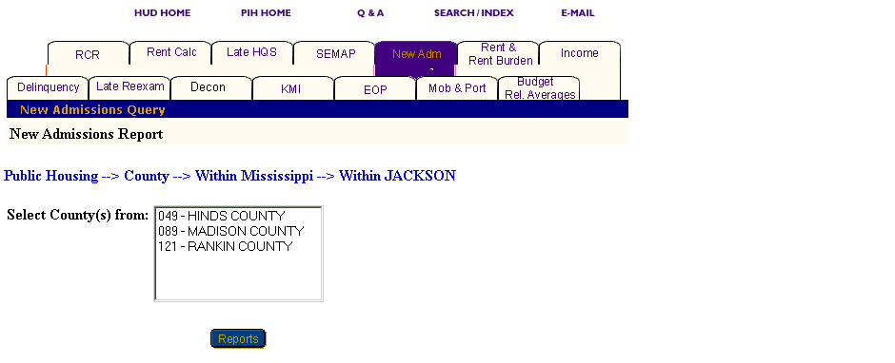
Figure 102: The Select County(s) from dialog box.
City or Locality

You have three options for generating a New Admissions Report at the city or locality level: Within a State, Within a State and Metropolitan Area, and Within a State and County.

Option 1: Within a State

Select this option if you know the state that contains the city you are looking for.

Step | Action/Result
1. Click City or Locality on the Select Level of Information list. | PIC displays a screen with three different options for identifying the city or locality: Within a State, Within a State and Metropolitan Area, and Within a State and County.
2. Click Within a State on the City or Locality Selection list. | PIC displays a Select State from dialog box.
3. Click the state that contains the city you want in the Select State from dialog box.
- Click the City button. | A Select City(s) from dialog box is displayed.
- Click the city you want. | Note: To select more than one city, press the CONTROL key as you click each one you want to include in the report.
- Click the Reports button. | PIC displays a New Admissions Report for the selected city(s).

Option 2: Within a State and Metropolitan Area

Select this option if you know the state and metropolitan area containing the city you are looking for.

Step | Action/Result
1. Click City or Locality on the Select Level of Information list. | PIC displays a screen with three different options for identifying the city or locality: Within a State, Within a State and Metropolitan Area, and Within State and County.
2. Click Within a State and Metropolitan Area on the City or Locality Selection list. | PIC displays a Select State(s) from dialog box.
3. Click the state you are looking for in the Select State(s) from dialog box.
- Click the MSA button. | PIC displays a Select MSA(s) from dialog box.
- Click the metropolitan area that contains the city you want.
- Click the City button. | A Select City(s) from dialog box is displayed (see Figure 103).
- Click the city you want. | Note: To select more than one city, press the CONTROL key as you click each one you want to include in the report.
- Click the Reports button. | PIC displays a New Admissions Report for the selected city(s).

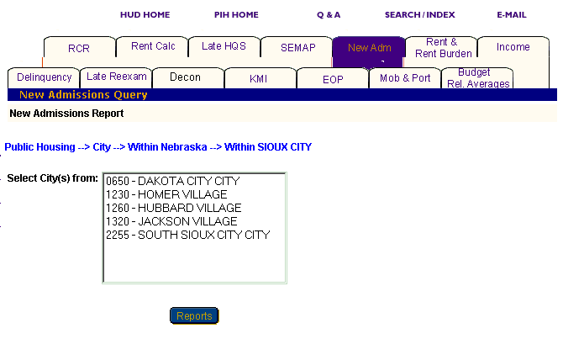
Figure 103: The Select City(s) from dialog box.

Option 3: Within a State and County

Select this option if you know the state and county that contain the city you are looking for.

Step | Action/Result
1. Click City or Locality on the Select Level of Information list. | PIC displays a screen with three different options for identifying the city or locality: Within a State, Within a State and Metropolitan Area, and Within State and County.
2. Click Within a State and County on the City or Locality Selection list. | PIC displays a Select State(s) from dialog box.
3. Click the state you are looking for in the Select State(s) from dialog box.
- Click the County button. | PIC displays a Select County(s) from dialog box.
- Click the county that contains the city you want.
- Click the City button. | A Select City(s) from dialog box is displayed.
- Click the city you want. | Note: To select more than one city, press the CONTROL key as you click each one you want to include in the report.
- Click the Reports button. | PIC displays a New Admissions Report for the selected city(s).

Public Housing Agency

You have three options for generating a New Admissions Report at the Public Housing Agency level: Within a State, Within a State and County, and Within a Field Office (see Figure 104).

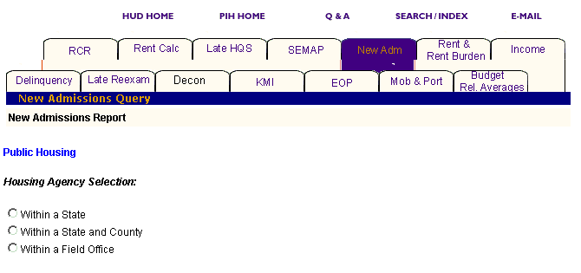
Figure 104: The Housing Agency Selection levels for a New Admissions Report.

Option 1: Within a State

Select this option if you know the state in which your Public Housing Agency is located.

Step | Action/Result
1. Click Public Housing Agency on the Select Level of Information list. | PIC displays a screen with three different options for identifying the Public Housing Agency: Within a State, Within a State and County, and Within a Field Office.
2. Click Within a State on the Housing Agency Selection list. | A Select State from dialog box is displayed.
3. Click the state you want in the Select State from dialog box.
- Click the HA List button. | A dialog box appears with a list of HAs within the selected state.
- Click the desired HA(s) in the Select HA(s) dialog box. | Note: To select more than one HA, press the CONTROL key as you click each HA you want to include in the report.
- Click the Reports button. | A New Admissions Report is generated for the selected Public Housing Agency(s).

Option 2: Within a State and County

Select this option if you know the state and county in which the PHA is located.

Step | Action/Result
1. Click Public Housing Agency on the Select Level of Information list. | PIC displays a screen with three different options for identifying a Public Housing Agency: Within a State, Within a State and County, and Within a Field Office.
2. Click Within a State and County on the Housing Agency Selection list. | A Select State from dialog box is displayed.
3. Click the state where the PHA is located in the Select State from dialog box.
- Click the County button. | A Select County from dialog box is displayed.
- Click the county you want in the Select County from dialog box.
- Click the HA List button. | A dialog box appears with a list of HAs associated with the selected county.
- Click the HA(s) you want in the Select HA(s) from dialog box. | Note: To select more than one HA, press the CONTROL key as you click each HA you want to include in the report.
- Click the Reports button. | A New Admissions Report is generated for the selected Public Housing Agency(s).

Option 3: Within a Field Office

Select this option if you know the field office containing the PHA you are looking for.

Step | Action/Result
1. Click Public Housing Agency on the Select Level of Information list. | PIC displays a screen with three different options for identifying the Public Housing Agency: Within a State, Within a State and County, and Within a Field Office.
2. Click Within a Field Office on the Housing Agency Selection list. | A Select Field Office from dialog box is displayed.
3. Click the field office you want in the Select Field Office from dialog box.
- Click the HA List button. | A dialog box appears with a list of HAs associated with the selected field office.
- Click the desired HA(s) in the Select HA(s) dialog box. | Note: To select more than one HA, press the CONTROL key as you click each HA you want to include in the report (see Figure 105).
- Click the Reports button. | A New Admissions Report is generated for the selected Public Housing Agency(s).

Project

You have five options to generate a New Admissions Report at the project level: Within a State, Within a State and Metropolitan Area, Within a State and County, Within a State and City or Locality, and Within a Public Housing Agency (see Figure 105).

Note: You can only generate a New Admissions Report for a project if you have selected Public Housing in the Select Program Type dialog box. If you select any other program, a message appears telling you the project level is only available for Public Housing.

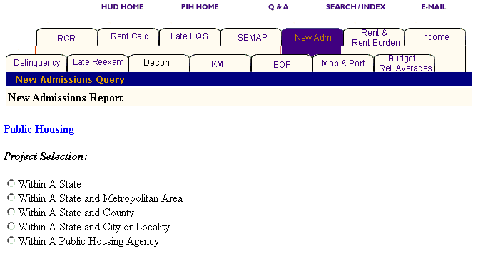
Figure 105: The Project Selection levels
for a New Admissions Report.

Option 1: Within a State

Select this option if you know the state containing the project you are looking for.

Step | Action/Result
1. Click Project on the Select Level of Information list. | PIC displays a screen with five different options for identifying the project: Within a State, Within a State and Metropolitan Area, Within a State and County, Within a State and City or Locality, and Within a Public Housing Agency,
2. Click Within a State on the Project Selection List. | A Select State from dialog box is displayed.
3. Click the state you want in the Select State from dialog box.
- Click the Projects button. | A dialog box appears with a list of projects within the selected state.
- Click the desired project(s) in the Select Projects(s) dialog box. | Note: To select more than one project, press the CONTROL key as you click each HA you want to include in the report.
- Click the Reports button. | A New Admissions Report is generated for the selected project(s).

Option 2: Within a State and Metropolitan Area

Select this option if you know the state and metro area containing the project you are looking for.

Step | Action/Result
1. Click Project on the Select Level of Information list. | PIC displays a screen with five different options for identifying the project: Within a State, Within a State and Metropolitan Area, Within a State and County, Within a State and City or Locality, and Within a Public Housing Agency.
2. Click Within a State and Metropolitan Area on the Project Selection list. | A Select State from dialog box is displayed.
3. Click the state you want in the Select State from dialog box.
- Click the MSA button. | A Select Metro Area from dialog box is displayed.
- Click the Metro Area you want in the Select Metro Area from dialog box.
- Click the Projects button. | A dialog box appears with a list of projects within the selected state and metro area.
- Click the desired project(s) in the Select Projects(s) dialog box. | Note: To select more than one project, press the CONTROL key as you click each HA you want to include in the report.
- Click the Reports button. | A New Admissions Report is generated for the selected project(s).

Option 3: Within a State and County

Select this option if you know the state and county in which the project is located.

Step | Action/Result
1. Click Project on the Select Level of Information list. | PIC displays a screen with five different options for identifying the project: Within a State, Within a State and Metropolitan Area, Within a State and County, Within a State and City or Locality, and Within a Public Housing Agency.
2. Click Within a State and County on the Project Selection list. | A Select State from dialog box is displayed.
3. Click the state where your project is located in the Select State from dialog box.
- Click the County button. | A Select County from dialog box is displayed.
- Click the county you want in the Select County from dialog box.

- Click the Projects button. | A dialog box appears with a list of projects located in the selected county.
- Click the project(s) you want in the Select Project(s) from dialog box. | Note: To select more than one project, press the CONTROL key as you click each HA you want to include in the report.
- Click the Reports button. | A New Admissions Report is generated for the selected project(s).

Option 4: Within a State and City or Locality

Select this option if you know the particular state and city in which the project you are looking for is located.

Step | Action/Result
1. Click Project on the Select Level of Information list. | PIC displays a screen with five different options for identifying the project: Within a State, Within a State and Metropolitan Area, Within a State and County, Within a State and City or Locality, and Within a Public Housing Agency.
2. Click Within a State and City or Locality on the Project Selection list. | A Select State from dialog box is displayed.
3. Click the state where your project is located in the Select State from dialog box.
- Click the City button. | A Select City(s) from dialog box is displayed.
- Click the city you want in the Select City(s) from dialog box.
- Click the Projects button. | A dialog box appears with a list of projects located in the selected city.
- Click the project(s) you want in the Select Project(s) from dialog box. | Note: To select more than one project, press the CONTROL key as you click each HA you want to include in the report.
- Click the Reports button. | A New Admissions Report is generated for the selected project(s).

Option 5: Within a Public Housing Agency

Select this option if you know the particular Public Housing Agency associated with the project you are looking for.

Step | Action/Result
1. Click Project on the Select Level of Information list. | PIC displays a screen with five different options for identifying the project: Within a State, Within a State and Metropolitan Area, Within a State and County, Within a State and City or Locality, and Within a Public Housing Agency
2. Click Within a Public Housing Agency on the Project Selection list. | A Select State from dialog box is displayed.
3. Click the state where the Public Housing Agency and project you want are located in the Select State from dialog box.
- Click the HA List button. | A dialog box appears with a list of HAs located in the selected state.
- Click the Public Housing Agency you want in the Select HA from dialog box.
- Click the Projects button. | A Select Project(s) from dialog box appears for the Public Housing Agency you selected within the state (see Figure 106).
- Click the project(s) you want in the Select Project(s) from dialog box. | Note: To select more than one project, press the CONTROL key as you click each HA you want to include in the report.
- Click the Reports button. | A New Admissions Report is generated for the selected project(s).

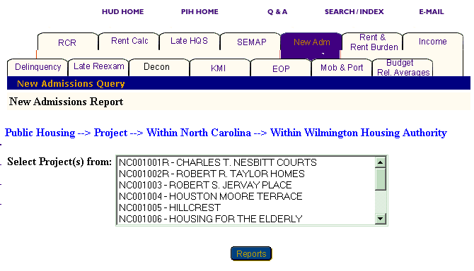
Figure 106: The Select Project(s) from dialog box for
Within a Public Housing Agency.

Congressional District

You have two options for generating a New Admissions Report at the Public Housing Agency level: Within US and Within a State.

Option 1: Within US

Select this option if you know the exact congressional district you are looking for.

Step | Action/Result
1. Click Public Housing Agency on the Select Level of Information list. | PIC displays a screen with two different options for identifying the congressional district: Within US and Within a State.
2. Click Within US on the Congressional District Selection list. | PIC displays a Select Congressional District(s) from dialog box.
3. Click the congressional district you want in the dialog box. | Note: To select more than one congressional district, press the CONTROL key as you click each one you want to include in the report.
- Click the Reports button. | PIC presents a New Admissions Report for the selected congressional district(s).

Option 2: Within a State

Select this option if you know only the state the congressional district is in.

Step | Action/Result
1. Click Public Housing Agency on the Select Level of Information list. | PIC displays a screen with two different options for identifying the congressional district: Within US and Within a State.
2. Click Within a State on the Congressional District Selection list. | PIC displays a Select State from dialog box.
- Click the state you want in the Select State from dialog box.
- Click the Cong Dist button. | A Select Congressional District(s) from dialog box is displayed (see Figure 107).
- Click the congressional district you want in the dialog box. | Note: To select more than one congressional district, press the CONTROL key as you click each one you want to include in the report.
- Click the Reports button. | PIC presents a New Admissions Report for the selected congressional district(s).

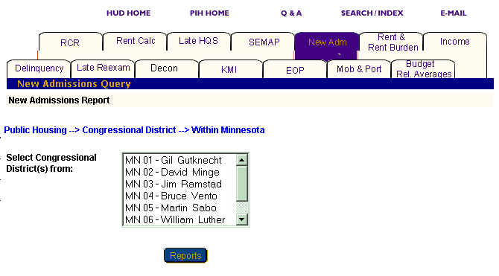
Figure 107: The Select Congressional District(s) from dialog box.

Information Presented in a New Admissions Report

When you complete your selections and click the Reports button, PIC generates the New Admissions Report for the particular program and level of information you have selected. The selections are listed at the top of the report in the heading and include the following:

- Program Type
- Level of Information
- Report Start Date
- Report End Date

Each report displays the same categories of information in tabs at the top of the report.

Some reports also contain subtabs that display when you click a tab. The New Admissions Report contains the following subtabs:

- Household
- Waiting

Note: Multiple data selections might be split into sets. For example, if you have selected several states to include in the report (generally more than four), some of those selections are not displayed in the first report page.

To view the information within a report:

Step | Action/Result
- Click the report tab to see the information. | The table(s) under that report tab display.
- Click the Next Set arrow located at the bottom right of the report page to view the next data set. | The next data set is displayed.
- Click the Prev Set arrow located at the bottom left of the report to return to the data set previously viewed. | The previous data set is displayed.

Reports generated at the state and field office levels also show national data. Reports generated at the Public Housing Agency and project levels show state data.

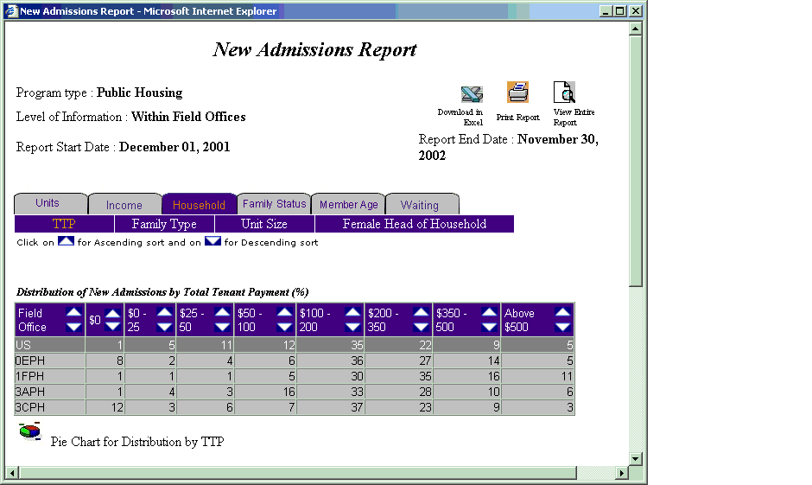
Figure 108: The New Admissions Report with the Household tab selected.

You can view information in ascending or descending order on a report by clicking the up or down arrow in the column you want to view.

The following table describes the information contained within each tab of the New Admissions Report.

Tab | Subcategories | Information Presented
Units | None | Default screen for the New Admissions Report, consisting of one table reporting:  - Number of New Admissions (%)  - New Admissions as Percentage of Total (%)
Income | None | Income consists of four tables reporting:  Distribution of New Admissions by Income, Average Annual (%)  - Extremely Low Income, Below 30% of Median  - Very Low Income, 50% of Median  - Low Income, 80% of Median  - Above Low Income  - Income Limit Unavailable  Income, Average Annual ($)  - Average Annual Income
Distribution of New Admissions by Income (%)
  - $0
  - $0 - $5,000
  - $5,000 - $10,000
  - $10,000 - $15,000
  - $15,000 - $20,000
  - $20,000 - $25,000
  - Above $25,000

Distribution of New Admissions by Source of Income Category (%)
- With any Wages
- With any Welfare
- With any SSI/SS/Pension
- With any Other Income

Household | TTP | TTP consists of two tables reporting:  Distribution of New Admissions by Total Tenant Payment (%)  - $0  - $0 - 25  - $25 - 50  - $50 - 100  - $100 - 200  - $200 - 350  - $350 - 500  - Above $500  TTP Average Monthly ($)  - Average TTP
 | Family Type | Family Type consists of two tables reporting:  Distribution by Family Type (%)  - Elderly, No Children, Non-Disabled  - Elderly, No Children, Disabled  - Elderly, With Children, Non-Disabled  - Elderly, With Children, Disabled  - Non-elderly, No Children, Non-Disabled  - Non-elderly, No Children, Disabled  - Non-elderly, With Children, Non-Disabled  - Non-Elderly, With Children, Disabled
Average TTP by Family Type ($)
- Elderly, No Children, Non-Disabled
- Elderly, No Children, Disabled
- Elderly, With Children, Non-Disabled
- Elderly, With Children, Disabled
- Non-elderly, No Children, Non-Disabled
- Non-elderly, No Children, Disabled
- Non-elderly, With Children, Non-Disabled
- Non-Elderly, With Children, Disabled

 | Unit Size | Unit Size consists of two tables reporting:  Distribution by Individual Family Household Size  - Average Household Size  - Persons (%)  1  2  3  4  5  6  7  8  9  10+  Distribution by Individual Unit Size  - Bedrooms (%)  0  1  2  3  4  5+
 | Female Head of Household | Female Head of Household consists of one table reporting:  Female Head of Household with Children  - Percent (%)  - Average TTP ($)

Tab | Subcategories | Information Presented
Family Status | None | Family Status consists of three tables reporting:  Distribution of New Admissions by Head of Household’s Race (%)  - White Only  - Black/African American Only  - American Indian/Alaska Native Only  - Asian Only  - Native Hawaiian/Other Pacific Islander Only  - White, American Indian/Alaska Native Only  - White, Black/African American Only  - White, Asian Only  - Other  Distribution of New Admissions by Head of Household’s Ethnicity (%)  - Hispanic or Latino  - Non-Hispanic or Latino  Distribution of New Admissions by Family Subsidy Status (%)  - Full Subsidy  - Prorate Subsidy
Member Age | None | Member Age consists of one table reporting:  Distribution of New Admissions by Individual Family Household Member’s Age  - Number of Family Members  - Age  0 - 5  6 -17  18 - 50  51 - 61  62 - 82  83+

Tab | Subcategories | Information Presented
Waiting | Admissions | Admissions consists of one table reporting:  Waiting Period for New Admissions  - Percent of Families Homeless at New Admissions (%)  - Average Waiting Period in Months  - Percent Waiting List Time not Reported (%)
 | Income | Income consists of one table reporting:  Average Wait Time in Months by Family Income  - Extremely Low Income, Below 30% of Median  - Very Low Income, 50% of Median  - Low Income, 80% of Median  - Above Low Income
 | Family Type | Family Type consists of one table reporting:  Average Wait Time in Months By Family Type  - Elderly, No Children, Non-Disabled  - Elderly, No Children, Disabled  - Elderly, With Children, Non-Disabled  - Elderly, With Children, Disabled  - Non-elderly, No Children, Non-Disabled  - Non-elderly, No Children, Disabled  - Non-elderly, With Children, Non-Disabled  - Non-Elderly, With Children, Disabled

Tab | Subcategories | Information Presented
 | Family Status | Family Status consists of three tables reporting:  Average Wait Time in Months by Head of Households Race  - White Only  - Black/African American Only  - American Indian/Alaska Native Only  - Asian Only  - Native Hawaiian/Other Pacific Islander Only  - White, American Indian/Alaska Native Only  - White, Black/African American Only  - White, Asian Only  - Other  Average Wait Time in Months by Head of Household Ethnicity  - Hispanic or Latino  - Non-Hispanic or Latino  Average Wait Time in Months by Family Subsidy Status (%)  - Full Subsidy  - Prorate Subsidy
 | Unit Size | Unit Size consists of one table reporting:  Average Wait Time in Months by Unit Size  - Bedrooms  0  1  2  3  4  5+
 | Female Head of Household | Female Head of Household consists of one table reporting:  Average Wait Time in Months, Female Head of Household, With Children  - Average Wait Time in Months

The two graph or chart icons at the bottom of most tables are available, so you can view the information in either a Pie Chart or Bar Graph form. When the two icons are not visible, the information is only available in tabular form.

Figure 108: The icons for converting table
information into a Bar Graph or Pie Chart.

The New Admissions Report screen contains three options for further use of the data. The options are located on the top right side of the report screen.

Select one of the following options:

  - Download in Excel: The report downloads to an Excel spreadsheet for further data manipulation.

  - Print Page: The report prints as a web page:

Note: For the best results, print in landscape orientation.

  - View Entire Report: All report subcategory tables display together on one screen.

Figure 109: The options
for
further use of report data.

To generate another report, repeat the process by returning to the Reports screen and selecting the tab for the report you want next. Refer to the corresponding section of this user manual, and follow the steps provided to generate that report.

The Mobility and Portability Report
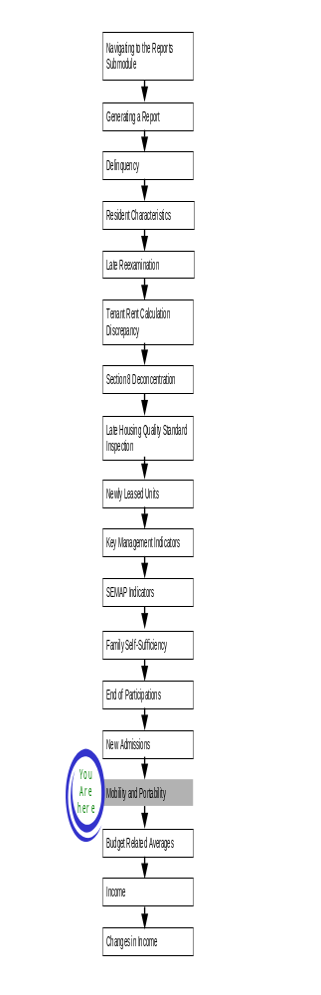
The Mobility and Portability (MAP) Report profiles families who received Section 8 assistance and moved within the PHA’s jurisdiction (mobility) or moved to another unit in another PHA’s jurisdiction (portability).

To access the MAP Report start page:

Step | Action/Result
- Log on to PIC. | The PIC main page is displayed.
- Move your cursor over the Form-50058 button. | A list of submodules is displayed.
- Click the Reports link. | The Delinquency Report page is displayed. Other available reports are listed in tabs at the top of the page.
- Click the MAP tab. | The MAP Report start page displays (see Figure 110).

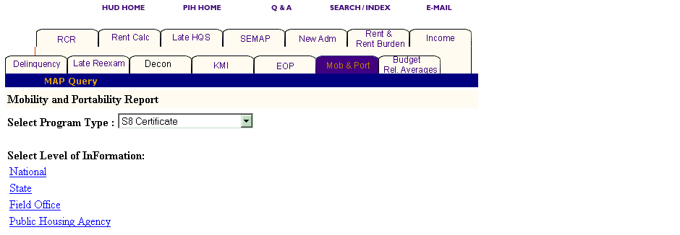
Figure 110: The MAP Report tab and start page.
Generating a MAP Report

After you reach the MAP Report start page, select the program and level of information to be viewed.

To select MAP Report criteria:

Step | Action/Result
- Click the program type you want in the Program Type dialog box. | - S8 Certificate  - S8 Voucher  - S8 Moderate Rehabilitation  - Certificate and Voucher  - All Relevant Programs  Note: S8 Certificate is the default option for the Program Type dialog box.
- Click the link on the Select Level of Information list that corresponds to the level of information you want on the report. | The module formulates the rest of the criteria necessary to generate the report based on the level you select here. For example, click State when the program type you are interested in is located at that level. A dialog box containing a list of state names appears. Click the state where the program type you are interested in is located, and generate the report.

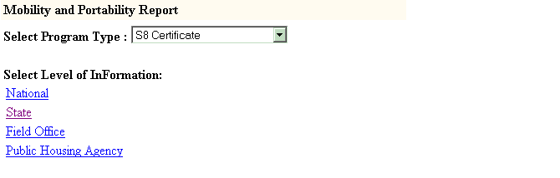
Figure 111: The Select Level of Information links for a MAP Report.

There are four levels of information in a MAP Report (see Figure 2), as follows:

- National
- State
- Field Office
- Public Housing Agency

Depending on security clearance, users have limited access within certain levels of information. For example, if you are an HA user, you only have access to the states and field offices associated with your housing agency.
The following tables outline how to generate a MAP Report for each level.

National

Step | Action/Result
1. Click the National link in the Level of Information list. | PIC generates a MAP Report at the national level containing aggregated data.

State

Step | Action/Result
1. Click State in the Select Level of Information list. | A Select State(s) from dialog box is displayed.
2. Click the state you want from the Select State(s) from dialog box. | Note: To select more than one state, press the CONTROL key as you click each state you want to include in the report.
3. Click the Reports button. | PIC presents the MAP Report for the state(s) selected.

Field Office

Step | Action/Result
1. Click Field Office on the Select Level of Information list. | A Select Field Office(s) from dialog box is displayed (see Figure 112).
2. Click the field office(s) you want in the Select Field Office(s) from dialog box. | Note: To select more than one field office, press the CONTROL key as you click each office you want to include in the report.
3. Click the Reports button. | PIC presents the MAP Report for the field office(s) selected.

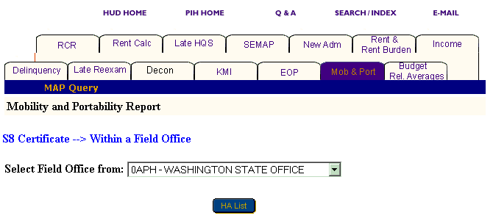
Figure 112: The Select Field Office from dialog box.

Public Housing Agency

You have three options for generating a MAP Report at the Public Housing Agency level: Within a State, Within a State and County, and Within a Field Office.

Option 1: Within a State

Select this option if you know the state in which your Public Housing Agency is located.

Step | Action/Result
1. Click Public Housing Agency on the Select Level of Information list. | PIC displays a screen with three different options for identifying the Public Housing Agency: Within a State, Within a State and County, and Within a Field Office.
2. Click Within a State on the Housing Agency Selection list. | A Select State from dialog box is displayed.
3. Click the state you want in the Select State from dialog box.
- Click the HA List button. | A dialog box is displayed with a list of HAs within the state selected.
- Click the desired HA(s) in the Select HA(s) dialog box. | Note: To select more than one HA, press the CONTROL key as you click each HA you want to include in the report.
- Click the Reports button. | PIC displays the MAP Report for each Public Housing Agency you selected within the state.

Option 2: Within a State and County

Select this option if you know the state and county in which your PHA is located.

Step | Action/Result
1. Click Public Housing Agency on the Select Level of Information list. | PIC displays a screen with three different options for identifying the Public Housing Agency: Within a State, Within a State and County, and Within a Field Office.
2. Click Within a State and County on the Housing Agency Selection list. | A Select State from dialog box is displayed.
3. Click the state where your PHA is located in the Select State from dialog box.
- Click the County button. | A Select County from dialog box is displayed (see Figure 113).
- Click the county you want in the Select County from dialog box.
- Click the HA List button. | A dialog box is displayed with a list of HAs associated with the county selected.
- Click the HA(s) you want in the Select HA(s) from dialog box. | Note: To select more than one HA, press the CONTROL key as you click each HA you want to include in the report.
- Click the Reports button. | A MAP Report is generated for each Public Housing Agency selected.

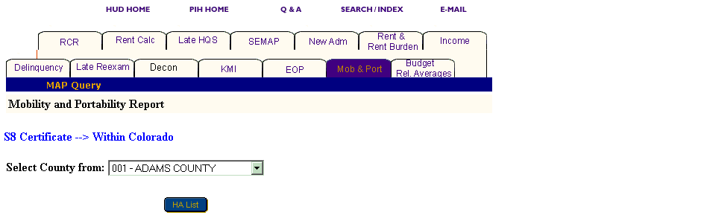
Figure 113: The Select County from dialog box.

Option 3: Within a Field Office

Select this option if you know the field office in which your PHA is located.

Step | Action/Result
1. Click Public Housing Agency on the Select Level of Information list. | PIC displays a screen with three different options for identifying the Public Housing Agency: Within a State, Within a State and County, and Within a Field Office.
2. Click Within a Field Office on the Housing Agency Selection list. | A Select Field Office from dialog box is displayed.
3. Click the field office you want in the Select Field Office from dialog box.
- Click the HA List button. | A dialog box is displayed with a list of HAs associated with the field office selected.
- Click the desired HA(s) in the Select HA(s) dialog box. | Note: To select more than one HA, press the CONTROL key as you click each HA you want to include in the report.
- Click the Reports button. | A MAP Report is generated for each Public Housing Agency selected.

Information Presented in a MAP Report

When you complete your selections and click the Reports button, PIC generates the MAP Report for the particular program and level of information you identified.

The following headings are included in the heading of a MAP report:

- Program Type
- Level of Information
- Report Start Date
- Report End Date

Each MAP Report offers the same categories of information, which are displayed in tabs that at the top of the report directly beneath the heading. Some reports contain subcategories that display when you point and click your mouse cursor over a tab. The MAP Report tabs contain no subcategories.

Note: Multiple data selections might be split into sets. For example, if selected several states to include in the report (generally more than four), some of those selections are not displayed in the first report page.

To view the information within a report:

Step | Action/Result
- Click the report tab to see the information. | The table(s) under that report tab display.
- Click the Next Set arrow located at the bottom right of the report page to view the next data set. | The next data set displays.
- Click the Prev Set arrow located at the bottom left of the report to return to the data set previously viewed. | The previous data set displays.
Note that reports generated at the state and field office levels also provide national data. The Public Housing Agency level provides state data.

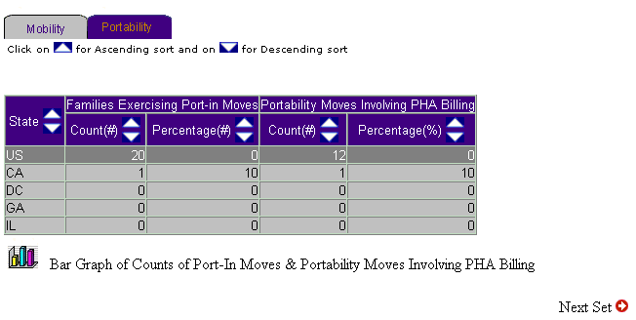
Figure 114: The MAP Report with the Portability tab selected.

View information on a report in ascending or descending order by clicking the up or down arrow in the column to be viewed.

The following table describes the information contained under each tab of the MAP Report.

Tab | Subcategories | Information Presented
Mobility | None | Default screen for the MAP Report, consisting of one table reporting:  - Admission Involving a Move  Count (#)  Percentage (%)  - Admission Involving a Lease in Place  Count (#)  Percentage (%)  - Total Families that Moved  Count (#)  Percentage (%)  - Total Hard to House Families that Moved  Count (#)  Percentage (%)  - Previously Assisted Families that Moved  Count (#)  Percentage (%)  - Families Moving From Public Housing (#)
Portability | None | Portability consists of one table reporting:  - Families Exercising Port-in Moves  Count (#)  Percentage (%)  - Portability Moves Involving PHA Billing  Count (#)  Percentage (%)

Two icons are available at the bottom of most tables, so you can view the information in either Bar Graph or Pie Chart form. When neither icon displays, the information is only available in tabular form.

Figure 115: The Icons for converting table
information to either a Bar Graph or Pie Chart.

The MAP Report screen contains three options for further use of the data. The options are located on the top right of the report screen.

Select one of the following three options:

- Download in Excel: The report downloads to an Excel spreadsheet for further data manipulation.

- Print Page: The report prints as a Web page.

Note: For the best results, print in landscape orientation.

- View Entire Report: All report subcategory tables display together on one screen.

Figure 116: The Options for
further use of report data.

To generate another report, repeat the process by returning to the Reports screen and selecting the tab for the report next. Refer to the corresponding section of this user manual that describes the report, and follow the steps to generate the report.

Rent and Rent Burden Report

The Rent and Rent Burden Report summarizes information about rents relative to the Fair Market Rent (FMR) and each family’s rent burden in relation to their income.

To access the Rent and Rent Burden Report:

Step | Action/Result
- Log on to PIC. | The PIC main page is displayed.
- Move your cursor over the Form-50058 button. | A list of submodules is displayed.
- Click the Reports link. | The Delinquency Report page is displayed. Other available reports are listed in tabs at the top of the page.
- Click the Rent & Rent Burden tab. | The Rent and Rent Burden Report start page displays (see Figure 117).

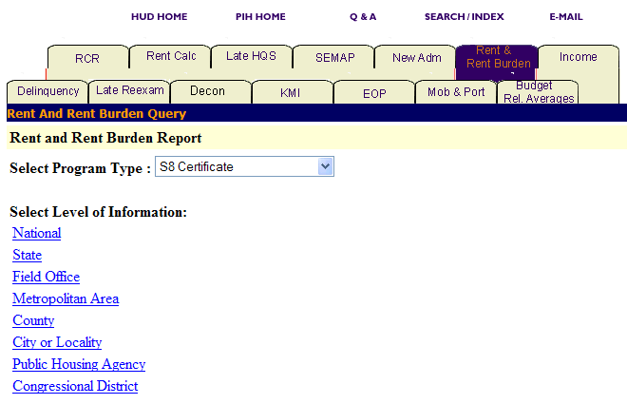
Figure 117: The Rent & Rent Burden tab and start page.

Generating a Rent and Rent Burden Report

After you reach the Rent and Rent Burden Report start page, select the program type and level of information to view.

To select Rent and Rent Burden Report criteria:

Step | Action/Result
1. Click the program type you want in the Program Type dialog box. | - S8 Certificate  - S8 Voucher  - S8 Moderate Rehabilitation  - All Relevant Programs  Note: S8 Certificate is the default option for the Select Program Type dialog box.
- Click the link on the Select Level of Information list that corresponds to the level of information you want on the report. | The module formulates the rest of the criteria necessary to generate the report based on the level you select here. For example, click State when the program type you are interested in is located at that level. A dialog box containing a list of state names appears. Click the state where the program type you are interested in is located, and generate the report (see Figure 118).

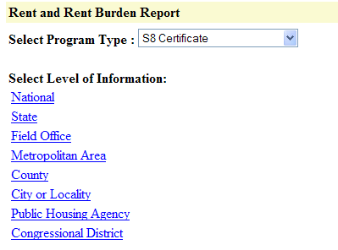
Figure 118: The Level of Information option
for the Rent and Rent Burden Report.

There are eight levels of information to choose from in a Rent and Rent Burden Report:

- National
- State
- Field Office
- Metropolitan Area
- County
- City or Locality
- Public Housing Agency
- Congressional District

Depending on security clearance, users have limited access within certain levels of information. For example, if you are an HA user, you only have access to the states and field offices associated with your housing agency.

The following tables outline how to generate a Rent and Rent Burden Report at each level.

National

Step | Action/Result
1. Click the National link in the Level of Information list. | PIC generates a Rent and Rent Burden Report at the national level containing aggregated data.

State

Step | Action/Result
1. Click State on the Select Level of Information list. | A Select State(s) from dialog box is displayed is (see  Figure 119).
2. Click the state you want from the Select State(s) from dialog box. | Note: To select more than one state, press the CONTROL key as you click each state you want to include in the report.
3. Click the Reports button. | PIC generates the Rent and Rent Burden Report for the state(s) selected.

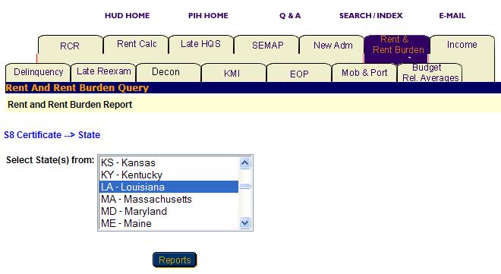
Figure 119: The Select State(s) from dialog box.

Field Office

Step | Action/Result
1. Click Field Office on the Select Level of Information list. | A Select Field Office(s) from dialog box is displayed.
2. Click the field office(s) in the Select Field Office(s) from dialog box. | Note: To select more than one field office, press the CONTROL key as you click each office you want to include in the report.
3. Click the Reports button. | PIC displays the Rent and Rent Burden Report for the field office(s) selected.

Metropolitan Area

You have two options for generating a Rent and Rent Burden Report at the metropolitan area level: Within US and Within a State (see Figure 120).

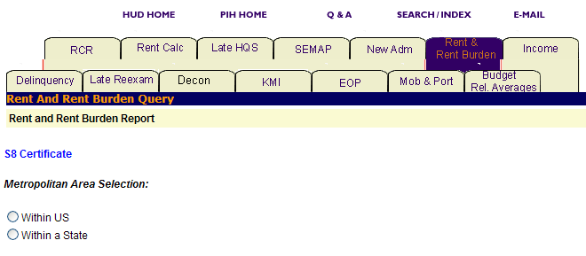
Figure 120: The Metropolitan Area Selection levels for a Rent and Rent Burden Report.
Option 1: Within US

Select this option if you know the exact metropolitan area you are looking for.

Step | Action/Result
1. Click Metropolitan Area on the Select Level of Information list. | PIC displays a screen with two different options for identifying the metropolitan area: Within US and Within a State.
2. Click Within US on the Metropolitan Area Selection list. | PIC displays a Select Metro Area(s) from dialog box (see Figure 121).
3. Click the metro area you are looking for in the Select Metropolitan Area(s) from dialog box. | Note: To select more than one metro area, press the CONTROL key as you click each one you want to include in the report.
- Click the Reports button. | PIC displays a Rent and Rent Burden Report for each metropolitan area selected within the US.

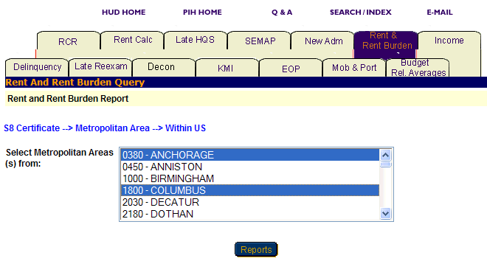
Figure 121: The Select Metropolitan Area(s) from dialog box with two selections.

Option 2: Within a State

Select this option if you know only the state the metropolitan area is in.

Step | Action/Result
1. Click Metropolitan Area on the Select Level of Information list. | PIC displays a screen with two different options for identifying the metropolitan area: Within US and Within a State.
2. Click Within a State on the Metropolitan Area Selection list. | PIC displays a Select State from dialog box.
- Click the state in the Select State from dialog box.
- Click the MSA button. | A Select Metropolitan Area(s) from dialog box is displayed.
- Click the metro area you are looking for in the Select Metropolitan Area(s) from dialog box. | Note: To select more than one metro area, press the CONTROL key as you click each one you want to include in the report.
6. Click the Reports button. | PIC displays a Rent and Rent Burden Report for each metropolitan area selected within the state.

County

You have two options for generating a Rent and Rent Burden Report at the county level: Within a State and Within a State and Metropolitan Area (see Figure 122).

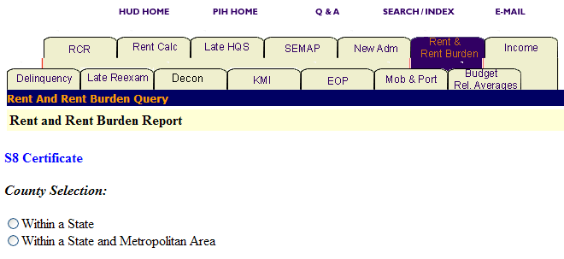
Figure 122: The County Selection Levels for a Rent and Rent Burden Report.

Option 1: Within a State

Select this option if you know only the state in which the county is located.

Step | Action/Result
1. Click County on the Select Level of Information list. | PIC displays a screen with two different options for identifying the county: Within a State and Within a State and Metropolitan Area.
2. Click Within a State on the County Selection list. | PIC displays a Select State(s) from dialog box.
3. Click the state in the Select State(s) from dialog box.
- Click the County button. | A Select County(s) from dialog box is displayed.
- Click the county you are looking for. | Note: To select more than one county, press the CONTROL key as you click each one you want to include in the report.
- Click the Reports button. | PIC displays a Rent and Rent Burden Report for each county selected within the state.

Option 2: Within a State and Metropolitan Area

Select this option if you know the state and metropolitan area in which the county you are looking for is located.

Step | Action/Result
1. Click County on the Select Level of Information list. | PIC displays a screen with two different options for identifying the county: Within a State and Within a State and Metropolitan Area.
2. Click Within a State and Metropolitan Area on the County Selection list. | PIC displays a Select State(s) from dialog box.
3. Click the state in the Select State(s) from dialog box.
- Click the MSA button. | PIC displays a Select MSA(s) from dialog box.
- Click the metropolitan area containing the county you are looking for.
- Click the County button. | A Select County(s) from dialog box is displayed.
- Click the desired county. | Note: To select more than one county, press the CONTROL key as you click each one you want to include in the report.
- Click the Reports button. | PIC displays a Rent and Rent Burden Report for each county selected within the state and metropolitan area.

City or Locality

You have three options for generating a Rent and Rent Burden Report at the city or locality level: Within a State, Within a State and Metropolitan Area, and Within a State and County (see Figure 123).

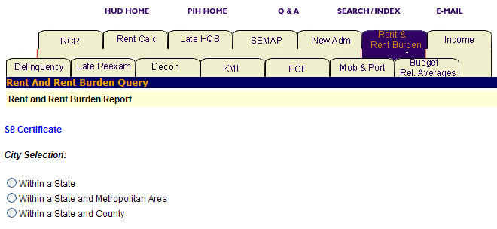
Figure 123: The City Selection levels for a Rent and Rent Burden Report.

Option 1: Within a State

Select this option if you know the state in which the city you are looking for is located.

Step | Action/Result
1. Click City or Locality on the Select Level of Information list. | PIC displays a screen with three different options for identifying the city or locality: Within a State, Within a State and Metropolitan Area, and Within a State and County.
2. Click Within a State on the City Selection list. | PIC displays a Select State from dialog box.
3. Click the state that contains the city you want in the Select State from dialog box.
- Click the City button. | A Select City(s) from dialog box is displayed.
- Click to select the city. | Note: To select more than one city, press the CONTROL key as you click each one you want to include in the report (see Figure 124).
- Click the Reports button. | PIC displays a Rent and Rent Burden Report for each city selected within the state.

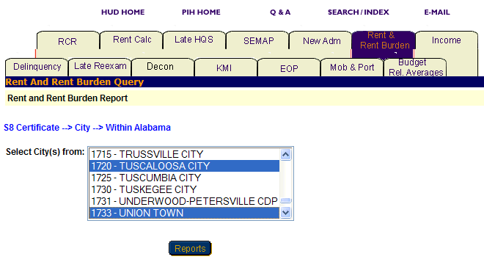
Figure 124: The Select City(s) from dialog box for the Rent and
Rent Burden Report with two selections.
Option 2: Within a State and Metropolitan Area

Select this option if you know the state and metropolitan area in which the city you are looking for is located.

Step | Action/Result
1. Click City or Locality on the Select Level of Information list. | PIC displays a screen with three different options for identifying the city or locality: Within a State, Within a State and Metropolitan Area, and Within State and County.
2. Click Within a State and Metropolitan Area on the City Selection list. | PIC displays a Select State(s) from dialog box.
3. Click the state in the Select State(s) from dialog box.
4. Click the MSA button. | PIC displays a Select MSA(s) from dialog box.
5. Click the metropolitan area that contains the city.
6. Click the City button. | A Select City(s) from dialog box is displayed.
- Click the city you want. | Note: To select more than one city, press the CONTROL key as you click each one you want to include in the report.
- Click the Reports button. | PIC displays a Rent and Rent Burden Report for each city or locality selected within the state and metropolitan area.

Option 3: Within a State and County

Select this option if you know the state and county in which the city is located.

Step | Action/Result
1. Click City or Locality on the Select Level of Information list. | PIC displays a screen with three different options for identifying the city or locality: Within a State, Within a State and Metropolitan Area, and Within State and County.
2. Click Within a State and County on the City Selection list. | PIC displays a Select State(s) from dialog box.
3. Click the state you are looking for in the Select State(s) from dialog box.
4. Click the County button. | PIC displays a Select County(s) from dialog box.
5. Click the county that contains the city.
6. Click the City button. | A Select City(s) from dialog box is displayed.
7. Click the desired city. | Note: To select more than one city, press the CONTROL key as you click each one you want to include in the report.
8. Click the Reports button. | PIC displays a Rent and Rent Burden Report for each city or locality selected within the state and metropolitan area.

Public Housing Agency

You have three options for generating a Rent and Rent Burden Report at the Public Housing Agency level: Within a State, Within a State and County, and Within a Field Office (see Figure 125).
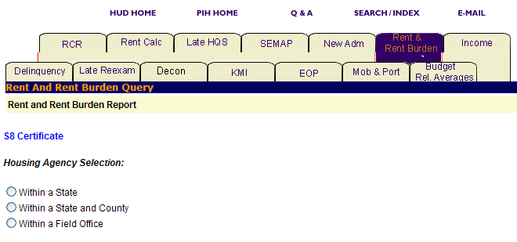
Figure 125: The Housing Agency Selection levels for a Rent and Rent Burden Report.

Option 1: Within a State

Select this option if you know the state in which your PHA is located.

Step | Action/Result
1. Click Public Housing Agency on the Select Level of Information list. | PIC displays a screen with three different options for identifying the Public Housing Agency: Within a State, Within a State and County, and Within a Field Office.
2. Click Within a State on the Housing Agency Selection list. | A Select State from dialog box is displayed (see Figure 126).
3. Click the state in the Select State from dialog box.
- Click the HA List button. | A dialog box is displayed with a list of HAs within the state selected.
- Click the desired HA(s) in the Select HA(s) dialog box. | Note: To select more than one HA, press the CONTROL key as you click each HA you want to include in the report.
- Click the Reports button. | PIC displays a Rent and Rent Burden Report for each PHA selected within the state.

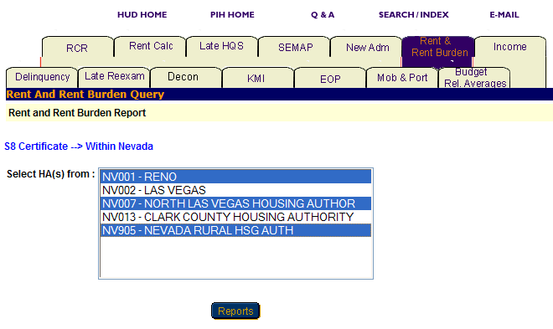
Figure 126: The Select HA(s) from dialog box for the Rent and
Rent Burden Report with three selections.

Option 2: Within a State and County

Select this option if you know the state and county in which your PHA is located.

Step | Action/Result
1. Click Public Housing Agency on the Select Level of Information list. | PIC displays a screen with three different options for identifying the Public Housing Agency: Within a State, Within a State and County, and Within a Field Office.
2. Click Within a State and County on the Housing Agency Selection list. | A Select State from dialog box is displayed.
3. Click the state where your PHA is located in the Select State from dialog box.
- Click the County button. | A Select County from dialog box is displayed.
- Click the county containing the HA you are looking for in the Select County from dialog box.
- Click the HA List button. | A dialog box is displayed with a list of HAs associated with the county selected.
- Click the HA(s) you want in the Select HA(s) from dialog box. | Note: To select more than one HA, press the CONTROL key as you click each HA you want to include in the report.
- Click the Reports button. | PIC displays a Rent and Rent Burden Report for each PHA selected within the state and county.

Option 3: Within a Field Office

Select this option if you know the field office in which the PHA you want is located.

Step | Action/Result
1. Click Public Housing Agency on the Select Level of Information list. | PIC displays a screen with three different options for identifying the Public Housing Agency: Within a State, Within a State and County, and Within a Field Office.
2. Click Within a Field Office on the Housing Agency Selection list. | A Select Field Office from dialog box is displayed.
3. Click the field office associated with the HA you want in the Select Field Office from dialog box.
- Click the HA List button. | A dialog box is displayed with a list of HAs associated with the field office selected.
- Click the desired HA(s) in the Select HA(s) dialog box. | Note: To select more than one HA, press the CONTROL key as you click each HA you want to include in the report.
- Click the Reports button. | PIC displays a Rent and Rent Burden Report for each PHA selected within the field office.

Congressional District

You have two options to generate a Rent and Rent Burden Report that contains information about all the PHAs in a particular congressional district: Within US and Within a State (see Figure 127).

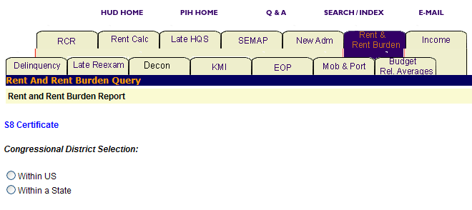
Figure 127: The Congressional District Selection levels for
a Rent and Rent Burden Report.

Option 1: Within US

Select this option if you know the exact congressional district you are looking for.

Step | Action/Result
1. Click Public Housing Agency on the Select Level of Information list. | PIC displays a screen with two different options for identifying the congressional district: Within US and Within a State.
2. Click Within US on the Congressional District Selection list. | PIC displays a Select Congressional District(s) from dialog box (see Figure 128).
- Click the congressional district you want in the dialog box. | Note: To select more than one congressional district, press the CONTROL key as you click each one you want to include in the report.
- Click the Reports button. | PIC displays a Rent and Rent Burden Report for each congressional district selected within the U.S.

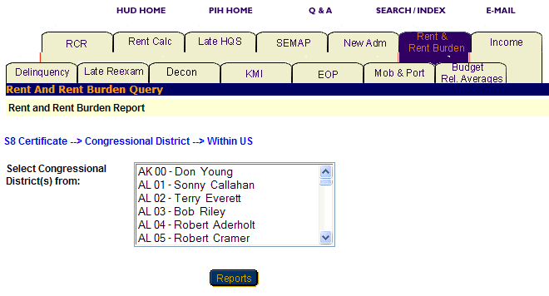
Figure 128: The Select Congressional District(s) from
dialog box for the Rent and Rent Burden Report.

Option 2: Within a State

Select this option if you know the state in which the congressional district is located.

Step | Action/Result
1. Click Public Housing Agency on the Select Level of Information list. | PIC displays a screen with two different options for identifying the congressional district: Within US and Within a State.
2. Click Within a State on the Congressional District Selection list. | PIC displays a Select State from dialog box.
- Click the state in the Select State from dialog box.
- Click the Cong Dist button. | A Select Congressional District(s) from dialog box is displayed.
- Click the congressional district in the dialog box. | Note: To select more than one congressional district, press the CONTROL key as you click each one you want to include in the report.
- Click the Reports button. | PIC displays a Rent and Rent Burden Report for each congressional district selected within the state.

Information Presented in a Rent and Rent Burden Report

When you complete your selections and click the Reports button, PIC generates the Rent and Rent Burden Report for the particular program and level of information selected.

The following labels are found in the heading for a Rent and Rent Burden Report:

- Program Type
- Level of Information
- Report Start Date
- Report End Date

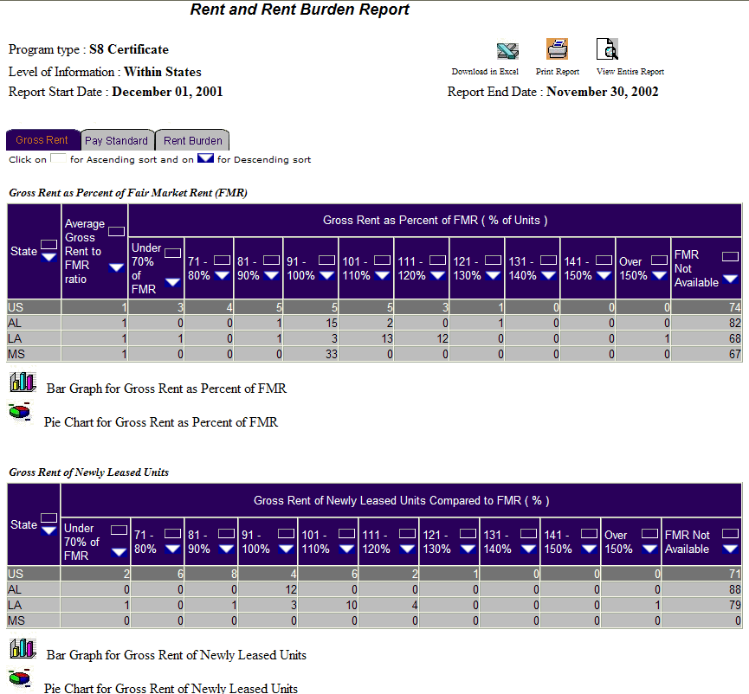
Figure 129: The Rent and Rent Burden Report screen.

You should note that reports at the state and field office level also present national data. Public Housing Agency and Project levels present state data.

Each report offers the same categories of information, which display in tabs that appear at the top of the report.

Note: Multiple data selections may be split into sets. For example, if you selected several states to include in the report (generally more than four), some of those selections are not displayed in the first report page.

To view the information within a table:

Step | Action/Result
- Click the report tab to see the information. | The table(s) under that report tab are displayed.
- Click the Next Set arrow located at the bottom right of the report page to view the next data set. | The next data set is displayed.
- Click the Prev Set arrow located at the bottom left of the report to return to the data set previously viewed. | The previous data set displays.

You can view information on a report in ascending or descending order by clicking the up or down arrow in the column.

The following table describes the information contained under each tab of the Rent and Rent Burden Report.

Tab | Information Presented
Gross Rent | Default screen for the Rent and Rent Burden Report, consisting of two tables reporting:  Gross Rent as a percentage of Fair Market Rent (FMR)  - Average Gross Rent to FMR ratio  - Gross Rent as Percent of FMR (% of Units)  Under 70% of FMR  71 – 80%  81 – 90%  91 – 100%  101 – 110%  111 – 120%  121 – 130%  131 – 140%  141 – 150%  Over 150%  FMR Not Available
Gross Rent of Newly-Leased Units
- Gross Rent of Newly-Leased Units Compared FMR (%)
Under 70% of FMR
71 – 80%
81 – 90%
91 – 100%
101 – 110%
111 – 120%
121 – 130%
131 – 140%
141 – 150%
Over 150%
FMR Not Available

Pay Standard | Pay Standard consists of one table reporting:  Pay Standard  - Average Payment Standard to FMR ratio  - Payment Standard as Percent of FMR by Unit Size  0 Bedrooms  1 Bedroom  2 Bedrooms  3 Bedrooms  4 Bedrooms
Rent Burden | Rent Burden consists of one table reporting:  Rent Burden as Percent of Adjusted Income  - Average Rent Burden  - Rent Burden as a Percent of Adjusted Income (% of Units)  Under 20% of Adjusted Income  20 – 25%  25 – 30%  30 – 35%  35 – 40%  40 – 45%  45 – 50%  Over 50%

Two icons at the bottom of most tables are used to view the information in either a Pie Chart or Bar Graph form. When the icons are not shown, the information is only available in tabular form.

Figure 130: The icons for converting table
information into a Bar Graph or Pie Chart.

The Rent and Rent Burden Report screen also includes three options for further use of the data. The options are located on the top right side of the report screen.

Select one of the following options:

- Download in Excel: The report downloads to an Excel spreadsheet for further data manipulation.

- Print Page: The report prints as a Web page.

Note: For the best results, print in landscape orientation.

- View Entire Report: All report subcategory tables display together on one screen.

Figure 131: The Options for
further use of report data.

To generate another report, repeat the process by returning to the Reports screen and selecting the tab for the report you want next. Refer to the section of this user manual that describes the report, and follow the steps to generate the report.

Budget Related Averages Report
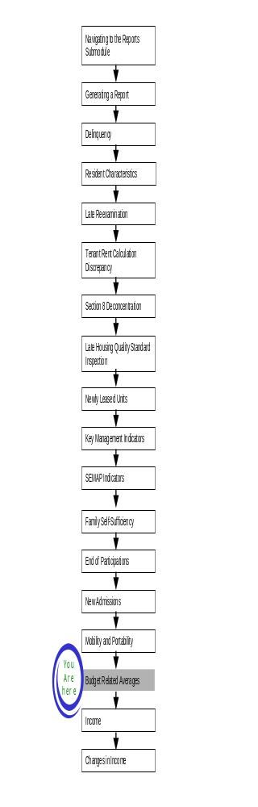
The Budget Related Averages Report displays averages for gross rent, total tenant payments, and assisted payments by unit size. The report also assists PHAs in determining rent reasonableness and annual budgets.

To access the Budget Related Averages Report:

Step | Action/Result
- Log on to PIC. | The PIC main page is displayed.
- Move your cursor over the Form-50058 button. | A list of submodules is displayed.
- Click the Reports link. | The Delinquency Report page is displayed. Other available reports are listed in tabs at the top of the page.
- Click the Budget Rel Averages tab. | The Budget Related Averages Report start page displays (see Figure 132).

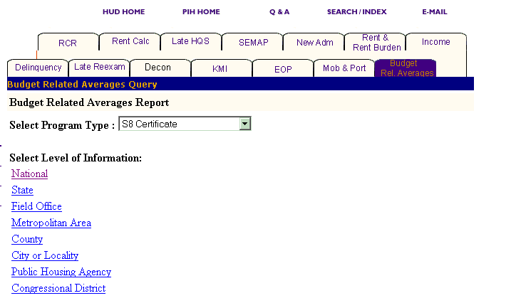
Figure 132: The Budget Related Averages tab and start page.

Generating a Budget Related Averages Report

After you reach the Budget Related Averages Report start page, select the program and level of information you want to view.

To select Budget Related Averages Report criteria:

Step | Action/Result
1. Click the program type in the Program Type dialog box. | - S8 Certificate  - S8 Voucher  - S8 Moderate Rehabilitation  - S8 Certificate and Voucher  - All Relevant Programs  Note: S8 is the default option for the Select Program Type dialog box.
2. Click the link on the Select Level of Information list that corresponds to the level of information you want on the report. | The module formulates the rest of the criteria necessary to generate the report based on the level you select here. For example, click State when the program type you are interested in is located at that level. A dialog box containing a list of state names appears. Click the state where the program type you are interested in is located, and generate the report (see Figure 133).

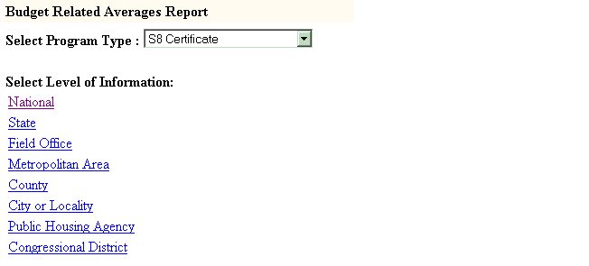
Figure 133: The Level of Information options available for the
Budget Related Averages Report.

There are eight levels of information to choose from in a Budget Related Averages Report:

- National
- State
- Field Office
- Metropolitan Area
- County
- City or Locality
- Public Housing Agency
- Congressional District

Depending on security clearance, users have limited access within certain levels of information. For example, if you are an HA user, you only have access to the states and field offices associated with your housing agency.

The following tables outline how to generate a Budget Related Averages report at each level.

National

Step | Action/Result
1. Click the National link on the Select Level of Information list. | PIC generates a Budget Related Averages Report at the national level containing aggregated data.

State

Step | Action/Result
1. Click State in the Select Level of Information list. | A Select State(s) from dialog box is displayed (see Figure 134).
2. Click the state you want from the Select State(s) from dialog box. | Note: To select more than one state, press the CONTROL key as you click each state you want to include in the report.
3. Click the Reports button. | PIC presents the Budget Related Averages Report for the state(s) selected.

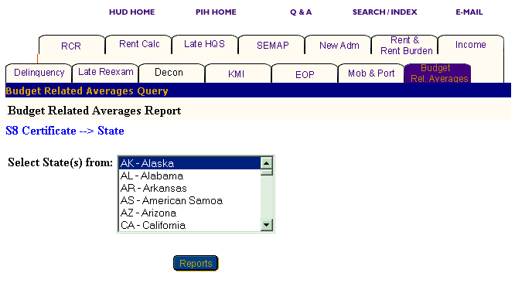
Figure 134: The Select State(s) from dialog box.

Field Office

Step | Action/Result
1. Click Field Office on the Select Level of Information list. | A Select Field Office(s) from dialog box appears.
2. Click the field office(s) you want in the Select Field Office(s) from dialog box. | Note: To select more than one field office, press the CONTROL key as you click each office you want to include in the report.
3. Click the Reports button. | PIC displays the Budget Related Averages Report for the field office(s) selected.

Metropolitan Area

You have two options for generating a Budget Related Averages Report at the Metropolitan Area level: Within US and Within a State (see Figure 135).

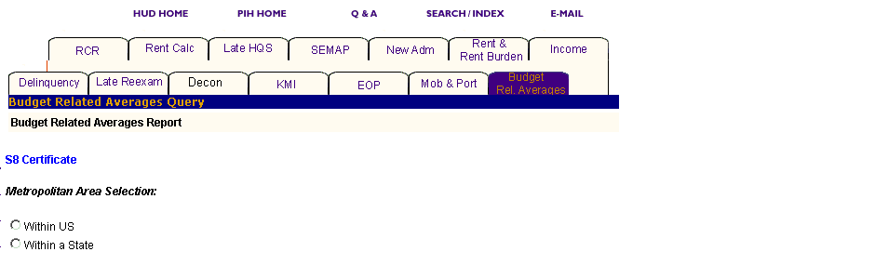
Figure 135: The Metropolitan Area Selection levels for
a Budget Related Averages Report.

Option 1: Within US

Select this option if you know the exact metropolitan area you want.

Step | Action/Result
1. Click Metropolitan Area on the Select Level of Information list. | PIC displays a screen with two different options for identifying the metropolitan area: Within US and Within a State.
2. Click Within US on the Metropolitan Area Selection list. | PIC displays a Select Metro Area(s) from dialog box.
3. Click the metro area you are looking for in the Select Metropolitan Area(s) from dialog box. | Note: To select more than one metro area, press the CONTROL key as you click each one you want to include in the report.
- Click the Reports button. | PIC presents a Budget Related Averages Report for the metro area(s) selected.

Option 2: Within a State

Select this option if you know only the state in which the metropolitan area is located.

Step | Action/Result
1. Click Metropolitan Area on the Select Level of Information list. | PIC displays a screen with two different options for identifying the metropolitan area: Within US and Within a State.
2. Click Within a State on the Metropolitan Area Selection list. | PIC displays a Select State from dialog box.
- Click the state you want in the Select State from dialog box.
- Click the MSA button. | A Select Metropolitan Area(s) from dialog box is displayed.
- Click the desired metro area in the Select Metropolitan Area(s) from dialog box. | Note: To select more than one metro area, press the CONTROL key as you click each one you want to include in the report.
- Click the Reports button. | A Budget Related Averages Report is generated for the metro area(s) selected.

County

You have two options for generating a Budget Related Averages Report at the county level: Within a State and Within a State and Metropolitan Area.

Option 1: Within a State

Select this option if you know only the state the county is in.

Step | Action/Result
1. Click County on the Select Level of Information list. | PIC displays a screen with two different options for identifying the county: Within a State and Within a State and Metropolitan Area.
2. Click Within a State on the County Selection list. | PIC displays a Select State(s) from dialog box.
3. Click the state you want in the Select State(s) from dialog box.
4. Click the County button. | A Select County(s) from dialog box is displayed.
- Click the county(s) you want included in the report. | Note: To select more than one county, press the CONTROL key as you click each one you want to include in the report.
- Click the Reports button. | PIC displays a Budget Related Averages Report for each county selected.

Option 2: Within a State and Metropolitan Area

Select this option if you know the state and metropolitan area where your county is located.

Step | Action/Result
1. Click County on the Select Level of Information list. | PIC displays a screen with two different options for identifying the county: Within a State and Within a State and Metropolitan Area.
2. Click Within a State and Metropolitan Area on the County Selection list. | PIC displays a Select State(s) from dialog box.
3. Click the state you want in the Select State(s) from dialog box.
- Click the MSA button. | PIC displays a Select MSA(s) from dialog box.
- Click the metropolitan area that contains the county you want.
- Click the County button. | A Select County(s) from dialog box is displayed (see Figure 136).
- Click the county(s) you want included in the report. | Note: To select more than one county, press the CONTROL key as you click each one you want to include in the report.
- Click the Reports button. | PIC displays a Budget Related Averages Report for each county selected.

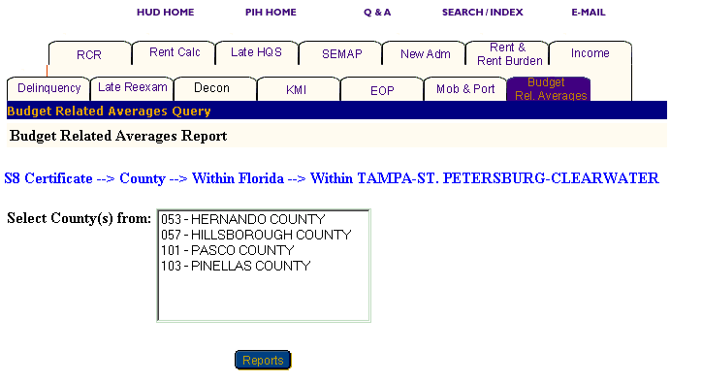
Figure 136: The Select County(s) from dialog box.
City or Locality

You have three options for generating a Budget Related Averages Report at the city or locality level: Within a State, Within a State and Metropolitan Area, and Within a State and County.

Option 1: Within a State

Select this option if you know the state that contains the city you are looking for.

Step | Action/Result
1. Click City or Locality on the Select Level of Information list. | PIC displays a screen with three different options for identifying the city or locality: Within a State, Within a State and Metropolitan Area, and Within a State and County.
2. Click Within a State on the City or Locality Selection list. | PIC displays a Select State from dialog box.
3. Click the state that contains the city in the Select State from dialog box.
- Click the City button. | A Select City(s) from dialog box is displayed (see Figure 137).
- Click the city(s) you want included in the report. | Note: To select more than one city, press the CONTROL key as you click each one you want to include in the report.
- Click the Reports button. | PIC displays a Budget Related Averages Report for each city selected.

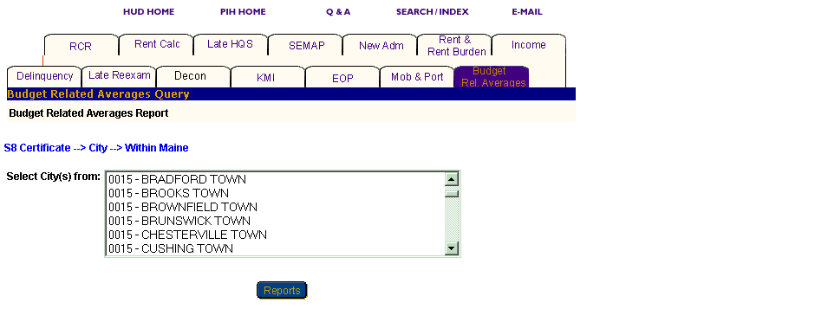
Figure 137: The Select City(s) from dialog box.
Option 2: Within a State and Metropolitan Area

Select this option if you know the state and metropolitan area containing the city you are looking for:

Step | Action/Result
1. Click City or Locality on the Select Level of Information list. | PIC displays a screen with three different options for identifying the city or locality: Within a State, Within a State and Metropolitan Area, and Within a State and County.
2. Click Within a State and Metropolitan Area on the Metropolitan Area Selection list. | PIC displays a Select State(s) from dialog box.
3. Click the state in the Select State(s) from dialog box.
- Click the MSA button. | PIC displays a Select MSA(s) from dialog box.
- Click the metropolitan area that contains the city to be included in the report.
- Click the City button. | A Select City(s) from dialog box is displayed.
- Click the city(s) you want included in the report. | Note: To select more than one city, press the CONTROL key as you click each one you want to include in the report.
- Click the Reports button. | PIC displays a Budget Related Averages Report for each city selected.

Option 3: Within a State and County

Select this option if you know the state and county containing the city you want.

Step | Action/Result
1. Click City or Locality on the Select Level of Information list. | PIC displays a screen with three different options for identifying the city or locality: Within a State, Within a State and Metropolitan Area, and Within a State and County.
2. Click Within a State and County on the City or Locality Selection list. | PIC displays a Select State(s) from dialog box.
3. Click the state you want in the Select State(s) from dialog box.
- Click the County button. | PIC displays a Select County(s) from dialog box.
- Click the county that contains the city you want.
- Click the City button. | A Select City(s) from dialog box is displayed.
- Click the city you want included in the report. | Note: To select more than one city, press the CONTROL key as you click each one you want to include in the report.
- Click the Reports button. | PIC displays a Budget Related Averages Report for each city selected.

Public Housing Agency

You have three options for generating a Budget Related Averages Report at the Public Housing Agency level: Within a State, Within a State and County, and Within a Field Office (see Figure 138).

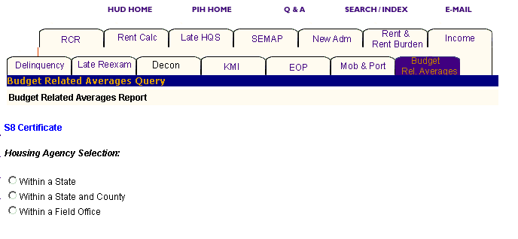
Figure 138: The Housing Agency Selection levels for a
Budget Related Averages Report.

Option 1: Within a State

Select this option if you know the state containing the PHA you want.

Step | Action/Result
1. Click Public Housing Agency on the Select Level of Information list. | PIC displays a screen with three different options for identifying the Public Housing Agency: Within a State, Within a State and County, and Within a Field Office.
2. Click Within a State on the Housing Agency Selection list. | A Select State from dialog box is displayed.
3. Click the state you want in the Select State from dialog box.
- Click the HA List button. | A dialog box appears with a list of HAs within the state you have selected.
- Click the desired HA(s) in the Select HA(s) dialog box. | Note: To select more than one HA, press the CONTROL key as you click each HA you want to include in the report.
- Click the Reports button. | A Budget Related Averages Report is generated for each Public Housing Agency selected within the state.

Option 2: Within a State and County

Select this option if you know the state and county where your PHA is located.

Step | Action/Result
1. Click Public Housing Agency on the Select Level of Information list. | PIC displays a screen with three different options for identifying the Public Housing Agency: Within a State, Within a State and County, and Within a Field Office.
2. Click Within a State and County on the Housing Agency Selection list. | A Select State from dialog box is displayed.
3. Click the state where your PHA is located in the Select State from dialog box.
4. Click the County button. | A Select County from dialog box is displayed.
- Click the county you want in the Select County from dialog box.
- Click the HA List button. | A dialog box appears with a list of HAs associated with the county selected.
- Click the HA(s) in the Select HA(s) from dialog box. | Note: To select more than one HA, press the CONTROL key as you click each HA you want to include in the report.
- Click the Reports button. | A Budget Related Averages Report is generated for each Public Housing Agency selected.

Option 3: Within a Field Office

Select this option if you know the field office containing the PHA you are looking for.

Step | Action/Result
1. Click Public Housing Agency on the Select Level of Information list. | PIC displays a screen with three different options for identifying the Public Housing Agency: Within a State, Within a State and County, and Within a Field Office.
2. Click Within a Field Office on the Housing Agency Selection list. | A Select Field Office from dialog box is displayed.
3. Click the field office associated with the HA you want in the Select Field Office from dialog box.
4. Click the HA List button. | A dialog box appears with a list of HAs associated with the field office selected.
- Click the desired HA(s) in the Select HA(s) dialog box. | Note: To select more than one HA, press the CONTROL key as you click each HA you want to include in the report (see Figure 139).
- Click the Reports button. | A Budget Related Averages Report is generated for each Public Housing Agency you selected that is associated with the field office identified.

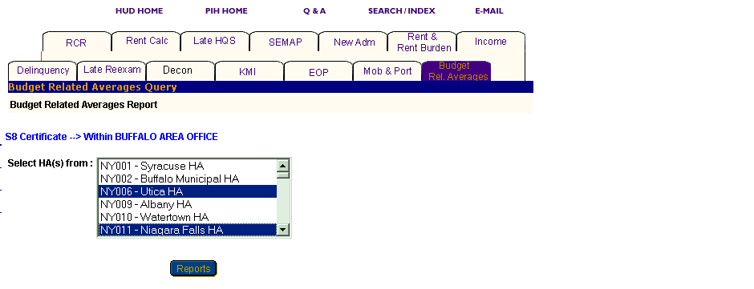
Figure 139: The Select HA(s) from dialog box with two HAs selected.

Congressional District

You have two options for generating a Budget Related Averages Report at the Congressional District level: Within US and Within a State.

Option 1: Within US

Select this option if you know the exact congressional district you are looking for:

Step | Action/Result
1. Click Congressional District on the Select Level of Information list. | PIC displays a screen with two different options for identifying the congressional district: Within US and Within a State.
2. Click Within US on the Congressional District Selection list. | PIC displays a Select Congressional District(s) from dialog box.
3. Click the congressional district you want in the dialog box. | Note: To select more than one congressional district, press the CONTROL key as you click each one you want to include in the report.
4. Click the Reports button. | A Budget Related Averages Report is generated for the congressional district(s) selected.

Option 2: Within a State

Select this option if you know only the state the congressional district is in.

Step | Action/Result
1. Click Congressional District on the Select Level of Information list. | PIC displays a screen with two different options for identifying the congressional district: Within US and Within a State.
2. Click Within a State on the Congressional District Selection list. | PIC displays a Select State from dialog box.
3. Click the state you want in the Select State from dialog box.
4. Click the Cong Dist button. | A Select Congressional District(s) from dialog box is displayed (see Figure 140).
5. Click the congressional district(s) you want included in the report. | Note: To select more than one congressional district, press the CONTROL key as you click each one you want to include in the report.
- Click the Reports button. | A Budget Related Averages Report is generated for the congressional district(s) selected.

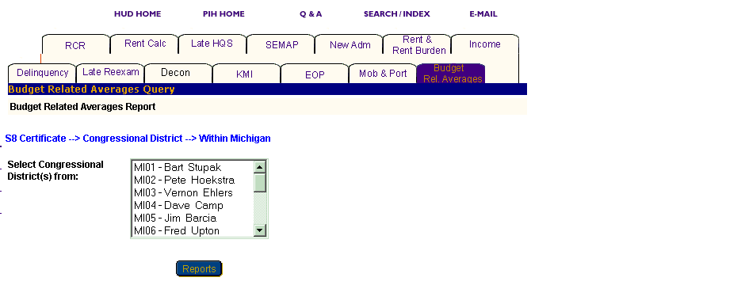
Figure 140: The Select Congressional District(s) from dialog box.

Information Presented in a Budget Related Averages Report

When you complete your selections and click the Reports button, PIC generates the Budget Related Averages Report for the particular program and level of information you selected. Each report offers the same categories of information, which are in tabs that display at the top of the report.

The following labels are found in the heading for a Budget Related Averages Report:

- Program Type
- Level of Information
- Report Start Date
- Report End Date

Some reports contain subcategories that display when you move your mouse over a tab. The Budget Related Averages Report tabs contain no subcategories.

Note: Multiple data selections might be split into sets. For instance, if you have selected several states to include in the report (generally more than four), some of those selections do not appear in the first report page.
To view the information within a report:

Step | Action/Result
- Click the report tab to see the information. | The table(s) under that report tab is displayed.
- Click the Next Set arrow located at the bottom right of the report page to view the next data set. | The next data set is displayed.
- Click the Prev Set arrow located at the bottom left of the report page to return to the data set previously viewed. | The previous data set is displayed.

You should note that reports generated at the state and field office levels also present national data. The Public Housing Agency level presents state data.

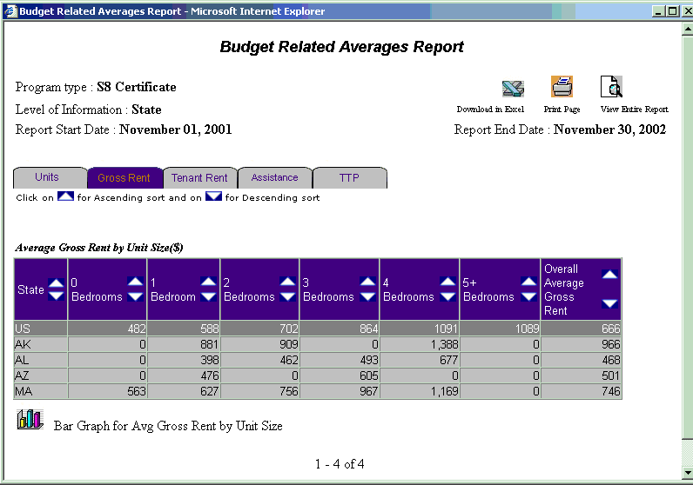
Figure 141: The Gross Rent tab for the Budget Related Averages Report.

You can view information on a report in ascending or descending order by clicking the up or down arrow in the column.

The following table describes the information contained under each tab of the Budget Related Averages Report.

Tab | Subcategories | Information Presented
Units | None | Default screen for the Budget Related Averages Report, consisting of one table reporting:  - Number of Units Reported  - Number of Units, Regular  - Number of Units, Prorated
Gross Rent | None | Gross Rent consists of one table reporting:  Average Gross Rent by Unit Size ($)  - 0 Bedrooms  - 1 Bedroom  - 2 Bedrooms  - 3 Bedrooms  - 4 Bedrooms  - 5+ Bedrooms  - Overall Average Gross Rent
Tenant Rent | None | Tenant Rent consists of two tables reporting:  Average Total Family Share by Unit Size ($) – Regular Rent  - 0 Bedrooms  - 1 Bedroom  - 2 Bedrooms  - 3 Bedrooms  - 4 Bedrooms  - 5+ Bedrooms  - Overall Average Tenant Rent  Average Total Family Share by Unit Size ($) – Prorated Rent  - 0 Bedrooms  - 1 Bedroom  - 2 Bedrooms  - 3 Bedrooms  - 4 Bedrooms  - 5+ Bedrooms  - Overall Average Tenant Rent
Assistance | None | Assistance consists of three tables reporting:  Average Assistance Payment by Unit Size ($) – All Families  - 0 Bedrooms  - 1 Bedroom  - 2 Bedrooms  - 3 Bedrooms  - 4 Bedrooms  - 5+ Bedrooms  - Overall Average Assistance Payment  Average Assistance Payment by Unit Size ($) – Regular Rent  - 0 Bedrooms  - 1 Bedroom  - 2 Bedrooms  - 3 Bedrooms  - 4 Bedrooms  - 5+ Bedrooms  - Over all Average Assistance Payment
Average Tenant Rent by Unit Size ($) –
Prorated Rent
- 0 Bedrooms
- 1 Bedroom
- 2 Bedrooms
- 3 Bedrooms
- 4 Bedrooms
- 5+ Bedrooms
- Overall Average Assistance Payment

TTP (Total Tenant Payment) | None | TTP consists of one table reporting:  Average Tenant Payment by Unit Size ($)  - 0 Bedrooms  - 1 Bedroom  - 2 Bedrooms  - 3 Bedrooms  - 4 Bedrooms  - 5+ Bedrooms  - Overall Average Family Share

An icon is available at the bottom of most tables, so you can view the information in a Bar Graph form.


Figure 142: The icon available for converting
table information into a Bar Graph.

The Budget Related Averages Report screen also contains three options for further use of the data. The options are located on the top right side of the report screen.

Select one of the following options:

- Download in Excel: The report downloads to an Excel spreadsheet for further data manipulation.

- Print Page: The report prints as a Web page.

Note: For the best results, print in landscape orientation.

- View Entire Report: All report subcategory tables display together on one screen.

Figure 143: The options available
for further use of report data.

To generate another report, repeat the process by returning to the Reports screen and selecting the tab for the report you want next. Refer to the section of this user manual that describes the report, and follow the steps to generate the report.

Income Report
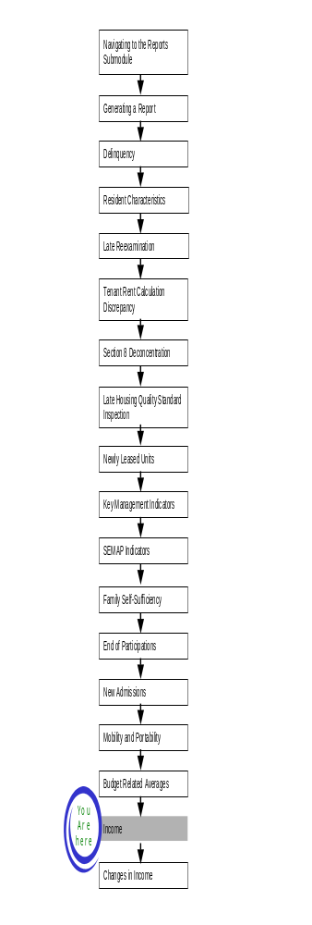
Income Reports summarize information about income distributions for all families, new admissions, and end of participations. Through these reports, you gain valuable income information about tenants in a specific program.

To access the Income Report start page:

Step | Action/Result
- Log on to PIC. | The PIC main page is displayed
- Move your cursor over the Form-50058 button. | A list of submodules is displayed.
- Click the Reports link. | The Delinquency Report page is displayed. Other available reports are listed in tabs at the top of the page.
- Click the Income tab. | The Income Report start page is displayed (see Figure 144).

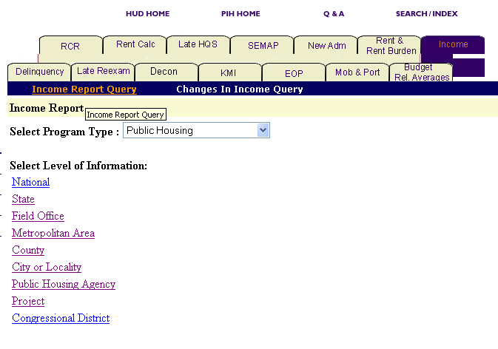
Figure 144: The Income Report tab and start page.

Generating an Income Report
After you have reached the Income Report start page, you need to select the program and the level of information you want to view.

To select Income Report criteria:

Step | Action/Result
- Click the program type you want in the Program Type dialog box. | - Public Housing  - S8 Certificate  - S8 Voucher  - S8 Certificate and Voucher  - S8 Moderate Rehabilitation  - All Relevant Programs  Note: Public Housing is the default option for the Program Type dialog box.
- Click the link on the Select Level of Information list that corresponds to the level you want on the report. | The module formulates the rest of the criteria necessary to generate the report based on the level you select here. For example, click State when the program type you are interested in is located at that level. A dialog box containing a list of state names appears. Click the state where the program type you are interested in is located, and generate the report.

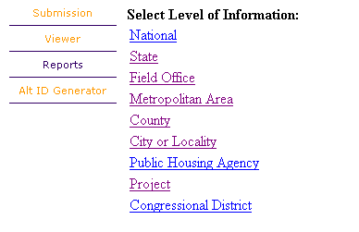
Figure 145: The Level of Information
Options for the Income Report.

There are nine levels of information to choose from in an Income Report (see Figure 145):

- National
- State
- Field Office
- Metropolitan Area
- County
- City or Locality
- Public Housing Agency
- Project
- Congressional District

Depending on security clearance, users have limited access within certain levels of information. For example, if you are an HA user, you only have access to the states, field offices, and projects associated with your housing agency.

The following tables outline how to generate an Income Report for each level.

National

Step | Action/Result
1. Click the National link on the Select Level of Information list. | PIC generates an Income Report at the national level containing aggregated data.

State

Step | Action/Result
1. Click State on the Select Level of Information list. | A Select State(s) from dialog box is displayed.
2. Click the state you want in the Select State(s) from dialog box. | Note: To select more than one state, press the CONTROL key as you click each state you want to include in the report.
3. Click the Reports button. | PIC presents the Income Report for the selected state(s).

Field Office

Step | Action/Result
1. Click Field Office on the Select Level of Information list. | A Select Field Office(s) from dialog box is displayed.
2. Click the field office(s) you want in the Select Field Office(s) from dialog box (see Figure 3). | Note: To select more than one field office, press the CONTROL key as you click each office you want to include in the report.
3. Click the Reports button. | PIC presents the Income Report for the selected field office(s).

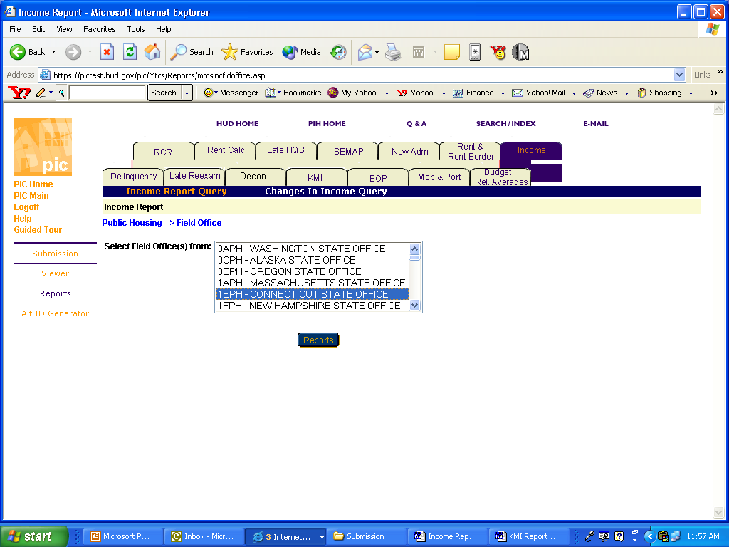
Figure 146: The Select Field Office(s) from dialog box
for the field office level of information.

Metropolitan Area

You have two options for generating an Income Report at the Metro Area level: Within the U.S. and Within a State.

Option 1: Within the U.S.

Select this option if you know the exact metro area you want:

Step | Action/Result
- Click Metropolitan Area on the Select Level of Information list. | PIC displays a screen with two different options for identifying the metro area: Within the U.S. and Within a State.
- Click Within the U.S. in the Metro Area selection list. | PIC displays a Select Metro Area(s) from dialog box.
- Click the area you are looking for in the dialog box list. | Note: To select more than one metro area, press the CONTROL key as you click each office you want to include in the report
- Click the Reports button. | PIC presents an Income Report for the selected metro area(s).

Option 2: Within a State

Select this option if you know only the state the metro area is in:

Step | Action/Result
- Click Metropolitan Area on the Select Level of Information list. | PIC displays a screen with two different options for identifying the metro area: Within the U.S. and Within a State.
- Click Within a State. | A Select State from dialog box is displayed.
- Click the state you want in Select State from dialog box.
- Click the MSA button. | A Select Metro Area(s) from dialog box is displayed.
- Click the metro area you want in the Select Metro Area(s) from dialog box. | Note: To select more than one metro area, press the CONTROL key as you click each metro area you want to include in the report.
- Click the Reports button. | PIC presents an Income Report for the selected metro area (s).

County

You have two options for generating an Income report at the county level: Within a State and Within a State and Metro Area.

Option 1: Within a State

Step | Action/Result
- Click County on the Select Level of Information list. | PIC displays a screen with two different options for identifying the county: Within a State and Within a State and Metro Area.
- Click Within a State. | A Select State from dialog box is displayed.
- Click the state you want in Select State from dialog box.
- Click the County button. | PIC presents a Select County(s) from dialog box (see Figure 147).
- Click the county(s) you are looking for. | Note: To select more than one county, press the CONTROL key as you click each county you want to include in the report.
- Click the Reports button. | PIC presents an Income Report for the selected county(s).

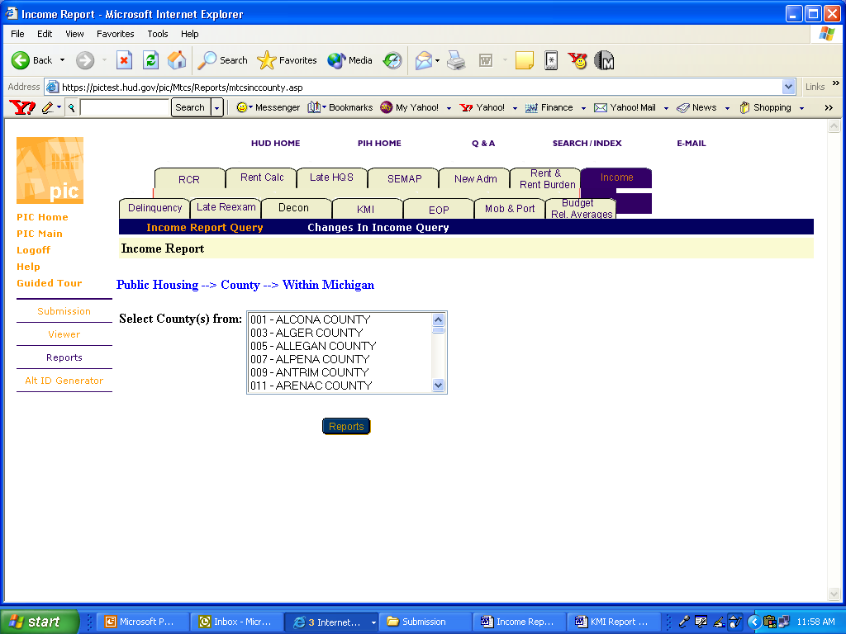
Figure 147: The Select County(s) from
dialog box for Within a State.

Option 2: Within a State and Metro Area

Step | Action/Result
- Click County on the Select Level of Information list. | PIC displays a screen with two different options for identifying the county: Within a State and Within a State and Metro Area.
- Click Within a State and Metro Area. | A Select State from dialog box is displayed.
- Click the state you want in Select State from dialog box.
- Click the MSA button. | PIC displays a Select Metro Area from list.
- Click the metro area that contains the county you are looking for.
- Click the County button. | PIC presents a Select County(s) from dialog box.
- Click the county(s) you are looking for. | Note: To select more than one county, press the CONTROL key as you click each county you want to include in the report.
- Click the Reports button. | PIC presents an Income Report for the selected county(s).

City or Locality

You have three options for generating an Income Report at the City or Locality level: Within a State, Within a State and County, and Within a State and Metro Area.

Option 1: Within a State

Select this option if you know the state containing the city you want.

Step | Action/Result
- Click City or Locality on the Select Level of Information list. | PIC displays a screen with three different options for identifying the city or locality: Within a State, Within a State and County, and Within a State and Metro Area.
- Click Within a State. | A Select State from dialog box is displayed.
- Click the state you want in Select State from dialog box.
- Click the City button. | PIC presents a Select City(s) dialog box (see Figure 148).
- Click the city(s) you are looking for. | Note: To select more than one city, press the CONTROL key as you click each county you want to include in the report.
- Click the Reports button. | PIC presents an Income Report for the selected city(s).

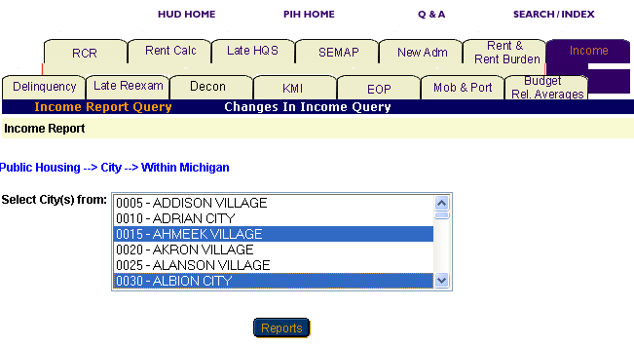
Figure 148: The Select City(s) dialog box for Within a State.

Option 2: Within a State and Metro Area

Select this option if you know the state and metro area containing the city you want:

Step | Action/Result
- Click City or Locality on the Select Level of Information list. | PIC displays a screen with three different options: Within a State and Within a State and Metro Area, and Within a State and County.
- Click Within a State and Metro Area. | A Select State from dialog box is displayed.
- Click the state you want in Select State from dialog box.
- Click the MSA button. | PIC displays a Select Metro Area from list.
- Click the metro area that contains the city you are looking for.
- Click the City button. | PIC presents a Select City(s) from dialog box.
- Click the city(s) you are looking for. | Note: To select more than one city, press the CONTROL key as you click each county you want to include in the report.
- Click the Reports button. | PIC presents an Income Report for the selected city(s).

Option 3: Within a State and County

Select this option if you know the state and county that contain the city you are looking for:

Step | Action/Result
- Click City or Locality on the Select Level of Information list. | PIC displays a screen with three different options: Within a State and Within a State and Metro Area, and Within a State and County.
- Click Within a State and County. | A Select State from dialog box is displayed.
- Click the state you want in Select State from dialog box.
- Click the County button. | PIC displays a Select County from list.
- Click the county that contains the city you are looking for.
- Click the City button. | PIC presents a Select City(s) from dialog box.
- Click the city(s) you are looking for. | Note: To select more than one city, press the CONTROL key as you click each county you want to include in the report.
- Click the Reports button. | PIC presents an Income Report for the selected city(s).

Public Housing Agency

You have three options for generating an Income Report at the Public Housing Agency level: Within a State, Within a State and County, and Within a Field Office (see Figure 149).

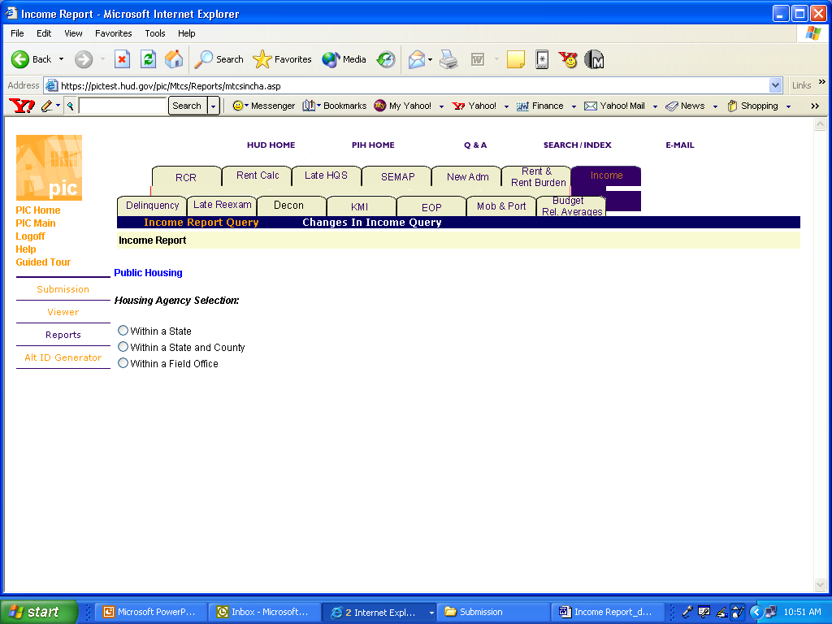
Figure 149: The Housing Agency Selection levels for an Income Report.

Option 1: Within a State

Step | Action/Result
- Click Public Housing Agency on the Select Level of Information list. | PIC displays a screen with three different options for identifying the Public Housing Agency: Within a State, Within a State and County, and Within a Field Office.
- Click Within a State. | A Select State from dialog box is displayed.
- Click the state you want in Select State from dialog box.
- Click the HA List button. | PIC presents a Select HA(s) dialog box (see Figure 149).
- Click the HA(s) you are looking for. | Note: To select more than one HA, press the CONTROL key as you click each county you want to include in the report.
- Click the Reports button. | PIC presents an Income Report for the selected HA(s).

Option 2: Within a State and County.

Select this option if you know the state in which your PHA is located.

Step | Action/Result
- Click Public Housing Agency on the Select Level of Information list. | PIC displays a screen with three different options: Within a State and Within a State and County, and Within a Field Office.
- Click Within a State and County. | A Select State from dialog box is displayed.
- Click the state you want in Select State from dialog box.
- Click the County button. | PIC displays a Select County from list.
- Click the county that contains the PHA you are looking for (see Figure 150).
- Click the HA List button. | PIC presents a Select HA(s) from dialog box.
- Click the HA(s) you are looking for. | Note: To select more than one HA, press the CONTROL key as you click each county you want to include in the report.
- Click the Reports button. | PIC presents an Income Report for the selected HA(s).

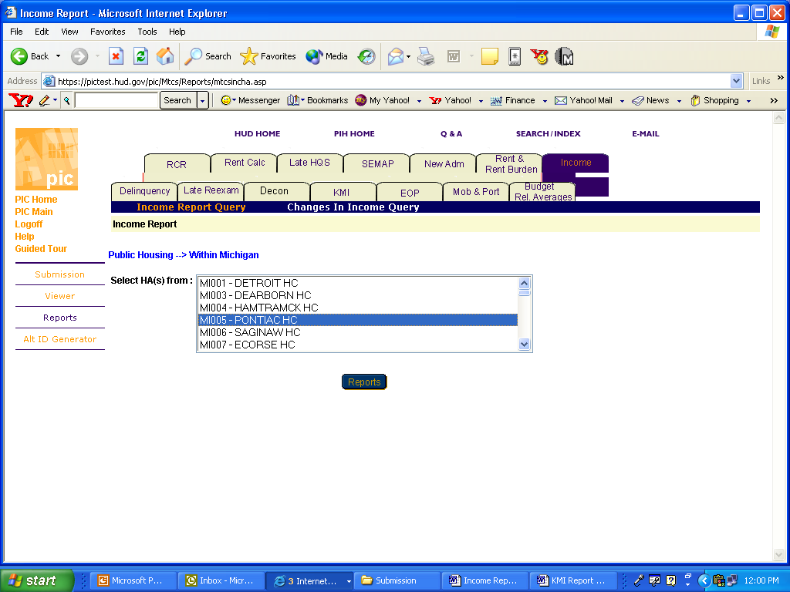
Figure 150: The Select HA(s) dialog box for Within a State.

Option 3: Within a Field Office

Select this option if you know the field office associated with the PHA you are looking for.

Step | Action/Results
1. Click Public Housing Agency on the Select Level of Information list. | PIC displays a screen with three different options for identifying the Public Housing Agency: Within a State, Within a State and County, and Within a Field Office.
2. Click Within a Field Office. | A Select Field Office from dialog box is displayed.
3. Click the field office you want in the Select Field Office from dialog box.
4. Click the HA List button. | A dialog box is displayed with a list of HAs associated with the selected field office.
- Click the desired HA(s) in the Select HA(s) dialog box. | Note: To select more than one HA, press the CONTROL key as you click each HA you want to include in the report.
- Click the Reports button. | An Income Report is generated for the selected HA(s).

Project

You have five options to generate a project level Income Report: Within a State, Within a State and Metropolitan Area, Within a State and County, Within a State and City or Locality, and Within a Public Housing Agency (see Figure 151).

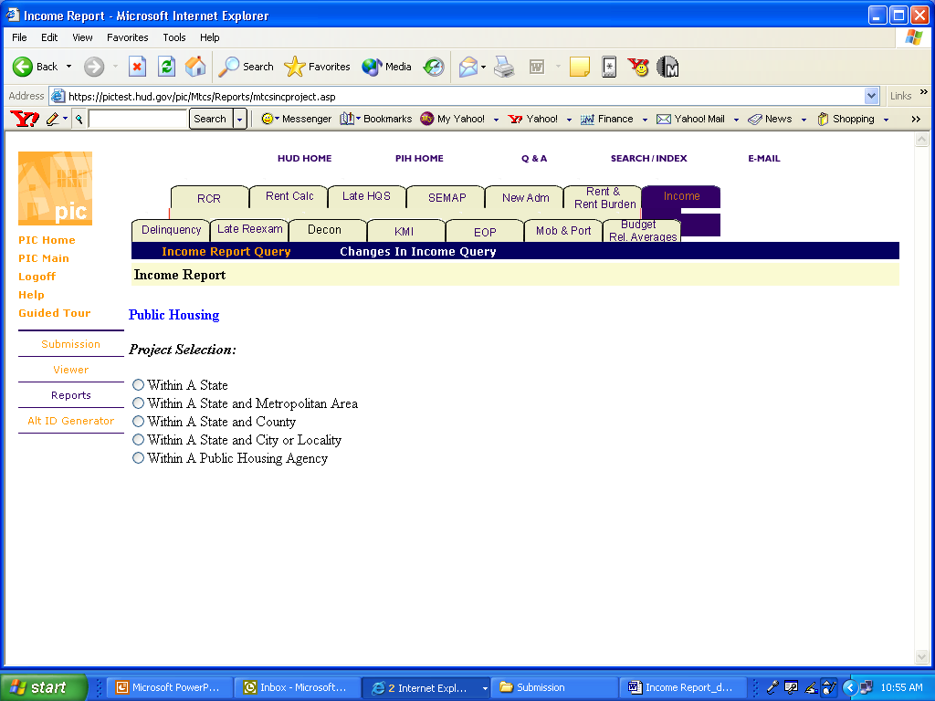
Figure 151: The Project Selection levels for an Income Report.

Note: You can only generate an Income Report for a project if you have selected the Public Housing or the All Relevant Program options in the Select Program Type dialog box. If you select any of the Section 8 programs, a message appears telling you there are no projects for Section 8.

Option 1: Within a State

Select this option if you know the state containing the project you are looking for.

Step | Action/Result
1. Click Project on the Select Level of Information list. | PIC displays a screen with five different options for identifying the project: Within a State, Within a State and Metropolitan Area, Within a State and County, Within a State and City or Locality, and Within a Public Housing Agency.
2. Click Within a State. | A Select State from dialog box is displayed.
3. Click the state you want in the Select State from dialog box.
4. Click the Projects button. | A dialog box is displayed with a list of projects within the selected state.
- Click the desired project(s) in the Select Projects(s) from dialog box. | Note: To select more than one project, press the CONTROL key as you click each HA you want to include in the report.
- Click the Reports button. | An Income Report is generated for each project selected within the state.

Option 2: Within a State and Metro Area

Select this option if you know the state and metro area containing the project you are looking for.

Step | Action/Result
- Click Project on the Select Level of Information list. | PIC displays a screen with five different options: Within a State and Within a State and Metro Area, Within a State and County, Within a State and City or Locality, and Within a Public Housing Agency.
- Click Within a State and Metro Area. | A Select State from dialog box is displayed.
- Click the state you want in Select State from dialog box.
- Click the MSA button. | PIC displays a Select Metro Area from list.
- Click the metro area that contains the city you are looking for.
- Click the Projects button. | PIC presents a Select Project(s) from dialog box (see Figure 152).
- Click the project(s) you are looking for. | Note: To select more than one project, press the CONTROL key as you click each county you want to include in the report.
- Click the Reports button. | PIC presents an Income Report for the selected project.

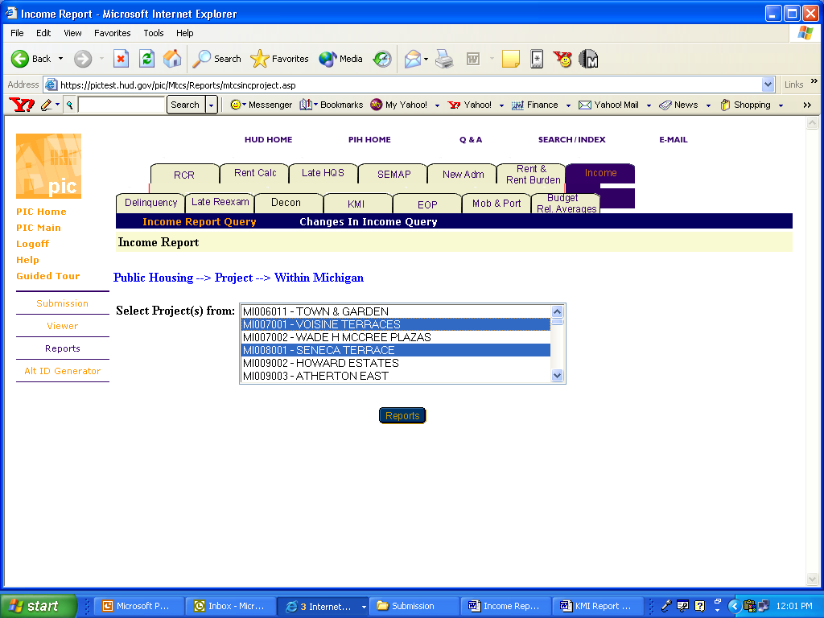
Figure 152: The Select Project(s) dialog box for Within a State.

Option 3: Within a State and County

Select this option if you know the state and county in which the project is located:

Step | Action/Result
- Click Project on the Select Level of Information list. | PIC displays a screen with five different options: Within a State and Within a State and Metro Area, Within a State and County, Within a State and City or Locality, and Within a Public Housing Agency.
- Click Within a State and County. | A Select State from dialog box is displayed.
- Click the state you want in Select State from dialog box.
- Click the County button. | PIC displays a Select County from list.
- Click the county that contains the project(s) you are looking for.
- Click the Projects button. | PIC presents a Select Project(s) from dialog box.
- Click the project(s) you are looking for. | Note: To select more than one project, press the CONTROL key as you click each county you want to include in the report.
- Click the Reports button. | PIC presents an Income Report for the selected projects.

Option 4: Within a State and City or Locality

Select this option if you know the particular state and city in which the project you are looking for is located:

Step | Action/Result
- Click Project on the Select Level of Information list. | PIC displays a screen with five different options: Within a State and Within a State and Metro Area, Within a State and County, Within a State and City or Locality, and Within a Public Housing Agency.
- Click Within a State and City or Locality. | A Select State from dialog box is displayed.
- Click the state you want in Select State from dialog box.
- Click the City button. | PIC displays a Select City from list.
- Click the city that contains the project(s) you are looking for.
- Click the Projects button. | PIC presents a Select Project(s) from dialog box.
- Click the project(s) you are looking for. | Note: To select more than one project, press the CONTROL key as you click each county you want to include in the report.
- Click the Reports button. | PIC presents an Income Report for the selected project.

Option 5: Within a PHA

Select this option if you know the particular Public Housing Agency associated with the project you are looking for.

Step | Action/Result
1. Click Project on the Select Level of Information list. | PIC displays a screen with five different options: Within a State and Within a State and Metro Area, Within a State and County, Within a State and City or Locality, and Within a Public Housing Agency.
2. Click Within a Public Housing Agency. | A Select State from dialog box is displayed.
3. Click the state containing the PHA and project you want from the Select State from dialog box.
- Click the HA List button. | A dialog box is displayed with a list of HAs associated with the selected field office.
- Click the desired HA(s) in the Select HA(s) dialog box.
- Click the Projects button. | A Select Project from dialog box is displayed for the Public Housing Agency selected within the state.
- Click the project(s) you want in the Select Projects from dialog box. | Note: To select more than one project, press the CONTROL key as you click each project you want included in the report.
- Click the Reports button. | An Income Report is generated for the identified project(s).

Congressional District

You have two options for generating an Income Report for a Congressional District: Within the U.S. and Within a State.

Option 1: Within the U.S.

Select this option if you know the exact district you want.

Step | Action/Result
1. Click Congressional District on the Select Level of Information list. | PIC displays a screen with two different options to identify the congressional district: Within the U.S. and Within a State.
2. Click Within the U.S. | PIC displays a Select Congressional District(s) from dialog box (see Figure 10).
3. Click the district you are looking for. | Note: To select more than one district, press the CONTROL key as you click each district you want included in the report.
- Click the Reports button. | PIC presents an Income Report for the selected district(s).

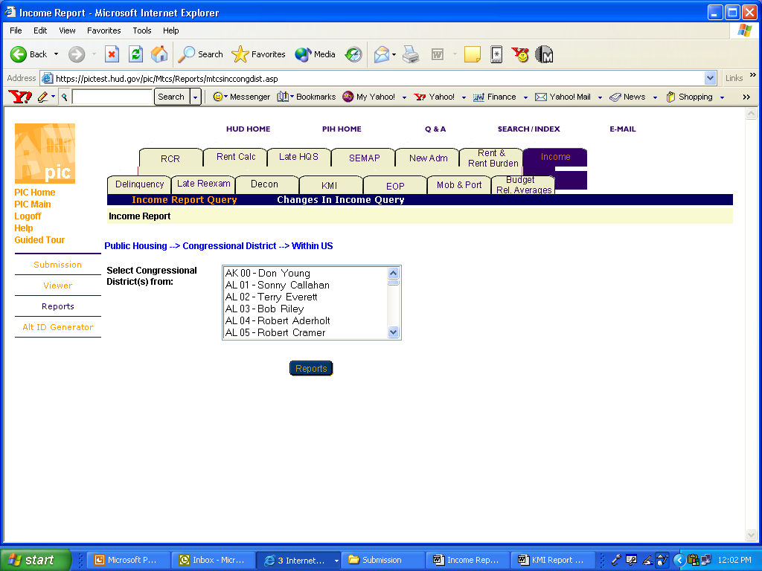
Figure 153: The Select Congressional District(s)
dialog box for Within the U.S.

Option 2: Within a State

Select this option if you know only the state the congressional district is in:

Step | Action/Result
1. Click Congressional District on the Select Level of Information list. | PIC displays a screen with two different options to identify the congressional district: Within the U.S. and Within a State.
2. Click Within a State. | PIC displays a Select State from dialog box.
3. Click the state containing the district you are looking for.
- Click the Congressional Districts button. | A Select Congressional District(s) from dialog box is displayed.
- Click the district you want from the dialog box. | Note: To select more than one district, press the CONTROL key as you click each district you want included in the report.
- Click the Reports button. | PIC presents an Income Report for the selected congressional district(s).

Information Presented in an Income Report
When you complete your selections and click the Reports button, PIC generates the Income Report for the particular program and level of information selected. These selections are listed at the top of the report along with the report’s start and end dates.

Income Reports are split into three groups:

  - Families
  - New Admissions
  - End of Participations

The group headings are listed as tabs (see Figure 154). Click the tab to view the information for the selected group.

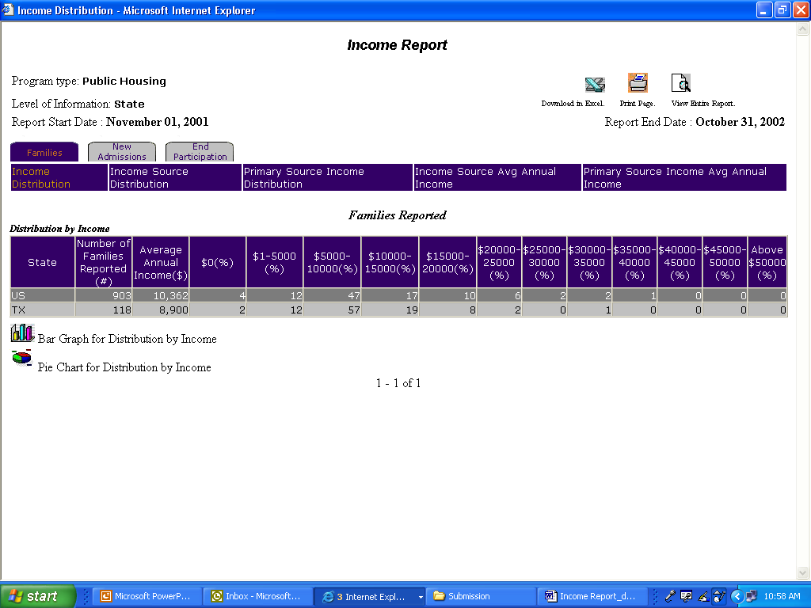
Figure 154: The Group Headings and three of the subtabs in an Income Report.

For each group, the PIC system presents the same categories of information, listed as subtabs:
- Income Distribution
- Income Source Distribution
- Primary Source Income Distribution
- Income Source Average Annual Income
- Primary Source Average Annual Income

Click one of these subtabs to view the information.

Note: Multiple data selections may be split into sets. For example, if you have selected several states to include in the report (generally more than four), some of those selections are not displayed in the first report page. To view these data selections:

Step | Action/Result
1. Click the Next Set arrow located at the bottom right of the report page to view the next data set. | The next data set is displayed.
2. Click the Prev Set arrow located at the bottom left of the report to return to the data set previously viewed. | The previous data set is displayed.

Reports generated at the state and field office level also provide national data. Metro area, county, city, public housing agency, project, and congressional district levels provide state data.

View information in ascending or descending order on a report by clicking the up or down arrow in any column.
This table details the information available in an Income Report for each group.

Subtab | Information Presented
Income Distribution | Default screen for the Income Report, consisting of one table:  - Number of Families Reported (#)  - Average Annual Income ($)  - $0(%) $1-5,000(%)  - $5,000- 10,000(%)  - $10,000-15,000(%)  - $15,000-20,000(%)  - $20,000-25,000(%)  - $25,000-30,000(%)  - $30,000-35,000(%)  - $35,000-40,000(%)  - $40,000-45,000(%)  - $45,000-50,000(%)  - Above $50,000(%)
Income Source Distribution | Consists of two tables reporting:  Distributions by Source of Income  - Number of Families Reported(#)  - Average Annual Income ($)  - Asset Income (%)  - Child Support (%)  - Federal Wage (%)  - Indian Trust/per capita (%)  - Military Pay (%)  - Own Business (%)  - Pension (%)  - SSI (%)  - Temporary Assistance to Needy Families (TANF) (%)  Other Sources of Income  - General Assistance (%)  - PHA Wages (%)  - Other Wages (%)  - Other NonWages (%)  - Social Security (%)  - Unemployment Benefits (%)  - Medical Reimbursements (%)  - Annual Imputed Welfare Income (%)
Primary Source Income Distribution | Consists of one table reporting:  - Number of Families Reported(#)  - Average Annual Income($)  - Asset Inc (%)  - Wages (%)  - Welfare (%)  - SSI/SS/Pensions (%)  - Other Income Sources (%)  - No Primary Source of Income (%)
Income Source Average Annual Income | Consists of two tables reporting:  Average Annual Income by Source of Income  - Number of Families Reported(#)  - Average Annual Income ($)  - Asset Income (%)  - Child Support (%)  - Federal Wage (%)  - Indian Trust/per capita (%)  - Military Pay (%)  - Own Business (%)  - Pension (%)  - SSI (%)  - TANF (%)  Other Sources of Income  - General Assistance (%)  - PHA Wages (%)  - Other Wages (%)  - Other NonWages (%)  - Social Security (%)  - Unemployment Benefits (%)  - Medical Reimbursements (%)  - Annual Imputed Welfare Income (%)
Primary Source Average Annual Income | Consists of one table reporting:  - Number of Families Reported(#)  - Average Annual Income($)  - Asset Inc (%)  - Wages (%)  - Welfare (%)  - SSI/SS/Pensions (%)  - Other Income Sources (%)  - No Primary Source of Income (%)
Two icons at the bottom of most tables (see Figure 12), are used to view the information in either Pie Chart or Bar Graph form. When the icons are not shown, the information is only available in tabular form.

Figure 155: The Icons for a Bar Graph or Pie Chart.

The Income Report screen contains three options for further use of the data (see Figure 156). The options are located on the top right side of the report screen.

Select one of the following options:

- Download in Excel: The report downloads to an Excel spreadsheet for further data manipulation.

- Print Page: The report prints as a Web page.

Note: For the best results, print in landscape orientation.

- View Entire Report: All report subcategory tables display together on one screen.

Figure 156: The options for
further use of report data.

To generate another report, repeat the process by returning to the Reports screen and selecting the tab for the next report. Go to the corresponding section of this PIC user manual that describes a specific report, and follow the steps provided to generate that report.

Changes in Income Report
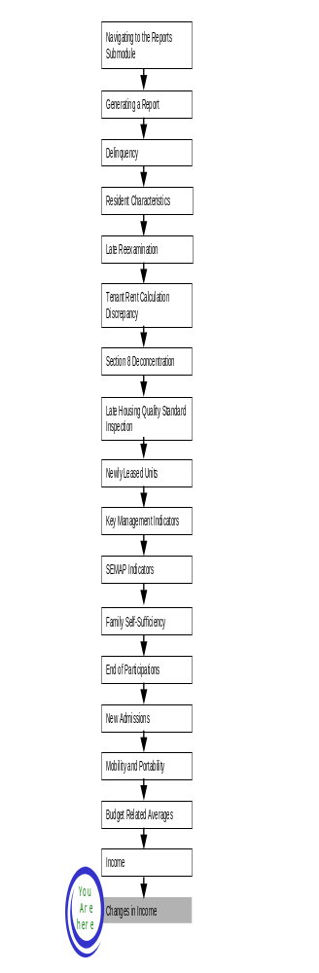
The Changes in Income Report identifies families with variations in income from quarter to quarter and from year to year. It summarizes information on income, general assistance (such as welfare), and earned wages on a quarterly basis.
To access the Changes in Income Report start page:

Step | Action/Result
- Log on to PIC. | The PIC main page is displayed.
- Move your cursor over the Form-50058 button. | A list of submodules is displayed.
- Click the Reports link. | The Delinquency Report page is displayed. Other available reports are listed in tabs at the top of the page.
- Click the Income tab. | The Income Report start page is displayed.
- Click the Changes in Income Query subtab. It is located just to the right of the Income Report Query subtab. | The Changes in Income Report start page is displayed (see Figure 157).

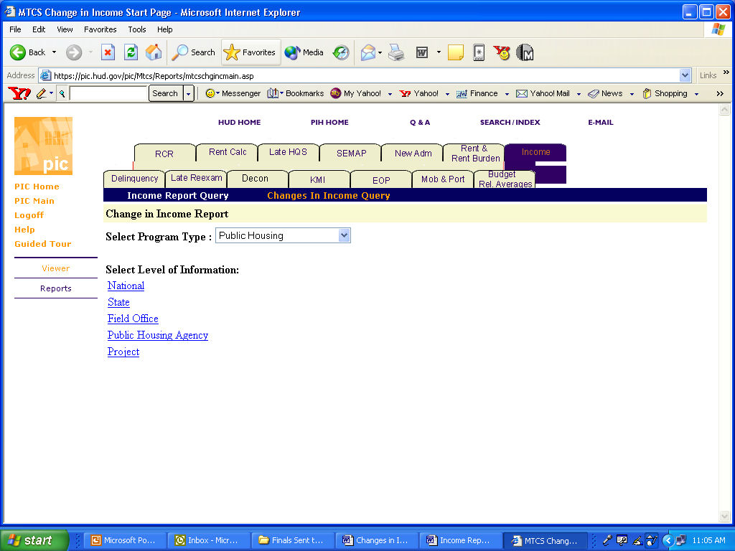
Figure 157: The Changes in Income Report tab and start page.

Generating a Changes in Income Report
On the Changes in Income start page, select the program type and the level of information you want to view.

To select Changes in Income Report criteria:

Step | Action/Result
- Click the program type you want in the Program Type dialog box. | - Public Housing  - S8 Certificate  - S8 Voucher  - S8 Moderate Rehabilitation  - All Relevant Programs  Note: Public Housing is the default option for the Program Type dialog box.
- Click the link on the Select Level of Information list that corresponds to the level of information you want on the report. | The module formulates the rest of the criteria necessary to generate the report based on the level you select here. For example, click State when the program type you are interested in is located at that level. A dialog box containing a list of state names appears. Click the state where the program type you are interested in is located, and generate the report.

Figure 158: The Level of Information options available
for the Changes in Income Report.

There are five levels of information to choose from in a Changes in Income Report:

- National
- State
- Field Office
- Public Housing Agency
- Project

Depending on security clearance, users have limited access within certain levels of information. For example, if you are an HA user, you only have access to the states, field offices, and projects associated with your housing agency.

The following tables outline how to generate a Changes in Income Report for each level.

National

Step | Action/Result
1. Click the National link on the Select Level of Information list. | PIC generates a Changes in Income Report at the national level containing aggregated data.

State

Step | Action/Result
1. Click State on the Select Level of Information list. | A Select State(s) from dialog box appears.
2. Click the state you want in the Select State(s) from dialog box. | Note: To select more than one state, press the CONTROL key as you click each state you want to include in the report.
3. Click the Reports button. | PIC presents the Changes in Income Report for the selected state(s).

Field Office

Step | Action/Result
1. Click Field Office on the Select Level of Information list. | A Select Field Office(s) from dialog box is displayed.
2. Click the field office(s) you want in the Select Field Office(s) from dialog box. | Note: To select more than one field office, press the CONTROL key as you click each office you want to include in the report.
3. Click the Reports button. | PIC presents the Changes in Income Report for the selected field office(s).

Public Housing Agency

There are two options for generating a Changes in Income Report at the Public Housing Agency level: Within a State and Within a Field Office
(see Figure 159).

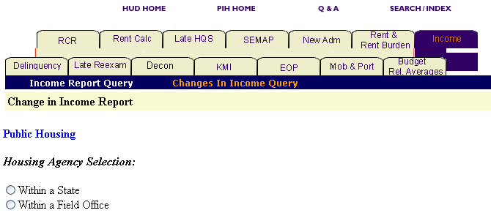
Figure 159: The Housing Agency Selection Levels
for a Changes in Income Report.

Option 1: Within a State

Select this option if you know the state containing the PHA you want.

Step | Action/Result
1. Click Public Housing Agency on the Select Level of Information list. | PIC displays a screen with two different options for identifying the Public Housing Agency: Within a State and Within a Field Office.
2. Click Within a State. | A Select State from dialog box appears.
3. Click the state you want in the Select State from dialog box.
- Click the HA List button. | A dialog box appears with a list of HAs within the selected state.
- Click the desired HA(s) in the Select HA(s) dialog box. | Note: To select more than one HA, press the CONTROL key as you click each HA you want to include in the report.
- Click the Reports button. | A Changes in Income Report is generated for each Public Housing Agency selected within the state.

Option 2: Within a Field Office

Select this option if you know the field office containing the PHA you are looking for.

Step | Action/Result
1. Click Public Housing Agency on the Select Level of Information list. | PIC displays a screen with two different options for identifying the Public Housing Agency: Within a State and Within a Field Office.
2. Click Within a Field Office. | A Select Field Office from dialog box appears.
3. Click the field office you want in the Select Field Office from dialog box.
4. Click the HA List button. | A dialog box appears with a list of HAs associated with the field office you have selected.
- Click the desired HA(s) in the Select HA(s) dialog box. | Note: To select more than one HA, press the CONTROL key as you click each HA you want to include in the report.
- Click the Reports button. | A Changes in Income Report is generated for each Public Housing Agency selected within the field office.

Project

You have two options to generate a Changes in Income Report at the project level: Within a State and Within a Public Housing Agency (see Figure 160).

Note: You can only generate a report for a project if you have selected the Public Housing or the All Relevant Program options in the Select Program Type dialog box. If you select any of the Section 8 programs, a message is displayed indicating there are no projects for Section 8.

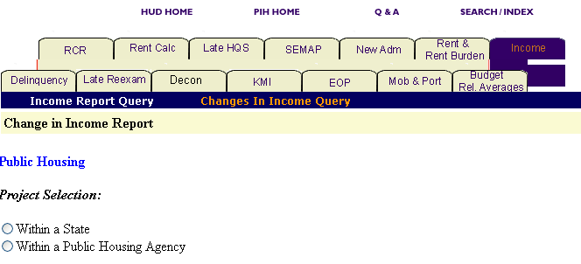
Figure 160: The Project Selection Levels for a Changes in Income Report

Option 1: Within a State

Select this option if you know the state containing the project you want.

Step | Action/Result
1. Click Project on the Select Level of Information list. | PIC displays a screen with two different options for identifying the project: Within a State and Within a Field Office.
2. Click Within a State. | A Select State from dialog box appears.
3. Click the state in the Select State from dialog box.
- Click the Projects button. | A dialog box is displayed with a list of projects within the selected state.
- Click the desired project(s) in the Select Projects(s) dialog box. | Note: To select more than one project, press the CONTROL key as you click each HA you want to include in the report.
- Click the Reports button. | A Changes in Income Report is generated for each project selected within the state.

Option 2: Within a Public Housing Agency

Select this option if you know the PHA containing the project you are looking for.

Step | Action/Result
1. Click Project on the Select Level of Information list. | PIC displays a screen with two different options for identifying the project: Within a State and Within a Public Housing Agency.
2. Click Within a Public Housing Agency. | A Select State from dialog box appears.
3. Click the state containing the PHA and project from the Select State from dialog box.
4. Click the HA List button. | A dialog box is displayed with a list of HAs associated with the selected field office.
5. Click the desired HA in the Select HA dialog box.
6. Click the Projects button. | A Select Project from dialog box is displayed for the selected Public Housing Agency within the state.
7. Click the project(s) in the Select Projects from dialog box. | Note: To select more than one project, press the CONTROL key as you click each HA you want to include in the report.
8. Click the Reports button. | A Changes in Income Report is generated for the identified project(s) that are associated with the selected HA.

Information Presented in a Changes in Income Report
When you complete your selections and click the Reports button, the PIC system generates the Changes in Income Report for the particular program and level of information selected. The selections are listed at the top of the report, along with the report’s start and end dates.

Changes in Income Reports contain two tables:

  - Other than Head of Household (HOH)-CoHead-Spouse
  - HOH-Cohead-Spouse

You can view information in ascending or descending order on a report by clicking the up or down arrow in any column.

Note: Multiple data selections might be split into sets. For example, if you have selected several states to include in the report (generally more than four), some of those selections are not displayed in the first report page.

To view these data selections:

Step | Action/Result
1. Click the Next Set arrow located at the bottom right of the report page to view the next data set. | The next data set displays.
2. Click the Prev Set arrow located at the bottom left of the report to return to the data set previously viewed. | The previous data set displays.
The following table details the information in a Changes in Income Report.

Table | Information Presented
Other than HOH-CoHead-Spouse | This table presents the following information on tenants in the selected level who are not the HOH, the co-HOH, or the HOH’s spouse:  - Age 18 to 62 (#)  - Non-Elderly or disabled (#)  - Wages with no welfare for the current quarter, the previous quarter, and the previous year (%)  - Welfare with no wages in the current quarter, previous quarter, and previous year (%)  - With both welfare and wages in the current quarter, previous quarter, and previous year (%)
HOH-Cohead-Spouse | This table reports the following information on tenants in the selected level who are the HOH, the co-HOH, or the HOH’s spouse:  - Age 18 to 62 (#)  - Non-Elderly or disabled (#)  - Wages with no welfare for the current quarter, the previous quarter, and the previous year (%)  - Welfare with no wages in the current quarter, previous quarter, and previous year (%)  - With both welfare and wages in the current quarter, previous quarter, and previous year (%)

The two graph or chart icons at the bottom of most tables are available, so you can view the information in either a Pie Chart or Bar Graph form. When the two icons are not visible, the information is only available in tabular form.

Figure 161: The Icons for converting table
information into a Bar Graph or Pie Chart.

The Changes in Income Report screen contains three options for further use of the data (see Figure 162). The options are located on the top right side of the report screen.

Select one of the following options:

  - Download in Excel: The report downloads to an Excel spreadsheet for further data manipulation.

  - Print Page: The report prints as a Web page.

Note: For the best results, print in landscape orientation.

- View Entire Report: All report subcategory tables display together on one screen.

Figure 162: The Options for further
use of report data.

To generate another report, repeat the process by returning to the Reports screen and selecting the tab for the next report. Go to the corresponding section of this PIC user manual that describes a specific report, and follow the steps provided to generate that report.

