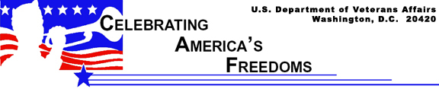

Guidelines for Display of the Flag

Public Law 94-344, known as the Federal Flag Code, contains rules for handling and displaying the U.S. flag. While the federal code contains no penalties for misusing the flag, states have their own flag codes and may impose penalties. The language of the federal code makes clear that the flag is a living symbol.

In response to a Supreme Court decision which held that a state law prohibiting flag burning was unconstitutional, Congress enacted the Flag Protection Act in 1989. It provides that anyone who knowingly desecrates the flag may be fined and/or imprisoned for up to one year. However, this law was challenged by the Supreme Court in a 1990 decision that the Flag Protection Act violates the First Amendment free speech protections.

Important Things to Remember

Traditional guidelines call for displaying the flag in public only from sunrise to sunset. However, the flag may be displayed at all times if it’s illuminated during darkness. The flag should not be subject to weather damage, so it should not be displayed during rain, snow and wind storms unless it is an all-weather flag.

It should be displayed often, but especially on national and state holidays and special occasions.

The flag should be displayed on or near the main building of public institutions, schools during school days, and polling places on election days. It should be hoisted briskly and lowered ceremoniously.

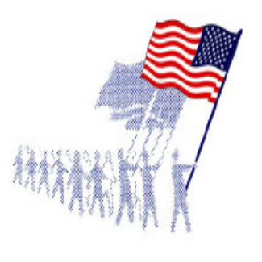When carried in procession with other flags, the U.S. flag should be either on the marching right (the flag’s right) or to the front and center of the flag line. When displayed on a float in a parade, the flag should be hung from a staff or suspended so it falls free. It should not be draped over a vehicle.When displayed with another flag against a wall from crossed staffs, the U.S. flag should be on its own right (left to a person facing the wall) and its staff should be in front of the other flag’s staff.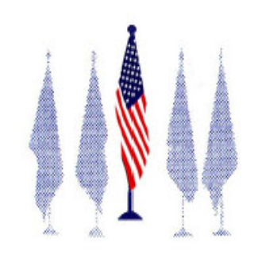In a group of flags displayed from staffs, the U.S. flag should be at the center and the highest point.
When the U.S. flag is displayed other than from a staff, it should be displayed flat, or suspended so that its folds fall free. When displayed over a street, place the union so it faces north or east, depending upon the direction of the street.When the U.S. flag is displayed from a staff projecting from a building, the union of the flag should be placed at the peak of the staff unless the flag is at half staff. When suspended from a rope extending from the building on a pole, the flag should be hoisted out, union first from the building.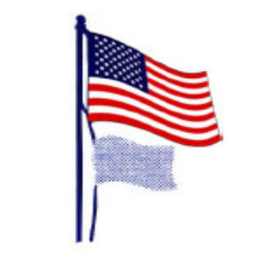When flags of states, cities or organizations are flown on the same staff, the U.S. flag must be at the top (except during church services conducted at sea by Navy chaplains).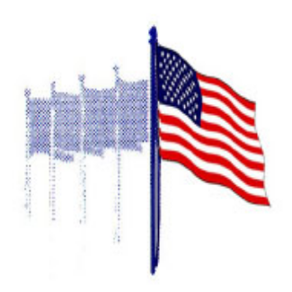When other flags are flown from adjacent staffs, the U.S. flag should be hoisted first
and lowered last. It must be on the right of other flags and no other flag should stand higher than it. Flags of other nations should be flown from separate staffs. International custom dictates that flags of different nations be displayed at the same height in peacetime and be approximately the same size.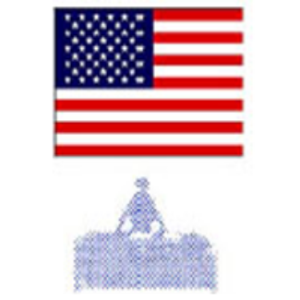When displayed flat against the wall on a speaker’s platform, the flag should be above and behind the speaker with the union on the left side as the audience looks at it (again, the flag’s right). 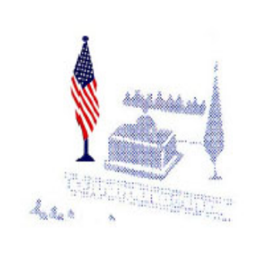When the flag hangs from a staff in a church or public place, it should appear to the audience on the left, the speaker’s right. Any other flags displayed should be placed on the opposite side of the speaker.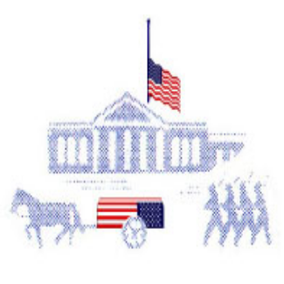The flag may cover a casket, but should not cover a statue or monument for unveiling. On a casket, the union (blue field) should be at the deceased person’s head and heart, over the left shoulder. But the flag should be removed before the casket is lowered into the grave and should never touch the ground. Whenever the flag is displayed at half-staff, it should be first raised to the top. Lowering from half-staff is preceded by first raising it momentarily to the top.
During the hoisting or lowering of the flag or when it passes in parade or review, Americans should stand at attention facing the flag and place their right hand over the heart. Uniformed military members render the military salute. Men not in uniform should remove any headdress and hold it with their right hand at their left shoulder, the hand resting over the heart. Those who are not U.S. citizens should stand at attention.

The flag should never be draped or drawn back in folds. Draped red, white and blue bunting should be used for decoration, with the blue at the top and red at the bottom.

The flag may be flown at half-staff to honor a newly deceased federal or state government official by order of the president or the governor, respectively. On Memorial Day, the flag should be displayed at half-staff until noon.

Other Things Not to Do with the Flag

Out of respect for the U.S. flag, never:
dip it for any person or thing, even though state flags, regimental colors and other flags may be dipped as a mark of honor.
display it with the union down, except as a signal of distress.
let the flag touch anything beneath it: ground, floor, water, merchandise.
carry it horizontally, but always aloft.
fasten or display it in a way that will permit it to be damaged or soiled.
place anything on the flag, including letters, insignia, or designs of any kind.
use it for holding anything.
use it as wearing apparel, bedding or drapery. It should not be used on a costume or athletic uniform. However, a flag patch may be attached to the uniform of patriotic organizations, military personnel, police officers and firefighters.
use the flag for advertising or promotion purposes or print it on paper napkins, boxes or anything else intended for temporary use and discard.

During the hoisting or lowering of the flag or when it passes in parade or review, Americans should stand at attention facing the flag and place their right hand over the heart. Uniformed military members render the military salute. Men not in uniform should remove any headdress and hold it with their right hand at their left shoulder, the hand resting over the heart. Those who are not U.S. citizens should stand at attention.

When the flag is worn out or otherwise no longer a fitting emblem for display, it should be destroyed in a dignified way, preferably by burning.

