

Version 4

EL-CID Point of Contact Information

EL-CID Support Center Web Site

HTTP://NTIACSD.NTIA.DOC.GOV/ELCID

NTIA Office of Spectrum Management Web Site

HTTP://WWW.NTIA.DOC.GOV/OSMHOME/OSMHOME.HTML

EL-CID Help Desk

Email: ELCIDHelp@AlionScience.Com

Comm. 410.573.7117 DSN 281.2411 x7117

Program Manager: NTIA (Craig Scammon, CScammon@ntia.doc.gov)

Table of Contents
INTRODUCTION 6
USEFUL TERMS AND HINTS 6
1. STARTING THE EL-CID PROGRAM 7
2. Setting System Preferences 9
3. Using Tools 11
4. Reviewing Help Topics 17
5. Creating a New Certification 18
5.1 Selecting Stations 20
5.2 Drawing Links between Stations 22
5.3 Entering General Information 24
5.4 Entering Location Data 25
5.5 Entering Application Classification Markings 30
5.6 Entering Station Data 31
5.6.1 Entering Transmitter Data 31
5.6.2 Entering Receiver Data 42
5.6.3 Entering Antenna Data 50
5.6.4 Getting Existing Transmitter Data 52
5.6.5 Getting Existing Receiver Data 54
5.6.6 Getting Existing Antenna Data 55
5.7 Entering Data For Links 56
5.8 Adding Attachments 65
5.9 Viewing The Status Log 68
6. RUNNING COMPLIANCE CHECKS 71
7. EXPORTING CERTIFICATION RECORDS 74
8. PRINTING A CERTIFICATION RECORD 77
9. IMPORTING A CERTIFICATION APPLICATION 81
10. OPENING AND EDITING AN UNAPPROVED CERTIFICATION RECORD 84
11. CLONING RECORDS 94
12. OPENING AND VIEWING AN APPROVED CERTIFICATION RECORD 100
13. CREATING A TRUNKING SYSTEM CERTIFICATION USING A TEMPLATE 105
14. ADDING LOCATIONS FROM THE MAP 107
15. PERFORMING QUERIES 111
APPENDIX A - QUICK REFERENCE GUIDE 119
APPENDIX B - IMPORTING UPDATED COMPLIANCE CHECKS 129
APPENDIX C - FREQUENTLY ASKED QUESTIONS 131
C.1 What do the non-compliance messages mean when running compliance checks? 131
C.2 I have failed a compliance check, what do I do? 131
C.3 I think that a compliance check is incorrect. 131
C.4 I just have one radio, how do I draw a link? 131
C.5 I don’t understand how repeaters are represented on the trunking diagram. 132
C.6 I have a change that I would like to be made to the EL-CID model. 132
C.7 The frequency allocation table does not list the operating frequencies of my transmitter as being valid. 132
C.8 Why can’t I draw links between some of the station icons? 133
C.9 What Frequency Range Do I Use For The Transmitter, The Operating Range Or The Range I Want To Use? 133
C.10 I have a range of power values, what do I do? 133
C.11 May I have multiple emission codes for a single transmitter? 133
C.12 When is NTIA going to require the use of EL-CID? 134
C.13 How can I get any data that NTIA has in EL-CID format? 134
C.14 How can I represent an antenna that has multiple gains or multiple frequencies? 134
C.15 Why is it possible to put location data on a station node? 134
C.16 Do I have to draw the line diagram first? 135
C.17 What receiver IF data do I put in the model? 135
C.18 How do I assign multiple radio services to a station icon? 135
C.19 How do I represent a ship board mobile earth station? 135
C.20 How do I represent an airborne radar station? 135
APPENDIX D – SAMPLE SATELLITE SYSTEM 137
APPENDIX E – SAMPLE RADAR SYSTEM 145

INTRODUCTION

The intent of this manual is to introduce you to some of the capabilities of the EL-CID program. An introduction to all of the capabilities would occupy more time then we are allotted. The user should become familiar with the help file that gives a greater in-depth explanation of the options of the model. Additional help can be obtained from the resources printed on the inside cover of this document.

We understand that these examples are simple in nature and may not completely mimic your operation, but are used to show the capabilities of the system.

If you have any comments please send them to the El-CID help desk or if you have a suggestion for the program operation, write a program change request and sent it to the EL-CID help desk.

Thank you,

EL-CID Development Team
EL-CID Training Team

USEFUL TERMS AND HINTS

Save There are at least three ways to save data:
1. Click on the save button . This will save your data and allow you to continue processing.

2. Click on the left side of the screen in the tree view section (any node or at the bottom of the tree). This will save your data and allow you to continue processing.
3. Click on the close button . This will save your data and close the certification.

Tree View
Refers to the left side of the screen and presents an image similar to windows explorer.

Expand Tree View
To expand the tree view, highlight a node in the tree view and press . All
nodes under the highlighted node will be expanded.

Collapse Tree View
To collapse the tree view, highlight a node in the tree view and press . All nodes under the highlighted node will be collapsed.

Data Grid
Refers to the right side of the screen and is a place to input data.

Move between lines in the data grid.
To move between lines in the data grid, click the mouse in the data field, or use the to move up or the to move down the grid. The also moves the cursor between fields in the data grid.

User Actions and input data
User actions and input data are highlighted.

1. STARTING THE EL-CID PROGRAM
Step 1. To start the EL-CID program, double-click the EL-CID icon  on the Windows desktop. The EL-CID Splash window will be displayed.

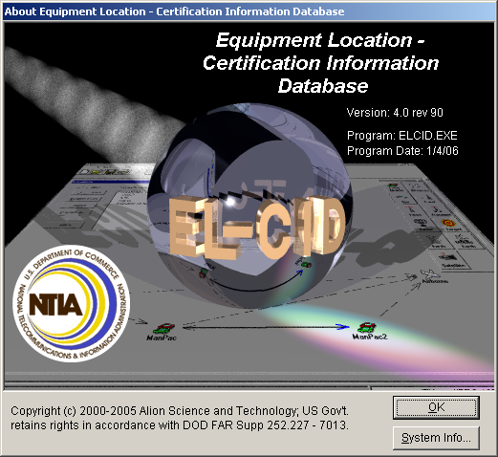

The EL-CID Release Information window will then be displayed.

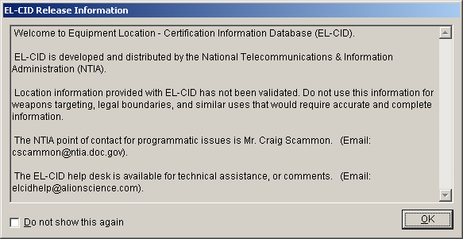

Step 2. Check the Do not show this again check box if you don't want to see the Release Information window in the future and then click OK.

HINT: If you check you can still retrieve this window by resetting the option in the Preferred Settings window.

The Login window is displayed.

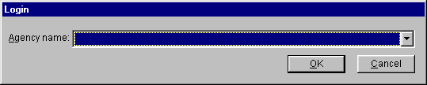
Step 3. Choose your Agency name by clicking the down arrow button and clicking on your agency (e.g., AR - Department of the Army) in the list that drops down. For purposes of this training, choose AR – Department of the Army.

HINT: You can type in the first character of your agency name abbreviation to go down in the list. Pressing the letter again will go to the next agency whose abbreviation begins with the letter.

Step 4. Click OK. The Startup EL-CID Wizard window is displayed.

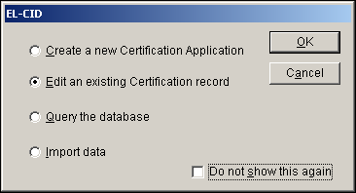

Step 5. You may select what you want to do by clicking on one of the radio buttons, and then clicking OK. You may click Cancel if you want to go directly into the EL-CID program without the aid of the Startup Wizard.

HINT: Check the Do not show this again check box if you don't want to use the Startup Wizard in the future.

Step 6. Click the Cancel button.

2. Setting System Preferences

Step 1. The Preferred Settings window permits you to set the default units for entry of data items that have associated units and to set the tool bar to use large or small icons. To change your settings, click the Preferences button on the tool bar.

The Preferred Settings window is displayed. The options you see checked in the screen above are the installed defaults.
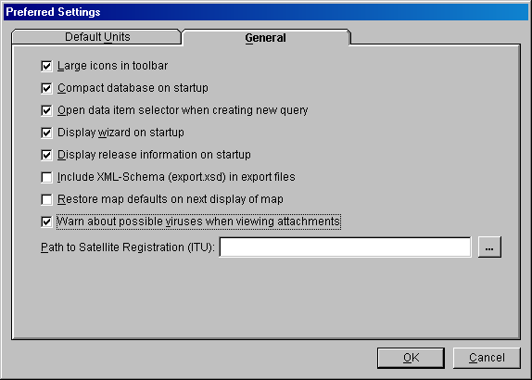

The Default Units tab permits you to control the units used to display numeric quantities throughout the program. Click in the field to select it and click the units to get the drop down list.

HINT: In Used For: The tree view node name is given first, followed by the field name.

Step 2. Click OK (to save changes) or Cancel.
3. Using Tools

This option is used to exercise the EL-CID tool options.

Step 1. Select Tools | Data Item Finder.

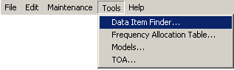

The Data Item Finder window is displayed.

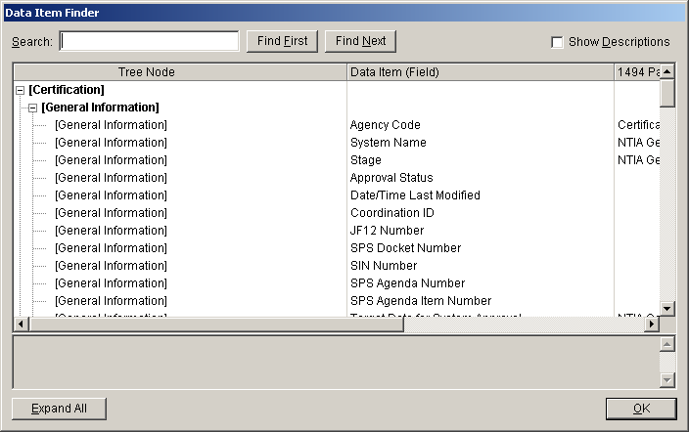

While working on EL-CID records, especially in the Tree View, you may have difficulty finding a specific data item. The Data Item Finder will help you locate where the item is in the tree. The Data Item Finder will also help you to cross-reference EL-CID data items to the individual blocks on DD 1494 printed forms. This window lists all the data items used in EL-CID in a tree-like structure closely paralleling the same structure used in the Tree View. It also shows the page and block where items are printed on DD 1494 forms.

Step 2. Close the Date Item Finder window by clicking OK.

Step 3. Select Tools | Frequency Allocation Table from the menu.

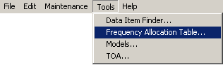
The Frequency Allocation Table is displayed.

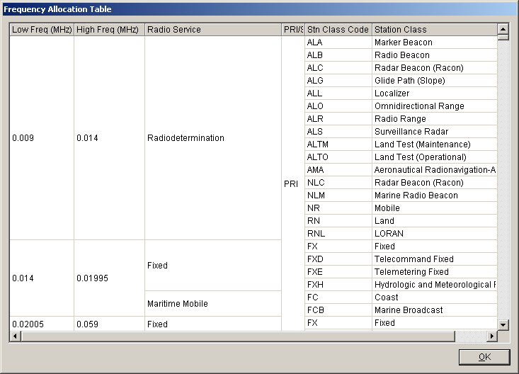

HINT: You can sort the data by clicking any of the column headers.

HINT: You can change the order of the columns by dragging the column headers right or left.

HINT: You can quickly find data by selecting the column and typing. For example, to find Mobile radio service rows, click the Radio Service column header to sort by Radio Service, then type MO.

HINT: You can copy data from the grid to the Windows clipboard for use in another program. To do this click anywhere in the grid and press Ctrl-C. A dialog appears with some options. Try it!

HINT: These grid capabilities are generally available throughout the program whenever you see a grid.

Step 4. Close the Frequency Allocation Table by clicking OK.

Step 5. Select Tools | Models from the menu.

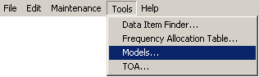

The Model window is displayed

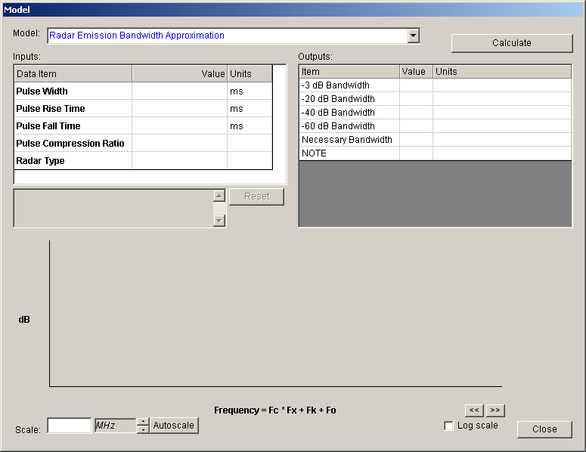

Step 6. Click on the down arrow to display all the models available. Choose Radar Emission Bandwidth Approximation

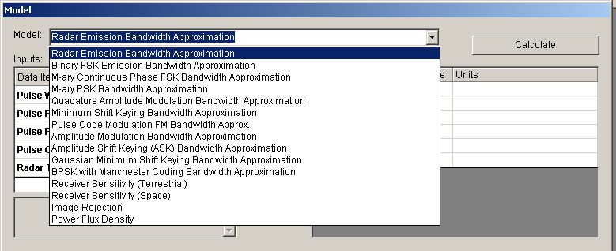

Step 7. Enter the following data and then click

Field | Value | Units
Pulse Width | 1 | usec (microseconds)
Pulse Rise Time | .05 | usec (microseconds)
Pulse Fall Time | .05 | usec (microseconds)
Pulse Compression Ratio | 50
Radar Type | FM Pulse Radar

HINT: Choose the units first; Click in the Units field and right-click to get the available units.
HINT: Notice when focus leaves a data item the units switch back to the default units on the preferences screen, and the value is converted.

The Model results window will appear.

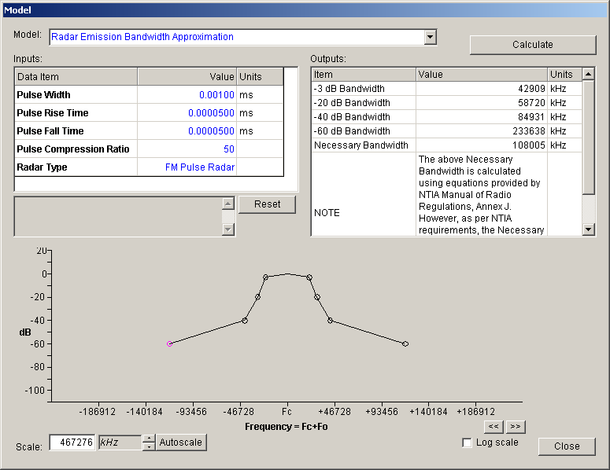

Step 8. Right-click on the graph and highlight Add Annotation

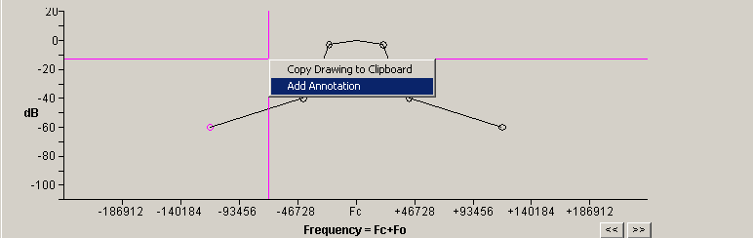

The Annotation window is displayed.

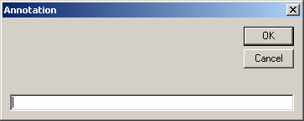

Step 9. Type Test Title and click OK.

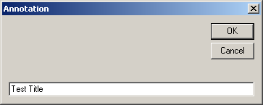

The title will appear on the graph and can be moved.

HINT: Multiple titles may be added by repeating Step 8 and Step 9.
HINT: The title may be dragged to a new location on the graph.

Step 10. Right-click on the title and additional options are available

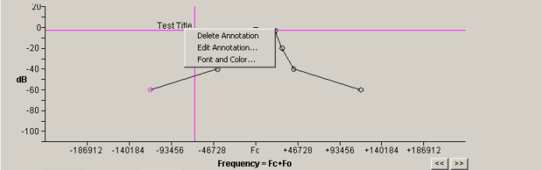

Step 11. Close the Model window by clicking Close.

Step 12. Select Tools | TOA from the menu.

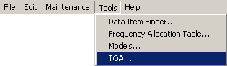

The Table of Allocation window is displayed.

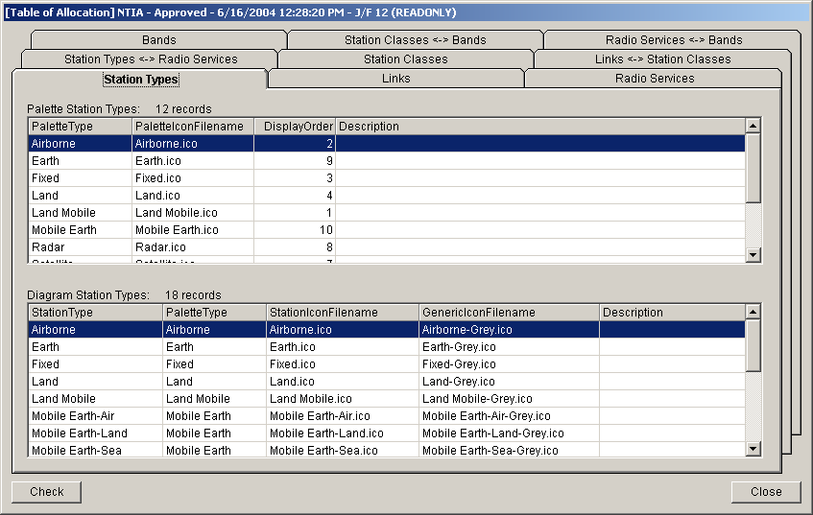

Step 13. Close the Table of Allocation window by clicking Close.
4. Reviewing Help Topics

This option is used to view the EL-CID help information.

Step 1. Select Help | Contents and Index, or select the  button.

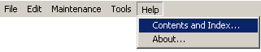

The EL-CID help file will be displayed. These help topics have been saved to a Microsoft Word document and it is on the installation CD (ELCIDhelp.doc) and in the Documents folder under the EL-CID program.

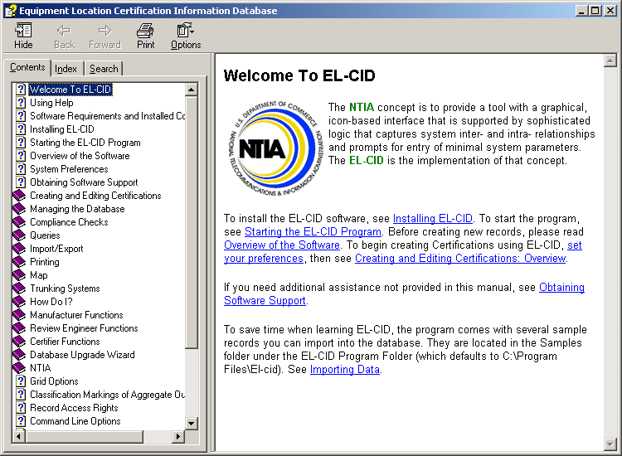

Step 2. Close the Help window by clicking the close button in the upper right corner.

5. Creating a New Certification
Step 1. Click the Create New Certification button on the tool bar or from the File menu select New | Certification.

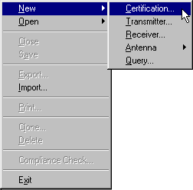

The New Certification Application window is displayed.

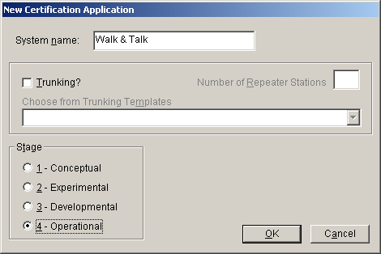

Step 2. Enter the following data and then click OK.

Field | Value
System name | Walk & Talk
Stage | 4-Operational

HINT: You may not use the word “and” in a System Name. You may use the ampersand or “AND” (uppercase).

HINT: We will use the Trunking option later in Section 13.

The Tree View is displayed with a blank Line Diagram automatically selected and the stations palette displayed.

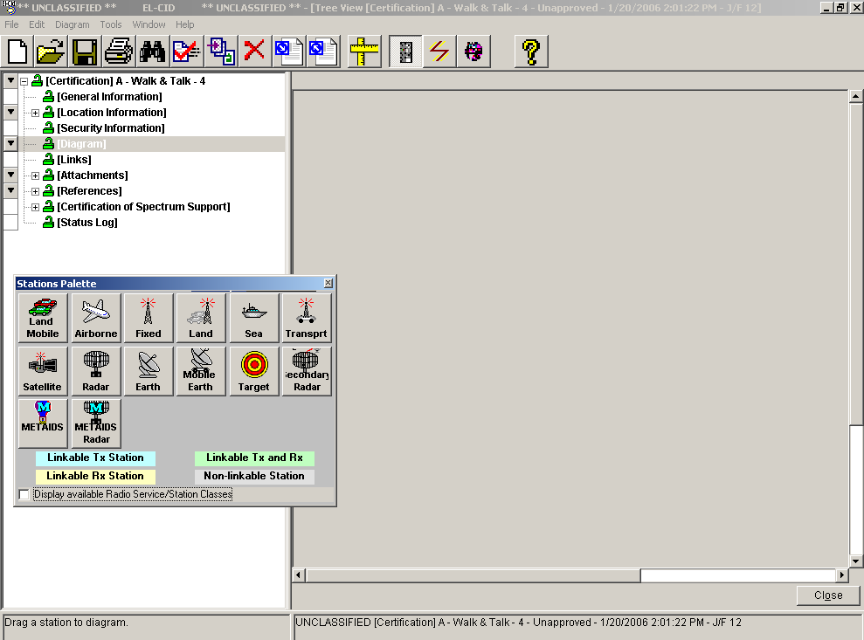

5.1 Selecting Stations
Step 1. On the Stations Palette window check the Display available Radio Service/Station Classes check box.

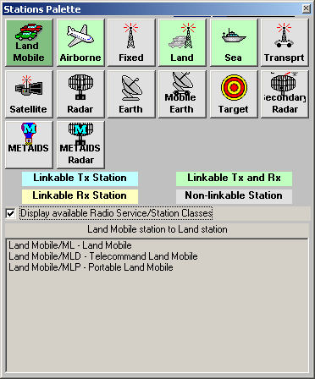

HINT: The icons you choose for your diagram will determine the radio service and station classes available for the links you draw between them. In addition there are rules about which icons can be linked to each other, these rules are displayed using various colors.

Step 2. Click on the Land Mobile icon and drag it to the drawing area on the right.

The Change Station Name window is displayed with Land Mobile as the station name.

Step 3. Type WAT1 and then click OK.

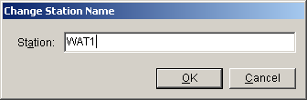

Step 4. Drag two more Land Mobile icons to the drawing area and name them WAT2 and WAT3.
Step 5. Close the palette using the X in the upper right or by clicking the Stations Palette button 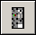 from the tool bar.

HINT: The Stations Palette may be redisplayed by clicking the Stations Palette button again.

The diagram will resemble the following.

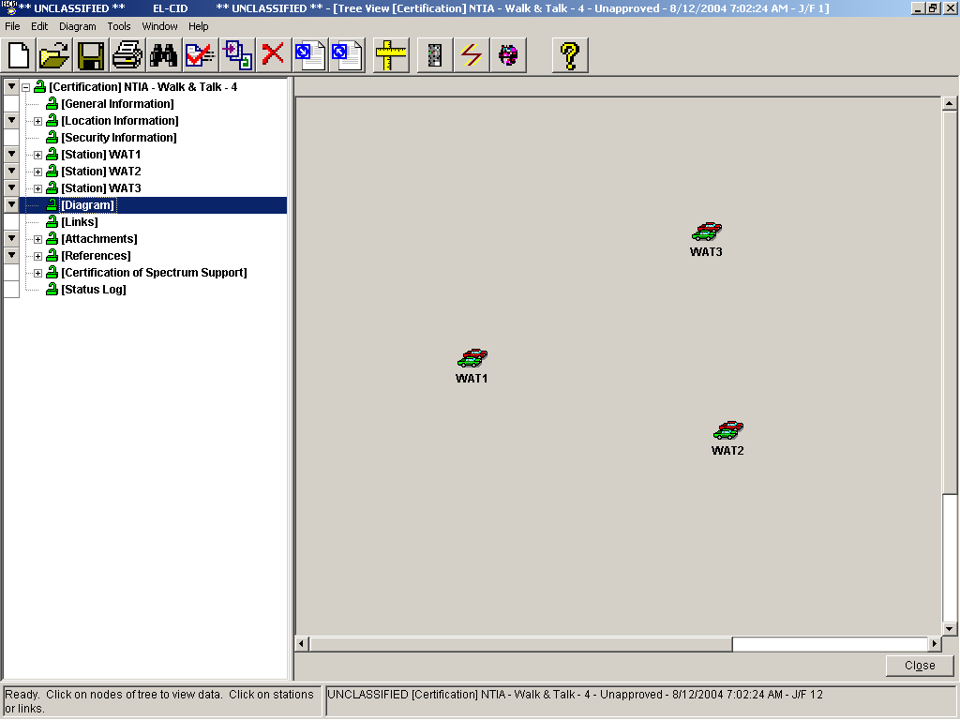

HINT: You may move the stations by clicking and dragging them.

HINT: When you hover the mouse pointer, the station type pops up in a small yellow box.

5.2 Drawing Links between Stations
Step 1. Click the Create New Links button on the tool bar. The words "Link Mode !!" appear at the top of the diagram, and the screen changes color, whenever the program is in Link Mode.

Step 2. Click once on the transmitting station WAT1 icon, and then click once on the receiving station, WAT2 icon. A dotted line will be drawn between the stations, with an arrowhead at the receiving end of the link. Notice that the link was added to the tree view.

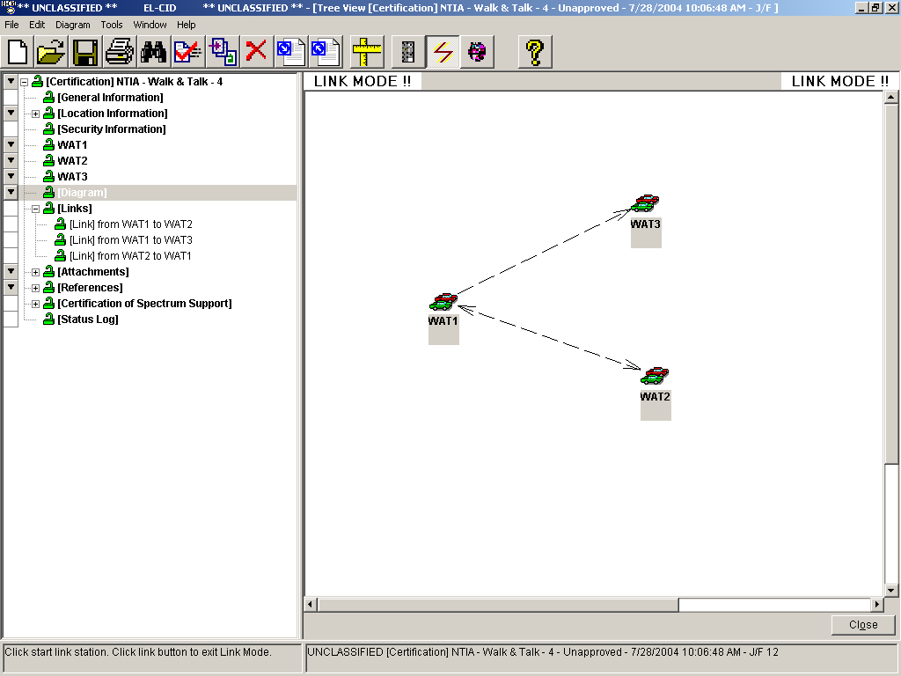

Step 3. Draw additional links from WAT2 to WAT1 and from WAT1 to WAT3. Do not draw a link from WAT3 to WAT1.

Step 4. Click the Create New Links button on the tool bar. The words "Link Mode !!" will disappear from the top of the diagram and the screen will change color.

Step 5. Right-click on the WAT3 Station icon, and then click Generic in the popup menu that is displayed,

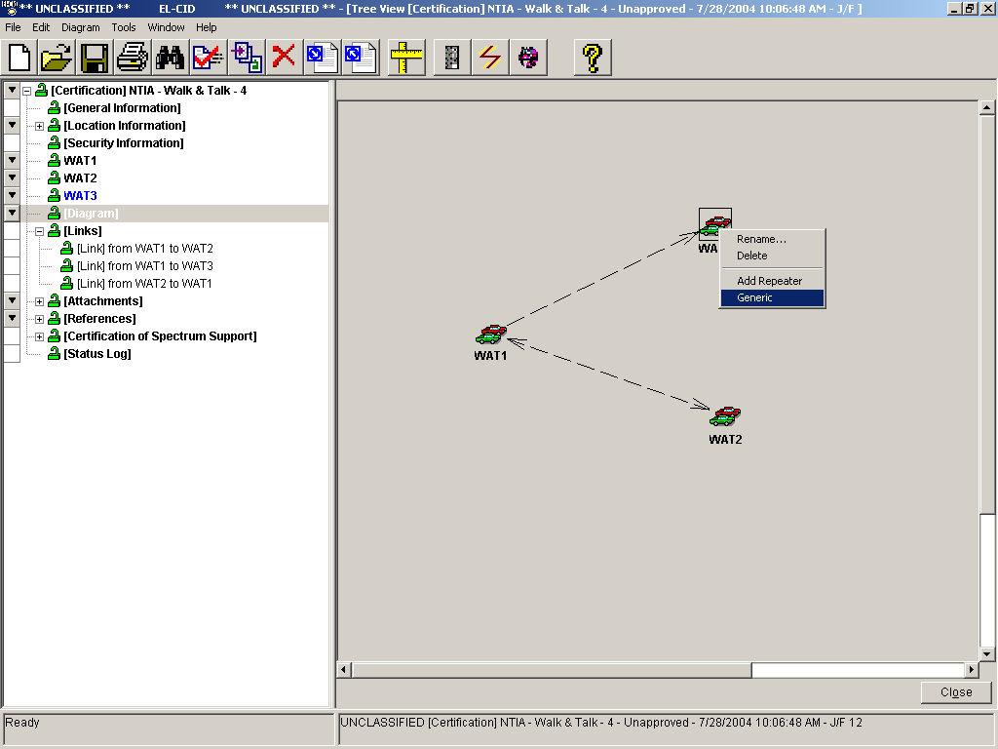

A shaded background is displayed around the Station icon to indicate that it is generic.

HINT: A generic icon 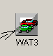 does not require receiving equipment data to be entered. The generic icon may be `used as a termination for a link but cannot be used as a transmitting station. The transmitting station is now able to enter the link data between the transmitter and the generic station.

5.3 Entering General Information
Step 1. Click on the General Information node in the tree view.

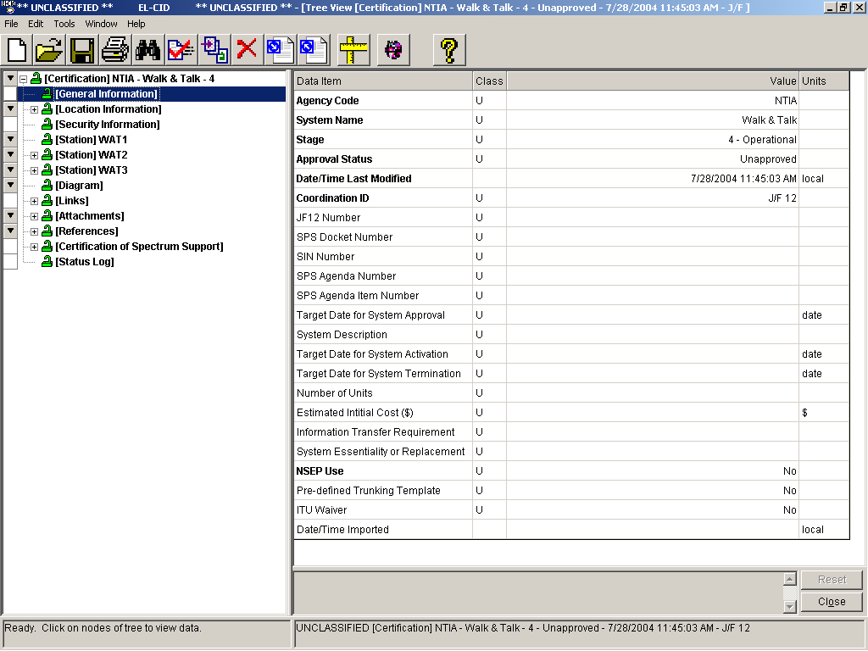
Step 2. Enter the following information by clicking in the appropriate field and entering the information.

Field | Value
Target Date for System Approval | 10/30/2006
System Description | This unit is a small, lightweight radio capable of providing two-way ground communications
Target Date for System Activation | 10/30/2006
Target date for System Termination | 10/30/2020

HINT: If entering data with units, select the units first, then enter the data. Check each data field to determine if there is a drop down list (indicated by ), an expanded memo field or user select list (indicated by ). Entries in BLUE indicate that the data is in the correct

format. Entries in RED indicate that there is a problem with the data format. When the data is saved by clicking on a node in the tree view, or by clicking , the data will turn BLACK. In

general If you click anywhere else on the screen outside the data grid, the data that you have

entered will be saved to the database.

5.4 Entering Location Data
Step 1. Right-click on the Location Information node in the tree view, then click Get Existing Location.

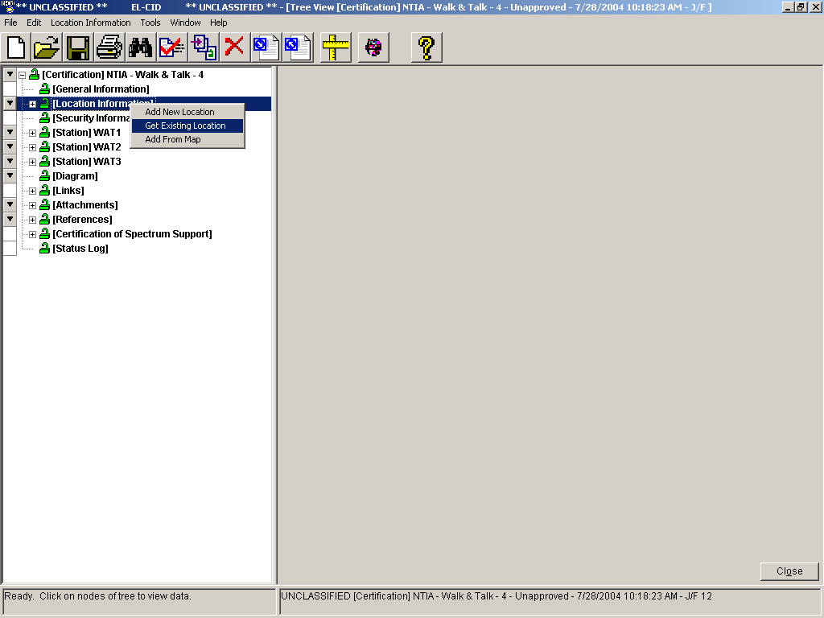

The Select State, Country or Area window is displayed.

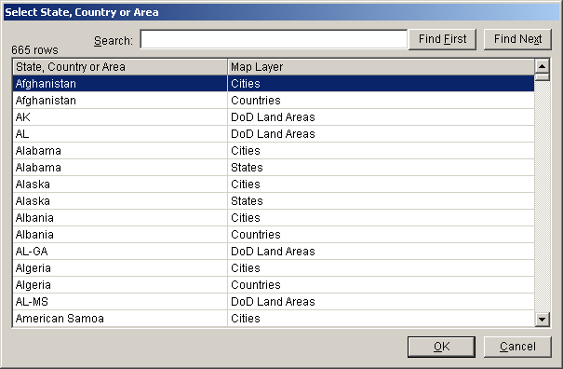

Step 2. Type Maryland, click the FindFirst button, then click the Maryland | States row. Click OK.

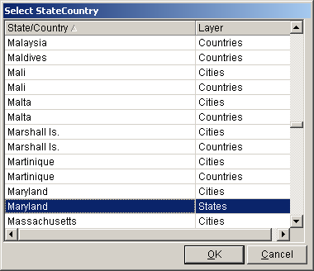

Step 3. The Select City or blank for Entire Area window is displayed. Click OK to select the States Layer.

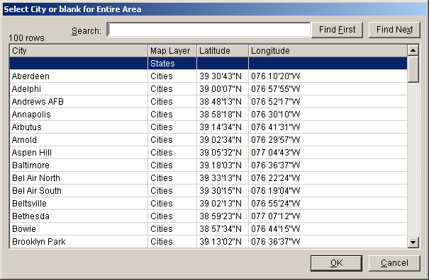

Step 4. The Pick Existing Location window is displayed.

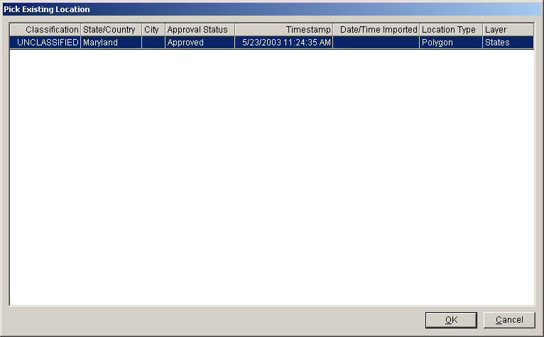

Step 5. Click OK The location data will be added and another entry in the tree view will be created.
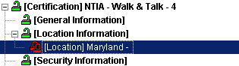

The red, closed padlock next to Maryland indicates that this is an Approved location and you are not permitted to alter the Maryland data.

Step 6. To create a new location, right-click on the Location Information node in the tree view and then click Add New Location.

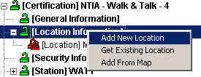

The New Location data grid is displayed.

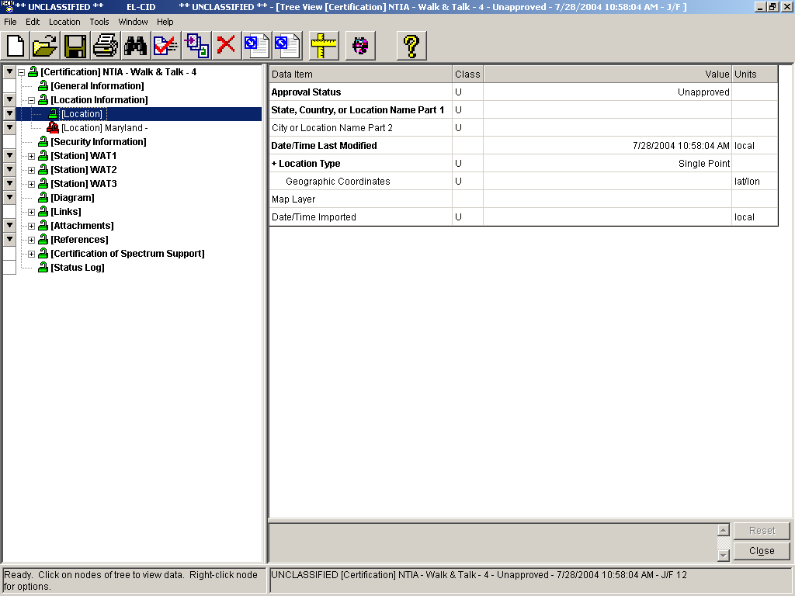

Step 7. Enter the following information.

Field | Value
State, Country, or Location Name Part 1 | Virginia
City or Location Name Part 2 | Training Area 1
Location Type | Center point and Radius
Geographic Coordinates | 370000N 0800000W
Radius | 100 km

HINT: The Geographic Coordinates are divided into two segments in the data field (latitude and Longitude).

Step 8. Save the data.

5.5 Entering Application Classification Markings
Step 1. Click the Security Information node from the tree view. The Security Information window will be displayed.

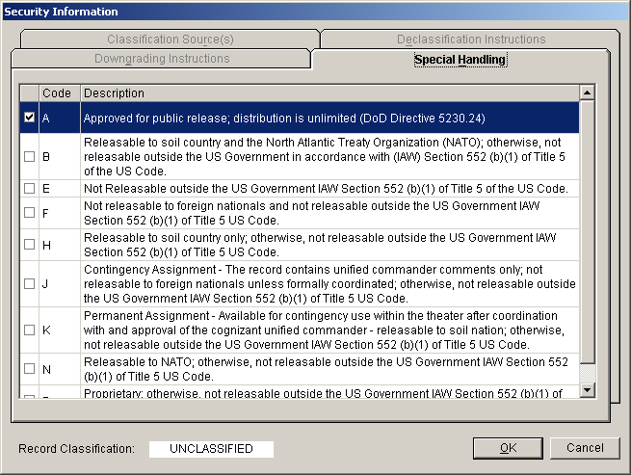

All Certification records are required to have a Special Handling Code. When you create a brand new Certification, the record is unclassified and the Special Handling Code defaults to "A", which means unlimited distribution. If a record becomes classified, the "A" code is erased and you must specify a new Special Handling Code. In addition, all classified records are required to have a Classification Source and Declassification Instructions. Secret records may also have Downgrading Instructions.

When the record is classified, use the 4 tab views on this screen to enter the appropriate security data.

Step 2. Click OK to save the data.

5.6 Entering Station Data
Station data consists of transmitter data, receiver data, and antenna data. If required, you could also enter specific location data.

5.6.1 Entering Transmitter Data
Step 1. Right-click on the [Station] WAT1 from the tree view and then select Add Transmitter | Add New Transmitter.

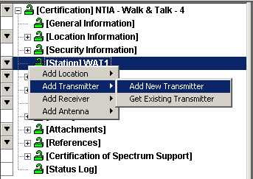

The Add Nomenclature window will be displayed.

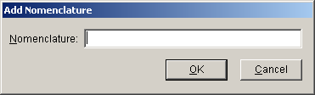

Step 2. Type Walk & Talk Tx and then click OK.

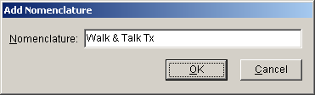

The Transmitter data grid is displayed:
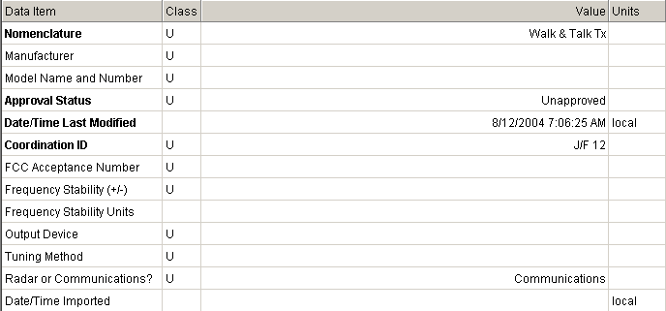

Step 3. Enter the following data

Field | Value
Manufacturer | RELM Communications, Inc
Model Name and Number | Model 127A
FCC Acceptance Number | K95LT20002
Frequency Stability (+/-) | 5
Frequency Stability Units | ppm
Output Device | Si Bipolar Transistor
Tuning Method | Synthesizer

HINT: Manufacturer is a user select list (indicated by ). You can type relm in the manufacturer list to find the correct entry.

Step 4. Right-click on [Transmitter] Walk & Talk Tx | Add Power.

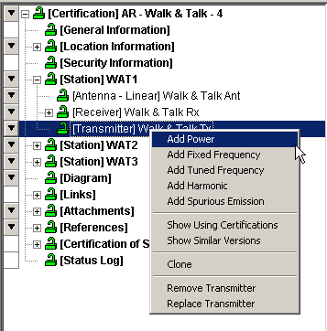

The Power data grid is displayed.

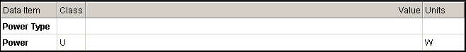

Step 5. Enter the following data.

Field | Value
Power Type | Mean
Power | 3 W

Step 6. Right-click on [Transmitter] Walk & Talk Tx | Add Tuned Frequency.

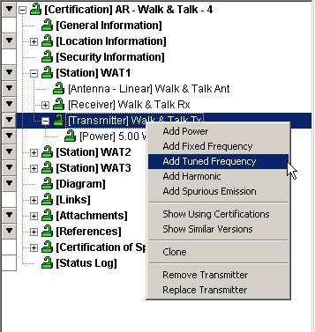

The Tuned Frequency data grid is displayed.

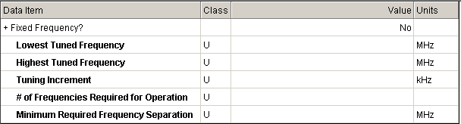

Step 7. Enter the following data.

Field | Value
Lowest Tuned Frequency | 136 MHz
Hightest Tuned Frequency | 160 MHz
Tuning Increment | 12.5 kHz

HINT: Frequencies may be entered as M136, 136M, K136000, or 136000K, etc.

Step 8. Right-click on [Transmitter] Walk & Talk Tx | Add Harmonic.

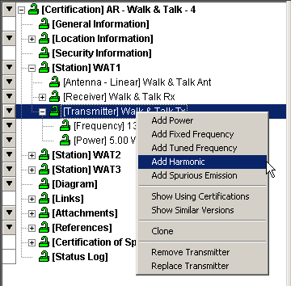

The Harmonic Level curve window is displayed.

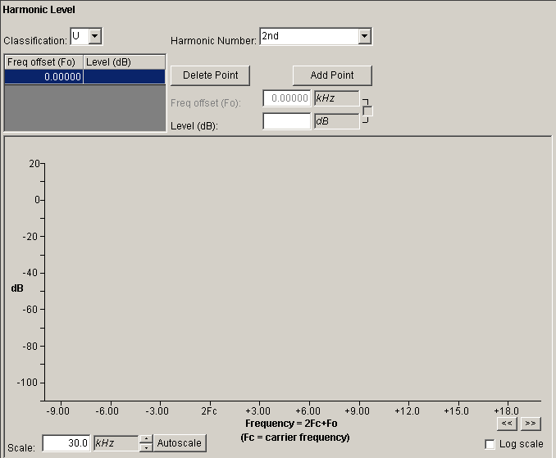

Step 9. Enter the following data and Save.

Field | Value
Harmonic Number | 2nd
Level | -60 dB

Step 10. Enter another harmonic data set as shown below, following step 8.

Field | Value
Harmonic Number | 3rd
Level | -60 dB

HINT: You may type the data in the block, or you may put the cursor on the graph and indicate the level that you want to enter by left-clicking. A combination of both may be used if you prefer.

HINT: If you type the value into the block, press Tab or click in the Freq offset/Level grid to complete the entry. Do not move the mouse pointer down into the graph area, otherwise the value you entered will change as it tracks the mouse pointer. If you make this mistake, simply move the mouse cursor out of the graph area without clicking. The value you entered will be restored.

Step 11. Right-click on [Transmitter] Walk & Talk Tx | [Frequency] 136.00 – 160 MHz | Add Emission Designator.

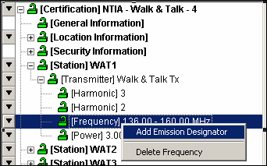

The Emission Designator data grid is displayed.

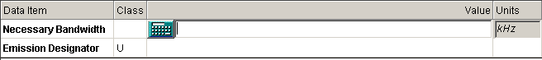

Step 12. Enter the following data.

Field | Value
Necessary Bandwidth | 11 kHz
Emission Designator | 11K0F3E

HINT: If you need help in determining the Necessary Bandwidth you can click on the button to access one of the models.
HINT: If you need help in determining the Emission Designator you can click on the button to access the Emission Designator Wizard.

Step 13. Right-click on [Emission Designator] 11K0F3E | Add Modulation.

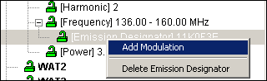

The Modulation data grid is displayed.

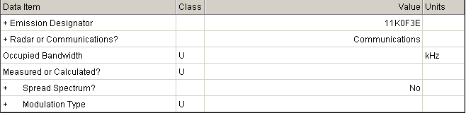

Step 15. Enter the following data and Save.

Field | Value
Occupied Bandwidth | 11 kHz
Measured or Calculated | Measured
Spread Spectrum | No
Modulation Type | Analog Modulation (AM, FM, or Phase)
Deviation Ratio | 0.833
Maximum Modulation Frequency | 3 kHz

Notice that the Deviation and Maximum Modulation Frequency items do not appear until Analog Modulation is chosen. The program will hide irrelevant items. The plus sign (+) next to Modulation Type indicates that other items will appear or disappear depending upon what you choose for the Modulation Type.

HINT: Notice that the Peak Deviation Field is calculated. Enter any two of the fields; Peak Deviation, Deviation Ratio, or Maximum Modulation Frequency and the third field will be calculated.

Step 16. Click on [RF Fundamental Curve].

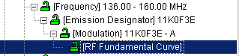

The RF Fundamental Curve window is displayed.

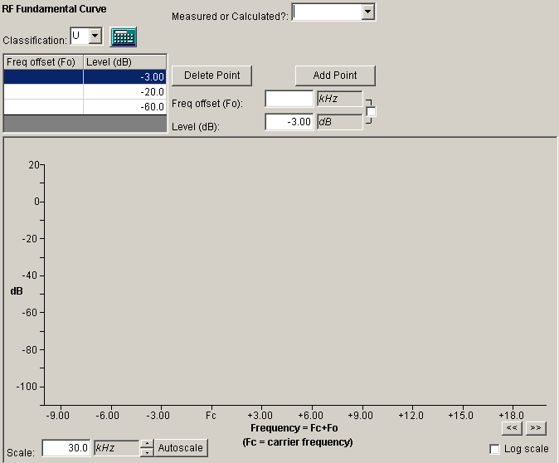

Step 15. Enter the following data.

Field | Value
Measured or Calculated | Measured

Step 16. Highlight the point to be entered in the point grid

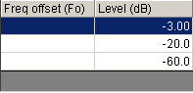

Step 17. Enter 4 in the Frequency Offset.

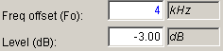

HINT: Freq offset equals ½ bandwidth

Step 18. Save the data

HINT: You can save the data in the traditional manner, or by clicking the first value in the point grid field. Each data point must be entered and saved.
Step 19. Enter the following data, by following Step 16 through Step 18.

Field | Value
Freq Offset (1/2 Bandwidth) at –20 dB | 4.5 kHz
Freq Offset (1/2 Bandwidth) at –60 dB | 10 kHz

Step 20. Click the button. The input grid will be empty.

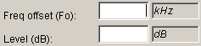

Step 21. Enter the following data and Save.

Field | Value
Freq Offset (1/2 Bandwidth) at –40 dB | 7.5 kHz

HINT: You may click in the data block and type the data, or you may put the cursor on the graph and indicate the level that you want to enter by left clicking, for either input (Freq Offset, or Level). A combination of both may be used if you prefer. If you use the check box you may use the cursor for both x and y inputs.

Click the Autoscale button. The resulting RF Fundamental Curve should look like the following:

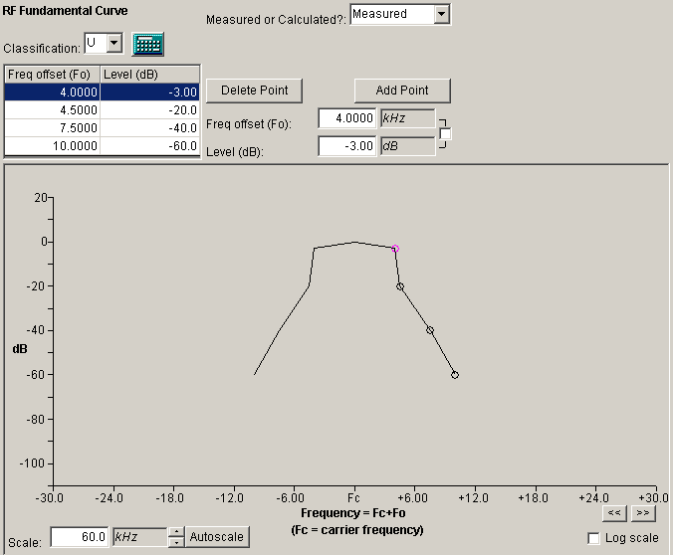

Step 22. Click on [Transmitter].Walk & Talk | Add Spurious Emission

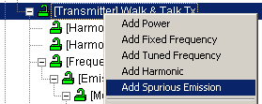

The Spurious Emission Curve window is displayed;

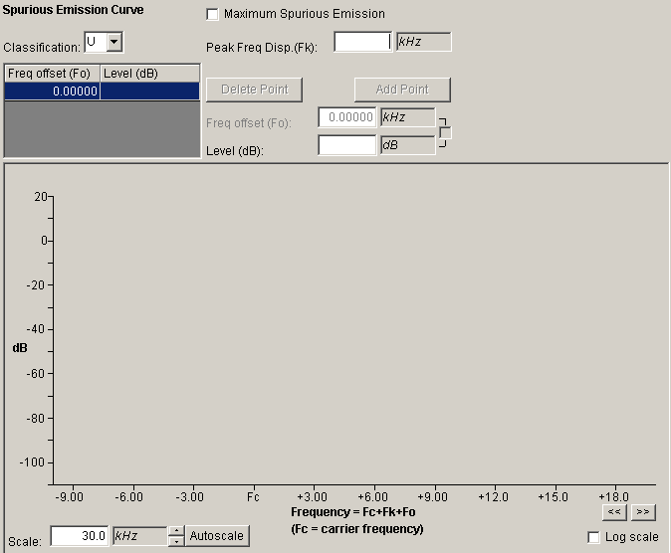

Step 23. Check the box

Step 24. Enter the following; either typing the data or graphically using the cursor, and Save.

Field | Value
Level | -60 dB

The Spurious Emission Curve appears as a single line because it represents the maximum of all spurious emissions across all frequencies.

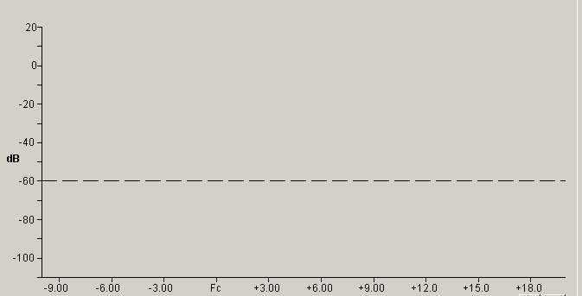

This completes the data entry for the Transmitter Walk & Talk Tx, and the tree view looks like the following:

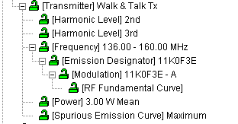

5.6.2 Entering Receiver Data
Step 1. Right-click on the [Station] WAT1 and highlight Add Receiver | Add New Receiver.

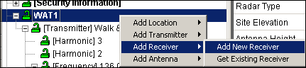

The Add Nomenclature window is displayed.

Step 2. Type Walk & Talk Rx and click OK.

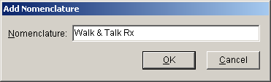

The Receiver data grid is displayed.

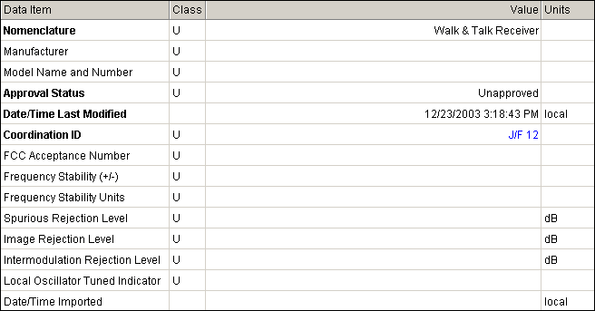

Step 3. Enter the following receiver data.

Field | Value
Manufacturer | RELM Communications, Inc
Model Name and Number | Model 127A
FCC Acceptance Number | K95LT20002
Frequency Stability (+/-) | 5
Frequency Stability Units | ppm
Local Oscillator Tuned Indicator | Below

HINT: You can type the Manufacturer name in the block, but it has to be the exact spelling and punctuation as appears in the user select list.

Step 4. Right-click on [Receiver] Walk & Talk Rx | Add Tuned Frequency.

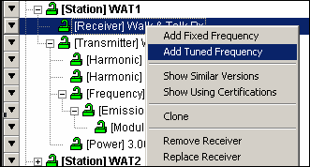

The Tuned Frequency data grid is displayed

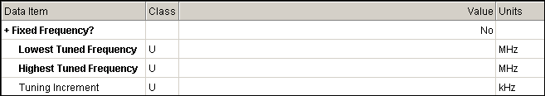

Step 5. Enter the following tuned frequency data.

Field | Value
Lowest Tuned Frequency | 136 MHz
Hightest Tuned Frequency | 160 MHz
Tuning Increment | 12.5 kHz

Step 6. Right-click on the Receiver [Frequency] 136 – 160 MHz | Add Emission – Stage Sensitivity.

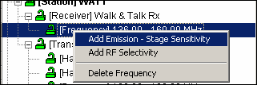

The Emission – Stage Sensitivity data grid is displayed.

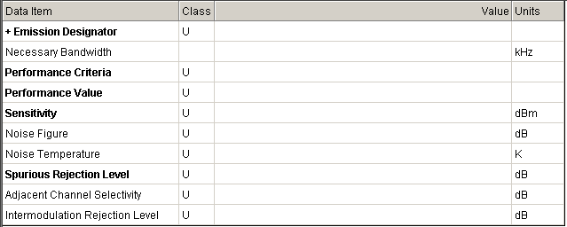

Step 7. Enter the following emission data.

Field | Value
Emission Designator | 11K0F3E
Performance Criteria | SINAD–Signal+Noise+Distortion-to-Noise+Distortion Ratio (dB)
Performance Value | 10
Sensitivity | -119 dBm
Spurious Rejection Level | 75 dB
Adjacent Channel Selectivity | 75 dB
Intermodulation Rejection Level | 75 dB

Step 8. Right-click on [Emission – Sensitivity] 11K0F3E – 119 dBm | Add IF Selectivity.

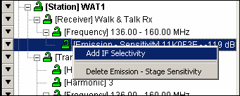

The IF Selectivity Curve window is displayed.

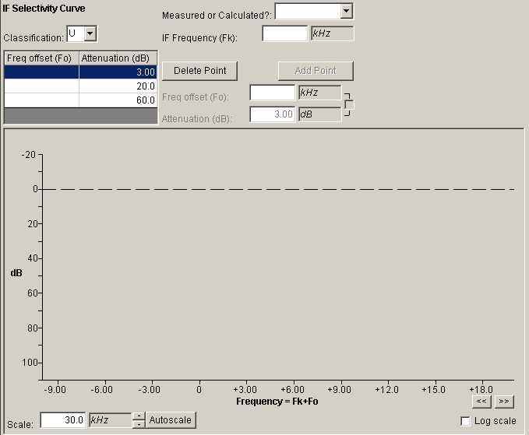

Step 9. Enter the following intermediate frequency data.

Field | Value
Measured or Calculated | Measured
IF Frequency | M455
Freq Offset (1/2 Bandwidth) at 3 dB | 4.5 kHz
Freq Offset (1/2 Bandwidth) at 20 dB | 7.5 kHz
Freq Offset (1/2 Bandwidth) at 60 dB | 15 kHz

Click the Autoscale button to redraw curve.
The resulting IF Selectivity Curve should look like the following:

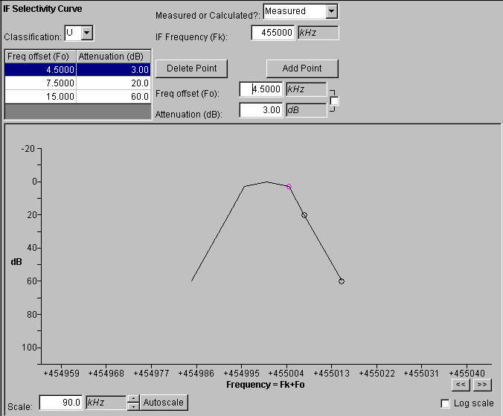

Step 10. Right-click on [Frequency] 136 – 160 MHz | Add Emission – Stage Sensitivity to enter a second set of data.

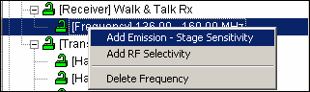

The Emission – Stage Sensitivity data grid is displayed.

Step 11. Enter the following data for the second set of emission data.
Field | Value
Emission Designator | 12K0F3E
Performance Criteria | SINAD–Signal+Noise+Distortion-to-Noise+Distortion Ratio (dB)
Performance Value | 10
Sensitivity | -119 dBm
Spurious Rejection Level | 75 dB
Adjacent Channel Selectivity | 75 dB
Intermodulation Rejection Level | 75 dB

Step 12. Right-click on [Emission – Sensitivity] 12K0F3E – 119 dBm | Add IF Selectivity to add the IF Selectivity values for the 2nd emission designator.

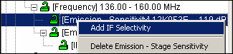
The IF Selectivity Curve window is displayed.

Step 13. Enter the following intermediate frequency data for the 12K0F3E emission.

Field | Value
Measured or Calculated | Measured
IF Frequency | 0
Freq Offset (1/2 Bandwidth) at 3 dB | 8 kHz
Freq Offset (1/2 Bandwidth) at 20 dB | 10 kHz
Freq Offset (1/2 Bandwidth) at 60 dB | 20 kHz

HINT: If you do not know the IF Frequency, enter 0.

Click the Autoscale button. The resulting IF Selectivity Curve should look like the following:

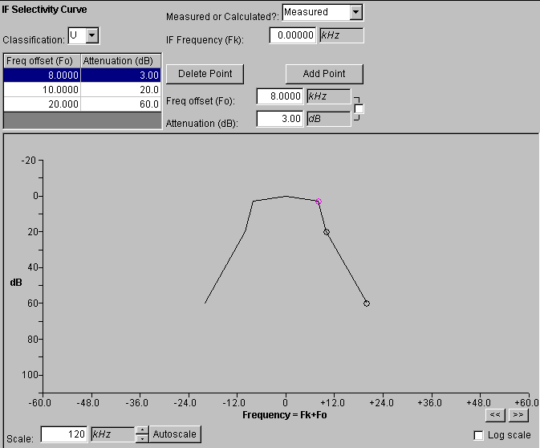
Step 14. Right-click on [Frequency] 136 – 160 MHz | Add RF Selectivity to add the RF selectivity.

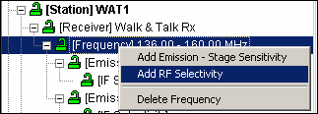

The RF Selectivity Curve window is displayed.

Step 15. Enter the following RF selectivity data.

Field | Value
Measured or Calculated | Measured
Freq Offset (1/2 Bandwidth) at 3 dB | 2M
Freq Offset (1/2 Bandwidth) at 20 dB | 6M
Freq Offset (1/2 Bandwidth) at `60 dB | 12.5M

Notice that when you enter M to choose megahertz frequency offset units, the scale of the x-axis on the graph automatically changes to MHz.

Click the Autoscale button. The resulting RF Selectivity Curve should look like the following:
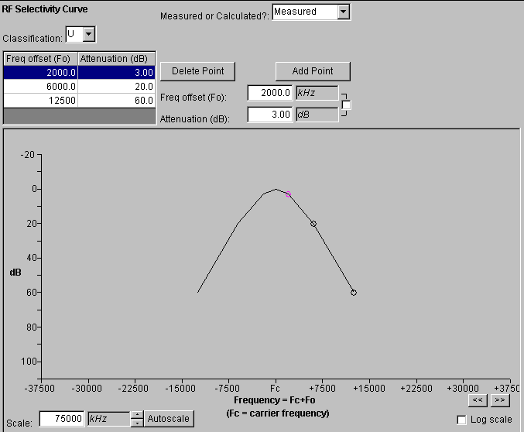

This completes the data entry for the Receiver Walk & Talk Rx, and the tree view looks like the following:

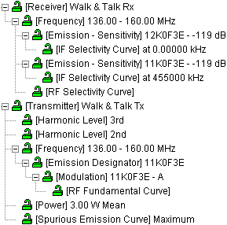

5.6.3 Entering Antenna Data
Step 1. Click on [Station] WAT1, and then right-click on Add Antenna | Add New Antenna | Add Linear.

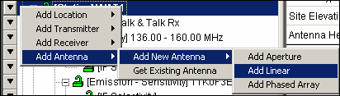

The Add Nomenclature window is displayed.

Step 2. Type Walk & Talk Ant and click OK.

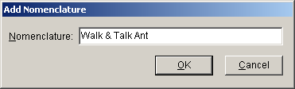

The Antenna data grid is displayed.

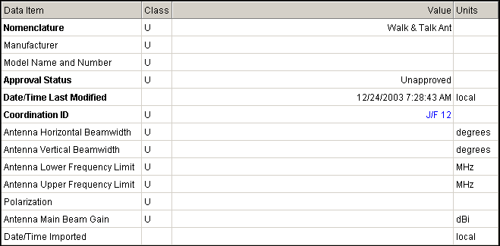

Step 3. Enter the following antenna data.

Field | Table
Manufacturer | RELM COMMUNICATIONS, INC
Model Name and Number | Model 127A
Antenna Horizontal Beamwidth | 360 degrees
Antenna Vertical Beamwidth | 45 degrees
Antenna Lower Frequency Limit | 136 MHz
Antenna Upper Frequency Limit | 160 MHz
Polarization: | Linear
Antenna Main Beam Gain | 0 dBi

Step 4. Save the data.

This completes the data entry for the Antenna Walk & Talk Ant, and the tree view looks like the following:

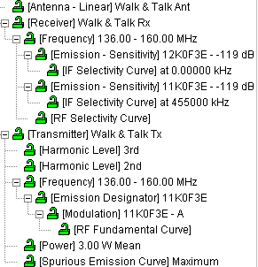

5.6.4 Getting Existing Transmitter Data
Step 1. We are going to add a transmitter to station WAT2 by selecting an existing transmitter from the list of transmitters that are already in the database. Right-click on [Station] WAT2 | Add Transmitter | Get Existing Transmitter.

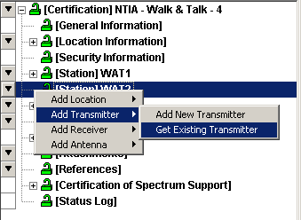

The Pick Existing Transmitter window is displayed.

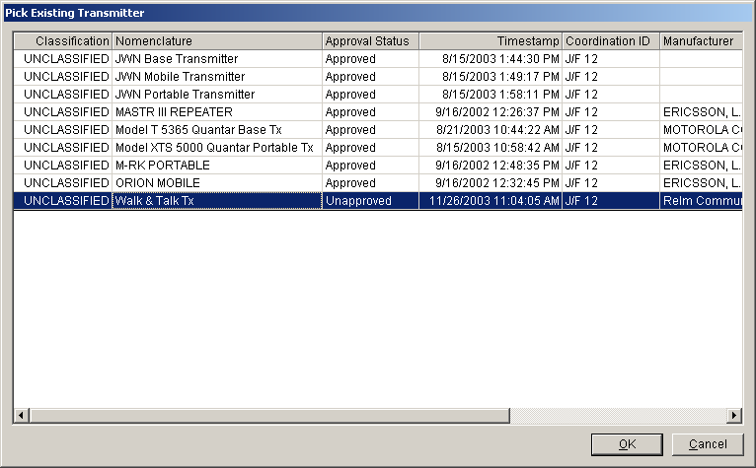

Step 2. Highlight Walk & Talk Tx and then click OK to add the Walk & Talk Tx to Station WAT2.

Step 3. Open all the nodes for the WAT2 station by clicking on the + beside each node. You will see that all of the transmitter data was inserted for the station.

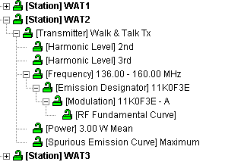

HINT: You may also expand a node and all its child nodes by holding down the Shift key and clicking on the node.

5.6.5 Getting Existing Receiver Data
Step 1. We are going to add a receiver to station WAT2 by selecting an existing receiver from the list of receivers that are already in the database. Right-click on [Station] WAT2 | Add Receiver | Get Existing Receiver.

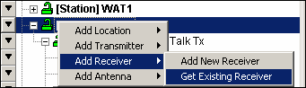

The Pick Existing Receiver window is displayed.

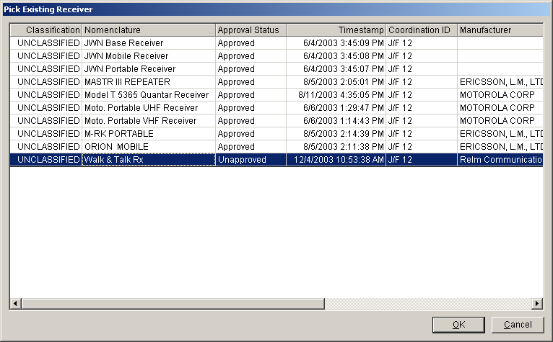

Step 2. Highlight Walk & Talk Rx and then click OK to add the Walk & Talk Rx to Station WAT2.

Step 3. Open all the nodes for the receiver of the WAT2 station by clicking on the + beside each node. You will see that all of the receiver data was inserted for the station.

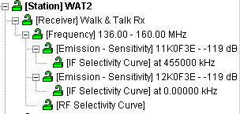

5.6.6 Getting Existing Antenna Data
Step 1. We are going to add an antenna to station WAT2 by selecting an existing antenna from the list of antennas that are already in the database. Right-click on [Station] WAT2 | Add Antenna | Get Existing Antenna.

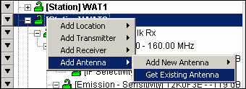

The Pick Existing Antenna window will be displayed.

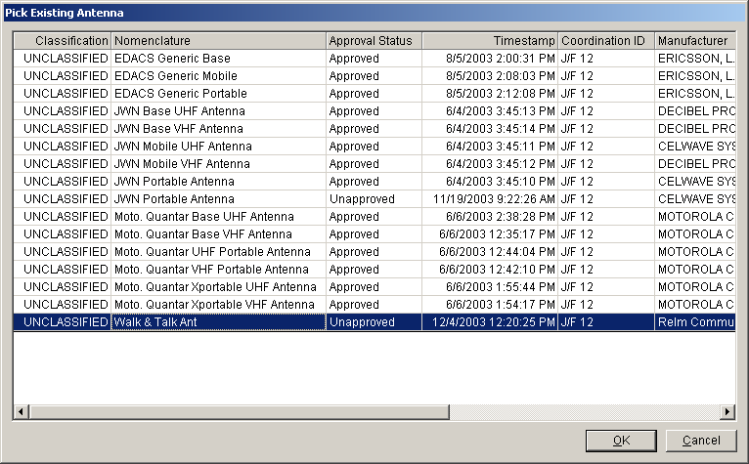

Step 2. Highlight Walk & Talk Ant and then click OK, to add the Walk & Talk Ant to Station WAT2. The added antenna will appear on the tree view under Station WAT2.

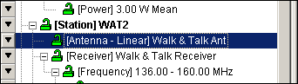

Recall that WAT3 is a Generic station. We do not enter equipment for it.

5.7 Entering Data For Links
Data can be entered by accessing the diagram and using the graphical links to select which link to edit. The following steps will illustrate this.

Step 1. Click on the [Diagram] node in the tree view. The Link Information node is displayed showing the links that had been defined earlier.

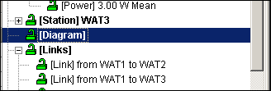

There are two ways to display the Link Information window.

Step 2. The first way is to right-click on the graphical link near the receiving end and and then click Edit in the popup menu that is displayed.

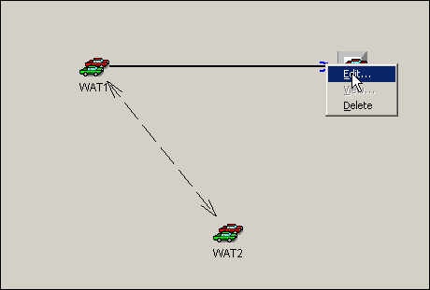

You must right-click on the line near the receiving end, but not too close to the station. Otherwise, the program will think you are clicking on the station.
The Link Information window will be displayed.

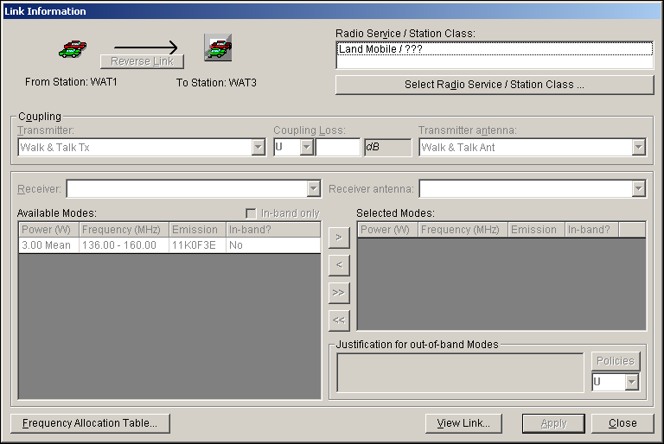

Step 3. Click Close to close the Link Information window.

Step 4. The second way to display the Link Information window is to click on the individual link shown in the tree view. Click on [Link] from WAT1 to WAT2. Again the Link Information window will be displayed.

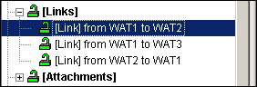

Step 5. Click the Select Radio Service/Station Class button.

The Select Radio Service/Station Class window is displayed.

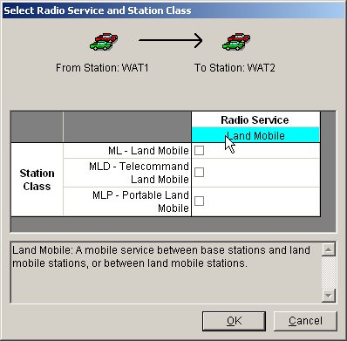

HINT: As you hover the mouse cursor over the Station Class or Radio Service, a description of each appears in the box below.

Step 6. Select station class ML and MLP (i.e., click the respective check boxes) as shown below and then click OK.
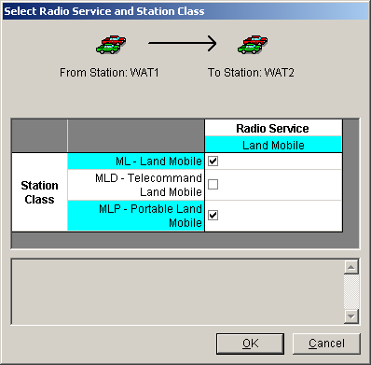

The Link Information window now becomes active.

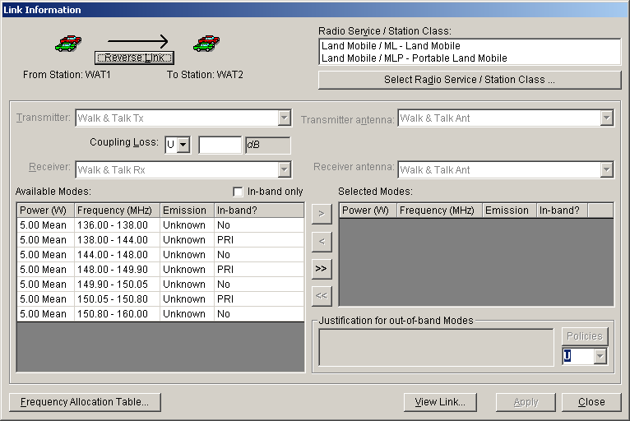

Step 7. If there is more than one transmitter, choose a specific Transmitter using the button. Currently, we have identified only one transmitter for Station WAT1, therefore the pick list is grayed out.

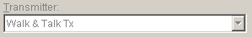

Step 8. If there is more than one transmitter antenna, choose a specific Transmitting Antenna using the button. Currently, we have identified only one Transmitting Antenna for Station WAT1.

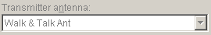

Step 9. Enter the transmitter to transmitter antenna coupling loss (e.g., cable insertion loss). The security classification is entered using the button. Since we haven’t entered this data before we could enter it now if we had the information.

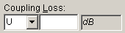

Note: Coupling Loss (as well as SPD) is required for certain Satellite links.

Step 10. If there is more than one receiver, choose a specific Receiver using the button. Currently, we have identified only one receiver for Station WAT2.

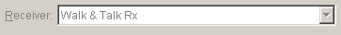

Step 11. If there is more than one receiver antenna, choose a specific Receiving Antenna at Station WAT2 by using the button.

Step 12. Select from the available modes the modes that you want to certify. Select the 3 modes which have a PRI in the In-band? column. You can hold down the Ctrl key and click each one as shown below.

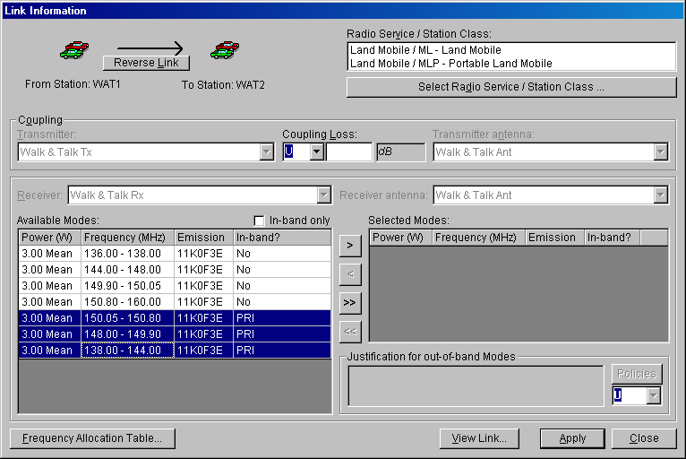

HINT: You can also put a check in the box and only the in-band frequencies will appear. Then they can be moved as a group using the button or individually by using the button. If you choose a frequency band that is not in-band, you will have to give a justification for using this band. 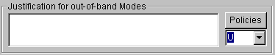

Step 13. Click the button to transfer the Available Modes to list of Selected Modes.

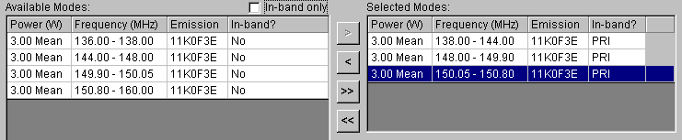

Step 14. Click Apply to save your choices. The Notification window is displayed.

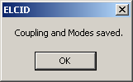

Step 15. Click OK.

Step 16. Click the View Link button to see the link information that you have saved.

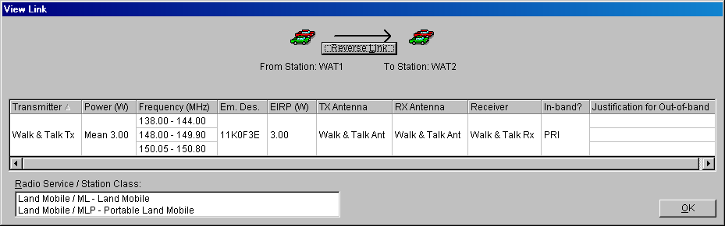

HINT: The link information screen will display all the modes for the link shown at the top of the window.

Step 17. Click OK after previewing the data.

Step 18. Click the Reverse Link button to display the reverse link (i.e., station WAT2 to station WAT1). The reverse link information will be displayed.

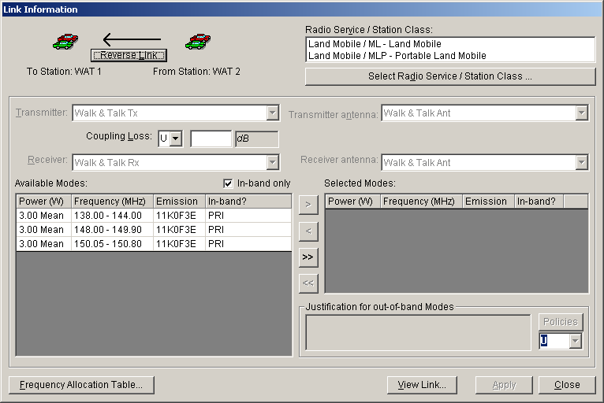

Step 19. To enter information for this link as we did the previous link, click the Select Radio Service/Station Class button. The Select Radio Service/Station Class window is displayed.

Step 20. On the Select Radio Service/Station Class window, select station class ML and MLP by clicking the associated check boxes and clicking OK. The Link Information window above now becomes active. Click the In-band only check box off and on to see all bands / in-band only modes.

Step 21. Since we only have one transmitter, receiver, transmitter antenna, and receiver antenna we cannot choose another but we can enter the Coupling Loss and its classification, and select the Modes to be certified. For now we will select each mode that has a PRI in the In-band? column, as shown below.

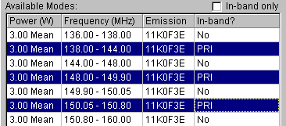

Step 22. Click the button to transfer the Available Modes to list of Selected Modes.

Step 23. Click Apply to save your choices, and then click OK on the Notification window that pops up.

Step 24. Click the View Link button to see the link information that you have saved.

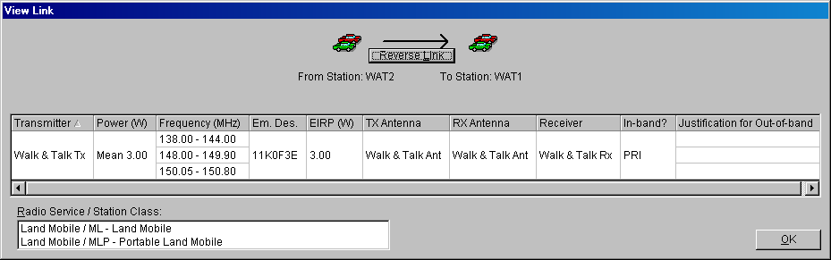

Step 25. Click OK to close the View Link window, and then click Close on the Link Information window to return to the tree view.

Step 26. Now we are going to use the graphical view to add data for our link from WAT1 to WAT3. First from the tree view, click Diagram. Notice the Receiver and Receiver antenna are blank because the receiving station is Generic.

Step 27. Next, right-click the arrow end of the WAT1 to WAT3 link and then click Edit.

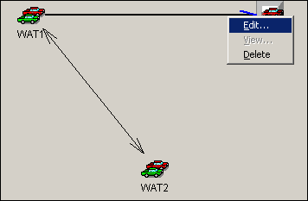

The familiar Link Information window will be displayed.

Step 28. Now that you know what to do, enter the following data for this link and save it.

- Radio Service / Station Class -- ML and MLP.
- Coupling Loss -- Leave Blank.
- Modes -- 3.00 Mean 138.00 - 144.00 11K0F3E PRI
3.00 Mean 148.00 - 149.90 11K0F3E PRI
3.00 Mean 150.05 - 150.80 11K0F3E PRI

The information should look like the following when you view the link.

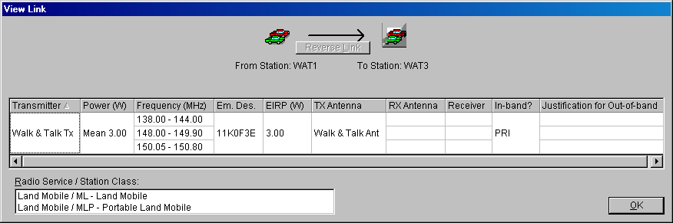

Step 29. Click OK to close the View Link window, and then click Close on the Link Information window to return to the tree view.

We have now finished entering data for our three links.

Hint: Notice that the dashed lines between the links have become solid lines. This indicates that data has been entered for the link.

5.8 Adding Attachments

Any kind of file can be attached to a certification application. The file could be a graphics file, a text file, or a spreadsheet file. The following steps will illustrate how to attach these files.

Step 1. Right-click on the [Attachments] node and then click Add Attachment.

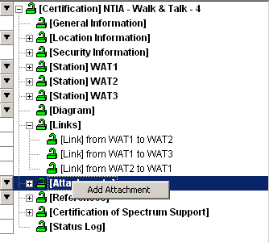

The Add Attachment data grid is displayed.

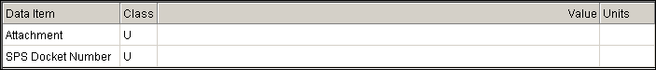

Step 2. Click in the Attachment Field and click the Browse button .

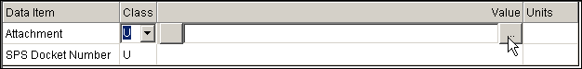

The Open window will be displayed for you to select the file that you want to attach. You will find the attachment file on your training CD-ROM.

Step 3. Go to {CD-ROM Drive Letter}/Training Material/Attachments and select all file types.

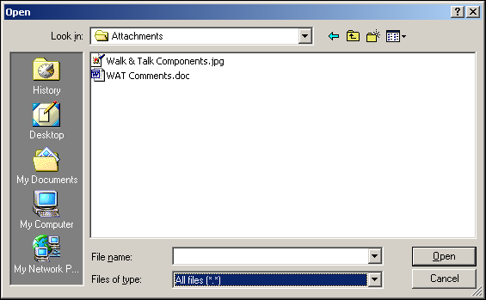

Step 4. Click on Walk & Talk Components.jpg and then click Open. The file will now be listed as an attachment to your certification application.

Step 5. To view the file, click on .

The Show Attachment window will be displayed.

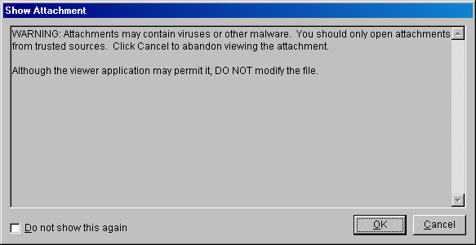

HINT: This window may be disabled by checking the box, or by setting the correct preferences.

Step 6. Click OK to open the file.

Step 7. Close the viewing window, and Save.

Step 8. We want to add the other file that was on our training CD-ROM as an attachment. Using what you have learned in Steps 1-7 above, add the file WAT Comments.doc as an attachment.

Step 9. Save.

5.9 Viewing The Status Log
A status log is created and updated while a certification application is being processed. The next few steps will show how to view the log and to add status to the log.

Step 1. From the tree view, click on the [Status Log] node.

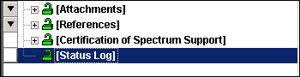

The Status Log window is displayed.

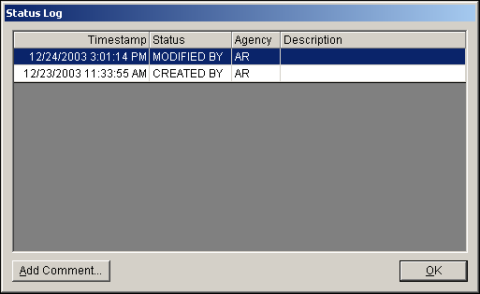

The following is an example log with more entries.
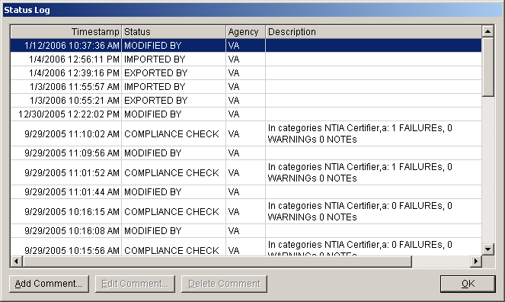

Step 2. Click the Add Comment button to add your own status entry.

The Add Comment window is displayed.

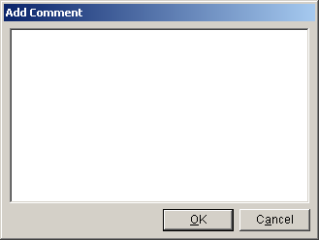

Step 3. In the window type EL-CID Training Class and then click OK.

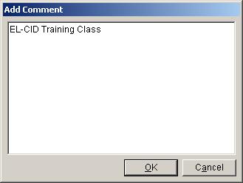

You will notice that your comment was added with the Status Code of COMMENT BY. Also notice that the latest status is displayed at the top of the log in chronological order.

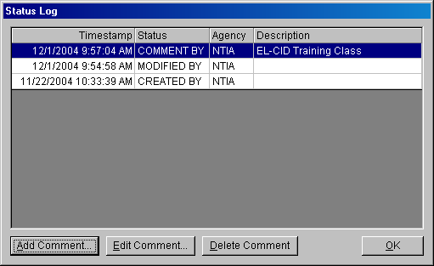

HINT: This comment may be edited (using the Edit and Delete buttons until the record is exported.

Step 4. Click OK to close the Status Log window.

The following shows what the tree view looks like so far.

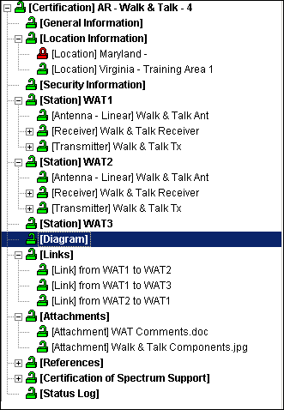

6. RUNNING COMPLIANCE CHECKS

Now that we have created our certification application we want to check it by running the EL-CID Compliance Checks.

Step 1. Click on the Compliance Checks button located on the Tool Bar.



The Compliance window is displayed.

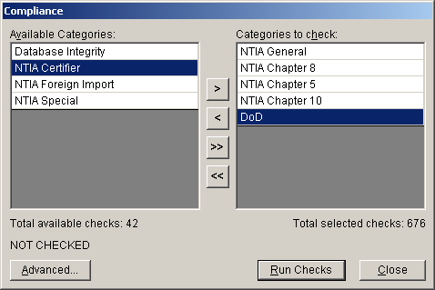

Items from the Available Categories list can be added to the Categories to check list by using the arrows in the middle of the screen. We will select the categories shown above.

You can view all the checks by clicking the Advanced button.

Step 2. Click the Run Checks button. The following EL-CID Compliance Checks Running window is displayed.

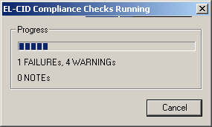

When the compliance checks have run the Compliance window is shown with the summary of the number of failures, warning, and notes.

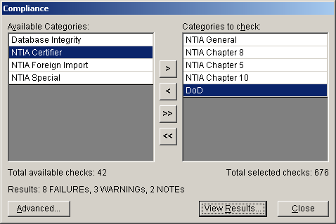

Step 3. To see the results, click the View Results button. The screen containing the first error will be displayed and the relevant compliance message will be shown at the bottom left of the screen.

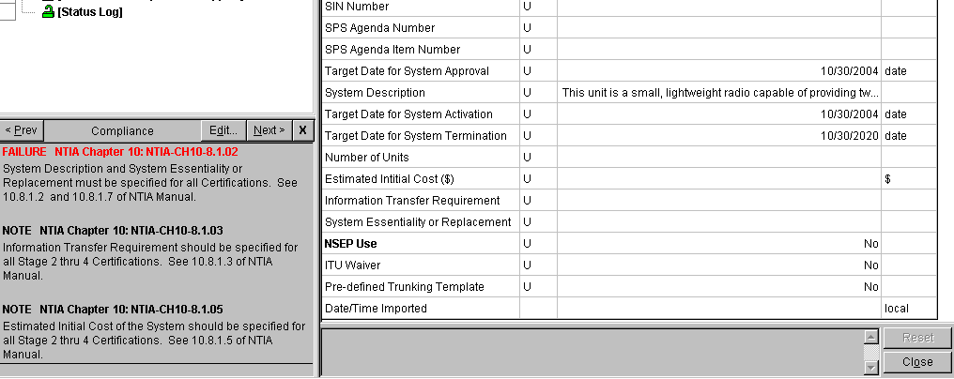

HINT: The Compliance Result window may be enlarged by dragging the divider upwards.

Notice that we did not fill out the field for System Essentiality or Replacement. This is a required field for a certifications.

Step 4. To see the remaining compliance messages click the Next button. As you can see the messages indicate the type of message (e.g., Failure, Warning, or Note), the reason for the message, and the reference document(s).

Notice in the Compliance Check that on the RF Fundamental Curve, the RF curve fails the NTIA standard curve.

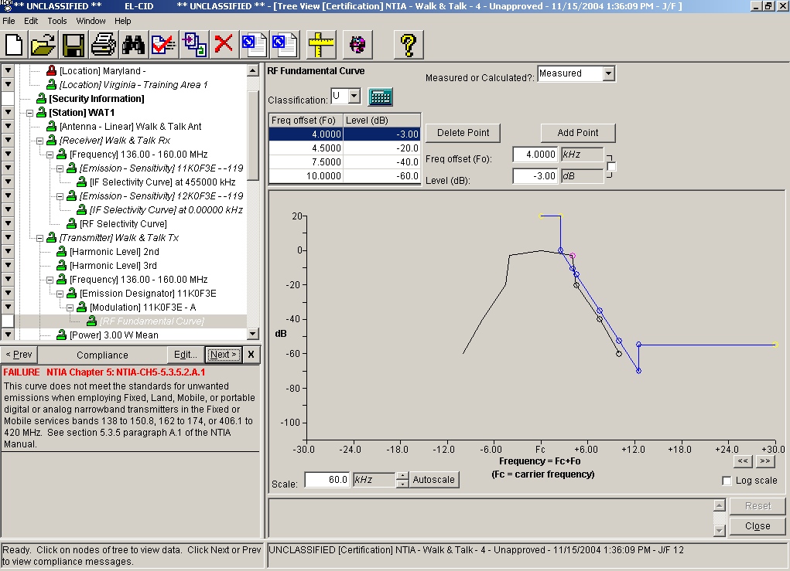

Step 5. Click on the button to close the Compliance Results window.
7. EXPORTING CERTIFICATION RECORDS

After you have corrected the certification error messages, you will want to export the certification so it can be forwared to the next higher organization that will review it. The next few steps will illustrate the exporting process.

Step 1. Click the Export button on the tool bar .

The Export Certification window is displayed.

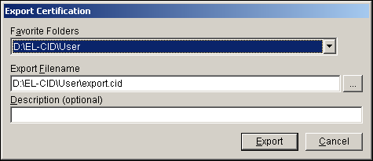

Notice that a default file name of export.cid will be entered, but you can specify a different filename.
Step 2. Click the Browse button and enter WalkandTalk as the filename, as shown below.

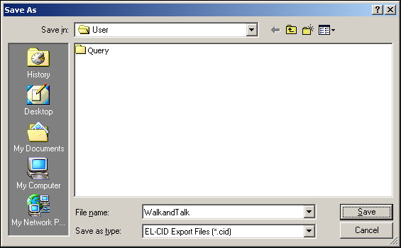

Step 3. Click Save. The Export Certification window is displayed again showing the path and filename that you selected.

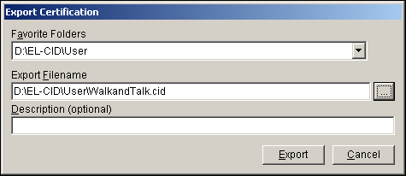

Step 4. Type EL-CID Training into the Description dialog box.

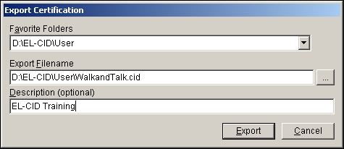

Step 5. Click Export. The Cover Sheet Classification Marking window is displayed.

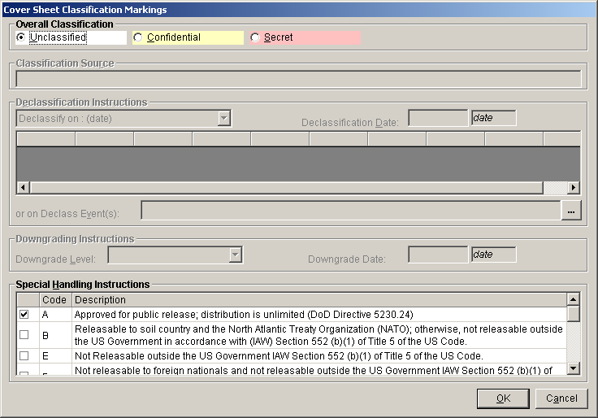

Step 6. Click OK. The Save to File – Security Markings window is displayed.

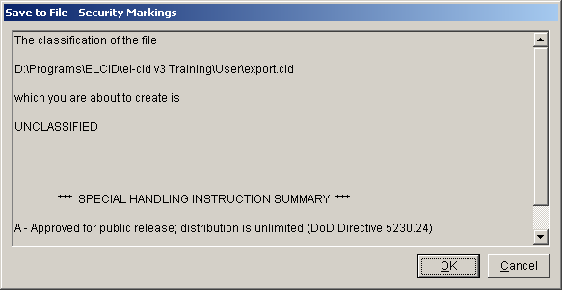

Step 7. Click OK. A Progress window is displayed. When it closes, the file has been saved and the Tree View will be displayed.

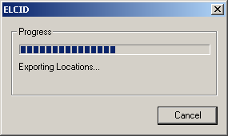

8. PRINTING A CERTIFICATION RECORD

If you want to print a copy of the certification record for filing, the next few steps will illustrate how this is done.

Step 1. Click the Print button on the toolbar.



The Print Options window is displayed.

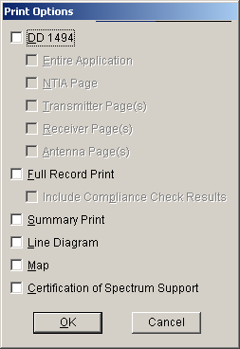

Step 2. Check the DD 1494 check box and then you will see that additional options will become active for the DD 1494 output.

Step 3. Next, Check the Transmitter Page(s) check box and then click OK.

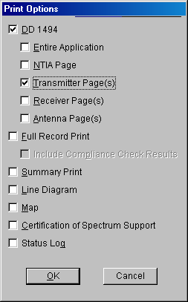

The DOD FORM 1494 window is displayed showing the cover page.

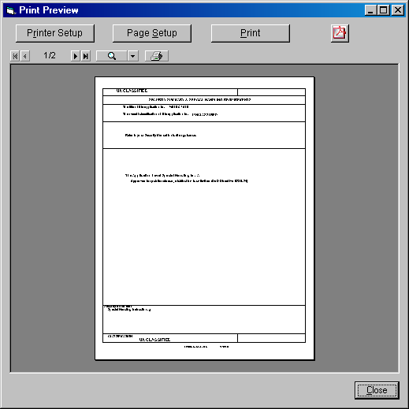

HINT: It may be helpful to maximize the window.

Step 4. Click to go to the next page. Use the magnifying glass icon to zoom in on the Transmitter Equipment Characteristics page.

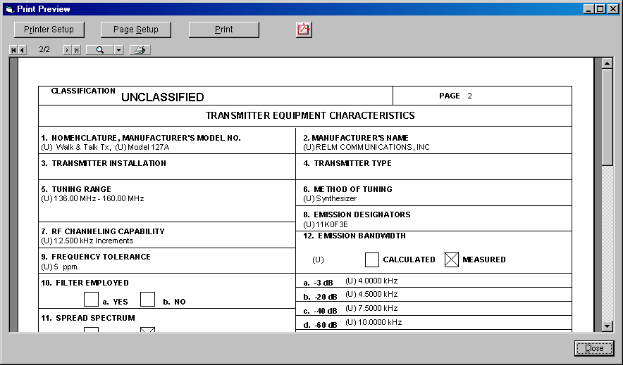

Step 5. Click the Close button.

Step 6. Click the Print button again, and then select the Full Record Print check box and the OK button.
Step 7. Review the various pages of the output. If you want to actually print the document you would click the Print button (but don’t actually print the document.)

Step 8. Click Close

Step 9. Click the Print button again, and then select the Summary Print check box and the OK button.

Step 10. Review the various pages of the output.

Step 11. Click Close.

Step 12. Click File | Close or use the button to close the current certification application.

9. IMPORTING A CERTIFICATION APPLICATION

You may need to import a certification application that was prepared by someone else. The following steps will illustrate how to perform this import.

Step 1. Click the Import button.



The Import window is displayed.

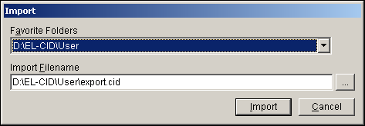

Step 2. Click the browse button to select the file to import. The folder we are using for training is D:\EL-CID\Samples. Highlight the filename Manpack.cid and then click Open.

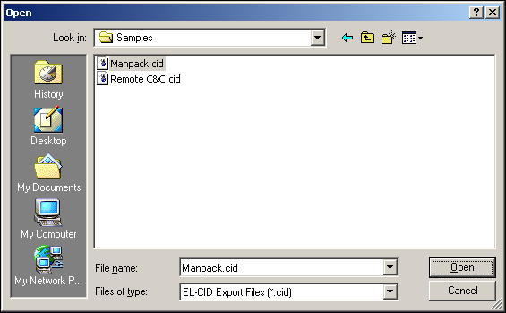

The Import window displays the selection.

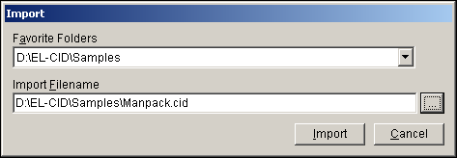

Step 3. Click Import. The File Description window is displayed.

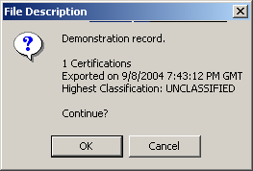

Step 4. Click OK. The Import Record List - Certification window is displayed.

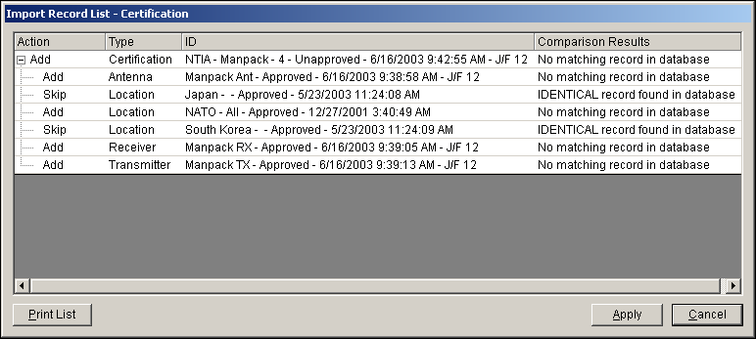

Notice the locations are marked Skip because identical Location records already exist in the database. There is no point in importing such records and creating duplicates. Instead, when the Manpack certification is imported, it will be associated with the existing Location records already in the database.

Step 5. Click Apply. The Progress window is briefly displayed and then the Import Record List - Certification window is again displayed.

Step 6. Click OK to close the window.

10. OPENING AND EDITING AN UNAPPROVED CERTIFICATION RECORD

Once you have saved or imported a certification application that has not been approved you can open it and then edit it. The following steps show how you can do this.

Step 1. Click the Open button to open a certification.



The Pick Existing Certification window is displayed.

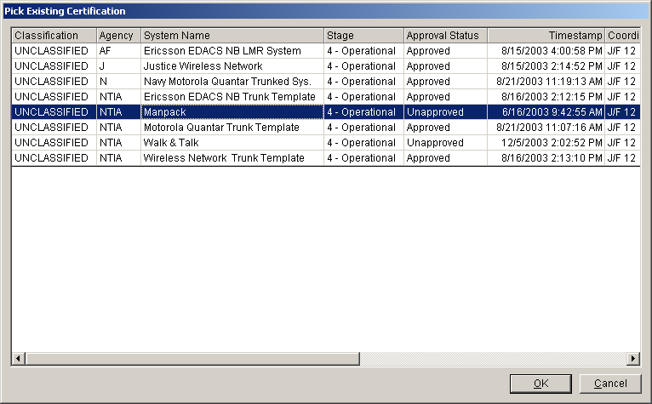

Step 2. Highlight the Manpack system and then click OK. The Certification’s tree view is open.

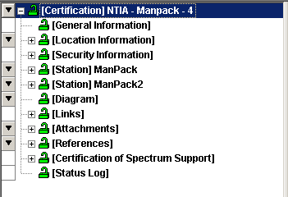

Step 3. Click [Diagram]. The Diagram node is open.

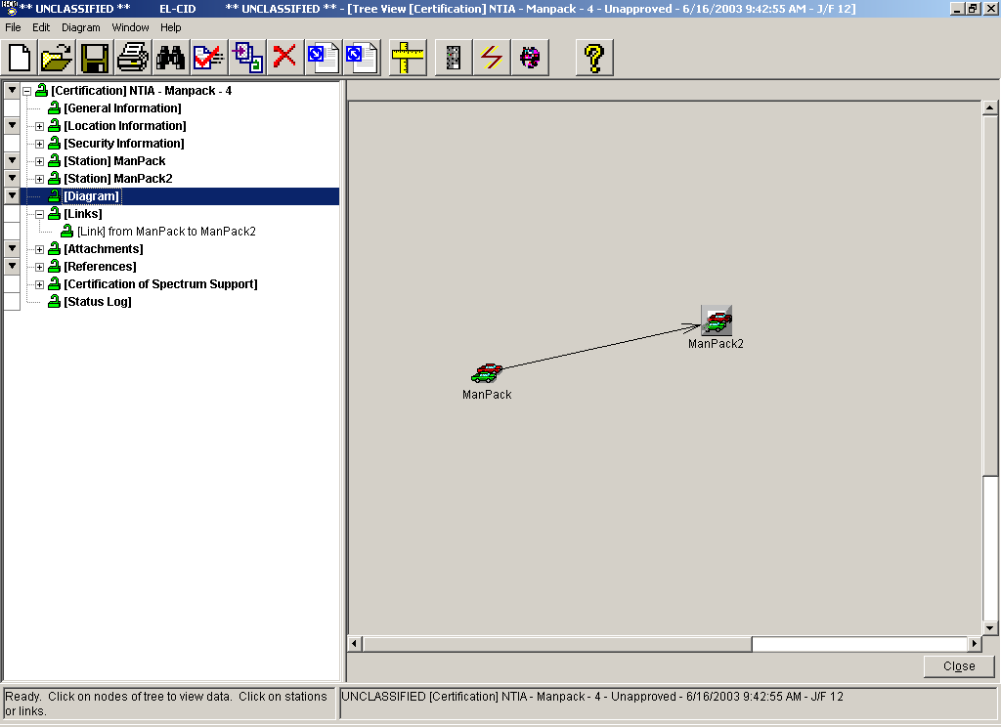

Step 4. Click the Show/hide Stations Palette button.

The Stations Palette window is displayed.

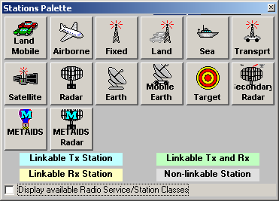

Step 5. Click on the Land Mobile icon and drag to the drawing area.

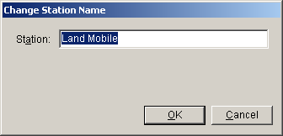

Step 6. Change the name to ManPack3 and click OK. The new icon will be displayed on the graphic screen with the new name.

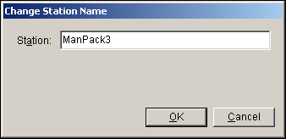

Step 7. Click the Stations Palette button again.

Step 8. Click the Creat New Links button to switch to Link mode.



Step 9. Click on the ManPack icon, and then click on the ManPack3 icon. A link from the ManPack station to the ManPack3 station will be drawn, as shown below.

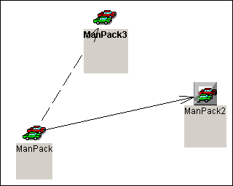

Step 10. Click on the ManPack3 icon, and then click on the ManPack icon. A link from the ManPack3 station to the ManPack station will be drawn (i.e., the link will be drawn with arrows at both ends of the link).

Step 11. Click the Creat New Links button again to turn the link mode off.

Step 12. Right-click on the ManPack2 icon and then select Delete.

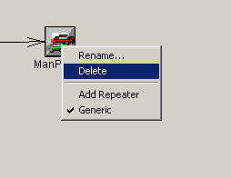

The following confirmation Delete Station window is displayed.

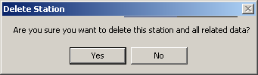

Step 13. Click Yes. The Station and associated Link are deleted.

Step 14. Right-click on [Station] Manpack3 | Add Transmitter | Get Existing Transmitter.

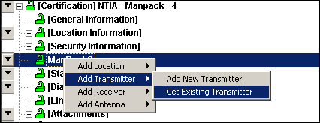

The Pick Existing Transmitter window is displayed.

Step 15. Highlight Manpack TX and then click OK.

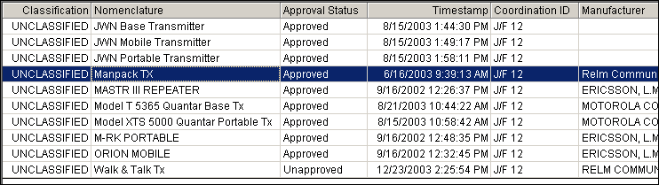

Step 16. Right-click on [Station] ManPack3 | Add Receiver | Get Existing Receiver.

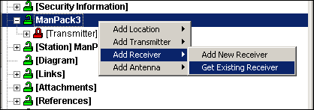

The Pick Existing Receiver window is displayed.

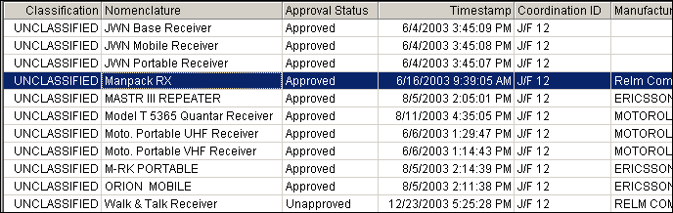

Step 17. Highlight Manpack RX and then click OK.

Step 18. Right-click on the [Station] ManPack3 | Add Antenna | Get Existing Antenna.

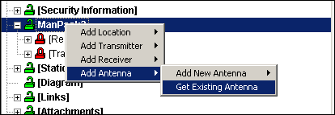

The Pick Existing Antenna window is displayed.

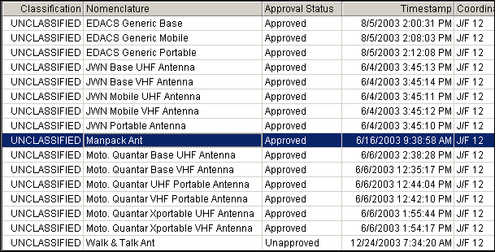

Step 19. Highlight Manpack Ant, and then click OK.

The equipment has been added to the station ManPack3.

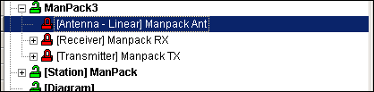

Step 20. Click on the [Diagram] node to switch to the diagram mode.

Step 21. Right-click on the link line and arrow next to the Manpack3 icon and select Edit.

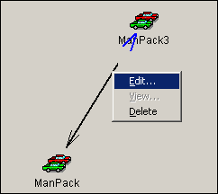

The Link Information window is displayed.

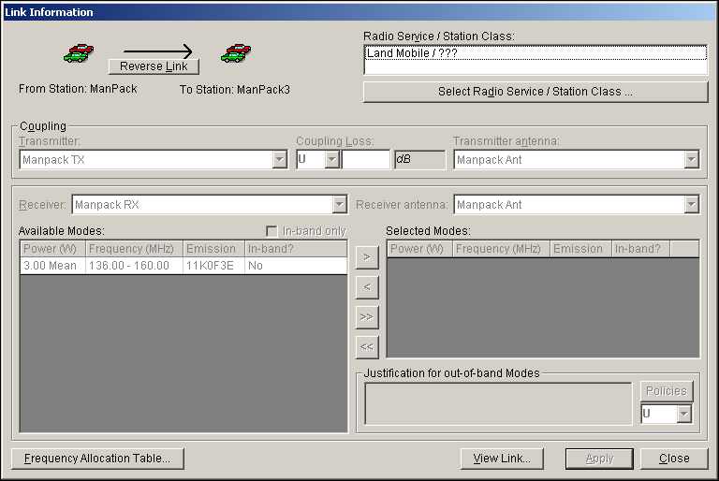

Step 22. Click the Select Radio Service / Station Class button.

The Select Radio Service and Station Class window is displayed.

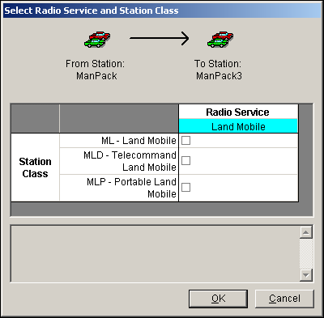

Step 23. Select station class ML and MLP by checking the respective check boxes, and then click OK. The Link Information window now becomes active.

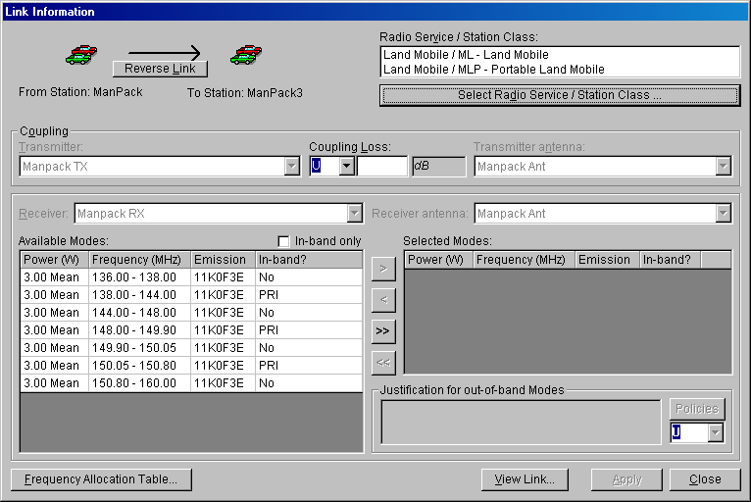

Since we only have one transmitter, receiver, and only one antenna each station all the pick lists are disabled. If you had more than one to choose from you could select from the lists by using the down arrow button beside each field.
Notice that you could change the classification and coupling loss fields.

Step 24. Select from the available modes the modes that you want to certify. Hold down the Ctrl key and then click the 3 rows of available mode that have a PRI in the In-band? column.

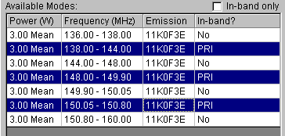

Step 25. Click the right arrow button to transfer the highlighted mode to the Selected Modes list.

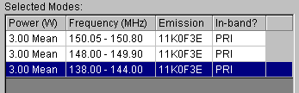
Step 26. Click Apply to save your choices, and then click OK to acknowledge that the changes have been saved.

Step 27. Click the View Link button to see the link information that you have saved.

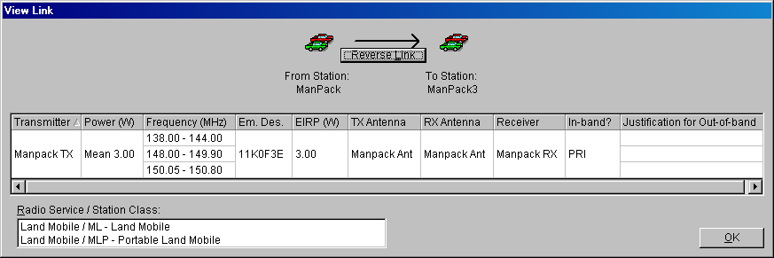

Step 28. Click OK to close the window.

Step 29. Click the Reverse Link button to edit the reverse link data.

The reverse link information will appear.

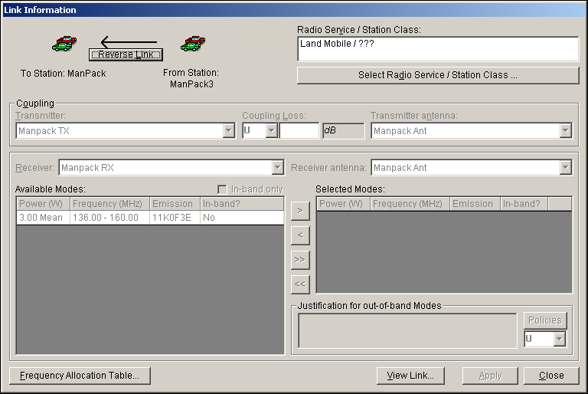

Step 30. Click the Select Radio Service / Station Class button.

Step 31. On the Select Radio Service and Station Class window select station classes ML and MLP and then click OK.

Step 32. On the Link Information window, select the 3 available modes with the word PRI in the In-band? column. Move them to the Selected Modes list.

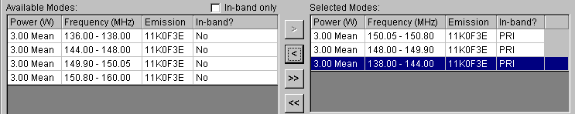

Step 33. Click Apply to save your choices, and then click OK to acknowledge that the data has been saved.

Step 34. Click the View Link button to see the link information that you have saved.

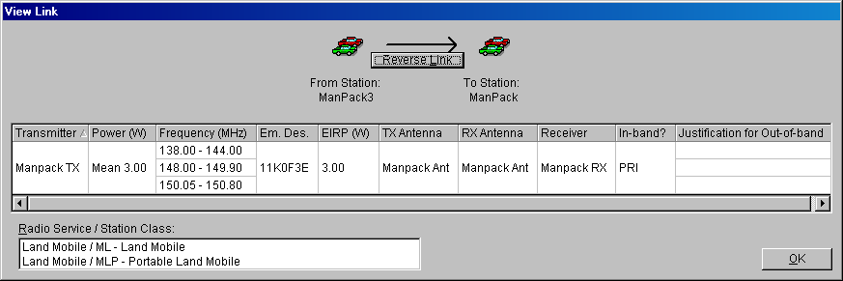

Step 35. Click OK to close the View Link window.

Step 36. Click Close to close the Link Information window.

11. CLONING RECORDS

You can clone a Certification, Transmitter, Receiver, Antenna, or Location from the Tree View.

Hint:: You can also clone a Certification, Transmitter, Receiver, Antenna, Location, or Compliance Check record from the Query Results window.

Step 1. Expand the [Station] ManPack3 node.

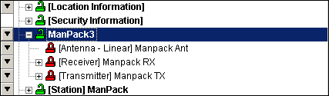

Step 2. Click on the [Transmitter] Manpack TX node to expand it. Next, right-click the node, and click on Clone.

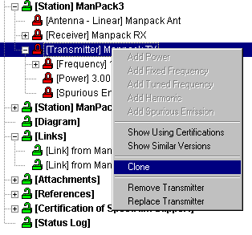

The Clone window is displayed.

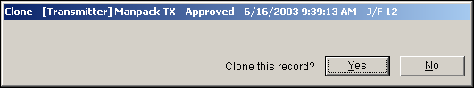

Step 3. Click Yes to clone the record. The cloned transmitter is displayed.

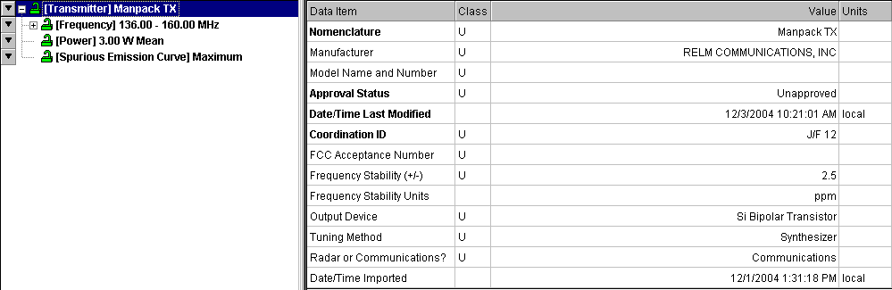

Hint:: When you clone a record you are adding it to the database and not to the active certification. Notice that the Red locks have turned to Green locks. When you close this window you will return to the active application.

Step 4. Click on the Nomenclature field, and change the name to Manpack TX Two.

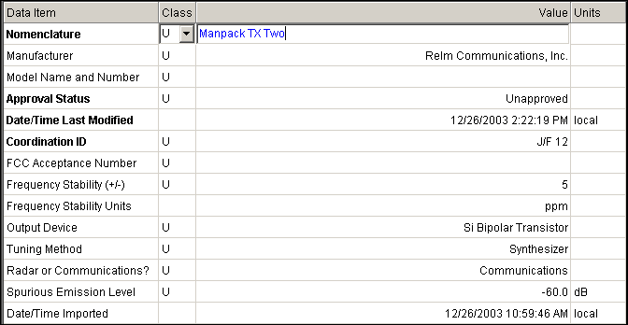

Step 5. Now we are going to edit the new transmitter. Save the transmitter. Right-click on [Transmitter] Manpack TX Two and select Add Power.

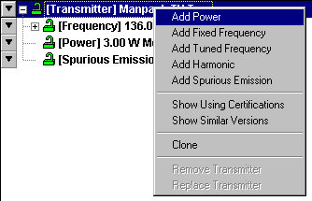

The Power data grid is displayed.

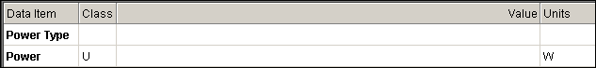

Step 6. Enter the following data.

Field | Value
Power Type | Mean
Power | 5 W

Step 7. Save the data.

Step 8. Click the Close button. The Original Certification window is displayed.

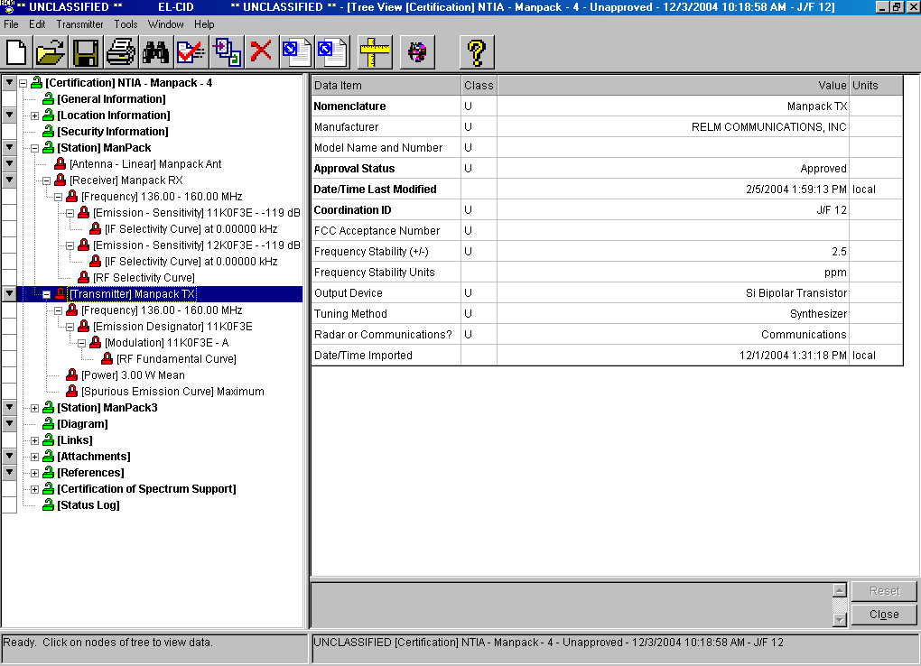

Now that we have a new transmitter record which was cloned (or copied) from an existing transmitter. We are going to add this new transmitter to our ManPack3 station.

Step 9. Right-click on the [Station] ManPack3 | Add Transmitter | Get Existing Transmitter.

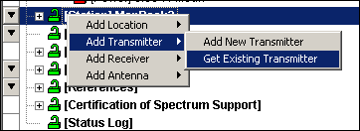

The Pick Existing Transmitter window is displayed.

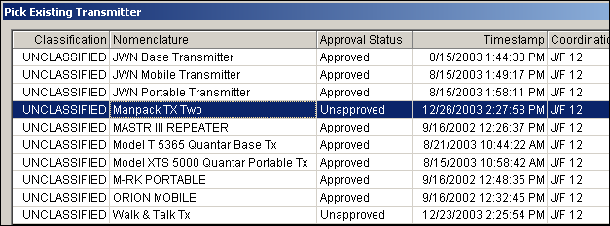

Step 10. Highlight Manpack TX Two and then click OK.

The Manpack TX Two transmitter is added to your certification for the Station ManPack3.

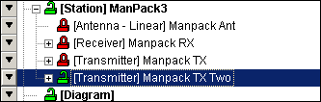

Step 11. Save the data.
Step 12. Click on the Diagram node. Highlight the link from Manpack3 to Manpack. Right-click and choose Edit

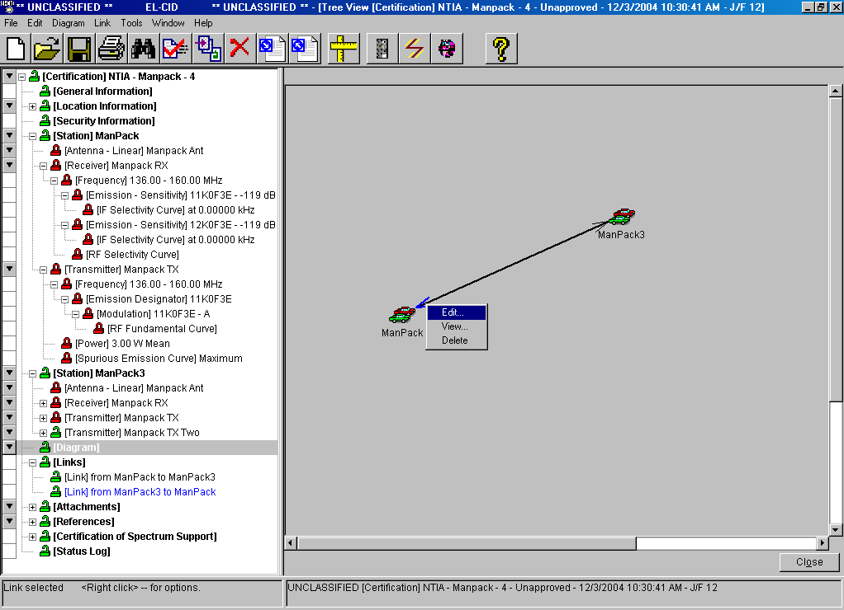

Step 13. Click the button on the transmitter and notice that two transmitters are now shown for this link.

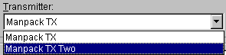

Choose the ManPack Tx Two transmitter. Complete this link, select the 6 available modes with the word PRI in the In-band? column. Move them to the Selected Modes list

Hint: The link for each Transmitter, Receiver, and Antenna combination must be defined.

Step 14. Click Apply to save your choices, and then click OK to acknowledge that the data has been saved.

Step 15. Click the View Link button to see the link information (two transmitters) that you have saved.

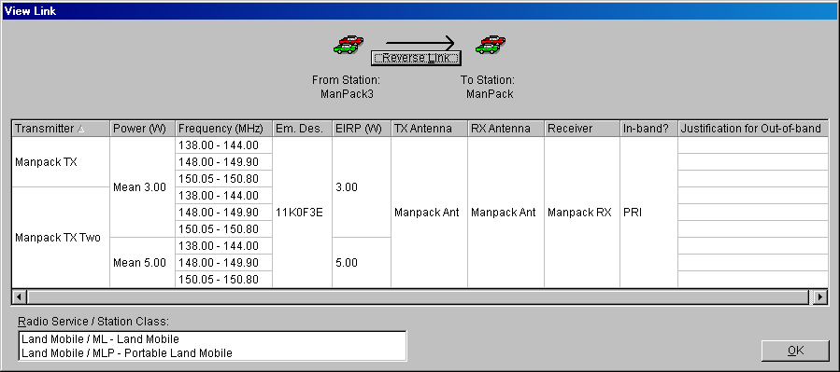

Step 16. Click OK to close the View Link window.

Step 17. Click Close to close the Link Information window.

Step 18. Click Close to close the current certification application.

12. OPENING AND VIEWING AN APPROVED CERTIFICATION RECORD

Approved records can be opened but they cannot be changed.

Step 1. Click the Open button.



The Pick Existing Certification window is displayed.

Step 2. Highlight Ericsson EDACS NB LMR System, and then click OK.

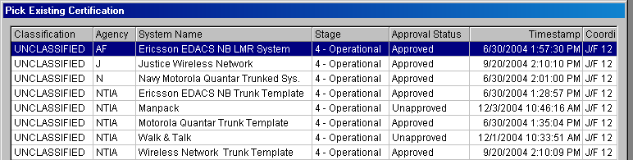

The approved certification is displayed.

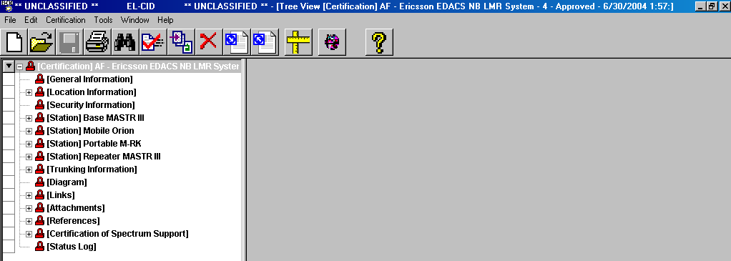

Step 3. Highlight the [Certification of Spectrum Support] node. Expand this node by clicking the button on the node.

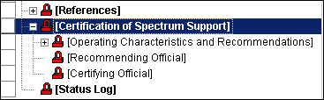

Step 4. Click on the [Operating Characteristics and Recommendations] node. The Progress window is displayed.

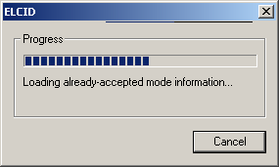

The Approval Operating Characteristics and Recommendations window is displayed.

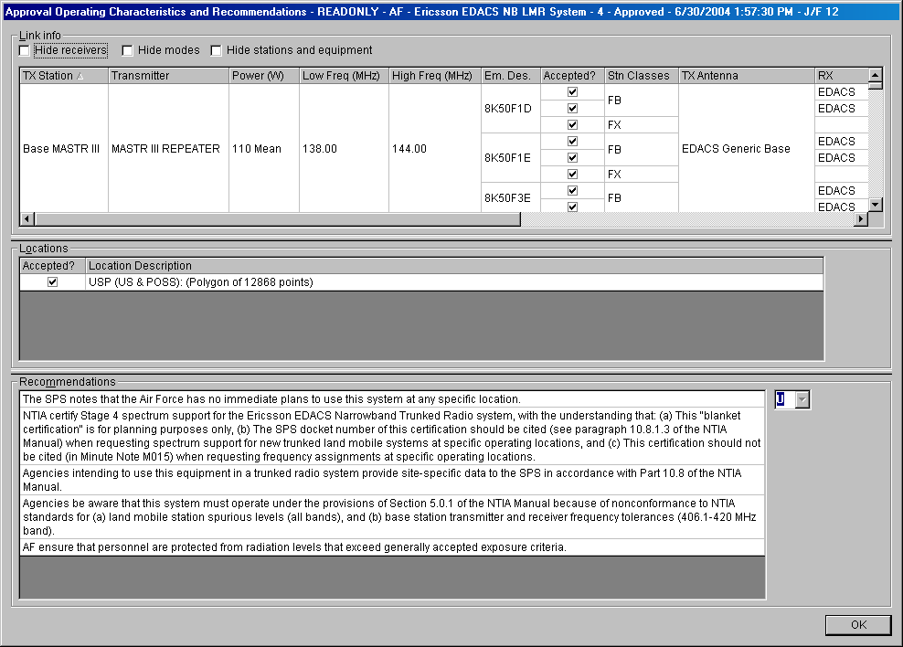

Step 5. Click OK to close the screen.

Step 6. Expand the [Attachments] node using the button, and then click on [Attachment] EDACS_Original_Paper_Cert.pdf. The Attachment data grid is displayed.

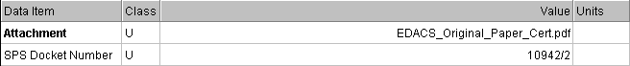

Step 7. Click in the Attachment Value cell.

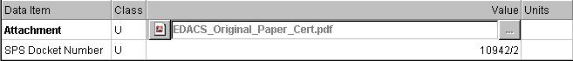

Step 8. Click the Format button for the PDF fomat.

The original Certification of Spectrum Support is displayed in Adobe Acrobat format.

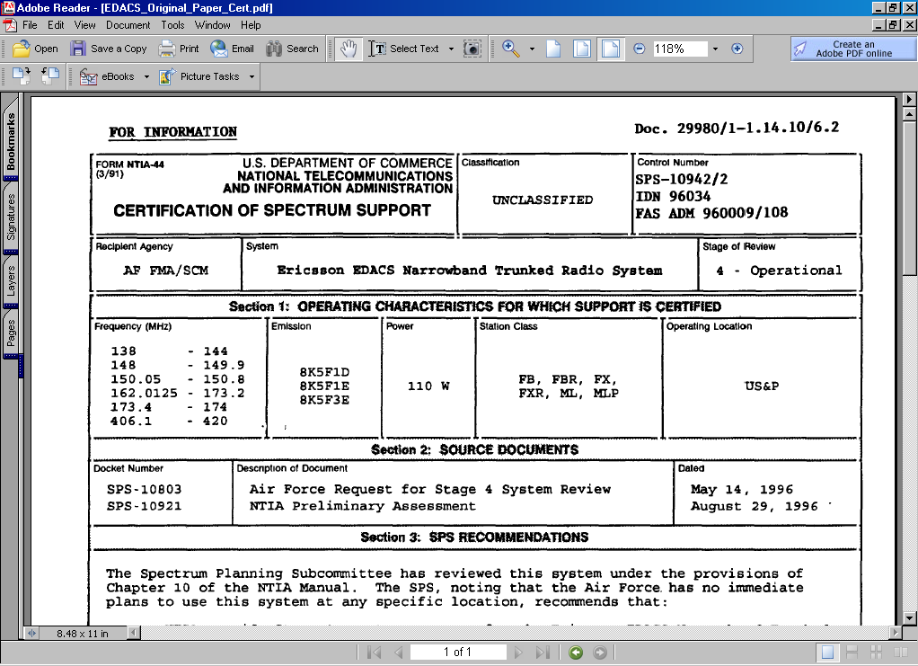

Step 9. Close the Adobe window by clicking the X in the top right-corner of the screen.

Step 10. Click the Print button. The Print Options window is displayed.

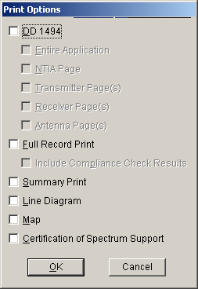

Step 11. Check Certification of Spectrum Support and then click OK. The print preview window is displayed showing the cover page.

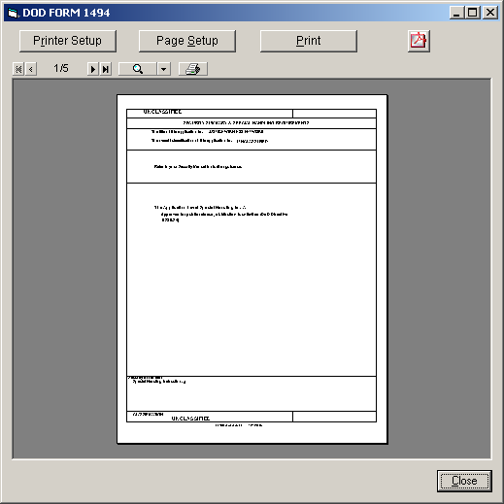

Step 12. Click to go to the next few pages. You can also use the zoom button to make the size such that you can read the data.

Step 13. To close the print preview, click Close.

Step 14. To see the links and stations on the graphical display, click on the [Diagram] node.

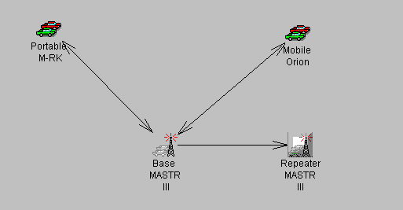

Step 15. Click Close to close this certification.

13. CREATING A TRUNKING SYSTEM CERTIFICATION USING A TEMPLATE
Step 1. Click the Create New Certification button on the tool bar. The New Certification Application window is displayed,

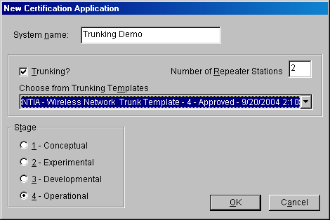

Step 2. Enter the data shown in the screen above and listed in the table below and then click OK.

Field | Value
System Name | Trunking Demo
Trunking | Checked
Number of Repeater Stations | 2
Choose from Trunking Templates | NTIA-Wireless Network Trunk Template - 4
Stage | 4- Operational

The Tree View is displayed with the template filled.

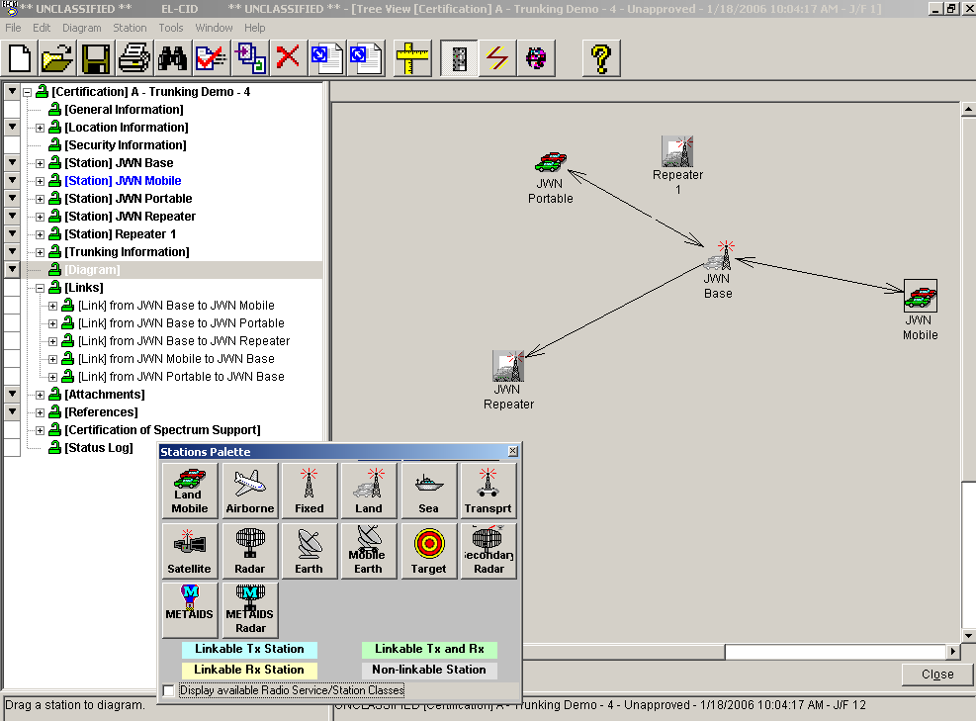

Step 3. Click the Station Palette button to close the Station Palette window.

Step 4. To see all the different tranmsitter, receivers, and antenna data, Expand the nodes using the button.

Hint: To expand the tree view, highlight a node in the tree view and press .
All nodes under the highlighted node will be expanded.
To collapse the tree view, highlight a node in the tree view and press . All nodes under the highlighted node will be collapsed.

In the help file,  (under Trunking Systems | Creating a New Trunking System) A table is shown (NTIA Manual Section 10.9.1 to EL-CID Cross-reference), that will give a cross-reference between the NTIA requirements in Section 10.9.1 and where they can be found in EL-CID.

14. ADDING LOCATIONS FROM THE MAP

If you want to add a location to your certification record but do not know the detailed information, you may be able to find the location by using the Map to find the desired location. If it is a city already in the database, follow the steps below to select the city and add its location data to your certification.

Step 1. Right-click [Station] JWN Repeater and then click Add Location | Add From Map.

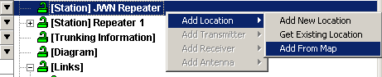

The Select Locations window is displayed.

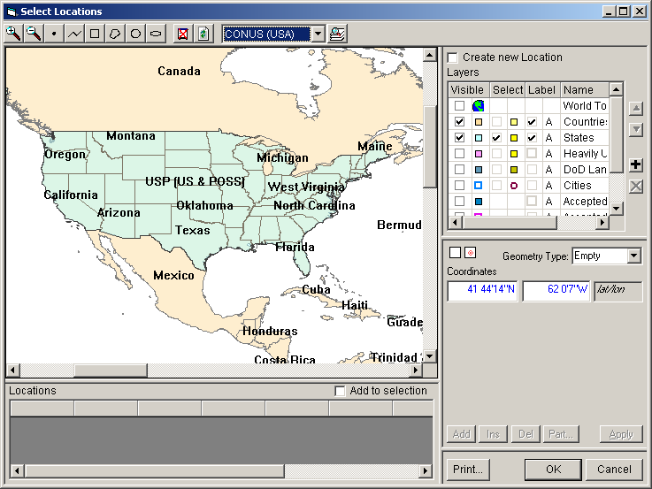

Step 2. Click on the Magnify button and then click in the Maryland region several times. You will zoom in on the Maryland area.

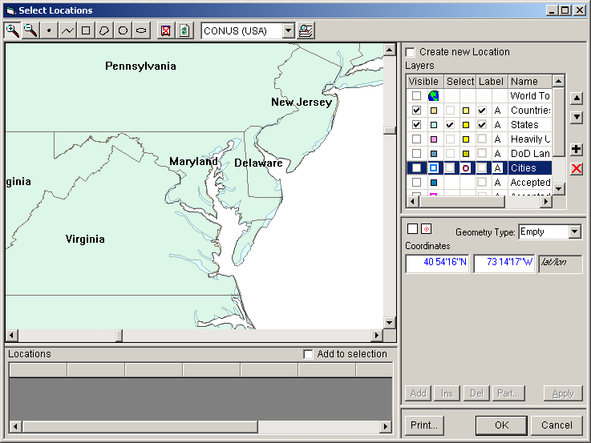

Step 3. Highlight the Cities Name in the Layers window. Click the check boxes for Visible, Select, and Label.

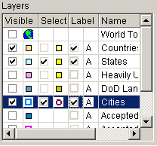

The Select Locations window will be displayed as shown below.

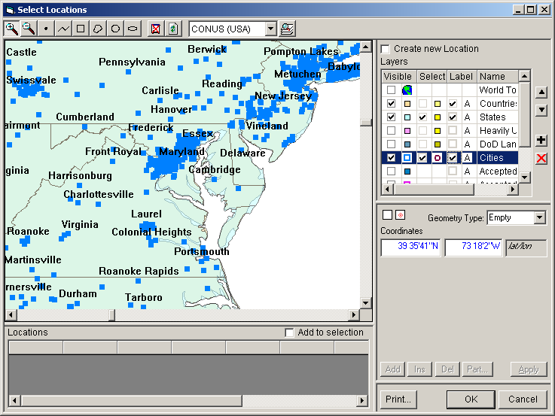

Step 4. Zoom in on the word Maryland several times.

Step 5. Click the Circle button. Place the cursor over the “a” in Maryland and drag the mouse while holding down the left mouse button to create a small circle. Release the mouse button. Make sure the circle is big enough to encircle Annapolis, MD.

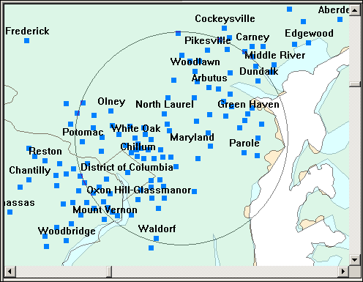
The Select Locations window displays the selections

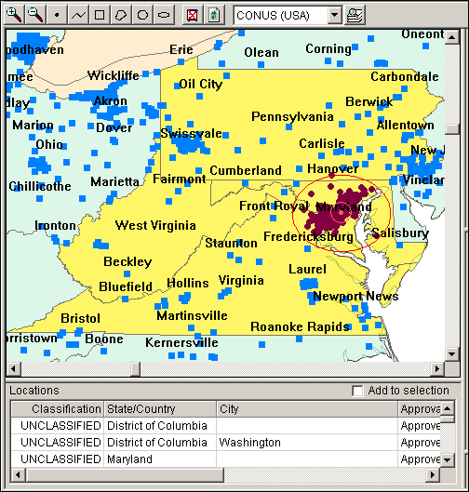

Step 6. Highlight Maryland | Annapolis in the location box and then click OK.

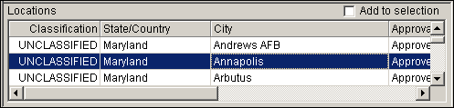

The Annapolis, MD location information is added to your repeater record.

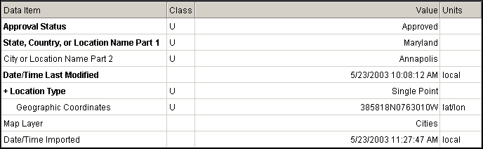

Step 7. Click the Close button.

15. PERFORMING QUERIES

You can select records (Certifications, Equipments, Locations, Policies, Transmitters, Compliance Checks, and etc.) from the database using any of the database fields.

Step 1. Click the query button on the tool bar.



The Query window opens with the Select Data Item window

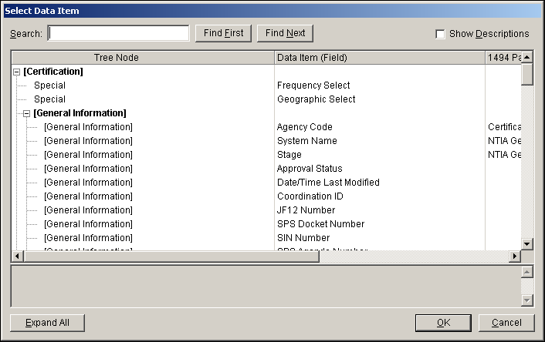

HINT: If the Select Data Item window does not automatically appear. Click the button at the end of the Field Row.

Step 2. Highlight Transmitter Nomenclature and click OK.
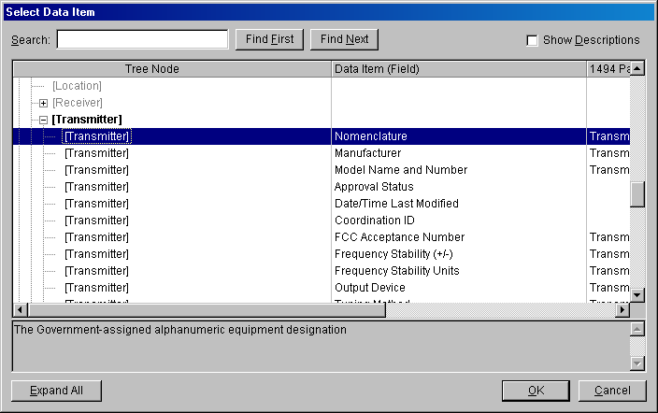

Step 2. Select $$Contains using the dropdown list button for the Operator field

Step 3. Type manpack in the Expression field.

Hint: You can use the button to get a listing of the entries in this field from the database.

Step 4. Select Transmitter using the dropdown list button for the Select Record.

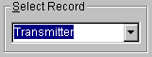

The select screen should resemble the following:

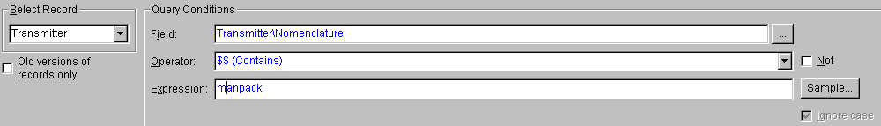

Step 5. Click the to execute the query.

HINT: You can also click the tab to run the query
Two records were found.

Step 6. Highlight the two rows and right-click

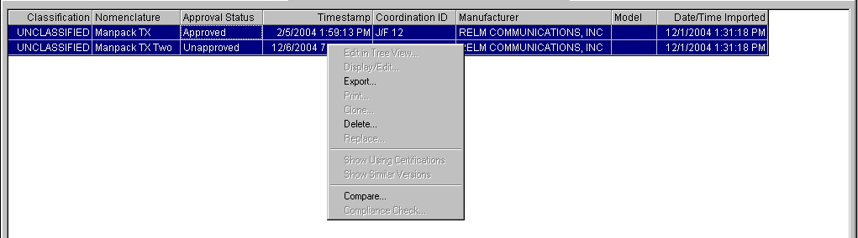

Step 7. Click on Compare

Step 8. The Comparison Details window will be displayed showing the differences in the two records.

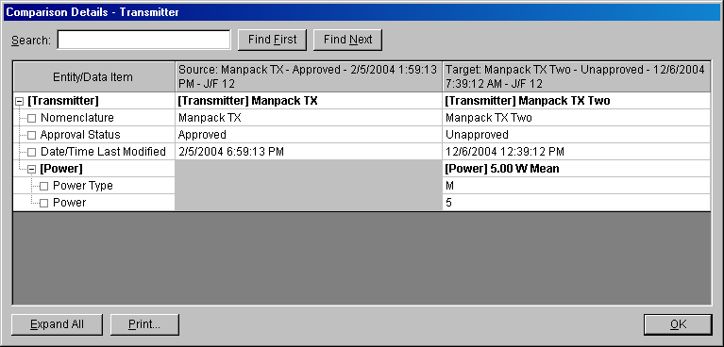

Student Information Sheet

Please print using block letter:

Date: ______________________Training Location: _________________________

Name: __________________________________________ Grade/Rank: __________
(Last) (First) (MI)

Organization: __________________________________________________________

Address: _______________________________________________________________

City/State/Zip code: ______________________________________________________

E-mail: ____________________________________________________

____________________________________________________

Telephone: Voice: CML:__________________ DSN:_______________________

Fax: CML:__________________ DSN:_______________________

STUDENT CRITIQUE SHEET

Dates of Training: From: _____________________To: ___________________________

Location of Training: _____________________________

Course Material

Information Received: ( ) Great Help ( ) Some Help ( ) No Help

Technical Value: ( ) About Right ( ) Too Hard ( ) Too Easy

Course Is: ( ) Too Long ( ) Too Short ( ) Long Enough

Course Material: ( ) Outstanding ( ) Adequate ( ) Not Adequate

Course Presentation

Lessons: ( ) Well Presented ( ) Adequate ( ) Poor

Instructor's Presentation: ( ) Easy to Follow ( ) Difficult to Follow

Instructor's Presentation: ( ) Easy to Understand ( ) Difficult to Understand

Instructors: ( ) Time to Ask Questions ( ) No Time to Ask Questions

Practice: ( ) Too Much ( ) About Right ( ) Not Enough

Value of Training Aids

Training Aids: ( ) Very Good ( ) Good ( ) Fair ( ) Poor

Opinion

Opinion Overall: ( ) Very Good ( ) Good ( ) Fair ( ) Poor

Remarks/Recommendations:
____________________________________________________________________________________________________________________________________________________________________________________________________________________________________________________________________________________________________________________________________________________________________________________________________________________________________________________________________________________________________________________________________________________________________________________________________________

Name & Grade:_________________________________

Job Title:______________________________________

Unit/Organization:______________________________________________________________

Additional Critique Comments:

______________________________________________________________________________________________________________________________________________________________________________________________________________________________________________________________________________________________________________________________________________________________________________________________________________________________________________________________________________________________________________________________________________________________________________________________________________________________________________________________________________________________________________________________________________________________________________________________________________________________________________________________________________________________________________________________________________________________________________________________________________________________________________________________________________________________________________________________________________________________________________________________________________________________________________________________________________________________________________________________________________________________________________________________________________________________________________________________________________________________________________________________________________________________________________________________________________________________________________________________________________________________________________________________________________________________________________________________________________________________________________________________________________________________________________________________________________________________________________________________________________________________________________________________________________________________________________________________________________________________________________________________________________________________________________________________________________________________________________________________________________________________________________________________________________________________________________________________________________________________________________________________________________________________________________________________________________________________________________________________________________________________________________________________________________________________________________________________________________________________________________________________________________________________________________________________________________________

APPENDIX A - QUICK REFERENCE GUIDE

APPENDIX B - IMPORTING UPDATED COMPLIANCE CHECKS

The following steps will illustrate how to perform the import of the updated Compliance Checks in the purge and replace mode. The updates are in two parts Compliance Checks, and Snippets.

Step 1. Click the Import button.

The Import window is displayed. (This illustration uses the same default folders that were shown during the training class. You may have loaded the EL-CID program using a different path name. You should use the path name where you loaded your EL-CID software.)

Step 2. Click the browse button to select the file to import. The folder we are using is on the EL-CID Training CD. Go to {CD-ROM Drive Letter}\Data Base Update. Highlight the filename
All Compliance Checks.cid and then click Open.

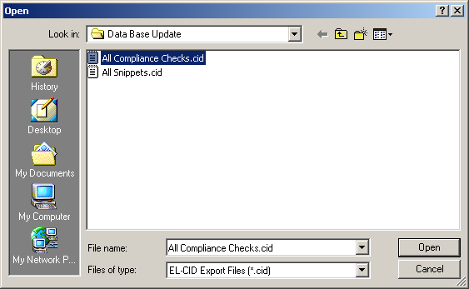

The Import window displays the selection.

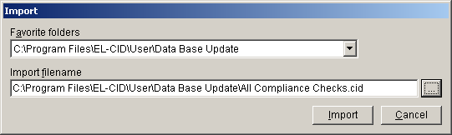

Step 3. Click Import. The File Description window is displayed.

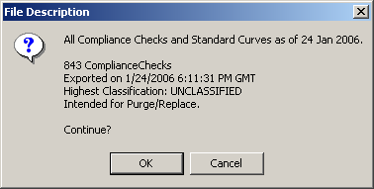

Step 4. Click OK. The Purge/Replace on Import window is displayed.

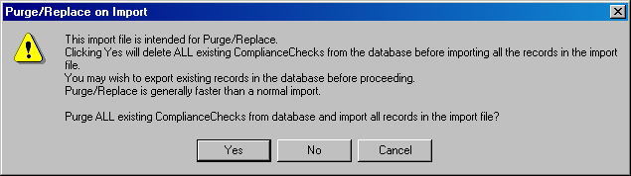

Step 5. Click Yes. The Progress window is briefly displayed and then disappears.

Step 6. Repeat the process, but this time choose All Snippets.cid from the import location.

APPENDIX C - FREQUENTLY ASKED QUESTIONS

C.1 What do the non-compliance messages mean when running compliance checks?
There are three levels of non-Compliance:``````````````

Failure – The record is not compliant and must be fixed, or a waiver must be obtained.
Warning – The record may not be compliant or there may be some other inconsistency or error in the data.
Note – These are messages to help you build more complete or more accurate data, but do not indicate a compliance failure.

C.2 I have failed a compliance check, what do I do?
Determine the cause of the failure. If the failure cannot be rectified, attach a document to the application to explain to NTIA why you should be granted a waiver from the standard.

C.3 I think that a compliance check is incorrect.
Send an email to the EL-CID Help Desk. Give the compliance check number and include a description of the problem. If possible, send the unclassified certification to the Help Desk. The Help Desk will notify NTIA that a potential problem exists. The Help Desk will further coordinate with NTIA to determine if the compliance check is accurate. If the compliance check is found to be inaccurate, a new one will be issued. If the user must submit the application before resolution of the issue, indicate to NTIA that a compliance check is in question and under review (you can do this by using an attachment document). The user will be notified of the action taken.

C.4 I just have one radio, how do I draw a link?
The link information that is gathered on the link node is most beneficial to NTIA. The link information gives the relationship between the transmitter, the transmitting antenna, transmitter power, and emission code. The applicable frequency bands are also listed.

The link can be drawn in three different ways.

1. Terminate the link with a generic icon. This allows the link to be drawn and the transmitter information to be entered with no receiver information. This represents that you are probably communicating with similar equipment in the same frequency range.

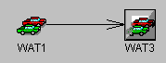

- Drag an identical icon to the screen and put the radio receiver characteristics on the second icon. This will allow you to give the receiver and receiver antenna data in the link.

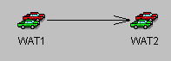
3. Drag an identical icon to the screen and put the full radio characteristics on the second icon. This will allow you to draw a link in the opposite direction. This represents that the radio will communicate with identical models of this radio.

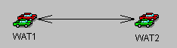

C.5 I don’t understand how repeaters are represented on the trunking diagram.
The typical trunking system consists of a base station communicating trough a repeater to the mobile.

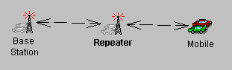

Since the repeater is usually the same radio equipment as the base station we have decided to ease the burden of repeating the transmitter information by calling it a generic station. Including the repeater icon is important, since the requirement exists to give the geographical location for each repeater; therefore we make a place holder of the repeater stations in order that they may be assigned geographic locations.

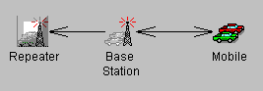

C.6 I have a change that I would like to be made to the EL-CID model.
In the documents directory under the EL-CID directory, you will find an EL-CID PCR (Program Change Request) Form. Fill this form out and email it to the EL-CID Help Desk. The Help Desk will coordinate the change with NTIA to determine if it is appropriate for use in EL-CID. If it is appropriate, the change will be included on the development schedule.

C.7 The frequency allocation table does not list the operating frequencies of my transmitter as being valid.
This situation can be caused by several reasons:

- The frequency allocation table frequencies are linked to the service station and radio class. Check to see if you have the correct icon on the diagram. The radio class is set on the link information page.

- Changes may have been made to the frequency allocation table and not updated in the EL-CID Model. If you see the frequency band for which you are interested and it is marked as being not in-band, you may still choose the band and give a reason for wanting to use the frequency band.

C.8 Why can’t I draw links between some of the station icons?
The station icons represent Radio Service/Station Classes and according to NTIA rules only certain Radio Service/Station Classes may communicate with each other. The station icons are color coded to show which icons can be linked together. The radio service and station classes are listed in the expanded station palette.

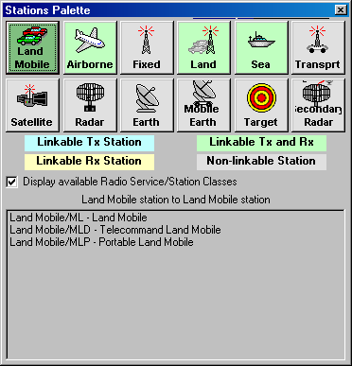

C.9 What Frequency Range Do I Use For The Transmitter, The Operating Range Or The Range I Want To Use?
You should enter the operating range of the transmitting equipment. EL-CID will scan the frequency allocation table using the station class and radio service and display on the link information window the applicable frequency ranges that are available to use.

C.10 I have a range of power values, what do I do?
Enter the maximum power value.

C.11 May I have multiple emission codes for a single transmitter?
Yes, you can. You may also have multiple power values, and harmonic levels.

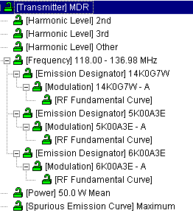

C.12 When is NTIA going to require the use of EL-CID?
Certifications using EL-CID can be submitted to NTIA immediately. NTIA has already received several submissions from agencies. NTIA currently plans during the calendar year 2006 to require the use of the EL-CID format for submission of certifications to NTIA.

C.13 How can I get any data that NTIA has in EL-CID format?
EL-CID files are FOR U.S. GOVERNMENT USE ONLY. The National Telecommunications
and Information Administration (NTIA), U.S. Department of Commerce, authorizes only Government frequency assignment personnel (including Spectrum Planning Subcommittee representatives) and approved supporting contractors to have access to and utilize the EL-CID files pursuant to the following limitations.

The EL-CID files are authorized for U.S. Government Use Only. Reproduction of the EL-CID files is prohibited without the prior written approval of NTIA. The EL-CID files shall not be sold or otherwise made available for commercial purposes. If an authorized user needs additional copies of the EL-CID files, requests should be directed to:

Department of Commerce
NTIA
ATTN: C. Scammon, Room 4600
1401 Constitution Avenue, N.W.
Washington, DC 20230

Or

email: cscammon@ntia.doc.gov

Government frequency assignment personnel (including Spectrum Planning Subcommittee
representatives) are authorized to distribute the EL-CID files to supporting contractors only with the prior approval of the controlling U.S. Government Contracting Officer and only for the stated purposes of the contract. All copies of the EL-CID files must be returned to the Contracting Officer or NTIA at the
conclusion of the work or the contract. Any other use of the EL-CID files by the supporting contractor is prohibited. The EL-CID files are intended for domestic U.S. Government use only. The EL-CID files shall not be made available to foreign governments or used in any contract with a foreign government without prior written approval by NTIA. An authorized user shall immediately notify NTIA or the controlling U.S. Government Contracting Officer of any violation of these limitations on the use of the EL-CID files.

C.14 How can I represent an antenna that has multiple gains or multiple frequencies?
EL-CID only allows one gain and one frequency range in an antenna record. You can create several antenna records with a different name showing the explicit data (i.e. myantenna 136-160, myantenna 180-200, myantenna 3db, myantenna 5db).

C.15 Why is it possible to put location data on a station node?
NTIA requires that for satellite and trunking systems, you provide location data for each station.

C.16 Do I have to draw the line diagram first?
No. You may create equipment records first (file|new|transmitter, receiver, antenna). You can export these equipment records and send them to someone else. When you create the new certification, you can draw the line diagram, right click on the tree view station node and (add ….| get existing …) from the data base.

C.17 What receiver IF data do I put in the model?
NTIA is interested in the most restrictive (narrowest) IF curve data. Only one set of IF data is needed for each emission-sensitivity node.

C.18 How do I assign multiple radio services to a station icon?
EL-CID only allows one radio service to be assigned to a station icon, except for Space which allows multiple radio services to be assigned to the Space Station Icon. If you need to represent more than one radio service for your station, drag the appropriate station icon to the diagram and indicate that it is the same transmitter (through the station name (i.e. my transmitter/1, my transmitter/2)). You can then add the appropriate equipment data to the new station and update the link information. Additional information can be represented in the attachment node using additional text or diagrams.

C.19 How do I represent a ship board mobile earth station?
When you drag out the mobile earth station icon you have the choice of ship, air, or land based.

C.20 How do I represent an airborne radar station?
When you drag out the radar station icon you have the choice of ship, air, or land based.

APPENDIX D – SAMPLE SATELLITE SYSTEM

Step 1. Draw a diagram and enter the following data to create a sample satellite system.

This example is a description of a system that has two way communications between an earth station (named “Earth” and a satellite (named “Satellite”). Each station transmits and receives through a different antenna. This is a developmental system (stage 3) called “Sample Satellite”.

General Data
Field | Value
Target date for System Approval | 6/30/2006
System Description | The sample satellite will provide a platform for scientific data collected by onboard experiments
Target date for System Activation | 6/30/2006
Target date for System Termination | 6/30/2010
Number of Units | 1
Estimated Initial Cost (&) | $260,000
Information Transfer Requirement | Telemetry data GMSK/9.6 kbps ; Experiment data BPSK/38.4 kbps
System Essentiality or Replacement | System is designed to detect and characterize plasma bubbles in the atmosphere

Earth Station 

Earth Station
Field | Value
Minimum Pointing Angle | 0.0 Degrees

Antenna – Aperture
Field | Value
Nomenclature | Earth Antenna Receiving
Manufacturer | Direction Corp
Model Name and Number | DC-Aperture-1
Antenna Horizontal Beamwidth | 14 Degrees
Antenna Vertical Beamwidth | 28 Degrees
Antenna Lower Frequency Limit | 2200 MHz
Antenna Upper Frequency Limit | 2290 MHz
Polarization | Horizontal
Antenna Main Beam Gain | 26 dBi
1st Sidelobe Level Plane Attenuation Horizontal | 8 dB
1st Sidelobe Level Plane Attenuation Vertical | 8 dB
1st Sidelobe Level Plane Attenuation Rel/Act | Actual dBi
First Sidelobe Plane Position Horizontal | 12 Degrees
First Sidelobe Plane Position Vertical | 12 Degrees
Horizontal Rotation Type | Horizontal Rotation 360 Degrees
Horizontal Rotation Rate | 0.0
Antenna Vertical Scan | Yes
Antenna Vertical Scan Rate | 0.0
Antenna Vertical Scan Maximum Elevation | 90 Degrees
Antenna Vertical Scan Minimum Elevation | 0 Degrees

Antenna – Linear
Field | Value
Nomenclature | Earth Antenna Transmitting
Manufacturer | Mirage System
Model Name and Number | MS-Linear-1
Antenna Horizontal Beamwidth | 34 Degrees
Antenna Vertical Beamwidth | 34 Degrees
Antenna Lower Frequency Limit | 144 MHz
Antenna Upper Frequency Limit | 150 MHz
Polarization | Right and Left Hand Circular
Antenna Main Beam Gain | 13 dBi
1st Sidelobe Level Plane Attenuation Rel/Act | Actual dBi
1st Sidelobe Level Plane Attenuation Horizontal | 6 dB
1st Sidelobe Level Plane Attenuation Vertical | 6 dB

Location
Field | Value
State, Country, or Location Name Part 1 | Colorado
City or Location Name Part 2 | Colorado Springs-USAF Academy
Location Type | Single Point
Geographic Coordinates | 390021N 1043534W
Map Layer | Cities

Earth Receiver
Field | Value
Nomenclature | Earth Receiver
Manufacturer | Kenwood
Model Name and Number | K-Ground-Rx
Frequency Stability | 15
Frequency Stability Units | ppm
Image Rejection Level | 60 dB
Local Oscillator Tuned Indicator | Below
Tuning Method | Synthesizer

Earth Receiver Frequency
Field | Value
Lowest Tuned Frequency | 2200 MHz
Highest Tuned Frequency | 2290 MHz
Tuning Increment | 0.0 kHz

Earth Receiver Frequency Emission Sensitivity
Field | Value
Emission Designator | 80K0G2D
Necessary Bandwidth | 80 kHz
Performance Criteria | BER – Bit Error Rate
Performance Value | 0.0001
Sensitivity | -110 dBm
Noise Figure | 0.600 dB
Spurious Rejection Level | 50 dB

Earth Receiver Frequency Emission Sensitivity IF Selectivity Curve
Field | Value
Measured or Calculated | Measured
IF Frequency | 70 MHz
3 dB Bandwidth / (Frequency Offset) | 130 kHz / (65 kHz)*
20 dB Bandwidth / (Frequency Offset) | 210 kHz / (105 kHz)*
60 dB Bandwidth / (Frequency Offset) | 1380 kHz / (690 kHz)*

*Remember that the curve editor wants frequency offset as an input (frequency offset =½ bandwidth)

Earth Receiver Frequency RF Selectivity Curve
Field | Value
Measured or Calculated | Measured
3 dB Bandwidth / (Frequency Offset) | 5 MHz / (2.5 MHz)*
20 dB Bandwidth / (Frequency Offset) | 20 MHz / (10 MHz)*
60 dB Bandwidth / (Frequency Offset) | 30 MHZ / (15 MHz)*

*Remember that the curve editor wants frequency offset as an input (frequency offset =½ bandwidth)

Earth Transmitter
Field | Value
Nomenclature | Earth Transmitter
Manufacturer | Kenwood
Model Name and Number | K-Ground-Tx
Frequency Stability | 3
Frequency Stability Units | ppm
Output Device | Transistor
Tuning Method | PLL Synthesizer
Radar or Communications? | Communications

Earth Transmitter Harmonic
Field | Value
2nd Harmonic | -70 dB
3rd Harmonic | -70 dB
Other Harmonic | -80 dB

Earth Transmitter Frequency
Field | Value
Lowest Tuned Frequency | 144 MHz
Highest Tuned Frequency | 152 MHz
Tuning Increment | 0.0 kHz

Earth Transmitter Frequency Emission Designator
Field | Value
Necessary Bandwidth | 30 kHz
Emission Designator | 30K0F2D

Earth Transmitter Frequency Emission Designator Modulation
Field | Value
Emission Designator | 30K0F2D
Measured or Calculated | Measured
Modulation Type | Digital Modulation
Digital Modulation Type | MSK – Minimum Shift Keying
Number of Digital States | 2
Transmission Bit Rate | 9600 bps
Digital Peak Deviation | 4.8 kHz
Digital Deviation Ratio | 0.500
Digital Maximum Modulation Frequency | 9.6 kHz
Digital Pulse Format | B- Non-Return to Zero (NRZ)

Earth Transmitter Frequency Emission Designator Modulation RF Fundamental Curve
Field | Value
Measured or Calculated | Measured
-3 dB Bandwidth / (Frequency Offset) | 7 kHz / (3.5 kHz)*
-20 dB Bandwidth / (Frequency Offset) | 32 kHz / (16 kHz)*
-40 dB Bandwidth / (Frequency Offset) | 57 kHz / (28.5 kHz)*
-60 dB Bandwidth / (Frequency Offset) | 90 kHz / (45 kHz)*

*Remember that the curve editor wants frequency offset as an input (frequency offset =½ bandwidth)

Earth Transmitter Power
Field | Value
Power Type | Mean
Power | 100 Watts

Earth Transmitter Spurious Emission Curve
Field | Value
Maximum Spurious Emission | Checked
Level | -80 dB

Satellite Station 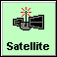

Antenna – Linear
Field | Value
Nomenclature | Satellite Antenna Transmitting
Manufacturer | Omni Tronix
Model Name and Number | OT-Linear-1
Antenna Horizontal Beamwidth | 360 Degrees
Antenna Vertical Beamwidth | 80 Degrees
Antenna Lower Frequency Limit | 2200 MHz
Antenna Upper Frequency Limit | 2290 MHz
Polarization | Vertical
Antenna Main Beam Gain | 3 dBi
1st Sidelobe Level Plane Attenuation Rel/Act | Actual dBi

Antenna – Linear
Field | Value
Nomenclature | Satellite Antenna Receiving
Manufacturer | OMERA(FRANCE)
Model Name and Number | O-Linear-1
Antenna Horizontal Beamwidth | 34 Degrees
Antenna Vertical Beamwidth | 34 Degrees
Antenna Lower Frequency Limit | 140 MHz
Antenna Upper Frequency Limit | 160 MHz
Polarization | Vertical
Antenna Main Beam Gain | 13 dBi
1st Sidelobe Level Plane Attenuation Rel/Act | Actual dBi
1st Sidelobe Level Plane Attenuation Horizontal | 6 dB
1st Sidelobe Level Plane Attenuation Vertical | 6 dB

Location
Field | Value
State, Country, or Location Name Part 1 | Space
City or Location Name Part 2 | Sample Satellite
Location Type | Non-geostationary Satellite
Altitude at Apogee | 370 km
Altitude at Perigee | 375 km
Equatorial Inclination | 51.6 Degrees
Period of Orbit | 5520 Seconds

Satellite Receiver
Field | Value
Nomenclature | Satellite Receiver
Manufacturer | SUR-TEC INC
Model Name and Number | S-Satellite-Rx
Frequency Stability | 25
Frequency Stability Units | ppm
Image Rejection Level | 60 dB
Local Oscillator Tuned Indicator | Below
Tuning Method | Fixed Crystal

Satellite Receiver Frequency
Field | Value
Lowest Tuned Frequency | 144 MHz
Highest Tuned Frequency | 150 MHz
Tuning Increment | 0.0 kHz

Satellite Receiver Frequency Emission Sensitivity
Field | Value
Emission Designator | 30K0F2D
Necessary Bandwidth | 30 kHz
Performance Criteria | BER – Bit Error Rate
Performance Value | 0.0001
Sensitivity | -130 dBm
Noise Figure | 0.300 dB
Noise Temperature | 1000 Degrees Kelvin
Spurious Rejection Level | 50 dB

Satellite Receiver Frequency Emission Sensitivity IF Selectivity Curve
Field | Value
Measured or Calculated | Measured
IF Frequency | 455 kHz
3 dB Bandwidth / (Frequency Offset) | 60 kHz / (30 kHz)*
20 dB Bandwidth / (Frequency Offset) | 80 kHz / (40 kHz)*
60 dB Bandwidth / (Frequency Offset) | 120 kHz / (60 kHz)*

*Remember that the curve editor wants frequency offset as an input (frequency offset =½ bandwidth)

Satellite Receiver Frequency RF Selectivity Curve
Field | Value
Measured or Calculated | Measured
3 dB Bandwidth / (Frequency Offset) | 30 MHz / (15 MHz)*
20 dB Bandwidth / (Frequency Offset) | 40 MHz / (20 MHz)*
60 dB Bandwidth / (Frequency Offset) | 60 MHZ / (30 MHz)*

*Remember that the curve editor wants frequency offset as an input (frequency offset =½ bandwidth)

Satellite Transmitter
Field | Value
Nomenclature | Satellite Transmitter
Manufacturer | SUR-TEC INC
Model Name and Number | ST-Satellite-1
Frequency Stability | 10
Frequency Stability Units | ppm
Output Device | Transistor
Tuning Method | Fixed Crystal

Satellite Transmitter Harmonic
Field | Value
2nd Harmonic | -60 dB
3rd Harmonic | -60 dB
Other Harmonic | -60 dB

Satellite Transmitter Frequency
Field | Value
Lowest Tuned Frequency | 2200 MHz
Highest Tuned Frequency | 2290 MHz
Tuning Increment | 0.0 kHz

Satellite Transmitter Frequency Emission Designator
Field | Value
Necessary Bandwidth | 80 kHz
Emission Designator | 80K0G2D

Satellite Transmitter Frequency Emission Designator Modulation
Field | Value
Emission Designator | 80K0G2D
Measured or Calculated | Measured
Modulation Type | Digital Modulation
Digital Modulation Type | PSK – Phase Shift Keying
Number of Digital States | 2
Transmission Bit Rate | 38400 bps
Digital Peak Deviation | 60.288 kHz
Digital Deviation Ratio | 1.57
Digital Maximum Modulation Frequency | 38.400 kHz
Digital Pulse Format | B- Non-Return to Zero (NRZ)

Satellite Transmitter Frequency Emission Designator Modulation RF Fundamental Curve
Field | Value
Measured or Calculated | Measured
-3 dB Bandwidth / (Frequency Offset) | 60 kHz / (30 kHz)*
-20 dB Bandwidth / (Frequency Offset) | 90 kHz / (45 kHz)*
-40 dB Bandwidth / (Frequency Offset) | 130 kHz / (65 kHz)*
-60 dB Bandwidth / (Frequency Offset) | 188 kHz / (94 kHz)*

*Remember that the curve editor wants frequency offset as an input (frequency offset =½ bandwidth)

Satellite Transmitter Power
Field | Value
Power Type | Mean
Power | 0.5 Watts

Satellite Transmitter Spurious Emission Curve
Field | Value
Maximum Spurious Emission | Checked
Level | -60 dB

Link Information: Earth to Satellite
Field | Value
Radio Service/Station Class | Space Operation / TT - Earth  Space Research / TH - Earth
Coupling Loss | 0.0 dB

Link Information: Satellite to Earth
Field | Value
Radio Service/Station Class | Space Operation / ET - Space  Space Research / EH - Space
Coupling Loss | 0.0 dB
Spectral Power Density | -48.8 dBW/Hz

Step 2. Run the compliance checks (0 Failures, 1 Warning, 4 Notes)

NOTE NTIA Chapter 10: NTIA-CH10-8.7.23
If this transmitter has been type accepted by the FCC, enter the FCC Acceptance Number. See section 10.8.7 paragraph 23 of the NTIA Manual.

NOTE NTIA Chapter 10: NTIA-CH10-8.7.23
If this transmitter has been type accepted by the FCC, enter the FCC Acceptance Number. See section 10.8.7 paragraph 23 of the NTIA Manual.

NOTE NTIA Chapter 10: NTIA-CH10-8.3.05
Stage 2 and above space systems are generally required to submit notification to the Radiocommunication Bureau (BR). See Section 3.3 of the NTIA Manual. If not installed on your system, install the ITU software. In EL-CID Preferences, General tab, enter the path to the ITU program. Use the ITU program to prepare the notification and attach it to the EL-CID Certification. If this system is exempt from BR notification, set ITU Waiver to True in the General Information node. See section 10.8.3 paragraph 5 of the NTIA Manual.

NOTE NTIA Chapter 10: NTIA-CH10-8.5
For all stages, submit reports of any previous EMC studies, predictions, analyses, and prototype EMC testing that are relevant to the assessment of the system (right-click Attachments in Tree View) You may reference documents previously provided to the IRAC/SPS, including references to previous stages of this system (right-click References in Tree View).

WARNING NTIA Chapter 8:NTIA-CH8-8.2.36.1.a-04-1-W
This Satellite (to Earth) link exceeds the Power Flux Density Limits of Table 8.2.36 (1525-1530, 1670-1710, 1761-1842 and 2200-2300 MHz). Click the [Coupling] node to display the Link Info screen, click Power Flux Density, and click Calculate to see the calculated PFD and limits.

Step 3. Follow the instructions on the above WARNING to see why the PFD is failing. (You can do a “what-if” analysis to see how varying the parameters will change the PFD result.)

Step 4. Import the sample satellite record from the training CD (under Training Materials / Samples)

Step 5. Use the query on Transmitters, Receivers, and Antennas to compare the two certifications.

APPENDIX E – SAMPLE RADAR SYSTEM

Step 1. Draw a diagram and enter the following data to create a sample radar system.

This example is a description of a land based radar system that has a station (named “Radar”) transmitting to a target (named “Target”). This is a developmental system (stage 3) called “Sample Radar”.

General Data
Field | Value
System Description | Radar to detect targets and weather
Target date for System Activation | 6/30/2006
Target date for System Termination | 6/30/2100
Number of Units | 1
Estimated Initial Cost (&) | $1,250,000
Information Transfer Requirement | Unmodulated and Linear FM pulses
System Essentiality or Replacement | Replace existing system

Location
Field | Value
State, Country, or Location Name Part 1 | USP(US&POSS)
City or Location Name Part 2
Location Type | Polygon
Map Layer | Countries

Radar Station 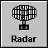

Antenna – Aperture
Field | Value
Nomenclature | Radar Antenna
Manufacturer | Andrew Antenna Corporation LTD
Model Name and Number | A-Aperture-1
Antenna Horizontal Beamwidth | 1.45 Degrees
Antenna Vertical Beamwidth | 4.8 Degrees
Antenna Lower Frequency Limit | 1200 MHz
Antenna Upper Frequency Limit | 1400 MHz
Polarization | Right and Left Hand Circular
Antenna Main Beam Gain | 34 dBi
1st Sidelobe Level Plane Attenuation Horizontal | 21 dB
1st Sidelobe Level Plane Attenuation Vertical | 21 dB
1st Sidelobe Level Plane Attenuation Rel/Act | Relative dBi
First Sidelobe Plane Position Horizontal | 3.5 Degrees
First Sidelobe Plane Position Vertical | 3.5 Degrees
Horizontal Rotation Type | Horizontal Rotation 360 Degrees
Horizontal Rotation Rate | 12.5 per minute
Antenna Vertical Scan | Yes
Antenna Vertical Scan Rate | 0.0
Antenna Vertical Scan Maximum Elevation | 5 Degrees
Antenna Vertical Scan Minimum Elevation | -3 Degrees
Antenna Horizontal Dimension | 5 meters
Antenna Vertical Dimension | 2.75 meters

Radar Receiver
Field | Value
Nomenclature | Radar Receiver
Manufacturer | Raytheon Co. or Raytheon Manufacturing Co.
Model Name and Number | R-Radar-Rx
Frequency Stability | 10
Frequency Stability Units | ppm
Image Rejection Level | 60 dB
Local Oscillator Tuned Indicator | Above
Tuning Method | Crystal Controlled

Radar Receiver Frequency
Field | Value
Lowest Tuned Frequency | 1200 MHz
Highest Tuned Frequency | 1400 MHz
Tuning Increment | 0.0kHz

Radar Receiver Frequency Emission Sensitivity
Field | Value
Emission Designator | 4M20Q3N
Necessary Bandwidth | 4200 kHz
Performance Criteria | S/N – Signal to Noise Ratio (dB)
Performance Value | -10
Sensitivity | -110 dBm
Noise Figure | 2.90 dB
Spurious Rejection Level | 65 dB

Radar Receiver Frequency Emission Sensitivity IF Selectivity Curve
Field | Value
Measured or Calculated | Measured
IF Frequency | 27.180 MHz
3 dB Bandwidth / (Frequency Offset) | 6.4 kHz / (3.2 kHz)*
20 dB Bandwidth / (Frequency Offset) | 9 kHz / (4.5 kHz)*
60 dB Bandwidth / (Frequency Offset) | 18.2 kHz / (9.1 kHz)*

*Remember that the curve editor wants frequency offset as an input (frequency offset =½ bandwidth)

Radar Receiver Frequency Emission Sensitivity
Field | Value
Emission Designator | 7M30P0N
Necessary Bandwidth | 7300 kHz
Performance Criteria | MDS – Minimum Discernable Signal (dB)
Performance Value | -10
Sensitivity | -109 dBm
Noise Figure | 3 dB
Spurious Rejection Level | 65 dB

Radar Receiver Frequency Emission Sensitivity IF Selectivity Curve
Field | Value
Measured or Calculated | Measured
IF Frequency | 75 MHz
3 dB Bandwidth / (Frequency Offset) | 5.8 MHz / (2.9 MHz)*
20 dB Bandwidth / (Frequency Offset) | 8 MHz / (4 MHz)*
60 dB Bandwidth / (Frequency Offset) | 21.8 MHz / (10.9 MHz)*

*Remember that the curve editor wants frequency offset as an input (frequency offset =½ bandwidth)

Radar Receiver Frequency RF Selectivity Curve
Field | Value
Measured or Calculated | Measured
3 dB Bandwidth / (Frequency Offset) | 568 MHz / (284 MHz)*
20 dB Bandwidth / (Frequency Offset) | 904 MHz / (452 MHz)*
60 dB Bandwidth / (Frequency Offset) | 2700 MHZ / (1350 MHz)*

*Remember that the curve editor wants frequency offset as an input (frequency offset =½ bandwidth)

Radar Transmitter
Field | Value
Nomenclature | Radar Transmitter
Manufacturer | Raytheon Co. or Raytheon Manufacturing Co.
Model Name and Number | R-Radar-Tx
Frequency Stability | 30
Frequency Stability Units | ppm
Output Device | Transistor
Tuning Method | Crystal Controlled

Radar Transmitter Harmonic
Field | Value
2nd Harmonic | -74 dB
3rd Harmonic | -80 dB
Other Harmonic | -80 dB

Radar Transmitter Frequency
Field | Value
Lowest Tuned Frequency | 1200 MHz
Highest Tuned Frequency | 1390 MHz
Tuning Increment | 0.0 kHz
Number of Frequencies Required for Operation | 2
Minimum Required Frequency Separation | 30 MHz

Radar Transmitter Frequency Emission Designator
Field | Value
Necessary Bandwidth | 4200 kHz
Emission Designator | 4M20Q3N

Radar Transmitter Frequency Emission Designator Modulation
Field | Value
Emission Designator | 4M20Q3N
Occupied Bandwidth | 4200 kHz
Measured or Calculated | Measured
Radar Type | FM Pulse Radar
Pulse Repetition Rate | 1391 pps
Pulse Rise Time | 0.000150 ms
Pulse Fall Time | 0.000150 ms
Pulse Width | 0.0256 ms
Pulse Compression Ratio | 74
Radar Pulse Compression Deviation | 2890 kHz

Radar Transmitter Frequency Emission Designator Modulation RF Fundamental Curve
Field | Value
Measured or Calculated | Measured
-3 dB Bandwidth / (Frequency Offset) | 2630 kHz / (1315 kHz)*
-20 dB Bandwidth / (Frequency Offset) | 4200 kHz / (2100 kHz)*
-40 dB Bandwidth / (Frequency Offset) | 9500 kHz / (4750 kHz)*
-60 dB Bandwidth / (Frequency Offset) | 30000 kHz / (15000 kHz)*

*Remember that the curve editor wants frequency offset as an input (frequency offset =½ bandwidth)

Radar Transmitter Frequency Emission Designator
Field | Value
Necessary Bandwidth | 7300 kHz
Emission Designator | 7M30P0N

Radar Transmitter Frequency Emission Designator Modulation
Field | Value
Emission Designator | 7M30P0N
Occupied Bandwidth | 7300 kHz
Measured or Calculated | Measured
Modulation Type | Non-FM Pulse Radar
Pulse Repetition Rate | 1391 pps
Pulse Rise Time | 0.000150 ms
Pulse Fall Time | 0.000150 ms
Pulse Width | 0.00200 ms

Radar Transmitter Frequency Emission Designator Modulation RF Fundamental Curve
Field | Value
Measured or Calculated | Measured
-3 dB Bandwidth / (Frequency Offset) | 3500 kHz / (1750 kHz)*
-20 dB Bandwidth / (Frequency Offset) | 7300 kHz / (3650 kHz)*
-40 dB Bandwidth / (Frequency Offset) | 11000 kHz / (5500 kHz)*
-60 dB Bandwidth / (Frequency Offset) | 150000 kHz / (75000 kHz)*

*Remember that the curve editor wants frequency offset as an input (frequency offset =½ bandwidth)

Radar Transmitter Power
Field | Value
Power Type | Peak Envelope
Power | 45000 Watts

Radar Transmitter Spurious Emission Curve
Field | Value
Maximum Spurious Emission | Checked
Level | -80 dB

Link Information: Radar to Target
Field | Value
Radio Service/Station Class | Radiodetermination / LR - Land

Step 2. Run the compliance checks (2 Failures, 1 Warning, 2 Notes).

FAILURE NTIA Chapter 5: NTIA-CH5-5.5.3.7-1
Group C radar receivers must have IF Selectivity characteristics commensurate with or narrower than the corresponding transmitter bandwidth. The receiver IF Selectivity curve is wider than the corresponding transmitter's RF Fundamental curve. See section 5.5.3 paragraph 7 of the NTIA Manual.

NOTE NTIA Chapter 10: NTIA-CH10-8.7.23
If this transmitter has been type accepted by the FCC, enter the FCC Acceptance Number. See section 10.8.7 paragraph 23 of the NTIA Manual.

FAILURE NTIA Chapter 5: NTIA-CH5-5.5.3.3.1-2
This Group C non-FM pulsed radar transmitter does not meet the standard emission bandwidth curve as required in section 5.5.3 paragraphs 3.1 and 4.1 of the NTIA Manual. Note that Pavg = Peak Power * Pulse Repetition Rate * Pulse Width is used for Pt in the curve formula.

WARNING NTIA Chapter 10: NTIA-CH10-8.7.19.e-W
FM pulse modulated radar transmitters should specify Pulse Compression Ratio in a Stage 3 Certification.

NOTE NTIA Chapter 10: NTIA-CH10-8.5
For all stages, submit reports of any previous EMC studies, predictions, analyses, and prototype EMC testing that are relevant to the assessment of the system (right-click Attachments in Tree View) You may reference documents previously provided to the IRAC/SPS, including references to previous stages of this system (right-click References in Tree View). See section 10.8.5 of the NTIA Manual.

Step 3. Import the sample radar record from the training CD (under Training Materials / Samples)

Step 4. Use the query on Certifications, Transmitters, Receivers, and Antennas to compare the two certifications.

