

Facility Access and Shipment Tracking (FAST)
October 2005
Version 4.0

1.0 Introduction 5
1.1 FAST Background 5
1.2 About This Guide 5
1.3 Common Application Features 6
1.4 Helpful Hints 22
2.0 Pre-Login 25
2.1 Facility Profile 25
2.2 Appointment Calendar 35
2.3 Closeout Data Report 39
2.4 BMC Information 43
2.5 Reference Documents 44
2.6 Message Board 49
2.7 What’s New Board 50
3.0 Login/Logout 51
3.1 Logging In/Logging Out 51
3.2 Message Board Pop Up 56
4.0 Landing pages 57
4.1 FAST Main Menu 57
4.2 Appointments 58
4.3 Facilities 60
4.4 Profiles 61
4.5 Reports 62
4.6 Resources 65
5.0 Facilities 67
5.1 Facility Profile 67
6.0 Appointments 79
6.1 Drop Ship Web 79
6.2 Creating a New Appointment 81
6.3 Creating an Appointment for a Multi-Stop 99
6.4 Managing Existing Appointments 116
6.5 Recurring Appointments 150
7.0 Corporate Profile 156
7.1 Corporate Profile 157
7.2 Scheduler Profile 160
8.0 Reports 163
8.1 Scheduler Report 163
8.2 Scheduler Performance Report 168
8.3 Appointment Calendar 172
8.4 Appointment Status Report 178
8.5 Holiday and Contingency Constraints Report 182
8.6 Corporate Rating Report 186
8.7 Appointment Rating Analysis Report 193
8.8 Closeout Data Report 204
9.0 Resources 207
9.1 Area-District 3-Digit Data 207
9.2 Reference Documents 207
9.3 Drop Ship Product File Download 221
9.4 Message Board 223
9.5 What’s New Board 224
10.0 Rating Overview 227
10.1 Appointment Rating 227
10.2 Corporate Rating 231
10.3 Timeline and Rating Calendar 233
11.0 Appendix 235
11.1 Security 235
11.2 Glossary 237
11.3 PostalOne! User Guide 242
11.4 PostalOne! Technical Guide 256

1.0 Introduction

  - FAST Background

The Postal Service has identified the need to replace the Drop Shipment Appointment System (DSAS) and greatly enhance the appointment scheduling capabilities with the creation of the Facility Access and Shipment Tracking System (FAST). The main objective of FAST is to improve the dock efficiency time. FAST will provide advance notification of inbound mail volumes to Surface Visibility and will use scan data from Surface Visibility to automatically close and track appointments. FAST will also integrate with other USPS systems such as the Drop Ship Product and Facilities Database for a more streamlined data maintenance and distribution process to improve the current data latency and discrepancy issues that exist.

  - About This Guide

This guide describes how to use the FAST functions. The guide provides an explanation of search fields and reports, detailed instructions for completing searches and viewing report details, and helpful notes that will assist the user in maximizing FAST capabilities. This section describes the common conventions used throughout the guide and includes:

1.2.1 Icons
1.2.2 User Guide Font Indicators

1.2.1 Icons

Several icons are used in this guide to aid the user in quickly locating specific information. The icons and their associated references are shown below:

Look for the magnifying glass icon to identify where page descriptions begin. Page descriptions provide explanations of the search fields, buttons, and report columns found on each new page.

Look for the computer mouse icon to identify where step by step instruction begins. These steps detail the action the user must take to complete search fields and view detailed report information.

Look for the paper and pen icon to identify additional notes. These notes provide reminders, alternative options, or helpful tips for using FAST.

    - User Guide Font Indicators

Throughout this guide the user will see several instances where selected words are bolded. These words are bolded to bring user attention to the key phrases.

Italicized words are used for all section and page titles, where no action is required by the user.

Additionally, capitalized words represent an action the user may take within the application. Some examples of capitalized words are ‘CLICK’, ‘SELECT’, and ‘ENTER’.

  - Common Application Features

There are several tools and processes that are common across the FAST application. The following section provides detailed instructions for these practices which include:

1.3.1 Procedures
- Navigation
- Top Navigation Bar
- Left Navigation Bar
- Go> Buttons
- Previous Screen Hyperlink
- Tables
- Sorting Data
- Pagination
- View Printable Version
- Downloading to Excel
1.3.2 Fields and Buttons
- Select Date Range
- Drop-Down Boxes
- Search Button
- Submit Button
- Cancel Button
1.3.3 Error Messages

1.3.1 Procedures

Navigation

There are several ways to navigate through the FAST application. The Top Navigation Bar allows the user to enter the USPS Home area, to enter the FAST Home area, and to sign out of the FAST application. The Left Navigation Bar allows the user to choose any functional area within the entire FAST application, as well as navigate between sections within the functional area they are currently using. The Previous Screen hyperlink, located within the report pages, allows the user to return to the page that brought them to the current page. More detailed information about navigation is found below.

Top Navigation Bar

The Top Navigation Bar allows the user to enter the USPS Home area, to enter the FAST Home area, and to sign out of the FAST application. The Top Navigation Bar is displayed below.

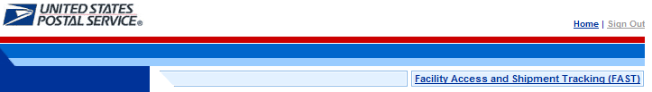

- CLICK the Facility Access and Shipment Tracking (FAST) link to return to the FAST Home area.

The USPS Home area features the USPS logo, a Home link, and a Sign Out link. This menu bar is highlighted below.

- CLICK the USPS logo or the Home link to open the United States Postal Service website: USPS.com.

- CLICK the Sign Out link to sign out of the FAST application.
Note:

The Sign Out button is displayed once logged into FAST.

Left Navigation Bar

The Left Navigation Bar allows the user to choose any functional area within the entire FAST application, as well as, navigate between sections within the functional area they are currently using. The name of the page that the user is currently on will be highlighted on the Left Navigation Bar. If there is more than one option under a menu choice in the Left Navigation Bar, each choice will be listed. In this example, the user is on the Appointments Landing page and the Appointment link is highlighted on the Left Navigation Bar. The Left Navigation Bar is highlighted below.

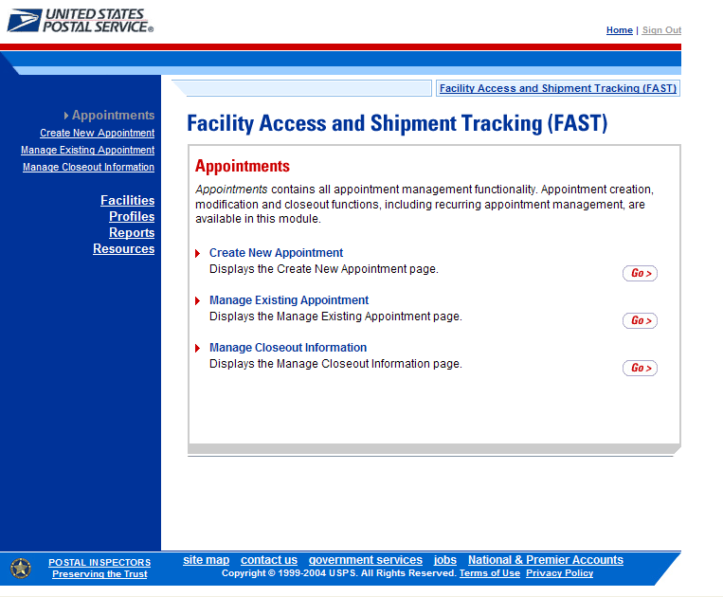

Left Navigation Bar options for each of the functional areas are listed below:

- The Appointment link includes the following sub-links: Create New Appointment, Manage Existing Appointment, Manage Closeout Information

- The Facility link includes the following sub-link: Facility Profile

- The Profile link includes the following sub-link: Corporate Profile

- The Report link includes the following sub-links: Scheduler Report, Scheduler Performance Report, Appointment Calendar, Appointment Status Report

- The Resource link includes the following sub-links: Reference Documents, Drop-Ship Product File Download, Message Board, What’s New Board

Go> Buttons

FAST displays a Go> button to the right of each functional area on the FAST Login page and FAST Landing pages, that takes the user to the appropriate page. Use the Go> button and other navigation tools described in this section instead of using the Internet browser’s Back and Forward buttons. Using the Internet browser buttons may result in incorrect information.

In the example displayed below, the user is on the Appointment Landing page as indicated on the Left Navigation Bar. CLICKING the Go> button takes the user to the corresponding page.

Previous Screen Hyperlink

FAST displays a Return to Previous Screen hyperlink at the top of the pages that takes the user back to the last page viewed.
Use the Return to Previous Screen hyperlink and the other navigation tools described in this section instead of using the Internet browser’s Back and Forward buttons. Using the Internet browser buttons may result in incorrect information.

In the example displayed below, the user is on the Appointment Calendar page as indicated by the title. CLICKING the Return to Previous Screen link takes the user to the Appointment Calendar Selection page, which will contain the search criteria previously entered.

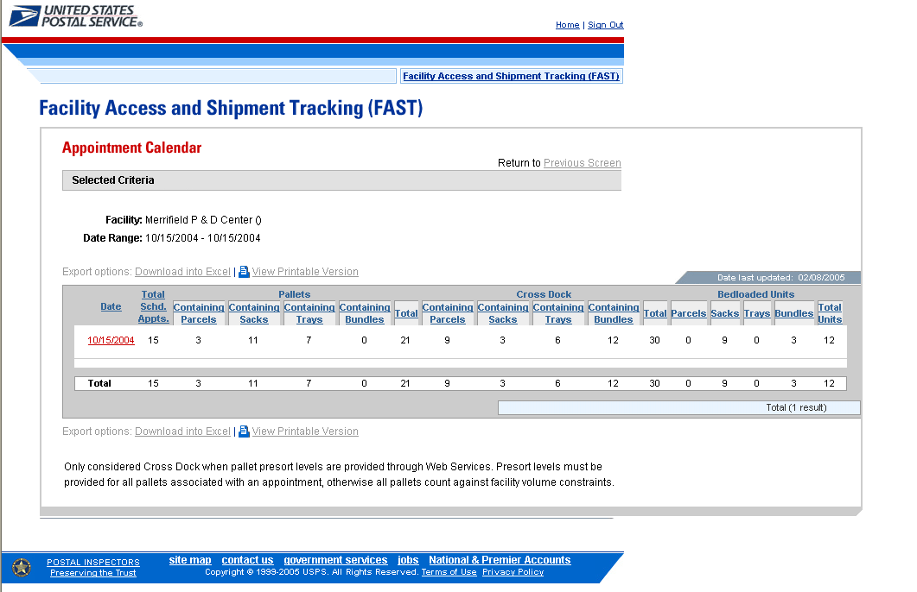

Note:
Any data that had been entered on the previous page is saved when the user clicks the Return to Previous Screen button.

Tables

Sorting Data

Each table displayed within FAST allows the user to sort data. Data may be sorted by CLICKING the column headers, with the first CLICK sorting in ascending order and the second CLICK sorting in descending order. All column headings that are underlined may be sorted in this manner.

- CLICK the heading of the column by which data is to be sorted. This sorts data in ascending order. The header will change from a blue underlined font to a red underlined font indicating the report has been sorted.

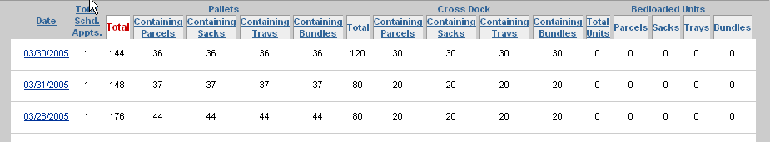

- CLICK the heading of the column by which data is to be sorted a second time to sort data in descending order. The column heading will remain in the same red underlined font, but the report will be re-sorted.

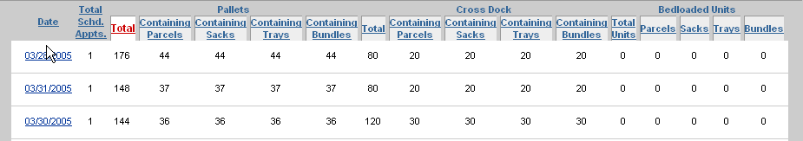

Note:
A sort on a particular column includes any data that is on a different page due to pagination.

Pagination

Reports in FAST may provide more data than may be displayed on one page. When this occurs, the user has the ability to view the other pages of the report. The total number of items displayed will also be shown.

- CLICK the First link, Prev link, Next link or Last link to navigate to multiple pages, OR:
- CLICK the hyperlinked page number in order to jump to the page. In the example on the following page, the user may CLICK the number 2. The page number that the user is currently on, number 1 in the example displays as a bold number.

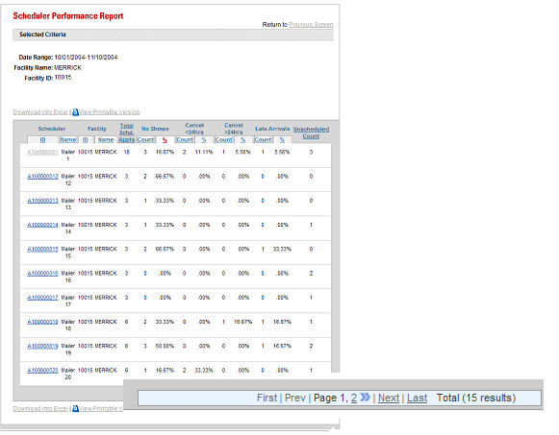

Note:
Pagination only occurs in the report pages. The Facility Profile Selection page displays a list as a scrolling window.

Viewing a Printable Version and Printing

The user has the ability to print information provided by the FAST application. The user may view a version suitable for printing that removes the navigation bars and shows all the data that the report contains.

- CLICK the View Printable Version link. There are two links for View Printable Version, above and below the report table. The example may be found on the following page.

A new window appears, displaying a version suitable for printing.

An example of a printable version is displayed below.
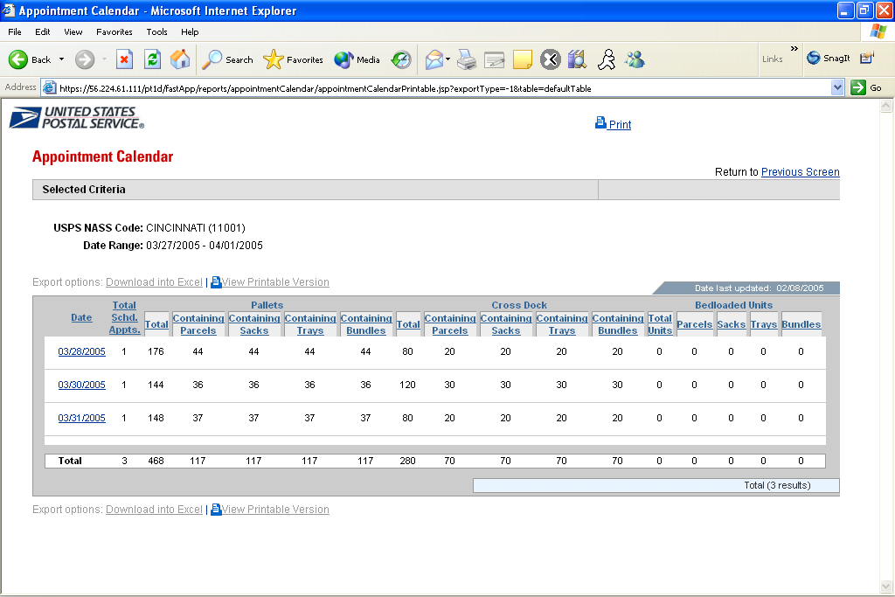

The user has two options for printing the report.

To print using the Print hyperlink:

- CLICK the Print hyperlink.

To print according to the settings on the individual computer:

- CLICK File from the browser menu bar.
- SELECT Print… from the File menu and print according to the settings on the individual computer.
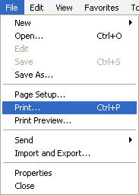

Printed reports are almost identical to what is seen online in the printable version, with just two differences. First, printed reports do not show the Internet browser bar that is visible online. Second, reports print out in a clear format that does not display row shading.
Note:
View Printable Version includes any data that is on a different page due to pagination. It may be a lengthy report and print several pages.
CLICKING the Return to Previous Screen hyperlink, on the printable version, will return the user to the Selection page.

Note:
If the printed report does not fit on a portrait page, change the orientation to landscape by CLICKING the File menu, selecting Page Setup…, and selecting the Landscape radio button.

Downloading to Excel

Several FAST Report pages allow the user to download information shown on the page into Microsoft Excel in order to manipulate and save data.

- CLICK the Download to Excel link. There are two links for Download to Excel, above and below the report table.
Note:
Download to Excel includes any data that is on a different page due to pagination.

Download to Excel may only be found on the FAST Report pages.

- A new window appears, prompting the user to either open the Excel report in a new window or save it to their computer.

a) CLICK Open to open a new window showing the report data in an Excel spreadsheet.
b) CLICK Save to select a directory on the computer to save the Excel spreadsheet.

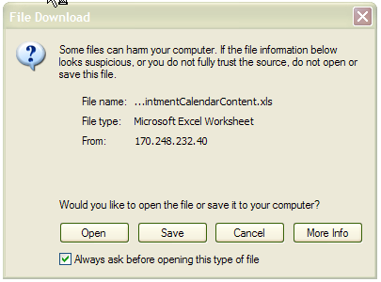

If the user decides to save the report, the Save As window opens, prompting them to select the location on their computer in which to save the Excel spreadsheet. The Save As window is displayed below.

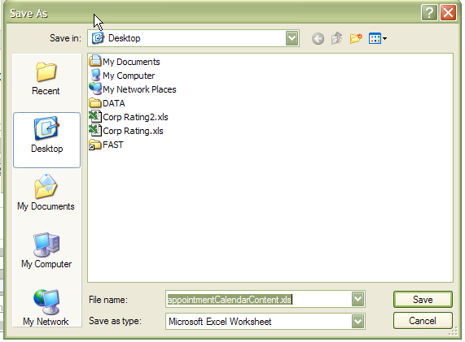

An example of a report that has been downloaded to Excel is displayed below.

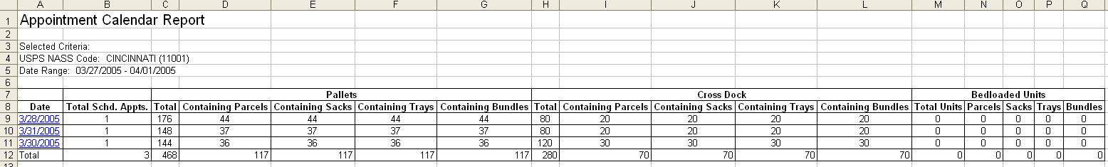

1.3.2 Fields and Buttons

Select Date Range

Many pages use a date range as one of the search criteria. The date range search criteria include a Date From field followed by a Date To field. All dates must be entered in MM/DD/YYYY format, as seen below, and the Date To may not be earlier than the Date From. Some pages may only allow the user to select one particular day.
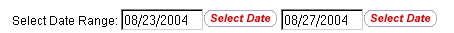

Date From
Date To

Note:
In the FAST functional areas, date range limitations differ depending upon the report. More detailed information about the date range is provided in the specific module.

Dates may be typed directly in the Date Range fields or selected from the date picker, as displayed below.

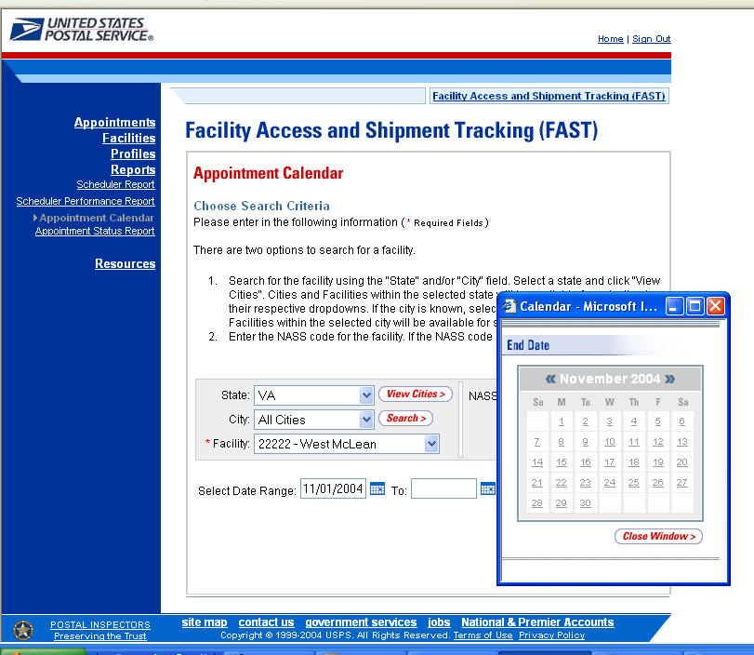

Using the Calendar

- CLICK the Calendar icon to bring up the Date Picker. The current date will be selected on the calendar. The Calendar icon is displayed below.
- VERIFY that the current month corresponds to the desired date range criteria.
- If not, CLICK the arrows next to the month field. The left arrow shifts the calendar to the previous month, and the right arrow shifts the calendar to the next month. The calendar shifts in chronological order when using these arrows, meaning that the year automatically changes when navigating from December of one year to January of the next.
- VERIFY that the current year corresponds to the desired date range criteria. If not, select the year to be entered in the Date field by CLICKING the arrows next to the month.
- SELECT the desired day by CLICKING the number of the day to be entered into the Date field. Once the date is clicked, the full month, day, and year selected will display in the Date field.

Drop Down Boxes

Several pages in the FAST application use drop-down boxes to provide choices for the user to select as search criteria. Drop-down boxes show all available options for a particular field. The user is limited to one choice for each drop-down box. In the example below, the State drop-down box may be used to search for only one of the following: California, District of Columbia, Illinois, Indiana, Kentucky, Nevada, or Virginia.
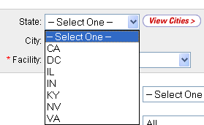
Note:

For most of the FAST application the drop-down lists are defined by what facilities are available for Drop Ship.

- CLICK the arrow on the right side of the box. This will display all available choices for that drop-down box.
- Place the cursor over the desired word or phrase so it is highlighted and CLICK. The selection then displays in the field.
Note:
For a user more experienced with FAST, the keyboard shortcut for making selections from drop-down boxes is to type the first letter of the selection. This highlights the first option in the drop-down box beginning with that letter. The arrow keys may then be used to scroll up and down in the list.

In addition to the State drop-down box, there are many drop-down boxes found in FAST some include: District, Area, Report View, and Scheduler ID. Examples of these drop-down boxes are displayed on the following page.
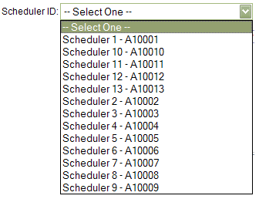
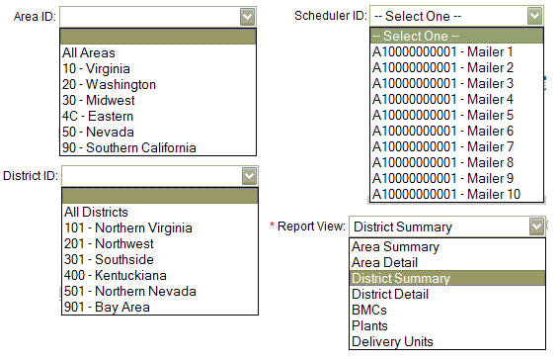

Search Button

FAST displays a Search button on the Selection pages. The Search button is used to retrieve information corresponding to the selected search criteria. It may be found next to a drop-down box, next to a text box, or at the bottom of the page.

In the example displayed on the following page, the user is on the Appointment Calendar Selection page as indicated on the Left Navigation Bar. CLICKING the Search button next to the city retrieves all of the facilities associated with Virginia and populates the Facility drop-down box. Additionally, CLICKING the Search button next to the NASS Code retrieves all of the facilities associated with the ID and populates the Facility drop-down box.

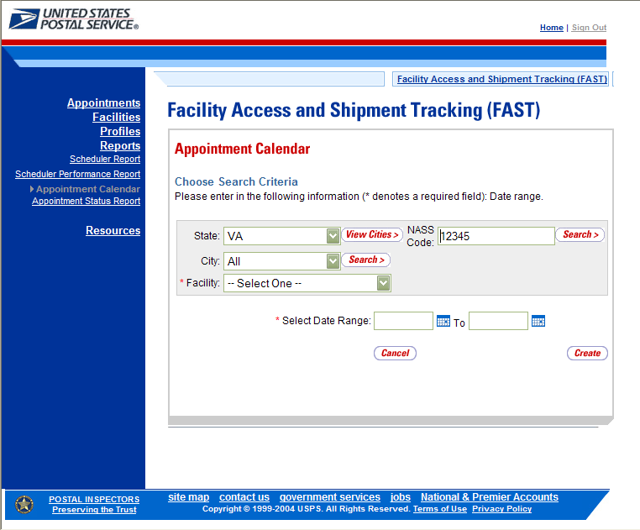

Submit Button

FAST displays a Submit button on the Selection pages. The Submit button is used to retrieve information corresponding to the selected search criteria or to save new data entered into FAST. It may be found next to a drop-down box, next to a text box, or at the bottom of the page.

In the example displayed on the following page, the user is on the Scheduler Report Selection page as indicated on the Left Navigation Bar. CLICKING the Submit button next to the Report View retrieves the facility search box.

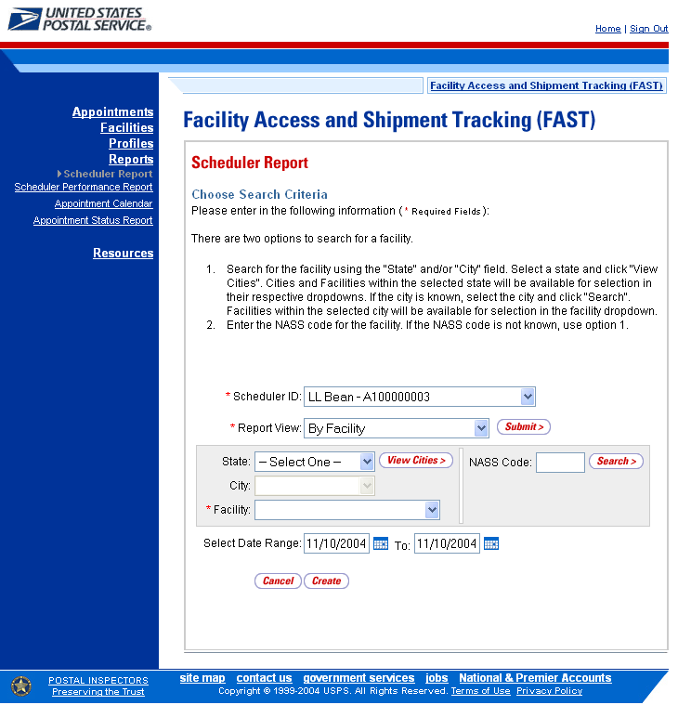

Cancel Button

FAST displays a Cancel button on the Selection pages. The Cancel button is used to return to the associated Landing page. It may be found at the bottom of the page.

In the example shown above, the user is on the Scheduler Report Selection page, as indicated on the Left Navigation Bar. CLICKING the Cancel button on the bottom of the page returns the user to the Reports Landing page.

1.3.3 Error Messages

Throughout the FAST application error messages may be displayed when the user enters incomplete or erroneous data. Some examples of generic error messages may be found on the following page. For more detailed error message information the user should go to the corresponding module.

- User not found in the Active Directory server.

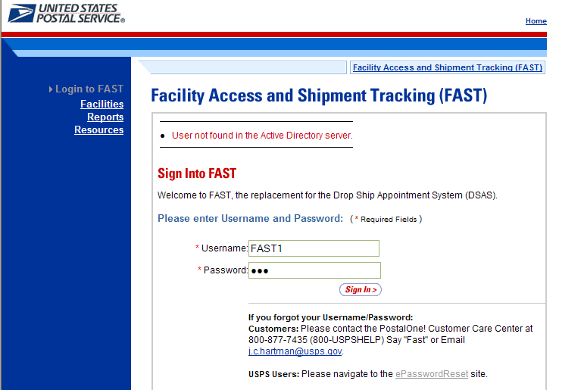

- The “start” date may not be after the “end” date

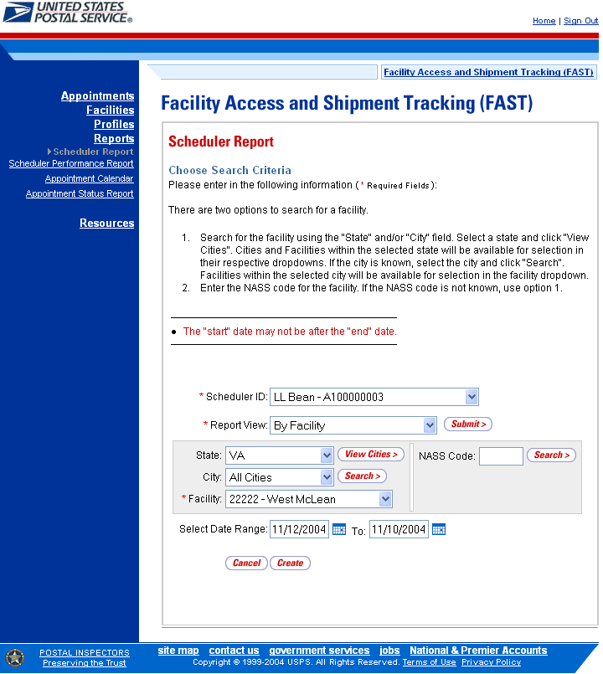

- Start Date – Not a valid date. Dates must be in MM/DD/YYYY format.

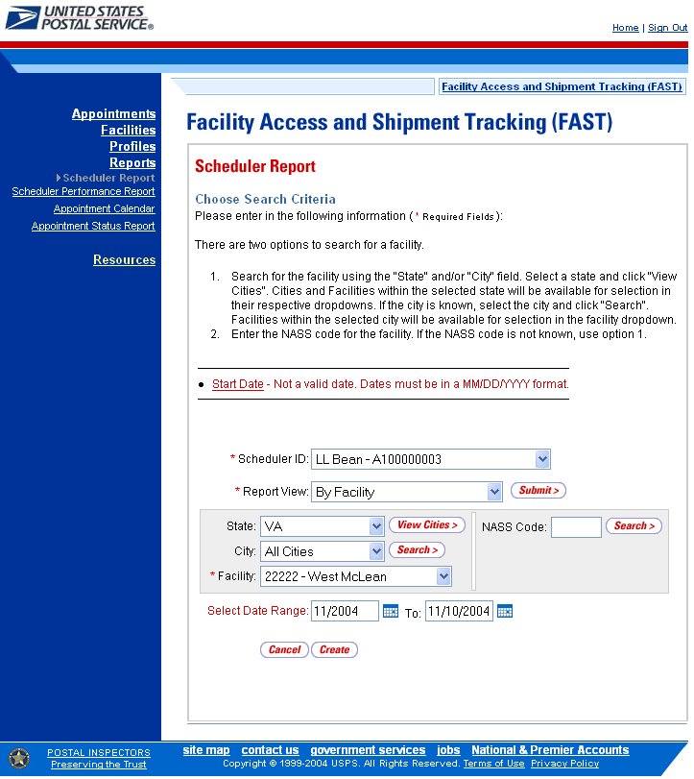

  - Helpful Hints

- The user will be logged out of FAST after fifteen minutes of inactivity.

- Throughout FAST the Scheduler ID drop-down box will only populate with those IDs associated to the user.

- The Left Navigation Bar is not displayed within the Reports section in order to give the user greater visibility to the displayed report. An example is displayed below.

- * Asterisks on a Selection page designate a required field. In the example displayed below, the user is on the Appointment Calendar Selection page. The required fields on this page are date range and facility.

- The Create button may be found on all Report Selection pages. In the example displayed below, the user is on the Appointment Calendar Selection page. After entering in the required fields the user will CLICK the Create button to display the corresponding report.

- The Facility drop-down box will not automatically be populated. The user may search for a specific facility using the State, State and City, or NASS Code search options. An example with the facility search box highlighted is displayed below.

2.0 Pre-Login
The user has several processes they may exercise before logging into the FAST application. The Pre-Login section includes:

2.1 Facility Profile – Describes how a user may view the Facility Profile information.

2.2 Appointment Calendar – Describes how a user may create and view an Appointment Calendar report.

2.3 Closeout Data Report – Describes how a user may create and view the Closeout Data Report

2.4 BMC Information – Describes how a user may access the BMC Office Information page.

2.5 Reference Documents – Describes how a user may access the FAST User Guide, PS Form 6241, Publication 804, and Domestic Mail Manuel.

2.6 Message Board – Describes how a user may access the FAST Message Board.

2.7 What’s New Board – Describes how a user may access the What’s New Board.

The user may access the processes associated with the above sections from the FAST Login page (described in module 4.0 - Landing pages) before logging into the application.

2.1 Facility Profile

Facility Profile information consists of the drop shipment contact information and facility information for a given facility. The pre-login user may only view the information.

The Facility Profile section describes the processes for viewing the facilities information.

A pre-login user begins the process from the FAST Login page. The user CLICKS the Facilities link located on the sidebar. The user is taken to the Facilities Landing page (described in module 4.0 - Landing pages) where the user may select the Facility Profile link, or associated Go> button to display the Facility Profile Selection page.

The fields and buttons on the Facility Profile Selection page are described below. A snapshot of the page is displayed after the field description.

* State | Drop-down box containing state options
View Cities button | Retrieves all cities within the selected state that have a facility and populates the cities in the City drop-down box
City | Drop-down box containing the cities within the specified state that have a facility
Search button | Retrieves the facilities located in the selected state and city and displays them in the table
* NASS Code | Textbox to input the NASS Code of the requested facility
Search button | Retrieves the facility associated with the NASS Code and displays it in the results table

The Facility Profile Selection page is displayed below.

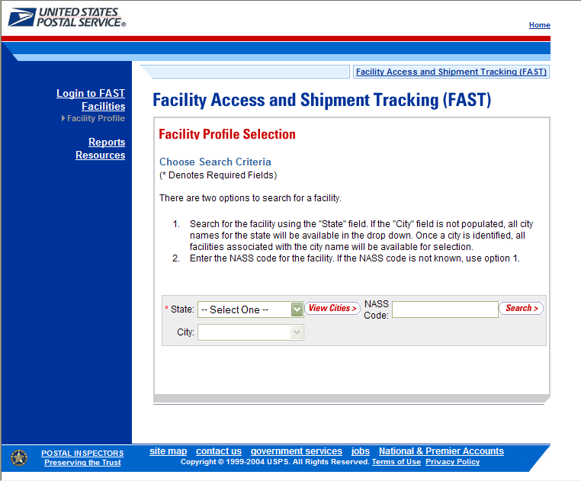

To view the profile of a facility, search for a facility by one of the following two ways:

To search by state and city:
- SELECT a state from the State drop-down box
- CLICK the View Cities button
- SELECT a city from the City drop-down box
- CLICK the Search button to populate the table with the retrieved facilities

To search by NASS Code:
- INPUT the NASS Code from the NASS Code text box
- CLICK the Search button to populate the table with the retrieved facilities

The Facility Profile Selection page refreshes with the facility associated to the specified search criteria displayed in a table. The additional fields and buttons on the page are described below. A snapshot of the page is displayed after the field descriptions.

Facility Name column | Name of the facility. Each name is a hyperlink to the Facility Profile Information page, where the user may view the facility’s drop shipment contact information.
Facility Type column | Displays the type of facility: BMC, Plant, Delivery Unit, Annex
City column | City where the facility resides
State column | Two character state code where the facility resides
ZIP column | Five digit ZIP Code where the facility resides
Accepts Drop Ship column | Displays if the Facility accepts drop shipments (Yes); does not accept drop shipments (No); in the process of determining if the facility will accept drop shipments (Pending)

The Facility Profile Selection page is displayed on the following page.
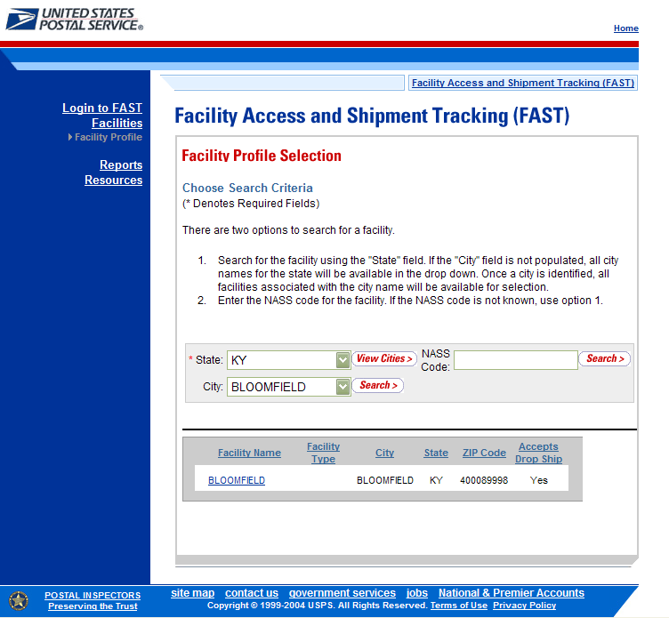

From the Facility Profile Selection page, the user may view the contact information for a drop shipment facility by CLICKING on the Facility Name hyperlink.

The Facility Profile page opens, displaying the contact information for the drop shipment facility. The fields and buttons on the page are described below. A snapshot of the page is displayed after the field description.

Facility Information Section
Name | The full name of the facility
Address | The street address of the facility
City | The city where the facility resides
State | The state code where the facility resides
ZIP + 4 | The 9 digit ZIP Code of the facility
District | The code and name of the district where the facility resides
Area | The code and name of the area where the facility resides
Locale Key | The locale key of the facility
Facility Rating On options | Indicates Yes if appointments and schedulers are subject to rating at that facility and No if they are not
Accepts Drop Shipments options | Indicates Yes if the facility accepts drop shipments or No if the facility does not accept drop shipments
NASS Code | The 3-5 character NASS Code of the facility
Drop Shipment Contact Information
Contact Name | Name of the primary contact person of the drop shipment facility
Hours of Availability | Time range to reach the drop shipment contact person
Phone Number | Phone number at the facility for the contact person
FAX Number | FAX number at the facility for the contact person
Email Address | Email address of the contact person
Alternative Drop Shipment Coordinator Information
Contact Name | Name of the alternative contact person of the drop shipment facility
Hours of Availability | Time range to reach the alternative contact person
Phone Number | Phone number at the facility for the alternative contact person
FAX Number | FAX number at the facility for the alternative contact person
Email Address | Email address of the alternative contact person
Alternative Drop Ship Contact Information
24 Hour Number | Phone number to reach the facility at any time of the day
Drop Shipment Hours
Days of the Week | Hours the facility accepts drop shipments for each day of the week
Facility Directions | Directions to the facility
Comments | Any additional information relevant to the facility
The Facility Profile page is displayed below.
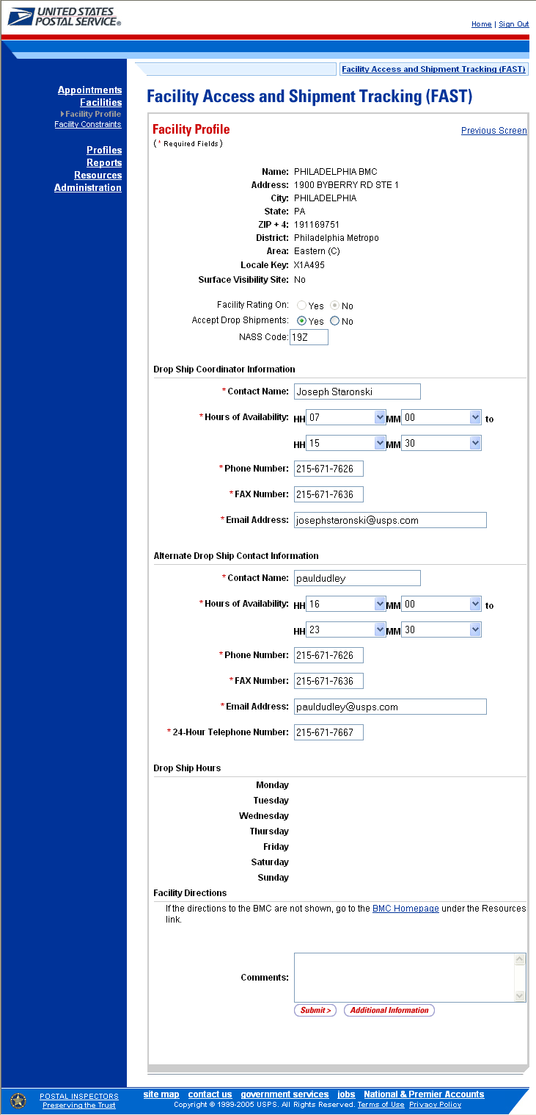
Note:

If the facility is a BMC, and there are no directions provided, the user will be given a link to the BMC Homepage.

If the facility is a DDU, and there are no directions provided, the user will be given a link to the USPS locator Homepage.

From the Facility Profile page, the user may CLICK the Additional Information> button to view additional information about the facility.

The Facility Profile—Additional Information page has two views; one for default facilities and one for non-default facilities. A default facility is a facility that drop shipments are redirected from. A non-default facility does not redirect any drop shipments. Drop shipments can be redirected to both default and non-default facilities. The table below describes the fields and buttons found on a default page. Following the table is a snapshot of the page for default facilities.

Default Processing
3-Digit Zip Codes Serviced | The Zip/Carrier Route per discount type that the facility serves as a default facility for.
Processing Redirections to Alternative Facilities
Provides information about what and where a facility redirects their mail to.
Pallet Code Legend: | Y = Yes, redirection applies to palletized mail  N = No, redirection applies to non-palletized mail  B = Both
View CIN List | Displays CIN List Page
Facility Name | Lists the facility name that the CIN group is redirected to.
CIN Group | Lists the CIN group or partial group of CINs that are redirected from the default facility
Pallet Code | Indicates whether the redirection applies to palletized mail, non-palletized mail or both
Discount | Lists the destination discount associated with CIN Group
ZIP/CRID Serviced | Lists of ZIP/Carrier Route that the redirection applies to for the given CIN Group and Discount
Processing Redirections From Default Facilities
Provides the CIN list of what is accepted at this facility and what is redirected there
CIN Group | See above
Pallet Code | See above
Discount | See above
ZIP/CRID Serviced | See above
Facility Dock & Yard Information
Provides height, width, depth and length information for the facility

The Facility Profile – Additional Information (default facility) page is displayed on the following page.
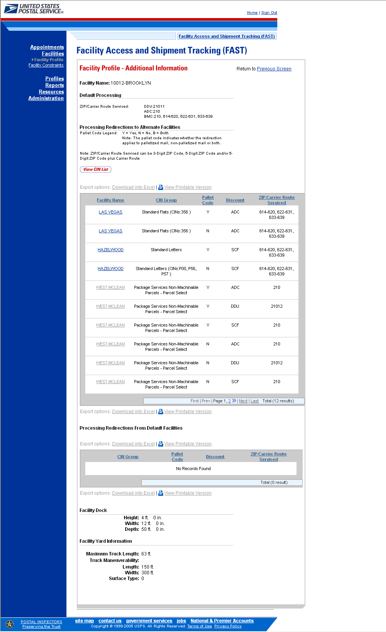

The Facility Profile –Additional Information page for non-default facilities is the same as the page for default facilities except for the deletion of the Processing Redirections to Alternate Facilities table. The Processing Redirections to Alternate Facilities section is omitted because non-default facilities do not redirect mail anywhere. The Facility Profile – Additional Information (non-default facility) page is displayed below.

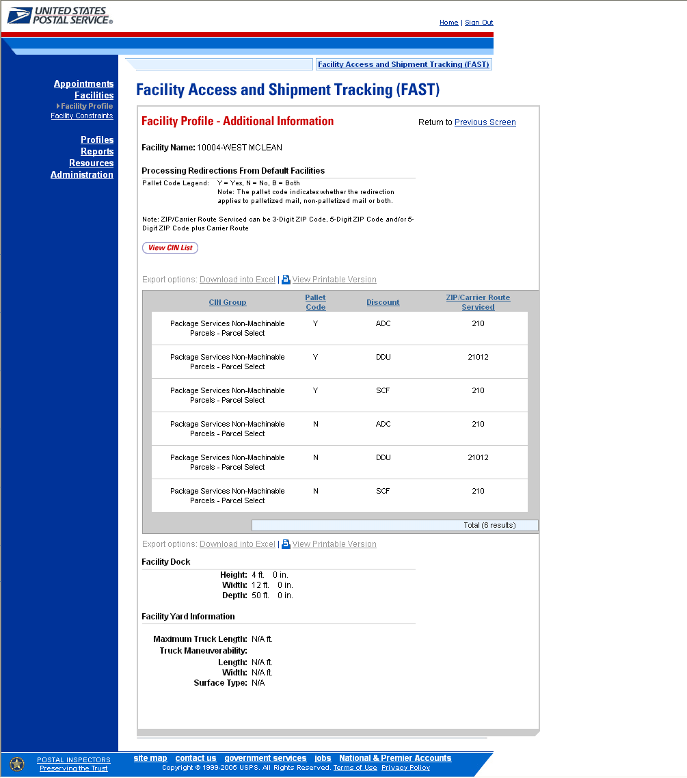

From the Facility Profile-Additional Information page, the user may CLICK the View CIN List button to view the definitions of the CIN groups.

The table below defines the fields used on the CIN List page. Following the table is a snapshot of the CIN List page

CIN | Lists the different CIN group numbers
Pallet Code | Indicates whether the CIN may be palletized (Y), not palletized (N) or both (B)
Mail Class | Lists the class of the given CIN
Mail Shape | Lists the shape of the given CIN
Sort Type | Lists the presort level and processing category of the given CIN

The CIN List page is displayed below.

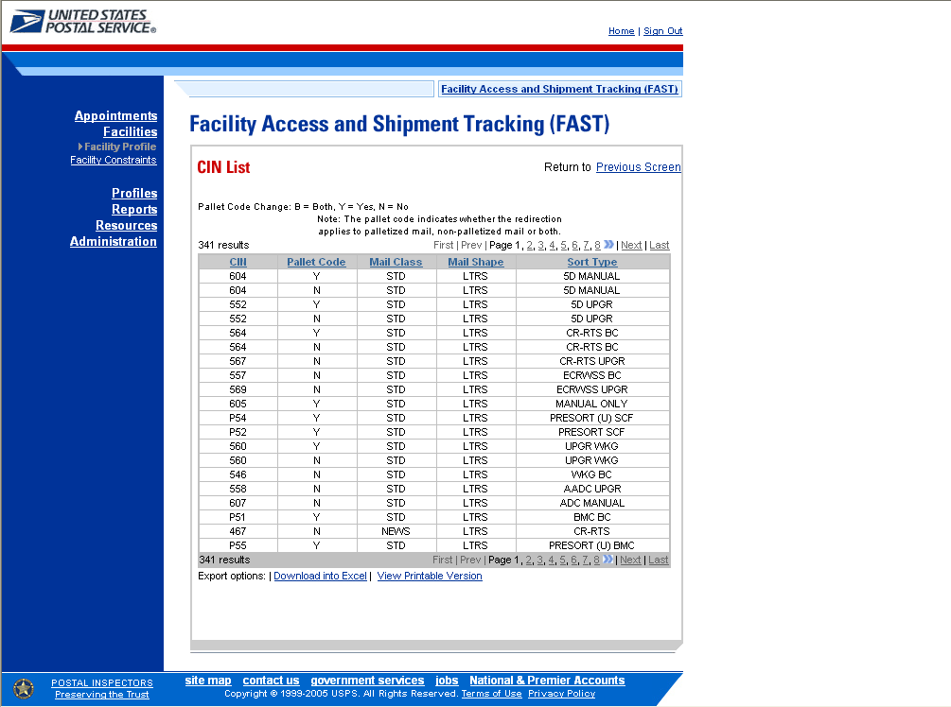

2.2 Appointment Calendar

The Appointment Calendar displays all appointment count data for a selected facility and scheduled drop date. The Appointment Calendar section describes the processes for viewing the Appointment Calendar.

The Appointment Calendar is accessible from two points in FAST, from the Login page (pre-login) and from the Reports Landing page (post-login). A pre-login user begins the process from the FAST Login page. The user CLICKS the Reports link located on the sidebar. The user is taken to the Reports Landing page (described in module 4.0 - Landing pages) where the user may select the Appointment Calendar link, or associated Go> button to display the Appointment Calendar Selection page.

The fields and buttons on the Appointment Calendar Selection page are described below. A snapshot of the page is displayed after the field description.

* State | Drop-down box containing state options
View Cities button | Retrieves all cities within the selected state that have a facility and populates the cities in the City drop-down box
City | Drop-down box containing the cities within the specified state that have a facility
Search button | Retrieves the facilities located in the selected state and city and displays them in the table
NASS Code | Textbox to input the five character NASS Code of the requested facility
Search button | Retrieves the facility associated with the NASS Code and displays it in the results table
* Facility | Drop-down box containing the facility(s) located in the specified city and state
* Select Date Range | Selects the date range to search for the specified facilities appointments. The range is restricted to 30 days prior to today’s date and 14 days after today’s date. The end date must be between today’s date and 14 days in the future. Both date fields default to the current date.
Search button | Retrieves the appointment count data for the specific date range based on the entered criteria and displays the Appointment Calendar

The Appointment Calendar Selection page is displayed below.

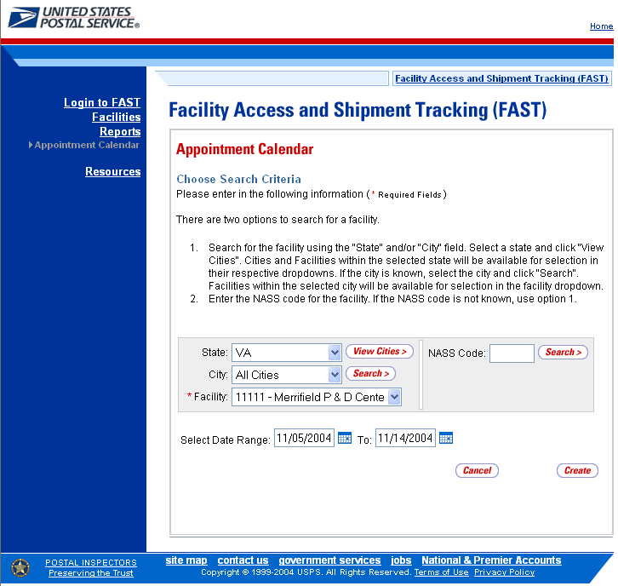

From the Appointment Calendar Selection page, the user may view the appointment information for the specified date range by performing the following steps:

- SEARCH for a specific facility by one of the following two ways:
To Search for a Facility by State and City:
- SELECT a State from the drop-down box
- CLICK the View Cities button
- SELECT a city from the City drop-down box
- CLICK the Search button

To Search for a Facility by NASS Code:
- ENTER the NASS Code in the text box
- CLICK the Search button

- ENTER the Date Range
- CLICK the Create button
Note:
The Start Date may not exceed 30 days prior to today’s date.
The End Date value must be between today’s date and the maximum threshold for appointment creation (14 days in the future).

The Appointment Calendar page opens, displaying the appointment count data for the specified facility and date range. The fields and buttons on the Appointment Calendar page are described below. A snapshot of the page is displayed after the field description.

Date | Displays the selected date of the appointments
Total Scheduled Appointments | The total scheduled appointments on a given date
Pallets- Total | The total count of pallets scheduled
Pallets- Parcels | The total count of pallets containing parcels scheduled
Pallets- Sacks | The total count of pallets containing sacks scheduled
Pallets- Trays | The total count of pallets containing trays scheduled
Pallets- Bundles | The total count of pallets containing bundles scheduled
Cross Dock - Total | The total count of cross docked mail scheduled
Cross Dock- Parcels | The total count of cross docked mail containing parcels scheduled
Cross Dock - Sacks | The total count of cross docked mail containing sacks scheduled
Cross Dock - Trays | The total count of cross docked mail containing trays scheduled
Cross Dock - Bundles | The total count of cross docked mail containing bundles scheduled
Bedloaded- Total | The total count of bedloads scheduled
Bedloaded- Parcels | The total count of bedloads containing parcels scheduled
Bedloaded- Sacks | The total count of bedloads containing sacks scheduled
Bedloaded- Trays | The total count of bedloads containing trays scheduled
Bedloaded - Bundles | The total count of bedloads containing bundles scheduled

The Appointment Calendar page is displayed below.

2.3 Closeout Data Report

The Closeout Data Report displays the appointment information for the entered appointment IDs. The Closeout Data Report section describes the processes for viewing the Closeout Data Report.

The Closeout Data Report is accessible from two points in FAST, from the Login page (pre-login) and from the Reports Landing page (post-login). A pre-login user begins the process from the FAST Login page. The user CLICKS the Reports link located on the sidebar. The user is taken to the Reports Landing page (described in module 4.0 - Landing pages) where the user may select the Closeout Data Report link, or associated Go> button to display the Closeout Data Report Selection page.

The fields and buttons on the Closeout Data Report Selection page are described below. A snapshot of the page is displayed after the field description.

Appointment ID | Provides a field for the user to enter the desired Appointment ID(s). Up to 10 Appointment IDs can be entered
Cancel button | Displays the Reports Landing page.
Create button | Retrieves the appointments’ closeout information.

A snapshot of the Closeout Data Report Selection page is on the following page.
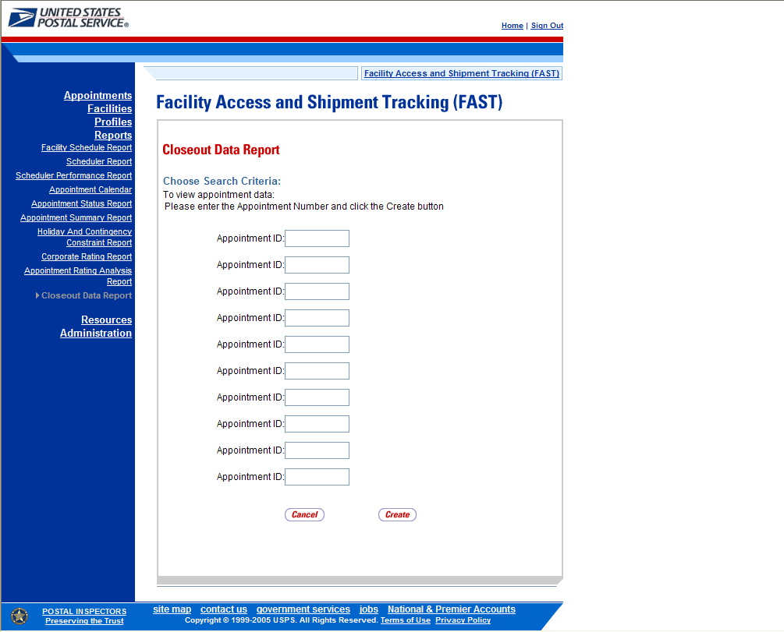

The user may view closeout information by performing the following steps:

- ENTER Appointment ID in the field next to the first Appointment ID
- REPEAT until the desired number of Appointment ID fields are filled
- CLICK Create

The Closeout Information Report page opens, displaying the closeout information for the specified Appointment IDs. The fields and buttons on the Closeout Data Report Selection page are described below. A snapshot of the page is displayed after the field description.

Appointment ID | The Appointment ID associated with the selected criteria
Status | The Appointment Status associated with the selected criteria  CA = Cancelled  CL = Closed  NS = No Show  O = Open  R = Rejected  U = Unscheduled
Facility Name | The Facility Name associated with the selected criteria
NASS Code | The NASS Code associated with the selected criteria
Appointment Date and Time | The Scheduled Appointment Date and Time associated with the selected criteria
Arrival Data and Time | The Actual Arrival Date and Time associated with the selected criteria
Unload Start Date and Time | The Unload Start Date and Time associated with the selected criteria
Unload End Date and Time | The Unload Start Date and Time associated with the selected criteria
Mail Integrity | The Mail Condition of the selected criteria
Content Discrepancy | The Difference between the scheduled volume and the actual volume associated with the selected criteria

A snapshot of the Closeout Data Report page is on the following page.

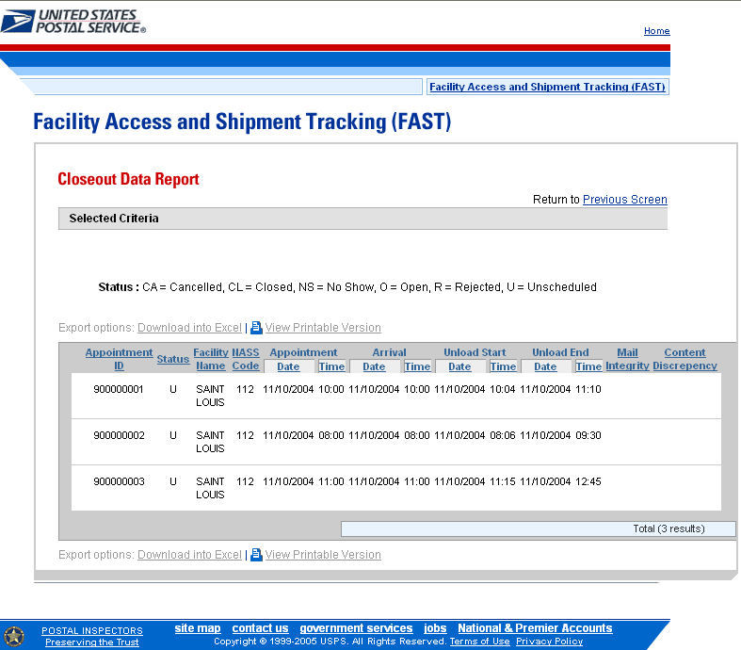

2.4 BMC Information

The BMC Information page is used to find out information about a particular Bulk Mail Center (BMC). The user may get office information or information on how to utilize the BMC network to receive discount rates. The BMC Information section describes how to access the website.

A pre-login user begins the process by CLICKING the BMC Information link on the FAST Login page. The user is then redirected to the BMC Office Information page.

The FAST Login page is displayed below with the BMC section highlighted.

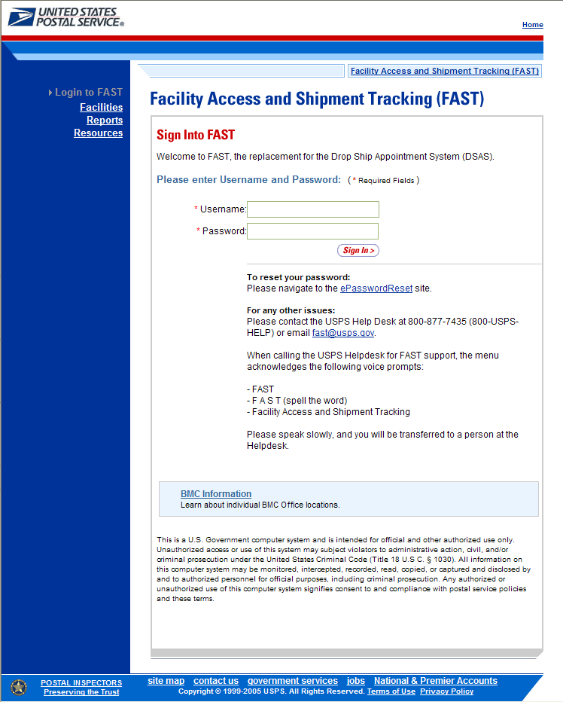

2.5 Reference Documents

The Reference Documents section describes the following processes:

2.5.1 Download User Guide
2.5.2 Link to PS Forms 8125 and 6241
2.5.3 Link to Publication 804
2.5.4 Link to Domestic Mail Manual

The user may access the processes associated with the above sections from the FAST Login page by CLICKING the Resources link. The Resources link takes the user to the Resources Landing page (described in module 4.0 – Landing pages) where the user may CLICK either the Reference Documents link, or the associated Go> button to display the Reference Documents page.

2.5.1 Download User Guide

The FAST User Guide is a document that explains the different features that FAST will provide the user. It contains detailed instructions for users to perform key functions in the FAST system. A pre-login user may only download the external version of the User Guide.

The FAST User Guide section describes the process for downloading the guide. More detailed information about downloading the FAST User Guide is described in module 9.1.1 – Download User Guide.

The user has the option to download the User Guide in .PDF format, .RTF format, or as a ZIP file. The user begins the process by CLICKING the associated Download button.

The Reference Documents page is displayed below with the FAST User Guide section highlighted.

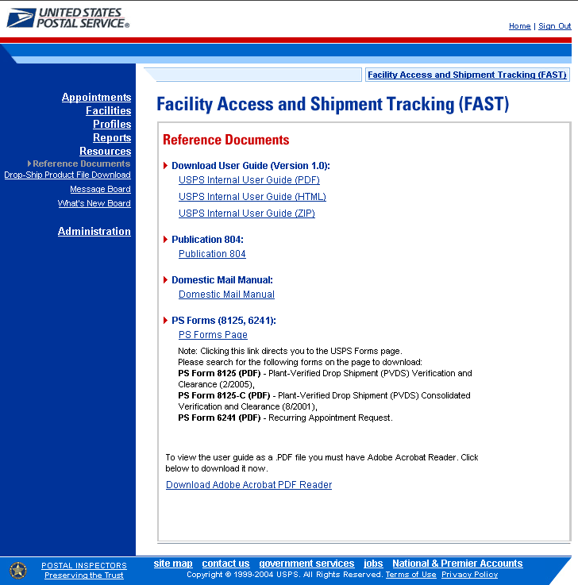

Note:
The pre-login user may only download the customer version of the FAST User Guide.

To view the FAST User Guide in .PDF format the user must have Adobe Acrobat Reader.

2.5.2 Link to PS Forms 6241 and 8125

The Recurring Appointment Request form, which is officially named the PS Form 6241, is for schedulers that want to request a recurring appointment. The mailing should be at least once a week, on the same day, during the same time period, with (generally) the same contents, and using the same form and size of transportation. The form requests information about the mail owner, transportation, mailing, as well as a signature by the scheduler.

The PS Form 8125 contains the expected unload and appointment information of the scheduled drop shipment. When the appointment arrives at the drop shipment facility, the dock floor personnel may record the arrival time and any content discrepancies found between what content was scheduled to arrive and what content actually arrived. A user may also indicate any load condition irregularities.

The PS Forms section describes the process for downloading the forms. More detailed information about downloading the Recurring Appointment Request Form and the Plant-Verified Drop Shipment Form is described in modules 9.1.2 – Download Recurring Appointment Request Form and 9.1.3 – Download PS Form 8125 (Plant-Verified Drop Shipment Form).

The user may download either form in .PDF format. The user begins the process by CLICKING the associated PS Forms Page hyperlink. Upon CLICKING the PS Forms Page hyperlink, the user is brought to the USPS Forms Page where they may search for PS Form 6241 or 8125.

The USPS Document page is displayed below with the PS Forms section highlighted.

2.5.3 Link to Publication 804

Drop Shipment Procedures for Destination Entry (Publication 804) was developed to assist Postal Service employees in handling drop shipments from the origin office to the destination office. The procedures consist of mailing standards found in the Domestic Mail Manual (DMM). They establish official Postal Service policy regarding the handling of drop shipments for Periodicals, Standard Mail, and Packaged Services Mail.

The Publication 804 section describes the process for viewing the publication. More detailed information about viewing Publication 804 is described in module 9.1.3 – Link to Publication 804.

The user has the option to view Publication 804 in .PDF format or text format. The user begins the process by CLICKING on the Publication 804 hyperlink. Upon CLICKING one of the hyperlinks the user is brought to a new page with Publication 804 displayed.

The USPS Document page is displayed below with Publication 804 section highlighted.

2.5.4 Link to Domestic Mail Manual

The Domestic Mail Manual (DMM) contains the official rates and standards of the U.S. Postal Service governing domestic mail services. The public may access the DMM in PDF format on the Postal Explorer website. The online DMM is updated monthly.

The Domestic Mail Manual section describes the process for viewing the manual. More detailed information about viewing the Domestic Mail Manual is described in module 9.1.4 – Link to Domestic Mail Manual.

The user may view the Domestic Mail Manual in .PDF format. The user begins the process by CLICKING the Domestic Mail Manual hyperlink. Upon CLICKING the hyperlink the user is brought to a new page with the Domestic Mail Manual displayed.

The USPS Document page is displayed below with the Domestic Mail Manual section highlighted.

2.6 Message Board

Messages are created by administrators in the FAST system to display facility-specific and general information to the FAST user. Messages are displayed to the user via the Message Board. Pre-login users may view all general and facility messages that have not yet expired.

The Message Board section describes the process for viewing the board. More detailed information about the Message Board is described in module 9.0 – Resources.

The Message Board is accessible from three points in FAST; from the FAST Login page (pre-login), from the Resources Landing page (post-login), and from the Message Board Pop Up (post-login). A pre-login user begins the process from the Resources page. The user CLICKS the Message Board link or associated Go> button to display the Message Board.

The FAST Message Board is displayed below.

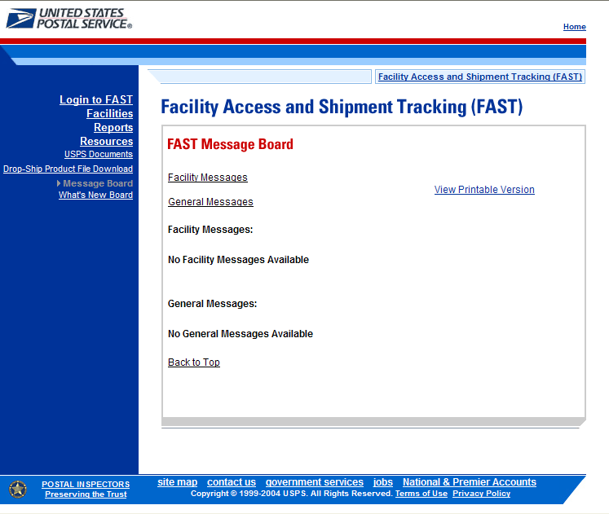

2.7 What’s New Board

What’s New is a message posting system where administrators of the FAST system may display system-related information to all FAST users. The board will contain any listings with an expiration date equal to or greater than the current date.

The What’s New Board section describes the process for viewing the board. More detailed information about the What’s New Board is described in module 9.0 – Resources.

The What’s New Board is accessible from two points in FAST; from the FAST Login page (pre-login) and from the Resources Landing page (post-login). The user begins the process from the Resources Landing page. The user CLICKS the What’s New Board link, or associated Go> button to display the What’s New Board.

The FAST What’s New Board is displayed below.

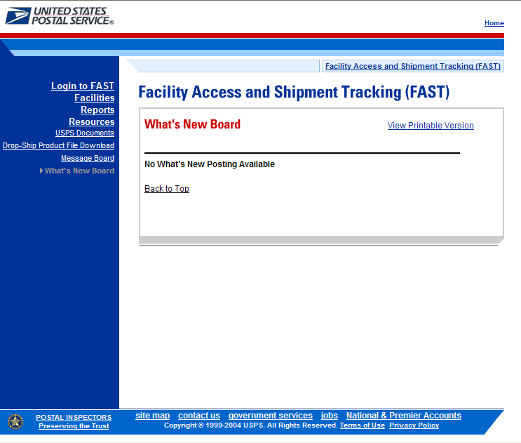

3.0 Login/Logout
When the user opens the FAST application, the first page that displays is the Facility Access and Shipment Tracking (FAST) Login page. Usernames are entered on this page and then verified by the system. If an external user does not have a FAST login, one must be obtained through PostalOne! ® (described in module 11.3 – PostalOne! User Guide). Upon login the FAST Main Menu page is displayed, as well as a message board pop-up.

The Login/Logout section includes:

3.1 Logging In/Logging Out

3.2 Message Board Pop Up

The user may access the processes associated with the above sections from the FAST Login page (described in module 4.0 - Landing pages).

3.1 Logging In/Logging Out

In order to access most of the processes available in FAST a user has to log in to the application. The FAST Login page will verify the user name and password information entered.

The Logging In/Logging Out section describes the following processes:

3.1.1 Logging into FAST
- Login difficulties
3.1.2 Logging Out of FAST
- Returning to FAST Login page

3.1.1 Logging into FAST

The user begins the process by entering the FAST Login page. The user must then enter a valid user name and password. Upon verification the user will be redirected to the FAST Login page. The URL for the Fast Login page is http://fast.usps.com.

The fields and buttons on the FAST Login page are described below. A snapshot of the page is displayed after the field description.

* User Name | Textbox where the user may enter their user name
* Password | Textbox where the user may enter the password for the associated user name
Sign In button | Allows the user access into the FAST application with the correct entry of a user name and password

The FAST Login page is displayed below.

To enter the FAST application, perform the following steps:

- CLICK the Username text box and ENTER the user name
- CLICK the Password textbox and ENTER the password
- CLICK the Sign In button.

A successful login brings the user to the FAST Login page.
FAST Login Difficulties

If the user login is unsuccessful an error message displays directly above the Username text box. There are seven possible error messages that may be displayed. The following are the three most common error messages:

- Username / Password is incorrect

If this message displays, the username or password may have been mistyped. Retype the username / password and try again. If this is unsuccessful, please refer to the specified help number on the Fast Login page.

- User has been locked out due to too many incorrect login attempts. User should call PostalOne! helpdesk to have their password reset.

If this message displays, the user has entered an incorrect password too many times. Contact the PostalOne! helpdesk to have your password reset.

- User’s password is about to expire. User log into PostalOne! to change their password.

If this message displays the user’s password is about to expire. CLICK the ePasswordReset link to change your password.

These are the additional error messages a user may encounter:

- User (Customer) has not changed the password after 90 days of previous password change and password expired.
- User must log into PostalOne! to change their password due to password reset.
- User needs to change the ‘Initial Password’ set during Account Creation. Please log into PostalOne! and Change the Password.
- Account disabled due to inactivity. User should call PostalOne! helpdesk to have their account re-enabled.

Note:
For help accessing PostalOne! or to get materials on PostalOne! reference module 11.2 – PostalOne! User Guide.

Note:
There are many login error messages the application may display. More detailed information about Error Messages is described in module 1.3.3 – Error Messages.

3.1.2 Logging Out of FAST

On each page of the FAST application there is a Sign Out link on the left of the top navigation bar. The Sign Out link is highlighted below.

To exit the FAST application, perform the following steps:

- CLICK the Sign Out button.
Note:

The Sign Out button is displayed once logged into FAST.

A successful logout brings the user to the FAST Logout page.

Returning to FAST Login page

- CLICK the Sign In button to return to the FAST Login page.

The FAST Logout page is displayed below. The Sign In button is highlighted.

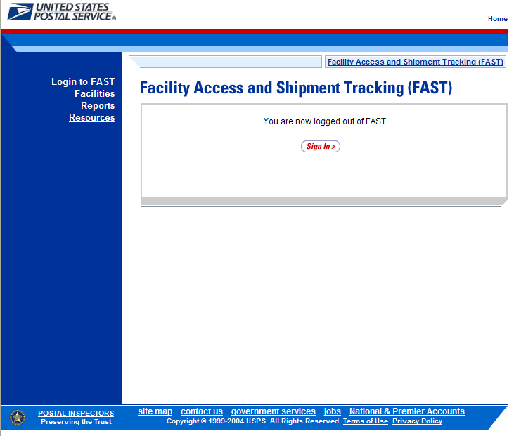

3.2 Message Board Pop Up

Messages are created by FAST administrators in the FAST system to display facility-specific and general information to the FAST user. Messages are displayed to users via the Message Board.

The Message Board Pop Up section describes the process for viewing the window. More detailed information about the Message Board is described in module 9.3 – Message Board.

The user begins the process by entering the FAST application. Upon login the Message Board Pop Up window is automatically displayed. The user may also access the Message Board by CLICKING the Message Board link, or associated Go> button from the Resources Landing page.

The FAST Message Board Pop Up is displayed below.

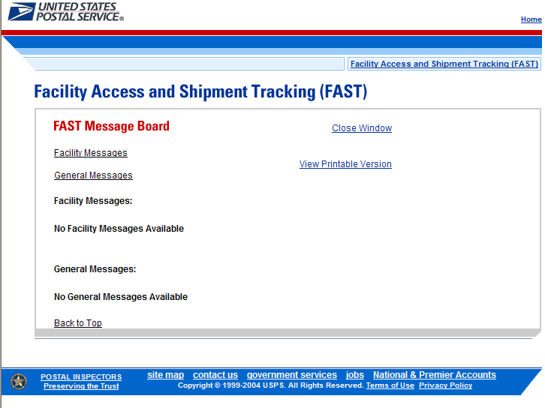

4.0 Landing pages
The user has several processes they may exercise upon login to the FAST application. The Landing pages section includes:

4.1 FAST Main Menu – Describes how a user may select the desired landing page.

4.2 Appointments – Describes how a user may select the desired appointment creation and management function.

4.3 Facilities – Describes how a user may select the desired facility information function.

4.4 Profiles – Describes how a user may select the desired profile function.

4.5 Reports – Describes how a user may select the report to view.

4.6 Resources – Describes how a user may select the desired resources function.

The user may access the processes associated with the above sections from the FAST Main Menu page by CLICKING the associated link or Go> button.

4.1 FAST Main Menu

The FAST Main Menu Landing page lists all FAST related functions accessible to the user depending on user access levels (described in module 11.1 – Security). The user has the following options to choose from:

- Appointments
- Facilities
- Profiles
- Reports
- Resources

The fields and buttons on the FAST Main Menu Landing page are described below. A snapshot of the page is displayed after the field description.

Go> (Appointments) | Redirects the user to the Appointments Landing page
Go> (Facilities) | Redirects the user to the Facilities Landing page
Go> (Profiles) | Redirects the user to the Profiles Landing page
Go> (Reports) | Redirects the user to the Reports Landing page
Go> (Resources) | Redirects the user to the Resources Landing page

The FAST Main Menu Landing page is displayed below.

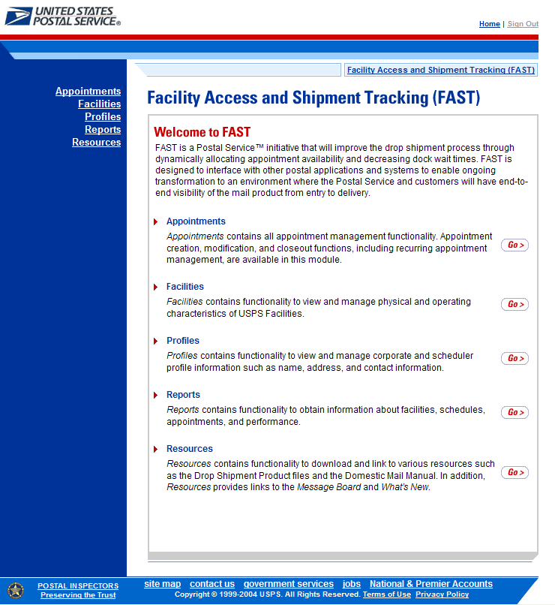

4.2 Appointments

The Appointment Management Landing page lists all appointment creation and management functions accessible to the user depending on user access level (described in module 11.1 – Security). The user has the following options to choose from:

- Create New Appointment page
- Manage Existing Appointment page
- Manage Closeout Information page

The user begins the process from the FAST Main Menu page. The user CLICKS on the Appointments link, or associated Go> button to display the Appointment Management Landing page.

The fields and buttons on the Appointment Management Landing page are described below. A snapshot of the page is displayed after the field description.

Go> (Create New Appointment) | Redirects the user to the Create New Appointment page
Go> (Manage Existing Appointment) | Redirects the user to the Manage Existing Appointment page
Go> (Manage Closeout Information) | Redirects the user to the Manage Closeout Information page

The Appointment Management Landing page is displayed below.

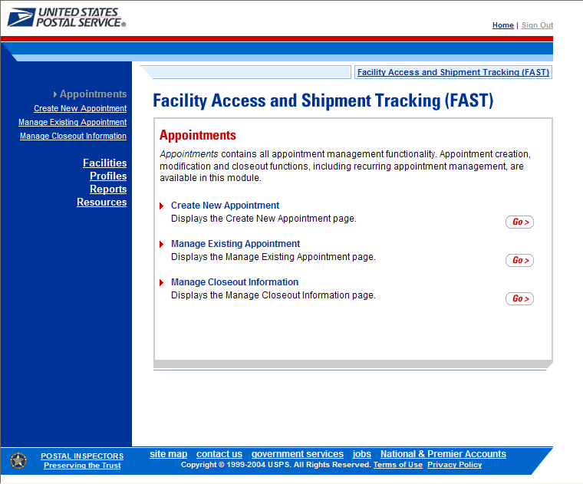

From the Appointment Management Landing page, the user may access the Create New Appointment page, Manage Existing Appointment page, or the Manage Closeout Information page (described in module 6.0 – Appointments).

4.3 Facilities

The Facilities Landing page lists all facility related functions accessible to the user depending on user access levels (described in module 11.1 – Security). The user may access the Facility Profile section from the Facilities Landing page.

The user begins the process from the FAST Main Menu page. The user CLICKS on the Facilities link, or associated Go> button to display the Facilities Landing page.

The fields and buttons on the Facilities Landing page are described below. A snapshot of the page is displayed after the field description.

Go> (Facility Profile) | Redirects the user to the Facility Profile Selection page

The Facilities Landing page is displayed below.

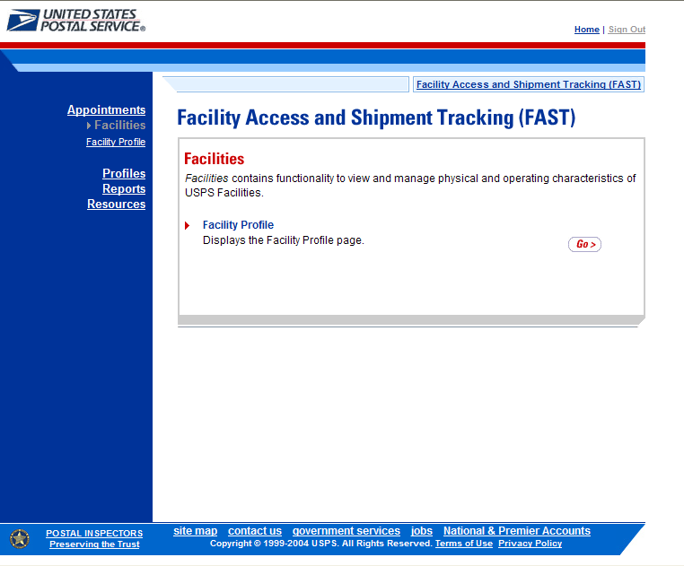

From the Facilities Landing page, the user may access the Facility Profile page (described in module 5.0 – Facilities).

4.4 Profiles

The Profiles Landing page allows the user to search for corporate or scheduler profiles. The Profiles Landing page lists all profile functions accessible to the user depending on user access levels (described in module 11.1 – Security). The user may access the Corporate Profile page from the Profiles Landing page.

The user begins the process from the FAST Main Menu page. The user CLICKS on the Profiles link, or associated Go> button to display the Profiles Landing page.

The fields and buttons on the Profiles Landing page are described below. A snapshot of the page is displayed after the field description.

Go> (Corporate Profile) | Redirects the user to the Corporate Profile Selection page

The Profiles Landing page is displayed below.

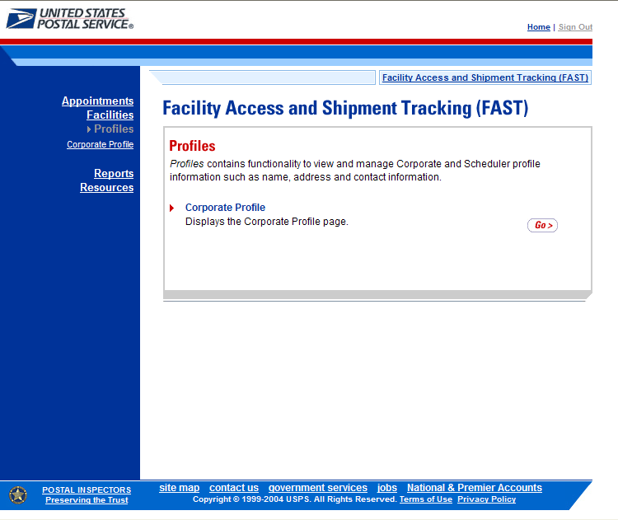

From the Profiles Landing page, the user may access the Corporate Profile page (described in module 7.0 – Corporate Profile).

Note:
The Profiles section allows the user to search for corporate or scheduler profile information. The user may search for USPS facility profiles by CLICKING on the Facilities link on the FAST Main Menu page (described in module 5.0 – Facility Information).

4.5 Reports

The Reports Landing page lists all reports management functions accessible to the user depending on user access levels (described in module 11.1 – Security). The user has the following options to choose from:

- Scheduler Report
- Scheduler Performance Report
- Appointment Calendar
- Appointment Status Report
- Holiday and Contingency Constraint Report
- Corporate Rating Report
- Appointment Rating Analysis Report
- Closeout Data Report

The user begins the process from the FAST Main Menu page. The user CLICKS the Reports link, or associated Go> button to display the Reports Landing page.

The fields and buttons on the Reports Landing page are described below. A snapshot of the page is displayed after the field description.

Go> (Scheduler Report) | Redirects the user to the Scheduler Report page
Go> (Scheduler Performance Report) | Redirects the user to the Scheduler Performance Report page
Go> (Appointment Calendar) | Redirects the user to the Appointment Calendar page
Go> (Appointment Status Report) | Redirects the user to the Appointment Status Report page
Go> (Holiday and Contingency Constraint Report) | Redirects the user to the Holiday and Contingency Constraint Report page
Go> (Corporate Rating Report) | Redirects the user to the Corporate Rating Report page
Go> (Appointment Rating Analysis Report) | Displays the Appointment Rating Analysis Report page
Go> (Closeout Data Report) | Displays the Closeout Data Report page

The Reports Landing page is displayed on the following page.
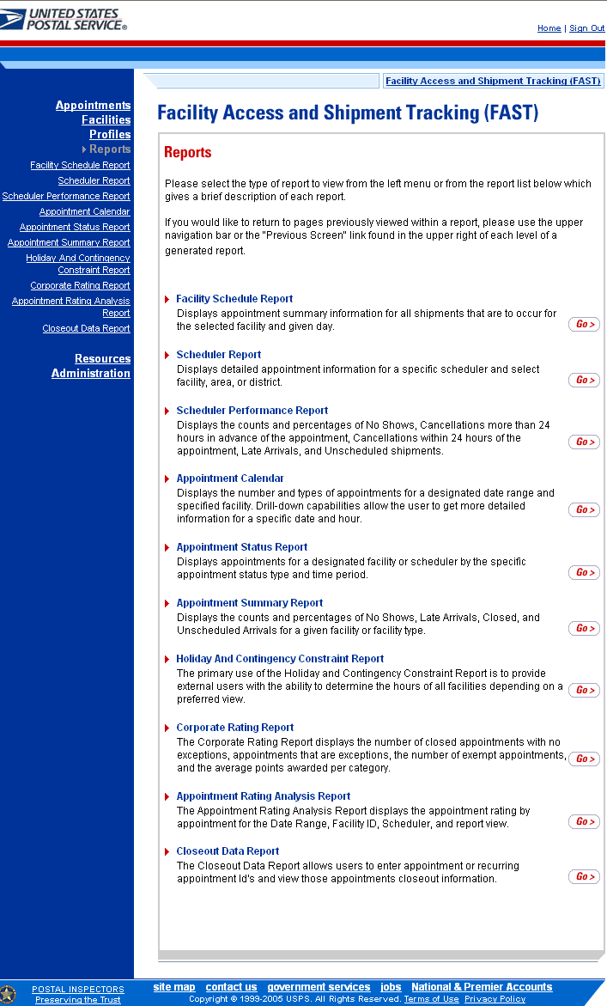
From the Reports Landing page, the user may access the Scheduler Report, Scheduler Performance Report, Appointment Calendar, Appointment Status Report, Holiday and Contingency Constraint Report, Corporate Rating Report, Appointment Rating Analysis Report, and the Closeout Data Report (described in module 8.0 – Reports).

4.6 Resources

The Resources Landing page lists all resources functions accessible to the user depending on user access levels (described in module 11.1 – Security). The user has the following options to choose from:

- Area-District 3-Digit Data
- Reference Documents
- Drop-Ship Product File Download
- Message Board
- What’s New Board

The user begins the process from the FAST Main Menu page. The user CLICKS on the Resources link, or associated Go> button to display the Resources Landing page.

The fields and buttons on the Resources Landing page are described below. A snapshot of the page is displayed after the field description.

Go> (Area-District 3- Digit Data) | Redirects the user to the Area-District 3-Digit Data page
Go> (Reference Documents) | Redirects the user to the Reference Documents page
Go> (Drop-Ship Product File Download) | Redirects the user to the Drop-Ship Product File Download page
Go> (Message Board) | Redirects the user to the Message Board page
Go> (What’s New Board) | Redirects the user to the What’s New Board page

The Resources Landing page is displayed on the next page.

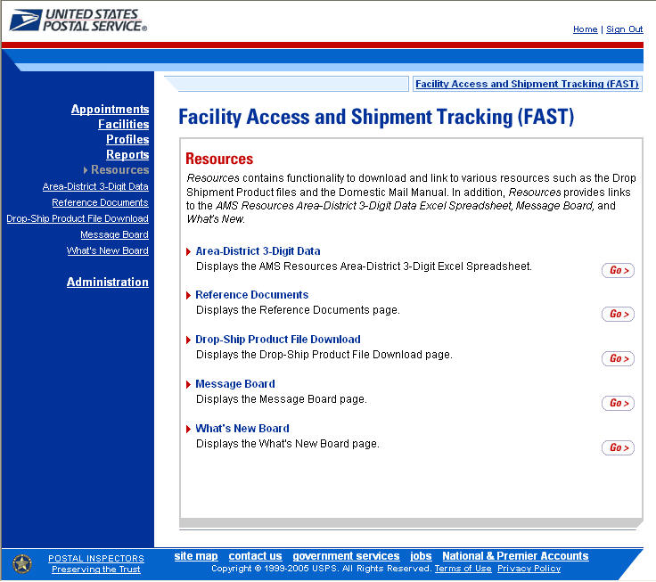

From the Resources Landing page, the user may access Reference Documents, Drop-Ship Product File Download, Message Board, and What’s New Board (described in module 9.0 – Resources).

5.0 Facilities
The Facilities section describes how a user may view facility drop shipment contact information and facility information within FAST and includes:

5.1 Facility Profile – Describes how a user may access the Facility Profile page to view facility drop shipment contact and facility information

Users may access the above area in FAST from the FAST Main Menu page by clicking on the Facilities link, which takes the user to the Facilities Landing page (described in module 4.0 - Landing Pages). From the Facilities landing page, a user may select either the Facility Profile link associated Go> button to view the Facility Profile page.

5.1 Facility Profile

Facility profile information consists of the drop shipment contact information for a given facility. A user may view facility information for any facility within FAST.

To view facility information, a user CLICKS the Facility Profile link on the Facilities Landing page. The user is taken to the Facility Profile Selection page where they may search for a specific facility to view the facility information.

The fields and buttons on the Facility Profile Selection page are described below. A snapshot of the page is displayed after the field description.

*State | Drop-down box containing state options
View Cities button | Retrieves all cities within the selected state that have a facility and populates the cities in the City drop-down box
City | Drop-down box containing the cities within the specified state that have a facility
Search button | Retrieves the facilities located in the selected state and city and displays them in the table
NASS Code | Textbox to input the NASS Code of the requested facility
Search button | Retrieves the facility associated with the NASS Code and displays it in the results table

The Facility Profile Selection page is displayed on the next page.

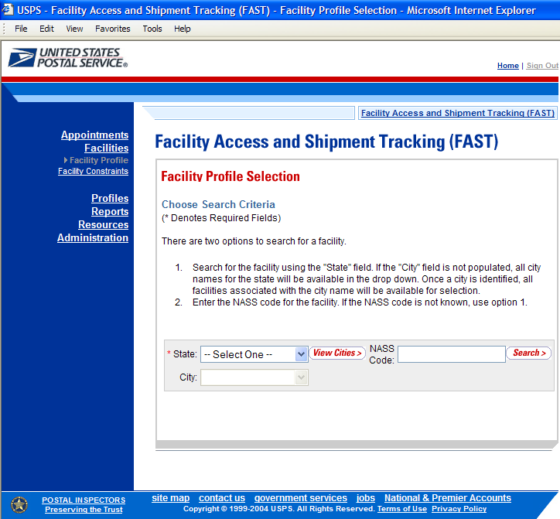

To view a facility profile, search for a facility by one of the following two ways:
To Search by State and City:
- SELECT a state from the State drop-down box
- CLICK the View Cities button
- SELECT a city from the City drop-down box
- CLICK the Search button to populate the table with the retrieved facilities

To Search by NASS Code:
- INPUT the NASS Code from the NASS Code text box
- CLICK the Search button to populate the table with the retrieved facilities

The Facility Profile page refreshes with the facility associated to the specified search criteria displayed in a table. The additional fields and buttons on the page are described below. A snapshot of the page is displayed after the field descriptions.
Facility Name column | Name of the facility. Each name is a hyperlink to the Facility Profile Information page, where the user may view the facility’s drop shipment contact information.
Facility Type column | Displays the type of facility: BMC, Plant, Delivery Unit, Annex
City column | City where the facility resides
State column | Two character state code where the facility resides
ZIP column | Five digit ZIP Code where the facility resides
Accepts Drop Ship column | Displays if the Facility accepts drop shipments (Yes); does not accept drop shipments (No); in the process of determining if the facility will accept drop shipments (Pending)

The Facility Profile page is displayed on the following page.
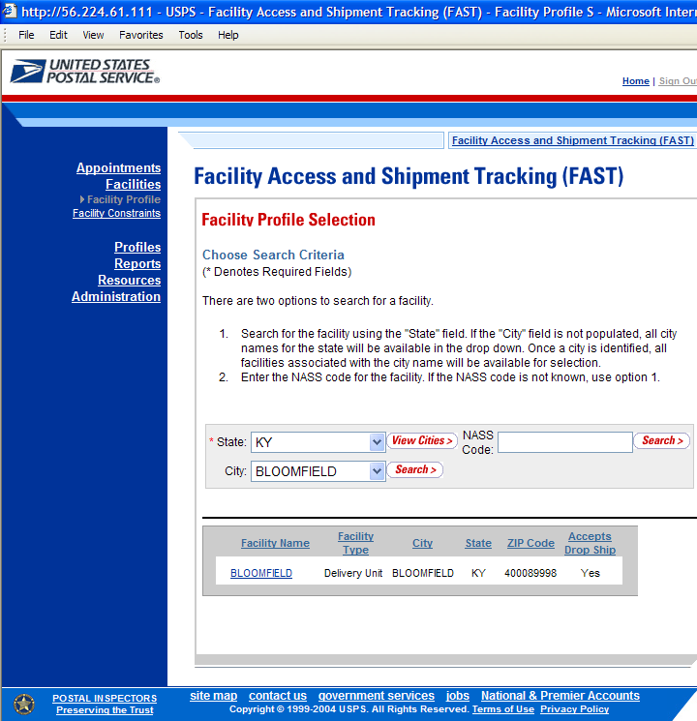

From the Facility Profile Selection page, the user may view the contact information for a drop shipment facility by CLICKING on the Facility Name hyperlink.

The Facility Profile page opens, displaying the contact information for the drop shipment facility. The fields and buttons on the page are described below. A snapshot of the page is displayed after the field description.

Facility Section
Name | The full name of the facility
Address | The street address of the facility
City | The city where the facility resides
State | The state code where the facility resides
ZIP + 4 | The 9 digit ZIP Code of the facility
District | The code and name of the district where the facility resides
Area | The code and name of the area where the facility resides
Locale Key | The locale key of the facility
Facility Rating On | Indicates Yes if appointments and customers are subject to rating at the given facility and No if they are not
Accepts Drop Shipments | Indicates Yes if the facility accepts drop shipments or No if the facility does not accept drop shipments
NASS Code | The 3-5 character NASS Code of the facility
Drop Ship Coordinator Information
*Contact Name | Name of the primary contact person of the drop ship facility
*Hours of Availability | Time range to reach the drop ship contact person
*Phone Number | Phone number at the facility for the contact person
*FAX Number | FAX number at the facility for the contact person
*Email Address | Email address of the contact person
Alternative Drop Ship Coordinator Information
*Contact Name | Name of the alternative contact person of the drop ship facility
*Hours of Availability | Time range to reach the alternative contact person
*Phone Number | Phone number at the facility for the alternative contact person
*FAX Number | FAX number at the facility for the alternative contact person
*Email Address | Email address of the alternative contact person
Alternative Drop Ship Contact Information
24-Hour Telephone Number | Phone Number to reach the facility at any time of day
Drop Ship Hours
Days of the Week | Hours the facility accepts drop shipments for each day of the week
Facility Directions | Directions to the Facility
Comments | Any additional information relevant to the facility

The Facility Profile page is displayed on the following page

Note:

If the facility is a BMC, and there are no directions provided, the user will be given a link to the BMC Homepage.

If the facility is a DDU, and there are no directions provided, the user will be given a link to the USPS locator Homepage.

Users may also enter directions in the comments section.

From the Facility Profile page, the user may CLICK the Additional Information > button to view additional information about the facility.

The Facility Profile—Additional Information page has two views; one for default facilities and one for non-default facilities. A default facility is a facility that drop shipments are redirected from. A non-default facility does not redirect any drop shipments. Drop shipments can be redirected to both default and non-default facilities. The table below describes the fields and buttons found on a default page. Following the table is a snapshot of the page for default facilities.

Default Processing
3-Digit Zip Codes Serviced | The Zip/Carrier Route per discount type that the facility serves as a default facility for.
Processing Redirections to Alternative Facilities
Provides information about what and where a facility redirects their mail to.
Pallet Code Legend: | Y = Yes, redirection applies to palletized mail  N = No, redirection applies to non-palletized mail  B = Both
View CIN List | Displays CIN List Page
Facility Name | Lists the facility name that the CIN group is redirected to.
CIN Group | Lists the CIN group or partial group of CINs that are redirected from the default facility
Pallet Code | Indicates whether the redirection applies to palletized mail, non-palletized mail or both
Discount | Lists the destination discount associated with CIN Group
ZIP/CRID Serviced | Lists of ZIP/Carrier Route that the redirection applies to for the given CIN Group and Discount
Processing Redirections From Default Facilities
Provides the CIN list of what is accepted at this facility and what is redirected there
CIN Group | See above
Pallet Code | See above
Discount | See above
ZIP/CRID Serviced | See above
Facility Dock & Yard Information
Provides height, width, depth and length information for the facility

The Facility Profile – Additional Information (default facility) page is displayed on the following page.

The Facility Profile –Additional Information page for non-default facilities is the same as the page for default facilities except for the deletion of the Processing Redirections to Alternate Facilities table. The Processing Redirections to Alternate Facilities section is omitted because non-default facilities do not redirect mail anywhere. The Facility Profile – Additional Information (non-default facility) page is displayed below.

From the Facility Profile-Additional Information page, the user may CLICK the View CIN List button to view the definitions of the CIN groups.

The table below defines the fields used on the CIN List page. Following the table is a snapshot of the CIN List page

CIN | Lists the different CIN group numbers
Pallet Code | Indicates whether the CIN may be palletized (Y), not palletized (N) or both (B)
Mail Class | Lists the class of the given CIN
Mail Shape | Lists the shape of the given CIN
Sort Type | Lists the presort level and processing category of the given CIN

The CIN List page is displayed below.

6.0 Appointments
The Appointments section describes the processes for creating, viewing and managing appointments in FAST. It also includes the processes for requesting recurring appointments at facilities and managing recurring appointment instances. The section includes the following:

6.1 Drop Ship Web Description – Gives a brief introduction to Drop Ship Web

6.2 Creating a New Appointment – Describes how a user may create and submit an appointment in FAST

6.3 Creating an Appointment for a Multi-Stop – Describes how a user may create and link appointments in a multi-stop trip

6.4 Managing Existing Appointments- Describes how a user may edit and cancel an appointment

6.5 Recurring Appointments – Describes how a user may request a recurring appointment and how a user may manage a single appointment instance of a recurring appointment

A user may access the processes associated with the above sections from the FAST Main Menu page by CLICKING on the Appointments link. The Appointments link takes the user to the Appointment Management landing page (described in module 4.0 – Landing pages) where the user may CLICK the Create New Appointment link or the Manage Existing Appointment link.

6.1 Drop Ship Web

The Drop Ship Web section details Drop Ship Web and how it will affect you. The Drop Ship Web section is outlined below:

6.1.1 What is Drop Ship Web?
6.1.2 Effects of Drop Ship Web

6.1.1 What is Drop Ship Web?

Drop Ship Web is an existing USPS application that manages the redirection of drop shipments. It is used to specify which facility to direct mail to based on Zip code (3-Digit, 5-Digit, or 5-Digit + Carrier Code), destination discount, and CIN (Content Identifier Number – a combination of mail class, mail shape and presort level/processing category). The information maintained in Drop Ship Web, is then used to generate the Drop Ship Product ZIP/CIN file. The purpose of this file is to let mailers know where to drop their mail based on the discount sought.

The ZIP/CIN data is now used by the FAST appointment creation and management process. FAST will upload this information from the DSP ZIP/CIN file on a weekly basis from AMS. The information is stored in CIN groups for the FAST system to use in appointment creation. The redirection information for a facility will be visible on the Facility Profile – Additional Information page (Section 2.1).

6.1.2 Effects of Drop Ship Web

FAST uses the ZIP/CIN information to check that the correct type of mail is dropped at the correct facility. Once you have clicked submit at the end of the Add Content Information page to create an appointment, FAST checks each contents’ mail class, mail shape and presort level against the ZIP/CIN list. If the validation fails, one of two error messages is displayed under the content that is not valid. For a Default facility, the error message says “<CIN Group> are not accepted at this facility. Please clear content and create an appointment at <NASS Code – Facility Name>.” For a Non- Default facility, the error message says “<CIN Group> are not accepted at this facility. Please refer to the Drop Ship Product for an accepting facility.”

The validation could also output a warning on the Confirm Content page. A warning means that there is an incomplete redirection. If this occurs a confirmation will appear that lists the contents and a warning. The warning will say, “Some <CIN Group> are redirected to <NASS Code – Facility Name>.” Please refer to the facility profile for specific directions. The user can ignore the warning and make the appointment by CLICKING the YES button. By CLICKING NO button, the user is returned to the previous page so the user can create the appointment at another facility. The Confirmation Content page is displayed below.

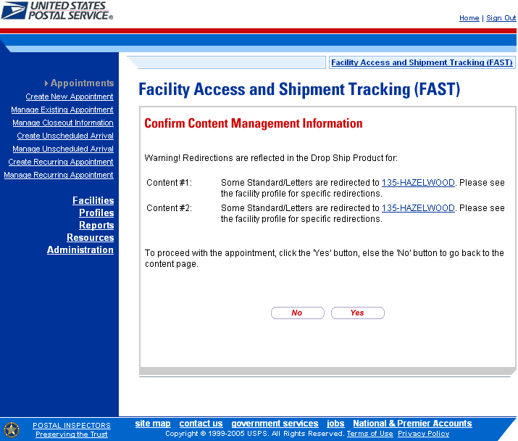

Note:
The NASS Code – Facility Name in the error or warning messages for a Default facility is a hyperlink to the Facility Profile – Additional Information page for the specified facility.

6.2 Creating a New Appointment

The Creating a New Appointment section consists of the different actions a user may perform to create a new appointment in FAST. A user may create appointments at any active facility but may only view and manage appointments to which they are associated. For example, a corporate user may view and manage appointments created by schedulers that are associated to the corporate user. Scheduler users may only view and manage appointments that they have created. Section 11.1 – Security describes what the different user types have access to view, create and modify.

Creating a new appointment requires a user to first search for availability for the desired date, volume capacity and appointment type at a specified facility. A user must associate at least one set of content information to the appointment for the appointment to be valid. Once the user has added all the separate sets of content information associated to the appointment, the appointment is submitted and created in the system.

The Creating a New Appointment section details the above process and is outlined below:

6.2.1 Searching for Appointment Slot Availability
- Searching for All Appointment Types on a Single Date
- Searching for a Specific Appointment Type on a Span of Dates
- Searching for All Appointment Types on a Single Date – Perishables and Periodicals
- Searching for a Specific Appointment Type on a Span of Dates – Perishables and Periodicals
6.2.2 Creating a New Appointment
6.2.3 Adding Content Information to an Appointment
6.2.4 Confirming New Appointment Creation

6.2.1 Searching for Appointment Slot Availability

A facility’s availability to receive a drop shipment is shown in FAST by listing the number of available ‘slots’ or appointments the facility may receive per hour and by displaying the remaining amount of mail volume a facility may process for the day. A user must not only select an available slot but must take into account the remaining volume available at the facility and ensure the appointment will not exceed it.

To search for an available slot for an appointment, a user must first CLICK the Create New Appointments link on the Appointment Management landing page. The user is taken to the Appointment Slot Availability page where they may search for available slots by specifying a facility, appointment type and date.

The fields and buttons on the Appointment Slot Availability page are described below. A snapshot of the page is displayed after the field description.

State | Drop-down box containing state options
View Cities button | Retrieves all cities within the selected state that have a facility and populates the cities in the City drop-down box
City | Drop-down box containing the cities within the specified state that have a facility
Search button | Retrieves the facilities located in the selected state and city and displays them in the Facility drop down box
NASS Code | Textbox to input the NASS Code of the requested facility
Search button | Retrieves the facility associated with the NASS Code and displays it in the Facility drop-down box
*Facility | Drop-down box containing the facility associated to the city/state combination or NASS Code
*Scheduler ID | Drop-down box listing the scheduler’s code and name to associate to the new appointment
*Appointment Type | Drop-down box listing the different appointment types: Pallet, Speedline, Bedload, Drop and Pick, All (to indicate all appointment types)
*Select Date Range | Selects the date range to search for available slots for the specified appointment type and facility. Depending on the appointment type, the range may be restricted to only one day or up to seven days total. Both date fields default to the current date.
All Contents are Perishable checkbox | Indicates the appointment contains only Perishable contents
All Contents are Periodical checkbox | Indicates the appointment contains only Periodical contents
Search button | Retrieves the available appointment slots based on the entered criteria

The Appointment Slot Availability page is displayed on the following page.

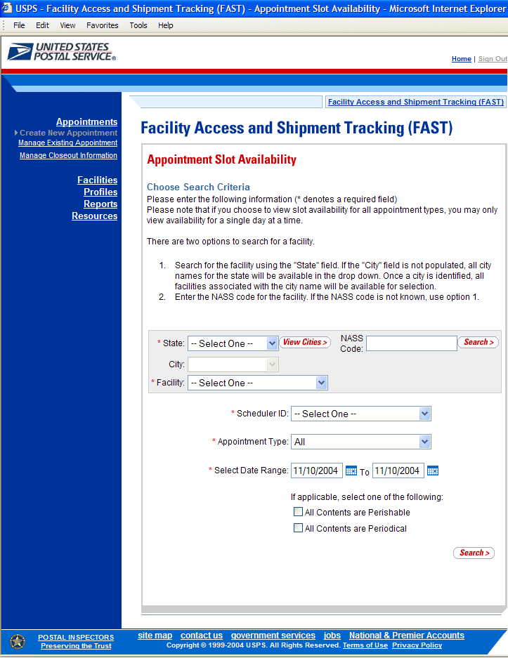

To view a facility’s availability for a drop shipment, the user must first search for the facility, which is then populated in the Facility drop-down box. Perform the following steps to search for a facility:

To Search for a Facility by State and City:
- SELECT a State from the drop-down box
- CLICK the View Cities button
- SELECT a city from the City drop-down box
- CLICK the Search button, populating the facility in the Facility drop-down
To Search for a Facility by NASS Code:
- ENTER the NASS Code in the text box
- CLICK the Search button, populating the facility in the Facility drop-down

Perform the following steps to view the facility’s availability for a drop shipment:
- SELECT the facility in the Facility drop-down
- SELECT the Scheduler ID from the drop-down
- SELECT the Appointment Type from the drop-down
- ENTER the Date Range
- CHECK the All Contents are Perishable checkbox if the appointment contains only perishable contents
- CHECK the All Contents are Periodical checkbox if the appointment contains only Periodicals contents.
- CLICK the Search button

The Appointment Slot Availability Results page opens. The results pages display the available slots and remaining volume capacity available for the given facility, appointment type, date range and scheduler.

When a user selects either the All Periodicals or All Perishables checkbox, the remaining volume is not displayed because volume availability is not affected by contents that are all perishable or all Periodicals. Also, available slots are displayed based on the facility’s capacity to receive a drop shipment, regardless of the appointment type. For each hour of the day, if the facility has been set up in FAST to allow drop shipments, regardless of available slots, the hour displays as available to receive a drop shipment for an appointment containing all Periodicals or all perishable contents.

Depending on the search criteria entered, there are four possible results pages:

- All Appointment Types on a Single Date - Displays four tables containing appointment slots organized by appointment type and a table displaying remaining volume available by mail shape

- Specific Appointment Type on a Span of Dates – Displays the available slots table for the specified appointment type and the remaining volume table arranged by dates within the date range

- All Appointment Types on a Single Date - Perishables and Periodicals – Displays four tables containing general availability per hour by appointment type

- Specific Appointment Type on a Span of Dates - Perishables and Periodicals - Displays a general availability table for the specified appointment type arranged by dates within the date range

The page descriptions for each result page are detailed below:

Appointment Slot Availability Results (All Appointment Types on a Single Date) page
The fields and buttons on the page are described below. A snapshot of the page is displayed after the field description.

Appointment Slots Available by Type tables | A table for each appointment type displaying the number of available slots per hour of the day
Hour row | Displays each hour of the day in military time
Slots row | Displays the number of available slots for each hour; each available slot number is a hyperlink where the user CLICKS to proceed in the appointment creation process
Remaining Volume Available table | Displays the remaining volume available at the facility for the specified day per mail shape

The Appointment Slot Availability Results (All Appointment Types on a Single Date) page is displayed on the following page.
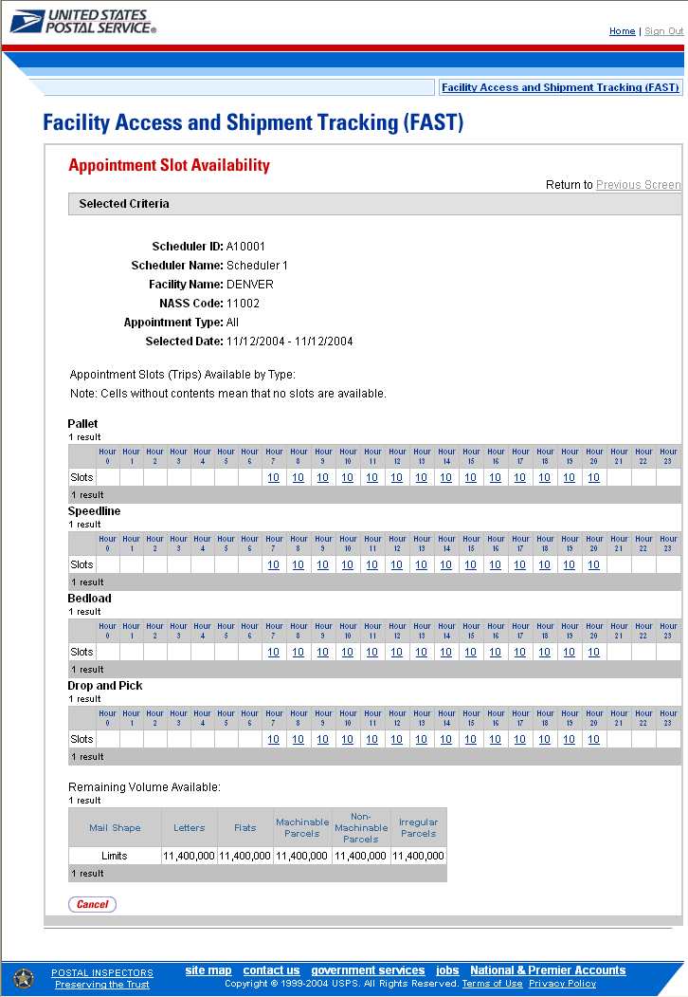

Note:
An available slot within eight hours of the current time does not display as an appointment slot option because appointments may only be created for a time that is greater than eight hours after the current time.

Appointment Slot Availability Results (Specific Appointment Type on a Span of Dates) The fields and buttons on the page are described below. A snapshot of the page is displayed after the field description.

Appointment Slots Available table | A table displaying the number of available trips for the appointment type for each hour for each day in the date range
Hour row | Displays each hour of the day in military time
Day column | Lists the days in the specified date range
Slots rows | Displays the number of available slots for each hour; each available slot number is a hyperlink where the user CLICKS to proceed in the appointment creation process
Remaining Volume Available table | Displays the remaining volume available at the facility for all days in the date range per mail shape
Day column | Lists the days in the specified date range
Remaining Volume rows | Displays the remaining available volume for each day in the date range per mail shape

Note:
The number of available slots and remaining volume amount that is displayed for each facility is based on the scheduler’s Tier level. For more information on Tier levels, please reference section 10.0 - Rating Overview.
Note:
The number of available slots and remaining volume amount that is displayed for each facility is based on the facility’s Tier level. For more information on Tier levels, please reference section x.x.x - Tier Summary.
Note:
Only a user that is associated to the facility may edit the facility’s drop ship contact information. All fields do not have to be updated, but all required fields must be populated.

The Appointment Slot Availability Results (Specific Appointment Type on a Span of Dates) page is displayed on the following page.

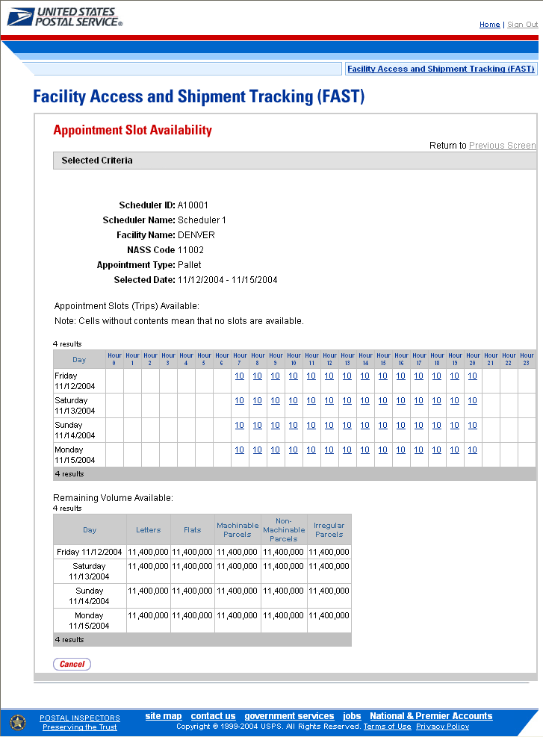

Note:
For all result pages, the available appointment slots displayed are hyperlinks which take the user to the next page in the appointment creation process. A user must ensure there is available volume at the facility for the appointment when selecting a slot.

Appointment Slot Availability Results (All Appointment Types on a Single Date - Perishables and Periodicals) page
The fields and buttons on the page are described below. A snapshot of the page is displayed after the field description.

All Contents are Perishable | Note displaying that all contents for the appointment are either perishable or Periodicals
Appointment Slots Available by Type tables | A table for each appointment type displaying the available hours the facility may accept drop shipments
Hour row | Displays each hour of the day in military time
Slots rows | Displays an ‘A’ to indicate that hour is available for drop shipments of an all perishable or Periodicals appointment

The Appointment Slot Availability Results (All Appointment Types on a Single Date - Perishables and Periodicals) page is displayed on the following page.
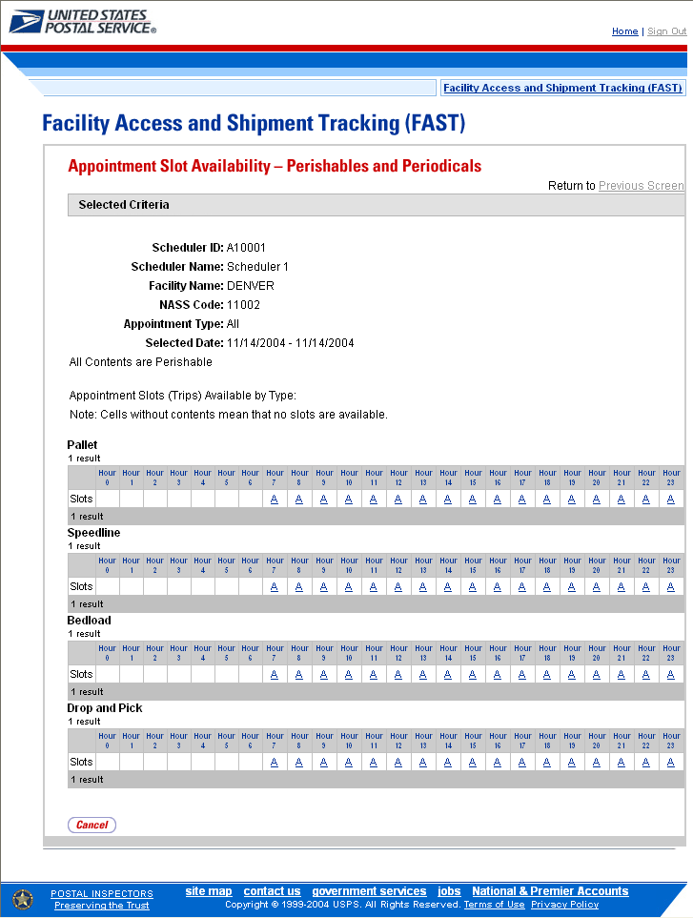

Appointment Slot Availability Results (Specific Appointment Type on a Span of Dates - Perishables and Periodicals) page
The fields and buttons on the page are described below. A snapshot of the page is displayed after the field description.

All Contents are Perishable | Note displaying that all contents for the appointment are either perishable or Periodicals
Appointment Slots Available table | A table displaying the hours the facility is available to receive drop shipments for all days in the specified date range
Hour row | Displays each hour of the day in military time (0-23)
Day column | Lists the days in the specified date range
Slots rows | Displays an ‘A’ to indicate that hour is available to receive an appointment of all Periodicals or all perishable contents

The Appointment Slot Availability Results (Specific Appointment Type on a Span of Dates - Perishables and Periodicals) page is displayed below.

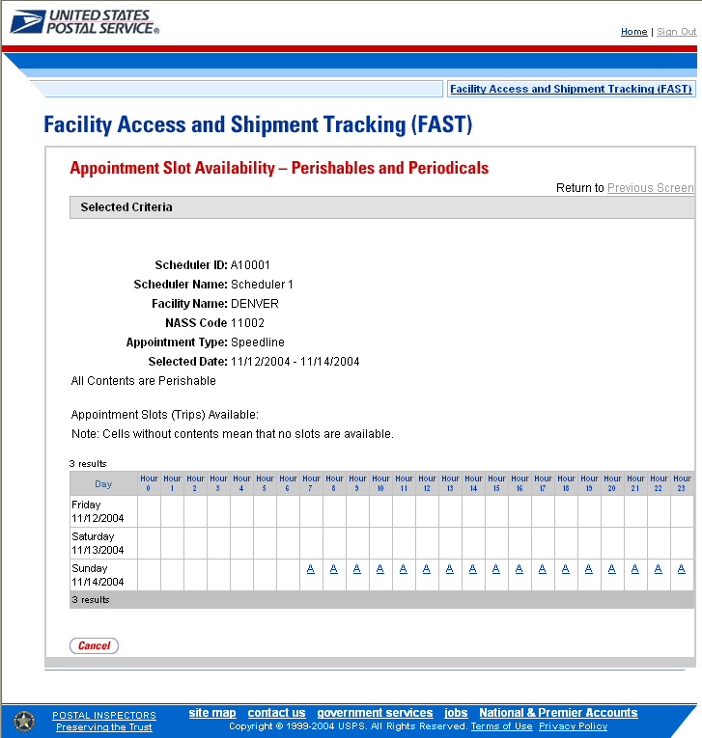

Note:
‘A’ indicates the facility is available to receive a drop shipment at the specific hour.

Availability for Perishable and Periodical appointments is based on the facility’s hours of operation.

6.2.2 Creating a New Appointment

From the Appointment Slot Availability Results page, a user CLICKS on an available slot hyperlink to continue the appointment creation process. After CLICKING a hyperlink, the user is taken to the Create New Appointment page for the specified scheduler, appointment type, appointment date and facility.

Appointment level information is entered on the Create New Appointment page.

The fields and buttons on the Create New Appointment page are described below. A snapshot of the page is displayed after the field description.

*Submission Method | Drop-down box where the user may specify if the appointment is being created online or via the phone; This field displays as read-only and set to Online due to the fact external users may only schedule an appointment online
Bill of Lading Number | The bill of lading number assigned to the appointment
Number of Pallet Positions | The number of pallet positions
Vehicle ID | The ID of the vehicle
Shipper Name | The name of the company transporting the shipment
Multi-Stop checkbox | Indicates if the appointment is the part of a multi-stop; enables linking of appointments within the system
Comments | Any additional comments
Add Content Info button | Displays the Add Content Information page
Cancel button | Displays the Appointments landing page

The Create New Appointment page is displayed on the following page.

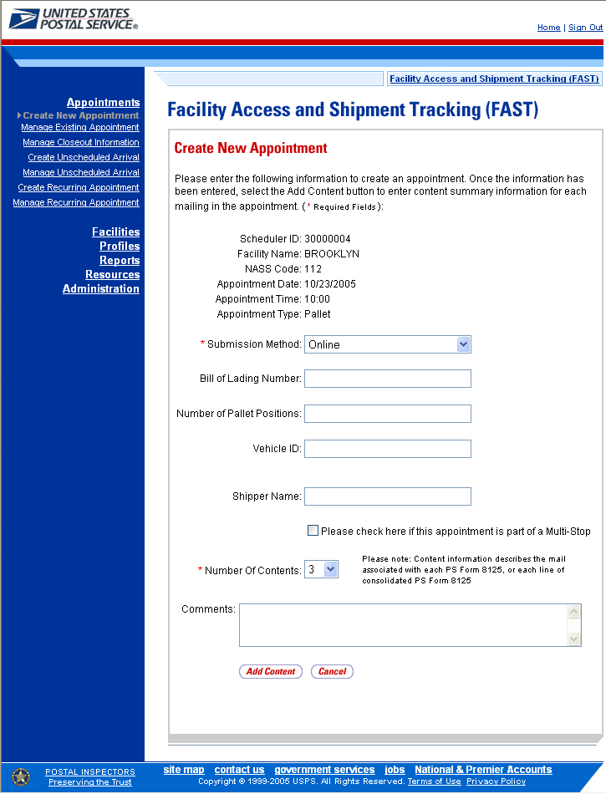

To enter appointment level information and access the Add Content Information page, perform the following steps on the Create New Appointment page:

- ENTER the Bill of Lading Number of the scheduled appointment
- ENTER the Number of Pallet Positions of the scheduled appointment
- ENTER the Vehicle ID of the scheduled vehicle for the appointment
- ENTER the Shipper ID of the scheduled appointment
- CHECK the Multi-Stop checkbox if this appointment is part of a multi-stop trip
Note:
Multi-Stop appointments are discussed in section 6.2 – Creating an Appointment for a Multi-Stop

- ENTER the Number of Contents associated with the appointment
- ENTER any additional Comments for the appointment
- CLICK the Add Content Info button, displaying the Add Content Information page

6.2.3 Adding Content Information to an Appointment

The Add Content Information page associates content information to an appointment. At least one content information set must be created to make a valid appointment. Content information describes the mail associated with each PS Form 8125, or each line of a consolidated PS Form 8125.

A user may encounter restrictions when entering content information, depending on the appointment type and if the appointment is to contain all Periodicals or all perishable contents. An error message (section 1.3.3 – Error Messages) displays if the user tries to submit a content that violates any of the restrictions. The message describes the restriction to help the user to submit valid information.

The fields and buttons on the Add Content Information page are described below. A snapshot of the page is displayed after the field description.

*Update Grid Capacity | Drop-down listing the number of contents associated with the current appointment
Change Button | Changes the number of contents associated with the current appointment
Content Number | The number of the current content being created
Clear Content Checkbox | Clears the data fields in the content
Mail Preparer ID | The ID associated to the mail preparer
Mail Owner ID | The ID associated to the mail owner
Content Name | The name of the content being created
*Mail Class | Drop-down listing the following mail class options for the content: Periodical, Standard, Package Services
News checkbox | Indicates if the content is news
*Mail Shape | Drop-down box listing the following options to specify mail shape: Letter, Flat, Machinable Parcel, Non-Machinable Parcel, Irregular Parcel
Perishable checkbox | Indicates if the content is perishables
Count of Pallets Containing Sacks | The total number of pallets containing sacks in the appointment
Count of Pallets Containing Trays | The total number of pallets containing trays in the appointment
Count of Pallets Containing Parcels | The total number of pallets containing parcels in the appointment
Count of Pallets Containing Bundles | The total number of pallets containing bundles in the appointment
Bedloaded Sack Count | The total number of sacks in the bedloaded appointment
Bedloaded Tray Count | The total number of trays in the bedloaded appointment
Bedloaded Parcel Count | The total number of parcels in the bedloaded appointment
Bedloaded Bundle Count | The total number of bundles in the bedloaded appointment
In Home Start date | The starting date and time the appointment is expected to arrive at the final destination
In Home End date | The ending date and time the appointment is expected to arrive at the final destination
Submit button | Saves all associated contents to the appointment and creates the appointment in the system

The Add Content Information page is displayed on the following page.
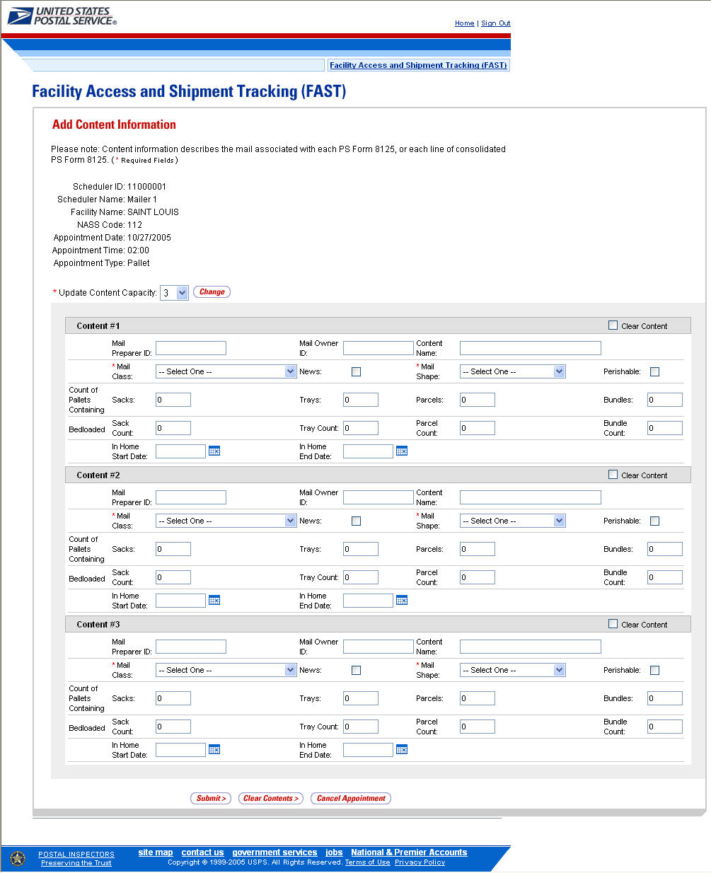

To enter content level information and save the appointment in the system, perform the following steps on the Add Content Information page:

- ENTER the Mail Preparer ID
- ENTER the Mail Owner ID
- ENTER the Content Name
- SELECT the Mail Class of the content
- CHECK the News checkbox if the content is news
- SELECT the Mail Shape of the content
- CHECK the Perishable checkbox if the content is perishable
- ENTER the number of Pallets containing Sacks, if applicable
- ENTER the number of Pallets containing Trays, if applicable
- ENTER the number of Pallets containing Parcels, if applicable
- ENTER the number of Pallets containing Bundles, if applicable
- ENTER the number of Bedloaded Sacks, if applicable
- ENTER the number of Bedloaded Trays, if applicable
- ENTER the number of Bedloaded Parcels, if applicable
- ENTER the number of Bedloaded Bundles, if applicable
- ENTER the In Home Start Date
- ENTER the In Home End Date
Note:
The In Home Start Date must be less than or equal to the In Home End Date which must be less than or equal to the appointment date

- CLICK the Submit button to save all contents to the appointment and create the appointment in the system
Note:
Please be aware of the following restrictions when adding content information:
- An all Periodicals appointment may only have a mail class of Periodicals
- The News checkbox may only be selected if the mail class selected is Periodicals
- An all perishable appointment may only have a mail class of Parcel Select
- The Perishable checkbox may only be selected if the mail shape is Parcels or Irregular Parcels
- The mail class must be Package Services for the user to select one of the specific Package Services sub-types: Parcel Select, BPM/Library/Media Mail

After CLICKING the Submit button, the Appointment Confirmation page is displayed.

6.2.4 Confirming New Appointment Creation

Once a user has entered all contents for an appointment and submits the appointment in the system, the Appointment Confirmation page displays to confirm the appointment contains valid information and has been created in the system.

The fields and buttons on the Appointment Confirmation page are described below. A snapshot of the page is displayed after the field description.

Appointment ID hyperlink | Displays the ID associated to the new appointment and is a hyperlink to the Appointment Management page where a user may edit the appointment
Scheduler ID | ID associated with the appointment’s scheduler
Scheduler Name | The name of the company location scheduling the appointment
Facility Name | The name of the facility of the appointment
Facility ID | The ID associated with the facility
Appointment Date | The date of the appointment
Appointment Type | The selected appointment type
Content ID | The ID(s) associated to the content(s) associated to the new appointment
Bill of Lading | The Bill of Lading number assigned to the appointment
Total # of Pallets | The number of pallets in the appointment

The Appointment Confirmation page is displayed on the following page.

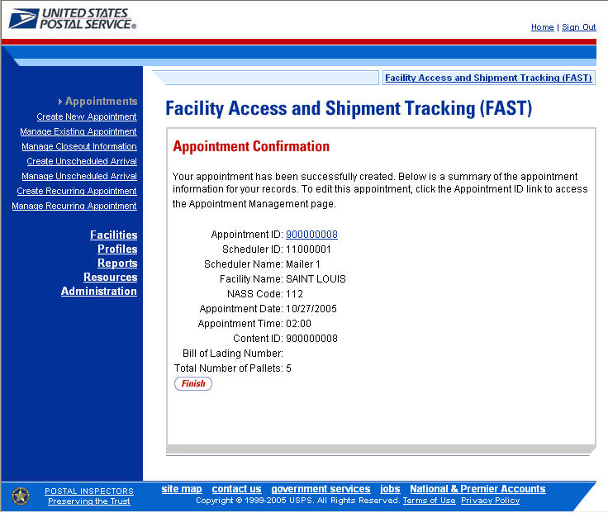

Note:
A volume validation is executed upon submission of the appointment. If the contents submitted exceed the available volume, an error message (described in section 1.3.3 - Error Messages) displays stating that the volume is no longer available. In addition, upon submitting the appointment, if the trip slot is no longer available, the user will be directed to select a new trip slot without losing any of the content information.

6.3 Creating an Appointment for a Multi-Stop

A user may designate any appointment as part of a multi-stop trip. Additional appointments may be added to existing multi-stop trips as well.

This section describes the above processes and includes:

6.3.1 – Creating an Appointment for a New Multi-Stop
6.3.2 – Creating an Appointment for an Existing Multi-Stop

6.3.1 Creating an Appointment for a New Multi-Stop

The process to create an appointment for a new multi-stop trip is similar to the process in section 6.1 - Creating a New Appointment. A user may also add the subsequent appointments in the multi-stop trip, ensuring the total time from the first stop to the last stop in a multi-stop trip is not more than 24 hours.

The user begins at the Appointment Slot Availability page to select a date with an available slot and volume for the specified facility. The user is taken to the Create New Appointment page where the user enters in the appointment level information. To indicate this appointment is part of a multi-stop, the user CHECKS the Multi-Stop checkbox which says: ‘Please check here if this appointment is part of Multi-Stop’.

Please reference section 6.2.2 - Creating a New Appointment to view the fields and buttons description of the Create New Appointment page. The page is displayed on the following page.
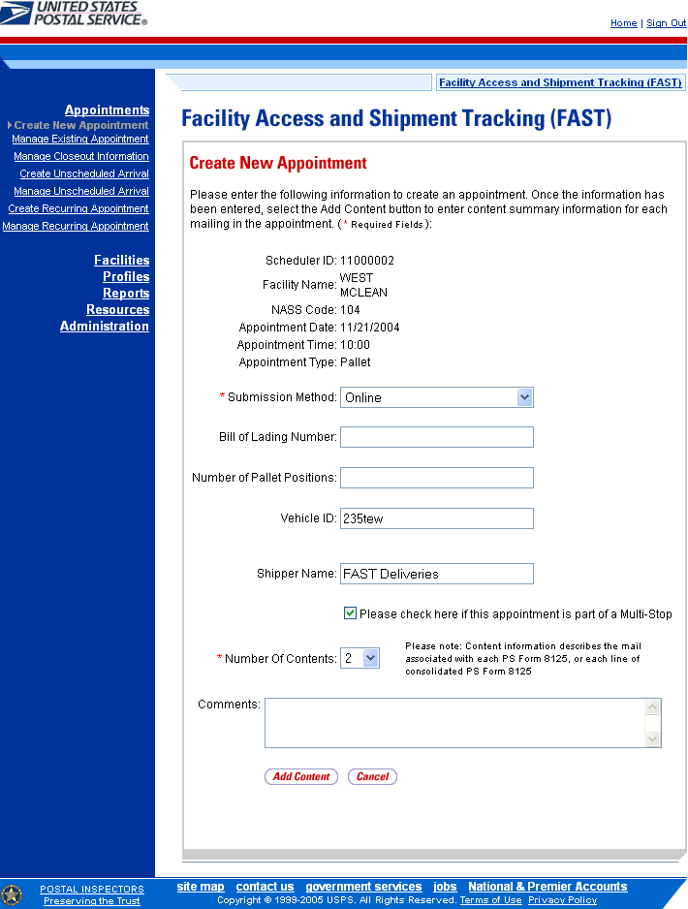
After checking the Multi-Stop checkbox, CLICK the Add Content button to continue the appointment creation process. The user is taken to the same Add Content Information page displayed in section 6.2 – Creating a New Appointment. The user enters content information required for the appointment. Any restrictions on content information found for single stop appointments also apply to multi-stop appointments. An additional restriction for multi-stop appointments is that the appointment may not be of type Drop and Pick.

After submitting all contents and the multi-stop appointment request, the Appointment Confirmation page is displayed. The multi-stop Appointment Confirmation page displays a multi-stop ID that is created for the multi-stop trip and a button that enables a user to add additional appointments to the multi-stop.

The fields and buttons on the Appointment Confirmation page are described below. A snapshot of the page is displayed after the field description.

Appointment ID hyperlink | Displays the ID associated to the new appointment and is a hyperlink to the Appointment Management page where a user may edit the appointment
Scheduler ID | ID associated with the appointment’s scheduler
Scheduler Name | The name of the company location scheduling the appointment
Facility Name | The name of the facility of the appointment
Facility ID | The ID associated with the facility
Appointment Date | The date of the appointment
Appointment Type | The selected appointment type
Content ID | The ID(s) associated to the content(s) associated to the new appointment
Bill of Lading Number | The Bill of Lading number associated to the new appointment
Total Number of Pallets | The total number of pallets contained in the new appointment
Multi-Stop ID | The ID associated to the multi-stop trip the appointment is a part of; only displays when the appointment is part of a multi-stop
Add Additional Appointment to Multi-Stop button | Takes the user to Appointment Slot Availability search page to select another appointment add to the multi-stop; only displays when the appointment is part of a multi-stop
Finish button | Takes the user to the Appointment Search page

The Appointment Confirmation page is displayed below.

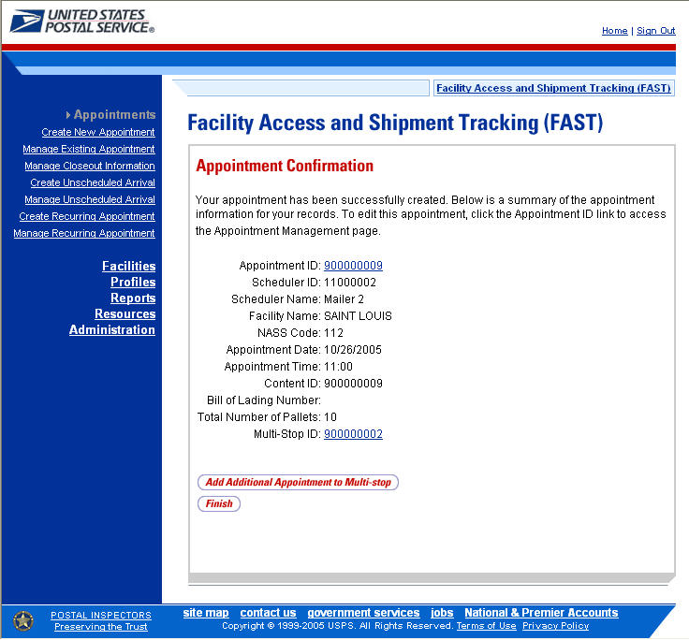

A user may add an additional appointment to this multi-stop appointment by CLICKING the Add Additional Appointment to Multi-Stop button. The user is taken to the Appointment Slot Availability search page to add another appointment to the multi-stop, as described in this section.

To add an appointment to an already existing multi-stop, the user performs a slightly different process, described in the following section – Creating an Appointment for an Existing Multi-Stop.

6.3.2 Create an Appointment for an Existing Multi-Stop

A user may add appointments to an existing multi-stop trip if the user is associated to the trip. The user searches for the existing multi-stop and then creates a new appointment and adds it to the multi-stop. A user beings the process by CLICKING the Appointments link on the FAST Main Menu page. The user is taken to the Appointment Management landing page where they may CLICK the Manage Existing Appointment link to search for an existing multi-stop trip. Section 6.3 – Manage Existing Appointments describes in more detail the functions related to managing appointments.

The Manage Existing Appointment link displays the Search Existing Appointment Information page. From this page a user may search for a multi-stop trip by either the multi-stop ID or the scheduler ID. A user may also search for appointments through this same page. Please reference section 6.3.1 – Appointment Search for a detailed description of appointment search options and processes.

Once a user searches for the existing multi-stop by either of the two ways, the user is redirected to the Multi-Stop Management page where they may add a new appointment to the multi-stop. A user may perform a number of other functions from the Multi-Stop Management page which are described in section 6.3.4 – Multi-Stop Management. This section details how to search for a multi-stop by the multi-stop ID, how to search for a multi-stop by the scheduler ID and create and add an appointment to the multi-stop.

Searching for an Existing Multi-Stop by the Multi-Stop ID

When a user knows the ID of the specific multi-stop they wish to add an appointment to, they may search directly by the multi-stop ID.

After CLICKING the Manage Existing Appointment link, the Search Existing Appointment Information page displays with some initial fields and buttons. The fields and buttons of the page are described below. A snapshot of the page is displayed after the field description.

*Search for: | Drop-down box to select to search for an appointment or a multi-stop
Submit button | Refreshes the page and displays a Search by button
Search button | Searches the database for the entered search criteria and displays either the Multi-Stop Management page or Appointment Management page only when all required fields have been entered
Cancel button | Displays the Appointment Management landing page

The Search Existing Appointment Information (Search for Multi-Stop) page is displayed on the following page.
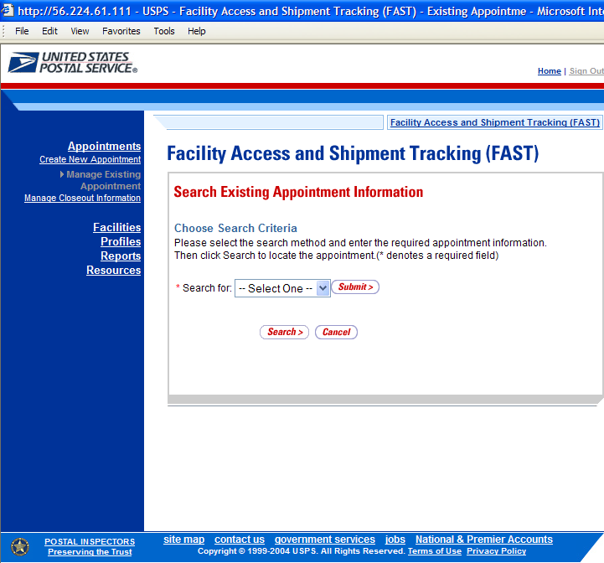

To search for a multi-stop by the multi-stop ID, perform the following initial steps on the Search Existing Appointment Information page:

- SELECT Multi-Stop in the Search for drop-down box
- CLICK the Submit button beside the Search for drop-down box

The Search Existing Appointment Information (Search for Multi-Stop) page refreshes with additional fields, described below.

*Search by: | Drop-down box to select to search by either multi-stop ID or scheduler ID when searching for a multi-stop or to search by appointment ID or scheduler ID when searching for an appointment
Submit button | Refreshes the page and displays either a multi-stop ID input box, appointment ID input box or a scheduler ID drop-down box with a facility search section to select a scheduler and facility for an existing multi-stop or appointment

The Search Existing Appointment Information (Search for Multi-Stop) page is displayed below.

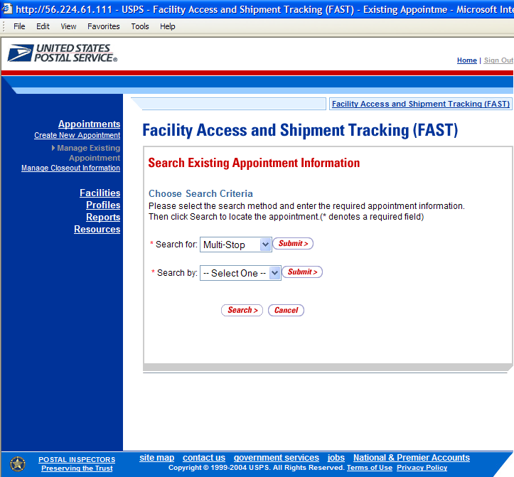

Perform the following steps on the Search Existing Appointment Information page:

- SELECT Multi-Stop ID in the Search by drop-down box
- CLICK the Submit button next to the Search by drop down box
The Search Existing Appointment Information (Search for Multi-Stop by multi-stop ID) page refreshes with an additional field, described below.
*Multi-Stop ID | Input box to enter the ID associated to the multi-stop

The Search Existing Appointment Information (Search for Multi-Stop by multi-stop ID) page is displayed below.

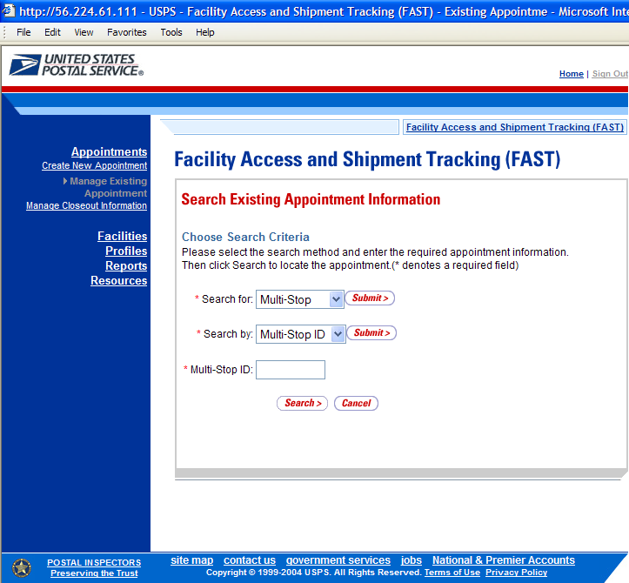

Perform the following final steps on the Search Existing Appointment Information page to view the Multi-Stop Management page for the specified multi-stop ID:

- ENTER the multi-stop ID in the Multi-Stop ID input box
- CLICK the Search button to display the Multi-Stop Management page for the multi-stop ID
Note:
A user may perform several different actions from the Multi-Stop Management page, please reference section 6.3.4 – Multi-Stop Management for a complete description of all possible actions.

Searching for a Multi-Stop by the Scheduler ID
Searching for a multi-stop by the scheduler ID displays a different Search Existing Appointment Information page then when searching by the multi-stop ID. This search combination may retrieve several multi-stops that fall within the specified search criteria and displays them in a summary table. Each multi-stop ID is a hyperlink to the Multi-Stop Management page for the ID.

After CLICKING the Manage Existing Appointment link on the Appointment Management page, the Search Existing Appointment Information page displays. The initial fields and buttons on the page are described below. A snapshot of the page is displayed after the field description.
*Search for: | Drop-down listing the options a user may search for: Appointment, Multi-Stop
Submit button | Displays the Search by: drop down box that contains search options based on the Search for selection
Search button | Searches the database for the entered search criteria and displays either the Multi-Stop Management page or Appointment Management page (depending on the search criteria) only after all required fields have been entered
Cancel button | Displays the Appointment Management landing page
The Search Existing Appointment Information (Search for Multi-Stop) page is displayed below.
To search for a multi-stop by the scheduler ID, perform the following initial steps on the Search Existing Appointment Information page:

- SELECT Multi-Stop in the Search for drop-down box
- CLICK the Submit button beside the Search for drop-down box
The Search Existing Appointment Information (Search for Multi-Stop) page refreshes with additional fields, described below.
*Search by: | Drop-down box to select to search by either multi-stop ID or scheduler ID when searching for a multi-stop or to search by appointment ID or scheduler ID when searching for an appointment
Submit button | Displays the Scheduler ID drop-down box, date range input boxes and facility search fields and buttons

The Search Existing Appointment Information (Search for Multi-Stop by scheduler ID) page is displayed below.

To search by the scheduler ID, perform the following steps on the Search Existing Appointment Information page:

- SELECT scheduler ID in the Search by drop-down box
- CLICK the Submit button next to the Search by drop down box

The Search Existing Appointment Information (Search for Multi-Stop by scheduler ID) page refreshes with the following additional fields, described below.
*Scheduler ID | Drop-down box listing scheduler names and IDs to select from
*Select Date Range | Enters the date range to search for a multi-stop between the first date and the second date
*State | Drop-down box listing all state options
View Cities button | Retrieves cities within the selected state that have a facility within them and populates the cities in the City drop-down box
City | Drop-down box listing all cities within the selected state that have facilities within them
Search button | Retrieves all facilities within the selected city and state and populates them in the Facility drop-down box
NASS Code | The five character NASS Code
Search button | Retrieves the facility associated with the entered NASS Code and populates it in the Facility drop-down box
Facility | Drop-down box containing the facility associated with either the State/City pair or the NASS Code or the All Facilities option
Search button | Retrieves all multi-stop trips that are for the specified scheduler, date range and facility and populates them in an Multi-Stop Summary table at the bottom of the page

The Search Existing Appointment Information (Search for Multi-Stop by scheduler ID) page is displayed below.
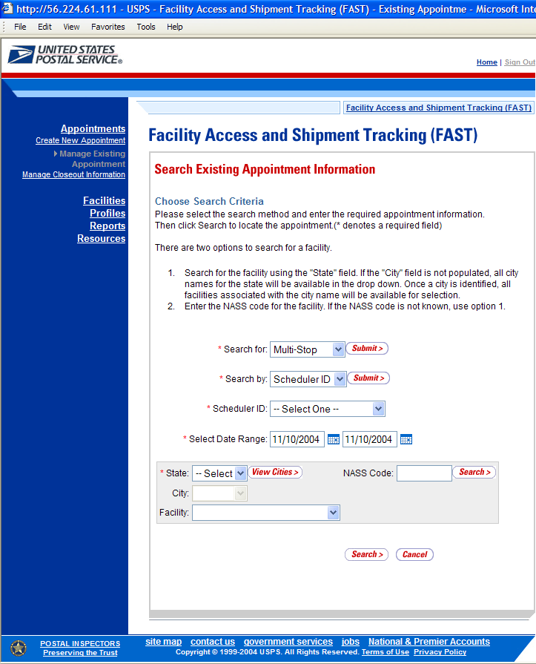

To view all multi-stops for the specified criteria, perform the following final steps on the Search Existing Appointment Information page:

- SELECT the scheduler to search for multi-stops associated with in the Scheduler ID drop-down box
- SELECT the time frame to look for multi-stops within in the Select Date Range textboxes
- SELECT a facility from the Facility drop-down box by searching for the facility by one of the following two ways:
To Search for a Facility by State and City:
- SELECT a state from the State drop-down box
- CLICK the View Cities button
- SELECT a city from the City drop-down box
- CLICK the Search button

To Search for a Facility by NASS Code:
- ENTER the NASS Code in the textbox
- CLICK the Search button

- SELECT the facility in the Facility drop down box, or SELECT the All Facilities option
- CLICK the Search button, refreshing the page and displaying the Multi-Stop Summary table

The Search Existing Appointment Information page displays with a Multi-Stop Summary table below the search fields and buttons. The new fields and buttons are described below.

Multi-Stop Summary section | Lists the multi-stops and their related information that fall within the specified search criteria
Multi-Stop ID hyperlink column | Lists the IDs of all multi-stops that are associated with the selected scheduler ID, facility, and within the date range and is a hyperlink to the Multi-Stop Management page for the multi-stop
1st Appt ID column | Lists the ID of the first appointment in the multi-stop
Date column | Lists the date of the first appointment in the multi-stop
Time column | Lists the time of the first appointment in the multi-stop
Facility ID column | Lists the ID of the facility for the first appointment in the multi-stop
Facility Name column | Lists the name of the facility for the first appointment in the multi-stop

The Search Existing Appointment Information page is displayed below.
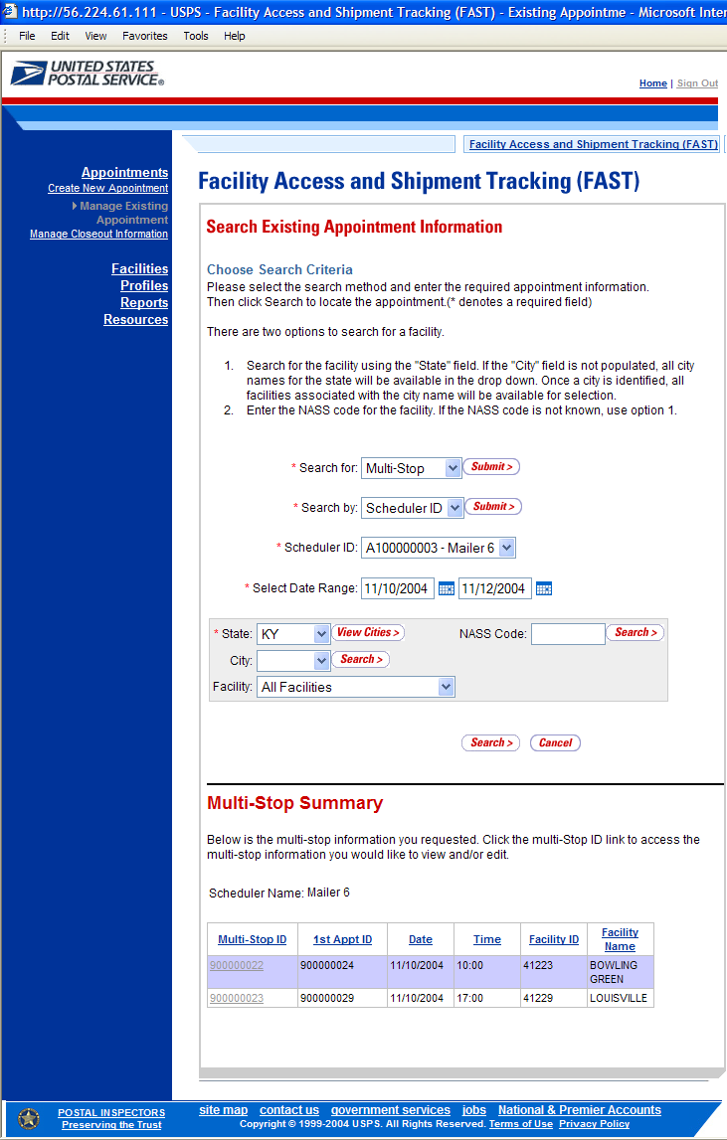

Creating and Adding a New Appointment to the Multi-Stop

After searching for a multi-stop by either the multi-stop ID or the scheduler ID, the user is taken to the Multi-Stop Management page. From this page, a user has the ability to add an additional appointment to the existing multi-stop. The Multi-Stop Management page lists the appointments that are already included in the multi-stop. The fields and buttons of the Multi-Stop Management page are described below. A snapshot of the page is displayed after the field description.
Multi-Stop ID | Displays the ID associated to the multi-stop trip
Results table | Displays all appointment IDs and their information that are included in the multi-stop
Appointment ID hyperlink | Displays the appointment ID of the associated appointment and is a hyperlink, which displays the Appointment Management page for the selected appointment
Remove hyperlink | Refreshes the page, displaying a note beneath the table stating that the selected appointment has been removed from the multi-stop but still exists as a stand-alone appointment
Date column | Lists the dates of each appointment in the multi-stop
Time column | Lists the time of each appointment in the multi-stop
Facility ID column | Lists the ID associated with the facility for each appointment in the multi-stop
Facility Name column | Lists the name of the facility for each appointment in the multi-stop
Add Additional Appointment to Multi-Stop button | Displays the Appointment Slot Availability Search page where the user begins the process to create a new appointment
Cancel Multi-Stop button | Displays the Confirm Cancel Multi-Stop page where a user may confirm cancellation of the multi-stop and its associated appointments
Cancel button | Displays the Search Existing Appointment Information page

The Multi-Stop Management page is displayed on the following page.

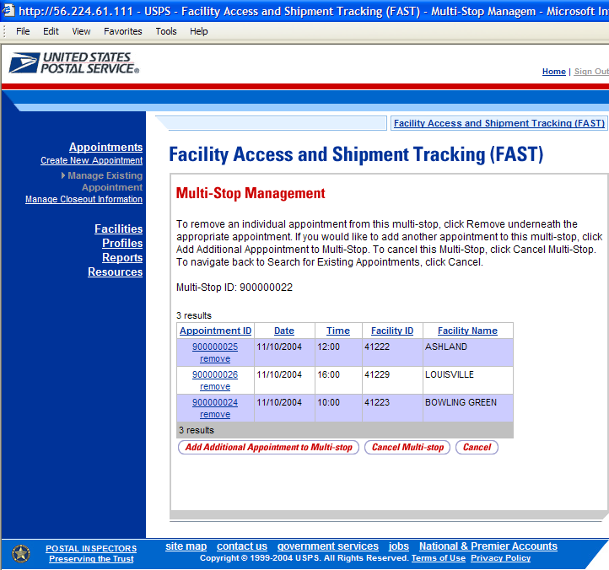

CLICK the Add Additional Appointment to Multi-Stop button, which displays the Appointment Slot Availability page. From this page, the user follows the same process as described in this section to create a new appointment and add it to the multi-stop trip.

Note:
The time difference between the first appointment’s arrival date and the last appointment’s arrival date in the multi-stop cannot be greater than 24 hours.

6.4 Managing Existing Appointments

From the Appointments landing page, a user may CLICK the Manage Existing Appointment link to access the appointment management area of the FAST application. A user may manage appointment information by editing appointment level information, editing content level information, adding content information, canceling content information, and canceling appointments. A user may modify appointment information created via Web Services. A user may view without editing closeout and unscheduled arrival information as well.

A user may modify and cancel multi-stop appointments as well as single stop appointments

The Managing Existing Appointments section includes:

6.4.1 Appointment Search
6.4.2 Appointment Management
6.4.3 Content Information Management
6.4.4 Multi-Stop Management
6.4.5 Web Services Appointment Management

6.4.1 Appointment Search

A user has the option to search for an appointment by either the appointment ID or by the scheduler ID. The resulting search page, Search Existing Appointment Information, may appear two different ways depending on how the user searches for the appointment.

One search combination, searching for an appointment by the appointment ID, displays a page similar to the multi-stop search page displayed in section 6.2.2 – Create an Appointment for an Existing Multi-Stop. The user may enter a specific appointment ID which takes the user to the Appointment Management page for the appointment ID.

The second combination, searching for an appointment by the scheduler ID, displays a different Search Existing Appointment Information page. This search combination may retrieve multiple appointments that fall within the specified search criteria and displays them in a summary table. Each appointment is a hyperlink to the Appointment Management page for the appointment ID.

Searching for an Appointment by the Appointment ID

After CLICKING the Manage Existing Appointment link, the Search Existing Appointment Information page displays with some initial fields and buttons. The fields and buttons are described below. A snapshot of the page is displayed after the field description.

*Search for: | Drop-down box to select to search for an appointment or a multi-stop
Submit button | Refreshes the page and displays a Search by button
Search button | Searches the database for the entered search criteria and displays either the Multi-Stop Management page or Appointment Management page only after all required fields have been entered
Cancel button | Displays the Appointment Management landing page

The Search Existing Appointment Information (Search for appointment) page is displayed below.

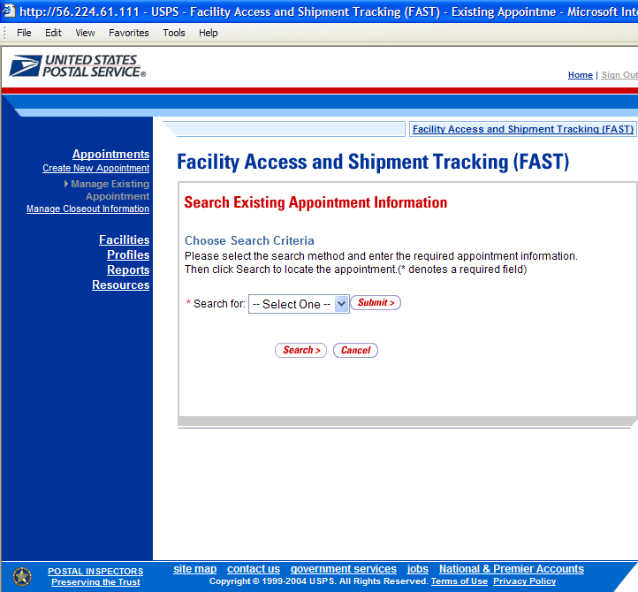

To search for an appointment by the appointment ID, perform the following initial steps on the Search Existing Appointment Information page:

- SELECT Appointment in the Search for drop-down box
- CLICK the Submit button beside the Search for drop-down box

The Search Existing Appointment Information (Search for appointment) page refreshes with additional fields, described below.
*Search by: | Drop-down box listing what a user may search by: Appointment ID, Scheduler ID, Multi-Stop ID
Submit button | Displays the Appointment ID textbox for the user to enter a specific appointment ID

The Search Existing Appointment Information (Search for appointment by appointment ID) page is displayed below.

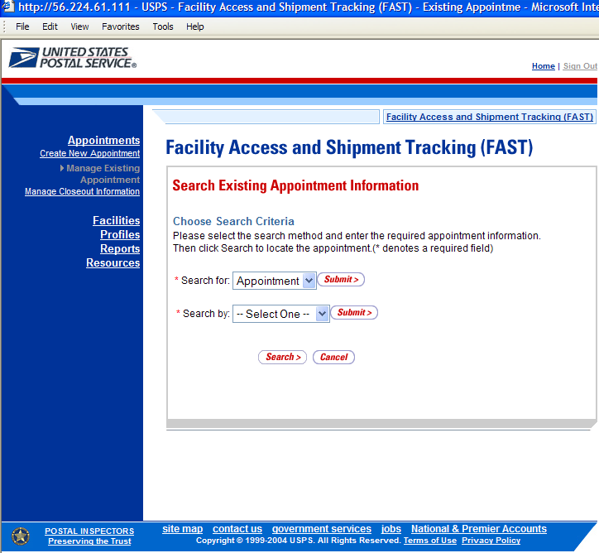

Perform the following steps on the Search Existing Appointment Information page:

- SELECT Appointment ID in the Search by drop-down box
- CLICK the Submit button next to the Search by drop down box

The Search Existing Appointment Information (Search for appointment by appointment ID) page refreshes with an additional field, described below.
*Appointment ID | Input box to enter the specific appointment ID

The Search Existing Appointment Information (Search for appointment by appointment ID) page is displayed below.

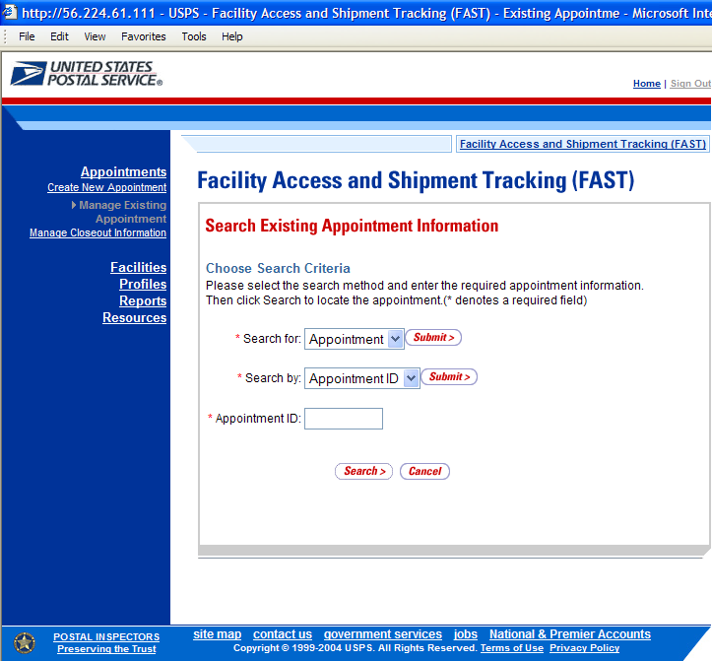

To view the Appointment Management page for the specified appointment ID, perform the following final steps on the Search Existing Appointment Information page:

- ENTER the appointment ID in the Appointment ID input box
- CLICK the Search button, displaying the Appointment Management page

Searching for an Appointment by the Scheduler ID
The second search combination, searching for an appointment by the scheduler ID, displays a different Search Existing Appointment Information page. After performing the initial steps 1 and 2 from the previous section, the user selects to Search by scheduler ID and CLICKS Submit, displaying the Search Existing Appointment Information page with the below fields and buttons.
*Search for: | Drop-down box listing the options a user may search for: Appointment, Multi-Stop
Submit button | Displays the Search by: drop down box that contains search options based on the search for selection
*Search by: | Drop-down box listing what a user may search by: Scheduler ID, Appointment ID, (Multi-Stop ID)
Submit button | Displays the Scheduler ID drop-down box, date range input boxes and facility search fields and buttons
*Scheduler ID | Drop-down box listing scheduler names and IDs to select from
*Select Date Range | Enters the date range to search for an appointment between the first date and the second date
*State | Drop-down box listing all state options
View Cities button | Retrieves cities within the selected state that have a facility within them and populates the cities in the City drop-down box
City | Drop-down box listing all cities within the selected state that have facilities within them
Search button | Retrieves all facilities within the selected city and state and populates them in the Facility drop-down box
NASS Code | The NASS Code of the facility
Search button | Retrieves the facility associated with the entered NASS Code and populates it in the Facility drop-down box
Facility | Drop-down box containing the facility associated with either the State/City pair or the NASS Code
Search button | Retrieves all appointments that are for the specified scheduler, date range and facility and populates them in an Appointment Summary table at the bottom of the page

The Search Existing Appointment Information page when searching for an appointment by the scheduler ID is displayed on the following page.

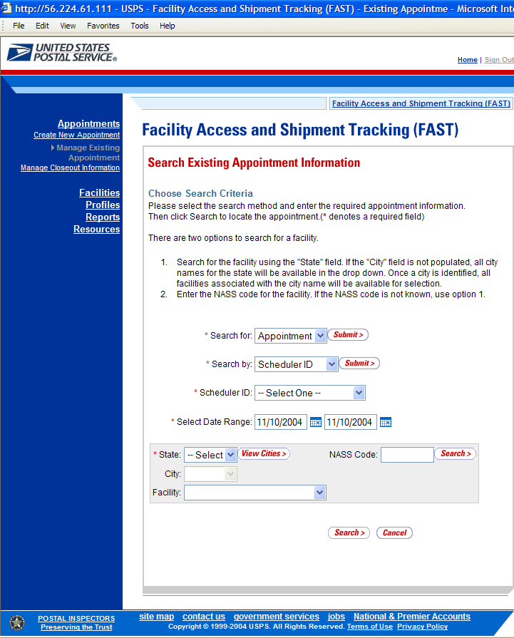

To search for and view all appointments for the specified criteria, perform the following steps on the Search Existing Appointment Information page:

- SELECT Appointment in the Search for drop-down box
- CLICK the Submit button
- SELECT Scheduler ID in the Search by drop-down box
- CLICK the Submit button
- SELECT the scheduler to search for appointments for in the Scheduler ID drop-down box
- SELECT the time frame to search within in the Select Date Range textboxes
- SEARCH for a facility by one of the following two ways:
TO SEARCH FOR A FACILITY BY STATE/CITY:
- SELECT a state from the State drop-down box
- CLICK the View Cities button
- SELECT a city from the City drop-down box
- CLICK the Search button, populating the Facility drop-down box

TO SEARCH FOR A FACILITY BY THE NASS Code:
- ENTER the NASS Code of the Facility in the NASS Code textbox
- CLICK the Search button, populating the Facility drop-down box
- SELECT a facility from the Facility drop-down box
- CLICK the Search button, refreshing the page and displaying the Appointment Summary table
The Search Existing Appointment Information page displays with an Appointment Summary table below the search fields and buttons. The new fields and buttons are described below.

Appointment Summary section | Lists the appointments and their related information that are fall within the specified search criteria
Appointment ID hyperlink column | Lists the appointment IDs of all appointments that are associated with the selected scheduler ID, facility, and within the date range and is a hyperlink to the Appointment Management page for the appointment
Date column | Lists the date of each listed appointment
Time column | Lists the time of each listed appointment
Facility ID column | Lists the ID of each listed appointment’s facility
Facility Name column | Lists the name of each listed appointment’s facility

The Search Existing Appointment Information page is displayed below.

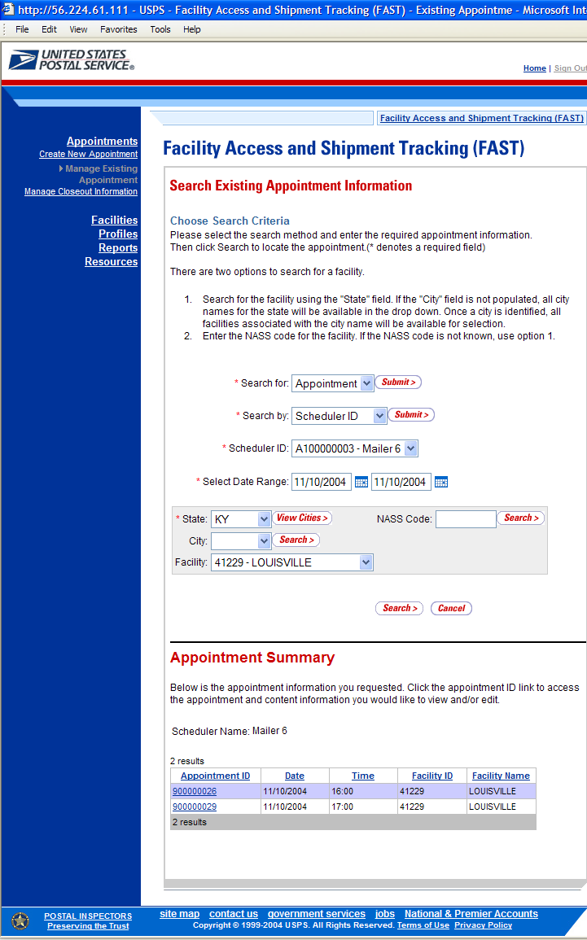

Note:
CLICKING the Appointment ID hyperlink displays the Appointment Management page where a user may view the appointment information; access the Appointment Closeout page to view closeout information and access the Content Information page to view content information.

6.4.2 Appointment Management

After a user searches for an appointment by either the appointment ID or the scheduler ID, they are taken to the Appointment Management page for the selected appointment. From the Appointment Management page, a user has the ability to:

- Edit appointment slot information
- Edit appointment level information
- Edit content level information
- Add additional contents
- View unscheduled arrival information
- View closeout information
- Cancel an appointment

The Appointment Management section details the steps and screens accessed when a user views closeout information, when a user cancels an appointment and briefly describes the previously discussed processes. Editing and adding contents is discussed in more detail in section 6.3.3 – Content Information Management.

All of the above actions may be accessed from the Appointment Management page. The fields and buttons on the page are described below. A snapshot of the page is displayed after the field description.
Appointment ID | The ID associated to the appointment
Status | The current status of the appointment: Open, Closed, Canceled, Unscheduled, No-show, Rejected
Scheduler Name | The name of the company location scheduling the appointment
Scheduler ID | The ID associated to the appointment’s scheduler
Appointment Slot Information table | Displays the current slot information of the appointment, includes Facility Name, Facility ID, Appointment Date, Appointment Time, Appointment Type and the Change button
Facility Name | The name of the facility for the appointment
Facility ID | The ID associated to the appointment’s facility
Appointment Date | The date the appointment is to arrive at the facility
Appointment Time | The time the appointment is to arrive at the facility
Appointment Type | The type of the appointment the facility is expecting
Change button | Displays the Appointment Slot Availability page
Bill of Lading Number | The bill of lading number associated to the appointment
Number of Pallet Positions | The number of pallet positions
Vehicle ID | The ID associated to the vehicle
Shipper ID | The ID associated to the shipper
Comments | Displays any miscellaneous comments regarding the appointment
Submit button | Displays the Appointment Confirmation page, saving any changes to the appointment
Cancel Appointment button | Cancels the appointment in the system
Cancel button | Displays the Search Existing Appointment Information page without saving any changes to the appointment
Closeout button | Displays the Appointment Closeout page
Appointment Contents section | Displays all contents associated to the appointment
Content ID column | Lists the IDs of each content associated to the appointment, which are hyperlinks to the Content Information Management page for the selected content ID
Mail Preparer | The ID associated to the mail preparer of the content
Content Name | Lists the name of the content
Manage Content button | Displays the Content Information Management page

Note:
Depending on if the user is associated to the scheduler of the appointment or is the scheduler, the fields on the Appointment Management page may be editable or read-only, allowing the user to only view the information without modifying it.

The Appointment Management page is displayed on the following page.
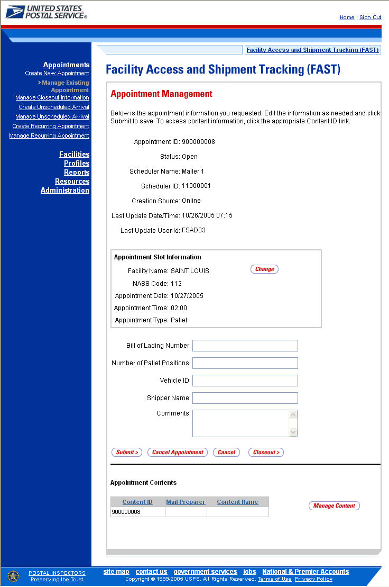
Editing Appointment Slot Information

When editing an appointment’s slot information, a user follows the same process described in section 6.2.1 – Searching for Appointment Slot Availability.

A user begins the process by accessing the Appointment Slot Availability page by CLICKING the Change button on the Appointment Management page. The Appointment Slot Availability page displays, populating the following fields with the existing appointment information:

- Facility
- Scheduler ID
- Appointment Type

If a user needs to change any of the above fields, the appointment is considered as a cancelled appointment when it is scored for scheduler rating (described in section 10.0 – Rating Overview). However, a user still has the ability to change any of those fields and the appointment will retain the same appointment ID.

The user CLICKS the Search button on the Appointment Slot Availability page, displaying the results page for the specified facility, scheduler ID and appointment type. A user may CLICK on a new appointment slot time to select the slot and display the Appointment Management page with the new appointment information. CLICKING the Submit button on the Appointment Management page updates the appointment with the new information and displays the Appointment Confirmation page.

When a user attempts to change the appointment’s slot information, the new slot information is checked against the trip and volume constraints, just like when a new appointment is created. If the new information is not valid due to a constraint violation, the user sees an error which describes the problem and the appointment is not updated with the new slot information.

Editing Appointment Level Information

A user may edit the following appointment level information on the Appointment Management page:

- Bill of Lading Number
- Number of Pallet Positions
- Vehicle ID
- Shipper Name
- Comments regarding the appointment

To edit any of the above fields, a user CLICKS in the desired textbox and replaces the entry with the new information. CLICKING the Submit button on the Appointment Management page then updates the appointment with the new information and displays the Appointment Confirmation page.

Editing Content Level Information

A user may edit an appointment’s content level information by accessing the Content Information Management page from the Appointment Management page.

To access the Content Information Management page, a user CLICKS on the Manage Content button in the Appointment Contents section of the Appointment Management page. After editing the content information, the user CLICKS the Submit button on the Content Information Management page, which updates the content information in the system and displays the Appointment Management page for the appointment.
Adding Additional Contents
A user may add additional contents to the appointment by accessing the Add Content Information page from the Appointment Management page.

To access the Add Content Information page, a user CLICKS the Add Additional Content button in the Appointment Contents section of the Appointment Management page. The user follows the same process as described in section 6.1.3 – Adding Content Information to a New Appointment, to enter in and add content information for the appointment.

Managing content information is detailed in section 6.3.3 – Content Information Management.

Viewing Unscheduled Arrivals

A user may view unscheduled arrival information in FAST by searching for the appointment and accessing the Appointment Management page. As there is no appointment number for an unscheduled arrival, a user may only search for the information by their scheduler ID. The Postal Service requires a shipper to enter the originating scheduler ID on the PS Form 8125 before they may drop ship to a facility. The scheduler may then search for an appointment by the scheduler ID associated to them at any or all facilities. The Status field on the Appointment Management page displays ‘Unscheduled’ to verify the appointment is an unscheduled arrival. The user may not edit this information.

Viewing Closeout Information

A user may view an appointment’s closeout information by accessing the Appointment Closeout page. A user may access the Appointment Closeout page by one of the following two ways.

A user may access the Appointment Closeout page through the Appointment Management page. A user searches for the closed appointment and is directed to the Appointment Management page. A user CLICKS the Closeout button on the Appointment Management page and is taken to the Appointment Closeout page. The fields display as read-only and contain all entered closeout information

A user may also access the Appointment Closeout page through the Appointments Landing page. A user CLICKS the Manage Closeout Information link on the landing page. The user is taken to the Manage Closeout Information search page where the user will search for an appointment in the same fashion as described in the prior section – Appointment Search. This process is described next in more detail.

The fields and buttons on the Manage Closeout Information search page are described below. A snapshot of the page is displayed after the field descriptions.

*Search by: | Drop down box listing the options to search for an appointment by: Appointment ID, Scheduler Id
Submit button | Refreshes the page and displays either an appointment ID input box or a scheduler ID drop-down box with a facility search section to select a scheduler and facility for an existing appointment
Cancel button | Displays the Appointment Management landing page

The Manage Closeout Information search page is displayed below.
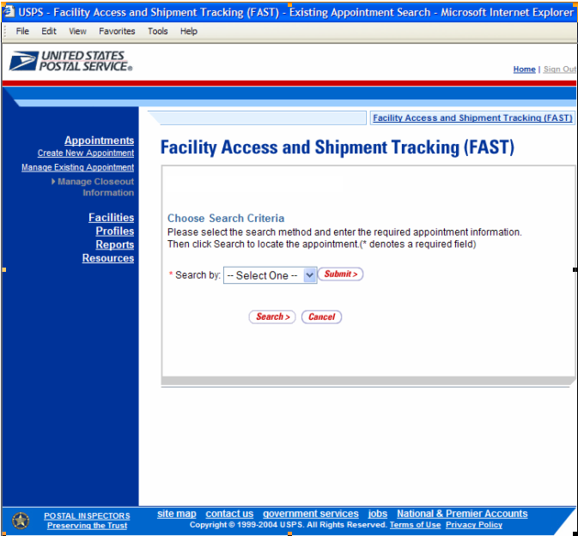

To search for an appointment by the appointment ID, perform the following steps on the Manage Closeout Information search page:

- SELECT Appointment ID in the Search by drop-down box
- CLICK the Submit button

The Manage Closeout Information search page refreshes with an additional field, described below. A snapshot of the page is displayed after the field description.

*Appointment ID | Input box to enter the requested appointment ID

The Manage Closeout Information search page with the additional field is displayed below.
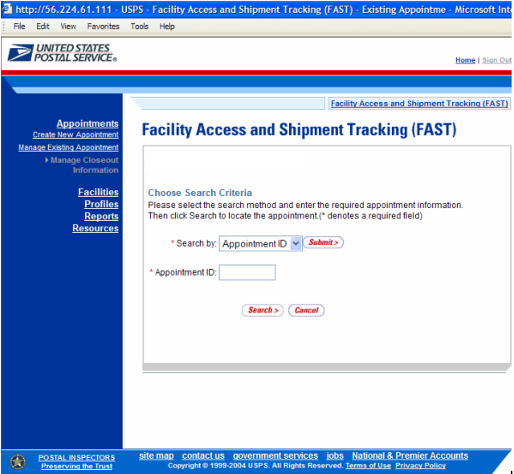

Perform the following final steps on the Manage Closeout Information search page to view the Appointment Closeout page for the specified appointment ID:

- ENTER the appointment ID in the Appointment ID input box
- CLICK the Search button to display the Appointment Closeout page for the appointment ID

The Appointment Closeout page displays and lists key appointment information. All fields display as read-only for both corporate and scheduler users. The fields and buttons on the page are described below. A snapshot of the page is displayed after the field descriptions.

Appointment ID | The ID associated to the appointment
Current Status | The current status of the appointment
Scheduler ID | The ID associated to the appointment’s scheduler
Scheduler Name | The name of the company location scheduling the appointment
USPS Facility Name | The name of the facility for the appointment
USPS Facility ID | The ID associated to the appointment’s facility
Date | The appointment’s scheduled arrival date
Appointment Time | The time the appointment is scheduled to arrive at the facility
*Arrival Date | The actual date the appointment arrived
*Arrival Time | The actual time the appointment arrived
*Unload Start Date | The actual date the appointment began to be unloaded
*Unload Start Time | The actual time the appointment began to be unloaded
*Unload End Date | The actual date the appointment finished being unloaded
*Unload End Time | The actual time the appointment finished being unloaded
Mail Integrity | Drop-down box listing the different mail integrity options of the appointment
Mail Integrity Comments | Additional comments regarding the mail integrity of the appointment
Content Discrepancy section | Lists the fields that record the differences between what content was scheduled and what content actually arrived
Bedloaded sacks percent | Displays the percent of the content type that arrived compared to what was expected
Bedloaded trays percent | Displays the percent of the content type that arrived compared to what was expected
Bedloaded parcels percent | Displays the percent of the content type that arrived compared to what was expected
Bedloaded bundles percent | Displays the percent of the content type that arrived compared to what was expected
Count of pallets containing sacks | Displays the number of pallets that arrived that are either more or less than the number expected
Count of pallets containing trays | Displays the number of pallets that arrived that are either more or less than the number expected
Count of pallets containing parcels | Displays the number of pallets that arrived that are either more or less than the number expected
Count of pallets containing bundles | Displays the number of pallets that arrived that are either more or less than the number expected
Content Discrepancy | Comments box displaying additional remarks regarding content differences
Comments | Additional comments

The Appointment Closeout page is displayed on the following page.

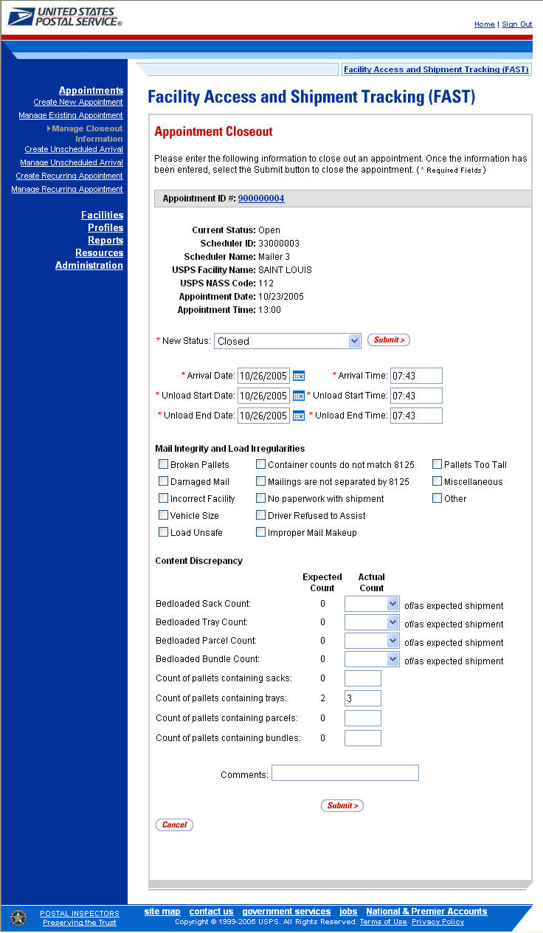

Canceling an Appointment

The following section details the process and pages to cancel an appointment in the FAST application. Canceling an appointment also cancels all contents that are associated to the appointment. Depending on the appointment type and content type, canceling an appointment redistributes the available appointment slot and volume back to the facility and tier they were pulled from when creating the appointment.

A user begins to cancel an appointment from the Appointment Management page by CLICKING the Cancel Appointment button. The Confirm Cancel Appointment page displays, which lists some of the important appointment information.

The fields and buttons on the Confirm Cancel Appointment page are described below. A snapshot of the page is displayed after the field description.

Appointment ID | The ID associated to the appointment
Scheduler Name | The name of the company location scheduling the appointment
Scheduler ID | The ID associated to the appointment’s scheduler
Facility Name | The name of the facility for the appointment
Facility ID | The ID associated to the appointment’s facility
Appointment Date | The date the appointment is to arrive at the facility
Appointment Time | The time the appointment is to arrive at the facility
Content ID | The IDs of each content associated to the appointment
Cancellation Reason | Drop-down indicating the reason for the cancellation of the appointment
Yes button | Finalizes the cancellation of the appointment and displays the Cancel Appointment Confirmation page
No button | Displays the Appointment Management page for the appointment and does not cancel it

The Confirm Cancel Appointment page is displayed on the following page.

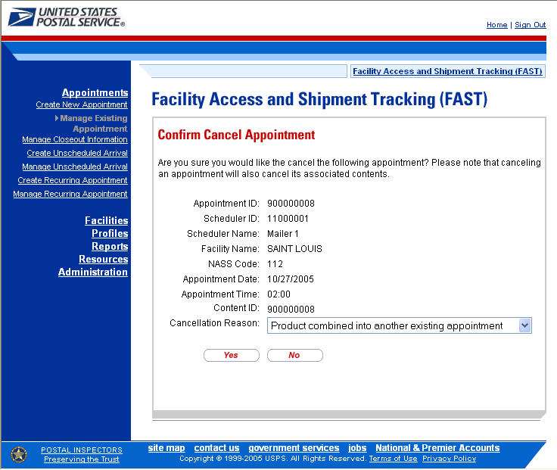

Note:
An appointment cannot be cancelled within one hour of its scheduled appointment time. Also, appointments are automatically no-showed if they have not arrived 24 hours after the scheduled appointment time.

The appointment is not officially cancelled until the user confirms the cancellation from the previous page.

To cancel the appointment and its associated contents, CLICK the Yes button. The Cancel Appointment Confirmation page displays, showing some of the key appointment information. When a user cancels an appointment, a cancellation number is generated for the appointment.

The fields and buttons on the Confirm Cancel Appointment page are described below. A snapshot of the page is displayed after the field description.

Cancellation Number | The confirmation number for the cancelled appointment
Appointment ID | The ID associated to the appointment
Scheduler Name | The name of the company location scheduling the appointment
Scheduler ID | The ID associated to the appointment’s scheduler
Facility Name | The name of the facility for the appointment
Facility ID | The ID associated to the appointment’s facility
Appointment Date | The date the appointment was to arrive at the facility
Appointment Time | The time the appointment was to arrive at the facility
Content ID | The IDs of each content associated to the appointment

Note:
A cancellation number is only generated for the appointment; the associated contents that are also canceled do not receive a cancellation number.

The Cancel Appointment Confirmation page is displayed on the following page.

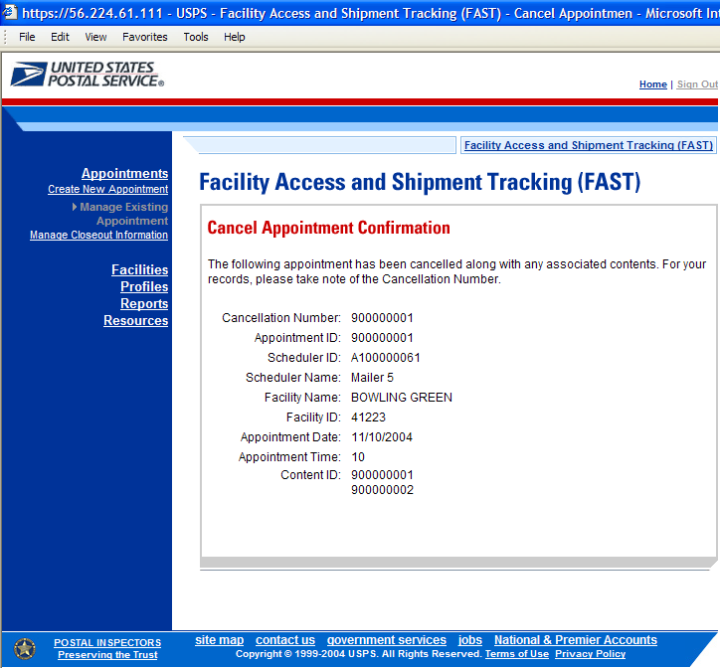

6.4.3 Content Information Management

A user may modify or cancel content level information for an appointment via the Content Information Management page. As described in section 6.4.2 – Appointment Management, a user may access the Content Information Management page by CLICKING on a Content ID hyperlink on the Appointment Management page. This section describes how to:

- Edit Content Level Information
- Cancel a Content from an Appointment

Editing Content Level Information
.
The Content Information Management page looks very similar to the Add Content Information page. The fields and buttons of the Content Information Management page are described below. A snapshot of the page is displayed after the field description.

Update Grid Capacity | Drop-down box allowing the user to change the number of contents associated to the appointment
Change button | Changes the number of contents associated to the appointment
Content ID | The ID associated to the particular content
Cancel Content checkbox | Indicates if the user wants to cancel an individual content from the appointment
Mail-Preparer ID | The ID associated to the mail preparer
Mail Owner ID | The ID associated to the mail owner
Content Name | The name associated to the content
*Mail Class | Drop-down listing the following mail class options for the content: Periodical, Standard, Package Services
News checkbox | Indicates if the content is news
*Mail Shape | Drop-down box listing the following options to specify mail shape: Letter, Flat, Machinable Parcel, Non-Machinable Parcel, Irregular Parcel
Perishable checkbox | Indicates if the content is perishables
Count of Pallets Containing Sacks | The total number of pallets containing sacks in the content
Count of Pallets Containing Trays | The total number of pallets containing trays in the content
Count of Pallets Containing Parcels | The total number of pallets containing parcels in the content
Count of Pallets Containing Bundles | The total number of pallets containing bundles in the content
Bedloaded Sack Count | The total number of sacks in the bedloaded content
Bedloaded Tray Count | The total number of trays in the bedloaded content
Bedloaded Parcel Count | The total number of parcels in the bedloaded content
Bedloaded Bundle Count | The total number of bundles in the bedloaded content
In Home Start date | The starting date and time the appointment is expected to arrive at the final destination
In Home End date | The ending date and time the appointment is expected to arrive at the final destination
Comments | Any additional comments regarding the appointment
Submit button | Updates the content with the new information and displays the Appointment Management page
Clear Contents button | Clears the data in each content of the appointment
Cancel button | Displays the Appointment Management page for the associated appointment

The Content Information Management page is displayed on the following page.

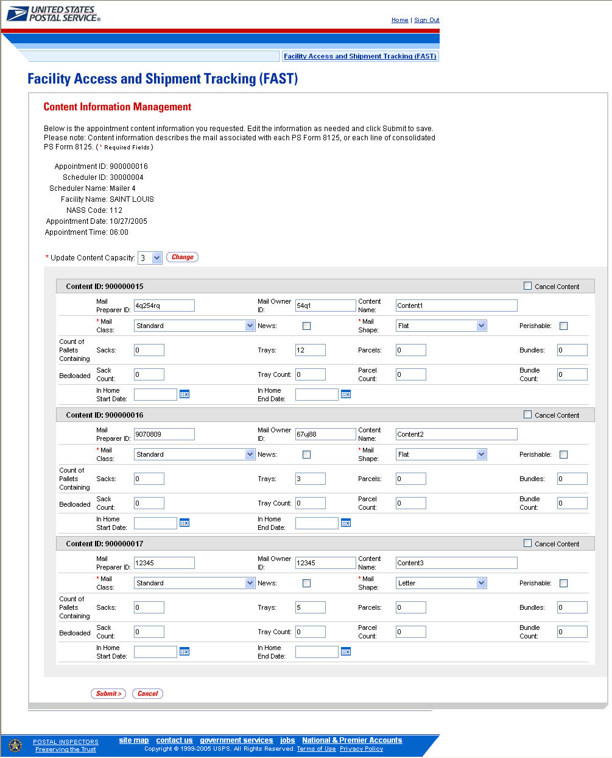

To edit or update the content level information, CLICK in any of the previously described fields and ENTER the new content information. Once all updates or edits have been made, CLICK the Submit button to save the new information to the content.

Note:
Updating content information is subject to the same constraints that are found in creating content information.

Canceling a Content from an Appointment

From the Content Information Management page described and shown previously, a user may cancel the content from the appointment. However, if it is the only content associated to the appointment, it may not be cancelled unless the appointment is cancelled.

To cancel a content from an appointment, CHECK the Cancel Content checkbox on the Content Information Management page. Then CLICK the Submit> button. The Confirm Content Cancellation page is displayed. The Confirm Content Cancellation page allows the user to finalize the cancellation of the content or to return to the Content Information Management page.

The fields and buttons on the Confirm Content Cancellation page are described below. A snapshot of the page is displayed after the field description.

Content ID | The ID associated to the content
Mail Preparer ID | The ID associated with the mail preparer for the content
Mail Owner ID | The ID associated with the mail owner for the content
Yes button | Finalizes the cancellation of the content
No button | Displays the Content Information Management page for the content

The Confirm Appointment Cancellation page is displayed below.

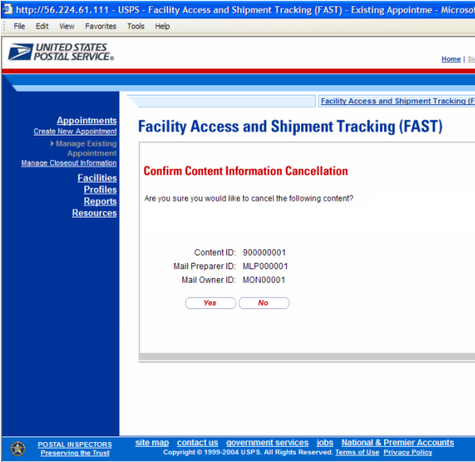

To finalize the cancellation of the content, CLICK the Yes button. The Appointment Confirmation page displays and the content ID is not listed as a content for the Appointment. Please reference section 6.2.4 – Confirming Appointment Creation for the description of the Appointment Confirmation page.

6.4.4 Multi-Stop Management

After a user searches for a multi-stop by either the multi-stop ID or the scheduler ID (described in section 6.3.2 – Creating an Appointment for an Existing Multi-Stop), they are directed to the Multi-Stop Management page for the selected multi-stop. From the Multi-Stop Management page, a user has the ability to:

- Add appointments to a multi-stop
- Remove appointments from a multi-stop
- Edit appointment information
- Cancel a multi-stop

The Multi-Stop Management section gives a brief description of the above processes, but details the steps and screens accessed when a user cancels a multi-stop.

All of the above actions may be accessed from the Multi-Stop Management page. The fields and buttons on the Multi-Stop Management page are described below. A snapshot of the page is displayed after the field description.

Multi-Stop ID | The ID associated to the multi-stop
Appointment ID column | Lists the ID’s of each appointment associated with the multi-stop, with each ID being a hyperlink to the Appointment Management page for the appointment
Remove hyperlink | Removes the appointment from the multi-stop and refreshes the multi-stop page, noting that the appointment has been removed from the multi-stop but still exists as a standalone appointment
Date column | Lists the date of each appointment in the multi-stop
Time column | Lists the time of each appointment in the multi-stop
Facility ID column | Lists the ID of each appointment’s facility in the multi-stop
Facility Name column | Lists the name of the facility for each appointment in the multi-stop
Add Additional Appointment to Multi-Stop button | Displays the Appointment Slot Availability page for the user to create a new appointment
Cancel Multi-Stop button | Displays the Confirm Cancel Multi-Stop page
Cancel button | Displays the Search for Existing Appointment page without saving any changes

The Multi-Stop Management page is displayed below.

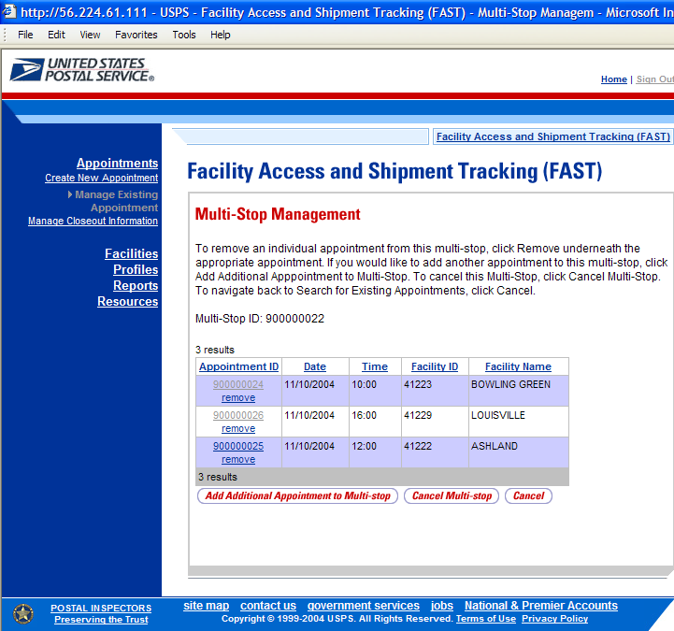

Adding Appointments to a Multi-Stop

A user may add a new appointment to an existing multi-stop from the Multi-Stop Management page by CLICKING the Add Additional Appointment to Multi-Stop button. Please reference section 6.3.2 – Creating an Appointment for an Existing Multi-Stop for the steps and actions needed to add an appointment to a multi-stop.

Removing an Appointment from a Multi-Stop

A user may remove an appointment from a multi-stop directly from the Multi-Stop Management page.

To remove an appointment from a multi-stop, CLICK the Remove hyperlink beneath the appointment to be removed.

The Multi-Stop Management page refreshes and displays the summary table without the selected appointment ID. A note displays stating the appointment has been removed from the multi-stop but the appointment still exists in the system as a standalone appointment.

Editing Appointment Information

A user may edit the appointment information for an appointment within a multi-stop by accessing the Appointment Management page. A user may edit the following appointment level information on the Appointment Management page:

- Bill of Lading Number
- Number of Pallet Positions
- Vehicle ID
- Shipper ID
- Comments regarding the appointment

To edit the appointment information, CLICK the Appointment ID hyperlink for the specific appointment. The Appointment Management page is displayed. CLICK in the desired textbox of the above options and replace the entry with the new information. CLICKING the Submit button on the Appointment Management page then updates the appointment with the new information and displays the Appointment Confirmation page. A user may modify the appointment slot information – as described in section 6.4.2 – Appointment Management.

From the Appointment Management page, a user may also manage the content information for the individual appointment, which is detailed in section 6.4.3 - Content Information Management.

Canceling a Multi-Stop

The following section details the process and pages to cancel a multi-stop through the FAST application. Canceling a multi-stop cancels all appointments associated with the multi-stop and all contents that are associated to each appointment. Depending on the appointment type and content type, canceling an appointment redistributes the available appointment slot back to the tier it was pulled from and redistributes the appointment volume back to the facility it was pulled from when creating the individual appointments.

A user begins to cancel a multi-stop from the Multi-Stop Management page by CLICKING the Cancel Multi-Stop button. The Confirm Cancel Multi-Stop page displays. The page displays the Multi-Stop ID and all associated appointment IDs.

The fields and buttons on the Confirm Cancel Multi-Stop page are described below. A snapshot of the page is displayed after the field description.

Multi-Stop ID | The ID associated to the multi-stop
Associated Appointments: | Lists each appointment in the multi-stop and their associated information, contains the below fields for each appointment in the multi-stop.
Appointment ID | The ID associated to the appointment
Scheduler Name | The name of the company location scheduling the appointment
Scheduler ID | The ID associated to the appointment’s scheduler
Facility Name | The name of the facility
Facility ID | The ID associated to the appointment’s facility
Appointment Date | The scheduled arrival date of the appointment
Appointment Time | The scheduled arrival time of the appointment
Content ID | The ID(s) of each content associated to the appointment
Yes button | Cancels the multi-stop and all associated appointments and displays the Cancel Multi-Stop Confirmation page
No button | Does not cancel the multi-stop and displays the Multi-Stop Management page

The Confirm Multi-Stop Cancellation page is displayed on the following page.
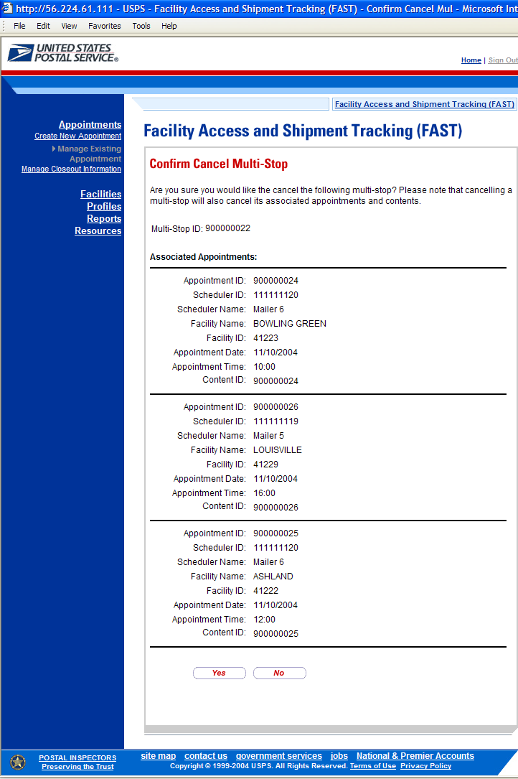
The multi-stop is not officially cancelled until the user confirms the cancellation from the above page.

To cancel the multi-stop and its associated appointments, CLICK the Yes button. The Cancel Multi-Stop Confirmation page displays. A cancellation number is generated for each appointment in the multi-stop.

The fields and buttons on the Cancel Multi-Stop Confirmation page are described below. A snapshot of the page is displayed after the field description.

Multi-Stop ID | The ID associated to the multi-stop
Associated Appointments sections | Displays the following fields for each appointment within the multi-stop
Cancellation Number | The confirmation number for the cancelled appointment
Appointment ID | The ID associated to the appointment
Scheduler Name | The name of the company location scheduling the appointment
Scheduler ID | The ID associated to the appointment’s scheduler
Facility Name | The name of the facility for the appointment
Facility ID | The ID associated to the appointment’s facility
Appointment Date | The scheduled arrival date of the appointment
Appointment Time | The scheduled arrival time of the appointment
Content ID | The ID(s) of each content associated to the appointment

The Cancel Multi-Stop Confirmation page looks identical to the Confirm Multi-Stop Cancellation page with the additional field(s) of the Cancellation Number.

6.4.5 Web Services Appointment Management

Appointments may be created via Web Services as well as through the online FAST application. A Web Services appointment is treated technically as an online appointment and is subject to the same restrictions and constraints as an online appointment. A user may perform many of the same actions to a Web Services appointment, such as editing appointment information and canceling the appointment. One restriction regarding Web Services appointments is that an online user may not modify content level information. They are restricted to modifying only appointment level information for the Web Services appointment. A user may only modify Web Services appointments that are associated to the user.

Please reference the section’s 11.3 – PostalOne! User Guide and section 11.4 – PostalOne! Technical Guide for more detailed descriptions of actions related specifically to PostalOne! and Web Services that occur outside of the online FAST application.

A user may modify the appointment level information on the Appointment Management page (see section 6.3.2 – Appointment Management for the steps to edit appointment information). The following lists the information a user may change in a Web Services appointment.

- Scheduler – restricted to schedulers associated to the user
- Facility
- Appointment Date/Time
- Appointment Type
- Bill of Lading Number
- Number of Pallet Position Counts
- Vehicle ID
- Shipper ID
- Comments

Web Services appointments are subject to normal trip and volume availability checks when updates are made to the appointments. Also, 100% Periodicals and perishable indicators may not be changed on appointment updates.

A user may perform the following actions to a Web Services appointment:

- Add an appointment to a multi-stop (described in section 6.3.2 – Creating an Appointment for an Existing Multi-Stop)
- Cancel an appointment (described in section 6.4.2 – Appointment Management)
Note:
All actions performed on a Web Services appointment are subject to the same timing, trip and volume constraints as an online appointment.

6.5 Recurring Appointments

A recurring appointment is classified as an appointment that happens on a consistent frequency, on the same day or days, at the same time of day, with usually the same contents and using the same form and size of transportation. The appointment may occur every week through the entire time period or on selected weeks in the time period. The Recurring Appointments section details the processes for requesting a recurring appointment and managing recurring appointment instances in FAST.

The process to request a recurring appointment requires postal customers to download the PS Form 6241 (Recurring Appointment Request form). The scheduler enters the appointment and content information on the PS Form 6241 and sends it to the selected USPS facility for approval. The appointment and content information is verified against the facility’s availability by the USPS personnel to ensure the facility may process the appointment on the required date(s) and time. The USPS user enters the recurring appointment information into FAST to create the appointment in the system. The USPS user notifies the given scheduler that the request has been approved by sending the appointment confirmation information to the customer.

All FAST users, USPS and customer users, are able to search for a single appointment instance of the recurring appointment series. They may edit the appointment and content information for the appointment instance. However, a new recurring appointment request must be submitted if the USPS customer wants to change the appointment or content information for an entire recurring appointment series. The new request must go through the same approval process as the original request.

The Recurring Appointments section describes how a user may request a recurring appointment, the PS Form 6241 and how to manage a single instance of a recurring appointment. The section includes:

6.5.1 Requesting a Recurring Appointment
- PS Form 6241
6.5.2 Managing a Recurring Appointment Instance

6.5.1 Requesting a Recurring Appointment

A user requests a recurring appointment by first downloading the PS Form 6241 in FAST. The user may download the form in the Resources area of the FAST application. A user CLICKS on the Resources hyperlink or associated Go> button from the FAST Main Menu page to access the Resources Landing page. The user CLICKS on the Reference Documents hyperlink or associated Go> button to access the page where the form may be downloaded. The user downloads the form and prints it out (Please reference module 9.0 – Resources for a complete description of the downloading process). The user must fill out the hard-copy form to mail to the specific facility for approval.

The PS Form 6241 enables a USPS customer to request an appointment that will occur on a pre-defined scheduled over a date range. The PS Form 6241 will contain options for the scheduler to select which week or weeks (first, second, third, fourth, last) the appointment will occur within the time period. To schedule the appointment for every week, each week option must be selected. FAST contains the same week options for the USPS user to select when creating the appointment online. The form is divided into three main sections for the user to complete:

- Requestor/Mail Owner Information
- Transportation Information
- Mailing Information

Requestor/Mail Owner Information
The Requestor/Mail Owner Information section of the form holds the requestor’s name, mail owner’s name, mail owner contact information and the beginning date and ending date of the desired date range of the recurring appointment request. The PS Form 6241 is displayed next with this section highlighted.
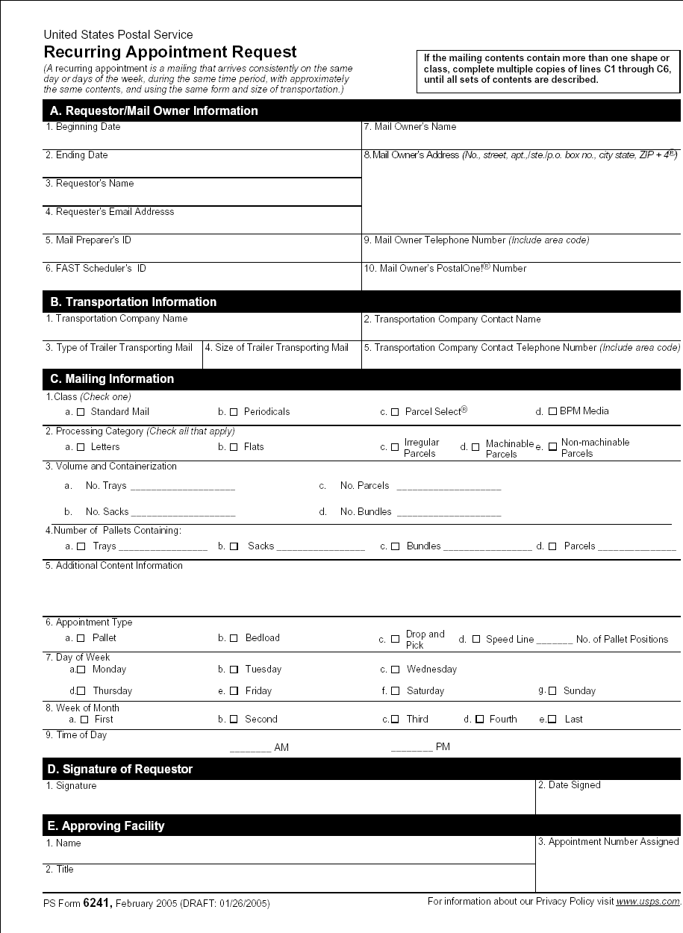

Transportation Information section

The transportation information section of the form holds all information related to the type of transportation the recurring appointment requires. It includes the transporting company name (referred to as Shipper Name in FAST), transportation company contact information and trailer-specific information. The PS Form 6241 is displayed below with this section highlighted.
Mailing Information section

The user enters all content level information in the mailing information section of the form. The content level information consists of mail class, mail shape, mail volume, bedload or pallet appointment type, the day(s) the appointment will occur on and time of day of which the appointment will occur. If a recurring appointment has more than one set of content information, the USPS customer must fill out sections 1 – 5 of the mailing information section on additional PS Form 6241s and attach these additional forms to the initial complete form. The PS Form 6241 is displayed below with this section highlighted.
After the recurring appointment request has been approved at the given facility, the USPS user creates the appointment in FAST and sends the appointment confirmation page to the scheduler as notification. The appointment confirmation page displays the key appointment information such as the destination facility, date range, appointment time, appointment frequency and scheduler information.

The confirmation page also displays a sequence number. This is the Recurring Sequence Number that is associated to every appointment instance in the recurring appointment series. The Recurring Sequence Number is used as the appointment ID on the PS Form 8125 for each individual appointment instance. The facility may then enter the unload information for the drop shipment based off of the Recurring Sequence Number when each appointment instance arrives. An example of an appointment confirmation page is displayed below.

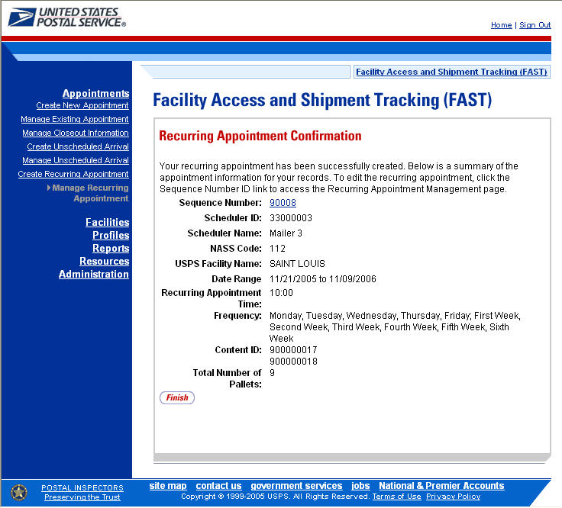

Note:
The Recurring Sequence Number is also used when a corporate or scheduler user manages a single recurring appointment instance (described in the next section).

6.5.2 Managing a Recurring Appointment

A user may update and cancel a single appointment instance of a recurring appointment. However, a scheduler must submit a new recurring appointment request if the appointment or content information for an entire recurring appointment series needs to be changed.

A user may manage a recurring appointment instance through the Appointments area in FAST. A user follows the same process as described in section 6.4 – Appointment Management to update appointment and content information, add additional contents to an appointment instance, cancel a content from an appointment instance and cancel the appointment instance.

In addition to the Recurring Sequence Number, which is used as the appointment number on the PS Form 8125, a unique ID number is created for each appointment instance in the recurring appointment series. This unique ID number will be used as the appointment ID when searching for the single appointment instance of the recurring appointment series. A user searches for the appointment instance using the unique ID number through the search for an appointment by the appointment ID process described in section 6.3 – Appointment Management. The unique ID number is derived from the Recurring Sequence Number associated to the recurring appointment series.

The format of the unique ID number is defined as:

Recurring Sequence Number + R + Date (mmdd)

The unique ID number distinguishes an appointment instance on one day from an instance on another day in the recurring series.

For example, a user needs to update information for an appointment that is scheduled to arrive on November 20th. The Recurring Sequence Number for the recurring appointment series is 10302. The unique ID number for that appointment instance would be 10302R1120, based on the defined format above. However, if the user needed to update the information for the appointment scheduled for November 25th in the same recurring series, the user would search for an appointment by the appointment ID of 10302R1125.

Please reference section 6.4 – Appointment Management for the steps and screens accessed to manage single appointments. The multi-stop management section is not applicable because recurring appointments are not included in multi-stop trips.

This page has been intentionally left blank.
7.0 Corporate Profile
Corporate Profile information refers to the Corporation’s contact information shown in FAST. This information is entered in PostalOne! upon registering as a FAST user. PostalOne! then passes along the entered information to FAST. The Corporate Profile page displays the Corporation’s Name, ID, Address, Contact Name, Phone Number, Fax Number, Email, and a hyperlinked listing of all schedulers associated with the Corporation. The hyperlink drills down to the Scheduler Profile page which displays all information regarding the specified scheduler.

The Profiles section includes:

7.1 Corporate Profile – Describes how a user may view the Corporate Profile information.

7.2 Scheduler Profile – Describes how a user may view the Scheduler Profile information for the selected Corporation.

The user may access the Corporate Profile and Scheduler Profile from Profiles link on the FAST Main Menu page. The user CLICKS on the Profiles link, or associated Go> button to display the Profiles Landing page (described in module 4.0 - Landing pages). The user may then CLICK the Corporate Profile link, or associated Go> button to display the Corporate Profile Selection page.

7.1 Corporate Profile

Corporate profile information consists of the contact information for a selected corporate ID. The user may view Corporation contact information for associated corporate IDs. Maintenance of the data occurs in PostalOne!.

The Corporate Profile section describes the process for viewing the Corporation’s information.

The user begins the process from the Profiles Landing page. The user CLICKS the Corporate Profile link, or associated Go> button to display the Corporate Profile Selection page. The user may select a Corporation from the Corporate ID drop-down box, on the Corporate Profile Selection page. Only Corporations associated to the user will be displayed in the drop-down box.

Note:
Users may only view the Corporate/Scheduler Profile for associated corporations and schedulers. If the user is only associated with one corporation the user will be directed to the Corporate Profile page without selecting a Corporation from the Corporate ID drop-down box.

The fields and buttons on the Corporate Profile Selection page are described below. A snapshot of the page is displayed after the field description.

* Corporate ID | Drop-down box containing Corporate Name and ID options
Search button | Retrieves the Corporate Profile associated with that Corporate ID and displays the Corporate Profile page

The Corporate Profile Selection page is displayed below.

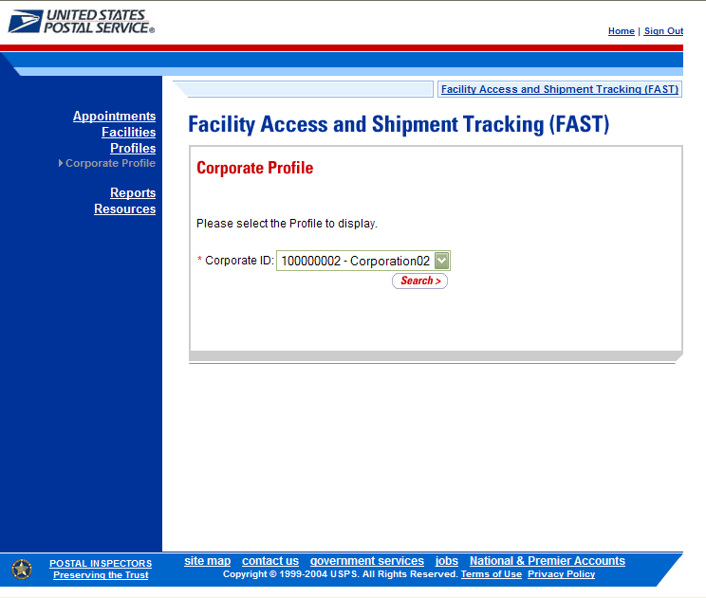

From the Corporate Profile Selection page, the user may view the contact information for a Corporate ID by performing the following steps:

- SELECT a corporation from the Corporate ID drop-down box.
- CLICK the Search button to view the Corporate Profile page.

The Corporate Profile page opens displaying the contact information for the Corporation. The fields and buttons on the Corporate Profile page are described below. A snapshot of the page is displayed after the field description.

Corporate Name | The full name of the Corporation
Corporate ID | The Corporate ID of the Corporation defined by PostalOne!
Address | The street address of the Corporation
Address 2 | The street address of the Corporation
City | The city where the Corporation resides
State | The state code where the Corporation resides
ZIP + 4 | The 9 digit ZIP Code where the Corporation resides
Contact Name | Name of the primary contact person of the Corporation
Contact Title | Title of the primary contact person of the Corporation
Contact Phone Number | Phone number for the contact person at the Corporation
Contact FAX Number | FAX number for the contact person at the Corporation
Contact Email Address | Email address of the contact person at the Corporation
Access Scheduler Profile | The associated Scheduler ID for the Corporation. Each scheduler ID is a hyperlink to the Scheduler Profile page, where the user may view the schedulers contact information.

The Corporate Profile page is displayed below.

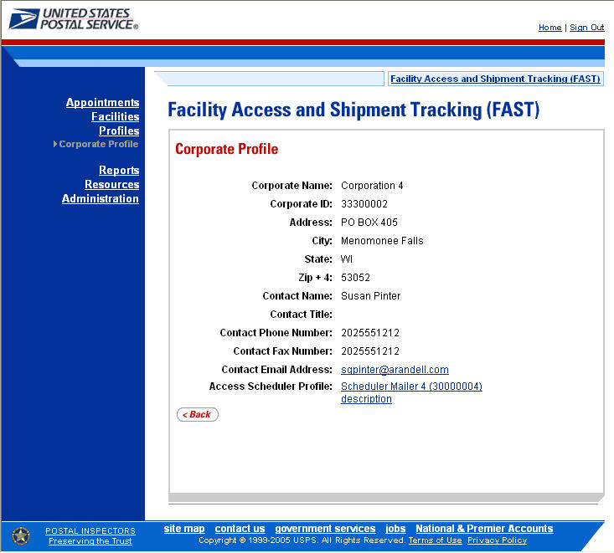

Note:
All fields on the Corporate Profile page are read-only regardless of the user’s security privileges.

Maintenance of the data occurs in PostalOne!.

7.2 Scheduler Profile

Scheduler profile information consists of contact information for a selected Scheduler ID. The user may view contact information for associated schedulers.

From the Corporate Profile page, the user may view the contact information for a Scheduler by CLICKING the Scheduler ID hyperlink.

The Scheduler Profile page opens displaying the contact information for the Scheduler. The fields and buttons on the Scheduler Profile page are described below. A snapshot of the page is displayed after the field description.

Corporate Name | The full name of the Corporation
Corporate ID | The Corporate ID of the Corporation defined by PostalOne!
Scheduler Name | The full name of the Scheduler
Scheduler ID | The Scheduler ID of the Scheduler
Address | The street address of the Scheduler
Address 2 | The street address of the Scheduler
City | The city where the Scheduler resides
State | The state code where the Scheduler resides
ZIP + 4 | The 9 digit ZIP Code where the Scheduler resides
Contact Name | Name of the primary contact person of the Scheduler
Contact Title | Title of the primary contact person of the Scheduler
Contact Phone Number | Phone number for the contact person at the Scheduler
Contact FAX Number | FAX number for the contact person at the Scheduler
Contact Email Address | Email address of the contact person at the Scheduler
Comments | Comments of the Corporate/Scheduler ID

The Scheduler Profile page is displayed below.

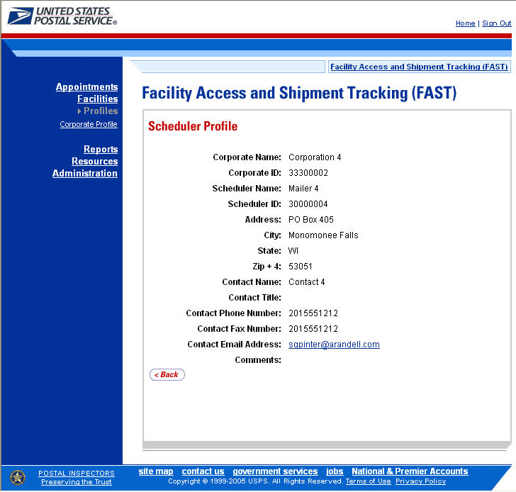

Note:
The user may access the Scheduler Profile from other functional areas in FAST. This includes accessing from the Scheduler Performance Report and Appointment Calendar Report.

This page has been intentionally left blank.

8.0 Reports
Users have restricted access to all reports listed below. The reports will only display results that directly relate to the user.

8.1 Scheduler Report – Displays detailed appointment information for a specific scheduler at selected USPS facilities.

8.2 Scheduler Performance Report – Displays the counts and percentages of No Shows, Cancellations more than 24 hours in advance of the appointment, Cancellations within 24 hours of the appointment, Late Arrivals, and Unscheduled shipments.

8.3 Appointment Calendar – Displays the number and types of appointments for a designated date range and specified facility.

8.4 Appointment Status – Displays appointments for a designated scheduler by the specific appointment status type and time period.

8.5 Holiday and Contingency Constraint Report – Displays which facilities have holiday constraints defined and the impacted facilities.

8.6 Corporate Rating Report – Displays the breakdown of the scheduler rating score.

  - Appointment Rating Analysis Report – Displays the breakdown of appointments for a given scheduler and date range.

  - Closeout Data Report – Displays closeout information and appointment status for entered appointment IDs. All information will be read-only.

The user may access the processes associated with the above sections from the FAST Main Menu page by CLICKING the Reports link or the associated Go> button. The Reports link takes the user to the Reports Landing page (described in module 4.0 – Landing pages).

A user may view reports for any facility but will only view appointment information contained within the report that is directly associated to the user (User access is described in section 11.1 – Security).

8.1 Scheduler Report

The Scheduler Report displays detailed appointment information for a specific scheduler and selected facility. The user has the ability to perform the following functions from the Scheduler Report page:

- View Scheduler Report
- Access the Appointment Management page

8.1.1 View Scheduler Report

The user begins the process from the Reports Landing page. The user CLICKS on the Scheduler Report link, or associated Go> button to display the Scheduler Report Selection page. The user must select a Scheduler ID, a facility, and a date range on the selection page.

The fields and buttons on the Scheduler Report Selection page are described below. A snapshot of the page is displayed after the field description.

* Scheduler ID | Drop-down box listing the Scheduler IDs
* Select Date Range | Selects the date range for the scheduler performance report. The start date is restricted to 30 days prior to the current date. The end date may not be greater than 14 days in the future.
* Report View | Drop-down box listing the report view to choose from: By Facility
Submit button | Triggers the application to show the Facility ID and search fields
State | Drop-down box listing all state options
View Cities button | Retrieves all cities within the selected state that have an active facility and populates the City drop-down box
City | Drop-down box listing all cities within the selected state that have a facility
Search button | Retrieves the facilities located in the selected state/city and populates the Facility drop-down
NASS Code | Textbox to input the NASS Code of the requested facility
Search | Retrieves the facilities associated with the NASS Code and populates the Facility drop-down
* Facility | Drop-down box listing all facilities associated with the selected state/city or NASS Code search criteria
Cancel button | Displays the Reports Landing page
Create button | Retrieves the appointments for the entered criteria and displays the Scheduler Report

The Scheduler Report Selection page is displayed below.

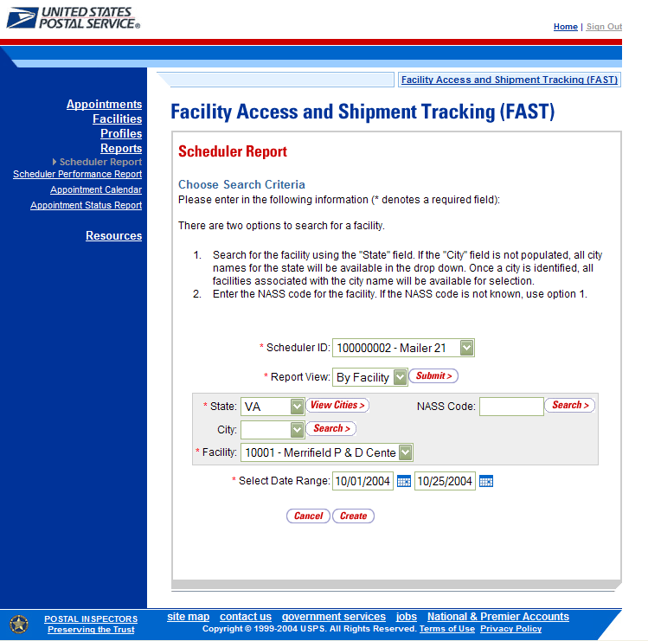

From the Scheduler Report Selection page, the user may view the scheduler information for the specified date range by performing the following steps:

- SELECT a Scheduler ID from the Scheduler ID drop-down box
- SELECT ‘By Facility’ from the Report View drop-down box
- CLICK the Submit button
- SELECT a state from the State drop-down box
- CLICK the View Cities button
- SELECT a facility from Facility drop-down box
- ENTER a Date Range
- CLICK the Create button

Note:

The Start Date may not exceed 30 days prior to the current date.
The End Date value may not exceed 14 days in the future.

The fields and buttons on the Scheduler Report page are described below. A snapshot of the page is displayed after the field description.

Appointment ID | The ID associated appointment. Each appointment ID is a hyperlink to the Appointment Management page, where the user may access more information about the appointment.
Facility | The name of the facility
Status | The status for a given appointment
Schedule Date/Time | The scheduled date and time
Arrival Date/Time | The actual arrival date and time
Unload End Date/Time | The unload end date and time
Vehicle ID | The ID of the transporting vehicle
Appt. Type | The type of appointment
Shipper Name | The name of the transporting company
Mail Integrity | The mail integrity for a given appointment

The Scheduler Report page is displayed below.

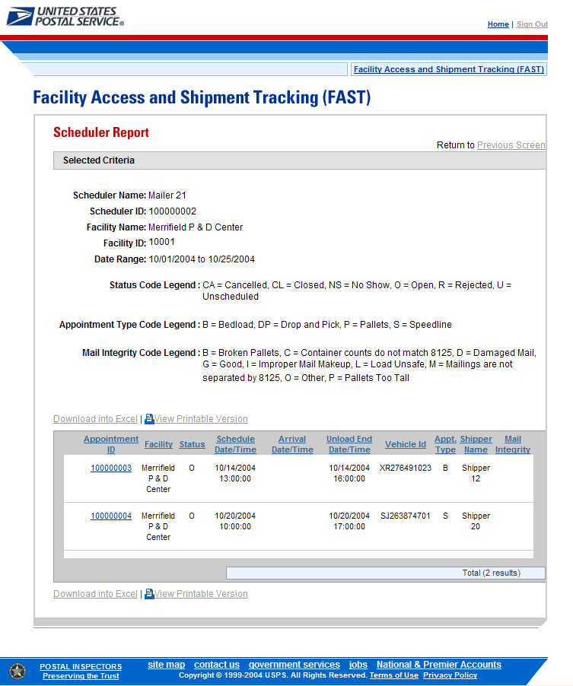

A user may view the Appointment Management page (described in module 6.1 – Creating a New Appointment) for the selected appointment by CLICKING the Appointment ID hyperlink.

8.2 Scheduler Performance Report

The Scheduler Performance Report displays the number and percentage of No Shows, Cancellations more than 24 hours before the scheduled appointment time, Cancellations within 24 hours of the scheduled appointment time, Late Arrivals, and Unscheduled shipments. The user has the ability to perform the following functions from the Scheduler Performance Report page:

- View Scheduler Performance Report
- Access the Scheduler Profile page

8.2.1 View Scheduler Performance Report

The user begins the process from the Reports Landing page. The user CLICKS on the Scheduler Performance Report link, or associated Go> button to display the Scheduler Performance Report Selection page. The user must select a scheduler and date range on the selection page.

The fields and buttons on the Scheduler Performance Report Selection page are described below. A snapshot of the page is displayed after the field description.

* Select Date Range | Selects the date range to search for the scheduler performance report. The start date is restricted to 45 days prior to the current date. The end date may not be greater than the current date.
* Report View | Drop-down box listing the report view to choose from: By Scheduler
Submit button | Triggers the application to show the Scheduler ID drop-down box
* Scheduler ID | Drop-down box listing all Scheduler ID options
Cancel button | Displays the Reports Landing page
Create button | Retrieves the scheduler performance information for the entered criteria and displays the Scheduler Performance Report

The Scheduler Performance Report Selection page is displayed below.

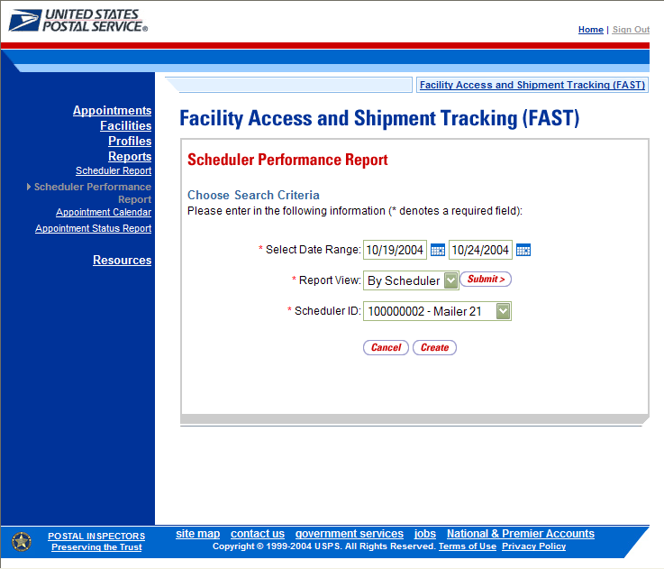

From the Scheduler Performance Report Selection page, the user may view the performance information for the specified date range by performing the following steps:

To Search for a Scheduler by Scheduler ID:
- ENTER a Date Range
- SELECT ‘By Scheduler’ from the Report View drop-down box
- CLICK the Submit button
- SELECT a scheduler from the Scheduler ID drop-down box
- CLICK the Create button
This will return all drop shipments for the specified scheduler.
Note:

The Start Date may not exceed 45 days prior to the current date.
The End Date value may not exceed the current date.

The Scheduler Performance Report page opens, displaying the performance information for the selected criteria. The fields and buttons on the page are described below. A snapshot of the page is displayed after the field description.

Scheduler ID | Displays the ID of the Scheduler. Each ID is a hyperlink to the Scheduler Profile page, where the user may view the Schedulers information.
Scheduler Name | The Scheduler Name associated with the selected criteria
Facility Code | The Facility NASS Code associated with the selected criteria
Facility Name | The Facility Name associated with the selected criteria
Total Schd. Appts. | The total scheduled appointments for the associated scheduler
No Shows – Count | The number of appointments that were no shows
No Shows - % | The percentage of appointments that were no shows
Cancel ≤ 24hrs – Count | The number of appointments that were cancelled within 24 hours of the scheduled appointment time
Cancel ≤ 24hrs - % | The percentage of appointments that were cancelled within 24 hours of the scheduled appointment time
Cancel > 24hrs – Count | The number of appointments that were cancelled, with at least 24 hours notice
Cancel > 24hrs - % | The percentage of appointments that were cancelled, with at least 24 hours notice
Late Arrivals – Count | The number of appointments that arrived 31 minutes up to 2.01 hours after the scheduled time
Late Arrivals - % | The percentage of appointments that arrived 31 minutes up to 2.01 hours after the scheduled time
Unscheduled Count | The number of shipments that arrived without an appointment

The Scheduler Performance Report page is displayed below.

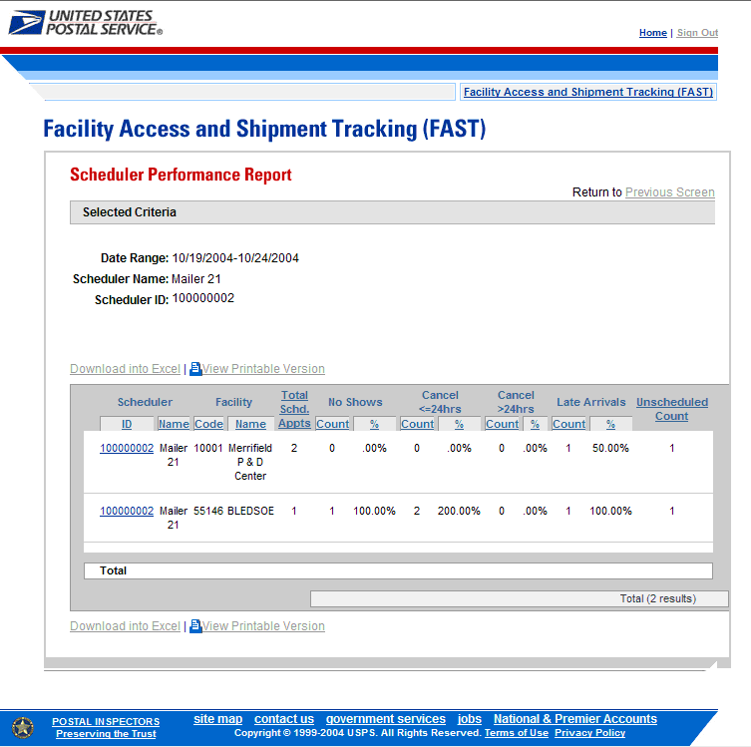

A user may view Scheduler Profile page (described in module 7.2 – Scheduler Profile) for the selected scheduler by CLICKING the Scheduler ID hyperlink.

8.3 Appointment Calendar

The Appointment Calendar displays the number and types of appointments for a designated date range and specified facility. The Appointment Calendar section describes the processes for viewing the Appointment Calendar.

The Appointment Calendar is accessible from two points in FAST; from the Login page (pre-login) and from the Reports Landing page (post-login). The user begins the process from the Reports Landing page. The user CLICKS on the Appointment Calendar link, or associated Go> button to display the Appointment Calendar Selection page. The user must select a specific facility and date range on the selection page.

The fields and buttons on the Appointment Calendar Selection page are described below. A snapshot of the page is displayed after the field description.

* State | Drop-down box listing all state options
View Cities button | Retrieves all cities within the selected state that have an active facility and populates the City drop-down box
City | Drop-down box listing the cities within the selected state that have a facility
Search button | Retrieves the facilities located in the selected state/city and populates the Facility drop-down box
NASS Code | Textbox to input the NASS Code of the requested facility
Search button | Retrieves the facilities associated with the NASS Code and populates the Facility drop-down box
* Facility | Drop-down box listing all facilities associated with the selected state/city or NASS Code search criteria
* Select Date Range | Selects the date range to search for the specified facilities appointments. The start date is restricted to 30 days prior to the current date. The end date must be between the current date and 14 days in the future.
Cancel button | Displays the Reports Landing page
Create button | Retrieves the appointment count data for the entered criteria and displays the Appointment Calendar

The Appointment Calendar Selection page is displayed below.

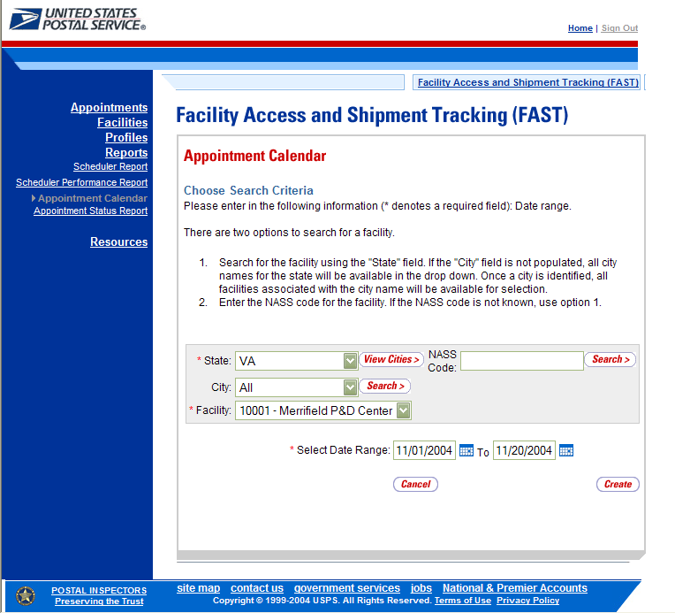

From the Appointment Calendar Selection page, the user may view the appointment information for the specified date range by performing the following steps:

- SEARCH for a specific facility by one of the following two ways:
To Search for a Facility by State and City:
- SELECT a State from the drop-down box
- CLICK the View Cities button
- SELECT a city from the City drop-down box
- CLICK the Search button

To Search for a Facility by NASS Code:
- ENTER the NASS Code in the text box
- CLICK the Search button
- ENTER the Date Range
- CLICK the Create button

Note:
The Start Date may not exceed 30 days prior to the current date.
The End Date value must be between today’s date and the maximum threshold for appointment creation (14 days in the future).

The Appointment Calendar page opens, displaying the appointment count data for the specified facility and date range. The fields and buttons on the page are described below. A snapshot of the page is displayed after the field description.

Date | Displays the selected date of the appointments
Total Scheduled Appointments | The total scheduled appointments on a given date
Pallets- Total | The total count of pallets scheduled
Pallets- Parcels | The total count of pallets containing parcels scheduled
Pallets- Sacks | The total count of pallets containing sacks scheduled
Pallets- Trays | The total count of pallets containing trays scheduled
Pallets- Bundles | The total count of pallets containing bundles scheduled
Cross Dock - Total | The total count of cross docked mail scheduled
Cross Dock- Parcels | The total count of cross docked mail containing parcels scheduled
Cross Dock - Sacks | The total count of cross docked mail containing sacks scheduled
Cross Dock - Trays | The total count of cross docked mail containing trays scheduled
Cross Dock - Bundles | The total count of cross docked mail containing bundles scheduled
Bedloaded- Total | The total count of bedloads scheduled
Bedloaded- Parcels | The total count of bedloads containing parcels scheduled
Bedloaded- Sacks | The total count of bedloads containing sacks scheduled
Bedloaded- Trays | The total count of bedloads containing trays scheduled
Bedloaded - Bundles | The total count of bedloads containing bundles scheduled

The Appointment Calendar Report page is displayed below.

To view the Appointment Calendar – Daily View, for the selected facility and date, the user CLICKS the Date hyperlink.

The Appointment Calendar – Daily View page opens, displaying the appointment count data for the specified facility and date. The fields and buttons on the Appointment Calendar –Daily View page are described below. A snapshot of the page is displayed after the field description.

Hour | Displays the hour of the appointments. Each hour is a hyperlink to the Appointment Calendar – Hourly View page, where the user may view the appointment data for the selected hour.
Total Schd. Appts. | The total scheduled appointments on a given hour
Pallets- Total | The total count of pallets scheduled on a given hour
Pallets- Parcels | The total count of pallets containing parcels
Pallets- Sacks | The total count of pallets containing sacks
Pallets- Trays | The total count of pallets containing trays
Pallets- Bundles | The total count of pallets containing bundles
Cross Dock - Total | The total count of cross docked mail scheduled
Cross Dock- Parcels | The total count of cross docked mail containing parcels scheduled
Cross Dock - Sacks | The total count of cross docked mail containing sacks scheduled
Cross Dock - Trays | The total count of cross docked mail containing trays scheduled
Cross Dock - Bundles | The total count of cross docked mail containing bundles scheduled
Bedloaded- Total | The total count of bedloads scheduled on a given hour
Bedloaded- Parcels | The total count of bedloads containing parcels
Bedloaded- Sacks | The total count of bedloads containing sacks
Bedloaded- Trays | The total count of bedloads containing trays
Bedloaded - Bundles | The total count of bedloads containing bundles

The Appointment Calendar - Daily Report page is displayed on the following page.
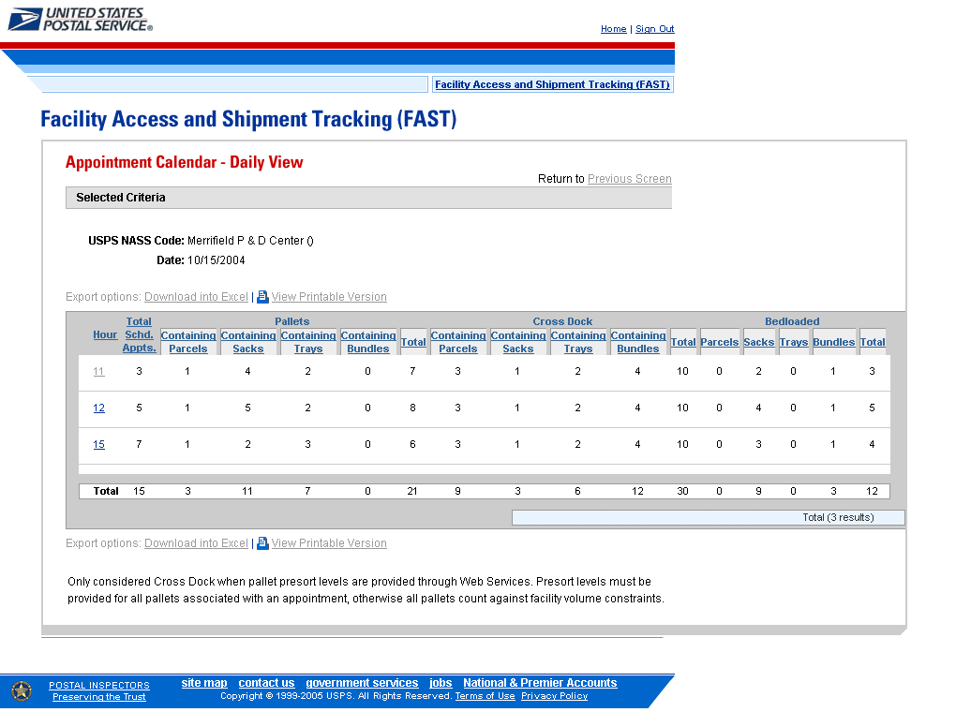

8.4 Appointment Status Report

The Appointment Status Report displays appointments for a designated scheduler by the specific appointment status type and time period. The user may elect to view a specific appointment’s status by entering a specific Appointment ID. To view a group of appointments, the user may select at least one of the appointment status options which include: Open, Closed, Cancelled, No-Show, and Unscheduled Arrival. The user must then search by Scheduler ID. The user has the ability to perform the following functions from the Appointment Status Report page:

- View Appointment Status Report
- Access the Appointment Management page

8.4.1 View Appointment Status Report

The user begins the process from the Reports Landing page. The user CLICKS on the Appointment Status Report link, or associated Go> button to display the Appointment Status Report Selection page. The user must enter an appointment ID or select an appointment status, date range, and scheduler.

The fields and buttons on the Appointment Status Report Selection page are described below. A snapshot of the page is displayed after the field description.

* Appointment ID | Textbox to input the Appointment ID
* Appointment Status | Allows the user to select which Appointment Statuses to search for in the checkboxes, including: Open, Cancelled, Closed, Unscheduled Arrival, No Show, Rejected
* Date Range | Selects the date range to search for the specified appointments. The start date is restricted to 30 days prior to the current date. The end date must no greater than14 days in the future.
Report View | Drop-down box listing the report view to choose from: By Scheduler
Submit button | A button that triggers the application to show the Scheduler ID drop-down
* Scheduler ID | Drop-down box listing the Schedulers IDs
Cancel button | Displays the Reports Landing page
Create button | Retrieves the appointment status data for the entered criteria and displays the Appointment Status Report

The Appointment Status Report Selection page is displayed below.

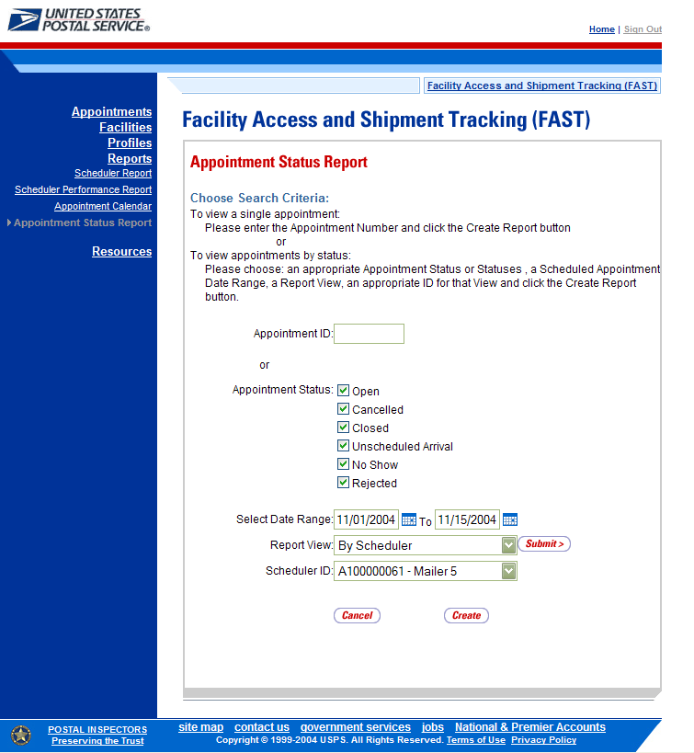

From the Appointment Status Report Selection page, the user may view the appointment information by one of two ways:

To Search for a specific Appointment ID:
- ENTER an Appointment ID in the text box
- CLICK the Create button

To Search for an Appointment by Scheduler ID:
- CLICK one/some/all Appointment Status checkboxes
- ENTER the Date Range
- SELECT ‘By Scheduler’ from the Report View drop-down box
- CLICK the Submit button
- SELECT the scheduler ID in the Scheduler ID drop-down
- CLICK the Create button
Note:

The Start Date may not exceed 30 days prior to the current date.
The End Date may not exceed 14 days in the future.

The Appointment Status Report page opens, displaying the appointment status information for the specified search criteria. The fields and buttons on the Appointment Status Report page are described below. A snapshot of the page is displayed after the field description.

Scheduler Name | Name of the appointment’s scheduler.
Appointment ID | The ID associated with the appointment. Each appointment ID is a hyperlink to the Appointment Management page, where the user may access more information about the appointment.
Status | The status for a given appointment
Appointment Date | The scheduled date for a given appointment
Appointment Time | The scheduled time for a given appointment
Arrival Date | The arrival date for a given appointment at the drop facility
Arrival Time | The arrival time for a given appointment at the drop facility
Unload Start Date | The unload start date for a given appointment at the drop facility
Unload Start Time | The unload start time for a given appointment at the drop facility
Unload End Date | The unload end date for a given appointment at the drop facility
Unload End Time | The unload end time for a given appointment at the drop facility

The Appointment Status Report page is displayed below.

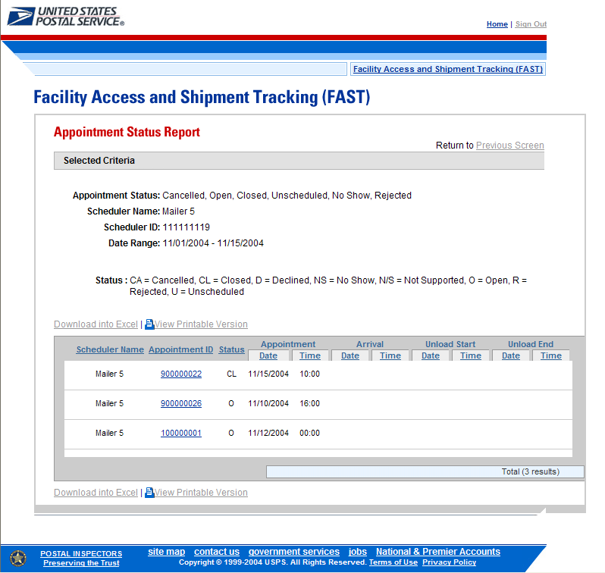

A user may view the Appointment Management page (described in module 6.4 – Manage Existing Appointment) for the selected appointment by CLICKING the Appointment ID hyperlink.

8.5 Holiday and Contingency Constraints Report

The Holiday and Contingency Constraints Report identifies which facilities have holiday constraints defined and what facilities may be impacted by those constraints. The user is asked to select a date range and report view in order to see holiday and contingency data.

The fields and buttons on the Holiday and Contingency Constraints Report Selection page are described below. A snapshot of the page is displayed after the field description.

* Date Range | Selects the date range for the holiday and contingency constraints. The start date may only be greater than or equal to the current date. The end date may not exceed 7 days from the current date.
* Report View | Drop-down box listing the report views to choose from: By Area, By District, By Facility.
Submit button | Triggers the application to show the variable drop-down: Area ID, District ID, Facility ID and search fields.
Area ID | If the user searches by Area: Drop-down box listing all area options.
District ID | If the user searches by District: Drop-down box listing all district options.
State | Only displays when user searches by Facility: Drop-down box listing all state options
View Cities button | Only displays when user searched by Facility: Retrieves all active cities within the selected state
City | Only displays when user searched by Facility: Drop-down box listing all active cities within the selected state
Search button | Only displays when user searched by Facility: Retrieves the facilities located in the selected state/city and populates the Facility drop-down
NASS Code | Only displays when user searched by Facility: Textbox to input the NASS Code of the requested facility
Search button | Only displays when user searched by Facility: Retrieves the facilities associated with the NASS Code and populates the Facility drop-down
Facility | Only displays when user searched by Facility: Drop-down box listing all facilities associated with the selected state/city or NASS Code search criteria
Cancel button | Displays the Reports Landing page.
Create button | Retrieves the holiday and contingency constraint data for the entered criteria and displays the Holiday and Contingency Constraints Report.

The Holiday and Contingency Constraints Report Selection page is displayed below.

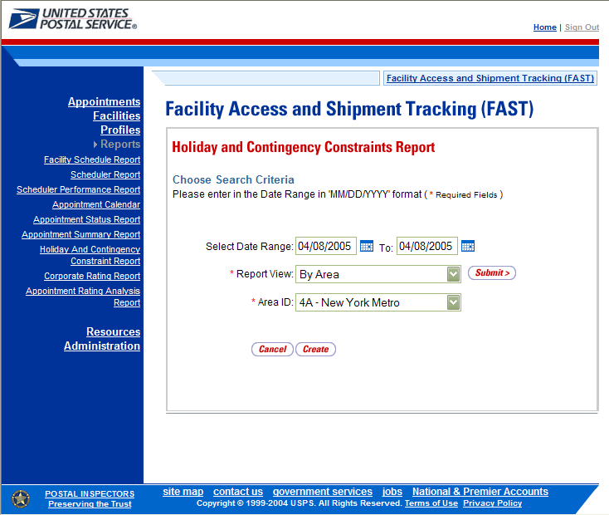

Note:
The Start Date must be greater than or equal to the current date.
The End Date may not exceed 7 days from the current date.

From the Holiday and Contingency Constraints Report Selection page, the user may view the holiday and contingency information by one of four ways:

To Search for holiday and contingency constraints information by Area:
- ENTER the Date Range
- SELECT ‘by Area’ from the Report View drop-down box
- CLICK the Submit button
- SELECT an area in the Area ID drop-down
- CLICK the Create button

To Search for holiday and contingency constraints information by District:
- ENTER the Date Range
- SELECT ‘by District’ from the Report View drop-down box
- CLICK the Submit button
- SELECT an district in the District ID drop-down
- CLICK the Create button

To Search for holiday and contingency constraint information by Facility by state and city:
- ENTER the Date Range
- SELECT ‘by Facility’ from the Report View drop-down box
- CLICK the Submit button
- SELECT a State from the drop-down box
- CLICK the View Cities button
- SELECT a city from the City drop-down box
- CLICK the Search button
- SELECT a facility from the Facility drop-down box
- CLICK the Create button

To Search for holiday and contingency constraint information by Facility by NASS Code:
- ENTER the Date Range
- SELECT ‘by Facility’ from the Report View drop-down box
- CLICK the Submit button
- ENTER the NASS Code in the text box
- CLICK the Search button
- SELECT a facility from the Facility drop-down box
- CLICK the Create button

The Holiday and Contingency Constraints Report page opens, displaying the holiday and contingency information and facility status for the specified search criteria. The fields and buttons on the Holiday and Contingency Constraints Report page are described below. A snapshot of the page is displayed after the field description.

Facility ID | The Facility ID associated with the selected criteria
Facility Name | The Facility Name associated with the selected criteria
Date | Date of when Holiday and Contingency Constraint is in effect
Hours of Operation | The times the associated facility is accepting any volume on that corresponding day

The Holiday and Contingency Constraints Report page is displayed on below:

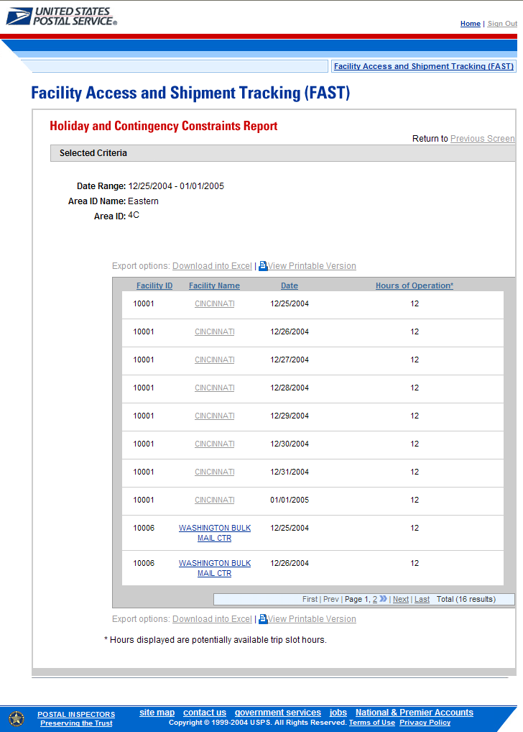

A user may view the Facility Profile page (described in module 5.1 – Facility Profile) for the selected facility by CLICKING the Facility Name hyperlink.

8.6 Corporate Rating Report
The Corporate Rating Report displays the breakdown of the corporate rating score. The report is generated based on the Effective Start Date Range, Facility, and Corporate ID. Once generated, the Corporate Rating Summary Report displays three tables: Closed Appointment With No Exceptions (Not Exempt From Rating), Exceptions (Not Exempt From Rating), and Exempt Appointments, respectively.

8.8.1 View Corporate Rating Report

The user begins the process from the Reports Landing page. The user CLICKS on the Corporate Rating Report link, or associated Go> button to display the Corporate Rating Report Selection page. The user must enter an effective start date range, facility, and corporate ID.

The fields and buttons on the Corporate Rating Report Selection page are described below. A snapshot of the page is displayed after the field description.

* Effective Start Date Range | Selects the effective start date range for the appointments. Displays with the 3 most recent effective start dates that are available to the user.
* Facility | Drop-down box listing all facilities associated with the selected state/city or NASS Code search criteria
* Corporate ID | Drop-down box listing the Corporate IDs
Cancel button | Displays the Reports Landing page.
Create button | Retrieves the corporate rating data for the entered criteria and displays the Corporate Rating Report.

The Corporate Rating Report Selection Page is displayed on the following page.
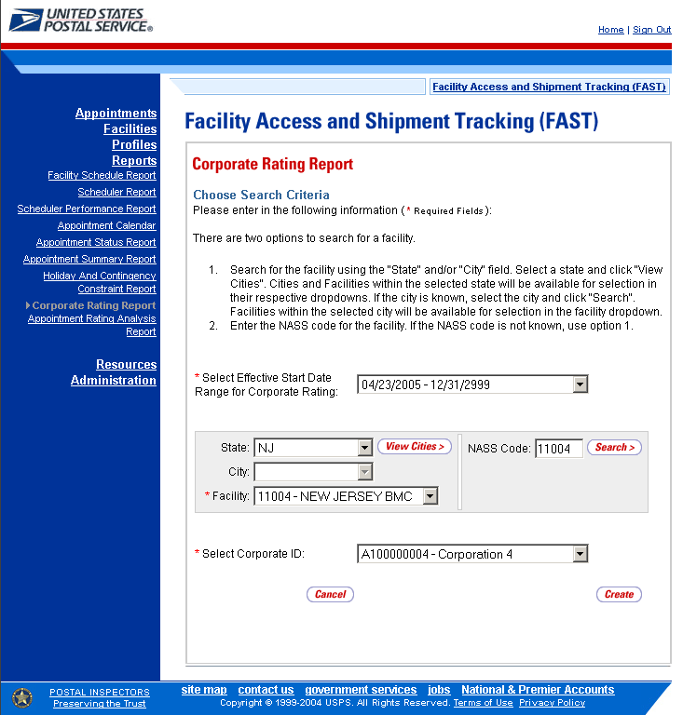

From the Corporate Rating Report Selection page, the user may view the rating information for the specified date range by performing the following steps:

- SELECT an Effective Start Date Range for Corporate Rating from the drop-down box.
- SEARCH for a specific facility by one of the following two ways:
To search for a facility by state and city:
- SELECT a State from the drop-down box
- CLICK the View Cities button
- SELECT a city from the City drop-down box
- CLICK the Search button

To search for a facility by NASS Code:
- ENTER the NASS Code in the text box
- CLICK the Search button

- SELECT a corporation from the Corporate ID drop-down box
- CLICK the Create button

The Corporate Rating Report page opens, displaying the corporate rating data for the specified effective start date range, facility, and corporation. The fields and buttons on the page are described below. A snapshot of the page is displayed after the field description.

Effective Date Range for Corporate Rating | The effective date range that the corporate rating will be in effect
Facility | The name of the facility
Corporate ID | The corporate ID of the facility
Date Range of Data used for this Corporate Rating | Range of the appointment date/time used to calculate the corporate rating.
Corporate Rating | The corporate rating of the corporation
Closed Appointments With No Exceptions (Not Exempt From Rating)
Submission Method | The submission method of the appointment being rated for the corporate. Possible Categories are: Mail.dat/WS (with Pallet Presort), Online/WS (no pallet presort), and Phone
Mail.dat/WS | Sub-column: Total count of Mail.dat/WS appointments
WS (No Pallet Presort)/Online | Sub-column: Total count of Online appointments
Phone | Sub-column: Total count of appointments made by phone
On-Time | The on-time accuracy of appointments. Possible categories are: On-Time, Late, and Significantly Late
On-Time | Sub-column: Total count of on-time appointments
Late | Sub-column: Total count of late appointments. An appointment is late if it arrives 30 minutes to 2:00 hours late.
Significantly Late | Sub-column: Total count of significantly late appointments. An appointment is late if it arrives 2:01 hours late to 8:00 hours late.
Content | The content discrepancy of what was scheduled and what actually arrived at the facility. Possible categories are: Accurate, Minor and Major
Accurate | Sub-column: Total count of accurate content
Minor | Sub-column: Total count of content inaccuracies that are minor
Major | Sub-column: Total count of content inaccuracies that are major
Content Deductions | The counts of any deductions. Possible categories are: Appointment Type Changes (>24 hours), Appointment Type Changes (<=24 hours), Volume Changes (>24 hours), Volume Changes (<=24 hours), and No Changes
Appointment Type (>24 hrs in advance) | Sub-column: Total count of appointments that have an appointment type change occurring greater than 24 hours in advance.
Appointment Type (<= 24hrs) | Sub-column: Total count of appointments that have an appointment type change occurring within 24 hours of appointment date/time.
Volume Change (>24 hrs in advance) | Sub-column: Total count of volume changes that occurred greater than 24 hours in advance.
Volume Change (<= 24hrs) | Sub-column: Total count of volume changes that occurred within 24 hours.
No Change | Sub-column: Total count of volume content volumes that did not change
Exceptions (Not Exempt From Rating)
No-Show & More Than 8 Hours Late | Displays the counts of exception appointments no-showed & more than 8 hours late
Unscheduled | Displays the counts of unscheduled appointments
Cancellations Date Change Location (>24 hours) | Total Count of appointments that are cancellations, date changes, and location changes occurring greater than 24 hours in advance
Cancellations Date Change Location (<=24 hours) | Total Count of appointments that are cancellations, date changes, and location changes within 24 hours of the appointment date/time
Rejected Appointments | Total count of rejected appointments
Exempt Appointments
USPS Delay | The total count of appointments that are USPS delayed
Constraint Changes | The total count of appointments that have constraint changes
DU Drops | The total count of appointments that are DU Drops
100% Perishable | The total count of appointments that are 100% Perishable
100% Periodical | The total count of appointments that are 100% periodical
Average Points Awarded Per Category
Submission Method | The average points awarded for submission method of appointments being rated for the corporate
On-Time | The average points awarded for on-time accuracy of appointments
Content | The average points awarded for content
Content Deductions | The average points deducted for content

The Corporate Rating Report page is displayed below.

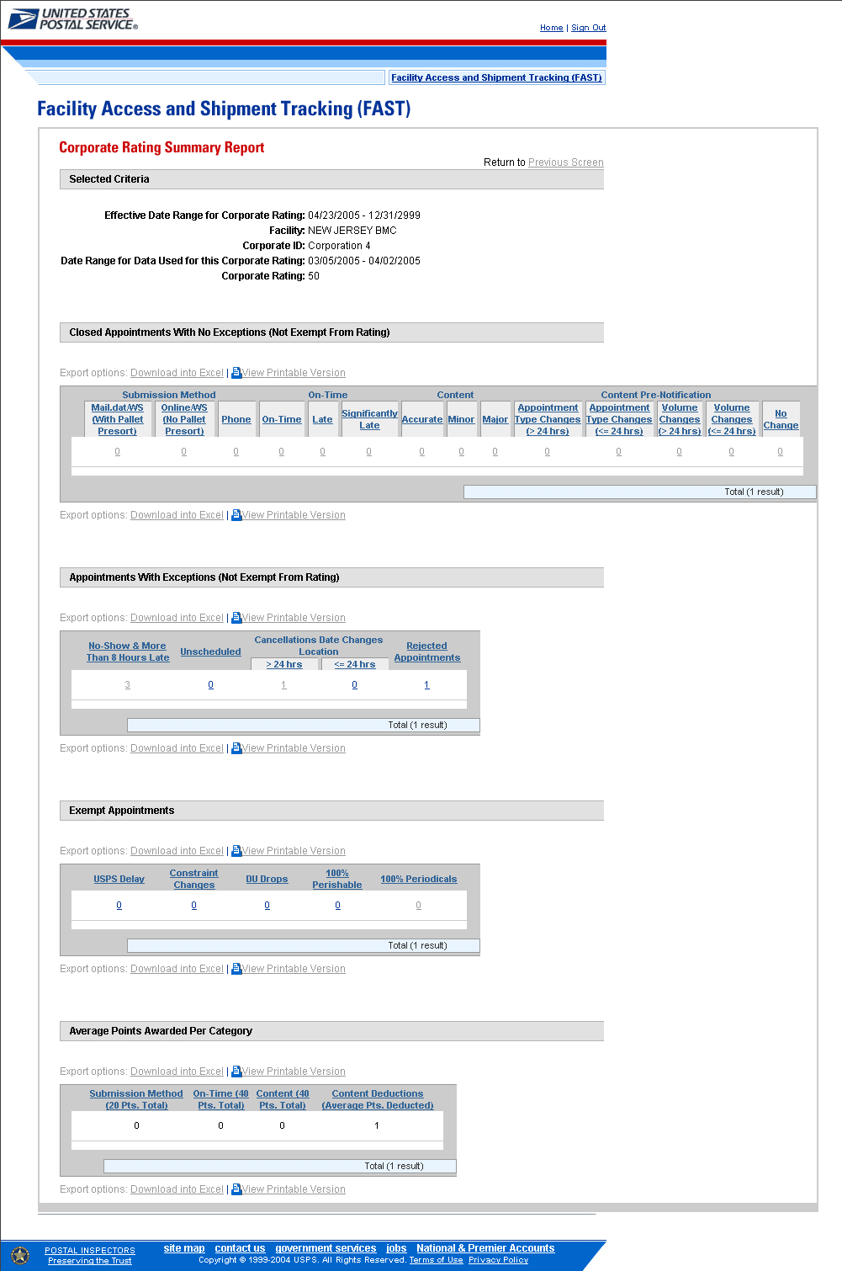

The user may click on one of the Count hyperlinks to view more details about the appointments associated to that count.

The Corporate Rating Appointment Detail Report page displays appointment data according to the selected search criteria as well as the type of appointment rating hyperlink selected. Each appointment that meets the criteria is displayed. The appointment data shows the appointment ID, scheduled appointment date and time, and the actual appointment date and time. A snapshot of the page is displayed after the field description.

Effective Date Range for Corporate Rating | Displays the effective date range for the corporate rating appointment being currently viewed
Facility | The name of the facility
Corporate ID | The name and identification number for the corporation
Date Range of data used for this Corporate Rating | The range of dates in which the appointments were actually scheduled
Corporate Rating | The rating for the corporation
Content Category | The content category from the Corporate Rating Summary Report, in which the user drilled down on
Appointment ID | The Appointment ID
Scheduled Appointment DTTM | The date/time entered when the appointment was scheduled
Actual Appointment DTTM | The date/time entered when the appointment actually arrived in the facility
Appointment Rating | The appointment rating value for the appointment

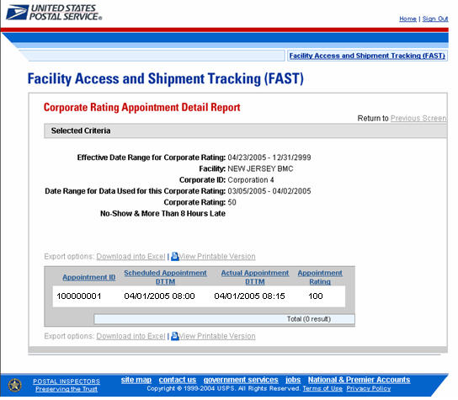

8.7 Appointment Rating Analysis Report

The Appointment Rating Report displays the breakdown of appointments for a given scheduler and date range. The user is asked to select a date range, report view, facility, and scheduler in order to see appointment rating data.

The fields and buttons on the Appointment Rating Analysis Report Selection page are described below. A snapshot of the page is displayed after the field description.

* Date Range | Selects the date range for the appointment rating analysis. The start date is restricted to 45 days prior to today’s date. The end date must be at least four days prior to the current date.
* Report View | Drop-down box listing the report views to choose from: Submission Method and Exemptions, On-Time Accuracy, Appointment and Content Accuracy.
State | Drop-down box listing all state options
View Cities button | Retrieves all active cities within the selected state
City | Drop-down box listing all active cities within the selected state
Search button | Retrieves the facilities located in the selected state/city and populates the Facility drop-down
NASS Code | Textbox to input the NASS Code of the requested facility
Search button | Retrieves the facilities associated with the NASS Code and populates the Facility drop-down
Facility | Drop-down box listing all facilities associated with the selected state/city or NASS Code search criteria
Scheduler ID | Drop-down box listing all the schedulers IDs
Cancel button | Displays the Reports Landing page.
Create button | Retrieves the holiday and contingency constraint data for the entered criteria and displays the Holiday and Contingency Constraints Report.

The Appointment Rating Analysis Report Selection page is displayed on the next page.

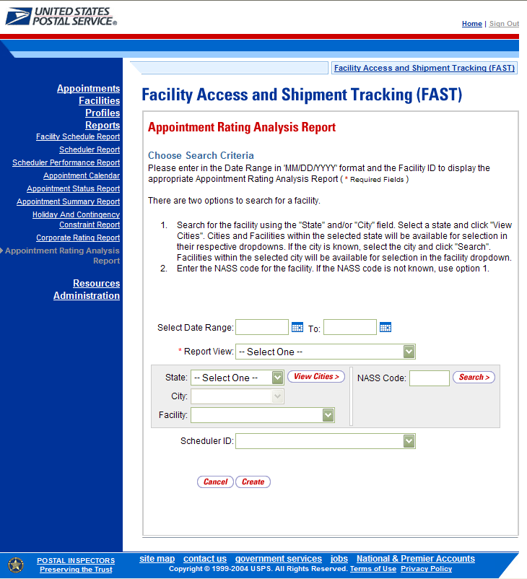

Note:
The Start Date may not exceed 45 days prior to the current date
The Start and End Dates must be at least 4 days prior to the current date
The date range must be a minimum of 1 day and maximum of 7 days

From the Appointment Rating Analysis Report Selection page, the user may view the appointment rating information by one of three ways:

To Search for appointment rating information by Submission Method and Exemptions:
- ENTER the Date Range
- SELECT ‘Submission Method and Exemptions’ from the Report View drop-down box
- SELECT a State from the drop-down box
- CLICK the View Cities button
- SELECT a city from the City drop-down box
- CLICK the Search button
- SELECT a facility from the Facility drop-down box
- SELECT a scheduler from the Scheduler ID drop-down box
- CLICK the Create button

To Search for appointment rating information by On-Time Accuracy:
- ENTER the Date Range
- SELECT ‘On-Time Accuracy’ from the Report View drop-down box
- SELECT a State from the drop-down box
- CLICK the View Cities button
- SELECT a city from the City drop-down box
- CLICK the Search button
- SELECT a facility from the Facility drop-down box
- SELECT a scheduler from the Scheduler ID drop-down box
- CLICK the Create button

To Search for appointment rating information by Appointment and Content Accuracy:
- ENTER the Date Range
- SELECT ‘Appointment and Content Accuracy’ from the Report View drop-down box
- SELECT a State from the drop-down box
- CLICK the View Cities button
- SELECT a city from the City drop-down box
- CLICK the Search button
- SELECT a facility from the Facility drop-down box
- SELECT a scheduler from the Scheduler ID drop-down
- CLICK the Create button

The Appointment Rating Analysis Report page opens, displaying the appointment rating information for the specified search criteria.

The Appointment Rating Analysis Report contains three report views. Each report view is described below:

The fields and buttons on the Appointment Rating Analysis Report – Submission Method and Exemptions Report View page are described below. A snapshot of the page is displayed after the field description.

Corporate Name | The Corporate Name associated with the selected criteria
Scheduler Name | The Scheduler Name associated with the selected criteria
Multi-stop ID | The Multi-stop ID associated with the selected criteria
App’t ID | The Appointment ID associated with the selected criteria
NASS Code | The NASS Code associated with the selected criteria
Facility Name | The Facility Name associated with the selected criteria
Scheduled App’t Date and Time | The Scheduled Appointment Date and Time associated with the selected criteria
App’t Status | The Appointment Status associated with the selected criteria
App’t Type | The Appointment Type associated with the selected criteria
Rating Points | The total number of appointment rating points rewarded to the appointment associated with the selected criteria
Submission Method | If the user searches by Submission Method and Exemptions: Submission Method associated with the selected criteria
Points Awarded | If the user searches by Submission Method and Exemptions: The number of points awarded depending on the submission method associated with the selected criteria
Appointment Rating Exempt – Delayed Multi-stop | If the user searches by Submission Method and Exemptions: Indicates whether the appointment was part of a delayed multi-stop
Appointment Rating Exempt – Holiday/Contingency Constraint Change | If the user searches by Submission Method and Exemptions: Indicates whether the appointment was affected by a holiday and contingency constraint change
Corporate Rating Exempt – All Periodicals | If the user searches by Submission Method and Exemptions: Indicates whether the appointment was deemed 100% Periodical
Corporate Rating Exempt – All Perishable | If the user searches by Submission Method and Exemptions: Indicates whether the appointment was deemed 100% Perishable
Corporate Rating Exempt – Destination Delivery Unit | If the user searches by Submission Method and Exemptions: Indicates whether the appointment was delivered to a Destination Delivery Unit
Export All button | Opens a new window with all three views of the report combined onto one spreadsheet

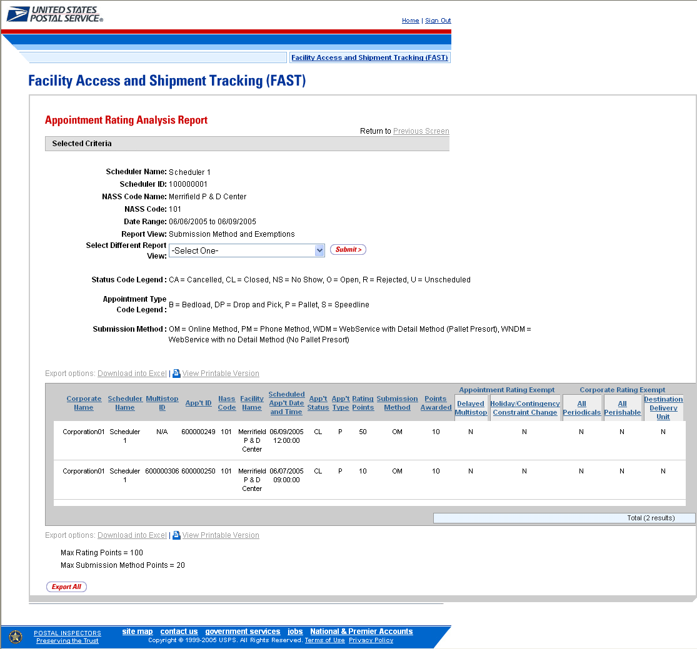
The fields and buttons on the Appointment Rating Analysis Report – On-Time Accuracy Report View page are described below. A snapshot of the page is displayed after the field description.

Corporate Name | The Corporate Name associated with the selected criteria
Scheduler Name | The Scheduler Name associated with the selected criteria
Multi-stop ID | The Multi-stop ID associated with the selected criteria
App’t ID | The Appointment ID associated with the selected criteria
NASS Code | The NASS Code associated with the selected criteria
Facility Name | The Facility Name associated with the selected criteria
Scheduled App’t Date and Time | The Scheduled Appointment Date and Time associated with the selected criteria
App’t Status | The Appointment Status associated with the selected criteria
App’t Type | The Appointment Type associated with the selected criteria
Rating Points | The total number of appointment rating points rewarded to the appointment associated with the selected criteria
Time Penalty Deductions – App’t Create w/in 8 Hours | The number of points deducted if the appointment was created within 8 hours
Time Penalty Deductions – App’t Update w/in 8 Hours | The number of points deducted if the appointment was updated within 8 hours
Actual Arrival Date and Time | If the user searches by On-Time Accuracy: The Actual Arrival Date and Time of the appointment associated with the selected search criteria
Scheduled and Actual Arrival Time Difference | If the user searches by On-Time Accuracy: The time difference between the scheduled and actual arrival time for the appointment associated with the selected search criteria
Unload Start Time | If the user searches by On-Time Accuracy: The Unload Start Time associated with the selected search criteria
Unload End Time | If the user searches by On-Time Accuracy: The Unload End Time associated with the selected search criteria
Induction Rating | If the user searches by On-Time Accuracy or by Appointment and Content Accuracy: The rating received depending on the arrival status of the associated appointment
Points Awarded | If the user searches by On-Time Accuracy or by Appointment and Content Accuracy: The points awarded depending on the induction rating
Export All button | Opens a new window with all three views of the report combined onto one spreadsheet

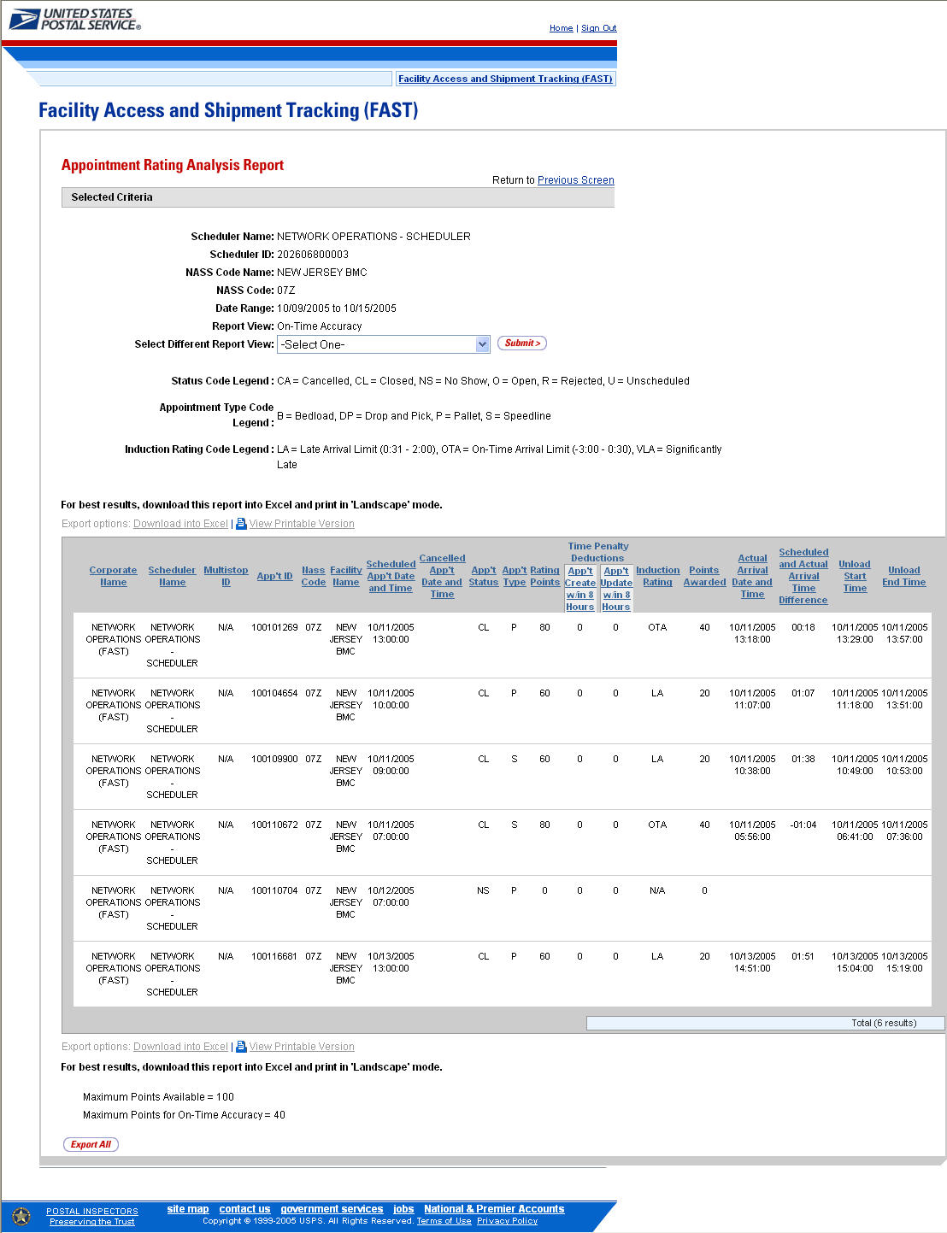

The fields and buttons on the Appointment Rating Analysis Report – Appointment and Content Accuracy Report View page are described below. A snapshot of the page is displayed after the field description.

Corporate Name | The Corporate Name associated with the selected criteria
Scheduler Name | The Scheduler Name associated with the selected criteria
Multi-stop ID | The Multi-stop ID associated with the selected criteria
App’t ID | The Appointment ID associated with the selected criteria
NASS Code | The NASS Code associated with the selected criteria
Facility Name | The Facility Name associated with the selected criteria
Scheduled App’t Date and Time | The Scheduled Appointment Date and Time associated with the selected criteria
App’t Status | The Appointment Status associated with the selected criteria
App’t Type | The Appointment Type associated with the selected criteria
Rating Points | The total number of appointment rating points rewarded to the appointment associated with the selected criteria
Actual Pallet Difference | The total difference between the total pallets expected to arrive and the total number of pallets that actually arrive.
Bedload % | The total percentage difference between the bedload capacity expected to arrive and the capacity that actually arrives.
Induction Rating | If the user searches by Appointment and Content Accuracy: The rating received depending on the arrival status of the contents of the associated appointment
Points Awarded | If the user searches by Appointment and Content Accuracy: The points awarded depending on the induction rating
Significant Volume Change Pre-notification | If the user searches by Appointment and Content Accuracy: Indicates whether the facility was notified of a significant volume change prior to the appointment arrival
Points Deducted | If the user searches by Appointment and Content Accuracy: The points deducted based on the significant volume change pre-notification indicator
App’t Type Change Pre-Notification | If the user searches by Appointment and Content Accuracy: Indicates whether the facility was notified of an appointment type change prior to the appointment arrival
Points Deducted | If the user searches by Appointment and Content Accuracy: The points deducted based on the appointment type change pre-notification indicator
Date Change | If the user searches by Appointment and Content Accuracy: Indicates whether there was a date change to the appointment
Location Change | If the user searches by Appointment and Content Accuracy: Indicates whether there was a location change to the appointment
Export All button | Opens a new window with all three views of the report combined onto one spreadsheet

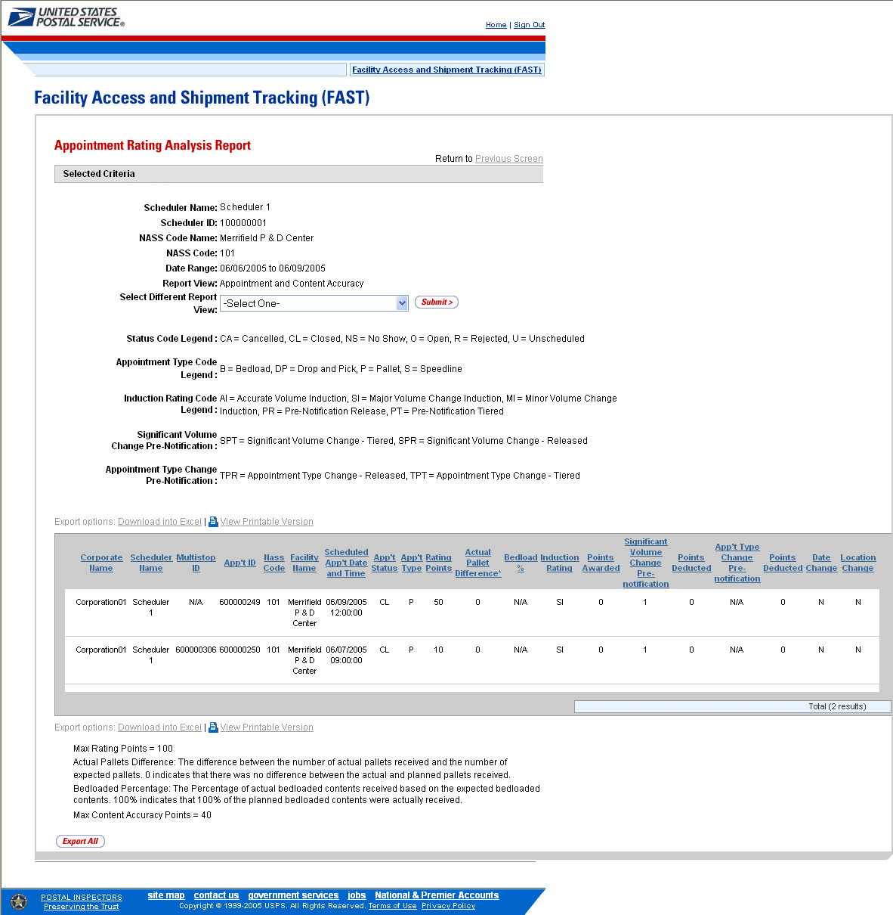

8.8 Closeout Data Report

Closeout Data Report provides the closeout information for all the appointment IDs’ the user provides.

The fields and buttons on the Closeout Data Report Selection page are described below. A snapshot of the page is displayed after the field description.

Appointment ID | Provides a field for the user to enter the desired Appointment ID(s). Up to 10 Appointment IDs can be entered
Cancel button | Displays the Reports Landing page.
Create button | Retrieves the appointments’ closeout information.

A snapshot of the Closeout Data Report Selection page is below.

The user may view closeout information by performing the following steps:

- ENTER Appointment ID in the field next to the first Appointment ID
- REPEAT until the desired number of Appointment IDs are entered
- CLICK Create button

The Closeout Information Report page opens, displaying the closeout information for the specified Appointment IDs. The fields and buttons on the Closeout Data Report Selection page are described below. A snapshot of the page is displayed after the field description.

Appointment ID | Lists the Appointment ID associated with the selected criteria
Status | Lists the Appointment Status associated with the selected criteria  CA = Cancelled  CL = Closed  NS = No Show  O = Open  R = Rejected  U = Unscheduled
Scheduler ID | List the Scheduler ID associated with the selected criteria
Scheduler Name | List the Scheduler Name associated with the selected criteria
Facility Name | Lists the Facility Name associated with the selected criteria
NASS Code | Lists the NASS Code associated with the selected criteria
Appointment Date and Time | Lists the Scheduled Appointment Date and Time associated with the selected criteria
Arrival Data and Time | Lists the Actual Arrival Date and Time associated with the selected criteria
Unload Start Date and Time | Lists the Unload Start Date and Time associated with the selected criteria
Unload End Date and Time | Lists the Unload Start Date and Time associated with the selected criteria
Mail Integrity | Lists the Mail Condition of the selected criteria
Content Discrepancy | Lists the Difference between the scheduled volume and the actual volume associated with the selected criteria

A snapshot of the Closeout Data Report page is below.

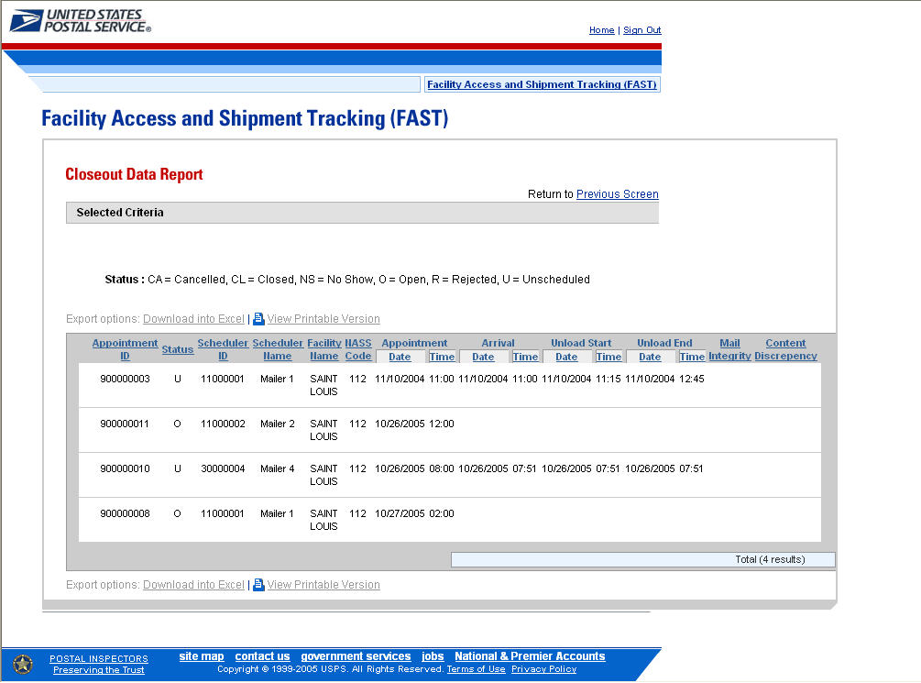

9.0 Resources
The user has several processes they may exercise upon logging into the FAST application. The Resources section includes:

9.1 Area-District 3 Digit Data- Downloads an excel spreadsheet to your computer from the AMS file.

9.2 Reference Documents – Describes how a user may access the External FAST User Guide, Recurring Appointment Request form (PS Form 6241), Publication 804, and Domestic Mail Manual.

9.3 Drop Ship Product File Download – Describes how a user may download the different Drop Ship Product Files.

9.4 Message Board – Describes how a user may access the Message Board.

9.5 What’s New Board – Describes how a user may access the What’s New Board.

The user may access the processes associated with the above sections from the FAST Main Menu page by CLICKING the Resources link or the associated Go> button. The Resource Documents link takes the user to the Resources Landing page (described in module 4.0 – Landing pages).

9.1 Area-District 3-Digit Data

By clicking on the Go> link, the AMS Resources Area-District 3-Digit Excel spreadsheet will download to the user’s computer. This spreadsheet contains a list of all the facilities in AMS and their NASS Codes. The list is used to reference which facilities have AMS discounts.

9.2 Reference Documents

The Reference Documents section describes the following processes:

9.2.1 Download User Guide
9.2.2 Download Recurring Appointment Request Form (PS Form 6241)
9.2.3 Download PS Form 8125 (Plant-Verified Drop Shipment Form)
9.2.4 Link to Publication 804
9.2.5 Link to Domestic Mail Manual

The user begins the process from the Resources page. The user CLICKS either the Reference Documents link, or the associated Go> button to display the Reference Documents page.

Note:
To download or access any of the Reference Documents in .PDF format, the user must have Adobe Acrobat Reader. The user may download Adobe Acrobat Reader by CLICKING Download Adobe Acrobat PDF Reader on the Reference Documents page.

9.2.1 Download User Guide

The FAST User Guide is a document that explains the different features that FAST provides to the user. It contains detailed instructions for the user to perform key functions in the FAST system. The user may only download an external version of the User Guide. The download for the External User Guide is accessible from two points in FAST; from the FAST Login page (pre-login) and from the Resources Landing page (post-login).

The FAST User Guide section describes the following processes:
- Downloading User Guide in .PDF format
- Downloading User Guide in .HTML format
- Downloading User Guide as a .ZIP file

The user begins the process from the Reference Documents page by CLICKING the associated Go> button.

The fields and buttons on the Reference Documents (FAST User Guide section) page are described below. A snapshot of the page is displayed after the field description.

Customer User Guide (PDF) hyperlink | Begins the downloading process of the FAST User Guide in .PDF format
Customer User Guide (HTML) hyperlink | Begins the downloading process of the FAST User Guide in .HTML format
Customer User Guide (ZIP) hyperlink | Begins the downloading process of the FAST User Guide as a .ZIP file

The Reference Documents page is displayed on the following page with the FAST User Guide section highlighted.

CLICK the Customer User Guide hyperlink, associated to the User Guide in .PDF format, to be redirected to a page with the User Guide in .PDF format.

CLICK the Customer User Guide hyperlink, associated to the User Guide in .HTML format, to be redirected to a page with the User Guide in .HTML format.

CLICK the Customer User Guide hyperlink, associated to the User Guide as a .ZIP file, to begin the downloading process. A new window will appear prompting the user to either open the WinZip file or save it to the computer. More detailed information about downloading files is described in module 1.3.1 – Procedures.
Note:
To extract and open any of the WinZip files, the user must have the WinZip application.

9.2.2 Download Recurring Appointment Request form (PS Form 6241)

The Recurring Appointment Request form (PS Form 6241) is for schedulers that want to request a recurring appointment. The mailing should be at least once a week, on the same day, during the same time period, with (generally) the same contents, and using the same form and size of transportation. The form requests information about the mail owner, transportation, mailing, as well as a signature by the scheduler.

The Recurring Appointment Form (PS Form 6241) section describes how the user may download the form in .PDF format.

The user begins the process from the Reference Documents page by CLICKING the associated Go> button.

The fields and buttons on the Reference Documents (PS Form 6241 section) page are described below. A snapshot of the page is displayed after the field description.

PS Forms Page hyperlink | Redirects user to the USPS Forms Page

The Reference Documents page is displayed below with the PS Form 8125 section highlighted.

CLICK the PS Forms Page hyperlink, to be redirected to the USPS Forms page. The user will search for the PS Form 6241, Recurring Appointment Request Form, to download in .PDF format.

The Recurring Appointment Request form (PS Form 6241) in .PDF format is displayed below.

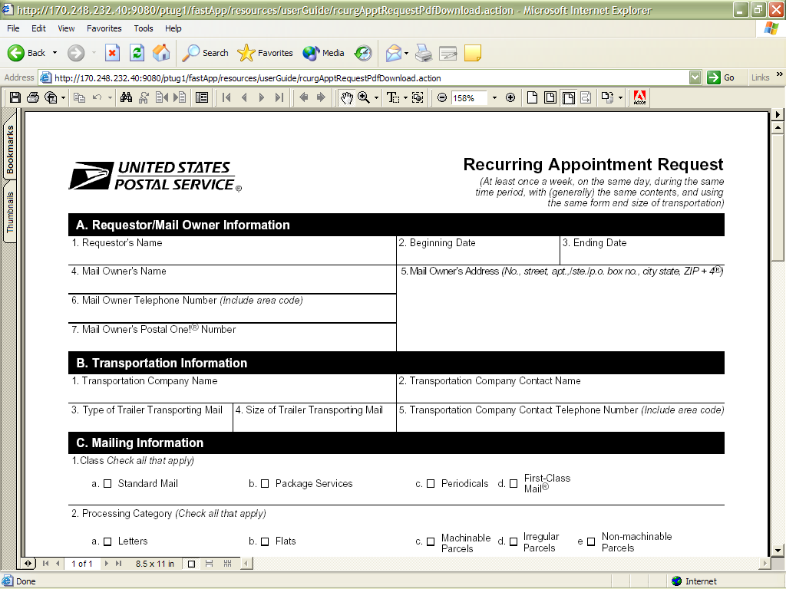

The full Recurring Appointment Request form (PS Form 6241) is displayed below.

9.2.3 Download PS Form 8125 (Plant-Verified Drop Shipment Form)

The PS Form 8125 contains the expected unload and appointment information of the scheduled drop shipment. When the appointment arrives at the drop shipment facility, the dock floor personnel may record the arrival time and any content discrepancies found between what content was scheduled to arrive and what content actually arrived. A user may also indicate any load condition irregularities.

The PS Form 8125 is divided into three main sections:

- Mailer Information section – Contains the scheduled appointment information
- Origin Post Office section – Contains more detailed appointment information that is verified by the originating Post Office
- Destination Entry Post Office or Delivery Unit section – Contains the actual arrival site, time and any discrepancies or irregularities of the appointment

The PS Form 8125 section describes how the user may download the form in .PDF format.

The user begins the process from the Reference Documents page by CLICKING the associated Go> button.

The fields and buttons on the Reference Documents (PS Form 8125 section) page are described below. A snapshot of the page is displayed after the field description.

PS Forms Page hyperlink | Redirects user to the USPS Forms Page

The Reference Documents page is displayed below with the PS Form 8125 section highlighted.

CLICK the PS Forms Page hyperlink, to be redirected to the USPS Forms page. The user will search for the PS Form 8125 to download in .PDF format.

The PS Form 8125 in .PDF format is displayed below:

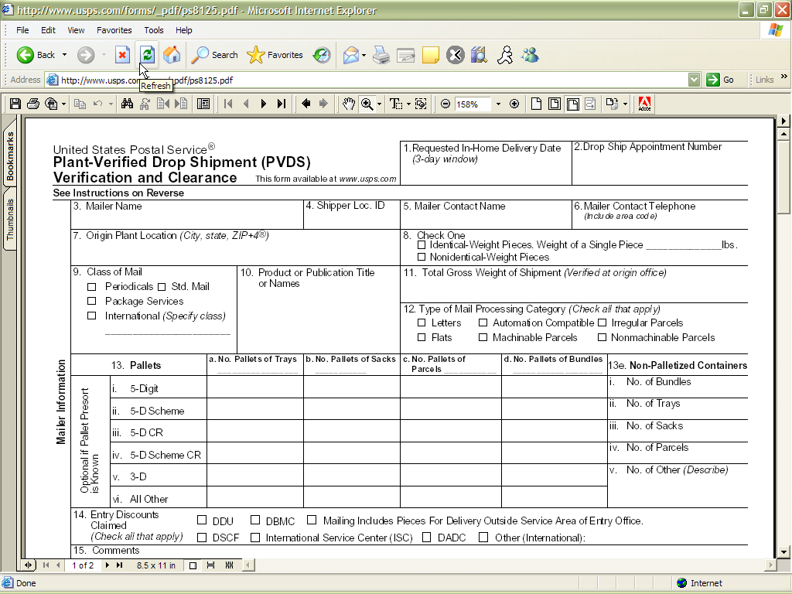

The full PS Form 8125 is displayed below:

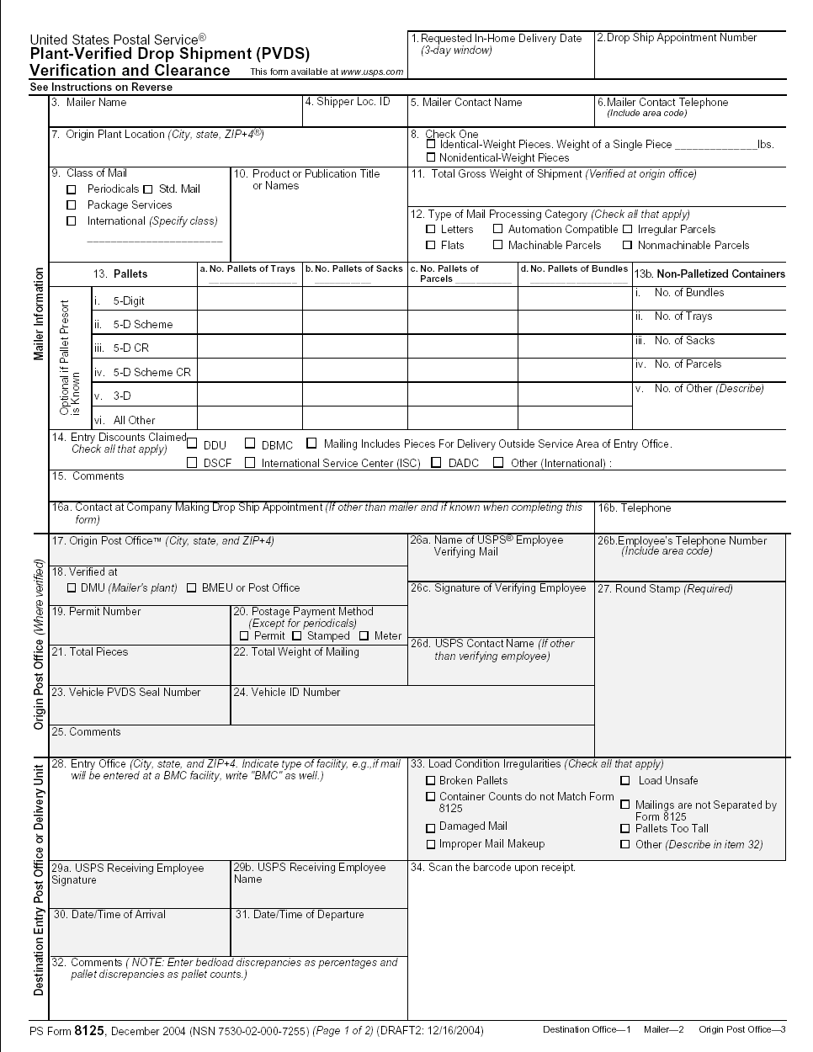
9.2.4 Link to Publication 804

Drop Shipment Procedures for Destination Entry (Publication 804) was developed to assist Postal Service employees in handling drop shipments from the origin office to the destination office. The procedures consist of mailing standards found in the Domestic Mail Manual (DMM). They establish official Postal Service policy regarding the handling of drop shipments for Periodicals, Standard Mail, and Packaged Services Mail.

The Publication 804 section describes the following processes:
- Linking to Publication 804 in .PDF format
- Linking to Publication 804 in text format

The user begins the process from the Reference Documents page by CLICKING the associated Go> button.

The fields and buttons on the Reference Documents (Publication 804 section) page are described below. A snapshot of the page is displayed after the field description.

Publication 804 hyperlink | Redirects the user to the USPS Publications Page

The Reference Documents page is displayed on the following page with the Publication 804 section highlighted.

CLICK the Publication 804 hyperlink, to be redirected to the USPS Publications Page. Search for Publication 804 and CLICK TEXT to download .TEXT format.

The Publication 804 in text format is displayed below with the shortcut highlighted.

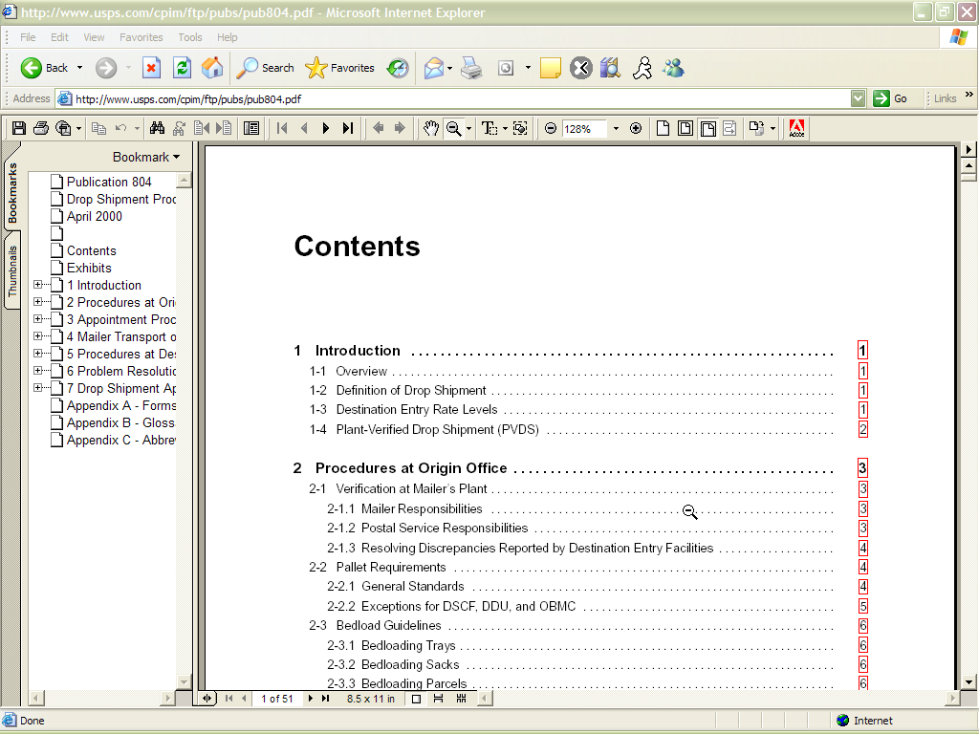
Note:

Publication 804 is under revision. The screenshot above reflects documents currently available.

CLICK the Publication 804 hyperlink, to be redirected to the USPS Publications Page. Search for Publication 804 and CLICK PDF to download .PDF format.

9.2.5 Link to Domestic Mail Manual

The Domestic Mail Manual (DMM) contains the official rates and standards of the U.S. Postal Service governing domestic mail services. The user may access the DMM in .PDF format on the Postal Explorer website. Postal Explorer holds the most recent Domestic Mail Manual.

The Domestic Mail Manual section describes how the user may view the manual in .PDF format

The user begins the process from the Reference Documents page by CLICKING the associated Go> button.

The fields and buttons on the Reference Documents (Domestic Mail Manual section) page are described below. A snapshot of the page is displayed after the field description.

Domestic Mail Manual hyperlink | Redirects the user to the USPS Domestic Mail Manual Page

The Reference Documents page is displayed below with the Domestic Mail Manual section highlighted.

CLICK the Domestic Mail Manual hyperlink, to be redirected to the USPS Domestic Mail Manual page. CLICK Download DMM to download the Domestic Mail Manual in .PDF format.
The Domestic Mail Manual in .PDF format is displayed below with the shortcut highlighted.

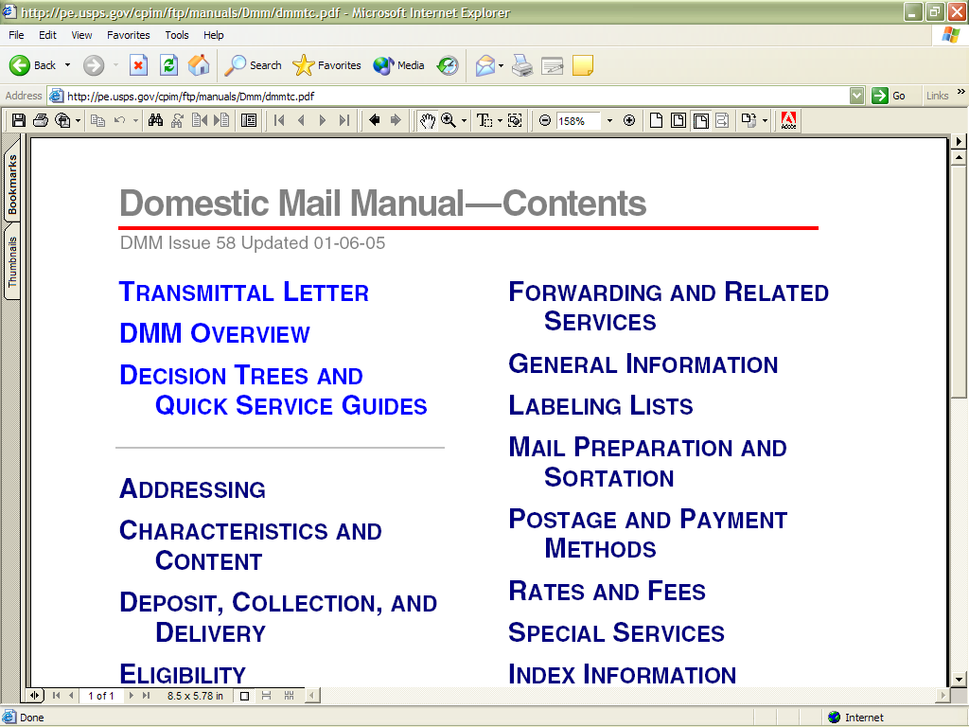

9.3 Drop Ship Product File Download

The Drop Ship Product page allows a user to download various drop ship product files. There are 5 different files that include:

- Address File – The Drop Ship Address portion of the product contains USPS facility address and telephone information.
- Supplemental Site File – The Drop Ship Supplemental Site portion of the product contains docking information, processing hours, and directions to the drop ship facilities.
- Parcel File – The Drop Ship Parcel portion of the product contains ZIP Codes and processing hours.
- ZIP/CIN File – The Drop Ship ZIP/CIN portion of the product contains ZIP Codes, carrier routes, CIN and drop ship carrier sequence barcode sorter (CSBCS) discount codes. It also contains a drop site key for additional discounts.
- ZIP/CRID File – The Drop Ship ZIP/CRID portion of the product contains ZIP Codes, carrier routes, and drop ship carrier sequence barcode sorter (CSBCS) discount codes. It also contains a drop site key and a drop site letter key for additional discounts.

The user may either download all of the files at once by selecting the All File download button or they may download each file individually.

The user begins the process from the Resources Landing page. The user CLICKS the Drop Ship Product File Download link, or associated Go> button to display the Drop Ship Product File Download page. The user may then select which file to download and CLICK the associated Download button.

The fields and buttons on the Drop Ship Product File Download page are described below. A snapshot of the page is displayed after the field description.

Download (All Files) | Begins the downloading process of all files in the Drop Ship Product File
Download (Address File) | Begins the downloading process of the Address File
Download (Supplemental Site File) | Begins the downloading process of the Supplemental Site File
Download (Parcel File) | Begins the downloading process of the Parcel File
Download (ZIPCIN File) | Begins the downloading process of the ZIPCIN File
Download (ZIPCRID File) | Begins the downloading process of the ZIPCRID File

The Drop Ship Product File Download page is displayed below.

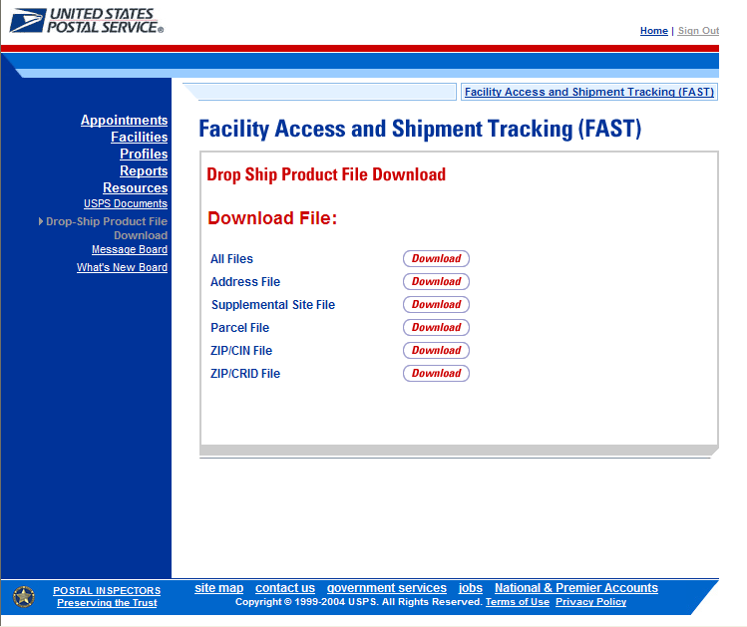

CLICK the Download button to begin the downloading process. A new window will appear prompting the user to either open the WinZip file or save it to the computer. More detailed information about downloading files is described in module 1.3.1 – Procedures.

Note:

To extract and open any of the WinZip files, the user must have the WinZip application.

9.4 Message Board

Messages are created by administrators in the FAST system to display facility-specific and general information to the FAST user. Messages are displayed to the user via the Message Board. Users may view all general and facility messages that have not yet expired.

The Message Board section describes the process for viewing the board.

The Message Board is accessible from three points in FAST; from the FAST Login page (pre-login), from the Resources Landing page (post-login), and from the Message Board Pop Up (post-login). The user begins the process from the FAST Login page. Upon login the Message Board Pop Up will automatically be displayed. The user may also access the Message Board from the Resources Landing page. The user CLICKS the Message Board link, or associated Go> button to display the Message Board.

The fields and buttons on the Message Board page are described below. A snapshot of the page is displayed after the field description.

Facility Messages link | Triggers the application to bring the user to the Facility Message section on the Message Board
General Messages link | Triggers the application to bring the user to the General Message section on the Message Board
Facility Messages | Includes all Facility Messages available
General Messages | Includes all General Messages available
Back to Top link | Triggers the application to bring the user back to the top of the Message Board

The FAST Message Board is displayed below.

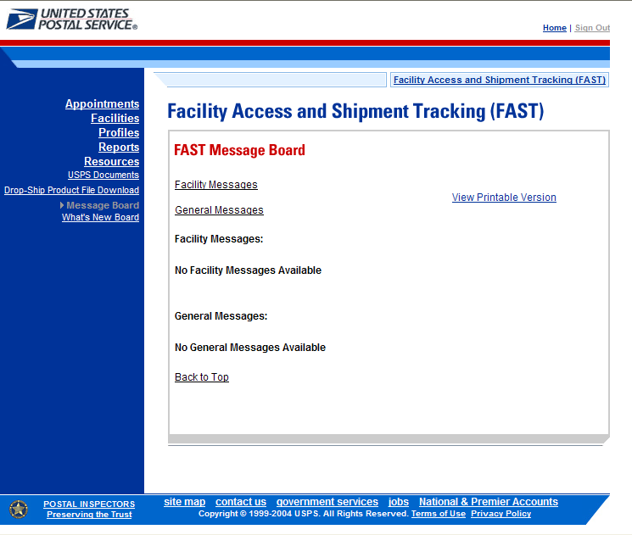

9.5 What’s New Board

What’s New is a message posting system where administrators of the FAST system may display system-related information to all FAST users. The board will contain any listings with an expiration date equal to or greater than the current date.

The What’s New Board section describes the process for viewing the board.

The What’s New Board is accessible from two points in FAST; from the FAST Login page (pre-login) and from the Resources Landing page (post-login). The user begins the process from the Resources Landing page. The user CLICKS the What’s New Board link, or associated Go> button to display the What’s New Board.

The fields and buttons on the What’s New Board page are described below. A snapshot of the page is displayed after the field description.

What’s New Post Date | The date the message was posted by the user
What’s New Expiration Date | The date the message will expire and cease to be displayed on the What’s New Board
Subject | The subject of the message entered by the user
What’s New | The text of the new message entered by the user
Back to Top link | Triggers the application to bring the user back to the top of the What’s New Board

The FAST What’s New Board is displayed below.

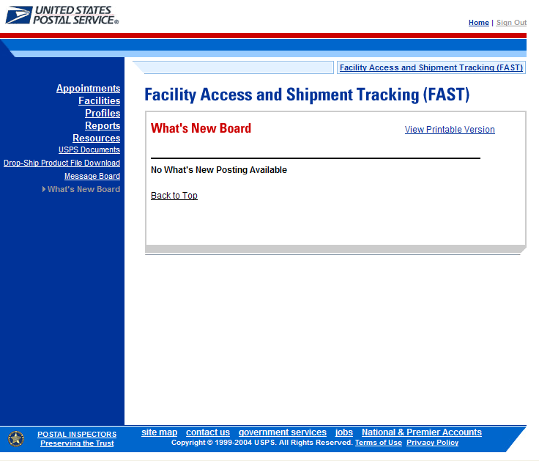

This page has been intentionally left blank.
10.0 Rating Overview
Ratings are calculated to promote accurate appointment scheduling and timely delivery of mail. FAST calculates two kinds of ratings: Appointment Rating and Corporate Rating. Individual appointments are evaluated and scored as they are finalized. The appointment scores are then used to calculate a corporate rating for each destination facility the corporation services. Corporations are evaluated and rated on a weekly basis. Corporate rating is based on all finalized appointment ratings over a 28 day period for each corporation and destination facility combination.

The Rating Overview section describes how appointments and corporations are rated in FAST. It also contains a timeline of the different deadlines and time frames that affect appointments and rating. The section includes:

10.1 Appointment Rating

10.2 Corporate Rating

10.3 Timeline and Rating Calendar

10.1 Appointment Rating

Appointments are given individual scores to rate accurate appointment scheduling data. An appointment may not be scored until it is considered finalized. Appointments are considered finalized at 96 hours past the scheduled appointment time. Closed appointments are scored in a separate manner than appointments that are considered exceptions (such as no show and unscheduled arrival appointments) when they are finalized.

The Appointment Rating section discusses the following topics:

10.1.1 – Closed Appointment Scoring
10.1.2 – Exception Scoring
10.1.3 – Exempt Appointments

10.1.1 Closed Appointment Scoring

An appointment may receive a score from 0 to 100, with 100 being a perfect score. Closed appointments are scored based on the following three criteria:

- Submission Method and Content Detail – 20 points possible
- On-Time Accuracy – 40 points possible
- Content Accuracy – 40 points possible

Submission Method and Content Detail

Corporations are evaluated on the amount of information provided in their pre-notification and the manner in which they provide the information. This category is used as an incentive for the corporations to provide a detailed level of information in an electronic format. Depending on the submission method of an appointment request and the detail of content contained in it, the appointment may receive a score of 0, 10 or 20 for this category.


On-Time Accuracy

In the on-time accuracy category, the corporations are evaluated on their ability to meet the planned date/time of their appointment. The scheduled appointment information is evaluated against the actual performance information. Depending upon the scheduled arrival time compared to the actual arrival time, an appointment may receive a score of 0, 20 or 40, displayed below.

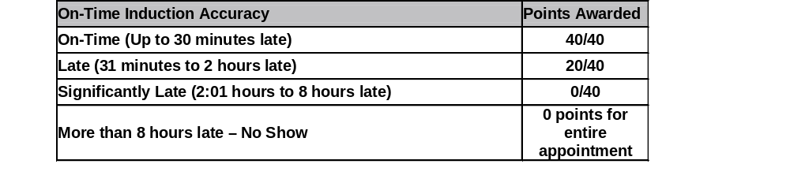
Content Accuracy

Content accuracy is divided into two sections:
- Induction Accuracy - Compares the actual content to the expected content
- Pre-Notification Accuracy - Evaluates the degree and timing of content changes to the appointment

In the induction accuracy category, the corporations are evaluated on whether the scheduled appointment contents match the actual contents. An appointment may receive a score of 0, 30 or 40 depending on the discrepancy level between what content was scheduled to arrive and what content actually arrived and the timing of the change.

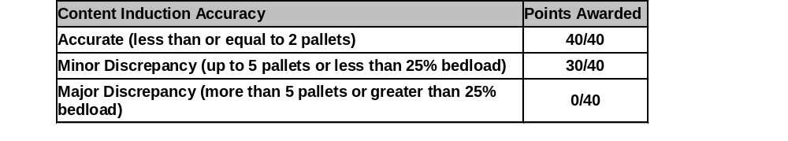
In the pre-notification accuracy category, the corporations are evaluated on their ability to accurately determine the actual contents of their shipment at the time that the appointment was booked. Pre-notification changes are grouped into two kinds of changes: appointment type changes and significant volume changes.

Appointment type changes are defined to be from Pallet to Bedload or Speedline to Bedload.

Significant volume changes are only evaluated for USPS defined working volume and are then evaluated by each mail shape submitted. Depending on whether the total pallet count is more than or less than 20 pallets, the significant volume threshold may be one of the following two values:
- If the total working volume Pallet count is greater than 20, more than a 10% change is significant and anything less than 10% is not considered significant

- If the total working volume Pallet count is less than or equal to 20, two pallets is considered a significant change and anything less than two pallets is not considered significant

Points are deducted from the appointment’s Content Accuracy score when either appointment type and/or significant volume changes occur.

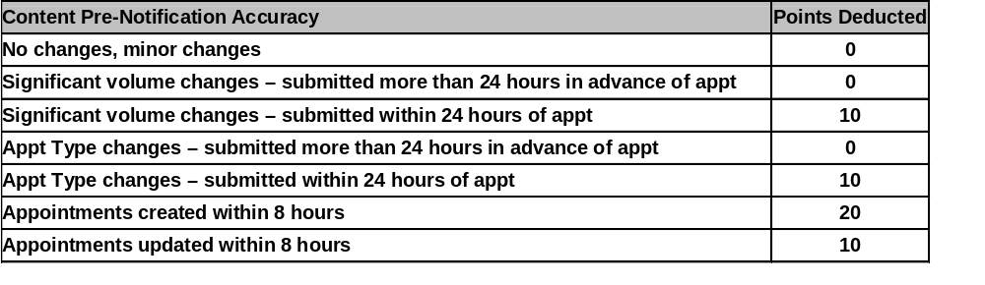
The appointment’s total score is calculated by adding each section’s individual score together:

Appointment Score = Submission Method/Content Detail + On-Time Accuracy + Content Accuracy

10.1.2 Exception Scoring

Appointments meeting certain criteria are considered exceptions to normal appointment score calculations. They are scored as follows:

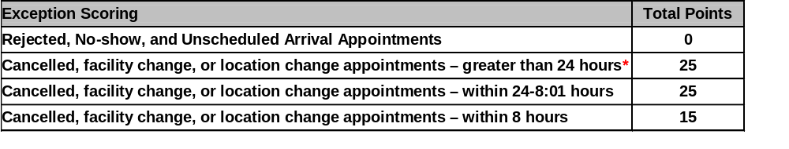* These appointments are acceptable to a threshold of 10% over a 28 day period. These appointments will only be factored into corporate rating once the 10% threshold over has been reached.

For example:
The threshold for a corporation at Facility A over a 28 day period is 10%. The corporation has a total of 100 appointments at Facility A over the 28 day period. Eight of the 100 appointments are cancelled appointments or appointments with location changes and date changes that were made more than 24 hours in advance of the original scheduled appointment time. Since the eight appointments do not meet the 10% threshold of the 100 total appointments, they are not included in corporate rating and the corporate rating is based off of the remaining 92 appointments.

10.1.3 Exempt Appointments

The following appointments are always exempt from appointment and corporate rating:

- Appointments impacted by holiday and contingency constraints
- 100% Periodicals appointments
- 100% perishable appointments
- Delivery Unit drops
- USPS delays to multi-stop appointments

The first appointment in a multi-stop receives an appointment score. Any subsequent appointment in a multi-stop that was delayed due to USPS is excluded from appointment rating. A USPS delayed appointment is determined using pre-defined timeframes per each appointment type.

- If the actual appointment arrival time is earlier than the scheduled appointment time, the timeframe evaluated is from the scheduled appointment date/time to the unload end time.
- If the actual appointment arrival time is less than or equal to 30 minutes after the scheduled appointment time, the timeframe evaluated is from the vehicle arrival time to the unload end time.
- If the actual appointment arrival time is greater than 30 minutes after the scheduled appointment time, the timeframe evaluated is from the unload start time to the unload end time.

The following lists the allowable timeframes for each appointment type by facility type. Anything over the allowable timeframe is considered a USPS delay and exempts the appointment from rating.

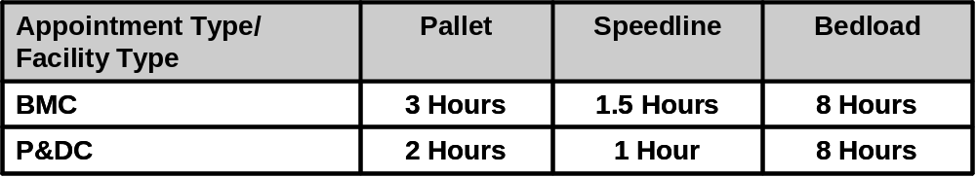

Drop & Pick Appointments scenarios are explained below:

- Scheduled appointment for a time period prior to 3pm and vehicle arrived prior to 3pm – 8 hours to unload
- Scheduled appointment for a time period prior to 3pm, but vehicle arrived after 3pm – 18 hours to unload
- Scheduled appointment for a time period after 3pm and vehicle arrived prior to 3pm – 18 hours to unload
- Scheduled appointment for a time period after 3pm, but vehicle arrived after 3pm – 18 hours to unload

Note:
Drop and Pick appointments cannot be included in a multi-stop.

10.2 Corporate Rating

Appointment scores are used when calculating corporate rating. Each corporation is given a separate rating for each postal facility where they have scheduled appointments. Corporations are placed into rating tiers depending upon their drop shipment performance. Tier levels are used for each corporation/facility pair to encourage good performance from corporations by reserving appointment slots for preferred corporations.

The Corporate Rating section describes the overall rating calculation and tier description. It includes:

10.2.1 – Corporate Rating Information
10.2.2 – Tier Summary

10.2.1 Corporate Rating Information

Corporate rating is defined as the average of all non-exempt appointment scores over a 28 day period for a given facility. The 28 day period includes finalized appointments that are 4 days older than the current date through 32 days older than the current date.

Corporate ratings are calculated weekly on Wednesday evenings. When a rating is calculated, it becomes effective two weeks following the rating calculation.

Each corporate rating score falls into one of four tiers for each of their rated facilities. The rating scores for each tier range are configurable by USPS and set at a national level by Headquarters. Tiers are described in the next section – Tier Summary.

10.2.2 Tier Summary

Tiers are assigned score ranges which are set by Headquarters. When a corporation’s rating is calculated for a designated facility, the corporation is placed in one of four tiers for that facility. USPS allocates dock slot availability and volume availability to the four tiers by a percent calculation. The percent calculation is based on the number of appointments for corporations within a specific rating tier at a facility compared to the total number of appointments at the facility over a 28 day period. The higher tier a corporation is placed in, the more options they have for available dock slots and volume capacity at the designated facility.

The following table illustrates how a corporation may have different tier ratings at different USPS facilities based on the tier score ranges.

USPS Tier Score Range
90 & up | Tier 1
80 - 89 | Tier 2
70 - 79 | Tier 3
69 & below | Tier 4
Customer A
Appointment Score per Facility |  | Tier Placement
Facility A | 83 | 2
Facility B | 76 | 3
Facility C | 92 | 1
Facility D | 66 | 4

Appointment slots and volume capacity are allocated to each of the four tiers and are based on the corporate rating distribution per facility. A corporation placed into Tier 1 has access to available slots in Tier 1, Tier 2, Tier 3 and Tier 4. A corporation placed into Tier 2 has access to available slots in Tier 2, Tier 3 and Tier 4 and so on.

To determine the percentage of dock slots and volume availability allocated for a tier, the total number of scheduled and finalized appointments for the specified tier for the previous 28 days is divided by the total number of scheduled and finalized appointments for the previous 28 days.

The percentage calculation allows for the availability of appointments to be based on the number of appointments that each tier had during the last 28 days. It helps to ensure that the allocation of appointment availability is in line with the number of appointments that the corporations have had during a range of time.

The following table illustrates the calculated tier availability percentages for a facility with 1000 scheduled and finalized appointments over the last 28 days.


Dock slot and volume availability allocation is based on the percentages calculated. If the available slots are below 4, then the logic below is utilized.

Number of available appointments | Allocation of appointments
1 available appointment | Tier 4 = 1 appointment
2 available appointments | Tier 4 = 1 appointment  Tier 3 = 1 appointment
3 available appointments | Tier 4 = 1 appointment  Tier 3 = 1 appointment  Tier 2 = 1 appointment
4 available appointments | Tier 4 = 1 appointment  Tier 3 = 1 appointment  Tier 2 = 1 appointment  Tier 1 = 1 appointment
More than 4 available appointments | FAST will calculate

10.3 Timeline and Rating Calendar

The following timeline lists the different deadlines affecting appointments. The timeline is based off an appointment scheduled for December 15 at 12pm.

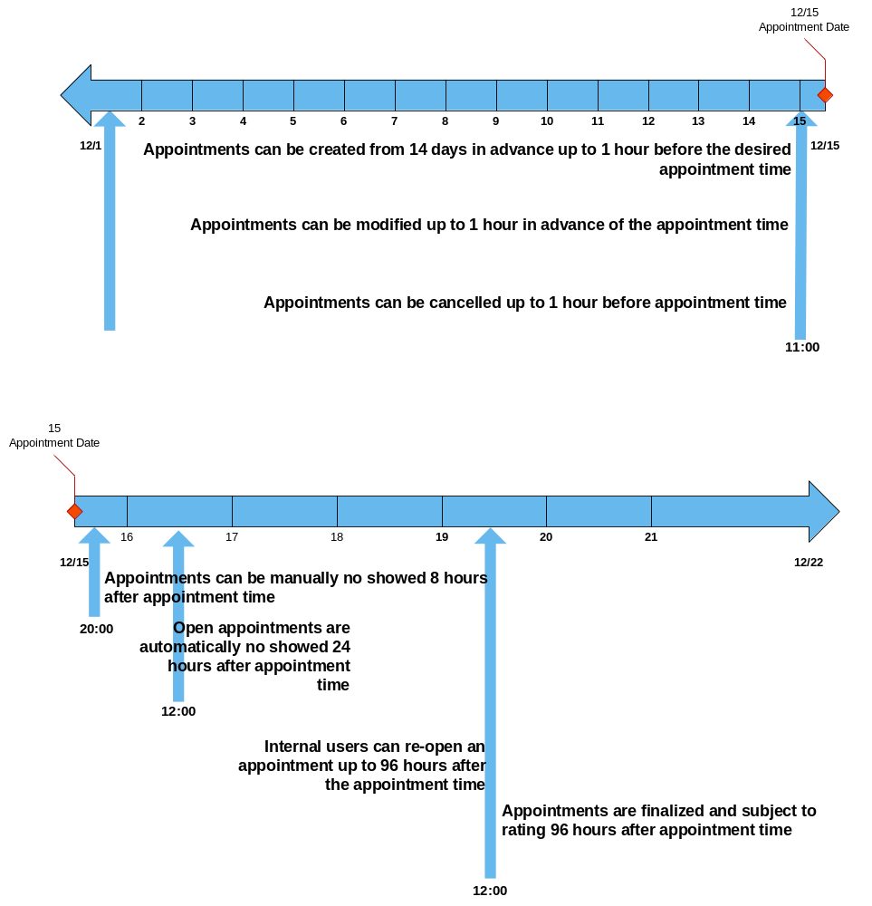

Note:
Appointments can not be manually no showed prior to 8.01 hours after the scheduled appointment time, as that is considered a significantly late appointment.

The following calendar displays the appointment and corporate rating timeline of events.

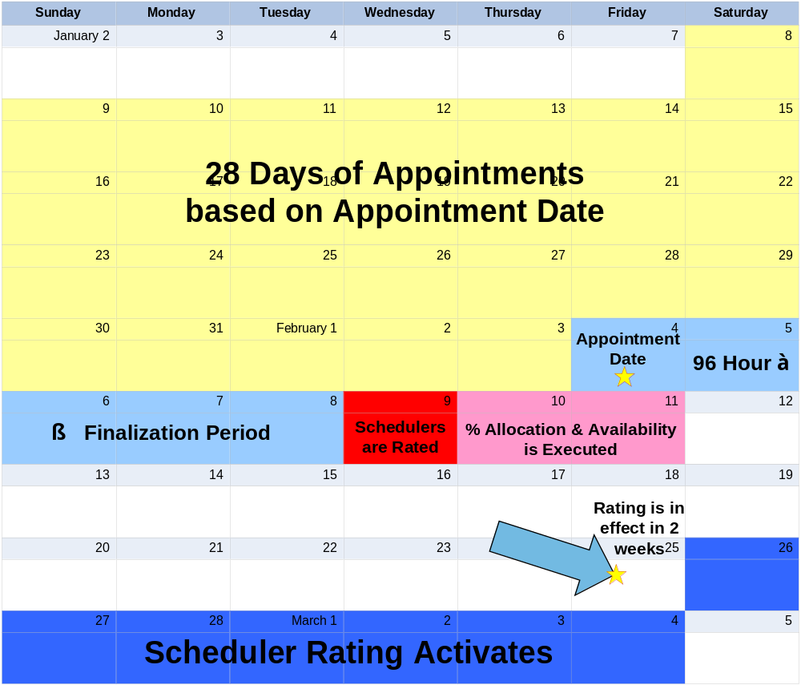

* Last appointment to be summarized is on Friday at midnight. USPS Operational week is from Saturday - Friday

11.0 Appendix
The Appendix contains the following sections:

11.1 – Security – Describes the different user groups for external customers
11.2 – PostalOne! User Guide – User Guide for the PostalOne! system
11.3 – PostalOne! Technical Guide – Technical Guide for the PostalOne! system
11.4 – Glossary – List of the relevant terms and their definitions used in FAST

11.1 Security

FAST uses different security types to ensure certain functionality within FAST is accessible to the appropriate user. This maintains data integrity in the system to guarantee the appointment or facility information a user wishes to view, create or edit is correct and has not been manipulated by unauthorized persons.

FAST allows login by two main groups of users – internal and external. Internal users are USPS employees and external users are USPS customers.
The following section describes the different types of external users and what they are able to access in FAST.

External Users

External users are divided into the following user groups in FAST:

- Corporate users – Users with the ability to view, create and update appointment data for all schedulers who are associated to their corporation. They may not view appointment data or create reports for any other corporations.

- Scheduler users – Users with the ability to view, create and update appointment data for themselves only. They may not view appointment data or create reports for any other schedulers.

External users are restricted to viewing only appointment information in FAST that is associated with that specific user. For example, a report generated by an external user only displays results that are directly related to the user. If the user generates the Facility Schedule Report, the report would only show the appointment information that was scheduled by that person (if the user is a scheduler) or by the scheduler associated to the user’s corporation (if the user is a corporate user).

The external user groups may be granted read-only access, read-only/restricted access or restricted access. Read-only access allows the pages to be viewed but not managed. Read-only/restricted access allows only pages that are associated to the user to be viewed only. Restricted access allows the pages to be viewed and to be managed if the information is associated to the user.

The graph shown on the following page displays the different areas and FAST and the access level for each user group.

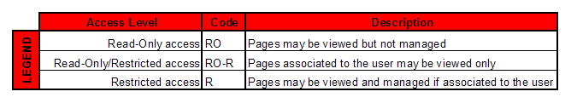

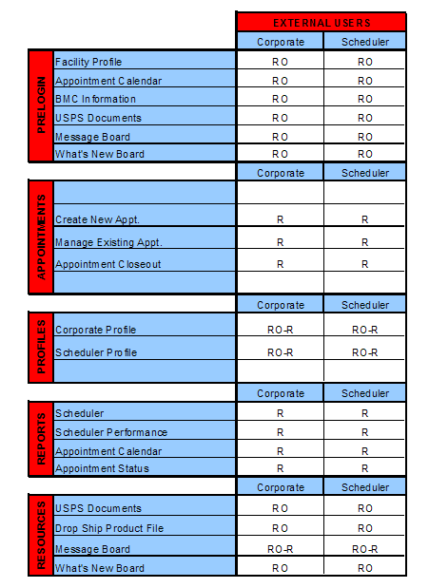
11.2 Glossary

Address Management System (AMS) - An application that allows USPS users to update the master addressing database; the AMS database is a repository of all deliverable mailing addresses in the United States and its affiliated territories, and their associated ZIP Codes, ZIP+4 Codes and city/state names.

Administration User - USPS employee that is an internal user with full access to all areas of FAST to view and edit information.

Appointment Number - A sequential number assigned when an appointment has been scheduled in FAST; must be included on the PS Form 8125; the PS Form 8125-CD, or the delivery receipt form with all associated PS Form 8125s attached.

Appointment Score - Numeric scores given to individual appointments to rate how efficiently the appointment was scheduled and managed; used in customer rating.

Appointment Status - Indicates the current standing of the appointment; Open, Closed, Cancelled, No Show, Unscheduled, Rejected.

Area Distribution Center (ADC) - A mail processing facility that receives and distributes mail destined for specific ZIP Codes under the Managed Mail Program (MMP).

Area User - USPS employee that is an internal user with full access to view all areas of FAST (except Administration) and may edit appointment and facility information for records at facilities in their designated area

Auxiliary Service Facility (ASF) - A facility that performs the same function as a Bulk Mail Center (BMC) in an area where volume is not sufficient to support the construction of a BMC.

Bill of Lading Number - The number associated to the bill of lading document; the document is issued by the facility to the appointment's shipper, listing and acknowledging receipt of goods for transport and specifying terms of delivery.

Bulk Mail Center (BMC) - A highly mechanized mail processing plant that distributes (1) Standard Mail in piece and bulk form, (2) Package Services Mail in piece form, (3) and Periodicals Mail in bulk form.

Cancellation Number - A confirmation number generated by FAST that is associated to a cancelled appointment.

Closed Appointment - A scheduled appointment that arrived at the correct destination facility and unloaded successfully.

Content – A set of information describing the mail associated with a PS Form 8125 or a line on the PS Form 8125-CD. An appointment may have multiple contents associated to it.

Content ID - The ID associated to a content set of information for an appointment.

Corporate User - USPS customer at a corporate level with the ability access, view, and edit records in FAST that are associated to all schedulers for the customer’s corporation and records created by the customer.

Daily Volume Constraints - The maximum number of mail per mail shape a facility can process in a day.
DDU

Default Constraints - The trip availability and daily volume constraints that are set for a facility as daily limits.
Delivery Unit - A post office, post office station, or office branch that accepts drop shipments.

Destination Area Distribution Center (DADC) – A rate category associated with the drop shipments to ADCs; (DMM L004).

Destination Bulk Mail Center (DBMC) – A rate category associated with the drop shipments to BMCs and ASFs; (DMM L601).

Destination Delivery Unit - A rate category associated with the drop shipments to Delivery Units; (no list).

Destination Sectional Center Facility (DSCF) - A rate category associated with the drop shipments to ADCs; (DMM L005).

Discontinued Date - The last date in a date range when the associated action is in effect
District User - USPS employee that is an internal user with access to view all areas of FAST (except Administration) and may edit appointment and facility information for records at facilities in their designated district.

Dock Slot (Slot) - An available time at a USPS facility for an appointment to be drop shipped.

Drop and Pick (D&P) - An appointment unique to DBMC drop shipments of bedload parcels, wherein the Postal Service waives the driver unload responsibility and allows a shipper to leave the trailer for postal unloading.

Drop Ship Web - An existing USPS application that manages the redirection of drop shipments.

Effective Date - The first date in a date range when the associated action is in effect.

Expiration Date - The date a Message Board message or What’s New Board posting is removed from the boards.

External User – A FAST user that is a USPS customer.

Facilities Database (FDB) - Repository of facility information such as a facility's physical characteristics, facility address and additional information.

Facility Constraints - The default and holiday/contingency constraints that are required for active facilities

Facility ID – The FAST generated ID associated to Postal Service facilities.

Facility User - USPS employee that is an internal user with full access to all areas in FAST (except Administration) and can edit appointment and facility information for their designated facility.

Finalized - The timeframe when an appointment can no longer be modified and is given an appointment score (96 hours past the scheduled appointment time).

Headquarters User - USPS employee that is an internal user with full access to all areas of FAST to only view information without editing.

Holiday/Contingency Constraints - The trip availability and daily volume constraints that are set for a facility when changes in constraint limits are needed for a short period of time.

In Home End Date - The end date of the timeframe when the mail should be delivered to the customer.

In Home Start Date - The start date of the timeframe when the mail should be delivered to the customer.

Internal User – A FAST user that is a USPS employee.

Late Appointment - An appointment that arrives 31 minutes after the scheduled appointment time up to two hours after the scheduled appointment time (see significantly late).

Mail Class – The class of mail associated to the appointment; Standard, Package Services, Periodicals.

Mail Integrity – The condition of the mail when it was dropped at the facility; matches to the Load Integrity Conditions section of the PS Form 8125.

Mail Owner ID - The owner of a mailing responsible for postage payment

Mail Preparer ID - The ID associated to the consolidator or printer of the mail

Mail Shape - The shape or shapes of mail associated with an appointment: Letters, Flats, Machinable Parcels, Non-Machinable Parcels, and Irregular Parcels.

Mailing - A group of mail pieces within the same mail class and mail processing category; a mailing may be split across multiple drop shipment appointments.

Major Content Discrepancy - Used to calculate appointment and scheduler rating; where the difference between the scheduled content and the actual content is more than 5 pallets or greater than 25% bedload.

Message Board - A messaging system for USPS Administrators to post messages for USPS facilities about facility related events or information; messages may be generic for all facilities or for specific facilities.

Minor Content Discrepancy - Used to calculate appointment and customer rating; where the difference between the scheduled content and the actual content is up to 5 pallets or less than 25% bedload.

Multi-Stop - A trip that contains multiple one stop appointments all carried by the same vehicle.

Multi-Stop ID - ID associated to the multi-stop trip to link each appointment within the multi-stop.

NASS Code - The National Air and Surface System (NASS) code associated to a USPS facility.

National User – USPS employee that is an internal user with full access to all areas in FAST (except Administration) and has the same rights as an area user but can be associated to multiple areas.

No Show - An appointment status when a scheduler fails to arrive within 8 hours of the scheduled appointment time at the destination facility.

Number of Pallet Positions - The number of positions on a trailer occupied by pallets.

On-Time Appointment - An appointment that arrives at the correct destination facility between 3 hours before the scheduled arrival time and up to 30 minutes after; Early arriving appointments are not guaranteed entry to a facility prior to the appointment time.

Open Appointment - A scheduled appointment that has not arrived at the destination facility and has not met any constraints to cause the appointment status to change.

Parcel Select – Package Services mail that is drop shipped at a destination entry rate.

Periodicals – Mail class associated to an appointment that contains publications and written work

Perishable - Content type associated to an appointment that contains products that are perishable

Plant Verified Drop Shipment (PVDS) - Procedure to enable origin verification and postage payment for shipments transported by the scheduler from the scheduler’s plant to destination post offices for USPS acceptance as mail. It is typically used for mailings for which a destination entry discount is claimed.

Post Date - The date a Message Board message or a What’s New posting is created and posted to the boards

PostalOne! - A system used to facilitate the integration of scheduler and Postal Service business processes to expedite mail and better support USPS and scheduler operations.

PS Form 8125 - The Plant Verified Drop Shipment (PVDS) Verification and Clearance formed containing the required appointment information for a drop shipment and is required for each content set of information within an appointment.

PS Form 8125-CD - A consolidated version of the PS Form 8125 where each set of content information on a PS Form 8125 is consolidated to one line in the PS Form 8125-CD.

Recurring Appointment - A drop shipment that is delivered to a destination office on a consistent frequency, on the same day or day(s) at the same time of day; The content of drop shipment must be consistent in terms of mail class, size, volume, containerization (pallets, pallet boxes, etc), and mode of transportation.

Recurring Appointment ID - Unique ID that is associated to one appointment instance in an approved recurring appointment record; Format is: Recurring Sequence ID + R + Date (MMDD).

PS Form 6241 - A form for USPS customers to provide the required appointment information, mailing information and frequency information to request a recurring appointment at a given facility; A link to the form is available through FAST. (Also known as the Recurring Appointment Request form)

Recurring Appointment Sequence Number - Sequential ID that is associated to every appointment instance within an approved recurring appointment series.

Rejected Appointment - An appointment that does not meet the criteria to be unloaded at a facility upon arrival.

Scheduler ID - ID associated to the scheduler user.

Scheduler Rating - A score given to each scheduler at each destination facility; rewards high performing schedulers with more dock slot options when scheduling an appointment.

Scheduler User - USPS customer that is an external user with the ability to view, create and update appointment data for appointments to which they are associated.

Sectional Center Facility (SCF) - A postal facility that serves as the processing and distribution center (P&DC) for post offices in a designated geographic area as defined by the first three digits of the ZIP Codes of those offices. Some SCFs serve more than one 3-digit ZIP Code range.

Shipper Location ID - A field on the PS Form 8125 and TIMES browser to hold the ID of the appointment's originating scheduler; this is the FAST scheduler ID of the appointment.

Shipper Name - The name of the appointment’s transporting company.

Significant Volume Change – A change to volume amount in a scheduled appointment; used to calculate appointment and scheduler rating.

Significantly Late - When the appointment arrives between 2.01 hours after the scheduled arrival time and up to 8 hours after the scheduled arrival time.

Tier - The score range a scheduler is placed into for each destination facility; used to calculate the percentage of slots the scheduler should be allocated at the given facility.

Transportation Information Management Evaluation System (TIMES) - An application that maintains all appointment arrival data in order to support other USPS systems that require the data.

Trip Availability Constraints - The number of available appointments, dock slots the dock may process per hour per appointment type (dock slot constraints).

Unscheduled Arrival - A drop shipment that arrives at a facility without a booked appointment for that facility.

Vehicle ID - The ID associated to the appointment's transporting vehicle.

Web Services - An interface between schedulers, PostalOne! and FAST that enables schedulers to submit appointment request through an electronic messaging system without accessing the FAST online application.

What’s New Board – A message posting system where administrators of the FAST system may display system-related information.

11.3 PostalOne! User Guide

PostalOne!® Facility Access and Shipment Tracking (FAST)
User Guide
Fast User Guide Table of Contents
1.0. FAST Welcome 244
1.1. About FAST 244
1.2. Applying for Participation 245
1.3. Site Administrator Responsibilities 245
1.4. Contact Us 245
1.5. Helpful Links 246
2.0 Introduction 246
2.1 Overview 246
2.2 Document Summary 246
2.3 Assumptions and Constraints 247
2.4 References 247
3.0 Business Scenarios 248
3.1 Shipper Queries for Open Appointment Slots 248
3.2 Shipper Requests to Schedule an Appointment 249
3.3 Shipper Updates an Appointment 250
3.4 Shipper Cancels an Appointment 251
3.5 Shipper Request a Single Appointment Close-Out 252
3.6 Shipper Request All Scheduled and Unscheduled Appointment Close-Out 253
3.7 Shipper Request Appointment Reply(s) Where Initial Request Timed Out 254

1.0. FAST Welcome

On behalf of Postal Service™ Facility Access and Shipment Tracking (FAST) and the PostalOne!® teams, we would like to welcome you into the program. We appreciate your feedback and look forward to working with you to improve the way we do business.

This document is a comprehensive user guide that explains how to use the functionality available to our customers for communicating in an automated fashion, via the PostalOne! system, with the Facility Access and Shipment Tracking system. The features described in this guide have been developed for the U. S. Postal Service customers who wish to conduct business electronically.

About FAST
FAST is an initiative that will improve the drop shipment process and decrease dock wait times, and is intended to replace Drop Shipment Appointment System (DSAS) by summer, 2005. FAST enables mailing shipment schedulers to inquire, create, update, and cancel appointment requests for plant verified drop shipments, as well as provide all necessary details about the mailing contents related to the appointments. The FAST system will provide up-to-date information about what mail can be entered at which facilities and provides request responses, status of appointments, and closeout information back to the schedulers.

Through the FAST website, the Postal Service will manage appointments, proactively manage operations at facilities, and control overall transportation management processing. FAST will provide the Postal Service with a system for rating the timeliness and accuracy of your shipping activities. Reports will provide specific information on the actual content of the mailing received, compared to the content information provided at the time of the appointment. Arrival time, date and destination accuracy will also be provided in reports available online. More scheduling options are available for schedulers with high accuracy ratings.

All customers needing access to the FAST system will be required to become participants of the PostalOne! system. Once your PostalOne! account has been established, you will be able to access FAST appointment-related services as follows:

- FAST website online scheduling - After logging into the PostalOne! system, schedulers go directly to the FAST website to schedule appointments online. Using this online option, all appointment and content information will be entered manually by the customer. With this method, there is no communication of information through the PostalOne! system other than login authentication.
- PostalOne! automated data exchange capability - Once a scheduler has logged on the PostalOne! system, the scheduler will send appointment and content information, using the PostalOne! system Web Services capabilities. The schedulers must make sure that they are sending the Web Services messages to the PostalOne! system with the SchedulerId and SchedulerCorpId that is provided to them via e-mail by the PostalOne! system at the time of their user registration. The PostalOne! system passes this information to FAST. Appointment availability is determined, and the appropriate response message is sent from FAST via the PostalOne! system back to the customer.

Customers using the suite of electronic services provided by the PostalOne! system (i.e. postage payment, eDocumentation) will be able to leverage their existing information (either Mail.dat) within the PostalOne! system to facilitate their appointment scheduling process. Information on Web Services messaging in accordance with the industry developed Mail.dat Transportation Messaging Specification, Version 1.0 is available at http://www.idealliance.org/maildat. Version 1.0 defines formats and methods for message exchange and summarizes the Transportation Messaging interface with FAST.

Applying for Participation

FAST utilizes the PostalOne! portal and users must register as a FAST user through the PostalOne! system to schedule appointments or access shipment information. It’s as easy as visiting the PostalOne! home page at www.usps.com/postalone and on the right corner, under New Customers Apply for a PostalOne! Account, click on the Learn More button. There, you will find additional information about the program and application process. Then click on Apply Online. If you have questions about the online application process, call our Customer Care Center at (800) 522-9085.

After completing your online application
Our Customer Care Center will review your online application to ensure that we have accurately established your account. Within 24-48 hours of completing your online application, you will receive a FAST Welcome Kit containing:
PostalOne! Data Exchange Agreement - an agreement between your company and the Postal Service that outlines the terms and conditions for participating in the program.
Site Administrator Card - you will fill out a card to designate a coordinator to oversee administrative requirements and user access. The designated corporate site administrator will receive a site administrator welcome kit with information and forms for user access.
Customer Request for Web Access, PS Form 1357-C - a form to be completed and signed by each new user applying for access to the PostalOne! system. A signed hardcopy must be mailed to the Customer Care Center after your required approval signatures are obtained.

Customer Account Activation - When all required forms have been signed and processed by the Customer Care Center, your account will be activated. The Customer Care Center will send the site administrator all usernames and passwords via e-mail.

Site Administrator Responsibilities

The site administrator role is a critical part of your company’s transition to access FAST through the PostalOne! system. The site administrator is the key contact for your company and is responsible for coordinating system administration within your company. This person also must approve all requests for computer access to the PostalOne! system within your company. The excerpts below are taken from the user agreement. For more information, please read the entire user agreement.

Site Administrator The participant will appoint a site administrator to administer participant’s access and use of the PostalOne! system. Participant will provide the PostalOne! Customer Care Center with the name of, and contact information for its site administrator by completing the Site Administrator Information Card.
Site Administrator Responsibility Participant or site administrator will (a) accept logon IDs from the PostalOne! Customer Care Center on behalf of its users, (b) be responsible for activating and deactivating its users’ logon IDs, and (c) be responsible for assigning the appropriate access levels to its users.
Site Administrator Obligations Participant or site administrator will advise its users of their obligations under this agreement.
Personnel Change Site Administrator Participant shall notify the PostalOne! team in writing when a site administrator leaves employment at participant’s company. If participant fails to notify the PostalOne! team, participant is liable for any loss sustained by the Postal Service and any other third-parties resulting from the subscriber's failure to submit such notification.

Contact Us

The Postalone! system is responsible for the “user” management and the automated data exchange process (Web Services) for the FAST system. If you are experiencing problems with:

- Applying to be a FAST user,
- System access (i.e., user ID or logon process, data transfer)
- The Web Service communication (i.e. data transmission, transmission errors, data receipt) process to and from the FAST system

Please contact the PostalOne! Customer Care Center at (800) 522-9085 and at the prompt,
press 1.

- - - - - - -

The FAST system is responsible for the overall business functionality of the system. If you are experiencing problems with:

- The FAST Web application
- Appointment scheduling and management
- Information or data content
- Reports or rating assessments

Please contact the FAST Help Desk at 1-800-USPSHELP.

Helpful Links

Access information about IDEAlliance®, Mail.dat® and the Transportation Messaging Specification, Version 1.0 at http://www.idealliance.org/maildat.

More information about FAST, the PostalOne! system and how to apply for access is available at www.usps.com/postalone.

Access to the PostalOne! – FAST Technical Guide, and PostalOne! – FAST IDEAllliance Appendix is provided on the left menu bar at https://cat.uspspostalone.com/fastxml/index.cfm

Introduction

2.1 Overview
This document will define the business scenarios for PostalOne!® implementation of the IDEAlliance transportation Web Services, and the IDEAlliance supported error messages for each Web Services message.

Document Summary

This section will describe all of the Postal Service supported IDEAlliance TM(s) business scenarios. Shippers will know how to use each business service within their mailing business model. For each business scenario, there will be a constraints section that describes any limitations the Postal Service will impose on these IDEAlliance business services that are not documented in the IDEAlliance TM document.

The IDEAlliance Business Process Workflows will define the following list of business scenarios and associated IDEAlliance TMs used to perform Facility Access and Shipment Tracking (FAST) appointment scheduling activities. Shipper business scenarios associated with using the IDEAlliance transportation Web Services are:
- Shipper Queries USPS Facility For Open Appointment Slots
- Shipper Requests An Appointment With a USPS Facility
- Shipper Updates an Appointment
- Update an Appointment Mail Contents
- Shipper Cancels an Appointment
- Shipper Requests Appointment Close-Out Information
  - Shipper Requests an Exact Appointment Close-Out
  - Shipper Requests All Appointment Close-Outs
- Shipper Requests Status Appointment Replies When Initial Process Times-out

Assumptions and Constraints

- It is the responsibility of the shipper to keep the Mail.dat data synchronized with the mail contents Web Services request.
- The list of assumptions and constraints will expand.

References

- Mail.dat Transportation Message Protocol, Data Dictionary Specification, Version 1.0, 2004 11 10.
- Mail.dat Transportation Message Protocol, Primer: Introduction and Overview, Version 1.0, 2004 11 10.
- Mail.dat Transportation Message Protocol, Transportation Messaging Specification, Version 1.0, 2004 11 10.
- Mail.dat Transportation Message Protocol, XML Specification, Version 1.0, 2004 11 10.
- Mail.dat Transportation Message Protocol, Fault and Return Information Specification, Version 1.0, 2004 11 10.
- PostalOne! - FAST IDEAlliance Appendix (Version 1.2).doc, 2004 11 16.
PostalOne! - AppointmentServices.wsdl, 2004, 11 12. This will be updated when the PostalOne! URL for FAST Web Services is finalized and is available.

3.0 Business Scenarios

3.1 Shipper Queries for Open Appointment Slots
In the mailing business model, a shipper will need to perform entry point planning to drop off mail jobs at Postal Service facility locations. In creating an entry point plan, the shipper will need the capability to query a Postal Service facility for open appointment slots. To model the query for open appointment slots business logic into a business workflow, the shipper will implement the DeliveryApptQueryRequest message and DeliveryApptQueryResponse Web Services. Figure 2.1 shows the business process for performing a query for open appointment facility slots for a specific mail load.

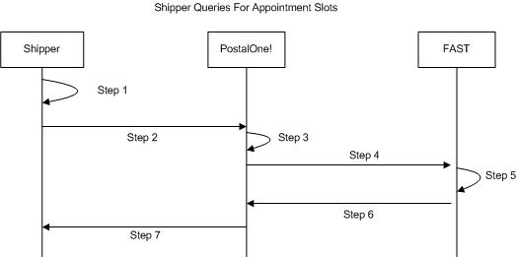
Figure 0-1 – Shipper Queries For Open Appointment Slots

- The shipper will populate the DeliveryApptQueryRequest Web Services data elements which include the Postal Service facility and mail contents to be delivered.
- The shipper will send the DeliveryApptQueryRequest request to the PostalOne! system.
- The PostalOne! system will check if the maildatSummary block(s) -> IncludedInSummarization flag equals “NO.” If so, the PostalOne! system will check if the maildatSummary section has all required values (User License Code, Job ID, Database Container ID, and ZIP+4) to retrieve the Mail.dat data from the PostalOne! database. After validating required values, the PostalOne! system will populate the USPSSummary information with stored Mail.dat data.
- The PostalOne! system will send the DeliveryApptQueryRequest message to FAST.
- FAST will check the facility availability for the specified date/time in the optionalAppt block and the facility’s capacity to receive the mail load.
- FAST will send the PostalOne! system back a DeliveryApptQueryResponse which will indicate if the specified Postal Service facility has the open appointment slot and can handle the mail load. In the future, FAST will be able to send multiple available appointments information. Currently, FAST will only provide one available slot info.
- The PostalOne! system will send the response back to the shipper.

3.2 Shipper Requests to Schedule an Appointment
Shippers will need the capability to schedule an appointment to notify a Postal Service facility of mailing(s) drop-off. Shippers will use DeliveryApptRequest and DeliveryApptResponse messages to incorporate appointment scheduling business logic into their business workflow process. Figure 2.2 shows the sequence of events for scheduling an appointment request.

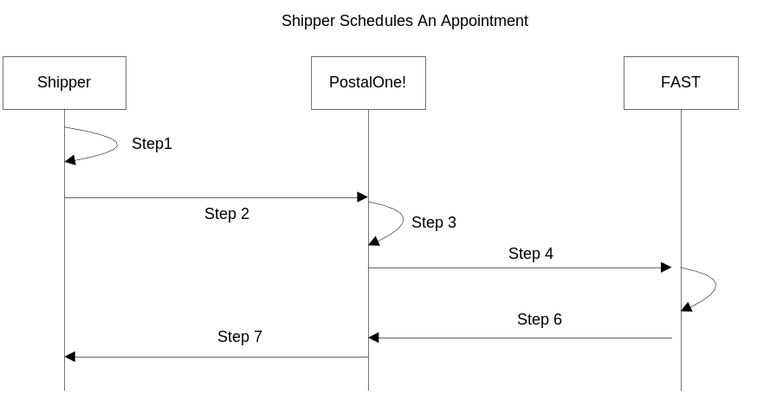

Figure 0-2 – Shipper Request to Schedule an Appointment

- The shipper will populate the DeliveryApptRequest Web Services data elements.
- The shipper will send the DeliveryApptRequest to the PostalOne! system.
- The PostalOne! system will check if the maildatSummary block(s) -> IncludedInSummarization flag equals “NO.” If so, the PostalOne! system will check if the maildatSummary section has all required values (User License Code, Job ID, Database Container ID, and ZIP+4) to retrieve the Mail.dat data from the PostalOne! database. After validating required values, the PostalOne! system will populate the USPSSummary information with stored Mail.dat data.
- The PostalOne! system will send the DeliveryApptRequest message to FAST.
- FAST will check the facility appointment availability for the specified date/time in the DeliveryApptRequest message and mail volume associated to the appointment. If the facility can accommodate the appointment request, FAST will schedule an appointment at that particular Postal Service facility, and populate the response in a DeliveryApptAccept block. If accommodation is not available, FAST will reject the appointment request and populate the response in a DeliveryApptReject block.
- FAST will include either the DeliveryApptAccept or DeliveryApptReject block in a DeliveryApptResponse message and send it back to the PostalOne! system.
- The PostalOne! system will send the DeliveryApptResponse message back to the shipper.

Shipper Updates an Appointment
As shippers produce the mailings or prepare transportation, they will need to update the appointment information, for example the header, mail content or trailer. Shippers will use the DeliveryApptUpdate message to update an appointment’s mail content, date, time, or facility. The Consignee will send shippers update appointment responses using the DeliveryApptUpdateResponse message. Figure 2.3 shows the sequence of events for making an appointment update.

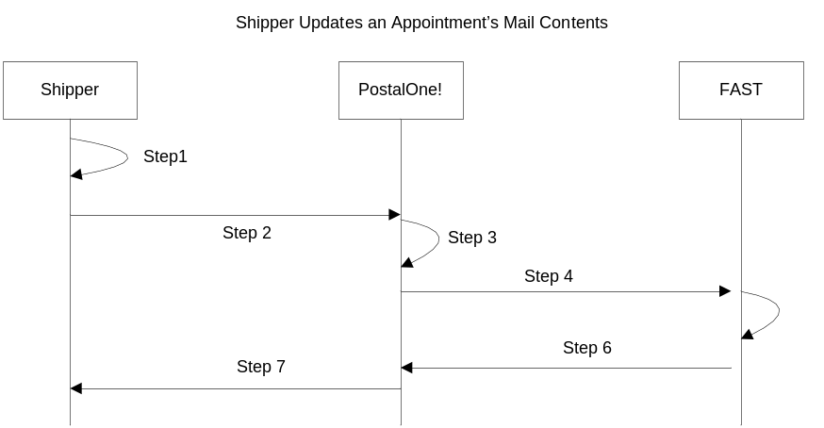
Figure 0-3– Shipper Updates an Appointment
- The shipper will populate the DeliveryApptUpdate Web Services data elements to update an appointment’s mail content, date, time, or facility.
- The shipper will send the DeliveryApptUpdate message to the PostalOne! system.
- The PostalOne! system will check if the maildatSummary block(s) -> IncludedInSummarization flag equals “NO.” If so, the PostalOne! system will check if the maildatSummary section has all required values (User License Code, Job ID, Database Container ID, and ZIP+4) to retrieve the Mail.dat data from the PostalOne! database. After validating required values, the PostalOne! system will populate the USPSSummary information with stored Mail.dat data.
- The PostalOne! system will send the DeliveryApptUpdate message to FAST.
- FAST will check the facility’s appointment availability for the specified date/time in the DeliveryApptUpdate and mail volume associated to the appointment. If the facility can accommodate the update appointment request, FAST will update the scheduled appointment and populate a DeliveryApptUpdateAccept block with the response information. If the Postal Service facility can not accommodate the appointment’s updated mail content, then FAST will put the rejection response in a DeliveryApptUpdateReject block.
- FAST will include either the DeliveryApptUpateAccept or DeliveryApptUpdateReject block in a DeliveryApptUpdateResponse message and send it back to the PostalOne! system.
- The PostalOne! system will send the response message back to the mailer.

Shipper Cancels an Appointment
As shippers produce or prepare transportation for mailings, they might run into problems or delays causing the shipper to cancel an existing appointment. Shippers will only be able to cancel a whole appointment. Shippers will use the DeliveryApptCancelRequest message to request an appointment to be canceled. A Consignee will send a DeliveryApptCancelResponse message back to a shipper indicating if the appointment was successfully canceled. Figure 2.4 shows the sequence of events for canceling an appointment.

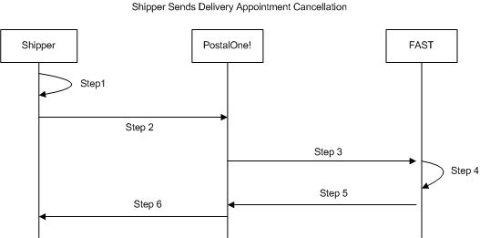
Figure 0-4– Shipper Cancels an Appointment

- The shipper will populate the DeliveryApptCancelRequest Web Services data elements.
- The shipper will send the DeliveryApptCancelRequest message to the PostalOne! system
- The PostalOne! system will route the message request to FAST.
- FAST will cancel the appointment.
- FAST will send a DeliveryApptCancelRequest message back to the PostalOne! system which will contain a cancelConfirmID indicating whether or not the appointment was successfully canceled.
- The PostalOne! system will send the message response back to the shipper.

Shipper Request a Single Appointment Close-Out
When a shipper’s mail job has arrived at a Postal Service facility, a dock clerk will close the appointment using TIMES. This system will send the appointment close-out information to FAST which will send the information to the PostalOne! system. A shipper will use the DeliveryApptStatusRequest message to request a single appointment close-out for the following types of appointment close-outs: an on-time scheduled appointment, a no-show appointment, or a rejected scheduled appointment. When a consignee receives a DeliveryApptStatusRequest message, the consignee will process the appointment close-out request message, populate a ConsigneeGoodsReceipt data type with the appointment close-out information, and send aDeliveryApptStatusResponse message back to the shipper that includes the ConsigneeGoodsReceipt data type. Refer to the business rules and constraints section below for specific business logic, rules, and constraints associated with this type of Web Services. Figure 2.5 shows the business process sequence for shippers receiving appointment close-out information from the PostalOne! system.

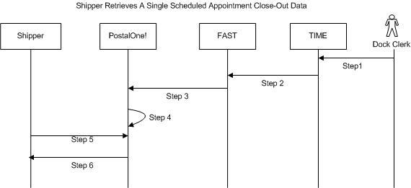
Figure 0-5- Shipper Receives An Appointment Close-Out
- The dock clerk enters an appointment close-out date and time into TIMES.
- TIMES system sends the appointment close-out data to FAST.
- FAST populates ConsigneeGoodsReceipt message with the appointment close-out data and enters the ConsigneeGoodsReceipt message into the PostalOne! message queue.
- The PostalOne! system receives the ConsigneeGoodsReceipt message and stores the data.
- Shippers and the PostalOne! system will have business rules established where the shipper can pull the PostalOne! system every 15 minutes for the appointment close-out data based on the scheduled induction date and time. The shipper will send a DeliveryApptStatusRequest to the PostalOne! system.
- The PostalOne! system will receive the request and send a DeliveryApptStatusRequest message back to the shipper with the included ConsigneeGoodsReceipt data type containing the appointment close-out data.

Shipper Request All Scheduled and Unscheduled Appointment Close-Out
A Shipper can receive scheduled and unscheduled appointment close information by sending the PostalOne! system an AllDeliveryApptCloseoutRequest message. The PostalOne! system will retrieve all of the shipper’s appointment close-out and send the information back to the shipper in an AllDeliveryApptCloseoutResponse message. A shipper can use the AllDeliveryApptCloseoutRequest message to retrieve the following types of appointment close-out information: an on-time scheduled appointment, a no-show appointment, a rejected scheduled appointment, or unscheduled appointments. Refer to the business rules and constraints section below for specific business logic, rules, and constraints associated with Web Services. Figure 2.6 shows the business process sequence for shippers receiving appointment close-out information from the PostalOne! system.

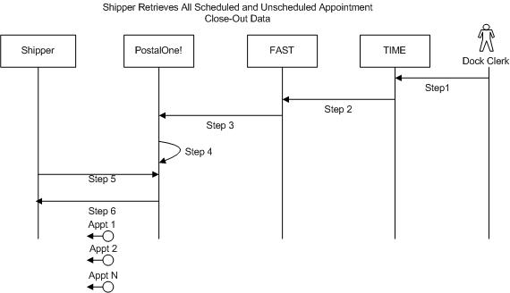

Figure 0-6- Shipper Receives An Appointment Close-Out

- The dock clerk enters an appointment close-out date & time into TIMES.
- TIMES system sends the appointment close-out data to FAST.
- If the appointment close-out is a scheduled appointment, FAST populates a ConsigneeGoodsReceipt message with the appointment close-out data. If the appointment close-out is an unscheduled appointment, FAST populates an UnscheduledConsigneeGoodsReceipt message with the appointment close-out data. FAST will put both messages, ConsigneeGoodsReceipt and UnscheduledConsigneeGoodsReceipt, on the PostalOne! message queue.
- The PostalOne! system receives the ConsigneeGoodsReceipt or UnscheduledConsigneeGoodsReceipt messages and stores the data.
- Shippers and the PostalOne! system will have business rules established where the shipper can poll the PostalOne! system every 15 minutes for the appointment close-out data. The shipper will send the PostalOne! system an AllDeliveryApptCloseoutRequest.
- The PostalOne! system will receive the request, retrieve all shipper scheduled and unscheduled appointment close messages based on corporation ID, and send a AllDeliveryApptCloseoutResponse message back to the shipper with all of the included ConsigneeGoodsReceipt and/or UnscheduledConsigneeGoodsReceipt data types.

Shipper Request Appointment Reply(s) Where Initial Request Timed Out
When the PostalOne! system receives an appointment request, it will process this request in synchronous mode first. If the session times out, the PostalOne! system will send a session time-out response to the shipper with a unique tracking ID in the fault block. If the shipper wishes to receive the appointment response associated to an initial request that timed out, the shipper will have to implement the USPS RetrieveApptRepliesRequest message where the shipper supplies at least one unique tracking ID in the message. The shipper will send the RetrieveApptRepliesRequest message to the PostalOne! system which will retrieve all the appointment response(s) associated to the listed unique tracking IDs. The PostalOne! system will put all the appointment response messages in a RetrieveApptRepliesResponse message and send it back to the shipper. Otherwise, the shipper will have to retrieve the appointment response information directly from the FAST website.

Figure 2.7 shows the business process sequence for shippers receiving appointment close-out information from the PostalOne! system.

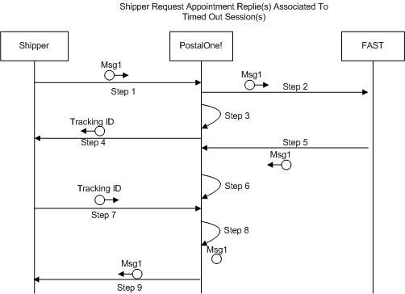
Figure 0-7- The shipper Request Appointment Response(s) Associated To Session Timed Out

- The shipper sends an appointment request message to the PostalOne! system.
- The PostalOne! system receives the message and sends the message to FAST.
- The PostalOne! session times out waiting for a reply message.
- The PostalOne! system sends an HTTP response time-out message with a unique tracking ID in the SOAP Fault message block back to the shipper.
- FAST finishes processing the appointment request and sends a response back to the PostalOne! system.
- The PostalOne! system receives the message and stores the data.
- Based on business rules defined between shippers and the PostalOne! system, shippers will periodically send a RetrieveApptRepliesRequest to the PostalOne! system, with at least one unique tracking ID referencing the appointment response associated to an initial appointment request where the session timed out.
- The PostalOne! system will receive the tracking IDs, retrieve the appointment response(s), populate all the appointment response(s) associated to the list of supplied unique tracking IDs into a RetrieveApptRepliesResponse message.
- The PostalOne! system will send the RetrieveApptRepliesResponse message containing all the appointment response(s)back to the shipper.

11.4 PostalOne! Technical Guide

PostalOne!® Facility Access and Shipment Tracking
Technical Guide

Version 1.0
January 2005

Fast Technical Guide Table of Contents
1 FAST WELCOME 258
1.1 Facility Access and Shipment Tracking (FAST) Welcomes You 258
1.2 FAST Program Overview 258
1.3 PostalOne! FAST Web Services 259
1.4 Simple Object Access Protocol 259
1.5 Web Services Definition Language 259
1.6 FAST Functional Architecture 259
1.7 PFWS Structure 260
2 Introduction 261
2.1 Overview 261
2.2 Document Summary 262
2.3 Assumptions and Constraints 262
2.4 References 262
3 Business Scenarios 263
3.1 Getting Ready for PostalOne! FAST Web Services 263
3.2 Fault Element 263
3.3 Scheduler Queries for Open Appointment Slots 263
3.4 Scheduler Requests to Schedule an Appointment 267
3.5 Scheduler Updates an Appointment 271
3.6 Scheduler Cancels an Appointment 275
3.7 Scheduler Request a Single Appointment Close-Out 277
3.8 Scheduler Request All Scheduled and Unscheduled Appointment Close-Out 279
3.9 Scheduler Request Appointment Reply(s) Where Initial Request Timed Out 281

1 FAST WELCOME

1.1 Facility Access and Shipment Tracking (FAST) Welcomes You
On behalf of Facility Access and Shipment Tracking (FAST) and the PostalOne!® team, we would like to welcome you into the program. We appreciate your feedback and look forward to working with you to improve the way we do business. If you need assistance, our Customer Care Center can be contacted at (800) 522-9085.

This document is a comprehensive technical guide that explains how to use the functionality available to our customers for FAST Web Services via the PostalOne! system. The features described in this guide have been developed for the Postal Service™ customers who wish to conduct business electronically. Access to the FAST User Guide, and PostalOne! – FAST IDEAllliance Appendix is provided on the left menu bar at https://cat.uspspostalone.com/fastxml/index.cfm

FAST Program Overview
FAST, an alternative to using the Drop Shipment Appointment System (DSAS) system, is a Postal Service initiative that will improve the drop shipment process and decrease dock wait times. FAST enables schedulers to inquire, create, update, and cancel appointment requests for plant verified drop shipments, and to also provide all necessary details about the mailing contents related to the appointments. The FAST system will provide up-to-date information about what mail can be entered at which facilities and provides request responses, status of appointments, and closeout information back to the schedulers.

Through the FAST website, the Postal Service will manage appointments, proactively manage operations at facilities, and control overall transportation management processing. FAST will provide the Postal Service with a system for rating the timeliness and accuracy of your shipping activities. Reports will provide specific information on the actual content of the mailing received, compared to the content information provided at the time of the appointment. Arrival time, date and destination accuracy will also be provided in reports available online. More scheduling options are available for schedulers with high accuracy ratings.

Once your PostalOne! account has been established, you will be able to access FAST appointment-related services as follows:

- FAST website online scheduling - After logging into the PostalOne! system, schedulers go directly to the FAST website to schedule appointments online. Using this online option, all appointment and content information will be entered manually by the customer. With this method, there is no communication of information through the PostalOne! system other than login authentication.

- PostalOne! Web Services data exchange capability - Once a scheduler has logged on the PostalOne! system, the scheduler will send appointment and content information, using Web Services, to the PostalOne! system. The PostalOne! system passes this information to FAST. Appointment availability is determined, and the appropriate response message is sent from FAST via the PostalOne! system back to the customer.

Customers using the suite of electronic services provided by the PostalOne! system (i.e. postage payment, eDocumentation) will be able to leverage their existing information (Mail.dat®) within the PostalOne! system to facilitate their appointment scheduling process. Information on Web Services messaging in accordance with the industry developed Mail.dat Transportation Messaging Specification, Version 1.0 is available at http://www.idealliance.org/maildat. Version 1.0 defines formats and methods for message exchange and summarizes the Transportation Messaging interface with FAST.

PostalOne! FAST Web Services

The PostalOne! FAST Web Services (PFWS) allows customers to electronically submit scheduling requests via the Simple Object Access protocol (SOAP) over the Internet. The PostalOne! FAST Web Services is an alternative to using the DSAS system and manually populating the Mail.dat data with appointment numbers for notifying Postal Service operations organization about planned verified drop shipments. The PostalOne! FAST Web Services allows schedulers to inquire, create, update, and cancel the appointment requests for Plant Verified Drop Shipments while also providing all necessary details about the mailing containers related to the appointments. The PostalOne! FAST Web Services also allows the Postal Service to provide responses, status of appointments, and closeout information back to the schedulers. The PFWS will also make use of all of the transportation and scheduling data to rate the corporations/schedulers as to the overall performance of their Transportation Management interface with the Postal Service. Schedulers can use the http://fast.uspspostalone.com URL to send Web Services messages to FAST via the PostalOne! system. Schedulers may view the status reports and can also manually create appointments by going to the FAST Website at http://fast.usps.com (launch date February 21, 2005). Postal Service internal users of FAST can also go to the FAST website to manage appointments, proactively manage operations at facilities, help with overall transportation management processing and provide a rating system for rating Schedulers.

Simple Object Access Protocol
Simple Object Access Protocol (SOAP) 1.1 is a key enabler of Web Services through XML. SOAP enables the exchange of XML messages so that services can easily describe their capabilities and allow any other service, application or device on the Internet to easily invoke those capabilities. TM, working with SOAP, adds the mechanisms for the management of syndication on the Web. SOAP is being widely used as transport for Web Services related RPC. TM 1.0 is designed to layer its communications on SOAP. This will enable developers and users to take advantage of their existing communication infrastructure and management services while taking advantage of TM for their content distribution applications or content subscription activities. SOAP V1.1 became a W3C Recommendation on June 24, 2003.

Web Services Definition Language
Web Services Definition Language (WSDL) is an XML-based description language that currently describes RPC based end-points. This is currently being developed by W3C for extending RPC to enable messaging-style program end-points. TM 1.0 has an XML-based protocol for conversation between client and server. For TM 1.0, we are defining TM end-points with WSDL (either message-oriented or RPC-based or both). This will eliminate the need for TM client packages. Any WSDL to Java or any other programming language-based generator will be able to generate TM client interfaces in that programming language

FAST Functional Architecture

The following figure 1-1 shows the PostalOne! FAST functional architecture.


Login
Closeout
Request
Closeout
Request
PostalOne
!
Mailers
FAST
User
logs in
PO!?
Yes
No
Appointment
Request/Response
Registration
Update
Registration
Update
Login
Registration
Update
Login
Authentication
Request/response
Appointment
Request/Response
Customer Registration -
A mailer either creates a new PostalOne! registration or updates an existing registration profile. PFSTI sends new or updated
information to FAST.
Authentication -
AST Web Service Overview. USPSe her a call.
exploratory surgery) will set the course. I am praying that it was all containeUser logs in through PostalOne! website or goes directly to FAST website. In both instances, the user is authenticated through PFSTI.
Appointment Scheduled -
Mailers sends appointment schedules to PFSTI, which are than sent to FAST.
Closeout Messages -
FAST sends closeout messages to PFSTI, which are then sent to mailers.
1
2
3
4
1
2
3
4
Extraction
Validation
Authentication
Extension
Update
PFSTI

PFWS Structure

The PFWS is part of the overall PostalOne! application and provides customers with the business to business (B2B) capability of submitting postal documents through the Internet using a Web service over a secure connection (HTTPS) with the Postal Service. The PFWS uses the SOAP protocol to transmit information in an XML format that insures that the data can be sent and received by applications written in various languages and deployed on various platforms.
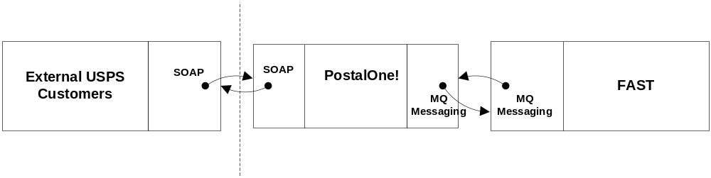
Figure 1-2. PostalOne! FAST Web Service Overview

PFWS is a stateless RPC-style Web service that accepts requests via the SOAP protocol using the HTTP bindings. PFWS uses an implementation of the SOAP 1.1 specification; therefore an application should be able to communicate with PFWS using any SOAP implementation that is compliant with the SOAP 1.1 specification. In addition, a client application should be able to be written in any language that has a SOAP implementation. Data is encoded using the SOAP encoding style as defined in section 5 of the SOAP 1.1 specification.

By using SOAP, the Web service de facto standard transmission protocols, the PFWS application allows Postal Service customers and commercial software vendors to develop SOAP-enabled custom software applications to generate postal transportation messaging documents and submit them electronically to the Postal Service PostalOne! system where, after format validation and in some cases after completion of messages via Mail.dat data, they will be passed to the FAST system. Once the FAST system processes the information, the FAST system sends messages back to the PostalOne! system and from there mailers can pull the messages. PFWS has opened up the ability for Postal Service customers to start performing actions on data without having to visit the FAST HTML-based application.

User Interface
The PFWS provides the capability to submit postal transportation messaging data electronically, so no user interface exists within the PostalOne! system to support such functionality. Each Postal Service customer must determine the best way to integrate the features of the PFWS into their own systems or to acquire third-party software capable of using PFWS features.

Functions and Processes
The PostalOne! FAST Web Services API consists of one major area of functionality, i.e. Transportation messaging, with its own Web Services Definition Language (WSDL) file that defines the objects and methods available. The different methods available are
- Query
- Create
- Update
- Cancel
- Closeout
The following sections in this guide describe each functional area in detail. The Web Services interface is described using WSDL. The WSDL document that describes the PostalOne! FAST Web Services can be found at the following location: Customer Acceptance Test (CAT) URL: https://cat.uspspostalone.com/fastxml/index.cfm

Introduction

Overview
This document will define the business scenarios for PostalOne!® implementation of the IDEAlliance® transportation Web Services, and the IDEAlliance supported error messages for each Web Services message.

Document Summary

This section will describe all of the Postal Service supported IDEAlliance TM(s) business scenarios. Developers will know how to use each business service within their mailing business model. For each business scenario, there will be a constraints section that describes any limitations the Postal Service will impose on these IDEAlliance business services that are not documented in the IDEAlliance TM document.

- See PostalOne! - FAST IDEAlliance Appendix (Version 1.0) for Postal Service specific assumptions and constraints.

The IDEAlliance Business Process Workflows will define the following list of business scenarios and associated IDEAlliance TMs used to perform Facility Access and Shipment Tracking (FAST) appointment scheduling activities. Scheduler business scenarios associated with using the IDEAlliance transportation Web Services are:
- Scheduler Queries USPS Facility For Open Appointment Slots
- Scheduler Requests An Appointment With a USPS Facility
- Scheduler Updates an Appointment
- Update an Appointment Mail Contents
- Scheduler Cancels an Appointment
- Scheduler Receives Appointment Close-Out Information
  - Scheduler Request an Exact Appointment Close-Out
  - Scheduler Request All Appointment Close-Outs
- Scheduler Requests Status Appointment Replies When Initial Process Times-out

Assumptions and Constraints

- It is the responsibility of the scheduler to keep the Mail.dat data synchronized with the mail contents Web Services request.
- It is the responsibility of the scheduler to keep track of SchedulerID and SchedulerCorpIds for its users who are responsible for sending Web Services messages to PostalOne! FAST.
- PostalOne! FAST Web Services are not completely supporting the IDEAlliance TM specifications. For further details, see PostalOne! - FAST IDEAlliance Appendix (Version 1.0) for Postal Service specific assumptions and constraints.
- The list of assumptions and constraints will expand.

References

- Mail.dat Transportation Message Protocol, Data Dictionary Specification, Version 1.0, 2004 11 10.
- Mail.dat Transportation Message Protocol, Primer: Introduction and Overview, Version 1.0, 2004 11 10.
- Mail.dat Transportation Message Protocol, Transportation Messaging Specification, Version 1.0, 2004 11 10.
- Mail.dat Transportation Message Protocol, XML Specification, Version 1.0, 2004 11 10.
- Mail.dat Transportation Message Protocol, Fault and Return Information Specification, Version 1.0, 2004 11 10.
- PostalOne! - FAST IDEAlliance Appendix (Version 1.0).
- PostalOne! - AppointmentServices.wsdl, 2004, 11 12.

Business Scenarios

Getting Ready for PostalOne! FAST Web Services

Before schedulers can send any Web Services messages to the PostalOne! system, all Web Services messages need to have a SchedulerId and SchedulerCorpId which is provided by the PostalOne! team at the time of customer registration. When a customer is successfully added to the PostalOne! system and user accounts are created, the user will be notified of his/her SchedulerId and SchedulerCorpId that “MUST” accompany all Web Services messages to the PostalOne! system. The SchedulerId represents a business role within the scheduler’s organization and the SchedulerCorpId represents the ID by which the PostalOne! system and FAST will recognize the customer’s corporation.

- See PostalOne! - FAST IDEAlliance Appendix (Version 1.0) for details.

Fault Element

The <Fault> element is designed to pass operational and implementation errors via the detail portion of SOAP Fault mechanism. The Fault has an optional TrackingID attribute which identifies the message that was interrupted by the fault and can be used for fault recovery. The Fault is made up of one or more Fault Codes with an optional Fault Description. See the error codes section with each specific Web Services message for PostalOne! and FAST specific fault or error codes and descriptions.

The following figure shows the Fault message structure.

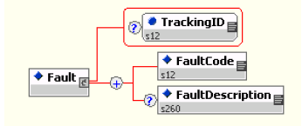
Fault Structure

Scheduler Queries for Open Appointment Slots

The following two figures show the DeliveryApptQueryRequest and DeliveryApptQueryResponse message structure.

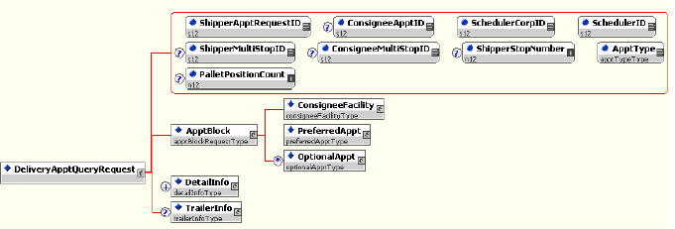
DeliveryApptQueryRequest

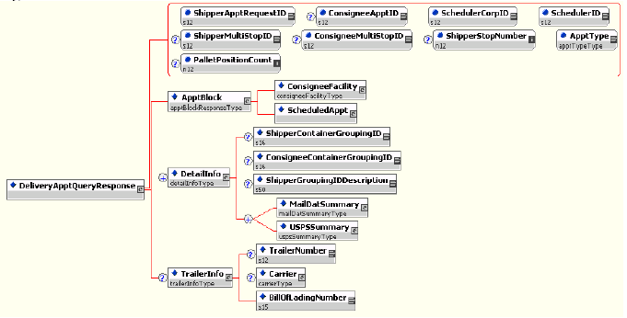
DeliveryApptQueryResponse

In the mailing business model, a scheduler will need to perform entry point planning to drop off mail jobs at Postal Service facility locations. In creating an entry point plan, the scheduler will need the capability to query a Postal Service facility for open appointment slots. To model the query for open appointment slots business logic into a business workflow, the scheduler will implement the DeliveryApptQueryRequest message and DeliveryApptQueryResponse Web Services. Figure 2.1 shows the business process for performing a query for open appointment facility slots for a specific mail load.

Figure 3-8 – Scheduler Queries For Open Appointment Slots

- The scheduler will populate the DeliveryApptQueryRequest Web Services data elements which include the Postal Service facility and mail contents to be delivered.
- The scheduler will send the DeliveryApptQueryRequest request to the PostalOne! system.
- The PostalOne! system will check if the maildatSummary block(s) -> IncludedInSummarization flag equals “NO.” If so, the PostalOne! system will check if the maildatSummary section has all required values (User License Code, Job ID, Database Container ID, and ZIP+4) to retrieve the Mail.dat data from the PostalOne! database. After validating required values, the PostalOne! system will populate the USPSSummary information with stored Mail.dat data.
- The PostalOne! system will send the DeliveryApptQueryRequest message to FAST.
- FAST will check the facility availability for the specified date/time in the optionalAppt block and the facility’s capacity to receive the mail load.
- FAST will send the PostalOne! system back a DeliveryApptQueryResponse which will indicate if the specified Postal Service facility has an open appointment slot and can handle the mail load.
- The PostalOne! system will send the response back to the scheduler.
PostalOne! Supported Error Conditions:

Error Condition |  | Error Carrier |  | Error Code
Web server not available |  | HTTP Response |  | HTTP: 404
Web service not available |  | HTTP Response |  | HTTP: 404
XML schema validation failed |  | SOAP Fault |  | TMErrorCode: 402
User authentication failed – Invalid user ID |  | SOAP Body |  | TMErrorCode: 412
User authentication failed – Invalid password |  | SOAP Body |  | TMErrorCode: 412
User authorization failed | SOAP Body |  | TMErrorCode: 412
Unrecognized operation Arguments – unexpected root element | SOAP Body |  | TMErrorCode: 408
Mail.dat user license code not supported by receiver | SOAP Body |  | TMErrorCode: 1100
Mail.dat job ID not in consignee database | SOAP Body |  | TMErrorCode: 1101
Mail.dat DatabaseContainerID not in consignee database | SOAP Body |  | TMErrorCode: 1102
Mail.dat verification ZIP+4 not in consignee database | SOAP Body |  | TMErrorCode: 1103
FAST too slow – system timed out | SOAP Body |  | TMErrorCode: 501
All other system level errors | SOAP Body |  | TMErrorCode: 500

FAST Support Error Conditions:

Error Condition | Error Carrier | Error Code
Invalid Scheduler ID for Scheduler Corp ID | SOAP Body | TMErrorCode: 1000
Invalid Scheduler Corp ID | SOAP Body | TMErrorCode: 1001
Facility not found. | SOAP Body | TMErrorCode: 1002
Volume requested exceeded available amount (VOLUME TYPE SPECIFIED) | SOAP Body | TMErrorCode: 1010
Appointments must be scheduled at least 8 hours in advance | SOAP Body | TMErrorCode: 1011
Appointments may only be scheduled up to 14 days in advance | SOAP Body | TMErrorCode: 1012
Requested appt date/time is past | SOAP Body | TMErrorCode: 1018
Invalid Mail Shape/ Handling Unit combination | SOAP Body | TMErrorCode: 1202
In Home Start Date must be earlier than the In Home End Date | SOAP Body | TMErrorCode: 1203
Mail Class not supported by Consignee | SOAP Body | TMErrorCode: 1300
Processing Category not supported by Consignee | SOAP Body | TMErrorCode: 1301
Presort Level not supported by Consignee | SOAP Body | TMErrorCode: 1302
Scheduler ID is not valid | SOAP Body | ErrorCode: 3000
Scheduled Appointment time must be scheduled on the hour | SOAP Body | ErrorCode: 3001
Optional Appointment Start Time must be before the Optional End Time | SOAP Body | ErrorCode: 3004
Optional Appointment Start Time must be within 8 hours of the Optional End Time | SOAP Body | ErrorCode: 3005
Appointment date/time must be earlier than In Home Start Date | SOAP Body | ErrorCode: 3007
A Speedline Appointment cannot have more than 6 pallet positions | SOAP Body | ErrorCode: 3009
Facility does not accept drop shipments. | SOAP Body | ErrorCode: 3011

Scheduler Requests to Schedule an Appointment
The following two figures show DeliveryApptRequest and DeliveryApptResponse message structures.

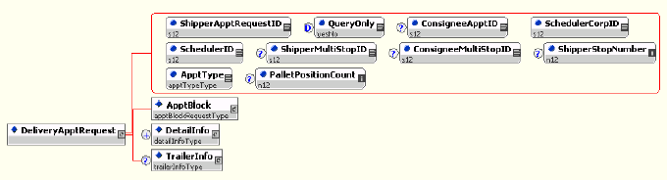
DeliveryApptRequest

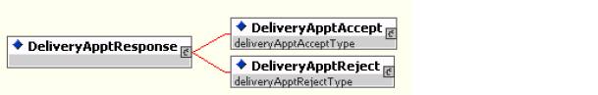
DeliveryApptResponse

Schedulers will need the capability to schedule an appointment to notify a Postal Service facility of mailing(s) drop-off. Schedulers will use DeliveryApptRequest and DeliveryApptResponse messages to incorporate appointment scheduling business logic into their business workflow process. Figure 2.2 shows the sequence of events for scheduling an appointment request.

Figure 3-9 – Scheduler Request to Schedule an Appointment

- The scheduler will populate the DeliveryApptRequest Web Services data elements.
- The scheduler will send the DeliveryApptRequest to the PostalOne! system.
- The PostalOne! system will check if the maildatSummary block(s) -> IncludedInSummarization flag equals “NO.” If so, the PostalOne! system will check if the maildatSummary section has all required values (User License Code, Job ID, Database Container ID, and ZIP+4) to retrieve the Mail.dat data from the PostalOne! database. After validating required values, the PostalOne! system will populate the USPSSummary information with stored Mail.dat data.
The following two figures show the MailDatSummary and USPSSummary structure.

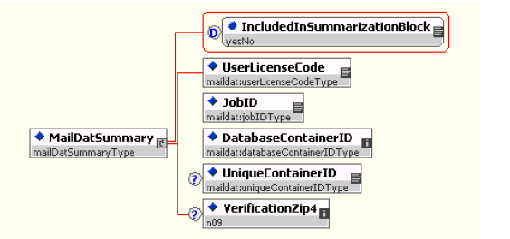
MailDatSummary

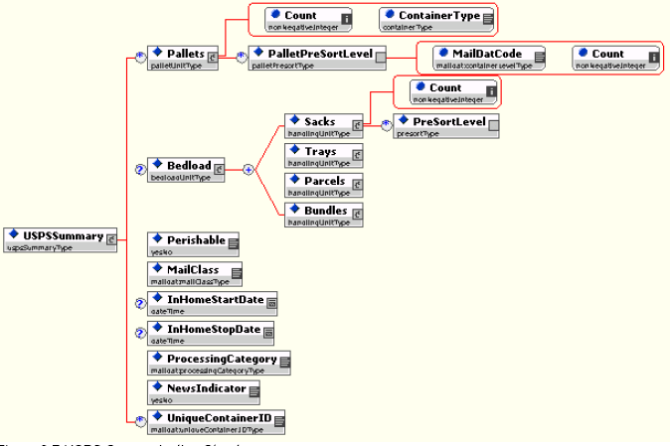
USPSSummary
- The PostalOne! system will send the DeliveryApptRequest message to FAST.
- FAST will check the facility appointment availability for the specified date/time in the DeliveryApptRequest message and mail volume associated to the appointment. If the facility can accommodate the appointment request, FAST will schedule an appointment at that particular Postal Service facility, and populate the response in a DeliveryApptAccept block. If accommodation is not available, FAST will reject the appointment request and populate the response in a DeliveryApptReject block.
- FAST will include either the DeliveryApptAccept or DeliveryApptReject block in a DeliveryApptResponse message and send it back to the PostalOne! system.
- The PostalOne! system will send the DeliveryApptResponse message back to the scheduler.
PostalOne! Support Error Conditions:

Error Condition | Error Carrier | Error Code
Web server not available | HTTP Response | HTTP: 404
Web service not available | HTTP Response | HTTP: 404
XML schema validation failed | SOAP Fault | TMErrorCode: 402
User authentication failed – Invalid user ID | SOAP Body | TMErrorCode: 412
User authentication failed – invalid password | SOAP Body | TMErrorCode: 412
User authorization failed | SOAP Body | TMErrorCode: 412
Unrecognized operation arguments – unexpected root element | SOAP Body | TMErrorCode: 408
Mail.dat user license code not supported by receiver | SOAP Body | TMErrorCode: 1100
Mail.dat job ID not in consignee database | SOAP Body | TMErrorCode: 1101
Mail.dat DatabaseContainerID not in consignee database | SOAP Body | TMErrorCode: 1102
Mail.dat verification ZIP+4 not in consignee database | SOAP Body | TMErrorCode: 1103
FAST too slow – system timed out | SOAP Body | TMErrorCode: 501
All other system level errors | SOAP Body | TMErrorCode: 500

FAST Support Error Conditions:

Error Condition |  | Error Carrier |  | Error Code
Invalid Scheduler ID for Scheduler Corp ID |  | SOAP Body |  | TMErrorCode: 1000
Invalid Scheduler Corp ID |  | SOAP Body |  | TMErrorCode: 1001
Facility not found. |  | SOAP Body |  | TMErrorCode: 1002
Invalid Multistop ID |  | SOAP Body |  | TMErrorCode: 1005
Duplicate Unique Container ID's |  | SOAP Body |  | TMErrorCode: 1006
No slots available for that time / type - dock limit |  | SOAP Body |  | TMErrorCode: 1009
Volume requested exceeded available amount (VOLUME TYPE SPECIFIED) |  | SOAP Body |  | TMErrorCode: 1010
Appointments must be scheduled at least 8 hours in advance |  | SOAP Body |  | TMErrorCode: 1011
Appointments may only be scheduled up to 14 days in advance |  | SOAP Body |  | TMErrorCode: 1012
Requested appt date/time is past |  | SOAP Body |  | TMErrorCode: 1018
News content is only valid when Mail Class is Periodicals |  | SOAP Body |  | TMErrorCode: 1200
Perishable content is only valid when Mail Class is Package Services |  | SOAP Body |  | TMErrorCode: 1201
Invalid Mail Shape/ Handling Unit combination |  | SOAP Body |  | TMErrorCode: 1202
In Home Start Date must be earlier than the In Home End Date |  | SOAP Body |  | TMErrorCode: 1203
Mail Class not supported by Consignee |  | SOAP Body |  | TMErrorCode: 1300
Processing Category not supported by Consignee |  | SOAP Body |  | TMErrorCode: 1301
Presort Level not supported by Consignee | SOAP Body |  | TMErrorCode: 1302
Scheduler ID is not valid | SOAP Body |  | ErrorCode: 3000
Scheduled Appointment time must be scheduled on the hour | SOAP Body |  | ErrorCode: 3001
Perishable content is only valid when Processing Category (Mail Shape) is Machineable Parcel, Outside Parcel (Non-Machineable Parcel), or Irregular Parcel | SOAP Body |  | ErrorCode: 3003
Optional Appointment Start Time must be before the Optional End Time | SOAP Body |  | ErrorCode: 3004
Optional Appointment Start Time must be within 8 hours of the Optional End Time | SOAP Body |  | ErrorCode: 3005
The time difference between the first and last appointment of a multi-stop must be within 24 hours | SOAP Body |  | ErrorCode: 3006
Appointment date/time must be earlier than In Home Start Date | SOAP Body |  | ErrorCode: 3007
Number of USPSSummary blocks exceeded maximum limit of 100 | SOAP Body |  | ErrorCode: 3008
A Speedline Appointment cannot have more than 6 pallet positions | SOAP Body |  | ErrorCode: 3009
Facility does not accept drop shipments. | SOAP Body |  | ErrorCode: 3011

Scheduler Updates an Appointment
The following two figures show the DeliveryApptUpdate and DeliveryApptUpdateResponse message structure.

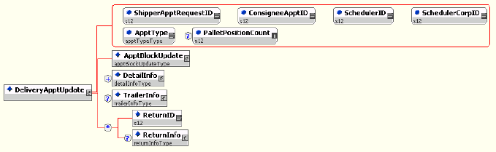
DeliveryApptUpdate

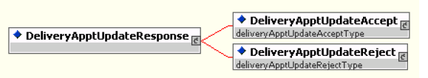
DeliveryApptUpdateResponse

As schedulers produce the mailings or prepare transportation, they will need to update the appointment information, for example the header, mail content or trailer. Schedulers will use the DeliveryApptUpdate message to update an appointment’s mail content. The consignee will send schedulers update appointment responses using the DeliveryApptUpdateResponse message. Figure 2.3 shows the sequence of events for making an appointment update.

Figure 3-10– Scheduler Updates an Appointment
- The scheduler will populate the DeliveryApptUpdate Web Services data elements to update an appointment’s mail content.
- The scheduler will send the DeliveryApptUpdate message to the PostalOne! system.
- The PostalOne! system will check if the maildatSummary block(s) -> IncludedInSummarization flag equals “NO.” If so, the PostalOne! system will check if the maildatSummary section has all required values (User License Code, Job ID, Database Container ID, and ZIP+4) to retrieve the Mail.dat data from the PostalOne! database. After validating required values, the PostalOne! system will populate the USPSSummary information with stored Mail.dat data.
- The PostalOne! system will send the DeliveryApptUpdate message to FAST.
- FAST will check the facility’s appointment availability for the specified date/time in the DeliveryApptUpdate and mail volume associated to the appointment. If the facility can accommodate the update appointment request, FAST will update the scheduled appointment and populate a DeliveryApptUpdateAccept block with the response information. If the Postal Service facility cannot accommodate the appointment’s updated mail content, then FAST will put the rejection response in a DeliveryApptUpdateReject block.
- FAST will include either the DeliveryApptUpateAccept or DeliveryApptUpdateReject block in a DeliveryApptUpdateResponse message and send it back to the PostalOne! system.
- The PostalOne! system will send the response message back to the mailer.

PostalOne! Support Error Conditions:

Error Condition | Error Carrier | Error Code
Web server not available | HTTP Response | HTTP: 404
Web service not available | HTTP Response | HTTP: 404
XML schema validation failed | SOAP Fault | TMErrorCode: 402
User authentication failed – Invalid user ID | SOAP Body | TMErrorCode: 412
User authentication failed – Invalid password | SOAP Body | TMErrorCode: 412
User authorization failed | SOAP Body | TMErrorCode: 412
Unrecognized operation Arguments – unexpected root element | SOAP Body | TMErrorCode: 408
Mail.dat user license code not supported by receiver | SOAP Body | TMErrorCode: 1100
Mail.dat job ID not in consignee database | SOAP Body | TMErrorCode: 1101
Mail.dat DatabaseContainerID not in consignee database | SOAP Body | TMErrorCode: 1102
Mail.dat verification ZIP+4 not in consignee database | SOAP Body | TMErrorCode: 1103
FAST too slow – system timed out | SOAP Body | TMErrorCode: 501
All other system level errors | SOAP Body | TMErrorCode: 500

FAST Support Error Conditions:

Error Condition |  | Error Carrier |  | Error Code
Invalid Scheduler ID for Scheduler Corp ID |  | SOAP Body |  | TMErrorCode: 1000
Invalid Scheduler Corp ID |  | SOAP Body |  | TMErrorCode: 1001
Facility not found. |  | SOAP Body |  | TMErrorCode: 1002
Invalid ConsigneeApptID |  | SOAP Body |  | TMErrorCode: 1004
No slots available for that time / type - dock limit |  | SOAP Body |  | TMErrorCode: 1009
Volume requested exceeded available amount (VOLUME TYPE SPECIFIED) |  | SOAP Body |  | TMErrorCode: 1010
Appointments must be scheduled at least 8 hours in advance |  | SOAP Body |  | TMErrorCode: 1011
Appointments may only be scheduled up to 14 days in advance |  | SOAP Body |  | TMErrorCode: 1012
Update/cancel refused - appointment closed/canceled |  | SOAP Body |  | TMErrorCode: 1015
Customer and Consignee Appointment ID do not correspond |  | SOAP Body |  | TMErrorCode: 1017
Requested appt date/time is past |  | SOAP Body |  | TMErrorCode: 1018
News content is only valid when Mail Class is Periodicals |  | SOAP Body |  | TMErrorCode: 1200
Perishable content is only valid when Mail Class is Package Services |  | SOAP Body |  | TMErrorCode: 1201
Invalid Mail Shape/ Handling Unit combination |  | SOAP Body |  | TMErrorCode: 1202
In Home Start Date must be earlier than the In Home End Date |  | SOAP Body |  | TMErrorCode: 1203
Mail Class not supported by Consignee |  | SOAP Body |  | TMErrorCode: 1300
Processing Category not supported by Consignee |  | SOAP Body |  | TMErrorCode: 1301
Presort Level not supported by Consignee |  | SOAP Body |  | TMErrorCode: 1302
Scheduler ID is not valid |  | SOAP Body |  | ErrorCode: 3000
Scheduled Appointment time must be scheduled on the hour |  | SOAP Body |  | ErrorCode: 3001
Customer and Consignee Multistop ID do not correspond |  | SOAP Body |  | ErrorCode: 3002
Perishable content is only valid when Processing Category (Mail Shape) is Machineable Parcel, Outside Parcel (Non-Machineable Parcel), or Irregular Parcel |  | SOAP Body |  | ErrorCode: 3003
Optional Appointment Start Time must be before the Optional End Time |  | SOAP Body |  | ErrorCode: 3004
Optional Appointment Start Time must be within 8 hours of the Optional End Time |  | SOAP Body |  | ErrorCode: 3005
Appointment date/time must be earlier than In Home Start Date |  | SOAP Body |  | ErrorCode: 3007
Number of USPSSummary blocks exceeded maximum limit of 100 |  | SOAP Body |  | ErrorCode: 3008
A Speedline Appointment cannot have more than 6 pallet positions |  | SOAP Body |  | ErrorCode: 3009
Appointments must be updated at least 8 hours in advance | SOAP Body |  | ErrorCode: 3010
Facility does not accept drop shipments. | SOAP Body |  | ErrorCode: 3011

Scheduler Cancels an Appointment

The following two figures show the DeliveryApptCancelRequest and DeliveryApptCancelResponse message structure.

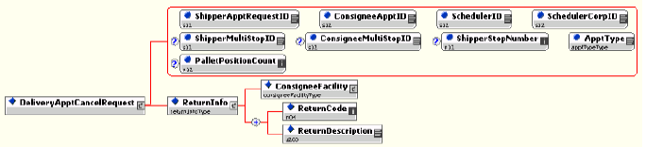 DeliveryApptCancelRequest

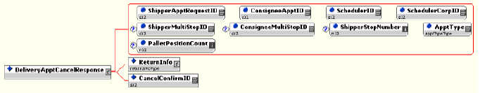
DeliveryApptCancelResponse

As schedulers produce or prepare transportation for mailings, they might run into problems or delays causing the scheduler to cancel an existing appointment. Schedulers will only be able to cancel a whole appointment. Schedulers will use the DeliveryApptCancelRequest message to request an appointment to be canceled. A consignee will send a DeliveryApptCancelResponse message back to a scheduler indicating if the appointment was successfully canceled. Figure 2.4 shows the sequence of events for canceling an appointment.

Figure 3-11– Scheduler Cancels an Appointment

- The scheduler will populate the DeliveryApptCancelRequest Web Services data elements.
- The scheduler will send the DeliveryApptCancelRequest message to the PostalOne! system.
- The PostalOne! system will route the message request to FAST.
- FAST will cancel the appointment.
- FAST will send a DeliveryApptCancelRequest message back to the PostalOne! system which will contain a cancelConfirmID indicating whether or not the appointment was successfully canceled.
- The PostalOne! system will send the message response back to the scheduler.
PostalOne! Support Error Conditions:

Error Condition | Error Carrier | Error Code
Web server not available | HTTP Response | HTTP: 404
Web service not available | HTTP Response | HTTP: 404
XML schema validation failed | SOAP Fault | TMErrorCode: 402
User authentication failed – invalid user ID | SOAP Body | TMErrorCode: 412
User authentication failed – invalid password | SOAP Body | TMErrorCode: 412
User authorization failed | SOAP Body | TMErrorCode: 412
Unrecognized operation arguments – unexpected root element | SOAP Body | TMErrorCode: 408
FAST too slow – system timed out | SOAP Body | TMErrorCode: 501
All other system level errors | SOAP Body | TMErrorCode: 500
FAST Support Error Conditions:

Error Condition | Error Carrier | Error Code
Invalid ConsigneeApptID | SOAP Body | TMErrorCode: 1004
Update/cancel refused - appointment closed/canceled | SOAP Body | TMErrorCode: 1015
Appointments must be updated at least 8 hours in advance | SOAP Body | ErrorCode: 3010

Scheduler Request a Single Appointment Close-Out
The following two figures show the DeliveryApptStatusRequest and DeliveryApptStatusResponse message structures.

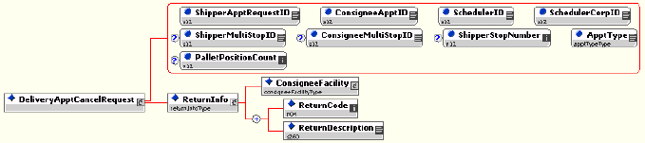
DeliveryApptStatusRequest

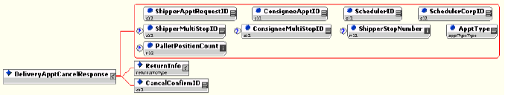
DeliveryApptStatusResponse

When a scheduler’s mail job has arrived at a Postal Service facility, a dock clerk will close the appointment using TIMES. This system will send the appointment close-out information to FAST which will send the information to the PostalOne! system. A scheduler will use the DeliveryApptStatusRequest message to request a single appointment close-out for the following types of appointment close-outs: an on-time scheduled appointment, a no-show appointment, or a rejected scheduled appointment. When a consignee receives a DeliveryApptStatusRequest message, the consignee will process the appointment close-out request message, populate a ConsigneeGoodsReceipt data type with the appointment close-out information, and send a DeliveryApptStatusResponse message back to the scheduler that includes the ConsigneeGoodsReceipt data type. Refer to the business rules and constraints section below for specific business logic, rules, and constraints associated with this type of Web Services. Figure 2.5 shows the business process sequence for schedulers receiving appointment close-out information from the PostalOne! system.

Figure 3-12- Scheduler Receives an Appointment Close-Out
- The dock clerk enters an appointment close-out date and time into TIMES.
- TIMES system sends the appointment close-out data to FAST.
- FAST populates ConsigneeGoodsReceipt message with the appointment close-out data and enters the ConsigneeGoodsReceipt message into the PostalOne! message queue.
- The PostalOne! system receives the ConsigneeGoodsReceipt message and stores the data.
- Schedulers and the PostalOne! system will have business rules established where the scheduler can pull the PostalOne! system every 15 minutes for the appointment close-out data based on the scheduled induction date and time. The scheduler will send a DeliveryApptStatusRequest to the PostalOne! system.
- The PostalOne! system will receive the request and send a DeliveryApptStatusRequest message back to the scheduler with the included ConsigneeGoodsReceipt data type containing the appointment close-out data.
PostalOne! Support Error Conditions:

Error Condition | Error Carrier | Error Code
Web server not available | HTTP Response | HTTP: 404
Web service not available | HTTP Response | HTTP: 404
XML schema validation failed | SOAP Fault | TMErrorCode: 402
User authentication failed – invalid user ID | SOAP Body | TMErrorCode: 412
User authentication failed – invalid password | SOAP Body | TMErrorCode: 412
User authorization failed | SOAP Body | TMErrorCode: 412
Unrecognized operation arguments – unexpected root element | SOAP Body | TMErrorCode: 408
All other system level errors | SOAP Body | TMErrorCode: 500

Scheduler Request All Scheduled and Unscheduled Appointment Close-Out
The following two figures show the AllDeliveryApptCloseoutRequest and AllDeliveryApptCloseoutResponse message structures.

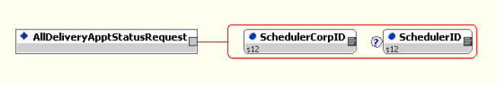
AllDeliveryApptCloseoutRequest

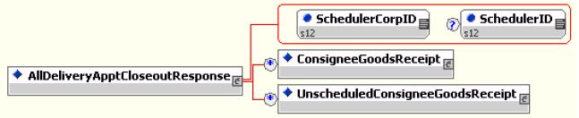
AllDeliveryApptCloseoutResponse

A scheduler can receive scheduled and unscheduled appointment close information by sending the PostalOne! system an AllDeliveryApptCloseoutRequest message. The PostalOne! system will retrieve all of the scheduler’s appointment close-out and send the information back to the scheduler in an AllDeliveryApptCloseoutResponse message. A scheduler can use the AllDeliveryApptCloseoutRequest message to retrieve the following types of appointment close-out information: an on-time scheduled appointment, a no-show appointment, a rejected scheduled appointment, or unscheduled appointments. Refer to the business rules and constraints section below for specific business logic, rules, and constraints associated with Web Services. Figure 2.6 shows the business process sequence for schedulers receiving appointment close-out information from the PostalOne! system.

Figure 3-13- Scheduler Receives an Appointment Close-Out

- The dock clerk enters an appointment close-out date & time into TIMES.
- TIMES system sends the appointment close-out data to FAST.
- If the appointment close-out is a scheduled appointment, FAST populates a ConsigneeGoodsReceipt message with the appointment close-out data. If the appointment close-out is an unscheduled appointment, FAST populates an UnscheduledConsigneeGoodsReceipt message with the appointment close-out data. FAST will put both messages, ConsigneeGoodsReceipt and UnscheduledConsigneeGoodsReceipt, on the PostalOne! message queue.
- The PostalOne! system receives the ConsigneeGoodsReceipt or UnscheduledConsigneeGoodsReceipt messages and stores the data.
- Schedulers and the PostalOne! system will have business rules established where the scheduler can pull the PostalOne! system every 15 minutes for the appointment close-out data. The scheduler will send the PostalOne! system an AllDeliveryApptCloseoutRequest.
- The PostalOne! system will receive the request, retrieve all scheduler scheduled and unscheduled appointment close messages based on corporation ID, and send a AllDeliveryApptCloseoutResponse message back to the scheduler with all of the included ConsigneeGoodsReceipt and/or UnscheduledConsigneeGoodsReceipt data types.
PostalOne! Support Error Conditions
Error Condition | Error Carrier | Error Code
Web server not available | HTTP Response | HTTP: 404
Web service not available | HTTP Response | HTTP: 404
XML schema validation failed | SOAP Fault | TMErrorCode: 402
User authentication failed – invalid user ID | SOAP Body | TMErrorCode: 412
User authentication failed – invalid password | SOAP Body | TMErrorCode: 412
User authorization failed | SOAP Body | TMErrorCode: 412
Unrecognized operation arguments – unexpected root element | SOAP Body | TMErrorCode: 408
All other system level errors | SOAP Body | TMErrorCode: 500

Scheduler Request Appointment Reply(s) Where Initial Request Timed Out
The following two figures from IDEAlliance TM specification 1.0 show the ApptResponseRetrievalRequest and ApptResponseRetrievalResponse message structure.

ApptResponseRetrievalRequest

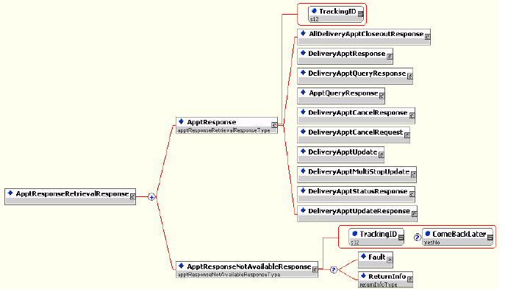
ApptResponseRetrievalResponse

When the PostalOne! system receives an appointment request, it will try to process this request in synchronous mode first. If the session times out, the PostalOne! system will send a session time-out response to the scheduler with a unique tracking ID in the fault block. If the scheduler wishes to receive the appointment response associated to an initial request that timed out, the scheduler will have to implement the Postal Service ApptResponseRetrievalRequest message where the scheduler supplies at least one unique tracking ID in the message. The scheduler will send the RetrieveApptRepliesRequest message to the PostalOne! system which will retrieve all the appointment response(s) associated to the listed unique tracking IDs. The PostalOne! system will put all the appointment response messages in a ApptResponseRetrievalResponse message and send it back to the scheduler. Otherwise, the scheduler will have to retrieve the appointment response information directly from the FAST website.

Figure 2.7 shows the business process sequence for schedulers receiving appointment close-out information from the PostalOne! system.

Figure 3-14- The Scheduler Request Appointment Response(s) Associated To Session Timed Out

- The scheduler sends an appointment request message to the PostalOne! system.
- The PostalOne! system receives the message and sends the message to FAST.
- The PostalOne! session times out waiting for a reply message.
- The PostalOne! system sends an HTTP response time-out message with a unique tracking ID in the SOAP Fault message block back to the scheduler.
- FAST finishes processing the appointment request and sends a response back to the PostalOne! system.
- The PostalOne! system receives the message and stores the data.

- Based on business rules defined between schedulers and the PostalOne! system, schedulers will periodically send a RetrieveApptRepliesRequest to the PostalOne! system, with at least one unique tracking ID referencing the appointment response associated to an initial appointment request where the session timed out.
- The PostalOne! system will receive the tracking IDs, retrieve the appointment response(s), populate all the appointment response(s) associated to the list of supplied unique tracking IDs into a RetrieveApptRepliesResponse message.
- The PostalOne! system will send the RetrieveApptRepliesResponse message containing all the appointment response(s)back to the scheduler.

PostalOne! Support Error Conditions:

Error Condition | Error Carrier | Error Code
Web server not available | HTTP Response | HTTP: 404
Web service not available | HTTP Response | HTTP: 404
XML schema validation failed | SOAP Fault | TMErrorCode: 402
User authentication failed – invalid user ID | SOAP Fault | TMErrorCode: 412
User authentication failed – invalid password | SOAP Fault | TMErrorCode: 412
User authorization failed | SOAP Fault | TMErrorCode: 412
Invalid tracking ID | SOAP Fault | TMErrorCode: 410
Invalid tracking ID – for the user ID | SOAP Fault | TMErrorCode: 410
Unrecognized operation arguments – unexpected root element | SOAP Body | TMErrorCode: 408
Response not yet available  try later | SOAP Fault | TMErrorCode: 501
All other system level errors | SOAP Fault | TMErrorCode: 500

