Pathology protocol analysis system procedures
National Toxicology Program Support

Document Number: | LP-1012
Version: | 3.1
Issued: | April 21, 1999
Reviewed & Approved by: | John Minnich, Program Director
Date:

Pathology PAS Procedures
National Toxicology Program Support
Pathology PAS Procedures

Prepared for: National Institute of Environmental Health Sciences
Research Triangle Park, NC 27709
Contract no.: 273-95-I-0012

Prepared by: Technology Planning & Management Corporation
Imperial Center
Canterbury Hall, Suite 310
4815 Emperor Boulevard
Durham, NC 27703

Revision Summary
Date Released | Document Number | Revision Level | Reason for Revision
4/99 | LP-1012 | 3.1 | Place manual in new template. Update for Hazel and TPMC references.
10/95 | LP-1012 | 2.1 | Added hamsters to protocol required tissues and updated print destination field.
12/94 | LP-1012 | 2.0 | Menu updates and procedure changes.
2/94 | LP-1012 | 1.0 | New

Table of Contents
Revision Summary
Table of Contents
Chapter 1
Introduction
Overview
Chapter 2
Pathology PEX Procedures
Copy Universal Download
Figure 1, TDMS Main Menu
Figure 2, PAS Main Menu
Figure 3, PEX PEIS Operation Selection Menu
Figure 4, PEX PEIS Copy Selection List
Enter Protocol Required Tissues
Add Segments
Figure 5, PEX PEIS Segment Selection Menu
Figure 6, Segment OPERATION Selection Menu
Figure 7, Protocol Required Tissue Definition
Figure 8, Protocol Required Tissue Definition ADD
Modify Protocol Required Tissues
Chapter 3
PAS Validation Report Procedures
Generate the PAS Validation Report
Figure 9, PAS Validation Report Request- PEIS
Verify the PAS Validation Report
Chapter 4
Pathology Download Procedures
Create Pathology Download Files
Figure 10, Select Transaction Type
Perform a Partial Download of Modified Transactions
Figure 11, Select PEIS Transactions to Download
Appendix a a
PEX Checklist a
Appendix b b
Protocol Required Tissues b

Introduction
Chapter
1

The purpose of this document is to provide Toxicology Data Management System (TDMS) liaison personnel with instructions for using PEX, the interactive maintenance system, to conduct the pathology phase of the TDMS studies.

Overview
PAS consists of two distinct subsystems. The Experiment Information System (EIS) is used to define the protocols for in-life data collection. The Post-Experiment Information System (PEIS) is used to define the protocols for pathology data collection. This document covers the pathology procedures.
First, the liaison copies a Universal Download for the appropriate species into the database and modifies this download for the specific experiment. Protocol required tissues are included in the file if it is for a chronic study.
The liaison then generates and prints the pathology Validation Report to verify that all tables are complete.
Finally, the liaison downloads the test protocol files to the on-site laboratory Communications Workstation. The downloaded files control the screen displays that are used to record data on the Pathology Workstation. The chart below gives an overview of the Pathology PAS Procedures.
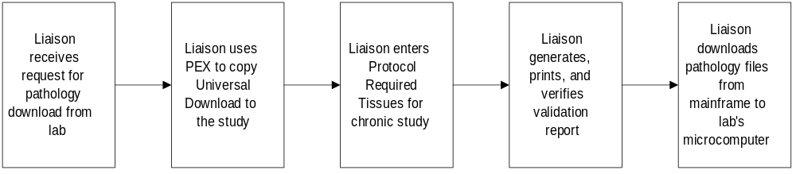

Pathology PEX Procedures

Chapter
2
This chapter outlines how to complete Pathology protocol.
PEX is the interactive maintenance system for PAS. Liaisons use PEX to indicate and define new Toxicology Data Management System (TDMS) studies and to modify existing study definitions.

Copy Universal Download
Follow these steps to copy the appropriate Universal Download to the database:
- At the prompt, type @TDMS. The TDMS Main Menu is displayed:
- 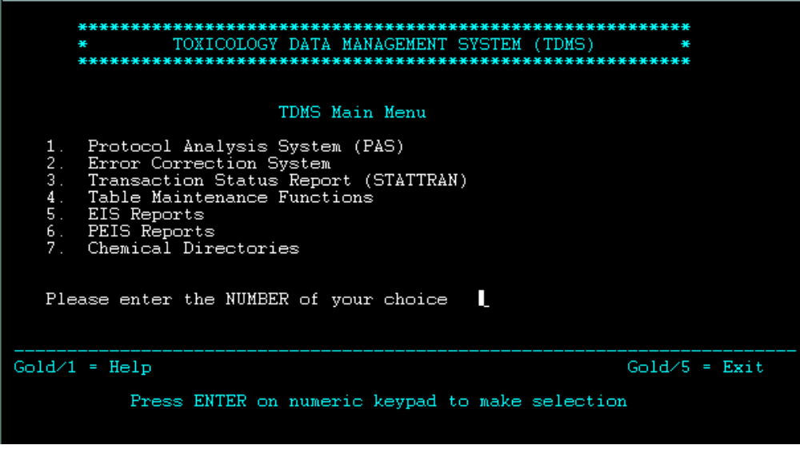
Figure 1, TDMS Main Menu
- At the Please enter the NUMBER of your choice prompt, press 1 for Protocol Analysis System. Press ENTER on the numeric keypad to advance. The PAS Main Menu is displayed:
- 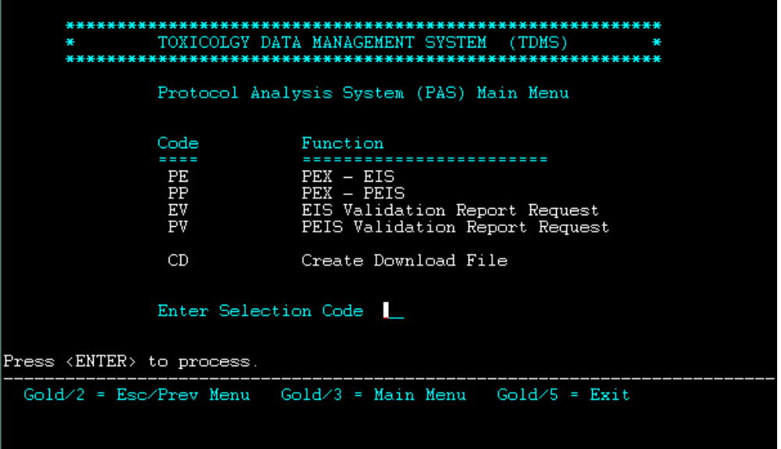
Figure 2, PAS Main Menu
- At the Enter Selection Code prompt, type PP (PEX-PEIS). Press <ENTER>. THE PEX-PEIS Operation Selection Menu is displayed:
- 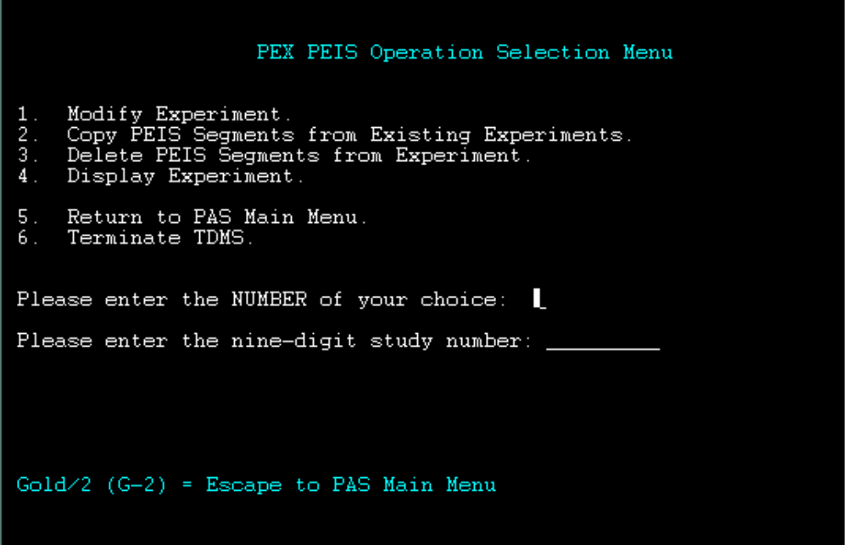
Figure 3, PEX PEIS Operation Selection Menu

- At the Please enter the NUMBER of your choice prompt, type 2 (Copy PEIS Segments from Existing Experiments).
- Type the nine-digit study number. Press <ENTER>. The PEX PEIS Copy Selection List is displayed:
- 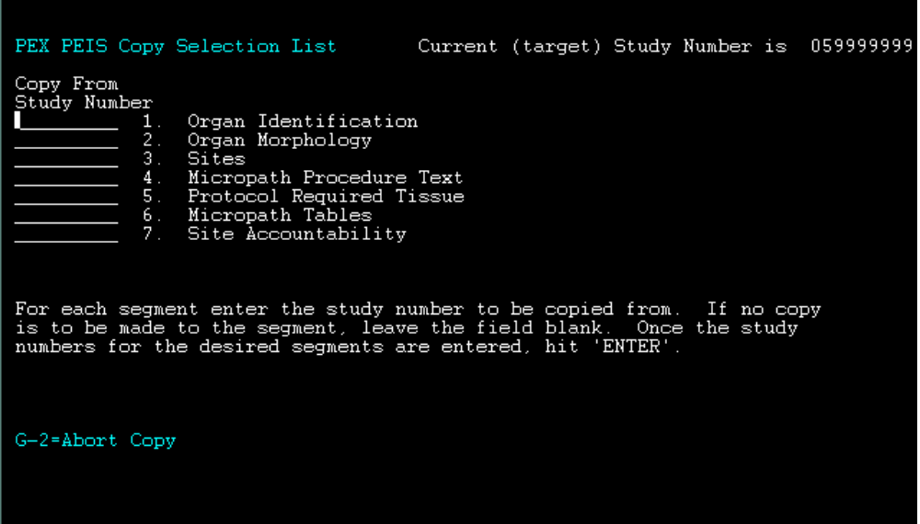
Figure 4, PEX PEIS Copy Selection List
- Enter the nine-digit experiment number of the Universal Download for each segment you wish to copy.
- The experiment numbers for the Universal Download are:
- 050505005 - Inhalation Rats
- 050505006 - Inhalation Mice, Hamsters
- 050505007 - Other Rats
- 050505008 - Other Mice, Hamsters
- There are four segments that will be entered for all studies:
- Organ Identification
- Organ Morphology
- Sites
- Micropath Tables
Segment 5, Protocol Required Tissue, can also be copied for chronic studies. Segments 4, Micropath Procedure Text, and 7, Site Accountability, became obsolete with the advent of a new data collection system.
Enter the Universal Study number in the Copy From Study Number field. If no copy is to be made to a particular segment, leave the field blank.
- Verify that the study numbers you entered are accurate.
- Press <ENTER>. The following message is displayed at the bottom of the PEX PEIS Copy Selection List screen:
- Are you sure you want to copy ALL replicates for selected segments? (Y/N)
- Type Y and press <ENTER>. The following message is displayed on the next screen:
- Copying of selected segments has been completed. Hit ‘ENTER’.
NOTE
The number of replicates copied to the target study for each segment are also displayed on this screen.
The correct numbers for replicates for Organ Morphology and Sites are
- 050505005 - | Inhalation Rats | 67 REPS COPIED
- 050505006 - | Inhalation Mice, Hamsters | 68 REPS COPIED
- 050505007 - | Other Rats | 65 REPS COPIED
- 050505008 - | Other Mice, Hamsters | 66 REPS COPIED
Press <ENTER>. The PEX PEIS Operation Selection Menu is displayed.
- At the Please enter the NUMBER of your choice: prompt, type 6 (Terminate TDMS).

Enter Protocol Required Tissues
If the experiment is a chronic study, the liaison adds the Protocol Required Tissues in the database and they are downloaded to the laboratory.
NOTE
When the liaison enters the in-life PEX data, the flag is set for ‘L’ if the Protocol Required Tissues are to added by the laboratory pathologist and ‘M’ if the Protocol Required Tissues are to be entered by the liaison.
Follow these steps to enter Protocol Required Tissues for the download file of a chronic study:
- Repeat Steps 1 through 5 of Copy Universal Download, in the beginning of this chapter.
- At the PEX PEIS Copy Selection List screen (see Figure 4, page 4), enter the nine-digit study number of the experiment you wish to copy in field 5 (Protocol Required Tissue).
- Select a study for this field that has the same dose route and the same number of Treatment Groups as the current study.
- When the pathology Validation Report is generated, the correct Text ID for the current study will be written in the Treatment Group field.

Add Segments
Follow these steps to add segments for more treatment groups.
- Repeat Steps 1 through 3 of Copy Universal Download, in the beginning of this chapter.
- At the Please enter the NUMBER of your choice: prompt on the PEX PEIS Operation Selection Menu (see Figure 3, page 3), type 1 (Modify Experiment). Type the nine-digit study number at the Please enter the nine-digit study number: prompt. Press <ENTER>. The PEX PEIS Segment Selection Menu is displayed:
- 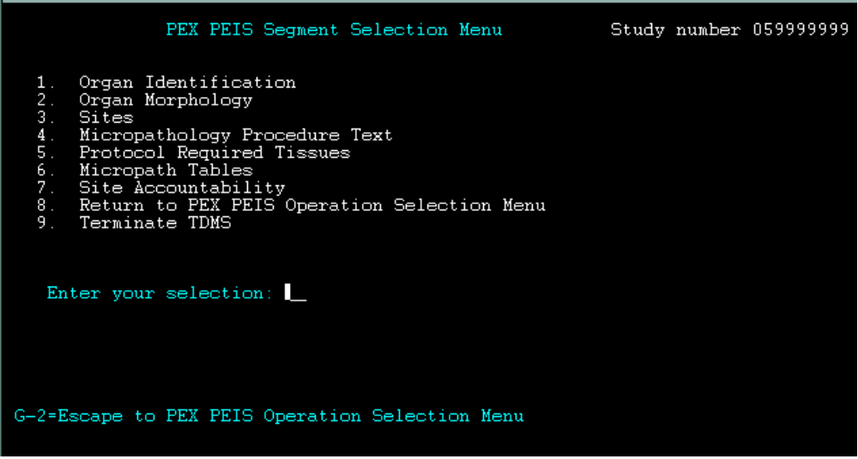
Figure 5, PEX PEIS Segment Selection Menu
- Type 5 (Protocol Required Tissues). Press <ENTER>. The Segment OPERATION Selection Menu is displayed:
- 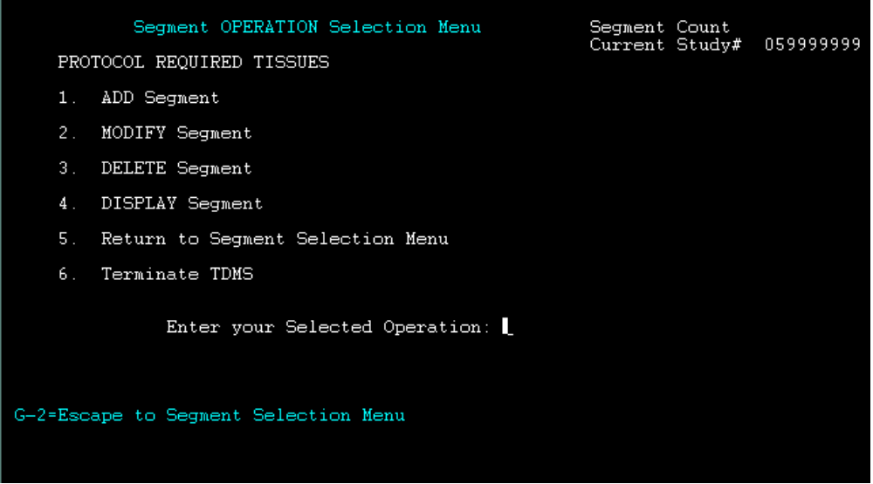
Figure 6, Segment OPERATION Selection Menu
- At the Segment OPERATION Selection Menu, type 1 (ADD Segment). Press <ENTER>. The first substructure of the Add Segment is displayed:
- 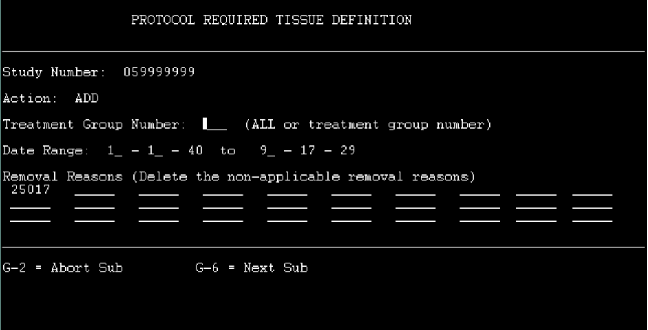
Figure 7, Protocol Required Tissue Definition
- Enter the Treatment Group Number. The Date Range and Removal Reasons can be modified on this screen. The Default Date Ranges on LDAS II are 01/01/70 to 09/17/29/ Press G-6. The next substructure is displayed:
- 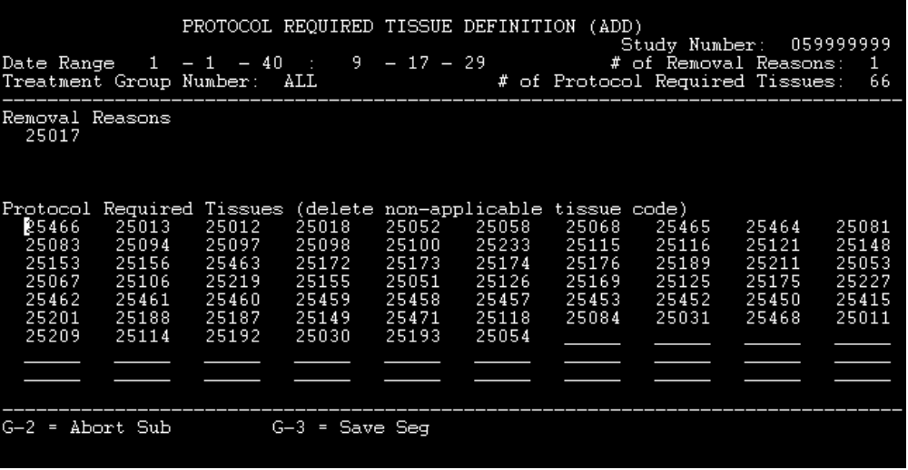
Figure 8, Protocol Required Tissue Definition ADD
- The number of Protocol Required Tissues on this screen will vary. Delete the excess tissue codes and add the missing male or female protocol required tissues. Refer to Appendix B, Protocol Required Tissues to modify this screen.
NOTE
The Date Range cannot be modified on this screen. The Removal Reasons can be modified.
- Press G-3 to save the segment. The first Protocol Required Definition screen is displayed. See Figure 7 on the previous page.
- Repeat Steps 3 through 5 to add all treatment groups.
- Press G-2 to save the segment. The Segment OPERATION Selection Menu is displayed. See Figure 6 on the previous page.
- Type 6 (Terminate TDMS).

Modify Protocol Required Tissues
After the segments are copied to the study, they may have to be modified or more segments may need to be added. Follow these steps to modify the Protocol Required Tissues segment:
- Repeat Steps 1 through 3 of Copy Universal Download, in the beginning of this chapter.
- At the Please enter the NUMBER of your choice: prompt on the PEX PEIS Segment Operation Selection Menu (see Figure 6, page 8), type 1 (Modify Experiment). Type the nine-digit study number at the Please enter the nine-digit study number: prompt. Press <ENTER>. The PEX PEIS Segment Selection Menu is displayed. See Figure 5, on page 7.
- Type 5 (Protocol Required Tissues). Press <ENTER>. The Segment OPERATION Selection Menu is displayed. See Figure , on page .
- If you wish to modify Protocol Required Tissue segments, type 2 (MODIFY SEGMENT). Press <ENTER>. Modifications are made on the Protocol Required Tissue Definition screen. See Figure 7, on page 8 of the Add Segments section of this chapter.
PAS Validation Report Procedures
Chapter
3
This chapter describes the procedures user to generate and review the Pathology PAS Validation Report.
Liaisons generate and print a Pathology PAS Validation Report to verify that all of the tables are correct. Print the Error Report on Starprint Directory. If errors are found, the liaison corrects them (using PEX) and then reruns the Validation Report.

Generate the PAS Validation Report
Follow these steps to generate the PAS Validation Report:
- At the prompt, type @TDMS. Press <ENTER>. The TDMS Main Menu is displayed. See Figure 1, on page 2.
- At the Please enter the NUMBER of your choice prompt, type 1 (Protocol Analysis System). Press <ENTER>. The PAS Main Menu is displayed. See Figure 2, on page 3.
- At the Enter Selection Code prompt, type PV for PEIS Validation Report Request. Press <ENTER>. The PAS Validation Report Request-PEIS screen is displayed:

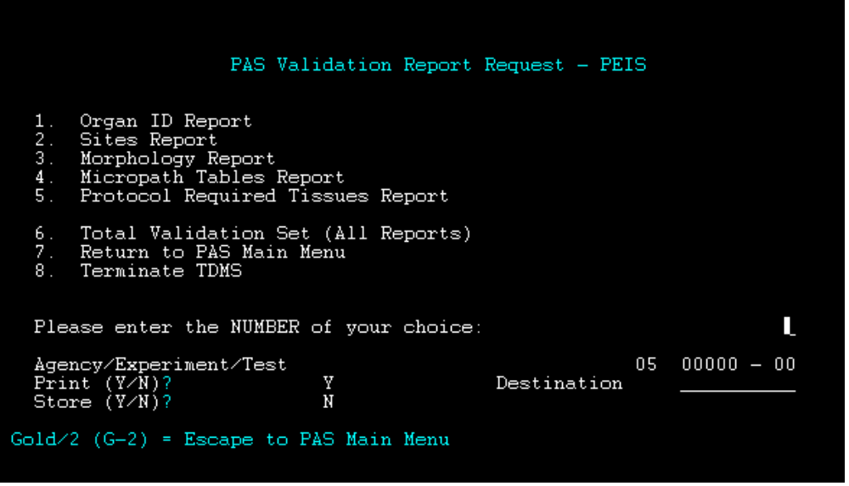
Figure 9, PAS Validation Report Request- PEIS
Follow these steps to generate validation reports:
- At the Please enter the NUMBER of your choice: prompt, type 6 (Total Validation Set (All Reports)) or an alternate report.
- In the Agency/Experiment/Test field, type the study number.
- To print the report, type a Y in the Print (Y/N)? field.
If you wish to store the validation report, type NOPRINT in the Destination field. It will be stored on the STARPRINT directory.
- In the Store (Y/N)? field, type N. This field refers to ESS storage.
- Press <ENTER>. The following message is displayed:
- Submit successful. Hit ENTER to continue.
- Press <ENTER>.
- Press G-2. The PAS Main Menu is displayed. See Figure 2 on page 3.
- Press G-5 to exit TDMS.
- At the prompt, type the following character string:
show queue starbatchq
This will indicate whether the file is waiting in the queue or executing. When the job completes, a message is displayed indicating the validation report has been generated. A sample message follows:
Job SPAPEITOTAL1_050999902 (queue STARBATCHBQ, entry 24) completed
- IF you entered NOPRINT in the Destination filed, follow these steps to print the report:
- At the prompt, type the following character string:
DIR/SIN STARPRINT: SPAEISTOTAL1*)
Press <ENTER>.
- Print the report using landscaped format.

Verify the PAS Validation Report
Follow these steps to verify the Pathology Validation Report:
- Even if no errors were found during the generation of the report, the Error Report displays one of the following messages:
**** | WARNING ERROR | **** | ORGAN SEGMENT CONTAINS | 65 | ORGANS
**** | WARNING ERROR | **** | ORGAN SEGMENT CONTAINS | 66 | ORGANS
**** | WARNING ERROR | **** | ORGAN SEGMENT CONTAINS | 67 | ORGANS
**** | WARNING ERROR | **** | ORGAN SEGMENT CONTAINS | 68 | ORGANS
The number of organs listed in the warning message depends on which Universal Download was copied to the experiment. It refers to the number of organs in the Organ Morphology and Sites tables. Disregard this error message.
- Verify that all reports you requested are included in the total Validation Report. Also verify that they are all complete.

Pathology Download Procedures
Chapter
4
This chapter addresses the pathology download system.
Liaisons use the PAS Download system to transfer TDMS protocol data from the mainframe at NIEHS to microcomputers at designated laboratories.

Create Pathology Download Files
To create the pathology download files, follow these steps:
- At the prompt, type @TMDS and press <ENTER>. The TDMS Main Menu is displayed. See Figure 1, page 2.
- At the Please enter the NUMBER of your choice prompt, press 1 Protocol Analysis System. The PAS Main Menu is displayed. See Figure 2, page 3.
- Select Create Download File by typing CD at the Enter Selection Code prompt. Press <ENTER>. The Select Transaction Type screen is displayed:
- 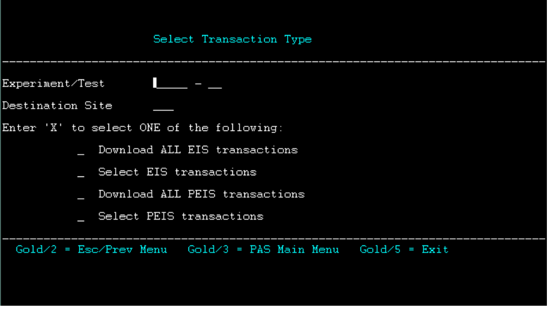
Figure 10, Select Transaction Type
- Complete the fields of the Select Transaction Type screen by following these steps.
- In the Experiment/Test field, type the number of the study you wish to download. The cursor will move to the next field.
- Type in the three-letter lab facility code in the Destination Site field. The cursor will move to the next field.

- Use the down arrow to move to the Download All PEIS Transactions field. Type an X in the space provided. Press <ENTER>. The following message is displayed.
- Download job submitted for all PEIS transaction types. Press ENTER to continue.
- Press <ENTER>. The PAS Main Menu is displayed. See Figure 2, page 3.
- Press G-5 to exit TDMS.
- At the prompt, type the following character string:
show queue starbatchbq
The download job will be pending in this queue.
Job SPDDOWNLOAD_050999902 (queue STARBATCHBQ, entry 130) completed
- Verification of a successful download is sent via e-mail.
- If the download was successful, type DIR YYYDOWNLOAD to verify that the file is on the lab download directory. (YYY-three-letter lab facility code).
For example, PXXXXXXX.DNL;1
- To delete a download file that contains errors from the Lab Download directory, do the following:
- At the prompt, type in the file to be deleted using the following format:
DEL YYYDOWNLOAD:PXXXXXXX.DNL;1
- Complete Steps 1 through 4 to create a new download.

Perform a Partial Download of Modified Transactions
To perform a partial download of pathology files, follow these steps:
- Repeat Steps 1 through 3 of Create Pathology Download Files.
- At the Select Transaction Type screen, use the down arrow to move to the Select PEIS Transactions field. Type an X in the space provided.
- Press <ENTER>. The Select PEIS Transactions To Download screen is displayed.
- 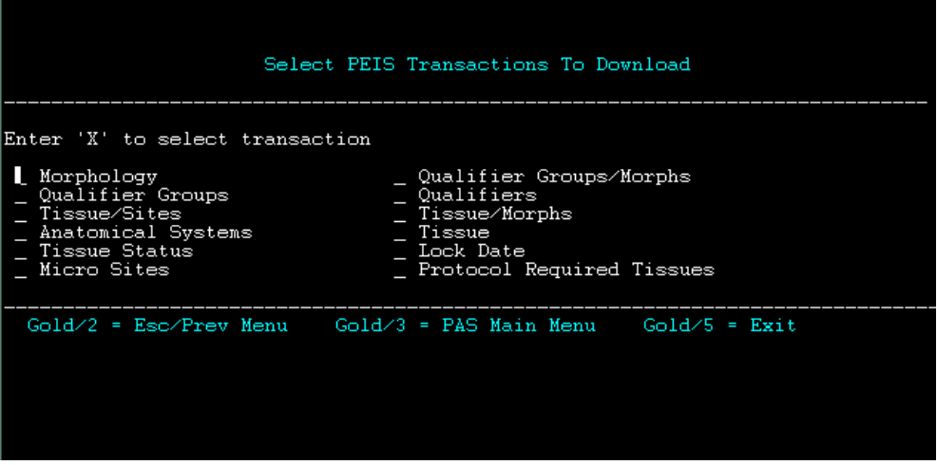
Figure 11, Select PEIS Transactions to Download
- Use the tab or arrow keys to move to the transaction file to be downloaded. Type an X in the space provided.
NOTE
Refer to Chapter 3 in the LDAS Technical Reference Manual to determine which Test Protocol Tables to download.
- Press <ENTER>. The following message is displayed at the top of the screen:
- Download job submitted for selected PEIS transaction types.
- Press <ENTER>. The PAS Main Menu is displayed.
- Press G-5 to exit TDMS.
- Repeat Steps 8 and 9 of Create Pathology Download Files to verify that the partial download was successful and to perform a new download if necessary.

PEX Checklist

Appendix
A
The PEX Checklist, which is displayed on the following page, is used to track the completion of liaison procedures relative to the study.
Update the pathology section of the original PEX Checklist that was filed with the experiment at the beginning of the study.

PEX Checklist
Chemical Name: _________________________________________
Study Number: ____________________________________________
Facility: ____________________________________________
Species: ____________________________________________
Route: ____________________________________________
Study Type: ____________________________________________
Start Date: ____________________________________________

PAS DATA ENTRY

Date |  |  | Segment
 |  | 1. | Weighed Items Range Validation
 |  | 2. | Loading Requirements and Weight Validation
 |  | 3. | Selected Clinical Observations
 |  | 4. | Animal Removal Actions
 |  | 5. | Balance Calibration Weights
 |  | 6. | Rack-Cage Configuration
 |  | 7. | Census Definition
 |  | 8. | Preparation Definition
 |  | 9. | Procedure Definition
 |  | 10. | Treatment Definition
 |  | 11. | Facility/Chemical Linkage Information
 |  | 12. | Responsible Parties

VALIDATION REPORT

Validation Report Printed
Validation Report Sent to Laboratory
Schedules sent to Laboratory
Certification Report received from Laboratory

IN-LIFE DOWNLOAD

EIS Download to Laboratory

PATHOLOGY PEX

Pathology Tables copied to the study
Pathology Required Tissues copied to chronic study
Pathology Validation Report Printed

PATHOLOGY DOWNLOAD

Pathology Download to Laboratory

Protocol Required Tissues
Appendix
B
Use the tables contained in this appendix to manually enter protocol required tissues or to verify tissue copied from another experiment.
Tissues |  | Notes | Totals
Adren Cortex | 25463
Adren Medulla | 25464
Brain | 25018
Clitoral Glands | 25030
Esophagus | 25052
Bone | 25013
Bone Marrow | 25012
Gallbladder | 25058 | Mice, Hamsters
Heart | 25068
Int Sm Duoden | 25457
Int Sm Jejunum | 25458
Int Sm Ileum | 25459
Int Lg Colon | 25460
Int Lg Rectum | 25461
Int Lg Cecum | 25462
Kidneys | 25083
Larynx | 25415 | Inhalation studies only
Liver | 25094
Lungs | 25097
Lym Node Mesen | 25452 | All Studies

Lym Node Mand | 25453 | All Studies
Lym Node Bron | 25454 | Inhalation Studies only
Lym Node Media | 25467 | Inhalation Studies only
Mammary Gland | 25100
Nose | 25233
Ovaries | 25114
Pancreas | 25115
Parathyroid Glands | 25116
Pituitary Gland | 25121
Preputitial Glands | 25125
Prostate | 25126
Salivary Glands | 25148
Skin | 25153
Spleen | 25156
Stomach Forst | 25465
Stomach Gland | 25466
Testes | 25169
Epididymus | 25051 |  | 44 - Inhalation, Rats
Seminal Vesicle | 25149 |  | 45 - Inhalation, Mice,  Hamsters
Thymus | 25172
Thyroid Gland | 25173 |  | 41 - Other, Rats
Trachea | 25176 |  | 42 - Other, Mice, Hamsters
Urinary Bladder | 25189
Uterus | 25148
Islets, pancreas | 25153

End of Document

