World Wind Scripting Version 1.0
Last updated February 12, 2005
Scripting provides a way to automate a user’s experience with World Wind. A World Wind script contains settings that determine and vary the user’s view of the world, including their location and the features annotating or overlaying the globe. A script can conduct a virtual tour, calling out points of interest along the way. Scripts can be created by anyone with a text editor. They can be used personally or shared with others.
Scripting supports scenarios like the following:
- Smoothly take the user from one city, region or geographical feature to another, stopping momentarily at key or interesting spots. At each stop – and between stops – display descriptive messages on the screen indicating noteworthy information about the location or the move. For example, “Now we’ll visit the Alps, and discover how markedly more rugged they are than the Pyrenees.”
- Play an animation, perhaps a sequence of WMS maps like those from NASA’s Scientific Visualization Studio, but after first moving the user’s position to a place in the sky that gives the best view of the animation’s most interesting feature. Leave the animation running repeatedly, and move the user from one spot to another to see and compare the activity at each stop.
- Fly around the world as though in an airplane or high altitude jet, banking and turning to circle cities and other interesting places. Or zoom through mountain ranges and valleys, flying low over land and water at a constant altitude.

Limitations
The current implementation of scripting does not provide the following features, even though they are obviously of value and might be considered important to include:
- The ability to get input or feedback from the user.
- The ability to play and synchronize audio files with the script.
- The ability to invoke other scripts from within a script.

Script Basics
Scripts automate World Wind by varying the values of certain parameters over time. These parameters include the viewer’s position on the globe, the direction she’s looking, and the World Wind features displayed as the script runs. The full list of variable parameters is:
- View Position. The viewer can be positioned anywhere around the globe at a specified elevation.
- View Direction. The view direction can change to direct the user’s gaze.
- Layers. Place names and borders can be displayed or not. Display of other intrinsic or add-on layers of information can be controlled and their opacity specified.
- WMS Images. Maps retrieved from WMS servers can be displayed on or over the globe. Sequences of overlays can be “played” as animations and synchronized to other actions in the script.
- Display Messages. Short text messages can be displayed within World Wind as the script runs.
- Latitude & Longitude Grid. The World Wind latitude/longitude grid can be turned on and off in a script.
Each of these parameters can be varied over time independently and simultaneously. The independence of the parameters allows scenarios that keep some parameters constant while others vary. Such a scenario is a fly-by of an island or a city, with the user’s gaze remaining focused on one area during the approach, pass, and departure. In this scenario the viewing position changes independently of the view direction, whose focal point remains constant. Another example is a tour around the globe while a weather animation is playing. Here, the view position changes independently of the animation.
A script is a sequence of simple statements that specify the values that certain World Wind parameters are to have at particular times. While the script runs, World Wind sets the parameters to the specified values at the indicated times. For some parameters, such as view position, World Wind interpolates the changes over time to smooth the variation. The user therefore sees steady change rather than sharp jumps.
Each of the available script parameters has its own timeline. World Wind manages one timeline for each parameter. At each tick of its internal clock it examines all the timelines to determine and set the value that each parameter should have then.
Time in a script begins at zero when the script starts and increases with clock time as the script runs. Time points are specified as the number of seconds since the script started – the elapsed time.
A script writer can choose to synchronize the timelines or not, and at which points in time to synchronize them. Imagine, for example, a script that starts an animation of global weather and specifies that the viewing position should be over central Africa when the animation starts, over India when the animation’s tenth frame is displayed five seconds later, and over Australia, South America and North America at subsequent frame numbers and times. This synchronization is achieved by specifying both the viewing position and the animation state at successive identical times.
A script can be repeated indefinitely or a specific number of times by indicating the desired behavior in the script header.
When a script starts, the initial values of scriptable parameters are those currently in effect in the running World Wind program. If the initial value of a parameter is significant to the purpose of the script, the script author should specify the desired initial value in the script at a time value of zero.
Scripts are defined in XML, and can therefore be created and edited in a text editor. We assume, however, that most scripts will be created by script-building software, and we therefore do not attempt to make the script elements especially readable or understandable by a user reading the XML. Nevertheless, the script elements are simple and straightforward and are likely to be understood by many readers knowledgeable of XML.
The term script in the context of computers has broad meaning. It’s often used to name a program in a language like Perl, JavaScript or other procedural programming language. But World Wind scripts are not procedural programs. They only declare parameter values and indicate when to change them. They are more like HTML page definitions (without embedded scripts), which merely declare, “This is what the user should see.” World Wind scripts additionally incorporate the variable of time: what the user sees depends on what time it is (relative to when the script started).

Parameters
The previous section identified the parameters that scripts can control. This section describes those parameters in more detail.
It’s convenient to be able to specify some parameters in different ways. View direction, for example, might in some cases be most easily given as viewing angles relative to the viewing position, and in other cases by a focal point on the globe’s surface. The scripting language supports such alternative definitions where they’re useful.

View Position
The view position places the user at a particular position about the globe. It’s specified by a latitude, a longitude and an elevation above the globe’s mean surface.
Zoom and image resolution are controlled in World Wind by the view position’s elevation. Decreasing the elevation zooms in, increasing it zooms out. World Wind automatically selects the resolution of the displayed imagery based on the elevation; image resolution can not be directly controlled by a script.
The view position does not indicate the direction the user is looking or the field of view. The view direction does this and is specified separately, as described below. The field of view is fixed in World Wind and is not a parameter that can be specified in a script.

View Direction
The direction of the user’s gaze is specified by the view direction. The most common view direction is straight down, perpendicular to the surface of the globe, but other view directions are of course also useful and possible. A fly-over script, for example, would likely have the view direction angled slightly downward from the horizontal.
View direction is specified in either of two ways. The most straightforward way is as a point on or slightly above the globe’s surface to keep always in the view’s center. This would be convenient in a fly-by animation in which the viewing position changes to circle a city, but the user’s gaze remains focused on the city’s center.
The other way to specify view direction is with two angles that indicate where to point the view relative to the viewing position. The first angle gives the compass direction the user is looking towards. An angle of 0° indicates a directly northward gaze, an angle of 90° indicates a gaze directly east. South is 180° and west is 270°. The second angle to specify indicates how steeply the user is looking down towards the surface. A value of 90° specifies a gaze perpendicular to the surface, directly towards the globe’s center. A value of 0° indicates a view parallel to the surface, as though looking directly forward out a cockpit window.

Layers
Most adornments such as political borders, place names and informational overlays are captured in World Wind as “layers.” Scripts can toggle these layers on or off and specify their opacity.
Scripts specify a collection of layers to be displayed at a given time point during the script. When the time point is reached, World Wind displays the indicated layers. The entire collection of layers remains displayed until the script specifies another collection at a subsequent time point. At that point, the previously displayed layers are removed from display and the new collection is displayed. At any given time there is only one collection of layers displayed. If the script specifies no layers, then the layers already on display when the script starts remain displayed throughout the running of the script.
Layers a script displays are “turned off” within a script by specifying a subsequent Layers element with an empty layer collection.

Vertical Exaggeration
The vertical exaggeration that World Wind applies to surface topography can be controlled in a script.

WMS Images
World Wind lets users download and display images that overlay the globe’s base imagery. These images come from organizations such as NASA and various national geological surveys. They are retrieved by World Wind from the web servers of those organizations via the Web Map Service (WMS) protocol defined by the Open Geospatial Consortium (http://www.opengeospatial.org).
World Wind scripts can specify WMS images to display and the times to display them, They can also indicate the opacity to apply to their display to control how much of the base imagery shows through. At any point during a script, only one WMS image is displayed, but different images can be displayed sequentially.
WMS images are identified in scripts by the WMS URL that indicates their source and their retrieval parameters.
When a WMS image is called for in a script but World Wind has not previously cached it on the local computer, the script will continue running while World Wind retrieves the image from the internet. Because initial retrieval typically takes an unknown amount of time – sometimes several seconds, sometimes several minutes – the image may not appear on the screen at the time specified in the script. It will, however, appear when it arrives from its source, unless it fails to arrive before a time point at which the script specifies a different image to display.

WMS Animations
Some organizations that provide images via WMS also provide sequences of images that can be played sequentially to create an animated sequence. Scripts can display these animations in World Wind. It’s possible to synchronize these animations to other parameter changes in the script. Scripts can also specify the opacity that World Wind should apply when displaying the animation images.
Like single images, animations are specified by their WMS URL indicating their source and retrieval parameters. Animation providers indicate the available animation frames – the individual images – and their correct display sequence via information in the animation’s WMS description, available from the image server. This sequence information is typically a range of dates or times. Scripts indicate which portion of this sequence to display and the rate at which to display it by specifying at time points within the script the sequence identifier of a specific frame to display at that time. World Wind synchronizes the animation to those times. The script need not specify every image of the animation: When World Wind recognizes that the WMS image URL is the same at two adjacent time points, differing only by sequence identifiers, it interpolates the correct image to display from those identifiers. The script can therefore specify only the first and last image of the animation, for example, and World Wind will retrieve and display all the intervening images.
Since animations are collections of WMS images, the same caveat mentioned above about retrieval timing applies: An image in the sequence will be displayed at the specified time if it is already available on the local computer, otherwise its retrieval will only be initiated at that time and the script will continue running. As the script repeats and the animation images arrive, World Wind will display them
By specifying other parameter values at identical times as specific animation frames, a script may synchronize the animation to other parameter changes in the script.

Display Messages
It’s often helpful and important for a script to describe to the user what it’s doing and perhaps why. Display messages provide the ability to do this. A script can specify messages to display and the locations and times to display them. The messages are displayed within the World Wind window in the window’s default font style and size.
Several messages can be displayed simultaneously. A script specifies a collection of messages to begin displaying at a specific time. Those messages are displayed until the script, at a subsequent time point, specifies a different set of messages, which replace the previous ones. So at any point in time, only one message collection is on display. (This is the same behavior as for Layers, as described above.)

Script Specification
This section describes the syntax and structure of scripts. Scripts are XML documents. The elements those documents may contain are described here. See the accompanying script schema for their full XML definition, organization and specification syntax.
Element names are case sensitive and use camel case: the first letter of the name is capitalized and the first letter of each subsequent word in the name is capitalized. For example, ViewPosition, ViewDirection, and DisplayMessages. Attribute names, on the other hand, are all lower-case. Acronyms are considered as one normal word, e.g., WmsImage.

Script Structure
The root element of a script is the Script element. It encloses all other elements of the script. It has an attribute to indicate the number of times to repeatedly play the script.
The Script element contains one or more At elements, each of which identifies a collection of parameter values to take effect at a particular time. These At elements are the most significant parts of the script. They define the parameter timelines, and they provide the mechanism for synchronizing parameter changes.
An At element contains one time value, in units of seconds since the script started running, and one or more parameter specifications. Each of these parameter specifications takes effect at the At element’s time value.
An At element may contain at most one parameter specification of each type (ViewPosition, ViewDirection, etc.).
A Script element may contain any number of At elements, but it must contain at least one.
Parameter specifications may be given a unique identifier via their id attribute. They can then be referred to by that id from within other At elements, using the referring element’s idref attribute. This provides a means to reuse parameter specifications within the script. All parameter specification elements may have an id or an idref attribute specified.
It’s important to realize that once a parameter setting takes effect, that setting remains in effect until new values for the same parameter are specified at a subsequent time point. To “turn off” something, the script must contain an empty setting for that parameter at the time point at which to “turn it off.” For example, if a WmsImage is specified to be displayed at 20 seconds, and the script author wants to end the display of that image at 50 seconds, then in addition to the script’s containing the time=20 element to display the image, there must be a WmsImage element with an empty URL at time=50 to end display of the image. This convention applies to all script parameters other than ViewPosition and ViewDirection, which have no sense of displayed vs. not displayed.
Also, when a script ends, the settings it last specified prior to ending remain in effect. The exception to this is display messages, which World Wind automatically removes from the screen when the script ends. If a script wants to remove the effect of its running when it ends, it must include empty settings of parameters (except the viewing parameters) in its final At element. And even though the script can reset the parameters this way, there is no reliable way to restore the state of World Wind to its state prior to the script’s running. A script can only “erase” what it’s done, not restore what was in effect before it ran. There is no means provided for the script to know what that state was.

Script Element
The Script element encloses all the other elements in the script. It is the root element of the XML file. It has an attribute to indicate whether it should run once, repeat several times, or run continuously. It must contain at least one At element.

Element Name: Script
Attributes
- name | A short (80 or fewer characters) name by which the script can be identified in a user interface. This attribute must be specified.
- repeat | Positive integer indicating the number of times to repeat the script. If not specified, or if a value of zero is specified, the script repeats continually.
Elements
- At | Declares a time at which to set indicated parameters to new values and the values to set them to. One At element must be present in the script; any number of them may be present.
- ShortDescription | A brief (200 or fewer characters) description of the script that conveys its purpose or other information to a user. It is not displayed within the World Wind window, but is optionally displayed within the user interface. A script may contain only one of these elements, but need not contain one.

At Element
The At element identifies a set of parameters and the values they are to take on at a given time. The element may contain at most one parameter specification of each parameter type. It must contain at least one parameter specification and a time value.

Element Name: At
Attributes
- time | Positive floating point number indicating the number of seconds since the script started running to effect the parameter changes identified within the element.
Elements
- DisplayMessages |  | - ViewDirection
- LatLonGrid |  | - ViewPosition
- Layers |  | - WmsImage
- VerticalExaggeration

DisplayMessages Element
The DisplayMessages element specifies a collection of text messages to display in the World Wind window. It contains a list of DisplayMessage elements that each specify a message to display and the location to display it.

Element Name: DisplayMessages
Elements
- DisplayMessage | Contains a message to display and its location. There can be up to ten of these in a single DisplayMessages element. If none are present, then any previously displayed messages are no longer displayed.
Each DisplayMessage element contains the following elements:
- Message: The text of the message.
- X: The floating point X coordinate of the location to place the message. Coordinate values may range between 0 and 1, inclusive. The coordinate origin is the upper left corner of the World Wind window. A value of 0 indicates the left edge of the window. A value of 1 indicates the right edge.
- Y: The floating point Y coordinate of the location to place the message. A value of 0 indicates the top edge of the window. A value of 1 indicates the bottom edge.

LatLonGrid Element
The LatLonGrid element indicates whether or not to display a grid of latitude and longitude lines.

Element Name: LatLonGrid
Elements
- Show | Boolean value indicating whether to display the latitude/longitude grid. The value may be either of the literal strings, true or false.

Layers Element
The Layers element specifies a collection of layers to display and the opacity of each.

Element Name: Layers
Elements
- Layer | Identifies a layer to display and its opacity. There can be up to twenty of these in a single Layers element. If none are present, then any layers previously displayed by the script are no longer displayed.
Each Layer element contains the following elements:
- Category: The layer category. For place names and political borders, the category is DatasetType.
- Name: The layer name. For place names this is PlaceNames. For political boundaries it is Borders.
- Opacity: A floating point value between 0 and 100, inclusive, indicating the opacity of the overlay. A value of 100 indicates the overlay is fully opaque; a value of 0 indicates the overlay is fully transparent.

VerticalExaggeration Element
The VerticalExaggeration element specifies a scale factor to apply to the elevation of surface topography.

Element Name: ViewingPosition
Elements
- Scale | A floating point number greater than or equal to 1.0 indicating the scale factor to apply to surface topography.

ViewDirection Element
The ViewDirection element specifies the direction of the user’s gaze, as described above. It can be specified in one of two ways:
- As a pair of angles, with the first indicating the compass direction, and the second indicating the downward direction.
- As a position on or above the globe on which to center the view.
World Wind’s default view direction is directly towards the center of the globe: (0°, 90°) as specified as a pair of angles.

Element Name: ViewDirection
Elements (only one group – Horizontal and Vertical Angle, or Latitude, Longitude and Elevation—can be specified)
- Horizontal | The compass direction, in floating point degrees, when specifying the direction as two angles. A value of 0° indicates North.
- Vertical | The downwards angle, in floating point degrees. A value of 90° indicates a direction perpendicular to the globe’s surface and towards the globe’s center.
- Latitude | A floating point number indicating the degrees of latitude of the position to center in the view when specifying the direction as a point to look at.
- Longitude | A floating point number indicating the degrees of longitude of the position to center in the view.
- Elevation | A non-negative floating point number indicating the meters of elevation of the position to center in the view.

ViewPosition Element
The ViewPosition element specifies the location of the viewer. It’s given as a position of latitude, longitude and elevation above the globe’s mean surface. See the parameter description above for a complete description of this parameter.

Element Name: ViewPosition
Elements
- Latitude | A floating point number indicating the view position’s degrees of latitude.
- Longitude | A floating point number indicating the view position’s degrees of longitude.
- Elevation | A non-negative floating point number indicating the view position’s elevation, in meters. A value of 0 indicates the globe’s mean surface.

WmsImage Element
The WmsImage element specifies a WMS image to display over the globe. The element gives the full URL of the image, including the WMS request parameters, and the opacity with which to display the image.

Element Name: WmsImage
Elements
- Url | The full URL, including the WMS request parameters, identifying the image. If empty, any WMS images previously displayed by the script are no longer displayed.
- Opacity | A floating point value between 0 and 100, inclusive, indicating the opacity of the overlay. A value of 100 indicates the overlay is fully opaque; a value of 0 indicates the overlay is fully transparent.

Schema Diagram
The following figure illustrates the script elements and their relationships.

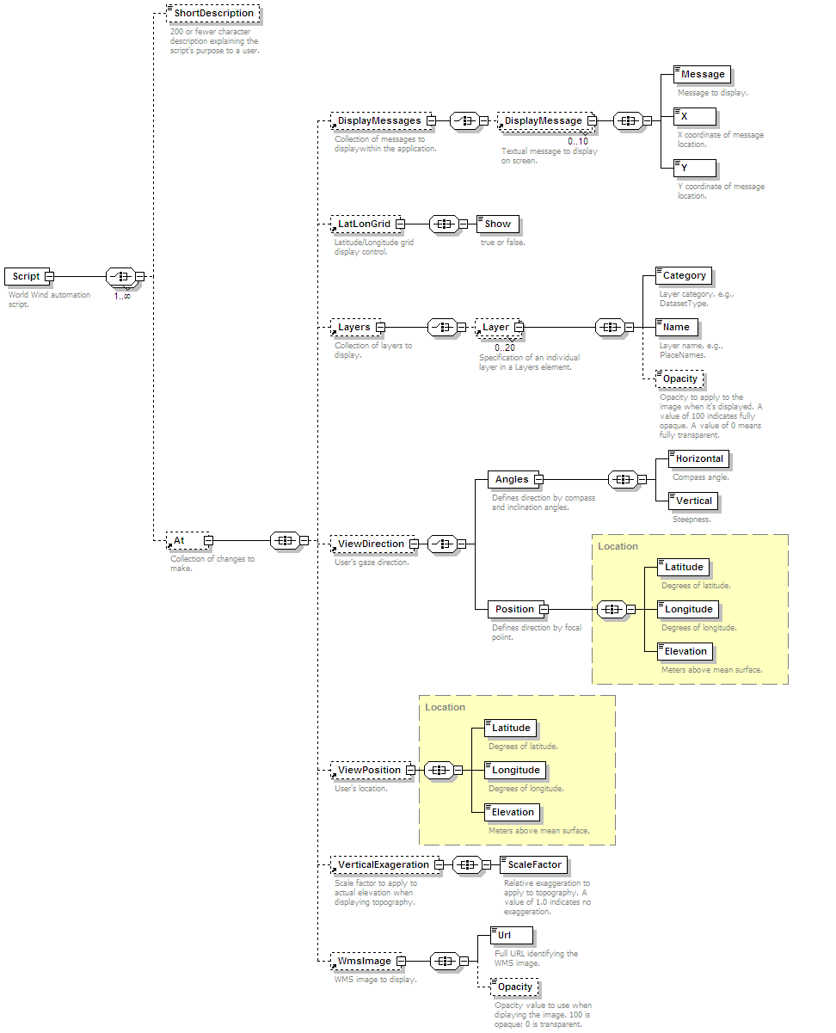

Examples
The following examples illustrate the specification of World Wind scripts.

Circling the Globe
This script circles the globe at various elevations over one minute. It starts at 0° latitude and longitude, moving to 50° North latitude and 120 West longitude at 10 seconds, then to 50° South latitude and 120° East longitude at 20 seconds, then back around to 0° latitude and longitude at 30 seconds. The view direction is initially set to and remains directly towards the surface and perpendicular to it. World Wind repeats the script two times.
<?xml version="1.0" encoding="UTF-8"?>
<Script name="Around the Globe" repeat="2">
<ShortDescription>Fly completely around the globe.</ShortDescription>
<At time="0">
<ViewDirection>
<Angles>
<Horizontal>0</Horizontal>
<Vertical>90</Vertical>
</Angles>
</ViewDirection>
<ViewPosition>
<Latitude>0</Latitude>
<Longitude>0</Longitude>
<Elevation>9.0e6</Elevation>
</ViewPosition>
</At>
<At time="10">
<ViewPosition>
<Latitude>50</Latitude>
<Longitude>-120</Longitude>
<Elevation>5.0e6</Elevation>
</ViewPosition>
</At>
<At time="20">
<ViewPosition>
<Latitude>-50</Latitude>
<Longitude>120</Longitude>
<Elevation>9.0e6</Elevation>
</ViewPosition>
</At>
<At time="30">
<ViewPosition>
<Latitude>0</Latitude>
<Longitude>0</Longitude>
<Elevation>9.0e6</Elevation>
</ViewPosition>
</At>
</Script>

Displaying Messages
The following script displays two messages at different locations when it starts. It displays two new messages at 5 seconds (and the original two are no longer displayed). At 10 seconds it specifies an empty DisplayMessages element in order to turn off the previous messages. At 15 seconds it displays a single new message, and at 18 seconds it turns off that message. Because the Script element includes the attribute setting, repeat=3, World Wind repeats the script 3 times.
<?xml version="1.0" encoding="UTF-8"?>
<Script name="Display Message Test 01" repeat="3">
<At time="0">
<DisplayMessages>
<DisplayMessage>
<Message>This is number one of two first messages.</Message>
<X>0.25</X>
<Y>0.25</Y>
</DisplayMessage>
<DisplayMessage>
<Message>This is number two of two first messages.</Message>
<X>0.5</X>
<Y>0.2</Y>
</DisplayMessage>
</DisplayMessages>
</At>
<At time="5">
<DisplayMessages>
<DisplayMessage>
<Message>This is the second message.</Message>
<X>0.5</X>
<Y>0.5</Y>
</DisplayMessage>
<DisplayMessage>
<Message>This is the second message repeated.</Message>
<X>0.5</X>
<Y>0.3</Y>
</DisplayMessage>
</DisplayMessages>
</At>
<At time="10">
<DisplayMessages/>
</At>
<At time="15">
<DisplayMessages>
<DisplayMessage>
<Message>End of Script!</Message>
<X>0.5</X>
<Y>0.5</Y>
</DisplayMessage>
</DisplayMessages>
</At>
<At time="18">
<DisplayMessages/>
</At>
</Script>

