Module GF004: Federal Trading Partner Note

Module Overview

The Federal Trading Partner Note module (GF004) is where agencies identify trading partners for those Closing Package line items that hold Intragovernmental balances.

For an entity to be displayed in module GF004, all of the entity’s financial statements must be marked final in module GF003, Reclassification.

Users must select a specific Closing Package line and manually enter the appropriate amounts for the desired trading partners. All Closing Package lines with an F/N (Federal / Non-Federal) indicator of “F” must be allocated to GFRS Trading Partners in their entirety. Module GF004 retrieves only these Federal Closing Package lines from module GF003, Reclassification. Because the identification of trading partners and related intragovernmental balances is a federal reporting requirement, GFRS requires that verifying agencies complete the module GF004 for each Closing Package statement that contains applicable lines.

Adjusted Trial Balance data can be viewed for each closing package line item. ATB data can be viewed at the SGL Account, Bureau and ATB code level.

Retrieving a Record

- Open the main form by entering “GF004” into the “Go to” field and pressing <enter> twice. The module can be opened by double-clicking on the GFRS Financial Report System (GFRS) and Intragovernmental Transactions Trading Partners (GF004) links with the mouse as well.

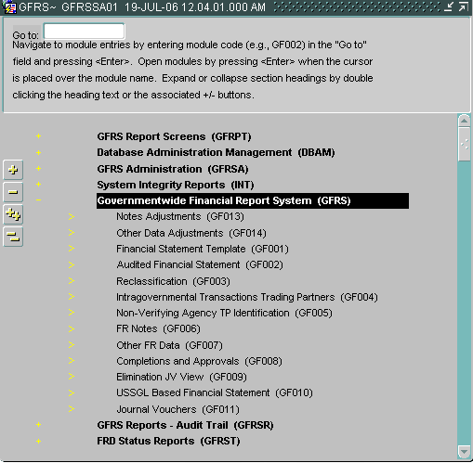

- The GF004 screen is opened; all of the financial statements that the user has permission to see are displayed. To retrieve a specific financial statement click on the Enter Query button on the toolbar.

  - To be displayed in module GF004, all of an entity’s financial statements must be flagged as final in module GF003, Reclassification.

- Place cursor in the Entity field and enter the entity number of the financial statement to be retrieved or double-click on the Entity field to open a List of Values (LOV). To select an entity from the LOV, select the desired entity and click the LOV’s OK button.

- Click on the Execute Query button on the toolbar to retrieve the Closing Package statements for the selected entity. The query will return all of the Closing Package statements for the selected entity. An entity’s financial statements were reclassified to Closing Package statements in module GF003, Reclassification.

- The values for the Fiscal Year and PD (Period) fields default to the current fiscal year and the current period. These values are view only.

Closing Package line descriptions and amounts populate based on the Closing Package lines that have amounts reclassified to them in module GF003. Each Closing Package Line’s amount is the total amount reclassified to that particular line in module GF003, per period.
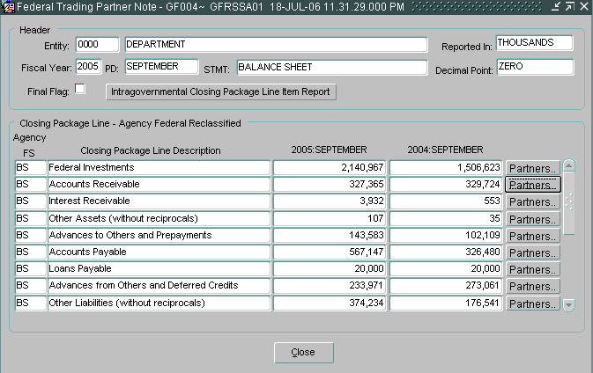
Populates based on selection in module GF002
First four columns populate based on CP lines and amounts reclassified to in module GF003
Agency FS displays the entity’s financial statement that the Closing Package line item was reclassified from.

Identifying Trading Partners

The identification of Trading Partners in module GF004 is the process of allocating intragovernmental balances reported on the Closing Package line item to GFRS Trading Partners.

The identification of trading partners is a two-step process. First, the user must select a Closing Package line item for which he will identify the trading partners and amounts. Once the Closing Package line has been selected, the second step is to allocate the Closing Package line amount to the appropriate Trading Partner/s. Each Closing Package line must be allocated in its entirety and all lines must be allocated.

- The Federal Trading Partner Note screen displays all of the federal Closing Package lines that had amounts reclassified to in module GF003, Reclassification.

- Only Closing Package lines that had a “F/N” attribute setting of “F” (Federal) and a non-zero amount reclassified for either the current and prior periods are displayed with enabled (active) Partners button.

Inactive Trading Partners Line

To the left of the GFRS Entity column, you will see an “I”. This indicates that this entity has been “inactivated” in the system. If you have previously reported amounts that were associated with the inactive entity, you will see your previously reported amount, but because the entity is no longer active, you will not be able to allocate TP dollars to this entity. The Prior Period column will not populate any prior amounts on first entering the screen for entities marked as inactive.

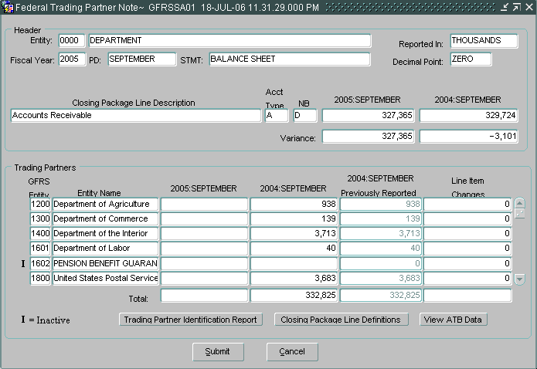

Detailed Instructions:

- After retrieving the correct Entity statement, press the Partners button for a Closing Package line in order to identify the Trading Partner/s and related amounts.

Click on the Partners button to identify Trading Partners.

- The Trading Partner Note screen will open.

- The Closing Package line description and the current and prior period amounts to be allocated are shown on the screen. These fields cannot be edited by the user.

The Trading Partner section of the screen will display all designated Trading Partner entities created by the system administrator. The entity that is performing the allocation is excluded from the list of Trading Partners.

- Select a Trading Partner by entering the related portion of the amount into the selected Trading Partner’s current period field. The allocation identifies the entity as a trading partner and identifies the portion of the amount that is related to the Trading Partner.

- As amounts are entered into the current period amount field of the identified trading partner, the current period variance is recalculated. The value displayed in the variance field is the amount of the Closing Package line item that still needs to be identified and allocated to a trading partner.

- The variance is calculated by subtracting the total amount allocated to Trading Partners for the period from the Closing Package line item amount for the same period.

- The module cannot be marked as Final until all Closing Package line items have been completely allocated and all variance fields equal zero.

- From the current period field, press the Tab key to navigate to the prior period amount field, and enter the prior period amount for the selected Trading Partner. The prior period amount field can also be accessed by using the mouse to click into the field.

- The first time the user selects the Partners button and enters the Federal Trading Partner Note screen for any accessible Closing Package line, the prior period field/s will automatically populate with the amounts reported by the entity for that Closing Package line during the previous year. The populated values are editable by the user.

- To select and allocate the remainder of the Closing Package line amounts to other Trading Partners, use the mouse to click into the current/prior period columns associated with other trading partners or use the up/down arrow key to navigate throughout the screen.

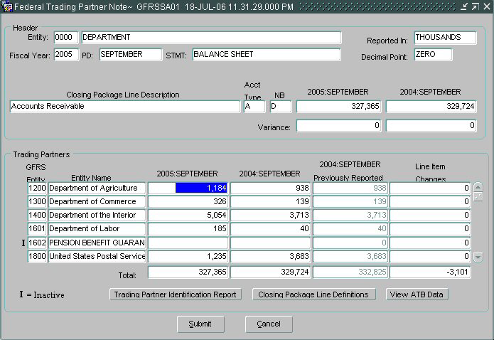

- The Previously Reported field/s will automatically populate with the amounts reported by the entity for that Closing Package line during the previous year.

- The Line Item Changes column is a calculated column that displays the difference between the Prior Period amount field and the Previously Reported amount field.

- Both the Previously Reported column and the Line Item Changes column are for display purposes only and cannot be edited.

- Click on the Closing Package Line Definitions button to view a description of the selected Closing Package Line. The definitions are created by the system administrator for each line item and are maintained in a separate DBA module.

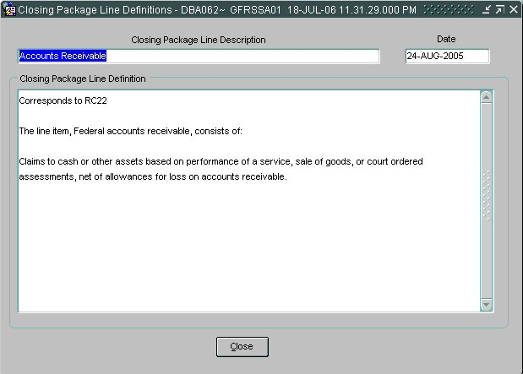

- Press the Trading Partner Identification Report button to run a report of the Trading Partner information displayed on the screen.

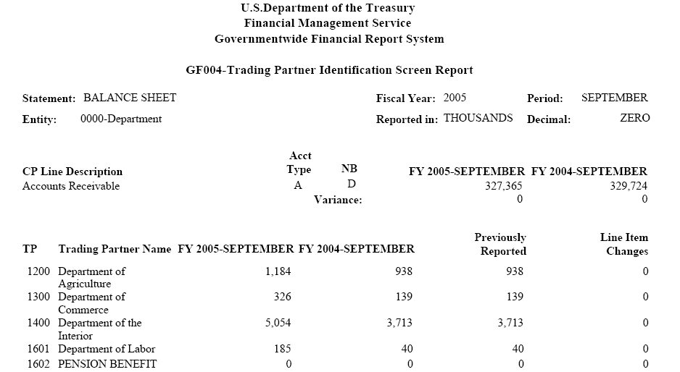

- To retrieve, view and print the report follow the instructions in the Message and Report Retrieval Screen WF003 section of the manual.

- Click on the Submit button to save changes and return to the main form. Click on the Close button to exit the screen without saving changes.

- To view all of the Closing Package Lines that require Trading Partner identification for the selected entity and financial statement, press the Intragovernmental Trading Partners Screen Report button located on the main Trading Partner Notes screen.

- To retrieve, view and print the report follow the instructions in the Message and Report Retrieval Screen WF003 section of the manual.

Viewing and Printing ATB Data
ATB data can be viewed for each Trading Partner by SGL account, Bureau and ATB Code. Each screen can be drilled down to the next level of ATB detail.
The ATB data available in this module is from the Adjusted Trial Balance information that was submitted via FACTS I. Data in these screens cannot be changed and is for informational purposes only.
At each level of ATB data, reports are available to be run that summarize the data displayed on the screen.

Detailed Instructions:
- Press the View ATB Data button to view the Adjusted Trial Balance Data for the Trading Partners displayed on the screen.

- The ATB data screen will open and display all of the ATB data that was submitted in the FACTS I ATB Submission for each Trading Partner (Entity).

- ATB data is displayed by Trading Partner (FACTS I department) as specified in the FACTS I ATB file submission. Trading Partners are displayed in two-digit codes. The ATB Data Report is available to show the user how the ATB data should map to the GFRS four-digit entities.

- All data displayed in the ATB Data screens is view only.

- The ATB amounts displayed are reported in ATB Actual and Rounded amounts. The Rounded amount uses the reporting method and decimal point location specified by the agency in module GF002.

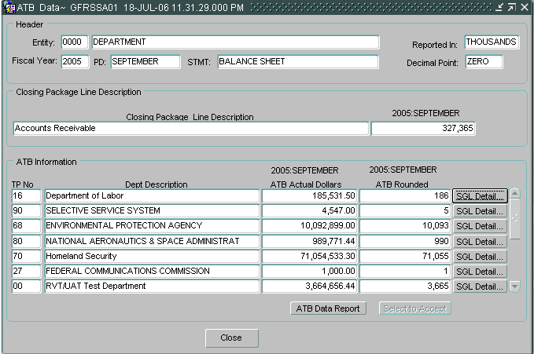
Trading partner is populated from the FACTS I interface and is linked to the appropriate GFRS entity.

- Click on the ATB Data Report button to print the ATB information displayed on the screen and determine how the two-digit FACTS I departments should map to the four-digit GFRS entities.

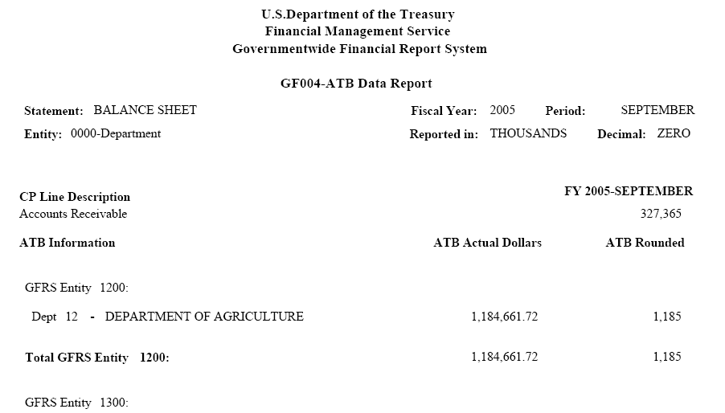

- To retrieve, view and print the ATB Data Report follow the instructions in the Message and Report Retrieval Screen WF003 section of the manual.

- Press the Close button to exit the screen and return to the previous screen.

- Press the SGL Detail button on the ATB Data screen to view the ATB data of a specific trading partner by SGL account number.

- The SGL Detail screen will open and display Trading Partner data at the SGL level.

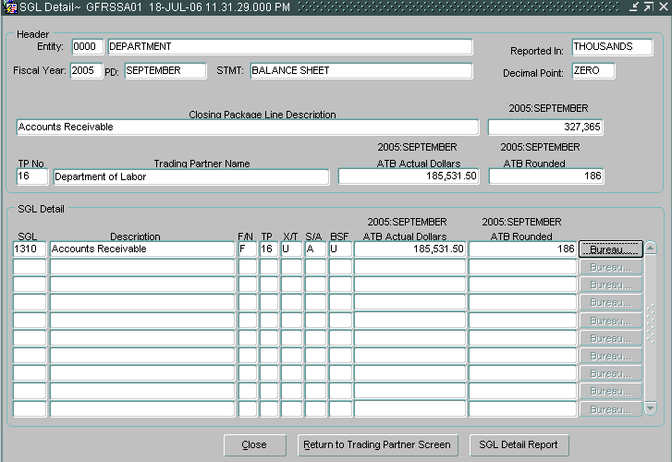

- Click on the SGL Detail Report button to print the ATB information displayed on the screen.

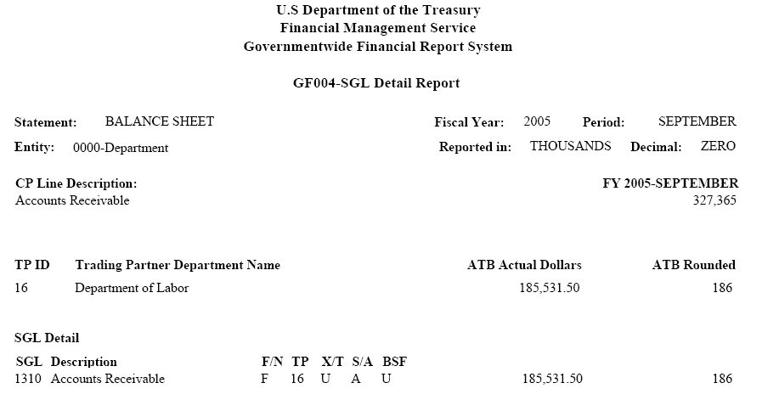

- To retrieve, view and print the ATB Data Report follow the instructions in the Message and Report Retrieval Screen WF003 section of the manual.

- Press the Close button to exit the screen and return to the previous screen.

- Press the Return to Trading Partner Screen button to return to the Trading Partner Identification Screen.

- Press the Bureau button to view the ATB data at the Bureau level for a selected SGL account.

- The Bureau Detail screen will open and display the ATB data at the Bureau code level.

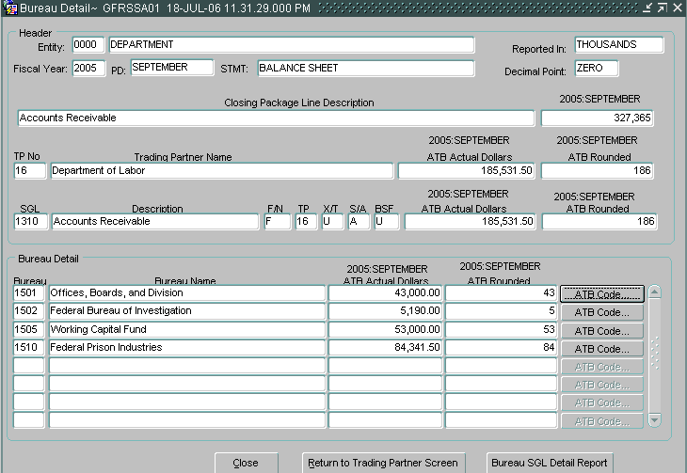

- Click on the Bureau SGL Detail Report button to print a report of the ATB information displayed on the screen.

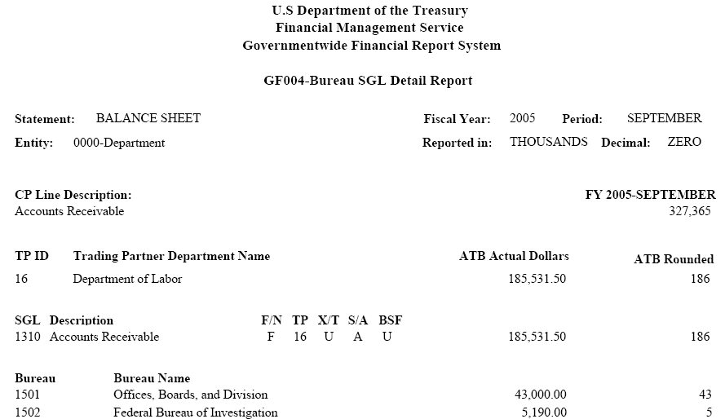

- To retrieve, view and print the ATB Data Report follow the instructions in the Message and Report Retrieval Screen WF003 section of the manual.

- Press the Close button to exit the screen and return to the previous screen.

- Press the Return to Trading Partner Screen button to return to the Trading Partner Identification Screen.

- Press the ATB Code button to view the ATB Data at the ATB code level for a selected bureau.

- The ATB Code Detail screen will open and the ATB data will be displayed by ATB code for the selected Bureau.

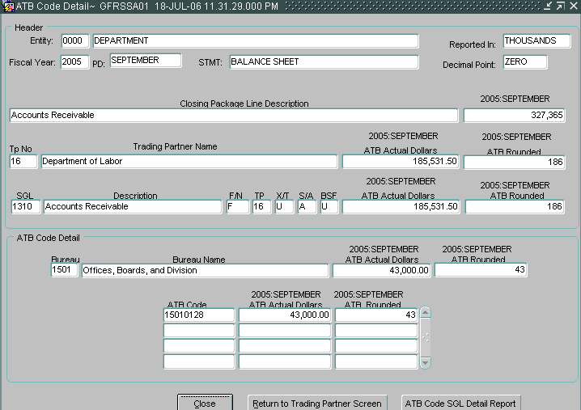

- Click on the ATB Code SGL Detail Report button to print a report of the ATB information displayed on the screen. .

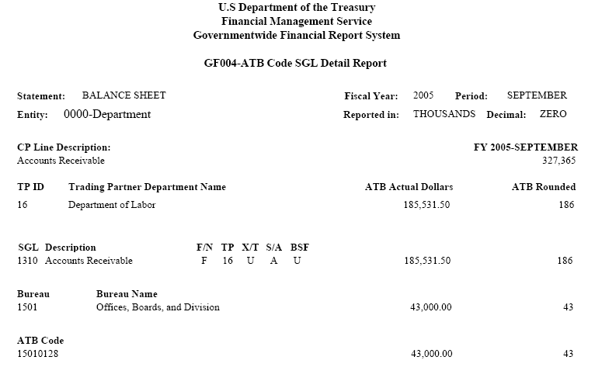

- To retrieve, view and print the ATB Data Report follow the instructions in the Message and Report Retrieval Screen WF003 section of the manual.

- Press the Close button to exit the screen and return to the previous screen.

- Press the Return to Trading Partner Screen button to return to the Trading Partner Identification Screen.

Final Flag setting

To complete the GF004 module, the final flag must to be checked for all statements for the entity. When the final flag is checked, the system initiates a validation that confirms that all Closing Package Line item amounts have been allocated to Trading Partners in their entirety.

- The final flag cannot be checked if a variance exists for any Closing Package Line item in the financial statement.

- The trading partner allocations cannot be modified while the final flag is checked for that particular statement. Should changes need to be made to a TP allocation in the GF004 module, the final flag button must be unchecked.

- If the system will not allow the final flag to be unchecked, the financial statement may be locked in the Completions and Approvals module (GF008). The FPA must unlock the GF004 module in the GF008 screen for the final flag to be modifiable. See Module GF008 for further explanation.

Detailed Instructions:

- To complete the statement in GF004, click on the “Final Flag” on the Federal Trading Partner Note Screen.
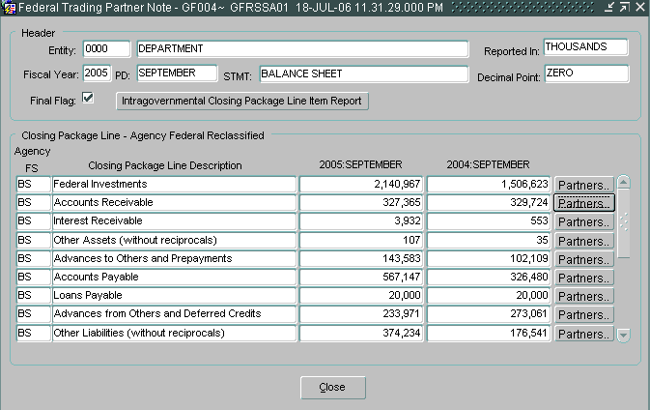

- If the financial statement fails the validation checks, an error message will be displayed. The message will reference the Closing Package Line item balance that has a variance.

- Click on the OK button to acknowledge the message and make the necessary changes to the trading partner allocation for the mentioned line item.

