Module GF002: Audited Financial Statement Module

Module Overview
In this module, agencies will manually enter their audited financial statement data by agency line item for each required financial statement. Agency line item descriptions were identified in the Financial Statement Template Module (GF001).
Agencies will select the entity’s reporting method and decimal point location in this module. The reporting method and decimal place setting is applied to all statements for that entity. The methods selected will be used in the Agency Audited Financial Statements Module, Reclassification Module, Intragovernmental Trading Partners Module and other modules, as needed. The reporting method and decimal point location assigned by the verifying agency are based upon the method used for the published agency audited financial statements. The reporting methods from which the user can select are hundreds, thousands, millions, billions, and whole dollars. The user will also select the number of decimal places from the right that the decimal point appears in their reported financial statements. The user can select from three options for decimal point location: one decimal place, two decimal places or zero decimal places.
Any “Inactive” lines from Module GF001 will not be presented in Module GF002.
For current period data, the user has the option to view the FACTS I trial balance data, but must enter the actual amounts manually. The system has a report available for the user to validate that all SGL’s used in the agency’s FACTS I submission are also assigned to line items in the template. The report is called the “SGL Report.”

Logging on to GF002

- Navigate to the GFRS menu screen.

- Type “GF002” into the “Go to” screen and press enter twice or open the screen by expanding the GFRS menu and placing the cursor on the GF002 selection. Double-clicking will open the module.

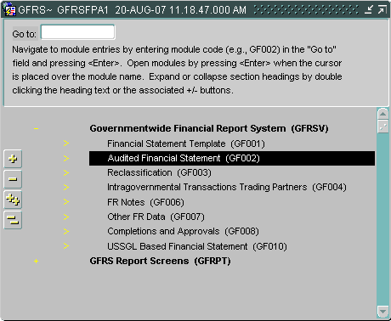

- The GF002 screen will open to the first record that the user has permission to view. All records that the user has permission to view will be ordered by entity number (starting from lowest to highest). The statement must already be flagged as FINAL in GF001 to view the statement in GF002.

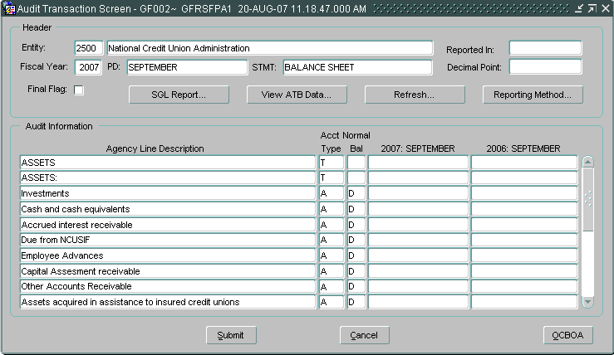

Querying a Record
This section describes the steps necessary to query and retrieve a financial statement in GF002. GFRS retrieves financial statements by entity number. To run a query and retrieve a financial statement follow the steps listed below:
- Place the cursor on the Entity field.

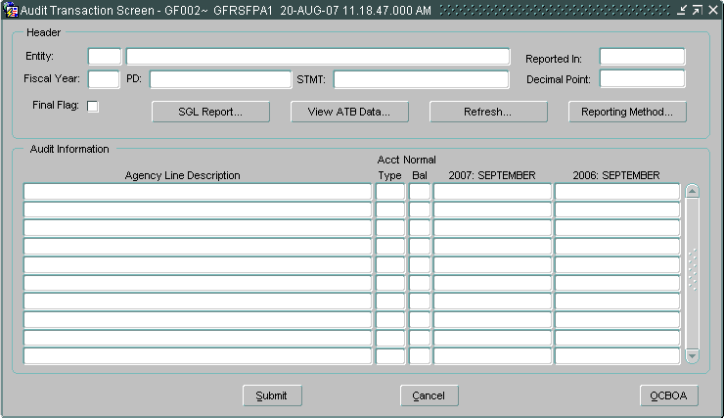
- Press the ENTER QUERY icon on the toolbar. If a record was already displayed on the screen before the user enters the query, the screen will be blank.
- Double-click on the entity field to open the list of values (LOV) for the entity field.

Option 1:
  - Scroll through the entities displayed and highlight the appropriate entity.
  - Press the “OK” button in the LOV to select the highlighted entity.

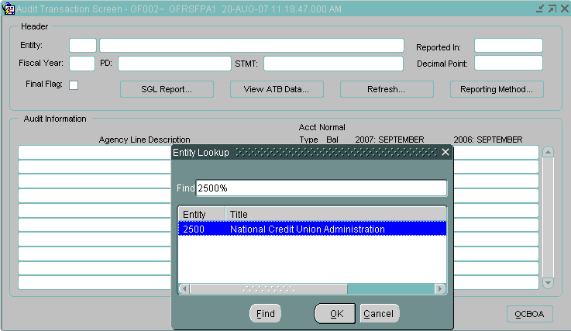
Option 2:
- The entity number may also be manually entered into the ENTITY field after hitting the ENTER QUERY icon.

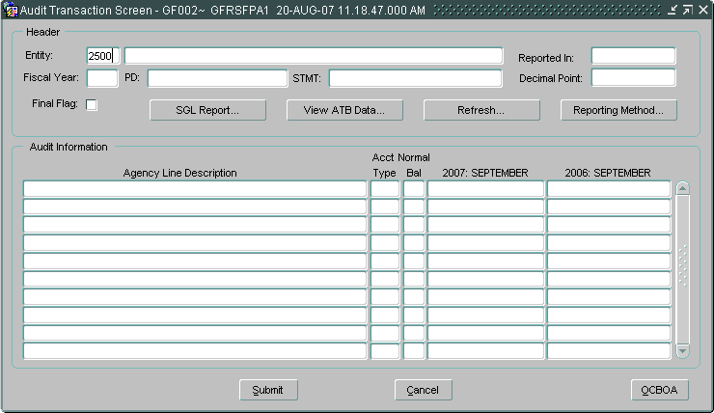
- Press the Execute Query icon on the toolbar and all agency statements for the selected entity will be returned.
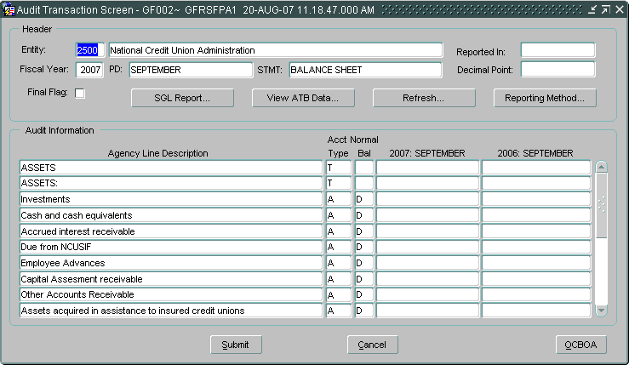
The query will return all records for the selected entity.
- To view other statements for the selected entity, press the NEXT RECORD icon and for previous Record icon on the tool bar to navigate to the next record. All financial statements that have been flagged as FINAL in GF001 for that entity will be available in GF002.
The user can also navigate through the financial statements by using the UP and DOWN arrow keys on the keyboard.
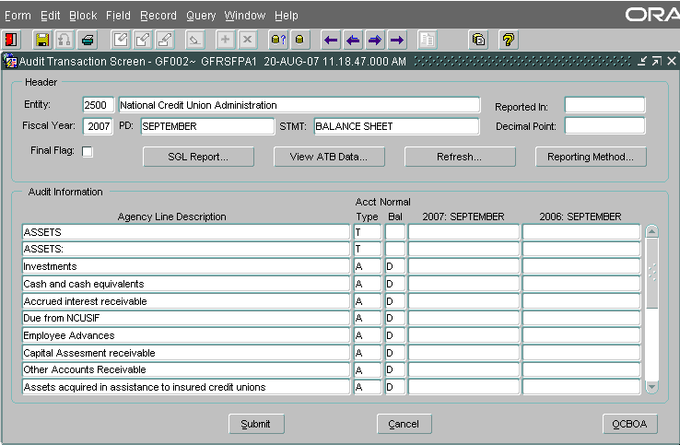

Assigning Reporting Method and Decimal Point Location
The reporting method and decimal point must be assigned for each agency. Both are assigned using the Reporting Method screen in the GF002 module. Reporting method defines how the agency financial data is displayed in the Audit Transaction screen. The data can be displayed in Whole Dollars, Hundreds, Thousands, Millions and Billions. Decimal place determines if decimals are to be displayed and if so, how many places to the right of the decimal point should appear. There are three possible selections: Zero (No decimals), one digit to the right, and two digits to the right.

- Users must select a decimal place setting and a reporting method before entering amounts into the Audit Transaction screen for any statement.
- The reporting method and decimal point selection made in the GF002 module are valid for all statements in subsequent modules, and for GF006 Notes on the Notes Line Item Tab.

Note: Once module GF002 is Final Flagged the “Reporting Method” can not be changed.

- Press the “Reporting Method” button on the main GF002 form. The reporting method screen will be displayed.

- Select one of the reporting method radio buttons (the default setting is “Whole Dollars”). There are five possible selections: Whole Dollars, Hundreds, Thousands, Millions & Billions.

- Click one radio button to select a decimal point setting. The default setting is “Zero.” There are three possible settings: Zero, One and Two.

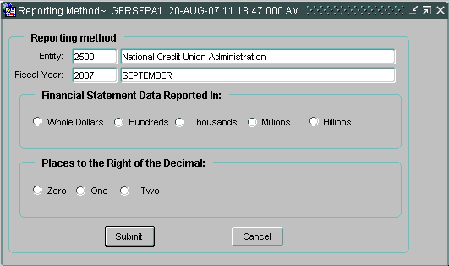

  - Only one reporting method and one decimal location can be selected for each entity.
  - The reporting method selected is also used in the Reclassification Module, the Intragovernmental Transaction Trading Partner Module, Closing Package Notes, and Other Data Modules.
- Press the “Submit” button to save the radio button settings.

- After selections are made for the decimal point and reporting method selections, “Reported In:” and “Decimal Point:” fields in the Audit Transaction Screen will be populated and will display the new settings.

- Selections made for Reporting Method and Decimal place are applied to all of the financial statements for a given entity. Should the Reporting Method or Decimal Position be changed in a financial statement, the same changes will be applied to all of the financial statements for the selected entity.
.
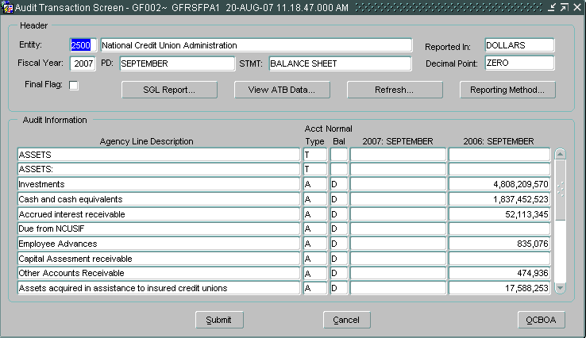

Entering Prior Period Information
Upon setting the reporting method in GF002, data is populated for the Prior Period column. These amounts are what the entity reported in the prior year Financial Statement. Prior period amounts can be modified if needed.

- Click mouse to move the cursor to the prior period field.
- Change desired amount(s) in the prior period field.
  - The user must use the mouse or the down arrow on the keyboard to move the cursor to a new line.
  - The REFRESH button in the header of the form will update prior period calculations.
  - All lines with the exception of lines with account type “C” or “T” must have a value entered. Template lines that have zero as an amount must have “0” entered, and cannot be left blank.

Entering the Current Period Information

- Current period agency line balances should be entered into the current period field.

The first column is for the current open period.

- Enter the balance of a line item from the Agency Audited Financial Statement into the corresponding field for the current open period.
  - Balances cannot be entered for lines that have account types of “T” (Title) and “C” (Calculation).

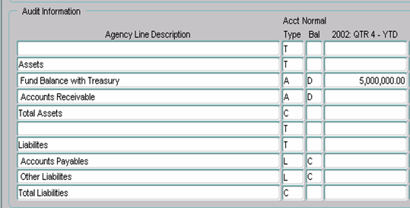
- As balances are entered for each line item, the user must refresh the screen to updated calculations. To view updated calculations, the “Refresh” push button must be pressed.

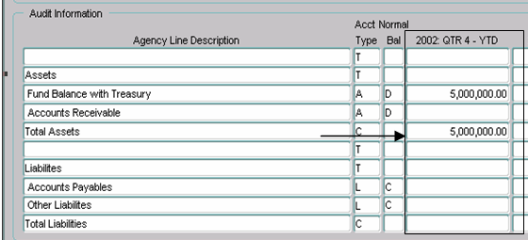

Other Cost Basis of Accounting (OCBOA)
Other Cost Basis of Accounting (OCBOA) agencies are treated differently in Module GF002: Audited Financial Statement Module. If an agency is unsure of if they are an OCBOA agency please contact your Financial Report Division (FRD) contact for information.

- Navigate to the GF002 screen. The OCBOA push button will be enabled.

- Press the “OCBOA” button to access the OCBOA Adjustment Screen.
- When the OCBOA button is enabled, users must press the OCBOA screen to populate the OCBOA fields with data from the Audit Transaction screen.

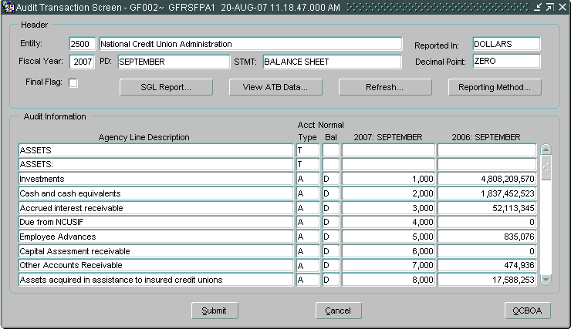

  - The first time the OCBOA button is clicked, this form will populate with the same numbers in the FEDERAL GAAP columns as those in the grayed out columns.
  - The user will manually adjust the Federal GAAP numbers as necessary.

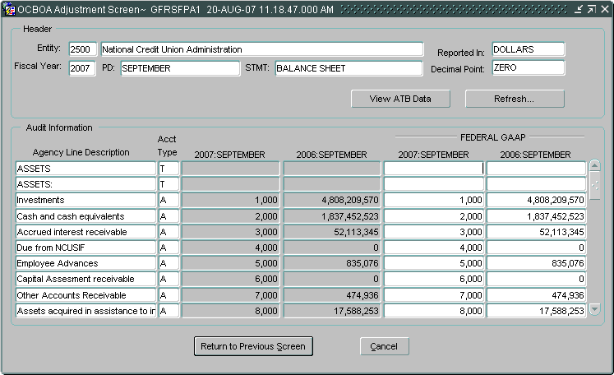
Values are populated from the Audit Transaction Screen
Users must enter amounts into the OCBOA (fields)

- Data entered into the OCBOA fields have the following validations that take place when the FINAL FLAG is checked.
- All lines with the exception of lines with account type “C” or “T” must have a value entered. “Zero” must be entered into template lines have zero as an amount to report.
- If the financial statement is a balance sheet, both the OCBOA statement and the Audit Template must be in balance (Debit Lines = Credit Lines).

- Press the “Refresh” button to update calculated fields with updated OCBOA amounts.
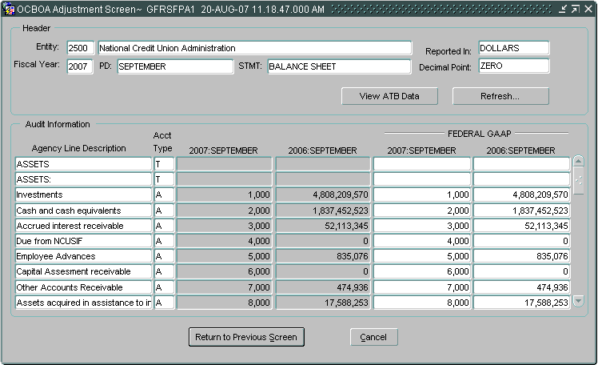

- Once the final flag is checked, the Federal GAAP amounts entered in the GF002 module are eligible for reclassification in the GF003. Only Federal GAAP amounts will be displayed in the GF003 module.

- Press the “Return to the Previous Screen” to save all changes and return the Audit Transaction screen. To exit the screen without saving changes press the “Cancel” button

- Users may also view ATB data that was submitted in the FACTSI submission by pressing the “View ATB Data” push button.

Normal Balance Settings
Understanding Normal Balances
When entering agency financial statement line amounts, users must be cognizant of the normal balance of both the Agency Financial Statement Line Items as it was selected in GF001. The rules for entering amounts is as follows:
- If the balance of the line item is the same as the normal balance of the line item (as assigned in GF001) then the amount should be entered as a positive number.
- If the balance of the line item is the opposite of the normal balance of the line item (as assigned in GF001) then the amount should be entered as a negative number.
  - Calculations will be performed in the system using the true balance of the account.
  - All calculations resulting in a debit balance will be displayed as positive numbers. All calculations resulting in a credit balance will be displayed as negative numbers.
  - Debits are treated as positive numbers and credits are treated as negative numbers, for purposes of calculations.

    - Total Debit Calculation
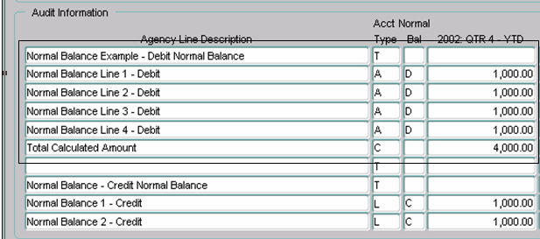
System adds the debit balances and displays the total as a positive number.

    - Total Credit Calculation
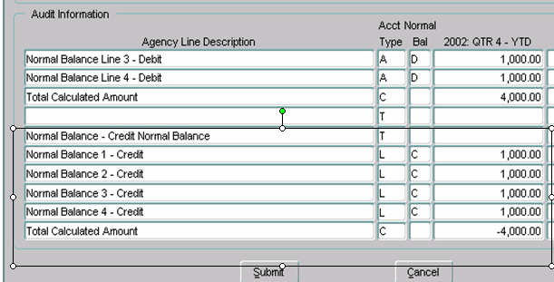
Credits are added together and displayed as a credit balance.

Saving Changes

- The template can be saved at any time by pressing the “Submit” button at the bottom of the form. The changes will be saved and the form will close.
- “Cancel” should be pressed to close the form and avoid saving changes.
- The changes to the template may also be saved by pressing the “Save” icon in the toolbar or selecting FORM -> FILE.

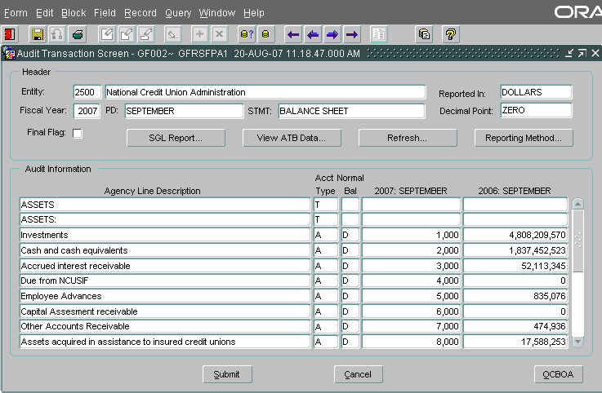
Press to close form
To save data on the form

Running the SGL Report
An SGL report is available to the user to compare the USSGL accounts assigned in the crosswalk to the financial statements in GF001 to the USSGL accounts used in the FACTS I file submission for that entity.
- To run the SGL report, press the “SGL Report” push button on the Audit Transaction Screen.

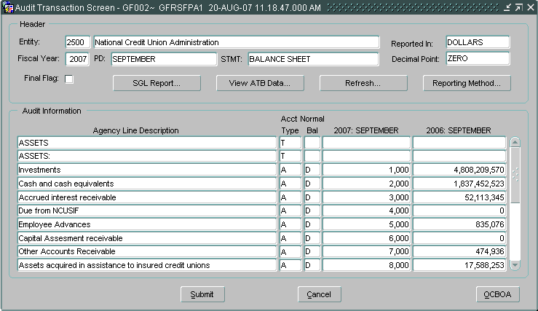

- A confirmation message will be displayed confirming that the report has been run and prompting the user to retrieve the report. Press “OK” to acknowledge the message.
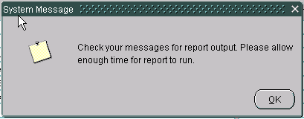

- To view the SGL report, press the Message Retrieval button on the tool bar to display the reports in the queue.
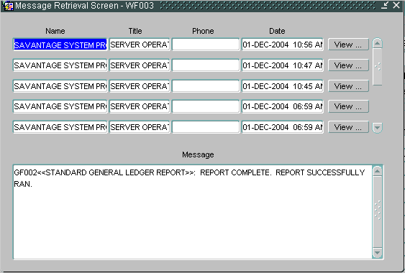

- The Message Retrieval screen (WF003) will open and display all of the reports that the user has requested. By default, the most recent report requested by that user will be the first report displayed. The message screen will provide a status of the report. To view the SGL report press the “View” push button and the report will be displayed.

- After pressing the view button, the report will be displayed in preview mode in PDF format. To print the report, press the print button on the PDF tool bar.

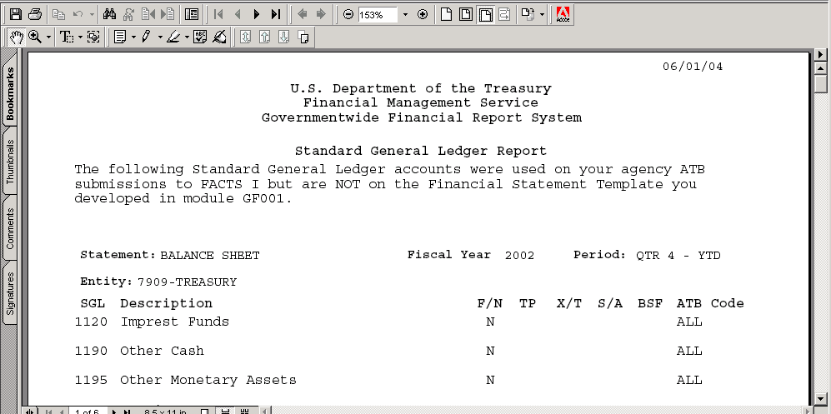
Save and Print

- The report can also be saved locally by pressing the save icon on the tool bar. When the save icon is pressed, the system will prompt the user with a screen to save the report in a designated folder. Select the location to save the report in the “Save in” field and press the “Save” button.

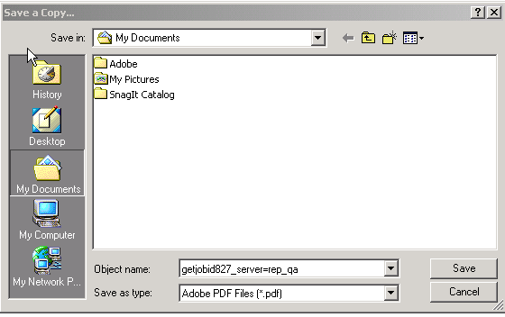

Viewing ATB Data
ATB data can be viewed for all template lines using the USSGL crosswalk defined by the agency in GF001. All agency lines with ATB data are displayed in the ATB data screen. Each selected agency line with ATB data can be detailed further by SGL account, Bureau and ATB code levels.

- To view the ATB data press the “View ATB data” button in the header of the form. The ATB data screen will open displaying all of the financial statement line items with ATB balances from the FACTS I submission. Only template lines with ATB data will be displayed.

  - All of the ATB data screens are view only.
  - The ROUNDED amounts on the form are displayed using the method assigned by the entity on the main GF002 form.

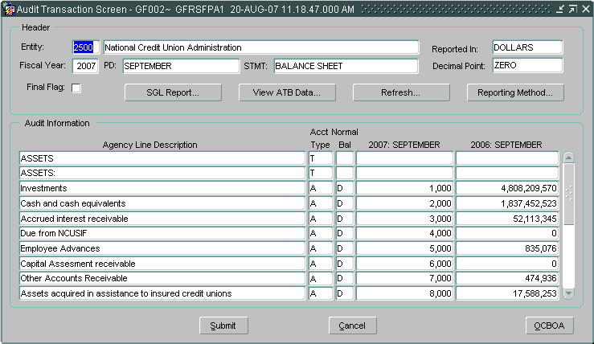

- To view the SGL data for any template line, press the SGL Detail button . ATB data is displayed for each line by SGL account number.

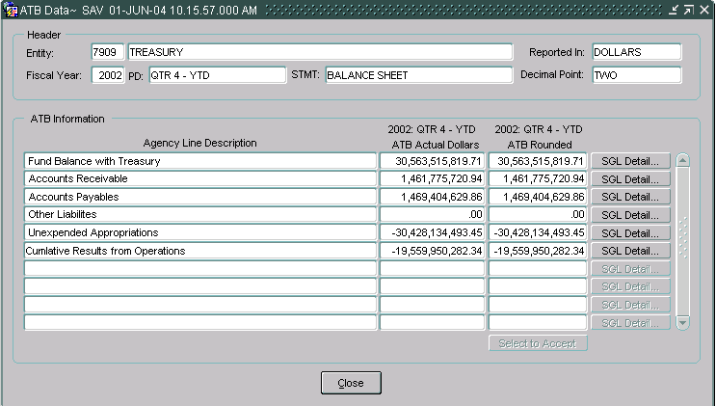

- To view ATB data at the bureau level for a selected SGL account, press the “Bureau” button to the right of the SGL line. The bureau screen will open and display all of the related bureaus and corresponding ATB balances for the selected SGL account.
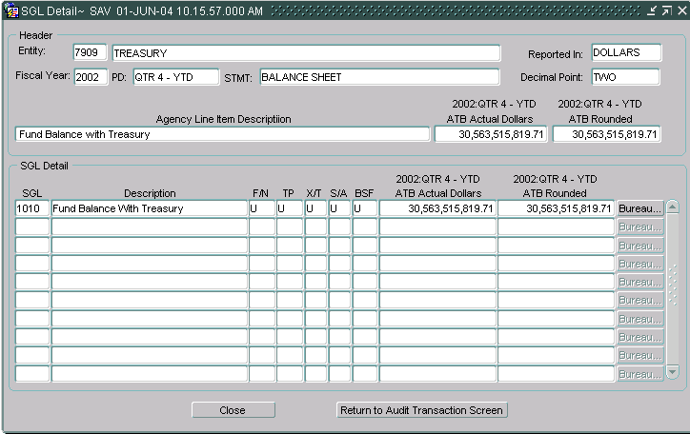

SGL data is listed by SGL account number
Press to view ATB data by Bureau

Press to view ATB Data by Bureau
- From the Bureau screen ATB data for a selected bureau code can be viewed by pressing the ATB data button. The ATB code detail screen displays the ATB data for a selected bureau.
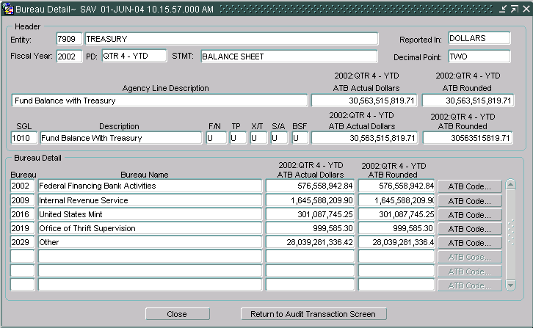
Bureau data is listed by dept/bureau number

To view ATB data by ATB Code, click the ATB CODE button

- Each ATB data screen has two push buttons, “Close” and “Return to Audit Transaction Screen.” Pressing the “Close” button will close the screen and return the user to the previous screen. The “Return to Audit Transaction Screen” button will return the user to the main form of the module.
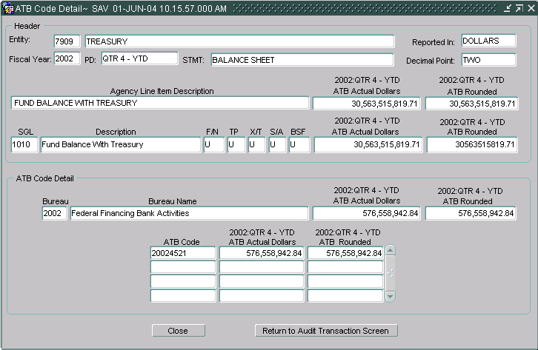

Flagging the Financial Statement as Final
Once all current period data and prior year data has been entered, the final flag must be checked to finalize the agency audited financial statement and to allow the user to proceed to the GF003. The data entered into GF002 cannot be used in other modules until the final flag button is checked.
When the final flag is checked, the system validates that amounts have been entered for all line items that are not “T” or “C.” If a financial statement line is blank, the system will display an error message and the user will be required to enter a numerical value for the affected line. The user must manually key a ‘0’ for line items with no amount. After the final flag is checked and the financial statement is complete, the statement becomes available for reclassification in GF003.
To set the final flag for balance sheets, the debits and credits must be in balance. If the balance sheet is set up for Other Cost Basis of Accounting (OCBOA) reporting, the debits and credits must be in balance in both the Audit Transaction screen and OCBOA Transaction screen.

- Check the Final Flag check box once the GF002 Financial Statement is complete. You should receive the following messages if you do not meet the edit checks to Final Flag the module.
- For the final flag for a balance sheet financial statement, the debits and credits must be in balance for both Audit and the OCBOA Transaction screens. Should either or both statements be out of balance an error message is displayed.
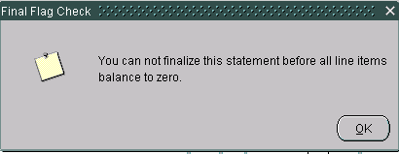

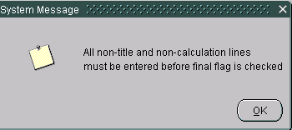
- All statement lines (Except lines with account types “T” or “C” must have values entered. Statement lines that do not have values should have “0” entered as an amount. Should the final flag be checked for a statement that has an empty line, the following error message is displayed.

- The user should enter an amount for the empty line item before clicking the FINAL FLAG again.

- Once the final flag is set in GF002, the reporting method cannot be changed. The GF002 will display a warning message telling the user that the Decimal Place and Reporting Method cannot be changed after the final flag is set.

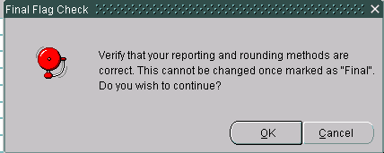

- The GF002 system will display a warning message asking the user if all of the data has been entered into the OCBOA screen. .
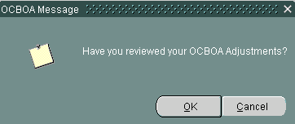

- Once all amounts have been entered properly, the system will allow the statement to be flagged as FINAL.

- Once all statements are flagged as final in the module, the user will receive the message below informing him that the module is ready for completion in the GF008 module by FPA. Press “OK” to acknowledge the message.
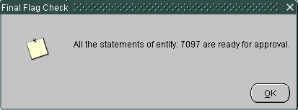

Modification of Existing Records

The ability to edit agency audited financial statements depends on the approval status of the statement. If the module has been approved and locked by the CFO or IG in GF008, the statement will be un-modifiable unless the CFO or IG unlocks the module for editing. (If the module has not been approved in GF008 the current period balances and the prior period balances can be changed). Modifications to the statement line descriptions cannot be made in GF002. The addition and subtraction of lines, the changing of line descriptions, and the changing of calculations must be done in GF001 (refer to section 1.8).

To make changes, the final flag must be unchecked. Once the changes have been made, the final flag must be re-checked and the Agency Financial statement re-validated before the changes can be finalized and approved in the GF008 module.

Modifying a Statement Marked as Final

- If the FPA has marked all statements as FINAL and marked the entire module as COMPLETE in GF008, the FPA must FIRST reopen the module in GF008 before making any changes within the GF002 module. If the FPA has not flagged all statements as final in GF008, he must only uncheck the final flag in GF002 to make edits.

- Once the module has been reopened from GF008 (if necessary), the user will uncheck the final flag in the GF002 main screen for the desired statement.

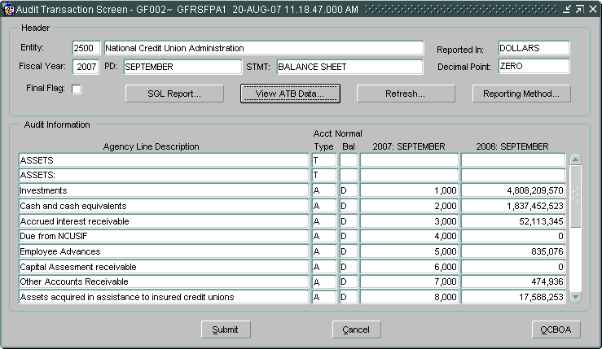

- Make the required changes to the statement.
- Values may be changed in both current and prior period fields.
- Check the final flag check box to finalize the financial statement and change the statement status to FINAL. By checking the final flag, the Audited Financial Statement is completed and is available in GF003.
- Click on the “SAVE” icon to save the changes and leave the screen open or press the “Submit” button to save and exit.
The button is used to exit the screen without saving changes.

