New Features in IMG 2.3 Web UI

(July 9, 2007)

Some changes have been made to the IMG 2.3 Web UI:

- Uploading Gene Cart feature is moved to the Gene Cart page (from MyIMG).
- Uploading Function Cart feature is moved to the Function Cart page (from MyIMG).
- Parts lists can be organized into Function Network.
- MyIMG annotations have been enhanced.
- Some additional attributes have been added.

1. Uploading Gene Cart

“Upload Gene Cart from File” feature is now in the Gene Cart page. Click the “Upload Gene Cart” button to upload gene cart contents from a file. Flat file format for gene cart upload remains the same as in IMG 2.2 and before.

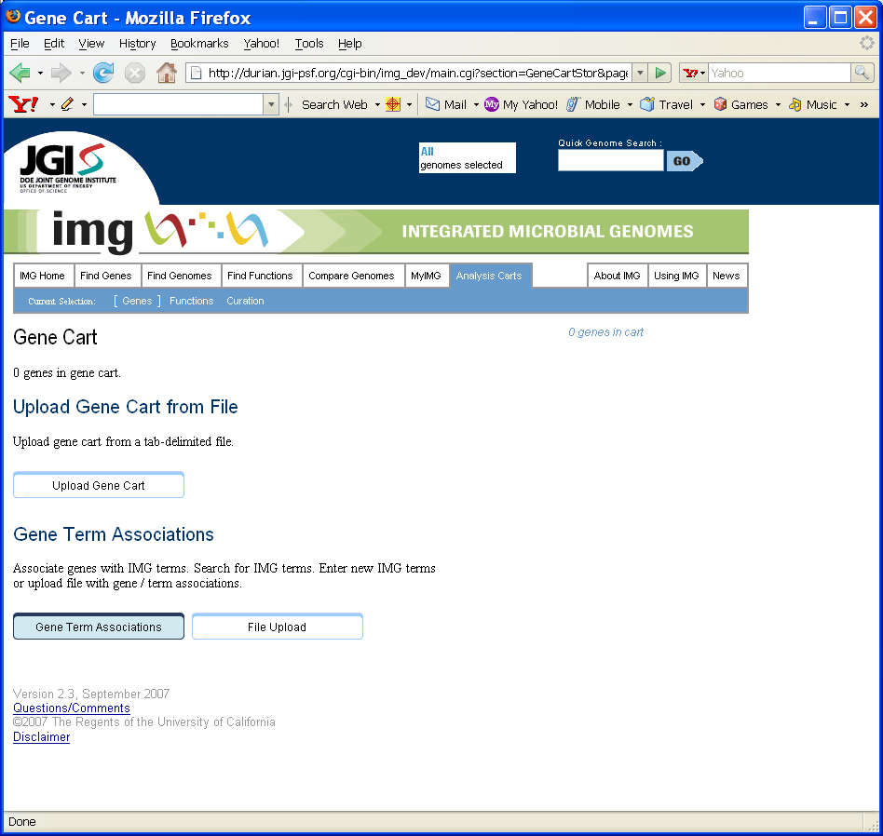

(Figure 1.1: New Gene Cart with “Upload Gene Cart” button)

2. Uploading Function Cart

“Upload Function Cart from File” feature is now in the Function Cart page. Click the “Upload Function Cart” button to upload function cart contents from a file. Flat file format for function cart upload remains the same as in IMG 2.2 and before.

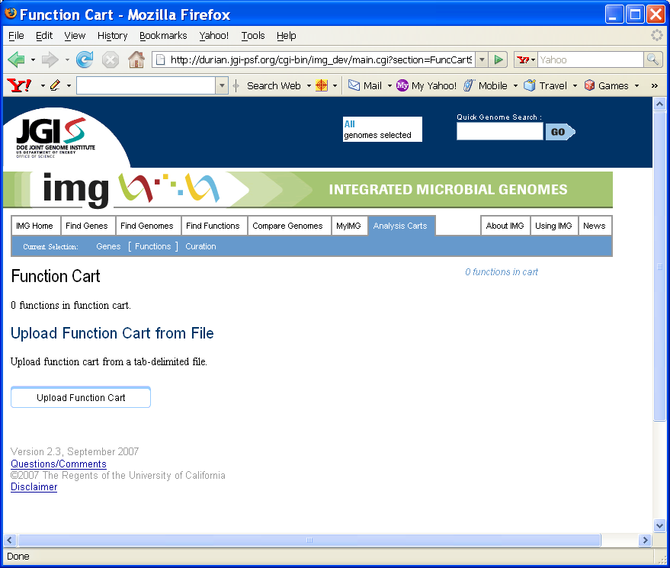

(Figure 2.1: New Function Cart with “Upload Function Cart” button)

3. Function Networks, Pathways and Parts Lists
The new Function Networks in IMG 2.3 can contain pathways and/or parts lists.

3.1 Browsing Networks, Pathways and Parts Lists

In IMG 2.2 and before, networks and pathways are all listed under “IMG Pathway” based on the network-pathway hierarchical structure. In the new IMG 2.3 UI:
- Function Network: show function network hierarchy with pathways and parts lists;
- IMG Pathway: list IMG pathways in alphabetical order;
- IMG Parts List: list IMG parts lists in alphabetical order.

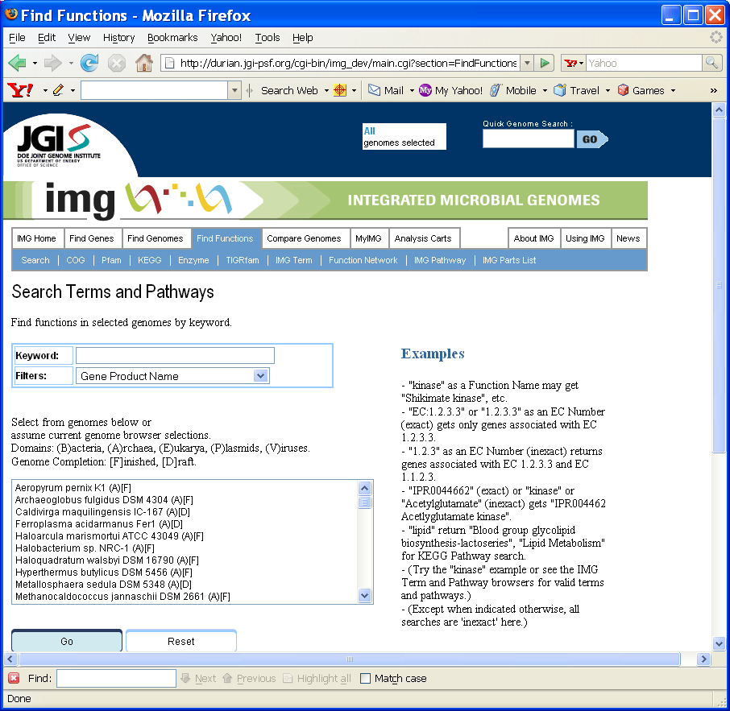
(Figure 3.1: New IMG 2.3 UI with “Function Network,” “IMG Pathway” and “IMG Parts List”)

Function Network Browser page (Figure 3.2) shows the Function Network hierarchy with pathways and parts lists.

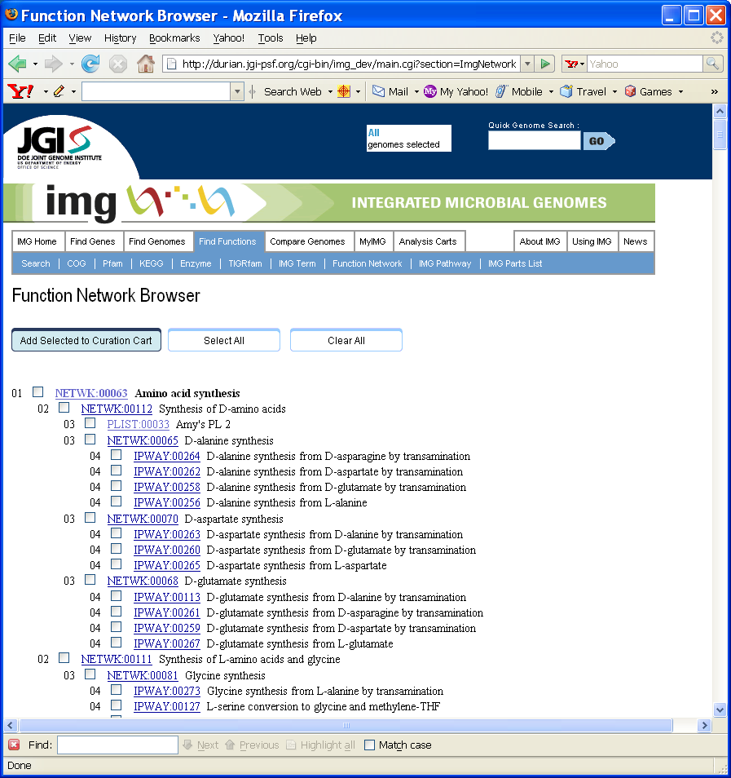
(Figure 3.2: Function Network Browser)

Click on a function network hyperlink, the function network detail, together with pathways and parts lists in this network, will be displayed in a new page.

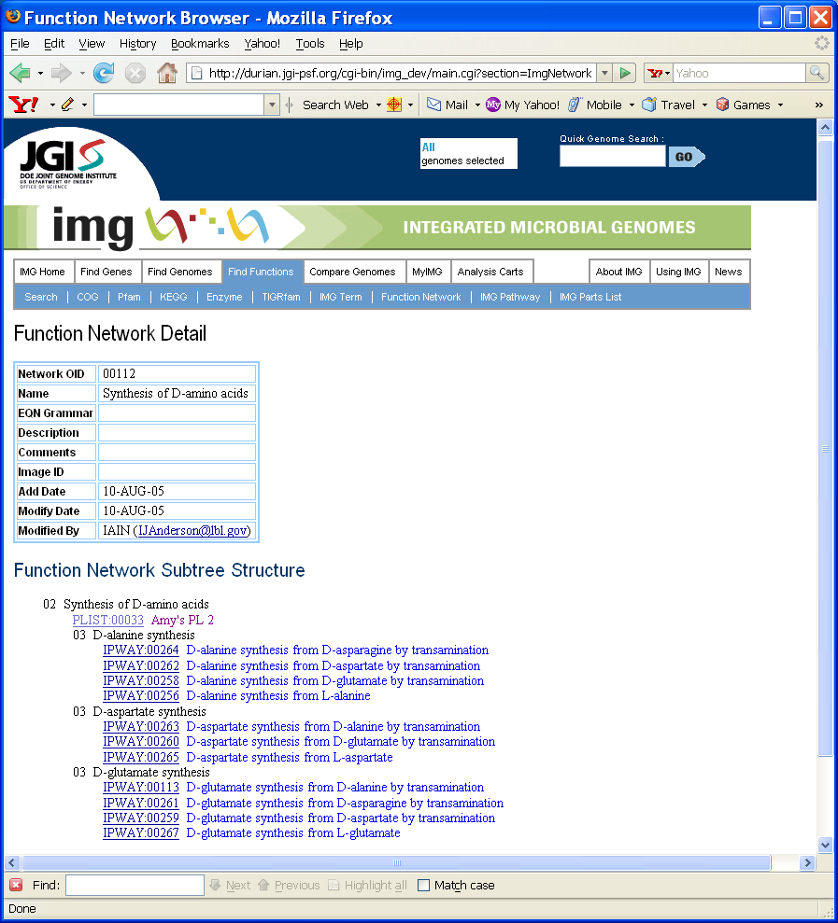
(Figure 3.3: Function Network Detail page)

IMG Pathways page (Figure 3.4) lists all pathways in alphabetical order.

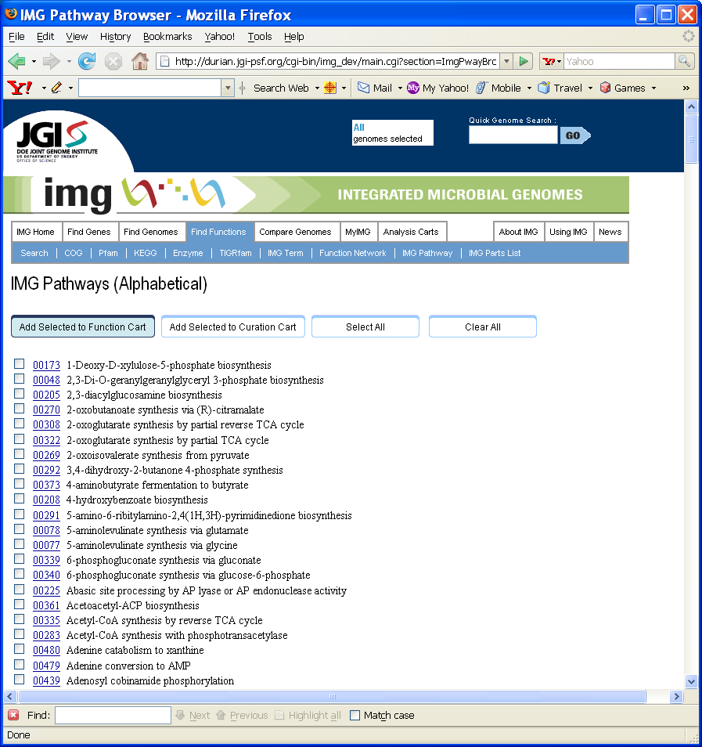
(Figure 3.4: IMG Pathways page)

IMG Parts List page (Figure 3.5) lists all parts lists in alphabetical order.

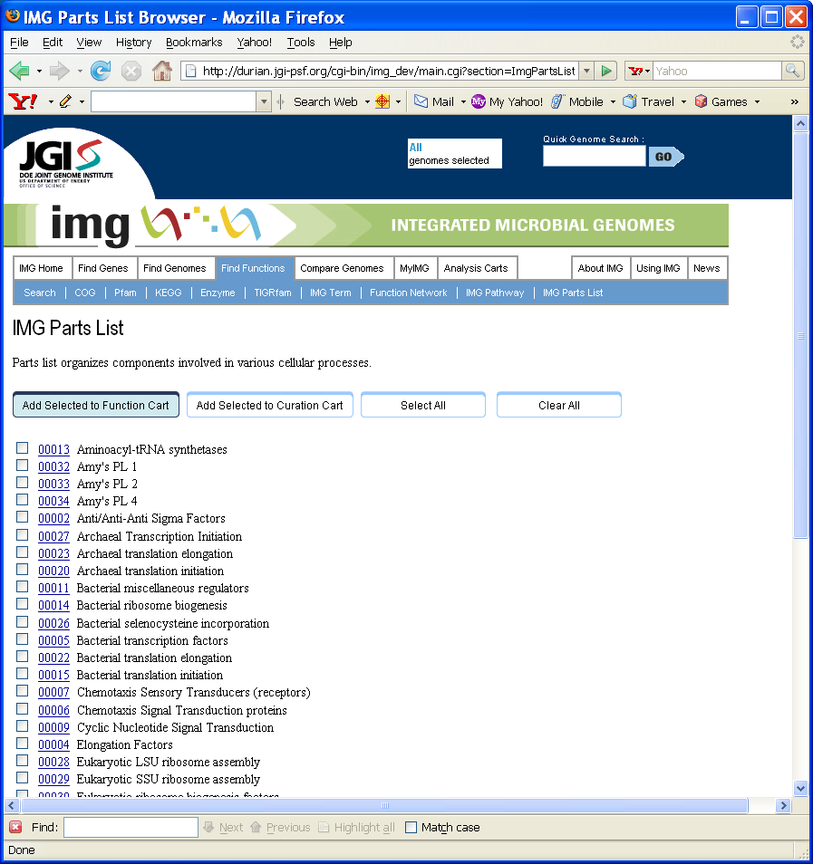
(Figure 3.5: IMG Parts List page)

3.2 Assigning Parts Lists to Network Hierarchy

The new Update IMG Parts List page (Figure 3.6) allows users to specify to which network(s) this parts list belong.

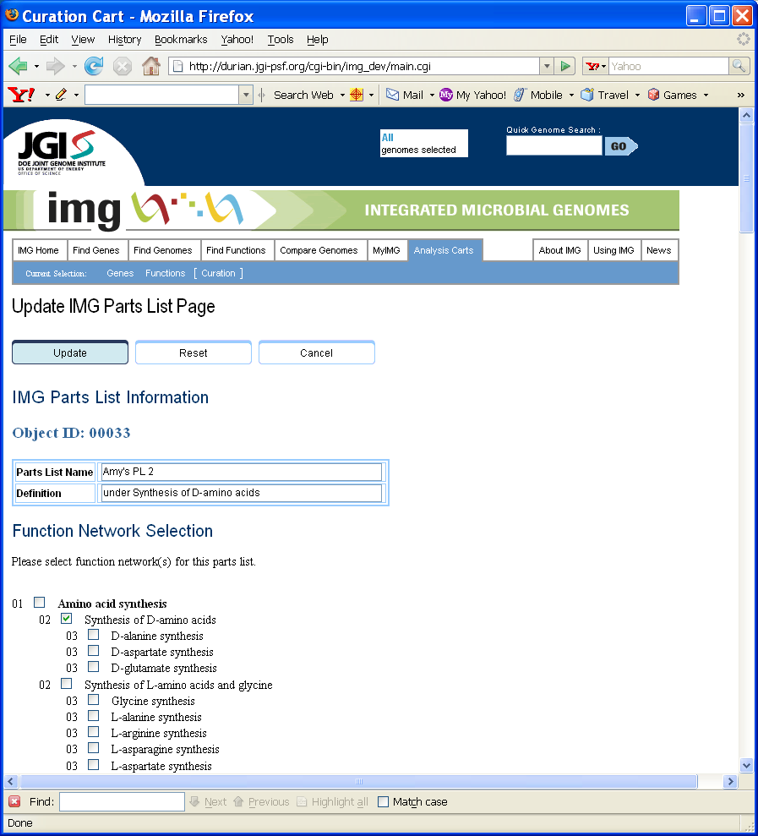
(Figure 3.6: Update IMG Parts List page)

Click to select network(s) in the “Function Network Selection” section, then click the “Update” button. The current parts list will be assigned to the selected network(s).

4. MyIMG Annotations

IMG 2.3 expands MyIMG annotations from “product name only” annotation to user annotations of the following properties:

- Product Name
- Prot Desc
- EC Number
- PUBMED ID
- Inference
- Is Pseudo Gene?
- Notes

4.1 View MyIMG Annotations on a Gene

Users can view their own annotations on a gene in the Gene Detail page (Figure 4.1 and Figure 4.2).

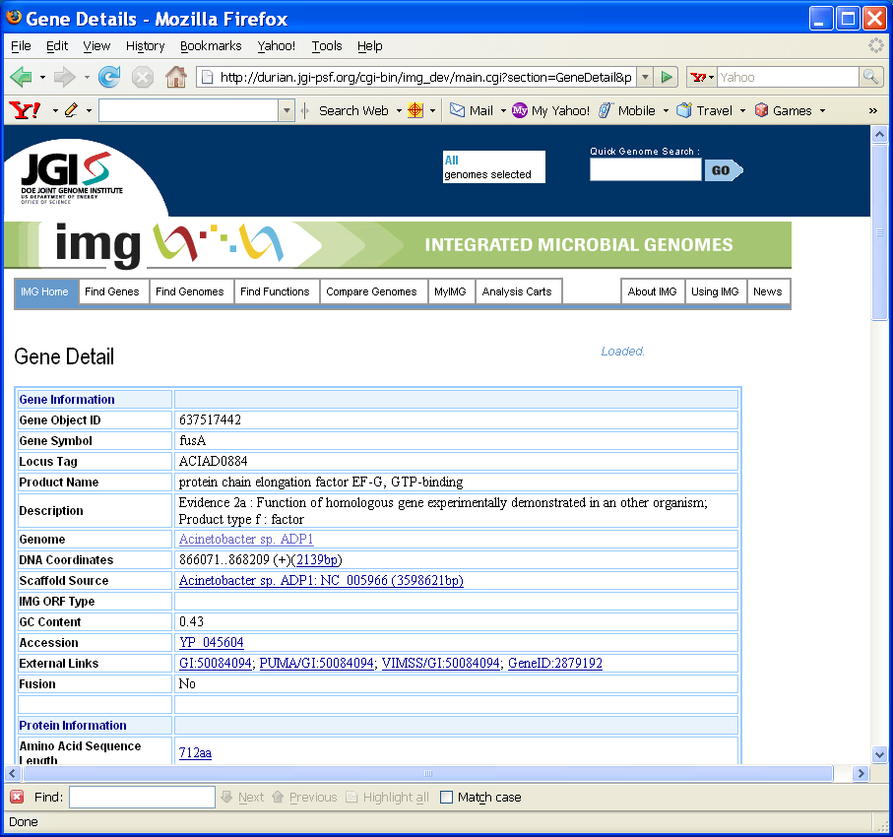
(Figure 4.1: Gene Detail page)

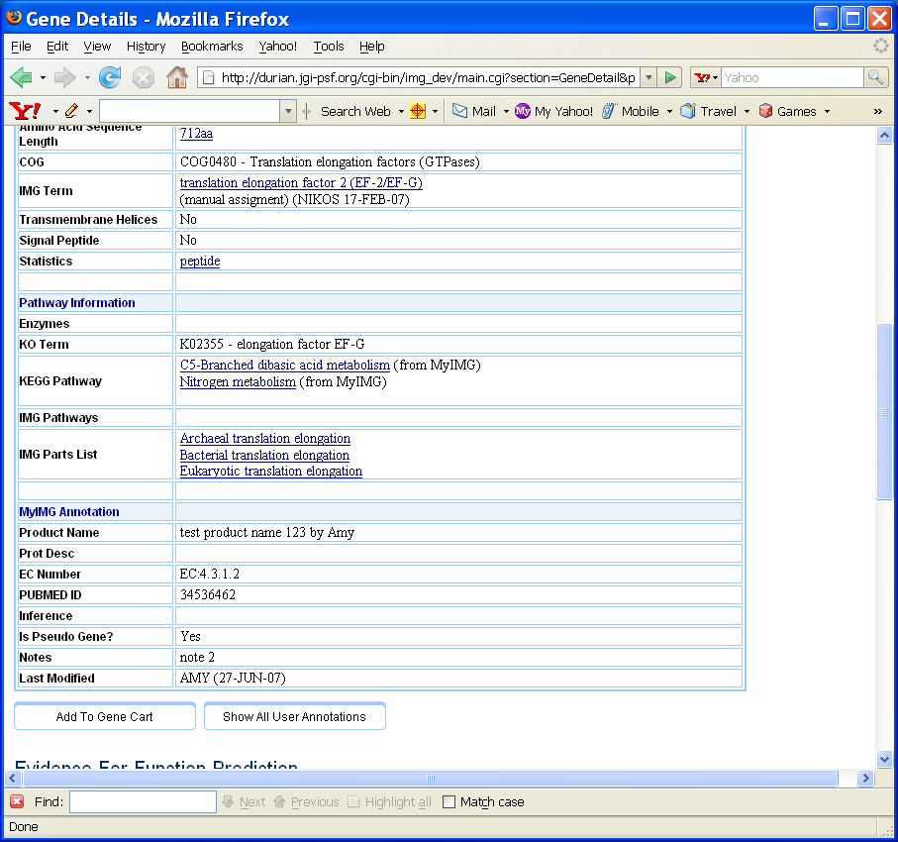
(Figure 4.2: Gene Detail page with MyIMG Annotation)

Click on the “Show All User Annotations” button, All User Annotations on Gene nnnnnnnnn (Figure 4.3) will be displayed. User’s own annotation (if any) will be displayed in the first line. Different annotations by other users are displayed in red for easy comparisons.

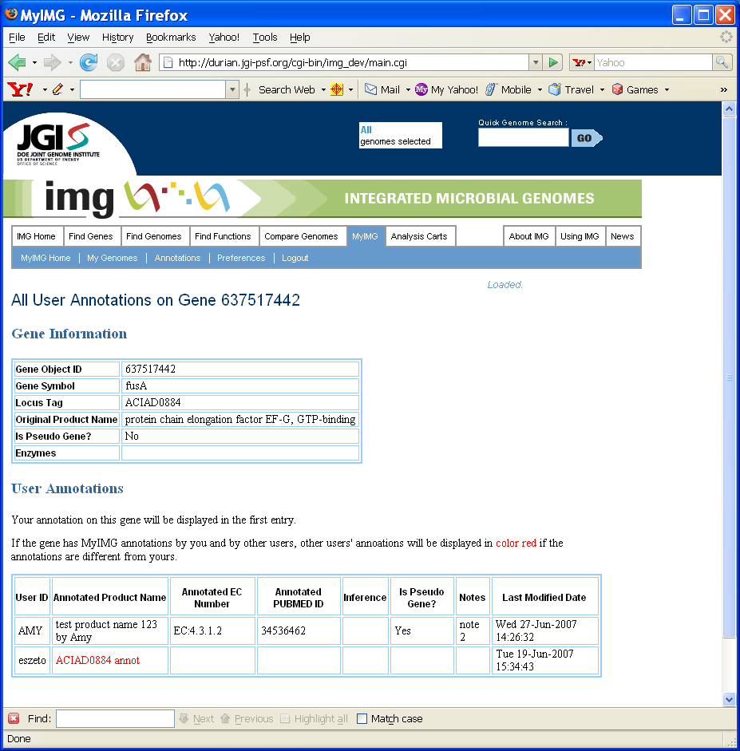
(Figure 4.3: All User Annotations on Gene page)

4.2 Enter or Delete MyIMG Annotations

Users can enter, modify or delete MyIMG annotations on genes. To enter or update MyIMG annotation on one or more genes, first add the gene(s) to the Gene Cart, and then click the “Annotate Selected Genes” button in the Enter MyIMG Annotation section (Figure 4.4).

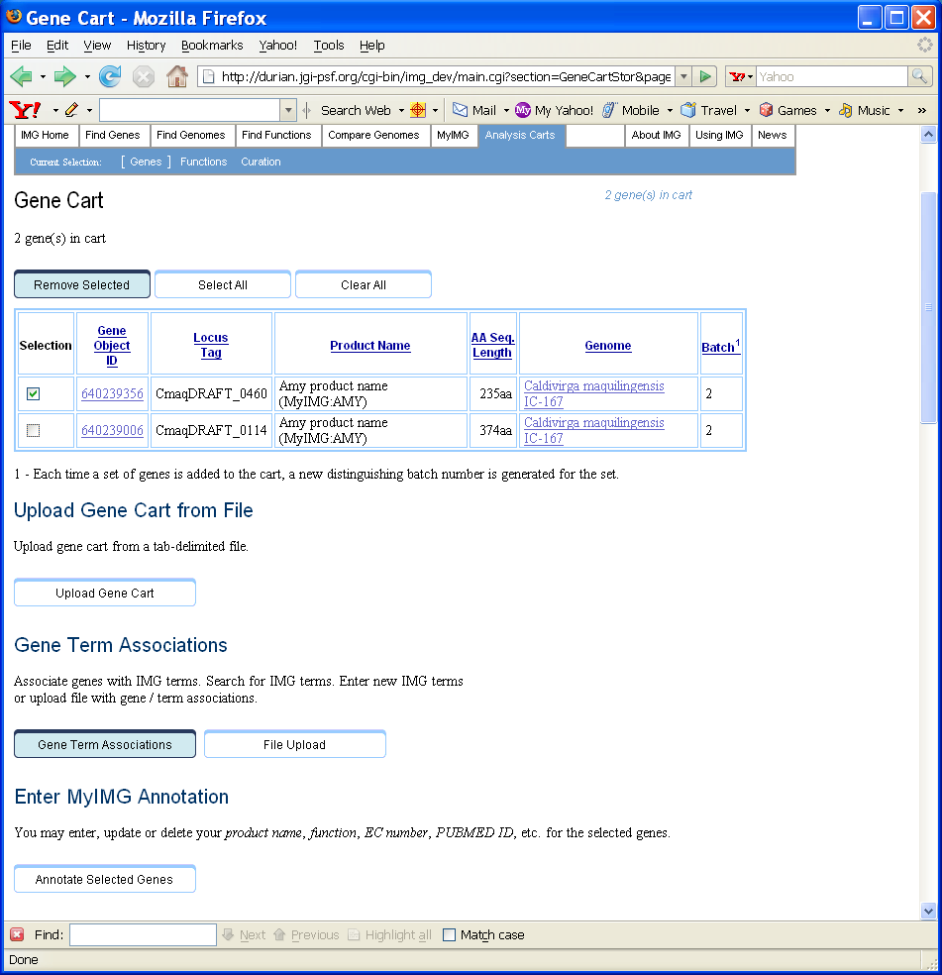
(Figure 4.4: Gene Cart page with “Annotate Selected Genes” button)

In the MyIMG Annotation for Selected Genes page (Figure 4.5), all selected genes from the Gene Cart will be displayed.

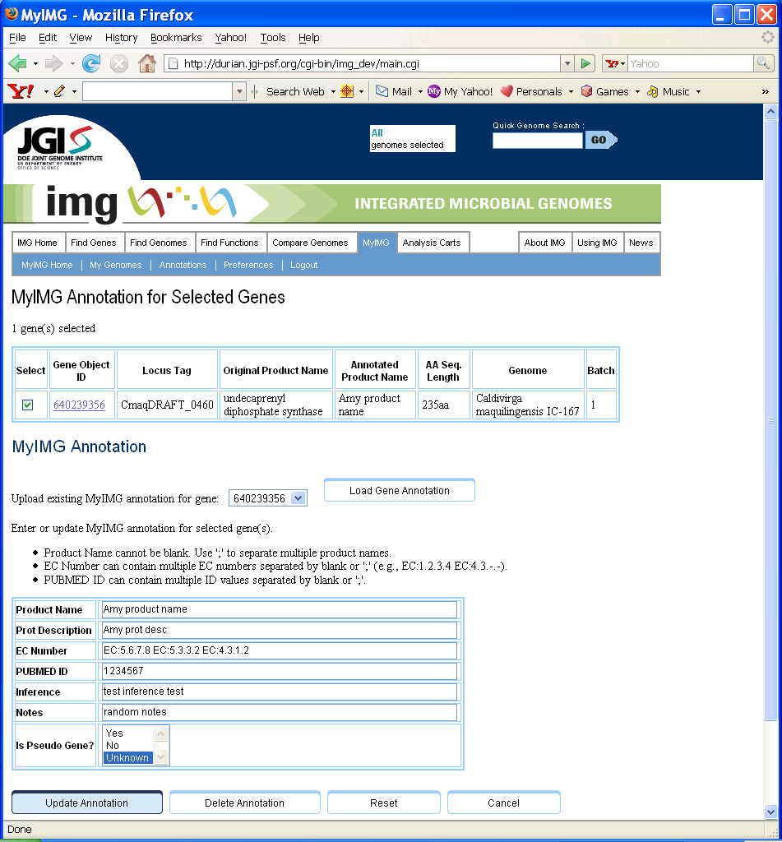
(Figure 4.5: MyIMG Annotation for Selected Genes page)

Users can select a gene OID in the “Upload existing MyIMG annotation for gene” listbox and click “Load Gene Annotation” button to fill in the form with existing annotations.

To enter or update MyIMG annotation on the selected genes, simply edit the text in each field, and then click the “Update Annotation” button to perform database update.

To delete existing annotations, simply click the “Delete Annotation” button.

Note that only selected genes will have their annotations updated or deleted.

4.3 View All MyIMG Annotations

To view annotations on more than one gene, select the “MyIMG” tab, and then select the “Annoations” sub-tab. A new IMG User Annotations page (Figure 4.6) will be displayed.

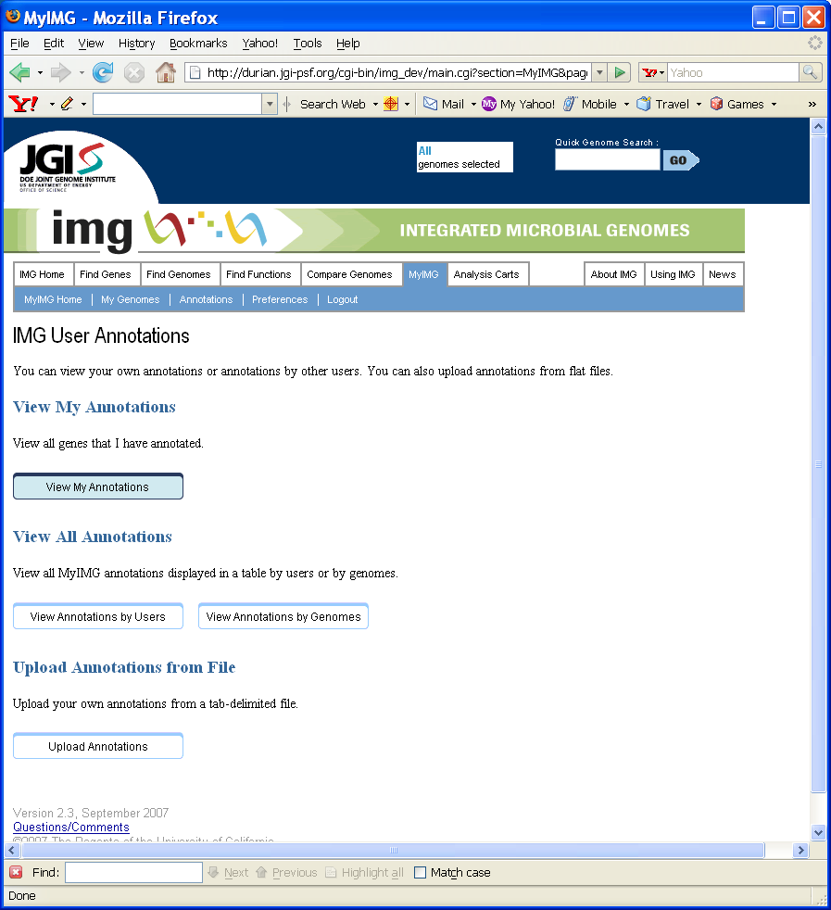
(Figure 4.6: IMG User Annotations page)

To view your own annotations, click the “View My Annotations” button, the following My Annotations page (Figure 4.7) will be displayed.

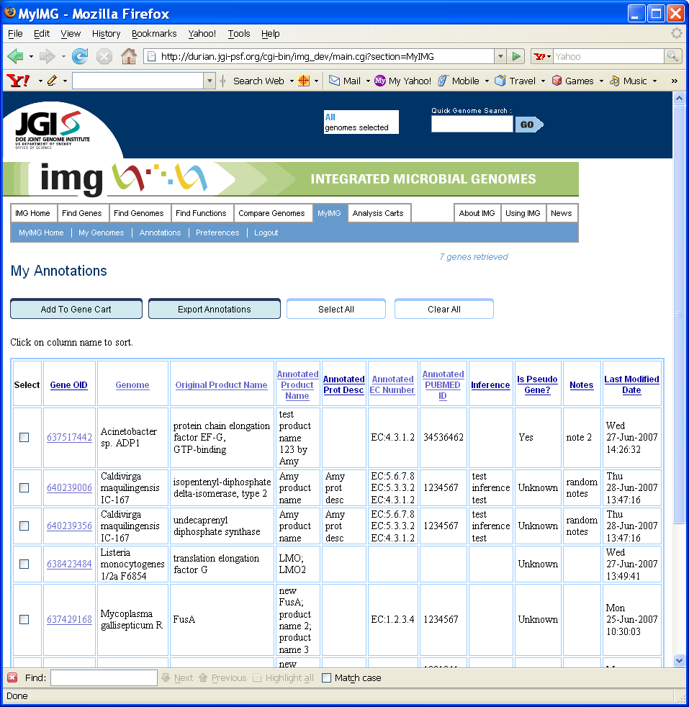
(Figure 4.7: My Annotations page)

Users can select genes to add to Gene Cart for further annotation (by clicking “Add to Gene Cart” buttin), or can export annotations to Excel (by clicking “Export Annotations” button).

4.4 View Annotations per User

To view annotation summary per user, click the “View Annotations by Users” button, the following All User Annotations page (Figure 4.8) will be displayed.

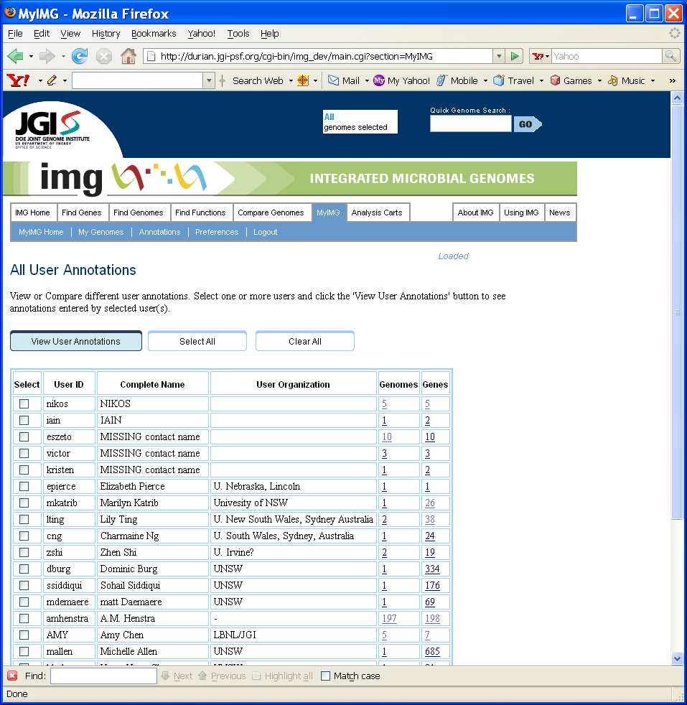
(Figure 4.8: All User Annotations page)

Click any number in the “Genomes” column, the following Genomes with Annotations by User xxxx page (Figure 4.9) will be displayed, showing all genomes that have genes annotated by corresponding user xxxx.

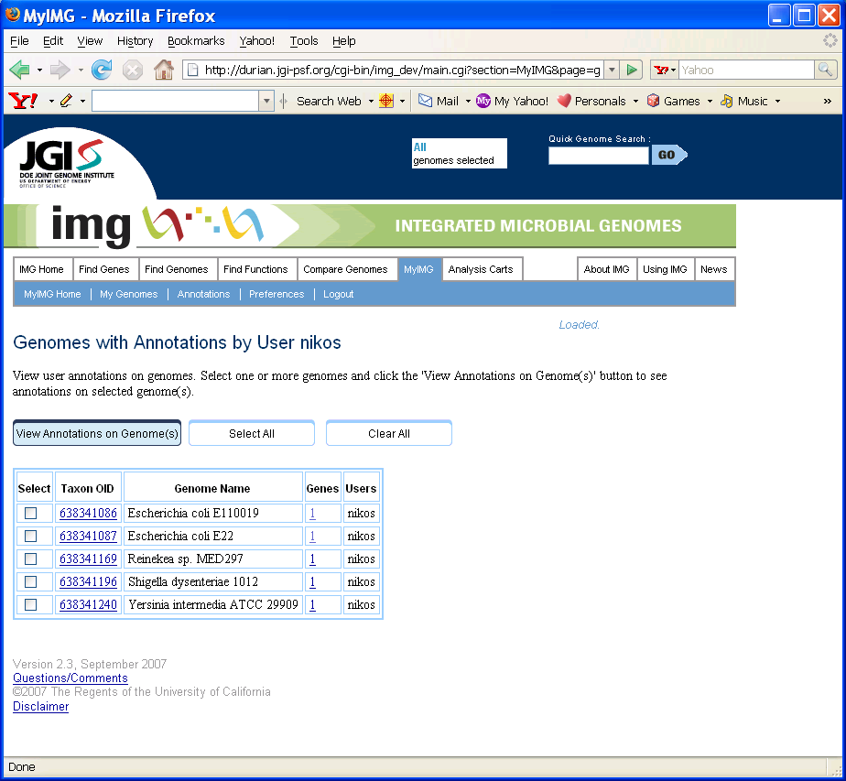
(Figure 4.9: Genomes with Annotations by User page)

Click any number in the “Genes” column, the following Annotations by User xxxx page (Figure 4.10) will be displayed, showing all genes annotated by corresponding user xxxx.

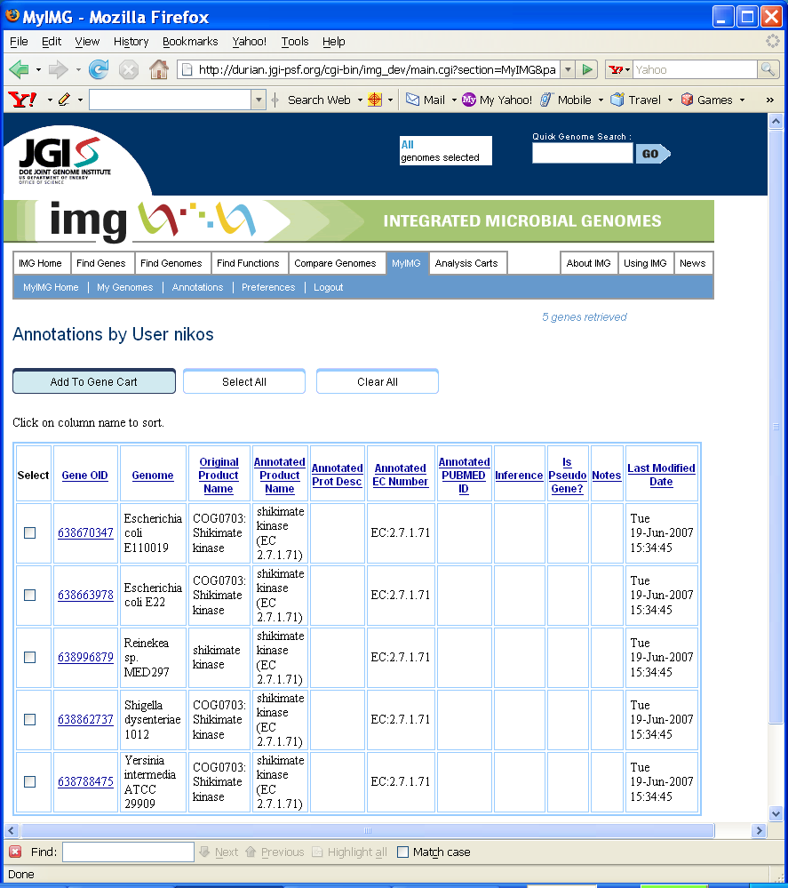
(Figure 4.10: Annotations by User page)

To view and comparison annotations by two or more users, first select those users, and then click the “View User Annotations” button on the All User Annotations page (Figure 4.8). The following Selected User Annotations page (Figure 4.11) will show up. All genes that have been annotated by any selected users will be displayed on this page. The display is sorted on Gene Object ID values. Repeated entries (i.e., same genes annotated by different users) will have Gene OID values shown in magenta for easy comparison (Figure 4.12).

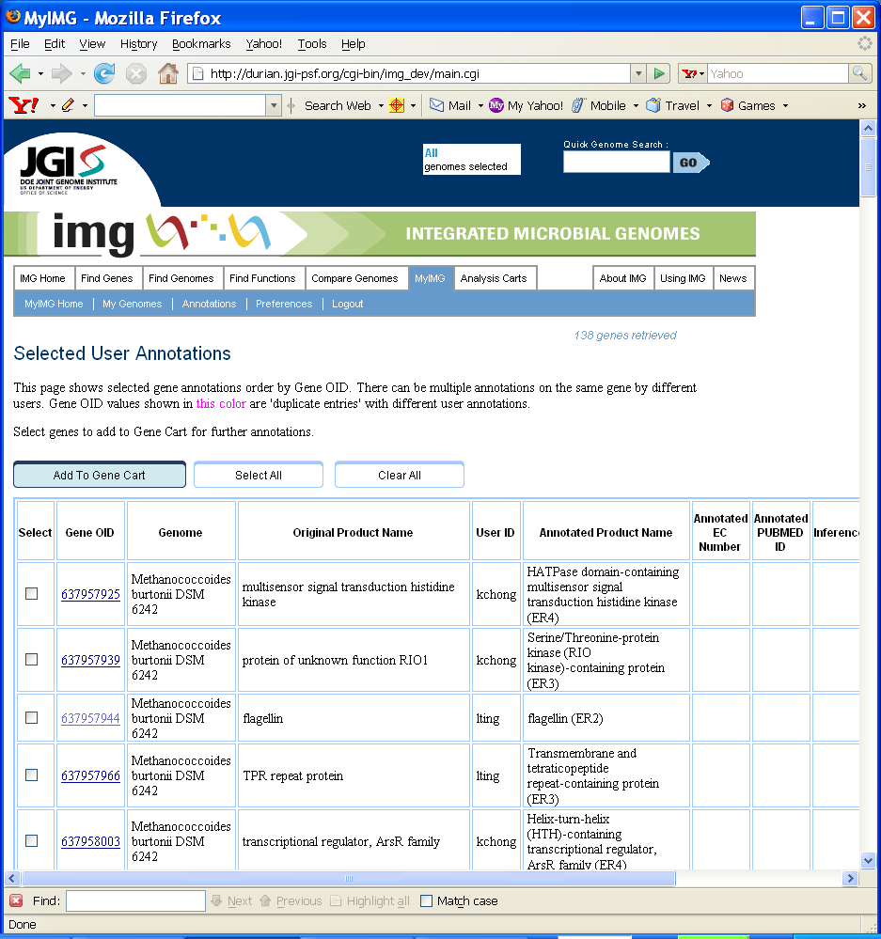
(Figure 4.11: Selected User Annotations page)

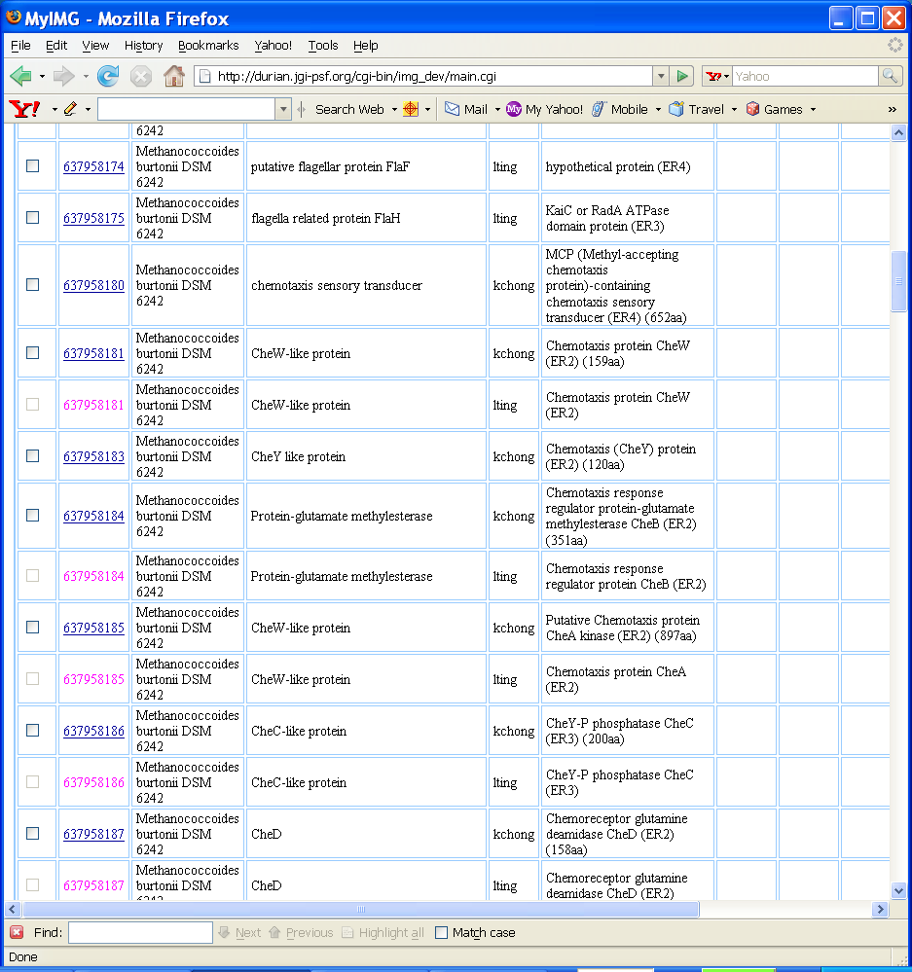
(Figure 4.12: Selected User Annotations page with “repeat entries”)

4.5 View Annotations per Genome

To view annotation summary per user, click the “View Annotations by Genomes” button, the following All Genome Annotations page (Figure 4.13) will be displayed.

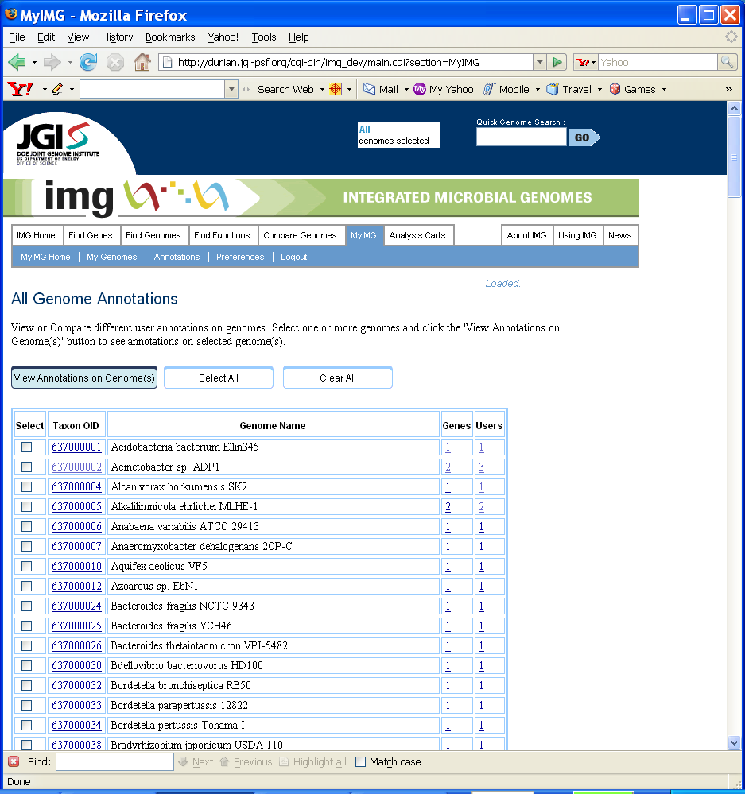
(Figure 4.13: All Genome Annotations page)

Click any numbers in the “Gene” column, the following View Annotations page (Figure 4.14) will show up, listing all genes in this genome that have user annotations. Users can select genes to add to Gene Cart for annotations.

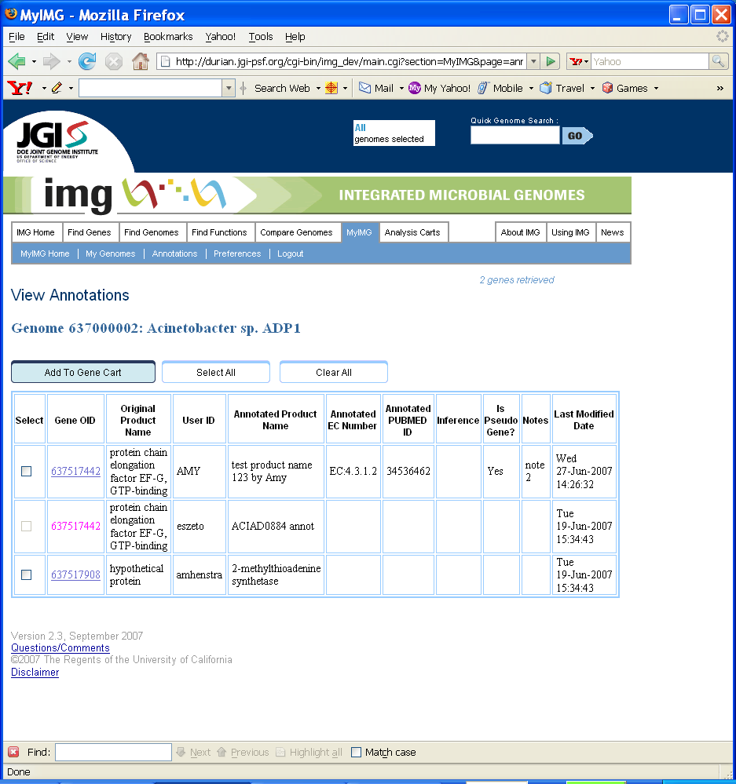
(Figure 4.14: View Annotations page)

Click any number in the “users” column, the following page (Figure 4.15) will be displayed showing all users who have annotated any genes in this genome.

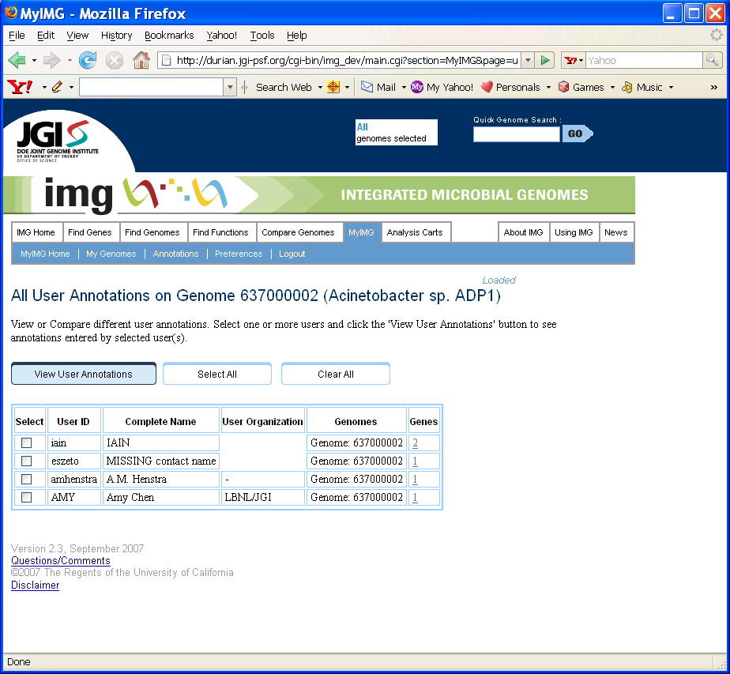
(Figure 4.15: Page showing all users who have annotated genes in a particular genome)

To view annotations on genes in different genomes, first select those genomes, and then click the “View Annotations on Genome(s)” button on the All Genome Annotations page (Figure 4.13). The following Selected Genome Annotations page (Figure 4.16) will show up. All genes in the selected genomes that have MyIMG annotations will be displayed on this page. The display is sorted on Gene Object ID values. Repeated entries (i.e., same genes annotated by different users) will have Gene OID values shown in magenta for easy comparison.

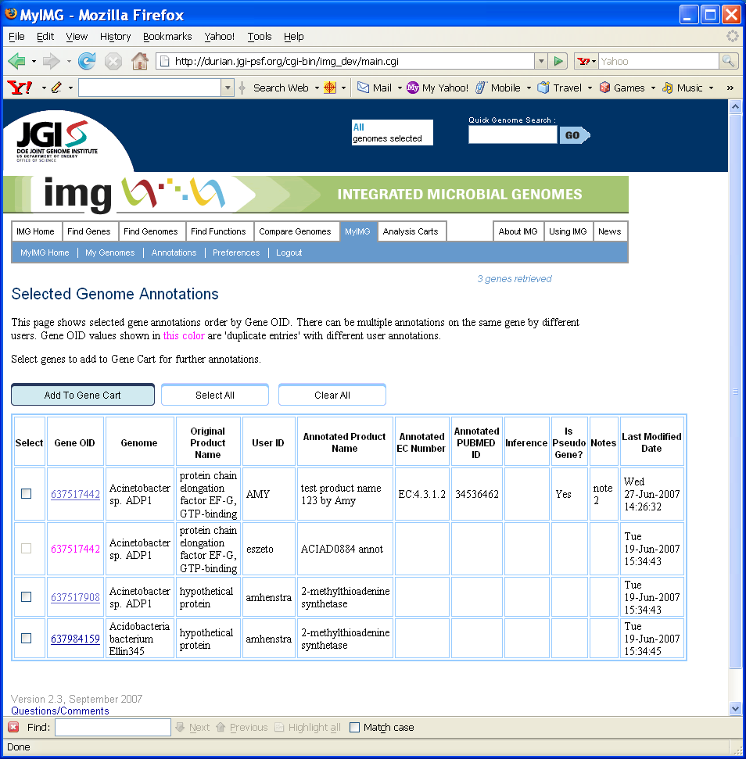
(Figure 4.16: Selected Genome Annotations page)

4.6 Download MyIMG Annotations

Users can download their own annotations to an Excel file. In order to export annotations, go to the My Annotations page (Figure 4.7), select one or more genes, and then click the “Export Annotations” button. The selected gene annotations will be exported to an Excel file. The file will have the following columns:
- gene_oid: Gene Object ID;
- MyIMG_Annotation: annotated product name;
- MyIMG_Prot_Desc: annotated prot desc;
- MyIMG_EC_Number: annotated enzyme EC number(s);
- MyIMG_PUBMED_ID: annotated PUBMED ID(s);
- MyIMG_Inference: annotated inference;
- MyIMG_Is_Pseudogene: is pseudo gene?
- MyIMG_Notes: user annotated free text notes.

4.7 Upload MyIMG Annotations from Flat File

Users can upload MyIMG annotations from a tab-delimited flat file. The file will have the same column header as the exported Excel file (see Section 4.6). Only “gene_oid” and “MyIMG_Annotation” columns are required. Others are optional.

In order to perform the file upload, first go to IMG User Annotations page (Figure 4.6), and click the “Upload Annotations” button. The following Upload MyIMG Annotations from File page (Figure 4.17) will show up.

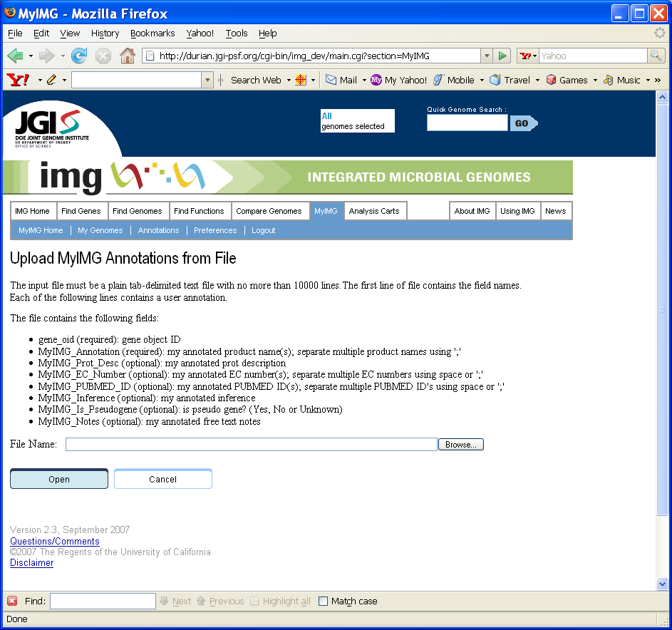
(Figure 4.17: Upload MyIMG Annotations from File page)

Enter the file name or use “Browse …” to find the file to upload, and then click the “Open” button. The file will be parsed and validated first. The validation process will check:
- Whether the file contains “gene_oid” and “MyIMG_Annotation” columns;
- Whether gene_oid exists;
- Whether EC numbers are in correct format;
- Whether PUBMED ID values are integers;
- Whether the MyIMG_Is_Pseudogene field value is ‘Yes’, ‘No’ or ‘Unknown’.

Figure 4.18 shows an example File Validation Result page with error messages. Users can correct any errors in the file and validate again, or they can click the “Upload” button to perform the actual upload.

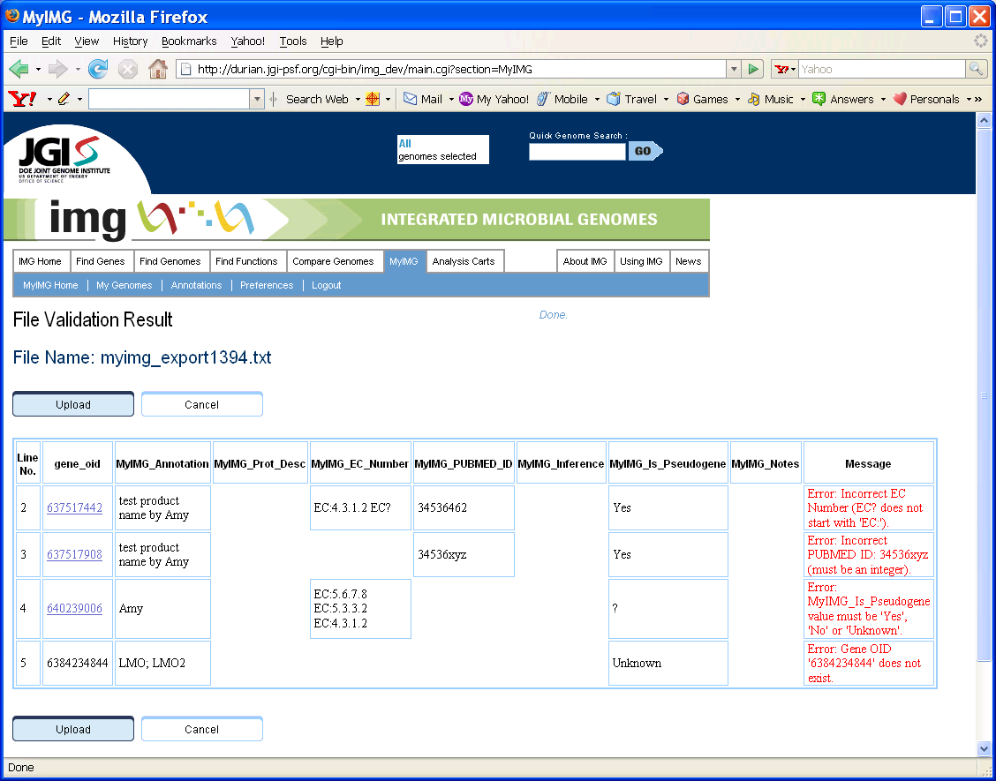
(Figure 4.18: File Validation Result page)

4.8 Set MyIMG Preferences

Users can select to whether override Gene Display Name in the Web UI using their own annotated product names. To set this preference, go to the “Preferences” sub-tab in the “MyIMG” tab. There is a new “MyIMG Preference” section (Figure 4.19). If the item is “checked”, then user annotated product names will override gene product name displays in IMG. Click the “Save MyIMG Preference to Database” button to apply and to save the change. Since the preference is saved in the IMG database, users don’t have to reset this option everytime.

(Question: Do we also override “Is Pseudo Gene”?)

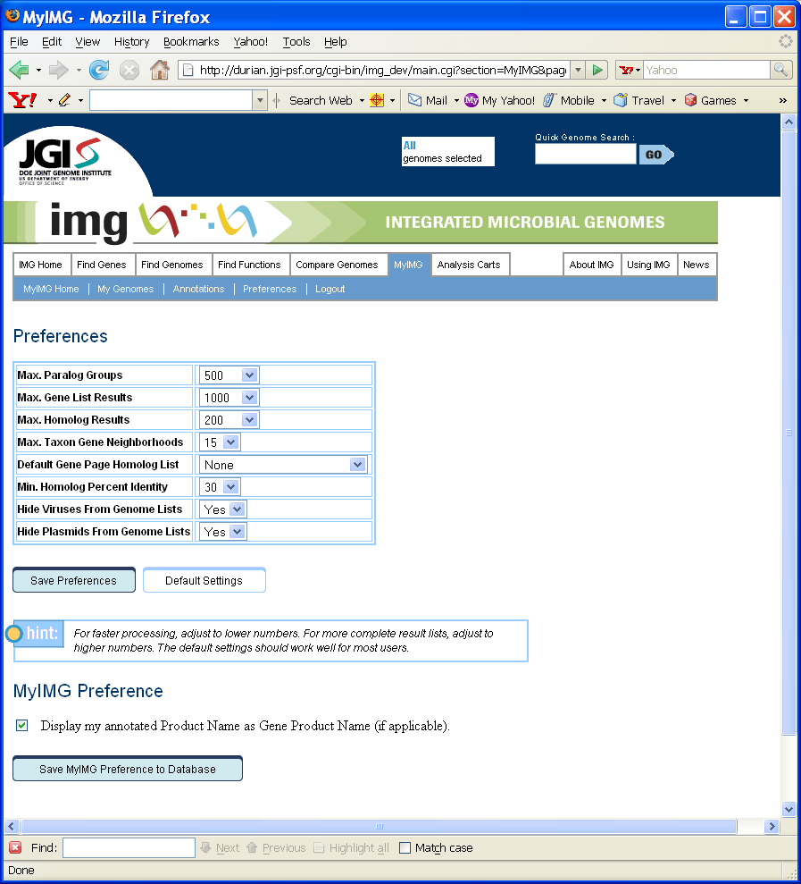
(Figure 4.19: Preferences page)

4.9 Output Genbank File with MyIMG Annotations

The existing “Output Genbank File” feature is revised to include the new MyIMG annotation options such as EC_Number and PUBMED ID. Users can select whether to include their own annotations in the Genbank file or not.

The mapping from MyIMG annotations to Genbank properties are as follows:

- MyIMG_Annotation (or annotated product name) → replacing /product
- MyIMG_Prot_Desc (or annotated prot_desc) → /prot_desc
- MyIMG_EC_Number → replacing /EC_Number
- MyIMG_PUBMED_ID → /db_xref
- MyIMG_Inference → /inference
- MyIMG_Is_Pseudogene → replacing /pseudo
- MyIMG_Notes → /note

Question: Do we need output EMBL files?

5. Additional Attributes

Additional attributes have been added to several object classes.

5.1 IMG_Term with Enzyme EC Numbers

In IMG 2.2 and before, enzyme EC numbers were embedded in the IMG terms. In IMG 2.3, enzyme EC numbers are explicitly stored in a separate set-valued attribute.

The following Update IMG Term Page (Figure 5.1) shows an IMG term with 2 enzyme EC numbers:

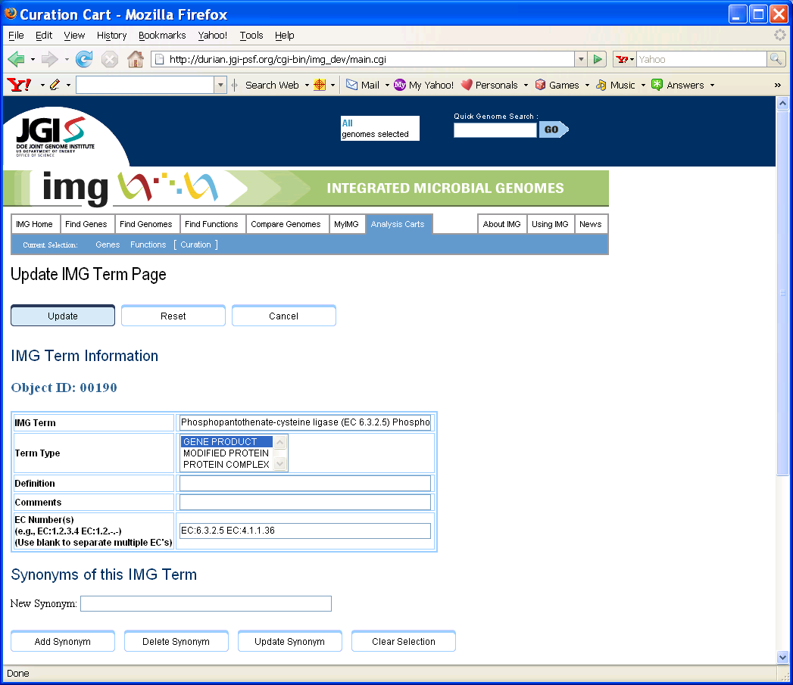
(Figure 5.1: New Update IMG Term Page with “EC Number(s)”)

EC numbers are entered in the “EC Number(s)” text field. If there are two or more EC numbers for the same term, use blank to separate them.

5.2 IMG_Reaction Reaction Type

A new “Reaction Type” attribute has been added to IMG_Reaction class. Reaction type is a free text field.

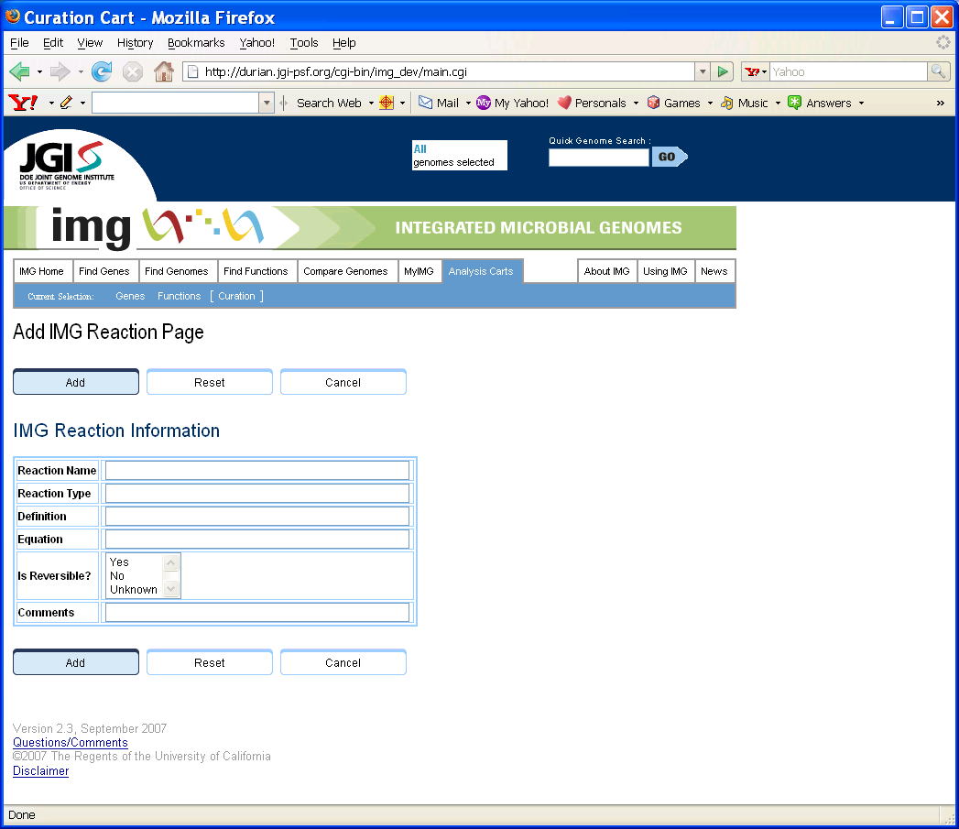
(Figure 5.2: New Add IMG Reaction Page with “Reaction Type”)

5.3 Sub-cell Localization IMG Reaction-Compound

A new “Sub-cell Localization” attribute has been added to IMG Reaction-Compound associations (Figure 5.3). Sub-cell Localization values are selected from a pre-defined drop-down list.

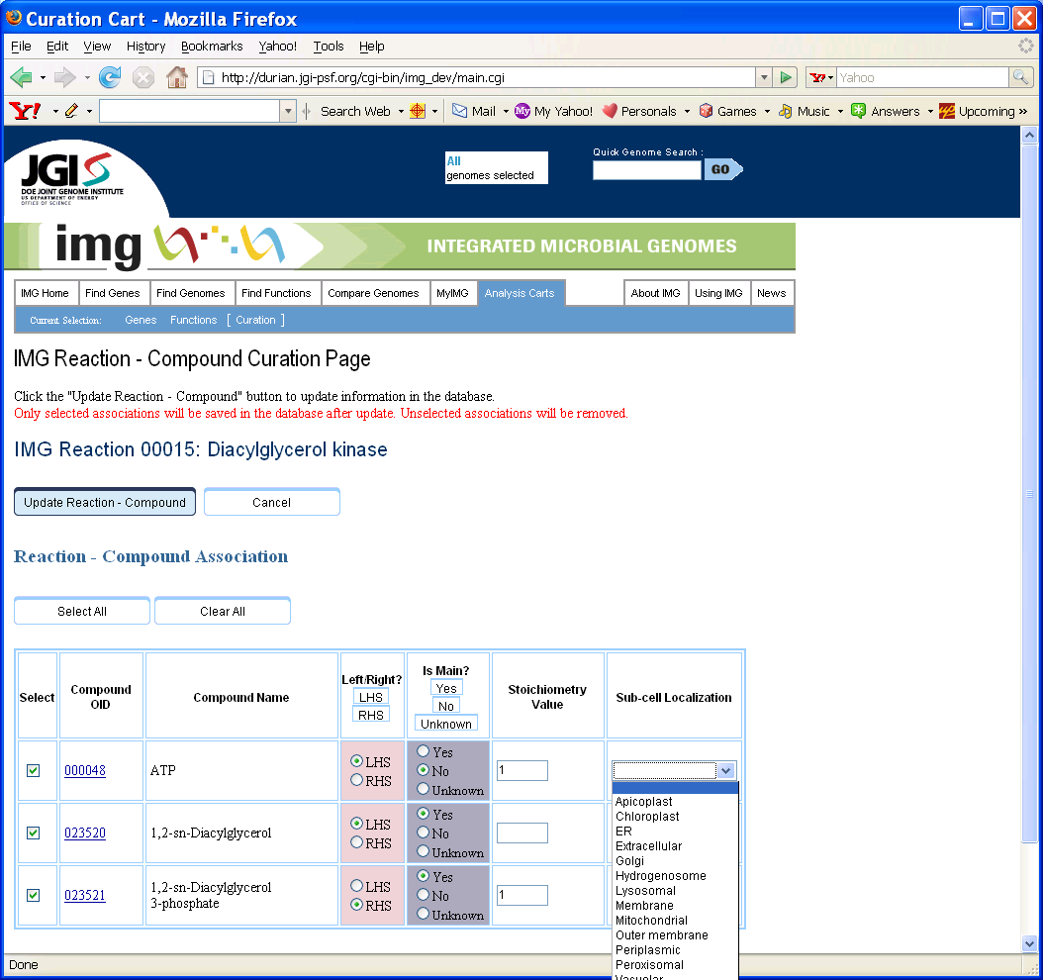
(Figure 5.3: New IMG Reaction – Compound Curation Page with “Sub-cell Localization”)

5.4 Sub-cell Localization IMG Term - Reaction

A new “Sub-cell Localization” attribute has been added to IMG Term – Reaction associations (Figure 5.4). Sub-cell Localization values are selected from a pre-defined drop-down list.

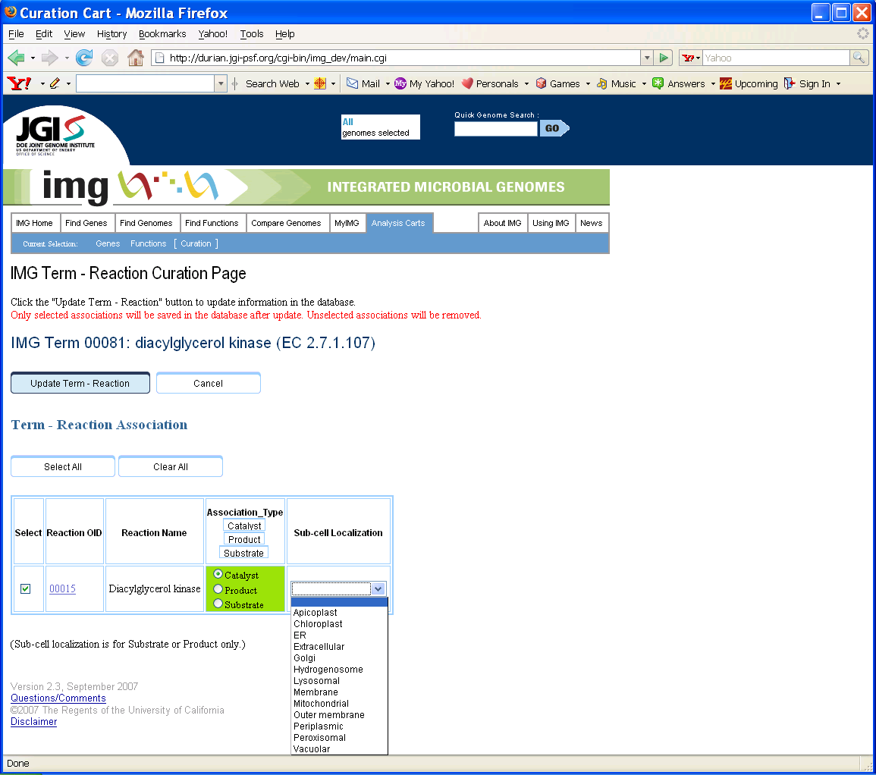
(Figure 5.4: New IMG Term - Reaction Curation Page with “Sub-cell Localization”)

