8 things you can do to save money and reduce your environmental footprint when you print!

- Shop for the most efficient printer

- Margins

- Line spacing

- Economode

- Electronic Filing

- Double sided printing

- Color vs. black and white

- Go paperless

1. Shop for the most efficient printer:

Get a shared or “network” printer that everyone can use instead of getting individual desktop printers for everyone. We found at our office that the desktop printer costs much more per page than the network printers due to ink cartridge and maintenance costs. EPEAT, a standard for environmental stewardship for computers, should soon be covering printers hopefully by the end of 2012. Be on the lookout, and write in your contracts now a place holder to require the purchase of only EPEAT registered printers when the standard becomes available. www.EPEAT.net.

2. Save paper; reduce those Margins! :

Click on Page Layout, then Margins, then click on "custom margins"

make sure your top, left, bottom, and right margins are where you want them, then click default (note: for special print jobs like official correspondence, you can set the margins wider for just that document quickly by clicking on one of the other options in the margins menu or by clicking on ok instead of default in the page setup screen without messing up your defaults)
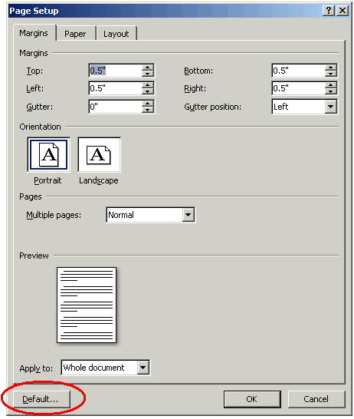

3. Change your line spacing to single spaced as a default.

=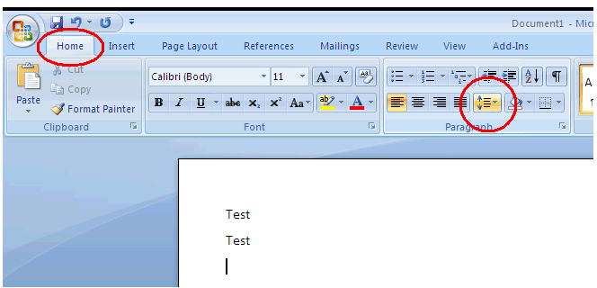

once selected. go back in the menu and select "line spacing options"

make sure there are zeros in the before and after boxes. then click on default...
then yes!

4. Also, you can save when you finally do print by using less ink! See for yourself if you can tell the difference when using “economode” (it may be called something else depending on the printer):

Make economode the default setting by going into your control panel. You can also set the settings on the printer itself to “Economode” or it may also be called “draft mode” or something similar.

5. Electronic Record Keeping
Electronic record keeping instead of paper record keeping: If you have the habit of printing out an email to keep as a record, try selecting the “document writer” or “adobe” printer instead of your normal printer. This will create an electronic file that you can keep an electronic record of (this is allowable).

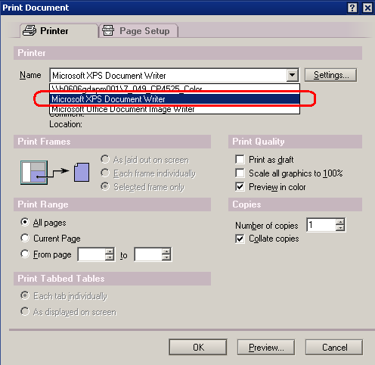

Take advantage of electronic file formats such as PDF’s. Instead of faxing, many printer/ scanners will have the option to scan a hardcopy to a pdf which you can send to yourself in an email straight from the printer. There are also online services that keep a digital image of your signature which you can use to electronically sign any document you wish and send it out without having to print. You can convert Microsoft Word documents to pdf’s in your save menu.

There are many advantages to electronic record keeping besides just the environmental benefit: It’s hard sometimes to sift through a bunch of paper files looking for one in particular. Electronic files are easy to search through. Even if you forget where you put the file, you can run a quick few second search (all computers have this ability)and you can search your whole computer for files by date you created the file, by key word in the filename or even in the file itself! Another advantage is it’s quicker and easier to make backup copies in case you lose the first copy. I store my records on my computer drive and then store a copy on my R drive which gets backed up by HQ every so often. So even if your computer and the building burns to the ground, you can still recover your records. Remember you have 3 different places you can store records electronically: the share drive, the R drive and your local drive. The share drive and R drives are maintained by EPA and backed up in case of technical failures. Your C: is not backed up so if you lose your computer of your computer breaks, you lose all your records, so it’s important to back them up on another drive like the share drive or the r drive.

6. Also, don't forget to print double sided when you can.
Some printers, especially desktop printers, claim that they have double sided printing capability but may require the user to physically turn a printer page over and manually reefed it back into the printer. This is a hassle and people may not want to manually feed every time. Make sure the printer you buy does this automatically. And remember to set your defaults in the control panel so you don’t have to think about it each time you print! Try printing 4 or even 8 per page. This is great for simple reading or powerpoint slide notes.

7. Do you really need that printed in color?
Try printing in just black and white when you can. Even when there is a little color on the page, that color printer per page costs up to 4 times as much!

8. And finally, why not take the "Go Paperless Challenge"!
Use your laptop for record keeping and to take notes at meetings. Ask others to email you that document instead. Try and see how few pages you can print in a month and challenge your neighbor!

A little effort by alot of people can go a long way!

