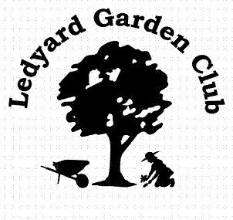
Ledyard Garden Club Scholarship Information - 2013

The Ledyard Garden Club is accepting applications for its $1,000 and $500 scholarships. Eligible applicants must reside in Ledyard or attend Ledyard High School. They can be graduating high school seniors who have been accepted at accredited colleges or post secondary schools. Previous recipients of this scholarship and previous applicants who are attending accredited colleges and post secondary schools may also apply.

Additional information and applications are available in the Ledyard High School guidance office or by contacting Pauline Zimmer, 549 Colonel Ledyard Highway, Ledyard, CT 06339 or at 860-536-1332. Completed applications must be received by March 31, 2013.

The Ledyard Garden Club encourages students to pursue careers in horticulture, floriculture, landscape design, forestry, botany, plant pathology, land management and other fields benefiting the environment.

REQUIREMENTS:

Applicant must: -Be a graduating senior, previous applicant or recipient of the scholarship who has be accepted at an accredited college or post secondary school
-Reside in Ledyard or attend Ledyard High School.
-Plan to pursue a major in horticulture, floriculture, landscape design, forestry, botany, plant pathology, land management and other fields benefiting the environment.
-Provide a 500 word essay on what you have done that is related to your proposed field of study and why you have chosen to pursue this field.
-Provide two letters of reference from people who know your abilities and talents.
-File an application, essay and letters of reference by March 31, 2013.
-Appear before the Ledyard Garden Club Scholarship Committee for a personal interview.

SCHOLARSHIP:

The recipients of our scholarships will be notified the first week of June. The $1,000 scholarship and the $500 scholarships will be awarded in one payment and will be sent directly to their schools of higher education.



Ledyard Garden Club
Scholarship Application
2013

Name: ____________________________________________________________________________________

Address: __________________________________________________________________________________

Telephone #: ____________________________________ Email Address: _____________________________

Intended Major: ____________________________________________________________________________

Colleges or Schools applied to: ________________________________________________________________

________________________________________________________________

________________________________________________________________

Application, essay and two letters of reference must be received by March 31, 2013 to be considered for scholarship.

Send to: Pauline Zimmer, Scholarship Chairwoman
Ledyard Garden Club
549 Colonel Ledyard Highway
Ledyard, CT 06339
860-536-1332

