CAR

Stanislav Krasulin
BSU Lyceum, Belarus
Introduction
In this task we were asked to “build model car powered by an engine, using an elastic air-filled toy-balloon as the energy source”. Then two main questions were raised: dependences of distance, travelled by such a car, on relevant parameters and maximizing efficiency of the car.
Obviously, we had to start from the first part of the task, building a model car. Since we had to increase distance travelled by car, we tried to reduce all friction forces; respectively, model had also to be as light as possible.
The balloon we had chosen for the car was a spherical rubber balloon, capable of stretching up to the volume of 40 liters. Spherical shape had been chosen because it made all calculations easier, and had no drawbacks compared to other shapes (it will be proven later in the article, that air drag is negligibly small).
Another major part of the car was engine; the very first idea was just to attach a nozzle to a balloon, creating a rocket-type car. We had also tried several concepts for using air stream to produce a rotational motion of the car’s wheels. However, high number of moving parts caused additional losses of energy on friction, making all those prototypes ineffective, compared to a simple propulsion engine.
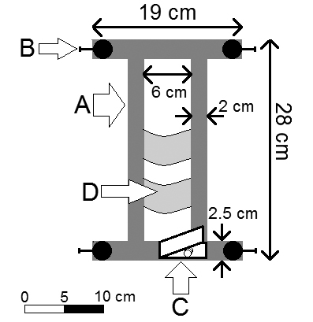
Car
Fig.1 shows our final version of the car. Its body (A) was cut out of sheet of balsa (6 mm thick). Length and width of the body were chosen through a series of tests, where car’s stability had been checked (we tried to make car as small as possible; however, too small models tended to turn over; also, balloon could touch the wheels).
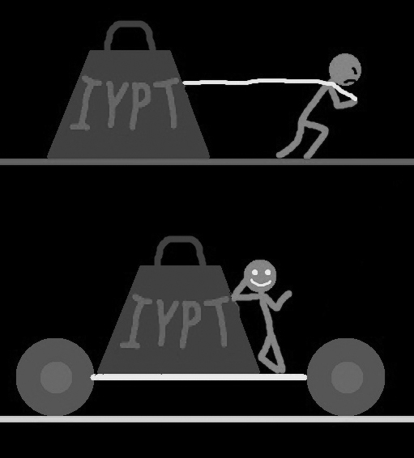
For reducing friction in the axes we had used bearings (B) (inner diameter 3 mm, outer 7 mm), to which we could attach different wheels. Bearings were placed on the small metal rods; other end of the rods was put into small pieces of balsa. These pieces of balsa were attached to the car’s body with needles. By changing angle between forward and rear wheels it was possible to set car for circle trajectory (since finding a long enough even surface wasn’t always possible).
Figure 1. Scheme of the car.
A clothespin (C) had been used for holding the nozzle, attached to the balloon. Small pieces of adhesive tape (D) prevented deflated balloon from falling down and touching the ground.
Efficiency
To describe efficiency of the car we used efficiency coefficient:
;
where A is useful work, and E is full energy of the system. For our car full energy is the energy stored in the balloon. But what is useful work for our system? What is main purpose of the car? Why do we use it? To understand it I’ve painted fig.2. And it became obvious: car is used to overcome friction. If energy from the balloon was used to overcome friction, it means that car has moved something forward, and, therefore, done something useful. And if energy was spent on the turbulence in the nozzle or on air drag, then it was wasted.
Figure 2. Smile makes everything obvious.
Energy in the balloon
The energy source for the car is balloon, so we have to determine how much energy it stores. Note, that energy hides itself in two places: in pressurized air inside balloon and in the balloon itself – as energy of the stretched rubber.
Let’s assume that balloon now has volume V₁ and pressure of air is P₁. The maximum energy from this air can be gained if it expands adiabatically, as there are no losses through heat. Air would expand until its pressure is equal to atmospheric pressure P_{atm}. Through equation of adiabatic process volume of the air after expansion can be found:
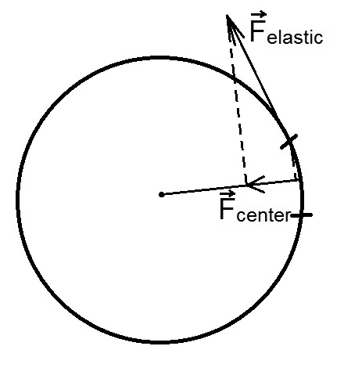
Now, it is possible to calculate work, done by the expanding air:
Please note, I don’t say that anywhere in the car an adiabatic process occurs, or that I want it to occur. This calculation is used to find the energy which is stored in air, independently of any processes in the car.
Figure 3. Elastic force, acting on a small piece of shell, and its component, directed towards center.
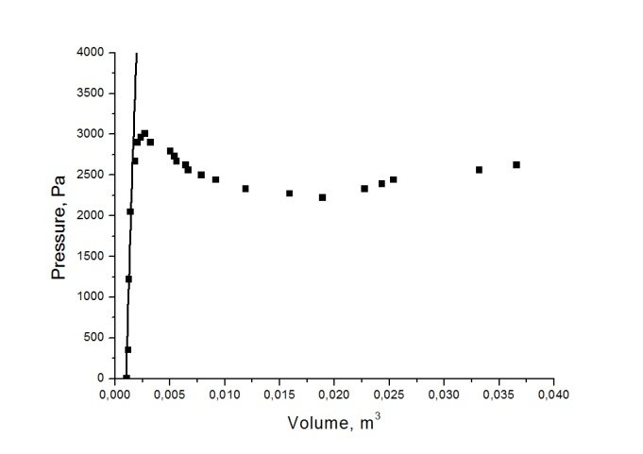
However, to use this formula we need to know pressure in the balloon and its volume. They can be connected through the mechanical stress in the balloon’s shell. On one hand, relative increase of area of some small part of the shell can be found as:
where E is Young’s modulus, μ is Poisson’s ratio, σ is mechanical stress. Relative increase of area of the whole surface of the balloon will be the same, and as soon as our balloon is a sphere, it will be 3/2 of relative increase of balloon’s volume.
On the other hand, if we consider elastic force acting on a small part of the balloon’s shell, because of the curve of surface it will have some projection towards balloon’s center (as shown on fig.3). This small force should be equal to the pressure force acting on this part of shell, so difference between pressure inside the balloon and atmospheric pressure is:
Figure 4. Line is plot of theoretical formula, while dots are experimental. Average error of volume measurements is 0.0008 m³
where d is width of the shell, R is balloon’s radius. Now, if two equations are combined:
where V₀ is original volume of the balloon. This formula is checked in the fig.4, where dependence of extra pressure ΔP on the total volume of balloon is shown. Certainly, we also had to know rubber’s properties for plotting formula. Our measurements had shown that rubber’s Young’s modulus E was equal to (0.47±0.03) MPa, Poisson’s ratio µ=(0.46±0.02); also width of the balloon shell d was (0.23±0.01) mm.
For volumes less than 1.8 liters results calculated through the formula are correct; however, at volume of 1.8 liters rubber reaches its proportionality limit and for bigger volumes it doesn’t behave according to Hooke’s law anymore. Since in this area even very small increase in stretching force will cause a significant deformation, we approximated that after volume of 1.8 liters pressure will remain constant.
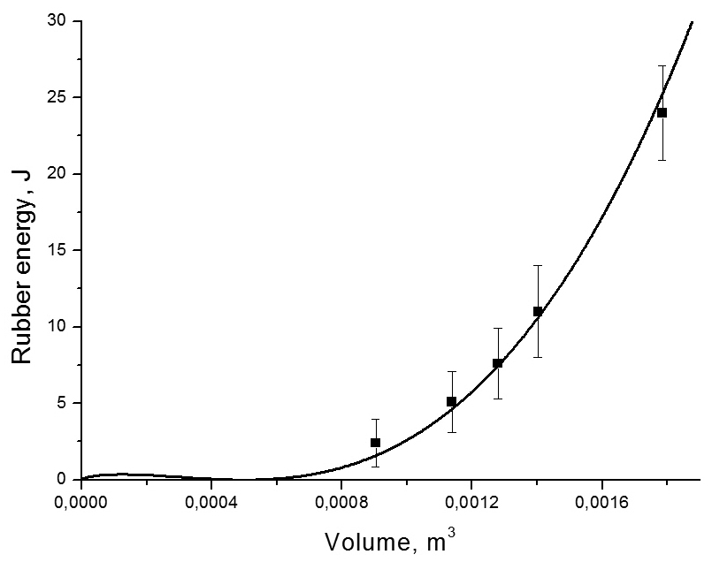
Energy of rubber
Rubber itself also stores energy. Knowing mechanical stress in the shell, energy density can be calculated as:
Therefore, energy in the shell is:
Certainly, the formula should be checked. So how can be energy stored in rubber measured? Well, we can easily find work done by the pump, when we are inflating balloon (for example, we can put a weight on the pump – change of weight’s potential energy will be equal to the work done by the pump). So, this difference in potential energy of the weight ΔE_{p} will turn into energy of pressurized air E_{air1}, energy of rubber E_{R} and energy of losses E_{L} (due to friction in the pump and heating of the air):
Figure 5. Dependence of the rubber energy on the volume. Line shows theoretical prediction, dots are experimental data.
How can we find these losses? The answer is: let’s inflate something else, with shell which can’t be stretched; for example, a plastic bag. Now, work of the pump will turn into energy of the air and energy of losses:
Since change in weight’s potential energy and energy of losses are same in both cases:
E_{air1} and E_{air2} can be calculated through volume and pressure of air in the balloon and plastic bag. Results of these manipulations are shown on fig.5. Again, at the volume of 1.8 liters rubber reaches its proportionality limit; therefore energy density will remain constant, and rubber energy will increase because of the increase of the volume of the shell itself.
It also should be noted, that for volumes less than 0.0005 m³ formula, in fact, tries to predict energy of the compressed balloon’s shell and, therefore, this area of plot shouldn’t be considered.
Efficiency
In the car, energy losses occur in the nozzle and also some energy is used to overcome air drag. However, air drag had been very small. To prove it, an experiment was made: we had put a sheet of cardboard on our car; first time – horizontally (for small drag), second time – vertically (for increased drag). Then we pushed the car forward manually and plotted law of its movement (fig.6). The difference between forces, which were stopping the car in two cases is less than 5%. Therefore, air drag can be ignored.
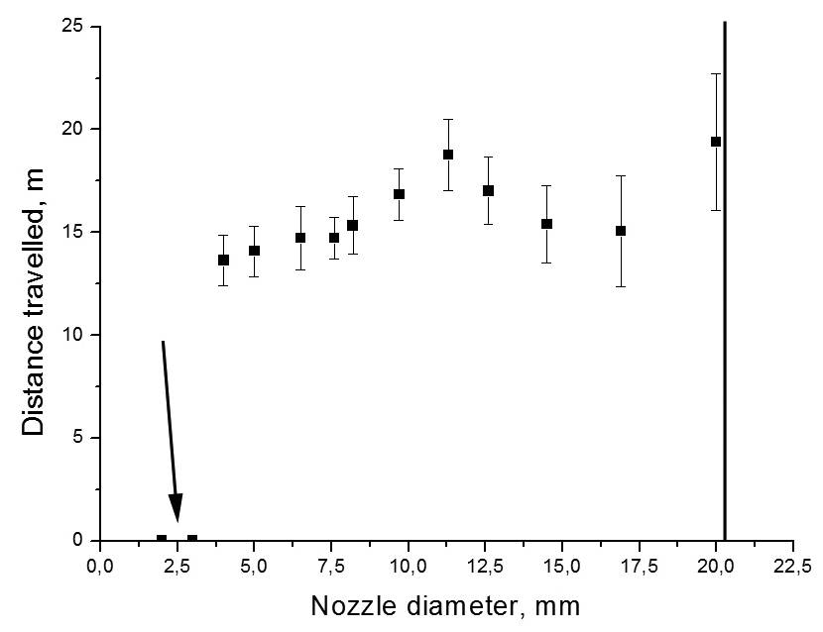
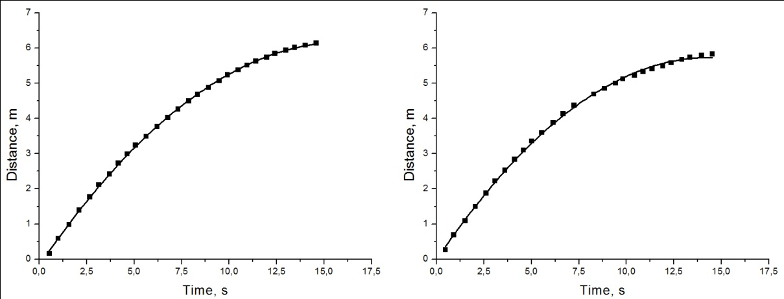
Unlike air drag, losses in nozzle are significant. There are three reasons of loosing energy in nozzle: turbulence, viscous drag and scattering of the jet, after it exits nozzle. Amount of energy, lost in any of this ways, strongly depends on the length and width of the nozzle. It is difficult to describe this dependence even for just one of the effects; describing all three effects at once is almost impossible. Therefore, we tried to research dependence of the efficiency coefficient on the nozzle parameters experimentally. We had inflated balloon to the same volume for all launches; respectively, full energies were equal. We also kept car’s mass the same, so friction forces were the same either. Therefore, the only thing changed with changing of efficiency coefficient was distance, travelled by car:
Figure 7. Arrow points at the dots, where car hasn’t moved at all. Black line shows nozzle diameter, after which car becomes unstable.
Figure 6. Left plot shows travel when a sheet of cardboard was placed horizontally, right – when vertically. Both are fitted by square parabola.
where F_{fr} is total friction force acting on the car and L is distance travelled by car. That is why instead of plotting efficiency coefficient against nozzle diameter, we plotted L against nozzle diameter (fig.7) – anyway, efficiency coefficient plot will look all the same, just multiplied by a constant value.
Let’s take a closer look at the plot. With too small diameter car just can’t move forward (first two dots). Then we have a local maximum of efficiency, and in the end dependence is growing. Unfortunately, with nozzle diameters bigger than 20 mm car is incapable of holding stable trajectory. But we can predict, that there will be another local maximum, after which dependence will fall to 0. It is easy to prove: if we take our balloon and stick adhesive tape over its equator, and then pierce it. The side, which we’ve pierced, will explode and let the air out; adhesive tape will prevent the other side from tearing apart. So we will achieve nozzle diameter equal to the diameter of the balloon. But when we had performed such experiment, our car travelled only 5 cm. Knowing all this, we can say that for maximal efficiency coefficient we should use the nozzle diameter from the first local maximum.
Unfortunately, for the length of the nozzle even experimental dependence wasn’t found: dots were jumping randomly.
Travelled distance
It is very interesting, that even if efficiency coefficient remains the same, travelled distance still can be varied through varying friction force.
In fact, there are two friction forces, acting in our system: rolling friction force (F₁) and static friction in the axes (F₂). These forces will be calculated as:
where R is wheels radius, M is car’s body mass, n is number of wheels, σ is surface density of wheel’s material, k and μ are static and rolling friction coefficients respectively. If car has travelled distance L, then work of rolling friction will be F₁*L; however, work of static friction will be F₂*L*(r/R), where r is radius of the axis; it is so because static friction force is applied closer to wheel’s center, where smaller distance will be covered. In total work of friction forces is equal:
Since we want for L to be maximal, we have to make X(R) minimal; to find its minimum we can take its derivative and put it equal to 0:
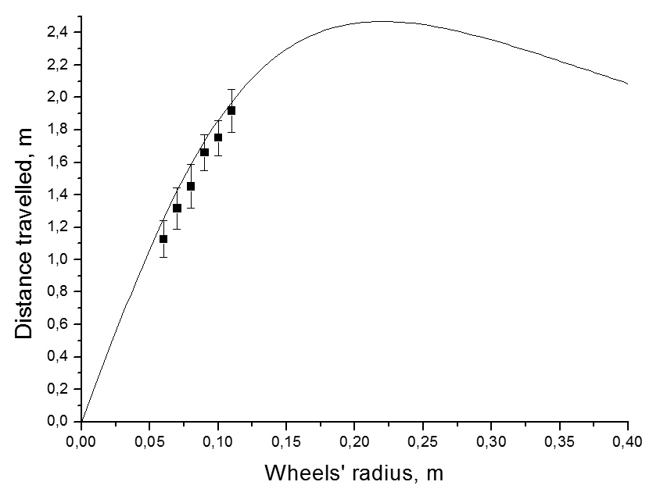
After solving these equations, a formula for optimal wheel radius is achieved:
It is interesting to note, that total mass of the wheels in this case is connected with car’s body mass by this equation:
Experimental check
Figure 8. Dots show experimental data, line is theoretical dependence.
To check dependence of the distance travelled on wheels’ radius it was necessary to find friction coefficients for our model. For finding static friction coefficient in the axis we had removed metal rod with bearing and wheel from the car and mounted it into a support. Then we painted a small dot on the edge of the wheel, and rotated it, filming everything on the high-speed camera. From the video, we had plotted angular velocity of the wheel depending on time. This dependence was linear; therefore, proving that we really can consider friction in the bearing as static. Then through angular coefficient of the line we had calculated static friction force and static friction coefficient. For finding rolling friction force we had performed same operation as for finding air drag: we had pushed car forward and plotted its motion; through this plot we found total friction force, acting on the car. Also we could already calculate static friction force; the difference between total friction force and static friction force was equal to rolling friction force. Through the rolling friction force we could calculate rolling friction coefficient.
Putting these friction coefficients into theoretical formula we plotted theoretical line, as seen on fig.7. Now we had to make experimental points. Since we had constant efficiency coefficient, constant amount of energy was used for overcoming friction forces. So, to increase accuracy of measurements, we had decided to give this amount of energy not through inflated balloon, but through a pendulum: it was turned to same angle and then released. It was hitting car, and car was moving forward (fig.8), having same amount of energy each time. It should be noted, that we hadn’t checked wheels with radius close to optimal value, because they were too big to fit the car. Well, just one wheel was size of the whole car.
Conclusions
Full energy stored in the balloon is a sum of energy of pressurized air and of stretched rubber. With help of the equation, which connects pressure and volume of the balloon, we can calculate both those energies.
All this energy goes into two places: some is used to overcome friction forces – that’s useful work; other is wasted on the losses in the nozzle. Air drag for our car was negligibly low.
Efficiency coefficient depends on the nozzle length and diameter; however, it’s impossible to describe these dependences theoretically. Experimentally we have found two peak values for the nozzle diameter; the first one should be used, because with second car became unstable.
Distance travelled by car depends mainly on the wheels’ parameters. They all can be connected in order to calculate optimal radius; however, it appears to be too big to use.

