IYPT 2011 PROBLEM №13 “LIGHT BULB”
Alexey Krotov, Yekaterinburg, Russia
Introduction.
An incandescent light bulb in the most known form was invented at the end of 1870s. The line production of such bulbs with wolfram filament has begun in 1906. That means the different properties of light bulbs have already been thoroughly investigated, and a humble school research can’t possibly add something to existing knowledge. Despite that, the major part of it wasn’t based on any prepared and structured plan and that may add a note of individuality into the whole work performed.
My research was based on the problem statement which was formulated as follows:
What is the ratio between the thermal energy and light energy emitted from a small electric bulb depending on the voltage applied to a bulb?
First of all I needed to analyze rough plan of demanded work. It’s said that the we’re to measure light energy and thermal energy. So, I had to figure out how to do it and what devices I would use. The research was planned to consist of experimental part where all needed parametres would be measured. And the next step had to be the theoretical model of phenomenon resulting in some quantitative estimations, which in turn had to be compared to experimental results.
Analysis
For a moment imagine a usual light bulb with rated power about 60W for the voltage 220V. It glows dimly when there’re some troubles with the electricity in your room and voltage is lower than rated (That is quite an often thing to happen in my country). And if the voltage is about for instance 40V, the bulb doesn’t glow at all, at least, we can’t see it. In the meantime the current passes through a filament and warms it. Thus it was assumed: while the voltage rises, the required ratio does it too.
Ask every person you meet and he/she will definitely agree, that all the bodies emit energy. However only a few will add that some part of energy can not be seen by human eye. The same is right for the bulb. The whole radiation is represented by infinite wavelength spectrum, only small part of which is perceived by human eye. Let’s define light energy as the energy of radiation in range from 400 to 800 nm. In the meanwhile the heat is perceived from all the spectrum. So let’s presumably define demanded light and heat ratio as the ratio between light energy and full energy, which is defined as P=U∙I.
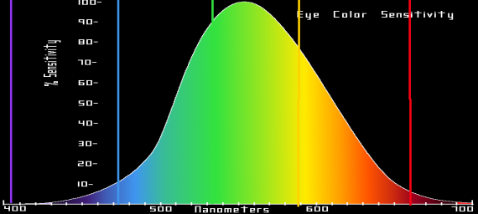
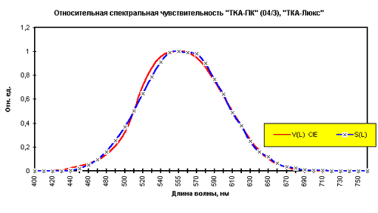
It was desided to use luxmeter to perform raw measurements of luminocity of light bulb. This decision was based on the relatively easy way to get the device, as contrasted to bolometer. Besides, the characteristics of the luxmeter and biological sources have shown that the curve of spectral sensitivity of light (Fig.1) is almost the same for both luxmeter and human eye (well, the “light” term applied to a bulb means light that people can perceive) .
Figure 1. The illustrative diagram of spectral sensitivity. The eye characteristic is shown as filled area; The used luxmeter characteristic is shown as red line
Experiment
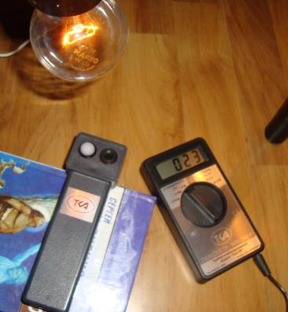
Definetely, the most interesting part of research is the practice of experiment. As mentioned before, a luxmeter was used to measure luminocity. Two bulbs were investigated – one of rated 0.125W power for the pocket torch, and the other one usual 60W 220V bulb. As we saw later, the first bulb gave results which could be called random, so it’s decided to concentrate on the standard one. An autotransformer with output voltage 0..250V was used as power supply. We also cut a reference resistor in a circuit in order to measure current stregth indirectly. The sensor of luxmeter was set at a known distance from the bulb. It was totally about 20 series of measurements performed each including 10 readings and each with different power applied. Those samples of luminocity were to be derived into the power samples. First approximation performed was to consider light bulb as point light source, however it was got over later. A luminocity is defined as luminous flux per square of area being illuminated. The flux is luminous intensity in the solid angle. As we consider that bulb emits flux all around itself, we finaly represent luminous intensity as 1/683 of luminous power and get to the derivation below:
Figure 2. The ratio between light energy and full energy emitted from bulb against voltage applied for different bulb orientations

where E is illumination and L is a distance between a bulb and luxmeter sensor. Thus we get desired result in Watts.
The problem with point source approximation was solved as follows: different positions of bulb relative to sensor (Fig.2) were considered and comparative results are illustrated on a chart. A result with the greatest amount was chosen for further investigation. However usually bulb is down-oriented as we see it in any room, and respective results are very close to the greatest.
Figure 3. The radiant emission percieved by human eye (shown as black shaded area), the visible part of radiation (shown as brown shaded area) and the total radiant emission for a blackbody warmed to 2600K, rough temperature for light bulb.
On a graph one can see the demanded dependence. It confirms the initial prediction. The ratio rises and dependence is non-linear. For the rated voltage of 220V the ratio is 1,22 per cent. Such a small amount may be explained by the graph (Fig.3) showing the part of light perceived by either human eyes or luxmeter in comparison with full radiation spectrum. As we can see, the “effective” part of radiation is very small comparing with the whole radiation. Now let’s try to create a theoretical model of light emission of the bulb.
Theory
Inherently, the idea is that bulb glows because of the electromagnetic radiation of it. This idea is scientifically based on such definitions as radiant emission R, which shows the energy radiated per time per surface area. And when one is considering spectral density of radiant emittance r (dependant on temperature and either wavelength or frequency), the part of radiation represented at the given wavelength is shown.
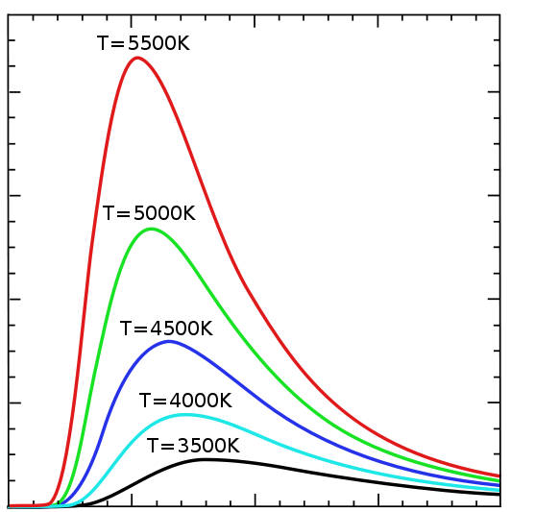
Our theoretical model bases on the grey-body model. One should also add a few words about blackbody model itself. Any body absorbs the radiation and emits it simultaneously, however efficiency of both absorption and radiation strongly depends on the color of the body and other paremetres. The blackbody has coefficients of 1 for emissivity and absorption ability. Considering the first ablility, the respective coefficient is called emissivity. It’s brought into play when it comes to Stefan-Boltzmanns Law, which defines the dependence between total radiant emission and the temperature of body-radiator: R=σT⁴. If one consider so called grey body, its emissivity is taken into formula: R= εσT⁴. However, most of the real bodies are neither black nor grey: their emissivity depends on the temperature and wavelength.
Figure 4. Diagram plotting Planck’s Law for blackbody of different temperature. Plot: spectral density of radiant emission against a wavelength.
The spectral density of radiant emittance depends on a wavelength under the law revealed by Plank (Fig. 4). It’s also possible to derive Stefan-Boltzmann’s Law as infinite integral from spectral density by wavelength increment. Let’s try to turn to the part of radiation perceived by light. It would be derived as an integral of the same function by wavelength increment in a range from 400 to 800 nm. And while dealing with a real body of given temperature, the emissivity has also to be accounted:

In the usual light bulb there’s a wolfram filament. We assumed that it’s emissivity characteristics are negligibly different from which are given in physical thesaurus “Fizitcheskie velitchiny”⁽¹⁾. The change of emissivity for “light” radiation within 400 and 800 nm is negligible (Fig. 5) and is approximately equal to 0.45. This amount has been taken into further estimation.
In order to achieve the dependence of r_{λ,T} on the temperature of filament we had to find out the remperature. As the only parameter known from experiment was power we had to relate it with the temperature. From experiment the power applied and the resistance of filament were found and respective dependence was plotted and approximated to power function: R=255.87∙P^{0.268}. It’s perfectly known that resistivity of conductors is dependant on temperature. From the same thesaurus took we that dependence and considered the reversed one also approximated it to power function T=3.1∙10⁸∙r^{0.831}.
Figure 5. Diagram plotting emissivity of wolfram against wavelength for different temperature.
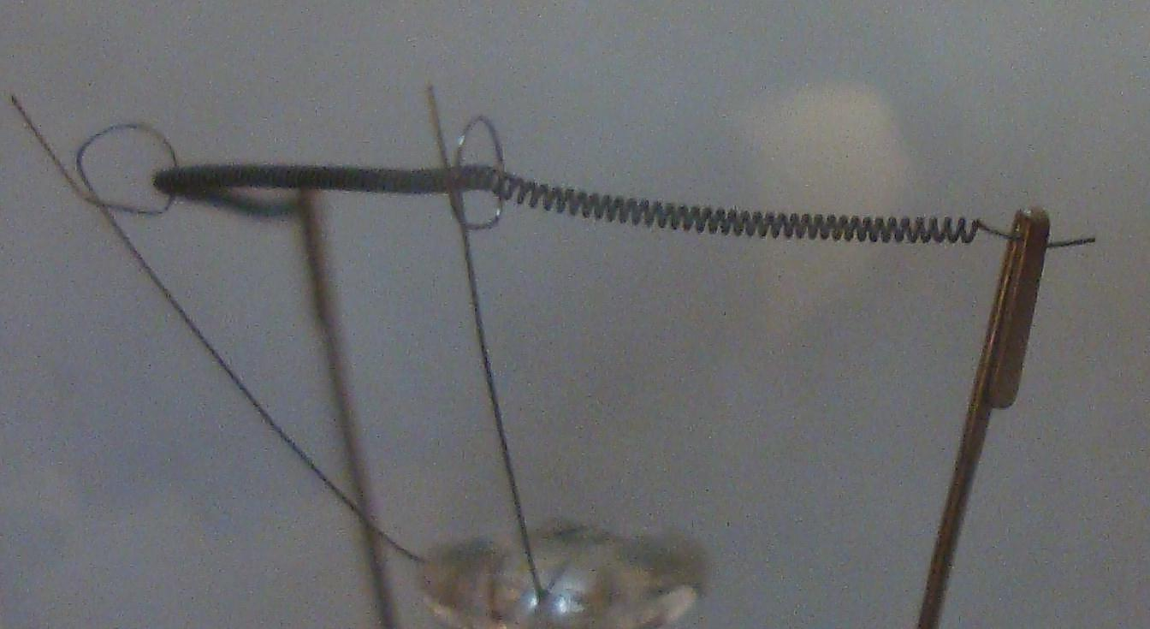
The next step to perform was to derive the resistivity from the given resistance. To fulfil that we’d to find the length and diameter of coil of filament. At first we tried to estimate those quantitatives using zoomed photo, but the error was too big, so we took the coil itself and managed to strighten it. The diameter found was 15µm±2µm and the length was 25.4cm±0.05cm. Thus we could derive both area of cross-section and surfae area which was needed to go turn from radiant emittance of “light” radiation to the light power .
Finalizing
It was time to unite all the parts of algorithm which had to be programmed. The first step was to evaluate the resistance from power given, then through a trivial formula it was converted to resistivity of coil, on which the temperature was dependant.Then the temperature was substituted into integral of spectral density of radiant emittance by 400-800nm wavelength. Finally the integral was multiplied by emitting surface area and the light power againts full electric power got as a result. Then there was little derivation to be done: convert the power given into a voltage using resistance for each power value found from the experiment.
After supeimposing the experimental and theoretical plot (Fig.6) we’ve got an intersection, fortunately, right in the point of rated 220V, the ratio for which is 1.22%. The little mismatch of the whole lines is easy to explain as we negliged error in emissivity and coil sizes estimation.
Neglections and predictions
In the very beginning it was mentioned that thermal conductivity is negligible comparing with heating radiation. That can be proved if mention that heat transferred through conductivity depends on the first power of temperature, while radiation depends on the fourth power of it, thus considering high temperatures thermal conductivity may also be neglected.
It’s definitely right that heated filament warms the envelope of bulb too and also warms itself, due to the fact that part of coil surface is directed inside the spiral. But finally all this energy is emitted to the ambience, because thermal equilibrium is to be mainained inside bulb-envelope system. As we can see, bulb doesn’t warming infinitely, so the energy of self-warming and energy of envelope is also radiated outside.
A glass of which the bulb shell is made absorbs some part of radiation. However there’s mostly ultraviolet light which is being filtered, and it almost brings no change to the light perceived. And as for the heat, almost all energy absorbed is then being radiated outside.
Figure 6. Comparison between theoretical and experimental plot
As for the kind of the light energy part depending on the voltage here’s an attempt to explain and predict that. Let’s return to the diagram of Planck’s Law and presume that wolfram has infinite melting point. When the voltage is small, the temperature is low and the maximum of emittance goes to the long wavelengthes. While the temperature rises so does the portion of visible light, and as expected it reaches its maximum when temperature equals 5600K. As the temperature continies to rise the portion of light slowly decreasing as the maximum radiation point is being displaced to lower wavelengthes.Thus considering the basic light/thermal ratio against power either voltage, we’d have got a curve with a maximum of power/voltage matching to a temperature of 5600K. But unfortunately it’s impossible, we can only hope for such refractory materials to be discovered.

Reference:
(1)Fizicheskie Velichiny: Spravochnik/Babichev, Babushkina, Bratkovskiy etc. Energoatomizdat, 1991 p. 447,781

