
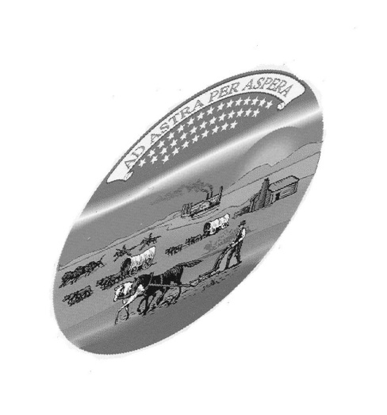

STUDENT APPLICATION

STUDENT NAME: GRADE: AGE:
STUDENT CONTACT INFO:

SCHOOL:
SCHOOL ADDRESS:
CITY: COUNTY: ZIP CODE:
SCHOOL CONTACT INFORMATION:

STUDENT’S STEM (science, technology, engineering or math) AREA OF INTEREST, EXCELLENCE:

STUDENT’S SCIENCE CLUB, COMPETITIONS, PROJECTS, AWARDS or OTHER EXAMPLES OF EXEMPLARY WORK:

NOMINATED BY:

REFERENCE(S)
NAME:
TITLE:
CONTACT INFO (phone or e-mail

NAME:
TITLE:
CONTACT INFO (phone or e-mail):

E-mail application to jeanettesteinert@att.net or mail to :
150th and Counting Project, Ad Astra Kansas Initiative, 211 E. Second, Hutchinson, KS 67501

DEADLINE OCTOBER 1, 2010
For questions, contact jeanettesteinert@att.net or call 620-669-8558. A list of honorees should be available around the first part of December.

The Ad Astra Kansas Initiative is a grassroots organization focused on promoting science in Kansas. Founded in 2001, it has been an affiliate of the Kansas Space Grant Consortium since 2003.

