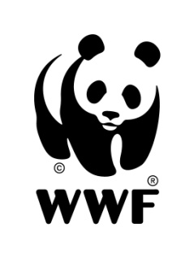
WWF-Mongolia is seeking a Species Officer for the Mongolia Programme Office based in Ulaanbaatar, Mongolia

I. Major Functions:

- Ensure effective implementation of activities related to species conservation in accordance with WWF policies, procedures and standards and responds to queries on matters relating to project administration
- Provide technical backstopping on species conservation issues to WWF funded programs and projects
- Assist in developing project proposals and writing technical project reports
- Ensure that findings of field projects effectively communicated at policy level in order to enable achieving goals/objectives set by Conservation Strategy
- Elaborate quarterly and annual work plans for related activities and monitor their implementation both in terms of conservation deliveries and financial compliance
- Establish and regularly update baseline data and information on related thematic issues and its external environment, and formulate clear WWF’s policy positions on thematic issues, based on finding of field activities
- Other tasks as assigned by the managers and conservation director of the WWF-Mongolia

II. Supervisory Responsibilities

- Responsible for supervision of short-term project employees for accomplishing of their duties and responsibilities

III. Minimum requirements:

- At least bachelor degree in conservation, natural resources management, natural sciences or related field.
  - Technical proficiency in the field of ecology and biology, nature conservation and natural resource management with at least 3 years professional experience in project planning and implementation
- Excellent capacity to manage financial resources, strong skills in project planning, financing, implementation and evaluation
- Ability to liaise effectively with local communities and governments at different levels
- Good communication and negotiation skills
- Ability to work in a team and motivate stakeholders
- Willingness to travel extensively in the field (1/3 annual time)
- At least intermediate level of English language

Application deadline: Monday, 21 January 2013
Please e-mail a CV (with 2 references) and cover letter to: info@wwf.mn prior to the specified deadline.

